Module 5 — Normalization & Functional Dependencies
  - DBMS Mastery: SEBI IT / RBI / GATE / Interview — In-Depth Notes (with visuals)
Prepared for nidhi.sharma@forensiccybertech.com
2026
Table of Contents

Module 5 — Normalization & Functional Dependencies
Where this module sits. Module 2 designed tables (ER), Module 3 made them precise (keys), Module 4 queried them (SQL). But a badly designed table — even a valid one — causes redundancy and anomalies. Normalization is the theory that tells us how to split tables so each fact lives in exactly one place. It is built on functional dependencies. This is the single highest-scoring topic in SEBI/RBI/GATE DBMS — numericals on candidate keys, closures, and “highest normal form” appear almost every year.
Importance ratings (out of 5):
Exam / Use | SEBI IT | RBI IT | GATE CS | Interview | Backend
This module | ★★★★★ | ★★★★ | ★★★★★ | ★★★★ | ★★★
Most-asked PYQ concepts (SEBI / RBI / GATE): attribute closure & candidate keys from FDs; prime vs non-prime; identify the highest normal form of a given relation; partial vs transitive dependency; 3NF vs BCNF; lossless join test; dependency preservation; minimal/canonical cover; Armstrong’s axioms; MVD & 4NF.

5.1 The Problem — Redundancy and Anomalies

Motivation (first principles)
Suppose we cram student and course and instructor data into one table. The moment one fact (a course’s name, an instructor) is stored in many rows, three problems appear. Each anomaly is the reason normalization exists.
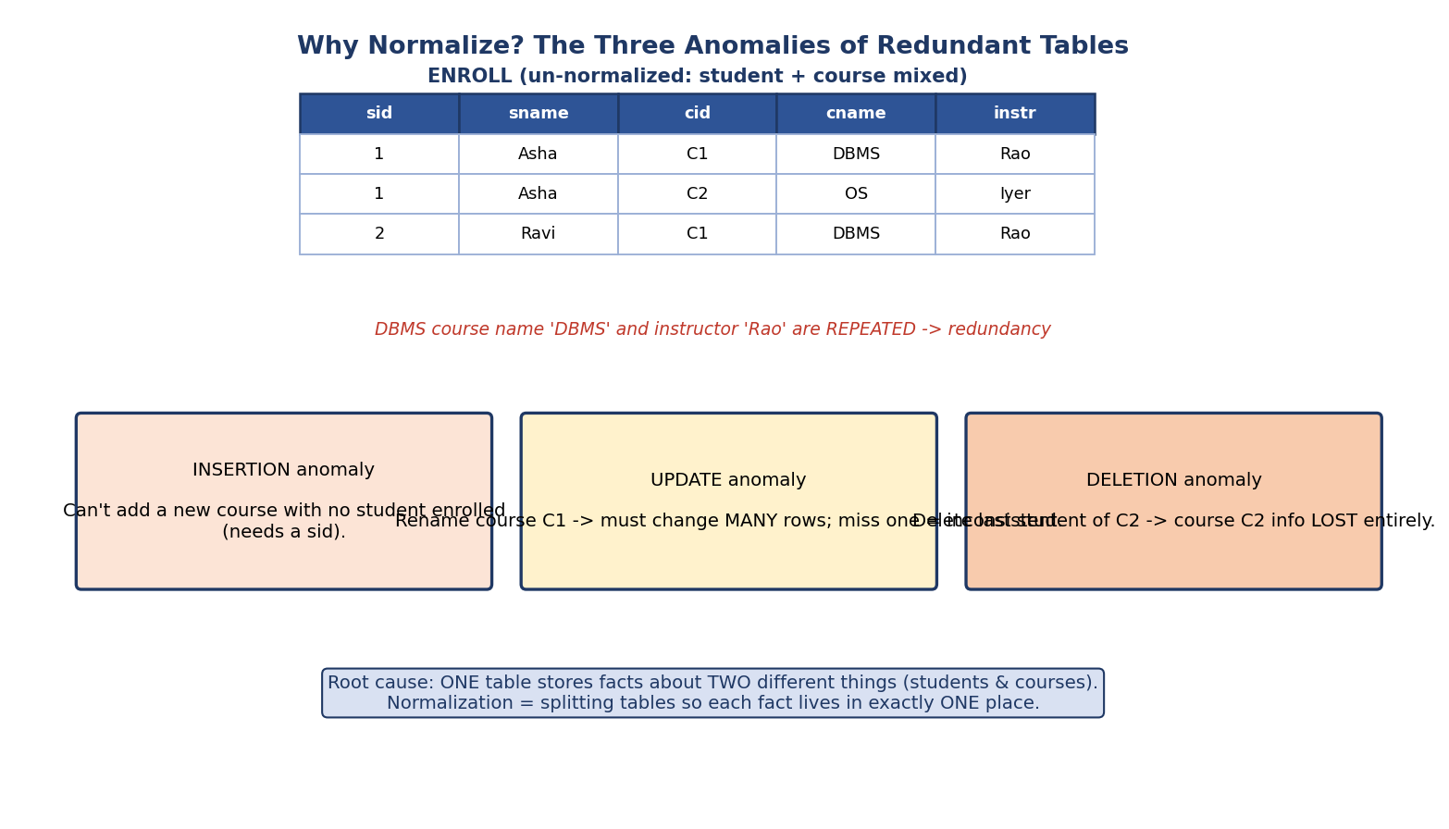
Three anomalies on a redundant ENROLL table: insertion (can’t add a course with no student), update (rename must touch many rows), deletion (removing last student loses the course).
Anomaly | What goes wrong
Insertion | Can’t add a new course until some student enrolls (the key needs a sid).
Update | Renaming a course means changing many rows; miss one → inconsistency.
Deletion | Deleting the last student of a course loses the course’s data entirely.
Root cause: one table is storing facts about two different things (students and courses). Normalization = decomposing tables so every fact lives in exactly one place, removing redundancy and these anomalies.
Trade-off preview: more normalization → less redundancy but more joins at query time. Sometimes we deliberately denormalize for read performance (Module 11). But you must know the normal forms first.

5.2 Functional Dependencies (FDs) — The Foundation

Definition
A functional dependency X → Y means: if two tuples agree on X, they must agree on Y. X functionally determines Y. X is the determinant.
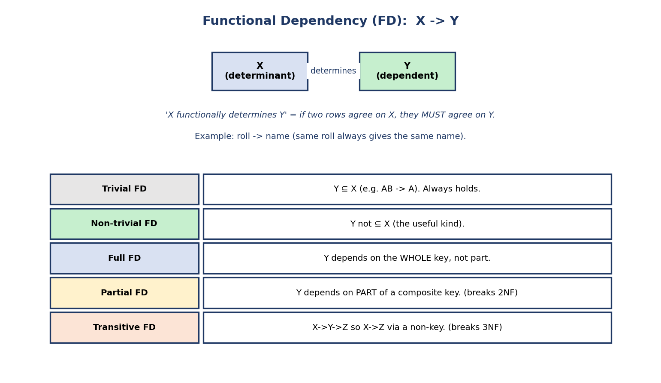
Functional dependency X→Y: X (determinant) determines Y (dependent); plus types — trivial, non-trivial, full, partial, transitive.
Example: roll → name — the same roll number always maps to the same name. But name → roll is false (two students can share a name).

Types of FD (each maps to a normal form)
Type | Meaning | Matters for
Trivial | Y ⊆ X (e.g. AB → A). Always true. | —
Non-trivial | Y ⊄ X (the useful kind). | everything
Full | Y depends on the whole key. | 2NF
Partial | Y depends on part of a composite key. | breaks 2NF
Transitive | X → Y → Z through a non-key Y. | breaks 3NF
FDs are a property of the schema/meaning, not of one instance. You assert roll → name because of the rule “one roll = one student”, not because the current rows happen to satisfy it. A common conceptual mistake is “inferring” FDs from sample data — sample data can only disprove an FD, never prove it.

5.3 Armstrong’s Axioms — Deriving All FDs
To reason about FDs formally (and compute closures), we use Armstrong’s axioms — a set of inference rules that are sound (derive only true FDs) and complete (derive all implied FDs).
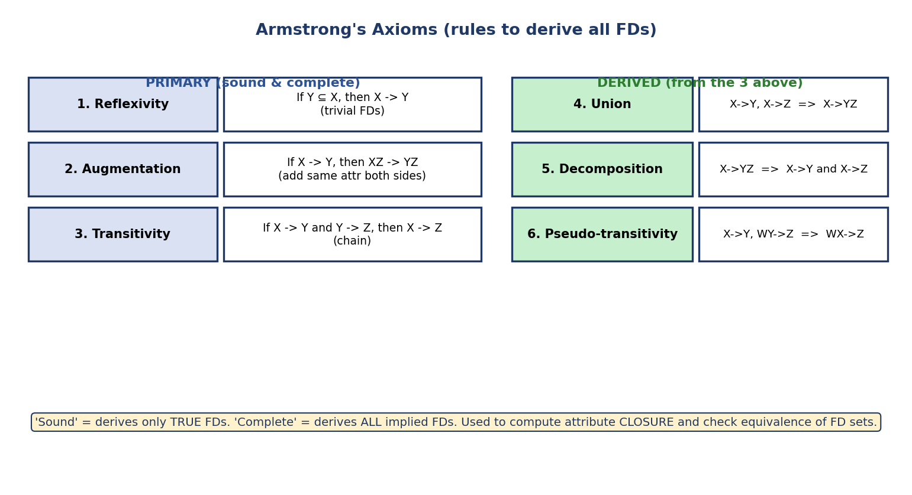
Armstrong’s axioms: primary rules (reflexivity, augmentation, transitivity) and derived rules (union, decomposition, pseudo-transitivity).
Primary (the 3 you must memorize):
- Reflexivity: if Y ⊆ X, then X → Y (gives trivial FDs).
- Augmentation: if X → Y, then XZ → YZ (add the same attribute to both sides).
- Transitivity: if X → Y and Y → Z, then X → Z (chaining).
Derived (from the three above):
- Union: X → Y, X → Z ⟹ X → YZ.
- Decomposition: X → YZ ⟹ X → Y and X → Z.
- Pseudo-transitivity: X → Y, WY → Z ⟹ WX → Z.
Why we care: these rules let us compute attribute closure, find candidate keys, and test whether two FD sets are equivalent — the machinery behind every normalization question.

5.4 Attribute Closure (X⁺) — The Master Tool
The closure of an attribute set X, written X⁺, is the set of all attributes functionally determined by X. This one algorithm answers almost every FD question.
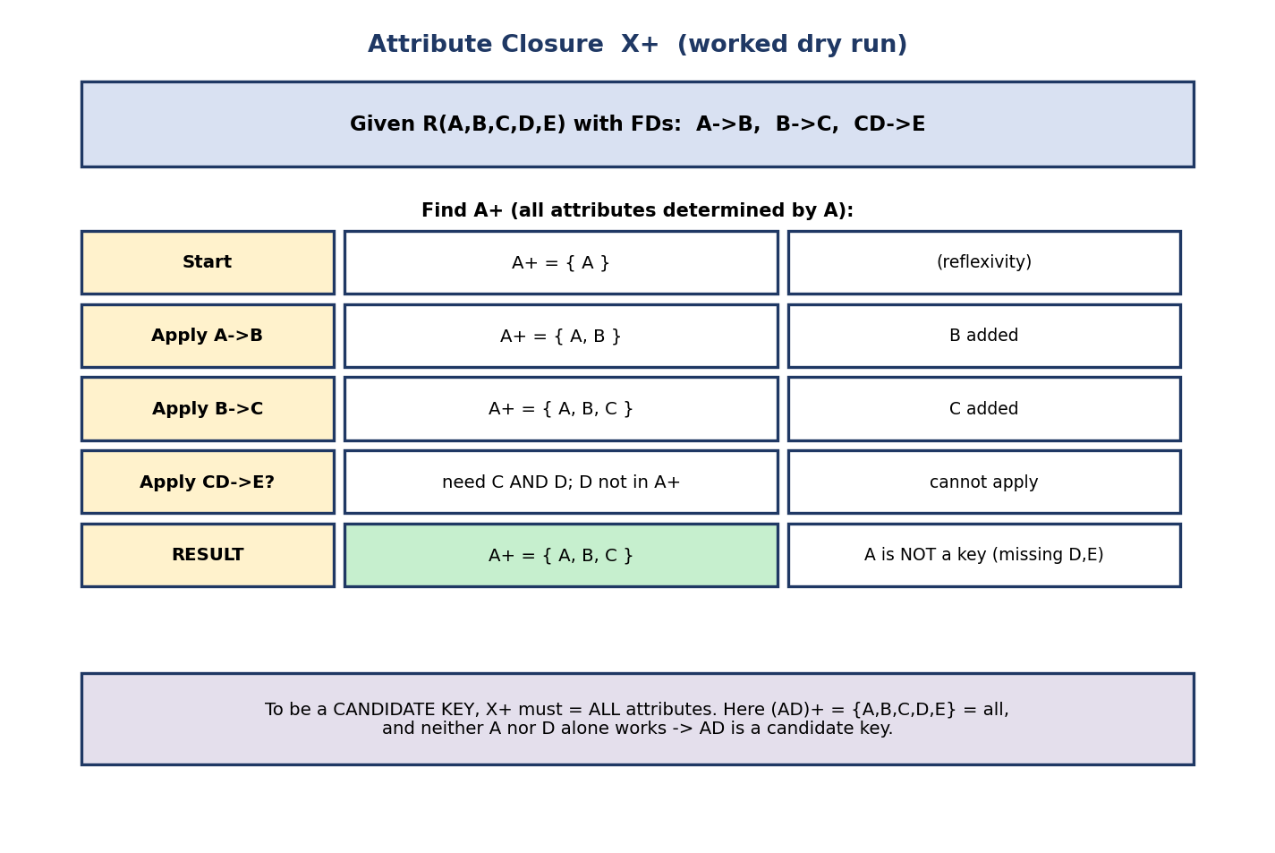
Worked attribute closure: given R(A,B,C,D,E) with A→B, B→C, CD→E, computing A+ = {A,B,C} step by step, concluding A is not a key.
Algorithm: start with X⁺ = X; repeatedly, for any FD L → R where L ⊆ X⁺, add R to X⁺; stop when nothing more can be added.
Worked example — R(A,B,C,D,E), FDs A→B, B→C, CD→E:
A⁺ = {A} start
A⁺ = {A,B} apply A→B
A⁺ = {A,B,C} apply B→C
CD→E? need C AND D — D ∉ A⁺ — cannot apply
A⁺ = {A,B,C} FINAL ⟹ A is NOT a key (D,E missing)
Uses of closure:
- Is X a super key? → yes iff X⁺ = all attributes.
- Find candidate keys → minimal X with X⁺ = all attributes.
- Does X → Y hold? → yes iff Y ⊆ X⁺.
- Are two FD sets equivalent? → each FD of one is implied by the other (check via closures). Worked example: is F = {A→B, B→C} equivalent to G = {A→B, A→C, B→C}? Check G ⊆ F⁺: under F, A⁺={A,B,C} so A→C holds ✓ (and A→B, B→C are in F). Check F ⊆ G⁺: under G, both A→B and B→C hold ✓. Both directions hold → F ≡ G (they cover the same FDs). F is the smaller (it’s a cover of G).
Candidate-key shortcut (asked constantly): attributes that appear only on the left of FDs (or in no FD) must be in every candidate key — start your search there. In the example, D appears only on a left side and never on a right side, so D must be in every key; indeed (AD)⁺ = {A,B,C,D,E} = all, and neither A nor D alone works → AD is the candidate key. (See the candidate-key flowchart in Module 3 §3.2.)
Finding ALL candidate keys (systematic procedure):
- Classify each attribute by where it appears in the FDs:
  - only on LHS / in no FD → essential (must be in every key).
  - only on RHS → never in any candidate key.
  - on both sides → “middle” attributes (may or may not be needed).
- Compute the closure of the essential set. If it’s already all attributes, that’s the only candidate key.
- Otherwise, add middle attributes (one, then pairs, …) to the essential set; any minimal combination whose closure = all attributes is a candidate key. Stop adding to a set once it becomes a key (supersets of a key are super keys, not candidate keys).
Example: R(A,B,C,D,E), A→B, BC→D, E→C, D→A. Essential = {E} (E is only on a LHS). E⁺={E,C} ≠ all, so pair E with a middle attribute: (A,E), (B,E), (D,E) each close to all → candidate keys = {A,E}, {B,E}, {D,E}. {B,C,E} contains the key {B,E}, so it’s a super key, not a candidate key.

5.5 Minimal (Canonical) Cover
A minimal cover is the smallest FD set equivalent to the original — handy for 3NF decomposition and for removing redundancy in constraints.
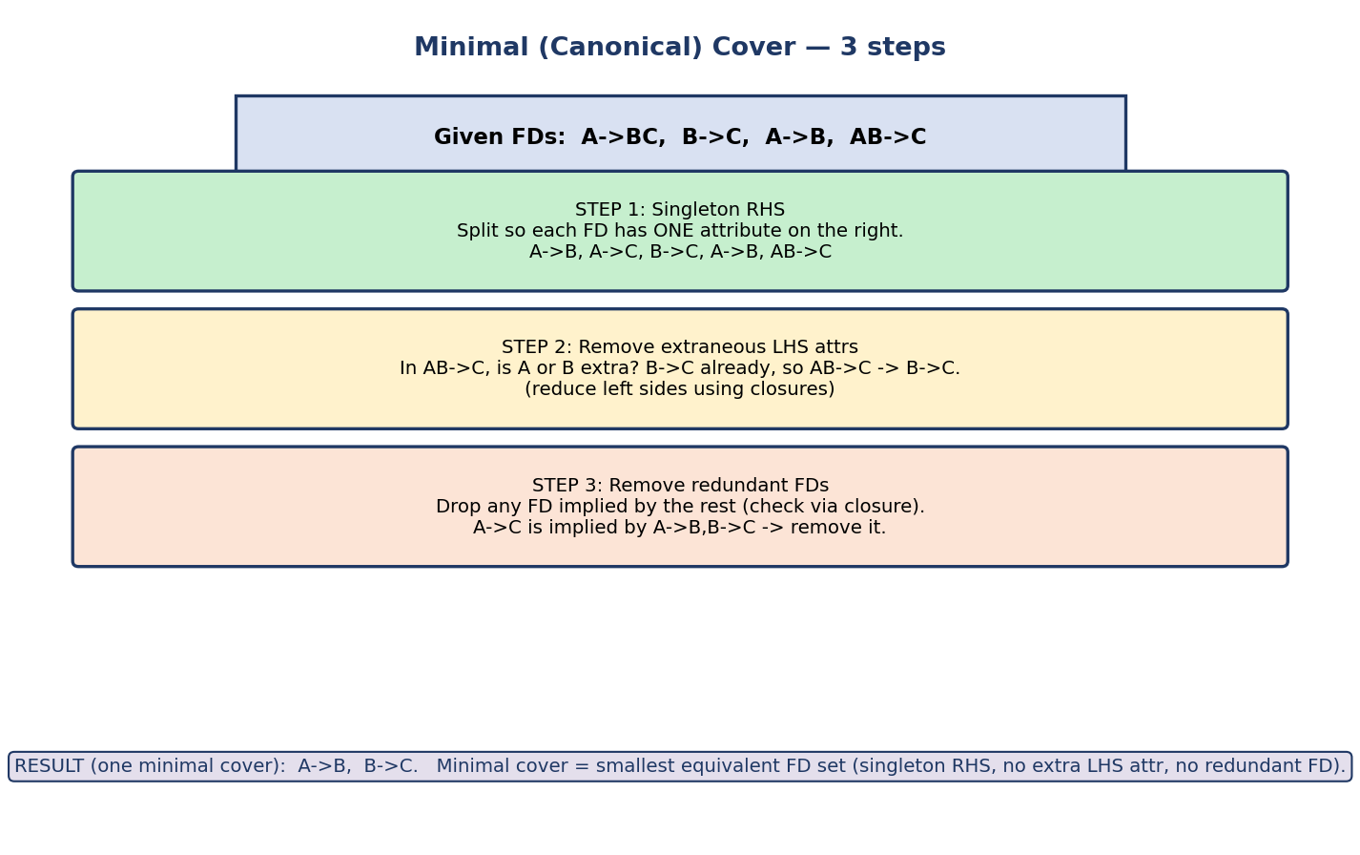
Minimal cover in 3 steps: make right-hand sides single attributes, remove extraneous left-hand attributes, remove redundant FDs.
Three steps:
- Singleton RHS — split every FD so the right side has one attribute (A→BC becomes A→B, A→C).
- Remove extraneous LHS attributes — for each FD with a composite left side, drop any attribute that isn’t needed. Precise test: attribute B is extraneous in XB → Y if Y ⊆ (X)⁺ computed under the current FD set (i.e. you can still derive Y without B). If so, replace XB → Y with X → Y.
- Remove redundant FDs — drop any FD that is still implied by the rest (check with closure).
Result for {A→BC, B→C, A→B, AB→C} → minimal cover {A→B, B→C}. A minimal cover is not always unique (the result can depend on the order you process FDs), but all minimal covers are equivalent.

5.6 The Normal Forms — Overview
A normal form is a rule about which FDs are allowed. Each higher form is stricter and removes more redundancy. Each form includes all lower forms.
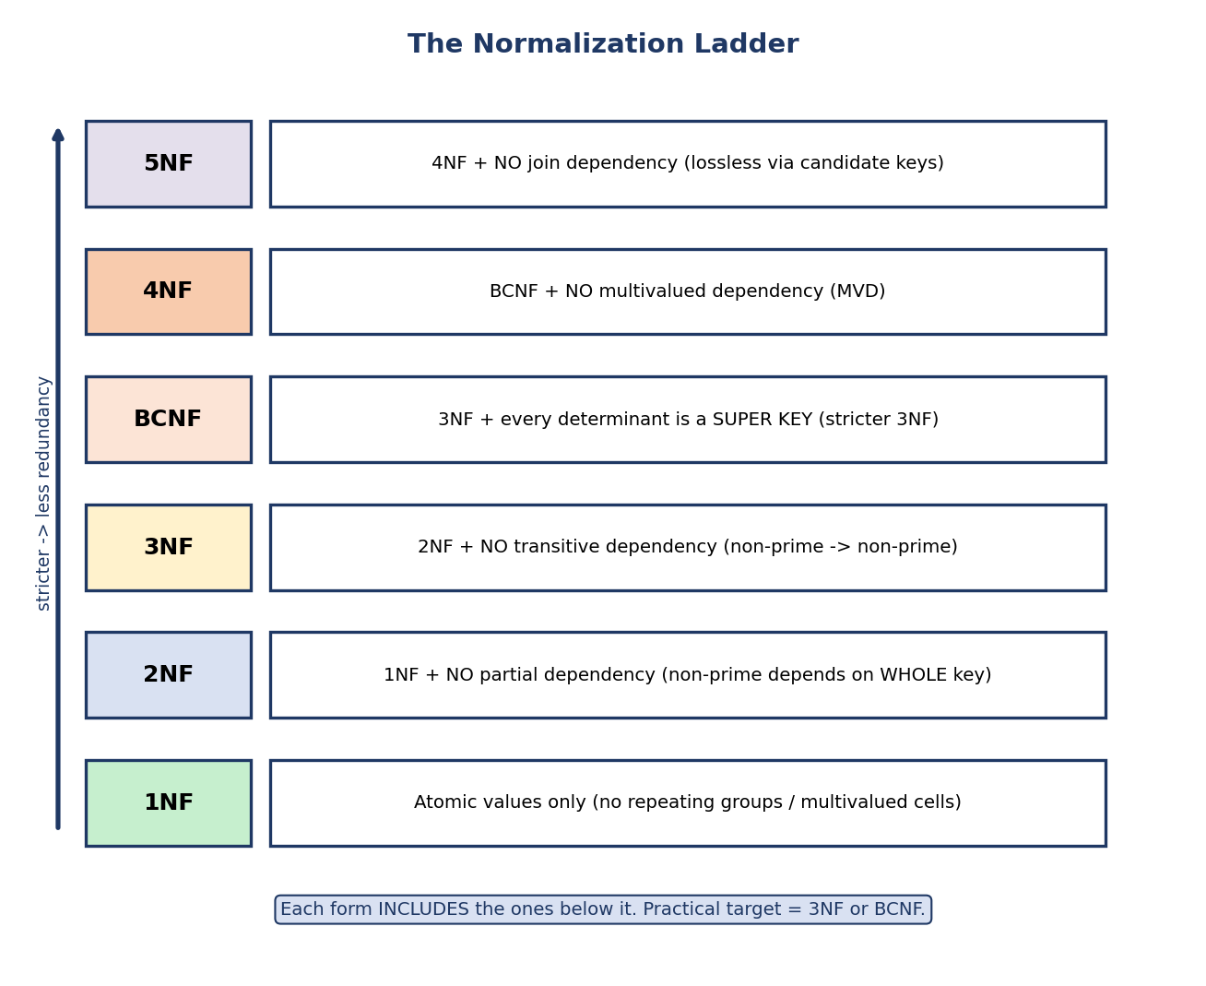
The normalization ladder: 1NF (atomic), 2NF (no partial dep), 3NF (no transitive dep), BCNF (every determinant a super key), 4NF (no MVD), 5NF (no join dependency).
Form | Requirement (on top of the previous)
1NF | all values atomic (no repeating groups / multivalued cells)
2NF | no partial dependency (non-prime depends on the whole key)
3NF | no transitive dependency (non-prime → non-prime)
BCNF | every determinant is a super key
4NF | no non-trivial multivalued dependency (MVD)
5NF | no join dependency (decomposable only via candidate keys)
Practical target: 3NF or BCNF. 4NF/5NF matter in specific cases. Most real schemas aim for 3NF (always achievable losslessly and dependency- preserving) and go to BCNF only where redundancy demands it.

5.7 First Normal Form (1NF)
1NF: every attribute value is atomic — no lists, sets, or repeating groups in a single cell.
Violation: a phones column holding "9991, 9992", or repeating columns course1, course2, course3. Fix: one value per cell — split the multivalued data into separate rows (or a separate table). This is the same atomic-domain rule from Module 3.
Note: the relational model technically assumes 1NF. So “un-normalized” in exams usually means a table with repeating groups that you must flatten first.

5.8 Second Normal Form (2NF) — No Partial Dependency
2NF: in 1NF and no non-prime attribute is partially dependent on a candidate key (i.e. every non-prime attribute depends on the whole key, not part of it).
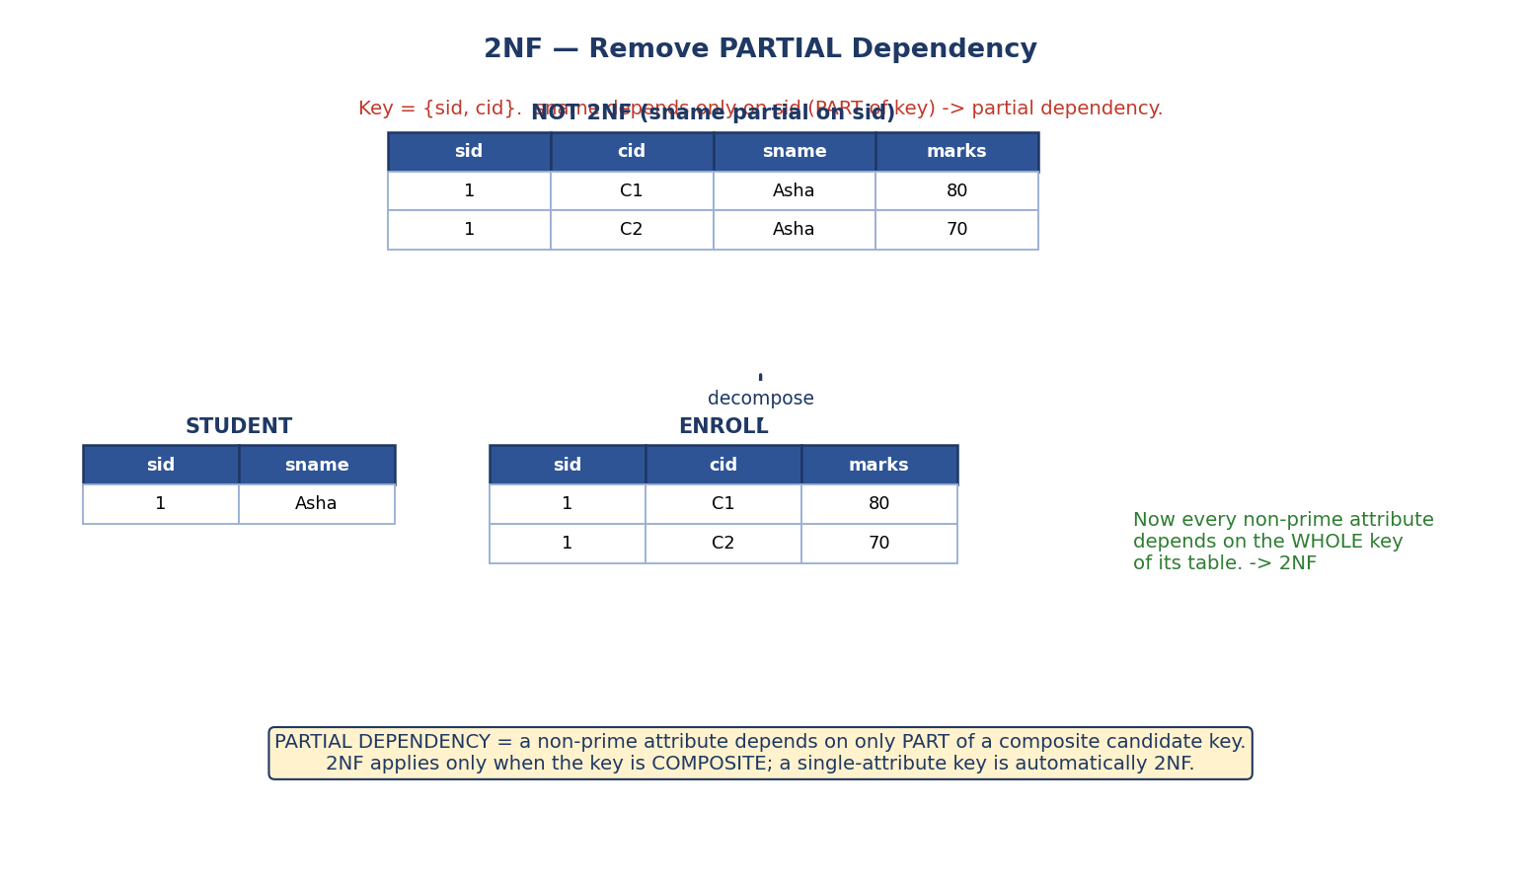
2NF: a table keyed by (sid,cid) where sname depends only on sid (partial dependency) is split into STUDENT(sid,sname) and ENROLL(sid,cid,marks).
Partial dependency = a non-prime attribute depends on part of a composite candidate key.
Example: ENROLL(sid, cid, sname, marks) with key {sid, cid}. Here sname depends only on sid (part of the key) → partial dependency → not 2NF. Fix: split into STUDENT(sid, sname) and ENROLL(sid, cid, marks).
Key fact (exam): 2NF is only relevant when the candidate key is composite. If every candidate key is a single attribute, the relation is automatically in 2NF (there’s no “part” of the key to depend on).

5.9 Third Normal Form (3NF) — No Transitive Dependency
3NF: in 2NF and no transitive dependency — no non-prime attribute depends on another non-prime attribute.
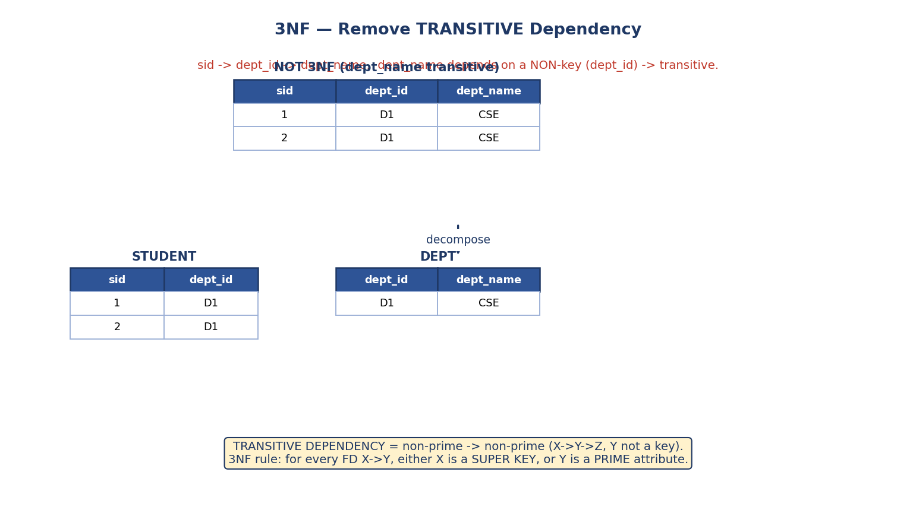
3NF: a table where sid→dept_id→dept_name (transitive) is split into STUDENT(sid,dept_id) and DEPT(dept_id,dept_name).
Transitive dependency = X → Y → Z where Y is not a candidate key, so a non-prime (Z) depends on a non-prime (Y).
Example: STUDENT(sid, dept_id, dept_name) with sid → dept_id → dept_name. dept_name depends on dept_id (a non-key) → transitive → not 3NF. Fix: STUDENT(sid, dept_id) and DEPT(dept_id, dept_name).
The formal 3NF test (memorize — this is the exact rule): a relation is in 3NF if for every non-trivial FD X → Y, either X is a super key, or every attribute of Y is a prime attribute (part of some candidate key). The second clause is the “escape hatch” that BCNF removes.
The phrase “no non-prime depends on another non-prime” is a handy heuristic for spotting violations, but the formal “super key OR Y is prime” test above is the precise definition — always apply the formal test in exams.

5.10 Boyce-Codd Normal Form (BCNF)
BCNF: for every non-trivial FD X → Y, X must be a super key. (It removes 3NF’s “Y is prime” exception — so BCNF is stricter than 3NF.)
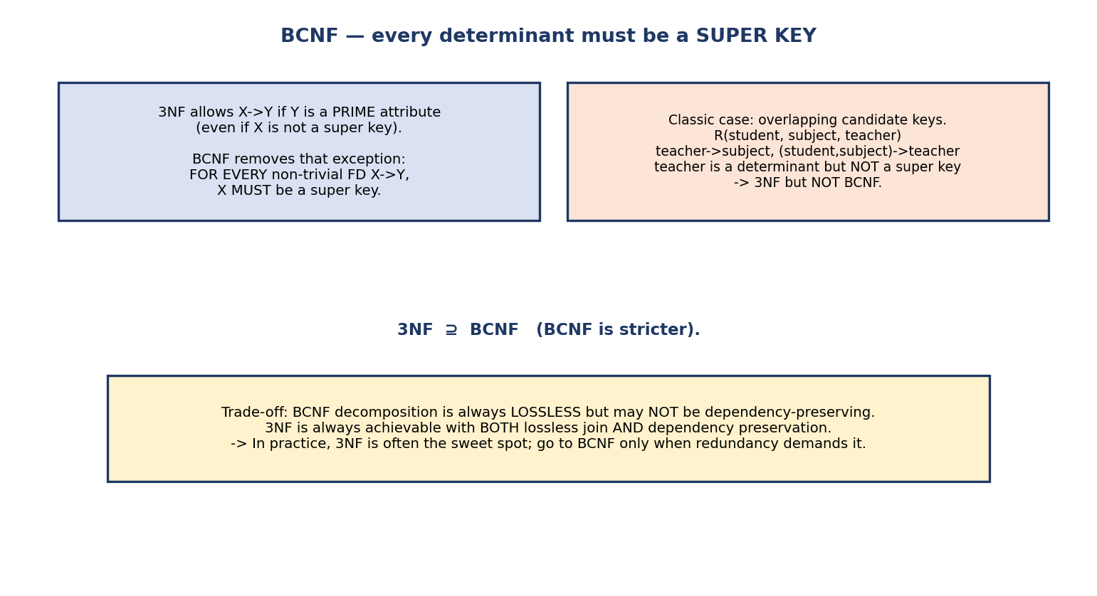
BCNF: for every non-trivial FD the determinant must be a super key; the classic violation is overlapping candidate keys (teacher→subject where teacher is not a super key).
Classic BCNF violation (overlapping candidate keys): R(student, subject, teacher) with teacher → subject and (student, subject) → teacher. Candidate keys: (student, subject) and (student, teacher). The FD teacher → subject has a determinant (teacher) that is not a super key → 3NF but not BCNF.
The crucial trade-off (a guaranteed exam/interview point): - BCNF decomposition is always lossless, but may not preserve all dependencies. - 3NF is always achievable with both lossless join and dependency preservation. - So: if you must keep all FDs checkable on single tables, stop at 3NF; go to BCNF only when the remaining redundancy is unacceptable.

5.11 Decomposition Properties — Lossless Join & Dependency Preservation
When we split a table, two properties decide whether the split is “good”.
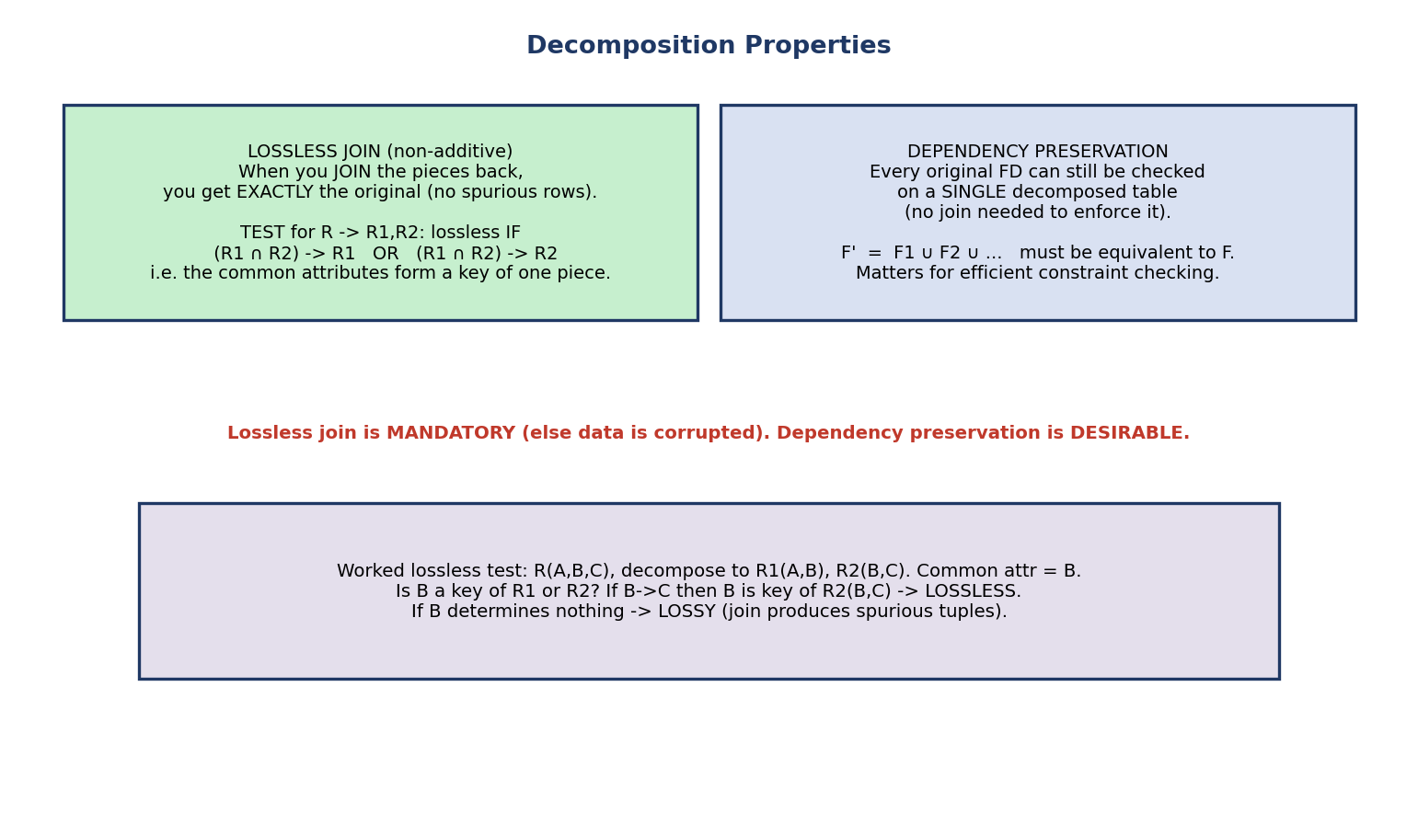
Decomposition properties: lossless join (rejoining gives exactly the original, no spurious rows; test via common attributes being a key of one piece) and dependency preservation (every FD checkable on a single table).

Lossless join (non-additive) — MANDATORY
Rejoining the decomposed tables must give back exactly the original — no spurious (extra) tuples.
The test for R → R1, R2: the decomposition is lossless iff the common attributes form a key of at least one piece: (R1 ∩ R2) → R1 or (R1 ∩ R2) → R2.
Worked example: R(A,B,C) → R1(A,B), R2(B,C), common attribute B. If B → C, then B is a key of R2(B,C) → lossless. If B determines nothing, the join produces spurious tuples → lossy.
For decomposition into 3+ tables, the simple two-table rule isn’t enough — use the chase / tableau (matrix) algorithm: build a grid of pieces × all attributes, fill matching symbols using the FDs, and the decomposition is lossless iff some row becomes all-distinguished (all original symbols). Know the name; GATE occasionally tests it.

Dependency preservation — DESIRABLE
Every original FD should be checkable on one decomposed table (without a join). Formally (F1 ∪ F2 ∪ …) ≡ F. If lost, enforcing a constraint needs a join every time — slow.
Summary rule: Lossless join is non-negotiable (else you corrupt data). Dependency preservation is desirable (else constraint-checking is expensive). 3NF guarantees both; BCNF guarantees only lossless.

5.11A Fully Worked GATE Numericals (do these until they’re automatic)
This is the highest-yield section for SEBI/RBI/GATE. Everything above is theory; here we grind the exact keystrokes of each computation. Cover the answer, redo it, and check.

(a) Closure X⁺ — every step shown
Given: R(A,B,C,D,E,F), F = { A→B, B→C, CD→E, A→D, E→F }. Compute A⁺.
A⁺ = {A} start
A→B? A⊆A⁺ → add B A⁺ = {A,B}
A→D? A⊆A⁺ → add D A⁺ = {A,B,D}
B→C? B⊆A⁺ → add C A⁺ = {A,B,C,D}
CD→E? C,D⊆A⁺ → add E A⁺ = {A,B,C,D,E}
E→F? E⊆A⁺ → add F A⁺ = {A,B,C,D,E,F}
nothing left to add A⁺ = {A,B,C,D,E,F} = ALL ⟹ A is a SUPER KEY
Reading the result: since A⁺ = all attributes, A alone determines everything → A is a super key, and (being a single attribute) it is the candidate key. If we ask “does A → E hold?”, the answer is yes because E ∈ A⁺.

(b) Finding ALL candidate keys — the LHS/RHS/BOTH classification
Given: R(A,B,C,D,E), F = { AB→C, C→D, D→B, A→E }. Find all candidate keys.
Step 1 — classify each attribute by where it appears across the FDs:
attr | appears on LHS? | appears on RHS? | verdict
-----+-----------------+-----------------+---------------------------
A | yes | no | ESSENTIAL (only-LHS) → in EVERY key
B | yes | yes (D→B) | middle
C | yes | yes (AB→C) | middle
D | yes | yes (C→D) | middle
E | no | yes (A→E) | only-RHS → NEVER in any key
Step 2 — close the essential set {A}:
A⁺ = {A}; A→E → {A,E}. AB→C needs B (∉); C→D needs C (∉); D→B needs D (∉).
A⁺ = {A,E} ≠ ALL → A alone is NOT a key. Must add a middle attribute.
Step 3 — add middle attributes minimally (try A + one of B/C/D):
(A,B)⁺: A,B,E then AB→C→C then C→D→D → {A,B,C,D,E} = ALL ✓ candidate key
(A,C)⁺: A,C,E then C→D→D then D→B→B then AB→C(have) → {A,B,C,D,E} = ALL ✓ candidate key
(A,D)⁺: A,D,E then D→B→B then AB→C→C → {A,B,C,D,E} = ALL ✓ candidate key
Each is minimal (A alone failed, and A is mandatory). No need to test triples — supersets of these are super keys, not candidate keys.
Answer: candidate keys = {A,B}, {A,C}, {A,D}. Prime attributes = union of all candidate keys = {A,B,C,D}; non-prime = {E}.

(c) Minimal (canonical) cover — all three passes worked
Given: F = { A→BC, B→C, AB→C, A→B }. Find a minimal cover.
Pass 1 — singleton RHS (split multi-attribute right sides):
A→BC ⟹ A→B , A→C
Now F = { A→B, A→C, B→C, AB→C, A→B } (A→B appears twice — keep the set)
Working set: { A→B, A→C, B→C, AB→C }
Pass 2 — remove extraneous LHS attributes (only FDs with composite LHS: AB→C):
Is A extraneous in AB→C? compute B⁺ under current set = {B,C}. C ∈ B⁺ → YES, A extraneous.
⟹ AB→C becomes B→C (already present) → drop the duplicate.
Working set: { A→B, A→C, B→C }
Pass 3 — remove redundant FDs (drop each FD, test if still derivable):
Remove A→C. Under { A→B, B→C }: A⁺ = {A,B,C} ⊇ {C}. So A→C is REDUNDANT → drop it.
Remove A→B. Under { B→C }: A⁺ = {A}. B ∉ A⁺ → NOT redundant → keep.
Remove B→C. Under { A→B }: B⁺ = {B}. C ∉ B⁺ → NOT redundant → keep.
Answer: minimal cover = { A→B, B→C }. (Process order matters — a different order can give a different but equivalent minimal cover.)

(d) Lossless-join check — the tableau (matrix / chase) method, 3 tables
The two-table rule (R1∩R2 is a key of a piece) can’t handle 3+ pieces. Use the tableau. Rows = decomposed tables, columns = all attributes. Put aⱼ (distinguished) where the table has that attribute, bᵢⱼ (non-distinguished) elsewhere. Then apply FDs: whenever two rows agree on the LHS, equate their RHS symbols (prefer an a). Lossless iff some row becomes all-a.
Given: R(A,B,C,D,E), decomposition R1(A,B), R2(B,C,D), R3(D,E); F = { A→BC, C→D, D→E }.
Initial tableau:
A B C D E
R1(AB) a1 a2 b13 b14 b15
R2(BCD) b21 a2 a3 a4 b25
R3(DE) b31 b32 b33 a4 a5
Apply FDs (equate RHS where LHS matches):
C→D: rows R2,R3? they must agree on C first — only R2 has a3, R3 has b33 → no match yet.
D→E: R2 and R3 agree on D (both a4) → equate E: R2's b25 := a5 (take the 'a').
R2 row: b21 a2 a3 a4 a5
C→D: (no two rows share the same C symbol) → no change.
A→BC: (only R1 has a1 for A) → no change.
Recheck: does any row have all a’s? Not yet. But note this particular decomposition is lossy — no row reaches all-a, and there is no way to recover A into R2/R3 (A only appears in R1, and nothing determines A).
Contrast — a lossless case: decompose the same R as R1(A,B,C), R2(C,D), R3(D,E). R1∩R2 = C, and C→D makes C a key of R2; R2∩R3 = D, and D→E makes D a key of R3; A→BC makes A a key of R1. Rejoining pairwise on a key each time is lossless at every step → lossless overall. (In the tableau, row R1 would fill to all-a.)
Fast two-table reflex (use whenever there are exactly 2 pieces): R(A,B,C) → R1(A,B), R2(A,C). Common attr = A. If A→BC (so A is a key), then (R1∩R2)→R1 holds → lossless. If instead only B→C, common attr A determines neither whole piece → lossy (spurious tuples on rejoin).

(e) Dependency-preservation check — worked both ways
Rule: decomposition {R1,…,Rk} preserves F iff (F1 ∪ F2 ∪ … ∪ Fk)⁺ = F⁺, where each Fᵢ is the projection of F onto Rᵢ (the FDs whose attributes all fit inside Rᵢ). Practically: for each original FD X→Y, check Y ⊆ X⁺ computed using only the preserved (local) FDs.
Given: R(A,B,C), F = { A→B, B→C, C→A }, decomposition R1(A,B), R2(B,C). Projected FDs: R1 keeps A→B (and B→A since C→A,A→B,B→C imply B→A…); R2 keeps B→C (and C→B).
Check each original FD using the local FDs {A→B, B→A, B→C, C→B}:
A→B : A⁺(local) = {A,B,...} ⊇ {B} ✓
B→C : B⁺(local) = {B, A, C} ⊇ {C} ✓
C→A : C⁺(local) = {C, B, A} ⊇ {A} ✓ (C→B→A via local FDs)
All three hold → dependency-preserving (and, since B is a key of R2 via B→C, also lossless).
Counter-example (dependency LOST): R(A,B,C), F = { AB→C, C→B }, candidate keys {A,B} and {A,C}. BCNF forces splitting off C→B: R1(C,B), R2(A,C). Now AB→C is not checkable on either single table (no table holds A, B, C together). So this BCNF decomposition is lossless but NOT dependency-preserving — the canonical illustration of the 3NF-vs-BCNF trade-off, continued in §5.11B.

5.11B Worked “Normalize this relation to BCNF” — every step
This is the capstone worked example: take one relation and drive it up the ladder, showing why BCNF may lose a dependency that 3NF keeps.
Given: R(A,B,C) with F = { AB→C, C→B }. (Read it as: (student, course)→instructor and instructor→course — the classic “one instructor teaches one course, a course has many instructors” case.)
Step 1 — candidate keys.
AB⁺ = {A,B} → AB→C → {A,B,C} = ALL → {A,B} is a super key (and minimal) → key
AC⁺ = {A,C} → C→B → {A,B,C} = ALL → {A,C} is a super key (and minimal) → key
A⁺ = {A} (nothing fires) ≠ ALL; B⁺={B}; C⁺={C,B}≠ALL → no single-attr key
Candidate keys = {A,B} and {A,C}. Prime = {A,B,C} (all three). Non-prime = ∅.
Step 2 — 2NF? Non-prime set is empty, so there is no partial dependency possible → 2NF holds (trivially).
Step 3 — 3NF? Test each FD: “LHS a super key OR every RHS attr prime”.
AB→C : AB is a super key ✓
C→B : C is NOT a super key, BUT B is PRIME (B ∈ key {A,B}) ✓ ← 3NF escape hatch
Both pass → R is in 3NF.
Step 4 — BCNF? Test each FD: “LHS must be a super key” (no prime escape).
AB→C : AB is a super key ✓
C→B : C is NOT a super key (C⁺={C,B}≠ALL) ✗ ← BCNF VIOLATION
So R is 3NF but not BCNF — the violating FD is C→B.
Step 5 — BCNF decomposition on the violating C→B. Split on C⁺ = {C,B}:
R1 = (C⁺) = R1(C, B) -- holds C→B
R2 = R − (C⁺ − C) = R(A,B,C) − {B} = R2(A, C)
- Lossless? R1∩R2 = {C}, and C→B makes C a key of R1(C,B) → lossless ✓
- Dependency-preserving? Projected FDs: R1 gives C→B; R2 gives nothing useful about AB→C. The original FD AB→C is now un-checkable on any single table (no table has A, B, C together) → dependency preservation LOST ✗
The trade-off, made concrete: - Stay at 3NF R(A,B,C) → keep both AB→C and C→B checkable, but tolerate the small redundancy that C→B causes. - Go to BCNF {R1(C,B), R2(A,C)} → zero anomaly from C→B, but you can no longer enforce AB→C without a join (or a costly assertion/trigger).
This is exactly why the standard advice is “decompose to 3NF (Bernstein synthesis, always lossless + dependency-preserving); go to BCNF only when the leftover redundancy is genuinely unacceptable.”
Exam phrasing to memorize: “Give a relation that is in 3NF but not in BCNF.” → R(A,B,C), AB→C, C→B. “Show its BCNF decomposition loses a dependency.” → split on C→B into (C,B) and (A,C); AB→C is lost.

5.12 Higher Normal Forms — 4NF (MVD) and 5NF

Multivalued dependency & 4NF
A multivalued dependency (MVD) X ↠ Y exists when, for each X, a set of Y values exists independently of the other attributes. Two independent multivalued facts in one table cause a Cartesian explosion.
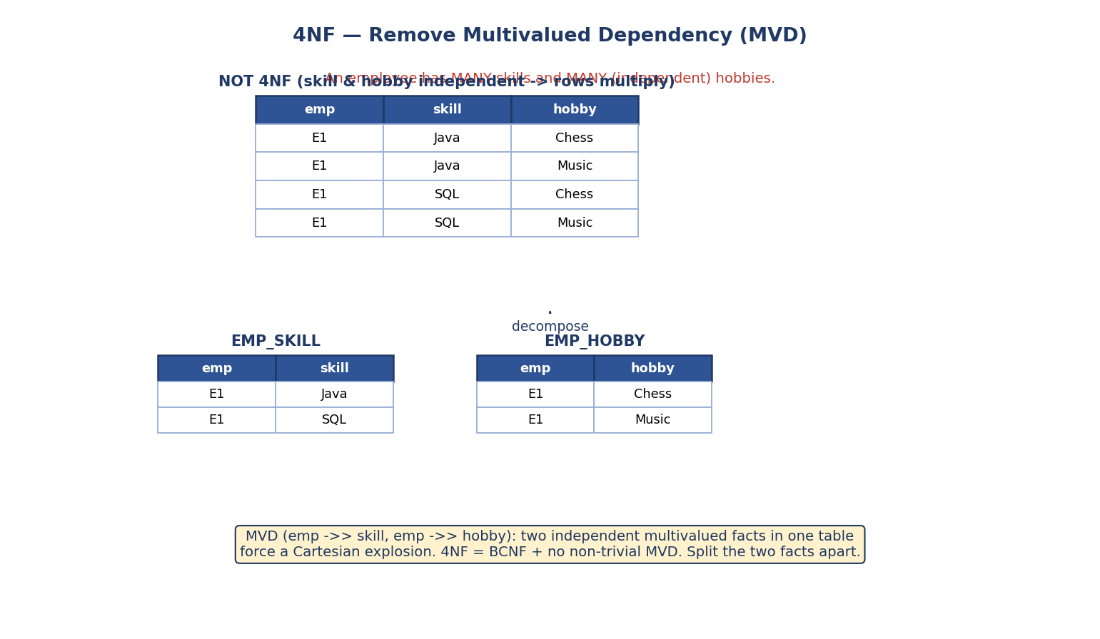
4NF: an employee with independent multivalued skills and hobbies forces rows to multiply; split into EMP_SKILL and EMP_HOBBY.
Example: EMP(emp, skill, hobby) where skills and hobbies are independent. Storing both forces every skill to pair with every hobby (rows multiply). 4NF = BCNF + no non-trivial MVD. Fix: split into EMP_SKILL(emp, skill) and EMP_HOBBY(emp, hobby).

Fifth Normal Form (5NF / PJNF)
5NF (Project-Join NF) deals with join dependencies: a table is in 5NF if it cannot be decomposed into smaller tables and rejoined without loss except via its candidate keys. It addresses rare cases where a relation must be split into three or more parts. Mostly theoretical; know the name and the one-line idea.

5.13 How to Normalize — The Procedure
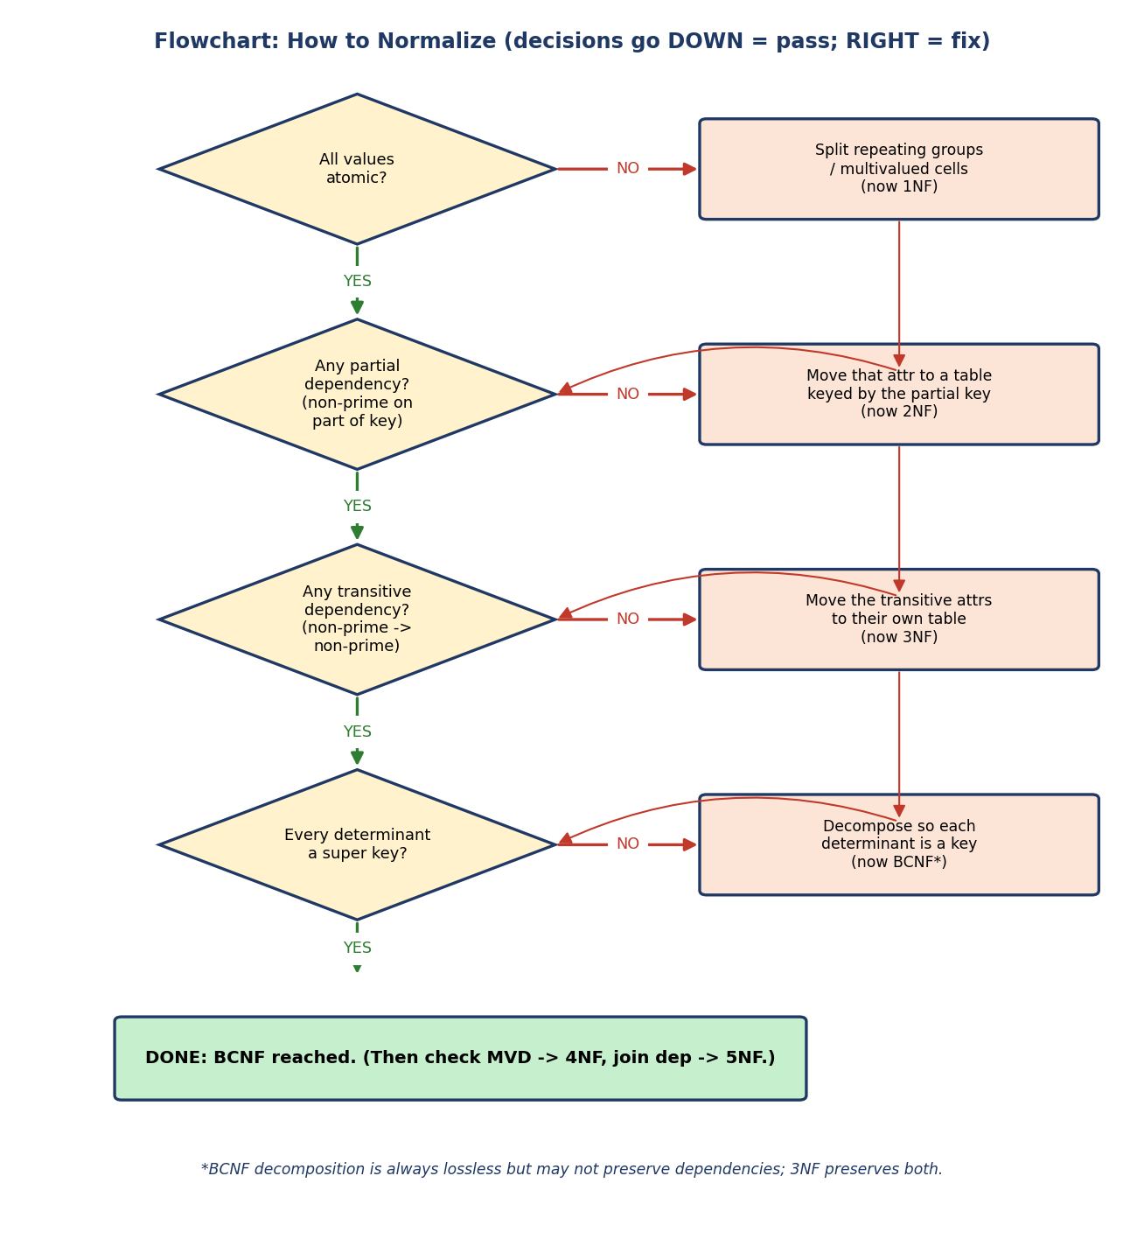
Flowchart for normalization: check atomic (1NF), partial dependency (2NF), transitive dependency (3NF), every determinant a super key (BCNF); each failure triggers a decomposition.
The repeatable procedure:
- Make all values atomic → 1NF.
- Find candidate keys (via closures), mark prime/non-prime attributes.
- Remove partial dependencies → 2NF.
- Remove transitive dependencies → 3NF.
- Check every determinant is a super key; if not, decompose → BCNF.
- (If needed) remove MVDs → 4NF; join dependencies → 5NF.

The two decomposition algorithms (know which guarantees what)
Algorithm | Produces | Guarantees
3NF synthesis (Bernstein) | a 3NF schema | lossless join + dependency preserving (always)
BCNF decomposition (analysis) | a BCNF schema | lossless join always; dependency preservation not guaranteed
- 3NF synthesis: compute a minimal cover; create one table per FD group (group FDs by identical left side, each group → table XY₁Y₂…); if no table contains a candidate key, add one table that is a candidate key. Done.
- BCNF decomposition: while some table has a violating FD X → Y (X not a super key), split it into (X⁺) and (R − (X⁺ − X)); repeat. Always lossless, but may drop a dependency.
Exam one-liner: “Which decomposition guarantees dependency preservation?” → 3NF (synthesis), not BCNF.

Dry run — “find the highest normal form” (the classic exam question)
Given: R(A,B,C,D), FDs AB → C, C → D, candidate key {A,B}. Prime = {A,B}; non-prime = {C,D}. - 1NF? assume atomic → yes. - 2NF? any non-prime on part of {A,B}? AB→C uses the whole key; no partial dep → 2NF holds. - 3NF? C → D: C is not a super key (C⁺ = {C,D} ≠ all), and D is non-prime → transitive dependency → fails 3NF. - Highest NF = 2NF. Fix: split into R1(A,B,C) and R2(C,D).
Exam technique: always (1) list candidate keys via closure, (2) mark prime/non-prime, (3) test each FD against 2NF→3NF→BCNF in order. The highest normal form is the last one that holds before the first failure.

5.14 Real-World & Backend Perspectives
- Backend: OLTP schemas are usually normalized to 3NF to avoid update anomalies in transactional data (orders, payments, users).
- Denormalization (deliberate): read-heavy systems and data warehouses (Module 11) often denormalize (star schema) to avoid expensive joins — trading redundancy for read speed. You normalize for writes, denormalize for reads.
- Migrations: splitting a table to reach a higher normal form is a routine (but careful) schema migration; the lossless-join property is what guarantees you don’t corrupt data.

5.15 Tradeoffs, Common Mistakes, Edge Cases
Common mistakes (exam + real life) - Confusing partial (depends on part of a key, 2NF) with transitive (non-prime → non-prime, 3NF). - Forgetting that a single-attribute key relation is automatically 2NF. - Thinking BCNF is always achievable with dependency preservation (it’s not). - “Proving” an FD from sample rows (data can only disprove an FD). - Forgetting to find all candidate keys before classifying prime/non-prime. - Assuming a lossless decomposition is automatically dependency-preserving.
Edge cases - A relation with no non-trivial FDs (only the full key determines things) is already in BCNF. - A relation where every attribute is prime is automatically in 3NF. - 2NF/partial-dependency analysis is irrelevant when keys are single-attribute. - Every binary (two-attribute) relation is always in BCNF — a classic one-liner exam fact (with only two attributes, any non-trivial FD’s determinant is necessarily a super key).
Tradeoffs
More normalization | Less normalization (denormalized)
Less redundancy, fewer anomalies | Faster reads (fewer joins)
More tables, more joins | Redundancy + update anomalies return
Great for OLTP / writes | Great for OLAP / read-heavy reporting

5.16 Exam, Interview & Coding Perspectives
Exam (SEBI/RBI/GATE): compute X⁺; find all candidate keys; prime/non-prime; identify the highest normal form; partial vs transitive; 3NF vs BCNF; lossless join test; dependency preservation; minimal cover; MVD/4NF.
Interview: “What is normalization and why?” (anomalies); “Difference between 3NF and BCNF?” (determinant must be super key; BCNF may lose dependency preservation); “When would you denormalize?” (read-heavy/reporting); “What’s a partial dependency?”.
Coding/practical: - Take a wide spreadsheet-style table and decompose it to 3NF by hand, then write the CREATE TABLEs with the right primary/foreign keys. - Verify your split is lossless by joining the pieces back and comparing.

5.17 Concept Checks & MCQs
- A→B, B→C. Is A→C derivable? → Yes (transitivity).
- R(A,B,C,D), A→B, B→C, C→D. A⁺ = ? → {A,B,C,D} (A is a key).
- Partial dependency breaks which NF? → 2NF.
- Transitive dependency breaks which NF? → 3NF.
- BCNF requires every determinant to be a ___ → super key.
- Which is stricter, 3NF or BCNF? → BCNF.
- Lossless test for R→R1,R2: common attributes must be a ___ of one piece → key.
- Which property does BCNF NOT always guarantee? → dependency preservation.
- A relation with a single-attribute key is always in ___ → 2NF.
- MVD is removed by which NF? → 4NF.
- Which decomposition algorithm guarantees dependency preservation? → 3NF synthesis (BCNF decomposition does not).
- Every binary (2-attribute) relation is always in ___ → BCNF.
- {B,C,E} contains key {B,E} — is it a candidate key? → No (super key, not minimal).
- Two FD sets are equivalent iff ___ → each implies the other (every FD of one is derivable from the other, checked via closures).
- Lossless decomposition into 3+ tables is tested with the ___ algorithm → chase / tableau (matrix).
- Given candidate key {A,B} in R(A,B,C,D), number of super keys = ___ → 2^(4−2) = 4 (every super key must contain both A and B).
- In R(A,B,C,D,E,F) with A→B, B→C, CD→E, A→D, E→F, is A a candidate key? → Yes — A⁺ = all six attributes (see §5.11A(a)).
- To make a right-hand side single-attribute is which minimal-cover step? → Step 1 (singleton RHS).
- In AB→C, if B⁺ = {B,C}, is A extraneous on the LHS? → Yes (you can derive C from B alone, so AB→C reduces to B→C).
- A BCNF decomposition of R(A,B,C) with AB→C, C→B produces which two tables? → (C,B) and (A,C) (splitting on the violating C→B).
- That BCNF split loses which dependency? → AB→C (not checkable on a single table).
- To test lossless join for a decomposition into 3 tables, which method? → tableau / chase (matrix) — lossless iff some row becomes all-distinguished.
- Prime attributes of R(A,B,C) with keys {A,B} and {A,C} = ___ → {A,B,C} (union of all candidate keys → all attributes prime → automatically 3NF).
- Dependency preservation is tested by ___ → checking (F1∪…∪Fk)⁺ = F⁺, i.e. every original FD X→Y still has Y ⊆ X⁺ using only the projected (local) FDs.
True/False - Every relation in BCNF is in 3NF. → True (BCNF is stricter). - 3NF is always lossless and dependency-preserving. → True. - BCNF is always dependency-preserving. → False. - You can prove an FD holds by looking at sample data. → False (only disprove).
Numerical (do it): > R(A,B,C,D,E), FDs A→B, BC→D, E→C, D→A. Find all candidate keys. > Hint: E appears only on the left of E→C and on no right side → E must be in > every key. E⁺ = {E,C} (not all), so pair E with one “entry” attribute. > Answer: the candidate keys are {A,E}, {B,E}, and {D,E} — all size 2. > Check: (A,E)⁺: A→B, E→C, then BC→D, D→A → all ✓. Similarly (B,E) and (D,E). > Note {B,C,E} is a super key but NOT a candidate key — its subset {B,E} is > already a key, so it isn’t minimal.

5.18 One-Page Revision Sheet
WHY: redundancy -> INSERT / UPDATE / DELETE anomalies. Normalize = one fact, one place.
FD X->Y: rows equal on X must be equal on Y. (schema rule, not from sample data)
types: trivial(Y⊆X) | non-trivial | full | PARTIAL(part of key->breaks 2NF)
| TRANSITIVE(non-prime->non-prime->breaks 3NF)
ARMSTRONG: Reflexivity, Augmentation, Transitivity (primary);
Union, Decomposition, Pseudo-transitivity (derived). sound+complete.
CLOSURE X+: all attrs X determines. X super key iff X+ = all attrs.
candidate key = minimal X with X+=all. Attrs only-on-LHS / in-no-FD MUST be in every key.
MINIMAL COVER (3 steps): singleton RHS | remove extraneous LHS attr | remove redundant FD.
NORMAL FORMS (each includes lower):
1NF atomic values
2NF 1NF + no PARTIAL dep (non-prime on part of composite key)
(single-attr key => automatically 2NF)
3NF 2NF + no TRANSITIVE dep; test: for X->Y, X is super key OR Y is prime
BCNF 3NF + EVERY determinant is a SUPER KEY (no "Y prime" escape)
4NF BCNF + no MVD (independent multivalued facts)
5NF no join dependency
DECOMPOSITION:
LOSSLESS (mandatory): (R1∩R2)->R1 OR (R1∩R2)->R2 (common attrs = key of a piece)
DEPENDENCY PRESERVATION (desirable): all FDs checkable on single tables.
3NF: lossless + dep-preserving (always). BCNF: lossless always, dep-pres NOT always.
ALGORITHMS: 3NF = SYNTHESIS (Bernstein, minimal cover -> table per FD group + key table;
lossless + dep-preserving). BCNF = DECOMPOSITION/analysis (split on violating X->Y into
X+ and R-(X+-X); lossless, dep-pres NOT guaranteed).
FACTS: every binary (2-attr) relation is in BCNF. all-prime relation is in 3NF.
ALL candidate keys: essential attrs(only-LHS/no-FD) MUST be in every key; add middle attrs minimally.
FD-SET EQUIVALENCE: F ≡ G iff each implies the other (check every FD via closures).
LOSSLESS for 3+ tables: chase/tableau (matrix) algorithm.
tableau: rows=pieces, cols=attrs; a=has-attr, b=not; apply FDs (equate RHS on matching LHS);
LOSSLESS iff some ROW becomes ALL-a.
DEP-PRESERVATION: (F1∪...∪Fk)+ = F+ i.e. every X->Y has Y⊆X+ using only PROJECTED/local FDs.
3NF-not-BCNF canonical: R(A,B,C), AB->C, C->B. keys {A,B},{A,C}. C->B ok in 3NF (B prime)
but fails BCNF (C not superkey). BCNF split (C,B)+(A,C) => LOSES AB->C (dep-pres lost).
#SUPERKEYS given a key: every super key must CONTAIN a candidate key (count subsets that do).
HIGHEST NF method: find candidate keys -> mark prime/non-prime -> test 2NF,3NF,BCNF in order.
DENORMALIZE for read-heavy/OLAP; normalize for write-heavy/OLTP.

Flash cards
Front | Back
Partial dependency breaks? | 2NF
Transitive dependency breaks? | 3NF
BCNF condition? | every determinant is a super key
3NF vs BCNF trade-off? | BCNF stricter but may lose dependency preservation
Lossless test? | common attrs are a key of one decomposed table
Closure X⁺ super-key check? | X⁺ = all attributes
Single-attribute key relation is in? | 2NF automatically
MVD removed by? | 4NF
Can sample data prove an FD? | No — only disprove
Minimal cover steps? | singleton RHS, remove extra LHS, remove redundant FD

Spaced repetition
- 24-hour: compute 5 closures + find candidate keys; redo MCQs.
- 7-day: classify 5 relations to their highest normal form, with reasons.
- 30-day: decompose 3 relations to BCNF, prove each split lossless, and note any lost dependency.

5.19 Summary
Normalization removes redundancy and its three anomalies (insert, update, delete) by decomposing tables using functional dependencies. We learned to reason about FDs with Armstrong’s axioms, compute attribute closure (X⁺) — the master tool for finding candidate keys and testing super keys — and reduce FD sets to a minimal cover. We climbed the normal-form ladder: 1NF (atomic), 2NF (no partial dependency), 3NF (no transitive dependency), BCNF (every determinant a super key), 4NF (no MVD), 5NF (no join dependency). We saw the decisive trade-off — lossless join is mandatory, dependency preservation is desirable; 3NF gives both, BCNF only the former — and a repeatable procedure for finding a relation’s highest normal form.
This module completes the design half of DBMS (ER → relational → SQL → normalization). Next, Module 6 — Storage & File Organization drops down to how these tables physically live on disk, setting up indexing (Module 7) which makes the queries from Module 4 fast.
You have mastered this module when you can: compute any closure and list all candidate keys; mark prime/non-prime; identify the highest normal form of a relation with reasons; explain partial vs transitive dependency and 3NF vs BCNF; and test a decomposition for lossless join and dependency preservation — all without notes.

