Module 2 — The ML System Design Interview Framework
  - ML System Design Mastery: FAANG / AI-Engineer / Staff-Level — In-Depth Notes (with visuals)
Prepared for nidhi.sharma@forensiccybertech.com
2026
Table of Contents

Module 2 — The ML System Design Interview Framework
Why this module exists. In Module 1 you learned what an ML system is and why it is different from ordinary software. But when an interviewer says “design an ML system for X”, you have 45 minutes and a blank whiteboard, and knowledge alone is not enough — you need a repeatable process that keeps you calm, complete, and in control. Most candidates fail not because they lack ML knowledge, but because they ramble: they jump to a model, forget metrics, never mention serving, and run out of time. This module gives you a single 7-step framework you can run on any design question, plus the soft skills — driving the conversation, managing time, and signalling seniority — that separate a hire from a no-hire. Everything here is plain English, built problem → naive attempt → why it breaks → the fix.
Importance ratings (out of 5):
Exam / Use | SEBI IT | RBI IT | GATE CS/DA | Interview | AI/MLE role
This module | ★ | ★ | ★ | ★★★★★ | ★★★★★
Flag — this is an interview-centric module. The 7-step framework, time management, and seniority signals are almost entirely interview material. Written exams (SEBI / RBI / GATE / ISRO) do not test “how you drive a design conversation”. If you are studying only for a written exam, skim this module; if you are preparing for FAANG / AI-engineer / staff interviews, this is one of the most valuable modules in the whole course.
What you must be able to do after this module: recite the 7-step framework and its mnemonic from memory; run it end-to-end on a cold prompt in 45 minutes; separate functional from non-functional requirements and show how the non-functional ones drive design; name business + ML and offline + online metrics for any problem; handle “I don’t know” and scope creep without losing composure; and describe how a junior, senior, and staff candidate answer the same question differently.
How to read this module. For every idea we go problem → simplest attempt → why it breaks → the fix, and we tie each step to what a strong interview answer sounds like out loud.

2.1 The Universal 7-Step Framework

Motivation (the problem that existed)
You are given a wide-open prompt: “Design YouTube recommendations.” The naive approach is to start talking about whatever comes to mind first — usually the model (“I’d use a neural network…”). Within two minutes you are deep in architecture details, you have never asked who the user is, you have not defined success, and the interviewer is quietly marking you down for being unstructured.
The fix is to have a fixed skeleton in your head that works for every question, so you never have to invent structure under pressure. You spend your mental energy on the content of each step, not on remembering what comes next.

Definition — the seven steps
- Clarify requirements & scope — ask questions; pin down the goal, users, scale, and constraints before designing anything.
- Frame as an ML problem (or decide NOT to use ML) — translate the business goal into one concrete ML task, or argue that a rule is better.
- Define metrics — pick business + ML metrics, and offline + online metrics.
- Data & feature design — what data exists, how it’s labelled, what features you compute, and how you avoid leakage and training-serving skew.
- Model selection & training — start with a baseline, justify complexity, pick a loss, plan training at scale.
- Serving, scaling & infrastructure — batch vs online, latency budget, caching, and how it scales to the required QPS.
- Monitoring, iteration & failure handling — detect drift, watch metrics, plan retraining, and design what happens when things break.
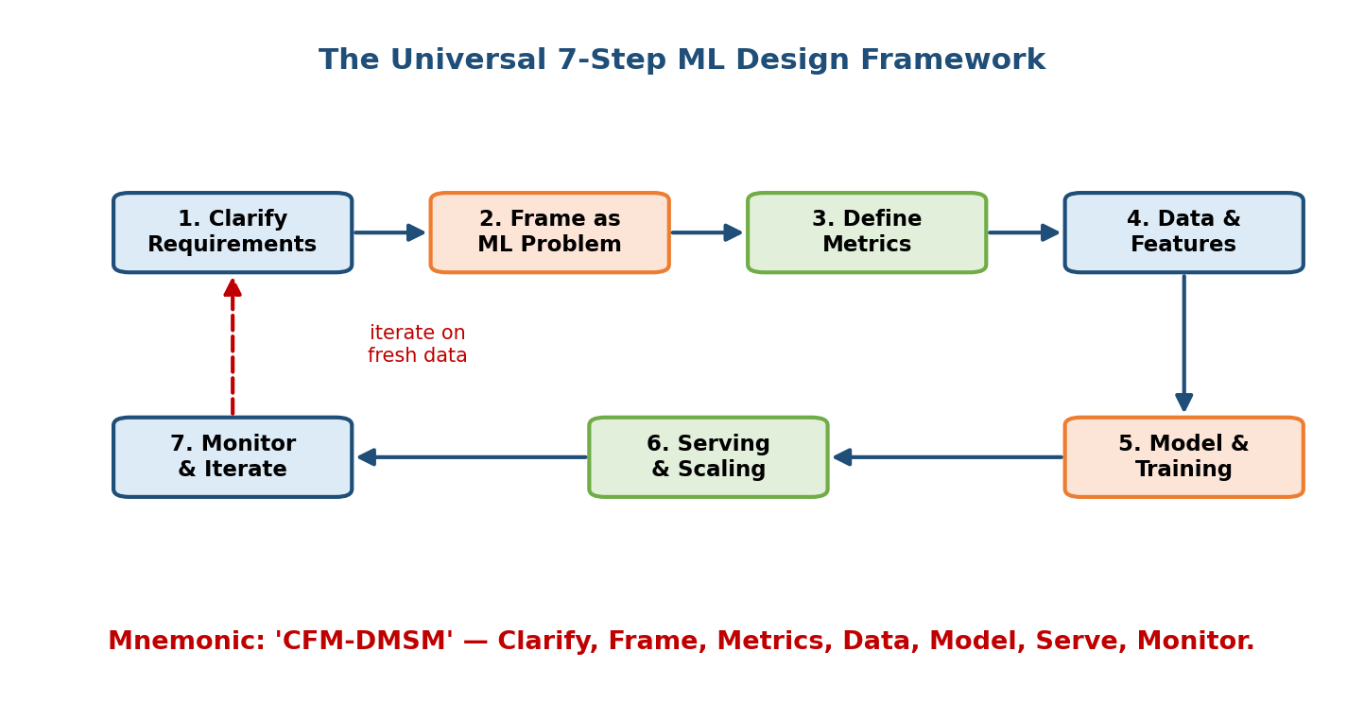
The seven framework steps drawn as a serpentine flow with a dashed feedback arrow from monitoring back to clarifying requirements.

Intuition & a memorable mnemonic
Think of the framework as a recipe card you pull out every time. You do not re-invent cooking each night; you follow steps and vary the ingredients.
A mnemonic that sticks: “Clever Frameworks Make Data Models Serve Metrics” — or just the initials C-F-M-D-M-S-M: Clarify, Frame, Metrics, Data, Model, Serve, Monitor. Say it three times; it fits on a sticky note and will not desert you when you are nervous.

First-principles: why exactly these seven, in this order
Each step answers a question that must be settled before the next makes sense:
- You cannot frame a problem until you know what “good” means → so clarify first.
- You cannot pick data/features until you know the metric you’re optimising.
- You cannot choose a model until you know the data and the target.
- You cannot design serving until you know model size and latency needs.
- You cannot monitor until something is deployed — and monitoring feeds fresh data back to step 1, which is why the diagram loops.
The order is not arbitrary: it is a dependency chain. Skipping a step forces you to guess, and a guess early on poisons everything downstream.

Worked mini-example (spam detection, one line per step)
- Clarify: “Filter spam in a webmail inbox, ~1B emails/day, false-positive hurts more than false-negative.”
- Frame: binary classification, spam vs not-spam.
- Metrics: business = user complaints / missed-important-mail; ML = precision at fixed recall (offline), user “mark as spam” rate (online).
- Data: past emails + user “spam/not-spam” labels.
- Model: start with logistic regression baseline → gradient-boosted trees.
- Serve: online scoring at delivery time, p99 < 50 ms.
- Monitor: watch precision, catch new spam campaigns (drift), retrain weekly.
That is a complete answer in seven sentences. The rest of the interview is you going deeper on whichever step the interviewer pushes on.

2.2 Step 1 — Clarify Requirements & Scope

Motivation
The single biggest reason candidates fail is designing the wrong thing. The prompt “design a news feed” could mean a chronological feed (no ML!) or a ranked, personalized feed at billion-user scale. If you assume, you might build something impressive that does not answer the question.

Naive attempt → why it breaks → fix
- Naive: start designing immediately to look decisive.
- Why it breaks: you bake in assumptions the interviewer never made; you optimise the wrong metric; you look junior.
- Fix: spend the first ~5 minutes asking targeted questions, then state your assumptions out loud and get a nod before proceeding.

The clarifying-question checklist
Ask about five things (memorise these buckets):
- Goal / business objective — what should improve? (engagement, revenue, safety). “What does success look like for the business?”
- Users & use case — who uses it, on what device, how often?
- Scale — how many users / requests per second / items in the catalogue?
- Constraints — latency budget, cost, privacy, regulation, team size.
- Scope for today — “Should I focus on the ranking model, or the whole pipeline?” This one sentence prevents you from spreading too thin.
Senior signal: finishing clarification with “So to confirm: we’re building X, optimising for Y, at Z scale, with these constraints — is that right?” This one-sentence recap shows structure and buys you a checkpoint.
We separate the what from the how well using functional vs non-functional requirements — the subject of Section 2.4.

2.3 Step 2 — Frame as an ML Problem (or Decide NOT To)

Motivation
A business goal (“keep users watching”) is not an ML task. You must translate it into a specific learning problem with a clear input and output — or recognise that ML is overkill.

The decision, then the mapping
First, honour the Module 1 rule: is a simple rule good enough? If yes, say so — proposing a rule-based baseline is a senior move, not a weakness. If not, map the goal to exactly one ML task type.
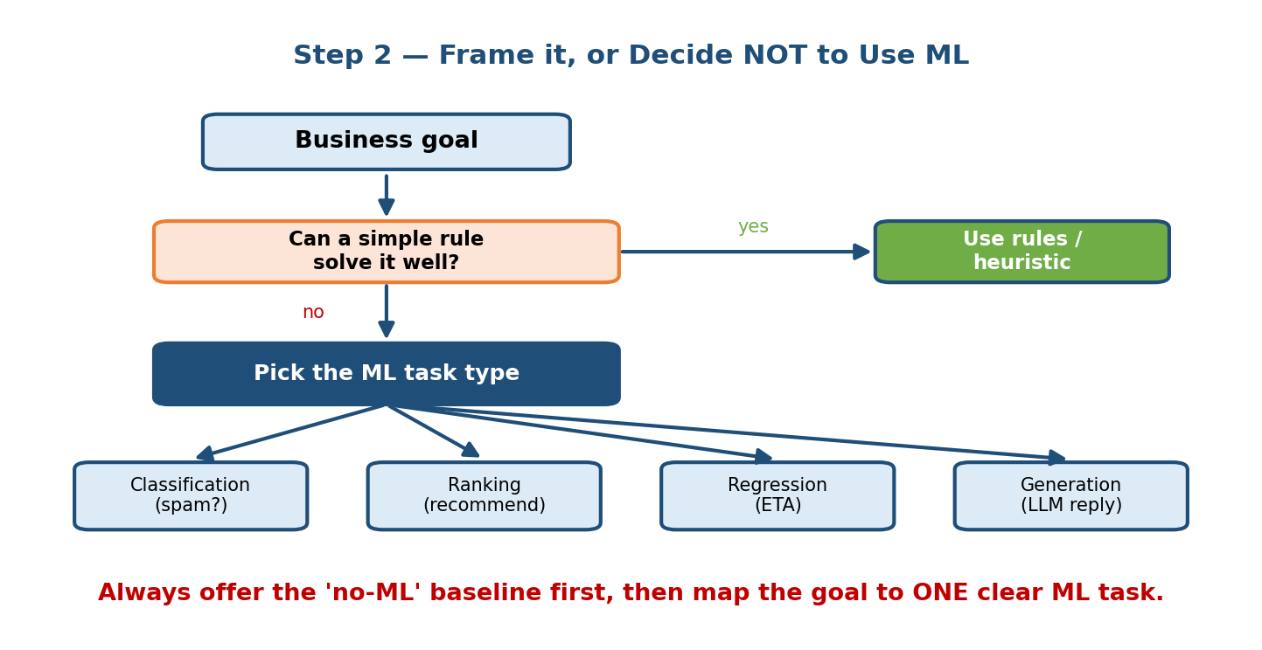
Decision flow: business goal, then ask if a simple rule solves it (yes leads to a rule/heuristic), otherwise pick one ML task type among classification, ranking, regression, or generation.

The common task types (know these cold)
Business goal | ML framing | Task type
“Is this email spam?” | predict a label | Binary classification
“Which video next?” | order items by relevance | Ranking / recommendation
“How long till delivery?” | predict a number | Regression
“Write a reply / summary” | produce text | Generation (LLM)
“Group similar users” | find structure, no labels | Clustering (unsupervised)

First-principles: what makes a good framing
A good framing is one where (a) you can get labels (or a signal) for the target, (b) the target is a proxy the business actually cares about, and (c) the prediction can be acted on. Framing “watch time” as “predict-probability-of-completing-a-video” is good because clicks/completions are logged, they correlate with watch time, and you can rank by the score.

Anti-pattern to avoid
Framing the problem as the business metric itself (“predict revenue”) when the model can only influence it indirectly. Predict the immediate, learnable signal (click, completion) and let the ranking of those scores move the business metric — which you then verify with an online test.

2.4 Functional vs Non-Functional Requirements

Motivation
Two systems can have the same function — “recommend 10 items” — but wildly different designs, because one needs answers in 20 ms at 100k QPS and the other can run overnight. The qualities decide the architecture, not the function.

Definitions
- Functional requirement = what the system does. “Return 10 ranked videos”, “flag fraudulent transactions”, “answer a question from our docs”.
- Non-functional requirement (NFR) = how well it must do it: latency, throughput, scale, availability, cost, freshness, privacy, fairness.
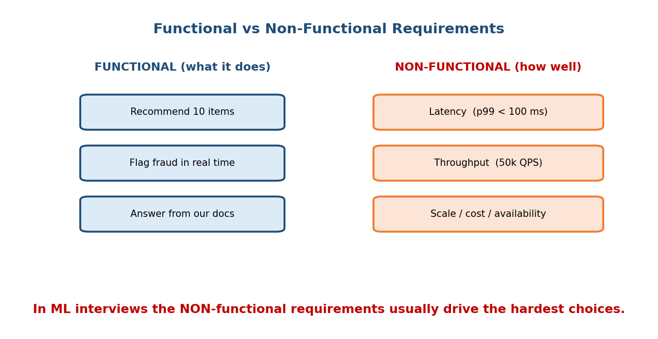
Two columns: functional requirements list what the system does; non-functional requirements list latency, throughput, and scale/cost/availability.

Why NFRs matter more in ML interviews
The functional part is often given in the prompt (“design recommendations”). The interesting design decisions — batch vs online, model size, caching, sharding — all come from the NFRs. A candidate who nails down “p99 < 100 ms at 50k QPS on a $X budget” has derived the design constraints rather than guessing.

The four NFRs you must always quantify
NFR | Question to ask | Why it drives design
Latency | “What p99 can the user tolerate?” | Decides online vs batch, model size
Throughput | “Requests per second at peak?” | Decides replicas, sharding, precompute
Scale | “How many users / items?” | Decides storage, ANN indexes, cost
Cost | “What’s the compute budget?” | Decides model complexity, caching
Rule of thumb: always put a number on each NFR, even a rough one. “About 100 ms” beats “fast”. Numbers let you do back-of-the-envelope sizing and show engineering maturity.

2.5 How Non-Functional Requirements Drive Design

Motivation
Beginners treat NFRs as a checklist to recite. Seniors use each NFR as a lever: state the number, then let it force a specific architectural choice. This is where the interview stops being a quiz and becomes engineering.

The requirement → implication map
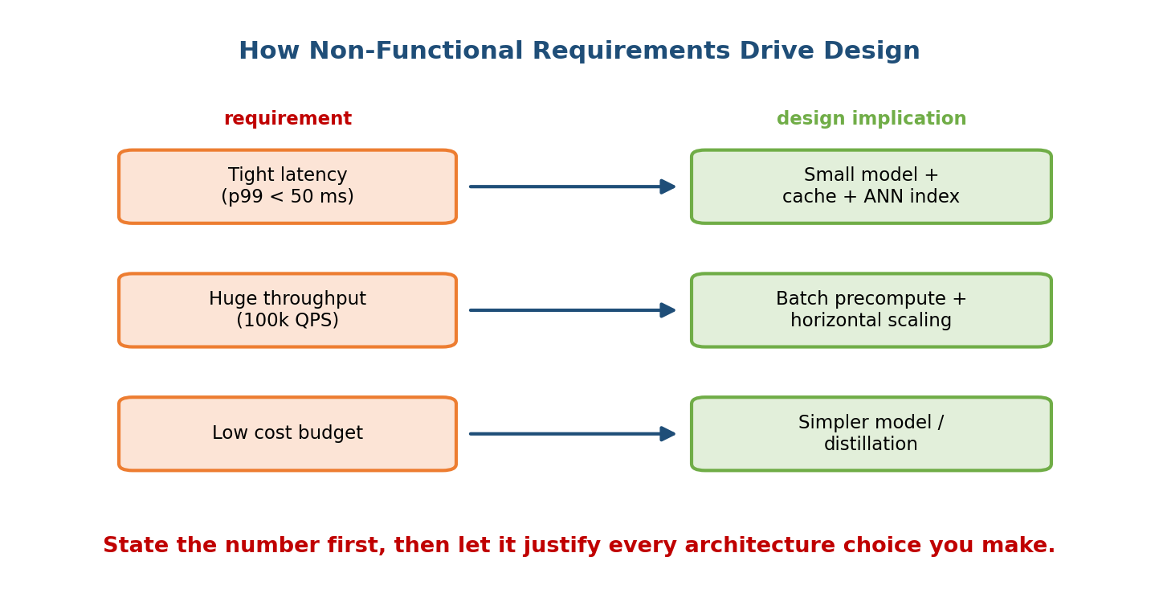
Three requirement boxes on the left map by arrows to design-implication boxes on the right: tight latency to small model plus cache plus ANN index; huge throughput to batch precompute plus horizontal scaling; low cost budget to a simpler model or distillation.
Read each row aloud in an interview as “Because the requirement is X, I will do Y.” That causal sentence is exactly the seniority signal graders listen for.

Worked reasoning chain
Suppose the interviewer says p99 < 30 ms at 80k QPS:
- 30 ms is too tight to run a giant model per request → precompute candidates in batch, then re-rank a small set online (the hybrid pattern from Module 1).
- 80k QPS × per-request work → you need many replicas behind a load balancer, plus a cache for hot users.
- Fetching nearest items from millions of candidates in real time → use an approximate-nearest-neighbour (ANN) index, not a brute-force scan.
Notice you designed the whole serving stack purely by taking the NFRs seriously. That is the point: NFRs are the design.

Trade-off table
If you tighten… | You usually pay with… | Typical fix
Latency | Model accuracy (smaller model) | Distillation, caching, hybrid serving
Cost | Freshness or accuracy | Batch precompute, fewer features
Throughput | Infra complexity | Horizontal scaling, sharding
Freshness | Cost / latency | Streaming features, online inference

2.6 Step 3 — Define Metrics (Business + ML, Offline + Online)

Motivation
If you cannot measure success, you cannot design toward it — and you certainly cannot know when to ship. Yet candidates routinely name a single metric (“accuracy”) and move on. Real systems need a small basket of metrics along two axes.

The two axes → four kinds of metric
- Business vs ML. Business metrics (revenue, retention, CTR) are what leadership cares about. ML metrics (AUC, F1, NDCG) are what you can optimise directly. They are linked but not the same.
- Offline vs online. Offline metrics are computed on held-out data before launch. Online metrics come from live users, usually via an A/B test.
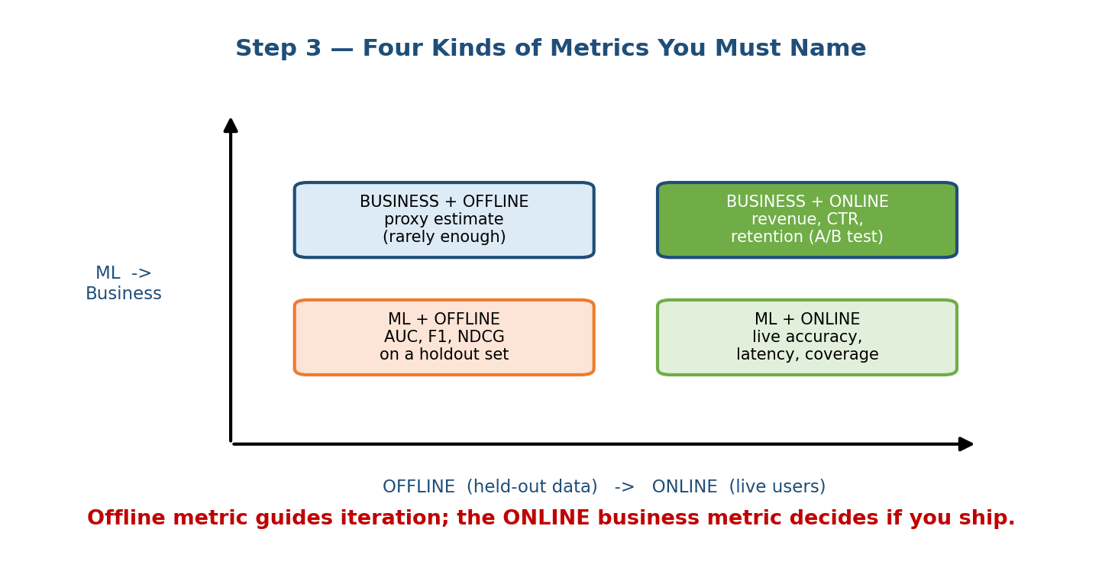
A 2x2 of metrics: axes are offline vs online and ML vs business, giving business+offline (proxy), business+online (revenue/CTR/retention via A/B), ML+offline (AUC/F1/NDCG on holdout), and ML+online (live accuracy, latency, coverage).

First-principles: why you need all four
- ML + offline lets you iterate fast without shipping (cheap, repeatable).
- Business + online is the only thing that proves value — but it is slow and expensive to run.
- The gap between them (the offline–online gap, Module 7) is why you need both: a model that wins offline can lose online.

Worked example (recommendations)
Axis | Metric | Used for
ML + offline | NDCG@10 on last week’s logs | day-to-day iteration
ML + online | live click-through rate | validating the model live
Business + online | watch time, 30-day retention | the ship/no-ship decision
Guardrail | latency p99, diversity | make sure we didn’t break UX
Senior signal: naming a guardrail metric (“we must not hurt latency or diversity while chasing CTR”) shows you think about side-effects, not just the target.

2.7 Steps 4–7 — Data, Model, Serving, Monitoring (in brief)
These four steps each get a full module later; here is the framework-level view so your answer is complete even before you go deep.
- Step 4 — Data & features. What data exists, how it’s labelled, freshness, and volume. Design features and store them so training and serving agree (avoid training-serving skew) and no future info leaks in (avoid leakage). (Modules 4–5.)
- Step 5 — Model & training. Always propose a simple baseline first (logistic regression, popularity, a heuristic), then justify each jump in complexity by a metric gain. Pick a loss aligned to the metric; plan distributed training if data is large. (Module 6.)
- Step 6 — Serving, scaling & infra. Choose batch / online / streaming from the NFRs; place caches and ANN indexes; size replicas for the QPS; state the latency budget. (Modules 8, 11, 19.)
- Step 7 — Monitoring, iteration & failure handling. Watch drift and the business metric; alert on degradation; plan retraining cadence; and design the failure path: shadow mode, canary rollout, kill switch, and a safe fallback (e.g. show popular items if the model is down). (Module 10.)
Completeness beats depth-in-one-spot. A candidate who names all seven steps and goes moderately deep beats one who spends 40 minutes only on model architecture and never mentions serving or monitoring.

2.8 Driving the Interview & Managing 45 Minutes

Motivation
You could know every step and still fail by spending 30 minutes on step 1 and never reaching serving. The interview is a time-boxed performance; managing the clock is itself a graded skill.

A time budget you can actually use
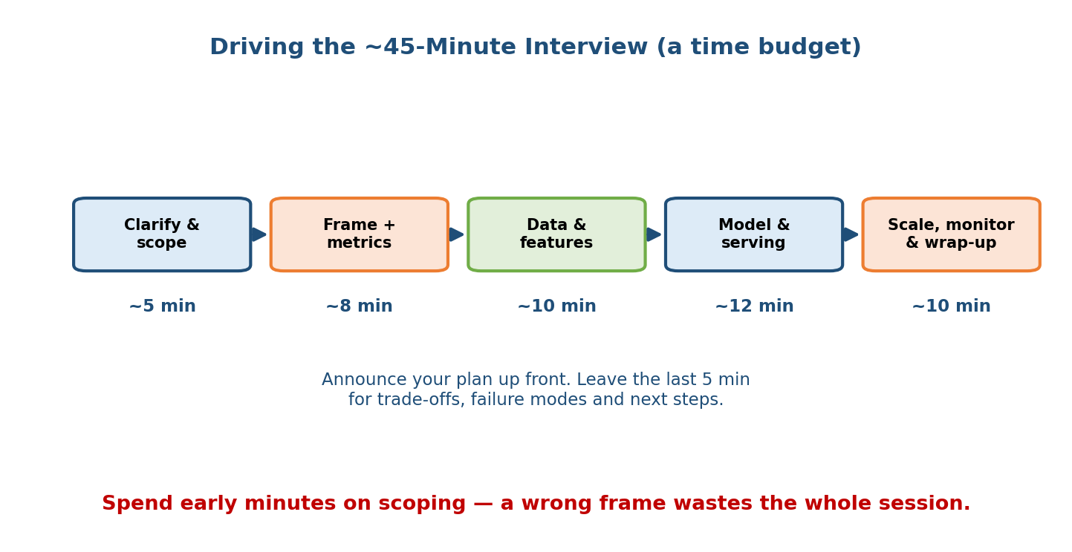
A five-phase horizontal timeline: clarify and scope (~5 min), frame plus metrics (~8 min), data and features (~10 min), model and serving (~12 min), scale/monitor and wrap-up (~10 min), with a note to announce the plan up front and reserve the last 5 minutes.
The exact minutes flex, but the shape holds: cheap up-front scoping, the bulk in the middle on data/model/serving, and a protected block at the end for trade-offs, failure modes, and “what I’d do next”.

How to drive (not be driven)
- Announce your plan first: “I’ll clarify, frame it, define metrics, then design data, model, serving, and monitoring — pushing me to go deeper anywhere is welcome.” This tells the interviewer you have structure and invites them to steer.
- Narrate your reasoning. Say why you choose each thing; graders score your thought process, not just the final diagram.
- Check in at transitions: “That’s the model — want me to go deeper here or move to serving?” This keeps you aligned and paced.
- Use the whiteboard as a map. Draw the 7 steps (or the architecture) early so both of you can see progress.

Handling “I don’t know”
Never freeze or bluff. The strong move is: state what you do know, reason from first principles, and say how you’d find out. Example: “I haven’t used that exact index, but the requirement is fast nearest-neighbour lookup over millions of vectors, so I’d reach for an ANN structure like HNSW and benchmark recall vs latency.” You just turned a gap into a display of reasoning.

Handling scope creep
Interviews sprawl — you can end up designing five subsystems at once. When that happens: “There are several directions here; the highest-impact one for our metric is X, so I’ll focus there and mention the others briefly.” Explicitly choosing scope is a seniority signal; trying to do everything shallowly is not.
Common mistake: treating interviewer interruptions as attacks. They are usually hints about where they want depth. Follow the pull.

2.9 Junior vs Senior vs Staff Answer Patterns

Motivation
The same question is asked of a new grad and a staff engineer; the difference is entirely in how they answer. Knowing the target behaviour lets you aim for the next level up.
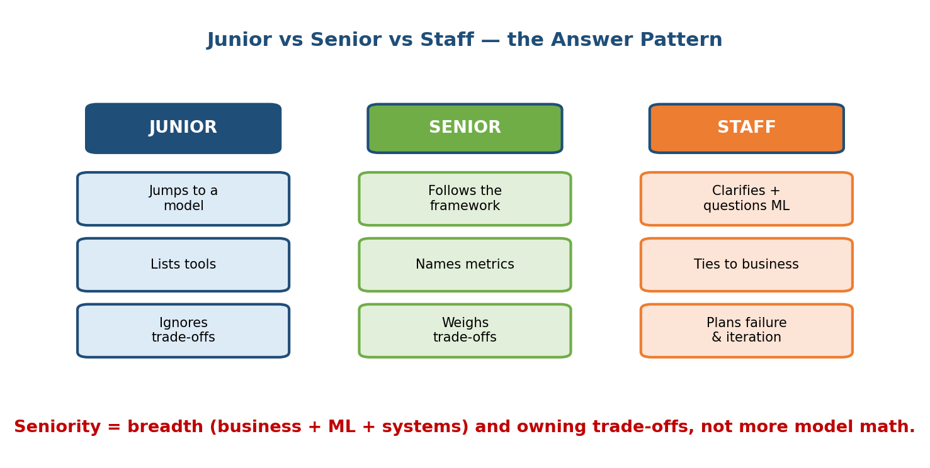
Three columns comparing junior, senior, and staff answers: junior jumps to a model, lists tools, ignores trade-offs; senior follows the framework, names metrics, weighs trade-offs; staff clarifies and questions whether ML is needed, ties to business, and plans failure and iteration.

The comparison in words
Dimension | Junior | Senior | Staff
Opening | Jumps to a model | Clarifies, then frames | Questions if ML is even needed
Structure | Ad-hoc, wanders | Follows the framework | Framework + adapts to the twist
Metrics | “Accuracy” | Business + ML, offline + online | Adds guardrails + cost of errors
Trade-offs | Ignores them | Weighs the obvious ones | Owns them, quantifies, decides
Systems | Talks model only | Covers serving & scale | Ties ML ↔ systems ↔ business
Failure | Not mentioned | Mentions monitoring | Designs rollback, canary, fallback
Scope | Tries to do all | Picks a focus when asked | Proactively scopes and prioritises

First-principles: what “seniority” actually is
Seniority in this interview is not deeper math. It is breadth plus ownership of trade-offs: connecting the business goal, the ML choice, and the systems constraint into one coherent story, and being willing to say “here’s the trade-off, and here’s the call I’d make, because…”. A staff candidate makes decisions; a junior lists options.
Aim one level up. If you’re targeting senior, don’t just follow the framework — start weighing trade-offs out loud and tie every choice to the business metric.

Module 2 — Interview Mapping (what companies probe)
Company | How Module 2 shows up | Junior answer | Staff answer
Google / Meta | “Design system for X” — they grade structure | Wanders, model-first | Runs the 7 steps, checks in, scopes
Amazon | Ties to Leadership Principles; “dive deep” on one step | Stays shallow everywhere | Goes deep where pushed, ties to customer
OpenAI / Anthropic | Framing + baselines + when NOT to use ML | Over-engineers | Proposes simple baseline, justifies complexity
Uber / Stripe | NFR-driven design (latency, fraud cost) | Ignores latency/QPS | Derives design from quantified NFRs
The single most common opening question: “How would you design an ML system for X?” Your first 60 seconds should announce the framework and start clarifying. That structure alone puts you ahead of most candidates.

Module 2 — Exam Mapping (SEBI / RBI / GATE / ISRO)
- This is an interview-only module. Written exams do not test how you drive a design conversation, budget 45 minutes, or signal seniority.
- SEBI IT / RBI IT / ISRO: may ask definitional items at most — the difference between functional and non-functional requirements (Section 2.4) is a standard software-engineering exam topic, so know that one crisply.
- GATE CS/DA: the ML task-type taxonomy (classification / regression / ranking / clustering) from Section 2.3 overlaps with the syllabus; the framework and time-management content does not appear.
Bottom line: if you are studying purely for a written exam, the only exam-relevant slice here is functional vs non-functional requirements and the task-type taxonomy. Everything else is high-value interview material.

Module 2 — Common Mistakes & Misconceptions
- Jumping straight to the model. Skipping clarify + frame is the #1 failure. Always start with questions. (Sections 2.2–2.3.)
- Naming one metric (“accuracy”). You need business + ML and offline + online, plus a guardrail. (Section 2.6.)
- Ignoring non-functional requirements. Latency/throughput/scale/cost are what actually drive the design. (Sections 2.4–2.5.)
- No time management. Spending 30 minutes on one step and never reaching serving or monitoring. (Section 2.8.)
- Bluffing on “I don’t know”. Reason from first principles and say how you’d find out instead. (Section 2.8.)
- Trying to design everything. Scope explicitly; depth-where-it-matters beats shallow-everywhere. (Section 2.8.)
- Forgetting the failure path. No monitoring, rollback, or fallback. A model will break; design for it. (Section 2.7.)

Module 2 — MCQs (with answers & explanations)
Q1. What should be the first thing you do when given “design an ML system for X”? a) Pick a neural network b) Clarify requirements, scope, and success metric c) Draw the database schema d) Estimate GPU cost
Answer
b. Clarifying the goal, users, scale, and constraints prevents you from designing the wrong thing. Everything downstream depends on it.
Q2. Which is a non-functional requirement? a) “Return 10 recommended videos” b) “Flag fraudulent transactions” c) “p99 latency under 100 ms at 50k QPS” d) “Answer questions from our docs”
Answer
c. Latency/throughput are qualities (how well), i.e. non-functional. The others describe what the system does (functional).
Q3. A model wins on offline NDCG but the live A/B test shows no lift in watch time. This illustrates: a) a compile error b) the offline–online gap c) overfitting the test set d) a cache miss
Answer
b. Offline and online metrics can disagree; the online business metric is what decides whether you ship. This is why you define metrics on both axes.
Q4. In the framework, why must “define metrics” come before “choose a model”? a) It doesn’t matter b) Because the metric decides the loss and what “better” means c) Models are optional d) To save time
Answer
b. You cannot choose a model or loss function, or tell whether one model beats another, without first knowing the metric you’re optimising.
Q5. The interviewer asks about a technique you’ve never used. Best response? a) Pretend you know it in detail b) Say “no idea” and stop c) State what you know, reason from first principles, and say how you’d find out d) Change the subject
Answer
c. Turning a gap into visible reasoning scores well; bluffing and freezing both score poorly.
Q6. Which best characterises a staff-level answer versus a junior one? a) Uses a bigger model b) Knows more math c) Owns trade-offs and connects ML ↔ systems ↔ business d) Talks faster
Answer
c. Seniority here is breadth plus owning trade-offs and decisions, not deeper math or a fancier model.
Q7. A requirement of “p99 < 30 ms at 80k QPS” most directly pushes you toward: a) Training a bigger model per request b) Hybrid serving: batch-precompute candidates + small online re-rank + cache c) Removing all caching d) Ignoring latency
Answer
b. Tight latency at high QPS forces precompute + a small online model + caching/ANN — the NFRs derive the architecture.
Q8. What is a guardrail metric? a) The single metric you optimise b) A metric you must not harm while chasing the target (e.g. latency, diversity) c) A database constraint d) A type of loss function
Answer
b. Guardrails protect against harmful side-effects of optimising the target metric; naming them is a senior signal.

Module 2 — Design Exercises (easy → hard)
- Easy. Classify each as functional or non-functional: (1) “recommend 5 songs”; (2) “99.9% availability”; (3) “detect toxic comments”; (4) “cost under $10k/month”. (Functional: 1, 3. Non-functional: 2, 4.)
- Easy. For “predict food-delivery ETA”, write the 7-step framework as one sentence per step.
- Medium. Given “design search ranking, p99 < 100 ms, 100k QPS”, list three design choices that follow directly from the NFRs and explain the causal link for each.
- Medium. For a fraud-detection system, name one metric in each quadrant of the metrics 2×2 (business/ML × offline/online) plus one guardrail.
- Hard. You’re 30 minutes into a 45-minute interview and have only covered clarify + frame + model. Describe how you’d re-budget the remaining 15 minutes and what you would deliberately cut.
- Hard. Take the prompt “design comment ranking for a social app” and write the same answer at three levels — junior, senior, staff — highlighting what changes at each level.

Module 2 — Concept Review (one page)
- The 7-step framework (mnemonic C-F-M-D-M-S-M): Clarify → Frame → Metrics → Data → Model → Serve → Monitor, looping back via monitoring.
- Clarify first — goal, users, scale, constraints, and scope for today — then recap assumptions before designing.
- Frame the goal as one ML task (classification / ranking / regression / generation / clustering), or argue for a rule if ML isn’t warranted.
- Metrics live on two axes: business vs ML and offline vs online; add a guardrail. Offline guides iteration, online decides shipping.
- Functional = what it does; non-functional (latency, throughput, scale, cost) = how well — and NFRs drive the architecture. Put a number on each.
- Data → Model → Serve → Monitor: agree train/serve features, start with a baseline, pick serving mode from NFRs, and design the failure path.
- Drive the interview: announce your plan, narrate reasoning, check in at transitions, budget the 45 minutes, scope explicitly.
- Seniority = breadth + owning trade-offs (business ↔ ML ↔ systems), not more math. Handle “I don’t know” by reasoning aloud.

Module 2 — Flash Cards (Q → A)
- The 7 steps in order? → Clarify, Frame, Metrics, Data, Model, Serve, Monitor.
- Mnemonic? → C-F-M-D-M-S-M.
- First thing to do in any design prompt? → Clarify requirements, scope, and success metric.
- Functional vs non-functional? → What it does vs how well (latency, throughput, scale, cost).
- Two axes of metrics? → Business vs ML; offline vs online.
- What decides ship / no-ship? → The online business metric (A/B test).
- Why define metrics before choosing a model? → The metric decides the loss and what “better” means.
- How to handle “I don’t know”? → State what you know, reason from first principles, say how you’d find out.
- Seniority in one line? → Breadth + owning trade-offs (business ↔ ML ↔ systems), not more math.
- What is a guardrail metric? → One you must not harm while chasing the target (e.g. latency, diversity).

Module 2 — Pattern Recognition (how to spot it in an interview)
- Hear “Design an ML system for X” → announce the 7-step framework, start clarifying.
- Hear “How would you measure success?” → give business + ML, offline + online, plus a guardrail.
- Hear “It must handle N QPS at M ms” → derive serving design from the NFRs (precompute, cache, ANN, replicas).
- Hear “What if you don’t know Z?” → reason from first principles, say how you’d find out.
- Hear “We could also do A, B, C…” (scope creep) → pick the highest-impact one, mention the rest briefly.
- Hear “What could go wrong in production?” → drift, monitoring, rollback, canary, and a safe fallback.
- Running low on time → protect the last 5 minutes for trade-offs and next steps.

Module 2 — Revision Notes / Mini Cheat Sheet
7-STEP FRAMEWORK (mnemonic: C-F-M-D-M-S-M)
1 CLARIFY goal / users / scale / constraints / SCOPE-for-today -> recap!
2 FRAME rule? else pick ONE task: classify | rank | regress | generate
3 METRICS axes = (business vs ML) x (offline vs online) + a GUARDRAIL
4 DATA labels, freshness, features; avoid leakage + train/serve skew
5 MODEL start SIMPLE baseline -> justify each jump; loss = metric
6 SERVE batch/online/streaming from NFRs; cache + ANN + replicas
7 MONITOR drift, business metric, retrain; rollback + canary + FALLBACK
-> monitoring feeds fresh data back to step 1 (LOOP)
REQUIREMENTS
FUNCTIONAL = what it does NON-FUNCTIONAL = how well
NFRs (number each!): latency | throughput | scale | cost
NFRs DRIVE DESIGN: say "because req X, I will do Y"
METRICS
offline (holdout) guides iteration | online (A/B) decides SHIP
offline win != online win (the offline-online gap)
INTERVIEW CRAFT (45 min)
announce plan -> clarify(5) frame+metrics(8) data(10) model+serve(12) wrap(10)
narrate WHY | check in at transitions | scope explicitly
"I don't know" -> reason from first principles + how to find out
SENIORITY = breadth + OWN the trade-offs (business <-> ML <-> systems)
junior lists options | staff makes decisions + plans failure

Next module: Module 3 — Framing: From Business Problem to ML Problem. We zoom into Step 2 of the framework and learn, in depth, how to translate a fuzzy business goal into a precise ML task — choosing the target, the label, and the proxy signal — and how a poor framing quietly dooms every later stage.

