Module 3 — Problem Framing & Requirements
  - ML System Design Mastery: FAANG / AI-Engineer / Staff-Level — In-Depth Notes (with visuals)
Prepared for nidhi.sharma@forensiccybertech.com
2026
Table of Contents

Module 3 — Problem Framing & Requirements
Why this module is the make-or-break step. More ML projects die from bad framing than from bad models. A brilliant model that predicts the wrong thing is worthless; a mediocre model pointed at the right objective can transform a business. This module teaches the first, most important 30 minutes of any design: turning a fuzzy business wish (“make users happier”, “reduce fraud”) into a concrete, measurable ML problem — the right task, the right label, the right objective — and then sizing the system with back-of-the-envelope math before you write a single line of model code. Getting this right is the clearest Staff-level signal in an interview.
Importance ratings (out of 5):
Exam / Use | SEBI IT | RBI IT | GATE CS/DA | Interview | AI/MLE role
This module | ★★ | ★★ | ★★ | ★★★★★ | ★★★★★
What you must be able to do after this module: take any vague business goal and translate it into a success metric, an ML objective, and a concrete label; pick the correct ML task (classification / regression / ranking / generation / retrieval / RL / anomaly detection) from the shape of the output; recognise and avoid the three label traps (proxy labels, label leakage, delayed labels); explain when a proxy metric silently fights the true goal; and do back-of-the-envelope capacity math — DAU → QPS → peak QPS and storage sizing — with real numbers, out loud, in an interview.
How to read this module. As in Module 1, every idea follows problem → simplest attempt → why it breaks → the fix, in plain English, with a worked example and the interview angle attached.

3.1 Translating a Business Goal into an ML Objective

Motivation (the problem that existed)
A product manager walks up and says: “We want people to spend more time on the app.” That sentence is not something a model can optimise. It has no label, no unit, no data type. The single most common beginner mistake is to grab this wish and immediately train a model on… what, exactly? Before any modelling, you must translate the business goal down a ladder until you reach something a model can actually predict.

Definition
- Business goal — what the company ultimately wants (money, growth, retention, safety). Expressed in dollars and users, never in AUC.
- Success metric — a measurable number that stands in for the goal (watch-time per session, 30-day retention, fraud-loss in dollars).
- ML objective — the thing the model predicts, i.e. the label and the prediction it produces (“probability this video is watched to completion”).
- ML task — the mathematical shape of that prediction (regression, classification, ranking, …).
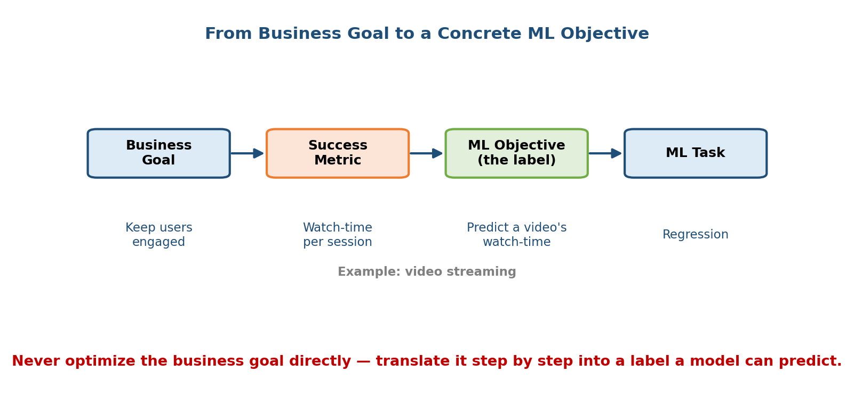
Translation ladder from business goal to success metric to ML objective (the label) to ML task, with a video-streaming example underneath each stage.

Intuition & analogy
Think of a doctor. The patient’s goal is “feel healthy” — untreatable directly. The doctor translates it into measurable proxies (blood pressure, cholesterol, weight), then into an intervention (a specific drug dose) they can actually control and measure. ML framing is the same descent: goal → metric → label → task. You never operate on the goal; you operate on the label.

First-principles derivation
A model is a function f(features) → prediction. To train it you need (features, label) pairs. So the framing question is really: “What is the single quantity y such that (a) I can measure it from data, (b) predicting it well moves the success metric, and (c) the success metric moves the business goal?” Every arrow in that chain is a place framing can go wrong.

Worked examples (goal → metric → label → task)
Business goal | Success metric | ML objective (label) | Task
Increase engagement (video) | Watch-time / session | Predicted watch-time of a video for a user | Regression / ranking
Reduce fraud loss | $ fraud prevented | P(transaction is fraud) | Classification
Grow marketplace GMV | Completed purchases | P(user buys item) → rank | Ranking
Cut support cost | Tickets auto-resolved | Best help-article for a query | Retrieval
Faster deliveries | On-time rate | Predicted delivery ETA (minutes) | Regression
Senior signal: Say the whole chain out loud. “The business goal is retention; the success metric is 30-day return rate; but I can’t train on that directly, so my ML objective is predicted watch-time, framed as a ranking task — and I’ll validate the link with an A/B test.” That sentence alone marks a strong candidate.

3.2 Choosing the ML Task

Motivation
Once you have a label, you must pick the task type — and this decides your model family, your loss function, and your evaluation metric. Beginners memorise “it’s classification” reflexively. The reliable trick is to look at the shape of the output the system must produce.
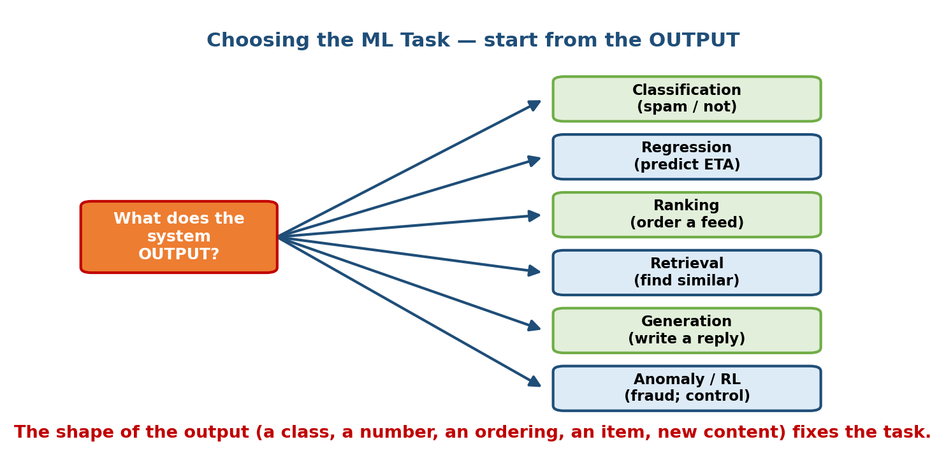
Decision fan: start from what the system OUTPUTS — a class label, a number, an ordering, a matching item, new content, or a rare event/action — and each maps to a task.

The tasks and when each fits
Output shape | Task | When it fits | Example
A category / class | Classification | Finite set of labels | Spam / not-spam, disease type
A continuous number | Regression | Real-valued target | ETA in minutes, house price
An ordering of items | Ranking | “Which items, in what order?” | Search results, news feed
A best match from a huge set | Retrieval | Millions of candidates, need top-k fast | Find similar products, RAG
Brand-new content | Generation | Output is text / image / audio | Chat reply, summarisation
Sequential decisions under reward | Reinforcement learning | Actions change future state | Ad bidding, robotics, game play
“Is this weird?” | Anomaly detection | Rare positives, few/no labels | Fraud, intrusion, machine faults

First-principles: why the output shape decides everything
The output shape fixes the loss function, which fixes the model and the metric:
- A class → cross-entropy loss → metrics like precision/recall/AUC.
- A number → squared/absolute error → RMSE/MAE.
- An ordering → pairwise/listwise ranking loss → NDCG/MAP.
- New content → likelihood / token loss → perplexity + human eval.
So if you can name the output shape, the rest of the pipeline falls out almost mechanically. This is why “start from the output” is such a powerful habit.

Edge cases & re-framings (a Staff move)
The same business problem can often be framed as different tasks — and the re-framing is where senior candidates shine:
- Recommendation can be classification (P(click) per item) or ranking (order all items) or retrieval (fetch top-k from millions). Real systems use retrieval then ranking (a two-stage funnel, Module 15).
- Fraud can be classification (labelled fraud) or anomaly detection (when labels are scarce).
- “What should we show next?” can be supervised ranking or an RL problem if today’s choice changes tomorrow’s data.
Interview tip: When asked “how would you model X?”, state the default task, then say “but if labels are scarce I’d frame it as anomaly detection” or “at this catalogue size I’d add a retrieval stage.” Showing you can re-frame is the point.

3.3 When NOT to Use ML (reinforced)

Motivation
Module 1 introduced this; framing is where it bites hardest. Having just translated a goal into an ML objective, the disciplined next question is: “Do we actually need a model for this?” Reaching for ML by default is a junior reflex; questioning it is a senior one.
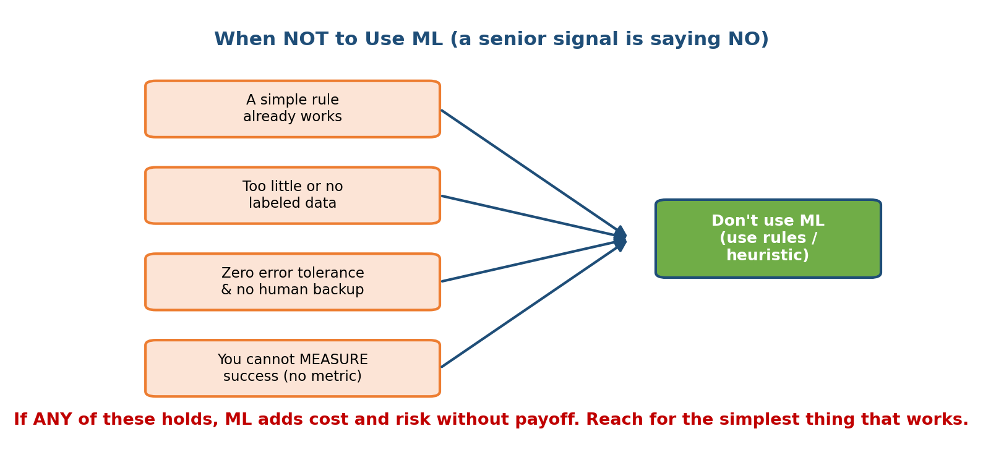
Four red-flag conditions — a simple rule already works, too little or no labeled data, zero error tolerance with no human backup, cannot measure success — all pointing to: don’t use ML, use rules or a heuristic.

The four red flags (any one → prefer rules)
- A simple rule already works. “Block transactions over $10,000 from a new device” may catch 80% of the fraud with zero training. Ship the rule; revisit ML only for the remaining hard cases.
- Too little or no labeled data. ML needs examples of the pattern. With a few dozen rows, a heuristic or a human beats any model.
- Zero error tolerance and no human backup. If a single mistake is catastrophic and nobody reviews the output, a probabilistic model is the wrong tool.
- You cannot measure success. No metric, no labels, no feedback → you can neither train nor tell if you improved. Fix measurement first.

First-principles
ML buys you the ability to handle patterns too complex or numerous to hand-code. That power costs you data pipelines, training infra, monitoring, drift, and non-determinism (all of Modules 4–12). If a rule gets you 90% of the value at 1% of that cost, the rule wins. ML must earn its complexity.
Common mistake: proposing a deep model for a problem a WHERE amount > threshold clause solves. Always offer the simplest baseline first; add ML only where the baseline demonstrably fails.

3.4 Defining the Label

Motivation
The label y is the ground truth your model chases. If the label is subtly wrong, the model faithfully learns the wrong thing — and no amount of tuning fixes it. Label definition is where most real-world ML projects quietly fail.
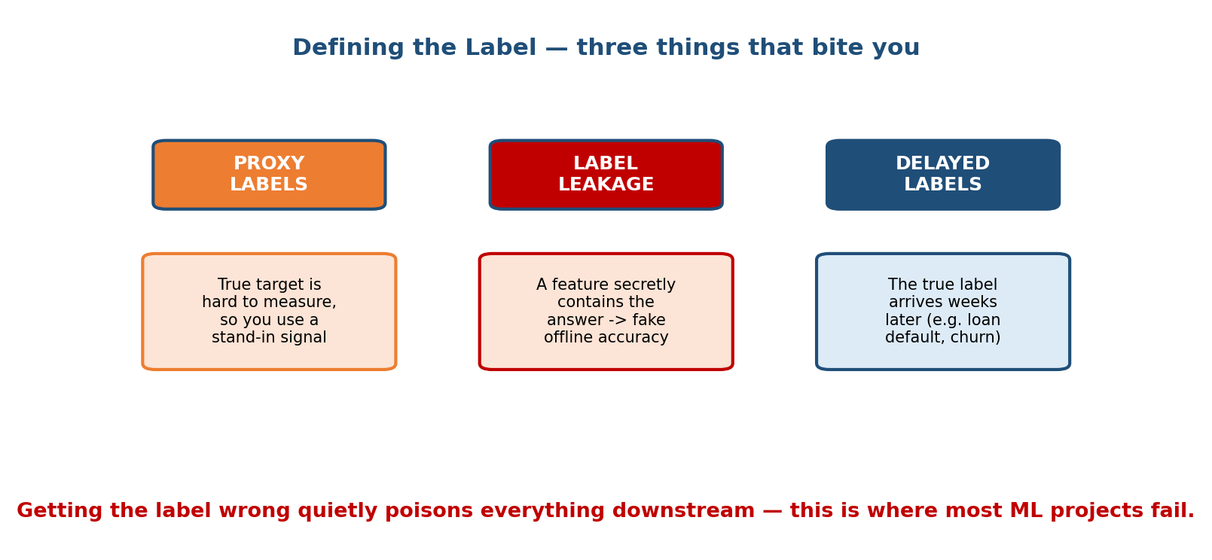
Three label failure modes as columns: proxy labels (stand-in for a hard-to-measure target), label leakage (a feature secretly contains the answer, giving fake offline accuracy), and delayed labels (the true label arrives weeks later).

Trap 1 — Proxy labels
Often the true target is hard or impossible to measure, so you substitute a proxy that is easy to log:
- True target: “did the user find this video satisfying?” → proxy: “did they watch > 80%?”
- True target: “is this a good hire?” → proxy: “did they stay 2 years?”
Proxies are usually necessary, but they are approximations. A watch-time proxy rewards long, slow videos; a click proxy rewards clickbait. Always name the gap between the proxy and the true target, and monitor it.

Trap 2 — Label leakage (the silent killer)
Label leakage happens when a feature secretly contains information about the label that would not be available at prediction time. The model looks brilliant offline (99% accuracy!) and collapses in production.
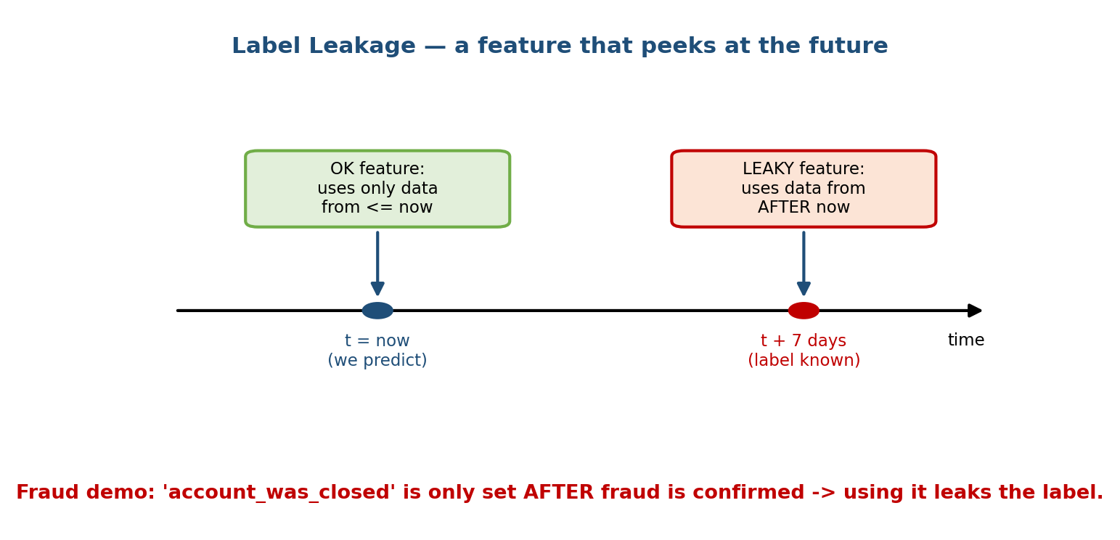
A time axis: at t = now we make the prediction using only data from t or earlier (OK feature, green); a leaky feature uses data from after now (t + 7 days, when the label is known). Fraud example: ‘account_was_closed’ is set only after fraud is confirmed.
Concrete failure: you build a fraud classifier and include the feature account_was_closed. Offline AUC is 0.999 — amazing! But an account is only closed after the fraud team confirms fraud. At real prediction time (when the transaction happens) that field is always empty. You leaked the label. The rule of thumb: every feature must be computable using only data available at or before the prediction timestamp. (This is the temporal cutoff idea; see also training-serving skew, Module 5.)

Trap 3 — Delayed labels
Sometimes the true label simply arrives late:
- Loan default: you approve a loan today; whether it defaults is known in months or years.
- Churn: “did this user leave?” is only answerable after the churn window passes.
- Ad conversion: a purchase may happen days after the click.
Delayed labels create two problems: (1) you cannot train on recent data (its labels aren’t ready), and (2) your monitoring lags reality. Fixes include using shorter-horizon proxy labels (early-payment behaviour predicts default), attribution windows, and clearly documenting the label delay in the design.
Interview gold: When you define a label, always ask three questions aloud — “Is this a proxy, and for what? Could any feature leak it? When does the true label actually arrive?” Nailing these three separates Staff answers from junior ones.

3.5 Objective Function Design & Business Alignment

Motivation
Even with a clean label, you choose an objective (loss) function that the model minimises. The danger: the thing you optimise (the proxy objective) can diverge from the thing you actually care about (the true business goal). The model is a ruthless optimiser — it will exploit any gap you leave.
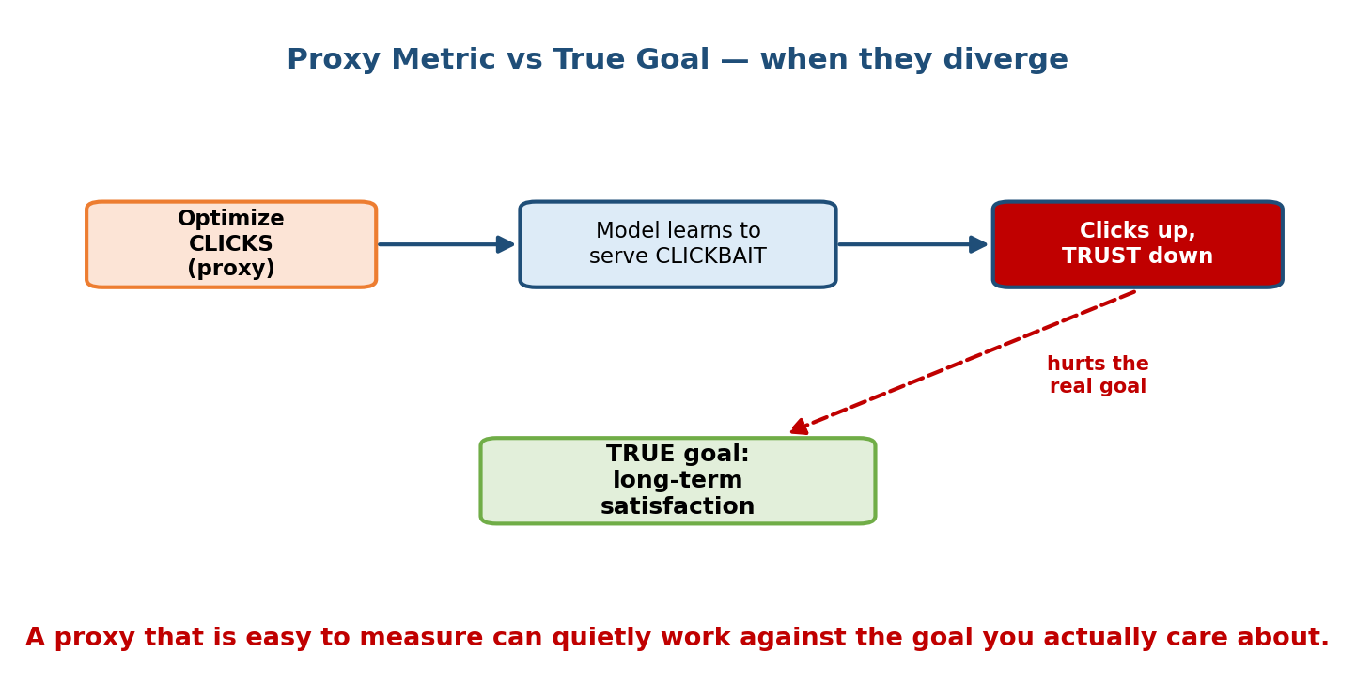
A chain showing optimizing CLICKS (a proxy) leads the model to serve CLICKBAIT, which drives clicks up but trust down, with a red dashed arrow showing this hurts the TRUE goal of long-term satisfaction.

The classic misalignment story
You optimise click-through rate. The model learns that the fastest way to get clicks is clickbait and outrage. CTR goes up — your proxy objective is winning! — but users lose trust, satisfaction drops, and long-term retention (the true goal) falls. This is proxy misalignment, and it has burned every major feed and recommender platform.

First-principles: choosing the objective
- Name the true goal (long-term satisfaction / retention / GMV).
- Pick a proxy objective you can train on (click, watch-time, purchase).
- Measure the gap between them, and design the objective to close it:
  - Combine signals (e.g. 0.3·click + 0.7·watch-time) so no single hack wins.
  - Add guardrail metrics that must not regress (report rate, dwell, unsubscribe).
  - Penalise known bad behaviour (down-weight clickbait, add a diversity term).
- Validate with an A/B test on the true metric, never the proxy alone.

Worked example — objective vs guardrails
Designing a news feed:
- Proxy objective: predicted engagement (a blend of click + dwell + share).
- Guardrail metrics (must not drop): 7-day retention, “see less like this” rate, source diversity.
- Why: optimising engagement alone drifts to outrage; guardrails catch the drift before it ships.
Senior signal: Explicitly separating the optimisation objective from the guardrail metrics, and tying both back to the true goal, is exactly what distinguishes a Staff-level framing answer.

Trade-offs
Choice | Pro | Con
Single simple proxy (CTR) | Easy to train, clear signal | Easily gamed; misaligns with goal
Blended objective | Harder to game, closer to goal | More weights to tune, less interpretable
Guardrails only | Safety without over-constraining | Doesn’t by itself improve the goal

3.6 Capacity Estimation (Back-of-the-Envelope Math)

Motivation
Before designing serving, you must know the scale: how many predictions per second, how much storage, how big the model. Interviewers expect you to do this math out loud with round numbers. It decides batch vs online, fleet size, caching, and whether the model fits in RAM. This is a defining Staff-level skill.

Worked example 1 — DAU → QPS → Peak QPS
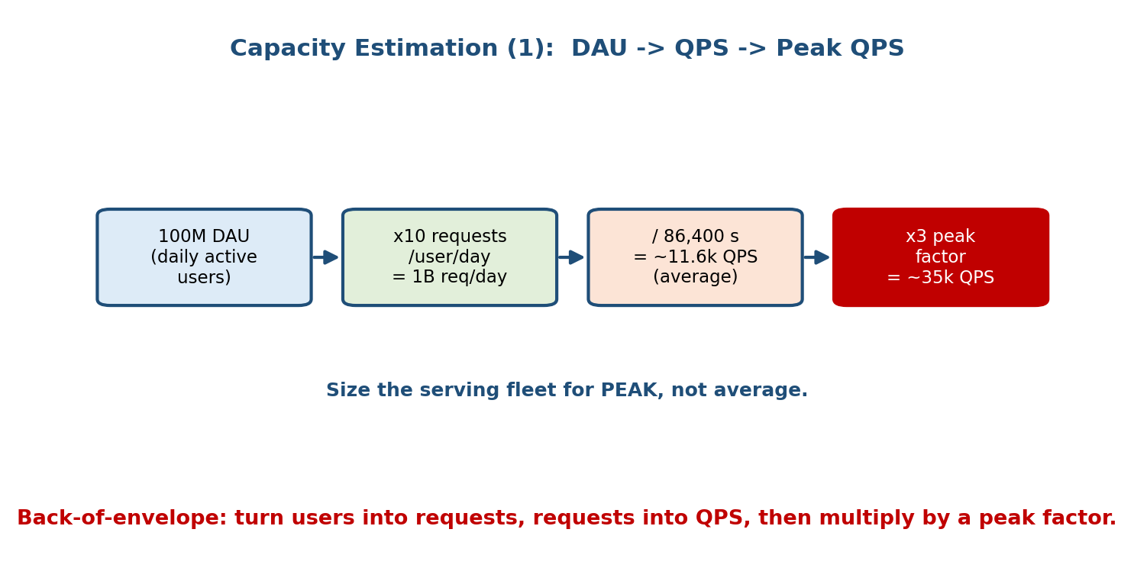
Four-box pipeline: 100M DAU, times 10 requests per user per day equals 1B requests/day, divided by 86,400 seconds equals about 11.6k QPS average, times a 3x peak factor equals about 35k QPS peak.
Suppose a feed product has 100 M daily active users (DAU), and each user triggers about 10 prediction requests/day (scrolls, refreshes).
Requests/day = 100,000,000 users x 10 req/user = 1,000,000,000 = 1B req/day
Seconds/day = 24 x 3600 = 86,400
Average QPS = 1,000,000,000 / 86,400 ≈ 11,574 ≈ 11.6k QPS
Peak QPS = average x peak_factor (2-4x) ≈ 11.6k x 3 ≈ 35k QPS
Interpretation. Traffic is not flat — evenings spike. Always size the fleet for peak, not average. If one server handles ~1,000 QPS, you need 35,000 / 1,000 = 35 servers just for the model, before redundancy (add ~30% for headroom and failover → ~45 servers). If latency budget is 50 ms and each request does one model call, that is easily met; if it fans out to 100 candidate scores, recompute per-item throughput.

Worked example 2 — Embedding table storage
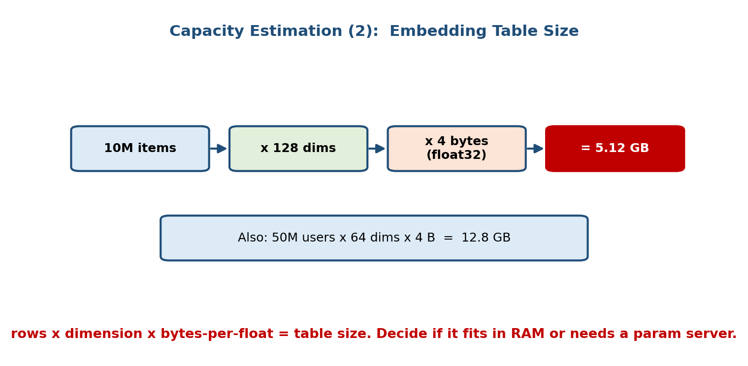
Four-box pipeline: 10M items, times 128 dims, times 4 bytes (float32) equals 5.12 GB; plus a second line, 50M users x 64 dims x 4 bytes = 12.8 GB.
A recommender learns an embedding vector per item and per user. Storage is just rows x dimension x bytes-per-number:
Item table: 10,000,000 items x 128 dims x 4 bytes (float32)
= 10e6 x 128 x 4 = 5,120,000,000 bytes ≈ 5.12 GB
User table: 50,000,000 users x 64 dims x 4 bytes
= 50e6 x 64 x 4 = 12,800,000,000 bytes ≈ 12.8 GB
Total embeddings ≈ 18 GB
Interpretation. 18 GB will not fit comfortably in a single serving process alongside the rest of the model. Options: shard across a parameter server, keep hot embeddings in RAM and cold ones on SSD, or reduce precision to float16/int8 (halving or quartering the size — 5.12 GB → 2.56 GB → 1.28 GB). Cutting dimension from 128 to 64 also halves item storage. These are the levers a Staff engineer reaches for.

A reusable back-of-the-envelope kit
Quantity | Formula | Handy numbers
Average QPS | requests/day ÷ 86,400 | 1B/day ≈ 11.6k QPS
Peak QPS | avg × peak factor | peak factor 2–4×
Servers needed | peak QPS ÷ per-server QPS | + ~30% headroom
Embedding storage | rows × dim × bytes | float32 = 4 B, fp16 = 2 B
Daily log volume | events/day × bytes/event | 1B × 1 KB = 1 TB/day
Model size (dense) | #params × bytes | 1B params × 2 B (fp16) = 2 GB
Senior signal: Round aggressively (86,400 → “~10⁵”), state assumptions (“assume 10 req/user/day, 3× peak”), and always convert the number into a decision (“so ~45 servers, and the table needs a param server”). Numbers without a decision are just trivia.

Module 3 — Interview Mapping (what companies probe)
Company | How Module 3 shows up | Junior answer | Staff answer
Google / Meta | “Design ranking for the feed” | Jumps to a model | Translates goal → metric → label; separates objective from guardrails; sizes QPS
Amazon | Ties to Customer Obsession & Dive Deep | Optimises a raw proxy | Names proxy-vs-true-goal gap; adds guardrail metrics
Uber / Stripe / DoorDash | ETA / fraud framing + scale | Picks a task, forgets scale | Chooses task from output shape, does QPS + storage math, flags delayed labels
OpenAI / Anthropic | When is ML the right tool; framing generation vs retrieval | Reaches for a big model | Questions if ML is needed; frames retrieval + generation two-stage
The single most common opening move: before modelling, spend 3–5 minutes on framing — restate the business goal, pick the success metric, define the label (and its traps), name the task, and size the system. That structure alone outperforms most candidates.

Module 3 — Exam Mapping (SEBI / RBI / GATE / ISRO)
- SEBI IT / RBI IT: may ask definitional items — supervised task types, what a label is, classification vs regression. Sections 3.2 and 3.4 cover this. Objective-design and capacity math are essentially interview-only.
- GATE CS / DA: knows classification vs regression, loss functions matched to task, and basic evaluation metric pairing. Section 3.2’s task→loss→metric chain is directly relevant.
- ISRO / DRDO: occasional basic ML task-type definitions only.
Flag: Capacity estimation and objective-alignment are high-value for interviews and MLE roles, low-value for written exams. Task types and label definitions carry the most exam value.

Module 3 — Common Mistakes & Misconceptions
- Optimising the business goal directly. You can’t train on “engagement”; translate it down to a label (Section 3.1).
- Picking the task by habit. Let the output shape choose the task, and consider re-framing (Section 3.2).
- Including a leaky feature. A feature computed using post-label information gives fake offline accuracy and fails live (Section 3.4).
- Forgetting the label delay. Loan default / churn labels arrive late; design for it or use a shorter-horizon proxy (Section 3.4).
- Trusting a single proxy metric. CTR-only optimisation breeds clickbait; add guardrails and validate on the true goal (Section 3.5).
- Skipping capacity math. Not sizing QPS/storage means you can’t justify batch vs online or fleet size (Section 3.6).
- Sizing for average, not peak. Traffic spikes; provision for peak QPS.

Module 3 — MCQs (with answers & explanations)
Q1. A PM says “increase watch-time”. Which is the correct ML objective? a) Watch-time itself b) Predicted watch-time (or watch probability) of a video for a user c) Daily active users d) Server latency
Answer
b. You can’t train on the aggregate goal; you predict a per-item label (predicted watch-time / completion probability) that, when optimised, moves the success metric.
Q2. You need to return the 20 most relevant products from a catalogue of 50 million. The most appropriate task is: a) Regression b) Binary classification c) Retrieval (then ranking) d) RL
Answer
c. With millions of candidates you first retrieve top-k cheaply, then rank them — the two-stage funnel. Scoring all 50M per request with a classifier is infeasible.
Q3. An offline fraud model scores AUC 0.999, but performs terribly in production. The most likely cause is: a) Too little regularisation b) Label leakage c) A slow database d) Overfitting the learning rate
Answer
b. A near-perfect offline score that collapses live is the signature of leakage — a feature carried information only available after the label (e.g. account_was_closed).
Q4. “Did the user find the content satisfying?” is measured by “watched > 80%”. The “watched > 80%” signal is a: a) Guardrail metric b) Proxy label c) Leaky feature d) Delayed label
Answer
b. The true target (satisfaction) is hard to measure, so completion is used as a proxy label. Name the gap and monitor it.
Q5. A product has 200M DAU and 5 requests/user/day. Approximately what is the average QPS? a) ~1.2k b) ~11.6k c) ~35k d) ~1M
Answer
b. 200M × 5 = 1B req/day; 1B ÷ 86,400 ≈ 11,574 ≈ 11.6k QPS average. (Peak would be ~35k at 3×.)
Q6. You store embeddings for 20M items at 256 dims in float32. Approximate table size? a) ~0.5 GB b) ~5 GB c) ~20 GB d) ~80 GB
Answer
c. 20e6 × 256 × 4 bytes = 20.48e9 bytes ≈ 20.5 GB. Consider fp16 or smaller dims if it must fit in RAM.
Q7. Optimising click-through rate makes CTR rise but 7-day retention fall. This is an example of: a) Data drift b) Proxy-objective misalignment c) Label leakage d) Cold start
Answer
b. The proxy (clicks) diverges from the true goal (retention). Fix with a blended objective plus guardrail metrics.
Q8. Which situation most argues against using ML? a) Millions of labelled examples exist b) A single rule (amount > 10000) already catches most cases c) The pattern is complex and changing d) Some error is tolerable and there is a human reviewer
Answer
b. If a simple, stable rule already solves it, ML adds cost and risk without payoff. Ship the rule first.

Module 3 — Design Exercises (easy → hard)
- Easy. For each, name the ML task from the output shape: (1) predict tomorrow’s temperature; (2) tag an email as spam/not; (3) order 100 search results;
  - generate a product description. (Regression; classification; ranking; generation.)
- Easy. For “reduce customer churn”, write the full ladder: business goal → success metric → ML objective (label) → task. Note when the label arrives.
- Medium. You are building a loan-default model. Identify (a) one proxy label you could use for the delayed true label, and (b) two features that would leak the label. Explain why each leaks.
- Medium. A team optimises “time-on-app” and engagement rises but complaints spike. Redesign the objective: name one blended objective and two guardrail metrics.
- Hard. Size a search backend: 300M DAU, 8 queries/user/day, 4× peak factor, one server ≈ 2,000 QPS. Compute average QPS, peak QPS, and server count with 30% headroom. State one decision the numbers drive.
- Hard. Design the label, objective, guardrails, and a QPS + embedding-storage estimate for a short-video recommender (say 500M items, 128-dim embeddings). Where would you put a retrieval stage and why?

Module 3 — Concept Review (one page)
- Framing ladder: business goal → success metric → ML objective (label) → ML task. You optimise the label, never the goal directly.
- Pick the task from the OUTPUT shape: class → classification; number → regression; ordering → ranking; match from many → retrieval; new content → generation; sequential decisions → RL; rare/odd → anomaly detection. Be ready to re-frame.
- When NOT to use ML: simple rule works / no data / zero error tolerance & no human / cannot measure success.
- Three label traps: proxy (stand-in for a hard target), leakage (feature uses post-label info → fake offline win), delayed (true label arrives late).
- Objective alignment: the proxy objective can fight the true goal (CTR → clickbait). Use a blended objective + guardrail metrics, validate on the true metric via A/B.
- Capacity math: avg QPS = req/day ÷ 86,400; peak = avg × (2–4×); embeddings = rows × dim × bytes. Always size for peak and convert numbers into a decision.

Module 3 — Flash Cards (Q → A)
- Framing ladder in one line? → goal → success metric → label → task.
- How do you pick the ML task? → From the shape of the output.
- Retrieval vs ranking? → Retrieval fetches top-k from millions; ranking orders the shortlist.
- What is a proxy label? → An easy-to-log stand-in for a hard-to-measure true target.
- Signature of label leakage? → Great offline metric, terrible in production.
- Leakage rule of thumb? → Every feature must use only data available at/before the prediction time.
- Delayed-label example + fix? → Loan default; use a shorter-horizon proxy.
- Proxy misalignment example? → Optimise CTR → clickbait → trust/retention drop.
- Fix for proxy misalignment? → Blended objective + guardrail metrics + A/B on the true goal.
- Average QPS formula? → requests per day ÷ 86,400.
- Embedding table size? → rows × dimension × bytes-per-number.
- Size the fleet for average or peak? → Peak (avg × 2–4×), plus headroom.

Module 3 — Pattern Recognition (how to spot it in an interview)
- Hear “increase engagement / revenue / retention” → run the framing ladder; don’t optimise the goal directly.
- Hear “how would you model this?” → name the task from the output shape, then offer a re-framing.
- Hear “millions of items, return the best few” → say retrieval then ranking.
- Hear “the offline metric is amazing” → suspect label leakage; check the temporal cutoff.
- Hear “the label is not known for weeks” → say delayed labels; propose a proxy horizon.
- Hear “CTR went up but users are unhappy” → say proxy misalignment; add guardrails.
- Hear “how many servers / how much storage?” → do QPS and rows×dim×bytes math out loud, size for peak.

Module 3 — Revision Notes / Mini Cheat Sheet
FRAMING LADDER: business goal -> success metric -> ML OBJECTIVE (label) -> ML TASK
(optimise the LABEL, never the goal directly)
PICK TASK BY OUTPUT SHAPE:
class -> classification | number -> regression | ordering -> ranking
match-from-many -> retrieval | new content -> generation
sequential decisions -> RL | rare/odd -> anomaly detection
(recsys = RETRIEVAL then RANKING; re-frame when labels are scarce)
WHEN NOT TO USE ML: simple rule works | no data | zero error tolerance & no human
| cannot measure success
LABEL TRAPS: PROXY (stand-in) | LEAKAGE (uses post-label info) | DELAYED (late label)
leakage rule: every feature uses ONLY data available at/before prediction time
OBJECTIVE ALIGNMENT: proxy objective can fight the true goal (CTR -> clickbait)
fix = blended objective + GUARDRAIL metrics + A/B on true goal
CAPACITY MATH:
avg QPS = requests/day / 86,400 (1B/day ~ 11.6k QPS)
peak QPS = avg x 2..4 (size the fleet for PEAK)
servers = peak QPS / per-server QPS (+30% headroom)
embeddings= rows x dim x bytes (fp32=4B, fp16=2B, int8=1B)
ALWAYS turn the number into a DECISION.

Next module: Module 4 — Data: Collection, Labelling & Versioning. Now that we have framed the problem and defined the label, we go get the data — how to collect it, label it (manually, weakly, or programmatically), split it without leakage, and version it so training is reproducible. Data is where most of the real ML work lives.

