Module 6 — Model Development & Training at Scale
  - ML System Design Mastery: FAANG / AI-Engineer / Staff-Level — In-Depth Notes (with visuals)
Prepared for nidhi.sharma@forensiccybertech.com
2026
Table of Contents

Module 6 — Model Development & Training at Scale
Why this module matters. By now you can frame a problem (Module 3), gather data (Module 4), and build features (Module 5). This is the module where you finally pick a model, choose what it should minimise, and train it — possibly across hundreds of GPUs. This is the part beginners think ML is all about; in reality it is one stage of the loop, but it is the stage with the most math. We handle that math from first principles and in plain English: every loss function is derived, every optimizer explained by what it is actually doing, and every distributed- training trick motivated by a concrete pain (“the model won’t fit on one GPU”). The golden rule that runs through the whole module: start simple, add complexity only when a simpler thing provably fails.
Importance ratings (out of 5):
Exam / Use | SEBI IT | RBI IT | GATE CS/DA | Interview | AI/MLE role
This module | ★★ | ★★ | ★★★★★ | ★★★★ | ★★★★★
What you must be able to do after this module: pick a model family from the data type and justify it; explain why a baseline comes first; define bias and variance and connect them to under/overfitting; write and derive MSE, cross-entropy, hinge, pairwise-ranking, and contrastive losses and say what each optimizes; explain SGD vs Adam and the role of the learning rate; contrast data / model / tensor / pipeline parallelism and know when to reach for ZeRO/FSDP and mixed precision; and choose between grid / random / Bayesian / Hyperband tuning and between training-from-scratch and transfer learning.
How to read this module. As always: problem → simplest attempt → why it breaks → the fix. The math is here to serve the intuition, never to replace it. If a formula ever feels opaque, re-read the plain-English line right beside it.

6.1 Choosing a Model: Linear → Trees/GBDT → Deep Nets → Transformers

Motivation (the problem that existed)
You have clean features and a target. Now: which model? Beginners reach straight for a deep neural network because it sounds powerful. But a deep net on 500 rows of tabular data will overfit horribly, train slowly, and lose to a 30-line gradient-boosted-trees model. The right choice is driven by the shape of your data and the amount of it — not by what is fashionable.

Definition
- Linear / logistic models — the output is a weighted sum of features (plus a squashing function for classification). Few parameters, fast, interpretable.
- Trees / GBDT (Gradient Boosted Decision Trees: XGBoost, LightGBM) — build many small decision trees, each correcting the previous one’s errors. King of tabular data.
- Deep neural networks (DNNs) — stacked layers of learned non-linear transforms; excel at perception (images, audio) and sequences.
- Transformers — attention-based deep nets that dominate language and, increasingly, any domain with huge data and long-range structure.
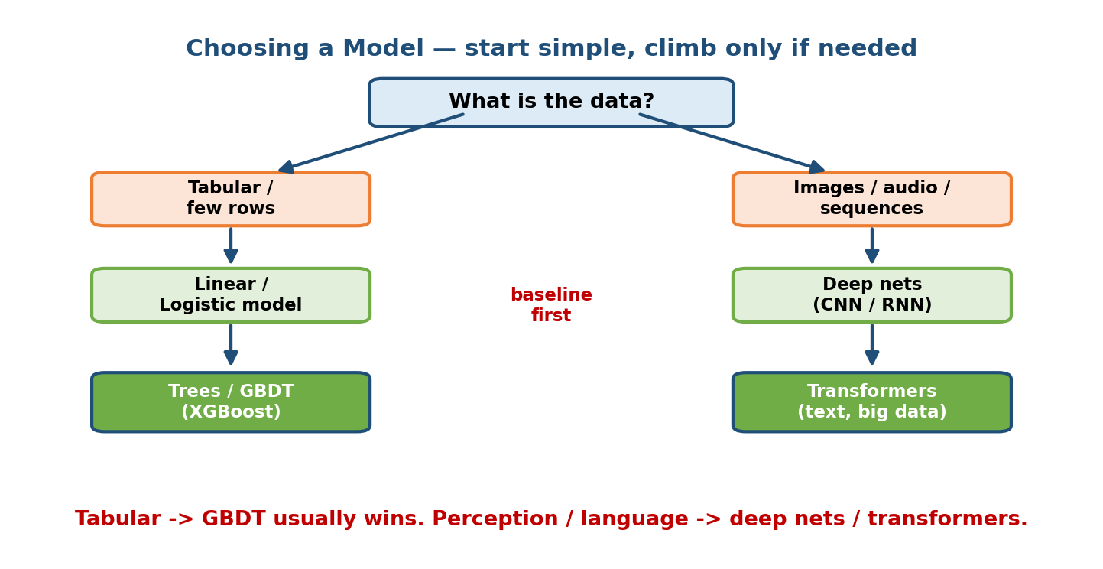
Decision flow for choosing a model: split by data type, then climb from linear to GBDT for tabular, and from deep nets to transformers for perception/language.

Intuition & analogy
Think of tools in a workshop. A screwdriver (linear model) is fast and you understand exactly what it did. A power drill (GBDT) handles almost any tabular “screw” and is the reliable default. A CNC machine (deep net / transformer) is incredibly powerful but needs lots of setup, lots of raw material (data), and lots of electricity (compute). You do not use the CNC machine to hang a picture.

First-principles: why GBDT wins on tabular data
Tabular columns are often heterogeneous (age, country, price) with no spatial or sequential structure to exploit. Decision trees split on one feature at a time using thresholds — exactly the piecewise, rule-like structure tabular data has. They handle mixed scales and missing values naturally and need little tuning. Deep nets, by contrast, shine when there is structure to share: nearby pixels in an image, or nearby words in a sentence. No such structure ⇒ no advantage for depth, and the DNN just overfits.

Quick decision table
Data / situation | First choice | Why
Tabular, < ~100k rows | GBDT (XGBoost) | Best accuracy/effort on tabular
Tabular, need interpretability | Linear / logistic | Coefficients are readable
Images, audio, video | CNN / deep net | Exploits spatial structure
Sequences, time series | RNN / Transformer | Exploits order / long-range deps
Text, huge corpora | Transformer | Attention + scale
Very little data | Linear / GBDT + regularization | Deep nets overfit small data
Senior signal: “For this tabular churn problem I’d start with logistic regression as a baseline, then XGBoost — a deep net is unlikely to pay for itself here.” That one sentence signals judgment.

6.2 Baselines and Why They Matter

Motivation
You train a model and get 82% accuracy. Is that good? You cannot know without a reference point. If 80% of emails are “not spam”, a model that always predicts “not spam” gets 80% — your 82% is nearly worthless. A baseline is the cheap reference every real model must beat.

The baselines to always compute
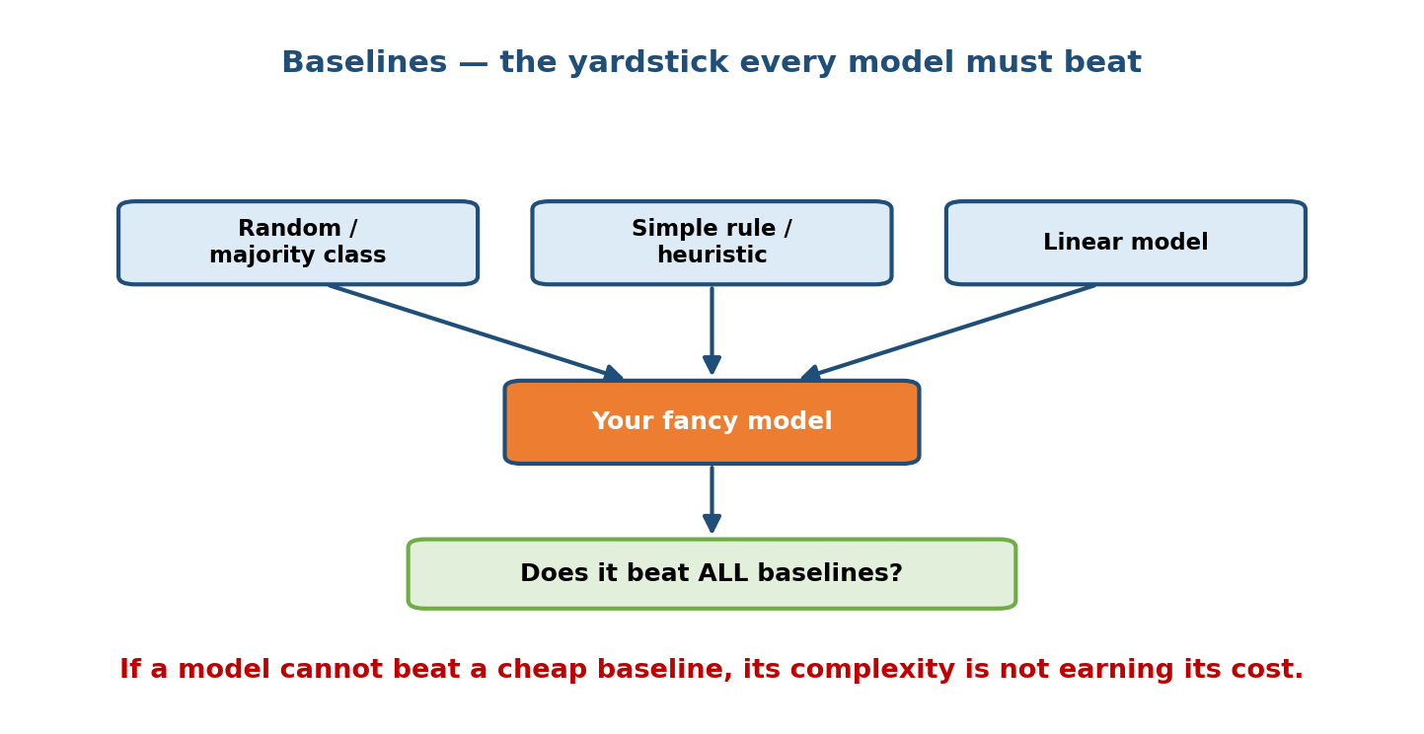
Baselines ladder: random/majority-class, a simple rule, and a linear model all feed into the question — does the fancy model beat every one of them?
- Random / majority-class — predict the most common label, or predict at the base rate. Sets the floor.
- Simple heuristic / rule — a hand rule a domain expert would write (“flag transactions over $10k from a new device”).
- Simple model — logistic regression or a shallow tree.

First-principles: why bother
A baseline answers three questions at once: (a) is there signal in the data at all? (b) how much lift does complexity buy? (c) is my evaluation pipeline even wired up correctly? If your fancy model loses to the majority-class baseline, you have a bug, a leak, or no signal — and you just saved weeks. A baseline also gives the business a concrete cost/benefit: “the deep model is 3% better but 20× more expensive to serve — worth it?”
Common mistake: reporting a single accuracy number with no baseline. In an interview, always say what you are comparing against.

6.3 Bias, Variance, Regularization, and Over/Underfitting

Motivation
The central tension of ML: a model must be complex enough to capture the real pattern, but simple enough not to memorise noise. Get it wrong in either direction and the model fails on new data — which is the only data that matters.

Definition (bias and variance, in plain English)
- Bias = error from the model being too simple to represent the truth (it makes systematic mistakes). High bias → underfitting.
- Variance = error from the model being too sensitive to the particular training set (it memorises noise). High variance → overfitting.
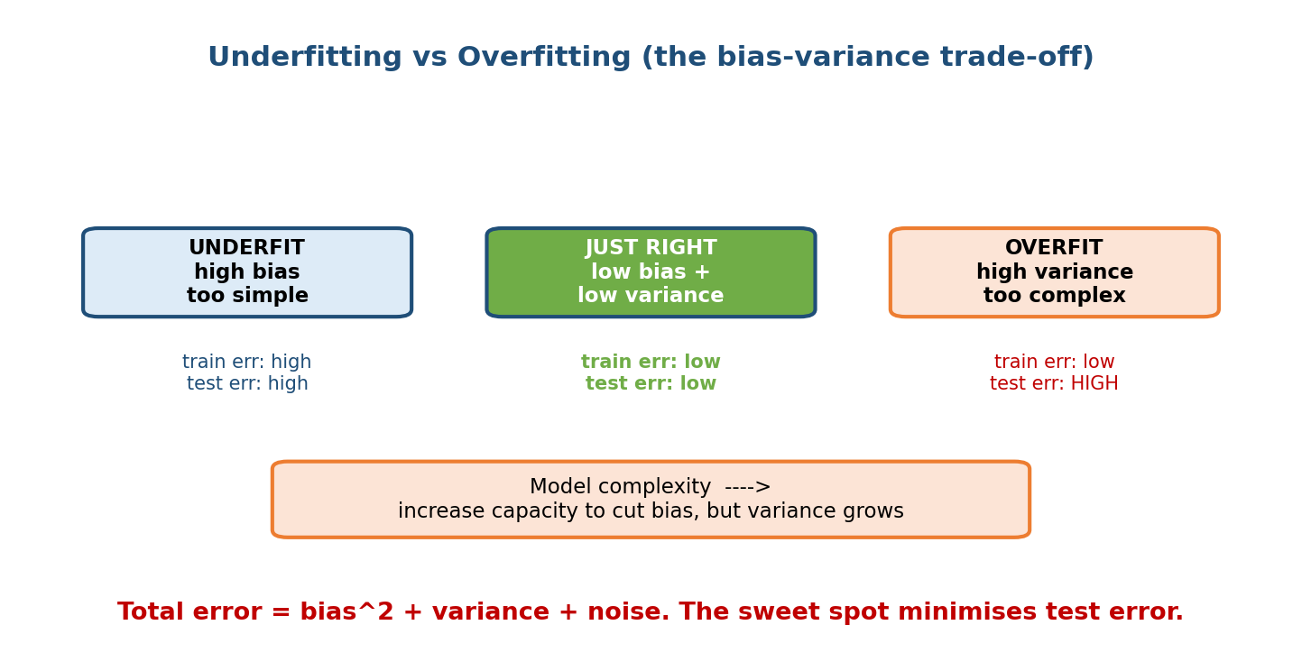
Three regimes side by side: underfit (high bias, high train and test error), just right (low bias and low variance), and overfit (low train but high test error), under a model-complexity axis.

First-principles derivation (the decomposition)
For a squared-error regression, the expected test error at a point decomposes exactly into three pieces:
$$E\left[(y−\hat{f}(x))^{2}\right]=\underset{\text{too simple}}{\underset{⏟}{(\text{bias})^{2}}}+\underset{\text{too sensitive}}{\underset{⏟}{\text{variance}}}+\underset{\text{irreducible noise}}{\underset{⏟}{σ^{2}}}$$
In words: total error = how wrong on average + how much you wobble across datasets + noise you can never remove. Making the model more complex lowers bias but raises variance. The sweet spot minimises their sum — that is what you are hunting for. The irreducible term $σ^{2}$ is a wall: no model beats it.

The fix: regularization (penalise complexity)
The cleanest way to slide toward the sweet spot is to add a penalty for large weights to the loss, so the optimizer prefers simpler solutions.
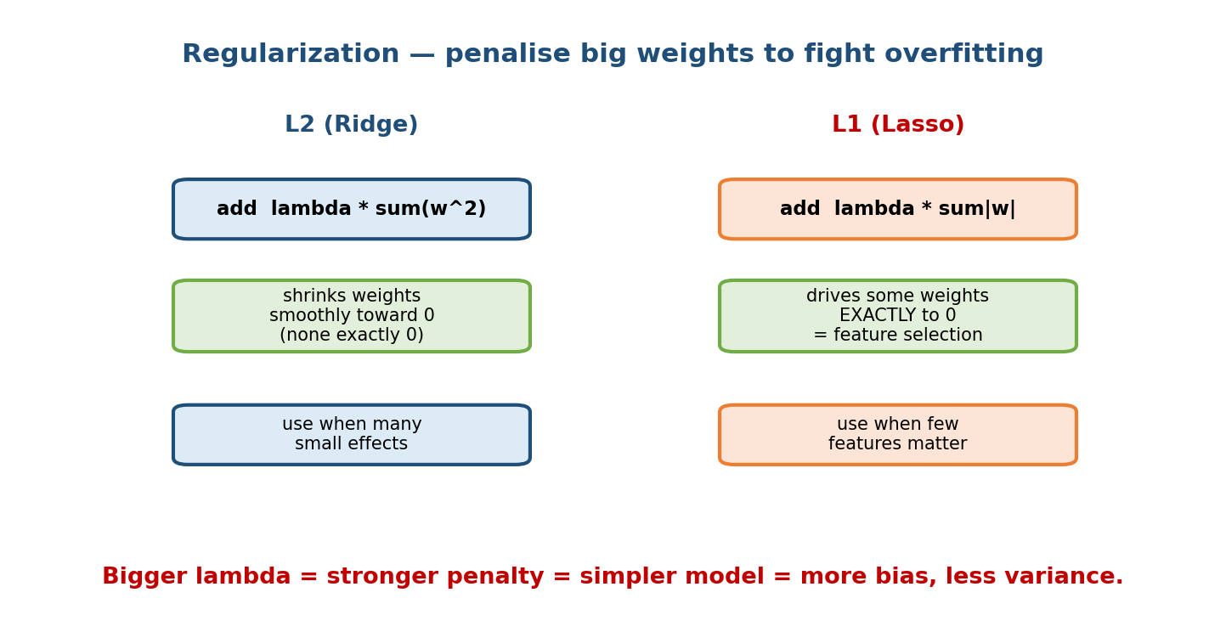
L2 (Ridge) adds lambda times sum of squared weights and shrinks weights smoothly; L1 (Lasso) adds lambda times sum of absolute weights and drives some weights exactly to zero for feature selection.
- L2 (Ridge): add λi​wi2. Shrinks all weights smoothly toward zero; none become exactly zero. Good when many features each contribute a little.
- L1 (Lasso): add λi​|wi|. Its corner-shaped penalty pushes some weights exactly to zero, so it doubles as automatic feature selection. Good when you suspect only a few features matter.
- $λ$ (the strength knob): bigger $λ$ = stronger penalty = simpler model = more bias, less variance. It is itself a hyperparameter (Section 6.7).
- Other regularizers: dropout (randomly zero neurons during training), early stopping (stop before the model memorises), data augmentation, weight decay (the optimizer form of L2).

Worked example
Fitting a wiggly degree-15 polynomial to 20 noisy points: it passes through every point (train error ≈ 0) but swings wildly between them (huge test error) — classic overfitting / high variance. A straight line misses the curve entirely (high train and test error) — underfitting / high bias. A degree-3 curve with mild L2 nails the trend without chasing noise.
Interview line: “Train error low but validation error high ⇒ overfitting ⇒ add regularization, get more data, or reduce capacity. Both errors high ⇒ underfitting ⇒ add capacity or better features.”

6.4 Loss Functions — with Math and Derivations

Motivation
Training = choosing weights that minimise a loss. The loss is your definition of “good”. Pick the wrong loss and even a perfectly optimised model solves the wrong problem. Below, each loss is derived from what it is really trying to do.
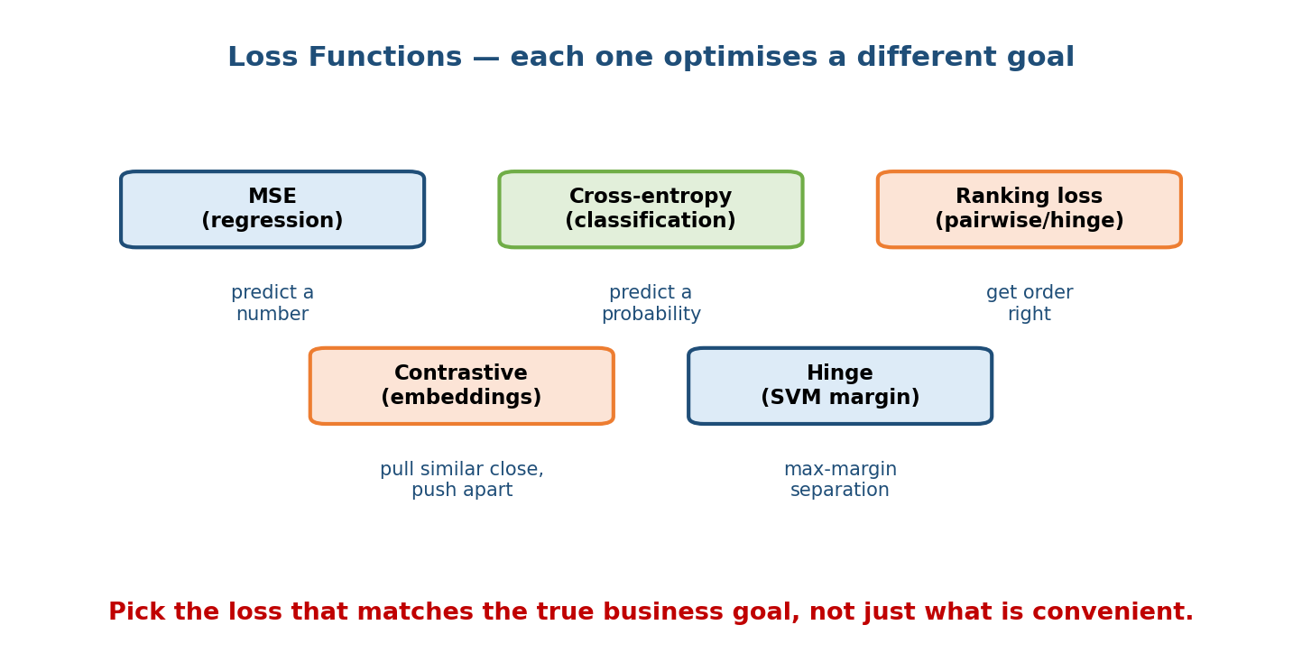
Map of loss functions: MSE for regression, cross-entropy for classification, ranking loss for ordering, contrastive loss for embeddings, and hinge loss for max-margin classification, each labelled with the goal it optimises.

MSE (Mean Squared Error) — for regression
$$L_{\text{MSE}}=\frac{1}{n}\sum_{i=1}^{n}{(}y_{i}−{\hat{y}}_{i})^{2}$$
Penalises the square of the error, so big misses hurt disproportionately. It is the right loss when errors are roughly Gaussian and large errors are genuinely worse. Downside: sensitive to outliers (one huge error dominates). Use MAE (absolute error) or Huber loss when outliers are a concern.

Cross-entropy — for classification (derived from MLE)
Where does cross-entropy come from? From Maximum Likelihood Estimation. For binary labels, the model outputs $\hat{y}=P(y=1∣x)$. The probability of seeing the actual label under the model is ${\hat{y}}^{ y}(1−\hat{y})^{1−y}$. We want weights that make the observed data most likely, i.e. maximise the product of these over all examples. Maximising a product is awkward, so take the log (turns product into sum) and flip the sign (maximise → minimise):
$$L_{\text{CE}}=−\frac{1}{n}\sum_{i=1}^{n}{\left[y_{i}log{\hat{y}}_{i}+(1−y_{i})log(1−{\hat{y}}_{i})\right]}$$
In words: be confident and right → tiny loss; be confident and wrong → enormous loss (the $log$ blows up as $\hat{y}→0$ while $y=1$). For multi-class it generalises to −c​yclogyc over classes. This is why classification uses cross-entropy, not MSE: MSE on probabilities gives weak, flat gradients when the model is confidently wrong, so learning stalls.

Hinge loss — the max-margin (SVM) idea
$$L_{\text{hinge}}=max(0, 1−y⋅s), y∈\{−1,+1\}$$
where $s$ is the raw score. If a point is on the correct side and past a margin of 1, loss is exactly 0 — the model stops caring about already-safe points and focuses on the boundary. This produces the maximum-margin separator that SVMs are famous for.

Ranking losses — pairwise / order matters, not the exact value
For search and recommendations you care about order, not absolute scores. A pairwise loss takes a relevant item $i^{+}$ and a less-relevant item $i^{−}$ and pushes their scores apart:
$$L_{\text{pair}}=max\left(0, m−(s_{i^{+}}−s_{i^{−}})\right)$$
It is happy once the good item outscores the bad one by margin $m$. (BPR, RankNet are smooth variants using a logistic on the score difference.) This directly optimizes ranking metrics like NDCG far better than a pointwise MSE would.

Contrastive loss — for learning embeddings
Used in metric learning and self-supervised learning (e.g. two-tower models, SimCLR). Given pairs labelled similar ($y=1$) or dissimilar ($y=0$) with embedding distance $d$:
$$L_{\text{contrastive}}=y d^{2}+(1−y) max(0, m−d)^{2}$$
Similar pairs are pulled together ($d→0$); dissimilar pairs are pushed apart until at least margin $m$. This shapes an embedding space where distance means semantic similarity. (Triplet loss extends this to anchor/positive/negative triples.)

Which loss when?
Task | Loss | Optimizes
Predict a number | MSE / MAE / Huber | Closeness of value
Classify (probabilities) | Cross-entropy | Calibrated correct probability
Max-margin classify | Hinge | Wide separating margin
Rank a list | Pairwise / listwise | Correct ordering
Learn embeddings | Contrastive / triplet | Meaningful distances

6.5 Optimization: SGD, Adam, and the Learning Rate

Motivation
Given a loss, how do we actually find the weights that minimise it? We cannot try all weight combinations (there are billions). We walk downhill on the loss surface using gradients.

Gradient descent from first principles
The gradient $∇L$ points in the direction of steepest increase of the loss. So to decrease the loss we step in the opposite direction:
$$w←w−η ∇L(w)$$
$η$ (eta) is the learning rate — the step size. Repeat until the loss stops improving. That is the whole idea; everything else is a refinement.
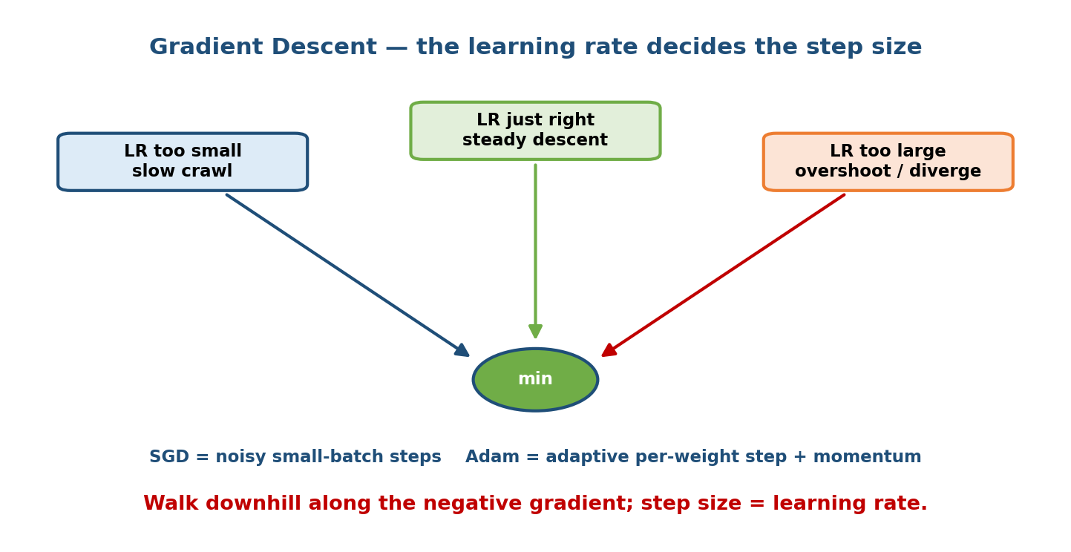
Loss-surface picture: three boxes feed arrows toward the minimum — a tiny learning rate crawls, a right-sized one descends steadily, and a too-large one overshoots and can diverge.

The learning rate is the most important knob
- Too small: training crawls; may take forever or get stuck.
- Too large: steps overshoot the valley, bounce around, or diverge (loss goes to infinity / NaN).
- Just right: steady, fast descent.
In practice you use a schedule: warm up, then decay (cosine or step decay).

SGD vs Adam (intuition)
- SGD (Stochastic Gradient Descent): compute the gradient on a small mini-batch instead of the whole dataset. Cheaper per step and the noise actually helps escape shallow traps. Add momentum to keep rolling in a consistent direction and smooth out the noise.
- Adam: adapts the step size per weight using running averages of the gradient (momentum) and its squared magnitude (scale). Weights with big, noisy gradients get smaller steps; quiet weights get bigger steps. It “just works” with little tuning, which is why it is the default for deep nets. SGD + momentum sometimes generalises slightly better for vision, so it is still used.
Rule of thumb: start with Adam and a learning rate around ${10}^{−3}$; if the loss explodes, lower it; if it barely moves, raise it. Tune the LR before anything else.

6.6 Distributed Training at Scale

Motivation
Two walls force you off a single GPU: (1) the dataset is so large that one GPU would take weeks, or (2) the model itself is too big to fit in one GPU’s memory. Two walls, two different families of solution.

Data parallelism vs model parallelism
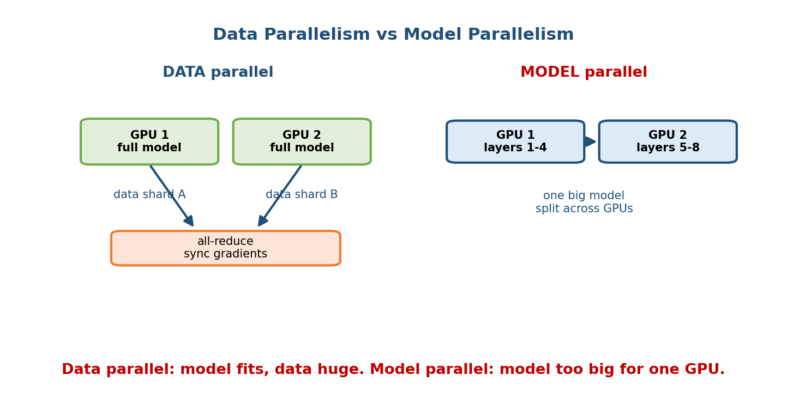
Data parallelism keeps a full model copy on each GPU and feeds each a different data shard, then all-reduces gradients; model parallelism splits one big model’s layers across GPUs.
- Data parallelism — every GPU holds a full copy of the model; each processes a different shard of the batch, computes gradients, and then all GPUs average their gradients so the copies stay in sync. Use when the model fits on one GPU but the data is huge. This is the common case.
- Model parallelism — the model is too big to fit, so you split it across GPUs. Two flavours:
  - Tensor parallelism: split within a layer (e.g. shard a giant matrix multiply across GPUs).
  - Pipeline parallelism: put different layers on different GPUs and stream micro-batches through like an assembly line.

How gradients get synced: parameter server vs all-reduce
- Parameter server: worker GPUs send gradients to central server(s) that hold the weights, update, and send weights back. Simple, but the server becomes a bandwidth bottleneck.
- All-reduce (ring all-reduce): GPUs exchange gradients directly with each other in a ring so bandwidth is used evenly and there is no central bottleneck. This is the modern default for synchronous data-parallel training.

Memory-saving techniques (fitting bigger models)
- ZeRO / FSDP (Fully Sharded Data Parallel): even in data parallelism, every GPU redundantly stores the full weights, gradients, and optimizer states. ZeRO shards these across GPUs so each holds only a slice, gathering pieces only when needed. This lets you train models far larger than one GPU’s memory while keeping data-parallel simplicity.
- Mixed precision: store and compute in 16-bit (FP16/BF16) instead of 32-bit. Roughly halves memory and speeds up math on modern GPUs; a small FP32 “master copy” and loss scaling keep it numerically stable. Almost free win — use it by default.
- Gradient checkpointing: recompute activations during the backward pass instead of storing them all — trades compute for memory.

The scaling decision (in order)
- One GPU + mixed precision — cheapest, try first.
- Data parallel + all-reduce — data too big, model still fits.
- ZeRO / FSDP — model states too big; shard them.
- Tensor + pipeline parallel — model genuinely too large for one device.
Senior signal: climb this ladder only as far as forced to. Every rung adds communication cost, complexity, and failure modes. “Do we actually need model parallelism, or does FSDP + mixed precision fit?” is the mature question.

6.7 Hyperparameter Tuning

Motivation
Learning rate, tree depth, number of layers, $λ$ — these are hyperparameters you set before training (the model does not learn them). The search space is huge and each trial costs a full training run, so you need a strategy smarter than guessing.
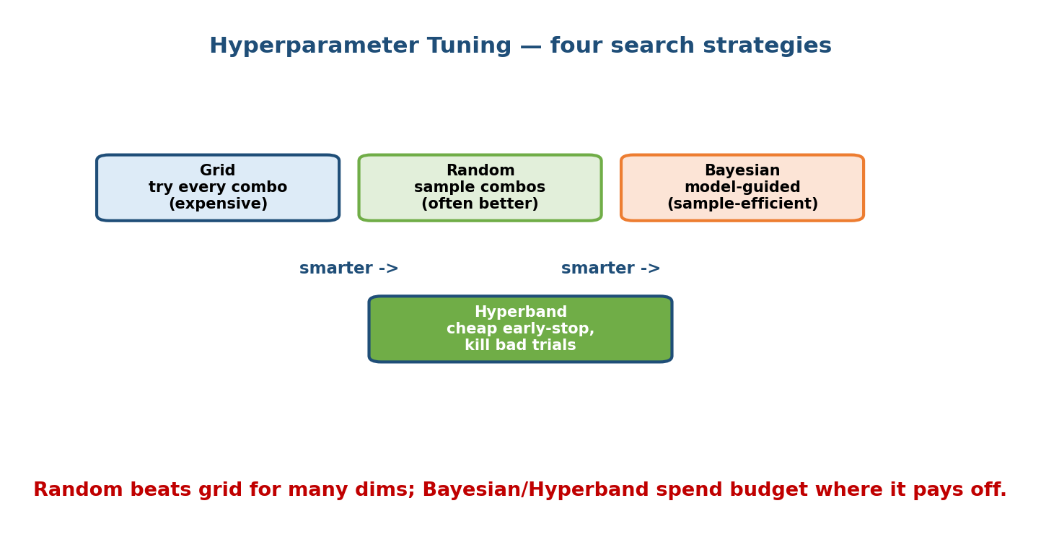
Four hyperparameter search strategies: grid tries every combination, random samples combinations, Bayesian is model-guided and sample-efficient, and Hyperband cheaply early-stops bad trials.

The four strategies
Method | Idea | Best when
Grid | Try every combination on a fixed grid | Very few hyperparameters
Random | Sample combinations at random | Many dims (usually beats grid)
Bayesian | Build a model of “params → score”, sample where it looks promising | Expensive trials, want efficiency
Hyperband | Start many trials cheaply, kill the losers early, give survivors more budget | Trials that can be stopped early

First-principles: why random beats grid
Usually only one or two hyperparameters really matter. A grid wastes most of its trials varying the unimportant ones at fixed values of the important ones. Random search, in the same budget, tries many distinct values of the important hyperparameter — so it explores the axis that matters far better. This is a classic, counter-intuitive result (Bergstra & Bengio, 2012).
Bayesian optimization goes further: it learns from finished trials to propose the next promising point, so it needs fewer total runs. Hyperband attacks a different axis — it saves compute by early-stopping obviously-bad trials rather than running them to completion. (BOHB combines both.)

6.8 Transfer Learning, Fine-Tuning, and Pretraining

Motivation
Training a big model from scratch needs enormous data and compute you often do not have. But someone already trained a model on a massive generic dataset. Why throw away everything it learned? Reuse it.
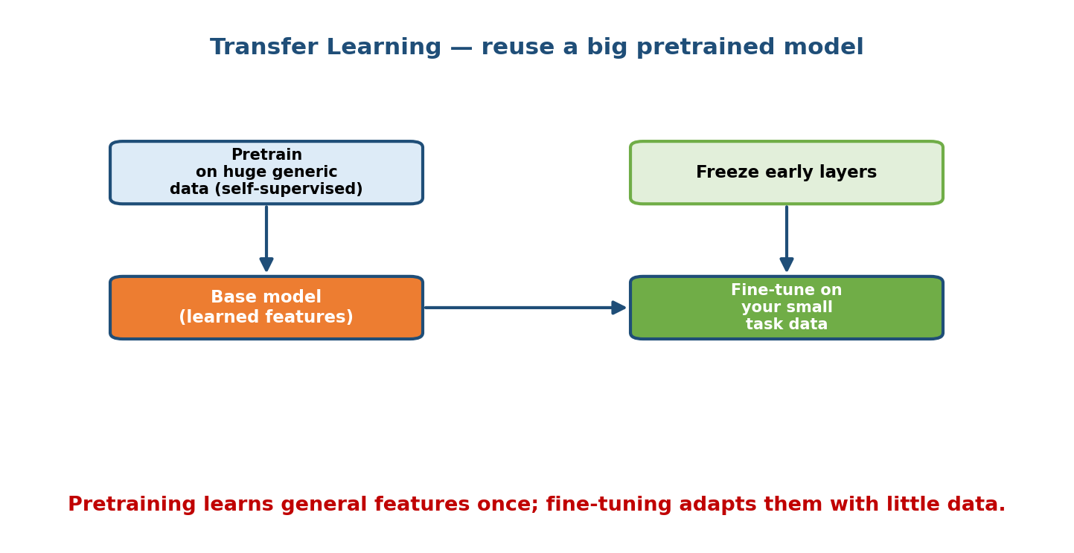
Transfer learning: pretrain a base model on huge generic data with self-supervision, then freeze its early layers and fine-tune the rest on your small task-specific dataset.

The three terms
- Pretraining: train a large model once on a huge, generic corpus — often self-supervised (predict the next word, or fill in masked pixels), so no human labels are needed. It learns broadly useful features.
- Transfer learning: take that pretrained model and reuse its learned features for a different, related task.
- Fine-tuning: continue training the pretrained model on your (usually small) task-specific labelled data, so it adapts.

First-principles: why it works
Early layers learn general features (edges, textures; grammar, syntax) that transfer across tasks. Only the later layers are task-specific. So you can freeze the early layers (keep their weights) and only train the top — needing far less data and compute — because you are not re-learning “what an edge is”.

Practical patterns
- Feature extraction: freeze the whole backbone, train only a new head. Least data, fastest, best when your data is tiny and similar to the pretraining data.
- Full fine-tuning: unfreeze everything and train with a small learning rate. Best when you have moderate data and the domain differs.
- Parameter-efficient fine-tuning (LoRA, adapters): train a tiny number of extra weights while freezing the giant base — the modern default for adapting large models cheaply.
Interview line: “With only 5k labelled images I would not train a CNN from scratch — I’d fine-tune a pretrained backbone, freezing early layers.” That is the expected answer.

Module 6 — Interview Mapping (what companies probe)
Company | How Module 6 shows up | Junior answer | Staff answer
Google / Meta | “How would you train this at scale?” | “Use more GPUs” | Distinguishes data vs model parallel, mentions all-reduce, FSDP, mixed precision, and why
Amazon | Model choice for a tabular problem | Jumps to deep learning | Baseline → GBDT, justifies against a DNN on cost
OpenAI / Anthropic | Loss design, pretraining/fine-tuning | Vague on the loss | Derives cross-entropy from MLE, explains LoRA / fine-tuning trade-offs
Uber / Stripe | Regularization, overfitting on fraud model | “Add more data” | Diagnoses bias vs variance from train/val gap, picks the right fix
Most common trap: proposing a deep net for tabular data, or reporting a metric with no baseline. Naming the baseline first and matching model family to data type instantly reads as senior.

Module 6 — Exam Mapping (SEBI / RBI / GATE / ISRO)
- GATE CS / DA: HIGH relevance. The DA (Data Science & AI) paper tests the ML-algorithm core covered here directly — bias-variance trade-off, L1/L2 regularization, gradient descent and learning rate, cross-entropy and MSE, over/underfitting, and hyperparameter concepts are all fair game as numerical or conceptual questions. Know the loss formulas and the bias-variance decomposition cold.
- SEBI IT / RBI IT: definitional only — what is overfitting, what is gradient descent, supervised loss basics.
- ISRO / DRDO: occasional basic definitions (loss function, learning rate).
Flag: the distributed-training and transfer-learning systems content is largely interview/role-only; the algorithmic content (6.3–6.5, 6.7) is the exam-heavy part, especially for GATE-DA.

Module 6 — Common Mistakes & Misconceptions
- “Deep learning is always best.” For tabular data, GBDT usually wins with far less effort. (6.1)
- “82% accuracy is good.” Meaningless without a baseline; a majority-class guess may already hit 80%. (6.2)
- “Overfitting means the model is bad.” It means it is too complex for the data — regularize, get more data, or reduce capacity. (6.3)
- “Use MSE for classification.” No — cross-entropy gives proper gradients; MSE on probabilities stalls learning. (6.4)
- “Data parallelism helps when the model won’t fit.” No — that is what model parallelism / ZeRO is for; data parallelism assumes the model fits. (6.6)
- “Grid search is the thorough, correct way.” Random search usually finds better configs per unit compute in high dimensions. (6.7)
- “Always train from scratch.” With little data, fine-tune a pretrained model instead. (6.8)

Module 6 — MCQs (with answers & explanations)
Q1. You have 20k rows of tabular customer data. Best first real model? a) A 12-layer transformer b) XGBoost (GBDT) c) A large CNN d) k-means
Answer
b. GBDT dominates tabular data of this size; deep nets rarely pay off and tend to overfit. Start with a linear baseline, then XGBoost.
Q2. Cross-entropy loss is derived from: a) minimising squared error b) maximum likelihood estimation c) the triangle inequality d) the bias-variance decomposition
Answer
b. Maximising the likelihood of the observed labels, then taking the negative log, yields exactly the cross-entropy loss.
Q3. Train error is low, validation error is high. This indicates: a) underfitting b) overfitting (high variance) c) high bias d) a learning rate that is too small
Answer
b. The model memorised the training set. Fix with regularization, more data, or less capacity.
Q4. Which regularizer tends to drive some weights exactly to zero (feature selection)? a) L2 / Ridge b) L1 / Lasso c) dropout d) momentum
Answer
b. L1’s corner-shaped penalty produces exact zeros; L2 shrinks smoothly but leaves weights non-zero.
Q5. The learning rate is too large. Most likely symptom? a) training is extremely slow b) loss diverges / oscillates c) perfect convergence d) the model underfits by definition
Answer
b. Oversized steps overshoot the minimum and can send the loss to infinity/NaN.
Q6. Your model is too big to fit in a single GPU’s memory. Best approach? a) Data parallelism only b) Model/tensor/pipeline parallelism or ZeRO/FSDP c) A smaller learning rate d) Grid search
Answer
b. Splitting or sharding the model across GPUs is what fits an oversized model; plain data parallelism assumes it already fits.
Q7. Why does random search often beat grid search? a) It uses more compute b) Only a few hyperparameters matter, and random search explores their values better per unit budget c) It is deterministic d) It never overfits
Answer
b. Grid wastes trials on unimportant dims; random samples more distinct values of the important ones (Bergstra & Bengio, 2012).
Q8. You have 5k labelled images. Best strategy? a) Train a large CNN from scratch b) Fine-tune a pretrained backbone, freezing early layers c) Use logistic regression on raw pixels d) Collect 10M images first
Answer
b. Transfer learning reuses general features; fine-tuning adapts with little data and compute.

Module 6 — Design Exercises (easy → hard)
- Easy. For each, name the model family and one baseline: (1) predict house price from 8 columns; (2) classify cat vs dog photos; (3) rank search results. (GBDT+linear; CNN/transfer+majority; ranking model+popularity.)
- Easy. Write the MSE and binary cross-entropy formulas from memory and say which is for regression vs classification.
- Medium. A model gets 99% train accuracy, 71% validation accuracy. Diagnose the problem and list three concrete fixes in priority order.
- Medium. You must train a 3B-parameter language model but each GPU holds only 1B parameters’ worth of state. Describe the exact combination of techniques you’d use and why.
- Hard. Design the loss function for a two-tower recommender that must both
  - rank relevant items above irrelevant ones and (b) learn a useful embedding space. Justify your choice.
- Hard. You have a fixed 100-GPU-hour tuning budget and 6 hyperparameters, one of which dominates. Design a tuning plan (method + budget split) and explain why it beats grid search.

Module 6 — Concept Review (one page)
- Model choice follows the data: linear/GBDT for tabular, deep nets for perception, transformers for language/scale. Start simple; climb only if a simpler model provably fails.
- Baselines (majority / rule / linear) are mandatory — a metric with no baseline is meaningless.
- Bias = too simple (underfit); variance = too sensitive (overfit). Test error $=$ bias$​^{2}$ + variance + noise. Regularization (L1 exact-zeros / feature selection; L2 smooth shrink; dropout; early stopping) trades a little bias for less variance.
- Losses: MSE (regression), cross-entropy from MLE (classification), hinge (max-margin), pairwise (ranking), contrastive (embeddings). The loss is your definition of good.
- Optimization: step downhill by $−η∇L$. Learning rate is the key knob (too big diverges, too small crawls). SGD+momentum vs Adam (adaptive, per-weight — the default).
- Distributed: data parallel (model fits, data huge; all-reduce) vs model parallel (model too big; tensor/pipeline). ZeRO/FSDP shards states; mixed precision halves memory. Climb the ladder only as needed.
- Tuning: grid < random < Bayesian; Hyperband early-stops losers.
- Transfer learning: pretrain once on generic data, freeze early layers, fine-tune the rest on little data (LoRA/adapters for cheap adaptation).

Module 6 — Flash Cards (Q → A)
- Default model for tabular data? → GBDT (XGBoost).
- Why compute a baseline? → A metric is meaningless without a reference; it also catches bugs and leaks.
- Bias vs variance in one line? → Bias = too simple (underfit); variance = too sensitive (overfit).
- L1 vs L2? → L1 drives weights to exactly 0 (feature selection); L2 shrinks smoothly.
- Where does cross-entropy come from? → Negative log-likelihood (MLE) of the labels.
- Learning rate too large? → Loss overshoots / diverges.
- Adam in one line? → Adaptive per-weight step size with momentum; the default.
- Data vs model parallelism? → Data: full model per GPU, split the data. Model: split the model across GPUs (it doesn’t fit).
- What does ZeRO/FSDP do? → Shards weights/gradients/optimizer states across GPUs to fit bigger models.
- Random vs grid search? → Random usually wins — only a few hyperparameters matter and it explores them better.
- Transfer learning in one line? → Reuse a pretrained model’s general features; fine-tune on little data.

Module 6 — Pattern Recognition (how to spot it in an interview)
- Hear “tabular data” → say baseline → GBDT, question the need for a DNN.
- Hear “great on train, bad on test” → say overfitting / high variance → regularize, more data, less capacity.
- Hear “predict a probability” → say cross-entropy, not MSE.
- Hear “rank / order results” → say pairwise / listwise ranking loss.
- Hear “learn an embedding / similarity” → say contrastive / triplet loss.
- Hear “training won’t fit / is too slow” → distinguish data vs model parallel, mention all-reduce, FSDP, mixed precision.
- Hear “little labelled data” → say transfer learning / fine-tuning.
- Hear “tune the model” → say random or Bayesian, Hyperband to early-stop, and tune the learning rate first.

Module 6 — Revision Notes / Mini Cheat Sheet
MODEL CHOICE: linear -> GBDT (TABULAR default) -> deep nets (perception)
-> transformers (language/scale). START SIMPLE.
BASELINE FIRST: majority-class / rule / linear. Metric without baseline = useless.
BIAS-VARIANCE: test_err = bias^2 + variance + noise
underfit = high bias (simple) overfit = high variance (memorises noise)
REGULARIZE: L1 |w| -> exact zeros (feature select) | L2 w^2 -> smooth shrink
dropout | early-stop | weight-decay | augmentation. bigger lambda=simpler
LOSSES:
MSE (y - yhat)^2 regression
Cross-ent -[y log yhat + (1-y)log(1-yhat)] classification (= MLE!)
Hinge max(0, 1 - y*s) max-margin (SVM)
Pairwise max(0, m - (s+ - s-)) ranking
Contrastive y*d^2 + (1-y)*max(0,m-d)^2 embeddings
OPTIMIZE: w <- w - eta * grad(L)
LR too big=diverge | too small=crawl. SGD+momentum vs ADAM(adaptive, default)
DISTRIBUTED:
data-parallel = full model/GPU, split DATA, all-reduce grads (model FITS)
model-parallel = split MODEL across GPUs (tensor within layer / pipeline layers)
ZeRO/FSDP = shard weights+grads+optim states | mixed-precision = FP16, half mem
ladder: 1GPU+FP16 -> data-parallel -> ZeRO/FSDP -> tensor+pipeline (only as needed)
TUNING: grid < random < Bayesian ; Hyperband early-stops losers ; tune LR first
TRANSFER: pretrain(generic, self-sup) -> freeze early layers -> fine-tune (LoRA)

Next module: Module 7 — Model Evaluation: Offline Metrics, Leakage & A/B Testing. We’ve trained a model — but is it actually good? We’ll pick the right offline metric (precision/recall, AUC, NDCG), hunt down data leakage, understand the offline–online gap, and design the A/B test that decides whether it ships.

