Module 7 — Model Evaluation
  - ML System Design Mastery: FAANG / AI-Engineer / Staff-Level — In-Depth Notes (with visuals)
Prepared for nidhi.sharma@forensiccybertech.com
2026
Table of Contents

Module 7 — Model Evaluation
Why this module is the heart of ML. Training a model is easy; knowing whether it is any good is the hard, senior part. Evaluation is where ML meets reality. Pick the wrong metric and you will happily ship a model that looks great on a slide and quietly loses the company money. Almost every famous ML failure — a fraud model that misses fraud, a recommender that recommends the same five items, a “99% accurate” cancer test that is useless — is really an evaluation failure: someone optimised the wrong number. This module teaches you to choose the right metric for the task, compute it by hand, read the curves, check calibration, split the data honestly, and finally prove your model works on real users with an A/B test. We build every metric from first principles and work a numeric example for each family.
Importance ratings (out of 5):
Exam / Use | SEBI IT | RBI IT | GATE CS/DA | Interview | AI/MLE role
This module | ★★★ | ★★★ | ★★★★★ | ★★★★★ | ★★★★★
What you must be able to do after this module: draw a confusion matrix and derive accuracy, precision, recall, and F1 from it; say when precision matters more than recall and why; read ROC and PR curves and know which to use on imbalanced data; compute MAE / MSE / RMSE / MAPE / R² for a regression; compute NDCG, MAP, MRR, and Precision@K for a ranking (a favourite interview drill); name the right metric for NLP/LLM and CV tasks; explain why an accurate model can be mis-calibrated and how to fix it; split data by time to avoid leakage; and design an A/B test with a real notion of statistical significance and guardrails.
How to read this module. For every metric we go what problem it solves → the formula → a worked number → when it lies to you. Metrics are only useful when you know what they hide.

7.1 Why Evaluation Is the Whole Game

Motivation (the problem that existed)
Suppose you build a model to detect a rare disease that affects 1 in 1000 people. You proudly report 99.9% accuracy. Sounds amazing — until you notice that a model which always says “healthy” also scores 99.9%, because 999 of every 1000 people are healthy. Your model may have learned nothing. Accuracy lied to you because the classes are imbalanced.
This is the central lesson of evaluation: a metric is a lossy summary of behaviour, and the wrong summary hides exactly the failure you care about. Choosing the metric is a design decision as important as choosing the model.

Definition
- Offline evaluation = measuring quality on held-out historical data before deployment (accuracy, AUC, RMSE, NDCG…). Cheap, fast, repeatable, but a proxy for what you really want.
- Online evaluation = measuring the real business effect on live users (clicks, revenue, retention) via an A/B test. Expensive and slow, but it is the truth.

Intuition & analogy
Offline metrics are like a practice exam: you can take them a hundred times, they are cheap, and a high score is encouraging — but the practice exam is not the real exam. Online metrics are the real exam with real stakes. Good students use practice tests to decide what to study, then confirm on the real thing. Good ML teams use offline metrics to decide what to ship into an A/B test, then let the A/B test decide what to launch.

First-principles: every metric answers one question
A metric exists to answer a specific question about a specific kind of mistake. Before you pick one, finish this sentence: “The mistake that costs us most is ____.” If a false alarm costs most → precision. If a miss costs most → recall. If being over-confident costs most → calibration/log-loss. If putting the right item lower in the list costs most → a ranking metric. The cost of being wrong (Module 1) chooses your metric.

7.2 Classification Metrics

The confusion matrix — the source of everything
Every classification metric is just a ratio of four counts. Fix a positive class (the thing you are trying to detect, e.g. “spam”), pick a decision threshold, and count:
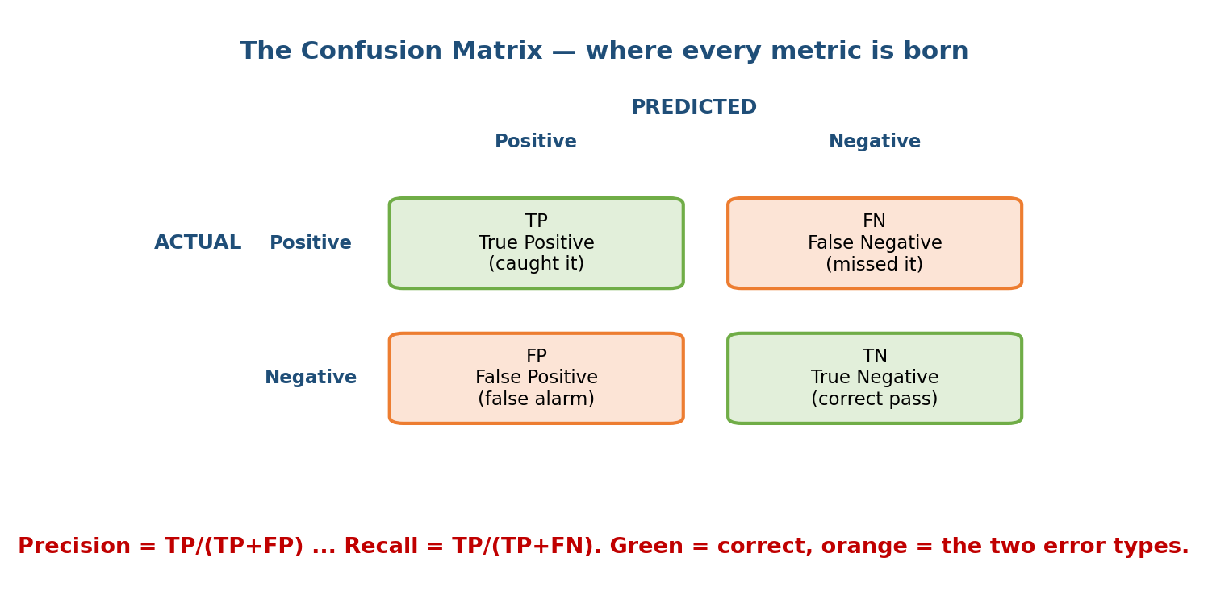
The 2x2 confusion matrix: rows are the true label, columns are the prediction; TP and TN are correct, FP (false alarm) and FN (miss) are the two error types.
- TP (true positive): predicted positive, really positive — caught it.
- FP (false positive): predicted positive, really negative — false alarm.
- FN (false negative): predicted negative, really positive — a miss.
- TN (true negative): predicted negative, really negative — correct pass.

The formulas (memorise these)
$$\text{Accuracy}=\frac{TP+TN}{TP+TN+FP+FN} \text{Precision}=\frac{TP}{TP+FP} \text{Recall}=\frac{TP}{TP+FN}$$
$$F_{1}=\frac{2⋅P⋅R}{P+R} (\text{harmonic mean of precision and recall})$$
- Precision answers: “of everything I flagged, how much was right?”
- Recall (a.k.a. sensitivity, TPR) answers: “of all real positives, how many did I catch?”
- F1 balances the two; use it when you need one number and classes are imbalanced. The harmonic mean punishes a low value harder than the plain average, so F1 is only high when both precision and recall are high.

Worked example (do this by hand)
A spam filter is run on 1000 emails: 100 are truly spam, 900 are ham. The model produces:
 | Predicted spam | Predicted ham
Actually spam | TP = 80 | FN = 20
Actually ham | FP = 30 | TN = 870
- Accuracy $=(80+870)/1000=0.95$
- Precision $=80/(80+30)=80/110=0.727$
- Recall $=80/(80+20)=80/100=0.80$
- $F_{1}=2(0.727)(0.80)/(0.727+0.80)=0.762$
Notice accuracy (0.95) looks great, but precision (0.73) reveals that ~1 in 4 emails we sent to the spam folder was actually a real email — which users hate. Accuracy hid the error that matters.

Log-loss (a.k.a. cross-entropy) — grading the probabilities
Accuracy/precision only look at the final yes/no. Log-loss grades the model’s confidence: it rewards being right and confident, and punishes being wrong and confident very harshly.
LogLoss=−1Ni​yilogpi+(1−yi)log(1−pi)
If the true label is 1 and you predict $p=0.9$, loss $=−log0.9=0.105$ (small). If you predict $p=0.01$ for a true-1, loss $=−log0.01=4.6$ (huge). Lower is better; a perfect confident model scores 0. Log-loss is the natural metric when you care about the probability itself (see calibration, 7.8), not just the label.

ROC-AUC and PR-AUC — threshold-free scores
A single threshold gives one confusion matrix. If you sweep the threshold from strict to lenient, you trace a curve. Two curves matter:
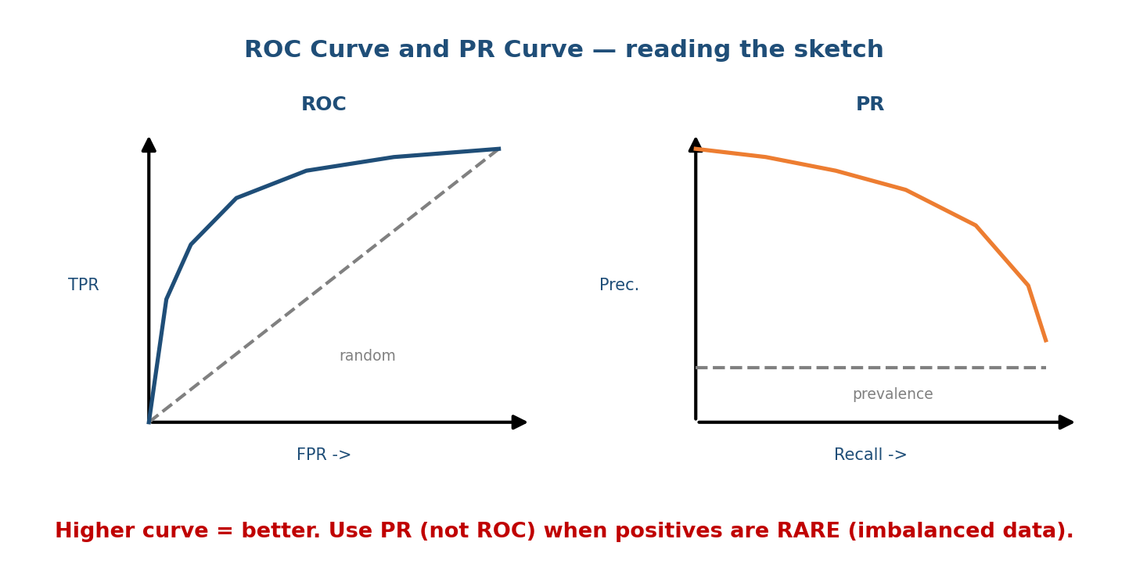
Left: ROC curve plots TPR against FPR; the diagonal is a random model, higher-left is better. Right: PR curve plots precision against recall; the dashed line is class prevalence.
- ROC curve: True Positive Rate (recall) vs False Positive Rate $(FP/(FP+TN))$. ROC-AUC = area under it = the probability that a random positive is scored higher than a random negative. 0.5 = random, 1.0 = perfect.
- PR curve: Precision vs Recall. PR-AUC (a.k.a. average precision) summarises it.
Key senior point: on imbalanced data (rare positives — fraud, disease, click), use PR-AUC, not ROC-AUC. ROC-AUC can look flatteringly high because the huge number of true negatives keeps FPR tiny, hiding a terrible precision. PR-AUC’s baseline is the positive prevalence, so it exposes the problem.

7.3 Precision vs Recall — Which Error Hurts More?

The trade-off
Precision and recall pull against each other. Lower the threshold (flag more things) → recall goes up, precision goes down. Raise it (flag fewer, only the sure ones) → precision up, recall down. There is no free lunch; you pick the operating point that matches the cost of each error type.
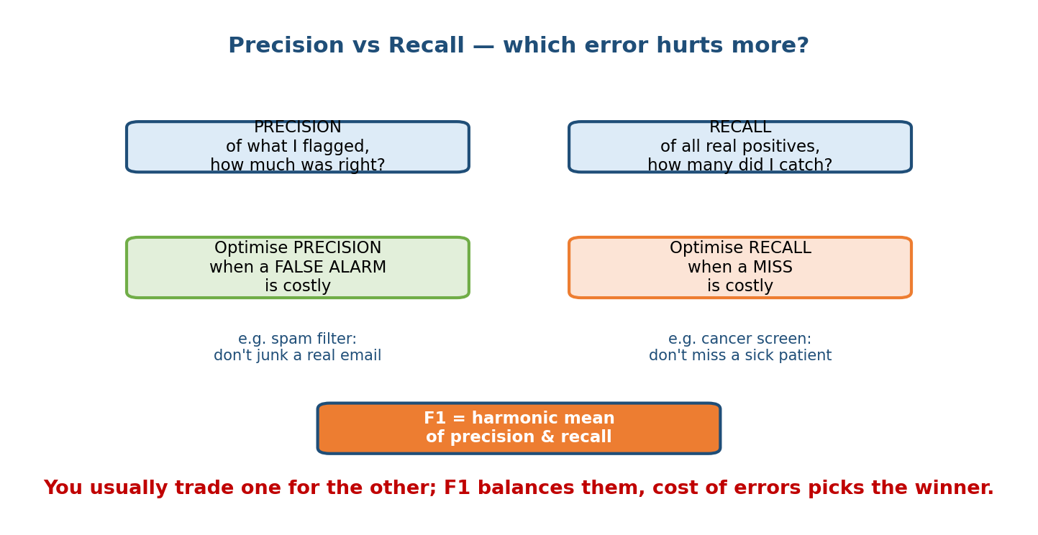
Precision matters when a false alarm is costly (spam filter); recall matters when a miss is costly (cancer screening); F1 balances the two.

First-principles rule
- Optimise precision when a false positive is expensive: junking a real email, blocking a legitimate transaction, a false fraud accusation.
- Optimise recall when a false negative is expensive: missing a cancer, a security threat, a critical safety fault. You would rather have a few false alarms than miss the real thing.
- Use F1 (or Fβ, which weights recall β times as much as precision) when you need a single balanced number.
Interview line: “Before I pick a metric I need to know the cost of a false positive vs a false negative — that decides precision vs recall.” Saying this is a clear senior signal (ties back to Module 1’s cost-of-being-wrong 2×2).

7.4 Regression Metrics

Motivation
When the target is a number (price, ETA, demand) instead of a class, “correct” no longer makes sense — every prediction has an error (residual) $e_{i}=y_{i}−{\hat{y}}_{i}$. Regression metrics are different ways to summarise the size of those residuals.
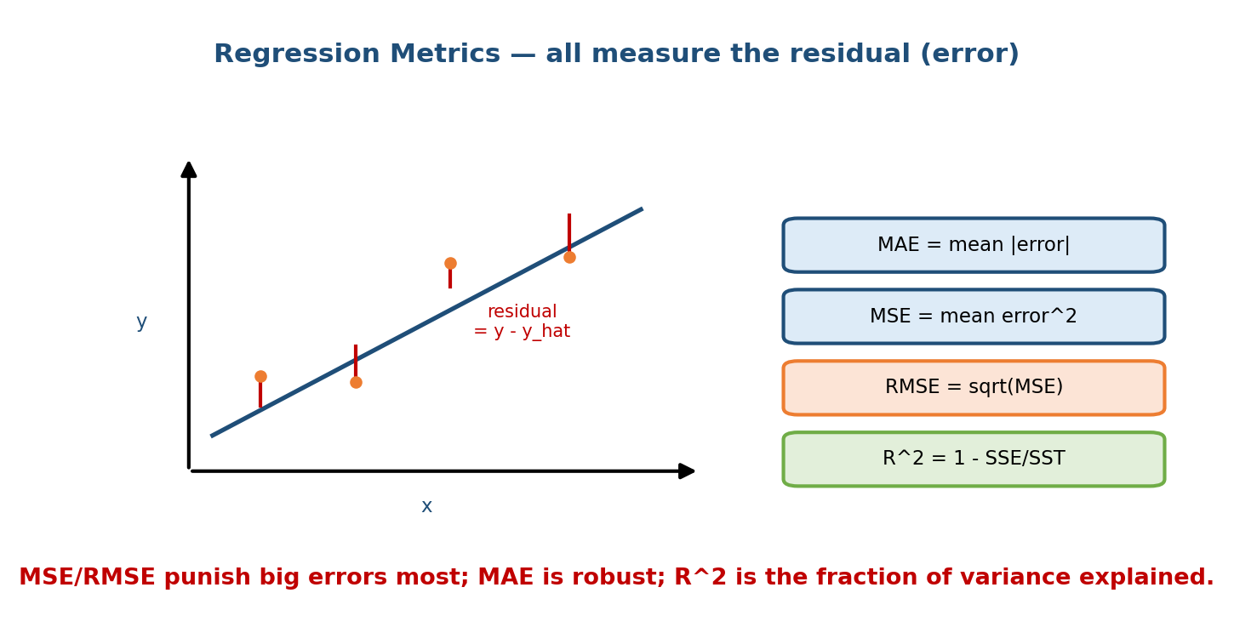
A fitted line through scattered points; the red sticks are residuals (y minus prediction). MAE averages their size, MSE/RMSE square them, R-squared is the fraction of variance explained.

The formulas
$$\text{MAE}=\frac{1}{N}∑|e_{i}| \text{MSE}=\frac{1}{N}∑e_{i}^{2} \text{RMSE}=\sqrt{\text{MSE}}$$
$$\text{MAPE}=\frac{100\%}{N}∑\left|\frac{e_{i}}{y_{i}}\right| R^{2}=1−\frac{∑e_{i}^{2}}{∑(y_{i}−\overset{‾}{y})^{2}}=1−\frac{SSE}{SST}$$
- MAE — mean absolute error. Same units as the target, easy to explain, robust to outliers (each error counts linearly).
- MSE / RMSE — square the errors, so big errors are punished much more. RMSE is in the target’s units (interpretable); MSE is the thing you usually minimise mathematically.
- MAPE — percentage error, unit-free, good for comparing across scales — but explodes when $y_{i}≈0$ and is asymmetric. Use with care.
- R² — fraction of the target’s variance the model explains. 1 = perfect, 0 = no better than predicting the mean, negative = worse than the mean.

Worked example
Actuals $y=[3,5,2,8]$, predictions $\hat{y}=[2.5,5,4,7]$, so errors $e=[0.5,0,−2,1]$.
- MAE $=(0.5+0+2+1)/4=3.5/4=0.875$
- MSE $=(0.25+0+4+1)/4=5.25/4=1.3125$
- RMSE $=\sqrt{1.3125}=1.146$
- MAPE $=1/4(0.167+0+1.0+0.125)=0.323=32.3\%$
- $R^{2}$: $\overset{‾}{y}=4.5$, $SST=({1.5}^{2}+{0.5}^{2}+{2.5}^{2}+{3.5}^{2})=21$, $SSE=5.25$, so $R^{2}=1−5.25/21=0.75$.
RMSE (1.15) > MAE (0.875): the gap is the fingerprint of the one big error (−2). When RMSE ≫ MAE, you have outliers.

7.5 Ranking & Recommender Metrics

Motivation
Search and recommender systems do not output one label — they output an ordered list. Getting the right items near the top matters far more than getting them anywhere in the list. So we need rank-aware metrics that reward putting good items high.

The metric family (with @K = “look only at the top K”)
- Precision@K = (relevant items in top K) / K. “How clean is my top K?”
- Recall@K = (relevant items in top K) / (all relevant items).
- Hit Rate@K = 1 if at least one relevant item is in the top K, else 0 (averaged over users). “Did we get anything useful up top?”
- MRR (Mean Reciprocal Rank) = average of $1/(\text{rank of first relevant item})$. Great when there is essentially one right answer (e.g. “I’m feeling lucky”, QA).
- MAP (Mean Average Precision) = mean over queries of Average Precision = average of Precision@k taken at each rank where a relevant item appears.
- NDCG (Normalised Discounted Cumulative Gain) = the gold standard, because it supports graded relevance (not just yes/no) and discounts lower ranks.

NDCG — the worked example interviewers love
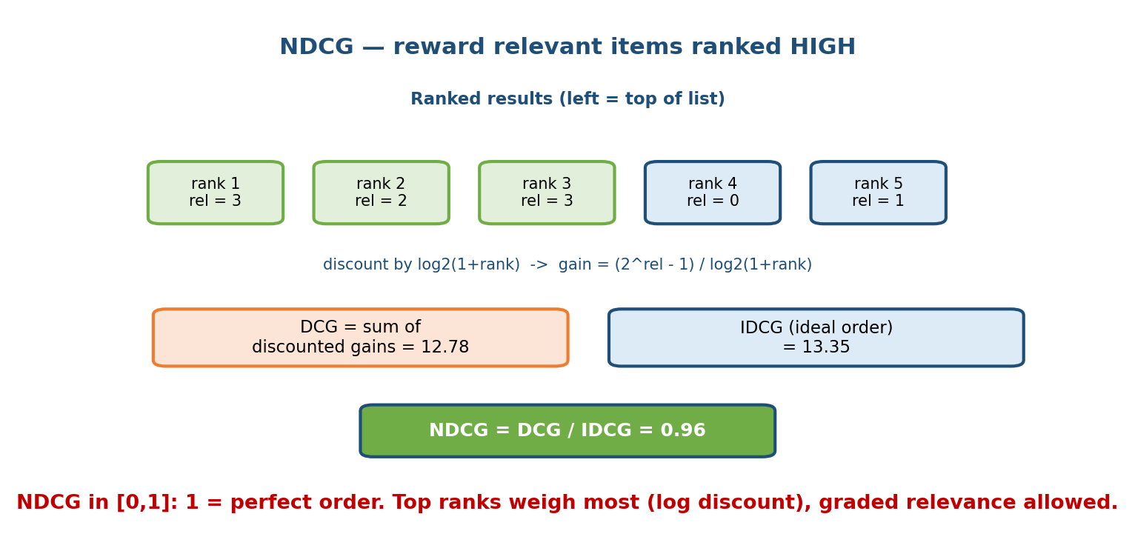
Five ranked results with graded relevance; each gain is discounted by log2(1+rank); DCG divided by the ideal ordering IDCG gives NDCG in 0 to 1.
Suppose the top 5 results have graded relevances (0–3): rank1=3, rank2=2, rank3=3, rank4=0, rank5=1. Use the standard gain $g_{i}=(2^{rel_{i}}−1)/\log_{2}(1+i)$:
$$DCG=\underset{7.00}{\underset{⏟}{7/{\log_{2}2}}}+\underset{1.89}{\underset{⏟}{3/{\log_{2}3}}}+\underset{3.50}{\underset{⏟}{7/{\log_{2}4}}}+\underset{0}{\underset{⏟}{0/{\log_{2}5}}}+\underset{0.39}{\underset{⏟}{1/{\log_{2}6}}}=12.78$$
The ideal order sorts relevances descending $[3,3,2,1,0]$:
$$IDCG=7.00+4.42+1.50+0.43+0=13.35 ⇒ NDCG=\frac{12.78}{13.35}=0.96$$
For the same ranking, the binary metrics (treat rel > 0 as relevant; 4 relevant items total): Precision@3 $=3/3=1.0$, Recall@3 $=3/4=0.75$, MRR $=1/1=1.0$, Average Precision $=(1+1+1+0.8)/4=0.95$, Hit Rate@3 $=1$.
Why NDCG wins: it is the only one here that (a) uses graded relevance and (b) cares how high each good item sits. That is exactly what a search ranker optimises.

7.6 NLP / LLM Metrics
Text output has no single “correct” string, so we compare against references or score fluency.
- Exact Match (EM) — 1 if the output string equals the reference exactly (after normalisation). Used for short factual answers (QA). Brutal but clear.
- BLEU (translation/generation) — precision of overlapping n-grams between output and reference(s), with a brevity penalty so you can’t cheat by being too short. Higher = closer to the reference wording.
- ROUGE (summarisation) — recall of overlapping n-grams / longest common subsequence (ROUGE-N, ROUGE-L). “How much of the reference did I cover?”
- Perplexity — for language models, $exp(\text{average log-loss per token})$. It measures how “surprised” the model is by real text; lower is better. It is an intrinsic metric (no references needed) but does not directly measure usefulness.
- LLM-as-judge — use a strong LLM to score or compare outputs against a rubric (helpfulness, correctness, harmlessness) or to pick the better of two (pairwise). Scales far cheaper than human raters, but beware biases (length bias, position bias, self-preference); calibrate against human labels.
Trade-off: BLEU/ROUGE are cheap and reproducible but reward surface word overlap, not meaning — a perfect paraphrase can score low. Human eval and LLM-as-judge capture quality better but cost more and are harder to reproduce.

7.7 Computer-Vision Metrics
- IoU (Intersection over Union) — for detection/segmentation, the overlap between predicted and true regions: $\text{IoU}=\frac{\text{area of overlap}}{\text{area of union}}$. A prediction usually counts as correct if IoU ≥ 0.5.
- mAP (mean Average Precision) — the standard object-detection score: compute Average Precision (area under the precision–recall curve) at one or more IoU thresholds, then average over classes (and, in COCO, over IoU thresholds 0.5–0.95). It rewards both finding objects (recall) and not hallucinating them (precision).

7.8 Calibration — Being Right About How Right You Are

Motivation
Two models can have the same accuracy yet very different probability quality. If your model says “0.7” for a batch of cases, do 70% of them actually turn out positive? If yes, it is calibrated; if not, the numbers are misleading — dangerous when a downstream decision (loan pricing, medical triage, expected-value bidding) multiplies by the probability.
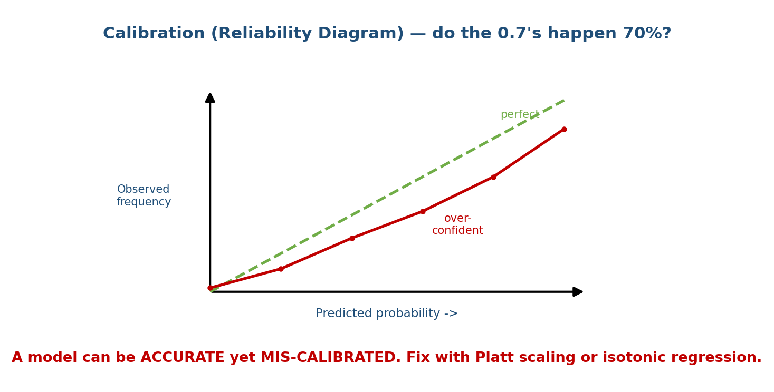
A reliability diagram: predicted probability on the x-axis, observed frequency on the y-axis; the green diagonal is perfect calibration, the red curve sags below it, showing an over-confident model.

Reliability diagram (how to read it)
Bucket predictions (e.g. all cases predicted 0.6–0.7), then plot mean predicted probability (x) vs actual fraction positive (y). Perfect calibration lies on the diagonal. A curve below the diagonal = over-confident (says 0.8 but only 0.6 happen); above = under-confident. The Expected Calibration Error (ECE) is the average gap across buckets.

Fixes (post-hoc, on a validation set)
- Platt scaling — fit a small logistic regression $σ(a⋅s+b)$ that maps the raw score $s$ to a calibrated probability. Simple, parametric, assumes a sigmoid shape; great with little data.
- Isotonic regression — fit a non-parametric, monotonic step function. More flexible (any monotonic shape) but needs more data and can overfit.
First-principles takeaway: accuracy asks “is the label right?”; calibration asks “is the probability right?” Modern deep nets are often accurate but over-confident — always check calibration when the probability feeds a decision.

7.9 Splits, Cross-Validation, and Data Leakage

The basic split
Divide data into train (fit the model), validation (tune hy-parameters / choose the threshold), and test (a one-time honest estimate you never tune on). If you tune on the test set, it stops being honest and you fool yourself.

Cross-validation
With little data, a single split is noisy. k-fold cross-validation splits the data into k parts, trains on k−1 and validates on the held-out part, rotating k times, and averages. This uses all data for both roles and gives a variance estimate — but it assumes rows are exchangeable (i.i.d.), which breaks for time series.

Temporal splits — the production-correct way
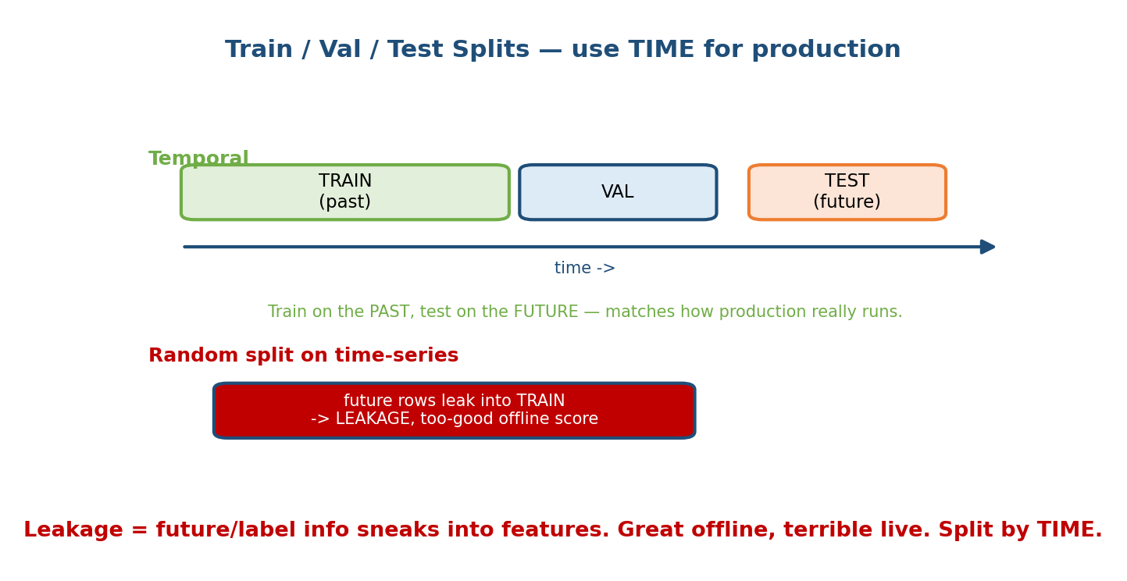
Temporal split: train on the past, validate, then test on the future along a time axis. A random split on time-series data lets future rows leak into training, giving a falsely high offline score.
In production you always predict the future from the past. So your test must imitate that: train on older data, test on newer data. A random shuffle lets tomorrow’s rows sit in the training set, which is leakage — the model peeks at the future, scores brilliantly offline, and collapses live.

Data leakage — the silent killer
Leakage = information that would not be available at prediction time sneaks into the features (or the split). Classic examples:
- A feature computed using the label (e.g. “total refunds” when predicting fraud, if refunds happen after the fraud is known).
- Random-splitting time-series so future leaks into train.
- Normalising/imputing using statistics computed over the whole dataset (including test) before splitting.
- Duplicate rows appearing in both train and test.
Symptom: offline metrics are suspiciously high but online performance is poor. (Cross-links to Module 1’s training-serving skew and the offline–online gap.)

7.10 Online Evaluation — Proving It on Real Users

Why offline is not enough
Offline metrics are computed on past logged data, which was collected under the old model. A new model changes what users see, which changes their behaviour — something no static dataset can capture. The only honest test is to run it live.

A/B testing
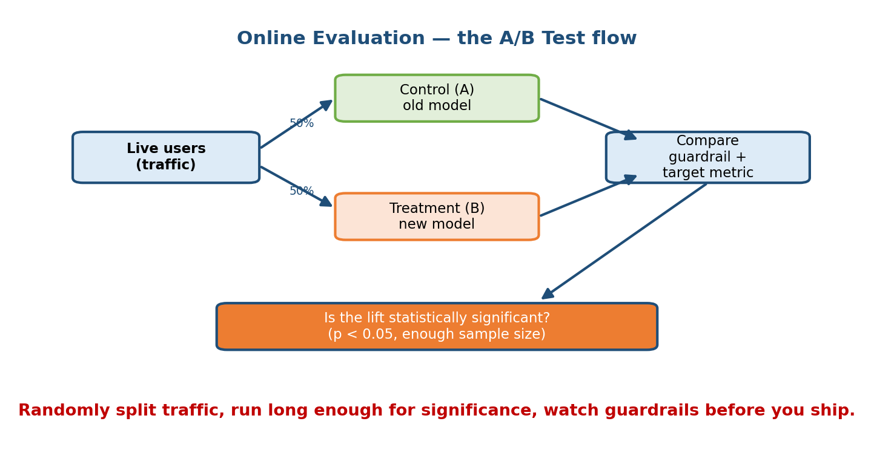
A/B test flow: split live traffic 50/50 into control (old model) and treatment (new model), compare guardrail and target metrics, then check whether the lift is statistically significant.
Randomly assign users to control (A, current system) and treatment (B, new system), keep everything else equal, run for a set period, and compare the target metric (e.g. conversion). Randomisation is what lets you claim causation, not just correlation.

Statistical significance (don’t ship noise)
Any two groups differ a little by luck. A hypothesis test asks: if the two systems were truly identical, how likely is a difference this big? That probability is the p-value; by convention $p<0.05$ is “statistically significant.” You must decide the sample size in advance — a bigger effect needs fewer users, a smaller effect needs many more. Key pitfalls:
- Peeking / early stopping — checking daily and stopping the moment $p<0.05$ massively inflates false positives. Fix the horizon (or use sequential tests).
- Multiple comparisons — test 20 metrics and one will look “significant” by chance; correct for it.

Effects that fool A/B tests
- Novelty effect — users click a new feature just because it is new; the lift fades. Run long enough to see steady state.
- Network effects — one user’s treatment leaks to control users (social feeds, marketplaces, ride pricing), breaking independence. Use cluster/geo randomisation.
- Guardrail metrics — metrics you must not harm even while chasing the target (latency, crash rate, revenue, complaints). A treatment that lifts clicks but doubles latency should not ship. Always watch guardrails.

Cheaper / smarter online methods
- Interleaving — for ranking, blend results from A and B into one list per user and see which system’s items get clicked. Far more sensitive than A/B, so it needs less traffic — but only compares rankers.
- Multi-armed bandits — instead of a fixed 50/50 split, shift traffic toward the winning arm as evidence accumulates. This reduces the cost of showing the worse variant (“regret”) — good for many short-lived options (headlines, creatives), less so when you need a clean, static causal read.

7.11 The Offline–Online Gap (and How to Bridge It)

The core problem
Your offline metric improves, you celebrate, you launch — and the business metric does not move (or drops). This offline–online gap is one of the most cited ML system-design topics.
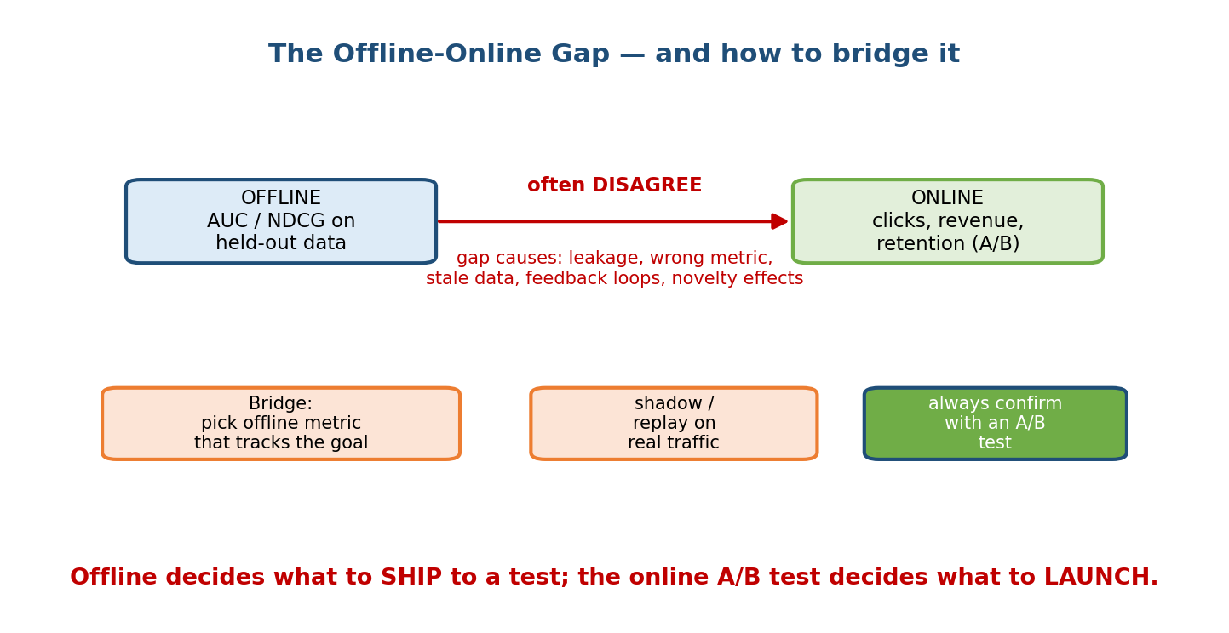
Offline metrics like AUC and NDCG often disagree with online metrics like clicks and revenue; bridge the gap by choosing an offline metric that tracks the goal, replaying on real traffic, and always confirming with an A/B test.

Why the gap exists
- Wrong proxy: the offline metric (e.g. AUC) doesn’t track the business goal (e.g. revenue).
- Leakage / stale data: offline scores are inflated (7.9).
- Feedback loops: logged data reflects the old model’s choices, not user intent (Module 1).
- Novelty / position effects the offline set can’t see.

How to bridge it
- Pick an offline metric that correlates with the online goal — validate the correlation historically before trusting it.
- Replay / shadow the new model on real recent traffic to catch skew and engineering bugs before exposing users.
- Always confirm with an A/B test. Offline decides what to ship into the test; online decides what to launch. Never let an offline win alone justify a launch.

Module 7 — Interview Mapping (what companies probe)
Company | How Module 7 shows up | Junior answer | Staff answer
Google / Meta | “What metric would you optimise for search / feed?” | “Accuracy” | Chooses NDCG/CTR, names guardrails, plans an A/B test
Amazon | Cost of false positive vs negative (Dive Deep) | Reports accuracy | Ties precision/recall to customer & dollar cost
Stripe / Uber | Fraud/ETA on imbalanced data | Uses ROC-AUC | Uses PR-AUC + recall at fixed precision, watches calibration
OpenAI / Anthropic | How to evaluate an LLM | “BLEU” | Mixes EM/ROUGE + human & LLM-as-judge, flags judge bias
Netflix / Spotify | Offline metric moved, online didn’t | Confused | Explains the offline–online gap and how to bridge it
The most common trap question: “Your model is 99% accurate — ship it?” The right move is to ask about class balance and the cost of each error, then propose precision/recall/PR-AUC instead of accuracy.

Module 7 — Exam Mapping (SEBI / RBI / GATE / ISRO)
- GATE CS / DA: very high value. Confusion-matrix arithmetic (precision/recall/F1), ROC-AUC intuition, MSE/RMSE/R², and bias–variance are frequently tested and are directly computable — practice the numeric drills.
- SEBI IT / RBI IT: definitional and formula-based questions on precision/recall/accuracy and overfitting/regularisation appear; expect a confusion-matrix computation. Online A/B design is interview-only.
- ISRO / DRDO: occasional formula recall for accuracy/precision/recall.
Flag: the metric formulas and confusion-matrix computations in 7.2–7.5 carry the highest exam value in this whole course. The A/B testing and offline–online material (7.10–7.11) is mostly interview value.

Module 7 — Common Mistakes & Misconceptions
- “High accuracy = good model.” Not on imbalanced data — a constant predictor can score 99%. Use precision/recall/PR-AUC. (7.1, 7.2.)
- “ROC-AUC is always the right classification metric.” For rare positives, PR-AUC is far more honest. (7.2.)
- “An accurate model has trustworthy probabilities.” No — accuracy ≠ calibration. Check a reliability diagram. (7.8.)
- “Just shuffle and split randomly.” For time-series that causes leakage; split by time. (7.9.)
- “The offline metric went up, so we’re done.” Confirm with an online A/B test; the two often disagree. (7.11.)
- “Stop the A/B test the moment p < 0.05.” Peeking inflates false positives; fix the sample size / horizon first. (7.10.)
- “F1 is the average of precision and recall.” It’s the harmonic mean, which is dominated by the smaller of the two. (7.2.)

Module 7 — MCQs (with answers & explanations)
Q1. A disease affects 1 in 1000 people. A model always predicts “healthy.” Its accuracy is: a) ~50% b) ~99.9% c) 0% d) undefined
Answer
b. 999/1000 are healthy, so always-“healthy” is 99.9% accurate yet useless — the classic imbalanced-data trap. Use recall/PR-AUC instead.
Q2. You must not miss a fraudulent transaction, even at the cost of some false alarms. You should optimise: a) precision b) recall c) specificity d) accuracy
Answer
b. A miss (false negative) is the expensive error, so maximise recall (catch as many real frauds as possible).
Q3. On a highly imbalanced dataset, which curve gives the more honest picture? a) ROC b) Precision–Recall c) calibration d) learning curve
Answer
b. PR-AUC’s baseline is the positive prevalence, so it exposes poor precision that ROC-AUC hides behind the huge count of true negatives.
Q4. For actuals $[3,5,2,8]$ and predictions $[2.5,5,4,7]$, the RMSE is: a) 0.875 b) 1.146 c) 1.3125 d) 0.75
Answer
b. MSE $=5.25/4=1.3125$; RMSE $=\sqrt{1.3125}=1.146$. (0.875 is the MAE, 0.75 is $R^{2}$.)
Q5. NDCG is preferred over Precision@K for ranking because it: a) is easier to compute b) uses graded relevance and discounts lower ranks c) needs no ground truth d) ignores position
Answer
b. NDCG rewards graded relevance and puts more weight on higher ranks via a log discount, then normalises by the ideal order.
Q6. A model is 90% accurate, but when it says “0.9” only 60% of those cases are positive. The problem is: a) high variance b) poor calibration c) data leakage d) low recall
Answer
b. The labels are often right but the probabilities are over-confident — a calibration problem. Fix with Platt scaling or isotonic regression.
Q7. You shuffle a year of daily sales randomly into train/test and get a great $R^{2}$, but the live model is poor. Most likely cause: a) underfitting b) temporal data leakage c) too few features d) high bias
Answer
b. Random shuffling let future rows leak into training. Split by time (train on past, test on future).
Q8. In an A/B test, checking results every hour and stopping as soon as $p<0.05$ leads to: a) faster valid results b) inflated false-positive rate c) higher recall d) no effect
Answer
b. Repeated peeking massively inflates the false-positive (Type I error) rate. Fix the sample size/horizon in advance or use sequential-testing methods.

Module 7 — Design Exercises (easy → hard)
- Easy. Given a confusion matrix (TP=40, FP=10, FN=20, TN=930), compute accuracy, precision, recall, and F1. Say which error type dominates.
- Easy. For a rare-event fraud model, state which single curve you’d report and why (PR vs ROC).
- Medium. You are ranking search results with graded relevance. Compute NDCG@5 for the order [rel = 2, 3, 1, 0, 2] and state the ideal ordering.
- Medium. A credit model is 88% accurate but badly over-confident. Describe how you’d diagnose (reliability diagram, ECE) and fix (Platt vs isotonic) it, and why calibration matters for loan pricing.
- Hard. Design the full evaluation plan for a video recommender: pick offline metrics, a temporal split to avoid leakage, guardrail metrics, and an A/B test with a sample-size and significance plan. Explain the offline–online gap you expect and how you’ll bridge it.
- Hard. Your marketplace A/B test shows a clear treatment lift, but you suspect network effects (sellers shared across arms). Redesign the experiment (cluster/geo randomisation) and justify it.

Module 7 — Concept Review (one page)
- Confusion matrix (TP/FP/FN/TN) is the source of accuracy, precision, recall, F1. Accuracy lies on imbalanced data.
- Precision = clean flags (false-alarm cost); Recall = catch everything (miss cost); F1 = harmonic balance. Cost of errors picks which.
- ROC-AUC vs PR-AUC: use PR when positives are rare. Log-loss grades probabilities.
- Regression: MAE (robust), MSE/RMSE (punish big errors, same units), MAPE (percent, breaks near 0), R² (variance explained).
- Ranking: Precision@K, Recall@K, MRR (first hit), MAP, and NDCG (graded + discounted, the gold standard). Hit Rate = got anything up top.
- NLP/LLM: EM, BLEU (precision of n-grams), ROUGE (recall), perplexity (lower = better), LLM-as-judge (cheap but biased). CV: IoU, mAP.
- Calibration: accuracy ≠ correct probabilities; read reliability diagram; fix with Platt / isotonic.
- Splits: train/val/test, k-fold, but temporal split for production; leakage = future/label info sneaks in → great offline, terrible live.
- Online: A/B test with randomisation, pre-set sample size, p < 0.05, watch guardrails; beware novelty & network effects; interleaving & bandits are cheaper. Offline decides what to test; online decides what to launch.

Module 7 — Flash Cards (Q → A)
- Precision vs recall in one line? → Precision = of what I flagged how much was right; recall = of all real positives how many I caught.
- F1 is the ___ mean? → Harmonic mean of precision and recall.
- When PR-AUC over ROC-AUC? → When positives are rare (imbalanced data).
- RMSE vs MAE? → RMSE squares errors so it punishes big ones and flags outliers; MAE is robust.
- What does R² = 0 mean? → No better than predicting the mean.
- Why NDCG over Precision@K? → Graded relevance + log discount for lower ranks.
- Accurate but wrong probabilities = ? → Mis-calibration; fix with Platt / isotonic.
- Why temporal split? → Production predicts the future from the past; random split leaks the future (leakage).
- What is a guardrail metric? → A metric you must not harm (latency, revenue) while chasing the target.
- Offline vs online decision rule? → Offline picks what to A/B test; online A/B picks what to launch.

Module 7 — Pattern Recognition (how to spot it in an interview)
- Hear “the model is 99% accurate” → ask about class balance and cost of errors; propose precision/recall/PR-AUC.
- Hear “we must not miss any” → recall; “we must not false-alarm” → precision.
- Hear “rare event / fraud / disease” → PR-AUC, recall at fixed precision, check calibration.
- Hear “predict next month / future” → temporal split, watch for leakage.
- Hear “the probability feeds a decision (pricing/bidding)” → talk calibration.
- Hear “offline improved but the metric didn’t move” → offline–online gap, confirm with an A/B test.
- Hear “how do you know it actually helped users” → A/B test, significance, sample size, guardrails.

Module 7 — Revision Notes / Mini Cheat Sheet
CONFUSION MATRIX -> everything
Accuracy=(TP+TN)/all Precision=TP/(TP+FP) Recall=TP/(TP+FN)
F1 = 2PR/(P+R) (harmonic) Log-loss = grade the PROBABILITY
ROC-AUC (balanced) | PR-AUC (RARE positives) <- pick PR when imbalanced
PRECISION when FALSE ALARM costs ; RECALL when a MISS costs
REGRESSION: MAE (robust) | MSE/RMSE (punish big, same units) | MAPE (% , dies near 0)
R^2 = 1 - SSE/SST (1 perfect, 0 = mean, <0 worse)
RANKING: P@K , R@K , HitRate , MRR (first hit) , MAP , NDCG=DCG/IDCG (graded+discount)
NLP/LLM: EM | BLEU (n-gram precision) | ROUGE (recall) | perplexity(low=good) | LLM-judge
CV: IoU (overlap/union) | mAP (AP over classes & IoU)
CALIBRATION: accuracy != right probability ; reliability diagram + ECE ;
fix = Platt (logistic) or Isotonic (monotonic steps)
SPLITS: train / val / test(once) ; k-fold ; **TEMPORAL** for production
LEAKAGE: future/label info in features -> great offline, terrible live
ONLINE: A/B (randomise, fix sample size, p<0.05, GUARDRAILS)
traps: peeking, novelty, network effects ; interleaving & bandits = cheaper
BRIDGE OFFLINE->ONLINE: correlated offline metric -> shadow/replay -> A/B test
Offline decides what to TEST ; Online decides what to LAUNCH

Next module: Module 8 — Model Serving & Deployment. Now that you can prove a model is good, we put it into production behind an API: batch vs online serving, latency/throughput budgets, model compression (quantization, distillation), shadow deployments, canaries, and rollbacks — the systems layer that carries your well-evaluated model to real users.

