Module 12 — Recommendation Systems
  - ML System Design Mastery: FAANG / AI-Engineer / Staff-Level — In-Depth Notes (with visuals)
Prepared for nidhi.sharma@forensiccybertech.com
2026
Table of Contents

Module 12 — Recommendation Systems
Why this module matters so much. If ML system design interviews had a “most-asked” list, recommendation would sit at the very top. Every large consumer company — YouTube, Netflix, TikTok, Instagram, Amazon, Spotify — is, at its core, a giant recommender. The question “design the YouTube homepage / TikTok For-You feed / Amazon ‘customers also bought’” is a rite of passage. It is beloved by interviewers because it touches everything in this course at once: framing a fuzzy business goal, picking a metric, building features, choosing a model, and — above all — designing a serving architecture that works at the scale of billions of items and requests. This module builds the whole thing from first principles, in plain English, so you can walk into that interview and drive the conversation instead of being dragged through it.
Importance ratings (out of 5):
Exam / Use | SEBI IT | RBI IT | GATE CS/DA | Interview | AI/MLE role
This module | ★ | ★ | ★★ | ★★★★★ | ★★★★★
What you must be able to do after this module: state the recsys problem and the business metric it serves; explain collaborative filtering (user-user and item-item) and why item-item scales better; derive matrix factorization with its objective and know ALS vs SGD; contrast content-based, collaborative, and hybrid approaches; draw and defend the two-stage candidate-generation → ranking architecture (the single most important picture in the module); explain two-tower retrieval with ANN lookup; name what Wide & Deep, DeepFM, DLRM, DCN each add; describe sequential models (GRU4Rec, SASRec); handle cold start for users and items; reason about exploration vs exploitation (bandits); and run a full 7-step design of “recommend videos” end to end.
How to read this module. As always: problem → simplest attempt → why it breaks → the fix. Recommendation is the perfect subject for this because each classic idea (CF → matrix factorization → two-tower → two-stage) is literally the fix for the previous one’s scaling wall.

12.1 The Recommendation Problem & Business Framing

Motivation (the problem that exists)
A user opens an app. There are millions of things they could be shown — videos, products, songs, posts. The screen fits maybe ten. Which ten? Showing the wrong ten wastes the single most valuable thing the company has: the user’s attention. Showing the right ten keeps them watching, buying, and coming back. That is the recommendation problem: given one user and a huge catalog, produce a short, ordered list the user is most likely to engage with.
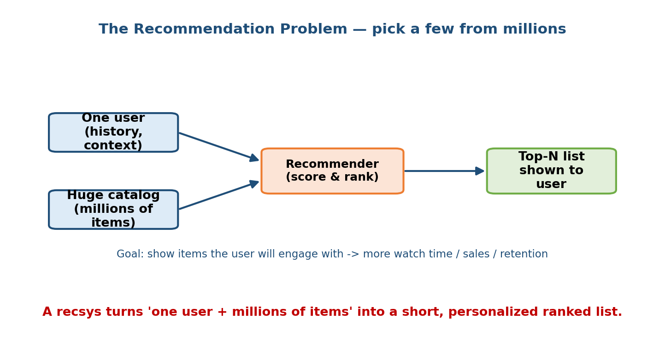
A recommender turns one user plus millions of items into a short personalized ranked list, with the goal of increasing engagement.
As the figure above shows, the recommender sits between two very lopsided inputs — a single user’s history and context on one side, a catalog of millions of items on the other — and squeezes them into a top-N list. Everything hard about recsys comes from that asymmetry of scale.

Definition
- A recommendation system predicts, for a given user and context, how much the user will like (click, watch, buy, save) each candidate item, and returns the highest-scoring items as a ranked list.
- The feedback we learn from is usually implicit (clicks, watch time, purchases) rather than explicit (1–5 star ratings). Implicit feedback is abundant but noisy — a click is not the same as “liked it”.

Business framing (why it is worth billions)
Recsys is never optimised for its own sake; it exists to move a business metric:
Company | The list they recommend | The business metric it drives
YouTube | Home feed, “Up next” | Watch time / sessions
Netflix | Rows of titles | Retention (fewer cancellations)
Amazon | “Customers also bought” | Revenue per visit
TikTok | For-You feed | Time spent, session length
Spotify | Discover Weekly | Engagement, subscription retention
Senior signal: open a recsys interview by naming the business objective and the proxy you will actually optimise (e.g. “long-term retention, proxied by expected watch time per session”). Juniors jump straight to “matrix factorization”; seniors first pin down what good means.

First-principles: why not just show the most popular items?
The simplest baseline is “show everyone the globally most popular items.” It is not personalised at all, but it is a real, strong baseline you should always mention. It breaks because tastes differ wildly, popular-only creates a rich-get- richer feedback loop (Module 1), and it ignores the long tail where most of the catalog’s value hides. Personalisation is the fix — and the rest of this module is how to personalise at scale.

12.2 Collaborative Filtering (User-User & Item-Item)

Motivation
How do you personalise without knowing anything about what the items actually are? The insight of collaborative filtering (CF) is beautiful: you do not need to understand the items or the users — you only need the matrix of who interacted with what. “People who behaved like you, liked this” is enough.
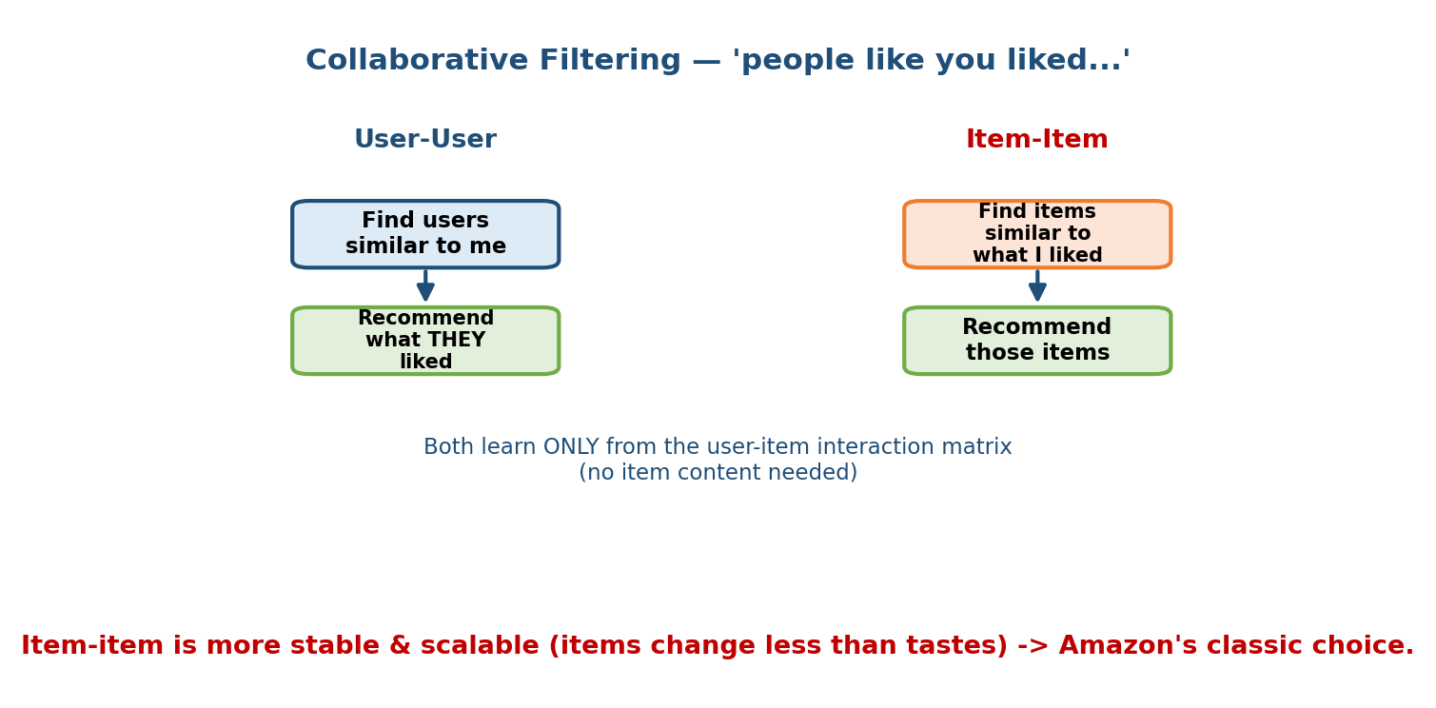
Collaborative filtering has two flavours: user-user finds similar users and recommends what they liked; item-item finds items similar to ones you liked. Both use only the interaction matrix.

The two flavours (see the figure above)
- User-user CF. Find users whose past behaviour is similar to mine (e.g. by cosine similarity of their rating rows), then recommend items they liked that I have not seen. Intuitive, but users are many and their tastes shift fast, so similarities must be recomputed constantly.
- Item-item CF. Find items that tend to be liked by the same people as the items I already liked, and recommend those. Amazon’s famous “customers who bought X also bought Y” is item-item CF.

First-principles: why item-item usually wins at scale
Item-item CF is the workhorse of classic recsys for two reasons the figure hints at:
- Stability. Item-item similarities change slowly (the relationship between two movies is stable), while a user’s taste vector shifts daily. So you can precompute an item-item similarity table offline and reuse it.
- Scale. There are usually far fewer distinct behaviours per item to compare than users, and the item catalog is more stable, making the neighbourhood computation cheaper and cacheable.

How similarity is computed
Represent each item as its column in the user-item matrix (who interacted with it). Similarity between items $i$ and $j$ is typically cosine similarity:
$$\text{sim}(i,j)=\frac{r_{i}⋅r_{j}}{\left\|r_{i}\right\| \left\|r_{j}\right\|}$$
To score item $j$ for user $u$, take a similarity-weighted sum of that user’s ratings on items similar to $j$.

Where plain CF breaks
- Sparsity. The matrix is >99% empty; most user-item pairs have no signal.
- Cold start. A brand-new user or item has no row/column at all (Section 12.9).
- No content. CF cannot use the fact that two movies share a director — it only sees co-interaction. The fix for sparsity and scale is matrix factorization, next.

12.3 Matrix Factorization (with the Math)

Motivation
Neighbourhood CF stores a giant, sparse similarity table and struggles with sparsity. Matrix factorization (MF) — made famous by the Netflix Prize — replaces that with something far more compact and powerful: it learns a small dense vector for every user and every item such that their dot product reconstructs the ratings. This is the birth of embeddings in recsys.
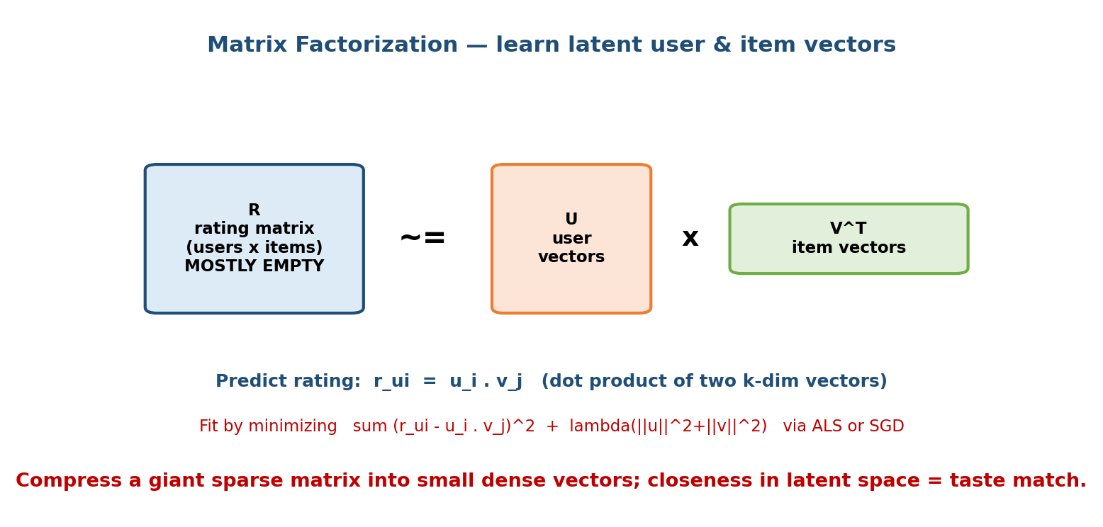
Matrix factorization approximates the sparse rating matrix R as the product of a small user-vector matrix U and item-vector matrix V-transpose; a predicted rating is the dot product of a user and item vector.

The setup (see the figure above)
We have a rating matrix $R$ of shape (users × items), mostly empty. We approximate it as a product of two thin matrices:
$$R≈UV^{⊤}$$
where $U$ has one latent vector $u_{i}∈R^{k}$ per user, and $V$ has one latent vector $v_{j}∈R^{k}$ per item. Here $k$ (the number of latent factors) is small, e.g. 32–256. The predicted rating is just a dot product:
$${\hat{r}}_{ui}=u_{i}⋅v_{j}=\sum_{f=1}^{k}{u_{if}} v_{jf}$$
Intuitively, each of the $k$ dimensions is a hidden “taste axis” (how much comedy, how much action…) learned automatically. If a user’s vector and an item’s vector point the same way, the dot product is large → strong recommendation.

The objective (what we minimise)
We fit the vectors so predictions match the observed ratings, plus an L2 regularisation term to prevent overfitting:
minU,V(u,i) ∈ observed​rui−ui⋅vj2 + λui2+vj2
Notice we sum only over observed entries — we do not try to fit the empty cells. In practice we also add bias terms (a global average, a per-user bias, a per-item bias) because some users rate high and some items are universally loved: ${\hat{r}}_{ui}=μ+b_{u}+b_{i}+u_{i}⋅v_{j}$.

How we optimise it: ALS vs SGD
Two standard algorithms fit these vectors:
- ALS (Alternating Least Squares). Fix all item vectors, and the objective becomes a plain least-squares problem in the user vectors that has a closed- form solution — solve for all users. Then fix the users and solve for the items. Alternate until convergence. ALS is easily parallelised (each user/item solves independently) and is the classic choice for implicit feedback at scale (Spark MLlib uses it).
- SGD (Stochastic Gradient Descent). Loop over observed ratings; for each, nudge $u_{i}$ and $v_{j}$ down the gradient of the squared error. Simpler, more flexible (easy to add biases, custom losses), and the default when the model is part of a larger deep network.

Implicit feedback twist
With clicks/watches (not star ratings) there are no explicit negatives — a non-click might mean “disliked” or “never saw it”. The standard fixes: treat interactions as confidence-weighted positives (implicit-ALS, Hu et al. 2008) or train with a ranking loss like BPR (Bayesian Personalized Ranking) that just says “observed items should rank above unobserved ones.”
Key takeaway. MF’s dot-product-of-embeddings idea is the seed of everything modern: the two-tower retrieval model (Section 12.6) is literally “matrix factorization where the vectors are produced by neural networks instead of looked up.”

12.4 Content-Based Filtering & Hybrid Systems

Motivation
CF and MF share a blind spot: they know nothing about the items themselves. A brand-new movie with zero views is invisible to them. Content-based filtering fixes this by recommending items whose features resemble those the user already liked.
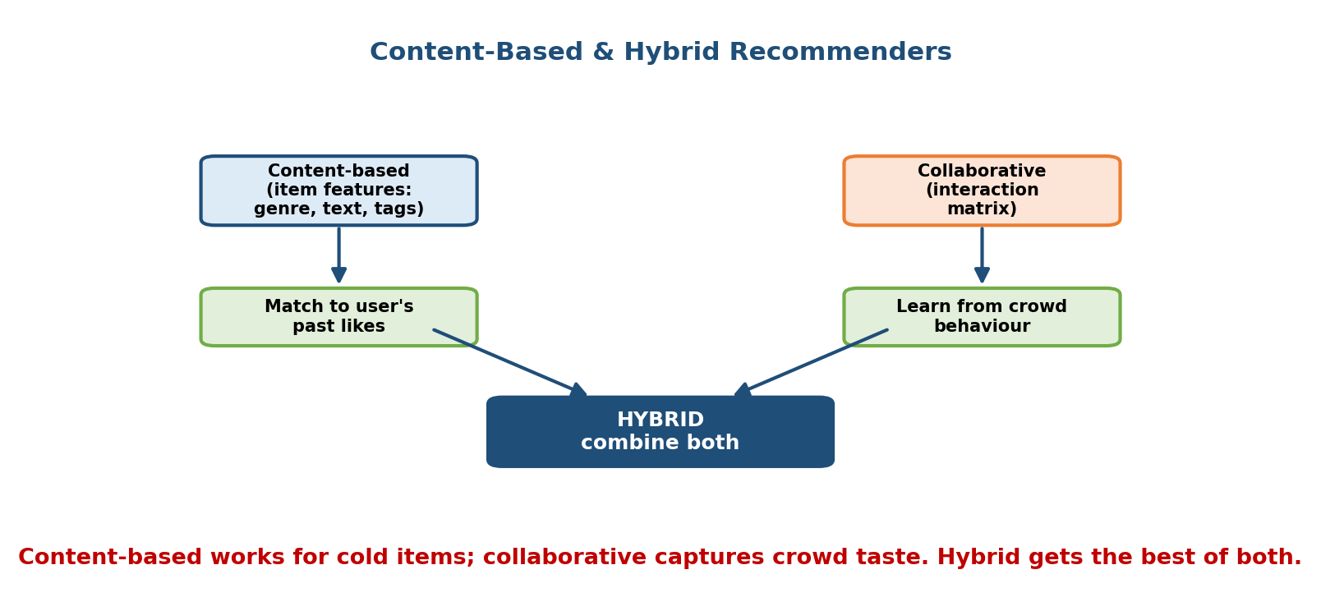
Content-based filtering uses item features and matches them to a user’s past likes; collaborative filtering uses the interaction matrix; a hybrid combines both.

Content-based filtering
Describe each item by features: genre, tags, text embeddings of the description, audio features (for music), the creator, etc. Build a user profile as an aggregate of the features of items they liked. Then recommend items whose feature vector is close to that profile. Because it depends only on item content, it works for brand-new items (no interactions needed) — this is its superpower.
Weaknesses: it stays inside the user’s existing bubble (over-specialisation, poor serendipity), and it needs good item features to work at all.

Hybrid systems (what real products actually use)
As the figure shows, the two families are complementary: content-based handles cold items and explainability; collaborative captures crowd wisdom and serendipity. Hybrids combine them. Common recipes:
- Weighted / switching: blend or choose between the two scores depending on how much interaction data exists (use content when cold, CF when warm).
- Feature fusion: feed both interaction embeddings and content features into one model — this is exactly what modern deep recommenders (Section 12.7) and two-tower models (Section 12.6) do. The towers take content features and learned ID embeddings.
Interview line: “Nearly every production recommender is a hybrid — the two- tower retrieval model already fuses content features with ID embeddings, which is why it degrades gracefully on cold items.”

12.5 The Two-Stage Architecture (the Centrepiece)

Motivation — the scaling wall
Here is the crux of real-world recsys. Suppose you have the world’s best ranking model — a deep network that, given a (user, item) pair, predicts engagement very accurately. The naive plan is: score every item for the user, sort, take the top ten. With a catalog of tens of millions of items and a latency budget of tens of milliseconds, this is completely impossible — you cannot run a heavy neural network millions of times per request. This wall is what forces the industry-standard design.
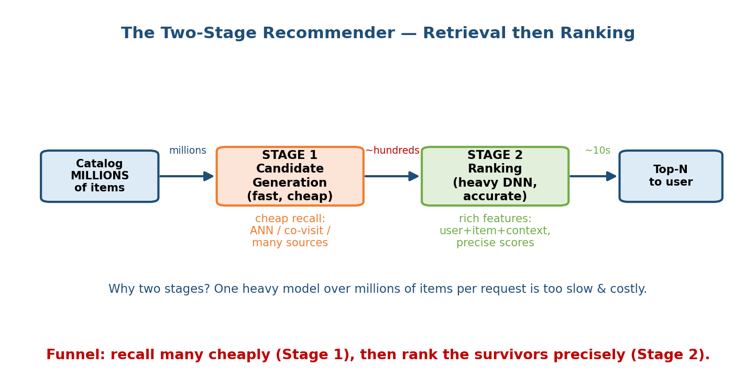
The two-stage recommender: a catalog of millions goes through Stage 1 candidate generation which is fast and cheap and returns hundreds, then Stage 2 ranking which is a heavy accurate DNN and returns tens, then the top-N goes to the user.

The fix: a funnel with two stages
As the centrepiece figure shows, we split the work into two stages with very different jobs:
- Stage 1 — Candidate Generation (Retrieval). Cheaply and quickly reduce millions → hundreds. Optimise for recall (don’t miss good items), not precision. Techniques: two-tower ANN lookup (Section 12.6), item-item co-visitation, popularity, freshly-uploaded, “from creators you follow”, etc. Often several candidate sources are unioned together. Each source is a cheap approximation; the ranker sorts out the details.
- Stage 2 — Ranking. Take those few hundred candidates and score each one precisely with a heavy model using rich features (full user history, item features, context, cross features). Optimise for precision at the top. Because it only runs on hundreds of items, we can afford a big DNN.
Some systems add a third re-ranking stage for business rules: diversity, freshness, fairness, “don’t show three videos from the same channel in a row”, and de-duplication.

First-principles: why the split works
The numbers on the arrows tell the story: millions → ~hundreds → ~tens.
- The expensive-per-item model (ranking) only ever sees hundreds of items, so its cost is bounded regardless of catalog size.
- The cheap-per-item step (retrieval) can scan the whole catalog because its per-item cost is tiny (a nearest-neighbour lookup, or a table read).
- The two stages optimise different metrics on purpose: retrieval maximises recall (cast a wide net); ranking maximises precision (put the best on top).
This is the single most important diagram to reproduce in an interview. When asked to “design YouTube recommendations,” draw the funnel first and label the item counts. It instantly signals you understand production recsys, not just textbook MF.

12.6 Two-Tower / Dual-Encoder Retrieval

Motivation
Stage-1 retrieval needs to find “items relevant to this user” among millions, in milliseconds. The two-tower model (also called dual-encoder) makes this a nearest-neighbour search in an embedding space — the modern, learned way to do candidate generation.
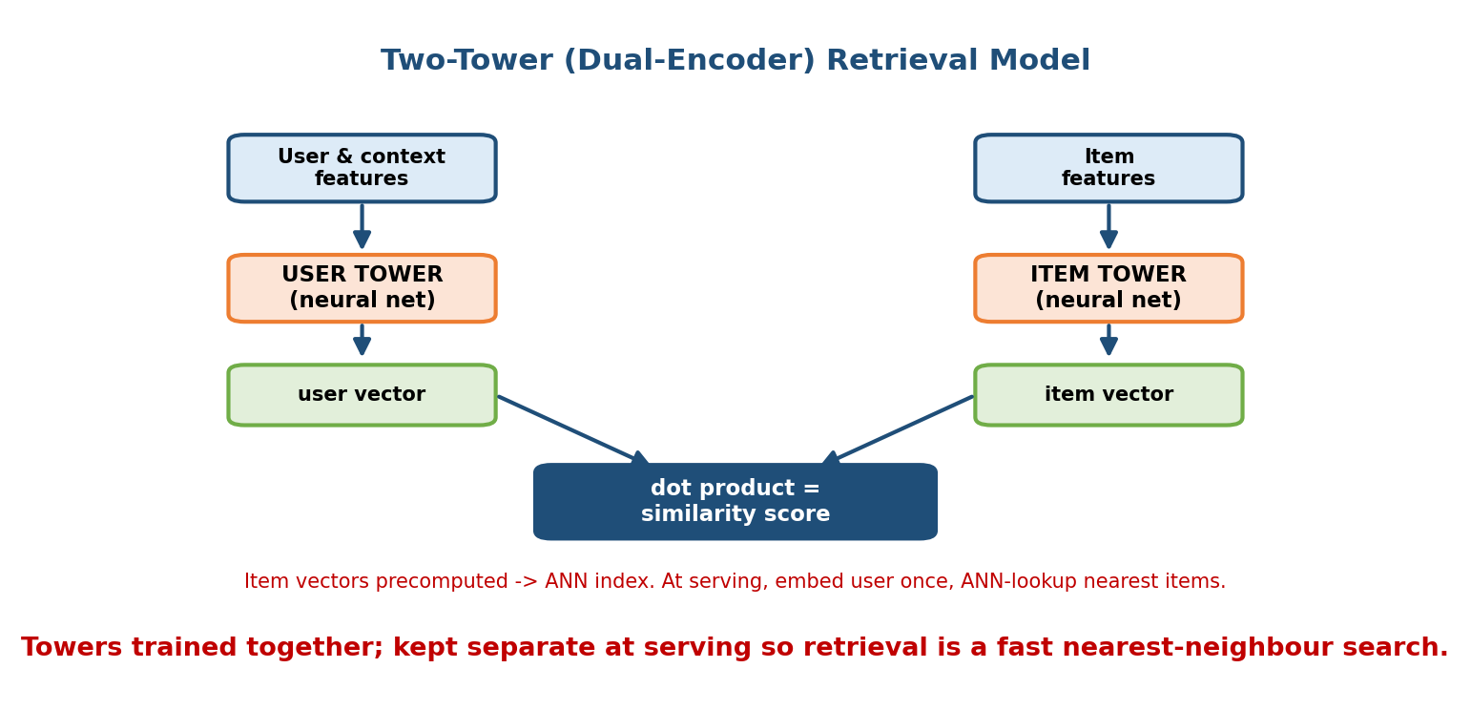
The two-tower model: a user tower encodes user and context features into a user vector, an item tower encodes item features into an item vector, and their dot product is the similarity score. Item vectors are precomputed into an ANN index.

The architecture (see the figure above)
There are two separate neural networks (“towers”):
- The user tower takes user + context features (history, location, time, device) and outputs a user embedding.
- The item tower takes item features (ID, category, content) and outputs an item embedding.
- The score is the dot product (or cosine) of the two embeddings — exactly like matrix factorization, but the vectors are computed by neural nets rather than looked up, so they generalise to new items and use rich features.
Training uses in-batch negatives: for a batch of positive (user, item) pairs, every other item in the batch serves as a negative, and a softmax/contrastive loss pushes each user close to its true item and away from the rest.

Why the towers are kept separate (the key trick)
Because the item embedding depends only on item features and the user embedding only on user features, we can:
- Precompute all item embeddings offline and load them into an ANN index (Approximate Nearest Neighbour — e.g. FAISS, ScaNN, HNSW).
- At request time, run the user tower once to get the user vector, then ask the ANN index for the k nearest item vectors in sub-millisecond time.
This is what makes retrieval over millions of items feasible. Contrast this with a model that mixes user and item features early (a “cross” model): it would have to be re-run for every candidate, which is fine for ranking (hundreds of items) but impossible for retrieval (millions). The separation is the whole point.
Interview tie-in: two-tower for retrieval + a cross-feature DNN for ranking is the canonical modern recsys stack. Say those two sentences and you have covered 80% of the architecture question.

12.7 Deep Recommenders: Wide & Deep, DeepFM, DLRM, DCN

Motivation
The ranking stage wants the most accurate possible score for a few hundred candidates, so it can be a big model. The central challenge is feature interactions: “this user + this time-of-day + this genre” together predict a click far better than any feature alone. The following families are all different answers to “how do we model feature interactions on top of embeddings?”
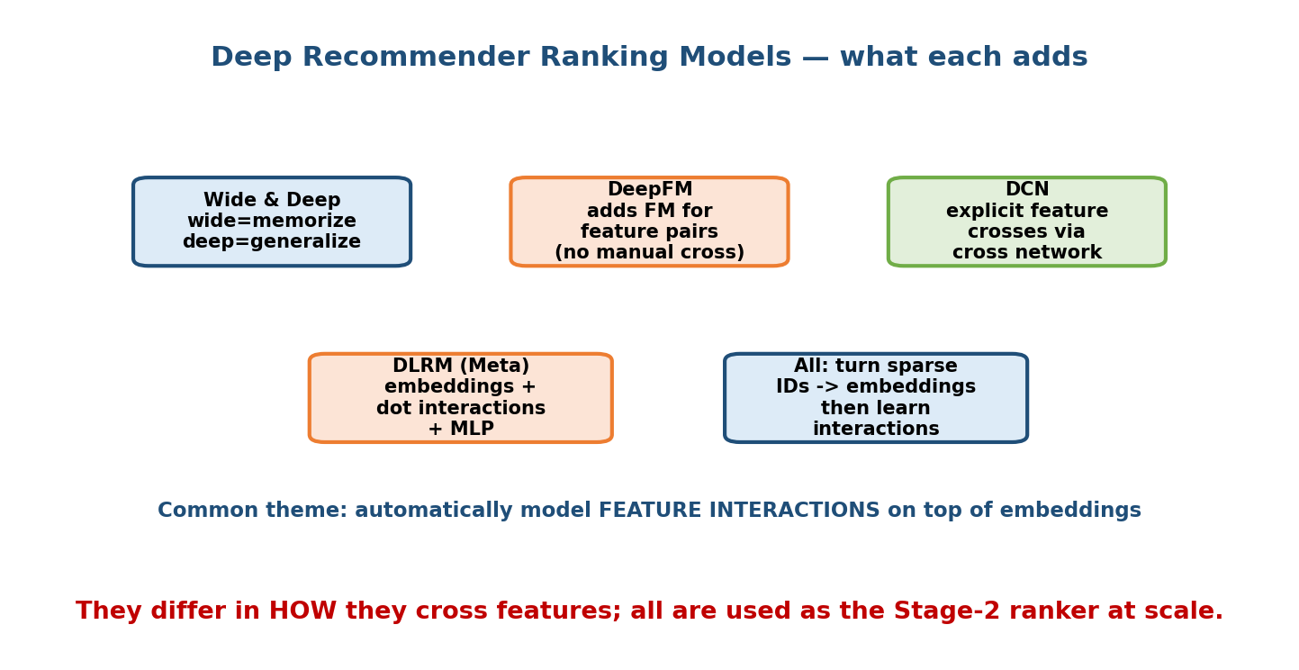
Deep recommender ranking models: Wide and Deep combines memorization and generalization; DeepFM adds a factorization machine for feature pairs; DCN adds explicit crosses via a cross network; DLRM uses embeddings plus dot interactions plus an MLP. All turn sparse IDs into embeddings then learn interactions.

What each one adds (see the figure above)
- Wide & Deep (Google, 2016). Two parts trained jointly: a wide linear model over crossed features that memorises specific combinations (“users who installed app A also install app B”), and a deep network over embeddings that generalises to unseen combinations. The insight: you want both memorisation and generalisation.
- DeepFM (2017). Replaces the hand-engineered wide crosses with a Factorization Machine component that automatically models all pairwise feature interactions via embedding dot products, sharing embeddings with the deep part. No manual feature crossing needed.
- DCN — Deep & Cross Network (2017, v2 2020). Adds a cross network that explicitly and efficiently computes higher-order feature crosses layer by layer, alongside a deep network. More expressive crosses than FM’s pairwise.
- DLRM — Deep Learning Recommendation Model (Meta, 2019). The industrial workhorse: turn categorical IDs into embeddings, model interactions via explicit pairwise dot products between embeddings, then feed through an MLP. Designed for enormous embedding tables sharded across many machines.
The common thread, stated at the bottom of the figure: all of them turn sparse categorical IDs into dense embeddings, then learn how features interact — they just differ in the mechanism (manual crosses, FM, cross-network, dot interactions).
What to say: “For ranking I’d start with a DLRM/DCN-style model — embeddings for the sparse IDs, an interaction layer, and an MLP head — trained on click/watch logs with a ranking or logistic loss.” That is a precise, credible answer.

12.8 Sequential / Session-Based Recommendation

Motivation
Everything so far ignores order and recency. But what you watched just now matters enormously — after three cooking videos, the next recommendation should probably be cooking, not last month’s favourite genre. Sequential models treat a user’s recent actions as an ordered sequence and predict the next item.
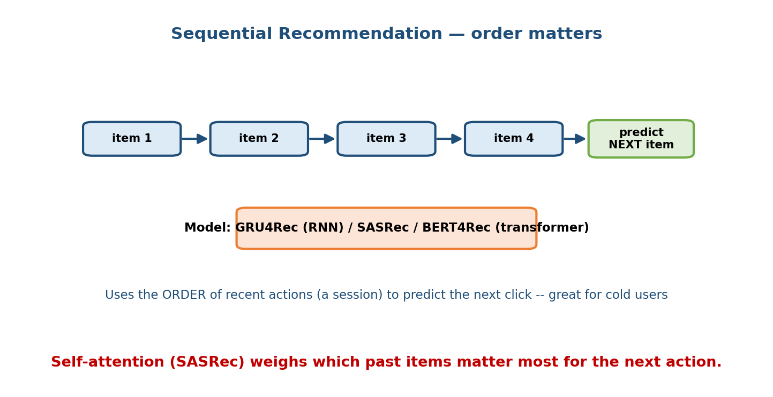
Sequential recommendation: a sequence of recent items feeds a model (GRU4Rec, SASRec, or BERT4Rec) that predicts the next item; it uses the order of recent actions and helps with cold users.

The models (see the figure above)
- GRU4Rec (2016). An RNN (GRU) that reads the session item-by-item and predicts the next click. First big “session-based” model; great when you have no long-term profile (a logged-out user, a fresh session).
- SASRec (2018). A self-attention / transformer over the item sequence. Attention lets the model decide which past items matter most for the next action — usually stronger and more parallelisable than RNNs.
- BERT4Rec (2019). Like SASRec but trained with a masked-item objective (predict a hidden item using items on both sides), borrowing BERT’s bidirectional trick.

Why it helps cold and returning users
Sequential models shine for session/cold users because they need only the current session, not a long history. They also capture short-term intent (the user is shopping for a laptop right now) that a static profile misses. This is a big part of why the TikTok For-You feed feels so responsive — it reacts to your last few swipes almost immediately.

12.9 Cold Start (User & Item)

Motivation
Collaborative methods need history. But every system constantly gets new users (no interactions) and new items (no one has seen them). The cold-start problem is how you make good recommendations with zero collaborative signal — a guaranteed interview follow-up.
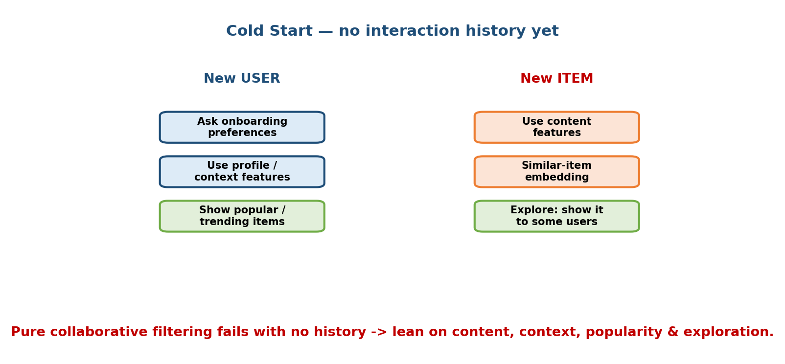
Cold start strategies: for a new user, ask onboarding preferences, use profile and context features, or show popular items; for a new item, use content features, similar-item embeddings, or explore by showing it to some users.

Strategies (see the figure above)
New user (no history):
- Onboarding preferences — ask a few “pick genres you like” questions.
- Context / profile features — country, device, language, signup source; a content-based or context model works with zero clicks.
- Popularity fallback — show trending items until enough signal accumulates.
- Sequential model — start personalising from the very first session click.
New item (no interactions):
- Content features — the item tower embeds it from its metadata/text/thumbnail, so a two-tower model can retrieve it immediately.
- Similar-item embedding — place it near similar known items in latent space.
- Exploration — deliberately show it to a slice of users to gather signal (see bandits, next).
Senior signal: note that pure MF/CF cannot handle cold items at all (no column exists), which is a core reason production systems use feature-based two-tower / content-hybrid models rather than plain MF. Connecting the cold- start requirement to the architecture choice is the mark of a strong answer.

12.10 Exploration vs Exploitation (Bandits)

Motivation
Recsys has a nasty feedback loop (Module 1): you only ever collect data on items you choose to show. If you always show the current best guesses (exploit), you never learn whether the items you didn’t show are actually better — and new/niche items never get a chance. You must sometimes explore.
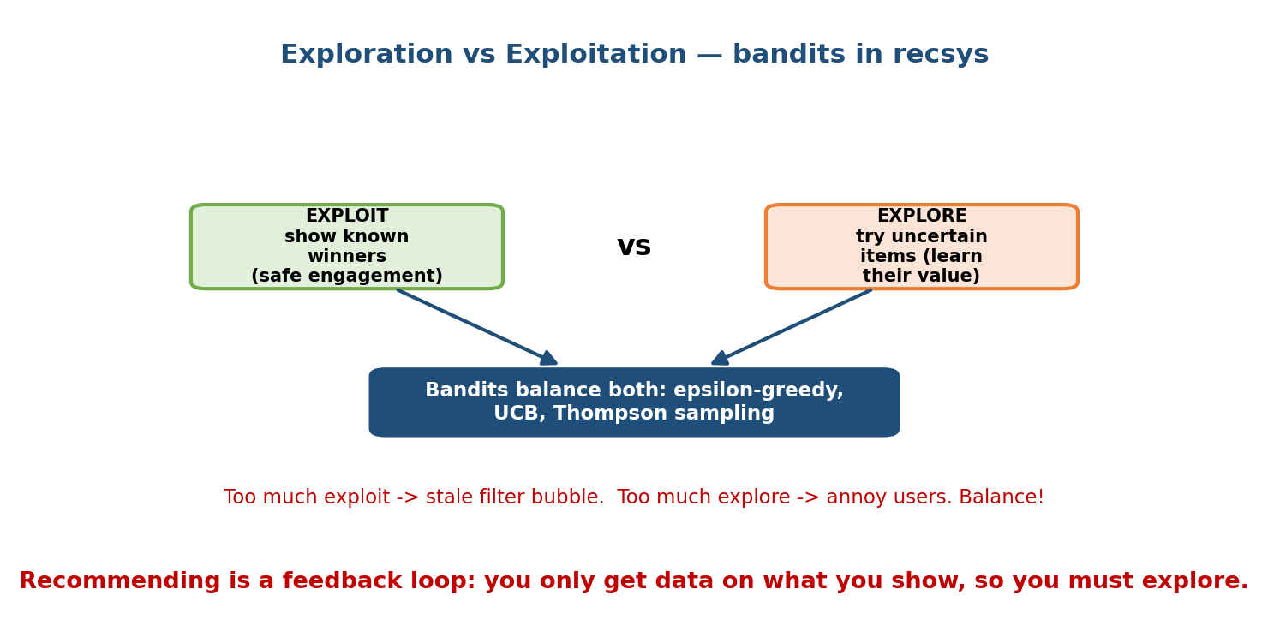
Exploration vs exploitation: exploit shows known winners for safe engagement, explore tries uncertain items to learn their value; bandits (epsilon-greedy, UCB, Thompson sampling) balance both.

The trade-off (see the figure above)
- Exploit = show items you are confident about → safe short-term engagement.
- Explore = show uncertain items → learn their true value, surface fresh and long-tail content, and avoid a stale filter bubble.
Too much exploit → the system ossifies and the catalog’s tail dies. Too much explore → you annoy users with irrelevant items. The right answer is a principled balance.

Bandit algorithms
- ε-greedy — exploit the best item with probability $1−ε$, pick a random item with probability $ε$. Simple, effective.
- UCB (Upper Confidence Bound) — pick the item with the highest optimistic score (mean + uncertainty bonus); naturally tries under-explored items.
- Thompson sampling — keep a probability distribution over each item’s value, sample from it, and show the sampled winner; explores in proportion to uncertainty.
- Contextual bandits — the reward depends on the user’s context (features), so the model learns per-context which arm to pull. This is how many news/feed systems handle fresh content.
Interview tie-in: connect this back to the feedback-loop danger from Module 1 — exploration is how you break a harmful popularity loop and keep the flywheel healthy.

12.11 Real Systems (How the Giants Do It)
Grounding the theory in real designs is a strong interview move. Know these at a one-paragraph level.
- YouTube (two-stage deep recommender, 2016 paper). The canonical two-stage design: a candidate-generation DNN retrieves a few hundred videos from millions (treated as extreme multiclass, then approximate nearest neighbour), then a ranking DNN scores them with rich features, optimising expected watch time (not just clicks — clickbait gets clicks but low watch time).
- Netflix. Famous for the Netflix Prize (MF), but production is a hybrid of many models producing personalised rows; they optimise retention and even personalise artwork/thumbnails. Ranking is row-by-row and page-level.
- TikTok “Monolith”. A recommendation system built for real-time, collisionless embedding tables with online training — the model updates from fresh interactions almost immediately, which is why the For-You feed adapts to your swipes so fast. Heavy use of sequential signals.
- Instagram / Meta. Multi-stage ranking (retrieval → first-pass light ranker → heavy ranker → re-ranking for diversity/integrity), multi-task models predicting several engagement events (like, comment, save, time) and combining them into one value score. DLRM-style ranking at massive scale.
- Spotify. Hybrid: collaborative filtering on listening logs + content (audio analysis, NLP on playlists/reviews) — Discover Weekly blends CF with content and sequence. Content signals are crucial for cold tracks.
Pattern: every one of these is a multi-stage funnel (retrieval → ranking → re-ranking), uses embeddings, is increasingly multi-task and real-time, and optimises a long-term engagement/retention metric via short-term proxies. That sentence is your executive summary of modern recsys.

12.12 Worked Mini-Design — “Recommend Videos” (7-Step Framework)
Let us run the 7-step framework from Module 2 (Clarify → Frame → Metrics → Data & Features → Model → Serve → Monitor) end to end on a YouTube-style “what to watch next” system. This is the payoff of the whole module.
Step 1 — Clarify requirements. Functional: show a personalised home feed of ~20 videos and an “Up next” list. Non-functional: catalog ~ hundreds of millions of videos; ~billions of users; p99 latency < ~100 ms end to end; huge QPS; fresh (react within a session); must handle cold users and freshly-uploaded videos. Clarify the business goal: long-term user satisfaction and retention.
Step 2 — Frame as an ML problem. It is a ranking problem: score candidate videos by expected engagement and return the top-N. Frame the target as expected watch time (weighted), not raw clicks, to avoid clickbait. Multi-task heads (P(click), P(watch>30s), P(like)) combined into one score is the modern framing.
Step 3 — Define metrics. Offline: ranking metrics — NDCG, recall@k for retrieval, AUC/logloss for the ranker. Online (the real test): watch time per session, session count, day-7 retention, measured with an A/B test. Guardrails: diversity, and integrity metrics. Note the offline-online gap (Module 7): improve offline NDCG only ships if the online metric moves.
Step 4 — Data & features. Data: interaction logs (impressions, clicks, watch time, likes, skips) — mostly implicit feedback; log both positives and shown-but-not-clicked negatives. Features: user (watch history embeddings, demographics, context: time, device), item (video ID embedding, channel, topic, age, thumbnail/text embeddings), and cross features. Beware training-serving skew and leakage (Modules 5, 7) — compute features the same way offline and online.
Step 5 — Model & training. Adopt the two-stage design: - Retrieval: a two-tower model → precompute item embeddings into an ANN index; add extra candidate sources (subscriptions, trending, sequential next-item) and union them. Handles cold items via content features. - Ranking: a DLRM/DCN-style deep model with multi-task heads over the few hundred candidates, trained on logged engagement with a ranking/logistic loss. - Re-ranking: apply diversity, freshness, and dedup rules. Add a bandit/exploration slice for fresh content and cold items.
Step 6 — Serving & scaling. Item embeddings and popularity are precomputed in batch; the ANN index and feature store are read at request time; the ranker runs online on hundreds of candidates behind a gRPC service under the latency budget. Cache user embeddings and popular candidates. This is a hybrid batch + online design (Module 1) — heavy lifting precomputed, final decision fresh.
Step 7 — Monitor & iterate. Watch for drift (Module 10), the health of the feedback loop (is the system collapsing into a popularity bubble?), online metrics, and cold-start coverage. Retrain the ranker frequently (even continuously, TikTok-style), refresh item embeddings, and A/B test every change. This closes the loop.
Why this answer scores well: it names the business metric first, uses a proxy (watch time) instead of clicks, draws the two-stage funnel, picks a concrete model per stage, connects each choice to a non-functional requirement, and plans the feedback loop. That is a Staff-level answer.

Module 12 — Interview Mapping (what companies probe)
Company | How Module 12 shows up | Junior answer | Staff answer
YouTube / Google | “Design video recommendations” | One big ranking model over all videos | Two-stage funnel, watch-time objective, two-tower retrieval + deep ranker
Meta (IG/FB) | “Design the feed / reels ranking” | Single-task CTR model | Multi-stage, multi-task ranking, value model combining events, integrity/diversity re-rank
Amazon | “Customers who bought X…” | “Use collaborative filtering” | Item-item CF for stability + embeddings, connects to revenue and cold items
TikTok / ByteDance | “Why is For-You so fast?” | “Good model” | Real-time online training, sequential signals, exploration for fresh content
Netflix / Spotify | “Design recommendations / Discover Weekly” | MF only | Hybrid CF+content, retention metric, cold-start via content, personalised rows
The single most common opening question: “Design the recommendation system for X.” Your first 90 seconds should: (1) name the business metric and a sensible proxy, (2) sketch the two-stage funnel with item counts, (3) say two-tower retrieval + deep ranker. That structure alone puts you ahead of most candidates.

Module 12 — Exam Mapping (SEBI / RBI / GATE / ISRO)
Flag: this is an interview-heavy, exam-light module. Recommendation system design is essentially interview-only and rarely appears on written government/academic exams.
- SEBI IT / RBI IT: at most a definitional mention of “recommendation system” or collaborative filtering; the architecture material here is not tested.
- GATE CS / DA: the DA paper may touch collaborative filtering and the idea of matrix factorization / latent factors at a conceptual level, and cosine similarity. Two-stage serving and deep recommenders are not exam material.
- ISRO / DRDO: occasional one-line ML definitions only.
The exam-transferable ideas are the general ones — cosine similarity, the notion of embeddings/latent factors, and the exploration-exploitation trade-off (which overlaps reinforcement-learning basics).

Module 12 — Common Mistakes & Misconceptions
- “Just score every item and sort.” Impossible at scale — you must use the two-stage funnel. This is the number-one thing juniors miss. (Section 12.5.)
- “Optimise clicks.” Clicks reward clickbait. Optimise a quality proxy like watch time / long-term engagement. (Sections 12.1, 12.12.)
- “Matrix factorization is state of the art.” MF is the foundation; modern systems use two-tower retrieval + deep ranking and feature-based models.
- “CF handles new items.” Pure CF/MF cannot — no column exists. Cold items need content features or exploration. (Sections 12.4, 12.9.)
- “One model does everything.” Retrieval and ranking optimise different metrics (recall vs precision) and use different architectures (separated towers vs early feature crosses). (Sections 12.5, 12.6.)
- “Always exploit the best predictions.” Ignoring exploration creates a filter bubble and starves the long tail (a harmful feedback loop). (Section 12.10.)
- “Offline NDCG going up means we ship.” Only the online A/B business metric decides — mind the offline-online gap. (Section 12.12.)

Module 12 — MCQs (with answers & explanations)
Q1. Why do large recommenders use a two-stage (candidate generation → ranking) architecture? a) To use two different programming languages b) Because running a heavy ranking model over millions of items per request is too slow and costly c) Because collaborative filtering needs it d) To store more data
Answer
b. Retrieval cheaply cuts millions to hundreds (optimising recall); the expensive ranker then runs only on those hundreds (optimising precision), keeping cost bounded regardless of catalog size.
Q2. In matrix factorization, the predicted rating for user $u$ and item $i$ is: a) the cosine of their raw rating rows b) the dot product of their learned latent vectors c) the global average rating d) the number of items they share
Answer
b. ${\hat{r}}_{ui}=u_{i}⋅v_{j}$ — the dot product of the user’s and item’s $k$-dimensional latent vectors (optionally plus bias terms).
Q3. Why can the two-tower model retrieve from millions of items in milliseconds? a) It scores every item with a big DNN b) Item embeddings are precomputed into an ANN index, so serving is a fast nearest-neighbour lookup after embedding the user once c) It uses SQL joins d) It caches the final answer for all users
Answer
b. Because the towers are separate, item vectors depend only on item features and can be precomputed into an approximate- nearest-neighbour index; only the user tower runs per request.
Q4. Which method can recommend a brand-new item with zero interactions? a) User-user collaborative filtering b) Plain matrix factorization c) Content-based / feature-based (e.g. an item tower using metadata) d) Item-item co-visitation counts
Answer
c. Only content/feature-based methods work with no interaction history; CF and MF have no row/column for the new item (the cold-start problem).
Q5. What does the “exploration” side of the exploration-exploitation trade-off buy you? a) Lower latency b) Learning the value of items you are unsure about and avoiding a filter bubble c) Smaller models d) Guaranteed higher short-term clicks
Answer
b. Exploration gathers data on uncertain / fresh items so the system can improve and surface long-tail content; it may cost short-term engagement but prevents a harmful popularity loop.
Q6. Between user-user and item-item CF, why is item-item usually preferred at scale? a) Items have more features b) Item-item similarities are more stable over time and can be precomputed and cached c) Users are more numerous than items always d) It needs no data
Answer
b. Item relationships change slowly, so the item-item similarity table can be computed offline and reused, unlike fast- shifting user tastes.
Q7. In the YouTube-style design, why optimise watch time rather than clicks? a) Clicks are hard to log b) Clicks reward clickbait; watch time better reflects genuine satisfaction c) Watch time is easier to predict d) There is no difference
Answer
b. A click-only objective rewards misleading thumbnails/titles that get clicks but low satisfaction; expected watch time is a better proxy for the real goal.
Q8. What do Wide & Deep, DeepFM, DCN, and DLRM all have in common? a) They are retrieval models b) They turn sparse categorical IDs into embeddings and then model feature interactions c) They avoid neural networks d) They require star ratings
Answer
b. All are ranking-stage deep models that embed sparse IDs and learn feature interactions; they differ only in the interaction mechanism (manual crosses, FM, cross-network, dot interactions).

Module 12 — Design Exercises (easy → hard)
- Easy. For a small bookstore with 5,000 books and 50,000 users, would you build a two-stage funnel or score all items directly? Justify with the numbers. (Direct scoring is fine — only 5k items; the funnel is for millions.)
- Easy. Given a user-item rating matrix, write the objective that matrix factorization minimises, and name two ways to optimise it. (Regularised squared error over observed entries; ALS or SGD.)
- Medium. Design candidate generation for a music app: list three distinct candidate sources and why each exists (e.g. two-tower personalised, recently- played sequence, trending/popularity for cold users).
- Medium. Your recommender keeps pushing the same few viral videos and new creators get no views. Diagnose the feedback loop and propose an exploration strategy to fix it (ε-greedy vs Thompson sampling trade-offs).
- Hard. Design the full “For-You” feed for a short-video app that must react within a session. Cover: real-time features, sequential model, two-stage serving, freshness/exploration, and how you’d A/B test it.
- Hard. You must add a brand-new product category (cold items) to an e-commerce recommender that currently uses matrix factorization. Explain why MF fails and redesign the retrieval stage to handle cold items gracefully.

Module 12 — Concept Review (one page)
- The problem: one user + millions of items → a short ranked list, to move a business metric (watch time, revenue, retention) via a proxy target.
- Collaborative filtering: learn from the interaction matrix only. User-user (“people like you”) vs item-item (“items like this”); item-item is more stable & scalable (precomputable).
- Matrix factorization: $R≈UV^{⊤}$; predict ${\hat{r}}_{ui}=u_{i}⋅v_{j}$; minimise regularised squared error over observed entries via ALS (parallel, closed-form alternation) or SGD. Seed of embeddings.
- Content-based uses item features (handles cold items, but narrow); hybrid combines content + collaborative — what real systems use.
- Two-stage funnel (centrepiece): candidate generation (millions → hundreds, optimise recall) → ranking (hundreds → tens, heavy DNN, optimise precision) → optional re-ranking (diversity/rules).
- Two-tower retrieval: separate user & item towers, dot-product score; item vectors precomputed → ANN lookup; enables retrieval over millions.
- Deep rankers: Wide & Deep (memorise + generalise), DeepFM (auto pairwise), DCN (explicit crosses), DLRM (embeddings + dot interactions + MLP) — all model feature interactions.
- Sequential: GRU4Rec (RNN), SASRec/BERT4Rec (transformers) predict the next item from recent actions — great for cold/session users.
- Cold start: users → onboarding/context/popularity; items → content features/similar-item/exploration. Pure CF/MF can’t do cold items.
- Exploration vs exploitation: bandits (ε-greedy, UCB, Thompson) break the feedback loop and surface the long tail.
- Real systems are all multi-stage, embedding-based, increasingly multi-task & real-time, optimising long-term engagement.

Module 12 — Flash Cards (Q → A)
- Recsys problem in one line? → One user + millions of items → short ranked list that moves a business metric.
- User-user vs item-item CF? → Similar users’ likes vs similar items; item-item is more stable and precomputable.
- MF prediction formula? → ${\hat{r}}_{ui}=u_{i}⋅v_{j}$ (dot product of latent vectors).
- ALS vs SGD? → ALS: alternate closed-form least squares (parallel); SGD: gradient step per observed rating.
- Why two stages? → A heavy model can’t score millions per request; retrieve cheaply (recall) then rank precisely (precision).
- Why keep two towers separate? → Item vectors precompute into an ANN index → fast nearest-neighbour retrieval.
- What do Wide&Deep / DeepFM / DCN / DLRM share? → Embed sparse IDs, then model feature interactions.
- Cold item fix? → Content/feature-based (item tower) + exploration; pure CF can’t.
- Why explore? → Break the feedback loop, learn uncertain items, surface the long tail.
- Why watch time over clicks? → Clicks reward clickbait; watch time proxies real satisfaction.

Module 12 — Pattern Recognition (how to spot it in an interview)
- Hear “design recommendations for X” → business metric + proxy → two-stage funnel → two-tower retrieval + deep ranker.
- Hear “millions of items, tight latency” → say candidate generation + ANN, not “score everything”.
- Hear “brand-new items / creators” → cold start: content features + exploration.
- Hear “our recs keep showing the same popular stuff” → feedback loop; add exploration / bandits and diversity re-ranking.
- Hear “react within the session / real-time” → sequential model + online training + hybrid serving.
- Hear “which model for ranking?” → DLRM/DCN-style deep model with embeddings and feature interactions, multi-task heads.
- Hear “how do you measure success?” → offline NDCG/recall but online A/B on the business metric decides.

Module 12 — Revision Notes / Mini Cheat Sheet
RECSYS = one user + millions of items -> short ranked list -> business metric
optimise a PROXY (watch time), not clicks (clickbait) or raw popularity
COLLABORATIVE FILTERING: use interaction matrix only
user-user ("people like you") | item-item ("items like this" - stable, cacheable)
MATRIX FACTORIZATION: R ~= U V^T ; r_ui = u_i . v_j (dot of k-dim latent vectors)
min sum_obs (r_ui - u_i.v_j)^2 + lambda(||u||^2+||v||^2) via ALS (parallel) or SGD
-> births EMBEDDINGS ; implicit feedback -> confidence weights / BPR ranking loss
CONTENT-BASED: item features (handles COLD items) | HYBRID = content + collaborative
TWO-STAGE FUNNEL (centrepiece):
catalog(millions) -> CANDIDATE GEN (recall, cheap) -> ~hundreds
-> RANKING (precision, heavy DNN) -> ~tens
-> RE-RANK (diversity/rules) -> top-N
TWO-TOWER RETRIEVAL: user tower + item tower -> dot product
item vectors PRECOMPUTED -> ANN index (FAISS/ScaNN/HNSW) ; embed user once/request
DEEP RANKERS (all embed IDs + model feature interactions):
Wide&Deep (memorise+generalise) | DeepFM (auto pairwise) | DCN (explicit crosses)
| DLRM (embeddings + dot interactions + MLP)
SEQUENTIAL: GRU4Rec (RNN) | SASRec/BERT4Rec (transformer) -> predict NEXT item
COLD START: user->onboarding/context/popular ; item->content/similar/explore
EXPLORE vs EXPLOIT: epsilon-greedy | UCB | Thompson -> break feedback loop, long tail
REAL SYSTEMS: YouTube (2-stage, watch-time) | Netflix (hybrid rows, retention)
TikTok Monolith (real-time online train) | Meta (multi-stage multi-task) | Spotify (CF+content)

Next module: Module 13 — Search & Ranking Systems. Recommendation and search are close cousins — both retrieve then rank — but search adds an explicit query and relevance. We will reuse the two-stage funnel and two-tower retrieval here, and add learning-to-rank, query understanding, and relevance metrics.

