Module 13 — Search & Ranking Systems
  - ML System Design Mastery: FAANG / AI-Engineer / Staff-Level — In-Depth Notes (with visuals)
Prepared for nidhi.sharma@forensiccybertech.com
2026
Table of Contents

Module 13 — Search & Ranking Systems
Why this module matters. Search and ranking are the beating heart of almost every large ML product: web search, e-commerce product search, app stores, feeds, ads, and even the “retrieval” step of a RAG system all boil down to the same question — given a query and millions of candidates, which few should we show, and in what order? Ranking is where classic information retrieval (IR) meets modern deep learning, and where the systems constraints (latency, scale, freshness) bite hardest. Interviewers love it because a strong answer forces you to connect an IR baseline, a learning-to-rank model, embeddings + ANN, and a multi-stage serving funnel — all under a tight latency budget. We build the whole picture from first principles, starting with a 1960s data structure and ending with a full product-search design.
Importance ratings (out of 5):
Exam / Use | SEBI IT | RBI IT | GATE CS/DA | Interview | AI/MLE role
This module | ★★ | ★★ | ★★★ | ★★★★★ | ★★★★★
What you must be able to do after this module: explain an inverted index and why it makes search fast; write the TF-IDF and BM25 scoring formulas and say why BM25 beats plain TF-IDF; distinguish pointwise, pairwise (RankNet), and listwise (LambdaRank / LambdaMART) learning-to-rank and say what each optimizes; explain dense / semantic retrieval with a dual-encoder plus approximate nearest neighbour (ANN) search, and how it relates to two-tower models (M12) and vector DBs (M16); draw the multi-stage funnel (retrieval → pre-rank → rank → re-rank) with a latency budget per stage; compute NDCG by hand; and run a full 7-step design for web / product search ranking.
How to read this module. For every idea we go problem → simplest attempt → why it breaks → the fix. We explain the why before the how and tie each concept to how it shows up in a real Google / Amazon / Meta interview.

13.1 Information Retrieval Foundations

Motivation (the problem that existed)
You have a billion documents (web pages, product listings). A user types “red running shoes”. You must return the most relevant few in tens of milliseconds. The naive approach — scan every document, check if it contains the words — is hopeless: a billion string scans per query. We need a data structure that turns “which documents contain this word?” into an instant lookup. That structure is the inverted index, and it is the foundation of every search engine ever built.

The inverted index
A normal (“forward”) index maps document → words in it. An inverted index flips this: it maps word → list of documents that contain it. That list is called a posting list. To answer “red running shoes”, you fetch the posting lists for red, running, shoes and intersect them — a few list merges instead of a billion scans.
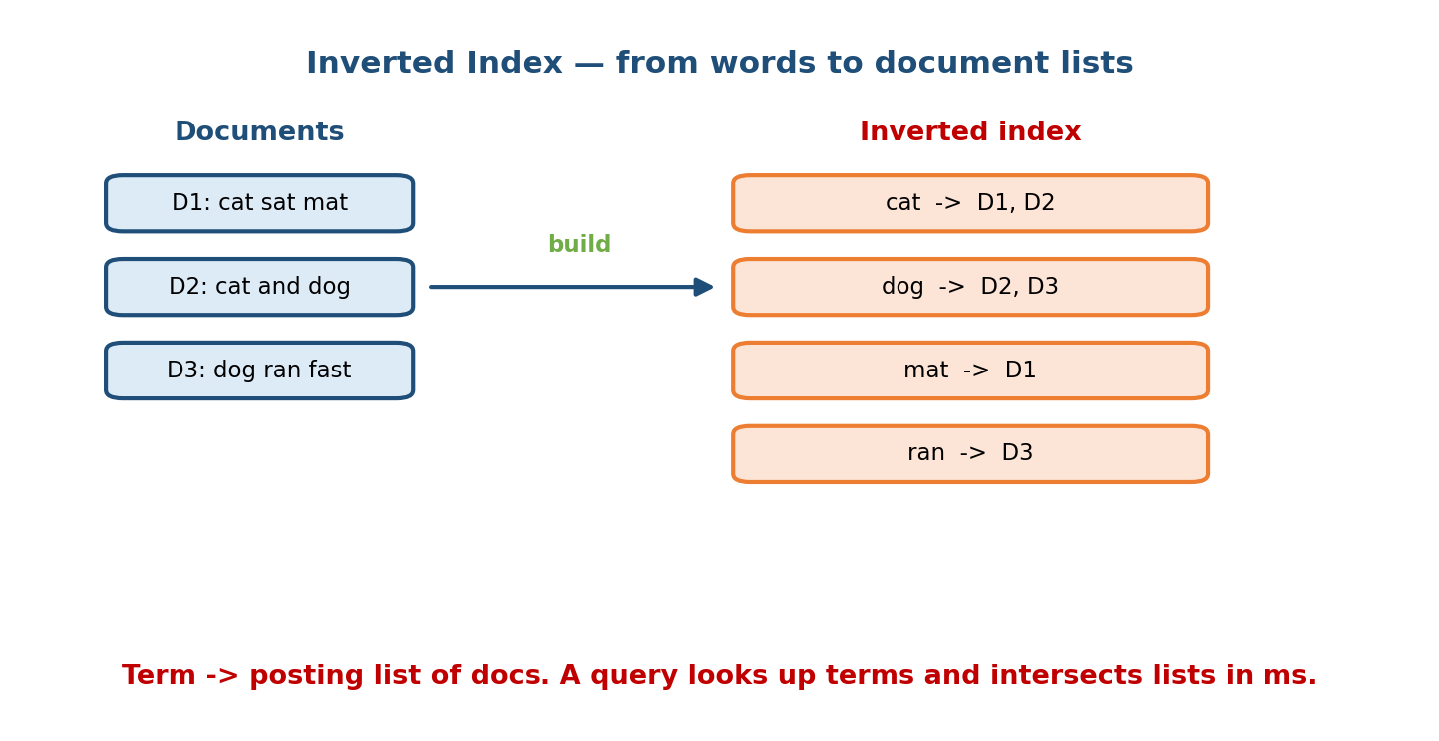
Left: three documents. Right: the inverted index maps each term to the list of documents that contain it. A query looks up terms and intersects their posting lists in milliseconds.
As the diagram shows, cat -> D1, D2 means the word “cat” appears in documents 1 and 2. Posting lists are usually sorted by document id and heavily compressed, and they often store extra data (term positions, term counts) so we can rank and support phrase queries. The index is built offline (batch) and served from memory or SSD; queries only read it. This is why keyword search is cheap and scalable — the expensive work happened at index build time.

TF-IDF — the first scoring idea
Finding documents that contain the words is not enough; we must rank them. The oldest good idea is TF-IDF (Term Frequency × Inverse Document Frequency). The intuition, from first principles:
- Term Frequency (TF): a document that uses the query word many times is probably more about it. TF rewards repetition.
- Inverse Document Frequency (IDF): a word that appears in almost every document (like “the”) carries little information; a rare word (like “chondroma”) is highly discriminative. IDF down-weights common words and up-weights rare ones.
For a term $t$ in document $d$ within a collection of $N$ documents:
$$\text{TF-IDF}(t,d)=\text{tf}(t,d)×log\frac{N}{\text{df}(t)}$$
where $\text{tf}(t,d)$ is the count of $t$ in $d$, and $\text{df}(t)$ is the number of documents containing $t$. A document’s score for a query is the sum of TF-IDF over the query terms. Simple, fast, and for decades it was the default.

BM25 — why it beats TF-IDF
TF-IDF has two real flaws:
- TF grows linearly forever. A document that repeats “shoes” 100 times scores 100× — but a page is not 100× more relevant just because it spams a word. Relevance should saturate.
- No length normalization. A very long document naturally contains more term occurrences, so it unfairly out-scores a short, on-point document.
BM25 (Best Match 25, the Okapi weighting scheme) fixes both. Its score for a document $d$ and query $Q$ is:
BM25(d,Q)=t∈Q​IDF(t)⋅tf(t,d) (k1+1)tf(t,d)+k11−b+b |d|avgdl
The two tuning knobs are the whole point:
- $k_{1}$ (typically 1.2–2.0) controls saturation: as term frequency rises, the extra reward shrinks. Ten mentions is barely more than five.
- $b$ (typically 0.75) controls length normalization: it penalizes documents longer than the average length avgdl, so a short focused document competes fairly with a long one.
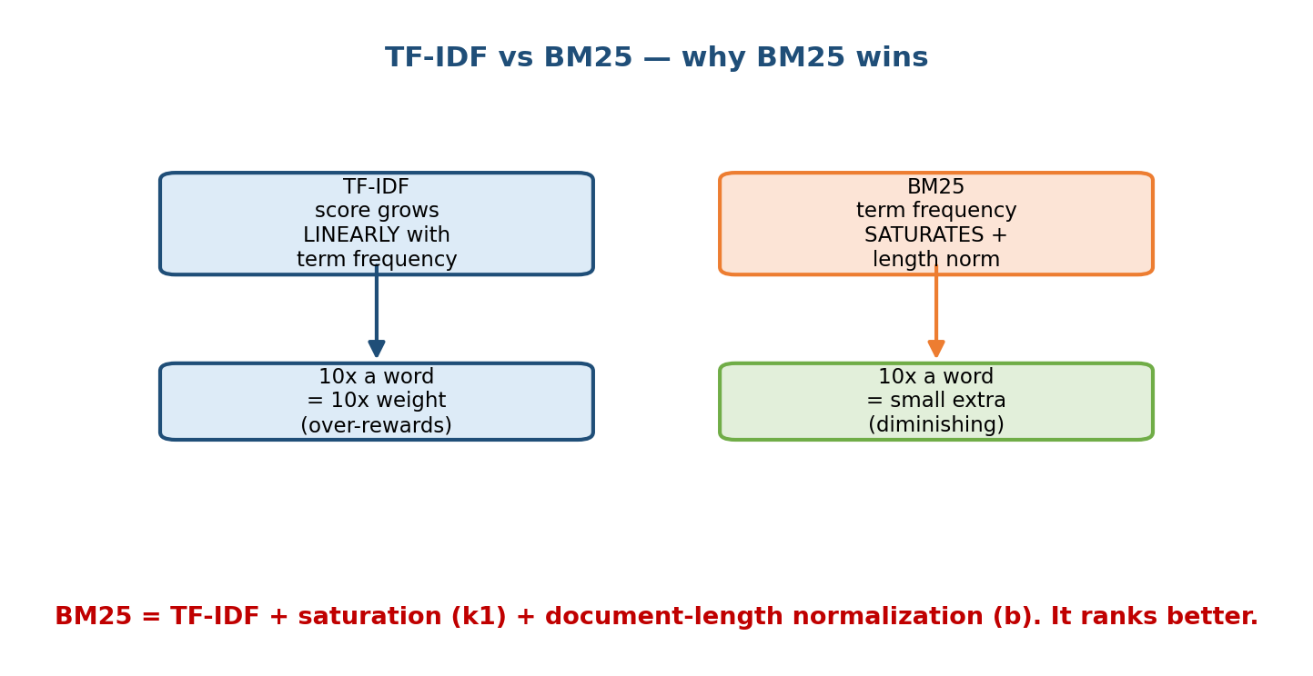
TF-IDF grows linearly with term frequency and has no length normalization, so it over-rewards repetition and long documents. BM25 saturates term frequency (via k1) and normalizes by document length (via b), so it ranks better.
As the figure summarizes: BM25 = TF-IDF + saturation + length normalization. It is still the strongest keyword baseline today, ships in Elasticsearch / Lucene by default, and is the number you must beat before adding any ML.
Senior signal: In a search design, always name BM25 as your retrieval baseline. Reaching straight for embeddings without a keyword baseline is a junior move — BM25 is cheap, interpretable, and surprisingly hard to beat on exact-match (“head”) queries.

13.2 Learning to Rank (LTR)

Motivation
BM25 uses one text signal. Real ranking wants to combine hundreds of signals — text match, click history, price, freshness, seller rating, user personalization. Hand-tuning weights for all of these is hopeless (recall the whack-a-mole problem from Module 1). Learning to Rank trains a model to combine features into a relevance score, using logged relevance judgments or clicks as labels. There are three families, differing in what unit they look at and what they optimize.
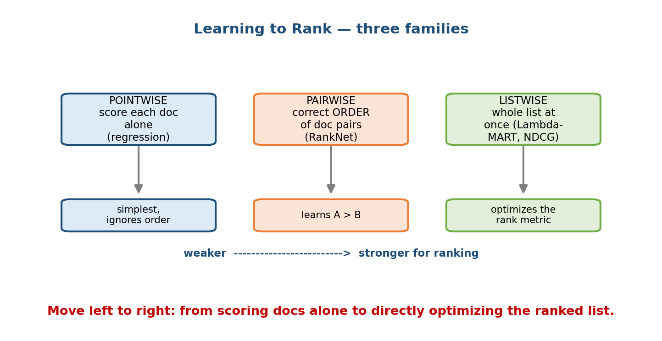
Three learning-to-rank families. Pointwise scores each document alone as a regression problem. Pairwise learns the correct order of document pairs (RankNet). Listwise optimizes the whole ranked list at once (LambdaMART), aligned with NDCG. Left to right is weaker to stronger for ranking.

Pointwise
Treat each (query, document) pair independently and predict an absolute relevance score or label (e.g. regression to a 0–4 grade, or binary click/no-click). Then sort documents by predicted score. What it optimizes: a per-document loss (squared error, log-loss). It is the simplest and most like ordinary supervised learning, and it works when you have graded labels. Its weakness: it does not care about relative order — getting document A’s absolute score slightly wrong may still flip it above B, which is what actually hurts.

Pairwise (RankNet)
Look at pairs of documents for the same query and learn which one should rank higher. RankNet (Burges et al., Microsoft) feeds both documents through the same neural net to get scores $s_{i},s_{j}$, converts the score difference into a probability that $i$ beats $j$ via a sigmoid, and minimizes cross-entropy against the true preference. What it optimizes: the number of correctly ordered pairs (closely related to minimizing inversions). This matches ranking much better than pointwise because ranking is about relative order. Its weakness: it treats every pair equally, but a mistake at position 1 matters far more than a mistake at position 50.

Listwise (LambdaRank, LambdaMART)
Look at the entire list for a query and optimize a list-level ranking metric directly. The problem: metrics like NDCG are flat or discontinuous (swapping two docs changes NDCG in steps), so you cannot take a gradient of them. LambdaRank’s clever trick is to skip the loss and define the gradient directly: it takes the RankNet pairwise gradient and scales it by the change in NDCG (|ΔNDCG|) you would get by swapping that pair. So pairs whose swap would move NDCG a lot get a big push; pairs near the bottom get almost none. LambdaMART = LambdaRank gradients plus gradient-boosted decision trees (MART), and it is the workhorse that has won many ranking competitions.
What each optimizes, in one line:
Family | Unit | Optimizes | Example
Pointwise | one doc | absolute relevance score | regression / classification
Pairwise | doc pair | correct order of pairs | RankNet
Listwise | whole list | a list metric (NDCG) | LambdaRank, LambdaMART

How NDCG ties in
The reason listwise methods win is that the business cares about top-of-list quality, and NDCG (Normalized Discounted Cumulative Gain) is the metric that captures it: it rewards putting highly relevant documents near the top and discounts relevance by position. LambdaMART bakes ΔNDCG straight into its gradient, so it is directly chasing the metric you report. We compute NDCG by hand in Section 13.6.
Senior signal: Say “I’d start with LambdaMART / gradient-boosted trees for tabular ranking features, because they train fast, handle mixed feature types, and directly optimize NDCG.” Only reach for a deep ranker when you have huge data and rich text/embedding features.

13.3 Embedding-Based (Semantic / Neural) Retrieval

Motivation — the vocabulary-mismatch problem
Keyword search fails when the words differ but the meaning matches. A user searches “how to fix a flat tyre”; the best document says “repairing a punctured wheel” and shares almost no words. BM25 scores it near zero. We need retrieval based on meaning, not exact tokens. That is dense / semantic retrieval: represent both query and documents as vectors (embeddings) in a shared space where closeness = semantic similarity.

Dual-encoder (two-tower) retrieval
The standard architecture is a dual-encoder, also called two-tower (covered as a modeling pattern in Module 12): one neural encoder turns the query into a vector, another encoder turns each document into a vector, and relevance is the dot product (or cosine similarity) of the two vectors. Crucially, the document vectors are precomputed offline and indexed; at query time you only encode the query and search the index.
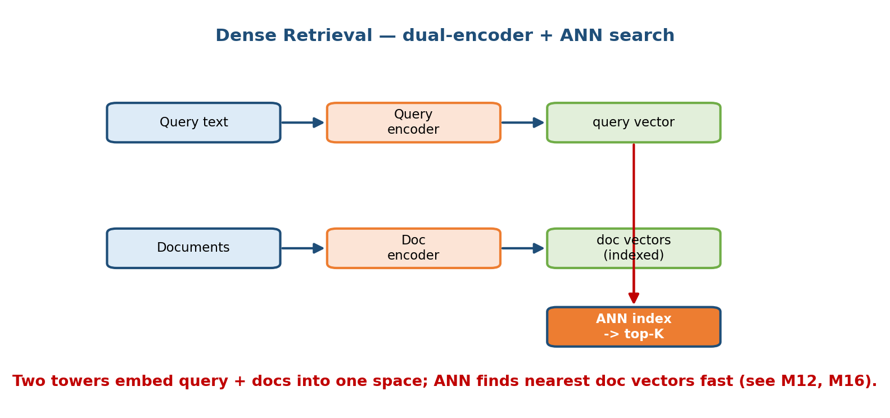
Dense retrieval with a dual-encoder. A query encoder maps the query to a vector; a doc encoder maps every document to a vector, precomputed and indexed. An ANN index finds the nearest doc vectors to the query vector and returns the top-K. Cross-links to two-tower (M12) and vector DBs (M16).
Because the towers are separate, all the heavy document encoding happens in batch, and the online cost is: one query encode + one nearest-neighbour search. This is exactly the two-tower recommendation retrieval pattern from Module 12, reused for search.

Approximate Nearest Neighbour (ANN)
Finding the closest document vectors to the query vector by brute force means computing a billion dot products per query — far too slow. Approximate Nearest Neighbour (ANN) search trades a tiny bit of accuracy for a massive speed-up, returning almost the true nearest neighbours in sub-millisecond time. Common methods:
- HNSW (Hierarchical Navigable Small World): a layered graph you greedily walk toward the query; excellent recall/latency, memory-heavy.
- IVF (Inverted File): cluster vectors, search only the nearest few clusters.
- PQ (Product Quantization): compress vectors so more fit in RAM.
These indexes live inside vector databases (FAISS, ScaNN, Milvus, Pinecone), the subject of Module 16. The key trade-off is recall vs latency vs memory — you tune how many clusters/graph-neighbours to visit.

Dense vs sparse — use both
Dense retrieval catches meaning but can miss exact matches (part numbers, rare names, “iPhone 15 Pro Max 256GB”). Keyword/BM25 nails exact matches but misses synonyms. The strong production answer is hybrid retrieval: run BM25 and dense retrieval, then merge the candidate lists (e.g. reciprocal rank fusion) before ranking. This is also the modern RAG retrieval recipe.
Senior signal: Propose hybrid (BM25 + dense) retrieval and explain why: dense for semantic “torso/tail” queries, sparse for exact-match “head” queries. Then note the cross-links — two-tower (M12) for the encoders, vector DB / ANN (M16) for the index.

13.4 Multi-Stage Ranking (the Funnel)

Motivation
You cannot run your expensive, feature-rich ranking model on a billion documents — that would blow the latency budget by orders of magnitude. But you also cannot run a cheap model on everything and still be accurate. The universal solution is a funnel: several stages, each keeping fewer candidates but spending more compute per candidate. Cheap-and-broad first, expensive-and-precise last.
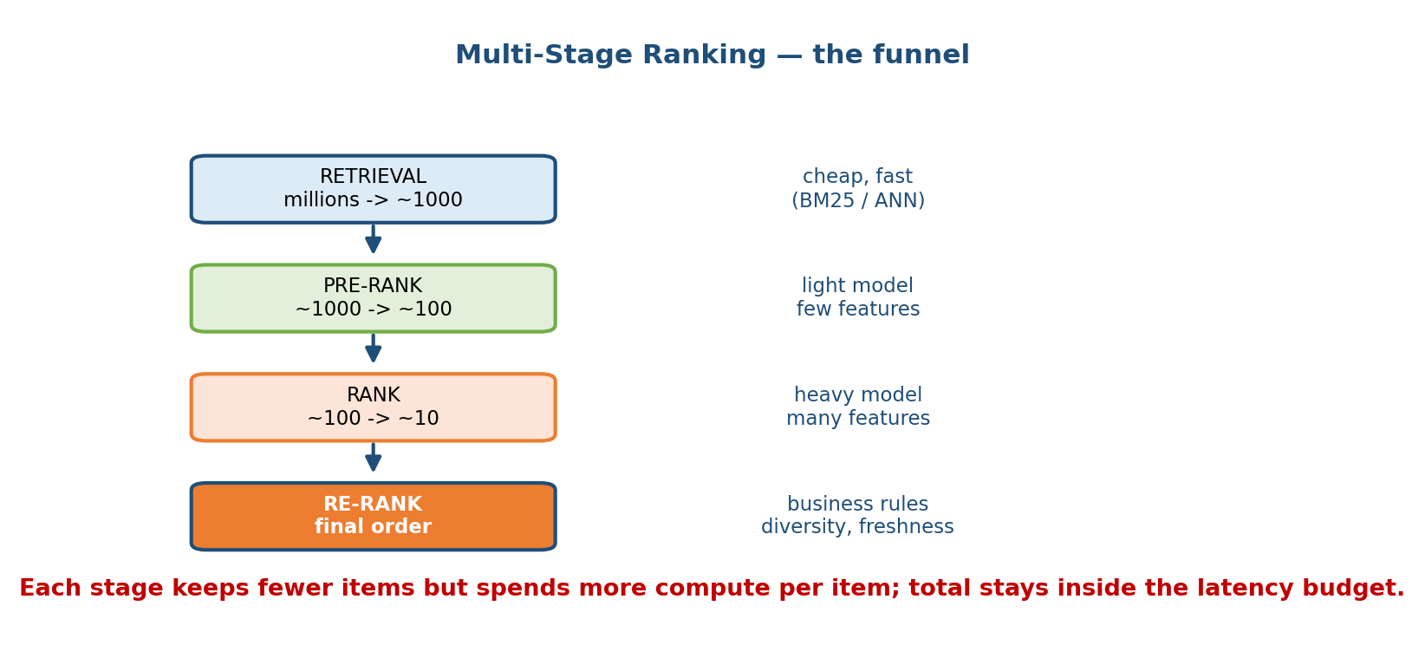
The multi-stage ranking funnel. Retrieval narrows millions to about 1000 using cheap methods (BM25 / ANN). Pre-rank narrows to about 100 with a light model. Rank narrows to about 10 with a heavy model and many features. Re-rank applies business rules, diversity, and freshness to set the final order. Each stage keeps fewer items but spends more compute per item, so the total stays inside the latency budget.

The four stages and their latency budget
- Retrieval (candidate generation). Input: millions. Output: ~1000. Use the cheapest recall methods — BM25 over the inverted index, plus ANN over dense vectors (often several sources unioned). Optimizes recall (don’t lose good docs). Budget: a few ms.
- Pre-rank (first-pass ranking). Input: ~1000. Output: ~100. A light model (e.g. a small GBDT or the two-tower dot product) with a handful of cheap features prunes the list. Budget: a few ms.
- Rank (full ranking). Input: ~100. Output: ~10. The heavy model — LambdaMART with hundreds of features, or a deep cross-attention ranker — does the precise scoring. This is where most model quality lives. Budget: the bulk of the tens of ms.
- Re-rank (post-processing). Input: top ~10. Reorder for business rules, diversity, freshness, de-duplication, and policy (e.g. don’t show 10 results from the same seller). Budget: ~1 ms.
Why the funnel works: total cost ≈ (millions × tiny) + (1000 × small) + (100 × large) + (10 × huge). Because each stage shrinks the count roughly 10×, you can afford a 100× more expensive model at each step and still meet, say, a 100 ms end-to-end p99 budget. This is the single most important structural idea in ranking systems, and it mirrors the “hybrid batch + online” pattern from Module 1.
Interview move: When asked “how do you serve ranking at scale?”, draw this funnel first. Then attach a model and a latency figure to each stage. It instantly signals you understand the systems constraint, not just the model.

13.5 Query Understanding, Personalization & Freshness

Motivation
A ranking model that sees only the raw query text is leaving huge signal on the table. The same three words mean different things to different users at different times. Great search fuses three extra signal sources before and during ranking.
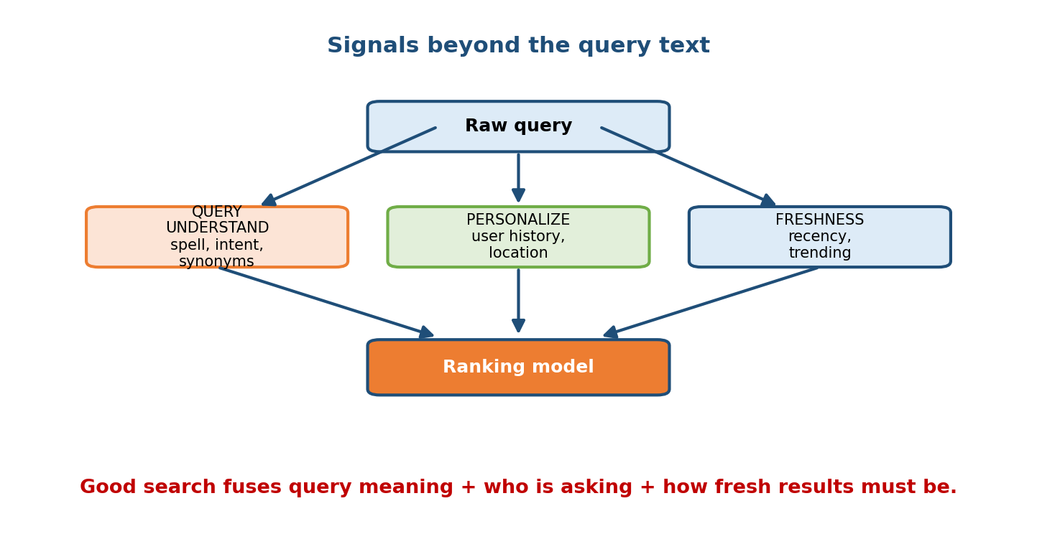
Beyond the raw query, three signal sources feed the ranking model. Query understanding does spell correction, intent detection, and synonym expansion. Personalization adds user history and location. Freshness adds recency and trending. Good search fuses query meaning, who is asking, and how fresh results must be.

Query understanding
Before retrieval, clean and enrich the query:
- Spell correction: “runing shoes” → “running shoes”.
- Tokenization / normalization: lowercasing, stemming, handling accents.
- Intent classification: is “apple” a fruit, a company, or a location? Is the query navigational (go to a site), informational, or transactional (buy)?
- Query expansion / synonyms: add “sneakers” when the user typed “trainers”.
- Entity recognition: detect “iphone 15” as a product entity.
Better query understanding improves retrieval recall and gives the ranker cleaner features.

Personalization
Two users typing the same query may want different results. Signals: past searches and clicks, purchase history, location (a “coffee” search wants nearby shops), language, device. Personalization is usually injected as user features (and user embeddings) into the ranking model — never by over-fitting so hard that a user gets trapped in a filter bubble. Beware the feedback loop from Module 1: personalization trained on clicks reinforces what it already shows.

Freshness
For news, social, and trending products, recency is relevance. A perfect match from three years ago may be useless. Freshness enters as features (document age, recent click velocity, “trending” scores) and as re-ranking rules that boost new content. There is a tension: freshness vs authority/quality — tuned per vertical (news leans fresh; reference leans authoritative).

13.6 Evaluation — NDCG and Online Metrics

Offline: why not just accuracy?
Ranking quality is about order, not classification. The dominant offline metric is NDCG@k. Build it up from three ideas:
- Gain: each result has a relevance grade (e.g. 0=irrelevant … 3=perfect). The gain is the relevance (or $2^{rel}−1$ for the exponential variant).
- Discounted Cumulative Gain (DCG): rewards putting relevant items high by dividing each gain by a positional discount:
$$\text{DCG@}k=\sum_{i=1}^{k}{\frac{{\text{gain}}_{i}}{\log_{2}(i+1)}}$$
- Normalize: divide DCG by the ideal DCG (IDCG) — the DCG of the best possible ordering — so the metric lands in $[0,1]$ and is comparable across queries: $\text{NDCG@}k=\text{DCG@}k/\text{IDCG@}k$.

Worked example
Suppose our ranking returns four documents with relevance grades $[3,2,3,0]$ (using linear gain = relevance):
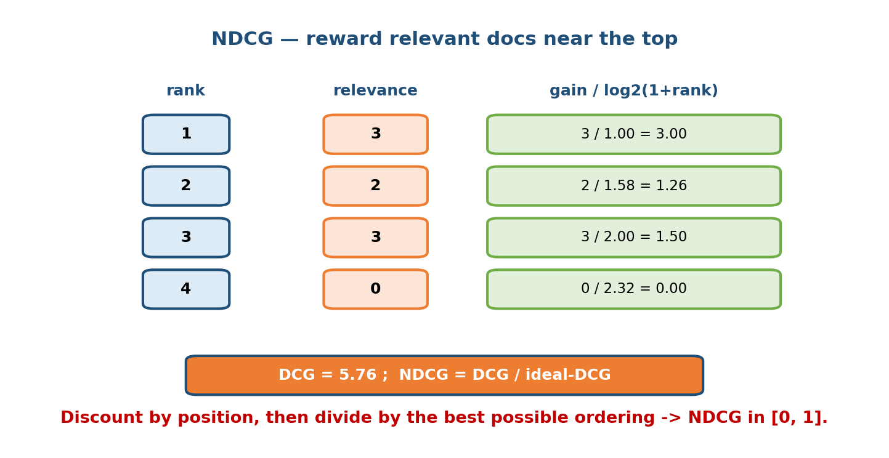
NDCG worked example. For a ranking with relevance grades 3, 2, 3, 0, each gain is divided by log2(1+rank): 3.00, 1.26, 1.50, 0.00, summing to DCG = 5.76. NDCG is DCG divided by the ideal DCG, landing in [0, 1].
As the figure computes:
- Rank 1: $3/\log_{2}(2)=3/1.00=3.00$
- Rank 2: $2/\log_{2}(3)=2/1.58=1.26$
- Rank 3: $3/\log_{2}(4)=3/2.00=1.50$
- Rank 4: $0/\log_{2}(5)=0/2.32=0.00$
- DCG = 5.76.
The ideal ordering sorts by relevance: $[3,3,2,0]$, giving $3.00+3/1.58+2/2.00+0=3.00+1.89+1.00=5.89$ = IDCG. So $\text{NDCG}=5.76/5.89=0.98$ — very good; the only flaw is the second-best doc sits at rank 3 instead of 2.
Other offline metrics you should name: MAP (Mean Average Precision, for binary relevance), MRR (Mean Reciprocal Rank, for “first correct answer” — great for question answering), and Precision@k / Recall@k.

Online metrics — the real judge
Offline NDCG uses labels or logged clicks, which are biased (position bias: users click top results just because they are on top). The true test is an online A/B test (Module 7 / 10) measuring business outcomes:
- Click-through rate (CTR) and click position.
- Conversion / purchase rate (product search), watch time (video).
- Query reformulation / abandonment rate (low = users found it).
- Session success and long-term revenue / retention.
Beware the offline–online gap: a model can lift NDCG offline yet lose the A/B test (e.g. because offline labels came from the old ranker). Always confirm online.

13.7 Worked Mini-Design — Web / Product Search Ranking (7-step framework)
We now run the Module 2 seven-step framework end to end on “design product search ranking for an e-commerce site.”
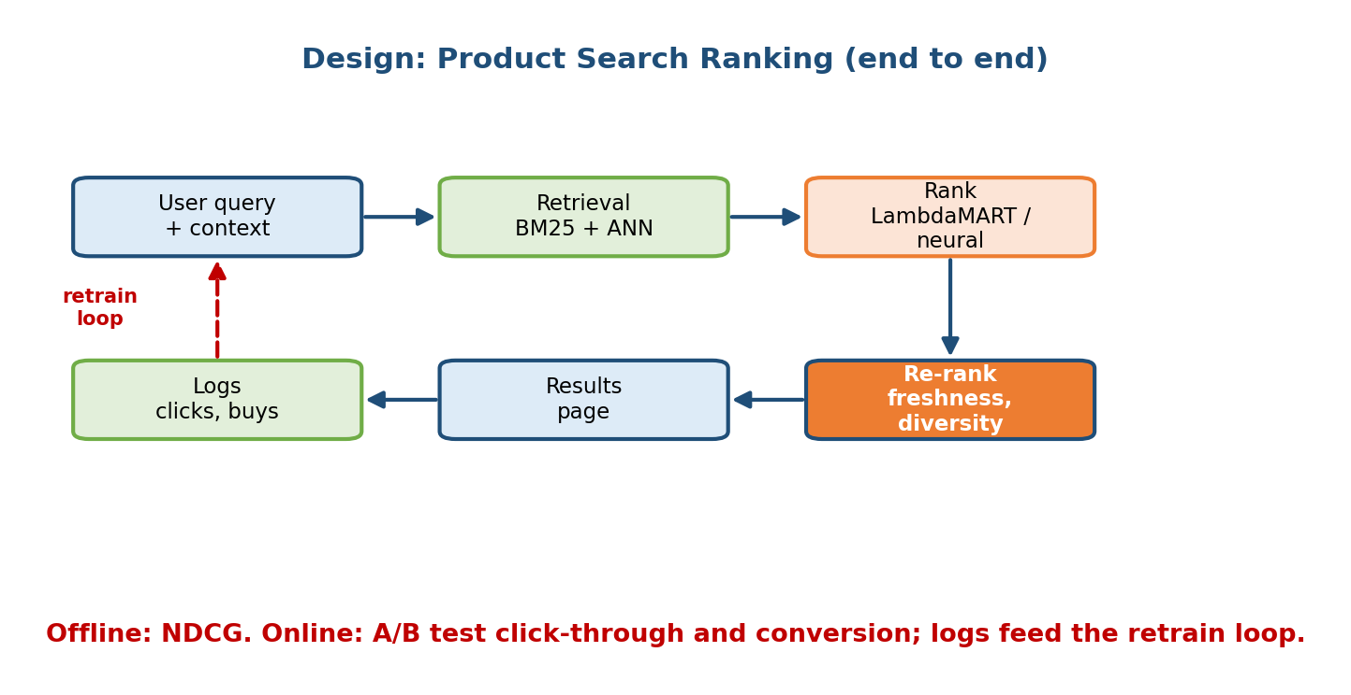
End-to-end product search ranking design. A user query plus context goes to retrieval (BM25 + ANN), then to a rank stage (LambdaMART or neural), then to a re-rank stage for freshness and diversity, producing the results page. Logs of clicks and purchases feed a retrain loop back to the model. Offline evaluation uses NDCG; online uses A/B tests of click-through and conversion.
Step 1 — Clarify requirements & framing. Business goal: increase purchases / revenue, not just clicks. Scale: 100M products, 10k QPS peak, p99 latency budget ~150 ms. Freshness: new products and price changes should surface within minutes. Both text and structured signals (price, rating, stock) matter.
Step 2 — Frame as ML problem. Ranking task: given (query, user, candidate products), predict a relevance/purchase score to order the results. Labels: from logged clicks and purchases (with position-bias correction), plus periodic human relevance judgments.
Step 3 — Data. Query logs, click/add-to-cart/purchase events, product catalog (title, description, category, price, ratings, stock), and user history. Watch for leakage (don’t use post-click signals as features) and feedback loops.
Step 4 — Features & retrieval. Build an inverted index (BM25) and a dense two-tower index (ANN) over product embeddings — hybrid retrieval. Query understanding (spell-fix, synonyms, entity detection) runs first. Features for ranking: BM25 score, dense similarity, price, rating, popularity, freshness, personalization (user–category affinity), query–product category match.
Step 5 — Model & multi-stage serving. Use the funnel: retrieval (BM25 + ANN) → pre-rank (light GBDT / two-tower dot product) → rank (LambdaMART, directly optimizing NDCG, or a neural ranker if data is huge) → re-rank for diversity (limit results per seller), freshness boosts, and business rules (sponsored placements, out-of-stock demotion).
Step 6 — Evaluation. Offline: NDCG@10 and MAP on held-out judged queries. Online: A/B test conversion rate, revenue per search, and query abandonment — the offline metric only gates which models reach the A/B test.
Step 7 — Deploy, monitor, iterate. Serve behind a low-latency service (cross-link M8/M11); precompute product embeddings in batch, re-rank online. Monitor CTR/conversion, latency tails, and drift (M10) as the catalog and trends change. Logs feed the retrain loop — closing the flywheel from Module 1.

Module 13 — Interview Mapping (what companies probe)
Company | How Module 13 shows up | Junior answer | Staff answer
Google | “Design web search ranking” | Jumps to a neural ranker | BM25 baseline → LTR → hybrid dense → multi-stage funnel with latency budget
Amazon | “Design product search” (Customer Obsession) | Optimizes CTR only | Optimizes purchase/revenue, handles exact-match part numbers, diversity by seller
Meta / LinkedIn | Feed / people / job search ranking | Ignores personalization | Adds user features, freshness, and guards against feedback loops
OpenAI / Anthropic | Retrieval for RAG | Uses only dense retrieval | Hybrid BM25 + dense, reranker, cites ANN recall/latency trade-off
The single most common opening: “How would you design search ranking for X?” Your first 90 seconds: (1) clarify the business metric and latency budget, (2) name BM25 as the retrieval baseline, (3) draw the multi-stage funnel. That structure alone separates you from most candidates.

Module 13 — Exam Mapping (SEBI / RBI / GATE / ISRO)
- GATE CS / DA: information retrieval basics appear — inverted index, TF-IDF, precision/recall, and sometimes cosine similarity. Know the TF-IDF formula and how an inverted index answers a query. (Sections 13.1, 13.6.)
- SEBI IT / RBI IT: occasional definitional IR questions (what is an inverted index, TF-IDF). Learning-to-rank and system-design depth are interview-only.
- ISRO / DRDO: rare; at most basic IR definitions.
Flag: the scoring formulas (TF-IDF, BM25, NDCG/DCG) and the inverted index carry the most exam value; the funnel, LTR families, and dense retrieval are primarily interview / role material.

Module 13 — Common Mistakes & Misconceptions
- “Just use embeddings for everything.” Dense retrieval misses exact matches (part numbers, rare names). Hybrid BM25 + dense is stronger. (Section 13.3.)
- “Skip the BM25 baseline.” BM25 is cheap, interpretable, and hard to beat on head queries — always the baseline. (Section 13.1.)
- “Run the big model on all candidates.” Impossible under latency; you need the multi-stage funnel. (Section 13.4.)
- “Optimize accuracy / CTR.” Ranking is about order (NDCG) and the business metric (conversion, revenue), not classification accuracy or raw clicks. (Sections 13.2, 13.6.)
- “Offline NDCG win = ship it.” The offline–online gap is real; confirm with an A/B test. Clicks are position-biased. (Section 13.6.)
- “Pointwise is enough.” Pairwise/listwise (RankNet, LambdaMART) match the ranking objective far better because they model relative order. (Section 13.2.)
- “Personalization is free.” It can create filter bubbles and feedback loops that amplify what the model already shows. (Section 13.5.)

Module 13 — MCQs (with answers & explanations)
Q1. An inverted index maps: a) documents → the words they contain b) words → the list of documents that contain them c) queries → users d) documents → their length
Answer
b. A term maps to its posting list of documents. This turns “which docs contain this word?” into an instant lookup, which is why keyword search is fast.
Q2. Why does BM25 usually beat plain TF-IDF? a) It uses a neural network b) It saturates term frequency and normalizes by document length c) It ignores rare words d) It needs no index
Answer
b. BM25 adds a saturation term (via $k_{1}$) so repetition has diminishing returns, and length normalization (via $b$) so long documents don’t unfairly win. TF-IDF grows linearly and ignores length.
Q3. Which learning-to-rank method directly ties its gradient to the change in NDCG from swapping two documents? a) Pointwise regression b) RankNet c) LambdaRank / LambdaMART d) BM25
Answer
c. LambdaRank scales the pairwise gradient by |ΔNDCG|; LambdaMART combines those gradients with boosted trees, so it chases NDCG directly.
Q4. In a dual-encoder (two-tower) retrieval system, at query time you: a) re-encode all documents b) encode only the query and search an ANN index of precomputed doc vectors c) run BM25 only d) train the model
Answer
b. Document vectors are precomputed and indexed offline; online you encode the query once and do an approximate nearest-neighbour search. This is the two-tower pattern from Module 12.
Q5. In the multi-stage funnel, which stage spends the most compute per candidate? a) Retrieval b) Pre-rank c) Rank d) All equal
Answer
c. Rank sees the fewest candidates (~100 → ~10) so it can afford the heaviest model with the most features. Retrieval is cheap-and-broad.
Q6. A ranking returns relevance grades [3, 2, 3, 0]. Using linear gain and $\log_{2}(1+\text{rank})$ discount, the DCG is: a) 8.0 b) 5.76 c) 5.89 d) 3.00
Answer
b. $3/1.00+2/1.58+3/2.00+0=3.00+1.26+1.50+0=5.76$. (Dividing by IDCG = 5.89 gives NDCG ≈ 0.98.)
Q7. Approximate Nearest Neighbour (ANN) search trades a small amount of ______ for a large gain in ______. a) latency; accuracy b) accuracy (recall); speed c) memory; correctness d) cost; documents
Answer
b. ANN returns almost the true nearest neighbours much faster than brute force. You tune recall vs latency vs memory (HNSW, IVF, PQ) — the domain of vector DBs in Module 16.
Q8. Which is the strongest reason to use hybrid (BM25 + dense) retrieval? a) It is cheaper than either alone b) Dense catches semantic matches while BM25 catches exact matches c) It removes the need for ranking d) It avoids building an index
Answer
b. They are complementary: dense for synonyms/meaning (torso/tail queries), sparse/BM25 for exact tokens (head queries like part numbers). Merge the lists before ranking.

Module 13 — Design Exercises (easy → hard)
- Easy. Given three short documents, build the inverted index by hand, then list which documents a query of two words would retrieve (intersection).
- Easy. For the ranking [2, 3, 0, 1], compute DCG@4 with linear gain, then the IDCG and NDCG.
- Medium. You have 100M products and a 120 ms p99 budget. Sketch the multi-stage funnel: name the method and candidate count at each stage, and give a rough latency for each.
- Medium. A query “cheap flights to blr” returns poor results. Which query understanding steps (spell, synonym, entity, intent) would you add, and what new ranking features do they enable?
- Hard. Design retrieval for a RAG chatbot over 10M internal documents. Choose sparse, dense, or hybrid; pick an ANN index; state the recall vs latency trade-off and how you’d add a reranker.
- Hard. Your new ranker lifts offline NDCG@10 by 4% but loses the online A/B test on conversion. Give three plausible causes and how you’d diagnose each (hint: position bias, offline label source, freshness, diversity).

Module 13 — Concept Review (one page)
- Inverted index = term → posting list of docs; makes keyword search fast. Built offline, read at query time.
- TF-IDF = term frequency × inverse document frequency; rewards rare, repeated terms. BM25 adds saturation ($k_{1}$) and length normalization ($b$), so it ranks better and is the keyword baseline.
- Learning to Rank: pointwise (score each doc), pairwise / RankNet (order pairs), listwise / LambdaRank & LambdaMART (optimize the list; gradient scaled by ΔNDCG). Listwise best matches the ranking objective.
- Dense retrieval = dual-encoder / two-tower embeds query and docs into one space; ANN finds nearest doc vectors fast (recall vs latency vs memory). Cross-links: two-tower M12, vector DBs M16. Use hybrid BM25 + dense.
- Multi-stage funnel: retrieval (millions→1k, cheap) → pre-rank (1k→100, light) → rank (100→10, heavy) → re-rank (diversity/freshness/rules). Each stage fewer items, more compute each → fits the latency budget.
- Query understanding, personalization, freshness are the signal sources beyond raw text.
- Evaluation: offline NDCG@k (DCG / IDCG), MAP, MRR; online A/B on CTR / conversion / revenue. Mind the offline–online gap and position bias.

Module 13 — Flash Cards (Q → A)
- What does an inverted index map? → Term → posting list of documents.
- BM25’s two knobs? → $k_{1}$ = term-frequency saturation; $b$ = document-length normalization.
- Why BM25 > TF-IDF? → Saturation + length normalization stop over-rewarding repetition and long docs.
- Three LTR families? → Pointwise, pairwise (RankNet), listwise (LambdaMART).
- What does LambdaMART optimize? → NDCG — gradient scaled by ΔNDCG, with boosted trees.
- Dual-encoder online cost? → Encode the query once + ANN search of precomputed doc vectors.
- ANN trades what for what? → A little recall for a lot of speed.
- The four funnel stages? → Retrieval → pre-rank → rank → re-rank.
- NDCG range and idea? → [0,1]; DCG (position-discounted gain) ÷ ideal DCG.
- Why confirm online after offline NDCG? → Offline–online gap; clicks are position-biased.

Module 13 — Pattern Recognition (how to spot it in an interview)
- Hear “design search / ranking for X” → clarify metric + latency → BM25 baseline → multi-stage funnel.
- Hear “results miss synonyms / meaning” → propose dense retrieval (dual-encoder) + hybrid with BM25.
- Hear “we can’t run the big model on everything” → draw the funnel; cheap retrieval first, heavy rank last.
- Hear “which ranking model?” → LambdaMART for tabular features (optimizes NDCG); deep ranker only with huge data.
- Hear “how do you measure it?” → NDCG@k offline, A/B on conversion online; warn about position bias.
- Hear “serve at scale / low latency” → precompute doc embeddings in batch, ANN retrieval, re-rank online (hybrid).
- Hear “results feel stale / same items” → freshness features + diversity in re-rank; watch feedback loops.

Module 13 — Revision Notes / Mini Cheat Sheet
SEARCH = RETRIEVE candidates -> RANK them -> RE-RANK for rules/diversity
IR BASELINE:
inverted index: term -> posting list of docs (fast lookup, built offline)
TF-IDF = tf * log(N/df) (linear TF, no length norm)
BM25 = TF-IDF + saturation(k1) + length-norm(b) <- beats TF-IDF, the baseline
LEARNING TO RANK:
pointwise -> score each doc alone (regression)
pairwise -> order of doc PAIRS (RankNet)
listwise -> whole LIST, optimize NDCG (LambdaRank / LambdaMART) <- strongest
DENSE / SEMANTIC:
dual-encoder (two-tower, M12): query vec . doc vec
doc vectors precomputed + indexed; ANN search (HNSW/IVF/PQ, M16)
ANN = trade recall for speed; HYBRID = BM25 + dense (exact + meaning)
FUNNEL (latency budget!): millions -> 1000 -> 100 -> 10
retrieval(cheap) -> pre-rank(light) -> rank(heavy) -> re-rank(rules)
SIGNALS: query-understanding (spell/intent/synonym) | personalization | freshness
EVAL: offline NDCG@k = DCG/IDCG , MAP, MRR ; online A/B: CTR / conversion
beware offline-online gap + click position bias

Next module: Module 14 — Recommendation Systems at Scale. We build on the retrieval + ranking funnel from this module and specialize it for recommendations: candidate generation, collaborative filtering, matrix factorization, deep recommenders, and the cold-start problem — the other half of the “retrieve-then-rank” world.

