Module 15 — NLP Systems
  - ML System Design Mastery: FAANG / AI-Engineer / Staff-Level — In-Depth Notes (with visuals)
Prepared for nidhi.sharma@forensiccybertech.com
2026
Table of Contents

Module 15 — NLP Systems
Why this module exists. A huge share of the world’s data is text: emails, reviews, chat messages, support tickets, search queries, legal documents. Natural Language Processing (NLP) is how we turn that messy human language into something a machine can reason about. Almost every product you use runs NLP somewhere — spam filters, autocomplete, search, translation, sentiment dashboards. This module builds the classic and BERT-era NLP mental model from first principles: how text becomes numbers, how embeddings evolved, how the main tasks are framed, and how you serve an NLP model under a real latency budget.
Scope note. Large Language Models (GPT-style, prompting, RAG, fine-tuning) get their own deep treatment in Module 16. Here we deliberately stay on the foundations — tokenization, embeddings, classic tasks, semantic search, and serving — because these ideas are what LLMs are built on top of, and they are what interviews and exams still test directly.
Importance ratings (out of 5):
Exam / Use | SEBI IT | RBI IT | GATE CS/DA | Interview | AI/MLE role
This module | ★★ | ★★ | ★★★ | ★★★★★ | ★★★★★
What you must be able to do after this module: explain the full text pipeline (clean → tokenize → embed → model) and why text must become numbers; compare word / subword-BPE / character tokenization and say why subword won; tell the embeddings story (word2vec → GloVe → BERT → modern) and crisply distinguish static vs contextual embeddings; frame the core tasks (classification, sentiment, NER, QA, summarization, translation) as either “predict a label/tag” or “generate a sequence”; design semantic search with embeddings + cosine similarity; reason about NLP serving latency (tokenization cost, sequence length, the n² attention wall); and sketch end-to-end designs for spam/abuse detection, support-ticket routing, and autocomplete.
How to read this module. As always we go problem → simplest attempt → why it breaks → the fix, in plain English, and we tie every idea to how it shows up in a real interview or exam.

15.1 The Text Pipeline — Why Text Must Become Numbers

Motivation (the problem that existed)
A model — any model, from logistic regression to a transformer — does arithmetic on numbers. It multiplies, adds, and compares floating-point values. But a user hands you "I love it". A computer cannot multiply the word love. So the very first problem in every NLP system is: how do we turn a string of characters into an array of numbers without throwing away the meaning?
That single question drives the whole pipeline. Every stage below exists to move one step closer to “meaningful numbers”, and every stage costs time and memory that you will later have to defend in a serving-latency discussion.

The pipeline, stage by stage
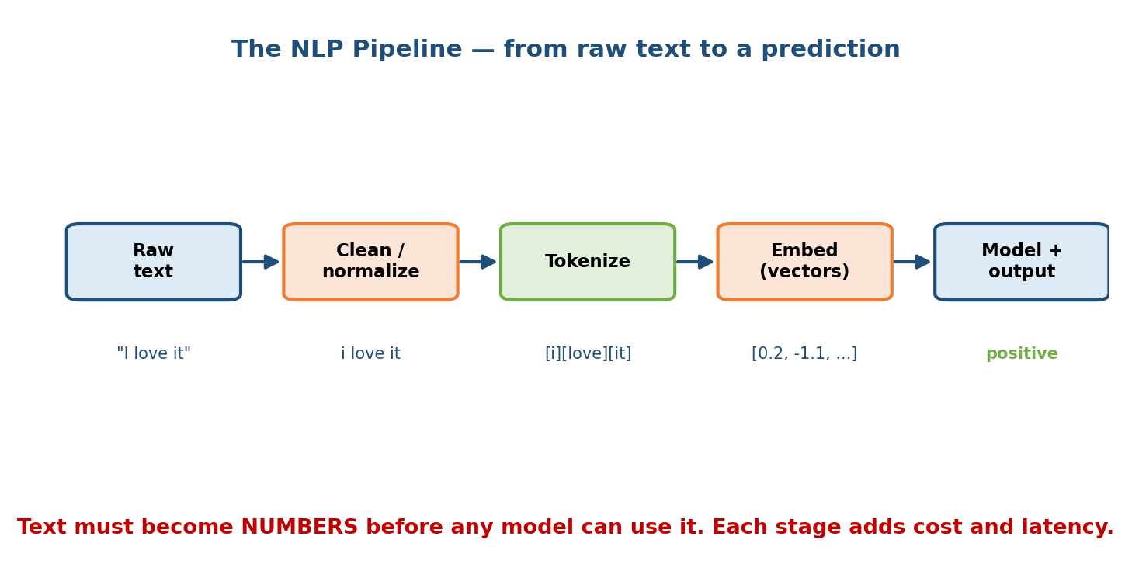
The NLP pipeline: raw text is cleaned/normalized, split into tokens, mapped to embedding vectors, then fed to a model that produces the output.
- Raw text. The input as it arrives: "I love it", possibly with emojis, HTML, mixed case, typos, and multiple languages.
- Clean / normalize. Lowercase, strip HTML, fix encoding, maybe remove accents or expand contractions. Be careful: lowercasing “US” (the country) to “us” can destroy meaning — normalization is a design choice, not a reflex.
- Tokenize. Split the text into small units (tokens) — words or pieces of words. "I love it" → [i] [love] [it]. Each token maps to an integer id from a fixed vocabulary.
- Embed. Look up (or compute) a dense vector for each token id, e.g. [0.2, -1.1, 0.7, ...]. This is where meaning finally becomes numbers.
- Model + output. Feed the vectors to a model that produces the answer — a label (positive), a tag per token, or generated text.

First-principles: why not just use ASCII codes?
A naive idea: “the letter a is 97, so just feed character codes.” This fails because those numbers carry no semantic relationship — 97 and 98 (a and b) are close numerically but unrelated in meaning, while “good” and “great” are close in meaning but would be far apart as raw codes. The whole point of the pipeline is to produce numbers where distance ≈ difference in meaning. That is exactly what embeddings (Section 15.3) give us.
Senior signal: every box in this pipeline is a latency and failure surface. Mentioning “and this is where training-serving skew sneaks in — the cleaning and tokenization must be identical offline and online” (see M05) marks you as someone who has shipped NLP, not just trained it.

15.2 Tokenization — Word, Subword (BPE), Character

Motivation
Tokenization decides your vocabulary — the fixed list of tokens the model knows. Get it wrong and you either have a giant, brittle vocabulary or hopelessly long sequences. Three strategies compete.
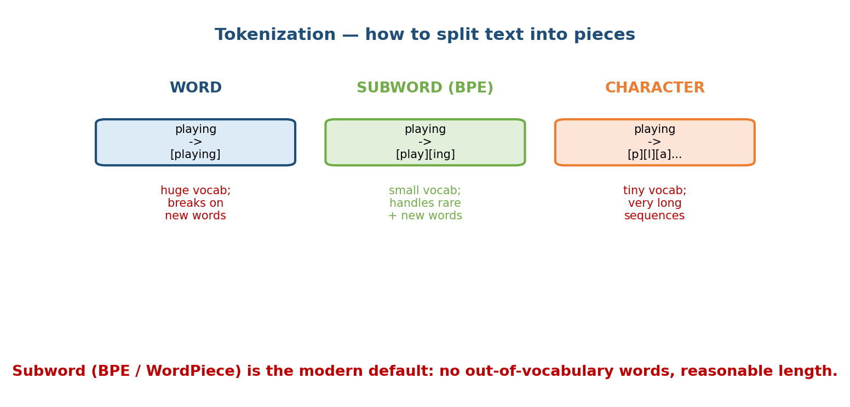
Three tokenization strategies: word-level (huge vocab, breaks on new words), subword/BPE (small vocab, handles rare and new words), and character-level (tiny vocab, very long sequences).

The three strategies
1. Word-level. One token per word: playing → [playing].
- Problem: the vocabulary must contain every word form — play, plays, played, playing are four separate entries. Real languages have millions of word forms, so the vocabulary explodes. Worse, any word not seen in training is an out-of-vocabulary (OOV) token — the model literally has no vector for it, so it maps everything unknown to a single <UNK> and loses the meaning.
2. Subword / Byte-Pair Encoding (BPE). Split rare words into reusable pieces: playing → [play] [ing].
- BPE starts from characters and greedily merges the most frequent adjacent pairs until it reaches a target vocabulary size (say 30k–50k pieces). Common words stay whole (the, play); rare words break into known pieces (tokenization → token + ization). WordPiece (used by BERT) and SentencePiece are close cousins.
- Why it won: no OOV problem (any string can be built from pieces), a small fixed vocabulary, and reasonable sequence lengths. This is the modern default.
3. Character-level. One token per character: playing → [p][l][a][y]....
- Tiny vocabulary (~100 symbols), literally never OOV — but sequences become very long (a 5-word sentence is ~30 tokens instead of 5), which makes the model slower and forces it to learn spelling from scratch.

Why sequence length matters later
Hold onto one number: tokens-per-input. It appears again in Section 15.6 because model cost usually grows with sequence length (often ~n² for attention). Character-level maximizes length; word-level minimizes it; subword sits in the sweet spot. This is not an accident — it is the trade-off subword was designed to win.
Exam pointer (GATE DA): know that BPE is a data-driven, frequency-based merging algorithm and that it eliminates OOV by falling back to smaller pieces.

15.3 Embeddings — How Words Become Vectors

Motivation
We can now turn text into token ids. But an id like 4173 is just a name — it has no meaning. We want a vector where similar words sit close together, so the model can generalize: if it learns something about “good”, it should partly transfer to “great”. That vector is an embedding. The history of NLP is largely the history of better embeddings.
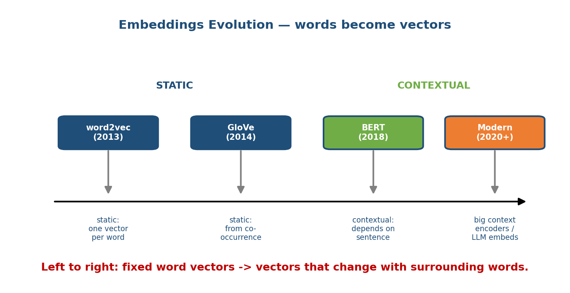
Embeddings evolution timeline: word2vec (2013, static) and GloVe (2014, static) give one fixed vector per word; BERT (2018) and modern encoders (2020+) give contextual vectors that depend on the whole sentence.

The story, left to right
- word2vec (2013). Learn a vector per word by predicting nearby words (the “you shall know a word by the company it keeps” idea). Famous result: king − man + woman ≈ queen — meaning shows up as directions in vector space. It is static: one vector per word, fixed forever.
- GloVe (2014). Same static idea, but learned from a global co-occurrence matrix (how often words appear together across the whole corpus) rather than local windows. Also one vector per word.
- BERT (2018). A transformer that reads the whole sentence and produces a vector for each word in context. This is contextual: the same word gets different vectors in different sentences. Trained by masking words and predicting them (“masked language modelling”).
- Modern (2020+). Larger context encoders and sentence/embedding models (e.g. sentence-transformers, and the embedding endpoints of LLM providers). These power today’s semantic search. Their generative cousins are Module 16.

Static vs contextual — the single most-tested distinction
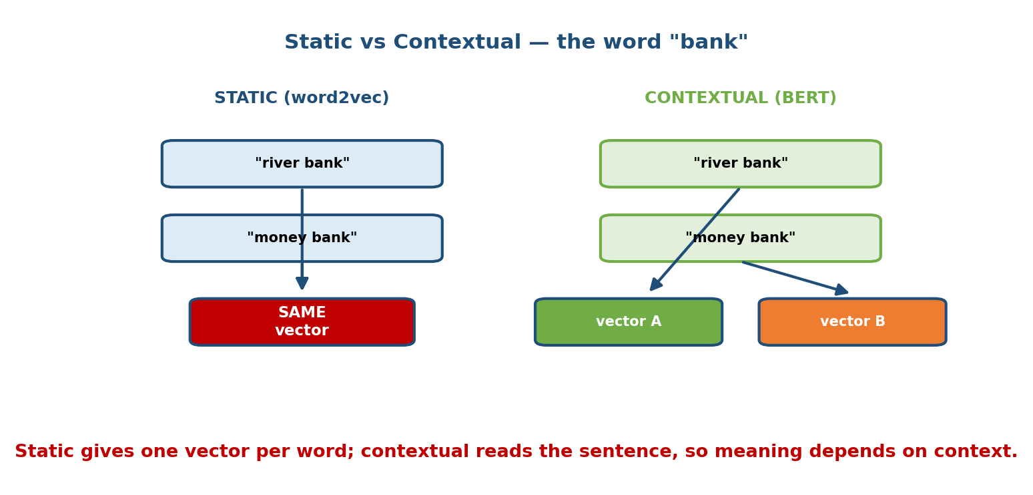
The word “bank”: a static model gives the SAME vector for “river bank” and “money bank”; a contextual model reads the sentence and produces different vectors (A vs B) for the two meanings.
- Static (word2vec, GloVe): the word bank has one vector, no matter what. So “river bank” and “money bank” collapse to the same point — the model cannot tell the two meanings apart. Cheap (just a lookup table), fast, and often good enough for simple classification.
- Contextual (BERT): the model reads the surrounding words, so bank in “river bank” gets vector A and bank in “money bank” gets vector B. This resolves ambiguity (polysemy) but costs a full model forward pass, not a table lookup — which is exactly why contextual models are slower to serve.
Interview line that lands: “word2vec is a dictionary — one entry per word. BERT is a reader — it re-reads the sentence every time, so the same word can mean different things.” That one sentence shows you truly understand the leap.

15.4 Core NLP Tasks — How Each Is Framed

Motivation
Interviewers rarely ask “what is NER” — they ask “how would you frame this as an ML problem?” The skill is recognizing which of a few standard shapes a business request maps to. There are two big families.
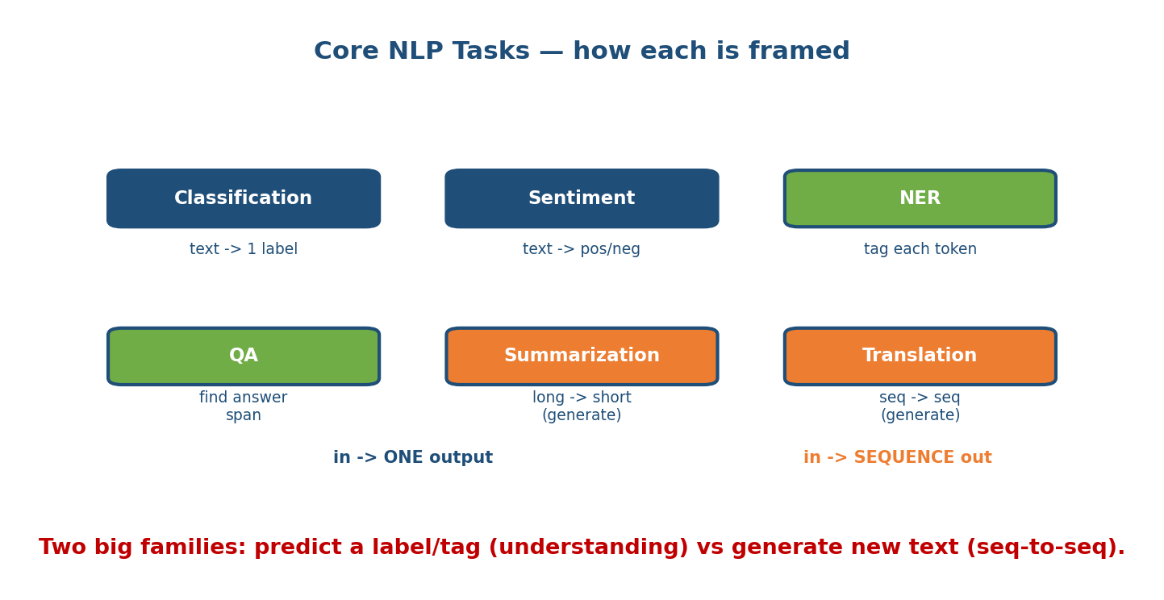
Core NLP tasks: classification, sentiment, and NER map text to a label or per-token tag (understanding); QA, summarization, and translation produce a sequence of new text (generation).

Family A — predict a label or tag (“understanding”)
- Text classification. Whole input → one label from a fixed set. Examples: spam vs not-spam, topic = {sports, politics, tech}. Framed as supervised classification; metric is precision/recall/F1 (M07).
- Sentiment analysis. A special case of classification: text → {positive, negative, neutral}, or a 1–5 star score (then it is ordinal/regression).
- Named Entity Recognition (NER). Tag each token: label every word as Person / Organization / Location / Other. This is sequence labelling (one prediction per token, usually with a BIO tagging scheme). Powers “extract all company names from these filings”.

Family B — generate a sequence (“generation” / seq-to-seq)
- Question Answering (QA). Two flavours: extractive QA finds the answer as a span inside a given passage (predict start and end token — still an understanding task); generative QA writes a free-form answer (M16).
- Summarization. Long document → short summary. Extractive picks existing sentences; abstractive generates new text. A sequence-to-sequence task.
- Machine translation. Sequence in one language → sequence in another. The original poster-child for the encoder-decoder (seq-to-seq) architecture.

First-principles: why the split matters for design
The family decides your output layer, metric, and cost. Family A ends in a softmax over a small label set — cheap, easy to evaluate (F1/accuracy). Family B generates tokens one at a time — expensive at serving time, and hard to evaluate (you need metrics like BLEU/ROUGE, or human review). When an interviewer offers a vague task, first classify it into A or B: it instantly tells you the model shape, the metric, and the latency profile.

15.5 Search & Semantic Similarity

Motivation
Keyword search matches strings: a query for “car” misses a document that only says “automobile”. Humans mean the same thing; the letters differ. Semantic search fixes this by comparing meaning instead of characters — and meaning, as we just learned, lives in embedding vectors.
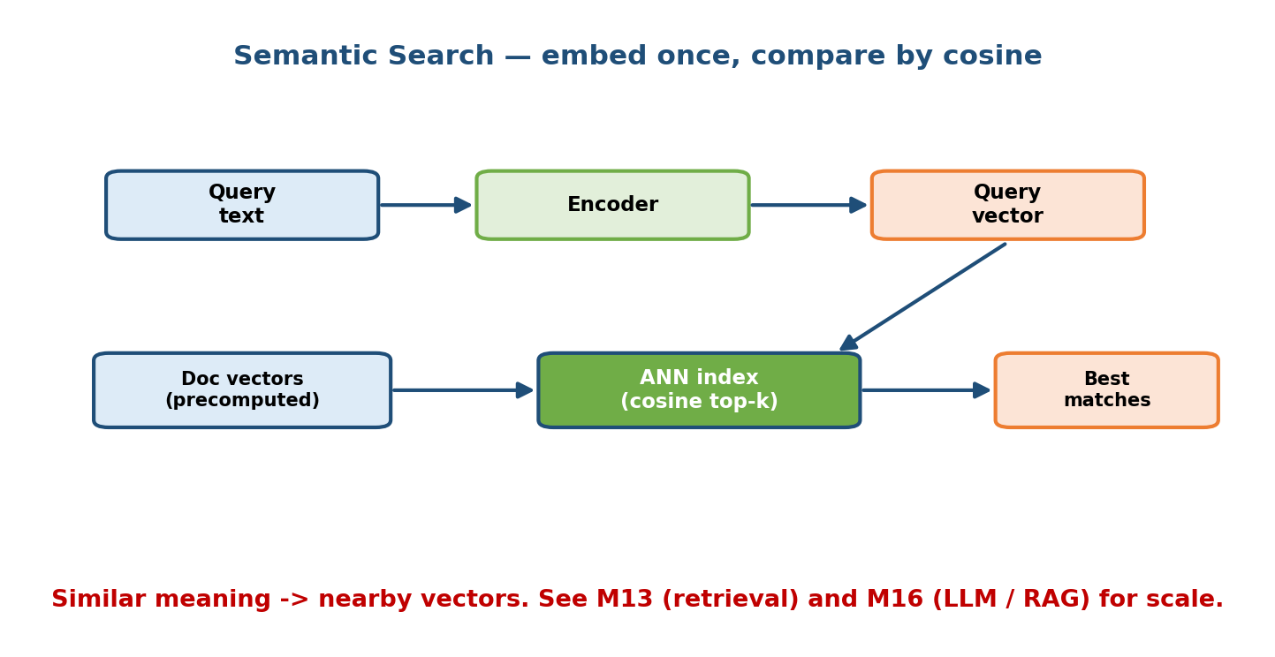
Semantic search: the query text goes through an encoder to a query vector; document vectors are precomputed; an ANN index finds the top-k nearest by cosine similarity and returns the best matches.

The core idea: embed everything, compare by cosine
- Embed the documents once, offline. Run every document through an encoder and store its vector. This is precomputed — you pay for it in batch, not at query time.
- Embed the query live. When a query arrives, encode it to a vector.
- Compare by cosine similarity. Two vectors that point in the same direction have cosine ≈ 1 (very similar); perpendicular ≈ 0 (unrelated). Cosine ignores length and cares only about direction, which is what we want for meaning.
- Return the top-k nearest. The most similar document vectors are the best semantic matches.

Why you need an ANN index (the scaling problem)
Comparing the query to every document (exact nearest neighbour) is O(N) per query — fine for thousands of docs, hopeless for billions. So we use an Approximate Nearest Neighbour (ANN) index (HNSW, IVF, ScaNN) that finds almost the closest vectors in roughly logarithmic time, trading a tiny bit of accuracy for a massive speed-up. This is the heart of a vector database.
Cross-links: retrieval and ANN indexes are covered in depth in Module 13 (retrieval / recommendation candidate generation), and this exact embed-and-retrieve pattern is the “R” in RAG in Module 16. Semantic search is the bridge between classic NLP and modern LLM systems.

15.6 Serving NLP Models & Latency

Motivation
You can train a beautiful model and still fail the interview if you cannot serve it inside a latency budget. NLP serving has costs that classic tabular models don’t — and the biggest one is hidden in a variable you already met: sequence length.
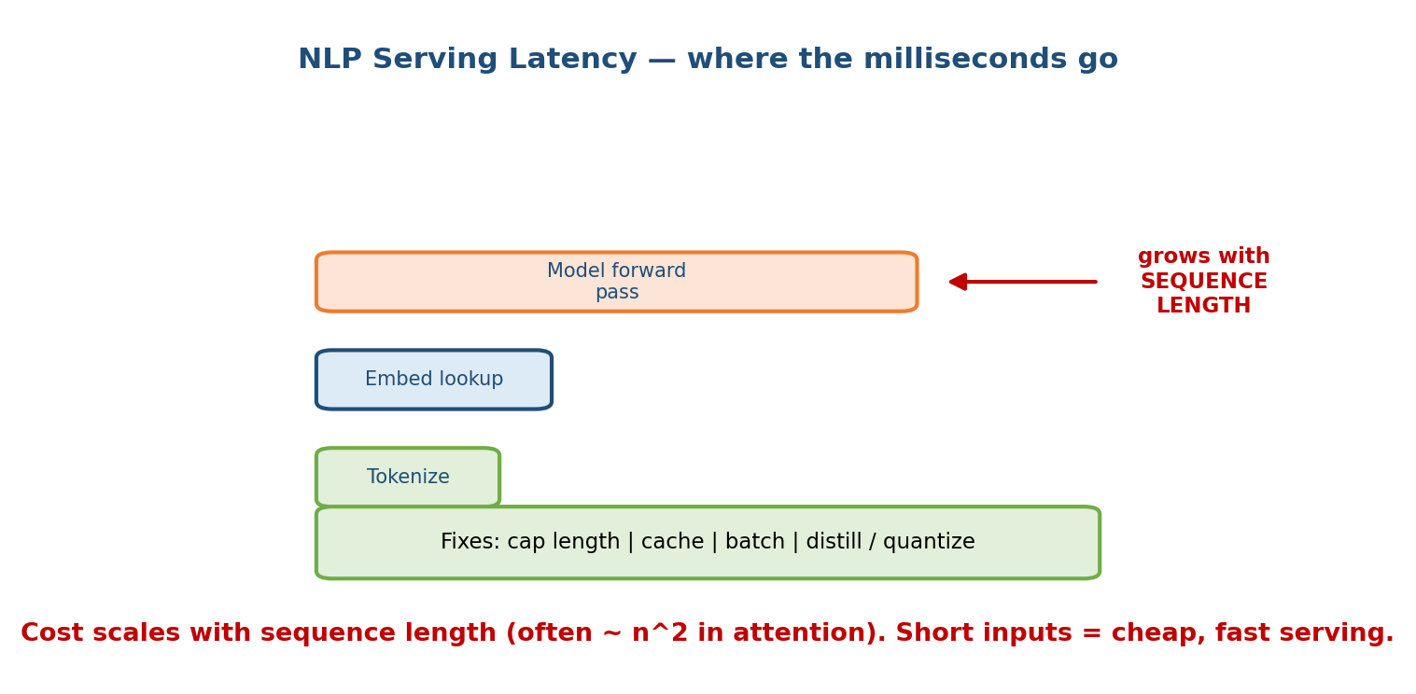
NLP serving latency breakdown: tokenization and embedding lookup are cheap; the model forward pass dominates and grows with sequence length. Fixes: cap length, cache, batch, distill/quantize.

Where the milliseconds go
- Tokenization cost. Usually cheap, but not free — and it must run on the exact same code path as training to avoid training-serving skew (M05). At very high QPS, tokenization can become a measurable slice.
- Embedding lookup. For static embeddings, a fast table lookup. For contextual models it is fused into the forward pass.
- Model forward pass — the dominant cost. For transformer/BERT-style models, self-attention is roughly O(n²) in the number of tokens n. Double the sequence length and you roughly quadruple the compute. This is the single most important serving fact in this module.

The levers you pull to hit a budget
- Cap / truncate sequence length. Most tickets, reviews, and queries are short; setting a max length (e.g. 128 or 256 tokens) bounds the worst case.
- Cache. Many queries repeat — cache embeddings for popular inputs, and cache document vectors permanently (they don’t change).
- Batch requests. GPUs love parallelism; grouping requests raises throughput (at a small latency cost — a classic throughput-vs-latency trade).
- Shrink the model. Distillation (train a small model to mimic a big one, e.g. DistilBERT) and quantization (use 8-bit instead of 32-bit numbers) cut latency and memory. (Covered as serving optimizations in M08.)
Senior signal: the crisp statement “attention is O(n²), so my first lever is capping sequence length, then batching, then distillation” connects the ML internals to a concrete serving plan. That linkage is exactly what staff-level interviews reward.

15.7 Case Studies (short 7-step sketches)
Below are three compact end-to-end sketches. Each follows the same rhythm: frame → data → features/tokens → model → serve → guardrail → feedback.

Case A — Spam / abuse detection
- Frame. Binary text classification: message → {spam/abuse, ok}. (Family A.)
- Data. Historical messages with labels from user reports + moderator decisions. Beware class imbalance (spam is rare).
- Tokens/features. Subword tokens + light metadata (sender age, links, repetition).
- Model. Start with a simple baseline (logistic regression on TF-IDF or averaged embeddings); upgrade to a fine-tuned BERT if it earns its cost.
- Serve. Online, low latency (block before the message is shown). Short inputs → cheap.
- Guardrail. Tune the threshold by cost of being wrong (M01): a false positive silences a real user, a false negative lets abuse through. Send borderline cases to human moderators.
- Feedback. Adversaries adapt (spammers obfuscate), so this drifts fast — monitor and retrain frequently on fresh reports.

Case B — Support ticket routing
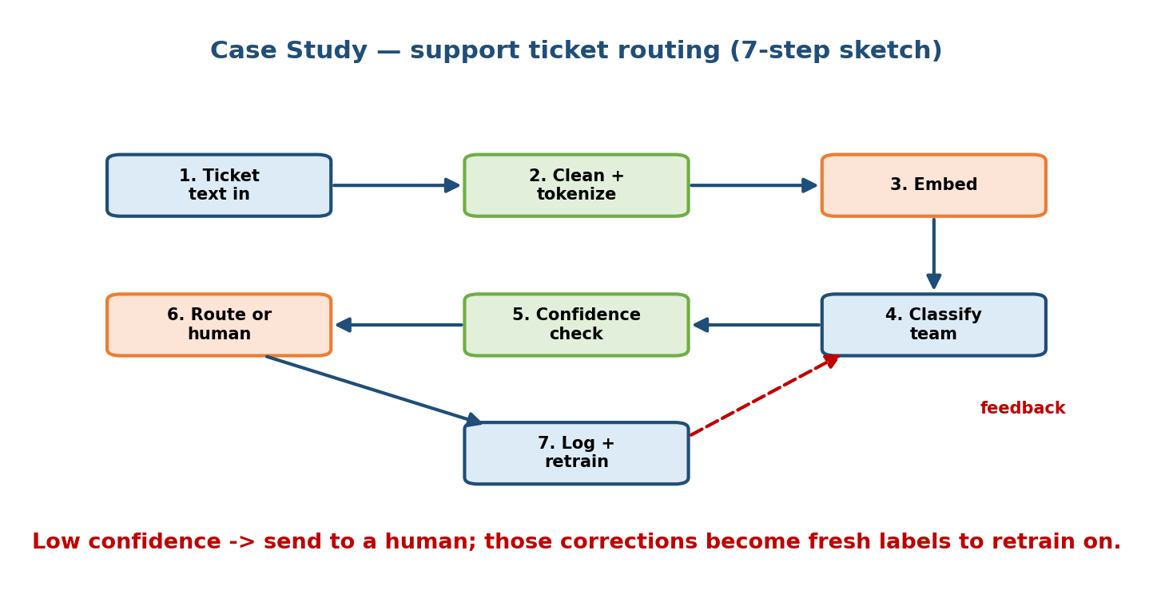
Support ticket routing as a 7-step loop: ticket text in → clean+tokenize → embed → classify team → confidence check → route or send to human → log+retrain, with a feedback arrow returning corrections to the model.
- Ticket text in. A customer writes a free-form problem.
- Clean + tokenize. Normalize and subword-tokenize.
- Embed. Encode to a vector.
- Classify team. Multi-class classification → {billing, tech, returns, …}.
- Confidence check. Look at the top class probability.
- Route or human. High confidence → auto-route; low confidence → a human triages it (keep a human in the loop where the model is unsure).
- Log + retrain. Human corrections become fresh labels — the dashed feedback arrow — which retrain the model and steadily shrink the “send to human” pile. This is the data flywheel (M01) in miniature.

Case C — Autocomplete / next-word suggestion
- Frame. Predict the next token(s) given the prefix typed so far — a generation task, but small and local.
- Data. Anonymized past queries / typed text; heavy use of frequency.
- Tokens. Subword or word-level over a prefix.
- Model. Often a lightweight n-gram / small language model — because…
- Serve. …the latency budget is brutal: suggestions must appear within a few ms per keystroke. This is why autocomplete frequently runs on-device (M01) and stays small.
- Guardrail. Filter offensive/unsafe completions; never suggest private data.
- Feedback. Which suggestion the user accepts is a strong training signal — but beware the feedback loop: only suggesting popular completions makes them even more popular.

Module 15 — Interview Mapping (what companies probe)
Company | How Module 15 shows up | Junior answer | Staff answer
Google / Meta | “Design a system to detect toxic comments / route messages” | Jumps to “fine-tune BERT” | Frames task family, starts with a cheap baseline, plans threshold by cost of error, monitors for drift
Amazon | “Classify / route millions of support tickets” | Talks model only | Ties to Customer Obsession, adds human-in-loop for low confidence, feedback loop for retraining
OpenAI / Anthropic | Tokenization, static vs contextual embeddings, why subword | Vague on tokenization | Explains BPE eliminates OOV, static vs contextual with the “bank” example, forward-links to LLMs (M16)
Uber / Stripe | “Semantic search over docs” or “fraud from text” | Keyword match / one big model | Embed + cosine + ANN index, caps sequence length, discusses p99 latency and O(n²) attention
Common opener: “How would you build an NLP system for X?” Your first move: (1) classify the task into label/tag vs generate; (2) name the pipeline (clean → tokenize → embed → model); (3) propose a simple baseline first (TF-IDF + logistic regression) before any transformer; (4) call out latency and drift. That structure alone beats most candidates.

Module 15 — Exam Mapping (SEBI / RBI / GATE / ISRO)
- SEBI IT / RBI IT: may ask definitional NLP items — what is tokenization, what is an embedding, what is sentiment analysis, bag-of-words vs word embeddings. Sections 15.1–15.3 cover these.
- GATE CS / DA: the DA paper can test tokenization (BPE), word embeddings (word2vec skip-gram/CBOW idea, GloVe co-occurrence), TF-IDF, and the static-vs-contextual distinction. Cosine similarity for text is fair game.
- ISRO / DRDO: occasional basic NLP definitions and TF-IDF / vector-space model questions.
Flag: the system design parts (serving latency levers, ANN indexes, case-study architectures) are largely interview-only. The concept parts (tokenization, embeddings, tasks, cosine similarity) carry the exam value.

Module 15 — Common Mistakes & Misconceptions
- “word2vec understands context.” No — word2vec/GloVe are static: one fixed vector per word. Context awareness starts with BERT. (Section 15.3.)
- “Word-level tokenization is fine.” It explodes the vocabulary and breaks on any unseen word (OOV). Subword/BPE is the modern default. (Section 15.2.)
- “Semantic search is just keyword matching.” Keyword matches characters; semantic search matches meaning via embeddings + cosine similarity.
- “Bigger transformer = better.” Often a TF-IDF + logistic-regression baseline is faster, cheaper, and good enough — and it tells you if ML even helps. Start simple.
- “Latency doesn’t depend on the input.” Transformer cost grows ~O(n²) with sequence length; long inputs are expensive. Cap the length. (Section 15.6.)
- “Train the tokenizer one way, serve another.” That is training-serving skew — cleaning and tokenization must be identical on both paths. (M05.)
- “Sentiment is always positive/negative.” It can be neutral, multi-class, or a 1–5 score (ordinal) — frame it to match the business need.

Module 15 — MCQs (with answers & explanations)
Q1. Which statement best distinguishes static from contextual embeddings? a) Static embeddings are larger vectors b) Contextual embeddings give the same word different vectors depending on the sentence c) Static embeddings require a GPU d) Contextual embeddings cannot be used for classification
Answer
b. word2vec/GloVe (static) give one fixed vector per word; BERT (contextual) re-reads the sentence, so “bank” in “river bank” and “money bank” get different vectors.
Q2. Why did subword/BPE tokenization largely replace word-level tokenization? a) It is faster to type b) It eliminates out-of-vocabulary words while keeping the vocabulary small c) It removes the need for embeddings d) It only works for English
Answer
b. Any word can be built from known sub-pieces, so there is no OOV problem, and the vocabulary stays small (~30–50k).
Q3. In semantic search, why is cosine similarity used to compare vectors? a) It measures the length of each vector b) It measures direction (angle), so it captures meaning regardless of magnitude c) It is the only metric a GPU supports d) It requires no embeddings
Answer
b. Cosine looks at the angle between vectors; similar meaning → similar direction → cosine near 1, independent of vector length.
Q4. A transformer’s self-attention cost grows roughly as: a) O(1) b) O(log n) c) O(n) with sequence length d) O(n²) with sequence length
Answer
d. Attention compares every token with every other token, so cost scales ~n². This is why capping sequence length is the first serving lever.
Q5. “Tag each token as Person / Organization / Location” is which task? a) Text classification b) Named Entity Recognition (NER) c) Summarization d) Translation
Answer
b. NER is sequence labelling — one prediction per token — not a single label for the whole text.
Q6. Which is the strongest first move when asked to build a text classifier? a) Fine-tune the largest transformer available b) Build a simple baseline (e.g. TF-IDF + logistic regression) to establish a floor c) Collect no data and start serving d) Use character-level tokenization for speed
Answer
b. A cheap baseline tells you whether ML helps at all and gives a number to beat before you pay for a transformer.
Q7. In the support-ticket routing design, what should happen on a low confidence prediction? a) Auto-route anyway b) Drop the ticket c) Send it to a human, whose correction becomes new training data d) Retrain immediately on that one ticket
Answer
c. Keep a human in the loop where the model is unsure; their corrections are fresh labels that feed the retraining flywheel.
Q8. Autocomplete typically runs on-device with a small model mainly because: a) Phones have more compute than servers b) The per-keystroke latency budget is extremely tight and privacy matters c) On-device models are always more accurate d) It avoids the need for tokenization
Answer
b. Suggestions must appear within a few ms per keystroke, and keeping typed text on the device protects privacy — so the model must be small and local.

Module 15 — Design Exercises (easy → hard)
- Easy. For each, name the task family (label/tag vs generate) and one metric:
  - detect spam; (2) extract all dates from contracts; (3) translate reviews;
  - score reviews 1–5 stars. (1 classification/F1; 2 NER/F1; 3 translation/BLEU; 4 ordinal/MAE.)
- Easy. Given "unbelievable", show how word / subword / character tokenization each split it, and say which produces OOV on an unseen word.
- Medium. Design semantic search over 50 million help-center articles. Specify: what you precompute, what runs per query, the similarity metric, and why you need an ANN index. State a p99 latency target.
- Medium. Your BERT-based ticket classifier meets accuracy but blows the latency budget at peak traffic. List three levers (with trade-offs) to bring p99 down without retraining from scratch.
- Hard. Design an abuse-detection system for a chat app. Cover baseline vs transformer, threshold by cost of error, human review, and how you detect and respond to adversarial drift over weeks.
- Hard. A team wants “smart autocomplete” in a legal editor. Decide on-device vs server, tokenization, model size, the per-keystroke latency budget, and one feedback-loop risk plus how you’d detect it.

Module 15 — Concept Review (one page)
- Pipeline: raw text → clean/normalize → tokenize → embed → model → output. Text must become numbers where distance ≈ difference in meaning.
- Tokenization: word (huge vocab, OOV) · subword/BPE (small vocab, no OOV — the default) · character (tiny vocab, very long sequences).
- Embeddings: word2vec → GloVe (static, one vector per word) → BERT (contextual, vector depends on the sentence) → modern encoders. The “bank” example is the canonical static-vs-contextual illustration.
- Tasks, two families: predict a label/tag (classification, sentiment, NER, extractive QA) vs generate a sequence (summarization, translation, generative QA). The family fixes the output layer, metric, and cost.
- Semantic search: embed docs offline + query live, compare by cosine, retrieve top-k via an ANN index (vector DB). Links to M13 and M16 (RAG).
- Serving: attention is ~O(n²) in sequence length; levers are cap length → cache → batch → distill/quantize. Tokenization must match training (no skew).
- Case studies: spam (fast drift, threshold by cost), ticket routing (confidence → human → retrain), autocomplete (tiny model, on-device, per-key budget).

Module 15 — Flash Cards (Q → A)
- Why must text be tokenized + embedded? → Models do math on numbers; embeddings put meaning into vector distance.
- Word vs subword vs char in one line? → Word = big vocab + OOV; subword = small vocab, no OOV (default); char = tiny vocab, long sequences.
- What does BPE do? → Frequency-based merging of characters into subword pieces; removes OOV.
- Static vs contextual embedding? → Static = one fixed vector per word (word2vec); contextual = vector depends on the sentence (BERT).
- Embeddings timeline? → word2vec → GloVe (static) → BERT (contextual) → modern encoders.
- Two task families? → Predict a label/tag vs generate a sequence.
- How does semantic search compare texts? → Embed both, take cosine similarity, retrieve top-k via an ANN index.
- Biggest NLP serving cost + first lever? → Attention ~O(n²) in sequence length; cap the length first.

Module 15 — Pattern Recognition (how to spot it in an interview)
- Hear “classify / detect / flag text” → Family A; propose a simple baseline first, then BERT if it earns it; threshold by cost of error.
- Hear “extract entities / tag each word” → NER (sequence labelling), F1 metric.
- Hear “summarize / translate / answer” → Family B (seq-to-seq), expensive serving, BLEU/ROUGE or human eval; forward-link to M16 for LLMs.
- Hear “find documents that mean the same thing” → embeddings + cosine + ANN index (semantic search), link to M13/M16.
- Hear “it must respond in a few ms” → sequence-length cap, caching, batching, distillation; maybe on-device.
- Hear “handles emojis / typos / new slang” → subword tokenization, no OOV; and expect drift → monitor + retrain.

Module 15 — Revision Notes / Mini Cheat Sheet
NLP PIPELINE: raw text -> clean/normalize -> TOKENIZE -> EMBED -> model -> output
(goal: numbers where distance ~ difference in meaning)
TOKENIZE: word (huge vocab, OOV) | subword/BPE (small vocab, NO OOV = default)
char (tiny vocab, long sequences) BPE = frequency-based merges
EMBEDDINGS: word2vec -> GloVe = STATIC (one vector per word)
BERT -> modern = CONTEXTUAL (vector depends on sentence)
"bank": static=SAME vector | contextual=A(river) vs B(money)
TASKS (2 families):
label/tag -> classification | sentiment | NER (per-token) | extractive QA
generate -> summarization | translation | generative QA (seq-to-seq)
SEMANTIC SEARCH: embed docs offline + query live -> COSINE similarity
-> top-k via ANN index (vector DB) [links M13, M16 RAG]
SERVING: attention ~ O(n^2) in seq length
levers: CAP length -> cache -> batch -> distill/quantize
tokenizer MUST match training (no train-serve skew)
CASES: spam(fast drift, cost threshold) | tickets(low-conf -> human -> retrain)
autocomplete(tiny model, on-device, per-keystroke budget)
LLMs -> Module 16. This module = classic + BERT-era foundations.

Next module: Module 16 — Large Language Models & LLM Systems. We build on everything here — tokenization, embeddings, and semantic search — and go deep on LLMs: prompting, in-context learning, fine-tuning vs RAG (retrieval-augmented generation), context windows, and how to design and serve LLM-powered systems at scale.

