Module 17 — Flagship Case Studies
  - ML System Design Mastery: FAANG / AI-Engineer / Staff-Level — In-Depth Notes (with visuals)
Prepared for nidhi.sharma@forensiccybertech.com
2026
Table of Contents

Module 17 — Flagship Case Studies
Why this module is the capstone. Everything you have learned so far — the lifecycle (M1), the 7-step framework (M2), framing (M3), data and features (M4–M5), training and evaluation (M6–M7), serving and scale (M8, M11), MLOps and monitoring (M9–M10), and the deep-dive systems (recommendation M12, search M13, and the rest) — was preparation for this. In a real interview you are not asked “explain BM25”; you are asked “design YouTube recommendations” or “design fraud detection for a payments company.” This module is a worked-answer bank: seven flagship systems designed end-to-end with the same 7-step skeleton, plus six more sketched quickly. Study these until the shape of a great answer becomes automatic. The goal is not to memorise these designs — it is to internalise the pattern so you can improvise a strong answer to a system you have never seen. Everything is in plain English, with concrete numbers and honest trade-offs.
Importance ratings (out of 5):
Exam / Use | SEBI IT | RBI IT | GATE CS/DA | Interview | AI/MLE role
This module | ★ | ★ | ★ | ★★★★★ | ★★★★★
Flag — this is an interview-centric module. Case-study design is almost entirely interview and on-the-job material. Written exams (SEBI / RBI / GATE / ISRO) do not ask you to design YouTube. If you are studying only for a written exam, skim this; if you are preparing for FAANG / AI-engineer / staff interviews, this is the single most practically valuable module in the course.
What you must be able to do after this module: run the 7-step framework cold on any of these seven flagship prompts and produce a complete, numbered answer in ~40 minutes; state the business metric, the ML proxy, and the offline + online metrics for each; draw the serving architecture with a latency budget per stage and a rough capacity estimate; name the one or two gotchas that make each system hard (feedback loops, delayed labels, position bias, class imbalance, leakage, hallucination); and recognise, from the wording of a new prompt, which known pattern it is closest to so you can reuse the right skeleton.
How to read this module. Each flagship study follows the exact same seven headings so you can compare them side by side: Clarify → Frame → Metrics → Data & Features → Model → Serving & Scale → Monitoring. Read the first two in full, then try to predict the next five before reading them — that active recall is what builds interview fluency. We deliberately cross-link to M12 (recommendation), M13 (search) and M16 (LLMs/RAG & vector DBs) rather than repeating their theory; this module is about assembling what you know.

17.1 The Reusable Answer Template (Master Funnel)

The one skeleton behind every answer
Almost every large ML product, when you squint, is the same funnel: a huge pool of candidates is narrowed, in stages, into a tiny final output, under a tight latency budget, with a feedback loop that feeds tomorrow’s training data. If you can draw this master funnel and hang the 7 steps off it, you can answer questions about systems you have never designed.
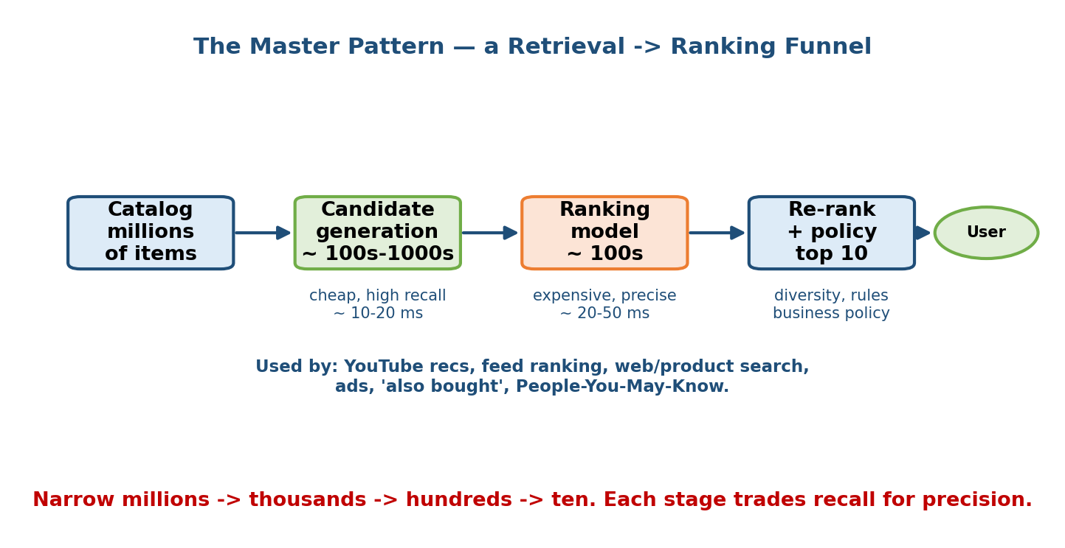
The master ML system funnel: raw events and a large candidate pool flow through retrieval, then ranking, then re-ranking and business rules, into a small final result shown to the user; user feedback is logged and loops back to training. The seven framework steps (clarify, frame, metrics, data/features, model, serving, monitoring) are labelled around the funnel.
The seven steps, as a checklist you say out loud at the start of every answer:
- Clarify — goal, users, scale (QPS, catalogue size, users), constraints (latency, cost, privacy), and scope for today.
- Frame — one concrete ML task (classification / ranking / regression / retrieval / generation), or a rule if ML is overkill.
- Metrics — business + ML, offline + online, plus a guardrail.
- Data & features — sources, labels, freshness; avoid leakage and training-serving skew.
- Model — simple baseline first, then justify each jump in complexity.
- Serving & scale — batch / online / streaming from the NFRs; the funnel stages; caches, ANN indexes, replicas; a capacity estimate.
- Monitoring — drift, the business metric, alerting, retraining cadence, and the failure path (shadow, canary, kill switch, fallback).
Senior signal: announce this plan in your first 30 seconds (“I’ll clarify, frame, define metrics, then design data, model, serving and monitoring”), then drive through it, checking in at each transition. Structure alone puts you ahead of most candidates.
Two structural ideas recur so often they deserve names you can reuse verbatim:
- The two-stage funnel (retrieval → ranking): cheaply narrow millions to hundreds, then spend an expensive model only on those hundreds. Reused in recommendation (M12), search (M13), ads, feed, and RAG.
- The hybrid batch+online split: precompute the heavy, slow-changing parts offline (embeddings, candidate pools, aggregate features); compute only the small, fresh, per-request part online. This is how you hit millisecond latency at millions of QPS without a giant per-request model.
Keep these two in your pocket. Most of the seven studies below are just these two ideas dressed in different business clothes.

17.2 Case Study 1 — YouTube Video Recommendation
Prompt: “Design the video recommendation system for YouTube’s home feed.” This is the archetypal recommender. Full theory is in M12; here we assemble it end to end.
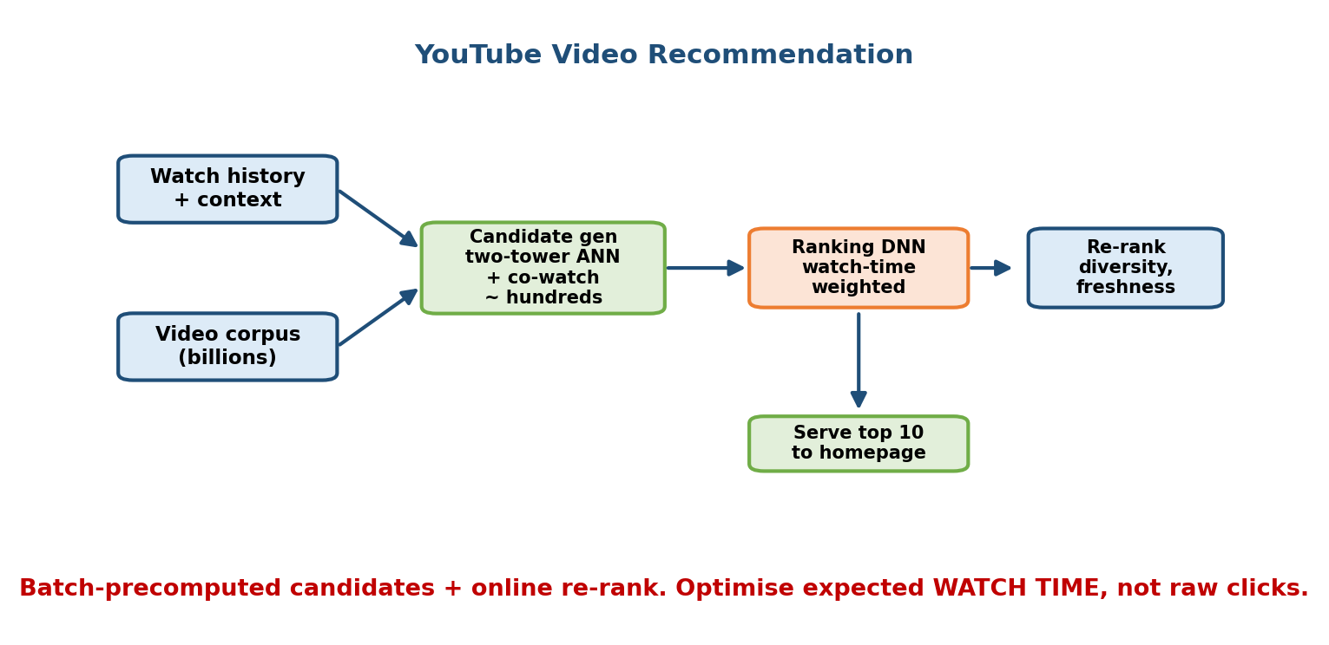
YouTube recommendation architecture: user request enters a candidate generation stage (two-tower retrieval with ANN over billions of videos plus recent/subscribed/trending sources) producing a few hundred candidates, then a heavy deep ranking model scores them using user, video, and context features, then a re-ranking layer applies diversity and freshness and business rules, returning about 20 videos; watch and click events are logged back to training.

1. Clarify
Goal: increase long-term user satisfaction, proxied by watch time and return visits (not raw clicks — clickbait hurts retention). Users: ~2B monthly, personalised home feed on phone/TV/web. Scale: billions of videos, hundreds of thousands of requests per second at peak, catalogue growing by ~500 hours of video per minute. Constraints: feed must load in a few hundred ms; must handle brand-new videos and brand-new users (cold start). Scope for today: the home-feed ranking pipeline, not the search box.

2. Frame
A two-stage ranking / recommendation problem. Stage A (retrieval): from billions of videos, pick a few hundred plausible candidates per user. Stage B (ranking): score those few hundred by expected satisfaction and return the top ~20. Frame the ranking target as a multi-objective score — predicted watch time and probability of a positive engagement (like, share, not-dislike) — because optimising clicks alone breeds clickbait.

3. Metrics
- Business (online): total watch time, daily/weekly active users, 28-day retention. Decided by A/B test.
- ML (online): live CTR, average watch time per impression, satisfaction survey score. Guardrails: diversity, freshness (don’t only show old viral hits), and no increase in “reported/not-interested” rate.
- ML (offline): ranking metrics on logged data — NDCG / MAP and held-out watch-time regression error; retrieval recall@k (did the candidate set contain the videos the user actually watched?).

4. Data & Features
Logged implicit feedback: impressions, clicks, watch time, likes, skips, “not interested”. Features: user (watch history embeddings, subscribed channels, demographics, device), video (topic embeddings, age, channel, historical CTR/watch-time), context (time of day, device, session position). Beware feedback loops (the feed only logs engagement on what it chose to show) and position bias (top slots get clicked more regardless of quality) — log the position and correct for it. Avoid leakage: never use “what the user watched after this impression” as a feature.

5. Model
- Baseline: most-popular + subscribed-channel uploads. Always mention it.
- Retrieval: a two-tower model — a user tower and a video tower produce embeddings in the same space; nearest videos are fetched with an ANN index (M12/M13). Video embeddings are precomputed in batch; the user embedding is computed fresh per request.
- Ranking: a deep neural network (the DLRM/Wide-&-Deep family, M12) that takes hundreds of features and outputs multiple heads (watch-time, click, like). Combine heads into one score with tuned weights.

6. Serving & Scale
Classic hybrid two-stage funnel. Video-tower embeddings and candidate pools are refreshed in batch (hourly/daily) and stored in an ANN index; retrieval and ranking run online per request. Capacity sketch: at ~500k QPS, retrieval must return in ~10–20 ms (ANN over a sharded index), ranking scores ~500 candidates with a compact model in ~30–50 ms; total feed budget a few hundred ms. Cache per-user results for a short TTL to absorb refreshes and repeated scrolls. Thousands of serving replicas behind load balancers; GPUs/accelerators for the ranking model.

7. Monitoring
Watch the business metric (watch time, retention) and guardrails (diversity, report rate) live. Monitor drift in feature distributions and in the video mix (new formats, trends). Retrain ranking frequently (daily) and retrieval regularly; refresh embeddings continuously so new videos are reachable (mitigates item cold start). Failure path: if the ranker is down, fall back to popularity + subscriptions; canary every new model on a small traffic slice before full rollout.
The one gotcha to say out loud: feedback loops + position bias. Naming these, and proposing logged-position debiasing and exploration, is the senior signal on any recommender.

17.3 Case Study 2 — Facebook / Instagram Feed Ranking
Prompt: “Design the ranking system for the Facebook/Instagram home feed.” Similar funnel to YouTube, but the candidates are posts from your own network, engagement is multi-action, and integrity (down-ranking bad content) is first-class.
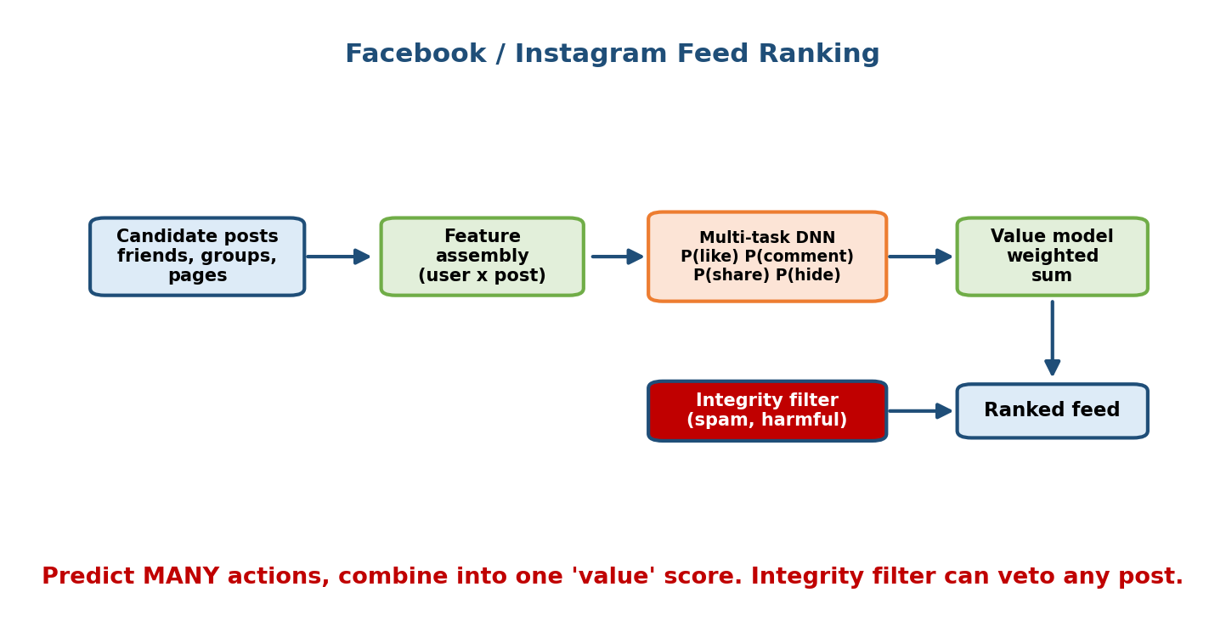
Facebook/Instagram feed ranking architecture: candidate posts are gathered from friends, followed accounts, groups, and recommended sources (inventory), a multi-task ranking model predicts probabilities of several actions (like, comment, share, hide, dwell) for each post, these are combined via a weighted value model into a single score, then integrity demotions and diversity rules re-rank the list before the final feed is shown; all interactions are logged back.

1. Clarify
Goal: meaningful engagement and time well spent, not just raw time. Users: billions, feed refreshed many times a day. Scale: each feed load considers thousands of eligible posts (friends, follows, groups, recommended), at huge QPS. Constraints: low-latency feed build (a few hundred ms), strong integrity requirements (suppress misinformation, borderline, clickbait). Scope: the ranking of an already-fetched candidate set.

2. Frame
Multi-task ranking. For each candidate post predict the probability of several actions — like, comment, share, dwell/long-view, and negative actions (hide, report). Combine them into a single value score with business-chosen weights (a comment or share is worth more than a passive scroll; a hide is strongly negative). This “predict many actions, then weight them” pattern is the heart of modern feed ranking.

3. Metrics
- Business (online): meaningful interactions, sessions, retention; down-weighting integrity-violating content. A/B tested.
- ML (offline): per-action AUC / calibration for each head; ranking NDCG on logged sessions.
- Guardrails: integrity (prevalence of harmful content shown), diversity (not all from one author), and negative-feedback rate (hides/reports).

4. Data & Features
Logged engagement per (user, post) with action types. Features: author↔viewer affinity (past interactions), post (type, media, age, topic embedding, early engagement velocity), viewer (interests, session context), and integrity signals (classifier scores for misinformation/borderline). Beware position bias and presentation bias; log positions. Cold start for new posts: rely on content features and author priors until engagement accrues.

5. Model
Baseline: reverse-chronological (an honest, real baseline — mention it). Then a multi-task deep network with a shared bottom and one head per action, so the heads share representation but predict distinct behaviours. A separate integrity model produces demotion signals applied after scoring.

6. Serving & Scale
Candidates are gathered online from the social graph (fan-out) plus recommended inventory; the multi-task model scores a few hundred–thousand candidates within the latency budget; a re-ranking layer applies integrity demotions and diversity (avoid many posts from one author, mix content types). Precompute expensive embeddings and affinity features offline; compute the freshest signals (early engagement velocity) in streaming. Cache candidate sets briefly.

7. Monitoring
Track engagement, negative feedback, and integrity prevalence live. Watch for drift and for the model over-optimising a single action (e.g. chasing comments creates outrage bait — a guardrail must catch it). Retrain frequently; canary and shadow new value-model weightings, since re-weighting the heads can swing the whole feed. Fallback: chronological or affinity-only ranking if the model fails.
Gotcha to say out loud: optimising one engagement signal (clicks, or comments) can degrade long-term satisfaction and integrity. The senior move is multi-objective ranking with a guardrail on negative/harmful outcomes.

17.4 Case Study 3 — Ad Click-Through-Rate (CTR) Prediction
Prompt: “Design the CTR prediction system for a large ad network.” This is a calibrated-probability problem: the number matters, not just the ranking, because it feeds an auction.
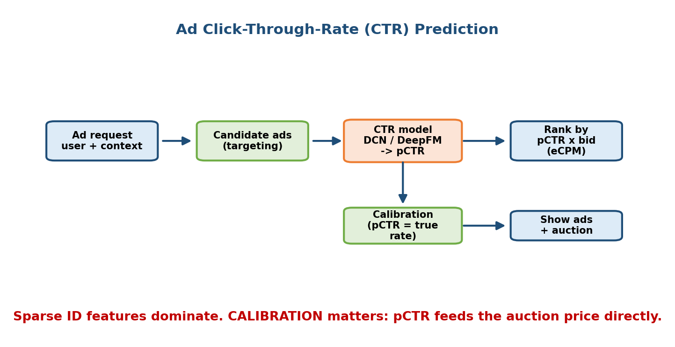
Ad CTR prediction and auction architecture: a page/query request retrieves eligible ads, a fast CTR model predicts a well-calibrated click probability (pCTR) for each ad using user, ad, advertiser, and context features (heavy on embeddings for high-cardinality IDs), the auction ranks ads by bid times pCTR (expected value), the winning ads are shown, and click/no-click labels flow back with a delay to retrain the model.

1. Clarify
Goal: maximise long-term ad revenue while keeping ads relevant (bad ads hurt the platform). The ranking rule is an auction: expected value ≈ bid × pCTR (and quality). So we need a calibrated probability, not just an order. Scale: enormous — millions of QPS, billions of (user, ad) pairs, very high-cardinality categorical features (user IDs, ad IDs). Constraints: single-digit-millisecond scoring; the auction must complete in the ad slot’s tight budget. Scope: the pCTR model that feeds the auction.

2. Frame
Binary classification with calibrated probability output. Predict P(click | user, ad, context). Calibration is essential: if the model says 2%, clicks should happen ~2% of the time, because that number is multiplied by the bid to decide who wins and what they pay.

3. Metrics
- Business (online): revenue, revenue per mille (RPM), advertiser ROI, long-term user retention (guardrail against too many/bad ads).
- ML (offline): AUC / PR-AUC for ranking quality, and log-loss / calibration (reliability curve, ECE) for probability quality — calibration is as important as AUC here.
- ML (online): live CTR vs predicted, revenue lift in A/B.

4. Data & Features
Impression logs with click/no-click labels. Delayed & biased labels are the central data problem: a “no click” now might become a conversion later, and you only observe clicks on ads you chose to show (selection bias). Features: user (history, interests), ad (creative, advertiser, category embeddings), context (page, query, device, time), and crossed features (user×ad category). High-cardinality IDs are handled with embeddings and hashing.

5. Model
Baseline: logistic regression with hashed cross features — historically the industry workhorse and still a great baseline; mention it. Then the Wide & Deep / DeepFM / DCN / DLRM family (M12): a wide memorised part for seen cross-features plus a deep generalising part with embeddings. Keep the model small and fast because latency and QPS dominate.

6. Serving & Scale
Fully online, per request, in a few milliseconds. Precompute and cache embedding tables (they are huge — often sharded across a distributed parameter store); the per-request compute is a small forward pass. Capacity: at millions of QPS you need thousands of replicas, aggressive caching of embeddings, and an auction service colocated with the model to avoid extra network hops.

7. Monitoring
Watch calibration drift obsessively (retrain often — hourly/daily — because ad inventory and user behaviour shift fast), plus revenue and CTR. Monitor feature freshness and the embedding store. Handle the delayed-label problem with delayed-feedback modelling and short retrain windows. Fallback: a simpler calibrated model or historical-CTR lookup if the main model degrades.
Gotcha to say out loud: calibration and delayed/biased labels. Ranking AUC is not enough — the probability itself is consumed by the auction, so a mis-calibrated model directly loses money.

17.5 Case Study 4 — Fraud / Anomaly Detection
Prompt: “Design a fraud detection system for a payments company.” The defining features: extreme class imbalance, an adversary who adapts, and a very asymmetric cost of errors.
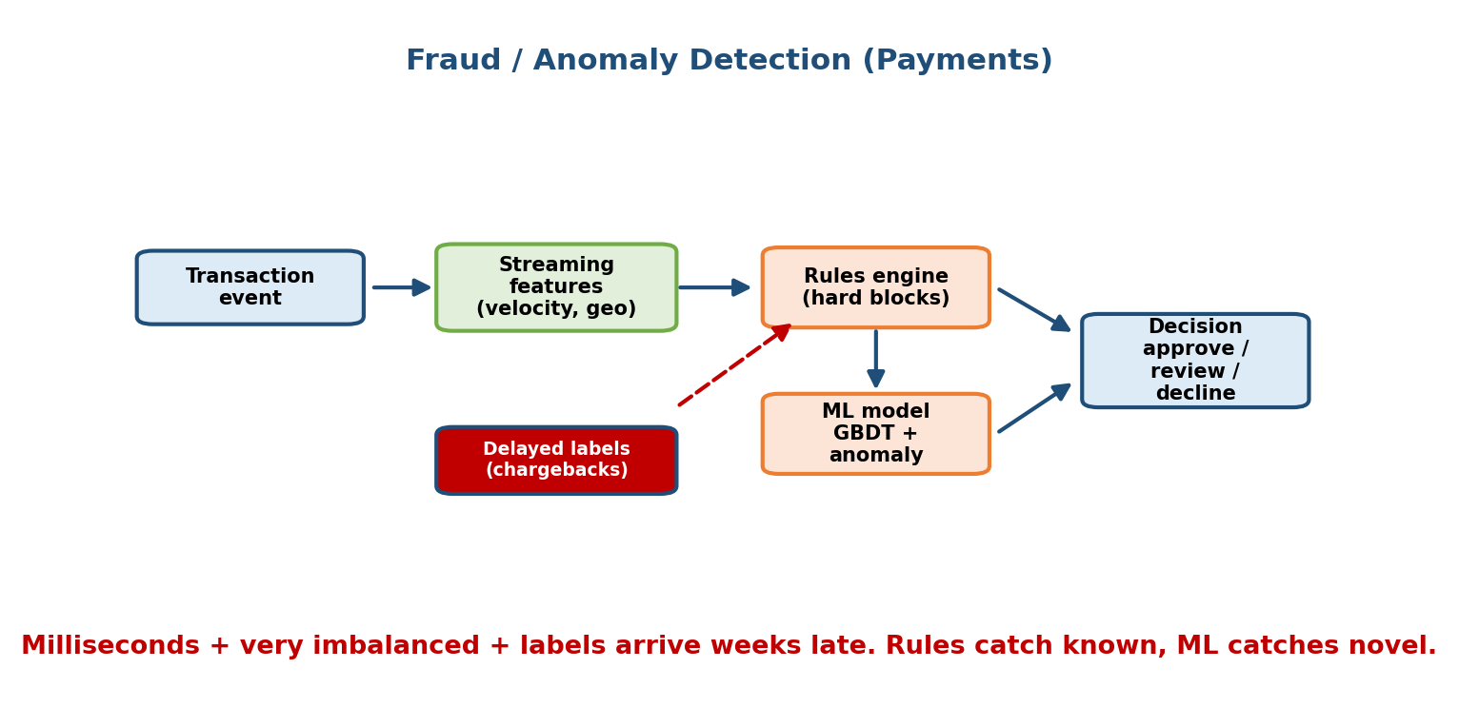
Fraud detection architecture: an incoming transaction is enriched with real-time streaming features (velocity counts, aggregates over recent windows) and historical user/merchant features, scored by a gradient-boosted-tree/ensemble model that outputs a fraud probability, then a decision layer applies thresholds and business rules to approve, decline, or send to step-up verification or a human review queue; confirmed-fraud and chargeback labels return with a long delay to retrain.

1. Clarify
Goal: minimise fraud losses without annoying legitimate customers (false declines are extremely costly — lost sales and churn). Latency: score in tens of milliseconds, inline with the transaction. Scale: tens of thousands of transactions per second. Cost of errors is asymmetric and business-specific: a missed fraud (false negative) costs the chargeback amount; a false positive blocks a good customer. Scope: real-time transaction scoring + the decision layer.

2. Frame
Binary classification (fraud vs legit) with a heavily imbalanced positive class (often <0.1%), or anomaly detection where labelled fraud is scarce. Usually a hybrid: supervised model on known fraud patterns + unsupervised anomaly signals + hard rules for known-bad. The output feeds a decision policy (approve / decline / step-up challenge / human review), not a raw label.

3. Metrics
- Business (online): fraud loss ($), false-decline rate, chargeback rate, investigation cost.
- ML (offline): PR-AUC / recall at a fixed low false-positive rate — never accuracy (99.9% accuracy is trivial when 99.9% is legit). Precision at the operating threshold.
- Guardrail: customer-friction rate (how many good users get challenged).

4. Data & Features
Transaction stream + labels from chargebacks/investigations — which arrive weeks late, so recent data is only partially labelled. Features are heavily streaming aggregates: velocity (“# transactions from this card/device/IP in the last 1m/1h/24h”), amount vs the user’s norm, device/geo mismatch, merchant risk. These require a real-time feature pipeline (M5). Beware leakage from post-transaction fields.

5. Model
Baseline: hand-written rules (block if amount > X and new device) — genuinely strong here and always deployed alongside ML. Then gradient-boosted trees (XGBoost/LightGBM) — the industry default for tabular fraud — often ensembled with an anomaly detector (isolation forest / autoencoder) for novel attacks. Handle imbalance with class weights / focal loss / careful thresholding, not naive oversampling that leaks.

6. Serving & Scale
Online + streaming. A stream processor (Kafka/Flink) maintains velocity features in real time; the model scores inline in tens of ms; a decision engine applies the threshold and routes to approve / decline / step-up / review queue. Capacity: tens of thousands of TPS, each needing fresh aggregates — the feature store’s freshness is the bottleneck, not the model.

7. Monitoring
Because there is an adversary, drift is fast and deliberate — attackers probe and adapt. Monitor score distributions, precision/recall on the trickle of confirmed labels, and challenge/decline rates. Retrain often and keep a fast path to add rules for new attack patterns. Failure path: fail closed (safer to challenge than to let fraud through) for high-risk, fail open for low-risk to avoid blocking everyone if the model dies.
Gotcha to say out loud: imbalance + delayed labels + adversarial drift. Say “accuracy is useless here; I optimise recall at a fixed low false-positive rate and expect to retrain constantly against an adversary.” That is the senior signal.

17.6 Case Study 5 — Uber / DoorDash ETA Prediction
Prompt: “Design the ETA (estimated time of arrival) prediction system.” A regression problem where the number is shown to users and drives dispatch — so bias and tail errors matter more than average error.
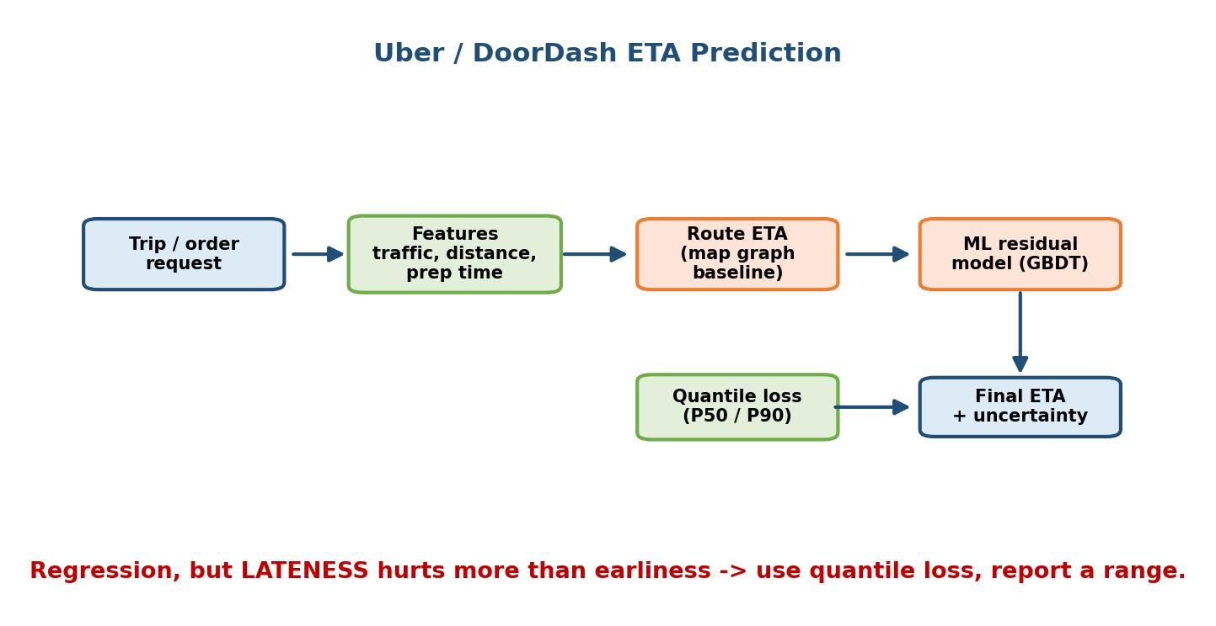
ETA prediction architecture: a request (origin, destination, time) is combined with a routing engine’s base travel time, real-time features (current traffic, weather, driver supply/demand, restaurant prep-time signals) and historical segment speeds, fed to a gradient-boosted / neural regression model that predicts total ETA (and its components); the prediction is shown to the user and used for dispatch, and actual delivery times flow back as labels for retraining.

1. Clarify
Goal: an accurate, well-calibrated ETA that users trust and that dispatch can plan on. Two sub-problems often: travel-time and (for food) prep-time. Cost of error is asymmetric — being late is worse than being early (broken promise), so the loss may be tilted. Latency: fast (tens of ms), called constantly during a trip. Scale: high QPS, global, per-city patterns. Scope: the point-ETA model.

2. Frame
Regression: predict total minutes to arrival. Often decompose into components (to-restaurant + prep + to-customer) and sum, or predict end-to-end. Consider predicting a distribution / quantiles (e.g. p50 and p90) rather than a single number, so the app can show a reliable range and dispatch can plan for the tail.

3. Metrics
- Business (online): on-time rate, user satisfaction/cancellations, dispatch efficiency.
- ML (offline): MAE / RMSE, and crucially quantile loss / calibration and the late-error rate (fraction where actual ≫ predicted). Average error hides the painful tail.
- Guardrail: systematic bias per city/time (don’t be chronically optimistic).

4. Data & Features
Historical trips with actual durations (clean, abundant labels — a nice change from fraud). Features: route distance and the routing engine’s base time, real-time traffic, time of day / day of week, weather, driver supply/demand, restaurant historical prep time and current load, historical segment speeds. Real-time traffic and supply are streaming features. Watch leakage: don’t use anything only known after the trip completes.

5. Model
Baseline: the routing engine’s physics-based estimate (distance ÷ typical speed) — a strong, always-available baseline; the ML model corrects it. Then gradient-boosted trees (great for tabular spatio-temporal data) or a neural model; often quantile regression or a custom asymmetric loss that penalises lateness more than earliness.

6. Serving & Scale
Online, low latency, backed by a real-time feature store for traffic and supply. Precompute slow features (historical segment speeds, restaurant prep baselines) in batch; join fresh traffic/supply online. The routing engine and the ML correction are colocated to meet the budget. Capacity: high QPS with heavy reuse — cache ETAs for identical/near routes for a short TTL.

7. Monitoring
Track MAE, late-rate, and bias per city/segment/time (a model can be great globally and terrible at airport pickups at 5pm). Watch for drift from road changes, events, and demand shocks. Retrain regularly and per-region. Fallback: the routing-engine estimate if the ML correction fails — graceful and always sane.
Gotcha to say out loud: asymmetric error and the tail. “I’d use quantile/asymmetric loss and monitor late-rate and per-segment bias, because a chronically optimistic ETA erodes trust even if MAE looks fine.”

17.7 Case Study 6 — Web Search Ranking
Prompt: “Design web search ranking.” The classic multi-stage retrieval → ranking funnel. Full IR theory (inverted index, BM25, learning-to-rank, NDCG) is in M13; here we assemble the whole engine.
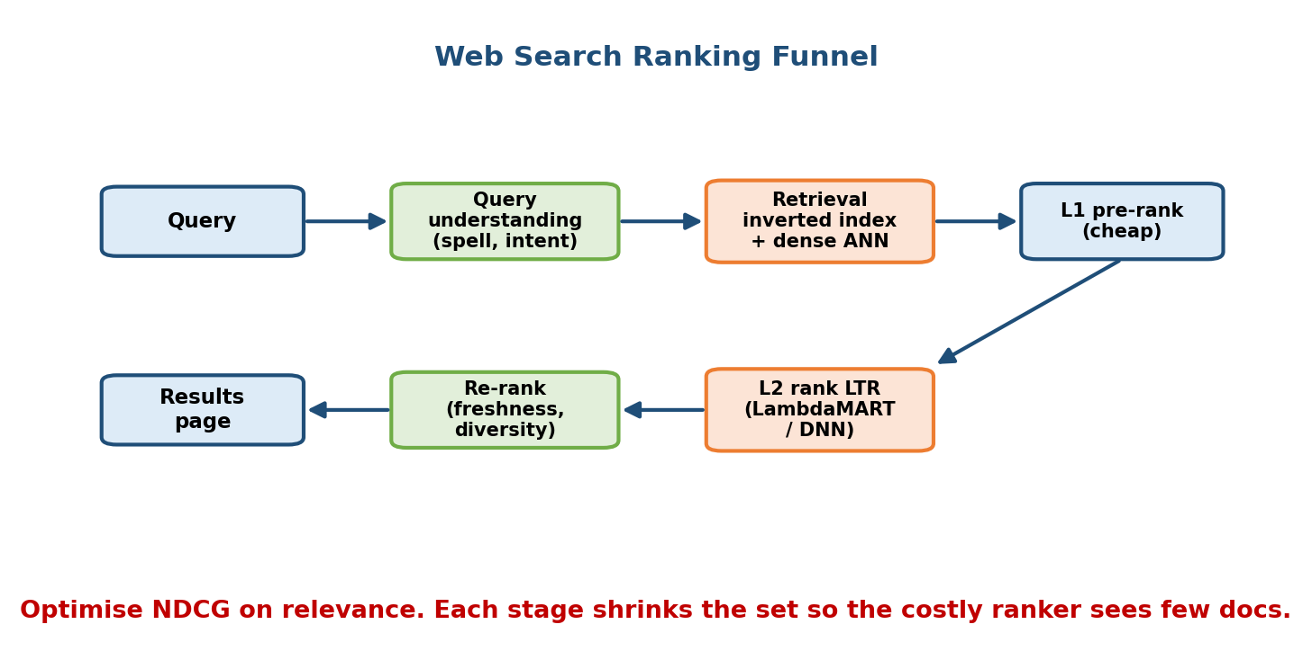
Web search ranking funnel: a user query is processed (tokenised, spell-corrected, expanded, embedded), then two retrieval paths run in parallel over billions of documents — a lexical inverted-index (BM25) path and a dense embedding + ANN path — producing a candidate set of a few thousand; a lightweight pre-ranker cuts to a few hundred; a heavy learning-to-rank / cross-encoder model produces the final order; a re-ranking layer applies freshness, diversity and policy before showing ten results; clicks and dwell feed back.

1. Clarify
Goal: return the most relevant results fast; success is the user finding what they need (proxied by clicks with long dwell, low query reformulation). Scale: billions of documents, huge QPS, sub-second (ideally <300 ms) end to end. Constraints: freshness (news queries need minutes-old pages), spam/quality control. Scope: the ranking pipeline given a crawled+indexed corpus.

2. Frame
Multi-stage ranking / learning-to-rank. Retrieve candidates cheaply (lexical + semantic), then rank with a learned model. Relevance labels come from human raters and/or click models. This is the canonical retrieval → pre-rank → rank → re-rank funnel.

3. Metrics
- Business (online): successful sessions, click-with-long-dwell, low reformulation/abandonment rate.
- ML (offline): NDCG@k (the search metric — compute it by hand in the interview, M13), MAP, MRR on human-judged query-doc pairs.
- Online: interleaving / A/B on click and dwell; guardrail on latency and on showing spam/low-quality.

4. Data & Features
Query logs + clicks + human relevance judgments. Features: lexical (BM25, term match, field matches in title/URL/anchor), semantic (query-doc embedding similarity), document quality (PageRank-style authority, freshness, spam score), and user/context (locale, personalisation, device). Handle click bias (position, presentation) with a click model; don’t treat a top-position click as ground-truth relevance.

5. Model
Baseline: BM25 over an inverted index — a genuinely strong, must-mention baseline. Retrieval adds a dense dual-encoder + ANN path for semantic matches BM25 misses (M13/M16). Ranking uses learning-to-rank — LambdaMART (gradient-boosted trees optimising NDCG) or a neural ranker; the final re-rank stage may use a heavy cross-encoder on the top few dozen for maximum precision.

6. Serving & Scale
The funnel with a latency budget per stage: retrieval (BM25 + ANN, sharded across the index) ~tens of ms returning a few thousand; a cheap pre-ranker cuts to a few hundred (~10 ms); the main ranker scores those (~30–50 ms); a cross-encoder re-ranks the top ~50 (~20 ms). Index is built offline/batch and served from memory/SSD across many shards; queries only read. Cache results for popular queries.

7. Monitoring
Track NDCG on fresh judgments, click/dwell/reformulation live, and freshness lag (are new pages retrievable?). Monitor for query drift (new entities, trending topics) and index health. Retrain the ranker regularly; rebuild/refresh indexes continuously. Fallback: if the neural ranker fails, serve BM25 + document-quality ordering — degraded but always sane.
Gotcha to say out loud: combine lexical and semantic retrieval, and debias clicks. Pure keyword misses meaning; pure embeddings miss exact/rare terms and are costly — a strong answer uses both and treats clicks as biased signal, not truth.

17.8 Case Study 7 — Enterprise RAG Assistant
Prompt: “Design a question-answering assistant over a company’s internal documents.” The modern retrieval-augmented generation system. LLM, embedding, vector-DB and evaluation theory is in M16; here we assemble a production RAG pipeline and its failure modes.
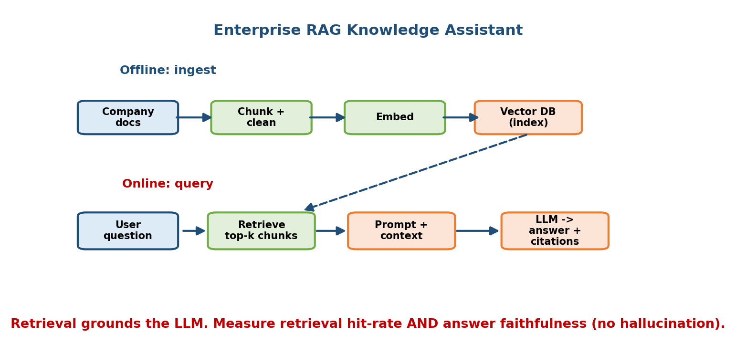
Enterprise RAG architecture: offline ingestion chunks and embeds internal documents into a vector database with access-control metadata; at query time the user question is embedded and used for hybrid retrieval (vector ANN plus keyword) filtered by the user’s permissions, top chunks are re-ranked, then a prompt (question plus retrieved context plus citations) is sent to an LLM which generates a grounded answer with source links; feedback (thumbs up/down, cited-source clicks) is logged for evaluation and improvement.

1. Clarify
Goal: let employees get accurate, grounded, cited answers from internal docs (wikis, tickets, PDFs) instead of searching manually. Hard constraints: permissions (a user must never see content they can’t access), freshness (docs change), groundedness (no hallucinations; every claim cited), and cost/ latency of LLM calls. Scale: thousands–millions of documents, moderate QPS. Scope: the RAG pipeline, not training the base LLM.

2. Frame
Retrieval + generation, not a single model. Retrieval is a search problem (reuse M13/M16): find the few most relevant, permitted chunks. Generation is an LLM grounded on those chunks, instructed to answer only from context and cite sources, and to say “I don’t know” when the context is insufficient.

3. Metrics
- Business (online): answer usefulness (thumbs up/down), deflection of support tickets, time saved.
- Offline (retrieval): recall@k / precision@k of the retrieved chunks against question→relevant-doc pairs.
- Offline (generation): faithfulness / groundedness (does the answer stick to the sources?), answer correctness, and citation accuracy — often scored by an LLM-as-judge plus a human-labelled eval set (M16). Guardrail: hallucination rate and permission leaks (must be ~zero).

4. Data & Features
The corpus of internal documents, chunked (with overlap) and embedded; each chunk carries access-control metadata, source, and timestamp. The “features” are the embeddings plus keyword index plus permission tags. Ingestion must re-embed changed docs (freshness). Beware chunking choices — too big dilutes retrieval, too small loses context.

5. Model
- Retrieval: hybrid — dense embeddings + ANN over a vector DB plus keyword/BM25, filtered by the user’s permissions, then a cross-encoder re-ranker on the top chunks (M16).
- Generation: a strong instruction-following LLM with a prompt that includes the question, the retrieved chunks, and an instruction to answer only from them and cite. Start with a hosted model + good prompting as the baseline before considering fine-tuning.

6. Serving & Scale
Offline: ingest → chunk → embed → upsert into the vector DB (batch/streaming on doc changes). Online: embed query → permission-filtered hybrid retrieval (ANN, ~tens of ms) → re-rank → assemble prompt → LLM generate (the dominant latency, often 1–5 s). Cache embeddings and frequent Q&A. Capacity is usually bound by LLM cost/latency, so retrieve tightly (few high-quality chunks) to keep the prompt short.

7. Monitoring
Track thumbs up/down, groundedness, citation clicks, and — critically — permission-leak incidents and hallucination rate. Watch retrieval recall and freshness lag. Run a regression eval set on every prompt/model change (prompts are code — version them, M16). Failure path: if retrieval returns nothing relevant, the assistant must say “I couldn’t find this” rather than inventing an answer; guardrail models filter unsafe output.
Gotcha to say out loud: grounding, permissions, and hallucination. The senior answer treats RAG as “search + a generation head with strict grounding and access control”, evaluates faithfulness (not just fluency), and never lets the LLM answer beyond the retrieved, permitted context.

17.9 Six More Systems, Briefly (Key Framing + Gotchas)
The seven flagships above cover the main shapes. These six show how the same skeletons stretch to other prompts. For each: the framing in one breath, and the one gotcha that trips candidates. Cross-links tell you which flagship/module to borrow the full design from.
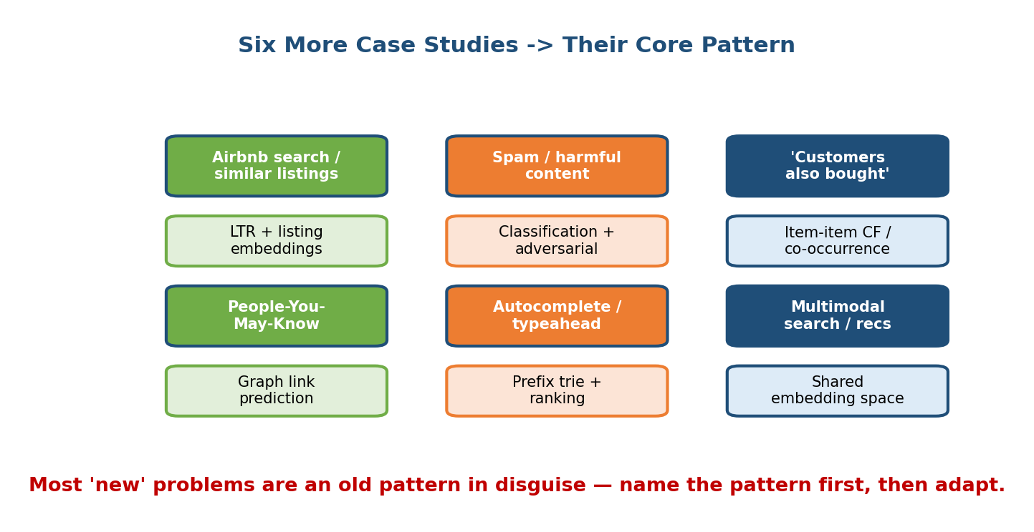
A grid introducing six more case studies — Airbnb search / similar listings, spam and harmful-content detection, e-commerce “customers also bought”, People-You-May-Know, autocomplete / typeahead, and multimodal recommendation & search — each shown as a small card with its core ML framing.

Airbnb search / similar listings
Framing: learning-to-rank over listings for a query (location + dates + filters), plus a “similar listings” retrieval using listing embeddings. It is the search funnel (17.7 / M13) with a two-sided marketplace twist: optimise for bookings, and balance guest relevance with host/geographic diversity and availability. Gotcha: strong location + availability constraints (a listing must be free for those dates), and seasonality; embeddings must capture “listings booked in the same session are similar.”

Spam / harmful-content detection
Framing: binary (or multi-label) classification of content as spam/toxic/harmful, feeding a moderation decision (allow / demote / remove / human review). Same skeleton as fraud (17.5): imbalance, adversary, asymmetric cost. Gotcha: adversarial drift (attackers obfuscate — “f.r.e.e”, leetspeak, image text) and precision/recall trade-off tied to harm severity; combine ML with rules and human review, and never optimise accuracy.

E-commerce “customers also bought”
Framing: item-item recommendation (M12) — given the current item/cart, recommend complementary items. Baseline is co-occurrence / market-basket (“bought together”); upgrade to item embeddings. Gotcha: distinguish complements from substitutes (don’t recommend another phone right after a phone purchase — recommend a case), and beware popularity bias drowning the long tail.

LinkedIn / Meta “People You May Know”
Framing: link prediction on a social graph — rank candidate people by probability of a real connection. Candidates come from friends-of-friends and graph features (common connections, shared org/school, embeddings). It is the two-stage funnel over a graph. Gotcha: feedback loops and fairness (recommending only the already-popular densifies the rich), plus the classic “met once, now haunted by suggestions” privacy sensitivity — be careful which signals you use.

Autocomplete / typeahead
Framing: predict the most likely completions of a prefix, ranked by popularity + personalisation + recency; served from a trie / prefix index with a language-model score. Extreme latency constraint: must respond in a few ms per keystroke. Gotcha: it is a latency and freshness problem more than a modelling one — precompute top completions per prefix, cache aggressively, and add safety filters so it never suggests harmful/offensive queries.

Multimodal recommendation / search
Framing: retrieval and ranking where items and/or queries span text + image (+ audio/video) — e.g. search Pinterest by image, or recommend products from a photo. Uses shared multimodal embeddings (CLIP-style) so text and images live in one space, then the usual ANN retrieval + ranking funnel (M12/M13/ M16). Gotcha: aligning modalities (a good joint embedding is the whole game) and cold start for new items using content embeddings when there is no interaction history yet.

17.10 The Case-Study Pattern Cheat Sheet
Every prompt above collapses into a handful of patterns. If you can map a new question to one of these in the first minute, you already know the skeleton of your answer.
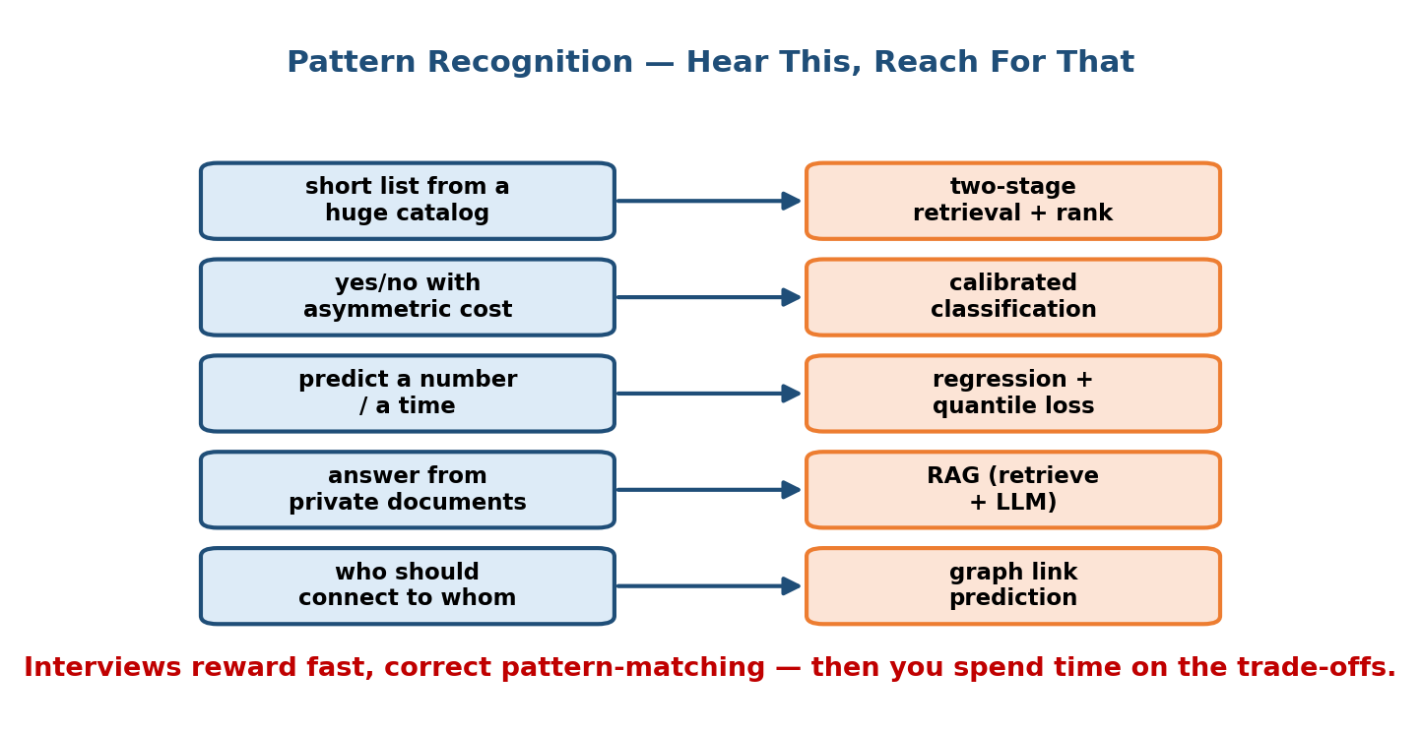
Case-study pattern cheat sheet: a table mapping problem type to canonical pattern — recommendation/feed to two-stage retrieval+ranking funnel; search/RAG to multi-stage retrieval then rank then (generate); CTR/ads to calibrated classification feeding an auction; fraud/spam to imbalanced classification plus rules with an adversary; ETA to regression with asymmetric/quantile loss; each row lists the key metric and the signature gotcha.
Prompt smells like… | Pattern to reuse | Key metric | Signature gotcha
“recommend / feed / for-you” | two-stage retrieval → ranking funnel (M12) | NDCG / watch-time; retention | feedback loops, position bias, multi-objective
“search / find / rank docs” | multi-stage retrieval → rank → re-rank (M13) | NDCG / MRR | click bias; lexical and semantic
“answer from our docs” | RAG = retrieval + grounded generation (M16) | faithfulness, recall@k | hallucination, permissions, chunking
“predict click / ad” | calibrated classification → auction | log-loss / calibration, AUC | calibration, delayed/biased labels
“detect fraud / spam / abuse” | imbalanced classification + rules, adversary | recall @ fixed FPR, PR-AUC | imbalance, adversarial drift, asym. cost
“how long / how much” (ETA, price) | regression (quantile/asymmetric) | MAE + late-rate/quantile loss | the tail, systematic bias
“people/items you may know/like” | link prediction / item-item over a graph | ranking + connection rate | feedback loop, fairness, privacy
“typeahead / suggest” | prefix index + LM score, precompute | latency, acceptance | ms-latency, freshness, safety
The universal moves that apply to all of them:
- Always propose a simple baseline first (popularity, BM25, rules, co-occurrence, routing-engine estimate) — it is a senior signal and a real fallback.
- Split batch (precompute embeddings, pools, aggregates) from online (fresh per-request scoring) — the hybrid pattern hits low latency at scale.
- Name business + ML + offline + online metrics and a guardrail.
- Say the gotcha for the pattern (loops, bias, imbalance, calibration, hallucination, tail error) — this is what separates senior from junior.
- Design the failure path: shadow, canary, kill switch, and a safe fallback. Every model will break.

Module 17 — Interview Mapping (what companies probe)
Company | Favourite case-study prompts | Junior answer | Staff answer
Google | Web search ranking, YouTube reco, ads CTR | Jumps to a model | Multi-stage funnel, NDCG, lexical+semantic, latency budget per stage
Meta | Feed ranking, PYMK, harmful-content, ads | Single-objective | Multi-task ranking + integrity guardrail; feedback loops
Amazon | “Customers also bought”, product search | Generic reco | Complements vs substitutes; ties to revenue and Customer Obsession
Uber / DoorDash / Lyft | ETA, dispatch, fraud | RMSE only | Asymmetric/quantile loss, per-segment bias, streaming features
Stripe / banks | Payment fraud / risk | “accuracy” | Recall @ fixed FPR, imbalance, adversary, fail-open vs closed
OpenAI / Anthropic / startups | Enterprise RAG, LLM assistants | “just prompt an LLM” | Retrieval + grounding + faithfulness eval + permissions
The single most common opening: “Design an ML system for X.” Map X to a pattern (17.10), announce the 7 steps, and drive. That structure plus one named gotcha is most of the score.

Module 17 — Exam Mapping (SEBI / RBI / GATE / ISRO)
- Interview-only, in practice. Written exams do not ask you to design YouTube or a fraud system end to end.
- GATE CS/DA: the underlying concepts can appear standalone — task types (classification / regression / ranking), evaluation metrics (precision/recall, AUC, RMSE, NDCG), and class imbalance. Learn those from M7; the assembly here is interview material.
- SEBI / RBI / ISRO: at most definitional ML items. The value of this module is overwhelmingly for interviews and the job.
Bottom line: treat this module as interview/on-the-job training. Its exam-relevant residue (metrics, task types, imbalance) is already covered in the exam-heavy modules.

Module 17 — Common Mistakes & Misconceptions
- Jumping to the model without clarifying scope/scale or naming the business metric. Announce the 7 steps first. (17.1)
- One metric (“accuracy”). Fatal for fraud/ads/search. Use the pattern’s right metric — recall@FPR, calibration, NDCG, faithfulness — plus a guardrail.
- Ignoring the gotcha. Not mentioning feedback loops (reco), calibration (ads), imbalance (fraud), the tail (ETA), or hallucination (RAG) reads as junior.
- Skipping the baseline. Popularity / BM25 / rules / routing-estimate are real, strong, and your fallback — always propose one.
- No batch/online split. Trying to run one giant model per request at millions of QPS. Precompute the heavy parts; keep the online part small.
- Treating clicks as truth. Clicks are biased (position, presentation, selection). Debias them.
- Forgetting the failure path. No shadow/canary/kill-switch/fallback. Every model breaks; design for it.
- RAG = “just an LLM”. Ignoring retrieval quality, permissions, and faithfulness evaluation.

Module 17 — MCQs (with answers & explanations)
Q1. Why is the two-stage (retrieval → ranking) architecture used in recommendation and search? a) It is easier to code b) Retrieval cheaply narrows millions to hundreds so the expensive ranker runs on few candidates c) It removes the need for metrics d) It avoids using embeddings
Answer
b. You cannot run a heavy model on billions of items per request. Cheap retrieval (ANN / BM25) narrows the pool, then the expensive ranker scores only the survivors. (17.1, 17.2, 17.7)
Q2. In ad CTR prediction, why does calibration matter as much as AUC? a) It doesn’t b) Because the predicted probability is multiplied by the bid in the auction, so a mis-calibrated pCTR directly mis-prices ads c) Because calibration improves latency d) Because AUC is unmeasurable
Answer
b. Expected value ≈ bid × pCTR. If the probability is wrong in absolute terms, the auction pays the wrong amount even if the ranking (AUC) is fine. (17.4)
Q3. For fraud detection with 0.1% fraud, which metric is appropriate? a) Accuracy b) Recall at a fixed low false-positive rate (and PR-AUC) c) RMSE d) BLEU
Answer
b. With extreme imbalance, 99.9% accuracy is trivial and useless. You care about catching fraud without too many false declines — recall at a fixed FPR, PR-AUC. (17.5)
Q4. Why prefer quantile / asymmetric loss for ETA prediction? a) It’s faster to train b) Being late is more costly than being early, and the app needs a reliable range, so the tail and asymmetry matter more than mean error c) It removes the need for features d) It guarantees zero error
Answer
b. A chronically optimistic ETA breaks trust even at low MAE; asymmetric/quantile loss penalises lateness and lets you show p50/p90. (17.6)
Q5. In an enterprise RAG assistant, which is the most important correctness concern beyond fluency? a) Font rendering b) Groundedness/faithfulness, correct citations, and never leaking documents the user lacks permission to see c) Model size d) GPU brand
Answer
b. RAG must answer only from retrieved, permitted context and cite it; hallucination and permission leaks are the defining risks. (17.8)
Q6. A recommender keeps pushing the same popular items, which get more engagement, which promotes them further. This is: a) a cache miss b) a feedback loop (popularity/bias amplification) c) overfitting d) label leakage
Answer
b. The system’s own choices shape the next training data, amplifying popularity. Mitigate with exploration and position-debiasing. (17.2)
Q7. Web search retrieval works best when it combines: a) only BM25 b) only dense embeddings c) lexical (BM25) and semantic (dense + ANN) retrieval d) neither
Answer
c. Lexical catches exact/rare terms; semantic catches meaning/synonyms. Hybrid retrieval covers both, then a ranker merges them. (17.7)
Q8. For “customers also bought”, the key modelling subtlety is: a) using RMSE b) distinguishing complements from substitutes (recommend a case, not another phone) and avoiding popularity bias c) training an LLM d) using a trie
Answer
b. Co-occurrence alone can recommend substitutes; the value is in complements, and the long tail must survive popularity bias. (17.9)

Module 17 — Design Exercises (easy → hard)
- Easy. For each prompt, name the pattern (from 17.10) and its signature gotcha: (1) TikTok For-You feed; (2) credit-card fraud; (3) “answer from our HR docs”; (4) food-delivery ETA; (5) app-store search.
- Easy. Give the baseline you would propose for each of the seven flagship systems.
- Medium. Design Spotify Discover Weekly end to end using the 7 steps. Which flagship does it most resemble, and what is different (weekly batch, audio features, exploration)?
- Medium. For YouTube reco, sketch a latency budget across retrieval, ranking, and re-ranking that fits a few-hundred-ms feed at 500k QPS, and say what you precompute vs compute online.
- Hard. Design payment fraud and justify a fail-open vs fail-closed policy for two transaction risk tiers. State your metric and threshold logic.
- Hard. Design an enterprise RAG assistant with strict document permissions. Where exactly do you enforce access control, and how do you evaluate faithfulness and detect permission leaks before launch?
- Hard. You are given a brand-new prompt: “design a system to recommend which push notification to send each user, and when.” Map it to known patterns, name the business metric, the gotcha (annoyance/opt-outs as a guardrail), and sketch the funnel.

Module 17 — Concept Review (one page)
- Almost every large ML product is the same funnel: candidates → retrieval → ranking → re-rank/rules → small output, with a feedback loop to training.
- Run the 7 steps on every prompt: Clarify → Frame → Metrics → Data → Model → Serve → Monitor. Announce them and drive.
- Two-stage retrieval → ranking (M12/M13) and the hybrid batch+online split are the two skeletons behind most systems.
- Metrics per pattern: reco/feed → NDCG + watch-time/retention; search → NDCG/MRR; ads → calibration + AUC; fraud/spam → recall@FPR + PR-AUC; ETA → MAE + late-rate/quantile; RAG → faithfulness + recall@k. Always add a guardrail.
- The gotchas define seniority: feedback loops & position bias (reco), multi-objective + integrity (feed), calibration + delayed labels (ads), imbalance + adversary + asymmetric cost (fraud), the tail + bias (ETA), lexical+semantic + click bias (search), hallucination + permissions + grounding (RAG).
- Always propose a baseline, split batch vs online, and design the failure path (shadow, canary, kill switch, fallback).
- Map a new prompt to a known pattern in the first minute — that is the whole skill this module builds.

Module 17 — Flash Cards (Q → A)
- Skeleton behind reco and search? → Two-stage retrieval → ranking funnel.
- Metric for fraud with 0.1% positives? → Recall at a fixed low FPR / PR-AUC, never accuracy.
- Why calibration in ad CTR? → pCTR × bid drives the auction, so absolute probability must be right.
- ETA loss of choice and why? → Quantile/asymmetric — lateness costs more than earliness; watch the tail.
- RAG’s three defining risks? → Hallucination, permission leaks, stale/poor retrieval; evaluate faithfulness.
- Reco’s signature gotcha? → Feedback loops + position bias → use exploration & debiasing.
- Best web-search retrieval? → Hybrid lexical (BM25) + semantic (dense+ANN).
- “Customers also bought” subtlety? → Complements vs substitutes; beat popularity bias.
- Universal senior moves? → Baseline first; batch/online split; right metric + guardrail; name the gotcha; design the failure path.
- First thing to do on a new prompt? → Map it to a known pattern, then run the 7 steps.

Module 17 — Pattern Recognition (how to spot it in an interview)
- Hear “recommend / feed / for-you / up-next” → two-stage funnel; NDCG + engagement; say feedback loops & position bias.
- Hear “search / rank documents / product search” → retrieval→rank→re-rank; NDCG/MRR; lexical + semantic, debias clicks.
- Hear “answer questions from our documents” → RAG; retrieval + grounded generation, faithfulness, permissions.
- Hear “predict clicks / serve ads” → calibrated classification + auction; calibration + delayed labels.
- Hear “detect fraud / spam / abuse” → imbalanced classification + rules; recall@FPR, adversary, fail-open vs closed.
- Hear “how long / estimate time or cost” → regression; asymmetric/quantile loss, the tail, per-segment bias.
- Hear “people/items you may know or like” → link prediction / item-item over a graph; feedback loop, fairness, privacy.
- Hear “suggest as they type” → prefix index + LM; millisecond latency, freshness, safety filters.
- Any prompt → baseline first, batch/online split, guardrail metric, failure path.

Module 17 — Revision Notes / Mini Cheat Sheet
MASTER FUNNEL: events + huge candidate pool
-> RETRIEVAL (cheap, ANN/BM25) -> hundreds
-> RANKING (heavy model) -> tens
-> RE-RANK + business rules -> small final output
-> log feedback -> retrain (LOOP)
RUN 7 STEPS EVERY TIME: Clarify Frame Metrics Data Model Serve Monitor
PATTERN -> METRIC -> GOTCHA
reco/feed NDCG + watch/retention feedback loops, position bias, multi-obj
search NDCG / MRR lexical+semantic, click bias
RAG faithfulness, recall@k hallucination, permissions, chunking
ads CTR calibration + AUC calibration, delayed/biased labels
fraud/spam recall@fixed-FPR, PR-AUC imbalance, adversary, asym cost, fail o/c
ETA/price MAE + late-rate/quantile the TAIL, systematic bias
PYMK/item ranking + connect rate feedback loop, fairness, privacy
typeahead latency, acceptance ms-latency, freshness, safety
UNIVERSAL MOVES
1 baseline first (popularity/BM25/rules/routing-est/co-occurrence)
2 split BATCH (precompute embeds/pools/aggregates) vs ONLINE (fresh per-req)
3 metrics = business + ML + offline + online + GUARDRAIL
4 SAY THE GOTCHA for the pattern (this = seniority)
5 failure path = shadow -> canary -> kill switch -> safe fallback
MAP THE PROMPT TO A PATTERN IN THE FIRST MINUTE. Then drive the 7 steps.

Next module: Module 18 — Responsible AI: Fairness, Bias, Privacy & Safety. Every case study above quietly raised an ethical edge — feedback loops that amplify bias, fraud models that wrongly decline real customers, RAG systems that could leak private documents, feeds that could push harmful content. Module 18 turns those scattered “guardrails” into a first-class discipline: how to measure fairness, protect privacy, and build safety and accountability into an ML system by design, not as an afterthought.

