Module 18 — Responsible & Trustworthy AI
  - ML System Design Mastery: FAANG / AI-Engineer / Staff-Level — In-Depth Notes (with visuals)
Prepared for nidhi.sharma@forensiccybertech.com
2026
Table of Contents

Module 18 — Responsible & Trustworthy AI
Why this module matters. A model can be accurate and still be wrong to ship. It can quietly deny loans to one group, leak the private data it was trained on, be fooled by a sticker on a stop sign, or make a life-changing decision that no one — not even its builders — can explain. Responsible AI is the discipline of building systems that are fair, private, explainable, secure, governed, and safe. For a Staff-level engineer this is not optional garnish: in regulated domains (finance, hiring, healthcare) it is a hard requirement that decides whether the system is allowed to exist at all. And for the SEBI / RBI IT exams, the governance, privacy, and security ideas here carry real, direct exam value — flagged throughout. We build every idea from first principles, in plain English.
Importance ratings (out of 5):
Exam / Use | SEBI IT | RBI IT | GATE CS/DA | Interview | AI/MLE role
This module | ★★★★ | ★★★★ | ★★ | ★★★★ | ★★★★★
What you must be able to do after this module: name the three sources of bias and the three fairness metrics (with their formulas) and say when each applies; place a mitigation as pre-, in-, or post-processing; explain differential privacy as a privacy budget (epsilon) and describe federated learning + secure aggregation; pick SHAP vs LIME vs attention and distinguish global from local explanations; name the four main ML attacks (poisoning, evasion, model stealing, membership inference) and one defense each; describe governance artifacts (model cards, datasheets, audit logs) and the EU AI Act risk tiers and GDPR; and sketch the safety stack for an LLM (RLHF + guardrails).
How to read this module. For every idea we go problem → simplest attempt → why it breaks → the fix, and we tie each concept to how it shows up in a real interview and on the SEBI/RBI syllabus.

18.1 Fairness & Bias — where unfairness comes from

Motivation (the problem that existed)
Suppose you train a hiring model on ten years of a company’s past hires. The model learns to predict “would we hire this person?” and it is 90% accurate on held-out data. You ship it. Six months later a journalist shows that the model rejects almost every woman who applies for engineering roles. Nothing in your code says “reject women” — so how did this happen?
The answer: the model faithfully learned the patterns in the data, and the data was unfair. The company historically hired mostly men, so “looks like a past hire” quietly became “looks like a man”. The model did exactly what it was told; the training signal was poisoned by history. This is the core lesson of fairness: a model is a mirror of its data, and if the data encodes past injustice, the model will scale it up.

Three sources of bias
Bias does not come from one place. There are three main entry points, and a good design blocks all three.
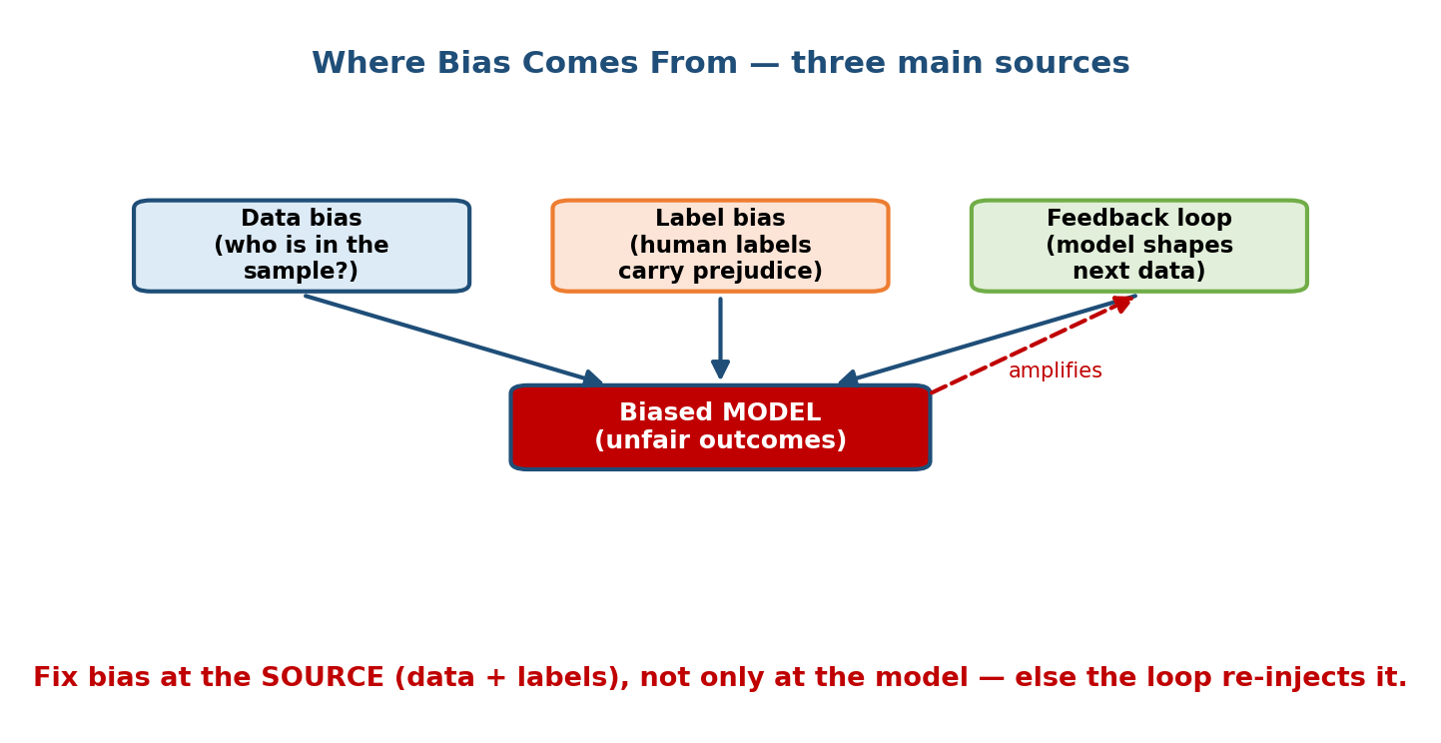
Three sources of bias — data bias, label bias, and feedback loops — all flow into a biased model, and the feedback loop re-injects the bias over time.
As the diagram shows:
- Data bias (sampling bias). The training data does not represent the real population. A face model trained mostly on light-skinned faces performs worse on dark-skinned faces. The who is in the sample question.
- Label bias. The labels themselves carry human prejudice. If past loan officers rejected certain groups unfairly, “approved / rejected” labels encode that prejudice, and the model copies it.
- Feedback loops. The model’s own outputs shape the next batch of training data (recall Module 1). A model that under-serves a group collects less good data about that group, gets even worse for them, and the loop tightens. The dashed red arrow in the diagram is this amplification.
First-principles takeaway: you cannot fix bias only at the model. If the data and labels are biased, “fixing the model” just re-launders the same unfairness. Fix it at the source where you can, and break the feedback loop.

Protected attributes
A protected attribute is a feature the law (or ethics) says you must not discriminate on: race, sex, age, religion, disability, etc. A common rookie mistake is “just delete the protected column and we’re fair”. This fails, because other features are proxies: postal code proxies for race, first name proxies for gender. The model reconstructs the protected attribute from proxies. Fairness must be measured, not assumed away.

18.2 Fairness Metrics — what exactly must be equal?

Motivation
“Be fair” is a slogan, not a spec. To test fairness you need a number. But here is the subtle part that separates senior candidates: there are several definitions of fairness, they are not the same, and you usually cannot satisfy them all at once. You must choose the one that matches the harm you care about.
Let the model output be $\hat{Y}∈\{0,1\}$ (e.g. approve = 1), the true label be $Y$, and $A$ be the protected group ($a$ vs $b$).
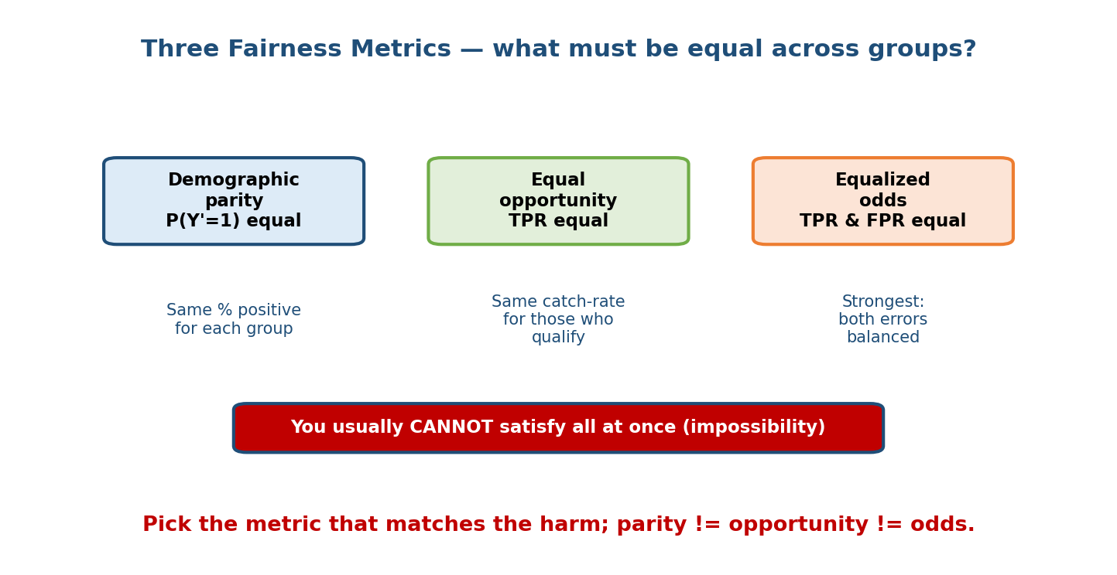
Three fairness metrics: demographic parity (equal positive rate), equal opportunity (equal true-positive rate), and equalized odds (equal TPR and FPR). You usually cannot satisfy all at once.

The three main metrics (with formulas)
1. Demographic (statistical) parity. The positive rate is equal across groups, regardless of the truth:
$$P(\hat{Y}=1∣A=a)=P(\hat{Y}=1∣A=b)$$
“Each group gets approved at the same rate.” Good when you want equal access (e.g. equal share of ads shown). Weakness: it ignores whether people actually qualify, so it can force accepting unqualified applicants from one group.
2. Equal opportunity. The true-positive rate (recall) is equal across groups:
$$P(\hat{Y}=1∣Y=1,A=a)=P(\hat{Y}=1∣Y=1,A=b)$$
“Among people who truly qualify, each group is caught at the same rate.” Good for opportunities (loans, jobs) where missing a qualified person is the harm.
3. Equalized odds. Both the true-positive rate and the false-positive rate are equal across groups:
$$P(\hat{Y}=1∣Y=y,A=a)=P(\hat{Y}=1∣Y=y,A=b) \text{for }y∈\{0,1\}$$
The strongest of the three: it balances both kinds of error. Hardest to achieve.

The impossibility result (a senior signal)
There is a proven impossibility: except in trivial cases you cannot have demographic parity and equalized odds and calibrated scores all at once. So fairness is a choice, not a checkbox. In an interview, saying “which fairness definition do we optimise, given the harm, and what do we trade away?” is a strong signal. A related legal rule of thumb is the 80% (four-fifths) rule: if one group’s selection rate is below 80% of the top group’s, that is evidence of adverse impact.

18.3 Bias Mitigation — pre-, in-, and post-processing

Motivation
Once you can measure unfairness, you must reduce it. There are exactly three places you can intervene, matching the pipeline stages: before training, during training, and after training.
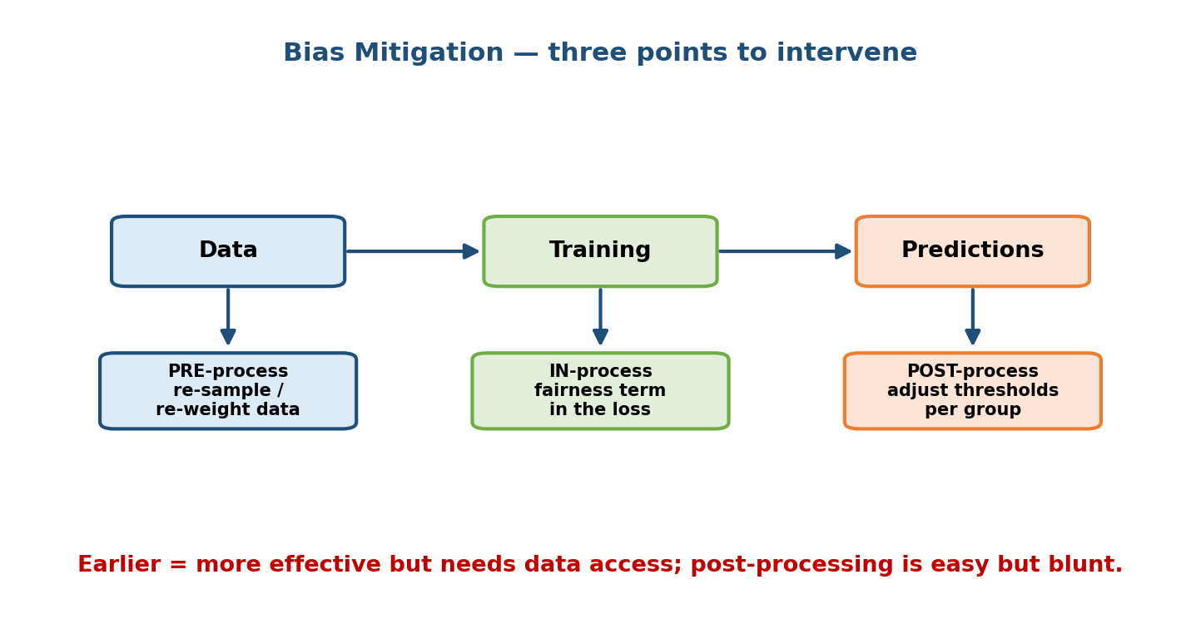
Bias mitigation at three points: pre-processing (re-sample or re-weight the data), in-processing (add a fairness term to the loss), and post-processing (adjust thresholds per group).

The three families
- Pre-processing (fix the data). Re-sample or re-weight so under-represented groups are properly present; remove biased labels; learn representations that drop protected information. Most effective because it attacks the root, but needs access and rights to modify the training data.
- In-processing (fix the training). Add a fairness penalty to the loss so the optimiser is punished for unfair outcomes:
$$L=L_{\text{accuracy}}+λ⋅L_{\text{fairness}}$$
- Also adversarial debiasing (a second network tries to predict the protected attribute from the prediction; you train so it cannot). Powerful, but requires changing the model and training code.
- Post-processing (fix the outputs). Leave the model alone and adjust decision thresholds per group so a chosen fairness metric is met. Easy, works on a black-box model, and needs no retraining — but it is blunt and can feel like explicit different treatment, which may itself be legally sensitive.
Trade-off to state out loud: earlier interventions are more effective but need more access; post-processing is the easiest lever when the model is a vendor black box. There is also an accuracy–fairness trade-off — expect to give up a little accuracy for a fairer system, and justify it with the cost of the unfairness.

18.4 Privacy — differential privacy, federated learning
SEBI / RBI flag — HIGH value. Data privacy, consent, and data-protection law are core to financial-regulator IT syllabi. Know differential privacy and federated learning at the conceptual level here.

Motivation
Models memorise. A language model can regurgitate a credit-card number it saw in training; an attacker can sometimes tell whether your record was in the training set (Section 18.5). If the data is medical, financial, or personal, that is a serious breach. We need training that is useful in aggregate but reveals nothing about any single person.

Differential privacy (DP) — the epsilon idea
The core promise of DP: the released result should be (almost) the same whether or not any one person’s data was included. If your row cannot change the output much, an attacker cannot learn about you from the output.
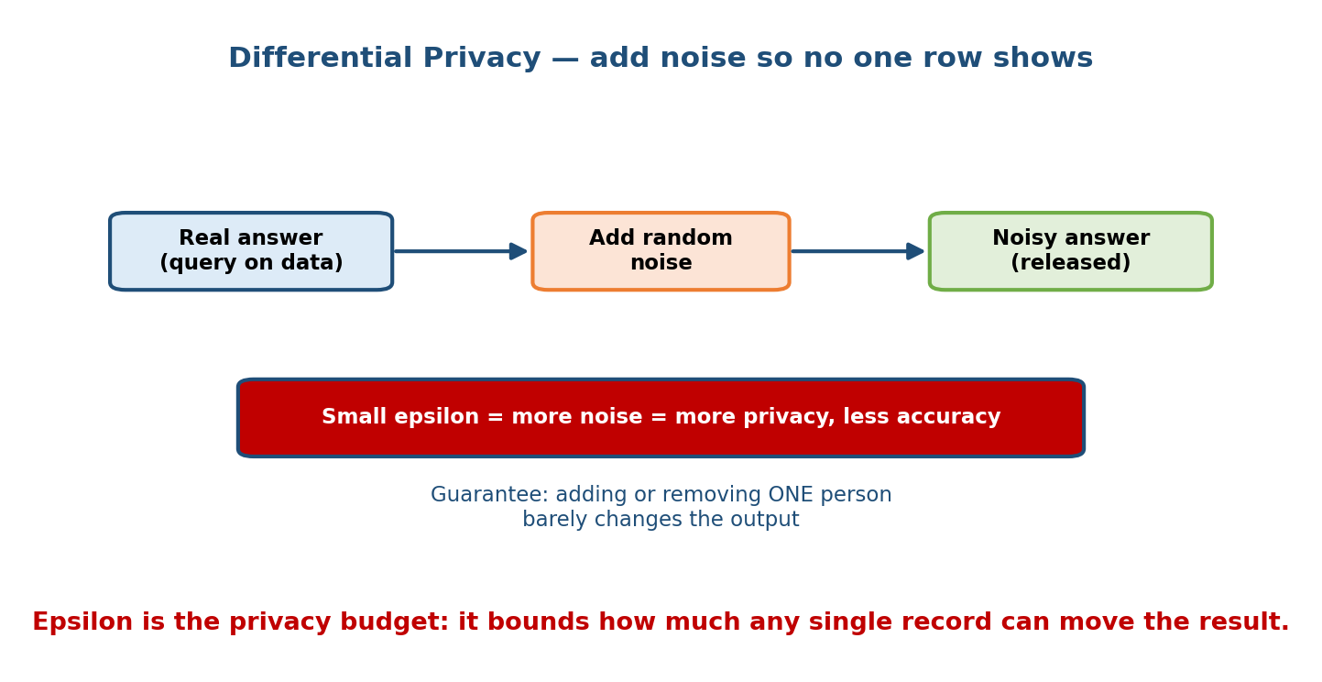
Differential privacy: take the real answer to a query, add calibrated random noise, and release the noisy answer. A smaller epsilon means more noise, more privacy, and less accuracy.
The mechanism is simple: compute the true answer, then add carefully calibrated random noise before releasing it. Formally, a mechanism $M$ is $ε$-differentially private if for any two datasets $D$, $D^{′}$ that differ by one record and any output $S$:
$$P(M(D)∈S)≤e^{ε} P(M(D^{′})∈S)$$
- Epsilon ($ε$) is the privacy budget. Small $ε$ (e.g. 0.1) = strong privacy, lots of noise, lower accuracy. Large $ε$ = weak privacy, little noise, higher accuracy. It is a dial between privacy and utility.
- In deep learning we use DP-SGD: clip each example’s gradient and add Gaussian noise, so no single example dominates the update.
- The budget composes: each query spends some $ε$; run too many queries and privacy is used up.
One-line intuition: DP adds just enough noise that “you” are hidden in the crowd, and $ε$ measures how big the crowd effectively is.

Federated learning + secure aggregation
DP hides individuals inside an answer. Federated learning goes further: the raw data never leaves the device at all.
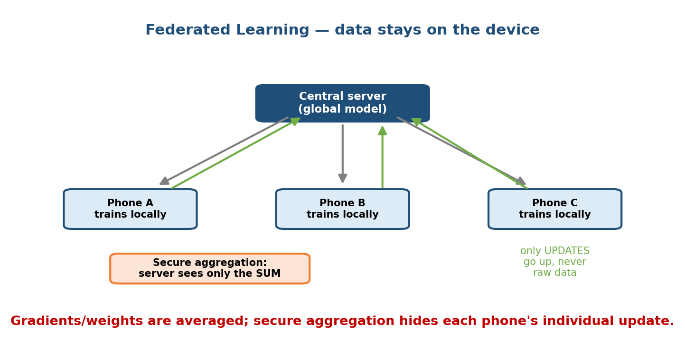
Federated learning: the central server sends the global model to each phone; each phone trains locally and sends back only model updates (never raw data); secure aggregation lets the server see only the summed update.
The loop, as drawn:
- The server sends the current global model down to many devices (phones).
- Each device trains locally on its own private data.
- Each device sends back only the model update (gradients/weights) — never the raw data (the green arrows up).
- The server averages the updates (Federated Averaging) into a new global model, and repeats.
Secure aggregation adds a cryptographic layer so the server sees only the sum of all updates, not any single device’s update — so even the server cannot reverse-engineer one user. Google’s mobile keyboard (Gboard) is the classic real example. Federated learning and DP are often combined: train federated, and add DP noise to the aggregate.

18.5 Explainability & Interpretability

Motivation
A regulator asks: “Why was this specific customer denied a loan?” “The neural network said so” is not an acceptable answer — and under GDPR it may be illegal. Explainability is the ability to give a human-understandable reason for a model’s behaviour. It is needed for debugging, trust, appeals, and legal compliance.
Two questions, two scopes:
- Global explanation: how does the model behave overall? Which features matter across all predictions.
- Local explanation: why THIS one prediction? Which features pushed this single decision. Appeals and audits need local explanations.
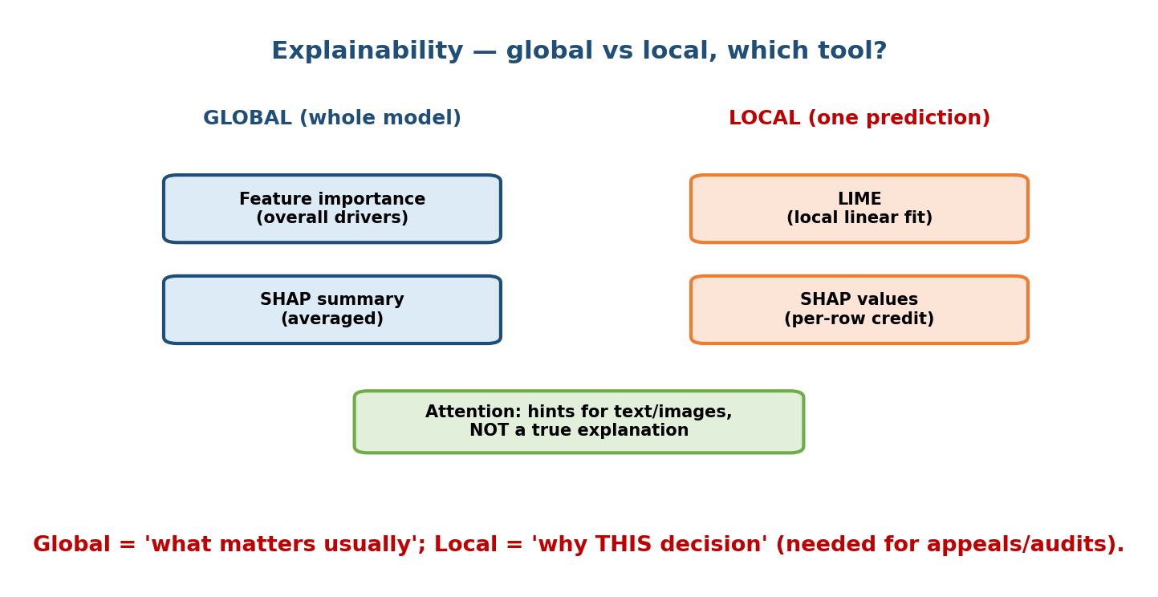
Explainability tools mapped to scope: global tools (feature importance, SHAP summary) explain the whole model; local tools (LIME, SHAP values) explain one prediction; attention gives hints for text and images but is not a true explanation.

The main tools and when to use each
- Feature importance (global). Ranks features by overall contribution (e.g. permutation importance, tree gain). Cheap, coarse, model-level. Use for a quick “what drives this model?”.
- SHAP (SHapley Additive exPlanations). Based on game theory: it fairly splits a prediction into per-feature contributions that add up to the output. Local per row and can be averaged for a global view. Theoretically grounded and consistent, but slow on large models. The go-to when you need trustworthy per-decision credit.
- LIME (Local Interpretable Model-agnostic Explanations). Fits a simple linear model around one prediction by perturbing the input and watching the output. Local only, model-agnostic, fast, but the explanation can be unstable (re-run gives a slightly different story). Good for a quick local peek at any black box.
- Attention weights (for transformers). Show which input tokens the model “looked at”. Useful hints for text/images — but note: attention is not a faithful explanation; high attention does not prove causation. Treat it as a diagnostic, not proof.
Interview line: “For a loan denial appeal I’d use SHAP for a faithful, additive, per-customer reason; for a fast sanity check on any black box, LIME; attention is only a hint, not a legal explanation.”

18.6 Security — attacks on ML systems and defenses
SEBI / RBI flag — HIGH value. Cyber-security of IT systems is central to regulator exams; ML-specific attacks are increasingly examinable and are directly relevant to financial fraud systems.

Motivation
Classic security protects the software. ML adds a new attack surface: the data and the model themselves can be attacked. An attacker may never touch your servers and still break your model.
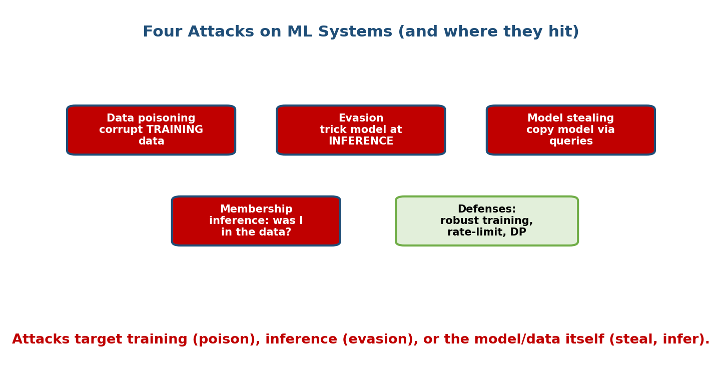
Four attacks on ML systems: data poisoning corrupts training data; evasion tricks the model at inference; model stealing copies the model via queries; membership inference asks whether a record was in the training data. Defenses include robust training, rate-limiting, and differential privacy.

The four main attacks
- Data poisoning (attacks training). The attacker injects corrupted examples into the training set so the model learns a wrong or backdoored behaviour (e.g. “classify anything with this trigger patch as safe”). Common when you train on scraped or user-submitted data.
- Evasion / adversarial examples (attacks inference). The attacker makes a tiny, often invisible change to a legitimate input that flips the prediction — a few pixels, or a sticker on a stop sign that a vision model reads as “speed limit”. The model was never retrained; the input was crafted.
- Model stealing / extraction. By sending many queries and recording outputs, an attacker trains a copy (“clone”) of your model — stealing your IP or building a local model to craft further attacks against.
- Membership inference. The attacker asks “was this specific record in the training data?” If yes, that can itself be a privacy breach (e.g. “this person was in the HIV-patients training set”). Overfit models leak more.

Defenses (name at least one per attack)
- Poisoning: validate and sanitise training data; anomaly detection on inputs; provenance/lineage tracking; robust training.
- Evasion: adversarial training (train on adversarial examples), input preprocessing, ensembles, detecting out-of-distribution inputs.
- Model stealing: rate-limit and authenticate the API, add small output noise, watermark the model, monitor for scraping patterns.
- Membership inference: train with differential privacy, reduce overfitting (regularisation), limit output confidence detail.
Cross-link: these defenses reuse ideas from Module 10 (monitoring for anomalous inputs) and Section 18.4 (DP protects against membership inference).

18.7 Governance — model cards, datasheets, regulation
SEBI / RBI flag — HIGH value. Governance, auditability, and regulatory compliance are the single most exam-relevant part of this module for financial-regulator IT roles. Learn the artifacts and the risk tiers.

Motivation
Fairness, privacy, and security are properties. Governance is the process that makes an organisation prove and maintain them: documentation, audit trails, sign-offs, and legal compliance. When a regulator investigates, governance artifacts are the evidence.

Documentation artifacts
- Model cards. A short standard document that ships with a model: what it does, intended use, training data, evaluation results broken down by group (fairness), known limitations, and ethical considerations. Think “nutrition label for a model”.
- Datasheets for datasets. The same idea for data: how it was collected, who is in it, consent, known biases, and appropriate uses. Answers “should we even train on this?”.
- Audit logs / lineage. Immutable records of which model version, trained on which data, made which decision, when. This is what makes a decision auditable and reproducible — essential in finance.

Regulation you must be able to name
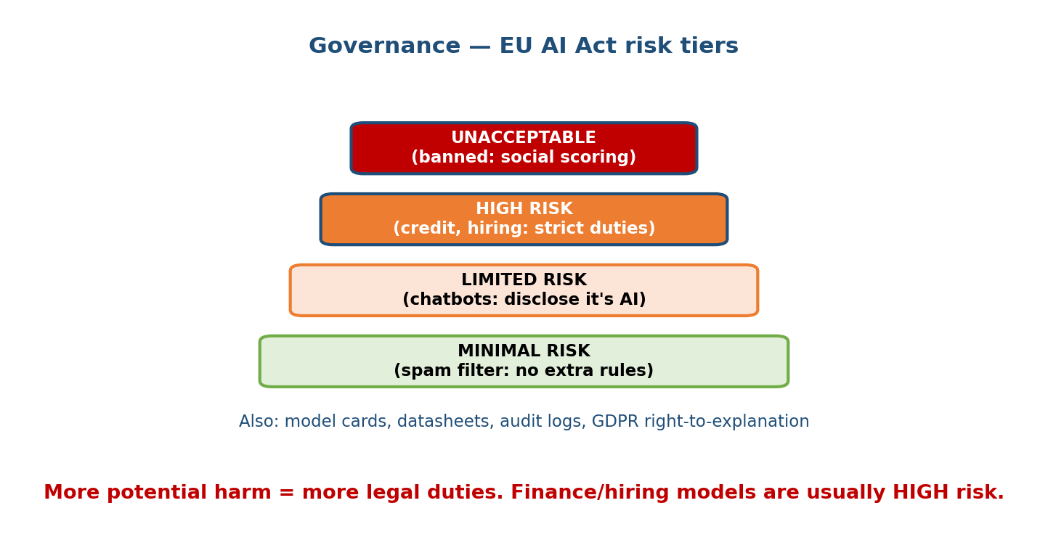
Governance and the EU AI Act risk tiers: unacceptable risk (banned), high risk (credit and hiring, strict duties), limited risk (chatbots must disclose), and minimal risk (spam filters, no extra rules). Also model cards, datasheets, audit logs, and GDPR right-to-explanation.
- EU AI Act — risk tiers (the diagram): the more potential harm, the more legal duty.
  - Unacceptable → banned (e.g. government social scoring).
  - High risk → allowed but heavily regulated (credit scoring, hiring, biometric ID): risk management, documentation, human oversight, logging. Most finance ML lands here.
  - Limited risk → transparency duty (a chatbot must disclose it is AI).
  - Minimal risk → no extra obligations (spam filter, game AI).
- GDPR (EU data-protection law): lawful basis and consent for personal data, data minimisation, the right to explanation for automated decisions, and the right to erasure. Directly motivates DP, model cards, and explainability above.
- Sector rules (India-relevant): RBI and SEBI issue their own IT, data localisation, model-risk, and outsourcing guidelines; the DPDP Act 2023 is India’s data-protection law. The pattern is the same everywhere: document, justify, audit, and keep a human accountable.

18.8 Safety & Alignment for LLM Systems

Motivation
Generative models add new risks: they can produce toxic, false (“hallucinated”), biased, or dangerous text, and they can be manipulated by cleverly worded prompts. Alignment is making the model want to do what we intend; safety guardrails are the surrounding controls that catch failures anyway. (Deep LLM-serving detail is in Module 16 — here we cover the responsible-AI core.)

The alignment idea — RLHF
Base language models predict the next token; they are not naturally helpful or harmless. RLHF (Reinforcement Learning from Human Feedback) aligns them in three steps:
- Supervised fine-tuning: train on human-written good answers.
- Reward model: humans rank pairs of answers; train a model to predict “which answer humans prefer”.
- RL optimisation: fine-tune the LLM to maximise that reward (e.g. PPO), so it produces answers humans prefer. A newer variant, DPO, skips the separate RL step and optimises preferences directly.
The result is a model that is more helpful, honest, and harmless — though never perfectly so.

Guardrails (defense in depth)
Alignment is not enough; wrap the model in controls:
- Input filtering: block prompt-injection and jailbreak attempts, and unsafe requests, before they reach the model.
- Output filtering: a safety classifier checks generations for toxicity, PII, or policy violations after the model, before the user sees them.
- Grounding / RAG + citations: reduce hallucination by forcing answers to cite retrieved sources.
- Human-in-the-loop for high-stakes actions, plus rate limits and abuse monitoring.
Senior signal: treat safety as defense in depth — alignment (RLHF) + input guard + output guard + monitoring — not a single filter. Cross-link Module 16 for the serving mechanics.

Module 18 — Interview Mapping (what companies probe)
Company | How Module 18 shows up | Junior answer | Staff answer
Google / Meta | “How would you make this recommender/loan model fair?” | “Delete the race column” | Names bias sources, picks a fairness metric for the harm, measures + mitigates, breaks the feedback loop
Amazon | Ties to trust / customer harm | Talks accuracy only | Reasons about cost of a wrong decision to the customer + human-in-loop
OpenAI / Anthropic | LLM safety, alignment, jailbreaks | “Add a keyword filter” | Defense in depth: RLHF + input/output guards + monitoring
Stripe / banks / fintech | Privacy, auditability, model risk | Ignores compliance | Model cards, audit logs, DP, explainability for appeals, EU AI Act high-risk duties
Common opening: “Your model works — what could make it irresponsible to ship?” Cover the six pillars: fairness, privacy, explainability, security, governance, safety. Naming that checklist is itself the senior signal.

Module 18 — Exam Mapping (SEBI / RBI / GATE / ISRO)
- SEBI IT / RBI IT — HIGH value (flagged). Expect direct questions on: data privacy & protection law (GDPR ideas, DPDP Act, consent, data localisation); cyber-security (attack types, defenses); governance, auditability, and model risk. Sections 18.4, 18.6, and 18.7 are the money sections for these exams — study them closely.
- GATE CS / DA: may touch fairness metrics and privacy at a conceptual level; formulas for demographic parity / equal opportunity are fair game. Heavy regulation detail is not tested.
- ISRO / DRDO: occasional definitions (adversarial examples, differential privacy) only.
Flag: Unlike most interview-only modules, this module carries genuine written-exam value for SEBI/RBI via privacy, security, and governance. Do not skip 18.4–18.7 for those exams.

Module 18 — Common Mistakes & Misconceptions
- “Delete the protected attribute → fair.” No — proxies (zip code, name) let the model reconstruct it. Fairness must be measured. (18.1–18.2.)
- “There is one fairness metric.” No — parity, equal opportunity, and equalized odds differ, and you cannot satisfy all at once. Choose by harm.
- “Anonymising by dropping names = private.” No — re-identification and membership inference defeat naive anonymisation; use DP. (18.4–18.5.)
- “Attention weights explain the model.” No — they are hints, not faithful explanations. Use SHAP/LIME for real local explanations. (18.5.)
- “Security is just the servers.” No — data poisoning and adversarial inputs attack the ML itself without touching infrastructure. (18.6.)
- “Governance is paperwork we can skip.” No — for high-risk (finance, hiring) systems it is a legal precondition to deploy. (18.7.)
- “RLHF makes an LLM safe.” It helps but is not enough; you still need input/output guardrails and monitoring. (18.8.)

Module 18 — MCQs (with answers & explanations)
Q1. A model rejects far more women than men though sex is not a feature. Most likely cause? a) A compile bug b) Proxy features + biased historical labels c) Too little RAM d) Wrong learning rate
Answer
b. Features like name or career gaps proxy for sex, and historical labels encode past bias, so the model reconstructs and scales the unfairness. Deleting the column does not fix it.
Q2. “Among applicants who truly qualify, each group is approved at the same rate.” Which metric? a) Demographic parity b) Equal opportunity c) Equalized odds d) Calibration
Answer
b. Equal opportunity equalises the true-positive rate ($P(\hat{Y}=1∣Y=1)$) across groups. Demographic parity ignores the true label; equalized odds also equalises the false-positive rate.
Q3. In differential privacy, decreasing epsilon ($ε$) does what? a) More privacy, more noise, less accuracy b) Less privacy, less noise c) No effect d) Removes the need for consent
Answer
a. Epsilon is the privacy budget. Smaller $ε$ means the output changes even less when one record is added/removed — stronger privacy — achieved by adding more noise, costing accuracy.
Q4. A phone trains on-device and sends only model updates to a server that sees only their sum. This is: a) Batch inference b) Federated learning with secure aggregation c) Model stealing d) A/B testing
Answer
b. Raw data never leaves the device (federated learning); secure aggregation ensures the server sees only the summed update, not any individual’s.
Q5. A sticker on a stop sign makes a vision model read “speed limit”. This is: a) Data poisoning b) Evasion / adversarial example c) Membership inference d) Model stealing
Answer
b. The model is unchanged; the input is crafted at inference time to flip the prediction — an evasion / adversarial attack. Defense: adversarial training.
Q6. Under the EU AI Act, a credit-scoring model is typically classed as: a) Minimal risk b) Limited risk c) High risk d) Unacceptable (banned)
Answer
c. Credit scoring and hiring are high-risk: allowed but with strict duties — risk management, documentation, human oversight, and logging. This is why finance ML needs heavy governance.
Q7. Which tool gives a faithful, additive, per-prediction explanation you could show in a loan-denial appeal? a) Attention weights b) SHAP values c) Overall accuracy d) The confusion matrix
Answer
b. SHAP splits a single prediction into per-feature contributions that sum to the output (game-theoretic, consistent). Attention is only a hint; accuracy and confusion matrices are global, not per-decision.
Q8. Best defense against membership-inference attacks? a) Bigger model b) Train with differential privacy + reduce overfitting c) More epochs d) Remove the API rate limit
Answer
b. Overfit models leak whether a record was in training; DP and regularisation reduce that leakage. More epochs and bigger models usually increase memorisation.

Module 18 — Design Exercises (easy → hard)
- Easy. For a hiring model, list the three sources of bias and one concrete example of each in that setting.
- Easy. Given approval rates of 60% (group A) and 42% (group B), does this pass the four-fifths (80%) rule? (42/60 = 70% < 80% → fails.)
- Medium. You must explain individual loan denials to customers. Choose an explainability tool, say global vs local, and justify it against a regulator’s needs.
- Medium. Design a privacy strategy for training a next-word keyboard across millions of phones. Combine federated learning, secure aggregation, and DP; say what each one protects against.
- Hard. A fraud model is under attack. Describe how an adversary could use
  - evasion and (2) model stealing against it, and give a layered defense for each.
- Hard. Draft the outline of a model card for a credit-scoring model under the EU AI Act high-risk tier: list the sections and the fairness evidence you would include.

Module 18 — Concept Review (one page)
- Bias enters via data, labels, and feedback loops; a model mirrors and amplifies its data. Deleting protected attributes fails (proxies).
- Fairness metrics: demographic parity (equal positive rate) · equal opportunity (equal TPR) · equalized odds (equal TPR and FPR). You cannot satisfy all at once — choose by the harm.
- Mitigation happens at three stages: pre (fix data) · in (fairness term in the loss) · post (adjust thresholds). Earlier = stronger but needs more access.
- Differential privacy: add noise so one record barely changes the output; epsilon is the privacy budget (small = private, noisy, less accurate).
- Federated learning: train on-device, send only updates; secure aggregation hides each individual update. Often combined with DP.
- Explainability: global (feature importance, SHAP summary) vs local (SHAP values, LIME). SHAP = faithful additive credit; LIME = fast local; attention = hint only.
- Attacks: poisoning (training) · evasion (inference) · model stealing (queries) · membership inference (privacy). Defenses: data validation, adversarial training, rate-limit, DP.
- Governance: model cards · datasheets · audit logs; EU AI Act risk tiers (unacceptable/high/limited/minimal); GDPR right-to-explanation. Finance ML is usually high risk.
- LLM safety: RLHF aligns; guardrails (input + output filters + monitoring) are defense in depth.

Module 18 — Flash Cards (Q → A)
- Three sources of bias? → Data bias, label bias, feedback loops.
- Demographic parity in one line? → Equal positive rate across groups.
- Equal opportunity vs equalized odds? → Opportunity equalises TPR only; odds equalises TPR and FPR.
- What is epsilon in DP? → The privacy budget; smaller = more noise, more privacy, less accuracy.
- Federated learning sends what to the server? → Model updates, never raw data; secure aggregation hides individual updates.
- SHAP vs LIME vs attention? → SHAP = faithful additive (local+global); LIME = fast local approx; attention = hint, not explanation.
- Four ML attacks? → Poisoning, evasion, model stealing, membership inference.
- EU AI Act tier for credit/hiring? → High risk (strict duties).
- RLHF in one line? → Fine-tune an LLM to maximise human-preference reward.

Module 18 — Pattern Recognition (how to spot it in an interview)
- Hear “is this model fair?” → name bias sources, pick a fairness metric for the harm, measure + mitigate, break the feedback loop.
- Hear “the data is sensitive / medical / financial” → say differential privacy and/or federated learning, and mention consent + GDPR.
- Hear “why did the model decide this for this person?” → say local explanation; propose SHAP (or LIME for a quick check).
- Hear “could someone attack this model?” → name evasion, poisoning, model stealing, membership inference + one defense each.
- Hear “we operate in a regulated industry” → model cards, audit logs, human-in-loop, EU AI Act high-risk duties.
- Hear “the chatbot said something harmful” → defense in depth: RLHF + input guard + output guard + monitoring (link Module 16).

Module 18 — Revision Notes / Mini Cheat Sheet
RESPONSIBLE AI = FAIR + PRIVATE + EXPLAINABLE + SECURE + GOVERNED + SAFE
BIAS SOURCES: data | labels | feedback-loop (deleting protected attr FAILS: proxies)
FAIRNESS: demographic parity P(Y'=1|A) equal
equal opportunity P(Y'=1|Y=1,A) equal (TPR)
equalized odds TPR AND FPR equal (strongest)
-> can't satisfy all (impossibility); 4/5 rule = adverse impact
MITIGATION: PRE (fix data) | IN (fairness loss term) | POST (adjust thresholds)
PRIVACY: DP -> add noise; epsilon = privacy budget (small=private,noisy)
Federated -> train on-device, send updates not data
Secure aggregation -> server sees only the SUM
EXPLAIN: global = feature importance / SHAP summary
local = SHAP values (faithful) | LIME (fast) | attention (hint only)
ATTACKS: poisoning(train) | evasion(inference) | stealing(queries) | membership(privacy)
DEFENSES: data validation | adversarial training | rate-limit+auth | DP
GOVERNANCE: model cards | datasheets | audit logs
EU AI Act: unacceptable(ban) > high(credit,hiring) > limited(disclose) > minimal
GDPR: consent + right-to-explanation + erasure (finance ML = HIGH risk)
LLM SAFETY: RLHF (align) + guardrails (input/output filters) + monitoring = defense in depth

Next module: Module 19 — Systems Foundations for ML. We come back down to the classic-system-design layer every ML system rests on — load balancing, caching, databases, queues, replication, gRPC/REST, SLAs/SLOs, and back-of-the-envelope capacity math — so you can size and scale the serving layer you now know how to make responsible.

