Module 19 — Systems & Distributed Systems Foundations for ML
  - ML System Design Mastery: FAANG / AI-Engineer / Staff-Level — In-Depth Notes (with visuals)
Prepared for nidhi.sharma@forensiccybertech.com
2026
Table of Contents

Module 19 — Systems & Distributed Systems Foundations for ML
Why this module exists. An ML system is a distributed system that happens to have a model inside it. The model is the easy part. Getting a prediction to a million users in under 100 ms, without falling over when one machine dies, without serving stale garbage from a cache, and without going bankrupt on infrastructure — that is the hard part, and it is pure classic systems engineering. Almost every serving answer you will give in an interview (Modules 8 and 11) rests on the ideas in this module: load balancing, caching, the right database, message queues, the CAP theorem, gRPC, reliability budgets, the latency ladder, and back-of-the-envelope sizing. Candidates who cannot do a capacity estimate, or who think a cache is “just make it faster,” get exposed fast. We build every idea from first principles, in plain English, and tie each one to how it shows up in a real ML serving design.
Importance ratings (out of 5):
Exam / Use | SEBI IT | RBI IT | GATE CS/DA | Interview | AI/MLE role
This module | ★★★★ | ★★★★ | ★★★★ | ★★★★★ | ★★★★★
Flag — HIGH exam value. Unlike the framing and case-study modules, this one has strong CS-fundamentals overlap. Load balancing, caching, CAP, consistency, databases, and queues are staple GATE CS/DA, SEBI IT, and RBI IT topics and appear on almost every written exam. Learn this module for the exam and the interview — the return is double.
What you must be able to do after this module: choose L4 vs L7 load balancing and a routing algorithm; pick a cache pattern and eviction policy and explain cache-friendliness for ML; select SQL / NoSQL / key-value / vector / time-series storage for a given ML workload; explain Kafka’s log, partitions, and consumer groups; state the CAP theorem correctly and pick a consistency model; justify gRPC over REST for model serving; define SLA / SLO / SLI and design retries, timeouts, and circuit breakers; recite the latency ladder “numbers every engineer should know”; and do a back-of-the-envelope QPS, storage, and bandwidth sizing on the spot.
How to read this module. For every idea we go problem → simplest attempt → why it breaks → the fix, and we connect each systems concept to the ML serving decision it drives.

19.1 Load Balancing (L4 vs L7, and the algorithms)

Motivation (the problem that existed)
You trained a great model and wrapped it in one server. It handles 500 requests per second. Traffic grows to 50,000 QPS. One machine cannot do it, and if that one machine dies, your whole product is down. The obvious fix is to run many identical copies of the server. But now the client has a new question: which copy do I talk to? You cannot hard-code one address (that defeats the point), and you cannot make every client know about every server (they come and go).
The fix is a load balancer (LB): a single front door that spreads incoming requests across a fleet of backend servers, hides individual machines, and routes around dead ones.
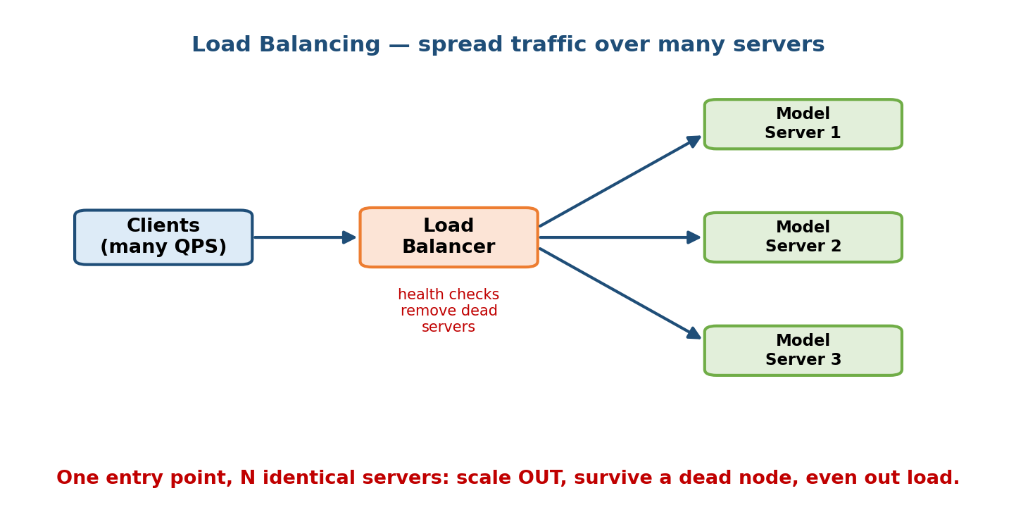
Load balancer sitting between clients and a fleet of identical backend model servers, spreading incoming requests across healthy replicas and routing around a failed one via health checks.

Definition
- A load balancer is a component that receives client requests and forwards each one to one of several backend servers, according to a routing algorithm, while continuously health-checking backends and removing dead ones from rotation.
- Layer 4 (L4) load balancing operates at the transport layer (TCP/UDP). It looks only at IP addresses and ports — not the request content. It is fast and cheap because it just forwards packets/connections.
- Layer 7 (L7) load balancing operates at the application layer (HTTP/gRPC). It can read the request — URL path, headers, cookies — and route based on content (e.g. send /predict/v2 to the new model, /predict/v1 to the old). It is smarter but does more work per request.

Intuition & analogy
Think of a busy clinic. An L4 receptionist just counts heads and sends you to “the next free doctor” without asking why you came. An L7 receptionist reads your form (“skin problem”) and sends you to the dermatologist. L7 is smarter and enables things like A/B routing and canary releases; L4 is faster and simpler.

Routing algorithms (first principles)
The LB must decide which backend gets the next request. Common policies:
Algorithm | How it works | Best when
Round robin | Send to servers in turn: 1, 2, 3, 1, 2, 3… | Backends are identical and requests are similar cost
Weighted round robin | Bigger servers get proportionally more traffic | Mixed hardware (some GPUs, some CPUs)
Least connections | Send to the backend with the fewest in-flight requests | Request costs vary a lot (some inferences slow)
Least response time | Combine active connections + measured latency | Latency-sensitive serving
Consistent hashing | Hash a key (user id) → always the same server | You want cache/session affinity (see 19.2)
Random (two-choices) | Pick 2 at random, send to the less-loaded one | Cheap, near-optimal spread at scale
ML angle. For a stateless model server, least-connections or round robin is fine. If each server caches per-user embeddings or holds a shard of a huge index, use consistent hashing so the same user keeps hitting the server that already has their data warm — a huge latency win.

Trade-offs and failure modes
- Health checks are non-negotiable. Without them the LB keeps sending traffic to a crashed server → users get errors. A good check hits a real /healthz that confirms the model is loaded, not just that the process is up.
- The LB itself is a single point of failure. In production you run the LB in a redundant pair (or use a managed/anycast LB) so it, too, survives a failure.
- Sticky sessions vs even spread. Affinity (always route a user to the same box) helps caches but can create hot spots if one user is very heavy.

19.2 Caching (Redis / Memcached, patterns, eviction)

Motivation
Some work is expensive and repeated. Recomputing a user’s recommendations, or re-reading the same product row from the database a million times a second, is wasteful. A cache stores the answer to expensive/repeated work in fast memory so the next request gets it in microseconds instead of milliseconds.
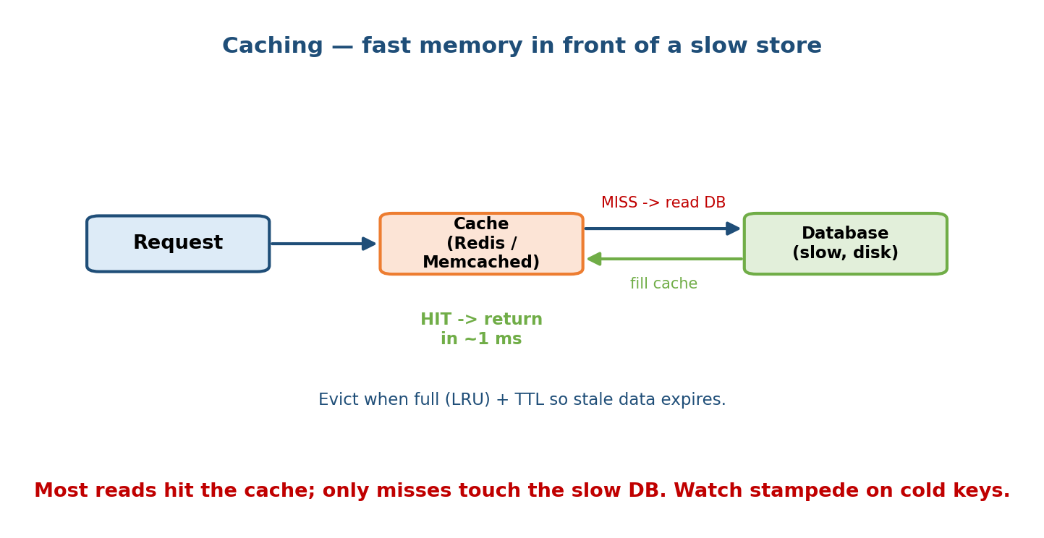
Cache-aside flow: application checks the cache first; on a hit it returns instantly, on a miss it reads the database, stores the result in the cache with a TTL, and returns it. Eviction policies LRU and LFU shown removing cold entries when memory fills.

Definition
A cache is a small, fast store (usually in RAM) that holds a copy of data that is expensive to fetch or compute. Redis and Memcached are the two industry-standard in-memory caches.
- Memcached: dead-simple key→value string cache, multi-threaded, great for pure “make reads fast.”
- Redis: richer — data structures (lists, sets, sorted sets, hashes), persistence, pub/sub, atomic ops. The default choice when you need more than plain get/set (e.g. leaderboards, rate limiters, feature caches).

Caching patterns (how the app and cache cooperate)
- Cache-aside (lazy loading). The app checks the cache first. Hit → return it. Miss → read the database, write the value into the cache (with a TTL), return it. Simplest and most common. Downside: the first request after a miss is slow, and the cache can hold stale data until it expires.
- Write-through. On every write, update the cache and the database together. Reads are always fresh; writes are a bit slower. Good when reads far outnumber writes.
- Write-back (write-behind). Write to the cache immediately, flush to the DB later in batches. Fastest writes, but you can lose data if the cache dies before flushing. Rare in ML serving.

Eviction policies (what to throw out when memory is full)
Cache memory is finite. When it fills, something must go:
Policy | Evicts | Good for
LRU (Least Recently Used) | The item untouched for the longest | General purpose; recent = likely-reused
LFU (Least Frequently Used) | The item accessed fewest times | Stable “popular items” that must stay hot
FIFO | The oldest inserted item | Rarely ideal; simple
TTL expiry | Anything past its time-to-live | Data that goes stale on a clock (prices, features)
TTL (time-to-live) is the seconds an entry is allowed to live before it is considered stale and dropped. TTL is your main knob for freshness vs load: a short TTL means fresher data but more cache misses (more DB/model load); a long TTL means less load but staler answers.

Cache-friendliness for ML
- Cache the expensive, reusable, and slow-changing. Precomputed batch recommendations, popular-item features, and embeddings are ideal cache contents. A per-request personalized score that is never repeated is not worth caching.
- Feature caching is standard: an online feature store keeps hot features in Redis so the serving path avoids a slow database read (Module 5).
- Beware the cache stampede (thundering herd): a hot key expires and thousands of requests all miss and hit the DB at once. Fixes: add small random jitter to TTLs, or use a lock so only one request refills the key.
- Cache invalidation is famously hard. When the model version changes, stale cached predictions become wrong. Version your cache keys (preds:v7:user123) so a new model naturally misses and refills.
Interview line. “There are only two hard things in computer science: cache invalidation and naming things.” Show you know when a cache helps (high read/compute cost + high reuse + tolerance for slight staleness) and when it hurts (write-heavy, must-be-fresh, low reuse).

19.3 Databases for ML (SQL, NoSQL, key-value, vector, time-series)

Motivation
“Where does the data live?” is not one question — different ML data has wildly different shapes and access patterns. Training data, online features, embeddings, and metrics logs each want a different kind of store. Picking the wrong one means slow queries, huge bills, or an index that cannot answer your question at all.
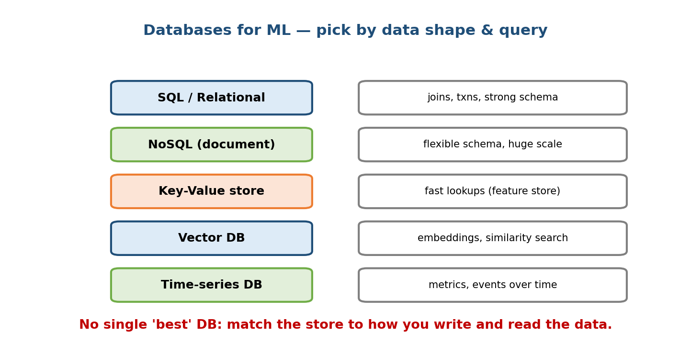
A row of database types — relational SQL, document/wide-column NoSQL, key-value, vector, and time-series — each labeled with the ML workload it serves best, from transactional metadata to nearest-neighbor embedding search and metrics.

The families (and when each wins)
- Relational / SQL (Postgres, MySQL). Data in tables with a fixed schema and relationships; strong consistency and joins; supports transactions (ACID). Best for structured, related data where correctness matters — user accounts, orders, labels, experiment metadata.
- NoSQL document / wide-column (MongoDB, Cassandra, DynamoDB). Flexible schema, scales horizontally to huge write volumes, weaker joins. Best for large-scale, semi-structured data and high write throughput — event logs, user profiles, clickstreams.
- Key-value (Redis, DynamoDB, RocksDB). Just get(key) / put(key, value), extremely fast. Best for the online feature store and low-latency lookups on the serving path.
- Vector database (FAISS, Milvus, Pinecone, pgvector). Stores high-dimensional embeddings and answers approximate nearest neighbour (ANN) queries — “find the 50 items most similar to this vector.” This is the backbone of semantic search, retrieval, and candidate generation for recommenders (Modules 12, 13).
- Time-series (Prometheus, InfluxDB, TimescaleDB). Optimized for timestamp-indexed metrics with fast range/rollup queries. Best for monitoring, drift metrics, and any “value over time” data (Module 10).

Comparison table
Type | Data shape | Query strength | Consistency | ML use
SQL | Tables, fixed schema | Joins, transactions | Strong (ACID) | Labels, metadata, experiments
NoSQL doc/column | Flexible docs / wide rows | Key + range, scale-out writes | Tunable/eventual | Event logs, profiles, clickstream
Key-value | Opaque value by key | Point get/put (µs) | Usually eventual | Online feature store, session cache
Vector | Dense embeddings | ANN similarity search | Eventual (index) | Semantic search, retrieval, recs
Time-series | (time, value) points | Range, downsample, rollup | Eventual | Monitoring, drift, metrics

First-principles: how to choose
Ask three questions: (1) What is the access pattern? Point lookups → key-value; similarity → vector; range over time → time-series; complex joins → SQL. (2) How big and how write-heavy? Massive writes that must scale out → NoSQL. (3) How strict is consistency? Money/labels → strong (SQL); logs/features → eventual is fine. A real ML system uses several of these together, not one.
Common real design. Postgres for metadata, Kafka + a data lake for raw events, Redis (key-value) as the online feature store, and a vector DB for candidate retrieval — all in one recommender. Naming this stack is a strong senior signal.

19.4 Message Queues & Streaming (Kafka, Flink, Spark Streaming)

Motivation
Systems must talk to each other, but calling a service directly and synchronously is fragile: if the downstream is slow or down, the caller blocks or fails, and a traffic spike overwhelms everyone. We want to decouple producers from consumers so each can work at its own pace and survive the other being down. The answer is a message queue / log in the middle.
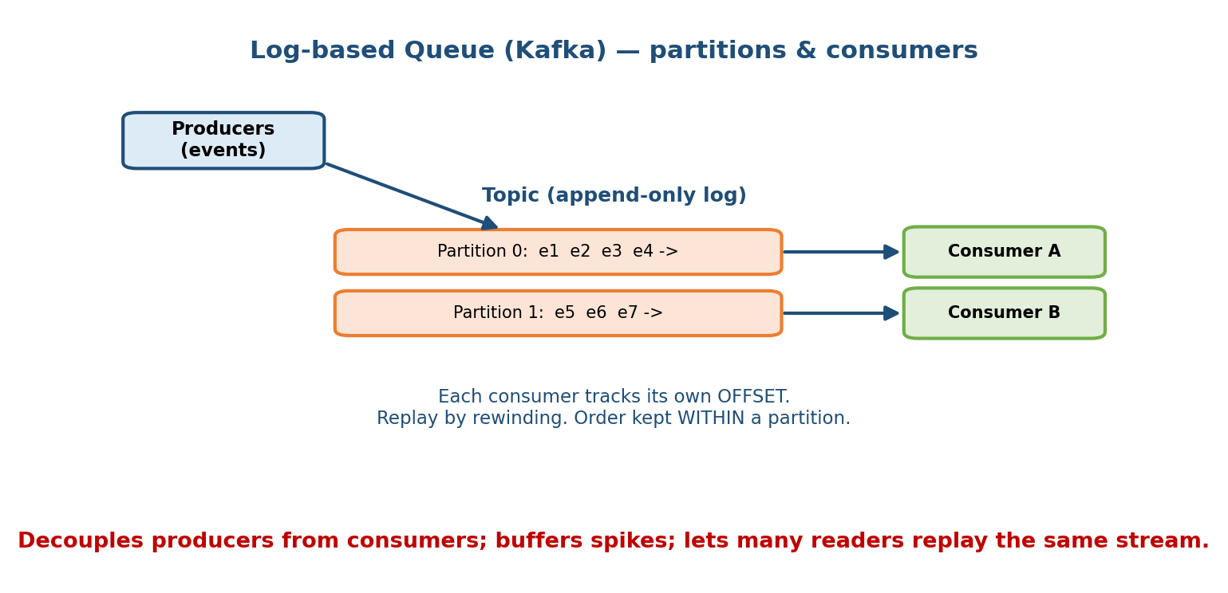
Kafka’s append-only commit log split into partitions, with producers appending events at the end, each consumer group tracking its own offset, and partitions distributed across brokers for parallelism and replay.

Kafka — the distributed commit log
Apache Kafka is not a classic queue that deletes messages after reading. It is a durable, append-only log: producers append events to the end; consumers read forward at their own pace and can replay history.
- Topic: a named stream of events (e.g. clicks, transactions).
- Partition: a topic is split into partitions — ordered, append-only sequences. Partitions are the unit of parallelism and are spread across brokers (servers). Order is guaranteed within a partition, not across partitions.
- Offset: each message’s position in a partition. A consumer stores its offset, so it knows where it left off and can rewind to reprocess.
- Consumer group: a set of consumers that share the work — each partition is read by exactly one consumer in the group, so adding consumers (up to the partition count) scales throughput. A second group reading the same topic gets its own independent copy of the stream.
- Replication: each partition is copied to several brokers, so a broker dying loses no data.
Why the log shape matters for ML. Because Kafka retains and replays, you can (1) feed the same event stream to real-time features and to a training pipeline (avoiding training-serving skew, Module 5), and (2) reprocess history when you add a new feature. A delete-on-read queue cannot do this.

Stream processors — computing on the flow
Kafka moves events; a stream processor computes on them continuously:
- Apache Flink. True event-at-a-time streaming with low latency, stateful windows, and event-time handling. Best for real-time features and fraud detection where every millisecond and correct time-windowing matter.
- Spark Streaming (Structured Streaming). Processes data in small micro-batches. Slightly higher latency but reuses the batch Spark ecosystem — great when you already run Spark for batch and want “good enough” near-real-time.
 | Batch | Micro-batch (Spark) | Streaming (Flink)
Latency | minutes–hours | seconds | milliseconds
Model | process a fixed dataset | small chunks on a clock | event-by-event
ML use | training, nightly features | near-real-time features | fraud, live personalization

Trade-offs
- Decoupling + buffering are the whole point: a spike is absorbed by the log instead of crushing the consumer; a down consumer catches up later.
- Ordering only holds within a partition — choose your partition key (e.g. by user id) so events that must stay ordered land in the same partition.
- At-least-once vs exactly-once. By default you may see a message twice on retry; design consumers to be idempotent, or use exactly-once semantics where supported.

19.5 CAP Theorem, Consistency, Replication & Sharding

Motivation
Once your data lives on many machines (for scale and to survive failures), a brutal truth appears: the network between them will fail sometimes, and when it does you must choose between answering with possibly-stale data or refusing to answer. This is the CAP theorem, and it silently shapes every distributed store you pick.
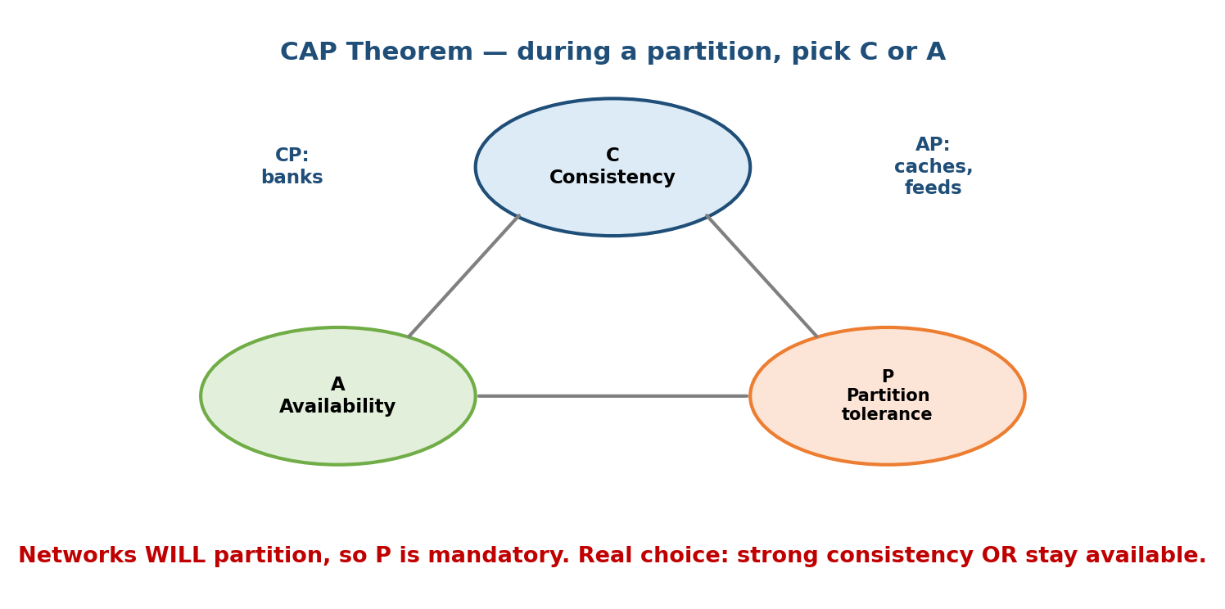
CAP theorem triangle showing Consistency, Availability, and Partition tolerance, with the rule that during a network partition a system can keep only two — illustrated as CP (refuse to serve stale) versus AP (serve possibly stale but stay up).

The CAP theorem (stated correctly)
A distributed data store can provide at most two of these three at once:
- C — Consistency: every read sees the most recent write (all nodes agree).
- A — Availability: every request gets a (non-error) response.
- P — Partition tolerance: the system keeps working even when the network between nodes is broken.
The subtlety most candidates miss: network partitions happen whether you like it or not, so P is not really optional. The real choice is, during a partition, do you sacrifice C or A?
- CP system (e.g. HBase, Zookeeper, a leader-based SQL): during a partition it refuses requests it cannot serve consistently → stays correct, drops availability. Choose when stale data is dangerous (bank balance).
- AP system (e.g. Cassandra, DynamoDB default): during a partition it keeps answering with possibly-stale data → stays up, drops consistency. Choose when being up matters more than perfect freshness (feature store, product catalog).

Consistency models (the shades between)
- Strong consistency: a read always reflects the latest write. Simple to reason about, but slower and less available. Needed for money, inventory, and labels.
- Eventual consistency: if writes stop, all replicas eventually converge; a read may briefly return stale data. Cheaper, faster, more available — and perfectly fine for most ML serving (a feature that is 2 seconds stale rarely matters).

Replication, partitioning & sharding
- Replication = keep multiple copies of the same data on different nodes. Buys durability (survive a node death) and read scaling (read from any replica). Introduces the consistency question above (which copy is authoritative?).
- Partitioning / sharding = split data across nodes so no single machine holds it all — each shard owns a slice (e.g. users A–M on shard 1, N–Z on shard 2). Buys write scaling and lets datasets exceed one machine.
- Real systems do both: shard for size, replicate each shard for safety.
- Watch for hot shards: a bad shard key (e.g. sharding by country when one country is 80% of traffic) overloads one node. Choose a high-cardinality, evenly-distributed key.
ML angle. A large embedding index or feature store is sharded (too big for one box) and each shard is replicated (for QPS and failure tolerance). Most ML serving data tolerates eventual consistency, which is exactly why ML platforms lean on fast AP stores.

19.6 Microservices & APIs (REST vs gRPC, service mesh)

Motivation
You could build the whole ML product as one giant program (a monolith). It is simple at first, but soon the feature pipeline, the model server, and the business logic all scale, deploy, and fail together — a change to one forces redeploying all. Microservices split the system into small, independently deployable services that talk over the network. Now the model server can scale on GPUs while the API layer scales on cheap CPUs.
But once services talk over the network, how they talk matters a lot for latency and throughput — this is where REST vs gRPC comes in.
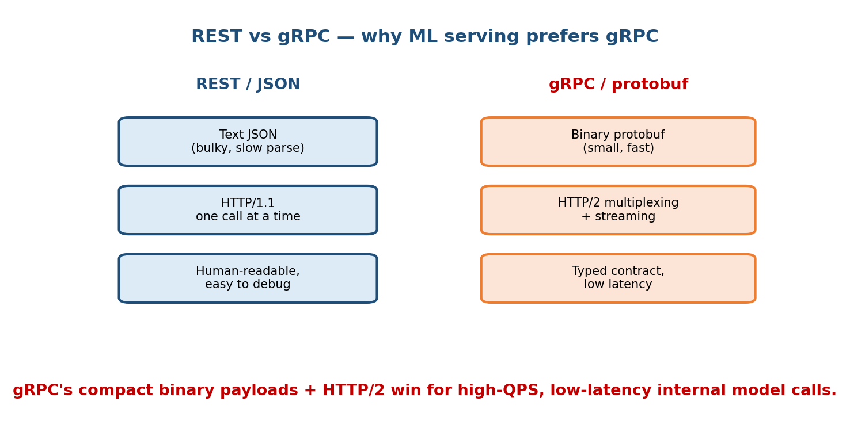
Side-by-side of REST (HTTP/1.1, JSON text payloads, human-readable) versus gRPC (HTTP/2, binary Protobuf, multiplexed streaming) with gRPC highlighted as the lower-latency, higher-throughput choice for internal model-serving calls.

REST vs gRPC
- REST (over HTTP/1.1, usually JSON). Text-based, human-readable, works in every browser and language, easy to debug with curl. But JSON is verbose to send and slow to parse, and HTTP/1.1 handles one request per connection at a time.
- gRPC (over HTTP/2, using Protobuf binary). Compact binary payloads, a typed schema (.proto) generating client/server code, multiplexed streams over one connection, and built-in streaming. Faster and lighter, but not browser-native and harder to eyeball.
 | REST + JSON | gRPC + Protobuf
Payload | Text (verbose) | Binary (compact)
Transport | HTTP/1.1 | HTTP/2 (multiplexed)
Schema/contract | Loose (OpenAPI optional) | Strong, generated from .proto
Streaming | Awkward | First-class (bi-directional)
Human-debuggable | Yes (curl) | No (binary)
Best for | Public/browser APIs | Internal service-to-service, ML serving

Why gRPC for ML serving
- Latency & throughput. Model serving is chatty, internal, high-QPS traffic where every millisecond counts. Binary Protobuf + HTTP/2 multiplexing cut serialization cost and connection overhead vs JSON/HTTP1 — often a large win.
- Tensors are numeric. ML payloads are big numeric arrays; encoding them as JSON text is wasteful, while Protobuf packs them compactly.
- Streaming. gRPC streams suit token-by-token LLM output and continuous feature pushes.
- Typed contracts catch shape mismatches (a classic serving bug) at compile time. This is why TensorFlow Serving and NVIDIA Triton expose gRPC.
Balanced answer. Expose a REST endpoint at the public edge (browser- and partner-friendly), and use gRPC for internal service-to-service and model-serving hops. Best of both.

Service mesh
As services multiply, every one needs retries, timeouts, TLS, load balancing, and metrics. A service mesh (e.g. Istio, Linkerd) pushes this into a sidecar proxy next to each service, so the network concerns are handled uniformly by infrastructure instead of being re-coded in every service. It gives you observability, traffic shifting (canary), and mTLS “for free” — very useful when rolling out a new model version to 5% of traffic.

19.7 Reliability (SLA / SLO / SLI, redundancy, degradation, retries)

Motivation
At scale, failure is normal, not exceptional. With thousands of machines, something is always broken. Reliability engineering is about making the system stay up and correct even though its parts fail. And you must measure it, because “is it reliable?” is meaningless without a number.
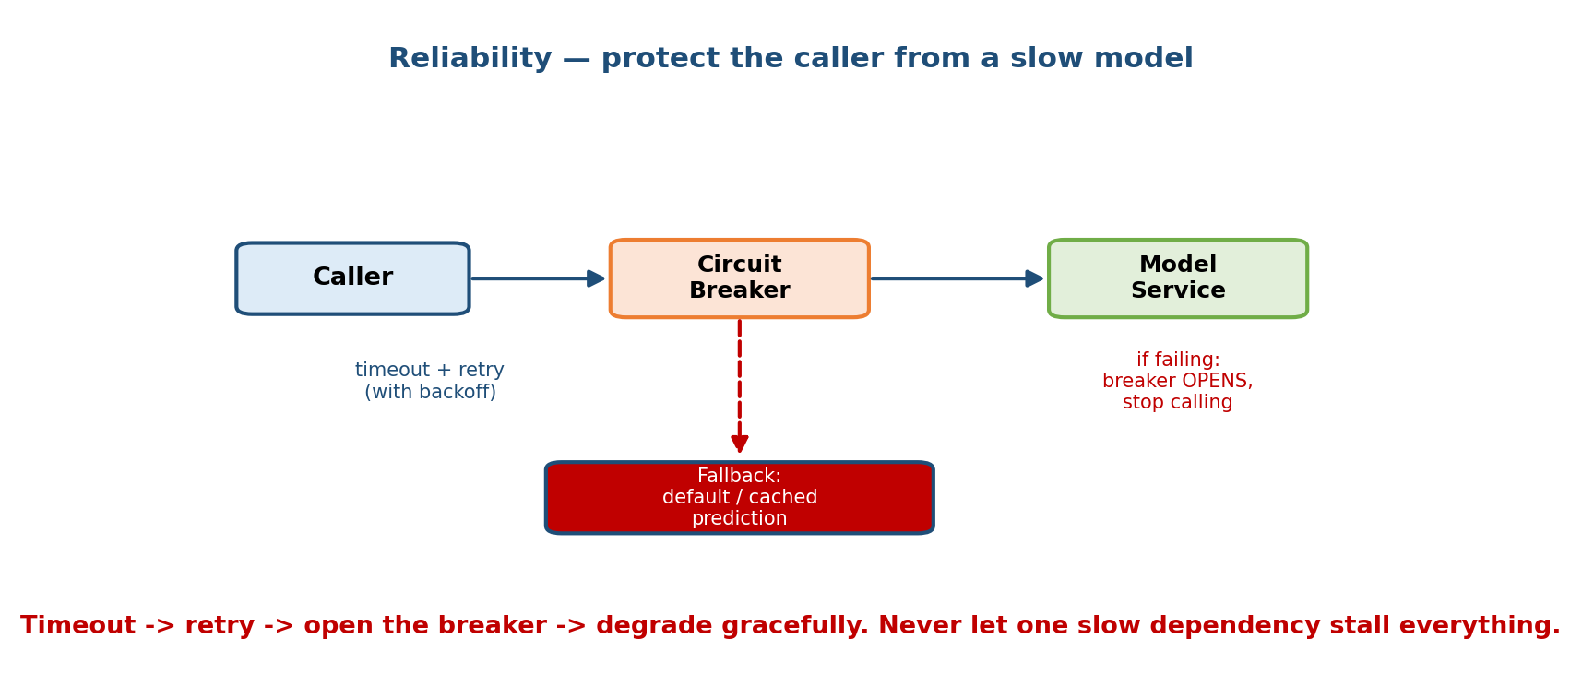
Reliability layers: SLI measurements feeding an SLO target and an SLA contract at the top, with redundancy, graceful degradation, and the retry/timeout/circuit-breaker request-protection pattern shown as the mechanisms underneath.

SLI, SLO, SLA (measure, target, promise)
- SLI — Service Level Indicator: the measured number. E.g. “99.95% of requests succeeded in the last 30 days,” or “p99 latency = 80 ms.” It is a fact.
- SLO — Service Level Objective: the internal target for an SLI. E.g. “p99 latency < 100 ms” or “availability ≥ 99.9%.” It is a goal you engineer to.
- SLA — Service Level Agreement: the contractual promise to customers, with penalties if broken. E.g. “99.9% uptime or you get a refund.” The SLA is looser than the SLO on purpose, so you have a safety margin.
Memory hook: SLI = Indicator (measured), SLO = Objective (target), SLA = Agreement (promise with teeth). The “nines”: 99.9% ≈ 8.7 h downtime/year; 99.99% ≈ 52 min/year; 99.999% ≈ 5 min/year. Each extra nine costs a lot more.
ML-specific SLOs. Serving has classic SLOs (latency, availability) plus ML-quality ones: prediction latency p99, model freshness (“features < 5 min old”), and even an accuracy/AUC floor monitored in production (Module 10).

Mechanisms that buy reliability
- Redundancy. Run N+1 (or more) copies across different machines, racks, and availability zones, so one death does not take the service down. No single point of failure — including the LB and the database (use replicas).
- Graceful degradation. When a dependency fails, return a worse but useful answer instead of an error. If the personalized model times out, serve popular items (a cheap fallback). A degraded answer beats a blank page.

Retries, timeouts & circuit breakers (protecting a request)
- Timeout. Never wait forever. Cap how long you wait for a downstream (e.g. 50 ms); past that, fail fast or fall back. Without timeouts, one slow dependency freezes threads and cascades into a full outage.
- Retry (with backoff + jitter). A transient blip? Try again — but with exponential backoff and random jitter so you don’t stampede the struggling service. Cap the number of retries.
- Circuit breaker. If a downstream keeps failing, stop calling it for a while (the breaker “opens”), immediately serving a fallback. This lets the sick service recover instead of being hammered, and it stops failures cascading. After a cooldown the breaker “half-opens” to test if it recovered.
Interview trap. Naive retries make outages worse: a struggling service gets retried by everyone at once (a retry storm). Always pair retries with backoff, jitter, a retry cap, and a circuit breaker. Saying this unprompted is a senior signal.

19.8 The Latency Ladder (numbers every engineer should know)

Motivation
Every design decision — cache or not, one datacenter or many, in-memory or on disk — comes down to how long things take. If you carry rough numbers in your head, you can reason about latency budgets on the spot. If you don’t, you’ll propose designs that cannot possibly meet a 100 ms budget. These are Jeff Dean’s famous “numbers every engineer should know.”
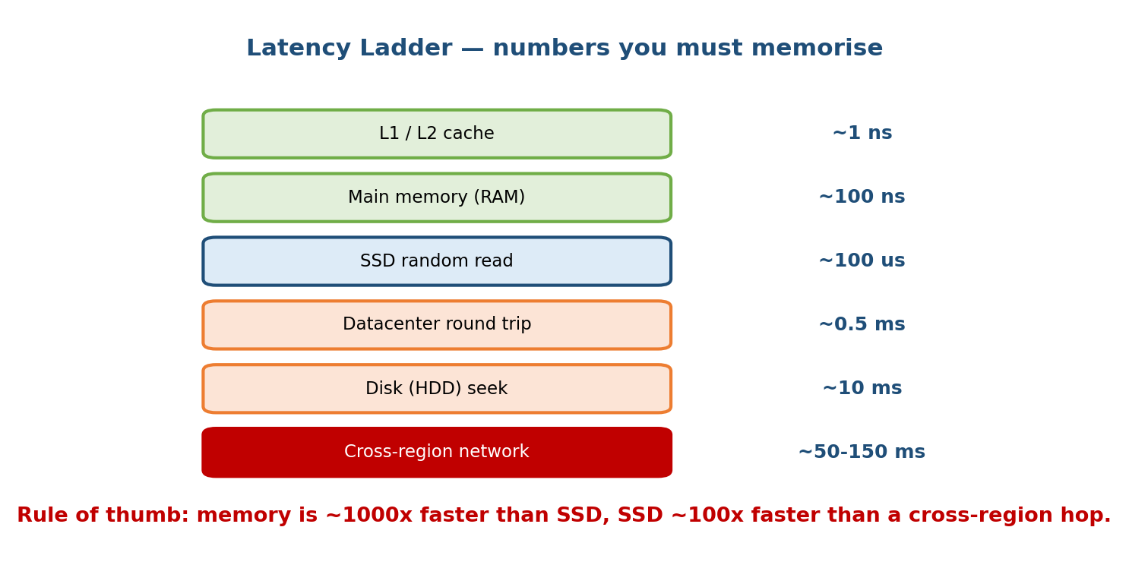
A latency ladder rising by orders of magnitude — from nanosecond L1/L2 cache and RAM reads, to microsecond SSD reads, to millisecond disk seeks and same-region network round trips, up to hundred-plus-millisecond cross-continent round trips — each rung annotated with its approximate time.

The ladder (approximate, order-of-magnitude)
Operation | Approx time | In “human” scale (×1e9)
L1 cache reference | ~1 ns | 1 second
Branch mispredict | ~3 ns | 3 s
L2 cache reference | ~4 ns | 4 s
Mutex lock/unlock | ~17 ns | 17 s
Main memory (RAM) reference | ~100 ns | ~1.5 min
Compress 1 KB | ~2 µs | ~33 min
Read 1 MB sequentially from RAM | ~10 µs | ~2.8 h
SSD random read | ~16 µs | ~4.4 h
Read 1 MB from SSD | ~200 µs | ~2.3 days
Round trip within same datacenter | ~500 µs | ~5.8 days
Read 1 MB from disk (HDD) | ~1–2 ms | ~11–23 days
Disk seek | ~2–10 ms | weeks
Round trip California ↔ Netherlands | ~150 ms | ~4.7 years

The lessons that actually matter
- RAM is ~100× faster than SSD, and SSD is ~100× faster than a disk seek, and the network is slower still. This is why caches exist (19.2) and why the online feature store keeps hot features in RAM.
- Memory (ns) ≪ SSD (µs) ≪ disk seek (ms) ≪ cross-region (100+ ms). Each step is roughly 1000× — spanning nanoseconds to hundreds of milliseconds.
- Cross-region round trips (~150 ms) can alone blow a 100 ms budget. So keep the serving path within one region; replicate data close to users; never make a synchronous cross-continent call on the hot path.
- A same-datacenter round trip (~0.5 ms) is cheap; a chain of 30 of them is not. Every microservice hop adds up — this is why you batch calls and prefer gRPC.
How to use it in an interview. When asked “can this meet 50 ms p99?”, add up the hops: LB → feature fetch (cache 0.5 ms or DB few ms) → model inference (say 20 ms) → response. If the sum blows the budget, that’s your cue to cache, co-locate, or shrink the model.

19.9 Back-of-the-Envelope Capacity Estimation

Motivation
Interviewers always ask “how many servers? how much storage? how much bandwidth?” They don’t want a precise number — they want to see you reason with round numbers and sensible assumptions. This skill also protects you from proposing a design that needs 10,000 machines when 10 will do (or vice versa).
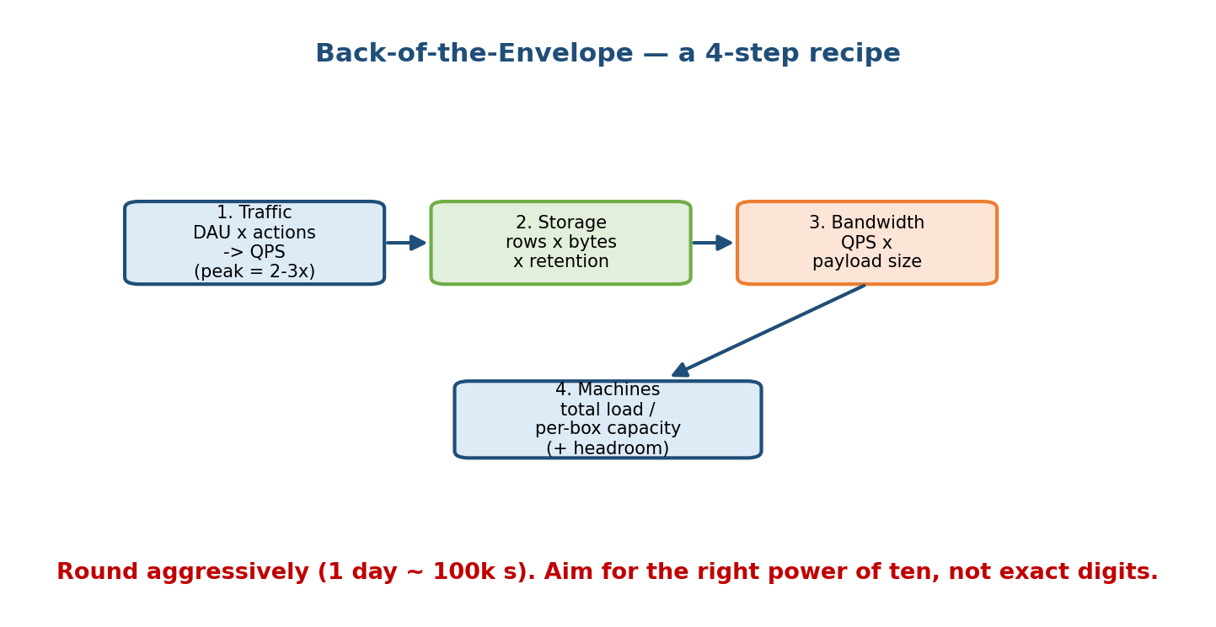
A worked back-of-the-envelope estimation panel: from daily active users and requests-per-user to average QPS and peak QPS, then storage per record times record count to total storage, and QPS times payload size to bandwidth — the reusable estimation pipeline.

The reusable recipe
- State assumptions out loud (DAU, requests/user/day, payload size, retention). Round aggressively.
- QPS. average QPS = total daily requests / 86,400 s. Then peak QPS ≈ average × (2 to 10) to cover bursty traffic.
- Storage. bytes/record × records/day × retention days. Add replication factor (×3 is common).
- Bandwidth. QPS × payload size for both in and out.
- Servers. peak QPS / per-server capacity, then add headroom (×1.5–2) and replicas for redundancy.
Handy round numbers: 1 day ≈ 86,400 s ≈ 10^5 s; 1 million QPS-seconds/day etc. Use powers of ten and don’t sweat the last digit.

Worked sizing #1 — an online recommendation service
Assumptions: 100 M DAU; each user triggers 20 recommendation requests/day; each response is ~10 KB; we keep 90 days of prediction logs; replication ×3.
- Requests/day = 100 M × 20 = 2 × 10^9 req/day.
- Average QPS = 2 × 10^9 / 86,400 ≈ 23,000 QPS.
- Peak QPS ≈ 23k × 5 ≈ 115,000 QPS. Design for ~120k.
- Egress bandwidth (peak) = 115k × 10 KB ≈ 1.15 GB/s (~9.2 Gbps). You need multiple 10 GbE-class links / a CDN-like fanout.
- Log storage = 2 × 10^9 req/day × (say) 1 KB/log × 90 days × 3 replicas ≈ 2 × 10^9 × 10^3 × 90 × 3 ≈ ~540 TB. Plan a data lake, not one disk.
- Servers. If one server does ~2,000 inferences/s, need 120k / 2k = 60 servers; add headroom + redundancy → ~90–120 servers across zones.

Worked sizing #2 — storing user embeddings
Assumptions: 500 M users; each has a 256-dimensional float32 embedding.
- Bytes/embedding = 256 × 4 = 1,024 bytes ≈ 1 KB.
- Total = 500 M × 1 KB = 500 GB for one copy.
- With ×3 replication ≈ 1.5 TB. This won’t fit one machine comfortably as a low-latency index → shard it across, say, 10 nodes (~150 GB each) and replicate each shard. Now the vector-DB / sharding discussion from 19.3 and 19.5 is grounded in a real number.

Reusable cheat sheet
SECONDS/DAY ≈ 86,400 ≈ 1e5 WEEK ≈ 6e5 s MONTH ≈ 2.5e6 s
AVG QPS = requests_per_day / 86,400
PEAK QPS = AVG QPS × (2 … 10) (bursty)
STORAGE = bytes/record × records × retention × replication(×3)
BANDWIDTH = QPS × payload_bytes (do ingress AND egress)
SERVERS = PEAK_QPS / per_server_qps , then × headroom(1.5–2) + replicas
SIZES: float32 = 4 B | char ≈ 1 B | 1 KB row/log is a fine default
1 K=1e3 1 M=1e6 1 B=1e9 1 T=1e12
EMBEDDING BYTES = dim × 4 (float32) e.g. 256-d = 1 KB
Golden rule. State assumptions, use powers of ten, compute average → peak → storage → bandwidth → servers, then sanity-check against the latency ladder (19.8). Being organized matters more than being exact.

Module 19 — Interview Mapping (what companies probe)
Company | How Module 19 shows up | Junior answer | Staff answer
Google / Meta | “Serve this model at 100k QPS under 100 ms” | “Add servers” | Sizes QPS, adds LB + cache + gRPC, budgets the latency ladder, co-locates by region
Amazon | Reliability, cost, operational excellence | Ignores failure | Designs redundancy, timeouts, circuit breakers, graceful degradation, SLOs
Uber / Stripe | Streaming features, exactly-once, fraud latency | “Use Kafka” | Explains partitions, consumer groups, idempotency, Flink vs Spark trade-off
OpenAI / Anthropic | Low-latency LLM serving, streaming tokens | REST + JSON | gRPC streaming, batching, KV-cache, region locality
The recurring demand: connect the systems choice to the number. “We use a Redis feature cache (0.5 ms) instead of the DB (5 ms) so the p99 fits our 50 ms budget at 100k QPS, which needs ~50 servers plus headroom across two zones.” That sentence — mechanism + latency + capacity — is the staff bar.

Module 19 — Exam Mapping (SEBI / RBI / GATE / ISRO)
HIGH exam value. This is the most exam-relevant module in the course.
- GATE CS/DA: CAP theorem, ACID vs BASE, consistency models, SQL vs NoSQL, indexing, and sharding are recurring topics. Caching (LRU/LFU) and hashing are classic OS/DBMS questions. Know the definitions cold.
- SEBI IT / RBI IT: database types, ACID, load balancing, high availability, and networking basics (latency, bandwidth) appear in the IT/CS sections. The “nines” of availability and RTO/RPO-style reliability concepts show up too.
- ISRO / DRDO / UGC-NET: distributed systems fundamentals, CAP, and DB models are standard.
Focus for exams: CAP (pick 2), strong vs eventual consistency, SQL vs NoSQL, LRU vs LFU, replication vs sharding, SLA/SLO/SLI definitions.

Module 19 — Common Mistakes & Misconceptions
- “CAP means pick any 2 freely.” No — partitions are unavoidable, so you really choose C or A during a partition. P is not optional in a distributed system.
- “A cache always helps.” Only for high read/compute cost + high reuse + tolerance for slight staleness. For write-heavy, must-be-fresh, low-reuse data it adds complexity and bugs.
- “Retries make things more reliable.” Naive retries cause retry storms that deepen outages. Always add backoff, jitter, a cap, and a circuit breaker.
- “gRPC is just faster REST.” It’s binary + HTTP/2 + typed contracts + streaming. Use REST at the public edge, gRPC internally.
- “Kafka is a queue that deletes on read.” It’s a durable, replayable log — that replay property is exactly why ML uses it.
- “L4 and L7 are the same.” L4 routes by IP/port (fast, blind); L7 reads the request (smart, enables canary/A-B routing).
- “Eventual consistency = broken.” It’s a deliberate, correct trade for availability and speed, and it’s fine for most ML features.
- “Just add servers.” Without sizing QPS, latency budget, and the bottleneck, this is hand-waving. Do the back-of-the-envelope.

Module 19 — MCQs (with answers & explanations)
Q1. During a network partition, a CP system will: a) keep answering with possibly-stale data b) refuse/serve errors rather than return inconsistent data c) never experience partitions d) automatically switch to AP
Answer
b. CP keeps consistency and partition tolerance, sacrificing availability during the partition — it refuses rather than serve stale/inconsistent data.
Q2. Which cache eviction policy removes the entry that has not been accessed for the longest time? a) LFU b) FIFO c) LRU d) TTL
Answer
c. LRU (Least Recently Used) evicts the least-recently-touched item. LFU evicts the least-frequently used.
Q3. Why is gRPC often preferred over REST/JSON for internal model serving? a) It is browser-native b) Binary Protobuf + HTTP/2 multiplexing give lower latency/overhead, with typed contracts and streaming c) It cannot be debugged, which is good d) JSON cannot represent numbers
Answer
b. Compact binary payloads, multiplexed HTTP/2, generated typed contracts, and first-class streaming make gRPC faster and safer for high-QPS numeric ML traffic.
Q4. In Kafka, ordering is guaranteed: a) across the whole topic b) within a single partition c) never d) only with one consumer
Answer
b. Order holds within a partition. Choose a partition key so events that must stay ordered land in the same partition.
Q5. Approximately how long is a round trip between California and Europe? a) ~0.5 ms b) ~15 µs c) ~150 ms d) ~2 s
Answer
c. ~150 ms — large enough to blow a 100 ms budget by itself, which is why you keep the serving path within one region.
Q6. Which correctly orders SLI, SLO, SLA? a) Agreement, Objective, Indicator b) Indicator (measured) → Objective (target) → Agreement (contract) c) They are synonyms d) SLA is stricter than the SLO
Answer
b. SLI is the measured number, SLO is the internal target, SLA is the customer contract (deliberately looser than the SLO for safety margin).
Q7. You must store 500 M users × a 256-dim float32 embedding (one copy). Roughly how much? a) ~5 GB b) ~500 GB c) ~50 TB d) ~5 PB
Answer
b. 256×4 B = 1 KB/embedding; ×500 M ≈ 500 GB (×3 replication ≈ 1.5 TB), so you must shard + replicate.
Q8. A hot cache key expires and thousands of requests all miss and hit the DB at once. This is a: a) circuit breaker b) cache stampede / thundering herd c) partition d) retry budget
Answer
b. A cache stampede. Fix with TTL jitter or a refill lock so only one request repopulates the key.

Module 19 — Design Exercises (easy → hard)
- Easy. For each, name the best storage: (1) user account + orders; (2) find-similar-images by embedding; (3) online features read at serving time; (4) p99 latency over the last hour. (SQL; vector DB; key-value; time-series.)
- Easy. Give one case where a cache hurts and explain why.
- Medium. Design the routing for a model-serving fleet where each server caches per-user state. Which LB algorithm and why? What breaks if one user is 50% of traffic?
- Medium. A downstream feature service starts timing out under load and your service falls over with it. Add timeouts, retries (with backoff+jitter), a circuit breaker, and a graceful-degradation fallback. Describe each.
- Hard. Size an online fraud-scoring service: 50 M transactions/day, must score within 50 ms, keep 1 year of scored logs (~2 KB each), ×3 replication. Compute avg/peak QPS, storage, bandwidth, and rough server count. Which parts must be strong-consistent vs eventual?
- Hard. You must serve a recommender at 200k peak QPS under 80 ms p99 across two continents. Lay out LB (L4/L7), cache, feature store, model servers, DB (SQL/NoSQL/vector), Kafka for events, and region strategy. Justify each with a latency-ladder number.

Module 19 — Concept Review (one page)
- Load balancing spreads traffic over a fleet + routes around dead nodes. L4 = fast, IP/port-blind; L7 = smart, reads the request (enables canary/A-B). Algorithms: round robin, least-connections, consistent hashing.
- Caching stores expensive/repeated results in RAM (Redis/Memcached). Patterns: cache-aside, write-through, write-back. Eviction: LRU / LFU / TTL. Cache the expensive + reusable + slow-changing; beware stampedes and invalidation.
- Databases: SQL (structured, ACID, joins) · NoSQL (scale-out, flexible) · key-value (µs lookups, feature store) · vector (ANN over embeddings) · time-series (metrics/monitoring). Real ML uses several.
- Kafka = durable, replayable log; partitions = parallelism + ordering unit; consumer groups share work; offsets track position. Flink = event-at-a-time; Spark Streaming = micro-batch.
- CAP: during a partition, choose C or A. Strong vs eventual consistency. Replication = copies (durability/reads); sharding = split (scale/size). ML serving usually tolerates eventual (AP).
- REST vs gRPC: REST/JSON at the edge; gRPC/Protobuf/HTTP2 internally for low-latency ML serving + streaming + typed contracts. Service mesh handles retries/TLS/observability in sidecars.
- Reliability: SLI (measured) → SLO (target) → SLA (contract). Redundancy, graceful degradation, timeouts, backoff+jitter retries, circuit breakers.
- Latency ladder: RAM ≪ SSD ≪ disk seek ≪ cross-region (~150 ms). Cache, keep in RAM, co-locate by region.
- Estimation: assumptions → avg QPS → peak QPS → storage → bandwidth → servers, in powers of ten.

Module 19 — Flash Cards (Q → A)
- L4 vs L7? → L4 routes by IP/port (fast, blind); L7 reads the request (smart, enables canary/A-B).
- Cache-aside in one line? → App checks cache; miss → read DB, fill cache w/ TTL, return.
- LRU vs LFU? → LRU evicts least-recently-used; LFU evicts least-frequently-used.
- Which DB for embeddings similarity? → Vector DB (ANN).
- Kafka ordering guarantee? → Only within a partition.
- Consumer group rule? → Each partition is read by exactly one consumer in the group.
- CAP real choice? → During a partition, pick C or A (P is unavoidable).
- Replication vs sharding? → Replication = copies (safety/reads); sharding = split (scale/size).
- Why gRPC for ML serving? → Binary Protobuf + HTTP/2 + typed contracts + streaming = low latency at high QPS.
- SLI/SLO/SLA? → Measured / target / contract.
- Circuit breaker? → Stop calling a failing dependency for a while; serve fallback so it recovers.
- Cross-region round trip? → ~150 ms — can blow a 100 ms budget alone.
- Peak QPS rule of thumb? → avg QPS × 2–10.
- float32 embedding of dim d bytes? → d × 4 bytes.

Module 19 — Pattern Recognition (how to spot it in an interview)
- Hear “serve at N QPS under X ms” → do the sizing, then add LB + cache + gRPC + region locality; budget with the latency ladder.
- Hear “must survive a machine/zone failure” → redundancy (N+1), replicas, no single point of failure, graceful degradation.
- Hear “find similar / retrieve candidates” → vector DB + ANN.
- Hear “react to events as they happen” → Kafka + Flink; mind partitions and idempotency.
- Hear “can we tolerate stale data?” → CAP + eventual consistency; usually yes for ML features → pick an AP store.
- Hear “a downstream is flaky/slow” → timeouts + backoff/jitter retries + circuit breaker + fallback.
- Hear “how many servers / how much storage?” → back-of-the-envelope with powers of ten; state assumptions.
- Hear “roll out the new model safely” → L7/service-mesh canary to 5%, monitor SLOs, kill switch.

Module 19 — Revision Notes / Mini Cheat Sheet
LOAD BALANCING: L4 = IP/port (fast) | L7 = reads request (canary/A-B)
algos: round-robin | least-conn | consistent-hash (affinity) | 2-choices
CACHE (Redis/Memcached): cache-aside | write-through | write-back
evict: LRU | LFU | TTL | cache = expensive+reused+slow-changing
watch: stampede (jitter/lock), invalidation (version the keys)
DATABASES: SQL(ACID,joins) | NoSQL(scale-out) | KV(µs,feature-store)
VECTOR(ANN embeddings) | TIME-SERIES(metrics)
KAFKA: durable REPLAYABLE log | partition=parallelism+order | offset | group
Flink=event-at-a-time | Spark=micro-batch
CAP: partition unavoidable -> pick C or A | strong vs eventual
replicate=copies(safety/reads) | shard=split(scale/size) | ML~AP/eventual
API: REST/JSON @edge | gRPC/Protobuf/HTTP2 internal (fast, typed, streaming)
service mesh = sidecar retries/TLS/observability/canary
RELIABILITY: SLI(measured)->SLO(target)->SLA(contract)
redundancy N+1 | graceful-degrade | TIMEOUT | RETRY(backoff+jitter+cap) | BREAKER
LATENCY LADDER: L1~1ns | RAM~100ns | SSD~16µs | same-DC RT~0.5ms
disk seek~ms | cross-region RT~150ms (RAM<<SSD<<disk<<net)
ESTIMATION: day=86,400s(~1e5) | avgQPS=req/day/86400 | peakQPS=avg×(2..10)
storage=bytes×records×retention×3 | bw=QPS×payload | servers=peakQPS/cap×headroom
float32=4B | emb bytes=dim×4 | 1K=1e3 1M=1e6 1B=1e9

Next module: Module 20 — ML Serving & Inference Systems in Depth. We take these foundations and build the real serving stack: model servers (TF-Serving, Triton, TorchServe), dynamic batching, GPU utilization, model/version routing, autoscaling, and the end-to-end latency budget of a production prediction — all on top of the load balancers, caches, gRPC, and reliability patterns you just learned.

