Module 20 — ML System Design Interview Mastery
  - ML System Design Mastery: FAANG / AI-Engineer / Staff-Level — In-Depth Notes (with visuals)
Prepared for nidhi.sharma@forensiccybertech.com
2026
Table of Contents

Module 20 — ML System Design Interview Mastery
Why this module exists. You have now learned the whole toolkit: the lifecycle (M1), the 7-step framework (M2), framing, data, features, training, evaluation, serving, MLOps, monitoring, scaling, and the deep-dive systems (recommendation, search, vision, NLP, LLMs), and you have seen flagship designs assembled end to end (M17). Knowing all of that is necessary but not sufficient. The interview is a performance: 45 minutes, a blank whiteboard, a stranger grading you, and a wide-open prompt. This module is about winning that performance — recognising which of a small set of question patterns you are facing, budgeting your time, tuning your answer to the company in the room, running a clean mock from problem to follow-ups, recovering when you get stuck, avoiding the red flags that quietly fail people, and layering the extra reasoning that earns the Staff bar. Everything here is in plain English, and every idea is something you can do out loud under pressure.
Importance ratings (out of 5):
Exam / Use | SEBI IT | RBI IT | GATE CS/DA | Interview | AI/MLE role
This module | ★ | ★ | ★ | ★★★★★ | ★★★★★
Flag — this is an interview-only module. Written exams (SEBI / RBI / GATE / ISRO) do not test how you drive a design conversation, tune to a company, or recover from a curveball. If you are studying purely for a written paper, skim this. If you are preparing for FAANG / AI-engineer / staff interviews, this is one of the highest-leverage modules in the whole course — it converts knowledge into offers.
What you must be able to do after this module: map any cold prompt to one of eight question patterns in the first minute and name the module to borrow the blueprint from; run a clean 45-minute timeline that never starves serving and monitoring; adapt the same core answer to Google, Meta, Amazon, Netflix, Apple, OpenAI/Anthropic, NVIDIA, and Uber/Airbnb/Stripe; run a full mock — problem → clarifying questions → 7-step design → follow-ups → what a Staff answer adds; recover gracefully from “I don’t know”, scope creep, and curveballs; self-audit against the red-flag checklist; and know exactly what separates a junior, senior, and staff answer.
How to read this module. Treat it as a rehearsal manual, not a reading. For each section, close the book and try to perform it out loud. The mock walkthroughs in 20.4 are the core — do them like flashcards until the shape is automatic. We cross-link to Module 17 for the full designs rather than repeating them; here we focus on the delivery.

20.1 The Eight Question Patterns (Recognise, Then Reuse)

Motivation (the problem that existed)
Every candidate fears the “unseen” question. But here is the secret that calms you down: almost every ML system design prompt is one of about eight patterns. “Design TikTok’s For-You feed”, “rank Instagram posts”, “recommend who to follow” — all the same recommendation/ranking skeleton. Once you can map a prompt to its pattern in the first sixty seconds, you are no longer improvising from nothing; you are adapting a blueprint you already own.
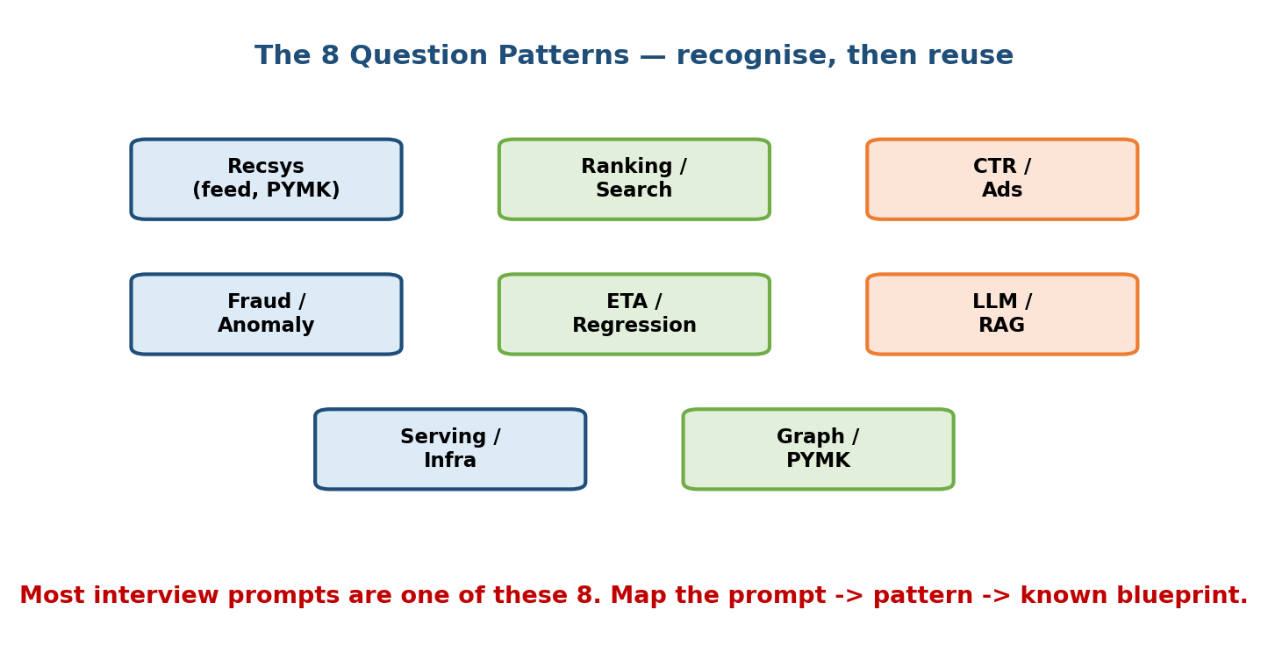
Eight labelled boxes grouping the interview question patterns: recsys (feed, PYMK), ranking/search, CTR/ads, fraud/anomaly, ETA/regression, LLM/RAG, serving/infra, and graph/PYMK — with a caption that most prompts are one of these eight, so you map prompt to pattern to a known blueprint.

The pattern → company → module map (memorise the shape)
This is your question bank. Read a prompt, find the row, and you instantly know the skeleton, the metric, the gotcha, and which module holds the full design.
Pattern | Sounds like… | Companies that love it | Study module
Recsys (feed, home, PYMK) | “For-You feed”, “home recommendations”, “who to follow” | Meta, YouTube/Google, TikTok, LinkedIn, Netflix, Spotify | M12, M17.2–17.3
Ranking / Search | “rank search results”, “product search”, “similar listings” | Google, Amazon, Airbnb, Etsy, Pinterest | M13, M17.7
CTR / Ads | “predict click probability”, “ad ranking”, “auction” | Google, Meta, Amazon Ads, Criteo | M12, M17.4
Fraud / Anomaly | “detect fraud”, “flag abuse”, “spam / harmful content” | Stripe, PayPal, banks, Meta integrity | M10, M17.5
ETA / Regression | “predict delivery time”, “estimate price”, “forecast demand” | Uber, DoorDash, Lyft, Instacart | M6/M7, M17.6
LLM / RAG | “answer from our docs”, “build an assistant”, “summarise” | OpenAI, Anthropic, startups, enterprises | M16, M17.8
Serving / Infra | “serve this at 1M QPS”, “cut latency/cost”, “on-device” | NVIDIA, infra teams, Apple (edge) | M8/M11/M19
Graph / PYMK | “people you may know”, “link prediction”, “fraud rings” | LinkedIn, Meta, payments risk | M12, M17.9
Senior signal: open your answer by naming the pattern out loud — “This is a two-stage retrieval-and-ranking problem, like a feed; I’ll reuse that funnel.” The interviewer immediately sees you have a map, not just facts.

First-principles: why so few patterns exist
There are only a handful of shapes an ML product can take, because there are only a handful of things a model can output: a label (classification → fraud, CTR), a number (regression → ETA), an ordering (ranking → search, feed), a retrieved set (retrieval → recsys candidates, RAG), or generated text (generation → LLM). Every business prompt is one of these wearing different clothes. Learn the five outputs and the eight patterns fall out naturally.

20.2 The Ideal 45-Minute Timeline

Motivation
The most common way a knowledgeable candidate fails is time. They spend 25 minutes lovingly designing the model, then the interviewer says “we’re almost out of time” and they never mentioned serving, scale, or monitoring — the exact things that separate senior from junior. Managing the clock is itself a graded skill, and you must manage it out loud.
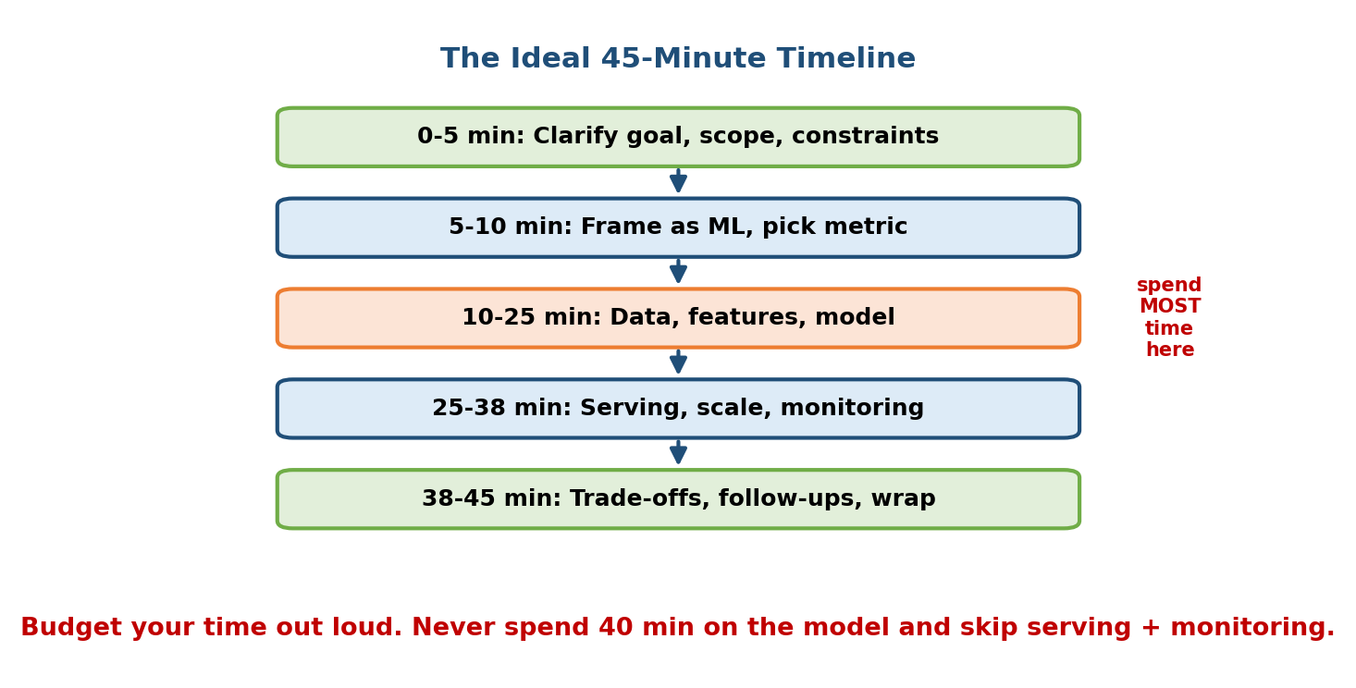
A five-stage vertical timeline for a 45-minute interview: 0-5 min clarify goal/scope/constraints; 5-10 min frame as ML and pick the metric; 10-25 min data, features, and model (marked spend MOST time here); 25-38 min serving, scale, and monitoring; 38-45 min trade-offs, follow-ups, and wrap, with a caption to budget time out loud and never spend 40 minutes on the model.

The budget, phase by phase
Time | Phase | What you actually do
0–5 min | Clarify | Ask about goal, users, scale, constraints, and scope for today. Recap assumptions.
5–10 min | Frame + metric | State the ML task (or a rule), and name business + ML + offline + online metrics + a guardrail.
10–25 min | Data, features, model | The core. Data sources, labels, features (avoid leakage/skew), baseline → complex model.
25–38 min | Serving, scale, monitoring | Batch vs online, funnel, latency budget, QPS sizing, drift + retraining + failure path.
38–45 min | Trade-offs + wrap | Own the trade-offs, answer follow-ups, say “what I’d do next”.

How to actually stay on time
- Announce the plan in the first 30 seconds. “I’ll clarify, frame, define metrics, then design data → model → serving → monitoring, and leave time for trade-offs.” This is time management made visible.
- Narrate transitions. “That’s the model; I’ve got about 15 minutes left, so I’ll move to serving unless you want more depth here.” You just showed a grader you are pacing yourself.
- Protect the last 5 minutes. Trade-offs and “what breaks at 100×” are where the staff signal lives — never let the clock eat them.
The single most common failure: spending 40 minutes on the model and skipping serving + monitoring. Budgeting time out loud is the fix, and it costs you nothing but a sentence.

20.3 Company-Specific Styles (Tune the Same Answer)

Motivation
The 7-step core never changes — but where you spend your emphasis should shift with the company in the room. The same “design recommendations” answer should sound a little different at Amazon (customer + Leadership Principles) than at NVIDIA (throughput + GPUs). Knowing the house style lets you land your strongest points on the axes that company rewards.
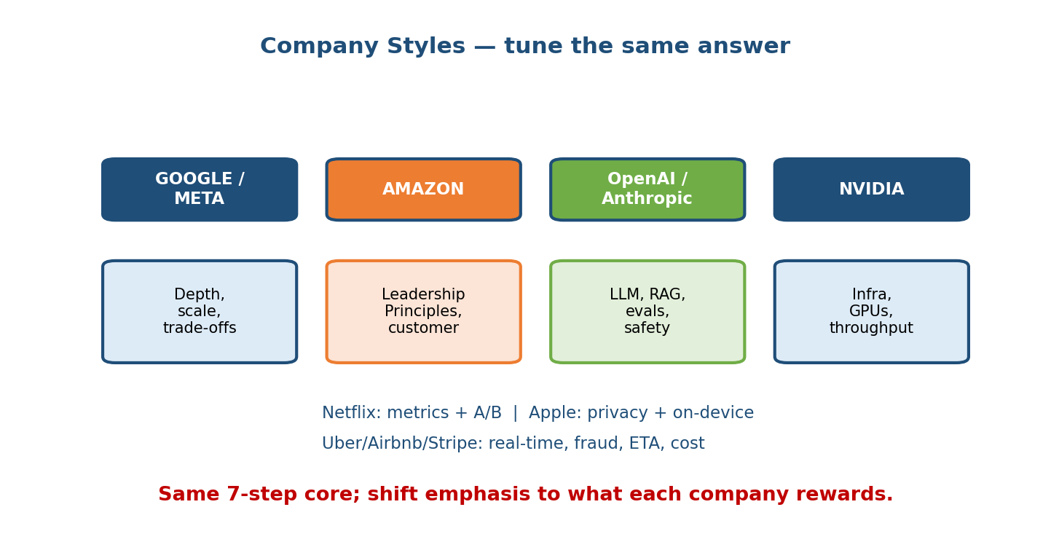
Four coloured header boxes — Google/Meta, Amazon, OpenAI/Anthropic, NVIDIA — each over a description: Google/Meta value depth, scale, and trade-offs; Amazon values Leadership Principles and customer focus; OpenAI/Anthropic value LLM, RAG, evals, and safety; NVIDIA values infra, GPUs, and throughput; with notes that Netflix rewards metrics plus A/B, Apple rewards privacy plus on-device, and Uber/Airbnb/Stripe reward real-time, fraud, ETA, and cost, all over the same 7-step core.

The comparison table
Company | What they reward most | Tune your answer by… | Favourite prompts
Google / Meta | Depth, scale, clean trade-offs | Going deep on the funnel, latency budget per stage, feedback loops | Search ranking, feed, YouTube reco, ads CTR
Amazon | Customer Obsession + Leadership Principles | Starting from the customer/business impact; use LP language (“dive deep”, “bias for action”); quantify cost of errors | Product search, “customers also bought”, forecasting
Netflix | Metrics discipline + A/B rigour | Being crisp on business vs ML metrics, guardrails, and experiment design | Reco, thumbnail selection, watch-time ranking
Apple | Privacy + on-device | Proposing on-device/edge inference, federated learning, no raw data leaving the phone | Keyboard, photos, face unlock, on-device ranking
OpenAI / Anthropic | LLM/RAG depth, evals, safety | Retrieval + grounding, faithfulness/eval sets, guardrails, when NOT to fine-tune | RAG assistants, LLM agents, eval design, safety
NVIDIA / infra teams | Throughput, GPUs, latency, cost | Batching, quantization/distillation, kernel/hardware utilisation, cost per query | “Serve this at 1M QPS”, cut latency/cost, inference infra
Uber / Airbnb / Stripe | Real-time, cost of errors | Streaming features, quantile/asymmetric loss, fraud fail-open/closed, per-segment bias | ETA, dispatch, fraud, marketplace search

First-principles: it’s still one answer
Do not memorise eight different scripts. Run the same 7 steps every time; just spend a little longer on the step that company cares about and use its vocabulary. Amazon still wants your metrics and serving — they just want you to open from the customer. NVIDIA still wants the ML framing — they just want you to go deep on serving. Same core, shifted emphasis.
Senior signal: at Amazon, tie a design decision to a Leadership Principle explicitly (“declining a good customer violates Customer Obsession, so I’ll optimise recall at a fixed low false-positive rate”). At OpenAI/Anthropic, raise safety/faithfulness before being asked.

20.4 Anatomy of a Mock Answer (Plus Worked Walkthroughs)

The structure of every strong mock run
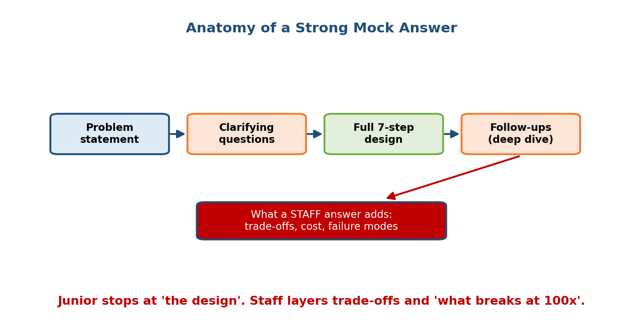
A left-to-right flow of four boxes — problem statement, clarifying questions, full 7-step design, follow-ups (deep dive) — with a red arrow dropping from follow-ups to a highlighted box reading “what a Staff answer adds: trade-offs, cost, failure modes”, and a caption that a junior stops at the design while staff layers trade-offs and what breaks at 100x.
Every good answer has the same four beats, then a Staff layer:
- Problem statement — the prompt, restated in one line so both of you agree.
- Clarifying questions — 5 minutes pinning goal, scale, constraints, scope.
- Full 7-step design — Clarify → Frame → Metrics → Data → Model → Serve → Monitor, driven and narrated.
- Follow-ups (deep dive) — the interviewer pushes on one step; you go deep.
- What a Staff answer adds — trade-offs, cost, and failure modes, offered without being asked.
Below are four fully worked mocks. For the complete architectures, we point to Module 17; here the focus is on how the conversation runs.

Mock 1 — “Design the TikTok For-You feed” (Recsys pattern → M12, M17.2)
Restate: “So: a personalised, infinitely-scrolling video feed that maximises long-term engagement, at very large scale.”
Clarifying questions (say these out loud): - What’s the business goal — watch time, retention, or something else? (Assume long-term retention, proxied by watch time; clickbait hurts it.) - Scale? (Assume ~1B users, billions of videos, hundreds of thousands of QPS.) - Latency budget for a feed load? (A few hundred ms.) - Cold start for new users and brand-new videos? (Yes, both matter.) - Scope for today — the ranking pipeline, not the video-upload path? (Confirm.)
7-step design (one or two lines each): 1. Clarify — above; recap: “personalised feed, optimise retention via watch-time, ~500k QPS, few-hundred-ms budget, handle cold start.” 2. Frame — two-stage retrieval → ranking; ranking target is multi-objective (watch time and positive engagement, minus “not interested”), because pure watch time breeds doomscroll bait. 3. Metrics — business: retention, session length (A/B). ML offline: NDCG, watch-time regression error, retrieval recall@k. Guardrails: diversity, freshness, “not interested” rate. 4. Data & features — implicit feedback (watch %, likes, skips, shares). User/video/context features. Beware feedback loops and position bias — log position, add exploration. No post-impression leakage. 5. Model — baseline: popularity + followed accounts. Retrieval: two-tower + ANN (video embeddings precomputed, user embedding fresh). Ranking: deep multi-head network. 6. Serve — hybrid batch+online funnel: batch-refresh embeddings/candidate pools, online retrieval (~10–20 ms) + ranking (~30–50 ms). Cache per-user for a short TTL. Thousands of replicas, accelerators for ranking. 7. Monitor — watch retention + guardrails live; drift in feature/video mix; retrain daily; refresh embeddings continuously (item cold start). Fallback: popularity if the ranker is down; canary new models.
Likely follow-ups: “How do you handle a brand-new video with no history?” (content embeddings + exploration slots). “How do you stop the feed collapsing to a few viral videos?” (diversity guardrail + exploration + debias position).
What a Staff answer adds: names the feedback-loop/filter-bubble risk unprompted, proposes an explore/exploit budget with a diversity guardrail, estimates the retrieval index size and the cost of daily retraining, and states the failure path explicitly. Ties it together: “cheap two-tower retrieval (ML) + ANN over a sharded index (systems) serves fresh personalised feeds at 500k QPS (business) — and I’d guardrail diversity so we don’t trade long-term retention for short-term watch time.”

Mock 2 — “Design fraud detection for a payments company” (Fraud pattern → M10, M17.5)
Restate: “Real-time scoring of card transactions to block fraud without wrongly declining good customers.”
Clarifying questions: - Cost of a false negative vs a false positive? (A missed fraud costs the chargeback; a false decline costs a lost sale + churn — both painful, business decides the ratio.) - Latency? (Inline with the transaction — tens of ms.) - Scale? (~tens of thousands of transactions/sec.) - Do we have clean labels? (Chargeback labels arrive weeks late — delayed & partial.) - Scope — the real-time scorer + decision layer? (Confirm.)
7-step design: 1. Clarify — recap the asymmetric cost, tens-of-ms budget, delayed labels. 2. Frame — binary classification with extreme imbalance (<0.1% fraud), feeding a decision policy (approve / decline / step-up / human review), not a raw label. Combine supervised model + anomaly signals + hard rules. 3. Metrics — never accuracy. Recall at a fixed low false-positive rate, PR-AUC (offline); fraud loss $, false-decline rate (online). Guardrail: customer-friction rate. 4. Data & features — transaction stream; streaming velocity aggregates (# tx from card/device/IP in last 1m/1h/24h), amount vs user norm, geo/device mismatch, merchant risk. Labels are delayed — recent data is only partly labelled. Watch post-transaction leakage. 5. Model — baseline: rules (block if amount > X and new device) — real and always deployed alongside ML. Then gradient-boosted trees (tabular default), optionally ensembled with an anomaly detector for novel attacks. Handle imbalance with class weights / thresholding. 6. Serve — online + streaming: Kafka/Flink maintains velocity features; model scores inline in tens of ms; decision engine routes. The feature store’s freshness is the bottleneck, not the model. 7. Monitor — the adversary makes drift fast and deliberate. Watch score distributions and precision/recall on the trickle of confirmed labels; fast path to add rules for new attacks. Fail closed for high-risk, fail open for low-risk.
Likely follow-ups: “Labels come weeks late — how do you train and evaluate?” (delayed-feedback modelling, short retrain windows, careful temporal splits). “An attacker changes tactics overnight — what happens?” (anomaly path + rules + frequent retrain; monitor challenge/decline rates).
What a Staff answer adds: names imbalance + delayed labels + adversarial drift as the three defining hardships in one breath; reasons about the business cost ratio to set the operating threshold rather than picking an arbitrary one; and designs the fail-open/fail-closed policy per risk tier so a model outage doesn’t block every customer or wave through every fraudster.

Mock 3 — “Design an enterprise RAG assistant over internal docs” (LLM/RAG pattern → M16, M17.8)
Restate: “Employees ask questions in natural language and get accurate, grounded, cited answers from our wikis/tickets/PDFs — never seeing docs they lack permission for.”
Clarifying questions: - Hard constraints? (Permissions must be respected, answers must be grounded and cited, docs change so freshness matters.) - Scale? (Thousands–millions of docs, moderate QPS.) - Latency + cost tolerance? (A few seconds is OK; LLM cost is the real budget.) - Scope — the RAG pipeline, not training a base model? (Confirm.)
7-step design: 1. Clarify — recap: grounded, cited, permission-safe QA over internal docs. 2. Frame — retrieval + generation, not one model. Retrieval = a search problem (find the few relevant, permitted chunks); generation = an LLM grounded on those chunks, told to answer only from context, cite, and say “I don’t know” when context is insufficient. 3. Metrics — retrieval recall@k / precision@k (offline); faithfulness / groundedness, citation accuracy, answer correctness via LLM-as-judge + a human eval set. Guardrails: hallucination rate and permission leaks ≈ zero. 4. Data & features — corpus chunked (with overlap) and embedded; each chunk carries access-control metadata, source, timestamp. Re-embed changed docs. Chunk size matters (too big dilutes, too small loses context). 5. Model — retrieval: hybrid dense (ANN over a vector DB) + keyword, permission-filtered, then a cross-encoder re-ranker. Generation: a strong instruction-following LLM with a grounding prompt. Baseline: hosted model + good prompting before any fine-tuning. 6. Serve — offline: ingest → chunk → embed → upsert. Online: embed query → permission-filtered hybrid retrieval (~tens of ms) → re-rank → assemble prompt → LLM generate (1–5 s, dominant cost). Retrieve tightly to keep prompts short and cheap. 7. Monitor — thumbs up/down, groundedness, citation clicks, and — critically — permission-leak incidents and hallucination rate. Regression eval set on every prompt/model change (prompts are code — version them). Fallback: “I couldn’t find this” rather than inventing an answer.
Likely follow-ups: “Where exactly do you enforce permissions?” (filter at retrieval time on chunk ACL metadata, before anything reaches the LLM — never rely on the LLM to withhold). “How do you know it’s not hallucinating?” (faithfulness eval set + LLM-judge + human spot checks; guardrail model on output).
What a Staff answer adds: treats RAG as “search + a grounded generation head with strict access control”, evaluates faithfulness not fluency, is explicit that permissions are enforced at retrieval (defence in depth), and reasons about cost being LLM-bound so the whole design pushes toward tight, high-quality retrieval and short prompts.

Mock 4 — “Design ETA prediction for food delivery” (Regression pattern → M6/M7, M17.6)
Restate: “Predict, and show the user, an accurate delivery time that dispatch can also plan on.”
Clarifying questions: - Cost of error — is late worse than early? (Yes — a broken promise; loss should be asymmetric.) - One number or a range? (A trustworthy p50/p90 range is better than a point.) - Latency + scale? (Tens of ms, high QPS, per-city patterns.) - Scope — the point/quantile ETA model, not full dispatch optimisation? (Confirm.)
7-step design: 1. Clarify — recap asymmetric cost, need for a reliable range, per-city. 2. Frame — regression; predict total minutes, optionally decomposed (to-restaurant + prep + to-customer). Prefer quantile regression (p50, p90) so the app shows a range and dispatch plans for the tail. 3. Metrics — MAE/RMSE, quantile loss / calibration, and the late-error rate (offline); on-time rate, cancellations (online). Guardrail: systematic bias per city/time. 4. Data & features — historical trips with actual durations (clean, abundant labels). Routing-engine base time, real-time traffic, weather, driver supply/demand, restaurant prep time/load, historical segment speeds. Traffic and supply are streaming. No post-completion leakage. 5. Model — baseline: the routing engine’s physics estimate (always available); ML corrects it. Then GBDTs (great for tabular spatio-temporal) or a neural model with asymmetric/quantile loss. 6. Serve — online, low latency, real-time feature store for traffic/supply; precompute slow features (segment speeds) in batch; cache ETAs for near-identical routes for a short TTL. 7. Monitor — MAE, late-rate, and bias per city/segment/time (great globally, terrible at airport-at-5pm). Drift from road changes and demand shocks; retrain per-region. Fallback: routing-engine estimate.
Likely follow-ups: “Your MAE looks fine but users complain — why?” (average error hides the painful tail; monitor late-rate and per-segment bias). “New city launch, no data?” (start from the routing baseline + transfer/global features).
What a Staff answer adds: raises asymmetric error and the tail unprompted, chooses quantile/asymmetric loss with a business reason, and monitors per-segment bias rather than a single global MAE — because a chronically optimistic ETA erodes trust even when the average looks great.

20.5 When You Get Stuck (Recover, Don’t Freeze)

Motivation
Every hard interview has a moment where you don’t know something, the interviewer throws a twist, or the problem balloons. How you recover is graded more than whether you hit the snag. Silence and bluffing both fail; narrated reasoning wins.
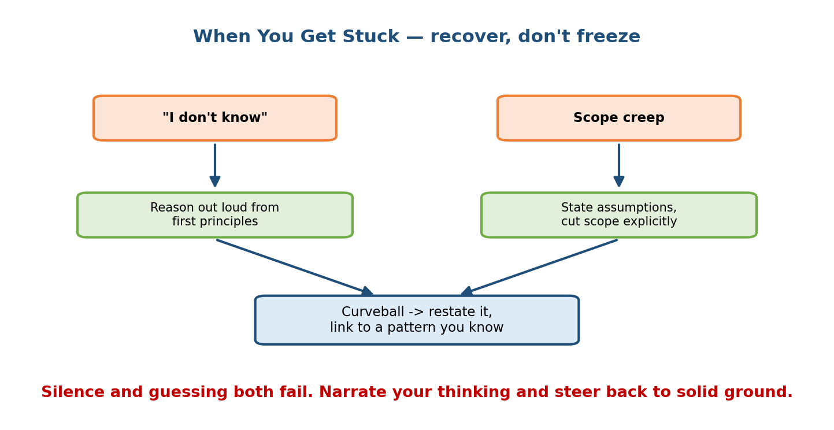
Two orange trigger boxes — “I don’t know” and “Scope creep” — each with a green arrow to a response box (“reason out loud from first principles”; “state assumptions, cut scope explicitly”), both feeding a blue box “curveball: restate it, link to a pattern you know”, under a caption that silence and guessing both fail so narrate your thinking and steer back to solid ground.

The three recovery moves
1. “I don’t know” → reason out loud from first principles. Never freeze or bluff. Say what you do know and derive the rest: “I haven’t used that exact index, but the requirement is fast nearest-neighbour search over millions of vectors, so I’d reach for an ANN structure like HNSW and benchmark recall vs latency.” You just turned a gap into a display of reasoning — which is what is actually being scored.
2. Scope creep → state assumptions and cut scope explicitly. Interviews sprawl; you can end up designing five subsystems at once. The senior move: “There are several directions here; the highest-impact one for our metric is X, so I’ll focus there and mention the others briefly.” Explicitly choosing scope is a seniority signal; trying to do everything shallowly is not.
3. Curveball → restate it, then link it to a pattern you know. When the interviewer changes the problem (“now it must run on-device”, “now the labels are adversarial”), don’t panic. Restate the new constraint in your own words, then map it to a known pattern or module: “On-device changes serving, not framing — that’s a model-compression + edge problem (M8): quantize/distill, ship a small model, update over the air.”

First-principles: why narration beats silence
The interviewer cannot grade thoughts you don’t say. A wrong idea reasoned aloud gives them something to correct and shows how you think; silence gives them nothing and reads as “stuck”. Always keep talking your reasoning — even “let me think about the trade-off here for a second” is better than a dead pause.
Reframe interruptions as hints. When an interviewer pushes on a step, they are usually telling you where they want depth. Follow the pull; don’t defend your original plan.

20.6 Red Flags That Fail Candidates

Motivation
Interviewers keep a mental checklist of disqualifiers. You can know a lot and still fail by tripping two or three of these. Knowing the list lets you audit yourself in real time and catch the mistake before it costs you the loop.
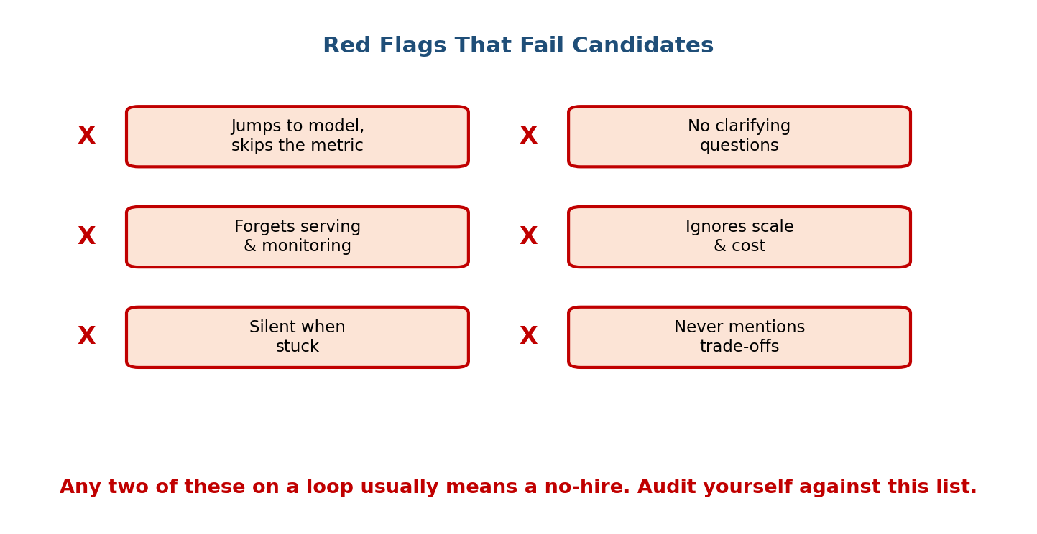
Six red-X checklist items in two columns: jumps to model and skips the metric; no clarifying questions; forgets serving and monitoring; ignores scale and cost; silent when stuck; never mentions trade-offs — with a caption that any two of these on a loop usually means a no-hire, so audit yourself against the list.

The checklist (say “not me” to each)
Red flag | Why it fails you | The fix
Jumps to a model, skips the metric | You’re optimising nothing you can measure | Define business + ML + offline + online metrics before modelling
No clarifying questions | You’ll design the wrong thing | Spend the first 5 minutes clarifying and recap assumptions
Forgets serving & monitoring | Half the system is missing; models decay | Always reach steps 6–7; budget time for them
Ignores scale & cost | The design won’t survive production | Put numbers on QPS, latency, and cost; size the system
Silent when stuck | Grader sees “can’t cope”, not “thinking” | Narrate reasoning from first principles
Never mentions trade-offs | Reads as junior; no ownership | Say “the trade-off is X, and here’s my call, because…”

First-principles: what these have in common
Every red flag is a form of not connecting the dots — model without metric, design without scale, choice without trade-off, or thinking without speaking. The antidote is the same everywhere: make the connection explicit and out loud.
Self-audit: any two of these on a single loop usually reads as a no-hire. After each practice mock, tick this list honestly. Fixing red flags is faster than learning new content and moves your score more.

20.7 What Earns the Staff Bar

Motivation
The same question is asked of a new grad and a staff engineer. The difference is entirely in how they answer. Knowing the target behaviour lets you deliberately aim one level up.
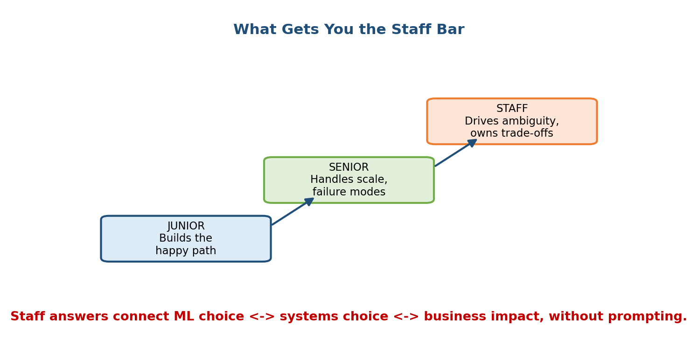
A three-step rising staircase: JUNIOR builds the happy path, then SENIOR handles scale and failure modes, then STAFF drives ambiguity and owns trade-offs, with a caption that staff answers connect ML choice to systems choice to business impact without being prompted.

The ladder in words
Level | What they deliver | What’s missing
Junior | Builds the “happy path” — a reasonable design that works when nothing goes wrong | Scale, failure modes, trade-offs, business tie-in
Senior | Handles scale and failure modes; follows the framework; weighs the obvious trade-offs | Proactive ambiguity resolution; owning the call
Staff | Drives ambiguity, owns trade-offs, connects ML ↔ systems ↔ business without being asked | — (this is the bar)

What “staff” actually is (it’s not more math)
Seniority in this interview is breadth plus ownership, not deeper equations. The staff behaviours you can practise:
- Drive the ambiguity. Don’t wait to be told the scope — propose it: “I’ll assume X and Y; stop me if that’s wrong.”
- Own the trade-off and decide. A junior lists options (“we could use A or B”); a staff engineer decides (“I’d use A because latency dominates here, and accept the small accuracy loss”).
- Connect three layers unprompted. Every big choice ties the business goal ↔ the ML choice ↔ the systems constraint in one sentence.
- Design for failure and the future. Shadow, canary, kill switch, fallback; and “what breaks at 100× and what I’d do next”.
Aim one level up. If you’re targeting senior, don’t just follow the framework — start weighing trade-offs aloud. If you’re targeting staff, resolve ambiguity and make decisions before you’re asked. The staff answer connects ML choice ↔ systems choice ↔ business impact without prompting.

20.8 Whiteboarding & Communication

Motivation
Two candidates with the same design can score very differently based purely on how they present it. A clear, narrated whiteboard is genuinely half the score; a brilliant idea drawn as an unreadable tangle is a weak answer.
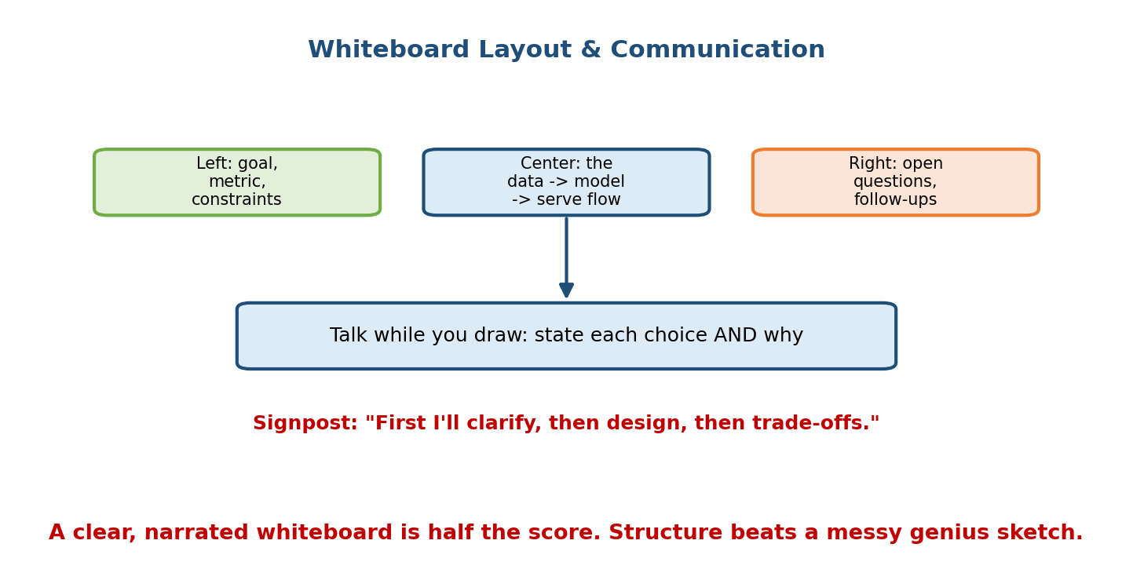
Three top boxes describing a whiteboard layout — left: goal, metric, constraints; center: the data → model → serve flow; right: open questions and follow-ups — with an arrow from the center box to a wide box reading “talk while you draw: state each choice AND why”, a signpost line “First I’ll clarify, then design, then trade-offs”, and a caption that a clear narrated whiteboard is half the score and structure beats a messy genius sketch.

A whiteboard layout that always works
Divide the board into three zones up front:
- Left — the frame: goal, business + ML metric, constraints (latency, QPS, cost). This anchors every later decision.
- Center — the flow: the data → model → serve pipeline (or the retrieval → ranking funnel). This is the heart; keep it a clean left-to-right flow with labelled boxes and arrows.
- Right — open questions & follow-ups: park tangents and “things I’d revisit” here so you don’t lose them or get derailed.

Communication rules that raise your score
- Signpost first: “First I’ll clarify, then design, then trade-offs.” The interviewer now knows the shape of the next 40 minutes.
- Talk while you draw — state each choice and the why: “I’ll put an ANN index here because brute-force search over millions of items blows the latency budget.” The why is the seniority signal.
- Keep boxes labelled and arrows directional. A grader should understand your system from the board alone.
- Check in at transitions: “That’s the serving path — deeper here, or on to monitoring?”

First-principles: structure beats brilliance
The grader is reconstructing your thinking from what they see and hear. A tidy, narrated, averagely-clever design is easy to follow and scores well; a genius insight buried in a messy sketch with no narration is hard to credit. Optimise for legibility and narration, not artistry.
Remote-interview note: on a shared doc or virtual whiteboard the same rules hold — use headings for the three zones, keep the flow linear, and narrate even more, since the interviewer has fewer cues.

Module 20 — Interview Mapping (what companies probe)
Company | How Module 20 shows up | Junior answer | Staff answer
Google / Meta | Grades structure + depth on a pattern | Wanders, model-first | Names the pattern, drives the timeline, deep on the funnel with a latency budget
Amazon | Ties to Leadership Principles; “dive deep” | Tech-only, shallow | Opens from the customer, uses LP language, quantifies cost of errors
OpenAI / Anthropic | RAG/LLM depth + safety + evals | “just prompt an LLM” | Retrieval + grounding + faithfulness eval + permissions, raises safety unprompted
NVIDIA / infra | Serving throughput, GPU/cost | Ignores latency/QPS | Batching, quantization/distillation, cost per query, sizes the fleet
Uber / Airbnb / Stripe | Real-time, cost of errors | One metric, one mode | Streaming features, asymmetric/quantile loss, fail-open/closed, per-segment bias
The single most common opening: “Design an ML system for X.” Map X to a pattern (20.1), announce the timeline (20.2), tune the emphasis to the company (20.3), and drive the mock (20.4). Structure plus one named gotcha is most of the score.

Module 20 — Exam Mapping (interview-only)
- This is an interview-only module. Written exams (SEBI IT / RBI IT / GATE CS-DA / ISRO) do not test how you run a mock, budget 45 minutes, tune to a company, or recover from a curveball. There is essentially zero written-exam content here.
- If you are preparing solely for a written paper, skip to the exam-heavy modules (foundations, data, features, evaluation metrics, systems foundations).
- If you are preparing for FAANG / AI-engineer / staff interviews, this module is where knowledge becomes an offer — treat it as the most practical chapter in the course and rehearse it out loud.
Bottom line: exam value ≈ none; interview and on-the-job value ≈ maximum.

Module 20 — Common Mistakes & Misconceptions
- Treating each prompt as brand-new. Almost every question is one of eight patterns — map it first. (20.1)
- No time budget. Spending 40 minutes on the model and skipping serving + monitoring. Announce and manage the clock out loud. (20.2)
- One-size-fits-all delivery. Not tuning emphasis to Amazon (customer/LP), NVIDIA (infra), or OpenAI (safety/evals). Same core, shifted emphasis. (20.3)
- Skipping clarifying questions. Designing the wrong thing because you assumed the goal, scale, or scope. (20.4)
- Freezing or bluffing when stuck. Narrate first-principles reasoning and say how you’d find out. (20.5)
- Never naming trade-offs or failure modes. The clearest junior tell; owning trade-offs is the staff bar. (20.6, 20.7)
- A messy, silent whiteboard. Structure and narration are half the score; don’t bury a good design in an unreadable sketch. (20.8)
- Listing options instead of deciding. A staff engineer makes the call and justifies it; a junior enumerates. (20.7)

Module 20 — MCQs (with answers & explanations)
Q1. You are given an unfamiliar prompt: “design a system to recommend which push notification to send each user.” The best first move is to: a) Start designing a neural network b) Map it to a known pattern (recsys/ranking) and announce the 7 steps c) Ask about the programming language d) Estimate GPU cost immediately
Answer
b. Nearly every prompt is one of ~8 patterns. Recognising this is a recsys/ranking problem lets you reuse the funnel blueprint (20.1) instead of improvising.
Q2. Halfway through a 45-minute interview you have only covered clarify, frame, and the model. The best move is to: a) Keep polishing the model — depth matters most b) Explicitly re-budget the remaining time and move to serving + monitoring c) Stay silent and think d) Skip straight to trade-offs
Answer
b. Forgetting serving and monitoring is a top red flag. Announce the re-budget out loud and cover the rest of the pipeline; completeness beats over-polishing one step. (20.2, 20.6)
Q3. At Amazon, the strongest way to frame a fraud design decision is to: a) Talk only about model architecture b) Tie it to a Leadership Principle and the customer (e.g. false declines violate Customer Obsession) c) Focus on GPU throughput d) Avoid mentioning cost
Answer
b. Amazon rewards Customer Obsession and LP language. Framing the false-decline cost as a customer issue lands on the axis they grade. (20.3)
Q4. The interviewer asks about an index you have never used. The best response is to: a) Pretend you know it in detail b) Say “no idea” and stop c) State the requirement, reason from first principles, name a plausible approach, and say how you’d validate it d) Change the subject
Answer
c. Turning a gap into visible first-principles reasoning (“fast NN search over millions of vectors → ANN like HNSW → benchmark recall vs latency”) scores well; freezing and bluffing both fail. (20.5)
Q5. Which set of behaviours is most likely a no-hire on a single loop? a) Names the metric, sizes the system, discusses trade-offs b) Jumps to a model, asks no clarifying questions, and never mentions serving c) Proposes a baseline, then a complex model d) Announces a plan and manages time
Answer
b. Those are three red flags at once — no metric, no clarification, no serving. Any two on a loop usually reads as a no-hire. (20.6)
Q6. What most distinguishes a staff answer from a senior one? a) Knowing more math b) Using a bigger model c) Proactively resolving ambiguity, owning trade-offs, and connecting ML ↔ systems ↔ business without being asked d) Talking faster
Answer
c. Staff is breadth plus ownership: drive ambiguity, make the call, and tie the three layers together unprompted — not deeper equations. (20.7)
Q7. In an enterprise RAG design, where should document permissions be enforced? a) Inside the LLM prompt, trusting the model to withhold b) At retrieval time, filtering on chunk access-control metadata before anything reaches the LLM c) Not needed d) Only in the UI
Answer
b. Never rely on the LLM to keep secrets; filter permitted chunks at retrieval so forbidden content never enters the prompt (defence in depth). (20.4, M17.8)
Q8. Why is a clear, narrated whiteboard “half the score”? a) Interviewers grade artistry b) The grader reconstructs your thinking from what they see and hear, so legibility + the “why” behind each choice drive the score c) It saves time d) It replaces the need for metrics
Answer
b. A tidy, narrated, averagely-clever design is easy to credit; a genius idea in a messy silent sketch is not. Optimise for legibility and narration. (20.8)

Module 20 — Design Exercises (easy → hard)
- Easy. For each prompt, name the pattern (20.1) and the module to borrow the blueprint from: (1) “rank the LinkedIn feed”; (2) “predict surge pricing”;
  - “answer questions from our legal docs”; (4) “serve a ranking model at 1M QPS”; (5) “detect payment fraud”.
- Easy. Write your 30-second opening “plan announcement” for any design prompt, from memory.
- Medium. Take “design YouTube reco” and write the same answer twice — once tuned for Google (depth, funnel, latency budget) and once for Amazon (customer, LP, cost of errors). What actually changes?
- Medium. You’re at 30/45 minutes and have only done clarify + frame + model. Write out loud how you’d re-budget the last 15 minutes and what you’d deliberately cut.
- Medium. Run a full mock for “design Spotify Discover Weekly”: restate → 5 clarifying questions → 7-step design → 2 likely follow-ups → what a staff answer adds. (Hint: it’s a recsys pattern with a weekly-batch twist.)
- Hard. Take a curveball: you designed an online fraud scorer, and the interviewer says “now it must run fully on-device with no network”. Restate the new constraint and adapt the design, naming what changes and what stays.
- Hard. Audit a recording (or a friend’s mock) against the six red flags (20.6). For each flag tripped, write the exact sentence that would have fixed it.
- Hard. For “design an enterprise RAG assistant”, write the three sentences that connect business ↔ ML ↔ systems and the one sentence that names the defining gotcha — i.e., the staff layer.

Module 20 — Concept Review (one page)
- Eight patterns cover almost every prompt: recsys/feed, ranking/search, CTR/ads, fraud/anomaly, ETA/regression, LLM/RAG, serving/infra, graph/PYMK. Map the prompt to a pattern in the first minute and reuse the blueprint (module in 20.1).
- The 45-minute timeline: clarify (0–5) → frame + metric (5–10) → data / features / model (10–25, the bulk) → serving / scale / monitoring (25–38) → trade-offs + wrap (38–45). Budget it out loud; never starve serving + monitoring.
- Company styles: same 7-step core, shifted emphasis — Google/Meta (depth, scale), Amazon (customer + LP), Netflix (metrics + A/B), Apple (privacy + on-device), OpenAI/Anthropic (LLM/RAG + safety + evals), NVIDIA (infra + GPUs
  - cost), Uber/Airbnb/Stripe (real-time, fraud, ETA, cost).
- Mock anatomy: restate → clarify → full 7-step design → follow-ups → the staff layer (trade-offs, cost, failure modes). Practise the four worked mocks (reco, fraud, RAG, ETA) until the shape is automatic.
- Recover, don’t freeze: “I don’t know” → reason from first principles; scope creep → cut scope explicitly; curveball → restate + link to a known pattern. Narrate always.
- Red flags (any two ≈ no-hire): jumps to model / no clarification / forgets serving + monitoring / ignores scale + cost / silent when stuck / no trade-offs.
- Staff bar = breadth + ownership: drive ambiguity, decide (don’t list), connect ML ↔ systems ↔ business unprompted, design for failure and the future.
- Whiteboard: three zones (frame / flow / open questions); signpost; talk while you draw and always say the why. Structure beats a messy genius sketch.

Module 20 — Flash Cards (Q → A)
- First move on any prompt? → Map it to one of the eight patterns and announce the plan.
- The 45-min bulk goes where? → Data, features, and model (10–25 min).
- Most common time failure? → 40 min on the model, skipping serving + monitoring.
- One answer or eight scripts? → One 7-step core; shift emphasis per company.
- Amazon’s tuning knob? → Customer Obsession + Leadership-Principle language.
- OpenAI/Anthropic tuning knob? → LLM/RAG depth, faithfulness evals, safety.
- NVIDIA tuning knob? → Throughput, GPUs, latency, cost per query.
- Handle “I don’t know”? → Reason from first principles; say how you’d find out.
- Handle scope creep? → Pick the highest-impact scope explicitly; mention the rest briefly.
- Handle a curveball? → Restate it, then link it to a pattern/module you know.
- Two red flags on a loop means? → Usually a no-hire — audit yourself.
- Staff in one line? → Breadth + ownership: drive ambiguity, decide, connect ML ↔ systems ↔ business.
- Why is the whiteboard half the score? → The grader reconstructs your thinking; legibility + the “why” carry it.
- The four mock beats + staff layer? → Restate → clarify → 7-step → follow-ups → trade-offs/cost/failure.

Module 20 — Pattern Recognition (how to spot it in an interview)
- Hear “design a feed / recommendations / who to follow” → recsys pattern; two-stage funnel (M12); say feedback loops + multi-objective + diversity guardrail.
- Hear “rank search results / product search / similar items” → ranking pattern (M13); lexical + semantic retrieval, NDCG, debias clicks.
- Hear “predict clicks / serve ads” → CTR pattern (M17.4); calibration + delayed labels + auction.
- Hear “detect fraud / abuse / spam” → fraud pattern (M17.5); imbalance, adversary, recall@FPR, fail-open/closed.
- Hear “estimate time / price / demand” → regression pattern (M17.6); asymmetric/quantile loss, the tail, per-segment bias.
- Hear “answer from our documents / build an assistant” → RAG pattern (M16/M17.8); retrieval + grounding + faithfulness + permissions.
- Hear “serve at N QPS / cut latency or cost / on-device” → serving pattern (M8/M11/M19); batching, quantize/distill, cache, cost per query.
- Hear “almost out of time” → protect the last 5 min for trade-offs + next steps.
- Feel yourself freezing → narrate first-principles reasoning out loud.
- Notice the company → shift emphasis (Amazon→customer/LP, NVIDIA→infra, OpenAI→safety/evals) over the same 7-step core.

Module 20 — Revision Notes / Mini Cheat Sheet
8 PATTERNS (map the prompt in <60s):
recsys/feed ranking/search CTR/ads fraud/anomaly
ETA/regress LLM/RAG serving/infra graph/PYMK
-> each has a known blueprint (M12/M13/M17/M16/M8-11-19)
45-MIN TIMELINE (announce it out loud):
0-5 clarify goal/scope/constraints
5-10 frame as ML + pick metric (biz+ML, offline+online, +guardrail)
10-25 DATA + FEATURES + MODEL <- spend MOST time here
25-38 SERVING + SCALE + MONITORING <- never skip these
38-45 trade-offs, follow-ups, wrap
COMPANY STYLES (same core, shift emphasis):
Google/Meta depth, scale, funnel, latency budget
Amazon Customer Obsession + Leadership Principles
Netflix metrics + A/B rigor
Apple privacy + on-device / federated
OpenAI/Anthro LLM/RAG, faithfulness evals, safety
NVIDIA throughput, GPUs, cost per query
Uber/Airbnb/Stripe real-time, fraud, ETA, cost of errors
MOCK ANATOMY: restate -> clarify -> 7-step design -> follow-ups
-> STAFF layer = trade-offs + cost + failure modes
STUCK? (recover, never freeze)
"I don't know" -> reason from first principles + how to find out
scope creep -> cut scope EXPLICITLY, highest-impact first
curveball -> restate it, link to a pattern you know
NARRATE ALWAYS. silence and bluffing both fail.
RED FLAGS (any 2 on a loop ~ no-hire):
jumps to model | no clarifying Qs | forgets serve+monitor
ignores scale+cost | silent when stuck | no trade-offs
STAFF BAR = breadth + OWNERSHIP:
drive ambiguity | DECIDE (don't list) | connect ML<->systems<->business
design for failure + "what breaks at 100x"
WHITEBOARD: 3 zones (frame | flow | open Qs) | signpost first
talk while you draw + always say WHY | structure > messy genius

Next module: Module 21 — Behavioural & Cross-Functional Signals. The design whiteboard is only half of a staff interview. Module 21 covers the other half: telling crisp project stories (STAR), showing leadership and influence without authority, handling disagreement and ambiguity, and the cross-functional signals — working with product, data, and infra teams — that hiring committees weigh just as heavily as your architecture.

