Module 23 — Competitive Exam Mapping (SEBI / RBI / GATE / ISRO)
  - ML System Design Mastery: FAANG / AI-Engineer / Staff-Level — In-Depth Notes (with visuals)
Prepared for nidhi.sharma@forensiccybertech.com
2026
Table of Contents

Module 23 — Competitive Exam Mapping (SEBI / RBI / GATE / ISRO)
Why this module comes last. You have now learned ML system design the way a FAANG or Staff-level interview tests it: end to end, trade-off by trade-off. But many readers of this course also sit written competitive exams — SEBI Grade A (IT), RBI Grade B (IT), GATE CS and GATE DA, ISRO, and DRDO. Those exams do not ask you to “design a recommender for 100 million users”. They ask crisp, single-answer, objective questions. This final module is a map: it tells you, honestly, which parts of this course carry real exam value, which parts are interview-only, and exactly what to revise. It also gives you PYQ-style (previous-year-style) practice on the high-overlap topics. Think of this module as the bridge between “I understand ML systems” and “I can pass a timed objective paper on the parts that overlap.”
Importance ratings (out of 5):
Exam / Use | SEBI IT | RBI IT | GATE CS | GATE DA | ISRO/DRDO | Interview | AI/MLE role
This module | ★★★★★ | ★★★★★ | ★★★★★ | ★★★★★ | ★★★★ | ★★ | ★★
What you must be able to do after this module: name which of the six “exam-heavy” modules to revise first; read a topic and instantly say whether it is exam-relevant or interview-only; place any topic on the SEBI / RBI / GATE-CS / GATE-DA / ISRO / DRDO matrix and guess its weight; answer the high-overlap objective areas — ML basics, DBMS-for-ML, data pipelines/ETL, evaluation metrics, statistics & probability, and systems foundations (caching, DB, CAP); and run a disciplined revision cycle in the final weeks before an exam.
How to read this module. Unlike the earlier modules, this one is not a teaching module — it is a navigation and revision module. Every section points you back to where the real content lives, tells you the exam weight, and gives objective practice. Read it once now to plan, then again in your last revision week.

23.1 The Competitive-Exam Landscape

Motivation (the problem that existed)
This course was built for interviews, where you talk for 45 minutes and are judged on judgment and trade-offs. Competitive exams are the opposite world: you get 60–120 seconds per question, there is exactly one correct option, and “it depends” earns zero marks. If you revise for an exam the way you prepare for an interview, you will over-study design narratives that are never tested and under-study crisp definitions and formulas that are. The first step is to see the landscape clearly.
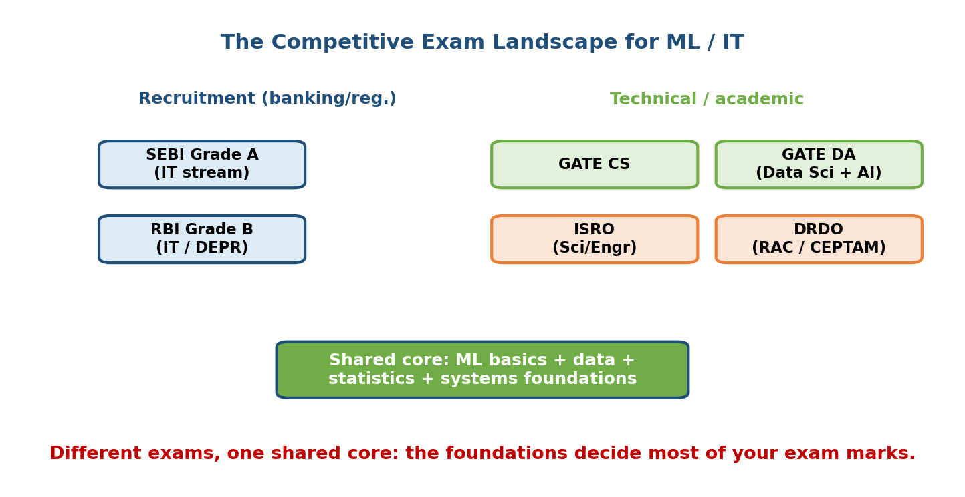
Landscape of Indian competitive exams that touch ML and data topics — SEBI Grade A IT, RBI Grade B IT, GATE CS, GATE DA, ISRO and DRDO — arranged by how heavily each tests core ML, data, and systems fundamentals.

The exams at a glance
- SEBI Grade A (IT stream) — a financial-regulator officer exam. The IT paper tests computer-science fundamentals: DBMS, networking, data structures, and basic ML/AI definitions. It favours breadth and definitions over depth.
- RBI Grade B (DEPR / DSIM / IT) — the DSIM (statistics) and IT streams reward statistics, probability, and data fundamentals heavily. Strong overlap with our data and evaluation modules.
- GATE CS (Computer Science) — the classic engineering entrance/recruitment exam. Databases, operating systems, algorithms, and some ML in the newer syllabus. Rigorous and formula-heavy.
- GATE DA (Data Science & Artificial Intelligence) — a newer paper, and the single best match for this course. It directly tests ML foundations, probability & statistics, data handling, and evaluation metrics.
- ISRO / DRDO (scientist/engineer) — CS-fundamentals exams with occasional basic AI/ML definitional questions. Lower ML weight, high DBMS/OS/networks weight.
First-principles takeaway: exams reward crisp, closed-form knowledge (a definition, a formula, a single metric value). Interviews reward open, comparative judgment. Same subject, opposite testing style. Revise for the style, not just the subject.

23.2 The Topic → Exam Mapping Matrix

Motivation
The most common revision mistake is treating all topics as equally likely to appear. They are not. A single matrix — topic down the side, exam across the top — tells you where to spend your hours. Below is the master matrix; the image shows it visually, and the table repeats it so you can revise from text.
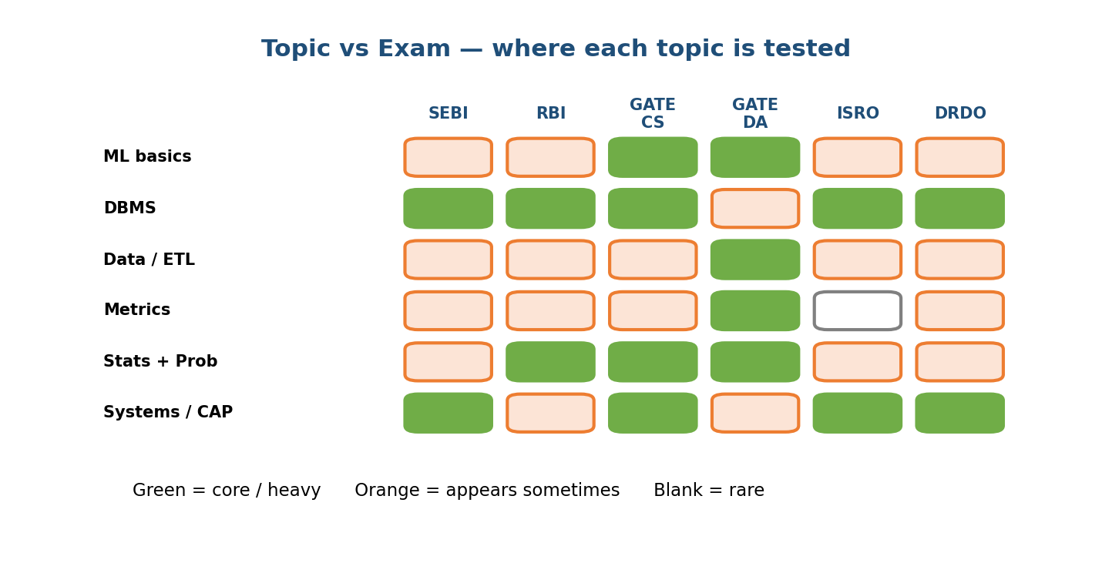
A large matrix mapping course topics (rows) against six competitive exams (columns: SEBI Grade A IT, RBI Grade B IT, GATE CS, GATE DA, ISRO, DRDO), with each cell shaded by how heavily that exam tests the topic.

The master matrix (weight: High / Med / Low / —)
Topic (course module) | SEBI IT | RBI IT | GATE CS | GATE DA | ISRO | DRDO
ML basics / supervised vs unsup. (M01, M06) | Med | Med | Low | High | Low | Low
Problem framing / design (M02, M03) | — | — | — | Low | — | —
Data engineering & ETL (M04) | Med | High | Med | High | Low | Low
Feature engineering / stores (M05) | Low | Med | Low | Med | — | —
Model training / optimization (M06) | Low | Med | Med | High | Low | Low
Evaluation metrics (M07) | Med | High | Med | High | Low | Low
Statistics & probability (M04, M07) | Med | High | Med | High | Med | Med
DBMS for ML (M04, M19) | High | High | High | Med | High | High
Serving / deployment (M08) | Low | Low | Low | Low | — | —
MLOps / monitoring / drift (M09, M10) | — | Low | — | Low | — | —
Scaling / systems foundations (M19) | Med | Med | High | Med | High | High
Caching / CAP / distributed (M19) | Med | Med | High | Low | High | High
Recommendation / search (M12, M13) | — | — | — | Low | — | —
Computer vision / NLP (M14, M15) | Low | Low | Low | Med | Low | Low
Responsible AI / privacy / governance (M18) | Med | Med | — | Low | — | —

How to read the matrix
- Columns with many High cells (GATE DA, RBI IT) mean this course maps strongly onto that exam — study most of it.
- Rows with many High cells (DBMS, statistics, evaluation metrics, systems foundations) are the universal high-overlap rows — study them first no matter which exam you sit.
- Rows that are mostly “—” (serving, MLOps, recommendation case studies) are interview-only. They are gold for interviews and almost worthless for a written exam. Do not burn revision hours there.
Senior signal (exam version): a smart candidate reads this matrix and allocates study time in proportion to the shading — not evenly across modules.

23.3 The High-Overlap, Frequently-Asked Concepts

Motivation
Six topic clusters appear again and again across every exam that touches data or CS. If your revision time is short, these are the concepts with the highest expected marks-per-hour. Learn these cold.
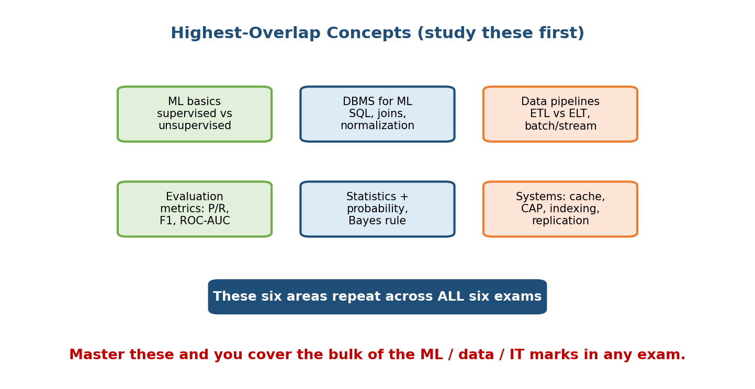
The high-overlap core: six clusters that recur across SEBI, RBI, GATE and ISRO — ML basics, DBMS for ML, data pipelines/ETL, evaluation metrics, statistics and probability, and systems foundations (caching, DB, CAP) — shown as overlapping circles converging on a shared exam core.

The six high-overlap clusters (with exam-ready facts)
1. ML basics. Supervised vs unsupervised vs reinforcement; classification vs regression; overfitting vs underfitting; bias–variance trade-off; train/validation/test split; what a loss function is; gradient descent in one line. (Course: M01, M06.) Typical question: “Which of the following is an unsupervised algorithm?” → k-means clustering.
2. DBMS for ML. Normalization (1NF/2NF/3NF/BCNF), keys (primary/foreign/candidate), SQL joins, ACID properties, indexing, and the difference between OLTP and OLAP. This is the single most exam-tested cluster across SEBI, GATE CS, ISRO, and DRDO. (Course: M04 for data, M19 for systems.) Typical question: “Which normal form removes transitive dependency?” → 3NF.
3. Data pipelines / ETL. Extract–Transform–Load vs ELT; batch vs streaming ingestion; data warehouse vs data lake; schema-on-write vs schema-on-read; idempotency; deduplication. (Course: M04.) Typical question: “In ELT, transformation happens after loading into the warehouse — true or false?” → true.
4. Evaluation metrics. Confusion matrix; precision, recall, F1; accuracy and why it misleads on imbalanced data; ROC curve and AUC; MSE / RMSE / MAE for regression; precision–recall trade-off. (Course: M07.) Typical question: “Precision = TP / (TP + FP) — true or false?” → true.
5. Statistics & probability. Mean/median/mode, variance, standard deviation; Bayes’ theorem; conditional probability; normal distribution and the empirical (68–95–99.7) rule; Central Limit Theorem; hypothesis testing, p-value, Type I vs Type II error; correlation vs causation. (Course: M04, M07.) Heavily tested in RBI DSIM and GATE DA. Typical question: “A Type I error is rejecting a true null hypothesis — true or false?” → true.
6. Systems foundations (caching / DB / CAP). Caching (LRU, cache hit/miss, write-through vs write-back); CAP theorem (Consistency, Availability, Partition-tolerance — pick two under partition); horizontal vs vertical scaling; load balancing; replication and sharding; latency vs throughput. (Course: M19.) Typical question: “Under a network partition, CAP says you must choose between consistency and availability — true or false?” → true.
First-principles takeaway: these six clusters are the intersection of “what this course teaches” and “what written exams actually test”. Everything else in the course is mostly interview fuel.

23.4 Exam-Relevant vs Interview-Relevant (Module by Module)

Motivation
Every module in this course leans one of two ways: it is either exam-relevant (objective, definitional, formula-based — testable on paper) or interview-relevant (open-ended design judgment — testable only in a conversation). Knowing which is which stops you from wasting revision time.
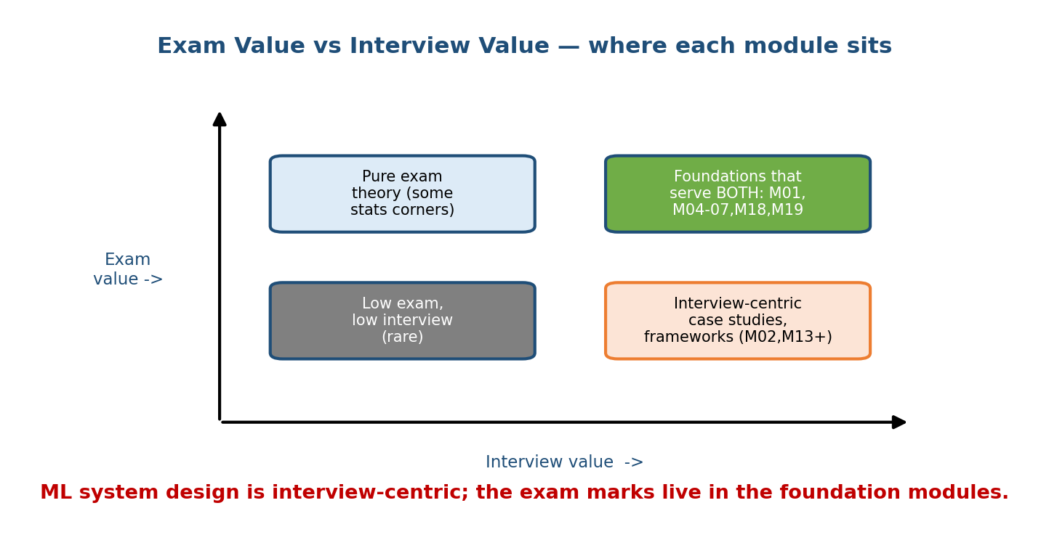
A module-by-module split showing each course module placed on a spectrum from exam-relevant (crisp, definitional, testable on paper) to interview-relevant (open design judgment), with foundations, data, ML basics, metrics, governance and systems on the exam side and framing, serving, MLOps and case studies on the interview side.

The split
Module | Leans | Why
M01 Foundations | Exam + Interview | Definitions (SW1.0/2.0, supervised/unsup) are testable; lifecycle framing is interview fuel
M02 Framework | Interview-only | A talking structure; nothing to objectively test
M03 Problem Framing | Interview-only | Judgment, not facts
M04 Data Engineering | Exam-heavy | ETL, warehouse vs lake, schemas — very testable
M05 Feature Stores | Mostly interview | Some definitional overlap; mostly architecture
M06 Model Training | Exam + Interview | Loss, gradient descent, overfitting are testable
M07 Evaluation | Exam-heavy | Precision/recall/F1/AUC are classic MCQ material
M08 Serving | Interview-only | Latency budgets and deployment patterns are design talk
M09 MLOps | Interview-only | Process and tooling, not objective facts
M10 Monitoring/Drift | Mostly interview | “Drift” definition testable; rest is design
M11 Scaling | Mixed | Distributed-training concepts occasionally tested
M12 Recommendation | Interview-only | Case study
M13 Search/Ranking | Interview-only | Case study
M14 Computer Vision | Mostly interview | A few CNN definitions testable in GATE DA
M15 NLP | Mostly interview | A few embedding/transformer definitions in GATE DA
M18 Responsible AI | Exam + Interview | Privacy/governance definitions testable; ethics is discussion
M19 Systems Foundations | Exam-heavy | Caching, CAP, DB, scaling — core CS-exam material

The rule of thumb
If a topic can be written as a single unambiguous statement with one correct answer, it is exam-relevant. If the best honest answer starts with “it depends on the business goal…”, it is interview-relevant. ML system design as a whole is firmly on the interview side — which is exactly why this course spends most of its pages there, and why this module exists to carve out the exam slice.

23.5 The Exam-Value Funnel (Where the Marks Actually Are)

Motivation
You have 22 modules but a finite number of revision days. Which modules deserve the hours? The exam-value funnel ranks modules by how many exam marks they plausibly protect. Study top-of-funnel first.
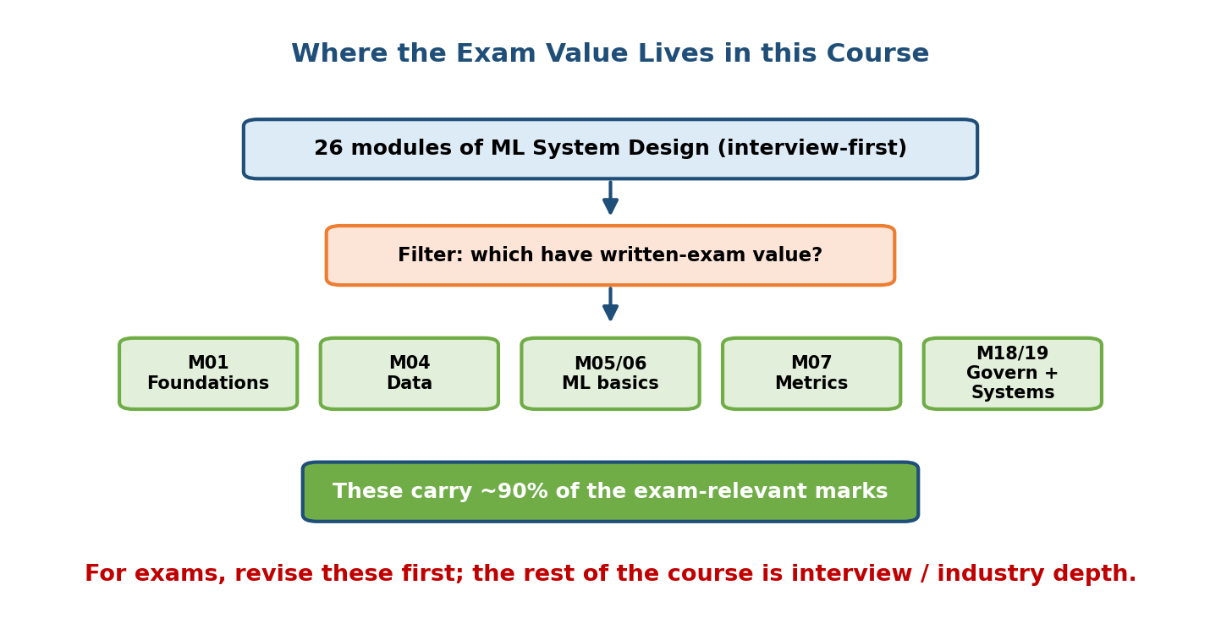
An exam-value funnel showing that a handful of modules carry almost all written-exam weight — M01 foundations, M04 data engineering, M05/M06 ML basics, M07 evaluation metrics, M18 governance and privacy, and M19 systems foundations — while the remaining design and case-study modules carry little exam weight.

The high-value modules (study these first)
- M19 — Systems foundations. Caching, CAP, DB, scaling. Highest overlap with GATE CS, ISRO, DRDO. (Also underpins SEBI/RBI IT.)
- M04 — Data engineering. ETL, warehouse vs lake, schemas, plus the statistics that live here. Huge in RBI IT and GATE DA.
- M07 — Evaluation metrics. Precision/recall/F1/AUC — the most reliable source of “free” MCQ marks across every data-oriented exam.
- M05 / M06 — ML basics. Supervised/unsupervised, overfitting, loss, gradient descent. Core of GATE DA; appears in SEBI/RBI.
- M01 — Foundations. Clean definitions of ML vs traditional programming and the supervised/unsupervised split. Cheap, high-yield revision.
- M18 — Governance / privacy. Data-protection and fairness definitions increasingly appear in regulator exams (SEBI/RBI).

The low-value-for-exams modules (do NOT over-revise)
M02, M03, M08, M09, M12, M13 — these are interview treasures but written-exam deserts. Skim their definitions only; spend no formula-drilling time here.
Senior signal (exam version): budgeting revision by expected marks — not by personal interest or module order — is the mark of an efficient exam-taker.

23.6 The Revision Cycle

Motivation
Knowing what to revise is half the battle; how to revise decides whether it sticks. Cramming once fails. A short, repeating revision cycle with spaced repetition and self-testing beats a single long read every time.
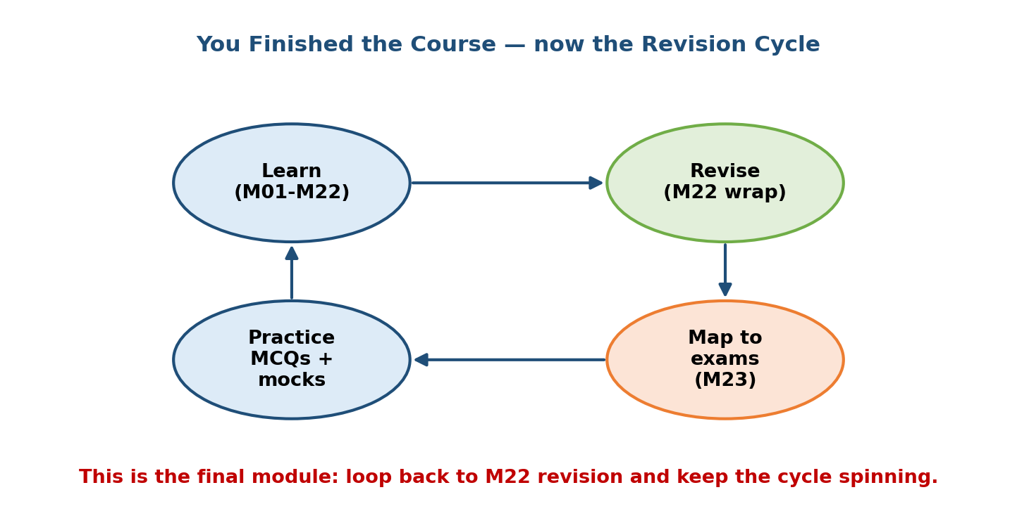
A revision cycle drawn as a loop: plan by weight, read the high-value module, self-test with PYQ-style MCQs, mark weak spots, space-repeat the weak spots, then loop back — with a final timed mock before the exam.

The five-step cycle (repeat weekly, tighten in the last week)
- Plan by weight. Use the funnel (23.5) and matrix (23.2) to pick the next module to revise. Highest expected marks first.
- Read the module’s Concept Review + Cheat Sheet only. Not the whole module — the one-page summaries are built for exactly this.
- Self-test immediately. Do the module’s MCQs and the PYQ-style set below closed-book. Testing yourself beats re-reading (the testing effect).
- Mark weak spots. Any question you missed goes onto a small “leech list”.
- Space-repeat the leeches. Revisit the leech list after 1 day, 3 days, then 1 week (spaced repetition). Weak items get more passes; mastered items drop off.
Close each cycle. Then, in the final week, run timed full-length mocks to build exam-speed and stamina, and to practise skipping-and-returning.

Why the cycle works (first principles)
- Spacing fights the forgetting curve — memory strengthens each time you recall just before forgetting.
- Active recall (self-testing) builds retrieval pathways that recognition (re-reading) never does.
- Weight-based planning maximizes expected marks per hour.
First-principles takeaway: revise little and often, test more than you read, and always spend the next hour where it protects the most marks.

Module 23 — Interview Mapping (what companies probe)
This is the one module that is not really interview material — but the meta-skill is. Interviewers do occasionally probe whether you understand the difference between exam knowledge and system-design judgment.
Company | How this shows up | Weak answer | Strong answer
Google / Meta | “You know the theory — but how would you apply it?” | Recites definitions | Moves from definitions to trade-offs and design
Amazon | Depth in fundamentals (Dive Deep) | Only buzzwords | Grounds design in solid DBMS/stats fundamentals
Any | “Is accuracy the right metric here?” | “Yes, always” | Explains why accuracy misleads on imbalanced data
The takeaway: exam knowledge (definitions, metrics, DBMS, stats) is the foundation that makes your interview answers credible. Interviews then test whether you can use that foundation to reason about open problems.

Module 23 — Exam Mapping (SEBI / RBI / GATE / ISRO)
This module is the exam map, so here we invert it — a quick per-exam study plan:
- SEBI Grade A (IT): prioritise DBMS (M04/M19), systems foundations (M19), basic ML definitions (M01/M06), evaluation basics (M07), and governance definitions (M18). Breadth over depth.
- RBI Grade B (IT / DSIM): prioritise statistics & probability and data engineering (M04), evaluation metrics (M07), then DBMS and systems (M19).
- GATE CS: prioritise DBMS, systems foundations, and algorithmic ML basics (M06, M19); ML content is a small slice.
- GATE DA: the best fit — cover ML basics (M01/M06), probability & statistics (M04/M07), evaluation (M07), and some CV/NLP definitions (M14/M15).
- ISRO / DRDO: prioritise DBMS, OS/networks (outside this course), and systems foundations (M19); expect only occasional basic-ML definitions.
Flag: everything design-flavoured (M02, M03, M08, M09, M12, M13) is interview-only. It carries near-zero written-exam weight. This is the whole point of the module — spend exam hours where the marks are.

Module 23 — Common Mistakes & Misconceptions
- “Revise every module equally.” No — revise by expected marks (the funnel). DBMS, stats, and metrics beat case studies for exams.
- “ML system design will be on my written exam.” Almost never. Design is interview-centric; exams test crisp fundamentals.
- “Re-reading is studying.” Re-reading feels productive but self-testing (active recall) sticks far better.
- “Accuracy is the best metric.” On imbalanced data it is misleading; know precision, recall, F1, and AUC.
- “CAP lets you have all three.” Under a network partition you pick two of {Consistency, Availability}; partition-tolerance is not optional in a distributed system.
- “ELT and ETL are the same.” In ELT, transformation happens after loading into the warehouse; in ETL, before.
- “Cram the night before.” Spaced repetition over weeks beats one long session — the forgetting curve wins otherwise.

Module 23 — MCQs (with answers & explanations)
Q1. Which module cluster carries the most written-exam weight across SEBI, GATE CS, ISRO, and DRDO? a) Recommendation case studies b) DBMS and systems foundations c) MLOps and monitoring d) The design framework
Answer
b. DBMS (normalization, keys, ACID) and systems foundations (caching, CAP, scaling) are the highest-overlap, most-tested CS-exam clusters. Case studies and MLOps are interview-only.
Q2. A topic where the best honest answer begins “it depends on the business goal” is most likely: a) exam-relevant b) interview-relevant c) untestable anywhere d) a formula
Answer
b. Open, comparative “it depends” topics are interview-relevant. Exams need single unambiguous answers.
Q3. Which exam is the single best match for this ML-focused course? a) SEBI Grade A IT b) ISRO c) GATE DA (Data Science & AI) d) DRDO
Answer
c. GATE DA directly tests ML foundations, probability/statistics, data handling, and evaluation metrics.
Q4. Best revision strategy given limited time? a) Read every module once, in order b) Allocate hours by expected marks (funnel/matrix), test yourself, space-repeat c) Only do full mocks d) Only re-read cheat sheets
Answer
b. Weight-based planning + active recall + spaced repetition maximizes marks per hour.
Q5. Which of these is interview-only (near-zero written-exam weight)? a) Evaluation metrics b) DBMS normalization c) A recommendation-system case study d) Probability
Answer
c. Case studies (M12/M13) are interview treasures but are not objectively testable on paper.
Q6. The “testing effect” says that: a) tests only measure, never teach b) retrieving an answer from memory strengthens it more than re-reading c) you should test only at the end d) recognition beats recall
Answer
b. Active recall (self-testing) builds retrieval pathways better than passive re-reading.
Q7. Which pairing is correct? a) ETL = transform after load b) ELT = transform after load c) ELT = never transform d) ETL = no loading step
Answer
b. In ELT, raw data is loaded first and transformed inside the warehouse; ETL transforms before loading.
Q8. Governance/privacy definitions increasingly appear on which exams? a) Only GATE CS b) SEBI and RBI (regulator exams) c) None d) Only ISRO
Answer
b. As financial regulators, SEBI and RBI test data-protection and governance definitions (Module 18).

Module 23 — PYQ-Style Questions (high-overlap areas)
These mimic the objective style of actual papers, drawn from the six high-overlap clusters. Attempt closed-book, then reveal.
P1. Which normal form eliminates transitive dependencies? a) 1NF b) 2NF c) 3NF d) BCNF
Answer
c. 3NF removes transitive dependencies (a non-key attribute depending on another non-key attribute).
P2. In a confusion matrix, recall is defined as: a) TP / (TP + FP) b) TP / (TP + FN) c) TN / (TN + FP) d) (TP + TN) / total
Answer
b. Recall (sensitivity) = TP / (TP + FN): of all actual positives, how many were caught. Option (a) is precision.
P3. k-means is an example of: a) supervised classification b) supervised regression c) unsupervised clustering d) reinforcement learning
Answer
c. k-means groups unlabeled data into clusters — unsupervised learning.
P4. Bayes’ theorem states P(A|B) = a) P(A)·P(B) b) P(B|A)·P(A) / P(B) c) P(A) + P(B) d) P(A|B)·P(B)
Answer
b. P(A|B) = P(B|A)·P(A) / P(B).
P5. A Type I error is: a) accepting a false null hypothesis b) rejecting a true null hypothesis c) a large p-value d) low statistical power
Answer
b. Type I = false positive = rejecting a true null. Type II = failing to reject a false null.
P6. Under the CAP theorem, during a network partition a system must sacrifice: a) partition-tolerance b) either consistency or availability c) nothing d) throughput
Answer
b. Partition-tolerance is mandatory in a distributed system, so under a partition you trade off consistency vs availability.
P7. Which property is NOT part of ACID? a) Atomicity b) Consistency c) Isolation d) Availability
Answer
d. ACID = Atomicity, Consistency, Isolation, Durability. Availability is a CAP property, not ACID.
P8. The empirical (68–95–99.7) rule applies to which distribution? a) uniform b) Poisson c) normal (Gaussian) d) exponential
Answer
c. For a normal distribution, ~68%, ~95%, and ~99.7% of data fall within 1, 2, and 3 standard deviations of the mean.
P9. Overfitting is best described as: a) high error on both train and test b) low train error but high test error c) high train error but low test error d) equal error everywhere
Answer
b. An overfit model memorizes the training data (low train error) but fails to generalize (high test error).
P10. AUC measures the area under which curve? a) precision vs recall only b) the ROC curve (TPR vs FPR) c) loss vs epoch d) the learning curve
Answer
b. AUC is the area under the ROC curve, which plots true-positive rate against false-positive rate.
P11. A cache eviction policy that removes the least recently used item is: a) FIFO b) LRU c) LFU d) write-through
Answer
b. LRU (Least Recently Used) evicts the item unused for the longest time.
P12. In ELT for a data warehouse, transformation happens: a) before loading b) after loading, inside the warehouse c) never d) only in streaming
Answer
b. ELT loads raw data first, then transforms it inside the warehouse (contrast with ETL).
P13. RMSE is a metric primarily used for: a) classification b) clustering c) regression d) ranking only
Answer
c. Root Mean Squared Error measures regression error (predicting continuous values).
P14. Which is a primary key property? a) can be NULL b) uniquely identifies each row and is not NULL c) always a foreign key d) can repeat across rows
Answer
b. A primary key uniquely identifies each row and cannot be NULL.
P15. Horizontal scaling means: a) adding more power (CPU/RAM) to one machine b) adding more machines to share the load c) reducing the dataset d) caching results
Answer
b. Horizontal scaling (scale-out) adds more machines; vertical scaling (scale-up) adds power to one machine.

Module 23 — Design Exercises (easy → hard)
- Easy. Take any five topics from your target exam’s syllabus and place each on the exam-relevant vs interview-relevant spectrum. Justify each in one line.
- Easy. Using the matrix (23.2), list the top four modules to revise for your exam, in order.
- Medium. Build a two-week revision plan using the funnel (23.5) and the five-step cycle (23.6). Assign modules to days by expected marks.
- Medium. Write five of your own PYQ-style MCQs on evaluation metrics, with answers. Test a study partner.
- Hard. Create a personal “leech list” template and a spaced-repetition schedule (1 day / 3 days / 1 week). Explain why the spacing intervals grow.
- Hard. For your exam, estimate the marks split across the six high-overlap clusters (23.3) and defend your allocation using the matrix.

Module 23 — Concept Review (one page)
- Exams ≠ interviews. Exams reward crisp, single-answer knowledge; interviews reward open trade-off judgment. ML system design is interview-centric.
- Six exam-heavy modules carry most written-exam weight: M19 (systems), M04 (data), M07 (metrics), M05/M06 (ML basics), M01 (foundations), M18 (governance).
- Six high-overlap clusters: ML basics · DBMS-for-ML · data pipelines/ETL · evaluation metrics · statistics & probability · systems foundations (caching/DB/CAP).
- The matrix tells you weight by (topic × exam). Study by shading, not evenly.
- GATE DA is the best-matched exam; RBI IT rewards statistics; GATE CS / ISRO / DRDO reward DBMS and systems; SEBI IT rewards breadth.
- Interview-only modules (M02, M03, M08, M09, M12, M13) carry near-zero written-exam weight — skim, don’t drill.
- Revision cycle: plan by weight → read summaries → self-test → mark leeches → space-repeat → mock. Active recall + spacing beat re-reading + cramming.

Module 23 — Flash Cards (Q → A)
- Best-matched exam for this course? → GATE DA (Data Science & AI).
- Highest-overlap topic cluster overall? → DBMS + systems foundations.
- Recall formula? → TP / (TP + FN).
- Precision formula? → TP / (TP + FP).
- 3NF removes what? → Transitive dependencies.
- CAP under partition? → Choose consistency or availability.
- ACID stands for? → Atomicity, Consistency, Isolation, Durability.
- ELT vs ETL? → ELT transforms after loading; ETL before.
- Type I error? → Rejecting a true null hypothesis.
- Best revision method? → Weight-based planning + active recall + spaced repetition.
- Interview-only modules? → Framework, framing, serving, MLOps, case studies.
- Overfitting? → Low train error, high test error.

Module 23 — Pattern Recognition (how to spot it on an exam)
- See a formula-shaped option (TP/(TP+FN)) → it’s a metrics question; recall precision vs recall exactly.
- See “normal form / key / ACID / join” → DBMS cluster; the highest-yield exam topic.
- See “under a partition / two of three” → CAP theorem.
- See “supervised / unsupervised / clustering” → ML basics; k-means is unsupervised.
- See “Type I / Type II / p-value / null hypothesis” → statistics; know the error definitions cold.
- See “transform before/after load” → ETL vs ELT.
- See an open “how would you design…” → that’s an interview question, not an exam one; different mode entirely.

Module 23 — Revision Notes / Mini Cheat Sheet
EXAM vs INTERVIEW: exams = 1 correct answer (definitions/formulas)
interviews = "it depends" trade-offs (ML SysDesign = interview)
EXAM-HEAVY MODULES (study first): M19 systems | M04 data | M07 metrics
M05/M06 ML basics | M01 foundations | M18 governance
INTERVIEW-ONLY (skim): M02 M03 M08 M09 M12 M13
HIGH-OVERLAP 6: ML-basics | DBMS-for-ML | ETL/pipelines | metrics |
stats+probability | systems (cache/DB/CAP)
BEST-FIT EXAM: GATE DA | RBI IT = stats | GATE CS/ISRO/DRDO = DBMS+systems
SEBI IT = breadth (DBMS + basic ML + governance)
MUST-KNOW FORMULAS/FACTS:
precision = TP/(TP+FP) recall = TP/(TP+FN) F1 = 2PR/(P+R)
3NF -> removes transitive dep ACID = Atomicity/Consistency/Isolation/Durability
CAP -> under partition pick C or A ELT -> transform AFTER load
Type I = reject true null overfit = low train err / high test err
k-means = unsupervised AUC = area under ROC (TPR vs FPR)
normal dist -> 68-95-99.7 LRU = evict least-recently-used
REVISION CYCLE: plan-by-weight -> read summary -> SELF-TEST -> mark leeches
-> space-repeat (1d/3d/1w) -> loop -> final timed mock

You’ve finished the course. This was the final module. There is no next module — instead, start a revision cycle beginning with Module 22 and work back through the exam-heavy modules using the funnel and matrix above. Read the Concept Review and Cheat Sheet of each module, self-test with its MCQs, keep a leech list, and space-repeat your weak spots. You now have both the interview-grade judgment and the exam-grade fundamentals. Go get it.

