Module 1 — Introduction to Operating Systems
  - OS Mastery: SEBI IT / RBI / NABARD / GATE / C-DAC / Interview / Backend — In-Depth Notes (with visuals)
Prepared for nidhi.sharma@forensiccybertech.com
2026
Table of Contents

Module 1 — Introduction to Operating Systems
Where this module sits. This is the front door to the whole subject. Before we can talk about processes, memory, or file systems, we need one clear picture: what an operating system actually is, why it exists, and the different shapes it takes (from the batch systems of the 1950s to today’s cloud hypervisors). Everything later in the course — scheduling (M6), synchronization (M7), memory (M9), Linux internals (M14) — is just a detailed answer to the question this module raises: how does one piece of software share a computer fairly, safely, and fast?
Importance ratings (out of 5):
Exam / Use | SEBI IT | RBI IT | GATE CS | Interview | Backend
This module | ★★★ | ★★★ | ★★ | ★★ | ★★★
Most-asked PYQ concepts (SEBI / RBI / GATE / C-DAC): definition & goals of an OS; the OS as resource manager vs extended (virtual) machine; multiprogramming vs multitasking vs multiprocessing (the classic confusion); time-sharing and the idea of a time quantum; real-time OS (hard vs soft) and which scheduling they use; types of OS one-liners; spooling and buffering; hypervisor type-1 vs type-2 (bare-metal vs hosted).

1.1 What Is an Operating System? (first principles)

Definition
An operating system (OS) is the master program that sits between your hardware and your applications. It has two jobs, and every OS topic is one of these two in disguise:
- Resource manager — it shares the CPU, memory, disk, and devices among many competing programs, fairly and efficiently.
- Extended machine (abstraction layer) — it hides ugly hardware details behind clean, easy interfaces (you write open("file.txt"), not “move disk arm to cylinder 4021, sector 12”).
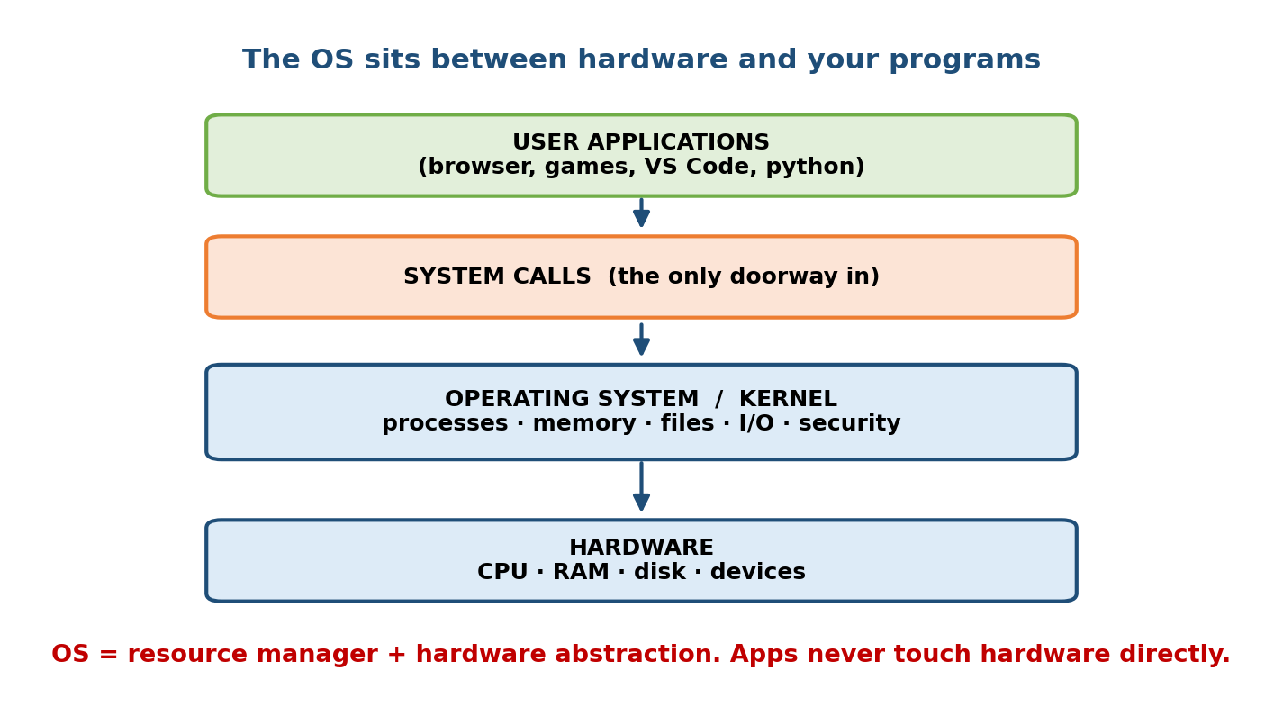
The OS is the layer between raw hardware and user programs; apps reach it only through system calls.
Memory hook: an OS is a hotel manager. Guests (programs) never go into the boiler room (hardware); they call the front desk (system calls), and the manager allocates rooms (memory), staff time (CPU), and services (I/O) so nobody fights and everybody thinks they have the place to themselves.

The two classic viewpoints (a favourite exam line)
- Top-down (user view): the OS is a convenience layer — it makes the machine easy and pleasant to use.
- Bottom-up (system view): the OS is a resource allocator and control program — it decides who gets what, and prevents programs from harming each other.

MCQs
- Two core roles of an OS? → resource manager and extended/virtual machine.
- How does an application ask the OS for a service? → via a system call.
- The OS component always resident in memory is called the? → kernel.

1.2 Why Operating Systems Exist — The Problem They Solve
Imagine a computer with no OS. Every program would have to:
- talk to the disk controller and mouse directly (thousands of lines of device-specific code in every app),
- make sure it doesn’t overwrite another program’s memory,
- decide by itself when to give the CPU to someone else.
This is impossible to scale. The OS exists to solve four hard problems at once:
Problem | Without an OS | The OS’s answer
Hardware is complex | every app re-writes device code | abstraction (files, sockets, drivers)
Resources are shared | programs fight for CPU/RAM | scheduling + allocation
Programs can misbehave | one crash takes down all | protection & isolation (user/kernel mode)
The CPU is fast, I/O is slow | CPU idles waiting on disk | multiprogramming (run another job meanwhile)
Memory hook: the single idea driving OS history is “never let the fast CPU sit idle.” Every type of OS below is another trick to keep the CPU busy.

MCQs
- Why do we need protection between programs? → so one crash/bug can’t corrupt others (isolation).
- The mismatch that motivates multiprogramming? → CPU fast, I/O slow.

1.3 A Short History (how we got here)
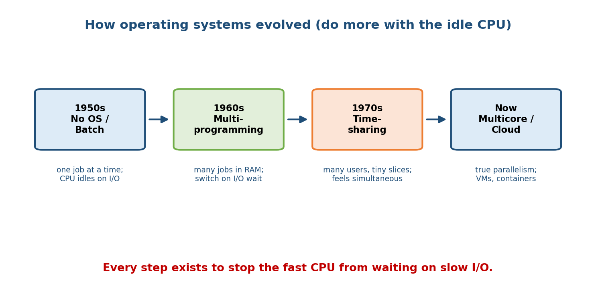
Each generation of OS was invented to stop the fast CPU from waiting on slow I/O.
- 1940s — no OS. Programs entered by switches/plugboards. The programmer was the operator.
- 1950s — batch systems. Jobs on punched cards were collected into a batch and run one after another by a resident monitor. Still one job at a time; the CPU idled during I/O.
- 1960s — multiprogramming. Keep several jobs in memory; when one waits for I/O, the CPU switches to another. CPU utilisation jumps.
- 1960s–70s — time-sharing (multitasking). Give each user a tiny time slice so many users at terminals feel like they each have the machine (CTSS, MULTICS, then UNIX, 1969).
- 1980s — personal computers. MS-DOS, early Windows, Mac OS — one user, GUIs.
- 1990s–2000s — networked & multiprocessor. Windows NT, Linux (1991), SMP.
- 2010s–now — mobile & cloud. Android/iOS on phones; virtual machines, containers, and hypervisors run thousands of isolated OSes in data centres.

MCQs
- First OS to popularise time-sharing lineage → MULTICS → UNIX.
- Year Linux was released? → 1991 (by Linus Torvalds).

1.4 Goals of an Operating System
An OS is designed to balance several goals — some for the user, some for the system:
- Convenience / usability — easy to use (GUI, simple APIs).
- Efficiency — high throughput and resource utilisation (keep CPU, RAM, disk busy with useful work).
- Fairness — no program is starved of resources.
- Reliability & robustness — survive faulty programs; recover from errors.
- Protection & security — isolate programs and users; enforce permissions.
- Scalability — work from a smartwatch to a 128-core server.
These goals often conflict (e.g. maximum throughput vs. fair response time), and the “right” OS is the one that strikes the balance its workload needs — a theme you’ll see again in CPU scheduling (M6).

MCQs
- “Amount of useful work done per unit time” is called? → throughput.
- Name a pair of goals that conflict. → throughput vs. fairness/response time.

1.5 Types of Operating Systems
This is the highest-yield section for objective exams. Learn each type by its one-line purpose and a real example.

1.5.1 Batch OS
Jobs with similar needs are grouped and run without user interaction; a resident monitor loads the next job automatically. - Pro: high throughput for bulk work. Con: no interactivity; hard to debug; CPU still idles on I/O (unless multiprogrammed). - Example: old mainframe payroll runs. Key terms: spooling, job control.

1.5.2 Multiprogramming OS
Keeps multiple jobs in memory; when the running job blocks on I/O, the CPU is handed to another ready job. Goal: maximise CPU utilisation.

1.5.3 Multitasking / Time-Sharing OS
An extension of multiprogramming where the CPU switches so rapidly (each job a small time quantum) that multiple users/programs appear simultaneous. - Goal: minimise response time. Example: UNIX/Linux, Windows.

1.5.4 Multiprocessing OS
Uses two or more CPUs/cores for true parallel execution. - SMP (symmetric): all CPUs are peers sharing one OS + memory (today’s norm). - AMP (asymmetric): a master CPU controls the others.
The #1 exam trap — say it out loud: Multiprogramming = many jobs in memory, one CPU switches on I/O wait. Multitasking = multiprogramming + rapid time slices for interactivity. Multiprocessing = many CPUs running truly in parallel.

1.5.5 Real-Time OS (RTOS)
Correctness depends on meeting deadlines, not just the answer. - Hard RTOS: missing a deadline = system failure (airbag, pacemaker, flight control). Soft RTOS: deadlines are important but occasional misses are tolerable (video streaming, VoIP). - Uses priority-based / EDF / rate-monotonic scheduling (see M6). Examples: VxWorks, FreeRTOS, QNX.

1.5.6 Distributed OS
Manages a network of independent computers so they appear as one system; resources and computation are shared across nodes. - Pro: resource sharing, speed, reliability. Con: complexity, network dependence. Example: cluster/grid systems (concepts carry into M18 cloud).

1.5.7 Embedded OS
A small, dedicated OS inside an appliance with tight memory/power limits (router, microwave, car ECU). Often is an RTOS. Examples: FreeRTOS, embedded Linux.

1.5.8 Mobile OS
Optimised for touch, battery, connectivity, and app sandboxing. Examples: Android (Linux-based), iOS (Darwin/BSD-based).

1.5.9 Cloud / Network OS
Manages pooled data-centre resources and virtual machines; users rent compute on demand. Built on virtualization (M17) and studied further in M18.

MCQs
- Goal of multiprogramming vs time-sharing? → CPU utilisation vs response time.
- Hard vs soft real-time difference? → a missed deadline = failure (hard) vs tolerable (soft).
- Android’s kernel is based on? → Linux.
- True parallel execution needs? → multiprocessing (multiple CPUs/cores).

1.6 Spooling and Buffering (small terms, big in MCQs)
- Buffering: overlap I/O with computation using a memory buffer — while the CPU processes block n, the device reads block n+1.
- Spooling (Simultaneous Peripheral Operation On-Line): use the disk as a giant buffer for a slow device. The classic case is the printer queue — many jobs spool to disk and print one by one, so the CPU never waits for the printer.
Memory hook: buffer = small waiting room (RAM); spool = big waiting hall on disk (printer queue is the textbook example).

MCQs
- Printer queue is an example of? → spooling.
- Buffering overlaps? → I/O with CPU computation.

1.7 Bare-Metal vs Hosted, and Hypervisors (a modern must-know)
A hypervisor (Virtual Machine Monitor) lets one physical machine run many guest OSes at once, each believing it owns the hardware.
- Type-1 (bare-metal): the hypervisor runs directly on hardware; guest OSes run on top. Fast, secure, used in data centres. Examples: VMware ESXi, Microsoft Hyper-V, Xen, KVM.
- Type-2 (hosted): the hypervisor runs as an app inside a host OS. Easy for desktops/testing, a bit slower. Examples: VirtualBox, VMware Workstation.
 | Type-1 (bare-metal) | Type-2 (hosted)
Runs on | hardware directly | on top of a host OS
Speed | faster | slower (extra layer)
Use | servers, cloud | desktops, testing
This is the foundation for virtualization (M17) and cloud OS (M18); containers (Docker) are a lighter-weight cousin covered there.

MCQs
- Type-1 vs Type-2 hypervisor? → runs on hardware directly vs inside a host OS.
- Give a Type-1 example. → ESXi / Hyper-V / Xen / KVM.

1.8 Real-World & Backend Perspectives
- Every backend server you deploy runs on Linux; understanding the OS’s job (processes, scheduling, memory, I/O) is what separates “it works on my machine” from “it scales to a million users.”
- Cloud (AWS/GCP/Azure) is hypervisors + schedulers at planetary scale — a VM is literally a guest OS on a Type-1 hypervisor; a container shares the host kernel.
- AI infra (M19) is an OS story too: GPUs are devices the OS/driver schedules, and LLM serving is bottlenecked by memory and I/O management.

1.9 Tradeoffs, Common Mistakes, Edge Cases
- Mistake: conflating multiprogramming / multitasking / multiprocessing — see §1.5’s out-loud rule.
- Mistake: thinking an RTOS is “fast.” An RTOS is predictable (deterministic deadlines), not necessarily high-throughput.
- Edge case: more programs in memory ≠ always faster — beyond a point you get thrashing (M9) as memory pressure dominates.
- Tradeoff: convenience vs control — a GUI OS is friendly; a server runs headless for efficiency and security.

1.10 Exam, Interview & Coding Perspectives
- SEBI / RBI / NABARD: expect 1–2 conceptual MCQs — definition/goals, type one-liners, spooling, hypervisor types, the multiprogramming/multitasking trap.
- GATE: M1 itself is light, but the vocabulary (throughput, response time, time quantum, SMP) recurs in the numerical modules (M6, M9).
- Interview: “What does an operating system actually do?” — answer with the two roles (resource manager + abstraction) and one example each.

1.11 Concept Checks & MCQs (test yourself)
- Define an OS in one sentence. → software that manages hardware resources and provides an abstraction for programs.
- Difference between multiprogramming and multitasking? → time-sharing adds rapid time slices for interactivity.
- What is a time quantum? → the small fixed CPU slice each job gets in time-sharing/Round Robin.
- Hard vs soft real-time? → deadline miss = failure vs tolerable.
- Spooling vs buffering? → disk as buffer for a slow device (printer) vs RAM overlap of I/O and CPU.
- Type-1 vs Type-2 hypervisor? → bare-metal vs hosted.
- SMP means? → symmetric multiprocessing: peer CPUs share one OS + memory.
- The always-resident core of the OS? → the kernel.

1.12 One-Page Revision Sheet
OS = (1) RESOURCE MANAGER (share CPU/RAM/disk/IO) + (2) EXTENDED MACHINE (hide hardware).
App -> SYSTEM CALL -> kernel -> hardware. Kernel = always-resident core.
Driving idea of all OS history: never let the fast CPU sit idle.
VIEWS: user=convenience ; system=resource allocator/control program.
HISTORY: no-OS -> BATCH(1 job, monitor) -> MULTIPROGRAMMING(many in RAM, switch on IO)
-> TIME-SHARING(slices, interactive; UNIX 1969) -> PC(GUI) -> networked/SMP(Linux 1991)
-> mobile/cloud(VMs, containers).
TYPES:
Batch group jobs, no interaction (spooling)
Multiprogramming many jobs in RAM, 1 CPU switches on IO -> maximise CPU util
Multitasking/Time-sharing rapid quanta, interactive -> minimise response time
Multiprocessing many CPUs, TRUE parallel (SMP=peers / AMP=master-slave)
Real-time (RTOS) meet DEADLINES; hard(fail) vs soft(tolerable); EDF/RMS; VxWorks/FreeRTOS
Distributed many nodes look like one system
Embedded tiny, dedicated (router/car); often RTOS
Mobile Android(Linux)/iOS(BSD); touch+battery+sandbox
Cloud/Network pooled DC resources, VMs on demand
TRAP: multiprogramming(many jobs,1 CPU) vs multitasking(+slices) vs multiprocessing(many CPUs).
SPOOLING = disk as buffer for slow device (PRINTER queue). BUFFERING = RAM overlap IO & CPU.
HYPERVISOR: Type-1 BARE-METAL on hardware (ESXi/Hyper-V/Xen/KVM, fast, cloud)
Type-2 HOSTED inside host OS (VirtualBox/VMware WS, easy, slower).

Flash cards
Front | Back
Two roles of an OS? | Resource manager + extended (virtual) machine
Doorway from app to OS? | System call
Multiprogramming goal? | Maximise CPU utilisation
Time-sharing goal? | Minimise response time
Many CPUs, true parallel? | Multiprocessing (SMP/AMP)
Hard vs soft RTOS? | Deadline miss = failure vs tolerable
Printer queue mechanism? | Spooling
Type-1 hypervisor? | Bare-metal (runs on hardware)
Android kernel? | Linux
Always-resident OS core? | Kernel

Spaced repetition
- 24-hour: recite the type one-liners and the multiprogramming/multitasking/ multiprocessing trap.
- 7-day: explain the two OS roles with examples; hard vs soft RTOS; spooling vs buffering.
- 30-day: given a device/scenario (phone, airbag, data centre, mainframe batch), name the OS type and justify it.

1.13 Summary
An operating system is the master resource manager and hardware abstraction layer: apps ask for services through system calls, and the kernel shares the CPU, memory, disk, and devices safely and efficiently. Its whole history is one long campaign to keep the fast CPU from idling — from batch to multiprogramming (many jobs in RAM), to time-sharing (rapid slices for interactivity), to multiprocessing (many CPUs in parallel), and on to today’s mobile and cloud systems built on hypervisors. We separated the confusing trio (multiprogramming vs multitasking vs multiprocessing), met real-time, distributed, embedded, and mobile OSes, and learned the small-but-tested terms spooling and buffering plus Type-1 vs Type-2 hypervisors.
Next, Module 2 — Computer Hardware Foundations goes one layer down to the CPU, registers, interrupts, and memory hierarchy the OS is built to manage — the hardware vocabulary that makes every later module click.
You have mastered this module when you can: state the two roles of an OS with examples; walk the history as a series of “keep the CPU busy” steps; instantly separate multiprogramming / multitasking / multiprocessing; classify any device into an OS type; and explain spooling, buffering, and Type-1 vs Type-2 hypervisors — all without notes.

