Module 2 — Computer Hardware Foundations
  - OS Mastery: SEBI IT / RBI / NABARD / GATE / C-DAC / Interview / Backend — In-Depth Notes (with visuals)
Prepared for nidhi.sharma@forensiccybertech.com
2026
Table of Contents

Module 2 — Computer Hardware Foundations
Where this module sits. Module 1 said the OS is a resource manager — but you cannot manage what you do not understand. This module is the hardware the OS manages: the CPU (its registers, ALU, control unit, and fetch–decode–execute heartbeat), the interrupt mechanism that lets slow devices grab the CPU’s attention, the memory hierarchy (registers → cache → RAM → disk), and the helpers — timers, MMU, DMA, PCIe, NUMA, multi-core. Almost every later chapter is the OS reacting to something here: scheduling is triggered by a timer interrupt (M6), context switches save registers (M5), virtual memory is the MMU doing address translation (M9), and device drivers ride interrupts and DMA (M12). Get this vocabulary solid and every later module clicks.
Importance ratings (out of 5):
Exam / Use | SEBI IT | RBI IT | GATE CS | Interview | Backend
This module | ★★★ | ★★★ | ★★★ | ★★★ | ★★★
Most-asked PYQ concepts (SEBI / RBI / GATE / C-DAC): the fetch–decode–execute cycle; register roles (PC, IR, MAR, MBR, ACC, SP); interrupts — types, the interrupt cycle, vectored vs polled, and trap vs interrupt (very high yield); the memory hierarchy with speeds/sizes; RAM vs ROM (volatile vs non-volatile); cache — levels, locality (temporal/spatial), hit/miss, mapping; MMU (logical → physical); DMA (why it frees the CPU, cycle stealing); PCIe, NUMA, and multi-core.

2.1 The CPU — Architecture From First Principles
Everything a computer does is the CPU (Central Processing Unit) repeatedly doing one tiny thing: fetch an instruction, understand it, do it. To do that, the CPU has three parts and a set of small, blazing-fast memories called registers.
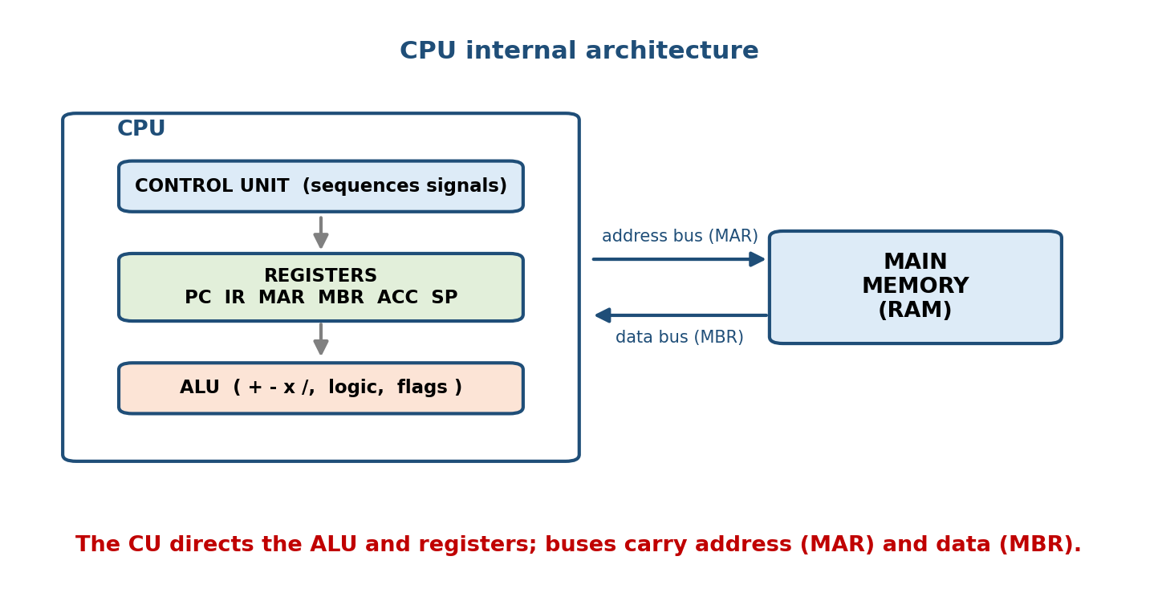
Inside the CPU: the control unit orchestrates the ALU and registers; the CPU talks to memory over the address bus (MAR) and data bus (MBR).
- ALU (Arithmetic Logic Unit) — the calculator. It does arithmetic (+ − × ÷) and logic (AND, OR, NOT, compare, shift). It sets flags (zero, carry, sign, overflow) that the control unit uses to make decisions (branches).
- Control Unit (CU) — the conductor. It reads each instruction, then sends the right control signals to the ALU, registers, and memory so the instruction happens in the right order. It is the CU that drives the fetch–decode–execute cycle.
- Registers — a handful of tiny storage cells inside the CPU (each a few bytes), the fastest memory that exists (~1 CPU cycle, sub-nanosecond).
Memory hook: the CPU is a tiny kitchen. The CU is the chef reading the recipe, the ALU is the stove doing the cooking, and registers are the countertop — the only surface small enough and close enough to work on right now. Everything else (RAM, disk) is the pantry down the hall.

MCQs
- Which unit performs arithmetic and comparisons? → the ALU.
- Which unit issues control signals and sequences an instruction? → the control unit.
- The fastest storage in a computer? → CPU registers.

2.2 Registers — The CPU’s Working Memory
Registers are worth memorising by role, because context switching (M5) is literally “save all the registers of process A, load all of process B”, and because register names are classic one-mark questions.
Register | Full name | Job
PC | Program Counter | holds the address of the next instruction to fetch
IR | Instruction Register | holds the instruction currently being executed
MAR | Memory Address Register | holds the address to read/write in memory
MBR / MDR | Memory Buffer (Data) Register | holds the data going to/from memory
ACC | Accumulator | holds an ALU operand / result (in simple CPUs)
SP | Stack Pointer | points to the top of the stack (calls, locals)
General-purpose | e.g. R0–R31, RAX/RBX… | hold operands, addresses, temporaries
PSW / FLAGS | Program Status Word | condition flags + mode bit + interrupt state
The PC vs IR trap (say it out loud): the PC points to the next instruction; the IR holds the current one. The very first thing “fetch” does is copy the instruction PC points at into the IR, then increment the PC.
MAR vs MBR: think of posting a letter. The MAR is the address on the envelope (where in memory); the MBR is the letter inside (what data). The MAR is wired to the address bus, the MBR to the data bus.
Memory hook: “PC next, IR now; MAR where, MBR what; SP top, ACC math.”

MCQs
- Which register holds the address of the next instruction? → PC.
- Which holds the instruction being executed? → IR.
- Data being transferred to/from memory sits in? → MBR/MDR.
- Top of the stack is tracked by? → SP (stack pointer).

2.3 The Fetch–Decode–Execute Cycle (the machine’s heartbeat)
This single loop, repeated billions of times a second, is computation. It is a guaranteed exam favourite — learn it as a fixed micro-sequence.
LOOP forever (the instruction / machine cycle):
1. FETCH
MAR <- PC ; put next-instruction address on the address bus
MBR <- Memory[MAR] ; read that instruction from memory
IR <- MBR ; move it into the instruction register
PC <- PC + 1 ; advance to the following instruction
2. DECODE
Control Unit interprets the opcode in IR (what to do, which operands)
3. EXECUTE
ALU / memory / I/O carry out the operation; results go to a register
4. (INTERRUPT CHECK)
if an interrupt is pending -> service it before the next fetch
- Fetch — bring the next instruction from memory into the IR (using PC → MAR → MBR → IR), and bump the PC.
- Decode — the CU works out the opcode and where the operands are.
- Execute — the ALU (or a memory/I-O step) actually performs the operation.
- Interrupt check — after each instruction the CPU checks for a pending interrupt (see §2.4); this is the hook the OS uses to regain control.
Memory hook: “Fetch → Decode → Execute → (check interrupts) → repeat.” The interrupt check at the loop’s end is why an OS is possible at all: without it, a running program would never give the CPU back.

Worked micro-trace (one instruction: ADD R1, R2)
State before: PC = 100, R1 = 5, R2 = 3
FETCH: MAR<-100 ; MBR<-Mem[100]="ADD R1,R2" ; IR<-MBR ; PC<-101
DECODE: opcode=ADD, operands = R1 and R2
EXECUTE: ALU computes 5 + 3 = 8 ; R1 <- 8 (zero flag=0)
State after: PC = 101, R1 = 8

MCQs
- Correct order of the machine cycle? → fetch → decode → execute.
- During fetch the PC is copied into which register? → MAR (then incremented).
- When does the CPU check for interrupts? → at the end of each instruction cycle.

2.4 Interrupts — How Hardware Grabs the CPU (high-yield)
The CPU is fast; devices are slow. Rather than the CPU polling (“keyboard, any key? disk, done yet?”) and wasting cycles, a device raises an interrupt — an electrical signal that says “stop what you’re doing, I need attention.” This is the single most important hardware idea for an OS: every timer tick, keypress, disk completion, and system call reaches the kernel as an interrupt/trap.

2.4.1 Types of interrupts
Category | Source | Synchronous? | Example
Hardware interrupt | external device (I/O, timer) | async | disk finished, key pressed, timer tick
Software interrupt / trap | a running instruction | sync | int 0x80 / syscall — a system call
Exception / fault | error in current instruction | sync | divide-by-zero, page fault, invalid opcode
Trap vs interrupt — the classic exam line. An interrupt is asynchronous and external (hardware, unrelated to the current instruction — e.g. the disk finishing). A trap (a.k.a. software interrupt or exception) is synchronous and internal — deliberately or accidentally caused by the currently executing instruction (a system call, a divide-by-zero, a page fault). Same handling machinery, different trigger.
Memory hook: interrupt = “someone knocked at the door” (external, async); trap = “I tripped over my own feet” (internal, sync).

2.4.2 The interrupt cycle (what the CPU/OS actually does)
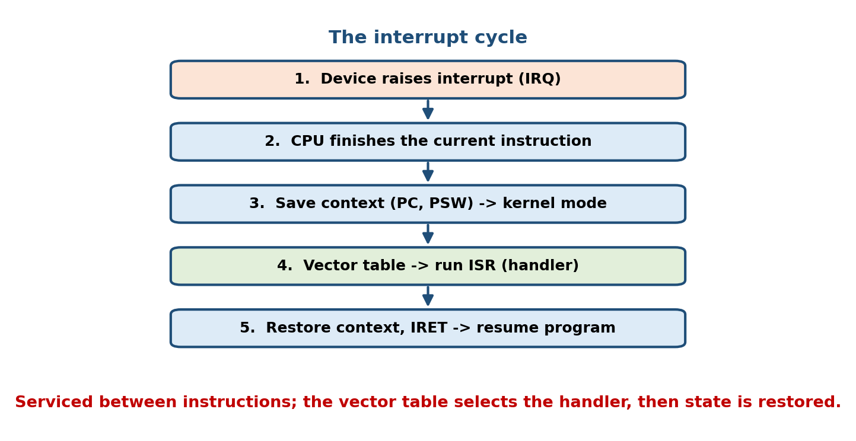
The interrupt cycle: finish the current instruction, save state, look up the ISR via the interrupt vector table, run the handler, restore state, resume.
1. Device raises an interrupt request (IRQ) on the interrupt line.
2. CPU FINISHES the current instruction (never mid-instruction).
3. CPU SAVES context: PC + PSW (and enough registers) pushed to the stack.
4. CPU switches to KERNEL MODE and disables further interrupts (or masks lower ones).
5. It reads the interrupt NUMBER, indexes the INTERRUPT VECTOR TABLE, and
jumps to that Interrupt Service Routine (ISR / handler).
6. ISR services the device (e.g. copies the disk block, acknowledges the device).
7. RESTORE the saved context (PC, PSW, registers).
8. Return-from-interrupt (IRET): re-enable interrupts, resume the interrupted program.
The interrupted program never knows it was paused — the OS restored its exact state. This save/restore is the seed of the context switch (M5).

2.4.3 Vectored vs polled interrupts
- Vectored interrupts: the device supplies (directly or via the controller) an interrupt number; the CPU uses it to index the interrupt vector table and jump straight to the right ISR. Fast — no searching.
- Polled (non-vectored) interrupts: a single, common handler runs and then asks each device in turn “was it you?” Simpler hardware, slower (linear search); order of polling sets priority.
Memory hook: vectored = the caller says which extension to ring (direct dial); polled = the operator rings every desk asking “did you call?”
Interrupt-driven I/O vs polling/busy-wait: polling I/O (the CPU loops reading a status bit) wastes CPU; interrupt-driven I/O lets the CPU work on something else and be notified on completion. Don’t confuse polled interrupts (§2.4.3, how the ISR is located) with polling I/O (how the CPU learns a device is ready) — different questions.

MCQs
- Trap vs interrupt? → trap = synchronous/internal (caused by the instruction); interrupt = asynchronous/external (hardware).
- A system call reaches the kernel as a? → software interrupt / trap.
- Vectored vs polled interrupt? → index a vector table (direct) vs one handler that polls each device.
- Divide-by-zero is a? → trap / exception (synchronous).
- When is a running instruction interrupted? → after it finishes, at the interrupt check.

2.5 The System Timer / Clock
A programmable timer (e.g. the PIT/APIC timer) is a device that raises a timer interrupt at a fixed interval (a “tick”, or in modern tickless kernels, on demand). It is small but foundational:
- Preemptive scheduling (M6): each timer tick lets the OS check whether the current process has used its time quantum and, if so, preempt it. Without a timer interrupt, a CPU-bound program could run forever — no time-sharing.
- Timekeeping: counting ticks maintains the system clock, timeouts, and sleep.
- Watchdogs: detect a hung system and reset it.
Memory hook: the timer interrupt is the OS’s heartbeat / alarm clock — it is how the kernel guarantees it periodically gets the CPU back to make scheduling decisions.

MCQs
- Which hardware makes preemptive scheduling possible? → the timer/clock.
- A CPU-bound loop is still preempted because of? → the timer interrupt.

2.6 The Memory Hierarchy — Speed vs Size vs Cost
There is no single memory that is fast, big, and cheap — so computers layer them. Each level is faster and smaller than the one below, and the hardware/OS tries to keep the data you need soon near the top.
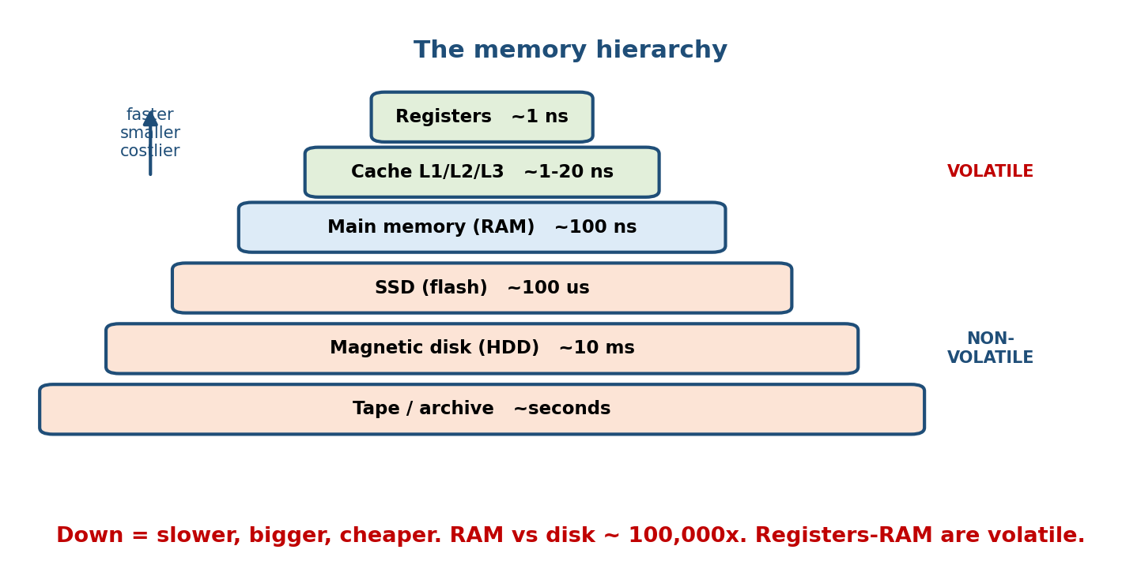
The memory hierarchy pyramid: registers → cache → RAM (volatile) → SSD → disk → tape (non-volatile); faster, smaller, costlier at the top.
Level | Typical speed | Typical size | Volatile? | Managed by
Registers | ~0.3–1 ns (1 cycle) | < 1 KB | yes | compiler / CPU
L1 cache | ~1 ns | 32–64 KB | yes | hardware
L2 cache | ~3–10 ns | 256 KB–1 MB | yes | hardware
L3 cache | ~10–20 ns | 2–64 MB | yes | hardware
Main memory (RAM) | ~50–100 ns | GBs | yes (volatile) | OS (virtual memory)
SSD (flash) | ~50–100 µs | 100s GB–TBs | no | OS / device
Magnetic disk (HDD) | ~5–10 ms | TBs | no | OS / device
Tape / archive | seconds | PBs | no | admin
The numbers that matter: RAM (~100 ns) vs disk (~10 ms) ≈ 100,000×. This single gap is why caching, virtual memory, and buffer pools exist — the whole game is avoid touching the slow levels.
Two great divides (memorise): - Volatile (registers/cache/RAM — lose data on power off) vs non-volatile (SSD/HDD/tape — persist). - Primary storage = directly CPU-addressable (registers, cache, RAM) vs secondary = disks/SSD (I/O, not byte-addressable by the CPU) vs tertiary = tape/optical archives.

MCQs
- Fastest → slowest of registers/RAM/cache/disk? → registers > cache > RAM > disk.
- Order-of-magnitude RAM-to-disk speed gap? → ~100,000×.
- Which levels are volatile? → registers, cache, RAM.
- Primary vs secondary storage divide? → CPU-addressable (RAM) vs I/O (disk).

2.7 RAM vs ROM (and memory types)
- RAM (Random Access Memory) — volatile read/write working memory; loses contents on power off. Two flavours:
  - SRAM (static) — fast, expensive, no refresh → used for cache.
  - DRAM (dynamic) — denser, cheaper, needs periodic refresh → used for main memory (DDR4/DDR5).
- ROM (Read-Only Memory) — non-volatile; keeps contents without power. Holds firmware — the boot code (BIOS/UEFI, §2.13) that runs first at power-on. Variants: PROM (write once), EPROM (UV-erasable), EEPROM / flash (electrically erasable; SSDs and UEFI firmware are flash).
Memory hook: RAM = a whiteboard (fast, rewritable, wiped when the lights go off). ROM = a printed manual (permanent, hard to change, always there at startup).
 | RAM | ROM
Volatile? | yes (lost on power off) | no (persists)
Read/write? | read and write | mostly read (firmware)
Speed | fast | slower
Use | running programs & data | boot firmware (BIOS/UEFI)

MCQs
- Which memory is volatile — RAM or ROM? → RAM.
- Cache is built from which RAM type? → SRAM. Main memory? → DRAM.
- DRAM needs periodic ___ → refresh.
- Boot firmware lives in? → ROM / flash (BIOS/UEFI).

2.8 Cache & the Principle of Locality (brief)
Cache is small, fast SRAM that sits between the CPU and RAM and keeps recently and soon-to-be-used data close. It works only because real programs obey the principle of locality:
- Temporal locality: data used now is likely used again soon (a loop variable, a hot function).
- Spatial locality: if you touch address X, you’ll likely touch nearby addresses (array elements, next instruction) — so caches fetch a whole cache line (e.g. 64 B), not one byte.
Hit vs miss: a cache hit = the data was in cache (fast). A cache miss = not there → fetch from the next level down (slow) and cache it. Hit ratio = hits / (hits + misses); average access time = hit_time + miss_rate × miss_penalty.
Cache mapping (how a memory block maps to a cache slot) — one line each:
Mapping | Rule | Trade-off
Direct-mapped | each block → exactly one slot | simple/fast, more conflicts
Fully associative | a block → any slot | fewest misses, costly search
Set-associative (e.g. 4-way) | block → one set, any slot in it | the practical middle ground
Memory hook: temporal = “same thing again soon”; spatial = “the neighbour next.” Caches bet on both — that’s why they work.

MCQs
- Loop reusing a variable exploits which locality? → temporal.
- Fetching a whole cache line exploits which? → spatial.
- Average access time formula? → hit time + miss rate × miss penalty.
- Mapping with exactly one slot per block? → direct-mapped.

2.9 The MMU — Memory Management Unit
The MMU is hardware (on the CPU) that translates the logical/virtual address a program uses into the physical address in RAM, on every memory access. It is what makes virtual memory, paging, and protection (M8–M9) possible.
- Programs run in their own virtual address space (each thinks it owns all of memory); the MMU maps virtual pages → physical frames via page tables.
- A small cache called the TLB (Translation Lookaside Buffer) stores recent translations so the MMU rarely walks the full page table (M9 covers this in depth).
- The MMU also enforces protection: an access outside a process’s mapping (or writing a read-only page) triggers a page fault / segmentation fault trap.
Memory hook: the MMU is a real-time translator + bouncer: it converts every “virtual” address to a real one and blocks addresses a process isn’t allowed to touch.

MCQs
- What does the MMU translate? → virtual/logical → physical addresses.
- Small cache of recent translations? → the TLB.
- Illegal memory access triggers a? → page/segmentation fault (trap).

2.10 DMA — Direct Memory Access (why it frees the CPU)
Moving a 4 KB disk block into RAM one word at a time would make the CPU copy every word through a register — thousands of instructions of pure babysitting. DMA hands that job to a dedicated DMA controller, so the CPU only sets up the transfer and is interrupted once, at the end.
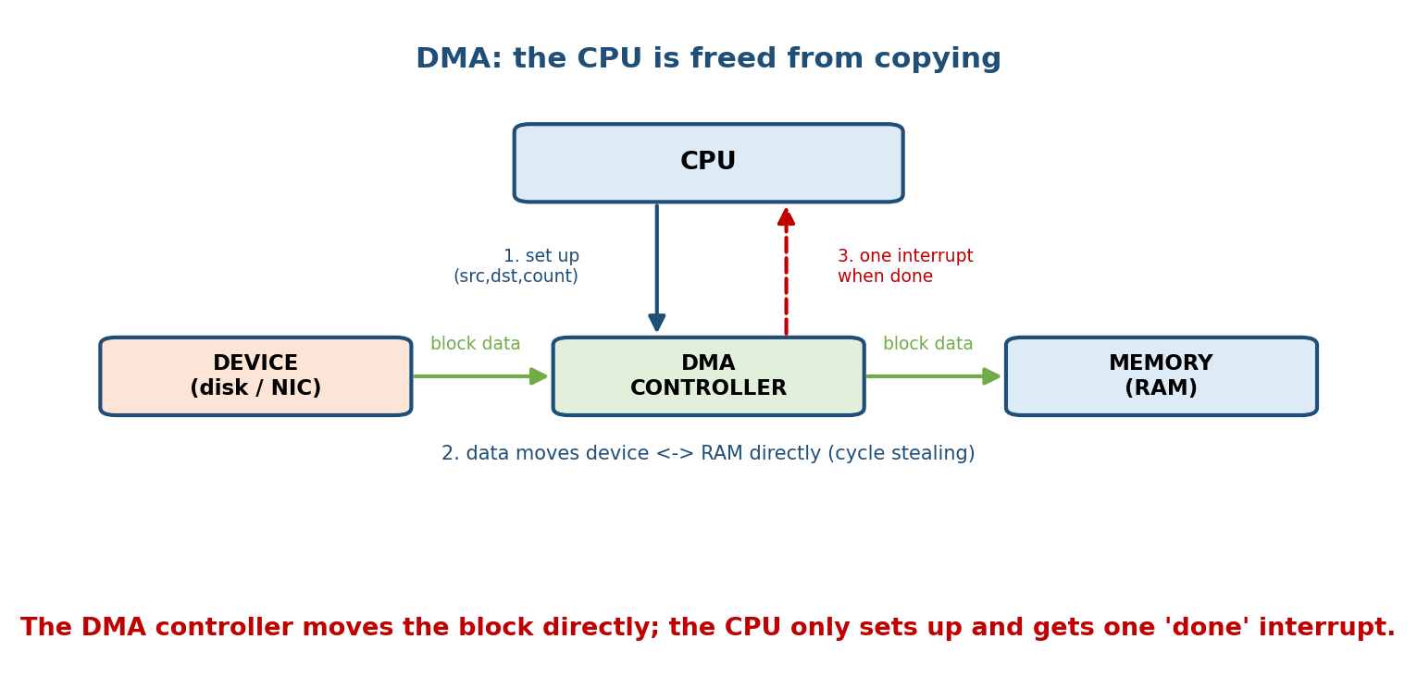
Without DMA the CPU copies every word (programmed I/O); with DMA the controller moves data device↔memory directly and interrupts the CPU only once, at completion.
Programmed I/O (no DMA): DMA:
device -> CPU register -> CPU tells DMA: "move N bytes, dev<->addr"
-> memory, word by word; DMA moves data device <-> memory directly,
CPU busy the whole time. CPU does other work; ONE interrupt at the end.
How DMA works:
- CPU programs the DMA controller: source, destination, byte count, direction.
- DMA controller performs the transfer directly between the device and RAM over the bus, without CPU involvement per word.
- On completion, the controller raises one interrupt; the CPU wraps up.
- Cycle stealing: the DMA controller “steals” occasional bus cycles from the CPU to move a word at a time, interleaving with CPU work — minimal disruption.
- Burst mode: DMA takes the bus and transfers a whole block at once — faster, but the CPU is blocked from the bus during the burst.
Why DMA matters (the exam point): DMA frees the CPU from data-copying, so the CPU does useful work during large I/O. It is essential for high-throughput devices (disk, SSD, network, GPU). The CPU is interrupted once per transfer, not once per word.

MCQs
- What is the main benefit of DMA? → frees the CPU from copying data during I/O.
- DMA “cycle stealing” steals what? → occasional bus cycles from the CPU.
- With DMA, how many interrupts per block transfer? → one (at completion).
- Who is programmed with source/dest/count? → the DMA controller.

2.11 Buses, Storage & I/O Devices, PCIe

Buses
The CPU, memory, and devices are wired together by buses:
- Address bus — carries which location (driven by the MAR); its width sets the addressable memory (e.g. 32 lines → 4 GB).
- Data bus — carries the actual bits (via the MBR).
- Control bus — carries signals like read/write, interrupt, clock.

Storage & I/O device classes
- Block devices (disk, SSD) — addressed in fixed-size blocks; support random access; read/written a block at a time.
- Character devices (keyboard, serial, mouse) — a stream of bytes, no seek.
- Network devices — send/receive packets (a special stream).
Each device has a controller (its own small processor + registers/buffers); the OS talks to it through a device driver (M12). Registers are accessed via memory-mapped I/O (device registers appear as memory addresses) or port-mapped I/O (special in/out instructions).

PCIe (Peripheral Component Interconnect Express)
PCIe is the modern high-speed bus connecting GPUs, NVMe SSDs, and network cards to the CPU. Key facts:
- Serial, point-to-point links (not a shared parallel bus) made of lanes; a slot is x1, x4, x8, or x16 (more lanes = more bandwidth).
- Each generation roughly doubles per-lane bandwidth (PCIe 3.0 → 4.0 → 5.0 …).
- NVMe SSDs and GPUs live on PCIe precisely because it is fast and uses DMA to move data straight to RAM.
Memory hook: PCIe = private multi-lane highways (point-to-point lanes) replacing the old shared single-lane road (legacy PCI).

MCQs
- Block vs character device? → fixed-size random-access blocks (disk) vs byte stream (keyboard).
- Device registers mapped into the address space is called? → memory-mapped I/O.
- x16 on a PCIe slot refers to? → the number of lanes.
- What sets the maximum addressable memory? → the address bus width.

2.12 Multi-Core & NUMA

Multi-core
A modern CPU chip contains several cores, each a full CPU (its own ALU, registers, L1/L2 cache) usually sharing an L3 cache and memory. This gives true parallelism (M1’s multiprocessing): the OS schedules one thread per core at a time. Hyper-threading / SMT lets one core present as two logical CPUs to hide stalls. Software must be written to parallelise to benefit — Amdahl’s Law caps speedup by the serial fraction.

NUMA (Non-Uniform Memory Access)
In big multi-socket servers, each CPU (socket) has its own local RAM. A core reaches its local memory fast, but a remote socket’s memory (over an interconnect) is slower — hence “non-uniform” access. Contrast with UMA (SMP), where every CPU sees the same memory latency.
- The OS is NUMA-aware: it tries to run a thread on the node whose local memory holds its data (memory affinity), because remote access can be ~1.5–2× slower.
Memory hook: UMA = one shared fridge for the whole office (everyone same distance). NUMA = each team has its own fridge — grabbing from your own is fast; from another team’s, slower.

MCQs
- UMA vs NUMA? → uniform memory latency for all CPUs vs local-fast, remote-slow.
- Why is an OS “NUMA-aware”? → to keep a thread near its local memory (affinity).
- One core acting as two logical CPUs is? → SMT / hyper-threading.
- What caps parallel speedup? → the serial fraction (Amdahl’s Law).

2.13 The Bus’s-Eye View: Putting It Together
A quick end-to-end picture of a disk read, which uses almost everything above:
1. Program calls read() -> TRAP (software interrupt) into the kernel (M3).
2. Kernel driver programs the disk controller + DMA (source LBA, dest RAM addr, count).
3. CPU goes off to run ANOTHER process (I/O is slow) -- multiprogramming (M1).
4. Disk finds the data; DMA moves the block DIRECTLY into RAM (cycle stealing).
5. Disk controller raises a HARDWARE INTERRUPT: "transfer complete."
6. CPU finishes its instruction, saves context, runs the ISR via the vector table.
7. ISR marks the waiting process READY; scheduler may resume it. Data is in RAM.
Trap, DMA, interrupt, vector table, memory hierarchy, scheduling — one operation, the whole module.

2.14 Real-World & Backend Perspectives
- Every performance problem is a memory-hierarchy problem. A cache-friendly data layout (contiguous arrays, spatial locality) can beat a “smarter” algorithm that thrashes cache. Backend hot paths live or die by L1/L2 hit rates.
- DMA is why servers scale I/O: NVMe, 100 GbE NICs, and GPUs all DMA data straight to RAM; the CPU orchestrates rather than copies. “Zero-copy” networking (sendfile, io_uring) is about avoiding needless CPU copies on top of that.
- NUMA tuning is real money in production: pinning threads and memory to the same NUMA node (numactl, taskset) can cut latency noticeably on big databases and JVMs.
- The timer interrupt is your scheduler’s pulse: understanding it explains why a runaway loop still yields (preemption) and why “tickless” kernels save power on idle servers.

2.15 Tradeoffs, Common Mistakes, Edge Cases
- Mistake: swapping PC and IR — PC = next address, IR = current instruction.
- Mistake: confusing MAR (address) with MBR (data).
- Mistake: calling a system call a hardware interrupt — it’s a trap (software interrupt / synchronous).
- Mistake: thinking DMA gives one interrupt per word — it’s one per transfer.
- Mistake: “cache miss rate low ⇒ fast” while ignoring miss penalty — a rare miss to disk still dominates.
- Edge case: on SSD, “seek time” ≈ 0, so the classic random-vs-sequential gap shrinks (but sequential still wins).
- Tradeoff: SRAM (fast, costly, cache) vs DRAM (dense, cheap, main memory); direct-mapped (simple, more conflicts) vs associative (fewer misses, costlier).
- Tradeoff: DMA burst mode (fast, hogs the bus) vs cycle stealing (gentle on the CPU, slower per transfer).

2.16 Exam, Interview & Coding Perspectives
- SEBI / RBI / NABARD: register roles, fetch-decode-execute order, trap vs interrupt, RAM vs ROM, memory-hierarchy ordering, DMA benefit — all classic one-markers.
- GATE: average memory access time (cache), locality types, vectored vs polled, DMA cycle stealing; the vocabulary underpins M6/M9 numericals.
- Interview: “What happens on a system call?” (trap → kernel mode → handler); “Why is DMA better than programmed I/O?”; “Explain the memory hierarchy and why caches work” (locality).
- Coding/practical: perf stat shows cache-miss rates and IPC; lscpu shows cores/threads/caches/NUMA nodes; numactl --hardware shows NUMA topology.

2.17 Concept Checks & MCQs (test yourself)
- Three parts of a CPU? → ALU, control unit, registers.
- PC vs IR? → address of next instruction vs current instruction.
- MAR vs MBR? → address (where) vs data (what).
- Order of the machine cycle? → fetch → decode → execute.
- Trap vs interrupt? → synchronous/internal vs asynchronous/external.
- A system call is which kind? → a trap (software interrupt).
- Vectored vs polled interrupt? → vector-table index vs poll each device.
- Which hardware enables preemptive scheduling? → the timer.
- Memory hierarchy fastest → slowest? → registers > cache > RAM > SSD > HDD > tape.
- RAM–disk speed gap? → ~100,000×.
- RAM vs ROM volatility? → RAM volatile, ROM non-volatile.
- SRAM vs DRAM use? → cache vs main memory (DRAM needs refresh).
- Two kinds of locality? → temporal and spatial.
- Average access time? → hit time + miss rate × miss penalty.
- What does the MMU do? → translate virtual → physical, enforce protection.
- TLB is a cache of? → recent address translations.
- Main benefit of DMA? → frees the CPU from copying I/O data.
- DMA interrupts per transfer? → one (at completion).
- Cycle stealing steals? → bus cycles.
- PCIe is ___ and ___ (topology)? → serial, point-to-point (lanes).
- UMA vs NUMA? → uniform vs local-fast/remote-slow memory.
- What caps multi-core speedup? → the serial fraction (Amdahl’s Law).
True/False - The PC holds the instruction currently executing. → False (that’s the IR). - A divide-by-zero is an asynchronous interrupt. → False (synchronous trap). - ROM loses its contents on power off. → False (non-volatile). - DMA raises one interrupt per word. → False (one per transfer). - Cache exploits temporal and spatial locality. → True. - In NUMA, all CPUs see equal memory latency. → False (that’s UMA).

2.18 One-Page Revision Sheet
CPU = ALU (math/logic + flags) + CONTROL UNIT (sequences signals) + REGISTERS (fastest).
REGISTERS: PC=next-instr addr | IR=current instr | MAR=addr(where) | MBR/MDR=data(what)
ACC=ALU operand/result | SP=top of stack | GPRs=temporaries | PSW/FLAGS=status+mode.
"PC next, IR now; MAR where, MBR what; SP top, ACC math."
MACHINE CYCLE: FETCH (MAR<-PC; MBR<-Mem; IR<-MBR; PC++) -> DECODE (CU reads opcode)
-> EXECUTE (ALU) -> CHECK INTERRUPTS -> repeat. (interrupt check = OS regains CPU)
INTERRUPTS: hardware(async, external: timer/IO) | trap/software(sync: syscall) |
exception(sync: div0, page fault). TRAP=internal/sync ; INTERRUPT=external/async.
CYCLE: finish instr -> save PC+PSW -> kernel mode -> vector table -> ISR -> restore -> IRET.
VECTORED = index vector table (fast) ; POLLED = one handler asks each device (slow).
TIMER = raises periodic interrupt -> enables PREEMPTIVE scheduling + timekeeping.
MEMORY HIERARCHY (fast/small/costly -> slow/big/cheap):
registers(~1ns) > L1 > L2 > L3 cache > RAM(~100ns, VOLATILE) > SSD(~100us) > HDD(~10ms) > tape.
RAM vs disk ~100,000x. VOLATILE=reg/cache/RAM ; PRIMARY=CPU-addressable vs SECONDARY=disk.
RAM(volatile, r/w): SRAM=cache(fast), DRAM=main mem(needs refresh).
ROM(non-volatile): firmware/BIOS/UEFI ; PROM/EPROM/EEPROM(flash).
CACHE: locality TEMPORAL(same soon) + SPATIAL(neighbour) -> fetch a line.
hit/miss ; hit ratio=hits/(hits+miss) ; AMAT = hit_time + miss_rate*miss_penalty.
mapping: direct(1 slot) | fully-assoc(any) | set-assoc(one set) .
MMU: virtual->physical each access + protection ; TLB caches translations ; bad access=fault.
DMA: controller moves data device<->RAM directly ; CPU freed ; ONE interrupt/transfer.
cycle stealing = grab occasional bus cycles ; burst = take bus for whole block.
BUSES: address(where/MAR) + data(what/MBR) + control(read/write/irq).
PCIe = serial, point-to-point LANES (x1/x4/x8/x16), doubles/gen ; GPUs/NVMe DMA to RAM.
MULTI-CORE: many full cores (true parallel), share L3 ; SMT=1 core->2 logical ; Amdahl caps.
NUMA: each socket has local RAM (local fast, remote slow) vs UMA(equal) ; OS uses affinity.

Flash cards
Front | Back
PC vs IR? | Next-instruction address vs current instruction
MAR vs MBR? | Address (where) vs data (what)
Machine cycle order? | Fetch → decode → execute
Trap vs interrupt? | Synchronous/internal vs asynchronous/external
System call is which type? | Trap (software interrupt)
Vectored vs polled? | Vector-table index vs poll each device
Hardware for preemption? | Timer interrupt
RAM–disk speed gap? | ~100,000×
RAM vs ROM? | Volatile r/w vs non-volatile firmware
SRAM vs DRAM? | Cache vs main memory (refresh)
Temporal vs spatial locality? | Same data again vs nearby addresses
AMAT formula? | hit time + miss rate × miss penalty
MMU does? | Virtual→physical + protection
Benefit of DMA? | Frees CPU from I/O copying
DMA interrupts/transfer? | One (at completion)
Cycle stealing steals? | Bus cycles
PCIe topology? | Serial, point-to-point lanes
UMA vs NUMA? | Equal latency vs local-fast/remote-slow

Spaced repetition
- 24-hour: recite the register roles and the fetch-decode-execute micro-steps; trap vs interrupt.
- 7-day: draw the memory hierarchy with speeds; explain DMA and cycle stealing; vectored vs polled.
- 30-day: trace a full read() (trap → DMA → interrupt → resume); explain locality, the MMU, and NUMA affinity without notes.

2.19 Summary
Underneath every OS is a CPU that forever repeats fetch → decode → execute, using tiny registers (PC for the next instruction, IR for the current, MAR/MBR for memory address/data, SP, ACC, and general-purpose) driven by the control unit with the ALU doing the math. The OS gets to run at all because of interrupts: hardware ones (async, external — timer, I/O), traps (sync, internal — a system call or fault), located via the vector table (vectored = direct, polled = search). The timer interrupt is the scheduler’s heartbeat. Because no memory is fast, big, and cheap, we layer a memory hierarchy — registers → cache → RAM (volatile) → SSD → disk → tape — where RAM is ~100,000× faster than disk, and caches win by exploiting temporal and spatial locality. We separated RAM vs ROM, met the MMU (virtual→physical + protection), and saw DMA free the CPU from I/O copying (one interrupt per transfer, cycle stealing the bus). Finally, PCIe (serial lanes), multi-core (true parallelism), and NUMA (local-fast, remote-slow) round out the modern machine.
Next, Module 3 — Operating System Architecture puts the OS itself on top of this hardware: kernel designs (monolithic vs microkernel vs hybrid), user vs kernel mode, system calls, and the boot process that brings the kernel to life.
You have mastered this module when you can: name each register’s role and trace the fetch-decode-execute cycle; explain trap vs interrupt and the interrupt cycle (vectored vs polled); draw the memory hierarchy with speeds and the volatile/non-volatile and primary/secondary divides; contrast RAM vs ROM and SRAM vs DRAM; explain locality, the MMU, and why DMA frees the CPU (cycle stealing, one interrupt/transfer); and describe PCIe, multi-core, and NUMA — all without notes.

