Module 3 — Operating System Architecture
  - OS Mastery: SEBI IT / RBI / NABARD / GATE / C-DAC / Interview / Backend — In-Depth Notes (with visuals)
Prepared for nidhi.sharma@forensiccybertech.com
2026
Table of Contents

Module 3 — Operating System Architecture
Where this module sits. Module 1 said what an OS is; Module 2 laid out the hardware it manages. Now we look at the shape of the OS itself: how its code is organised (kernel architectures — monolithic, microkernel, hybrid, modular, exokernel; the layered model), the hardware-enforced wall between user space and kernel space (dual mode), the system call — the one door programs use to ask the kernel for anything — and the boot process that brings the whole thing to life from power-on. This is the scaffolding for everything after: processes (M4) run in user space, make system calls into the kernel; drivers (M12) are kernel or user modules depending on the architecture; Linux internals (M14) are a deep dive into the monolithic-modular design introduced here.
Importance ratings (out of 5):
Exam / Use | SEBI IT | RBI IT | GATE CS | Interview | Backend
This module | ★★★ | ★★★ | ★★★ | ★★★★ | ★★★
Most-asked PYQ concepts (SEBI / RBI / GATE / C-DAC): monolithic vs microkernel (pros/cons, examples) — near-guaranteed; hybrid kernels (Windows/macOS); layered design (THE system); kernel vs user mode and the mode bit / dual mode; mode switch vs context switch; system calls (mechanism = trap, examples like fork/exec/open/read, categories, syscall vs library call, API); the boot process (BIOS vs UEFI, POST, bootloader/GRUB, kernel loading, init/systemd).

3.1 Kernel vs User Space, and Dual-Mode Operation (start here)
The kernel is the always-resident core of the OS that has full control of the hardware. To stop a buggy or malicious program from crashing the machine, the CPU provides two modes, selected by a mode bit in the status register (M2’s PSW):
- User mode (bit = 1): normal programs run here. Privileged instructions (halt the CPU, set the timer, do raw I/O, change page tables, switch mode) are forbidden — attempting one traps to the kernel.
- Kernel mode (bit = 0): the kernel runs here with full privileges — all instructions and all memory allowed.
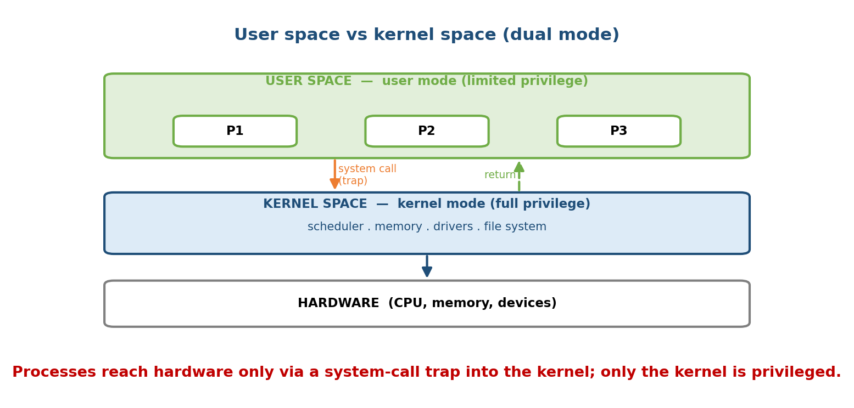
Two rings: user-space processes run with limited privilege; a system call traps across the boundary into kernel space, which alone touches hardware, then returns.
Correspondingly, memory is split into user space (where processes live) and kernel space (the kernel’s protected memory). A user process cannot read or write kernel space directly — it must ask via a system call.
Memory hook: user mode = the public lobby; kernel mode = the vault. The only way from lobby to vault is the system-call teller window — you hand over a request, staff (kernel) go inside and do it for you.
Mode switch vs context switch (classic confusion): - Mode switch = the same process crosses user → kernel (and back) on a system call/interrupt. Cheap — no scheduler, no change of process. - Context switch = the CPU is handed from one process to another (save all of A’s registers, load B’s). More expensive; involves the scheduler (M6). A mode switch does not imply a context switch.

MCQs
- What selects user vs kernel mode? → the mode bit in the PSW.
- Can a user program run privileged instructions? → no (it traps).
- Mode switch vs context switch? → user↔kernel in same process vs swap to a different process.
- Which is cheaper? → a mode switch.

3.2 System Calls — The Only Door Into the Kernel
A system call is a program’s request for a service the OS alone can perform (create a process, open a file, send on a socket). It is the controlled entry point across the user→kernel boundary from §3.1.

3.2.1 The mechanism (how a system call actually works)
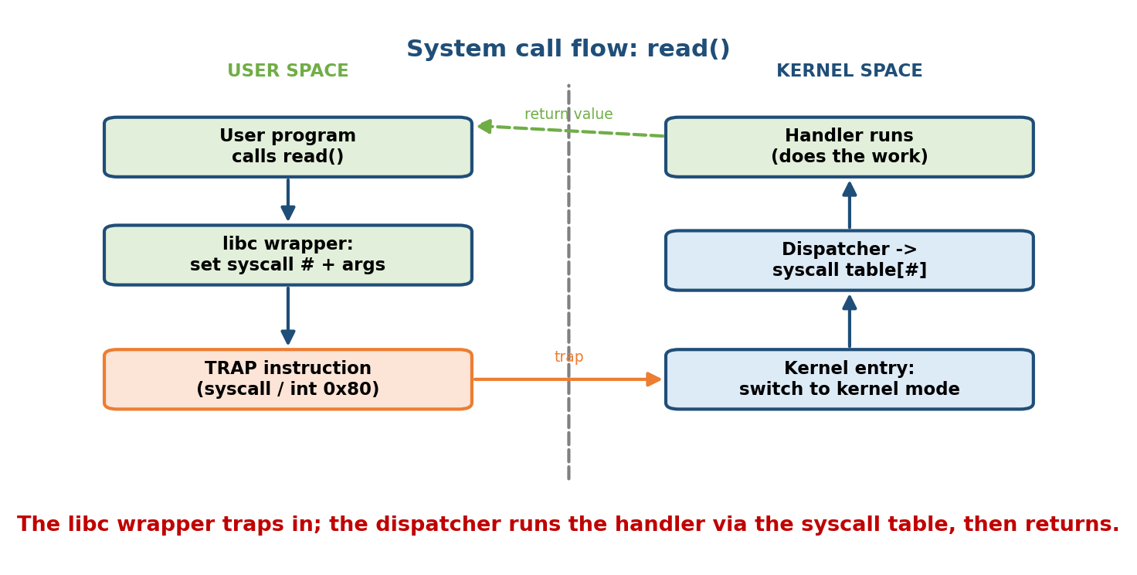
A system call: the library wrapper sets a call number and args, executes a trap; the CPU switches to kernel mode, the dispatcher runs the handler via the syscall table, then returns to user mode.
1. User program calls a library wrapper, e.g. read(fd, buf, n) (in libc).
2. Wrapper puts the SYSCALL NUMBER in a register + arguments in registers.
3. Executes a TRAP instruction (syscall / int 0x80 / svc) --> SOFTWARE INTERRUPT.
4. CPU switches USER -> KERNEL mode, jumps to the fixed syscall entry point.
5. Kernel's DISPATCHER indexes the SYSCALL TABLE by the number -> runs the handler.
6. Handler does the work (checks args/permissions, touches hardware).
7. Return value placed in a register; CPU switches KERNEL -> USER; wrapper returns.
The trap is the key: a system call is a software interrupt (M2 §2.4) — the program deliberately traps into the kernel. Arguments too big for registers are passed in a block/table whose address is passed, or on the stack.
Memory hook: a system call is ordering at a restaurant: you (user) don’t walk into the kitchen (kernel). You hand a numbered order (syscall number + args) through the pass (trap); the kitchen cooks it and hands the plate back (return value).

3.2.2 Categories of system calls (with examples)
Category | What it does | Examples (POSIX/Linux)
Process control | create/end/wait/load programs | fork, exec, wait, exit, kill
File management | create/open/read/write/close | open, read, write, close, lseek
Device management | request/release/use devices | ioctl, read, write, mmap
Information maintenance | get/set system data | getpid, time, gettimeofday, alarm
Communication | messaging, shared memory, sockets | pipe, shmget, socket, send, recv
Protection | permissions, access control | chmod, umask, chown
A tiny but complete example (creating a new process and running a program):
pid_t pid = fork(); /* process control: duplicate the process */
if (pid == 0) { /* child */
execlp("ls", "ls", NULL);/* process control: replace image with ls */
} else { /* parent */
wait(NULL); /* process control: wait for child to finish */
}

3.2.3 System call vs library call vs API (a favourite distinction)
- System call: a direct request to the kernel via a trap (read, write, fork). Involves a mode switch — relatively expensive.
- Library (function) call: ordinary code in user space (strlen, printf, malloc). No kernel involvement by itself — though it may make system calls underneath (printf eventually calls write; malloc may call brk/mmap).
- API (Application Programming Interface): the specification of functions a programmer uses (e.g. POSIX, the Win32 API). Programmers code to the API; the library implements it, invoking system calls as needed. You rarely invoke the raw trap yourself — you call the API, the library wraps the syscall.
The exam line: printf is a library call; write is the system call it uses. An API is the interface (contract); a system call is the actual kernel entry. Programs are portable across the same API even if the underlying syscalls differ.

MCQs
- A system call reaches the kernel via a? → trap (software interrupt).
- printf vs write? → library call vs system call.
- fork, exec, wait belong to which category? → process control.
- What indexes the correct handler? → the syscall number into the syscall table.
- POSIX / Win32 are examples of? → an API (interface, not the syscall itself).

3.3 Kernel Architectures — How the OS Is Structured
Where should OS services (scheduler, memory manager, file system, drivers, network stack) live — all inside the kernel, or outside as user processes? That one question defines the kernel architectures. It is the highest-yield conceptual topic in this module.
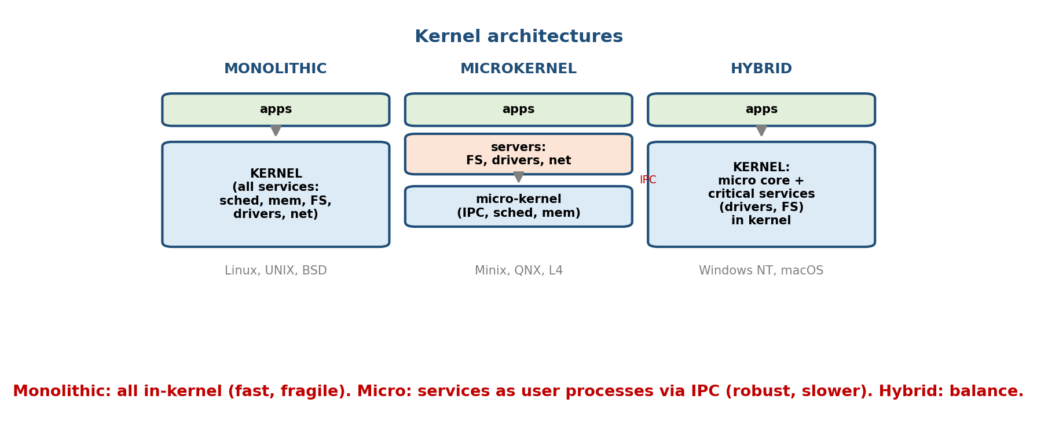
Monolithic keeps all services in one kernel address space; microkernel keeps only essentials in the kernel and runs services as user processes talking via IPC; hybrid puts performance-critical services back in the kernel.

3.3.1 Monolithic kernel
All OS services (scheduling, memory, file systems, drivers, networking) run together in one program in kernel space, sharing one address space and calling each other as fast function calls.
- Pros: fast (no messaging between services — direct calls); simple, mature.
- Cons: large and hard to maintain; a bug/driver crash can take down the whole kernel; less modular (though see modular, below).
- Examples: Linux, classic UNIX, BSD, MS-DOS.

3.3.2 Microkernel
Keep the kernel minimal — only the bare essentials: IPC, basic scheduling, and low-level address-space/memory management. Everything else (file system, drivers, network stack) runs as separate user-space server processes that communicate by message passing (IPC).
- Pros: reliable & secure — a crashed driver/service is just a user process the kernel can restart, not a kernel panic; modular; easier to verify; good for real-time.
- Cons: slower — every service request is IPC + mode switches instead of a function call (message-passing overhead).
- Examples: Minix, QNX (real-time), L4, Mach (research/base).

3.3.3 Hybrid kernel
A pragmatic middle ground: a microkernel-style structure, but performance- critical services (drivers, file systems, graphics) are pulled back into kernel space to avoid IPC cost. This is what most desktop OSes actually ship.
- Pros: balances the speed of monolithic with some modularity of microkernel.
- Cons: blurred boundaries; still large; “hybrid” is partly a marketing term.
- Examples: Windows NT family (Windows 10/11), macOS (XNU = Mach microkernel core + BSD monolithic parts + I/O Kit).

3.3.4 Modular kernel (loadable modules)
A monolithic kernel that can load and unload code at runtime as modules (e.g. a driver or file system loaded on demand). Combines monolithic speed with some flexibility — you don’t recompile the kernel to add a driver.
- Example: Linux is best described as monolithic + modular — it loads loadable kernel modules (LKMs) with insmod/modprobe.

3.3.5 Exokernel (and unikernels — awareness level)
An exokernel does as little abstraction as possible: it only securely multiplexes the raw hardware, and lets applications (linked with library OSes) implement their own abstractions for maximum performance/customisation.
- Pro: apps get near-hardware performance and can tailor policies. Con: far more work pushed to applications; research/niche. (A modern cousin: unikernels — a single app + minimal library OS compiled into one image.)

3.3.6 Comparison table (memorise this)
Feature | Monolithic | Microkernel | Hybrid
Services in kernel | all | minimal (rest in user space) | most critical ones
Communication | function calls (fast) | IPC / messages (slower) | mix
Speed | fast | slower (IPC overhead) | fast-ish
Reliability / isolation | driver crash → kernel down | crash = restartable user process | in between
Size / complexity in kernel | large | small | large
Extensibility | modules | services as processes | modules + services
Examples | Linux, UNIX, BSD | Minix, QNX, L4, Mach | Windows NT, macOS (XNU)
The #1 exam trade-off (say it out loud): monolithic = fast but fragile (everything in one address space, a driver bug can crash the kernel); microkernel = robust but slower (services are isolated user processes, but every request costs IPC). Hybrid trades a little isolation back for speed.
Memory hook: monolithic = open-plan office (everyone in one room, fast shouting, one fire spreads everywhere). microkernel = separate locked rooms (safe, but you must send memos = IPC). hybrid = mostly rooms, but the busy teams share one room for speed.

MCQs
- Where do drivers run in a microkernel? → in user space (as server processes).
- Why is a monolithic kernel fast? → services call each other directly (no IPC).
- Why is a microkernel more reliable? → a crashed service is a restartable user process, not a kernel panic.
- Classify Linux, QNX, Windows NT. → monolithic (modular), microkernel, hybrid.
- macOS’s kernel is called? → XNU (Mach + BSD, hybrid).
- Which architecture does the least abstraction? → exokernel.

3.4 The Layered Architecture
Instead of by where code runs, an OS can be organised by layers: each layer uses only the layer directly below it and offers services to the one above. Layer 0 is the hardware; the top layer is the user interface.
Layer N : user interface / applications
...
Layer 2 : device drivers / I/O
Layer 1 : CPU scheduling / memory management
Layer 0 : HARDWARE
- Pros: modular, easy to debug and verify one layer at a time (if lower layers are correct, you only test the new layer); clean abstraction.
- Cons: hard to define the layers cleanly (which layer owns what?); performance overhead — a request may pass through many layers.
- Classic example: THE operating system (Dijkstra, 1968) — the textbook layered design.
Memory hook: layered OS = a wedding cake — each tier rests only on the one below; clean, but a message from top to hardware traverses every tier.

MCQs
- In a layered OS, a layer may call? → only the layer directly below it.
- Main drawback of strict layering? → performance overhead + hard to define layers.
- The classic layered OS example? → THE (Dijkstra).

3.5 The Boot Process — From Power-On to Login
When you press power, there is no OS in RAM yet — so how does the OS load itself? By a chain of ever-larger loaders, each starting the next (“bootstrapping”, pulling yourself up by your bootstraps).
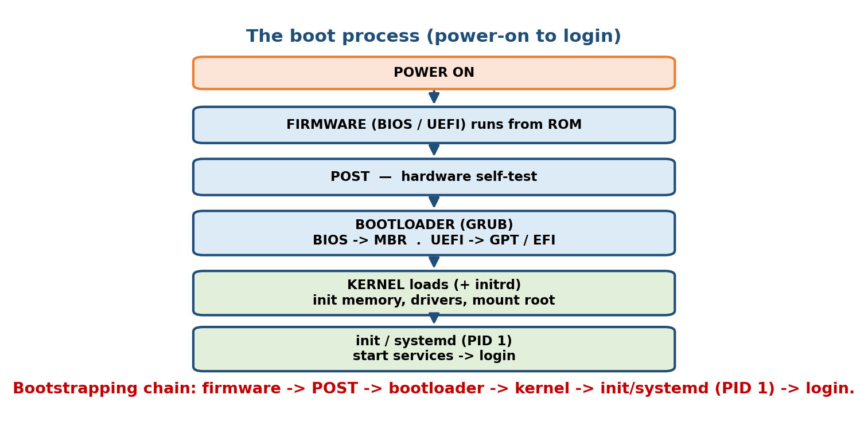
Boot sequence: firmware (BIOS/UEFI) runs POST, hands off to the bootloader (GRUB), which loads the kernel; the kernel initialises hardware and starts init/systemd (PID 1), which brings up user space.
POWER ON
1. FIRMWARE (BIOS or UEFI) runs from ROM/flash.
2. POST (Power-On Self-Test): check RAM, CPU, keyboard, disks.
3. Firmware finds the boot device and loads the BOOTLOADER.
BIOS : reads the 512-byte MBR (first sector) -> stage-1 loader.
UEFI : reads a .efi bootloader from the EFI System Partition (GPT).
4. BOOTLOADER (e.g. GRUB) shows the menu, loads the KERNEL (+ initrd) into RAM.
5. KERNEL initialises: sets up memory, drivers, mounts the root filesystem.
6. Kernel starts the first user process: INIT / systemd (PID 1).
7. init/systemd starts services (daemons), reaches a target/runlevel, spawns login.
READY: login prompt / desktop.

3.5.1 BIOS vs UEFI (high-yield comparison)
 | BIOS (legacy) | UEFI (modern)
Age / mode | old, 16-bit real mode | modern, 32/64-bit
Boot data | MBR (Master Boot Record, 512 B) | GPT + EFI System Partition (.efi)
Disk size limit | ≤ 2 TB (MBR) | > 2 TB (GPT)
Partitions | up to 4 primary | many
Speed / features | slower | faster boot, Secure Boot, GUI, network boot
Memory hook: BIOS = MBR (old, 2 TB cap, 16-bit); UEFI = GPT + EFI partition (modern, >2 TB, Secure Boot).

3.5.2 Key players
- POST — the firmware’s hardware self-check before anything loads.
- Bootloader (GRUB / GRUB2, Windows Boot Manager): loads and hands control to the kernel; on Linux it also loads the initrd/initramfs (a tiny temporary root FS with drivers needed to mount the real root).
- Kernel loading: the kernel decompresses, sets up memory management and core drivers, then mounts the root filesystem.
- init / systemd (PID 1): the first user-space process, ancestor of all others. Traditional SysV init used runlevels and shell scripts; systemd (today’s default on most Linux) uses units and targets, starts services in parallel (faster boot), and manages daemons.
Exam nuggets: PID 1 = init/systemd, the ancestor of every process. The MBR is 512 bytes and holds the stage-1 bootloader; GPT replaces it under UEFI. initrd/initramfs exists so the kernel has the drivers to mount the real root filesystem.

MCQs
- What runs first at power-on? → the firmware (BIOS/UEFI) from ROM/flash.
- POST checks? → basic hardware (RAM, CPU, devices).
- BIOS boot record vs UEFI? → MBR (512 B) vs GPT + EFI System Partition.
- GRUB is a? → bootloader.
- First user-space process / PID 1? → init / systemd.
- Why does Linux use an initrd/initramfs? → to carry drivers needed to mount the real root filesystem.

3.6 Real-World & Backend Perspectives
- Linux is monolithic-modular, and that’s why it’s fast: drivers and file systems are loadable modules (lsmod, modprobe), so you extend the kernel without a reboot-recompile, keeping the speed of in-kernel function calls.
- The syscall boundary is where performance and security meet: minimising syscalls (batching, io_uring, readv/writev) cuts mode-switch overhead; seccomp restricts which syscalls a process may make (container hardening).
- Containers vs microkernels: containers share the host’s monolithic Linux kernel (isolation via namespaces/cgroups), which is why they’re lightweight — contrast with a microkernel’s process-level isolation or a VM’s full guest kernel.
- systemd runs your servers: production services are systemd units (systemctl start/status, journald logs); understanding PID 1 and targets is everyday backend/DevOps work.
- eBPF lets you safely run sandboxed programs inside the Linux kernel — a modern way to extend a monolithic kernel without new modules.

3.7 Tradeoffs, Common Mistakes, Edge Cases
- Mistake: “microkernel is faster because it’s smaller.” No — smaller kernel, but slower due to IPC between services. It wins on reliability, not speed.
- Mistake: calling Linux a microkernel. Linux is monolithic (modular); Minix/QNX are microkernels.
- Mistake: confusing mode switch (user↔kernel, cheap) with context switch (process→process, costly).
- Mistake: printf is a system call. No — it’s a library call that uses the write system call.
- Mistake: BIOS uses GPT / UEFI uses MBR — it’s the reverse (BIOS→MBR, UEFI→GPT).
- Edge case: a hybrid kernel is not a clean category — Windows/macOS mix designs for pragmatism.
- Tradeoff: in-kernel drivers (speed, but a bug crashes the kernel) vs user-space drivers (isolation, but IPC overhead) — the monolithic/microkernel divide in miniature.

3.8 Exam, Interview & Coding Perspectives
- SEBI / RBI / NABARD: monolithic vs microkernel (pros/cons/examples), kernel vs user mode, system-call basics, BIOS vs UEFI, PID 1 = init/systemd.
- GATE: the mode bit / privileged instructions; syscall mechanism (trap); layered vs monolithic; the microkernel IPC trade-off.
- Interview: “What happens when you call read()?” (library wrapper → trap → kernel mode → syscall table → handler → return); “Monolithic vs microkernel — why is Linux monolithic?”; “What happens from power button to login?” (the boot chain).
- Coding/practical: strace ./prog shows the exact system calls a program makes; lsmod/modprobe list/load kernel modules; systemctl and dmesg inspect boot/services; uname -a shows the kernel.

3.9 Concept Checks & MCQs (test yourself)
- Two CPU modes and the bit that selects them? → user/kernel, the mode bit.
- Can user mode run privileged instructions? → no (traps to kernel).
- Mode switch vs context switch? → user↔kernel (same process) vs process→ process.
- A system call enters the kernel via? → a trap (software interrupt).
- fork/exec/wait category? → process control.
- printf vs write? → library call vs system call.
- API means? → the interface/specification (POSIX, Win32), not the syscall.
- Monolithic pros/cons? → fast, but a bug can crash the whole kernel.
- Microkernel pros/cons? → reliable/isolated, but slower (IPC).
- Classify Linux / QNX / Windows NT / macOS. → monolithic-modular / microkernel / hybrid / hybrid (XNU).
- Exokernel’s philosophy? → minimal abstraction, securely multiplex raw hardware.
- Layered OS rule and example? → each layer uses only the one below; THE.
- What runs first at power-on? → firmware (BIOS/UEFI); then POST.
- BIOS vs UEFI boot data? → MBR vs GPT + EFI System Partition.
- Bootloader example? → GRUB.
- PID 1? → init / systemd.
- Why an initrd/initramfs? → drivers to mount the real root filesystem.
- Where do containers get isolation? → the host’s monolithic kernel (namespaces/cgroups), not a separate kernel.
True/False - A microkernel is faster than a monolithic kernel. → False (more reliable, but slower due to IPC). - Linux is a microkernel. → False (monolithic + modular). - A system call requires a mode switch. → True. - printf is a system call. → False (library call using write). - UEFI uses the MBR. → False (UEFI uses GPT). - init/systemd is PID 1. → True.

3.10 One-Page Revision Sheet
DUAL MODE: MODE BIT (in PSW) -> USER(limited, no privileged instr) vs KERNEL(full power).
memory split: USER SPACE (processes) | KERNEL SPACE (protected). cross only via SYSCALL.
MODE SWITCH = user<->kernel, SAME process (cheap) ; CONTEXT SWITCH = process->process (costly).
SYSTEM CALL = program's request to kernel. MECHANISM:
libc wrapper -> put syscall NUMBER + args in registers -> TRAP (software interrupt)
-> kernel mode -> DISPATCHER indexes SYSCALL TABLE -> handler -> return value -> user mode.
CATEGORIES: process control(fork,exec,wait,exit) | file(open,read,write,close) |
device(ioctl,mmap) | info(getpid,time) | comms(pipe,socket,shmget) | protection(chmod).
SYSCALL vs LIBRARY vs API: syscall=kernel trap ; library=user code(printf,malloc, may call
syscalls); API=the interface/spec (POSIX, Win32). "printf=library, write=syscall".
KERNEL ARCHITECTURES:
MONOLITHIC : ALL services in kernel, direct calls -> FAST but a bug crashes kernel.
Linux, UNIX, BSD. (Linux also MODULAR: loadable kernel modules.)
MICROKERNEL: only IPC+sched+basic mem in kernel ; drivers/FS/net = USER processes via IPC
-> RELIABLE/isolated but SLOWER (IPC). Minix, QNX, L4, Mach.
HYBRID : microkernel-ish + critical services back in kernel for speed. Windows NT,
macOS (XNU = Mach + BSD).
EXOKERNEL : minimal abstraction, securely multiplex raw hardware (+ library OS). niche.
TRADE-OFF: monolithic FAST/fragile ; microkernel ROBUST/slower(IPC) ; hybrid = balance.
LAYERED: each layer uses only the one below (0=hardware, top=UI). easy to verify, but
overhead + hard to partition. Example: THE (Dijkstra).
BOOT: POWER -> FIRMWARE(BIOS/UEFI from ROM) -> POST(hw self-test) -> BOOTLOADER
(BIOS: MBR 512B ; UEFI: .efi on EFI partition, GPT) -> GRUB loads KERNEL(+initrd)
-> kernel init (mem, drivers, mount root) -> INIT/systemd = PID 1 -> services -> login.
BIOS: MBR, 16-bit, <=2TB. UEFI: GPT, >2TB, Secure Boot, faster. initrd=drivers to mount root.

Flash cards
Front | Back
What selects user/kernel mode? | The mode bit (in the PSW)
Mode switch vs context switch? | User↔kernel (same proc) vs proc→proc
System call mechanism? | Trap (software interrupt) into kernel
printf vs write? | Library call vs system call
What is an API? | The interface/spec (POSIX, Win32)
fork/exec/wait? | Process-control system calls
Monolithic: pro/con? | Fast / a bug crashes the kernel
Microkernel: pro/con? | Reliable / slower (IPC)
Linux kernel type? | Monolithic + modular
Minix, QNX? | Microkernel
Windows NT, macOS? | Hybrid (macOS = XNU)
Exokernel idea? | Minimal abstraction, multiplex hardware
Layered example? | THE (Dijkstra)
First code at power-on? | Firmware (BIOS/UEFI), then POST
BIOS vs UEFI boot data? | MBR vs GPT + EFI partition
Bootloader example? | GRUB
PID 1? | init / systemd

Spaced repetition
- 24-hour: recite monolithic vs microkernel vs hybrid (pros/cons/examples) and the syscall mechanism.
- 7-day: trace read() end-to-end (wrapper → trap → table → handler → return); BIOS vs UEFI; syscall categories.
- 30-day: draw the boot chain from power-on to login; explain dual mode, mode vs context switch, and the layered model without notes.

3.11 Summary
An OS enforces a hardware wall between user space (limited) and kernel space (full power), chosen by the mode bit — and a program crosses it only through a system call, a trap (software interrupt) that switches to kernel mode, runs a handler via the syscall table, and returns. We separated the system call (kernel trap), the library call (printf, user code that uses syscalls), and the API (the interface/spec like POSIX). The OS’s own code can be shaped as a monolithic kernel (all services in one address space — fast but fragile, e.g. Linux), a microkernel (essentials only; services as isolated user processes over IPC — robust but slower, e.g. Minix/QNX), a hybrid (the pragmatic mix — Windows NT, macOS/XNU), modular (Linux’s loadable modules), or an exokernel (minimal abstraction). The layered model (e.g. THE) stacks services, each using only the layer below. Finally, the boot process bootstraps the machine: firmware (BIOS/UEFI) → POST → bootloader (GRUB) loading the kernel → init/systemd (PID 1) bringing up user space.
Next, Module 4 — Processes builds directly on the syscalls (fork, exec, wait) and user/kernel boundary introduced here, defining the process, its states, and the PCB the kernel uses to manage it.
You have mastered this module when you can: explain dual mode and the mode bit, and distinguish mode switch from context switch; trace a system call end-to-end and tell syscall / library call / API apart with examples; compare monolithic, microkernel, hybrid, modular, and exokernel designs (pros/cons/examples) and classify Linux/QNX/Windows/macOS; describe the layered model; and walk the full boot process (BIOS vs UEFI, POST, GRUB, kernel, init/systemd) — all without notes.

