Module 4 — Processes
  - OS Mastery: SEBI IT / RBI / NABARD / GATE / C-DAC / Interview / Backend — In-Depth Notes (with visuals)
Prepared for nidhi.sharma@forensiccybertech.com
2026
Table of Contents

Module 4 — Processes
Where this module sits. Module 1 said an OS is a resource manager. But what is it managing? The answer is the process — a program in execution, the unit the OS schedules, protects, and accounts for. This is the beating heart of the whole subject: CPU scheduling (M6) decides which process runs next; synchronization (M7) keeps cooperating processes from corrupting shared data; memory management (M9) gives each process its own address space; and IPC (M7) lets processes talk. Get the process model right here and every later module clicks. This module covers the PCB, the process state diagram, context switching, and the UNIX creation syscalls fork / exec / wait that every backend engineer must know cold.
Importance ratings (out of 5):
Exam / Use | SEBI IT | RBI IT | GATE CS | Interview | Backend
This module | ★★★★ | ★★★★ | ★★★★ | ★★★★ | ★★★★★
Most-asked PYQ concepts (SEBI / RBI / GATE / C-DAC): program vs process; PCB contents; the process state diagram (esp. ready↔running↔waiting and the suspended states); context switch (what is saved, why it is pure overhead); fork() return value (parent vs child) and the classic “how many processes for N forks = 2ⁿ” counting question; exec() vs fork(); wait()/waitpid(); zombie vs orphan and how each is handled; daemon processes; IPC (shared memory vs message passing, pipes).

4.1 Program vs Process (first principles)
A program is a passive entity — a file of instructions sitting on disk (/bin/ls, a.out). A process is an active entity — that program loaded into memory and executing, with its own CPU state, memory, and OS bookkeeping.
Memory hook: a program is the recipe; a process is the cooking — the chef, the hot pans, the half-chopped onions. One recipe (program) can drive many simultaneous cookings (processes): run python in three terminals → one program, three processes, each with its own memory and progress.

The four segments of a process in memory
When a program becomes a process, the OS lays out its address space into four parts:
high address
┌───────────────┐
│ STACK │ ← function calls, local vars, return addrs (grows DOWN)
│ ↓ │
│ ... │ ← free gap
│ ↑ │
│ HEAP │ ← dynamic memory: malloc/new (grows UP)
├───────────────┤
│ DATA (BSS + │ ← global & static variables
│ initialised)│
├───────────────┤
│ TEXT (CODE) │ ← the machine instructions (read-only, shareable)
low address
└───────────────┘
- Text/Code — the instructions (read-only, so many processes running the same program can share one copy).
- Data — global and static variables (initialised data + BSS for zero-initialised).
- Heap — dynamically allocated memory (malloc, new), grows up.
- Stack — local variables, parameters, return addresses, grows down.
Why stack and heap grow toward each other: they start at opposite ends of the free region so each can expand into the shared gap. If they collide you get a stack overflow / out-of-memory.

MCQs
- Program vs process? → passive file on disk vs active program in execution.
- One program can have how many processes? → many (each independent).
- Which segment is read-only and shareable? → text/code.
- malloc/new memory comes from the? → heap.

4.2 The Process Control Block (PCB)
The PCB (also called the process descriptor, or task_struct in Linux) is the OS’s data structure for one process — everything the kernel must remember to pause, resume, schedule, and account for it. There is one PCB per process, kept in a kernel table.
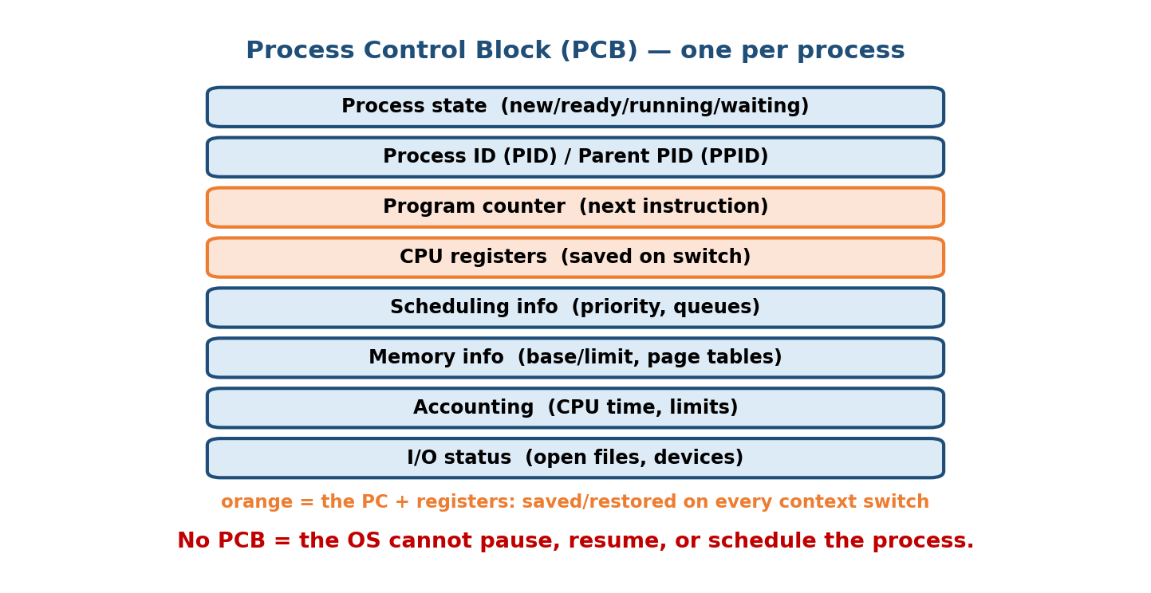
The Process Control Block stores identity, CPU state, scheduling, memory, and I/O information for one process; the OS keeps one per process.
Field group | What it stores
Process state | new / ready / running / waiting / terminated
Process ID (PID) | unique number identifying the process; parent PID (PPID)
Program counter (PC) | address of the next instruction to execute
CPU registers | all register values (saved on a context switch)
CPU-scheduling info | priority, scheduling queue pointers, time-quantum info
Memory-management info | base/limit registers, page tables / segment tables
Accounting info | CPU time used, time limits, process number
I/O status info | list of open files, allocated I/O devices, pending I/O
Memory hook: the PCB is the process’s passport + medical chart. When the CPU is taken away, the OS writes the process’s entire “vital signs” (PC, registers, state) into the PCB; to resume it, the OS reads them back. No PCB = the OS cannot manage the process.
The PC and registers are the crucial pair. They are exactly what makes it possible to stop a process mid-instruction-stream and resume later as if nothing happened — the whole illusion of multitasking rests on saving/restoring them.

MCQs
- Per-process OS data structure? → PCB (Process Control Block).
- What in the PCB points to the next instruction? → the program counter.
- Linux name for the PCB? → task_struct.
- Where are page-table pointers kept? → in the PCB’s memory-management info.

4.3 The Process State Diagram
A process is not always running — it moves through a small set of states as it competes for the CPU and waits on I/O. This diagram is one of the most-asked figures in the entire syllabus.
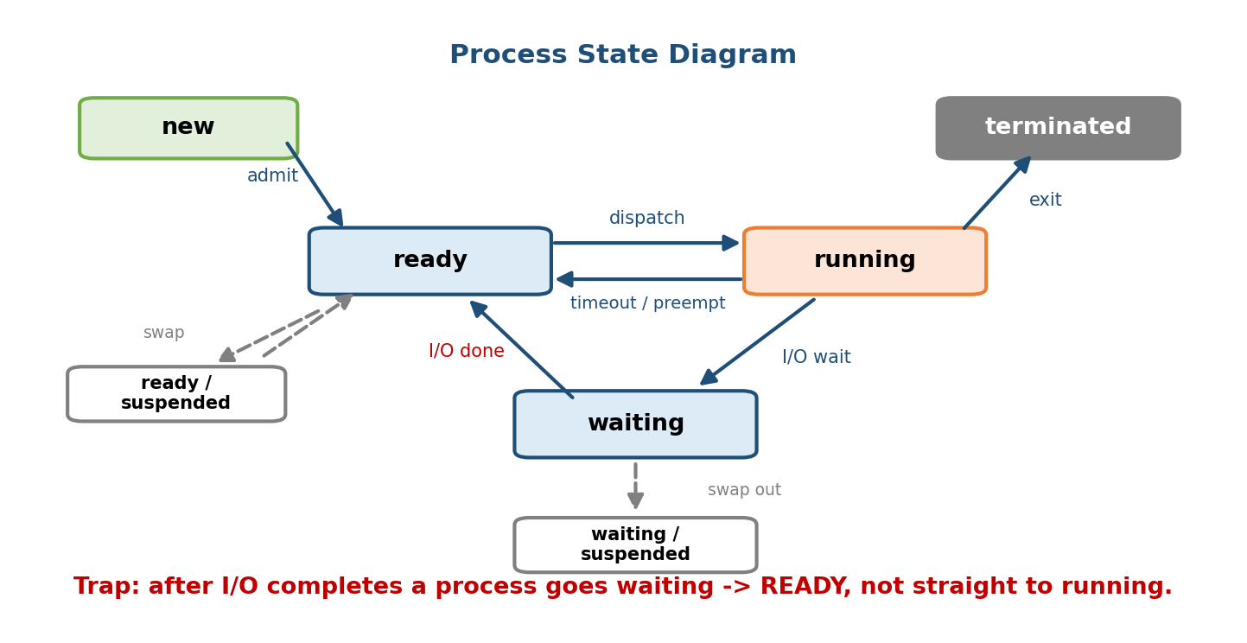
Process state diagram: new→ready→running, running↔ready via scheduler and interrupt, running→waiting on I/O and back to ready, running→terminated; plus suspended (swapped-out) ready and waiting states.

The five core states
State | Meaning
New | process is being created (PCB allocated, not yet ready)
Ready | in memory, waiting only for the CPU (sitting in the ready queue)
Running | instructions are executing on the CPU
Waiting / Blocked | waiting for an event (I/O completion, a signal, a lock)
Terminated / Exit | finished executing; PCB about to be released

The transitions (learn every arrow)
new ──admit──▶ ready ──dispatch(scheduler)──▶ running ──exit──▶ terminated
▲ │ │
│ ◀──interrupt/timeout────────┘ │ (time quantum expires)
│ ▼
└───I/O or event complete──── waiting ◀── I/O or event wait
- admit: new → ready (long-term scheduler admits it).
- dispatch: ready → running (short-term scheduler / dispatcher picks it).
- interrupt / timeout: running → ready (its time quantum expired, or a higher-priority process preempted it — it is still runnable).
- I/O or event wait: running → waiting (it requested I/O or a resource).
- I/O or event completion: waiting → ready (note: it goes back to ready, not straight to running — it must be re-scheduled).
- exit: running → terminated.
The #1 trap: after I/O completes, a process goes waiting → ready, not waiting → running. It must wait its turn for the CPU again. Only the dispatcher moves a process into running, and only one process per CPU core can be running at a time.

Suspended states (swapping)
When memory is scarce, the OS can swap a process out to disk, freeing RAM. This adds two states:
- Ready-suspended: was ready, now swapped out to disk (runnable once swapped in).
- Waiting/Blocked-suspended: was blocked and swapped out.
Memory hook: suspended = “on the bench, sent to the locker room (disk).” Swapping is the bridge to virtual memory (M9).

MCQs
- A process waiting only for the CPU is in which state? → ready.
- After I/O completes, a process moves to? → ready (not running).
- Which state means “waiting for an event/I/O”? → waiting / blocked.
- What moves a process from ready to running? → the dispatcher (short-term scheduler).
- Swapping a process to disk puts it in a ___ state → suspended.

4.4 Context Switching
A context switch is the act of saving the state of the running process into its PCB and loading the state of the next process from its PCB, so the CPU can switch from one process to another.
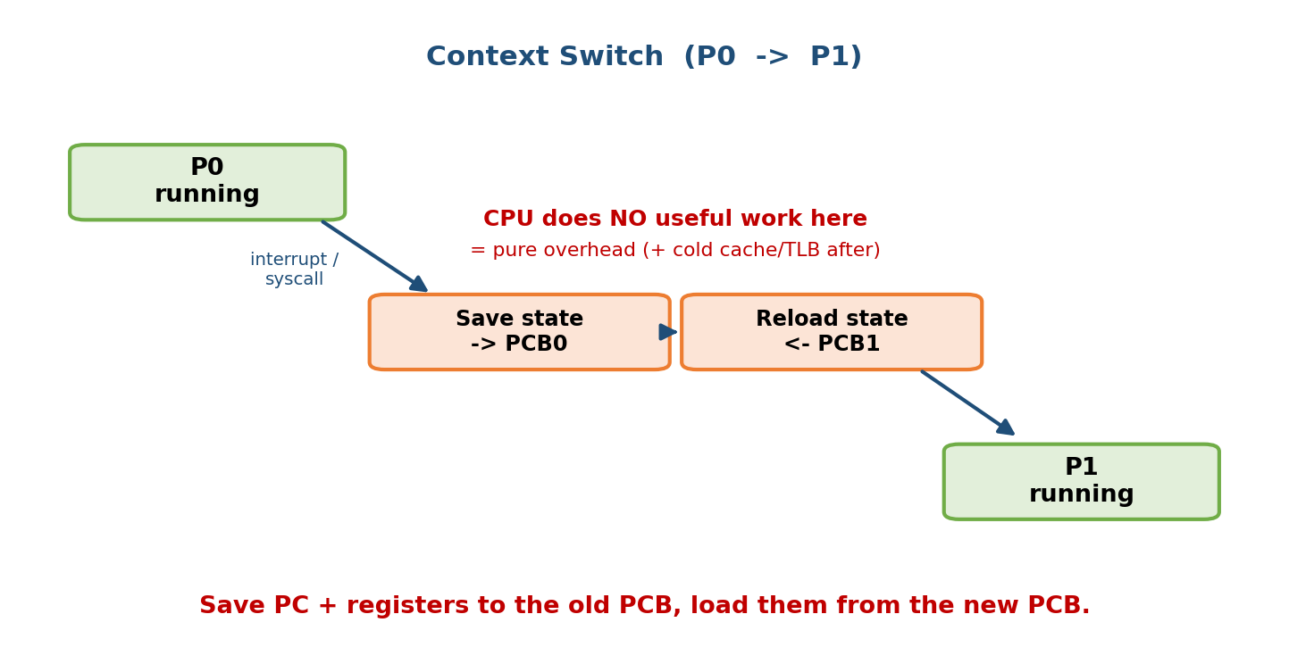
Context switch: process P0 running, an interrupt saves P0’s state into PCB0, the OS loads PCB1, P1 runs; the CPU is idle (pure overhead) during both save and restore.

What exactly is saved and restored?
The CPU context — everything in the PCB that defines “where the process was”:
- the program counter (next instruction),
- all CPU registers (general-purpose, stack pointer, status/flags),
- memory-management state (e.g. page-table base register — switching this may flush the TLB, adding cost).

When does a context switch happen?
- Timer interrupt — the running process’s time quantum expired.
- I/O request / wait — the process blocks.
- Higher-priority process becomes ready (preemption).
- System call / interrupt handling, and process exit.
Why a context switch is PURE OVERHEAD: during the switch the CPU does no useful user work — it is only shuffling bookkeeping. Every microsecond spent switching is a microsecond stolen from real computation. Typical cost is ~1–10 microseconds, but the hidden cost is bigger: the new process starts with a cold cache and cold TLB, so it runs slower until they warm up.
Design consequence (ties to M6): this is why the time quantum in Round Robin must not be too small — if the quantum ≈ the switch cost, the CPU spends half its time switching instead of working. It is also the reason threads (M5) are attractive: switching between threads of the same process is cheaper because the address space (and often the TLB) does not change.

MCQs
- What is saved on a context switch? → the PC + registers + memory-management state (into the PCB).
- Why is a context switch overhead? → the CPU does no useful work during it.
- Name two events that trigger a switch. → timer interrupt and I/O wait (also preemption, exit).
- Why is a thread switch cheaper than a process switch? → same address space (no page-table/TLB change).

4.5 The Process Tree & Process Creation
Every process (except the very first) is created by another process, forming a tree. In UNIX/Linux the root is init/systemd (PID 1), started by the kernel at boot; it is the ancestor of every other process.
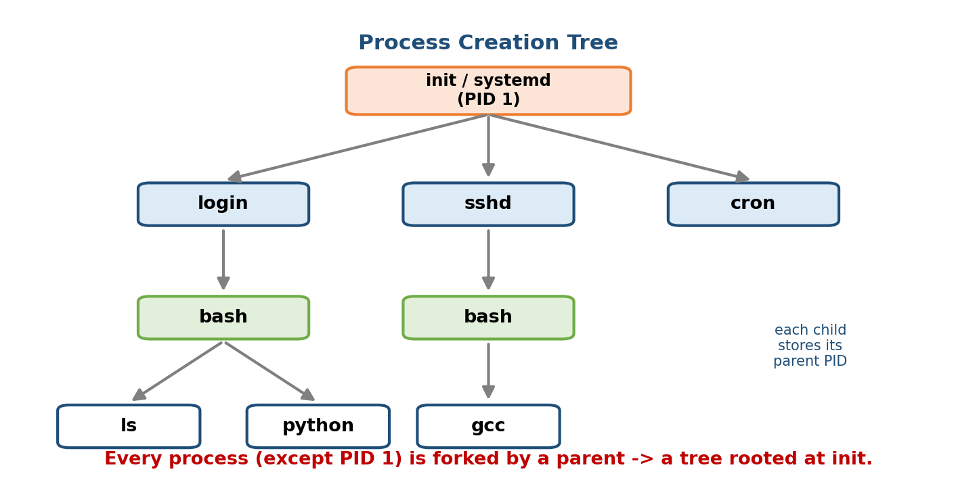
A process creation tree: init (PID 1) is the root; it spawns login/shell, which forks user programs; each child records its parent (PPID), forming a hierarchy.
init / systemd (PID 1)
/ | \
login sshd cron
| |
bash bash
/ \ \
ls python gcc ← each child has a parent PID (PPID)
- The creator is the parent; the created process is the child.
- Inspect the live tree with pstree or ps -ef (the PPID column).
- Resource sharing models: parent and child may share all, some, or no resources. Execution: the parent may run concurrently with the child, or wait for it to finish.

MCQs
- Root of the UNIX process tree? → init / systemd (PID 1).
- The process that creates another is the? → parent.
- Command to view the process tree? → pstree.

4.6 fork() — Creating a Process
fork() is the UNIX system call that creates a new process by duplicating the calling process. The child is an almost-exact copy of the parent: same code, same data (a separate copy), same open files, same PC — it resumes right after the fork().

The single most important fact: the return value
fork() is called once but returns twice — once in each process:
Where | fork() returns | Meaning
In the parent | the child’s PID (a positive number > 0) | so the parent knows its child
In the child | 0 | “you are the child”
On failure | −1 (in the parent; no child made) | e.g. process-table full
Memory hook: “Parent gets the child’s number; the child gets zero.” This is the branch every fork program uses to make parent and child do different things.

A worked C example
#include <stdio.h>
#include <unistd.h>
#include <sys/wait.h>
int main(void) {
pid_t pid = fork(); // called ONCE, returns TWICE
if (pid < 0) { // fork failed
perror("fork");
return 1;
} else if (pid == 0) { // ---- CHILD (fork returned 0) ----
printf("Child : my PID=%d, my parent=%d\n", getpid(), getppid());
} else { // ---- PARENT (fork returned child PID) ----
printf("Parent: my PID=%d, my child=%d\n", getpid(), pid);
wait(NULL); // reap the child (see 4.8) to avoid a zombie
}
return 0;
}
Copy-on-write (COW) — how fork is fast (interview gold): naively, copying the parent’s entire memory would be slow. Modern kernels instead let parent and child share the same physical pages, marked read-only; a page is copied only when one of them writes to it. So fork() is cheap until memory actually diverges.

The classic counting question: “how many processes for N forks?”
Each fork() doubles the number of processes (every existing process spawns one child). So after N successive fork() calls executed by all resulting processes:
Total processes = 2^N (including the original)
Children created = 2^N − 1
Worked example — 3 forks in a row:
fork(); // 1 → 2 processes
fork(); // 2 → 4 processes
fork(); // 4 → 8 processes
Total = 2³ = 8 processes (7 new children + 1 original). Trace it: after the 1st fork there are 2; both run the 2nd fork → 4; all four run the 3rd fork → 8. The number of printfs after the last fork would be 8.
Variant trap: if the code is fork() && fork() or fork() || fork(), short-circuit evaluation means not every process reaches the second fork — count carefully. And for(i=0;i<n;i++) fork(); is the same as n sequential forks → 2ⁿ processes.

MCQs
- What does fork() return in the child? → 0.
- In the parent? → the child’s PID (>0); −1 on failure.
- Total processes after 4 forks in a row? → 2⁴ = 16.
- How does modern fork() avoid copying all memory? → copy-on-write.

4.7 exec() — Replacing the Program
fork() makes a copy of the same program. To run a different program you use the exec() family, which replaces the current process’s memory image (text, data, heap, stack) with a new program — but keeps the same PID.
The fork–exec idiom (the core of how shells launch commands):
pid = fork(); // 1. duplicate ourselves
if (pid == 0) // 2. in the CHILD:
execvp("ls", args); // become a totally new program (ls)
else // 3. in the PARENT (the shell):
waitpid(pid, ...); // wait for the command to finish
This is exactly what your shell does for every command you type: fork a child, exec the program into it, wait for it.
- exec() succeeds → it never returns (the old program is gone). Any code after a successful exec does not run.
- exec() returns only on failure (e.g. file not found), returning −1.
- The family differs by how you pass arguments/environment/path:
Call | Args | PATH search | Environment
execl / execlp / execle | list (arg0, arg1, …, NULL) | p = yes | e = custom
execv / execvp / execve | vector (char *argv[]) | p = yes | e = custom
execve() is the real system call; all the others are C-library wrappers around it. Mnemonic: l = list of args, v = vector (array) of args, p = search PATH, e = pass an environment array.

MCQs
- What does a successful exec() return? → nothing — it never returns.
- Does exec() change the PID? → no (same process, new program).
- fork vs exec? → fork copies the current program; exec replaces it with a new one.
- The underlying system call for the exec family? → execve().

4.8 wait() / waitpid() — Reaping Children
When a child finishes, it becomes a zombie (see 4.9) until the parent collects its exit status. The parent does this with wait() (any child) or waitpid() (a specific child), an act called reaping.
int status;
pid_t child = wait(&status); // block until ANY child exits
// or wait for a specific child:
waitpid(pid, &status, 0); // 0 = block; WNOHANG = don't block
if (WIFEXITED(status)) // did it exit normally?
printf("child exited with %d\n", WEXITSTATUS(status)); // its exit code
- wait(&status) blocks the parent until any one child terminates, returns that child’s PID, and writes its exit info into status.
- waitpid(pid, &status, options) waits for a specific child; with the WNOHANG option it returns immediately (non-blocking poll) if no child has exited yet.
- Macros WIFEXITED / WEXITSTATUS decode the status word.
Why reaping matters: wait() is what lets the OS free the child’s PCB. Skip it and the finished child lingers as a zombie, leaking a PCB slot.

MCQs
- What does wait() do? → blocks the parent until a child exits and reaps it (frees its PCB).
- Non-blocking wait option? → WNOHANG with waitpid.
- How to get a child’s exit code? → WEXITSTATUS(status) (after WIFEXITED).

4.9 Zombie vs Orphan Processes
Two special situations arise from the parent–child relationship. Exams love the “which is which” contrast.
 | Zombie (defunct) | Orphan
What happened | child finished, but parent hasn’t wait()ed yet | parent died while the child is still running
Who is alive | child is dead; parent alive but negligent | child is alive; parent is dead
Problem | its PCB entry stays (holds a PID/status) | it has no parent to reap it
How it’s handled | parent calls wait() → PCB freed | it is reparented to init (PID 1), which reaps it
Memory hook: - Zombie = dead child, un-reaped (“dead but still in the process table, waiting to be buried by wait()”). - Orphan = live child, dead parent (“adopted by init”).
Why a zombie is (a little) dangerous: a zombie uses almost no memory (just a PCB slot holding the exit status), but a program that forks in a loop and never wait()s will fill the process table and eventually fork() fails (−1) — a real production bug. The fix: always reap children (call wait/waitpid, or handle SIGCHLD).
How orphans are auto-cleaned: when a parent dies, the kernel re-parents its children to PID 1 (init/systemd). init continuously calls wait(), so orphaned children never become permanent zombies.

MCQs
- Child finished but not reaped? → zombie.
- Parent died, child still running? → orphan.
- An orphan is adopted by? → init / systemd (PID 1).
- How is a zombie removed? → the parent calls wait() (reaps it).
- What happens if you never reap children in a loop? → the process table fills, fork() starts failing.

4.10 Daemons — Background Service Processes
A daemon is a long-running background process that provides a service and is not attached to a controlling terminal — it starts at boot and runs quietly. By convention their names often end in d: sshd (SSH server), httpd (web server), crond (scheduler), systemd.
- Typically parented by init/systemd (PID 1) and run without user interaction.
- Classic creation (“daemonizing”): fork(), let the parent exit (so the child is orphaned and adopted by init), setsid() to start a new session and detach from the terminal, then redirect stdin/stdout/stderr.
Memory hook: a daemon is a “waiter on standby” — always in the background, no terminal of its own, ready to serve requests (a connection, a timer, a print job). Every backend server you run (nginx, postgres, redis) runs as a daemon.

MCQs
- A background service process with no terminal? → daemon.
- Daemons are usually the child of? → init / systemd.
- Naming convention for daemons? → often ends in d (sshd, httpd).

4.11 Inter-Process Communication (IPC) — a Bridge to M7
Processes are isolated (each has its own address space), which is great for safety but means cooperating processes need an explicit way to exchange data. There are two fundamental models.
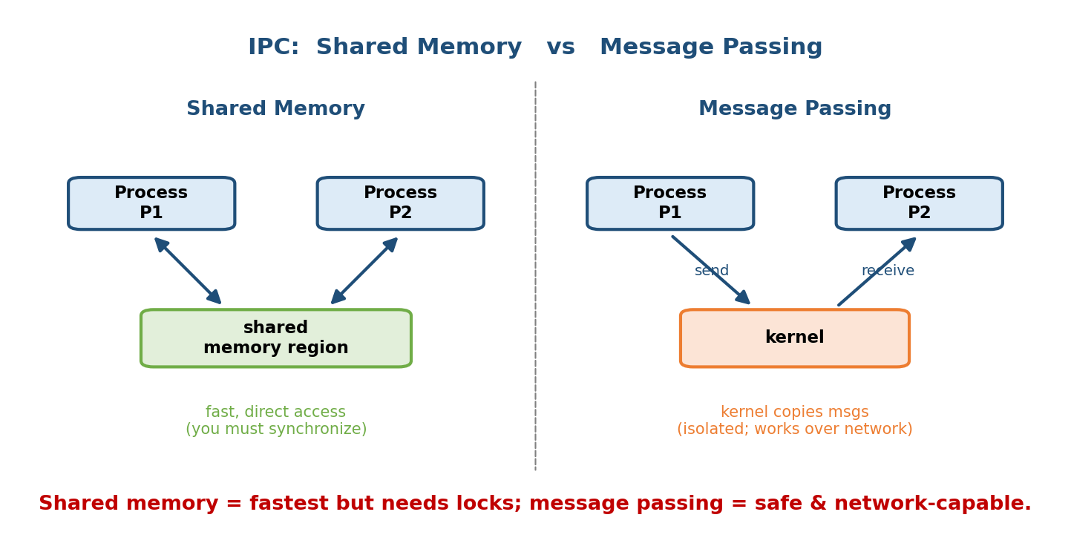
IPC models: shared memory (both processes map a common region and read/write it directly — fast, needs synchronization) vs message passing (processes send/receive via the kernel — slower, but clean isolation).

Model 1 — Shared Memory
The OS lets two processes map the same region of physical memory into both their address spaces; they then communicate by reading and writing that region directly.
- Pro: fastest — after setup, no kernel involvement per access (memory-speed).
- Con: the processes must synchronize themselves (semaphores/mutexes, M7) to avoid race conditions on the shared region.

Model 2 — Message Passing
Processes communicate by sending and receiving messages through the kernel (send/receive), never touching each other’s memory.
- Pro: clean isolation, easier to reason about, works across machines (networking).
- Con: slower — every message is copied via the kernel (two copies: user→kernel→user).
 | Shared memory | Message passing
Speed | fast (direct access) | slower (kernel-mediated copies)
Synchronization | you must do it (mutex/semaphore) | handled by send/receive
Scope | same machine | same machine or over a network
Ease | harder (races) | easier / safer

Common IPC mechanisms (know the list)
- Pipes — a one-way byte stream. Anonymous pipe (| in the shell) connects related processes (parent↔child); named pipe (FIFO) connects unrelated processes via a filesystem name.
- Message queues — kernel-maintained list of discrete messages.
- Shared memory — the model above (POSIX shm_open/mmap, System V shmget).
- Sockets — endpoints for communication, including across the network (the basis of all networked services).
- Signals — a lightweight async notification (e.g. SIGCHLD, SIGKILL).
Memory hook: shell pipe ls | grep txt is IPC in the wild — the kernel creates a pipe, ls’s stdout becomes the pipe’s write end and grep’s stdin its read end. Two processes, one byte stream. Full synchronization and the producer–consumer problem come in Module 7.

MCQs
- Two IPC models? → shared memory and message passing.
- Which is faster, and what’s its catch? → shared memory; it needs explicit synchronization.
- ls | grep uses which mechanism? → an (anonymous) pipe.
- IPC that works across a network? → sockets (message passing).
- Named pipe vs anonymous pipe? → FIFO connects unrelated processes; anonymous connects related (parent/child) ones.

4.12 Real-World & Backend Perspectives
- Every server is a fork/exec story. Classic servers (Apache prefork, PostgreSQL) fork a worker process per connection; the OS’s process model is your concurrency model. Understanding COW fork explains why forking is cheap.
- Zombies are a real outage cause. A supervisor that spawns workers but forgets to reap them (SIGCHLD/wait) slowly exhausts the PID table until nothing can start. docker PID-1 “zombie reaping” (--init / tini) exists exactly for this.
- Containers are processes. A Docker container is (mostly) a process tree in isolated namespaces; PID 1 inside it must reap orphans or you leak zombies.
- Context-switch cost is why async exists. Node.js/nginx use an event loop (few threads, no per-request process) precisely to avoid thousands of expensive context switches under high concurrency.

4.13 Tradeoffs, Common Mistakes, Edge Cases
- Mistake: thinking fork() returns the same value in both processes. It returns 0 to the child, child-PID to the parent.
- Mistake: believing code after a successful exec() runs. It never does (the old image is gone).
- Mistake: “waiting → running” after I/O. It is waiting → ready.
- Mistake: counting forks. n sequential forks = 2ⁿ processes, not 2n or n+1 — and watch short-circuit &&/||.
- Edge case: a zombie can’t be killed with kill — it’s already dead; you must make its parent reap it (or kill the parent so init adopts and reaps).
- Tradeoff: processes (isolation, safety, expensive to switch) vs threads (shared memory, cheap to switch, but need synchronization) — the whole reason Module 5 exists.

4.14 Exam, Interview & Coding Perspectives
- SEBI / RBI / NABARD: program-vs-process, PCB contents, the state diagram, zombie-vs-orphan one-liners, and daemon definitions are frequent MCQs.
- GATE: the fork-counting numerical (2ⁿ, with &&/|| traps) and the process-state transitions are perennial. Know that I/O completion → ready.
- Interview (backend/systems): “What happens when you type ls and press Enter?” → fork + exec + wait. “Zombie vs orphan?” “How does fork avoid copying all memory?” → copy-on-write. “Why are context switches expensive?”
- Coding: be able to write the fork/exec/wait skeleton and predict the output (and process count) of a small fork program.

4.15 Concept Checks & MCQs (test yourself)
- Program vs process? → passive file vs program in execution.
- Per-process kernel structure? → PCB (task_struct in Linux).
- Three things saved on a context switch? → PC, registers, memory-mgmt state.
- After I/O completes, the process becomes? → ready.
- fork() return value in child / parent? → 0 / child PID (−1 on fail).
- Processes after 5 sequential forks? → 2⁵ = 32.
- Does exec change the PID? → no.
- What does wait() return? → the terminated child’s PID (and its status).
- Dead child not reaped? → zombie; parent-less live child? → orphan.
- Orphan is adopted by? → init/systemd (PID 1).
- Background service process, no terminal? → daemon.
- Two IPC models? → shared memory (fast, needs sync) / message passing.
- ls | grep mechanism? → pipe.
- Real system call behind the exec family? → execve.
- Why is a context switch pure overhead? → no useful user work happens during it (plus cold cache/TLB afterwards).
True/False - fork() is called once and returns twice. → True. - Code after a successful exec() runs. → False. - A zombie can be removed with kill. → False (parent must wait). - I/O completion moves a process straight to running. → False (→ ready). - Threads of one process share the address space. → True (preview of M5).

4.16 One-Page Revision Sheet
PROGRAM = passive file on disk. PROCESS = program in execution (active).
Memory: TEXT(code,RO,shared) | DATA(globals+BSS) | HEAP(malloc, grows UP) | STACK(grows DOWN).
PCB (task_struct): STATE, PID/PPID, PROGRAM COUNTER, REGISTERS, sched info(priority,queues),
memory info(base/limit, PAGE TABLES), accounting(CPU time), I/O(open files). One per process.
STATES: new -admit-> READY -dispatch-> RUNNING -exit-> terminated
RUNNING -timeout/preempt-> READY ; RUNNING -I/O wait-> WAITING ; WAITING -I/O done-> READY(!)
SUSPENDED (swapped to disk): ready-suspended / blocked-suspended.
TRAP: I/O done => READY (not running). Only dispatcher -> running.
CONTEXT SWITCH: save PC+registers+mem-state to old PCB, load new PCB. PURE OVERHEAD (no user work;
cold cache/TLB after). Triggers: timer, I/O wait, preemption, exit. ~1-10us. Thread switch cheaper.
PROCESS TREE: root = init/systemd (PID 1). parent forks child (records PPID). pstree / ps -ef.
fork(): once-called, TWICE-returned. child gets 0 ; parent gets CHILD PID ; -1 on fail.
Copy-On-Write (share pages RO, copy on write) => fast. N sequential forks => 2^N processes.
(watch && / || short-circuit; for-loop n times = 2^n).
exec(): REPLACES image with new program, SAME PID. success => NEVER returns; -1 on fail.
family: l=list v=vector args, p=PATH search, e=env. real syscall = execve.
SHELL = fork + exec + wait.
wait(&st)/waitpid(pid,&st,opt): parent blocks, REAPS child (frees PCB). WNOHANG=nonblock.
WIFEXITED/WEXITSTATUS decode status.
ZOMBIE = dead child, NOT reaped (PCB lingers) -> parent wait() fixes. loop w/o wait => table full.
ORPHAN = live child, dead parent -> reparented to init(1), which reaps it.
DAEMON = background service, no terminal, child of init, name ends in 'd' (sshd/httpd/crond).
IPC: SHARED MEMORY (fast, direct, YOU synchronize) vs MESSAGE PASSING (kernel copies, isolated,
works over network). Mechanisms: PIPE(| anon=related, FIFO=unrelated), msg queue, shm, SOCKET, signal.

Flash cards
Front | Back
Program vs process? | Passive file vs program in execution
Per-process OS structure? | PCB (task_struct)
fork() in child / parent? | 0 / child PID (−1 on fail)
Processes after N forks? | 2ⁿ
exec() on success returns? | Never returns (same PID, new program)
What does wait() do? | Blocks parent, reaps child (frees PCB)
Dead child, not reaped? | Zombie
Live child, dead parent? | Orphan (adopted by init)
After I/O completes → state? | Ready (not running)
Two IPC models? | Shared memory / message passing
Why context switch = overhead? | No useful work + cold cache/TLB
How fork avoids full copy? | Copy-on-write

Spaced repetition
- 24-hour: recite the state diagram arrows and the fork() return-value rule; redo one 2ⁿ fork-count question.
- 7-day: explain fork/exec/wait as “what a shell does”; zombie vs orphan; why a context switch is pure overhead.
- 30-day: from scratch, draw the process state diagram (with suspended) and the memory layout; write a fork/exec/wait skeleton and predict its output.

4.17 Summary
A process is a program in execution — the active, schedulable unit the OS manages via one PCB per process (state, PID, program counter, registers, memory and I/O info). Each process moves through the state diagram — new → ready → running, back to ready on timeout, to waiting on I/O and back to ready when it completes, and finally terminated — with suspended states when swapped to disk. Switching the CPU between processes is a context switch: save/restore the PC and registers via the PCB, and it is pure overhead. UNIX builds processes in a tree with fork() (copy the parent — 0 to child, child-PID to parent, 2ⁿ for n forks, cheap via copy-on-write), exec() (replace the image with a new program, same PID, never returns on success), and wait() (reap the child, freeing its PCB). We distinguished zombie (dead child, un-reaped) from orphan (live child, dead parent → adopted by init), met daemons, and previewed IPC (shared memory vs message passing, pipes).
Next, Module 5 — Threads takes the process apart: multiple threads share one process’s address space to get concurrency without the cost of full processes — which is exactly why the context switch and IPC problems of this module get cheaper, and why synchronization (M7) becomes essential.
You have mastered this module when you can: draw the process state diagram (including suspended) and label every transition; list the PCB fields and what a context switch saves; explain fork/exec/wait and predict a fork program’s output and process count (2ⁿ); contrast zombie vs orphan and say how each is handled; and describe shared memory vs message-passing IPC — all without notes.

