Module 5 — Threads
  - OS Mastery: SEBI IT / RBI / NABARD / GATE / C-DAC / Interview / Backend — In-Depth Notes (with visuals)
Prepared for nidhi.sharma@forensiccybertech.com
2026
Table of Contents

Module 5 — Threads
Where this module sits. Module 4 gave us the process — powerful but heavy: creating one, switching to one, and making two of them talk (IPC) all cost real time. Yet a single program often needs to do many things at once — a browser rendering a page while downloading images while running JavaScript. The answer is the thread: a lightweight unit of execution inside a process that shares its memory with its siblings. Threads make concurrency cheap, but sharing memory is exactly what makes synchronization (M7) necessary, and how threads are mapped to the CPU shapes scheduling (M6). This module covers thread vs process, user vs kernel threads, the multithreading models, pthreads, thread pools, and the concurrency-vs-parallelism distinction every interviewer asks about.
Importance ratings (out of 5):
Exam / Use | SEBI IT | RBI IT | GATE CS | Interview | Backend
This module | ★★★ | ★★★ | ★★★★ | ★★★★★ | ★★★★★
Most-asked PYQ concepts (SEBI / RBI / GATE / C-DAC): thread vs process and what threads share vs keep private; user-level vs kernel-level threads (pros/cons, the blocking-call problem); the multithreading models (many-to-one, one-to-one, many-to-many); benefits of threads (responsiveness, resource sharing, economy, scalability); TCB vs PCB; pthreads create/join; thread pools; concurrency vs parallelism.

5.1 What Is a Thread? (first principles)
A thread is a single sequential flow of execution within a process — it has its own program counter, registers, and stack, but shares the process’s code, data (globals), heap, and open files with the other threads of that process.
- A traditional (“heavyweight”) process has one thread.
- A multithreaded process has several threads, all running the same program’s code but at different points, sharing the same memory.
Memory hook: a process is an office; threads are the workers in it. They share the same room, filing cabinets, and whiteboard (code, globals, heap, files) but each has their own desk and notepad (stack, registers, PC). Workers get more done in parallel — but if two scribble on the whiteboard at once, you get chaos (race conditions → M7).

MCQs
- What is a thread? → a flow of execution within a process (own PC/registers/ stack, shared memory).
- How many threads does a classic process have? → one.
- Threads of one process share which memory? → code, data (globals), heap, files.

5.2 Thread vs Process — What’s Shared, What’s Private
The single most-tested table in this module: what threads share (because they live inside one address space) versus what each thread owns privately.
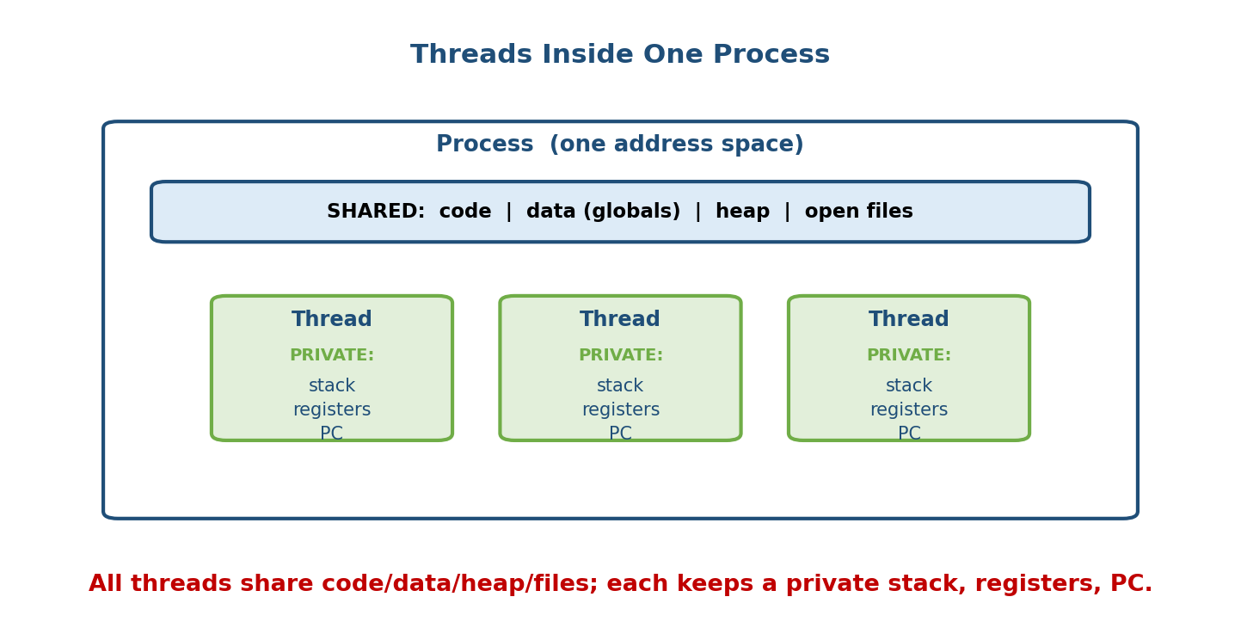
Thread vs process memory: a process holds one code/data/heap/files region shared by all its threads; each thread keeps a private stack, registers, and program counter.
Resource | Shared across threads? | Why
Code / text | Shared | all threads run the same program
Global / static data | Shared | one copy of globals (source of races!)
Heap (malloc) | Shared | one heap per process
Open files / sockets | Shared | shared file-descriptor table
Program counter (PC) | Private | each thread is at a different instruction
CPU registers | Private | each thread has its own working state
Stack | Private | each has its own call frames / locals
Thread ID | Private | each thread is individually identifiable
The core trade-off in one line: processes are isolated (safe, but talking needs IPC and switching is expensive); threads share memory (fast, easy to share data — but you must synchronize, or globals corrupt).

Cost comparison
 | Process | Thread
Creation | expensive (new address space, PCB) | cheap (shares address space)
Context switch | expensive (change page tables, flush TLB) | cheap (same address space)
Communication | via IPC (pipes, shm) | via shared memory directly
Isolation / safety | strong (one crash ≠ others) | weak (a bad thread can crash all)

MCQs
- What do threads keep private? → stack, registers, PC (and thread ID).
- What do threads share? → code, globals, heap, open files.
- Why is a thread switch cheaper than a process switch? → same address space (no page-table change / TLB flush).
- Why do threads need synchronization but separate processes need it less? → threads share global memory (races).

5.3 Benefits of Threads (the “why”)
Textbooks (Silberschatz) list four classic benefits — memorize them:
- Responsiveness — one thread can keep the UI responsive while another does slow work (a download, a computation). The app doesn’t “freeze.”
- Resource sharing — threads share memory and files by default, so they exchange data without the setup cost of IPC (unlike separate processes).
- Economy — creating and context-switching threads is far cheaper than processes (no new address space). “Threads are lightweight.”
- Scalability (parallelism) — on a multicore CPU, different threads run on different cores at the same time, so a multithreaded program actually gets faster with more cores (a single-threaded one cannot).
Memory hook: “R-R-E-S” — Responsiveness, Resource sharing, Economy, Scalability.

MCQs
- Four benefits of threads? → responsiveness, resource sharing, economy, scalability.
- Which benefit needs multiple cores? → scalability / parallelism.
- Why “economy”? → cheaper creation and context switch than processes.

5.4 Concurrency vs Parallelism (the interview classic)
These two words are not synonyms, and mixing them up is a classic interview stumble.
- Concurrency = dealing with many tasks by interleaving them so they all make progress. Possible on a single core (the CPU rapidly switches between threads). It’s about structure — tasks in progress at the same time.
- Parallelism = doing many tasks literally at the same instant, which requires multiple cores/CPUs. It’s about execution — tasks running at the same time.
CONCURRENCY (1 core, interleaved): PARALLELISM (2 cores, simultaneous):
core: A B A B A B A B core0: A A A A
(switching quickly) core1: B B B B
"in progress together" "running together"
Rob Pike’s line: “Concurrency is about dealing with lots of things at once; parallelism is about doing lots of things at once.” Concurrency is a design; parallelism is a runtime capability. You can have concurrency without parallelism (one core, time-sliced), and parallelism is achieved by running concurrent tasks on multiple cores.

MCQs
- Concurrency vs parallelism? → interleaving (progress together, 1 core ok) vs simultaneous execution (needs multiple cores).
- Can you have concurrency on a single core? → yes (time-slicing).
- What does true parallelism require? → multiple cores/CPUs.

5.5 User-Level vs Kernel-Level Threads
Threads can be managed in two places: entirely in a user-space library (kernel unaware), or by the kernel itself. This distinction drives everything about the multithreading models.

User-level threads (ULT)
Managed by a thread library in user space; the kernel sees only one process and knows nothing about the threads.
- Pros: very fast create/switch/schedule (no kernel/mode switch — it’s just a function call in the library); portable (works even if the OS has no thread support).
- Cons: if one thread makes a blocking system call, the whole process blocks (the kernel blocks the one entity it sees). Cannot use multiple cores in parallel (the kernel schedules the single process on one core).

Kernel-level threads (KLT)
Managed directly by the OS kernel; the kernel schedules each thread and knows about all of them.
- Pros: if one thread blocks, others keep running; threads can run on different cores in parallel (true multicore use).
- Cons: more overhead — creating/switching a thread requires a system call (mode switch) into the kernel, so it’s heavier than a ULT operation.
 | User-level (ULT) | Kernel-level (KLT)
Managed by | user-space library | the OS kernel
Kernel aware? | no (sees 1 process) | yes (schedules each thread)
Switch speed | very fast (no mode switch) | slower (system call)
One thread blocks → | whole process blocks | only that thread blocks
True parallelism (multicore)? | no | yes
Memory hook: ULT = fast but blind (kernel can’t help it — one blocking call sinks the ship). KLT = smart but heavier (kernel manages each thread, so it can keep others running and spread them across cores). Modern OSes (Linux, Windows) use kernel threads so a blocking call and multicore both work.

MCQs
- In ULTs, what happens when one thread makes a blocking syscall? → the whole process blocks.
- Which thread type can run truly in parallel on multiple cores? → kernel-level.
- Which is faster to switch, and why? → user-level (no kernel mode switch).
- Which does Linux/Windows use? → kernel-level threads.

5.6 Multithreading Models
Because there are user threads and kernel threads, we must decide how many user threads map onto how many kernel threads. Three models — a very common GATE/interview figure.
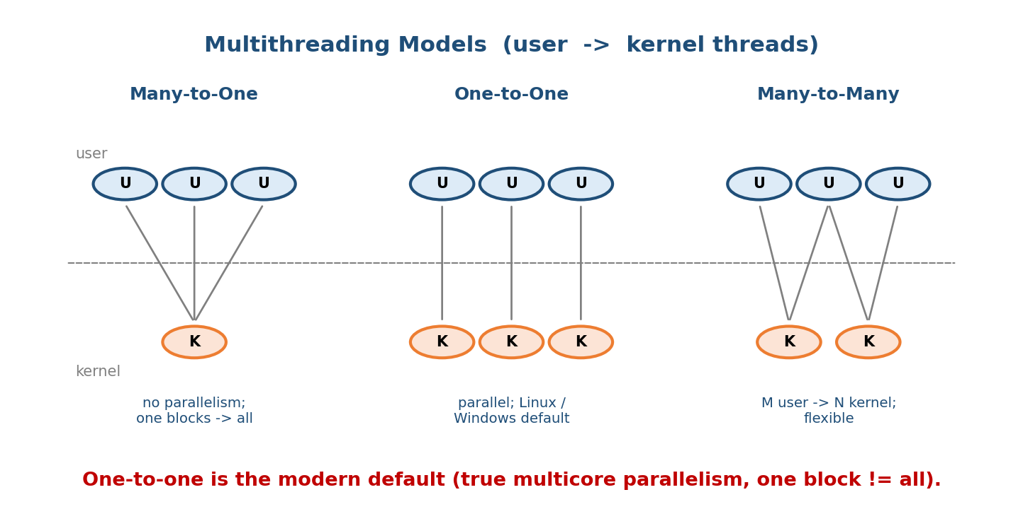
Multithreading models: many-to-one maps many user threads to one kernel thread; one-to-one maps each user thread to its own kernel thread; many-to-many multiplexes M user threads onto N kernel threads.

Many-to-One
Many user threads → one kernel thread.
- Thread management is in user space (fast), but one blocking call blocks all, and no multicore parallelism (only one kernel thread runs at a time).
- Example: old “green threads” (early Java, GNU Portable Threads).

One-to-One
Each user thread → its own kernel thread.
- True parallelism and one thread blocking doesn’t block others.
- Cost: each user thread needs a kernel thread, so creating many is expensive; OSes cap the number.
- Example: Linux (via clone/NPTL) and Windows — the dominant model today.

Many-to-Many
M user threads multiplexed onto N kernel threads (N ≤ M).
- Best of both: create many user threads, while the kernel runs several in parallel; if one blocks, another can be scheduled.
- More complex to implement. A variant is the two-level model (many-to-many plus the option to bind a user thread to a kernel thread).
- Example: Solaris (older), Windows fibers, Go’s goroutine scheduler is a spiritual M:N design.
Model | Parallel? | One blocks → all block? | Note
Many-to-one | no | yes | simple, obsolete (green threads)
One-to-one | yes | no | Linux/Windows, may limit count
Many-to-many | yes | no | flexible, complex (M user → N kernel)
Memory hook: count the arrows — many→one (all in one boat, no parallelism), one→one (everyone gets a car, but cars are pricey), many→many (a carpool — many riders, a few shared cars, flexible).

MCQs
- Model used by Linux and Windows? → one-to-one.
- Which model has no multicore parallelism? → many-to-one.
- In many-to-one, one blocking call causes? → all threads block.
- Which model multiplexes M user threads onto N kernel threads? → many-to-many.

5.7 TCB vs PCB
Just as each process has a PCB (Module 4), each thread has a Thread Control Block (TCB) — the kernel’s record of one thread’s state.
 | PCB (per process) | TCB (per thread)
Holds | PID, memory (page tables), open files, accounting, + shared state | thread ID, PC, registers, stack pointer, thread state, priority
Owns memory? | yes — the whole address space | no — shares the process’s memory
How many | one per process | one per thread (a process has ≥1)
Key idea: the TCB stores only what is private to a thread (PC, registers, stack). Everything shared — the address space, page tables, open files — stays in the PCB. That’s why a thread switch is cheap: you swap a small TCB, not the whole memory map.

MCQs
- Per-thread kernel structure? → TCB (Thread Control Block).
- Does a TCB own the address space? → no (the PCB does; threads share it).
- What does the TCB store? → thread ID, PC, registers, stack pointer, state.

5.8 Thread Lifecycle
A thread moves through states much like a process:
NEW ──start──▶ RUNNABLE ──scheduled──▶ RUNNING ──finish──▶ TERMINATED
▲ ▲ │ │
│ └───unblock──────────┘ │
│ (I/O/lock ready) ▼
└──────────────────────── BLOCKED / WAITING
(wait on I/O, lock, join, sleep)
- New — created but not yet started.
- Runnable / Ready — eligible to run, waiting for a CPU.
- Running — executing on a core.
- Blocked / Waiting — waiting on I/O, a lock/mutex, join, or sleep.
- Terminated — finished (or cancelled); its result may be collected via join.
(These map cleanly onto the process states of Module 4 — threads are scheduled by the same machinery.)

MCQs
- A thread waiting for a mutex is in which state? → blocked / waiting.
- A thread eligible to run but not on a CPU yet? → runnable / ready.

5.9 POSIX Threads (pthreads)
Pthreads is the POSIX standard API for threads on UNIX/Linux (it is a specification; Linux implements it as one-to-one kernel threads via NPTL). The two calls you must know are create and join.
#include <stdio.h>
#include <pthread.h>
void *worker(void *arg) { // the function each thread runs
long id = (long)arg;
printf("Hello from thread %ld\n", id);
return (void *)(id * id); // return a value to whoever joins us
}
int main(void) {
pthread_t t[3];
for (long i = 0; i < 3; i++)
pthread_create(&t[i], NULL, worker, (void *)i); // spawn 3 threads
for (int i = 0; i < 3; i++) {
void *ret;
pthread_join(t[i], &ret); // wait for each thread, collect its result
printf("thread %d returned %ld\n", i, (long)ret);
}
return 0; // (compile with: gcc file.c -pthread)
}
- pthread_create(&tid, attr, start_routine, arg) — creates a new thread that runs start_routine(arg); the thread ID is written to tid. attr = NULL for defaults.
- pthread_join(tid, &retval) — blocks until thread tid finishes and collects its return value (the thread analogue of wait() for processes). Joining also frees the thread’s resources — the equivalent of “reaping.”
- Others: pthread_exit() (terminate the calling thread), pthread_detach() (auto-reclaim on exit, no join needed), pthread_mutex_* (locks — Module 7).
Memory hook: create = fork for threads; join = wait for threads. But unlike fork (which copies memory), a new thread shares the process’s memory — the whole point.

MCQs
- Pthread call to create a thread? → pthread_create.
- Pthread analogue of wait()? → pthread_join.
- Flag to compile a pthreads program with gcc? → -pthread.
- How to avoid needing join for cleanup? → pthread_detach.

5.10 Thread Pools
Creating a new thread per task is cheap-ish but not free, and unbounded thread creation can exhaust memory and thrash the scheduler. A thread pool solves this: create a fixed set of worker threads up front, and feed them tasks from a queue; when a worker finishes a task it grabs the next one.
incoming tasks ─▶ [ task queue ]
│ │ │
┌────┘ │ └────┐
worker1 worker2 worker3 ← fixed pool, reused for every task
Why a thread pool:
- Faster — no create/destroy cost per task; threads are reused.
- Bounded resource use — a hard cap on live threads prevents overload (a server under a request flood won’t spawn a million threads and die).
- Decouples task submission from execution (a clean producer/consumer design).
Memory hook: a thread pool is a taxi rank — a fixed fleet of drivers (threads) waiting; a rider (task) takes the next free taxi and returns it after the trip. No hiring/firing a driver per ride.
Backend reality: every web/app server uses a pool — Java’s ExecutorService/ThreadPoolExecutor, Tomcat’s request threads, nginx/Postgres worker pools. Pool size ≈ number of cores for CPU-bound work; larger for I/O-bound work (threads spend time blocked, so more can overlap).

MCQs
- Why use a thread pool? → reuse threads (no per-task create cost) and bound the thread count.
- Good pool size for CPU-bound work? → roughly the number of cores.
- What structure feeds a pool? → a task queue (producer/consumer).

5.11 Thread Scheduling (brief)
- The OS scheduler (Module 6) schedules kernel threads — on a one-to-one system, that means it schedules each of your threads directly onto cores.
- Contention scope: PCS (process-contention scope) — user threads compete within a process for a kernel thread (many-to-many/many-to-one); SCS (system-contention scope) — kernel threads compete system-wide for a CPU (one-to-one, as on Linux/Windows).
- Threads have priorities; higher-priority runnable threads are dispatched first (details and algorithms are Module 6).

MCQs
- What does the OS actually schedule on Linux? → kernel threads (one-to-one).
- PCS vs SCS? → contention within a process vs system-wide for a CPU.

5.12 Synchronization — a Teaser to Module 7
The very thing that makes threads powerful — shared memory — is also their danger. If two threads update the same global without coordination, the result depends on timing: a race condition.
Two threads each run: counter = counter + 1 (counter starts at 0)
Thread A: read 0 ......................... write 1
Thread B: ......... read 0 ... write 1
Result: counter = 1 (a lost update — should be 2!)
The fix is synchronization: make the update atomic with a mutex/lock or semaphore, so only one thread touches the shared data at a time (the critical section).
Memory hook: shared memory is a shared whiteboard; without a “one writer at a time” rule (a lock), two threads scribble over each other and you lose updates. This is the entire subject of Module 7 (Process Synchronization) — critical sections, mutexes, semaphores, and deadlock.

MCQs
- Two threads updating a shared variable unsafely cause a? → race condition.
- The region of code touching shared data? → the critical section.
- Basic tool to protect it? → a mutex / lock (or semaphore).

5.13 Real-World & Backend Perspectives
- Servers are thread stories. Tomcat/Jetty serve each request on a pooled thread; a slow downstream call blocking a pool thread is why thread-pool exhaustion is a top production incident.
- The GIL caveat. CPython’s Global Interpreter Lock means Python threads give concurrency but not CPU parallelism — use processes (or async) for CPU-bound work. A perfect illustration of §5.4.
- Async vs threads. Node.js/nginx use a single-threaded event loop for I/O concurrency (avoiding per-request thread cost and locks) — a different point on the same concurrency spectrum.
- Goroutines / green threads return. Go multiplexes millions of goroutines onto a few OS threads (an M:N design), reviving user-level threading with a smart runtime scheduler.

5.14 Tradeoffs, Common Mistakes, Edge Cases
- Mistake: “concurrency = parallelism.” No — concurrency is interleaving (single core ok); parallelism needs multiple cores.
- Mistake: thinking threads are always faster. Shared state needs locks, and locking can serialize threads (and cause deadlock, M7). For CPU-bound Python, threads don’t help (GIL).
- Mistake: forgetting to join/detach threads → resource leaks (the thread analogue of a zombie).
- Edge case (isolation): one thread’s segfault crashes the whole process (shared address space) — unlike separate processes. Safety vs speed trade-off.
- Edge case (ULT): in a pure user-level (many-to-one) system, a single blocking syscall freezes every thread — the reason one-to-one won.
- Tradeoff: threads (fast, shared memory, need sync, weak isolation) vs processes (isolated, safe, expensive, IPC to talk).

5.15 Exam, Interview & Coding Perspectives
- SEBI / RBI / NABARD: thread-vs-process (shared vs private), benefits (RRES), user-vs-kernel threads, and the three models are common MCQs.
- GATE: the multithreading-models figure, ULT-vs-KLT properties (the blocking and parallelism points), and PCS-vs-SCS appear regularly.
- Interview (backend/systems): “Thread vs process?” (address-space sharing), “Concurrency vs parallelism?”, “Why a thread pool?”, “What’s a race condition and how do you prevent it?” (mutex → M7), “Why doesn’t Python thread well for CPU work?” (GIL).
- Coding: write a pthread_create/pthread_join snippet; reason about a race on a shared counter and fix it with a mutex.

5.16 Concept Checks & MCQs (test yourself)
- Thread vs process in one line? → thread = flow of execution sharing a process’s memory; process = isolated address space.
- What do threads share / keep private? → share code/globals/heap/files; private stack/registers/PC.
- Four benefits of threads? → responsiveness, resource sharing, economy, scalability (RRES).
- Concurrency vs parallelism? → interleaving (1 core ok) vs simultaneous (needs multiple cores).
- ULT: one blocking call → ? → whole process blocks.
- Which thread type gives true multicore parallelism? → kernel-level.
- Model used by Linux/Windows? → one-to-one.
- Model with no parallelism? → many-to-one.
- Per-thread control block? → TCB (shares PCB’s memory).
- Pthread create / join calls? → pthread_create / pthread_join.
- Why use a thread pool? → reuse threads, bound the count.
- Why is a thread switch cheaper than a process switch? → same address space.
- Two threads clobbering a shared variable → ? → race condition (fix: mutex).
- Does a TCB own memory? → no (the PCB does).
- Good thread-pool size for CPU-bound work? → ≈ number of cores.
True/False - Threads of a process share the heap. → True. - Each thread has its own stack. → True. - Concurrency requires multiple cores. → False (parallelism does). - In many-to-one, threads run in parallel on many cores. → False. - A crashing thread can take down the whole process. → True (shared address space). - pthread_join is the thread analogue of wait(). → True.

5.17 One-Page Revision Sheet
THREAD = flow of execution INSIDE a process. own PC/REGISTERS/STACK ; SHARES code/data(globals)/
heap/open-files with sibling threads. classic process = 1 thread.
SHARED vs PRIVATE: shared = CODE, GLOBALS/STATIC, HEAP, FILES. private = STACK, REGISTERS, PC, TID.
=> threads cheap to create/switch (same address space) BUT need SYNCHRONIZATION (shared globals).
BENEFITS (RRES): Responsiveness, Resource sharing, Economy(cheap), Scalability(multicore parallel).
CONCURRENCY vs PARALLELISM:
concurrency = DEALING WITH many (interleave; 1 core OK) ; parallelism = DOING many (needs >1 core).
concurrency = design ; parallelism = runtime. concurrency-without-parallelism = time-slice on 1 core.
USER-LEVEL (ULT): lib in user space, kernel sees 1 process. FAST switch, portable.
BUT 1 blocking syscall blocks ALL ; NO multicore parallelism.
KERNEL-LEVEL (KLT): kernel schedules each thread. others run if one blocks ; TRUE parallelism.
BUT heavier (syscall/mode switch to create/switch). Linux/Windows use KLT.
MODELS:
many-to-one many ULT -> 1 KLT : no parallel, one blocks->all (green threads)
one-to-one each ULT -> own KLT : parallel, one blocks!=all ; LINUX/WINDOWS ; may cap count
many-to-many M ULT -> N KLT (N<=M) : flexible, parallel (Solaris old; Go-like)
TCB vs PCB: PCB=per process (owns address space, page tables, files). TCB=per thread (PC, regs,
stack ptr, state) — does NOT own memory. thread switch = swap small TCB => cheap.
LIFECYCLE: new -> runnable -> running -> (blocked on I/O/lock/join) -> ... -> terminated.
PTHREADS (POSIX; Linux = one-to-one/NPTL):
pthread_create(&tid, attr, fn, arg) // = fork for threads (but SHARES memory)
pthread_join(tid, &ret) // = wait for threads (blocks, collects result, reaps)
pthread_exit / pthread_detach / pthread_mutex_* // compile: gcc x.c -pthread
THREAD POOL: fixed worker set + task queue. reuse (no per-task create), BOUND count (no overload).
size ~= #cores for CPU-bound ; larger for I/O-bound.
SYNC TEASER (M7): shared global + no lock => RACE CONDITION (lost update). protect CRITICAL SECTION
with MUTEX/semaphore. deadlock etc = Module 7.
CAVEATS: Python GIL => threads = concurrency not CPU parallelism (use processes). one thread crash
kills whole process (shared address space).

Flash cards
Front | Back
Thread shares what? | Code, globals, heap, files
Thread keeps private? | Stack, registers, PC (+ TID)
Four thread benefits? | Responsiveness, resource sharing, economy, scalability
Concurrency vs parallelism? | Interleave (1 core ok) vs simultaneous (needs cores)
ULT: one thread blocks → ? | Whole process blocks
Model of Linux/Windows? | One-to-one
Model with no parallelism? | Many-to-one
Per-thread control block? | TCB (shares PCB’s memory)
Create / join a pthread? | pthread_create / pthread_join
Why a thread pool? | Reuse threads + bound the count
Unsafe shared update? | Race condition (fix: mutex)
Why thread switch is cheap? | Same address space (no TLB flush)

Spaced repetition
- 24-hour: recite shared-vs-private and the three models; state concurrency vs parallelism in one sentence each.
- 7-day: explain ULT-vs-KLT with the blocking and multicore points; write a pthread_create/join snippet from memory.
- 30-day: draw the thread-vs-process memory picture and the multithreading models; explain a race condition and its fix (bridge to M7).

5.18 Summary
A thread is a lightweight flow of execution inside a process: it keeps its own PC, registers, and stack but shares the process’s code, globals, heap, and files with sibling threads. That sharing gives the four benefits — responsiveness, resource sharing, economy, and scalability (RRES) — and makes creation and context switching far cheaper than for processes (swap a small TCB, not the whole address space held in the PCB). We separated concurrency (interleaving, possible on one core) from parallelism (simultaneous, needs multiple cores), and user-level threads (fast but a blocking call freezes all, no multicore) from kernel-level threads (heavier but truly parallel — what Linux/Windows use). The multithreading models map user to kernel threads — many-to-one (no parallelism), one-to-one (the modern default), and many-to-many (flexible M:N). We wrote pthreads (create/join), saw why thread pools reuse and bound threads, and previewed the price of shared memory: race conditions, fixed by synchronization.
Next, Module 6 — CPU Scheduling decides which ready thread runs next and for how long (FCFS, SJF, Round Robin, priority — with Gantt charts and waiting-time numericals), and Module 7 — Process Synchronization tackles the race conditions this module warned about (critical sections, mutexes, semaphores, deadlock).
You have mastered this module when you can: list exactly what threads share vs keep private and why that makes them cheap; state the four benefits (RRES); distinguish concurrency from parallelism and ULT from KLT (blocking + multicore); draw the three multithreading models; write a pthread_create/pthread_join snippet; explain why thread pools exist; and describe a race condition and its fix — all without notes.

