Module 6 — CPU Scheduling
  - OS Mastery: SEBI IT / RBI / NABARD / GATE / C-DAC / Interview / Backend — In-Depth Notes (with visuals)
Prepared for nidhi.sharma@forensiccybertech.com
2026
Table of Contents

Module 6 — CPU Scheduling
Where this module sits. Modules 1–5 built the machinery — the OS, the hardware, processes and threads, and how they are created. Now comes the question that decides how fast and how fair a system feels: when several processes are ready, which one gets the CPU next, and for how long? That decision is CPU scheduling. This is the single most numerically loaded module of the whole course — GATE, SEBI IT, RBI IT and C-DAC ask you to draw a Gantt chart and compute average waiting and turnaround times almost every year. We build every algorithm from first principles, work a full example for each, and finish with real-time scheduling (EDF, Rate-Monotonic) — the part that separates a good score from a great one.
Importance ratings (out of 5):
Exam / Use | SEBI IT | RBI IT | GATE CS | Interview | Backend
This module | ★★★★ | ★★★★ | ★★★★★ | ★★★ | ★★★
Most-asked PYQ concepts (SEBI / RBI / GATE / C-DAC): Gantt chart + average waiting / turnaround for FCFS, SJF, SRTF, Priority, Round Robin; turnaround = completion − arrival and waiting = turnaround − burst; convoy effect; SJF is optimal for average waiting time; SRTF is preemptive SJF; Round Robin time-quantum effect (too small → context-switch overhead, too large → FCFS); starvation & aging in priority scheduling; preemptive vs non-preemptive; MLFQ rules; Rate-Monotonic utilisation bound U ≤ n(2^(1/n) − 1) and EDF.

6.1 The Scheduling Problem — First Principles

The CPU–I/O burst cycle
A process does not use the CPU continuously. Its life is a repeating cycle: a burst of computation (CPU burst), then a wait for input/output (I/O burst), then compute again, and so on until it exits.
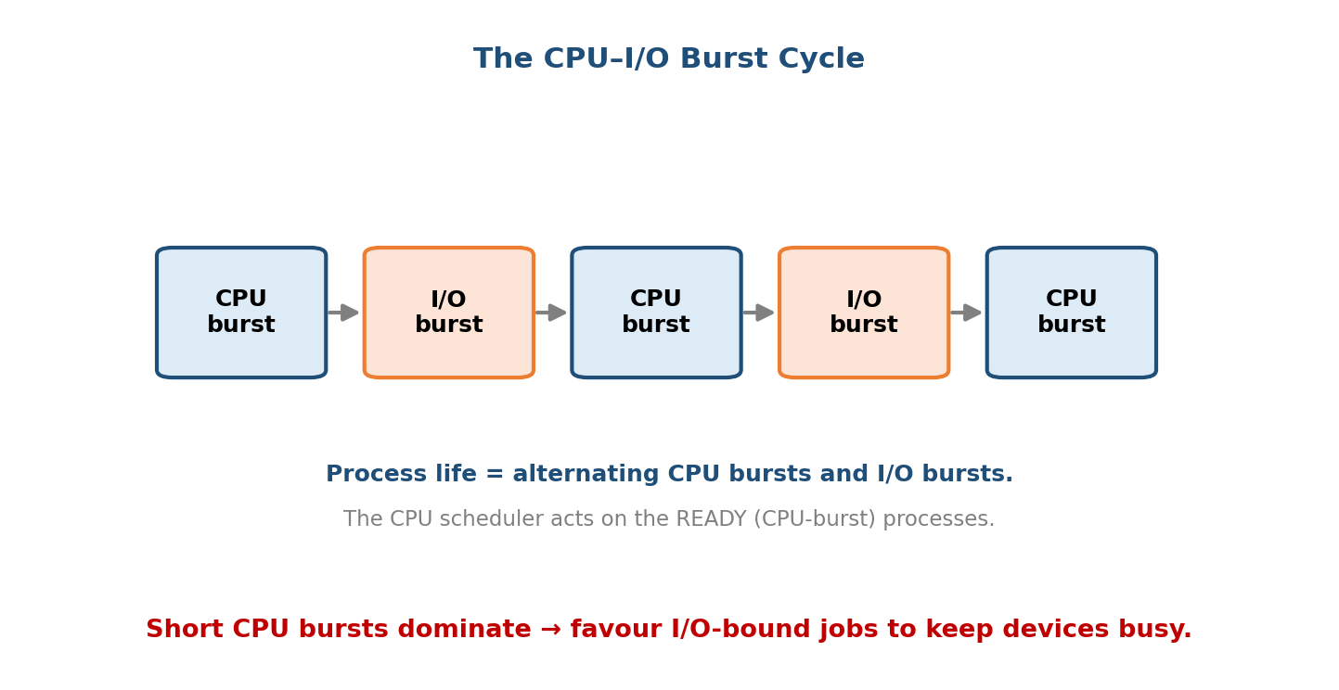
Short CPU bursts dominate; favouring I/O-bound jobs keeps the devices busy while the CPU runs someone else.
Real workloads have many short CPU bursts and a few long ones (an exponential-ish distribution). This one fact drives the whole module: if we could run the shortest bursts first, most processes finish quickly and the average wait plummets — which is exactly what SJF does (§6.5).
- CPU-bound process: long CPU bursts, few I/O waits (e.g. matrix multiply).
- I/O-bound process: short CPU bursts, frequent I/O waits (e.g. a text editor).
Memory hook: the scheduler is a traffic cop at a single-lane bridge (the CPU). Many cars (processes) wait; the cop decides the order and how long each may cross. Every algorithm below is just a different rule the cop uses.

The CPU scheduler and the dispatcher
- CPU (short-term) scheduler — chooses which ready process runs next. It runs extremely often (milliseconds), so it must be fast.
- Dispatcher — the module that actually hands the CPU over: it performs the context switch, switches to user mode, and jumps to the right instruction in the chosen program.
- Dispatch latency — the time the dispatcher takes to stop one process and start the next. This is pure overhead — no useful work happens during it.
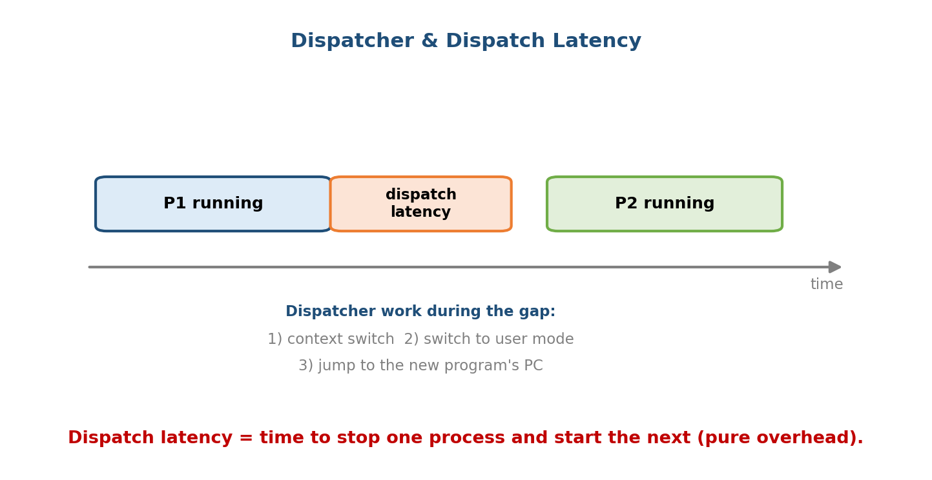
Dispatch latency is the unavoidable overhead of every context switch — keep it small and switch only when it pays off.
Exam line: the scheduler decides, the dispatcher does. Dispatch latency is the cost of the dispatcher’s work (context switch + mode switch + jump).

When does scheduling happen? (the four points)
The short-term scheduler is invoked when a process:
- switches from running → waiting (e.g. issues I/O, wait()),
- switches from running → ready (a timer interrupt / preemption),
- switches from waiting → ready (I/O completes),
- terminates.
Preemptive vs non-preemptive — the pivotal definition: - If scheduling happens only at points 1 and 4 (a process keeps the CPU until it blocks or exits), the scheme is non-preemptive (cooperative). - If it can also happen at points 2 and 3 (the OS can forcibly take the CPU away from a running process), the scheme is preemptive.
Preemption gives responsiveness but needs care: if the OS grabs the CPU while a process is mid-update to shared kernel data, you get race conditions (Module 7).

MCQs
- What component performs the context switch? → the dispatcher.
- Dispatch latency is? → the overhead to stop one process and start another.
- Non-preemptive scheduling switches only when a process ___ → blocks or exits.

6.2 Scheduling Criteria & Metrics (memorise the formulas)
We judge a scheduling algorithm by five metrics. The first two we want high, the last three we want low.
Metric | Meaning | Want
CPU utilisation | fraction of time the CPU is busy | high
Throughput | processes completed per unit time | high
Turnaround time | total time from arrival to completion | low
Waiting time | time spent waiting in the ready queue | low
Response time | arrival → first time it gets the CPU | low
The three formulas you will use in every numerical:
Turnaround time (TAT) = Completion time − Arrival time
Waiting time (WT) = Turnaround time − CPU Burst time
= (Completion − Arrival) − Burst
Response time (RT) = First-CPU time − Arrival time
Memory hook: TAT is the whole journey (door to door); WT is TAT minus the time actually spent working; RT is only how long until you’re first served. For a non-preemptive run of a single burst, RT = WT. When a process is preempted and resumes later, RT (first touch) can be much smaller than WT (total idle).
Why response time ≠ waiting time. In Round Robin a process may get the CPU quickly (low response time — good for interactivity) yet be preempted repeatedly and therefore accumulate a large total waiting time. Interactive systems optimise response time; batch systems optimise turnaround/waiting.
Little’s Law (backend bonus): in steady state, N = λ × W — average number of jobs in the system = arrival rate × average time in system. It links throughput (λ) to turnaround (W) and is the queueing-theory backbone of capacity planning.

MCQs
- Turnaround time formula? → completion − arrival.
- Waiting time formula? → turnaround − burst (= completion − arrival − burst).
- Response time measures time until? → the first CPU allocation.
- Metric interactive systems care about most? → response time.

6.3 How to Solve Any Scheduling Numerical (the recipe)
Every worked example below follows the same five steps. Learn the recipe once.
1. Draw the GANTT CHART: lay out who runs in each time interval (respect arrivals).
2. Read off COMPLETION time for each process (when its last slice ends).
3. TAT = Completion − Arrival (per process)
4. WT = TAT − Burst (per process)
5. AVERAGE the WT and TAT columns (sum ÷ number of processes).
Tie-break conventions (state them, exams expect these): when two processes are equal on the primary key, break ties by (a) earlier arrival, then (b) lower process id. For Round Robin, a newly arriving process is placed in the ready queue before a process that was just preempted at the same instant (a common convention — always state the rule you use).

6.4 FCFS — First-Come, First-Served
Rule: run processes in order of arrival. Non-preemptive. Implemented with a simple FIFO queue. Fair in the “first in line” sense, but blind to burst length.
Given: all arrive at t = 0 in the order P1, P2, P3.
Process | Arrival | Burst
P1 | 0 | 24
P2 | 0 | 3
P3 | 0 | 3
Gantt chart:
| P1 | P2 | P3 |
0 24 27 30
Process | Completion | TAT = C−A | WT = TAT−B
P1 | 24 | 24 | 0
P2 | 27 | 27 | 24
P3 | 30 | 30 | 27
Average WT = (0 + 24 + 27) / 3 = 51/3 = 17.0
Average TAT = (24 + 27 + 30) / 3 = 81/3 = 27.0

The convoy effect (why FCFS hurts)
Now reverse the order — P2, P3, P1 (short jobs first):
|P2|P3| P1 |
0 3 6 30
WT: P2=0, P3=3, P1=6 → Average WT = (0+3+6)/3 = 3.0
Same jobs, average wait fell from 17 to 3 — just by ordering. Under FCFS, one long CPU-bound job at the front makes all the short jobs behind it wait; the short jobs “convoy” behind the elephant. This is the convoy effect, and it is the motivation for SJF.
Memory hook: FCFS = supermarket queue behind the trolley piled high — you only have two items but you still wait. Fair by arrival, terrible for average wait.

MCQs
- FCFS is preemptive or non-preemptive? → non-preemptive.
- The problem when a long job arrives first? → convoy effect.
- Data structure behind FCFS? → FIFO queue.

6.5 SJF — Shortest Job First (non-preemptive)
Rule: when the CPU is free, pick the ready process with the shortest next CPU burst. Non-preemptive: once chosen, a process runs to the end of its burst.
SJF is provably optimal: it gives the minimum possible average waiting time for a given set of processes. Moving a shorter job ahead of a longer one always reduces total waiting. (Optimal, but only if you know the burst lengths.)
Given:
Process | Arrival | Burst
P1 | 0 | 7
P2 | 2 | 4
P3 | 4 | 1
P4 | 5 | 4
Reasoning: at t=0 only P1 is present → run P1 to completion (t=7). At t=7 the ready set is {P2(4), P3(1), P4(4)} → shortest is P3. Then {P2(4), P4(4)} tie → earlier arrival P2, then P4.
Gantt chart:
| P1 |P3| P2 | P4 |
0 7 8 12 16
Process | Arrival | Burst | Completion | TAT | WT
P1 | 0 | 7 | 7 | 7 | 0
P2 | 2 | 4 | 12 | 10 | 6
P3 | 4 | 1 | 8 | 4 | 3
P4 | 5 | 4 | 16 | 11 | 7
Average WT = (0 + 6 + 3 + 7) / 4 = 16/4 = 4.0
Average TAT = (7 + 10 + 4 + 11) / 4 = 32/4 = 8.0

The catch: predicting the next burst
You can’t know a process’s next burst in advance. SJF estimates it from history using an exponential moving average (exponential averaging):
τ(n+1) = α · t(n) + (1 − α) · τ(n)
τ = predicted next burst, t = actual last burst, 0 ≤ α ≤ 1
α = 0 → history only (ignore recent); α = 1 → last burst only.
Memory hook: SJF is the express checkout (“10 items or fewer”) — serve the quick ones first and the average wait for everybody drops. The snag: you must guess how full each basket is (burst prediction).

MCQs
- SJF is optimal for? → minimum average waiting time.
- The practical obstacle to SJF? → you must predict the next CPU burst.
- Formula to predict the next burst? → exponential averaging.

6.6 SRTF — Shortest Remaining Time First (preemptive SJF)
Rule: the preemptive version of SJF. At every arrival, compare the new process’s burst against the remaining time of the running one; if the newcomer is shorter, preempt. Also called SRTN.
We reuse the exact same table as SJF so you can see preemption pay off.
Given: P1(arr0, b7), P2(arr2, b4), P3(arr4, b1), P4(arr5, b4).
Step-by-step:
t=0 : only P1 → run P1. (P1 rem: 7)
t=2 : P2 arrives (4). P1 rem = 5. 4 < 5 → PREEMPT, run P2.
t=4 : P3 arrives (1). P2 rem = 2. 1 < 2 → PREEMPT, run P3.
t=5 : P3 finishes. P4 arrives (4). Ready {P1:5, P2:2, P4:4} → run P2 (2).
t=7 : P2 finishes. Ready {P1:5, P4:4} → run P4 (4).
t=11: P4 finishes. Run P1 (rem 5).
t=16: P1 finishes.
Gantt chart:
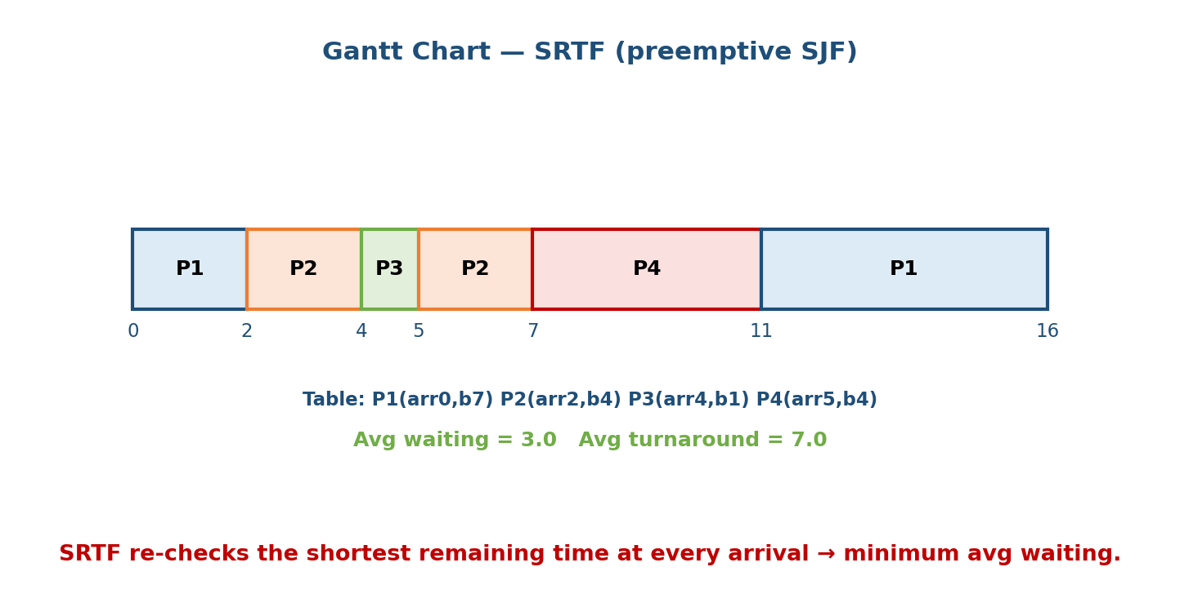
SRTF re-checks the shortest remaining time at every arrival, so short jobs slip ahead of long ones — giving the minimum average waiting time.
|P1|P2|P3|P2| P4 | P1 |
0 2 4 5 7 11 16
Process | Arrival | Burst | Completion | TAT | WT
P1 | 0 | 7 | 16 | 16 | 9
P2 | 2 | 4 | 7 | 5 | 1
P3 | 4 | 1 | 5 | 1 | 0
P4 | 5 | 4 | 11 | 6 | 2
Average WT = (9 + 1 + 0 + 2) / 4 = 12/4 = 3.0
Average TAT = (16 + 5 + 1 + 6) / 4 = 28/4 = 7.0
The payoff (same processes): SJF gave avg WT 4.0; SRTF gives 3.0. Preemption lets a freshly-arrived short job jump the queue immediately instead of waiting for the current burst to end. SRTF gives the theoretical minimum average waiting time of any algorithm — at the cost of more context switches and possible starvation of long jobs.

MCQs
- SRTF is the preemptive version of? → SJF.
- When is preemption checked in SRTF? → at every new arrival (compare remaining times).
- Which gives the lowest possible average waiting time? → SRTF.

6.7 Priority Scheduling
Rule: each process has a priority number; the CPU goes to the highest priority. Convention (and the usual exam convention): a lower number = higher priority. Can be non-preemptive (finish current burst) or preemptive (a higher-priority arrival preempts).
SJF is a special case of priority scheduling where priority = (predicted) next CPU burst.

Non-preemptive priority — worked example
Given: all arrive at t=0. Lower number = higher priority.
Process | Burst | Priority
P1 | 10 | 3
P2 | 1 | 1
P3 | 2 | 4
P4 | 1 | 5
P5 | 5 | 2
Order by priority (1→5): P2, P5, P1, P3, P4.
|P2| P5 | P1 |P3|P4|
0 1 6 16 18 19
Process | Burst | Completion | TAT | WT
P2 | 1 | 1 | 1 | 0
P5 | 5 | 6 | 6 | 1
P1 | 10 | 16 | 16 | 6
P3 | 2 | 18 | 18 | 16
P4 | 1 | 19 | 19 | 18
Average WT = (0 + 1 + 6 + 16 + 18) / 5 = 41/5 = 8.2
Average TAT = (1 + 6 + 16 + 18 + 19) / 5 = 60/5 = 12.0

Preemptive priority — worked example
Given: lower number = higher priority.
Process | Arrival | Burst | Priority
P1 | 0 | 4 | 2
P2 | 1 | 3 | 1
P3 | 2 | 1 | 3
t=0: P1 runs (only one).
t=1: P2 arrives, priority 1 > P1's 2 → PREEMPT, run P2.
t=2: P3 arrives, priority 3 (lower) → keep P2.
t=4: P2 done. Ready {P1 rem3 (pri2), P3 (pri3)} → run P1.
t=7: P1 done. Run P3.
t=8: P3 done.
|P1| P2 | P1 |P3|
0 1 4 7 8
Process | Arrival | Burst | Completion | TAT | WT
P1 | 0 | 4 | 7 | 7 | 3
P2 | 1 | 3 | 4 | 3 | 0
P3 | 2 | 1 | 8 | 6 | 5
Average WT = (3 + 0 + 5) / 3 = 8/3 ≈ 2.67
Average TAT = (7 + 3 + 6) / 3 = 16/3 ≈ 5.33

Starvation and aging
Problem — starvation (indefinite blocking): a steady stream of high-priority processes can mean a low-priority process never runs. (Legend: an IBM 7094 shut down in 1973 was found to still have a low-priority job submitted in 1967.)
Solution — aging: gradually raise the priority of a process the longer it waits. Eventually even the lowest-priority job’s priority climbs high enough to run.
Memory hook: starvation = the polite guest who never gets served; aging = the maître d’ who bumps up anyone who’s been waiting too long.

MCQs
- In the usual convention, lower number means? → higher priority.
- The danger of priority scheduling? → starvation of low-priority processes.
- The cure for starvation? → aging (raise priority with waiting time).
- SJF is a special case of priority scheduling with priority = ? → next CPU burst.

6.8 Round Robin (RR) — the time-sharing workhorse
Rule: FCFS with preemption and a fixed time quantum (time slice) q. Each process runs for at most q; if it isn’t finished, it is preempted and sent to the back of the ready queue. Preemptive, starvation-free, and the basis of interactive time-sharing.
Given: q = 4; all arrive at t = 0 in order P1, P2, P3.
Process | Arrival | Burst
P1 | 0 | 24
P2 | 0 | 3
P3 | 0 | 3
Gantt chart (P1 keeps getting re-queued because 24 > q):
| P1 |P2|P3| P1 | P1 | P1 | P1 | P1 |
0 4 7 10 14 18 22 26 30
Process | Burst | Completion | TAT | WT
P1 | 24 | 30 | 30 | 6
P2 | 3 | 7 | 7 | 4
P3 | 3 | 10 | 10 | 7
Average WT = (6 + 4 + 7) / 3 = 17/3 ≈ 5.67
Average TAT = (30 + 7 + 10) / 3 = 47/3 ≈ 15.67
Key property: with n processes and quantum q, no process waits more than (n−1) × q time units for its next turn. That bounded wait is why RR feels responsive.

The effect of the time quantum (the classic trap)
The quantum size trades responsiveness against overhead:
Quantum | Behaviour | Problem
too large (q ≥ largest burst) | RR degenerates into FCFS | loses responsiveness, convoy effect returns
too small (q → 0) | many tiny slices | context-switch overhead dominates (dispatch latency eaten every q)
“just right” | q a bit larger than a typical burst | most jobs finish in one slice; low overhead
Overhead, quantified. Suppose a context switch costs s time units. Each quantum of useful work q costs an extra s, so CPU efficiency = q / (q + s).
If s = 1 and q = 4 → efficiency = 4/5 = 80% (20% wasted on switching)
If s = 1 and q = 1 → efficiency = 1/2 = 50% (HALF the CPU lost to overhead!)
If s = 1 and q = 100→ efficiency = 100/101 ≈ 99% (but response time suffers → FCFS-like)
Rule of thumb (Silberschatz): a quantum of 10–100 ms with a context switch of ~10 µs keeps switching overhead under ~1%, and ~80% of CPU bursts should be shorter than the quantum. Typical Linux desktop slices are in this range.
Memory hook: RR quantum is a speed-dating timer. Too long and it’s just one long date (FCFS); too short and everyone spends all night swapping seats (context switches) instead of talking.

MCQs
- RR with a very large quantum behaves like? → FCFS.
- RR with a very small quantum suffers from? → context-switch overhead.
- Max wait for the next turn with n processes, quantum q? → (n−1)·q.
- Is RR starvation-free? → yes (every process gets a turn).

6.9 Multilevel Queue (MLQ) Scheduling
When processes fall into distinct, fixed classes, use several separate ready queues, each with its own scheduling algorithm, and a rule to pick between queues.
┌──────────────────────────────┐ highest priority
│ System processes (RR) │
├──────────────────────────────┤
│ Interactive processes (RR) │
├──────────────────────────────┤
│ Batch processes (FCFS) │ lowest priority
└──────────────────────────────┘
- Each queue has a fixed priority; typically a queue is served only if all higher-priority queues are empty (fixed-priority preemptive), or each queue gets a time slice of the CPU (e.g. 80% to foreground RR, 20% to background FCFS).
- A process is permanently assigned to one queue — it cannot move. This rigidity is the weakness (a batch job stuck low can starve), and it’s what MLFQ fixes.

MCQ
- Key limitation of a plain multilevel queue? → processes can’t move between queues (inflexible, can starve low queues).

6.10 Multilevel Feedback Queue (MLFQ)
The most practical, general-purpose scheduler (the ancestor of Windows/macOS schedulers). Like MLQ, but a process can move between queues based on its observed behaviour — so it learns whether a job is interactive or CPU-bound without being told.
The MLFQ rules:
Rule 1: If Priority(A) > Priority(B), A runs.
Rule 2: If Priority(A) = Priority(B), A and B run in ROUND ROBIN.
Rule 3: A new job enters at the TOP (highest) priority queue.
Rule 4: If a job uses its ENTIRE time slice, it DROPS one queue (CPU-bound → lower).
If it gives up the CPU early (I/O), it STAYS (interactive → high priority).
Rule 5: PRIORITY BOOST — periodically move ALL jobs to the top queue.
(prevents starvation + adapts if a CPU-bound job turns interactive)
- Top queues get a small quantum (fast response for interactive jobs), lower queues a larger quantum (efficient for long CPU-bound jobs).
- Why it works: interactive jobs (short bursts, frequent I/O) naturally stay high and stay responsive; CPU-bound jobs sink to the bottom where they run in long, efficient slices without hurting interactivity. It approximates SJF without ever knowing burst lengths, and Rule 5 prevents starvation and gaming (a job doing a tiny I/O just before its slice ends to stay high).
Memory hook: MLFQ is a video-game ranking system — you start at the top, get demoted if you hog the CPU (play too long), and a periodic season reset (boost) gives everyone another shot.

MCQ
- Difference between MLQ and MLFQ? → in MLFQ processes can move between queues (feedback); MLQ assignment is fixed.
- What prevents starvation in MLFQ? → periodic priority boost.

6.11 Lottery (Proportional-Share) Scheduling
A randomised, proportional-share scheme. Each process holds some tickets; the scheduler holds a lottery each slice and the process with the winning ticket runs. Expected CPU share = your tickets ÷ total tickets.
P1 holds 75 tickets, P2 holds 25 tickets (total 100)
→ over time P1 gets ≈ 75% of the CPU, P2 ≈ 25%.
- Probabilistically fair and starvation-free — any process with ≥1 ticket will eventually win. Shares are proportional and easy to adjust (give a job more tickets to speed it up). Ticket transfer lets a client lend tickets to a server working on its behalf (fights priority inversion, Module 7).
- Caveat: fairness is only guaranteed over the long run; short runs can be unlucky. Stride scheduling is a deterministic variant that removes the randomness.

MCQ
- In lottery scheduling, a process’s CPU share is proportional to its ___ → tickets.

6.12 Real-Time Scheduling — EDF and Rate-Monotonic
Real-time systems (Module 1’s RTOS) must meet deadlines, not just minimise averages. We model each task by its period p (how often it recurs), execution time c (worst-case CPU burst), and a deadline (usually = p). The CPU utilisation of a task is c/p, and the whole task set’s utilisation is U = Σ (c_i / p_i).

Rate-Monotonic Scheduling (RMS)
Rule: static priorities assigned by rate — a shorter period = higher priority (runs more often). Preemptive. RMS is the optimal static-priority algorithm.
Schedulability test (sufficient, not necessary): a set of n periodic tasks is guaranteed schedulable by RMS if
U = Σ (c_i / p_i) ≤ n · (2^(1/n) − 1)
The bound shrinks as n grows:
n = 1 : 1.000 n = 3 : 0.780
n = 2 : 0.828 n → ∞ : ln 2 ≈ 0.693
Reading the test: if U ≤ bound, RMS definitely works. If U > bound (but ≤ 1), RMS might still work — the test is only sufficient; you must draw the schedule to be sure.
Worked schedulability check (a set that PASSES):
T1: c=1, p=4 → U1 = 0.250
T2: c=2, p=6 → U2 = 0.333
T3: c=1, p=8 → U3 = 0.125
U = 0.250 + 0.333 + 0.125 = 0.708
Bound (n=3) = 0.780. 0.708 ≤ 0.780 → SCHEDULABLE by RMS. ✓
Worked case where RMS FAILS but EDF succeeds (the classic Silberschatz example):
T1: p=50, c=25 → U1 = 0.50
T2: p=80, c=35 → U2 = 0.4375
U = 0.9375 > bound(n=2)=0.828 → RMS not guaranteed.
Trace RMS (T1 has shorter period → higher priority):
0–25 T1 (1st) 50–75 T1 (2nd, PREEMPTS T2)
25–50 T2 runs 25 (rem 10) 75–85 T2 resumes → finishes at 85
T2's deadline was 80 → MISSED by 5. RMS fails.

Earliest-Deadline-First (EDF)
Rule: dynamic priorities — whichever ready task has the nearest absolute deadline runs next. Preemptive. EDF is the optimal dynamic-priority algorithm.
Schedulability test (necessary AND sufficient):
A set of periodic tasks is EDF-schedulable ⇔ U = Σ (c_i / p_i) ≤ 1
For the failing RMS set above, U = 0.9375 ≤ 1, so EDF schedules it:
0–25 T1 (deadline 50) At t=50, T2 (deadline 80) is nearer than
25–50 T2 (deadline 80) T1's new deadline (100) → T2 keeps running:
50–60 T2 finishes at 60 ✓ (deadline 80)
60–85 T1 (2nd) finishes at 85 ✓ (deadline 100)
EDF meets both deadlines exactly because it lets the tighter-deadline job go first — something static RMS priorities cannot do.
 | RMS | EDF
Priority | static (by period) | dynamic (by deadline)
Utilisation bound | n(2^(1/n)−1) (≈0.693 worst) | 1.0 (up to full CPU)
Test type | sufficient | necessary + sufficient
Overhead | low (fixed priorities) | higher (recompute nearest deadline)
On overload | high-rate tasks still meet deadlines | can cascade (domino) misses
Memory hook: RMS = seniority (whoever recurs most often outranks you, forever); EDF = whoever’s exam is soonest studies now. EDF squeezes the CPU to 100%; RMS is simpler but caps out near 69% in the worst case.

MCQs
- RMS assigns priority by? → rate (shorter period = higher priority).
- EDF assigns priority by? → earliest (nearest) deadline.
- RMS utilisation bound for n tasks? → n(2^(1/n) − 1) (→ ln 2 ≈ 0.693).
- EDF is schedulable iff? → U ≤ 1.
- Which can achieve 100% CPU utilisation? → EDF.

6.13 Putting It Together — Comparison & How to Pick
Algorithm | Preemptive? | Starvation? | Optimises | Overhead | Notes
FCFS | No | No | — (simple, fair by arrival) | very low | convoy effect
SJF | No | Yes (long jobs) | min avg waiting | low | needs burst prediction
SRTF | Yes | Yes (long jobs) | min avg waiting (theoretical) | medium | preemptive SJF
Priority | either | Yes | meeting importance | low–med | fix with aging
Round Robin | Yes | No | response time (fairness) | med–high | tune quantum q
MLQ | usually | Yes (low queues) | class separation | med | fixed queues
MLFQ | Yes | No (with boost) | balances all (adaptive) | med–high | approximates SJF
Lottery | Yes | No | proportional share | low | probabilistic fairness
RMS | Yes | possible (overload) | real-time deadlines (static) | low | bound ≈0.693
EDF | Yes | possible (overload) | real-time deadlines (dynamic) | higher | U ≤ 1
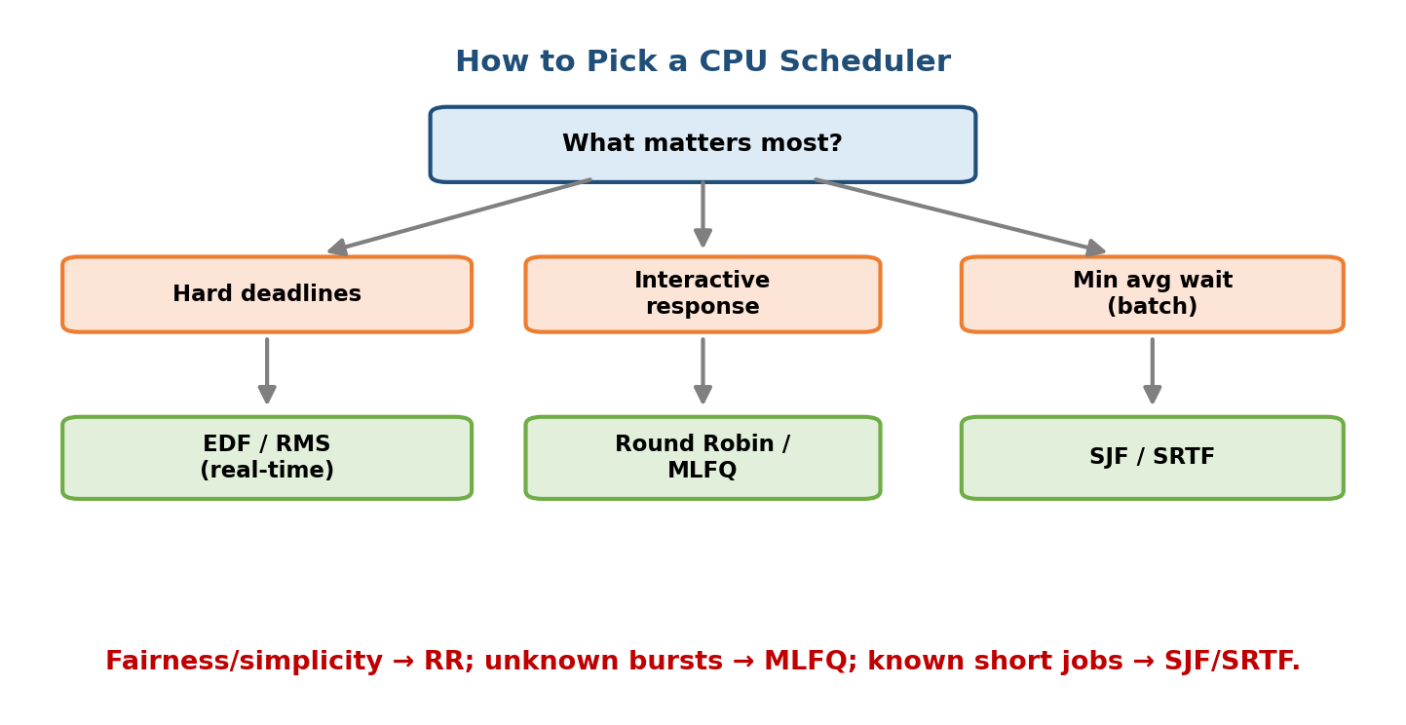
Match the scheduler to what matters: deadlines → EDF/RMS; interactivity → RR/MLFQ; minimum average wait → SJF/SRTF.
How to pick (decision):
- Deadlines are hard (control, sensors) → EDF or RMS.
- Interactive / fairness / general-purpose OS → Round Robin or MLFQ.
- Batch, bursts known, minimise average wait → SJF / SRTF.
- Simple, batch, order doesn’t matter → FCFS.
- Jobs differ in importance → Priority (add aging to avoid starvation).
- Guaranteed proportional shares (VMs, containers, cgroups) → Lottery / stride / CFS-style weights.

6.14 Real-World & Backend Perspectives
- Linux CFS (Completely Fair Scheduler). The default Linux scheduler is not any single textbook algorithm — it approximates an ideal fair share by tracking each task’s virtual runtime (vruntime) in a red-black tree and always running the task with the smallest vruntime. nice values act as weights (proportional share, like lottery tickets). (Newer kernels use EEVDF, a deadline-aware refinement.)
- Priority inversion (interview favourite). A high-priority task blocks on a lock held by a low-priority task that a medium-priority task keeps preempting — the high task is stuck. Real fix: priority inheritance (the low task temporarily inherits the high priority). This bug famously hit the Mars Pathfinder rover (1997). Detailed in Module 7.
- Containers & the cloud. Kubernetes CPU requests/limits and Linux cgroups CPU shares are proportional-share scheduling (§6.11) at the fleet level — you’re handing out “tickets” to pods.
- Thread pools & tail latency. Backend request schedulers face the same SJF-vs-fairness tension: run short requests first for low average latency, but bound the wait of long requests to protect p99 tail latency — exactly the FCFS-vs-SJF-vs-RR trade-off.

6.15 Tradeoffs, Common Mistakes, Edge Cases
Common mistakes (exam + real life)
- Forgetting to respect arrival times — a process can’t be scheduled before it arrives (idle CPU gaps are allowed on the Gantt chart).
- Using WT = Completion − Burst — wrong; it is Completion − Arrival − Burst (subtract arrival too).
- Assuming lower priority number = lower priority — the standard convention is the opposite (lower number = higher priority). Always state the convention.
- Treating response time = waiting time — they differ under preemption.
- Forgetting the RMS bound test is only sufficient: U > bound does not prove it’s unschedulable — you must draw the timeline.
- In SRTF, forgetting to re-evaluate at each arrival (that’s the whole point).
Edge cases
- All arrive together → SJF is just “sort by burst”; FCFS depends on the given order.
- Ties → break by arrival, then process id (state your rule).
- Idle CPU → if no process has arrived yet, the CPU sits idle; the Gantt chart shows a gap, and later turnaround still counts from arrival.
- RR quantum ≥ every burst → identical to FCFS (verify by tracing).
Tradeoffs
Choice | Gains | Costs
Preemption | responsiveness, lower waiting | context-switch overhead, race conditions
Small RR quantum | fast response | overhead dominates (efficiency q/(q+s))
SJF/SRTF | minimum average wait | starves long jobs; needs prediction
Static priority (RMS) | simple, predictable | wastes CPU (≤69% guarantee)
Dynamic priority (EDF) | up to 100% CPU | complex; can cascade on overload

6.16 Exam, Interview & Coding Perspectives
Exam (SEBI/RBI/GATE/C-DAC): the bread-and-butter is “given this process table, draw the Gantt chart and compute average waiting/turnaround time” for FCFS, SJF, SRTF, Priority, and RR — practise until it’s mechanical. Also expect one-liners on convoy effect, SJF optimality, starvation/aging, RR quantum extremes, MLFQ, and the RMS bound.
Interview: “Why is SJF optimal but impractical?” (min avg wait, but you can’t know bursts); “What happens if the RR quantum is too small / too large?”; “How does Linux schedule?” (CFS / vruntime / fair share); “What is priority inversion and how do you fix it?” (priority inheritance).
Coding/practical: - nice / renice set a process’s CFS weight; chrt sets real-time policies (SCHED_FIFO, SCHED_RR, SCHED_DEADLINE = EDF-like) on Linux. - sched_setscheduler(2) / sched_setaffinity(2) are the syscalls; top/htop show priorities (PR/NI).

6.17 Concept Checks & MCQs (test yourself)
- Turnaround time formula? → completion − arrival.
- Waiting time formula? → turnaround − burst (= completion − arrival − burst).
- Which algorithm gives the minimum average waiting time (non-preemptive)? → SJF.
- …and preemptively (theoretical minimum)? → SRTF.
- FCFS’s classic weakness? → convoy effect.
- Preemptive version of SJF is called? → SRTF / SRTN.
- Component that performs the context switch? → dispatcher.
- Overhead to start the next process? → dispatch latency.
- Cure for starvation in priority scheduling? → aging.
- RR with a huge quantum behaves like? → FCFS.
- RR with a tiny quantum is dominated by? → context-switch overhead.
- Max wait between turns in RR (n procs, quantum q)? → (n−1)·q.
- In MLFQ, what happens to a job that uses its whole slice? → it drops a queue.
- What prevents starvation in MLFQ? → periodic priority boost.
- Lottery scheduling gives CPU proportional to? → tickets.
- RMS priority rule? → shorter period = higher priority (static).
- RMS utilisation bound? → n(2^(1/n) − 1) (→ ln 2 ≈ 0.693).
- EDF is schedulable iff? → U ≤ 1.
- Which reaches 100% CPU utilisation for real-time sets? → EDF.
- SJF is a special case of ___ scheduling → priority (priority = next burst).
- Metric interactive systems optimise? → response time.
- Convention for priority numbers? → lower number = higher priority.
- Non-preemptive scheduling reschedules only when a process ___ → blocks/exits.
- Linux default scheduler? → CFS (fair share via vruntime).
- High-priority task stuck behind a lock held by a low one? → priority inversion (fix: priority inheritance).
True/False - SJF is optimal for average waiting time. → True. - RR can cause starvation. → False (it’s starvation-free). - FCFS is preemptive. → False. - A larger RR quantum improves response time. → False (it worsens it → FCFS). - EDF uses static priorities. → False (dynamic; RMS is static). - RMS can always schedule any set with U ≤ 1. → False (only up to its bound is guaranteed). - Response time equals waiting time under preemption. → False.
Numerical (do it yourself):
Given P1(arr0,b5), P2(arr1,b3), P3(arr2,b1), P4(arr4,b2). Compute the average waiting time under FCFS and under SRTF.
FCFS (served in arrival order P1, P2, P3, P4): Gantt: |P1|P2|P3|P4| boundaries 0,5,8,9,11 Completion = 5, 8, 9, 11 → TAT = 5, 7, 7, 7 → WT = 0, 4, 6, 5. Average WT = (0+4+6+5)/4 = 15/4 = 3.75.
SRTF (re-check remaining time at every arrival): t0 run P1; t1 P2(3) < P1(rem4) → run P2; t2 P3(1) < P2(rem2) → run P3; t3 P3 done, P2(rem2) < P1(rem4) → run P2; t5 P2 done, run P4(2); t7 run P1(rem4). Gantt: |P1|P2|P3| P2 | P4 | P1 | boundaries 0,1,2,3,5,7,11 Completion: P3=3, P2=5, P4=7, P1=11 → TAT = 11, 4, 1, 3 → WT = 6, 1, 0, 1. Average WT = (6+1+0+1)/4 = 8/4 = 2.0 — SRTF beats FCFS (2.0 < 3.75), as expected.

6.18 One-Page Revision Sheet
FORMULAS (memorise):
Turnaround (TAT) = Completion − Arrival
Waiting (WT) = TAT − Burst = Completion − Arrival − Burst
Response (RT) = First-CPU-time − Arrival
RECIPE: Gantt → Completion → TAT=C−A → WT=TAT−B → average.
SCHEDULER decides WHO; DISPATCHER does the switch; DISPATCH LATENCY = that overhead.
PREEMPTIVE (can grab CPU: ready↔run) vs NON-PREEMPTIVE (only on block/exit).
FCFS FIFO, non-preempt, fair-by-arrival, CONVOY EFFECT (long job first = all wait).
SJF non-preempt, pick shortest next burst → MIN AVG WAIT (optimal); needs prediction
(exp avg: τ' = α·t + (1−α)·τ). starves long jobs.
SRTF preemptive SJF; re-check at EVERY arrival → theoretical MIN avg wait.
PRIORITY lower number = higher prio; preempt/non-preempt; STARVATION → fix with AGING.
SJF = priority where priority = next burst.
ROUND ROBIN FCFS + quantum q; preempt to back of queue; STARVATION-FREE.
wait ≤ (n−1)·q. q too big → FCFS; q too small → context-switch overhead.
efficiency = q/(q+s). rule: q=10–100ms, ~80% bursts < q.
MLQ several fixed queues (system/interactive/batch), each own algo; NO movement.
MLFQ queues WITH feedback: new→top; use whole slice→drop; I/O early→stay;
periodic BOOST (anti-starvation). approximates SJF w/o knowing bursts.
LOTTERY tickets → CPU share = tickets/total; probabilistic, starvation-free.
REAL-TIME (task: period p, exec c, U=Σc/p):
RMS static, shorter period = higher prio; guaranteed if U ≤ n(2^(1/n)−1)
(n=2:0.828, n=3:0.780, ∞:ln2≈0.693). SUFFICIENT test only.
EDF dynamic, nearest deadline first; schedulable IFF U ≤ 1 (reaches 100%).
Classic: p1=50,c=25 & p2=80,c=35 (U=0.9375): RMS MISSES, EDF MEETS.
WORKED AVERAGES (remember the numbers):
FCFS P1=24,P2=3,P3=3 all@0 → avgWT 17 (reorder short-first → 3: convoy).
SJF (0,7)(2,4)(4,1)(5,4) → avgWT 4.0, avgTAT 8.0.
SRTF same table → avgWT 3.0, avgTAT 7.0.
RR q=4 (24,3,3) → avgWT 5.67, avgTAT 15.67.

Flash cards
Front | Back
Turnaround time? | Completion − Arrival
Waiting time? | Turnaround − Burst
Optimal for avg waiting? | SJF (preemptively: SRTF)
FCFS weakness? | Convoy effect
Preemptive SJF? | SRTF
Cure for starvation? | Aging
RR huge quantum → | FCFS
RR tiny quantum → | Context-switch overhead
RR max wait for turn? | (n−1)·q
MLFQ: uses whole slice → | Drops a queue
MLFQ anti-starvation? | Periodic priority boost
Lottery share ∝ | Tickets
RMS priority by? | Shortest period (static)
RMS bound? | n(2^(1/n)−1) → ln2≈0.693
EDF schedulable iff? | U ≤ 1
Linux default scheduler? | CFS (vruntime fair share)

Spaced repetition
- 24-hour: redo the FCFS, SJF, SRTF and RR(q=4) numericals from a blank page — Gantt + average WT/TAT — until fully mechanical.
- 7-day: explain convoy effect, SJF optimality + prediction, RR quantum trade-off, starvation/aging, and MLFQ’s five rules from memory.
- 30-day: state and apply the RMS bound and the EDF test; reproduce the RMS-fails/EDF-succeeds example; fill the comparison table (preemptive? starvation? optimises? overhead) from scratch.

6.19 Summary
CPU scheduling answers the central performance question of an OS: when many processes are ready, who runs next, and for how long? Every process alternates CPU and I/O bursts; the short-term scheduler picks a ready process and the dispatcher switches to it, paying dispatch latency. We measure success with CPU utilisation, throughput, turnaround (= completion − arrival), waiting (= turnaround − burst), and response time, and we compute them via one recipe: Gantt chart → completion → TAT → WT → average.
We worked every classic algorithm end-to-end: FCFS (simple but the convoy effect), SJF (optimal average waiting, but needs burst prediction), SRTF (preemptive SJF, the theoretical minimum), Priority (importance-driven, cured of starvation by aging), Round Robin (interactive, starvation-free, with the crucial quantum trade-off — too small wastes CPU on switching, too large becomes FCFS), and the practical hierarchies MLQ and MLFQ plus proportional-share Lottery. Finally, real-time scheduling gave us RMS (static, shorter-period-first, bound U ≤ n(2^(1/n)−1)) and EDF (dynamic, nearest-deadline-first, schedulable up to U ≤ 1), and the classic set where RMS misses a deadline but EDF meets it.
Next, Module 7 — Process Synchronization tackles what happens when those scheduled, preempted processes touch shared data at the same time: race conditions, critical sections, locks, semaphores, and the deadlocks that scheduling choices can create.
You have mastered this module when you can: from a raw process table draw the Gantt chart and compute average waiting/turnaround for FCFS, SJF, SRTF, Priority, and RR without hesitation; explain convoy effect, SJF optimality, starvation/aging, and the RR quantum trade-off in one sentence each; recite the MLFQ rules; and apply both the RMS utilisation bound and the EDF U ≤ 1 test — all without notes.

