Module 8 — Deadlocks
  - OS Mastery: SEBI IT / RBI / NABARD / GATE / C-DAC / Interview / Backend — In-Depth Notes (with visuals)
Prepared for nidhi.sharma@forensiccybertech.com
2026
Table of Contents

Module 8 — Deadlocks
Where this module sits. Module 7 gave us locks and semaphores to coordinate concurrent processes. This module studies what happens when that coordination jams permanently: a set of processes each holds a resource and waits for one another in a circle, so none can ever proceed. We build the whole theory — the four Coffman conditions that must all hold for deadlock, the Resource-Allocation Graph that lets you see it, and the four grand strategies (prevention, avoidance, detection, recovery) — anchored by the single most-asked numerical in the subject, the Banker’s Algorithm. GATE and the banking IT exams love this module; it is a direct continuation of the Dining Philosophers deadlock from M7.
Importance ratings (out of 5):
Exam / Use | SEBI IT | RBI IT | GATE CS | Interview | Backend
This module | ★★★★ | ★★★★ | ★★★★★ | ★★★ | ★★★
Most-asked PYQ concepts (SEBI / RBI / GATE / C-DAC): definition of deadlock; the four Coffman conditions (mutual exclusion, hold-and-wait, no preemption, circular wait); Resource-Allocation Graph — cycle rules for single vs multiple instances; the four strategies (prevention/avoidance/detection/ recovery); Banker’s Algorithm (safe state, safe sequence, request check — a guaranteed numerical); wait-for graph detection; starvation vs deadlock; the ostrich algorithm.

8.1 What Is a Deadlock? (first principles)
A deadlock is a situation where a set of processes are each blocked forever, because each holds a resource the next one needs and waits for a resource the previous one holds — a circular wait with no escape.
Everyday analogy — the one-lane bridge / gridlock: four cars enter a four-way intersection at once; each has advanced just enough to block the car to its right and is itself blocked by the car to its left. Nobody can move, and nobody will move without an outside intervention. That is a deadlock.
Memory hook: deadlock = “I’m waiting for you, you’re waiting for me, forever.” No amount of waiting fixes it — that’s what separates it from a temporary delay. Something external (kill, preempt, rollback) must break it.
A resource here is anything a process must hold exclusively for a while: a lock/semaphore, a printer, a tape drive, a database record, memory, a file. A resource type may have one instance (a specific printer) or several identical instances (say, 3 equivalent tape drives).
Deadlock vs a livelock vs starvation (don’t confuse them):
- Deadlock: processes are blocked (not running) and stuck permanently.
- Livelock: processes are running and keep changing state in response to each other but make no progress (two people stepping side-to-side in a corridor). CPU is busy; work isn’t done.
- Starvation: a process waits indefinitely because others are continuously favoured (e.g. low priority under SJF) — but it could run if the favouritism stopped.

MCQs
- Deadlock in one line? → processes each hold a resource and wait for one held by another, forever (circular wait).
- Deadlock vs livelock? → deadlock processes are blocked; livelock processes are running but not progressing.
- What breaks a deadlock? → an external action (kill/preempt/rollback), never more waiting.

8.2 The Four Coffman Conditions (necessary conditions)
A deadlock can occur only if all four of these hold simultaneously. Break any one and deadlock is impossible — this is the entire basis of prevention (§8.5). Memorise them (Coffman, 1971):
- Mutual Exclusion. At least one resource is held in a non-shareable mode — only one process can use it at a time. (Read-only/shareable resources never cause deadlock.)
- Hold and Wait. A process is holding at least one resource while waiting to acquire additional resources held by others.
- No Preemption. A resource cannot be forcibly taken from a process; it is released only voluntarily, after the process finishes with it.
- Circular Wait. There exists a cycle of processes P0 → P1 → P2 → … → Pn → P0 where each Pi waits for a resource held by P(i+1) (and Pn waits for one held by P0).
Memory hook — “MHNC” → “Must Have No Cycle” / mnemonic “My Hungry Nephew Cries”: Mutual exclusion, Hold-and-wait, No preemption, Circular wait. All four are necessary; together they are sufficient when resources have single instances.
Key subtlety (exam trap): circular wait implies hold-and-wait, so the four are not independent. But treat them separately, because each gives a different way to prevent deadlock.

MCQs
- How many Coffman conditions and must how many hold? → four, and all four simultaneously.
- Name them. → mutual exclusion, hold-and-wait, no preemption, circular wait.
- Which condition is a cycle of waiting? → circular wait.
- A read-only shared resource violates which condition (so is deadlock-safe)? → mutual exclusion.

8.3 Resource-Allocation Graph (RAG)
The RAG is a directed graph that lets you see who holds and who wants what:
- Vertices: processes drawn as circles P; resource types drawn as boxes R, with one dot per instance inside.
- Request edge Pi → Rj: process Pi has requested (is waiting for) a unit of Rj.
- Assignment edge Rj → Pi: a unit of Rj has been allocated to Pi (drawn from a dot to the process).
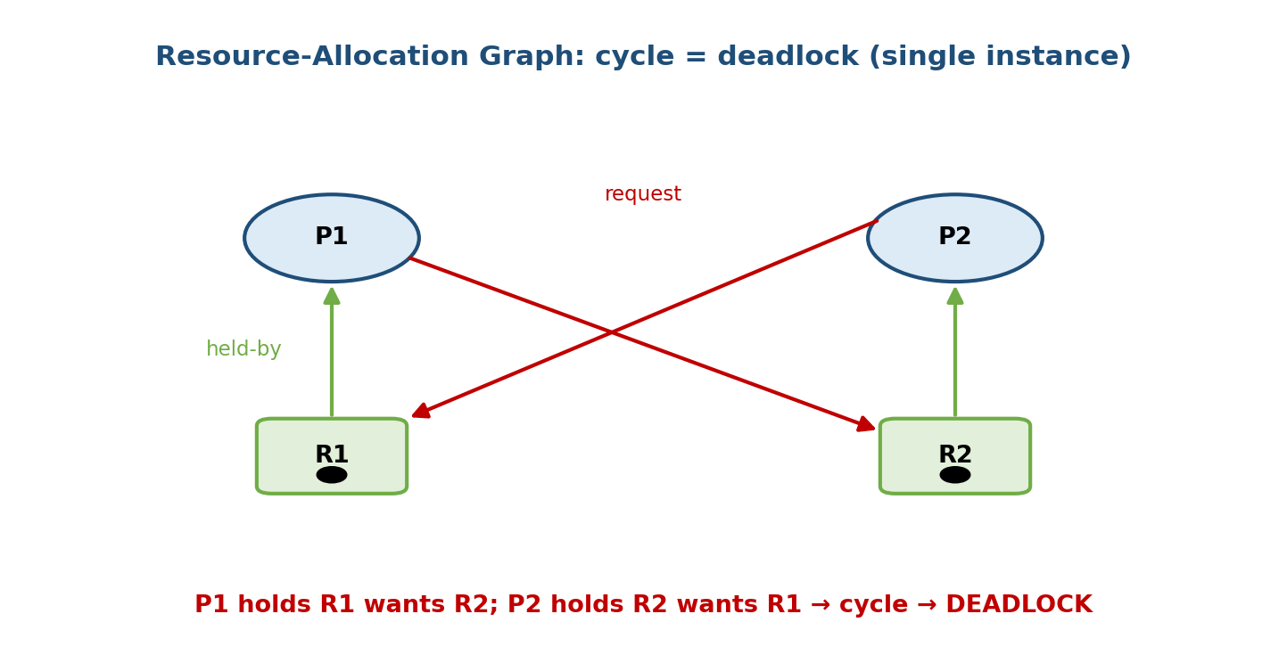
A resource-allocation graph with two single-instance resources: P1 holds R1 and requests R2, while P2 holds R2 and requests R1, forming a cycle that means deadlock.

The cycle rules (the high-yield part)
- Single instance per resource type: a cycle in the RAG is necessary AND sufficient → cycle ⇔ deadlock. (In the figure, P1 → R2 → P2 → R1 → P1 is a cycle, so both are deadlocked.)
- Multiple instances per resource type: a cycle is necessary but NOT sufficient. A cycle may or may not mean deadlock — you must analyse further (e.g. with the detection algorithm of §8.7). No cycle ⇒ no deadlock, always.
Memory hook: “cycle = deadlock” only when every resource is a single instance. With multiple instances, a cycle is a warning sign, not a verdict — another instance might free up and let the cycle drain.
Why multi-instance cycles can be safe: if a resource type has 2 units and the cycle passes through it, a third process outside the cycle may release a unit, satisfying one waiter and breaking the cycle. So you must check whether any process can finish.

MCQs
- Circle vs box in a RAG? → circle = process, box = resource type.
- Rj → Pi edge means? → a unit of Rj is allocated to Pi (assignment).
- Cycle in a single-instance RAG means? → deadlock (necessary & sufficient).
- Cycle in a multi-instance RAG means? → maybe deadlock (necessary, not sufficient).
- No cycle means? → no deadlock (always).

8.4 The Four Strategies — a map
There are exactly four ways to deal with deadlock. Know the one-liners and the trade-off (from strictest to most relaxed):
Strategy | Idea | When resources are given | Cost
Prevention | make one Coffman condition impossible by design | structurally restricted | low concurrency / wasted resources
Avoidance | grant a request only if the system stays in a safe state | dynamically, after a safety check | needs max claims known in advance (Banker’s)
Detection + recovery | allow deadlock, find it, then fix it | freely | periodic detection + recovery pain
Ignore (ostrich) | pretend it never happens | freely | rare deadlock → reboot
Memory hook: Prevention = “design it out.” Avoidance = “look before you leap” (Banker’s). Detection/recovery = “let it happen, then clean up.” Ostrich = “head in the sand.”
The next sections take each in turn.

MCQs
- Which strategy needs maximum demand known ahead? → avoidance (Banker’s).
- Which strategy lets deadlock happen then fixes it? → detection + recovery.
- What is the “do nothing” approach called? → the ostrich algorithm.

8.5 Strategy 1 — Deadlock Prevention
Prevention negates one of the four Coffman conditions so deadlock is structurally impossible. Attack each:
Condition to break | How to prevent | Downside
Mutual exclusion | make resources shareable (e.g. read-only files, or spool a printer) | many resources are intrinsically non-shareable
Hold and wait | require a process to request all resources at once (before starting), or release all before requesting more | low utilisation (resources held but idle); possible starvation
No preemption | if a process holding resources requests more and can’t get them, preempt (take back) what it holds | only works for state you can save/restore (CPU, memory — not a printer mid-print)
Circular wait | impose a total ordering on resource types; each process requests in increasing order only | must number all resources; can be restrictive
- Breaking circular wait with a global lock ordering is the most practical prevention technique in real software (always acquire locks in the same order → no cycle can form). This is the same idea as the “grab lower-numbered fork first” fix for Dining Philosophers (M7).
Memory hook: prevention = “remove one leg of the four-legged table and it can’t stand.” The cheapest leg to remove in code is circular wait (order your locks).

MCQs
- Prevent circular wait by? → a total ordering of resources (request in increasing order).
- “Request all resources up front” attacks which condition? → hold-and-wait.
- Which condition is hardest to remove for physical devices? → mutual exclusion / no preemption.

8.6 Strategy 2 — Deadlock Avoidance & the Banker’s Algorithm
Prevention is blunt (it wastes resources). Avoidance is smarter: allow the four conditions, but before granting each resource request, check that doing so leaves the system in a safe state. If not, the process waits even though the resource is free.

Safe state, unsafe state, deadlock
- A safe state is one where a safe sequence exists: an ordering ⟨P1, P2, …, Pn⟩ such that each Pi’s remaining needs can be met by the currently available resources plus what all processes before it release. If such a sequence exists, everyone can finish → no deadlock possible.
- An unsafe state may lead to deadlock (not guaranteed, but the system can no longer guarantee safety). Deadlock ⊆ unsafe ⊆ all states.
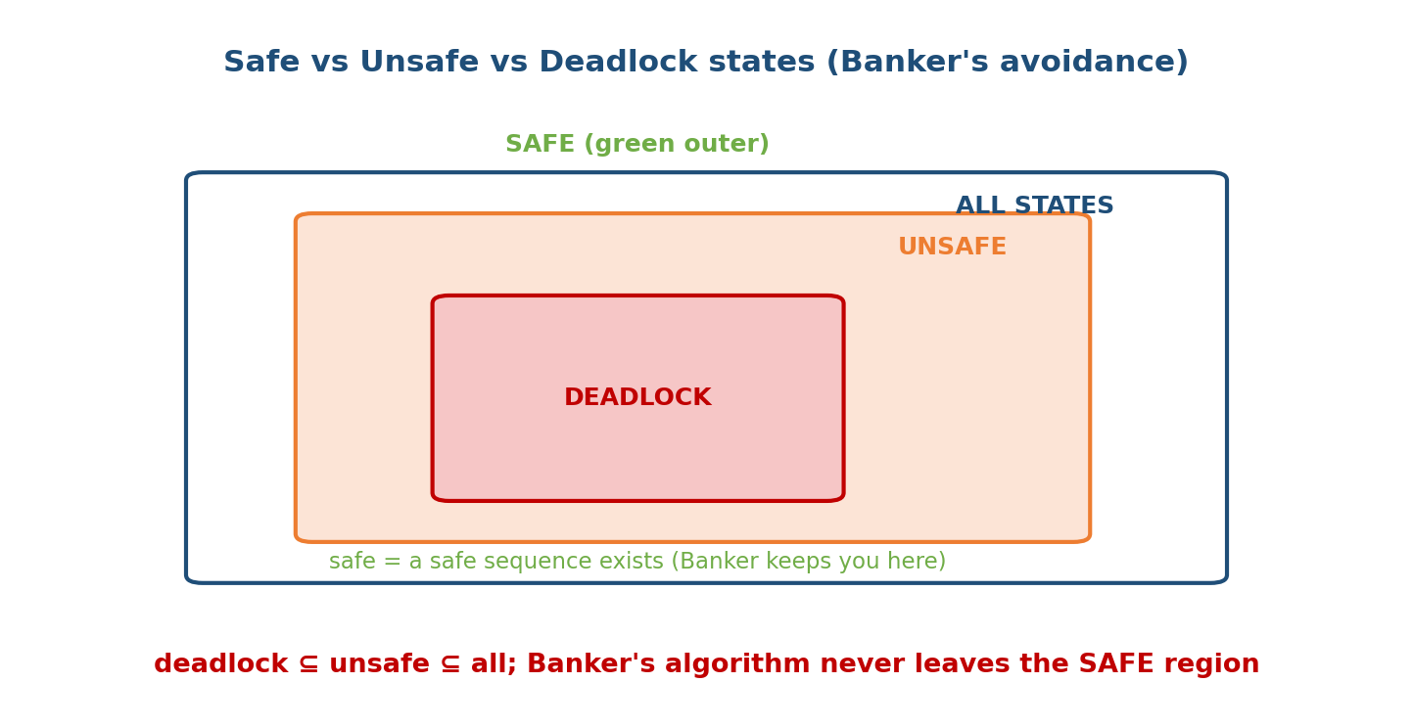
Nested regions: the deadlock set sits inside the unsafe set, which sits inside all states; the Banker’s algorithm keeps the system inside the outer safe region.
Memory hook: safe = “I can prove everyone finishes.” Unsafe isn’t necessarily deadlocked, but the OS refuses to risk it — the Banker’s algorithm never lets you step out of the safe region.

The Banker’s Algorithm (Dijkstra)
Like a banker who only lends cash if he can still satisfy all customers’ credit lines, the OS grants a request only if a safe sequence still exists afterwards. Data structures for n processes and m resource types:
Available[m] : units of each resource currently free
Max[n][m] : max demand each process may ever request
Allocation[n][m] : units currently held by each process
Need[n][m] : still required = Max - Allocation
The Safety Algorithm (is the current state safe?):
1. Work = Available ; Finish[i] = false for all i
2. Find an i with Finish[i] == false AND Need[i] <= Work (component-wise)
- if none exists, go to 4
3. Work = Work + Allocation[i] ; Finish[i] = true ; go to 2
4. If Finish[i] == true for ALL i -> SAFE (the order you picked = safe sequence)
else -> UNSAFE

Worked example — is the state safe? (do this by hand)
5 processes (P0–P4), 3 resource types A, B, C with totals A=10, B=5, C=7.
Allocation Max Need = Max - Allocation
A B C A B C A B C
P0 0 1 0 7 5 3 7 4 3
P1 2 0 0 3 2 2 1 2 2
P2 3 0 2 9 0 2 6 0 0
P3 2 1 1 2 2 2 0 1 1
P4 0 0 2 4 3 3 4 3 1
Available = Total − Σ Allocation = (10,5,7) − (7,2,5) = (3, 3, 2).
Now run the safety algorithm with Work = (3,3,2):
step Work try Need<=Work? Work += Allocation Finish
---- --------- ------------ ----------- --------------------- -------------
init (3,3,2)
1 (3,3,2) P1 (1,2,2) yes +(2,0,0) = (5,3,2) P1
2 (5,3,2) P3 (0,1,1) yes +(2,1,1) = (7,4,3) P3
3 (7,4,3) P4 (4,3,1) yes +(0,0,2) = (7,4,5) P4
4 (7,4,5) P0 (7,4,3) yes +(0,1,0) = (7,5,5) P0
5 (7,5,5) P2 (6,0,0) yes +(3,0,2) = (10,5,7) P2
All five finished → the state is SAFE, with safe sequence ⟨P1, P3, P4, P0, P2⟩. (Other valid sequences exist, e.g. ⟨P1, P3, P0, P2, P4⟩ — any order the algorithm can complete counts.)

The Resource-Request Algorithm — should we grant a request?
Now suppose P1 requests (1, 0, 2). Steps:
1. Is Request <= Need[P1]? (1,0,2) <= (1,2,2) -> YES (else error: over max)
2. Is Request <= Available? (1,0,2) <= (3,3,2) -> YES (else P1 must wait)
3. PRETEND to grant it:
Available = (3,3,2) - (1,0,2) = (2,3,0)
Alloc[P1] = (2,0,0) + (1,0,2) = (3,0,2)
Need[P1] = (1,2,2) - (1,0,2) = (0,2,0)
4. Run the SAFETY algorithm on this new state. Safe -> GRANT ; unsafe -> DENY & roll back.
Run safety with Work = (2,3,0):
P1 Need (0,2,0) <= (2,3,0)? yes -> Work = (2,3,0)+(3,0,2) = (5,3,2)
P3 Need (0,1,1) <= (5,3,2)? yes -> Work = (5,3,2)+(2,1,1) = (7,4,3)
P4 Need (4,3,1) <= (7,4,3)? yes -> Work = (7,4,3)+(0,0,2) = (7,4,5)
P0 Need (7,4,3) <= (7,4,5)? yes -> Work = (7,4,5)+(0,1,0) = (7,5,5)
P2 Need (6,0,0) <= (7,5,5)? yes -> Work = (7,5,5)+(3,0,2) = (10,5,7)
All finish → the new state is safe → the request is GRANTED. Safe sequence after granting: ⟨P1, P3, P4, P0, P2⟩.
Exam contrast: if instead P4 requested (3,3,0), then Available would drop to (0,0,2) and no process’s Need fits in (0,0,2) (P3 needs (0,1,1) — the B is 0), so the safety check fails → that request is denied even though the resources are physically free. That’s avoidance in action.
Memory hook — “the Banker only lends if he can still pay everyone”: compute Need = Max − Allocation, start Work = Available, and repeatedly “fund” whichever process fits and collect back its Allocation. If you can fund everyone, it’s safe.

MCQs
- Need = ? → Max − Allocation.
- Available in the example? → (3,3,2).
- A safe sequence for the base example? → ⟨P1,P3,P4,P0,P2⟩ (among others).
- First test in the request algorithm? → Request ≤ Need (else it exceeds max).
- If the pretend-grant state is unsafe? → deny and roll back (process waits).

8.7 Strategy 3 — Deadlock Detection
If we neither prevent nor avoid, we must detect deadlock after it happens and then recover. Detection differs by instance count:

Single instance per type — the Wait-For Graph (WFG)
Collapse the RAG by removing resource nodes: draw an edge Pi → Pj iff Pi is waiting for a resource currently held by Pj. A cycle in the WFG ⇔ deadlock. Detect by periodically searching for a cycle.
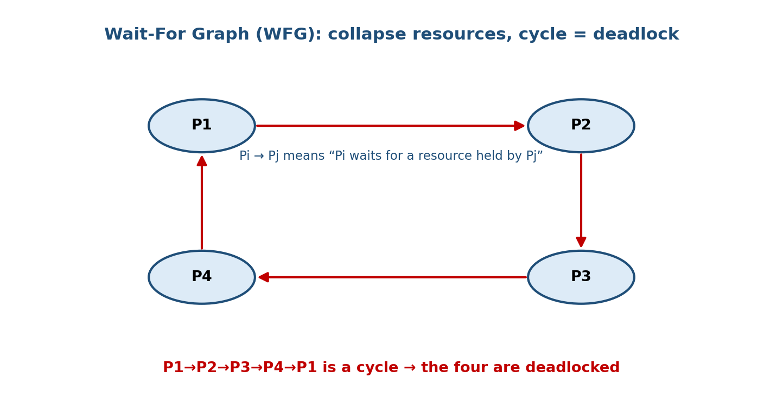
A wait-for graph where P1 waits for P2, P2 for P3, P3 for P4, and P4 for P1 — a cycle, so all four are deadlocked.

Multiple instances — the detection algorithm
Almost identical to the Banker’s safety algorithm, but it uses the current Request matrix (what each process is actually asking for now) instead of Need (the maximum it might ask):
1. Work = Available
Finish[i] = (Allocation[i] == 0) ? true : false // idle procs are "done"
2. Find i with Finish[i]==false AND Request[i] <= Work
- if none, go to 4
3. Work = Work + Allocation[i] ; Finish[i] = true ; go to 2
4. Any Finish[i] == false -> those processes are DEADLOCKED
Banker vs detection — the one-line difference (favourite exam point): avoidance uses Need (max future claim) before granting to stay safe; detection uses Request (current ask) after the fact to find who’s stuck.
When to run detection? Every request (expensive, catches it instantly), or periodically / when CPU utilisation drops (cheaper). More frequent = faster recovery but more overhead.

MCQs
- WFG cycle means (single instance)? → deadlock.
- Detection algorithm uses which matrix (vs Banker’s Need)? → Request (current).
- How is the WFG built from a RAG? → remove resources; Pi→Pj if Pi waits for a resource held by Pj.

8.8 Strategy 4 — Deadlock Recovery
Once detected, break the deadlock. Two families:
(a) Process termination
- Abort all deadlocked processes — simple, drastic, loses all their work.
- Abort one at a time until the cycle breaks — re-run detection after each kill. Choose the victim to minimise cost: lowest priority, least work done so far, fewest resources held, most restartable.
(b) Resource preemption
- Preempt resources from some process and give them to others. Three issues:
  - Victim selection — minimise cost (as above).
  - Rollback — the preempted process must be rolled back to a safe checkpoint and restarted (you can’t just yank a half-written resource).
  - Starvation — the same process may repeatedly be the victim; include the number of rollbacks in the cost so it eventually makes progress.
Memory hook: recover by killing (abort a victim) or stealing (preempt + rollback) — either way you pick the cheapest victim and guard against making it the victim every time (starvation).

MCQs
- Two recovery approaches? → kill processes or preempt resources.
- What must accompany preemption? → rollback to a safe checkpoint.
- A risk of repeatedly picking the same victim? → starvation (count rollbacks in the cost).

8.9 The Ostrich Algorithm & Starvation vs Deadlock
- Ostrich algorithm — stick your head in the sand and pretend deadlocks don’t happen. Used by most general-purpose OSes (UNIX, Linux, Windows) for kernel resources, because deadlock is rare, and prevention/avoidance cost too much performance for everyday use. If one occurs, the user reboots / kills the process. It’s an engineering trade-off, not laziness: cheap-common-case beats expensive-always-safe.
- Starvation vs deadlock (must not confuse):
 | Deadlock | Starvation
State | processes blocked forever | a process waits indefinitely
Cause | circular wait (mutual blocking) | continuous favouritism (e.g. priority, SJF)
Others progressing? | no (all in the cycle are stuck) | yes — others keep running ahead of it
Could it ever run? | never (without intervention) | yes, if the bias stopped
Memory hook: deadlock = a knot (nobody moves); starvation = the end of a never-shrinking queue (others keep cutting ahead, but the line is moving). Every deadlock is a permanent block; not every permanent wait is a deadlock.

MCQs
- OS that “ignores” deadlock uses the? → ostrich algorithm.
- Why do Linux/Windows ignore many deadlocks? → they’re rare; prevention costs more than the occasional reboot.
- In deadlock, are other processes progressing? → no; in starvation? → yes.

8.10 Real-World & Backend Perspectives
- Databases are where you meet deadlock daily: two transactions each lock a row the other needs. DBMSs run deadlock detection (a wait-for graph) and abort + roll back the cheapest victim transaction (you then retry) — that is literally §8.7 + §8.8. PostgreSQL, MySQL/InnoDB, and SQL Server all do this.
- Lock ordering is the standard prevention discipline in application code: always acquire locks in a fixed global order (negates circular wait). Tools like Java’s thread-dump / jstack and Go’s race detector help find violations.
- SELECT ... FOR UPDATE and long transactions are classic deadlock breeders; keeping transactions short and touching rows in a consistent order avoids them.
- Banker’s Algorithm is rarely used in practice — it needs every process’s maximum claim in advance, which real systems don’t know. It’s a beautiful exam tool and the intellectual root of avoidance, but detection+recovery (DBs) and prevention-by-lock-ordering (apps) dominate real systems.
- Distributed systems face distributed deadlock (locks across machines); detection is harder, so timeouts + retries are common.

8.11 Tradeoffs, Common Mistakes, Edge Cases
Common mistakes (exam + real life) - Saying a cycle always means deadlock — true only for single-instance resources; with multiple instances a cycle is necessary but not sufficient. - Confusing unsafe with deadlocked — unsafe may lead to deadlock; it is not deadlock yet. - Forgetting Need = Max − Allocation, or comparing Request > Need. - In detection, using Need instead of the current Request matrix. - Mixing up starvation (others progress) with deadlock (nobody progresses). - Thinking avoidance can run without knowing maximum claims — it can’t.
Edge cases - A resource that is shareable/read-only can’t cause deadlock (breaks mutual exclusion). - A safe state can still contain a cycle if resources have multiple instances — as long as a safe sequence exists. - Preemption-based recovery needs checkpointing; not all resources can be rolled back (a printer mid-page cannot).
Tradeoffs
Strategy | Pro | Con
Prevention | deadlock impossible by design | low utilisation / restrictive
Avoidance (Banker’s) | no deadlock, better utilisation than prevention | needs max claims; overhead per request
Detection + recovery | full concurrency | recovery is costly (kills/rollbacks)
Ostrich | zero overhead | rare deadlock → hang/reboot

8.12 Exam, Interview & Coding Perspectives
Exam (SEBI/RBI/GATE/C-DAC): the four conditions (name + how to break each); RAG cycle rules for single vs multiple instances; a full Banker’s numerical (compute Need, Available, find a safe sequence, test a request); WFG detection; starvation vs deadlock; the ostrich one-liner. Banker’s is the set-piece numerical — practise until it’s mechanical.
Interview: “What is a deadlock and what are the conditions for it?”; “How would you prevent deadlock in your service?” (lock ordering); “How do databases handle deadlock?” (detect + roll back victim); “Difference between deadlock and starvation?”.
Coding/practical: - Reproduce a deadlock: two threads take mutex A then B vs B then A. Fix by consistent lock ordering. - In PostgreSQL, trigger a deadlock with two interleaved UPDATEs in transactions; observe deadlock detected and the automatic victim rollback.

8.13 Concept Checks & MCQs (test yourself)
- Define deadlock. → processes each hold a resource and wait in a circle, forever.
- The four Coffman conditions? → mutual exclusion, hold-and-wait, no preemption, circular wait.
- How many must hold for deadlock? → all four.
- RAG: circle vs box? → process vs resource type.
- Cycle in single-instance RAG? → deadlock (necessary & sufficient).
- Cycle in multi-instance RAG? → maybe (necessary, not sufficient).
- No cycle in a RAG? → no deadlock.
- The four strategies? → prevention, avoidance, detection, recovery (+ ostrich).
- Which breaks circular wait? → total ordering of resource requests.
- “Request all up front” breaks? → hold-and-wait.
- Making resources shareable breaks? → mutual exclusion.
- Avoidance needs to know? → each process’s maximum claim.
- Need = ? → Max − Allocation.
- Safe state definition? → a safe sequence exists (all can finish).
- Deadlock ⊆ ___ ⊆ all states? → unsafe.
- Banker’s: first check on a request? → Request ≤ Need.
- Detection uses which matrix vs Banker’s Need? → current Request.
- Single-instance detection tool? → wait-for graph (cycle = deadlock).
- Two recovery methods? → kill processes / preempt + rollback.
- Risk of preemption recovery? → starvation (same victim repeatedly).
- OS “ignore deadlock” approach? → ostrich algorithm.
- Deadlock vs starvation — others progressing? → deadlock no, starvation yes.
True/False - A cycle always means deadlock. → False (only for single instances). - An unsafe state is always deadlocked. → False (may lead to deadlock). - Banker’s algorithm can run without maximum claims. → False. - The detection algorithm uses Need. → False (uses current Request). - Read-only shared resources can cause deadlock. → False (no mutual exclusion). - Linux uses Banker’s algorithm for kernel resources. → False (ostrich).
Numerical (do it): Totals A=10,B=5,C=7; the matrices of §8.6. (a) Available? → (3,3,2). (b) A safe sequence? → ⟨P1,P3,P4,P0,P2⟩. (c) Grant P1’s request (1,0,2)? → yes (resulting state is safe).

8.14 One-Page Revision Sheet
DEADLOCK = processes each HOLD a resource + WAIT for another in a CIRCLE, forever.
vs LIVELOCK (running, no progress) vs STARVATION (waits while others progress).
FOUR COFFMAN CONDITIONS (all must hold) -> "My Hungry Nephew Cries":
1 MUTUAL EXCLUSION (non-shareable)
2 HOLD AND WAIT (hold some, wait for more)
3 NO PREEMPTION (can't force-take)
4 CIRCULAR WAIT (P0->P1->...->P0 cycle)
Break ANY ONE -> no deadlock.
RAG: circle=process, box=resource(dots=instances). request Pi->Rj ; assign Rj->Pi.
SINGLE instance: cycle <=> DEADLOCK. MULTI instance: cycle = necessary, NOT sufficient.
NO cycle => NO deadlock (always).
STRATEGIES:
PREVENTION negate a condition: shareable(ME) / request-all-up-front(H&W) /
preempt(no-preempt) / TOTAL ORDER of locks(circular wait <- most practical).
AVOIDANCE grant only if SAFE STATE remains. Needs MAX claims. BANKER'S ALGORITHM.
DETECTION allow it; WFG cycle (single) or detection algo w/ current REQUEST (multi).
RECOVERY kill victim (cheapest) or preempt+ROLLBACK (watch starvation).
OSTRICH ignore it (Linux/Windows) - rare, cheap.
BANKER'S: Need = Max - Allocation ; Available = Total - sum(Allocation).
SAFETY: Work=Available; repeatedly pick i with Need[i]<=Work, Work += Allocation[i], mark done.
all done -> SAFE (order = safe sequence).
REQUEST(P,req): (1) req<=Need? (2) req<=Available? (3) pretend-grant, (4) safety-check -> grant/deny.
Example totals(10,5,7): Available=(3,3,2); safe seq <P1,P3,P4,P0,P2>; P1 req(1,0,2) -> GRANT.
SAFE (safe sequence exists) => no deadlock. DEADLOCK ⊆ UNSAFE ⊆ ALL states.
DETECTION uses current REQUEST ; AVOIDANCE uses max NEED. (the classic distinction)

Flash cards
Front | Back
Four Coffman conditions? | Mutual excl., hold-and-wait, no preemption, circular wait
Break which is most practical in code? | Circular wait (lock ordering)
Single-instance cycle means? | Deadlock (necessary & sufficient)
Multi-instance cycle means? | Maybe (necessary, not sufficient)
Need = ? | Max − Allocation
Safe state? | A safe sequence exists (all can finish)
Banker’s needs to know? | Each process’s maximum claim
Avoidance vs detection matrix? | Need (max) vs Request (current)
Recovery options? | Kill victim / preempt + rollback
Ignore-deadlock approach? | Ostrich algorithm
Deadlock vs starvation? | Blocked forever vs waits while others progress

Spaced repetition
- 24-hour: recite the four conditions + how to break each; redo the Banker’s safe-sequence computation for §8.6.
- 7-day: draw a RAG and a WFG; state single vs multi-instance cycle rules; run the request-grant check for a new request.
- 30-day: given matrices, compute Available/Need, find a safe sequence, and decide a request — plus explain prevention vs avoidance vs detection without notes.

8.15 Summary
A deadlock is a permanent circular wait: a set of processes each holding a resource and blocked on one another so none can ever proceed. It can happen only when all four Coffman conditions hold — mutual exclusion, hold-and-wait, no preemption, and circular wait — which is exactly why breaking any one prevents it. The Resource-Allocation Graph lets us see the danger: a cycle means deadlock for single-instance resources, but is only a warning when resources have multiple instances (no cycle ever means no deadlock). We surveyed the four strategies — prevention (design a condition away; lock ordering kills circular wait), avoidance (grant only if a safe state remains, via the fully worked Banker’s Algorithm: Need = Max − Allocation, find a safe sequence, test each request), detection (a wait-for graph or a Request-based algorithm) and recovery (kill a victim or preempt + rollback) — plus the pragmatic ostrich algorithm that real OSes actually use. Finally we separated deadlock (everyone blocked forever) from starvation (one waits while others progress).
Together, Modules 7 and 8 complete the concurrency story: M7 showed how to coordinate processes with locks, semaphores, and monitors; M8 showed how that coordination can jam — and how to prevent, avoid, detect, and recover from it. Next, Module 9 — Memory Management turns from sharing time to sharing space.
You have mastered this module when you can: state the four conditions and how to break each; apply the single- vs multi-instance RAG cycle rules; run the Banker’s Algorithm end to end (Need, Available, safe sequence, request check) without hesitation; explain WFG detection and the Need-vs-Request distinction; describe recovery by termination and preemption; and cleanly separate deadlock, livelock, and starvation — all without notes.

