Module 9 — Memory Management
  - OS Mastery: SEBI IT / RBI / NABARD / GATE / C-DAC / Interview / Backend — In-Depth Notes (with visuals)
Prepared for nidhi.sharma@forensiccybertech.com
2026
Table of Contents

Module 9 — Memory Management
Where this module sits. The CPU can only run code and touch data that live in main memory (RAM). Earlier modules kept the CPU busy by juggling many processes; but those processes must all fit and coexist in one finite RAM, without stepping on each other. This module is the OS’s answer to “how do many programs share physical memory safely, efficiently, and with the illusion that each owns a huge private address space?” We build up from address binding and the MMU, through contiguous allocation and its fragmentation problem, to the two great schemes exams love — paging (with the TLB, multi-level and inverted page tables) and segmentation. Module 10 then takes the final step: letting a process run even when it is bigger than RAM (virtual memory + demand paging). GATE lives here — address translation, page-table size, and TLB effective-access-time numericals appear almost every year.
Importance ratings (out of 5):
Exam / Use | SEBI IT | RBI IT | GATE CS | Interview | Backend
This module | ★★★★ | ★★★★ | ★★★★★ | ★★★ | ★★★★
Most-asked PYQ concepts (SEBI / RBI / GATE / C-DAC): logical vs physical address and address binding (compile/load/execution time); MMU + relocation (base/limit) registers; internal vs external fragmentation; first/best/worst fit (worked); compaction; paging address translation (logical → page#, offset → physical); page-table size calculations; TLB hit ratio + effective access time (EAT); multi-level paging (why, 2-level walk); inverted page table; segmentation (segment table, seg+offset) and segmentation with paging; buddy and slab allocators; huge pages.

9.1 Logical vs Physical Address, and Address Binding

The core distinction (first principles)
When you compile a program, the compiler has no idea where in RAM the program will actually be loaded — a hundred other processes might already be there. So the CPU works with logical (virtual) addresses — addresses as the program sees them, starting conceptually from 0 — and the hardware translates each one into a physical address — the real byte in the RAM chip.
Term | Meaning
Logical (virtual) address | generated by the CPU; the program’s view (0 … max)
Physical address | the actual location in RAM the memory unit sees
Logical address space | the set of all logical addresses a process can generate
Physical address space | the set of all physical addresses in the machine
Memory hook: logical address = the apartment number on your mail (Flat 3); physical address = the exact GPS coordinate of that flat. The MMU is the post office that maps one to the other, so you never need to know the GPS.

Address binding — when does a logical address get tied to a physical one?
A program’s instructions and data must be bound to memory addresses at some point. There are exactly three possible times — a classic exam list:
- Compile time — if you know at compile time where the program will live, the compiler generates absolute code (fixed physical addresses). Move the program and you must recompile. (Old MS-DOS .COM files.)
- Load time — if the load address isn’t known until load, the compiler generates relocatable code; the loader fixes final addresses when the program is loaded. To move it, you must reload.
- Execution (run) time — binding is deferred until the instruction actually runs; the process can be moved during execution. This needs hardware support (the MMU) and is what every modern OS uses — it is what makes paging, swapping, and relocation possible.
The one to remember: modern systems bind at execution time using the MMU, because only then can the OS freely relocate, swap, and page a process without touching its code.

MCQs
- Address the CPU generates vs the one RAM sees? → logical (virtual) vs physical.
- Which binding lets a process be moved while running? → execution-time (needs the MMU).
- Compile-time binding produces what kind of code? → absolute code.

9.2 The MMU and Relocation (Base/Limit) Registers
The Memory-Management Unit (MMU) is the hardware that performs logical → physical translation on every memory reference, at CPU speed. The simplest MMU is just two registers:
- Relocation (base) register — the smallest physical address the process may use; it is added to every logical address.
- Limit register — the size of the logical address space; every logical address is checked against it for protection.
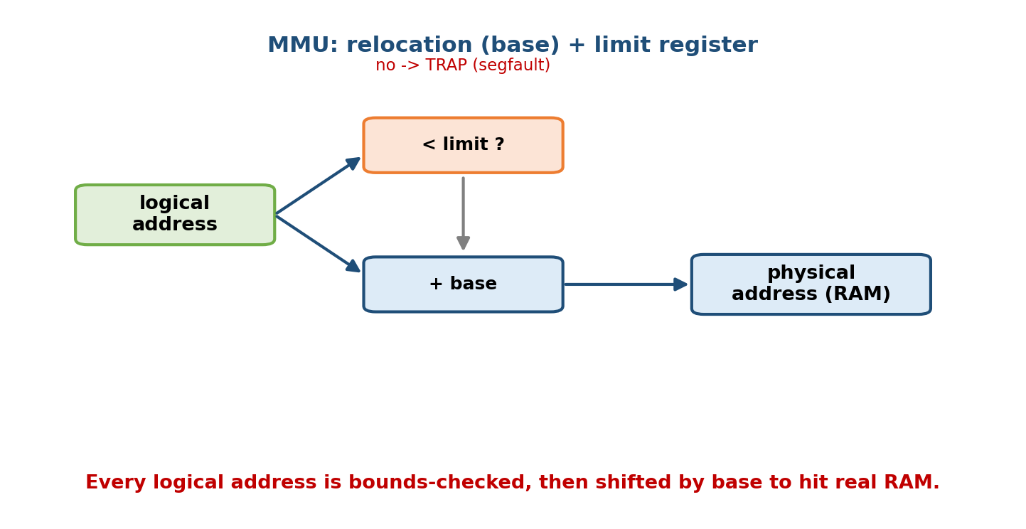
The MMU adds the relocation (base) register to each logical address and checks it against the limit register, turning the program’s view into a real RAM address while trapping out-of-bounds accesses.
Translation + protection, per reference:
if (logical_address < limit):
physical_address = base + logical_address # OK
else:
trap to OS -> addressing error (segfault) # protection!
Worked example: base = 14000, limit = 3000. A logical address 346 → physical 14000 + 346 = 14346 (valid, since 346 < 3000). A logical address 3500 → 3500 ≥ 3000 → trap (out of bounds; the OS kills the process).
Why two registers give protection for free: the limit check means a process cannot form a physical address outside its own region — it physically cannot read or write another process’s memory. This is the hardware root of memory isolation.

MCQs
- Hardware that maps logical → physical at run time? → the MMU.
- What is added to every logical address in the simplest MMU? → the relocation (base) register.
- What enforces that a process stays in its region? → the limit register check.

9.3 Contiguous Allocation and Fragmentation

The idea
In contiguous allocation, each process gets one single, continuous block of RAM. The OS tracks free regions (holes) and, when a process arrives, finds a hole big enough. Simple — but it leads directly to the fragmentation problem that motivates paging.

Two kinds of fragmentation (know both cold)
- External fragmentation — enough total free memory exists, but it is scattered into many small non-contiguous holes, so no single hole is big enough. Wasted space is between allocations. Contiguous allocation’s curse.
- Internal fragmentation — memory is handed out in fixed-size chunks, so a process gets a bit more than it asked for; the leftover inside its chunk is wasted. Wasted space is within an allocation. Paging’s small cost (last page).
Memory hook: External = wasted Everywhere between blocks; Internal = wasted Inside a block. Paging cures external fragmentation but introduces a little internal fragmentation (the partly filled last page).

Placement algorithms — First / Best / Worst fit
Given a list of free holes and a process needing memory, which hole do we pick? Three classic strategies:
Strategy | Rule | Tendency
First fit | first hole that is big enough (scan from start) | fast; leaves fragments near the front
Best fit | smallest hole that fits (least leftover) | least immediate waste, but many tiny unusable slivers; slow (scan all)
Worst fit | largest hole (most leftover) | tries to keep leftovers usable; usually worst in practice
Worked example (a GATE favourite). Free holes in order: 100, 500, 200, 300, 600 KB. Requests arrive as P1=212, P2=417, P3=112, P4=426 KB. Which strategy places all four?
First fit (first hole ≥ request):
P1 212 -> 500 (leftover 288) holes: 100, [288], 200, 300, 600
P2 417 -> 600 (leftover 183) holes: 100, 288, 200, 300, [183]
P3 112 -> 288 (leftover 176) holes: 100, [176], 200, 300, 183
P4 426 -> no hole >=426 remains -> P4 must WAIT (FAILS)
Best fit (smallest hole ≥ request):
P1 212 -> 300 (leftover 88) holes: 100, 500, 200, [88], 600
P2 417 -> 500 (leftover 83) holes: 100, [83], 200, 88, 600
P3 112 -> 200 (leftover 88) holes: 100, 83, [88], 88, 600
P4 426 -> 600 (leftover 174) ALL FOUR PLACED (BEST)
Worst fit (largest hole):
P1 212 -> 600 (leftover 388)
P2 417 -> 500 (leftover 83)
P3 112 -> 388 (leftover 276)
P4 426 -> largest remaining is 300/276 ... none >=426 -> P4 WAITS (FAILS)
Takeaway: here best fit wins (fits all four); first and worst fit both strand P4. In general no strategy is always best — but first fit is fastest and best fit tends to leave tiny useless slivers. Studies show first fit and best fit both beat worst fit; and even best fit can waste ~1/3 of memory to external fragmentation (the 50-percent rule: for N allocated blocks, ~0.5N are lost to fragmentation).

Compaction — the expensive cure for external fragmentation
Compaction slides all allocated blocks together at one end, merging the scattered holes into one big hole. It only works with execution-time binding (§9.1) because processes physically move. It is costly (copy lots of memory, processes paused) — which is exactly why we prefer paging, which avoids external fragmentation without ever compacting.
before: [P1][ hole ][P2][ hole ][P3][ hole ]
after: [P1][P2][P3][ one big hole ] <- compacted

MCQs
- Scattered free memory too small to use? → external fragmentation.
- Leftover inside a fixed chunk? → internal fragmentation.
- Fastest placement strategy? → first fit.
- Cure for external fragmentation (contiguous)? → compaction (needs execution-time binding).

9.4 Paging — The Central Scheme

The big idea (first principles)
Paging eliminates external fragmentation by dropping the requirement that a process occupy contiguous physical memory. We chop memory into equal-sized pieces:
- Page — a fixed-size block of the logical address space.
- Frame — a fixed-size block of physical memory, same size as a page (typically 4 KB).
Any page can go in any free frame — the process’s memory can be scattered all over RAM, and the page table records where each page landed. Because frames are all the same size, any free frame fits any page, so external fragmentation vanishes (the only waste is internal fragmentation in the last page).

Address translation — the heart of it (must know)
The MMU splits every logical address into two parts using the page size:
logical address = [ page number p | page offset d ]
high bits low bits
p = logical_address / page_size (which page)
d = logical_address % page_size (byte within the page)
page table[p] = f (the frame that holds page p)
physical address = f * page_size + d = [ frame number f | offset d ]
The offset d is copied unchanged; only the page number p is translated into a frame number f via the page table. If the page size is a power of two (always), this is just bit slicing — no division needed.
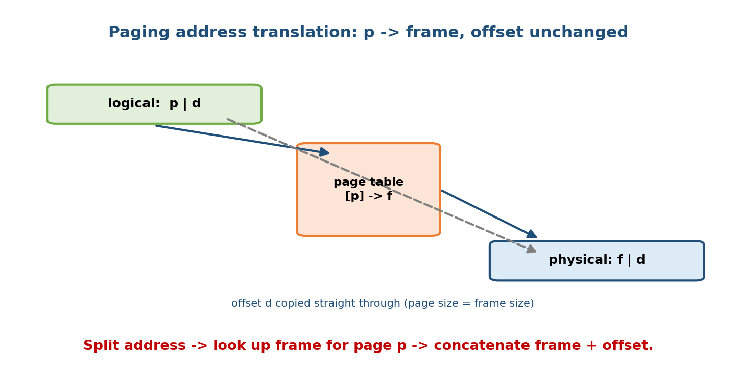
Paging address translation: the CPU’s logical address splits into page number p and offset d; the page table maps p to frame f; the physical address is frame f concatenated with the unchanged offset d.
Worked example 1 (decimal). Page size = 1 KB = 1024 B. Logical address = 3500. Then p = 3500 / 1024 = 3, d = 3500 mod 1024 = 3500 − 3072 = 428. If the page table says page 3 → frame 6, the physical address is 6 × 1024 + 428 = 6144 + 428 = 6572.
Worked example 2 (bit slicing). A 32-bit logical address with a 4 KB page (2^12). Then the low 12 bits are the offset d, and the high 20 bits are the page number p (so there are 2^20 ≈ 1 million pages per process). No arithmetic — just read the bit fields.
Memory hook: offset never changes — a page and its frame are the same size, so “byte 428 of the page” is “byte 428 of the frame.” Paging only reroutes which block, never where inside it.

Page-table size numericals (high yield)
A page table has one entry (PTE) per logical page. So:
number of pages = logical_address_space / page_size
page-table size (bytes) = number_of_pages * PTE_size
Worked example. Logical address space = 4 GB = 2^32, page size = 4 KB = 2^12, each PTE = 4 bytes. Then #pages = 2^32 / 2^12 = 2^20 (≈ 1,048,576 entries), so the page table is 2^20 × 4 B = 4 MB per process. With hundreds of processes, that is a lot of RAM spent just on page tables — which is exactly why we need multi-level and inverted page tables (§9.6–9.7).
Frame-number field width. If physical memory is 2^m bytes and frames are 2^k bytes, the frame number needs m − k bits, so a PTE is at least that many bits (plus valid/dirty/protection bits — see §9.10).

Where the page table lives
The page table sits in main memory; a page-table base register (PTBR) points to it, and a page-table length register (PTLR) bounds it. But this creates a problem: every memory access now needs two memory accesses — one to read the page table, one to read the actual data. That doubles memory latency — which the TLB (next section) fixes.

MCQs
- Paging eliminates which fragmentation? → external.
- A logical address splits into? → page number + offset.
- Does the offset change during translation? → no (copied unchanged).
- Page size 1 KB, logical address 3500 → page number and offset? → 3 and 428.
- 2^32 space, 4 KB pages, 4-B PTE → page-table size? → 2^20 × 4 = 4 MB.

9.5 The TLB and Effective Access Time (very high yield)

The problem and the fix
Because the page table is in RAM, a naive paged system needs two memory accesses per reference (page table, then data). The Translation Lookaside Buffer (TLB) is a small, fast associative cache (typically 64–1024 entries) inside the MMU that stores recently used (page → frame) mappings.
- TLB hit — the mapping is in the TLB → get the frame immediately (no page-table lookup), then one access for the data.
- TLB miss — not in the TLB → do the page-table lookup in RAM (an extra access), load that mapping into the TLB, then access the data.
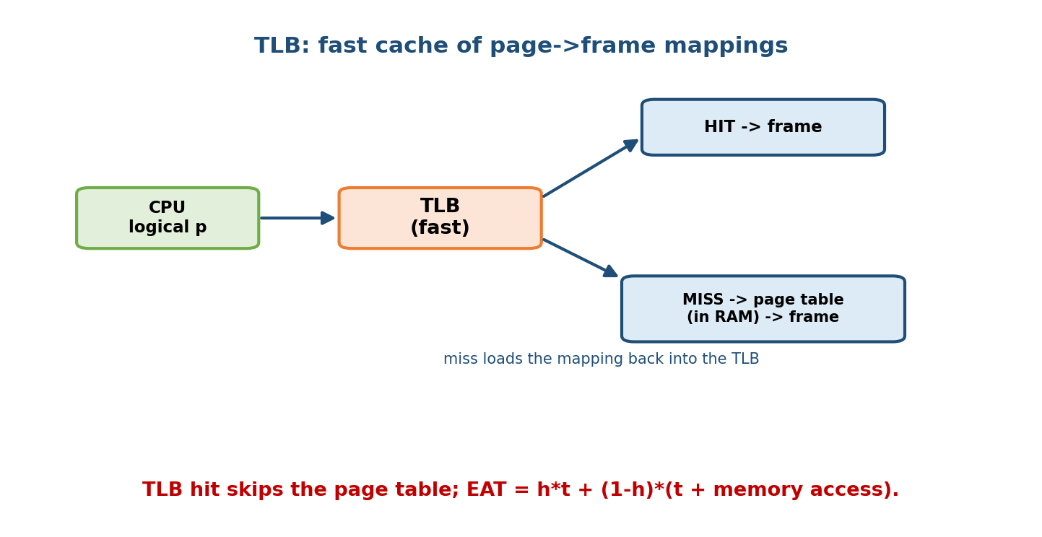
TLB path: the MMU first checks the fast TLB for the page-to-frame mapping (a hit skips the page table); a miss falls back to the in-memory page table and then loads the mapping into the TLB.
Why it works — locality. Programs reuse the same few pages intensely (loops, the stack, a hot data structure), so a small TLB catches the vast majority of references. Real hit ratios are typically ~98–99%.

Effective Access Time (EAT) — the formula you must be able to apply
EAT = h * (TLB_time + mem_time) + (1 - h) * (TLB_time + 2 * mem_time)
h = TLB hit ratio
TLB_time = time to search the TLB
mem_time = one main-memory access
on a hit : TLB search + 1 memory access (data)
on a miss: TLB search + 1 memory access (page table) + 1 memory access (data)
Worked example 1. TLB search = 20 ns, memory access = 100 ns, hit ratio h = 0.80. EAT = 0.80 × (20 + 100) + 0.20 × (20 + 100 + 100) = 0.80 × 120 + 0.20 × 220 = 96 + 44 = 140 ns. (Compare: no paging = 100 ns; naive paging with no TLB = 200 ns; the TLB got us most of the way back.)
Worked example 2 (the “TLB time negligible” variant many books use). If the TLB search time is ignored, EAT = h·m + (1−h)·2m. With h = 0.98, m = 100 ns: EAT = 0.98×100 + 0.02×200 = 98 + 4 = 102 ns — only 2% slowdown. That is why paging is practical.
Exam trap: read the question carefully — some give TLB time separately (add it on both hit and miss), others say “assume TLB access negligible.” Also watch whether a miss re-reads the TLB or not; the standard model above adds TLB_time once on both paths.

MCQs
- What does the TLB cache? → recent (page → frame) mappings.
- A TLB hit needs how many memory accesses for the data? → one.
- A TLB miss needs how many memory accesses total? → two (page table + data).
- EAT with TLB=20 ns, mem=100 ns, h=0.8? → 140 ns.
- Why does the TLB work so well? → locality of reference.

9.6 Multi-Level Paging (why, and the 2-level walk)

The problem it solves
We saw a single flat page table can be 4 MB per process (§9.4) — and it must be contiguous in RAM. For a 64-bit address space it would be absurdly huge. Multi-level (hierarchical) paging solves this by paging the page table itself: we split the page number into pieces and use a tree of small tables, so only the parts we actually use need to exist in memory.

The 2-level scheme (the classic example)
Take a 32-bit address, 4 KB pages (12-bit offset), so the page number is 20 bits. Split those 20 bits into 10 + 10:
logical address = [ p1 (10 bits) | p2 (10 bits) | offset (12 bits) ]
p1 -> index into the OUTER page table (page directory), 1024 entries
outer[p1] -> address of an INNER page table
p2 -> index into that INNER page table, 1024 entries
inner[p2] -> frame number f
physical address = f * 4KB + offset
Each inner table has 2^10 = 1024 entries × 4 B = 4 KB = exactly one page — elegant. The win: a process using little memory needs the outer table plus just a few inner tables, not a full 4 MB. The cost: a TLB miss now needs two page-table memory accesses (outer, then inner) — three total including the data — which is why the TLB matters even more here.
Memory hook: multi-level paging is a table of contents pointing to chapters. You don’t print every chapter of a 1000-chapter book — you keep the short table of contents and only the chapters you’re reading. (x86-64 uses 4 levels; some CPUs now use 5 for even larger address spaces.)

MCQs
- Why multi-level paging? → to avoid one huge contiguous page table (only allocate the parts in use).
- 32-bit address, 4 KB page, 10/10 split — entries per level? → 1024 each.
- A TLB miss with 2-level paging costs how many memory accesses? → 3 (two tables + data).

9.7 Inverted Page Tables
A normal page table has one entry per logical page, per process — enormous when address spaces are large. An inverted page table (IPT) flips this: it has one entry per physical frame — so its size depends on RAM size, not on the number/size of processes. There is one IPT for the whole system.
Each entry stores ⟨process id, page number⟩ — which process’s which page currently occupies that frame. To translate, the MMU searches the IPT for a matching ⟨pid, p⟩; the index where it’s found = the frame number.
physical memory has F frames -> IPT has exactly F entries
IPT[i] = <pid, page#> means frame i holds page (page#) of process (pid)
translate <pid, p>: find i such that IPT[i] == <pid, p> -> frame = i
- Pro: dramatically less memory for page tables (one table sized to RAM).
- Con: translation is now a search, not a direct index → slow. Fixed with a hash table on ⟨pid, p⟩ (a hashed inverted page table) and, of course, the TLB for the common case. Also, sharing pages between processes is awkward (an entry maps to only one ⟨pid, p⟩).
Memory hook: normal page table asks “where did page p go?”; inverted page table asks “who lives in frame i?” — one row per frame, not per page.

MCQs
- Inverted page table has one entry per? → physical frame.
- Its size depends on? → physical memory size (not process count).
- Its main drawback and the fix? → translation is a search; use a hash table (+ TLB).

9.8 Segmentation (and Segmentation with Paging)

The idea
Paging is invisible to the programmer and ignores a program’s logical structure. Segmentation instead matches the programmer’s view: memory is a collection of variable-length segments — one for code, one for the stack, one for the heap, one per data array, etc. Each has a name/ number and a length.
A logical address is ⟨segment number s, offset d⟩. A segment table gives, per segment, a base (physical start) and a limit (length):
logical address = [ segment number s | offset d ]
if d < limit[s]:
physical_address = base[s] + d # like a per-segment relocation
else:
trap -> segmentation fault # protection
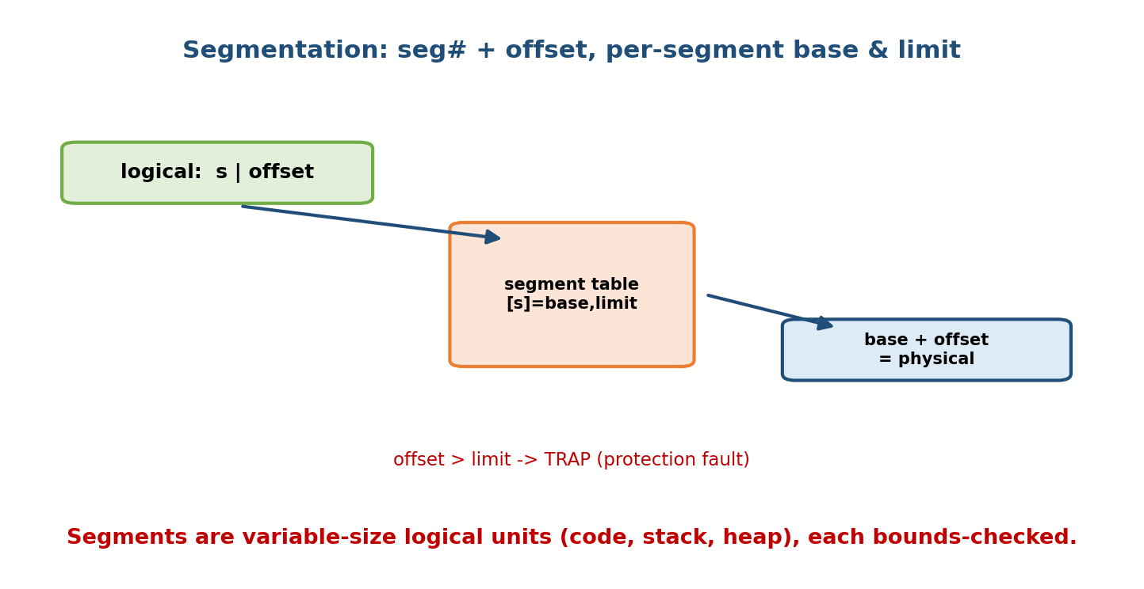
Segmentation: a logical address is a segment number plus an offset; the segment table gives each segment a base and a limit, so the offset is bounds-checked and then added to the base to form the physical address.
Worked example. Segment table: seg0 base=1400 limit=1000, seg1 base=6300 limit=400. Address ⟨seg0, 246⟩ → 246 < 1000 → physical 1400 + 246 = 1646. Address ⟨seg1, 500⟩ → 500 ≥ 400 → trap (seg fault).
- Pro: natural sharing (share the code segment), per-segment protection (read-only code, no-execute data), grows/shrinks logically.
- Con: segments are variable-length → back to external fragmentation (the very thing paging cured!).

Segmentation with paging (best of both)
Combine them: segment the address space (for the logical structure and protection), then page each segment (so physical allocation is frame-based and free of external fragmentation). Translation: ⟨s, d⟩ → segment table gives the segment’s page table → page the offset d normally.
- x86 (32-bit) historically used exactly this (segmentation then paging).
- Modern x86-64 essentially flattens segmentation and relies on paging — segmentation is largely legacy, but the concept is still tested.
Exam one-liner: paging kills external fragmentation but has a little internal; pure segmentation has external fragmentation but no internal; segmentation + paging gives segmentation’s structure with paging’s clean physical allocation.

MCQs
- A segmentation logical address is? → ⟨segment number, offset⟩.
- What does a segment-table entry hold? → base + limit.
- Segmentation suffers which fragmentation? → external (variable-length).
- What does segmentation-with-paging fix? → external fragmentation within segments.

9.9 Kernel Memory Allocators — Buddy, Slab, and Huge Pages
User memory is managed by paging; but the kernel itself needs to allocate memory (for page tables, PCBs, network buffers, etc.) with special constraints — some must be physically contiguous (for DMA), and allocation must be fast with little fragmentation. Linux uses two allocators.

Buddy allocator (physically contiguous blocks)
The buddy system manages memory in blocks that are powers of two pages (1, 2, 4, 8, … pages). To satisfy a request, it finds the smallest power-of-two block that fits, splitting larger blocks in half repeatedly; each half is the other’s “buddy.” When both buddies become free, they coalesce back into the larger block — which keeps external fragmentation low.
request 65 KB, page = 4 KB -> need >= 17 pages -> round up to 32 pages (128 KB)
split a 1 MB (256-page) block:
1 MB -> 512 KB + 512 KB
512 KB -> 256 KB + 256 KB
256 KB -> 128 KB + 128 KB <- allocate one 128 KB block; keep buddies to coalesce later
- Pro: fast, and coalescing limits external fragmentation.
- Con: internal fragmentation — rounding 65 KB up to 128 KB wastes ~63 KB (requests that aren’t near a power of two waste up to nearly half a block).

Slab allocator (many small same-size kernel objects)
The kernel constantly allocates/frees many identical small objects (e.g. task_struct, inodes, file structs). The slab allocator keeps a cache per object type; each cache holds slabs (one or more contiguous pages) carved into fixed object-sized slots.
- Allocation = grab a pre-formatted free slot: O(1), no fragmentation (slots exactly fit the object), and objects can be kept pre-initialized for reuse.
- Sits on top of the buddy allocator (slabs come from buddy pages).
- Linux variants: SLAB, SLUB (the modern default), SLOB (tiny systems).
Memory hook: buddy = keep halving big blocks until one fits (and coalesce buddies back); slab = a muffin tin of identical slots for one object type — pop one out instantly, drop it back when done.

Huge pages
Default pages are 4 KB. A memory-hungry process (a database, JVM, ML model) touching many GB needs millions of PTEs, and its working set overflows the TLB, causing constant TLB misses. Huge pages (e.g. 2 MB or 1 GB on x86-64) make each TLB entry cover far more memory, so one entry maps 2 MB/1 GB instead of 4 KB — drastically fewer TLB misses and smaller page tables.
- Pro: fewer TLB misses, less page-table overhead → big speedups for large working sets.
- Con: more internal fragmentation (a partly used 2 MB page wastes more), harder to allocate contiguously. Linux exposes them via HugeTLB and Transparent Huge Pages (THP).

MCQs
- Allocator that splits/coalesces power-of-two blocks? → buddy.
- Buddy’s main downside? → internal fragmentation (power-of-two rounding).
- Allocator for many identical small kernel objects? → slab.
- Why huge pages? → fewer TLB misses / smaller page tables for large working sets.

9.10 Memory Protection Bits (in the page/segment table)
Each page-table (or segment-table) entry carries control bits the MMU checks on every access — the hardware basis of protection and, later, virtual memory:
Bit | Meaning
Valid / invalid | is this page mapped? invalid → trap (used for demand paging in M10)
Protection (R/W/X) | read / write / execute permissions; violating them → trap
Dirty (modified) | page was written since load → must be written back before eviction (M10)
Reference (accessed) | page was used recently → drives LRU-approx replacement (M10)
Caching / no-cache | for memory-mapped device registers
These bits are why paging gives protection almost for free, and they are the exact hooks Module 10 uses: the valid bit triggers a page fault, the dirty bit decides whether to write a page back, and the reference bit powers the clock (second-chance) replacement algorithm.

MCQs
- Which bit triggers a page fault when a page isn’t in RAM? → valid/invalid.
- Which bit says a page must be written back before eviction? → dirty.
- Which bit powers clock/second-chance replacement? → reference (accessed).

9.11 Real-World & Backend Perspectives
- Every process you run gets its own virtual address space via paging; ps/top “VIRT” is the logical space, “RES” (RSS) is the frames actually in RAM. This module is literally what those columns mean.
- Databases and JVMs enable huge pages to cut TLB misses on multi-GB heaps/buffer pools — a real, measurable production tuning knob.
- malloc sits on top of paging: the C library gets big regions from the kernel (mmap/brk) and sub-allocates; user-space fragmentation is a cousin of §9.3’s problem. Slab-style object pools in app code mirror the kernel’s slab allocator.
- Security: the no-execute (NX) protection bit (§9.10) stops code execution from data pages, blocking classic stack-smashing exploits; ASLR randomizes segment/base placement.
- Containers/VMs: a hypervisor adds a second translation layer (guest virtual → guest physical → host physical), handled by nested/extended page tables — paging on paging.

9.12 Tradeoffs, Common Mistakes, Edge Cases
Common mistakes (exam + real life)
- Swapping internal vs external fragmentation (paging → internal; contiguous/segmentation → external).
- Forgetting the offset is unchanged in paging translation.
- In page-table-size problems, using physical space instead of logical space for the number of entries (entries = logical pages).
- In EAT problems, forgetting the miss path has two memory accesses (page table + data), or mishandling whether TLB time is added.
- Thinking segmentation cures external fragmentation — it causes it (variable-length).
- Assuming best fit is “best”: it often leaves many tiny unusable holes and is slow.
Edge cases
- Page size tradeoff: larger pages → smaller page tables & fewer TLB misses, but more internal fragmentation; smaller pages → less waste, but bigger tables & more TLB pressure.
- A TLB miss under multi-level paging costs more memory accesses (one per level) — the TLB matters more as levels grow.
- With execution-time binding you can compact/relocate; with compile/load binding you cannot.
Tradeoffs
Choice | Gains | Costs
Paging | no external frag; easy allocation | some internal frag; extra access (TLB fixes)
Larger page / huge pages | fewer PTEs & TLB misses | more internal fragmentation
Multi-level page table | only allocate what’s used | more accesses per TLB miss
Inverted page table | tiny (sized to RAM) | search cost; sharing is hard
Best fit | least immediate waste | slow; tiny sliver holes

9.13 Exam, Interview & Coding Perspectives
Exam (SEBI/RBI/GATE): address-translation numericals (page#, offset, physical address); page-table size calculations; EAT with TLB hit ratio; first/best/worst fit placement; internal vs external fragmentation; multi-level vs inverted page tables; segmentation base+limit; buddy vs slab.
Interview: “What happens on a memory access, step by step?” (CPU → logical addr → TLB → page table → frame → data, with the fault path). “Why do we page?” (kill external fragmentation + enable virtual memory). “What is the TLB and why does it help?” (cache of translations; locality). “Internal vs external fragmentation?”
Coding/practical:
- getconf PAGE_SIZE (usually 4096); inspect /proc/<pid>/maps to see a process’s segments (code/heap/stack) and permissions.
- cat /proc/meminfo | grep Huge to see huge-page config; /proc/buddyinfo for the buddy allocator’s free-block orders; /proc/slabinfo for slab caches.

9.14 Concept Checks & MCQs
- Address the CPU generates? → logical (virtual).
- Hardware doing run-time translation? → MMU.
- Three address-binding times? → compile / load / execution time.
- Binding that allows moving a running process? → execution-time.
- Base register does what to a logical address? → adds to it (relocation).
- Limit register does what? → bounds-checks (protection).
- External vs internal fragmentation? → wasted between blocks vs inside a block.
- Cure for external fragmentation in contiguous allocation? → compaction.
- Fastest placement policy? → first fit.
- Best-fit weakness? → tiny sliver holes; slow.
- Paging eliminates which fragmentation? → external.
- Logical address parts in paging? → page number + offset.
- Page size 1 KB, logical 3500, page 3→frame 6 → physical? → 6572.
- 2^32 space, 4 KB page, 4-B PTE → page-table size? → 4 MB.
- What does the TLB store? → recent page→frame mappings.
- EAT (TLB=20, mem=100, h=0.8)? → 140 ns.
- Why multi-level paging? → avoid one huge contiguous table.
- Inverted page table entry count = ? → number of physical frames.
- Segment-table entry holds? → base + limit.
- Segmentation suffers which fragmentation? → external.
- Buddy allocator manages blocks of size? → powers of two (pages).
- Slab allocator is best for? → many identical small kernel objects.
- Huge pages help by? → reducing TLB misses / page-table size.
- Bit that triggers a page fault? → valid/invalid.
True/False
- Paging causes external fragmentation. → False (it cures it; causes a little internal).
- The offset changes during paging translation. → False.
- Execution-time binding is needed for compaction. → True.
- A TLB miss needs two memory accesses (single-level). → True (page table + data).
- Inverted page-table size grows with the number of processes. → False (with RAM size).
- Segmentation with paging removes external fragmentation. → True.
Numerical (do it):
Logical address space 2^24 bytes, page size 2^10 bytes (1 KB), PTE = 2 bytes. #pages = 2^24 / 2^10 = 2^14 = 16384. Page-table size = 2^14 × 2 = 2^15 = 32 KB. A logical address 12345 → page = 12345 / 1024 = 12, offset = 12345 − 12×1024 = 12345 − 12288 = 57.
TLB hit ratio h = 0.90, memory access 200 ns, TLB search negligible. EAT = 0.90×200 + 0.10×(2×200) = 180 + 40 = 220 ns.

9.15 One-Page Revision Sheet
LOGICAL(virtual, CPU view) --MMU--> PHYSICAL(RAM). offset copied; only page/seg # translated.
BINDING times: COMPILE(absolute) / LOAD(relocatable, loader) / EXECUTION(run-time, MMU, movable).
MMU: physical = BASE(relocation) + logical, if logical < LIMIT else TRAP. => isolation for free.
CONTIGUOUS ALLOC -> EXTERNAL fragmentation (scattered holes).
FIT: FIRST(fast, from start) | BEST(smallest fit, slivers, slow) | WORST(largest, usually worst).
COMPACTION cures external frag (needs execution-time binding). Paging avoids needing it.
FRAGMENTATION: EXTERNAL=wasted BETWEEN blocks | INTERNAL=wasted INSIDE a fixed chunk (last page).
PAGING (kills EXTERNAL frag; small INTERNAL):
page (logical) == frame (physical), same size (~4KB). page table: page p -> frame f.
logical = [p | d]; p=addr/pagesize, d=addr%pagesize; phys = f*pagesize + d. OFFSET UNCHANGED.
page-table size = (space/pagesize) * PTE. e.g. 2^32 / 2^12 * 4B = 4 MB/process.
page table in RAM -> naive = 2 accesses/ref.
TLB = cache of page->frame (assoc, in MMU). hit=1 mem access; miss=2 (table+data).
EAT = h(TLB + m) + (1-h)(TLB + 2m). e.g. TLB20,m100,h0.8 -> 0.8*120+0.2*220 = 140 ns.
works because of LOCALITY (real hit ~98-99%).
MULTI-LEVEL paging: page the page table (10|10|12 for 32-bit,4KB). only allocate used parts.
TLB miss cost = one access per level + data. x86-64 = 4 levels.
INVERTED page table: 1 entry per FRAME (system-wide), entry=<pid,page#>. size ~ RAM.
translate = SEARCH (use hash + TLB). sharing hard.
SEGMENTATION: logical=<seg#, offset>. seg table = BASE+LIMIT. matches program structure;
sharing/protection per segment. BUT variable-length -> EXTERNAL fragmentation.
SEG + PAGING = structure of segments + no external frag (page each segment). x86 legacy.
KERNEL ALLOC: BUDDY = power-of-two blocks, split/coalesce buddies (internal frag).
SLAB = per-object-type caches of fixed slots (O(1), no frag; on top of buddy). SLUB=default.
HUGE PAGES (2MB/1GB): fewer TLB misses + smaller tables; cost = more internal frag.
PROTECTION BITS in PTE: valid | R/W/X | dirty(writeback) | reference(LRU-approx) -> used in M10.

Flash cards
Front | Back
Logical vs physical address? | CPU’s view vs actual RAM location
Three binding times? | Compile / load / execution
MMU translation? | physical = base + logical (if < limit)
External vs internal fragmentation? | Between blocks vs inside a chunk
Fastest fit? | First fit
Paging eliminates? | External fragmentation
Paging address = ? | page number + offset (offset unchanged)
Page-table size formula? | (space / page size) × PTE size
What does the TLB cache? | Recent page→frame mappings
EAT formula? | h(TLB+m) + (1−h)(TLB+2m)
Multi-level paging: why? | Avoid one huge contiguous table
Inverted page table: entries? | One per physical frame
Segment table entry? | base + limit
Buddy vs slab? | Power-of-two blocks vs fixed same-size object slots
Huge pages help by? | Fewer TLB misses / smaller tables

Spaced repetition
- 24-hour: redo one address-translation, one page-table-size, and one EAT numerical from scratch.
- 7-day: explain first/best/worst fit on a hole list; internal vs external fragmentation; the full CPU→TLB→page-table→data path.
- 30-day: compare paging vs segmentation vs seg+paging; buddy vs slab; and justify huge pages for a large-working-set app — all without notes.

9.16 Summary
Memory management lets many processes share one finite RAM safely and with the illusion of a private space. It starts with logical vs physical addresses and address binding (compile / load / execution time — the last needs the MMU and enables everything modern). The simplest MMU uses base + limit registers for relocation and protection. Contiguous allocation is simple but breeds external fragmentation (managed with first/best/worst fit and cured only by expensive compaction). Paging is the great fix: equal-size pages map to frames via a page table, killing external fragmentation; translation splits an address into page number + offset (offset unchanged), and the TLB rescues the doubled access cost — quantified by the EAT formula. Multi-level and inverted page tables tame page-table size; segmentation matches program structure (at the cost of external fragmentation), and segmentation with paging combines both. Finally, the kernel’s own buddy and slab allocators and huge pages round out how real systems allocate memory, and the protection bits in each PTE set up the next module.
Next, Module 10 — Virtual Memory Internals removes the last constraint — a process no longer needs to fully fit in RAM. Using the valid bit and page faults from §9.10, we do demand paging, choose victims with page replacement algorithms (FIFO, Optimal, LRU, clock), and confront thrashing.
You have mastered this module when you can: translate a logical address to physical for paging and segmentation by hand; compute page-table size and EAT from given numbers; run first/best/worst fit on a hole list; explain internal vs external fragmentation and how paging/segmentation/compaction relate to each; and describe multi-level, inverted, buddy, slab, and huge pages — all without notes.

