Module 10 — Virtual Memory Internals
  - OS Mastery: SEBI IT / RBI / NABARD / GATE / C-DAC / Interview / Backend — In-Depth Notes (with visuals)
Prepared for nidhi.sharma@forensiccybertech.com
2026
Table of Contents

Module 10 — Virtual Memory Internals
Where this module sits. Module 9 made many processes share RAM through paging — but every page of a running process still had to be physically present in memory. Virtual memory removes that final constraint: a process can run even if only part of it is in RAM, so programs can be larger than physical memory and far more of them can run at once. The magic hook is the valid bit from §9.10 — touch a page that isn’t resident and the hardware raises a page fault, which the OS quietly services by fetching the page from disk. That single mechanism gives us demand paging, and it forces the two biggest questions of this module: which page do we evict when RAM is full (page-replacement algorithms) and what happens when there isn’t enough RAM to go around (thrashing). This is a GATE goldmine — page-fault counting on a reference string (FIFO, Optimal, LRU) and Belady’s anomaly appear almost every year.
Importance ratings (out of 5):
Exam / Use | SEBI IT | RBI IT | GATE CS | Interview | Backend
This module | ★★★★ | ★★★★ | ★★★★★ | ★★★ | ★★★★
Most-asked PYQ concepts (SEBI / RBI / GATE / C-DAC): page fault & step-by-step handling; demand paging (pure demand paging); page-replacement algorithms with page-fault counts — FIFO, Optimal (OPT), LRU, clock/second-chance; Belady’s anomaly; frame allocation (equal vs proportional); thrashing + working-set model + page-fault frequency; copy-on-write (fork); memory-mapped files; shared memory; memory protection bits.

10.1 What Is Virtual Memory?
Virtual memory is a technique that lets a process execute while only some of its pages are in physical memory; the rest sit on disk (in a swap area / page file) and are brought in on demand. The process is given a large, contiguous virtual address space that is bigger than physical RAM; the OS + MMU maintain the illusion.
Why it is transformative:
- Programs can exceed RAM — a 4 GB program runs on a 1 GB machine.
- Higher multiprogramming — each process occupies less RAM, so more processes fit, keeping the CPU busier.
- Faster start-up & less I/O — load only what’s actually used (a huge binary starts instantly; unused features never load).
- Enables shared pages, copy-on-write, and memory-mapped files (§10.9–10.11).
Memory hook: virtual memory is a library with a small reading desk. You don’t carry the whole library (disk) to your desk (RAM) — you fetch a book (page) only when you open it, and return one to the shelf when the desk is full.

MCQs
- Virtual memory lets a program be? → larger than physical RAM.
- Where do non-resident pages live? → on disk (swap / page file).
- One key benefit besides “big programs”? → higher degree of multiprogramming.

10.2 Demand Paging and the Page Fault

Demand paging
In demand paging, a page is loaded into RAM only when it is referenced — never in advance. Each PTE has a valid/invalid bit (§9.10):
- valid → the page is in RAM at the recorded frame.
- invalid → the page is not in memory (it’s on disk, or illegal). Touching it raises a page fault.
Pure demand paging takes this to the extreme: start a process with zero pages in memory. The very first instruction faults, its page is brought in, and the process pages everything in purely on demand — nothing is pre-loaded.

The page fault — full step-by-step handling (know this cold)
A page fault is a trap raised by the MMU when a program references a page whose PTE is invalid. The OS handles it as follows:
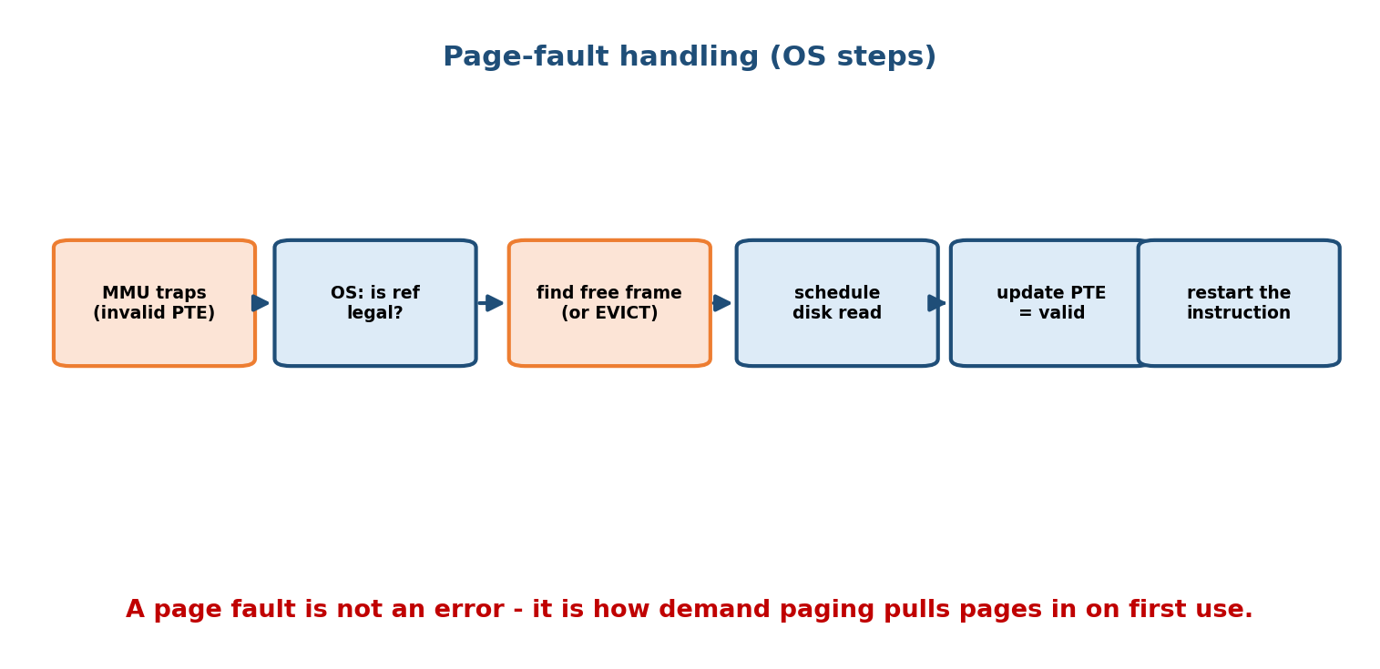
Page-fault handling: the MMU traps on an invalid PTE; the OS checks the reference is legal, finds a free frame (or evicts a victim), schedules the disk read of the page, updates the page table to valid, and restarts the faulting instruction.
1. MMU checks PTE -> valid bit = invalid -> TRAP to the OS (page fault).
2. OS checks an internal table: is the reference LEGAL?
illegal (outside address space) -> terminate process (segfault).
legal but not resident -> continue below.
3. Find a FREE FRAME (from the free-frame list).
none free -> run PAGE REPLACEMENT: pick a VICTIM frame;
if victim is DIRTY, write it back to disk first.
4. Schedule a DISK READ to load the desired page into the frame.
(process is BLOCKED; CPU may run another process meanwhile)
5. Disk read completes -> interrupt. Update the PAGE TABLE:
set frame number, set valid bit = valid.
6. RESTART the instruction that faulted -> now the access succeeds.
Key subtlety — instruction restart. A page fault can occur in the middle of an instruction (e.g. a block-move touching two pages). The hardware must restart the whole instruction cleanly after the page is in — otherwise state would be corrupted. This is why page-fault handling needs careful hardware support.
Effective access time with page faults (a numerical you may see). Let p = page-fault rate, ma = memory-access time, pf = page-fault service time. Then EAT = (1 − p) × ma + p × pf. Worked: ma = 200 ns, pf = 8 ms = 8,000,000 ns, p = 0.001 (1 in 1000). EAT = 0.999 × 200 + 0.001 × 8,000,000 ≈ 200 + 8000 = ~8200 ns — a ~40× slowdown from just 0.1% faults! This is why keeping the fault rate tiny (via good replacement + enough frames) is everything.

MCQs
- When is a page loaded in demand paging? → only when referenced (on the fault).
- What raises a page fault? → referencing a page whose PTE is invalid.
- Pure demand paging starts a process with how many pages? → zero.
- After servicing a fault, what does the CPU do? → restart the faulting instruction.

10.3 Page Replacement — The Setup
When a page fault occurs and no frame is free, the OS must evict a resident page to make room — this is page replacement. We want the algorithm that yields the fewest page faults on a program’s reference string (the sequence of page numbers it accesses).
The universal procedure for tracing (and counting faults):
- Keep the set of pages currently in the frames.
- For each reference:
if the page is already in a frame -> HIT (no fault).
else -> FAULT:
if a free frame exists -> load it there.
else -> pick a VICTIM by the algorithm's rule,
evict it, load the new page.
- Page faults = number of misses. (The first N distinct pages are always faults =
"cold-start" / compulsory misses.)
We now trace FIFO, Optimal, and LRU on one standard reference string with 3 frames, so you can compare fault counts directly:
Reference string (Silberschatz standard): 7 0 1 2 0 3 0 4 2 3 0 3 2 1 2 0 1 7 0 1, with 3 frames, all initially empty.

10.4 FIFO and Belady’s Anomaly

FIFO (First-In, First-Out)
Rule: evict the page that has been in memory longest (the oldest arrival) — a simple queue, regardless of how heavily it’s used.
ref: 7 0 1 2 0 3 0 4 2 3 0 3 2 1 2 0 1 7 0 1
F F F F H F F F F F F H H F F H H F F F (F=fault,H=hit)
7 7 7 2 . 2 2 4 4 4 0 . . 0 2 . . 7 7 1 <- frame contents
0 0 0 . 3 3 3 2 2 2 . . 3 3 . . 1 1 7 (queue; oldest evicted)
1 1 . 1 0 0 0 3 3 . . 1 1 . . 2 2 0
Page faults = 15
FIFO is trivial but ignores usage — it can evict a heavily used page just because it arrived first, so it performs poorly.

Belady’s anomaly (a must-know exam trap)
Intuition says more frames → fewer faults. For FIFO this can be FALSE: adding a frame can increase faults. This is Belady’s anomaly.
Classic worked example. Reference string 1 2 3 4 1 2 5 1 2 3 4 5, using FIFO.
With 3 frames:
ref: 1 2 3 4 1 2 5 1 2 3 4 5
F F F F F F F H H F F H
Page faults = 9
With 4 frames:
ref: 1 2 3 4 1 2 5 1 2 3 4 5
F F F F H H F F F F F F
Page faults = 10
The anomaly: going from 3 → 4 frames made faults go 9 → 10 — more memory, more faults! Only FIFO (and some others) suffer this. Stack algorithms — LRU and OPT — are immune (their set of pages with n frames is always a superset of the set with fewer frames, so faults can never increase).

MCQs
- FIFO evicts which page? → the oldest (first-in).
- FIFO faults on the standard string, 3 frames? → 15.
- Belady’s anomaly means? → more frames → more faults (possible under FIFO).
- Which algorithms are immune to it? → LRU and Optimal (stack algorithms).

10.5 Optimal (OPT / MIN) — The Theoretical Best
Rule: evict the page that will not be used for the longest time in the future. This gives the provably lowest possible number of faults — but it needs future knowledge, so it’s unimplementable. It exists as the benchmark you measure real algorithms against.
ref: 7 0 1 2 0 3 0 4 2 3 0 3 2 1 2 0 1 7 0 1
F F F F H F H F H H F H H F H H H F H H
Page faults = 9 <- the minimum achievable on this string with 3 frames
How to pick the victim by hand: at a fault, look forward in the string for each resident page; the one whose next use is farthest away (or never used again) is the victim. Example at ref 2 (step 4), resident {7,0,1}: 7’s next use is far (position 18), 0’s is soon (position 5), 1’s is later (position 14) → evict 7 (farthest future use).

MCQs
- OPT evicts the page? → used farthest in the future.
- Why isn’t OPT implementable? → needs future knowledge.
- OPT faults on the standard string, 3 frames? → 9 (the minimum).

10.6 LRU and Its Approximations

LRU (Least Recently Used)
Rule: evict the page unused for the longest time — use the past as a proxy for the future (locality: recently used → likely used again). LRU is the best practical algorithm and is immune to Belady’s anomaly.
ref: 7 0 1 2 0 3 0 4 2 3 0 3 2 1 2 0 1 7 0 1
F F F F H F H F F F F H H F H F H F H H
Page faults = 12 <- between OPT (9) and FIFO (15)
Fault comparison on the standard string (3 frames):
Algorithm | Page faults | Note
Optimal (OPT) | 9 | theoretical best (needs the future)
LRU | 12 | best practical; immune to Belady
FIFO | 15 | simplest; suffers Belady’s anomaly
Ordering to remember: OPT ≤ LRU ≤ FIFO (Optimal is always best; LRU usually beats FIFO because it respects usage).

Why exact LRU is expensive
Exact LRU must know the recency order on every access. Implementations:
- Counters/timestamps — stamp each PTE with a clock on every reference; evict the smallest. Needs a memory write on every access + a search → costly.
- Stack — move the referenced page to the top of a doubly-linked stack; bottom = LRU. Costly pointer updates per reference.
Because both are too slow in hardware, real systems use approximations built on the reference (accessed) bit (§9.10).

Clock / Second-Chance (the practical LRU approximation)
Each frame has a reference bit the hardware sets to 1 on use. Frames sit in a circular list with a “clock hand.” On a fault, the hand advances:
- reference bit 1 → give a second chance: clear it to 0, move on.
- reference bit 0 → this is the victim; evict it, load the new page (bit 1).
ring of frames, each [page:refbit], hand -> advances until it finds refbit 0
fault: hand at [A:1] -> clear to [A:0], advance
[B:1] -> clear to [B:0], advance
[C:0] -> VICTIM: evict C, load new page as [X:1]
So a page gets a “second chance” if it’s been used since the hand last passed — approximating LRU with just O(1) work and a single bit, no timestamps.
- Enhanced second-chance uses (reference, dirty) as an ordered pair, preferring to evict (0,0) — not recently used and clean (no write-back) — before (0,1), (1,0), (1,1). Saves disk writes.
Memory hook: clock = a security guard walking a circle of doors. A door flagged “recently opened” (bit 1) gets its flag wiped and a second chance; the first door found already un-flagged (bit 0) is the one evicted.

MCQs
- LRU evicts the page? → least recently used (longest unused).
- LRU faults on the standard string, 3 frames? → 12.
- What bit does clock/second-chance use? → the reference (accessed) bit.
- Clock gives a page a second chance when its reference bit is? → 1 (clears it and moves on).
- Is LRU subject to Belady’s anomaly? → No (stack algorithm).

10.7 Frame Allocation — How Many Frames per Process?
With many processes, how do we split the free frames among them? Two schemes:
- Equal allocation — split frames equally: m frames, n processes → m/n each. Simple, but unfair to big processes and wasteful for tiny ones.
- Proportional allocation — give frames in proportion to process size: process i of size s_i gets a_i = (s_i / Σs) × m frames. Bigger processes get more.
Worked example. m = 62 frames, two processes: s1 = 10 KB, s2 = 127 KB. Proportional: a1 = (10/137)×62 ≈ 4.5 → 4, a2 = (127/137)×62 ≈ 57.5 → 57. (Compare equal: 31 each — the tiny process would waste most of its 31.)
Global vs local replacement (a separate, tested axis):
- Local replacement — a process may only evict its own frames; its fault rate depends only on its own behavior (predictable, but can’t borrow from idle processes).
- Global replacement — a process may evict any process’s frame; better throughput, but a process’s fault rate now depends on others (unpredictable, and a key ingredient of thrashing). Most systems use global.

MCQs
- Equal vs proportional allocation? → same count each vs by process size.
- Proportional frames for a 10 KB process of {10,127} KB with 62 frames? → ~4.
- Global replacement lets a process evict? → any process’s frame.

10.8 Thrashing, the Working-Set Model, and PFF

Thrashing (the failure mode)
If a process has too few frames to hold its active working set, it faults constantly — every fetched page immediately evicts another page it’s about to need again. The process spends more time paging than computing. When many processes do this at once (under global replacement, they steal each other’s frames), CPU utilization collapses — this is thrashing.
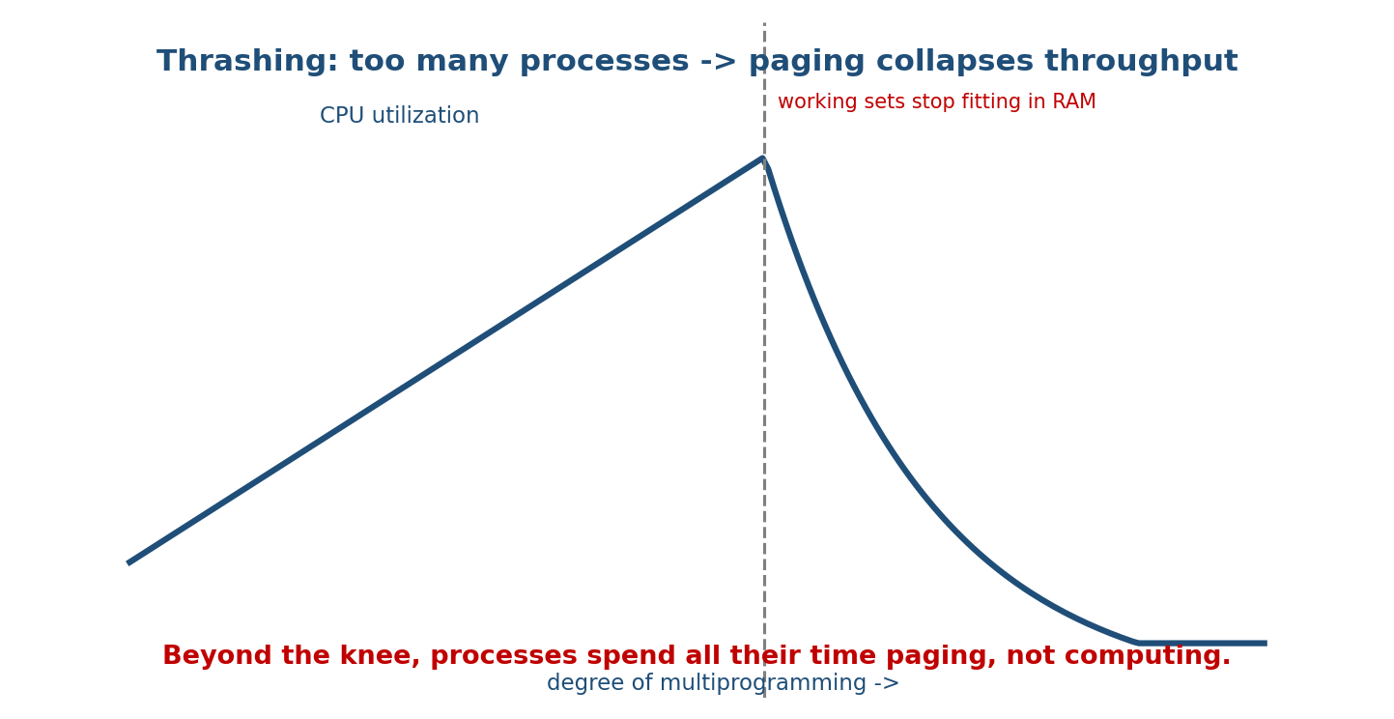
Thrashing curve: CPU utilization rises with the degree of multiprogramming until the working sets no longer fit in RAM, after which utilization collapses as processes spend all their time paging.
The classic trap. As you add processes, CPU utilization rises… then past a point it plunges: the scheduler, seeing idle CPU, adds even more processes (a vicious cycle), making it worse. The fix is to reduce the degree of multiprogramming (suspend/swap out some processes), not add more.

Working-set model (the principle behind the fix)
The working set W(t, Δ) is the set of distinct pages a process referenced in the last Δ references (its working-set window). By the locality principle, this is roughly the set it will need next.
- Let WSS_i = working-set size of process i. Total demand D = Σ WSS_i.
- If D > m (total frames) → thrashing. The OS should keep D ≤ m by suspending processes until demand fits.
- Give each process enough frames to hold its working set → it faults rarely.
Worked idea. Δ = 10 references, window = 2 6 1 5 7 7 7 5 1 6 → distinct pages {1,5,6,7} → WSS = 4 frames needed right now. If we grant ≥4 frames, this process runs smoothly; fewer, and it thrashes.

Page-Fault Frequency (PFF) — the practical control loop
Directly measuring the working set is expensive. PFF controls frames using the observed fault rate with an upper and lower bound:
if fault rate > UPPER bound -> process needs more locality -> GIVE it a frame.
if fault rate < LOWER bound -> it has spare frames -> TAKE a frame away.
if no frames to give and rate too high -> SUSPEND a process (reduce multiprogramming).
Memory hook: the working-set model predicts how many frames a process needs; PFF reacts to how many it’s actually short of. Both aim at the same target — keep each process’s hot pages resident so the fault rate stays low.

MCQs
- Thrashing is? → spending more time paging than computing (fault storm).
- Fix for thrashing? → reduce the degree of multiprogramming (suspend/swap out).
- Working set W(t,Δ) = ? → distinct pages used in the last Δ references.
- Thrashing condition? → Σ WSS > m (demand exceeds frames).
- PFF raises a process’s frames when its fault rate is? → above the upper bound.

10.9 Copy-on-Write (COW) — the trick behind fork
When a process calls fork(), the child is a copy of the parent’s entire address space — but copying every page immediately would be enormously wasteful, especially since the child often calls exec() right away and throws it all away. Copy-on-write avoids the copy:
- Parent and child share the same physical frames, all marked read-only.
- Reads by either just read the shared pages — no copying.
- The first write to a shared page triggers a protection fault; the OS then copies just that one page, makes the writer’s copy writable, and lets the write proceed.
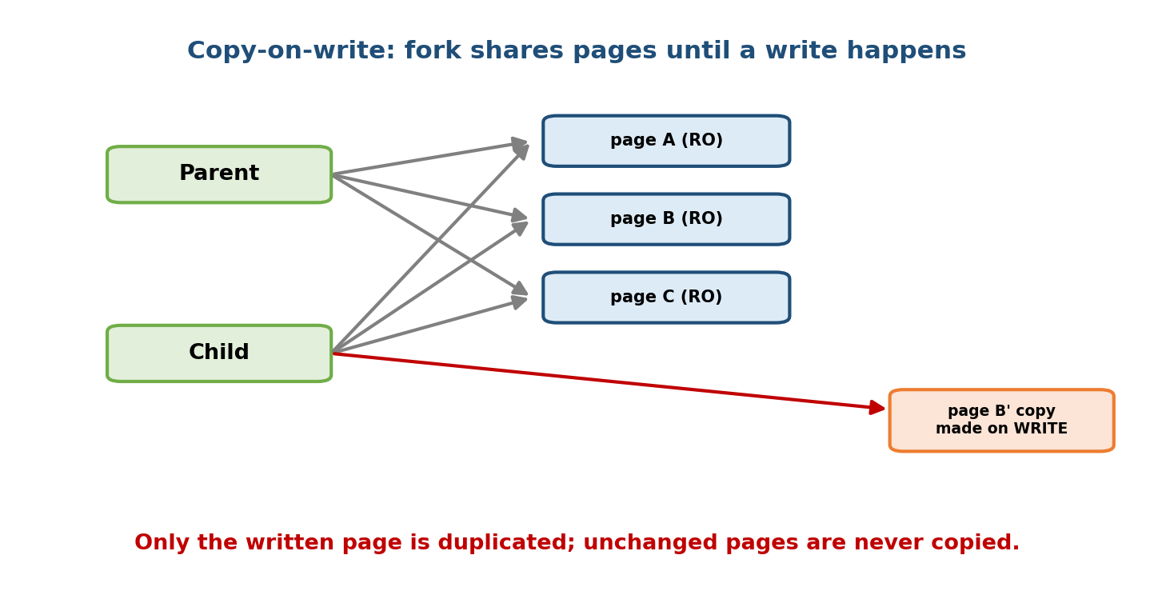
Copy-on-write after fork: parent and child share read-only frames; only when one writes a page does the OS duplicate that single page, so unmodified pages are never copied.
fork(): child page table = copy of parent's, ALL entries read-only, frames SHARED.
read: either process reads shared frame -> fine, nothing copied.
write P: protection fault -> OS copies frame of P -> writer gets private writable copy;
other process keeps the original. Only touched pages are ever duplicated.
Why it matters: fork() is fast and cheap even for a huge process, because almost nothing is copied. Only pages that are actually modified get their own frame. This is one of the most important optimizations in Unix.

MCQs
- What does COW share after fork? → the parent’s frames, marked read-only.
- When is a page actually copied? → on the first write to it (protection fault).
- Why does COW make fork cheap? → no eager copy; copy only modified pages.

10.10 Memory-Mapped Files
Memory mapping (mmap) maps a file directly into a process’s address space, so the file’s bytes appear as ordinary memory. Instead of read()/ write() syscalls, the program just dereferences pointers; the OS pages the file in on demand (a page fault reads the corresponding file block) and writes dirty pages back to the file.
- Pro: no explicit read/write syscalls; the buffer-cache/page-cache does the I/O lazily; large files processed without loading them fully; a mapped file can be shared between processes (shared mapping) for fast IPC.
- Executables and shared libraries are loaded via memory mapping — which is why demand paging can start a program before fully reading its binary.
Memory hook: mmap turns “file I/O” into “array indexing” — you read/write the file by touching memory, and the page-fault mechanism moves the bytes for you.

MCQs
- What does mmap do? → maps a file into the address space (access as memory).
- How is a mapped file’s data brought in? → on demand via page faults.

10.11 Shared Memory and Memory Protection

Shared memory (fastest IPC)
Two processes can map the same physical frames into both address spaces (POSIX shm_open+mmap, or System V shmget/shmat). Once set up, they communicate by reading/writing the same memory — no kernel copy per message, so it is the fastest IPC (but needs synchronization — semaphores/ mutexes — to avoid races, tying back to the concurrency modules).

Memory protection bits (recap, in the VM context)
The PTE control bits (§9.10) are what make virtual memory safe and powerful:
Bit | Role in virtual memory
valid/invalid | triggers the page fault that drives demand paging
read/write/execute | enforces read-only sharing, NX data, COW (read-only until write)
dirty | decides whether a victim must be written back on eviction
reference | powers clock/second-chance replacement
COW, memory-mapped files, and shared memory are all the same core idea — multiple page-table entries pointing at (or faulting into) physical frames, governed by these protection bits.

MCQs
- Fastest IPC mechanism? → shared memory (no per-message copy).
- Which bit makes read-only sharing and COW possible? → the write/protection bit.

10.12 Real-World & Backend Perspectives
- Swap & the OOM killer: Linux swaps cold pages to disk; when memory is truly exhausted it invokes the OOM killer. Heavy swapping is thrashing — you see it as a machine that goes unresponsive with the disk light solid.
- fork() + COW underlies process creation everywhere (shells, web servers like the classic Apache prefork, Gunicorn workers). Copy-on-write is why spawning a big Python/JVM process is cheap — until it writes and pages diverge.
- Redis persistence relies on COW: BGSAVE forks and dumps the snapshot while the parent keeps serving; only pages modified during the save get duplicated.
- mmap in databases: some engines (older MongoDB MMAPv1, LMDB, SQLite) map data files and let the OS page cache do the caching — the buffer-pool discussion from storage, delegated to the kernel.
- Containers set memory cgroups; exceeding the limit triggers reclaim/OOM — production tuning is largely about keeping each service’s working set within its cgroup so it doesn’t thrash.

10.13 Tradeoffs, Common Mistakes, Edge Cases
Common mistakes (exam + real life)
- Miscounting page faults: forgetting the first N distinct references are always faults (compulsory), or mis-tracking recency (LRU) / arrival (FIFO).
- Assuming more frames always help — false for FIFO (Belady’s anomaly).
- Claiming LRU or OPT suffer Belady’s anomaly — they don’t (stack algorithms).
- Confusing OPT’s rule (farthest future use) with LRU’s (farthest past use).
- Thinking the fix for thrashing is more processes — it’s fewer (reduce multiprogramming).
- Believing fork() copies all memory — it uses copy-on-write.
Edge cases
- Belady’s anomaly only for FIFO-like (non-stack) algorithms.
- Pure demand paging: even the first instruction faults (nothing preloaded).
- A dirty victim costs an extra disk write on eviction — enhanced second-chance prefers clean victims to avoid it.
- COW’s benefit vanishes if the child writes everything (then you pay for the copies anyway).
Tradeoffs
Choice | Gains | Costs
Demand paging | run big programs; fast start; more processes | page-fault latency (~ms)
More frames per process | fewer faults | fewer processes fit
Global replacement | better throughput | fault rate depends on others (thrash risk)
LRU vs FIFO | far fewer faults; no Belady | needs reference tracking (use clock)
COW | cheap fork | first-write fault; copies if heavily written

10.14 Exam, Interview & Coding Perspectives
Exam (SEBI/RBI/GATE): page-fault counting on a reference string for FIFO / OPT / LRU; Belady’s anomaly (the 1 2 3 4 1 2 5 1 2 3 4 5 example); EAT with page-fault rate; working-set size; thrashing condition ΣWSS > m; clock/second- chance mechanics; frame allocation (equal vs proportional); COW.
Interview: “What happens on a page fault, step by step?”; “FIFO vs LRU vs Optimal?”; “What is thrashing and how do you fix it?”; “How does fork() avoid copying memory?” (COW); “What is mmap and when would you use it?”
Coding/practical:
- /proc/<pid>/status (VmRSS), vmstat columns si/so (swap in/out — nonzero under thrashing), sar -B for page-fault stats, time -v shows “Major (requiring I/O) page faults.”
- getrusage() reports ru_majflt (faults that hit disk) vs ru_minflt (served from memory, e.g. COW).

10.15 Concept Checks & MCQs
- Virtual memory lets a program be? → larger than physical RAM.
- Demand paging loads a page? → only when referenced (on the fault).
- What raises a page fault? → an invalid PTE on reference.
- Last step of page-fault handling? → restart the faulting instruction.
- FIFO evicts? → the oldest page.
- FIFO faults, standard string, 3 frames? → 15.
- OPT evicts? → page used farthest in the future; 9 faults on the string.
- LRU evicts? → least recently used; 12 faults on the string.
- Fault ordering OPT/LRU/FIFO? → 9 ≤ 12 ≤ 15 (OPT best).
- Belady’s anomaly? → more frames → more faults (FIFO).
- Algorithms immune to Belady? → LRU, OPT (stack algorithms).
- Clock uses which bit? → reference (accessed).
- Second chance is given when reference bit = ? → 1 (clear it, move on).
- Equal vs proportional allocation? → same each vs by size.
- Global replacement can evict? → any process’s frame.
- Thrashing = ? → more time paging than computing.
- Fix for thrashing? → reduce the degree of multiprogramming.
- Working set = ? → distinct pages in the last Δ references.
- Thrashing condition? → ΣWSS > m.
- PFF adds frames when fault rate is? → above the upper bound.
- What makes fork() cheap? → copy-on-write.
- When does COW copy a page? → on the first write (protection fault).
- mmap maps a? → file into the address space.
- Fastest IPC? → shared memory.
True/False
- Optimal page replacement is implementable in practice. → False (needs the future).
- LRU can suffer Belady’s anomaly. → False.
- FIFO can suffer Belady’s anomaly. → True.
- Pure demand paging preloads the first page. → False (starts with zero).
- fork() immediately copies all of the parent’s memory. → False (COW).
- The reference bit powers the clock algorithm. → True.
Numerical (do it):
Reference string 1 2 3 4 1 2 5 1 2 3 4 5. FIFO faults with 3 frames vs 4 frames? → 9 vs 10 (Belady’s anomaly).
ma = 100 ns, page-fault service pf = 10 ms, fault rate p = 0.0005. EAT = (1−p)·ma + p·pf = 0.9995×100 + 0.0005×10,000,000 ≈ 100 + 5000 = ~5100 ns (a ~51× slowdown from a 0.05% fault rate).

10.16 One-Page Revision Sheet
VIRTUAL MEMORY: run a process with only SOME pages in RAM; rest on disk (swap).
-> programs bigger than RAM; more processes fit; faster start. Hook = VALID bit.
DEMAND PAGING: load a page only when referenced. PURE demand paging = start with 0 pages.
PAGE FAULT (invalid PTE -> trap): 1 check legal? 2 find free frame (else REPLACE victim;
if DIRTY write back) 3 disk read page in (process blocked) 4 set frame+valid 5 RESTART instr.
EAT = (1-p)*ma + p*(fault service). e.g. ma200ns,pf8ms,p0.001 -> ~8200ns (40x slowdown).
PAGE REPLACEMENT (fewest faults). Standard string 7 0 1 2 0 3 0 4 2 3 0 3 2 1 2 0 1 7 0 1, 3 frames:
FIFO = evict OLDEST arrival. faults = 15
OPT = evict page used FARTHEST in future. faults = 9 (min; needs future -> not real)
LRU = evict LEAST RECENTLY USED. faults = 12 (best practical)
order: OPT <= LRU <= FIFO.
BELADY'S ANOMALY: more frames -> MORE faults (FIFO only!). string 1 2 3 4 1 2 5 1 2 3 4 5:
3 frames = 9 faults, 4 frames = 10 faults. LRU & OPT immune (STACK algorithms).
LRU APPROX = CLOCK / SECOND-CHANCE: ring + REFERENCE bit. bit1 -> clear, second chance;
bit0 -> evict. O(1), no timestamps. Enhanced = (ref,dirty), prefer (0,0) clean victim.
FRAME ALLOCATION: EQUAL (m/n each) vs PROPORTIONAL (by size s_i/Ss * m).
LOCAL replace (own frames only) vs GLOBAL (any frame; better throughput; thrash risk).
THRASHING: too few frames -> constant faults -> CPU util COLLAPSES. FIX = REDUCE multiprogramming.
WORKING SET W(t,D) = distinct pages in last D refs (~ what it needs next). thrash if SUM WSS > m.
PFF: fault rate > upper -> give frame; < lower -> take frame; else suspend a process.
COW (fork!): child shares parent frames READ-ONLY; first WRITE -> copy just that page.
-> fork cheap, copy only modified pages. (Redis BGSAVE, web server workers.)
MMAP: map FILE into address space; access as memory; paged in on demand, dirty pages written back.
SHARED MEMORY = map same frames in 2 processes = FASTEST IPC (needs sync).
PROTECTION BITS: valid(fault) | R/W/X(NX, COW) | dirty(writeback) | reference(clock).

Flash cards
Front | Back
Virtual memory enables? | Programs larger than RAM; more multiprogramming
Page loaded when? (demand paging) | Only when referenced (on fault)
Pure demand paging starts with? | Zero pages in memory
Last step of fault handling? | Restart the faulting instruction
FIFO / OPT / LRU faults (std string, 3 frames)? | 15 / 9 / 12
Belady’s anomaly? | More frames → more faults (FIFO)
Immune to Belady? | LRU and Optimal (stack algorithms)
OPT rule? | Evict page used farthest in the future
Clock uses which bit? | Reference (accessed) bit
Thrashing fix? | Reduce degree of multiprogramming
Working set? | Distinct pages in last Δ references
Thrashing condition? | Σ working-set sizes > frames
What makes fork cheap? | Copy-on-write
COW copies a page when? | On first write (protection fault)
Fastest IPC? | Shared memory

Spaced repetition
- 24-hour: trace FIFO, OPT, LRU on the standard string and get 15 / 9 / 12; redo the Belady 3→4 frame example (9→10).
- 7-day: recite the page-fault handling steps; explain clock/second-chance; state the thrashing condition and its fix.
- 30-day: explain COW, mmap, and shared memory as one idea (page-table entries + protection bits), and compute an EAT-with-faults numerical — no notes.

10.17 Summary
Virtual memory lets a process run with only part of it in RAM, so programs can exceed physical memory and more of them can run at once. The mechanism is demand paging: an invalid PTE raises a page fault, and the OS finds a frame (evicting a victim if needed), reads the page from disk, marks it valid, and restarts the instruction — a rare fault is fine, but even a 0.1% fault rate causes a ~40× slowdown, so we minimize faults with good page replacement. On the standard reference string with 3 frames, FIFO = 15, LRU = 12, and Optimal = 9 faults (OPT ≤ LRU ≤ FIFO); FIFO alone suffers Belady’s anomaly (1 2 3 4 1 2 5 1 2 3 4 5: 3 frames → 9, 4 frames → 10 faults), while LRU and OPT are immune. Because exact LRU is expensive, real systems approximate it with clock/second-chance using the reference bit. We allocate frames equally or proportionally, chose global vs local replacement, and saw that too few frames cause thrashing — fixed by reducing multiprogramming, guided by the working-set model (ΣWSS > m ⇒ thrash) and page-fault frequency control. Finally, copy-on-write makes fork() cheap, memory-mapped files turn file I/O into pointer access, and shared memory is the fastest IPC — all the same idea of page-table entries and protection bits pointing at physical frames.
This completes the memory-management pair (M9–M10). Next comes the file system and I/O layers, where the same themes — caching, on-demand loading, and hiding slow disks — reappear one level up.
You have mastered this module when you can: list the page-fault handling steps from memory; trace FIFO, OPT, and LRU to the correct fault counts and demonstrate Belady’s anomaly; explain clock/second-chance with the reference bit; state the thrashing condition and its fix via the working-set/PFF models; and explain copy-on-write, memory-mapped files, and shared memory — all without notes.

