Module 11 — File Systems
  - OS Mastery: SEBI IT / RBI / NABARD / GATE / C-DAC / Interview / Backend — In-Depth Notes (with visuals)
Prepared for nidhi.sharma@forensiccybertech.com
2026
Table of Contents

Module 11 — File Systems
Where this module sits. Memory management (M9–M10) taught the OS to give each program a clean, private view of RAM. But RAM is volatile — pull the plug and it’s gone. The file system is the OS’s answer to the other half of storage: how to keep data safe, named, and organised on disk so it survives reboots and can be shared. This module is the logical view — files, directories, allocation, inodes, permissions, journaling — and it sits directly on top of the physical disk we study next in M12 (Disk Management) and the I/O path of M13. GATE and the banking IT papers love file-allocation methods, the inode indirect-pointer max-file-size numerical, and UNIX octal permissions.
Importance ratings (out of 5):
Exam / Use | SEBI IT | RBI IT | GATE CS | Interview | Backend
This module | ★★★★ | ★★★ | ★★★★ | ★★★ | ★★★★
Most-asked PYQ concepts (SEBI / RBI / GATE / C-DAC): file allocation methods (contiguous / linked / indexed — pros, cons, fragmentation); inode / index-block indirect pointers and the maximum file size numerical; access methods (sequential vs direct/random vs indexed); directory structures (single / two-level / tree / acyclic-graph); UNIX permissions (rwx, octal like 755, chmod); hard vs symbolic (soft) links (inode & link-count difference); journaling / write-ahead logging; FAT vs NTFS vs ext4 feature comparison.

11.1 What Is a File? (first principles)
A file is the OS’s fundamental abstraction for persistent, named storage. Raw disk is just a huge array of numbered blocks with no meaning. The file system turns that into something humans and programs can use: named containers of bytes that live independently of any running process.
Memory hook: a file is a labelled box in a warehouse. You ask for it by name (not “shelf 4021, bin 12”); the warehouse clerk (file system) knows where the box physically sits and fetches it. Naming + location-hiding is the whole game.

File attributes (the metadata every file carries)
Attribute | Meaning
Name | human-readable identifier
Identifier | unique internal number (the inode number on UNIX)
Type | text / executable / directory / device (from extension or magic bytes)
Location | pointer to the file’s blocks on disk
Size | current size in bytes (and blocks allocated)
Protection | owner, permissions (rwx), ACLs
Timestamps | created / last-modified (mtime) / last-accessed (atime)
Key idea: the bytes of a file are its data; everything else in the table above is metadata — data about the file, stored separately (in the inode on UNIX, §11.6). Exams love the data-vs-metadata split.

File operations (the system-call verbs)
The OS exposes files through a small set of system calls:
Operation | UNIX syscall | What it does
Create | creat/open (O_CREAT) | make a new file, allocate an inode
Open | open | set up an entry, return a file descriptor
Read | read | copy bytes from file into a buffer
Write | write | copy bytes from a buffer into the file
Seek | lseek | move the file offset (the read/write cursor)
Close | close | release the file descriptor
Delete | unlink | remove a directory entry (drops link count)
The open-file table (why open matters). open does the expensive work once — resolve the name to an inode, check permissions — and returns a small integer file descriptor (fd). Later read/write just pass the fd, so the OS skips re-parsing the path every time. The kernel keeps a per-process fd table and a system-wide open-file table holding the current offset and inode pointer. This is why two processes can open the same file with independent cursors.

MCQs
- Metadata about a file on UNIX is stored in the? → inode.
- open() returns a? → file descriptor (small integer).
- Which call moves the read/write cursor? → lseek (seek).

11.2 File Types and Structure
A file is just bytes to the OS, but the meaning of those bytes comes from a type:
- Regular files — ordinary data: text, images, executables.
- Directory — a special file whose contents are a list of (name → inode) entries (it’s a file that lists other files).
- Special / device files — represent devices (/dev/sda, /dev/null); reads and writes go to a driver, not disk (see M13).
- Symbolic link — a file whose content is a path to another file (§11.8).
How does the OS know a file’s type? Two schemes:
- Extension (Windows): .exe, .txt, .jpg — a naming convention, easily faked/renamed.
- Magic number (UNIX): the first few bytes identify the format (e.g. 0x7F ELF for Linux executables, %PDF for PDFs). The file command uses this.
Memory hook: Windows trusts the name tag (extension); UNIX peeks in the box (magic number). That’s why renaming photo.jpg to photo.txt fools Explorer’s icon but not file photo.txt.
File structure — internally the OS treats a file as an unstructured stream of bytes (the UNIX model). Any record/line structure is imposed by the application, not the OS. (Older mainframe OSes supported OS-level record structures; the byte- stream model won because it’s simplest and most flexible.)

MCQs
- A directory is really a? → file listing (name → inode) entries.
- UNIX identifies file type via? → magic number (first bytes), not extension.
- UNIX file model treats a file as a? → byte stream (no OS-imposed records).

11.3 Access Methods
Once a file is open, how do you move through its bytes? Three classic methods:

Sequential access
Read/write in order, front to back; each operation advances the cursor. This is the natural, most common pattern (reading a log, streaming a video). - Pro: simple, matches disk’s fast sequential I/O. Con: to reach byte N you pass through everything before it (like a cassette tape).

Direct (random / relative) access
Jump straight to any record/block number in constant time via lseek — the file is viewed as a numbered array of fixed-size records. Essential for databases. - Pro: O(1) to any position. Requires a device that supports it (disk yes, tape no). Think audio CD — skip to any track instantly.

Indexed access
Keep an index (like a book’s index) mapping a key → the block holding that record. To find a record, search the index, then jump directly to its block. Used by ISAM and database indexes (DBMS M7). Often layered on top of direct access.
Memory hook: sequential = cassette tape (must fast-forward); direct = CD track skip (jump anywhere); indexed = book index (look up key, jump to page).

MCQs
- Access method that must pass through earlier bytes? → sequential.
- lseek to any offset in O(1) is? → direct / random access.
- Which method needs an auxiliary key→block table? → indexed.

11.4 Directory Structures
A directory organises files into a namespace. Four historical designs, each fixing the previous one’s flaw:
1. SINGLE-LEVEL 2. TWO-LEVEL 3. TREE (hierarchical)
one dir for ALL one dir PER USER nested dirs, arbitrary depth
[ root ] [ master file dir ] /
a b c d | | | ├─ home/
(name clashes!) u1 u2 u3 │ ├─ nidhi/
a b a c b d │ │ └─ notes.txt
(u1/a != u2/a) │ └─ ravi/
└─ etc/
└─ passwd
Structure | Idea | Problem it solves / leaves
Single-level | one flat directory for everyone | simplest; name collisions, no grouping
Two-level | a separate directory per user | fixes collisions across users; no sub-grouping
Tree | nested subdirectories, arbitrary depth | grouping + unique path names; no sharing of one file under two names
Acyclic graph | allow a file/dir to have multiple parents (via links) | enables sharing; must avoid cycles & handle dangling references on delete

Acyclic-graph directories and the sharing problem
A tree gives every file exactly one path. But teams need to share a file under two names/locations. Allowing multiple directory entries to point to the same file turns the tree into an acyclic graph (a DAG). This is exactly what hard links do (§11.8).
Two dangers appear:
- Dangling references: if user A deletes the file, user B’s entry may point to freed space. Solution: a reference (link) count — free the data only when the count hits 0 (UNIX does this).
- Cycles: if directories can link to ancestors, you get infinite loops in traversal (find, backup). Solution: forbid hard-linking directories (only the symlink form, which is allowed to dangle, may point to a directory).
Memory hook: single → two-level → tree → acyclic-graph is a story of “more flexibility, more sharing, but now I must count references and ban cycles.”

MCQs
- Directory structure that first eliminated cross-user name clashes? → two-level.
- What makes a directory an acyclic graph? → a file with multiple parents (shared via links).
- Mechanism that prevents deleting shared data too early? → reference/link count.

11.5 File Allocation Methods
The core disk question: given a file that grows over time, which blocks on disk do we give it, and how do we remember which ones? Three methods — this is a top-tier GATE/interview topic.
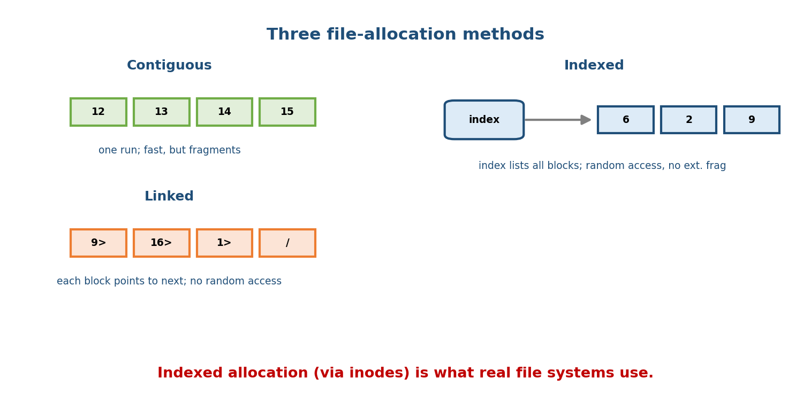
Three disk-allocation methods: contiguous (one run of blocks, fast but fragments), linked (each block points to the next, no random access), and indexed (one index block lists all data blocks, random access with no external fragmentation).

Contiguous allocation
Give the file one continuous run of blocks (start block + length). - Pros: excellent sequential and direct access (block i = start + i); minimal seek. Directory entry is tiny (start, length). - Cons: suffers external fragmentation (free space breaks into small unusable gaps); a file can’t grow past its neighbour without moving; must know size up front. Like booking a row of adjacent cinema seats.

Linked allocation
Scatter blocks anywhere; each block stores a pointer to the next (a linked list). - Pros: no external fragmentation; files grow easily (just link a new block). - Cons: no efficient direct access — to reach block N you follow N pointers from the start; a single corrupt pointer loses the rest of the file; pointers waste some space in each block. FAT is a smarter variant that pulls all the pointers into one File Allocation Table in memory (so you can follow the chain without reading every data block).

Indexed allocation
Give each file one index block that holds the list of all its data-block addresses. block[i] = the i-th entry of the index block. - Pros: direct access (index it like an array) and no external fragmentation. This is the basis of the UNIX inode (§11.6). - Cons: the index block itself is overhead (wasteful for tiny files); a single index block limits max file size — solved by indirect blocks (next section).
Method | Direct access | External frag. | Grows easily | Weakness
Contiguous | best | yes | no | fragmentation, must know size
Linked | no (O(N) walk) | no | yes | pointer chase, corruption spreads
Indexed | yes | no | yes | index-block overhead / size cap
Memory hook: Contiguous = a row of seats (fast, but can’t extend). Linked = a treasure hunt (each clue points to the next; can’t skip ahead). Indexed = a table of contents (jump to any chapter; but the ToC has a page limit — fixed by indirection).

MCQs
- Allocation method with the best direct access? → contiguous.
- Which method has no external fragmentation but no random access? → linked.
- FAT improves linked allocation by? → keeping all pointers in one table in memory.
- The UNIX inode uses which allocation method? → indexed (with indirect blocks).

11.6 Inodes and Indirect Pointers (the key numerical)
On UNIX/Linux, every file has an inode (index node) — the on-disk structure that holds all the metadata plus the pointers to the data blocks. Crucially, the file name is NOT in the inode; names live in directories and map to inode numbers. That separation is what makes hard links possible (§11.8).

What’s in an inode
- Metadata: type + permissions, owner (uid/gid), size, timestamps, and the link count (st_nlink).
- 15 block pointers (i_block[15]): 12 direct, 1 single-indirect, 1 double-indirect, 1 triple-indirect.
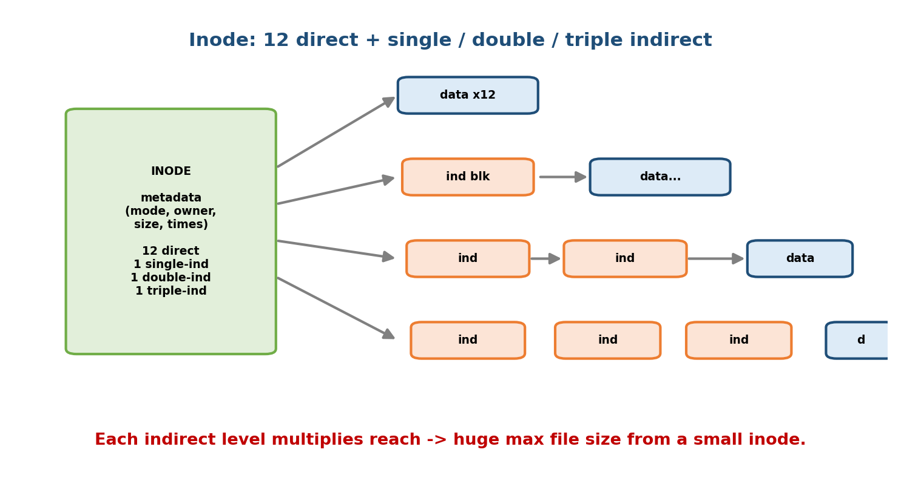
An inode holds metadata plus 12 direct pointers and one single, one double, and one triple indirect pointer; each indirect level points to a block full of further pointers, multiplying the reachable data blocks.
- Direct pointers (12): point straight to the first 12 data blocks. Small files (the vast majority) need no extra reads — very fast.
- Single indirect (1): points to a block that is full of pointers to data blocks. Adds (pointers-per-block) more blocks.
- Double indirect (1): points to a block of pointers to single-indirect blocks → squares the reach.
- Triple indirect (1): one more level → cubes the reach. This is what lets a small inode address a multi-terabyte file.
Memory hook: the inode is a filing cabinet. The 12 direct pointers are documents in the top drawer (grab instantly). The indirect pointers are notes saying “more documents in room X” — one room (single), a floor of rooms (double), a building of floors (triple).

The maximum-file-size numerical (do it cold)
Given: block size B = 4 KB (4096 B), block pointer size 4 B. Pointers that fit in one block: k = 4096 / 4 = 1024.
Direct blocks = 12
Single-indirect blocks = k = 1,024
Double-indirect blocks = k^2 = 1,048,576
Triple-indirect blocks = k^3 = 1,073,741,824
Total data blocks = 12 + k + k^2 + k^3 = 1,074,791,436 blocks
Max file size = total blocks × B
= 1,074,791,436 × 4 KB
≈ 4,402,345,721,856 bytes ≈ 4.0 TiB
Level-by-level (memorise the pattern):
Level | Blocks reached | Bytes (× 4 KB)
12 direct | 12 | 48 KiB
single indirect | 1,024 | 4 MiB
double indirect | 1,048,576 | 4 GiB
triple indirect | 1,073,741,824 | 4 TiB
The shortcut: the triple-indirect term dominates. With 4 KB blocks and 4-byte pointers, triple alone = k³ × B = 2³⁰ × 2¹² = 2⁴² = 4 TiB. The other terms (4 GiB + 4 MiB + 48 KiB) barely nudge it, so the answer is ≈ 4 TiB.
Practice variant (1 KB blocks, 4-B pointers → k = 256): triple alone = 256³ × 1 KiB = 2²⁴ × 2¹⁰ = 2³⁴ = 16 GiB, and the grand total ≈ 16.06 GiB. Same method, different k.
Reality check (backend note): modern ext4 actually replaces this classic indirect scheme with extents (contiguous ranges), and caps a single file at 16 TiB (with 4 KB blocks). The 12/single/double/triple calculation is the textbook/GATE model (ext2/ext3) and is still exactly what exams ask.

MCQs
- The UNIX inode holds the file’s ___ but not its ___ → metadata + data pointers; name (names live in directories).
- Standard inode pointer layout? → 12 direct + 1 single + 1 double + 1 triple.
- Block = 4 KB, pointer = 4 B — max file size? → ≈ 4 TiB (triple indirect dominates: 2⁴²).
- Which term dominates max file size? → the triple-indirect block.

11.7 UNIX Permissions (rwx, octal, chmod)
UNIX protects each file with three permission bits — read (r), write (x), execute (x) — for three classes — owner (user), group, others. Nine bits in all.
- rwx r-x r--
| | | |
type owner group others
Each triad is a 3-bit binary number → one octal digit:
r = 4 w = 2 x = 1 (add them up per class)
rwx = 4+2+1 = 7 r-x = 4+0+1 = 5 r-- = 4+0+0 = 4 rw- = 6
Worked example — read a mode string. rwxr-xr-x = owner rwx = 7, group r-x = 5, others r-x = 5 → 755. This is the classic 755 (“everyone can read/execute, only owner can write”) — the default for programs and directories.
Worked example — the other direction. chmod 644 file.txt = 6 rw-, 4 r--, 4 r-- → rw-r--r--: owner can read+write, everyone else read-only. The default for data files.
chmod two ways:
chmod 754 file # numeric (absolute): owner rwx, group r-x, others r--
chmod u+x file # symbolic (relative): add execute for the owner
chmod go-w file # remove write from group and others
On a directory, the bits mean something subtly different:
Bit | On a file | On a directory
r | read contents | list the names inside
w | modify contents | create/delete entries inside
x | execute it | enter/traverse it (cd, access a path through it)
Trap: you can have r on a directory (see the names) but without x you can’t cd into it or stat the files — and with x but no r you can access a file if you already know its exact name. Bank/GATE questions test this.
Special bits (4th octal digit): setuid (4), setgid (2), sticky (1). The classic is the sticky bit on /tmp → mode 1777: everyone can create files, but you can only delete your own — stops users deleting each other’s temp files.

MCQs
- rwxr-xr-x in octal? → 755.
- chmod 644 gives? → rw-r--r-- (owner read/write, others read-only).
- On a directory, the x bit means? → traverse/enter it (cd through it).
- /tmp is mode 1777 — what is the leading 1? → the sticky bit.

11.8 Hard Links vs Symbolic (Soft) Links
Both let a file appear under more than one name, but they work completely differently — a favourite interview and GATE distinction.
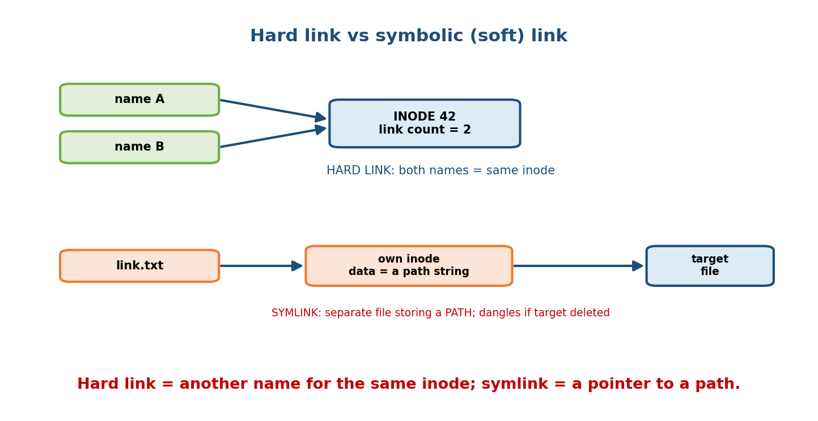
A hard link is a second directory entry pointing to the SAME inode, so both names are equal and the inode link count is 2; a symbolic link is a separate file whose data is the target’s path, with its own inode, and it dangles if the target is removed.

Hard link — a second name for the same inode
ln target new_name creates another directory entry pointing to the same inode number. Both names are equal peers — there is no “original”. The inode’s link count (st_nlink) goes up by one. The data is freed only when the link count reaches 0 and no process has it open. - Cannot cross filesystems (inode numbers are per-filesystem). - Cannot (normally) link a directory (would risk cycles — §11.4).

Symbolic (soft) link — a tiny file holding a path
ln -s target new_name creates a new file with its own inode whose contents are the path string of the target. Following it means “go read that path”. - Can cross filesystems and can point to a directory. - If the target is deleted/moved, the symlink dangles (points to nothing).

Worked walk-through (watch the inode number and link count)
$ echo hello > file.txt
$ ls -li file.txt
1234567 -rw-r--r-- 1 nidhi ... file.txt # inode 1234567, link count = 1
$ ln file.txt hard.txt # HARD link
$ ls -li file.txt hard.txt
1234567 -rw-r--r-- 2 nidhi ... file.txt # same inode 1234567,
1234567 -rw-r--r-- 2 nidhi ... hard.txt # link count now = 2
$ ln -s file.txt soft.txt # SOFT link
$ ls -li soft.txt
1234999 lrwxrwxrwx 1 nidhi ... soft.txt -> file.txt # DIFFERENT inode, type 'l'
$ rm file.txt # remove the original name
$ cat hard.txt # -> "hello" (data alive; link count now 1)
$ cat soft.txt # -> error: No such file (DANGLING symlink)
Property | Hard link | Symbolic (soft) link
Points to | the inode (data itself) | a path/name
Own inode? | no (shares target’s) | yes (separate small file)
Affects link count? | yes (+1) | no
Cross filesystem? | no | yes
Link a directory? | no | yes
Target deleted → | data survives (count>0) | dangles (broken)
ls -l type char | - (normal) | l (link, shows -> target)
Memory hook: a hard link is a joint bank account (two names, one balance — money gone only when both close it). A symlink is a sticky note saying “cash is in account #123” — tear up the account and the note points to nothing.

MCQs
- Which link shares the target’s inode? → hard link.
- Which link dangles if the target is deleted? → symbolic (soft) link.
- Creating a hard link changes the inode’s? → link count (+1).
- Which link can cross filesystems / point to a directory? → symbolic.

11.9 Metadata, Journaling, and Crash Consistency

The consistency problem
A single logical operation (say creating a file) touches several on-disk structures: allocate an inode, mark blocks used in the bitmap, add a directory entry, update free-space counts. If the machine crashes halfway (after the directory entry but before the bitmap update), the filesystem is now inconsistent — e.g. a block marked free but actually in use. The old fix was fsck, a full scan of the whole disk at boot — which took hours on large volumes.

Journaling = write-ahead logging (the fix)
A journaling filesystem first writes a description of the intended changes to a special journal (log) on disk, then applies them to their real locations.
1. Write the intended metadata changes to the JOURNAL (write-ahead)
2. Mark the journal transaction COMMITTED
3. Apply ("checkpoint") the changes to their real disk locations
4. Clear the journal entry
After a crash, the OS just replays the journal at boot: committed transactions are re-applied; incomplete ones are discarded. Recovery takes seconds, not hours, and the filesystem is always brought to a consistent state.
Memory hook: journaling is “write your intentions in a diary before you act.” If you faint mid-action, someone reads the diary and either finishes the job or tears out the unfinished page. This is the same write-ahead logging (WAL) idea as database recovery (DBMS M10) — first log, then do.
ext4 journaling modes (the classic trade-off):
Mode | What’s journaled | Safety | Speed
journal | metadata + data | safest | slowest (data written twice)
ordered (default) | metadata only, but data written before its metadata | good | good
writeback | metadata only, no ordering | weakest | fastest
Copy-on-write (CoW) alternative: newer filesystems (ZFS, Btrfs, APFS) never overwrite live data — they write new blocks and atomically flip a pointer, so the old version stays consistent until the switch. This gives crash consistency plus cheap snapshots, without a separate journal.

MCQs
- Journaling is another name for? → write-ahead logging (log first, then apply).
- What does the OS do with the journal after a crash? → replay committed transactions (discard incomplete ones).
- Default ext4 mode? → ordered (metadata journaled, data written first).
- What replaces journaling in ZFS/Btrfs/APFS? → copy-on-write (+ snapshots).

11.10 Real File Systems Compared (FAT / NTFS / ext4 / XFS / APFS)
Feature | FAT32 | NTFS | ext4 | XFS | APFS
OS | DOS/Windows, USB drives | Windows | Linux (default many distros) | Linux (RHEL default) | macOS/iOS (2017+)
Core structure | File Allocation Table (linked) | MFT (Master File Table) | inodes + extents | B+-tree extents, allocation groups | B-tree, copy-on-write
Journaling | none | yes (metadata) | yes | yes (metadata) | no — copy-on-write
Max file size | 4 GB | 16 EB (theory; huge) | 16 TiB | 8 EiB | 8 EiB
Max volume | ~2 TB | 256 TB+ | 1 EiB | 8 EiB | 8 EiB
Permissions/ACLs | none | ACLs | UNIX rwx + ACLs | UNIX rwx + ACLs | UNIX rwx + ACLs
Snapshots | no | shadow copies (VSS) | no | no (uses LVM) | yes (native, cheap)
Best at | universal compatibility | Windows features (encryption, compression) | reliable general Linux use | huge files, parallel I/O | SSD, snapshots, encryption
The one everyone trips on: FAT32’s 4 GB file limit. Because FAT32 stores a file’s size in a 32-bit field, no single file can exceed 2³² − 1 ≈ 4 GB. That’s why you can’t copy a 5 GB movie to a FAT32 USB stick — the fix is exFAT or NTFS. Also FAT has no permissions and no journaling — great for portability, poor for a system disk.
Quick picks: cross-device USB → exFAT/FAT; Windows system → NTFS; general Linux → ext4; big-data / large-file Linux servers → XFS; Apple / SSD-first → APFS.

MCQs
- Filesystem with a 4 GB max file size? → FAT32.
- NTFS’s central metadata structure? → the MFT (Master File Table).
- Which filesystem uses copy-on-write instead of journaling? → APFS (also ZFS/Btrfs).
- RHEL’s default filesystem, tuned for large files? → XFS.

11.11 Real-World & Backend Perspectives
- Everything is a file (UNIX philosophy). Devices (/dev/sda), pipes, sockets, and even kernel state (/proc, /sys) present a file interface — so the same read/write/fd API drives disk, terminal, and network. This uniformity is why UNIX I/O feels so composable (pipes in M13/M14).
- inotify / file watchers power dev tools (webpack, nodemon) that rebuild on save — they hook the filesystem’s change notifications.
- fsync and durability. A backend that must not lose data (a database, a message queue) calls fsync to force the OS page cache to disk — the same durability concern as journaling. Skipping it is a classic data-loss bug.
- Object storage (S3) is not a filesystem. It’s a flat key → blob store with no real directories, no partial writes, and eventual consistency — understanding POSIX file semantics is exactly what tells you where S3 differs.
- Containers layer filesystems (OverlayFS): a read-only image layer + a writable top layer, using copy-on-write — the §11.9 idea again.

11.12 Tradeoffs, Common Mistakes, Edge Cases
Common mistakes (exam + real life) - Saying the inode stores the file name — it does not; the directory maps name → inode number. - Thinking a hard link is “a copy” — it’s the same inode; edits show through both names. - Forgetting contiguous allocation is the one with external fragmentation. - Forgetting linked allocation has no random access (O(N) to reach block N). - Reading chmod octal wrong: r=4, w=2, x=1 (not r=1). - Assuming FAT32 can hold a file > 4 GB (it can’t).
Edge cases - A symlink can be dangling (target gone) yet still exist as a file. - On a directory: x without r = you can open a file by exact name but can’t list the directory; r without x = you can list names but can’t access them. - Deleting a file that a process still has open frees the name but not the data until the last fd closes (link count vs open count).
Tradeoffs
Choice | Gains | Costs
Contiguous allocation | fast sequential + direct access | external fragmentation, hard to grow
Indexed (inode) allocation | random access, no external frag. | index-block overhead, indirect reads for big files
Journaling (data mode) | crash-safe data | writes everything twice (slower)
Copy-on-write (APFS/ZFS) | snapshots + consistency | fragmentation, more space churn

11.13 Exam, Interview & Coding Perspectives
Exam (SEBI/RBI/GATE/C-DAC): file-allocation method pros/cons and which one fragments; the inode indirect-pointer max-file-size numerical; access methods; directory-structure evolution; octal permissions and chmod; hard vs soft link differences; journaling = write-ahead logging; FAT32’s 4 GB limit.
Interview: “Hard vs symbolic link?” (same inode vs a path; link count; dangling); “What’s in an inode?” (metadata + block pointers, not the name); “How does a journaling filesystem survive a crash?” (WAL + replay); “Why can’t FAT32 hold a 5 GB file?” (32-bit size field).
Coding/practical: - ls -li shows the inode number and link count — the fastest way to prove hard vs soft links. - stat file prints size, blocks, inode, permissions, and all timestamps. - df -i shows inode usage — a disk can be “full” because it’s out of inodes even with free space (millions of tiny files). - du vs ls: du counts blocks allocated (may exceed apparent size for sparse files).

11.14 Concept Checks & MCQs
- Where is a file’s metadata stored on UNIX? → the inode.
- Where is the file name stored? → in the directory (name → inode number).
- Allocation method with best direct access but external fragmentation? → contiguous.
- Allocation method with no random access? → linked.
- Allocation method behind the UNIX inode? → indexed.
- Inode pointer layout? → 12 direct + single + double + triple indirect.
- Block = 4 KB, pointer = 4 B → max file size? → ≈ 4 TiB (2⁴², triple dominates).
- Which indirect term dominates max file size? → triple indirect.
- rwxr-xr-x in octal? → 755.
- chmod 644 → symbolic? → rw-r--r--.
- On a directory, x means? → traverse/enter it.
- Leading 1 in mode 1777? → sticky bit.
- Hard link vs symlink — which shares the inode? → hard link.
- Which link dangles when the target is deleted? → symbolic.
- Journaling ≈ ? → write-ahead logging (log then apply).
- Default ext4 journaling mode? → ordered.
- Filesystem with a 4 GB max file? → FAT32 (32-bit size field).
- NTFS’s master metadata table? → MFT.
- Filesystem using copy-on-write instead of journaling? → APFS (ZFS/Btrfs).
- Access method that jumps to any block in O(1)? → direct/random.
- Structure that makes a directory an acyclic graph? → a file with multiple parents (links).
- Mechanism preventing early deletion of shared data? → link/reference count.
- df -i reports? → inode usage (a disk can run out of inodes).
- Practice: block = 1 KB, pointer = 4 B → max file size? → ≈ 16 GiB (2³⁴, k=256).
True/False - The inode stores the file name. → False (the directory does). - A hard link creates a second copy of the data. → False (same inode). - Contiguous allocation causes external fragmentation. → True. - Linked allocation supports fast random access. → False (O(N) walk). - FAT32 can store a 5 GB file. → False (4 GB cap). - Journaling replays committed transactions after a crash. → True.
Numerical (do it): > Block = 8 KB, pointer = 8 B → k = 8192/8 = 1024 pointers/block. Triple > indirect = k³ × B = 2³⁰ × 2¹³ = 2⁴³ = 8 TiB (dominant term), so max file size > ≈ 8 TiB. (Same shortcut: find k, then triple = k³ × B.)

11.15 One-Page Revision Sheet
FILE = named, persistent byte stream. Data = bytes; METADATA (type,size,perms,times,
LINK COUNT) lives in the INODE. NAME lives in the DIRECTORY (name -> inode #).
open() -> file descriptor (fd); kernel keeps per-proc fd table + system open-file
table holding the OFFSET. read/write use the fd (no re-parsing the path).
TYPES: regular, directory(=list of name->inode), device/special, symlink.
Windows types by EXTENSION; UNIX by MAGIC NUMBER (first bytes).
ACCESS: SEQUENTIAL(cassette, in-order) | DIRECT/RANDOM(CD skip, lseek O(1)) |
INDEXED(book index: key->block).
DIRECTORIES: single(flat, clashes) -> two-level(per user) -> TREE(nested, one path)
-> ACYCLIC GRAPH(multiple parents via links; needs LINK COUNT, ban dir cycles).
ALLOCATION:
CONTIGUOUS start+len; best seq+direct; EXTERNAL FRAG, can't grow (row of seats)
LINKED each block -> next; NO random access; corrupt ptr kills rest (FAT=ptrs in table)
INDEXED one index block lists data blocks; random access, no ext frag (UNIX inode)
INODE = 12 DIRECT + 1 SINGLE + 1 DOUBLE + 1 TRIPLE indirect. k = B / ptrsize.
MAX SIZE (B=4KB, ptr=4B, k=1024): 12 + k + k^2 + k^3 blocks x B ≈ 4 TiB.
Shortcut: triple dominates = k^3 x B = 2^30 x 2^12 = 2^42 = 4 TiB.
(1KB block,k=256 -> 16 GiB. 8KB block,k=1024 -> 8 TiB.)
PERMISSIONS: rwx x (owner,group,others). r=4 w=2 x=1. rwxr-xr-x=755, rw-r--r--=644.
DIR: r=list names, w=create/delete, x=enter/traverse. Sticky bit /tmp = 1777.
chmod 754 file | chmod u+x file | chmod go-w file.
LINKS: HARD = same INODE, +1 link count, no cross-FS, no dir (joint bank account).
SOFT/symlink = own inode holding a PATH; cross-FS + dir OK; DANGLES if target gone
(sticky note with an account number).
JOURNALING = WRITE-AHEAD LOG: log intent -> commit -> apply -> clear. Crash = REPLAY.
ext4 modes: journal(data+meta,safe/slow) | ordered(default) | writeback(fast/weak).
CoW (ZFS/Btrfs/APFS) = never overwrite + snapshots, no journal.
FILESYSTEMS: FAT32(no journal/perms, MAX FILE 4GB) | NTFS(MFT,journal,ACLs) |
ext4(inode+extents,16TiB) | XFS(huge files,8EiB) | APFS(CoW,snapshots,SSD).

Flash cards
Front | Back
Where is file metadata? | The inode
Where is the file name? | The directory (name → inode #)
Best direct access allocation? | Contiguous
No-random-access allocation? | Linked
UNIX inode uses which allocation? | Indexed (indirect blocks)
Inode pointers layout? | 12 direct + single + double + triple
Max size, 4 KB block, 4 B ptr? | ≈ 4 TiB (triple = 2⁴²)
rwxr-xr-x octal? | 755
Hard link shares? | The inode (link count +1)
Symlink stores? | A path (dangles if target gone)
Journaling = ? | Write-ahead logging → replay on crash
FAT32 max file? | 4 GB (32-bit size field)

Spaced repetition
- 24-hour: redo the inode max-file-size numerical for 4 KB and 1 KB blocks; recite the three allocation methods’ pros/cons.
- 7-day: explain hard vs soft links (inode/link count/dangling); convert three mode strings to octal and back; explain journaling as WAL.
- 30-day: given a workload (USB stick, Windows disk, big-data Linux server, Apple SSD), pick the filesystem and justify it; walk the directory-structure evolution.

11.16 Summary
A file system turns a raw array of disk blocks into named, persistent files. Metadata (type, size, permissions, timestamps, link count) lives in the inode; the name lives in a directory that maps name → inode number — a separation that makes hard links possible. Files are reached by sequential, direct, or indexed access, and organised in directories that evolved single → two-level → tree → acyclic-graph. Disk space is handed out by contiguous (fast, fragments), linked (grows freely, no random access), or indexed allocation — the last being the UNIX inode with 12 direct + single + double + triple indirect pointers, giving a ≈ 4 TiB max file on a 4 KB/4-byte system (triple indirect dominates: 2⁴²). We read UNIX permissions as octal (755, 644), distinguished hard vs symbolic links by inode and link count, and saw journaling = write-ahead logging keep the filesystem consistent across crashes. Finally we compared FAT32, NTFS, ext4, XFS, and APFS.
Next, Module 12 — Disk Management goes one layer down to the physical device these files sit on: HDD vs SSD vs NVMe, and the disk-scheduling algorithms (FCFS, SSTF, SCAN, C-SCAN, LOOK, C-LOOK) that decide the order of head movement — the performance floor beneath everything we just built.
You have mastered this module when you can: state what lives in an inode vs a directory; compare the three allocation methods and name the one that fragments; compute a max file size from block and pointer sizes cold; convert permission strings to octal and back; explain hard vs soft links with the inode/link-count difference; and explain journaling as write-ahead logging — all without notes.

