Module 12 — Disk Management
  - OS Mastery: SEBI IT / RBI / NABARD / GATE / C-DAC / Interview / Backend — In-Depth Notes (with visuals)
Prepared for nidhi.sharma@forensiccybertech.com
2026
Table of Contents

Module 12 — Disk Management
Where this module sits. Module 11 gave us the logical file system — files, inodes, directories. But all of that eventually turns into physical block reads and writes on a spinning platter or a flash chip, and disk is ~100,000× slower than RAM. This module is the OS’s job of making that slow device as fast and as fair as possible: the physical structure of HDD vs SSD vs NVMe, the disk-scheduling algorithms that reorder pending requests to cut head travel, disk formatting/partitions, and a recap of RAID. The disk-scheduling head-movement numericals (FCFS, SSTF, SCAN, C-SCAN, LOOK, C-LOOK) are a near-guaranteed GATE/C-DAC question and a classic interview warm-up.
Importance ratings (out of 5):
Exam / Use | SEBI IT | RBI IT | GATE CS | Interview | Backend
This module | ★★★ | ★★★ | ★★★★★ | ★★★ | ★★★★
Most-asked PYQ concepts (SEBI / RBI / GATE / C-DAC): disk-scheduling head movement for FCFS / SSTF / SCAN / C-SCAN / LOOK / C-LOOK on a request queue; seek time / rotational latency / transfer time breakdown; why SSDs have no seek time; HDD vs SSD vs NVMe; RAID levels (0/1/5/6/10) recap; disk formatting (low-level vs logical) and partitioning / boot block / MBR vs GPT.

12.1 The Disk as a Physical Device
A hard disk drive (HDD) stores bits as magnetic patterns on spinning platters. To read a block, three mechanical things must happen — and only the third moves data:
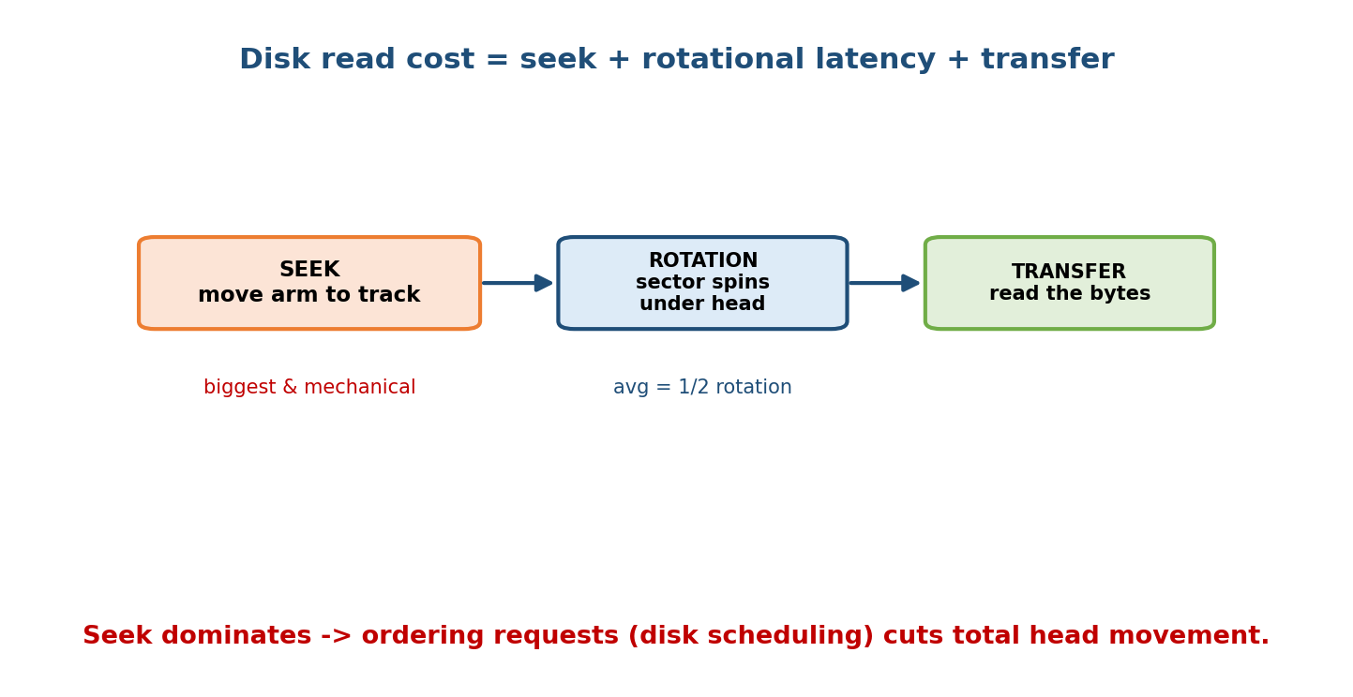
Reading a disk block costs seek time (move the arm to the track) + rotational latency (wait for the sector to spin under the head) + transfer time (read the bytes); seek dominates and is why request ordering matters.
Term | Meaning
Platter | a spinning magnetic disk (data on both surfaces)
Track | one concentric ring on a platter
Sector | an arc of a track — the smallest addressable unit (512 B / 4 KB)
Cylinder | the same track across all platters (no arm movement to switch)
Head / arm | floats over the surface; the arm moves it in/out to a track
Disk access time has three parts:
1. SEEK time — move the arm to the target TRACK/cylinder (mechanical, BIGGEST)
2. ROTATIONAL latency — wait for the SECTOR to spin under the head (avg = 1/2 rotation)
3. TRANSFER time — read the bytes as they pass the head
Average rotational latency = (1/2) x (60 / RPM) seconds
Why this whole module exists: seek time dominates and it depends on how far the arm must move. If we cleverly reorder the pending requests so the arm sweeps smoothly instead of jumping around, we cut total seek distance dramatically. That reordering is disk scheduling (§12.3). On an SSD there is no arm — so the story changes completely (§12.2).

MCQs
- Smallest addressable unit on a disk? → sector.
- Largest component of disk access time? → seek time.
- Average rotational latency? → ½ × (60/RPM) (half a rotation).

12.2 HDD vs SSD vs NVMe

HDD — mechanical, cheap, sequential-friendly
Moving arm + spinning platter. Random access is slow because every non-adjacent request pays seek + rotational latency (~5–10 ms). Great capacity per rupee; poor random IOPS (~100–200).

SSD — flash memory, no moving parts
An SSD stores bits in NAND flash cells; there is no arm and no platter, so a read is a purely electronic address lookup. This is the key exam line:
Why an SSD has no seek time. There is nothing to move — no mechanical head, no rotating platter. Any flash page is reached by addressing it electronically, so access time is roughly the same regardless of location. This collapses the huge random-vs-sequential gap that dominates HDDs; SSD random reads are ~100× faster than HDD.
But flash has its own quirks the OS must manage: - Erase-before-write / P/E cycles: flash is written in pages but erased in larger blocks, and each cell wears out after a limited number of program/erase cycles. - FTL (Flash Translation Layer): firmware that maps logical blocks to physical pages, doing wear levelling (spread writes) and garbage collection. - TRIM: the OS tells the SSD which blocks are no longer used so the FTL can reclaim them efficiently. - Write amplification: one logical write can trigger several physical writes (relocation during GC) — a durability/perf concern.

NVMe — a protocol, not a medium
NVMe (Non-Volatile Memory express) is the modern protocol for talking to an SSD over the PCIe bus, replacing the old SATA/AHCI interface that was designed for slow spinning disks. It exposes thousands of parallel queues with deep depth, matching flash’s parallelism, so NVMe SSDs reach multiple GB/s and very low latency.
Common confusion (interview): “SATA vs NVMe” is not medium vs medium — both can be SSDs. SATA is the legacy interface (one queue, ~550 MB/s ceiling); NVMe is the PCIe protocol built for flash’s parallelism (GB/s). An NVMe SSD is a flash SSD spoken to over PCIe with the NVMe command set.
 | HDD | SATA SSD | NVMe SSD
Medium | magnetic platters | NAND flash | NAND flash
Moving parts | yes (arm+platter) | no | no
Seek time | ~5–10 ms | none | none
Interface | SATA | SATA/AHCI | PCIe/NVMe
Throughput | ~100–200 MB/s | ~550 MB/s | GB/s (several)
Random IOPS | ~100–200 | ~50–100 K | 100 K–1 M+
Best for | bulk/cold storage | general use | databases, AI, hot data
Big implication for the rest of this module: the classic disk-scheduling algorithms exist to minimise arm movement — an HDD concern. On SSD/NVMe there is no arm, so the OS mostly passes requests straight through (Linux none/mq- deadline schedulers) and instead worries about parallelism, wear, and TRIM. Scheduling algorithms are still the #1 exam topic, but know why they matter less on flash.

MCQs
- Why does an SSD have no seek time? → no moving parts — data is addressed electronically.
- NVMe is a ___ , not a storage medium → protocol (over PCIe).
- SSD firmware that maps logical→physical and levels wear? → the FTL.
- Command telling an SSD which blocks are free? → TRIM.

12.3 Disk Scheduling — the Problem and the Metric
When many processes request disk blocks, they pile up in a request queue of cylinder numbers. The OS chooses the order to serve them, aiming to minimise total head (arm) movement — because seek time ∝ distance travelled.
The metric we compute: total head movement = sum of |next − current| cylinder distances as the head visits each request. Fewer cylinders travelled → less seek time → higher throughput.
The running example (used for every algorithm below). Disk cylinders 0–199. Head starts at 53. Pending request queue (arrival order):
98, 183, 37, 122, 14, 124, 65, 67
Sorted for convenience: 14, 37, [53=head], 65, 67, 98, 122, 124, 183. For the directional algorithms we assume the head is initially moving toward larger cylinder numbers (up). State the direction — it changes the answer.

MCQs
- Disk scheduling minimises? → total head (seek) movement.
- The queue holds? → cylinder numbers to be served.
- Why must you state the initial direction for SCAN/LOOK? → it changes the total movement.

12.4 FCFS and SSTF

FCFS — First-Come, First-Served
Serve requests in arrival order. Fair and simple, but the head can bounce wildly back and forth.
Order: 53 -> 98 -> 183 -> 37 -> 122 -> 14 -> 124 -> 65 -> 67
Jumps: 45 85 146 85 108 110 59 2
Total head movement = 45+85+146+85+108+110+59+2 = 640 cylinders
- Pro: fair (no starvation), trivial. Con: ignores distance → worst movement (640 here). Note the huge 183→37 = 146 swing.

SSTF — Shortest Seek Time First
Always serve the closest pending request to the current head position (greedy nearest-neighbour).
From 53: nearest is 65 (dist 12) -> 65
From 65: 67 (2) -> 67
From 67: 37 (30) -> 37
From 37: 14 (23) -> 14
From 14: 98 (84) -> 98
From 98: 122 (24) -> 122
From 122: 124 (2) -> 124
From 124: 183 (59) -> 183
Total = 12+2+30+23+84+24+2+59 = 236 cylinders
- Pro: far less movement than FCFS (236 vs 640). Con: starvation — a request in a far corner can wait forever if closer requests keep arriving; it’s the disk analogue of SJF’s starvation (M6).
Memory hook: SSTF = always grab the nearest snack. Efficient, but the food in the far cupboard may never get eaten (starvation).

MCQs
- FCFS total for our queue? → 640.
- SSTF total? → 236.
- SSTF’s fairness flaw? → starvation of far requests.

12.5 SCAN and C-SCAN (the elevator algorithms)

SCAN — the elevator
The head moves in one direction serving every request in its path until it reaches the end of the disk, then reverses and serves the rest — exactly like a lift going to the top floor then coming down.
Head at 53, moving up first, disk end = 199:
Up: 53 -> 65 -> 67 -> 98 -> 122 -> 124 -> 183 -> 199 (reach end)
Down: 199 -> 37 -> 14
Movement = (199 - 53) + (199 - 14) = 146 + 185 = 331 cylinders
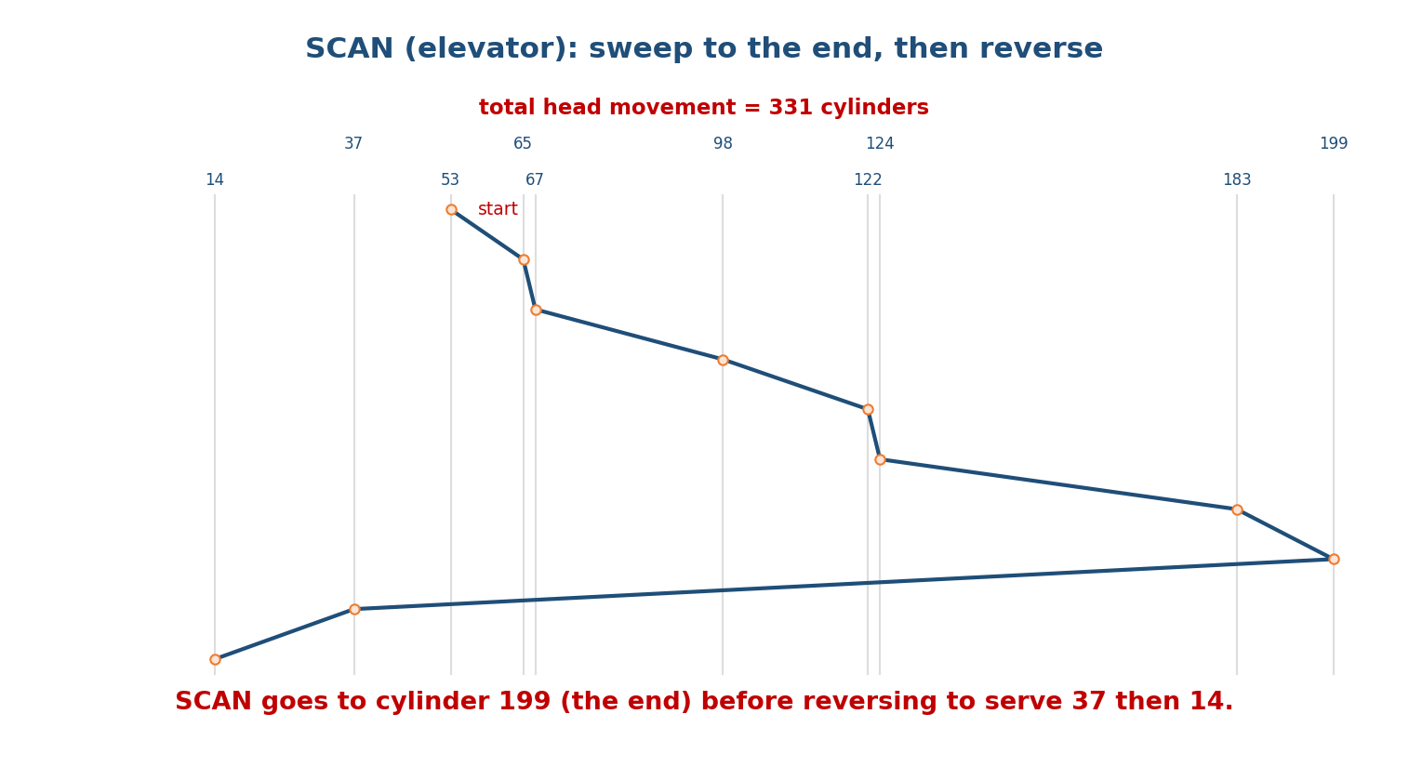
SCAN sweeps up to cylinder 199 servicing 65,67,98,122,124,183, then reverses and services 37,14; total head movement 331 cylinders. It reaches the disk end before turning, unlike LOOK.
- Pro: no starvation; smooth. Con: goes all the way to cylinder 199 even if no request is there (wasteful) — LOOK fixes this. Also, cylinders just behind the head wait almost a full sweep.

C-SCAN — Circular SCAN (fairer wait times)
Like SCAN, but when it hits the end it jumps straight back to the start (0) without servicing on the return, then sweeps in the same direction again. This treats the cylinders as a circular list, giving more uniform wait times (the just-missed cylinders don’t wait a whole double-sweep).
Head at 53, up, end = 199, then wrap to 0:
Up: 53 -> 65 -> 67 -> 98 -> 122 -> 124 -> 183 -> 199 (end)
Wrap: 199 -> 0 (jump back, no service)
Up: 0 -> 14 -> 37
Movement = (199 - 53) + (199 - 0) + (37 - 0) = 146 + 199 + 37 = 382 cylinders
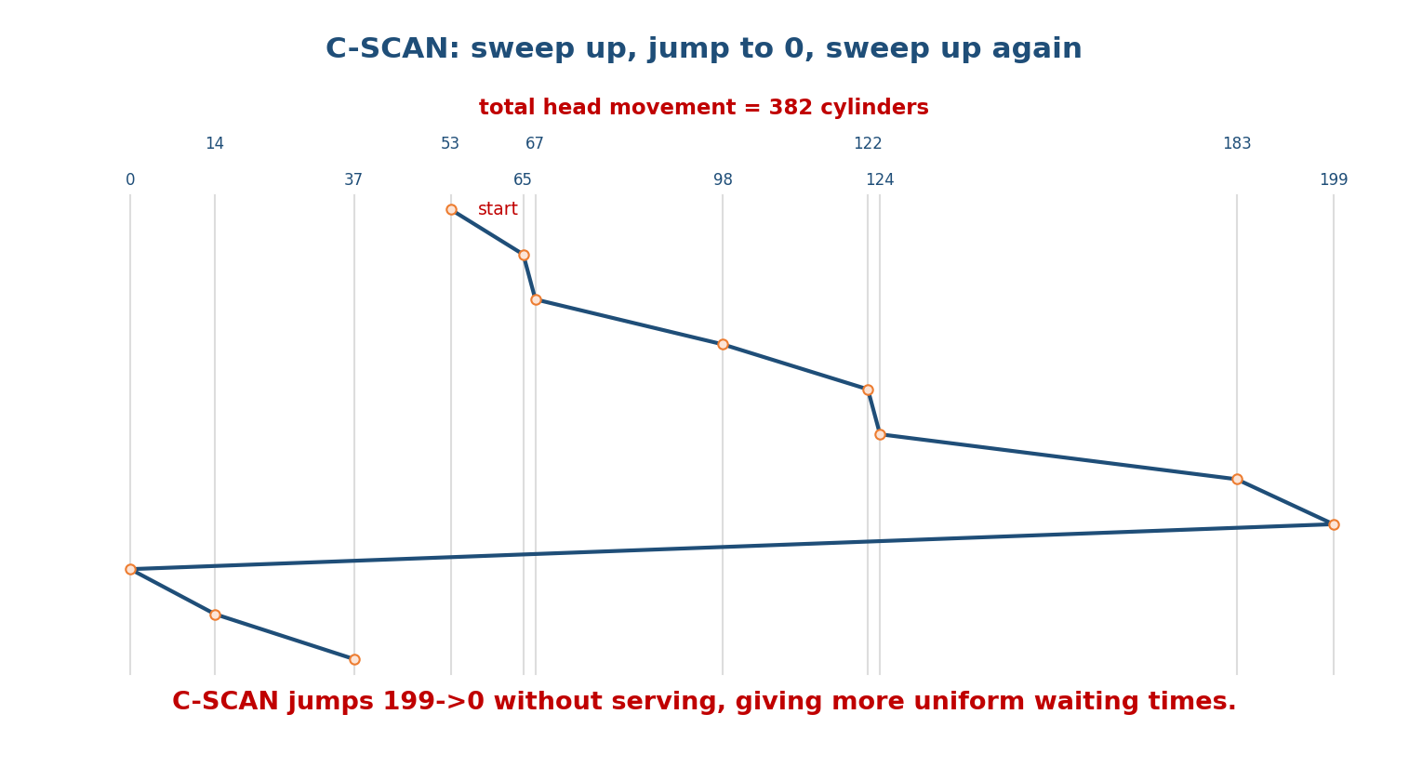
C-SCAN sweeps up to 199, jumps back to cylinder 0 without servicing, then sweeps up again to service 14 and 37; total head movement 382 cylinders. The wrap gives more uniform waiting times than SCAN.
- Pro: uniform waiting time (no cylinder waits a full round trip). Con: the return jump (199→0) is extra movement (382 > 331), and like SCAN it visits the disk ends even with no request there.
Convention note (read carefully for GATE): we count the return jump 199→0 as head movement (it’s real arm travel). Some textbooks report C-SCAN/C-LOOK excluding the jump — always state your convention. Here we include it.
Memory hook: SCAN = lift that stops on the way down too. C-SCAN = lift that only picks up going UP — express ride back to the ground floor, then up again (fairer for everyone, but the express ride is wasted distance).

MCQs
- SCAN total (up first, end 199)? → 331.
- Which algorithm gives the most uniform waiting time? → C-SCAN.
- C-SCAN’s extra cost vs SCAN? → the return jump to cylinder 0.

12.6 LOOK and C-LOOK (the practical versions)
LOOK and C-LOOK are the smart versions of SCAN/C-SCAN: instead of driving to the physical end of the disk, the head only goes as far as the last request in that direction, then turns. (The head “looks ahead” — if nothing’s there, don’t go.) These are what real HDDs actually use.

LOOK
Head at 53, up first; highest request is 183 (not 199), lowest is 14:
Up: 53 -> 65 -> 67 -> 98 -> 122 -> 124 -> 183 (last up-request, turn HERE)
Down: 183 -> 37 -> 14
Movement = (183 - 53) + (183 - 14) = 130 + 169 = 299 cylinders

C-LOOK
Head at 53, up; go to highest request 183, jump back to lowest request 14 (not 0), then continue up:
Up: 53 -> 65 -> 67 -> 98 -> 122 -> 124 -> 183 (highest request)
Jump: 183 -> 14 (to lowest request, not cylinder 0)
Up: 14 -> 37
Movement = (183 - 53) + (183 - 14) + (37 - 14) = 130 + 169 + 23 = 322 cylinders
- LOOK vs SCAN: LOOK saved the trip to cylinder 199 → 299 vs 331.
- C-LOOK vs C-SCAN: C-LOOK jumps only to the lowest request (14), not to 0 → 322 vs 382.
Memory hook: SCAN/C-SCAN go to the WALL; LOOK/C-LOOK stop at the LAST person. LOOK is “look before you leap — don’t drive to an empty end of the disk.”

Full comparison for our queue (head = 53, up-first, disk 0–199)
Algorithm | Service order | Total head movement | Note
FCFS | 98,183,37,122,14,124,65,67 | 640 | fair, worst movement
SSTF | 65,67,37,14,98,122,124,183 | 236 | greedy, can starve
SCAN | 65,67,98,122,124,183,→199,37,14 | 331 | elevator, hits end
C-SCAN | 65,67,98,122,124,183,→199,→0,14,37 | 382 | uniform wait, wrap cost
LOOK | 65,67,98,122,124,183,37,14 | 299 | SCAN without the wall
C-LOOK | 65,67,98,122,124,183,→14,37 | 322 | C-SCAN without the wall
Sanity ranking for this queue: SSTF (236) < LOOK (299) < SCAN (331) < C-LOOK (322… note C-LOOK > SCAN here) — orderings depend on the queue, so always compute. The only guaranteed winner in movement is often SSTF (greedy), but it starves; SCAN-family avoid starvation. FCFS is almost always the worst.

MCQs
- LOOK total? → 299. C-LOOK total? → 322.
- Difference SCAN vs LOOK? → LOOK turns at the last request, not the disk end.
- Difference C-SCAN vs C-LOOK? → C-LOOK jumps to the lowest request, not cylinder 0.
- Which two avoid starvation and don’t drive to empty disk ends? → LOOK / C-LOOK.

12.7 Disk Formatting, Partitions, and Booting
Before a disk can hold files it must be prepared in stages:
- Low-level (physical) formatting: the manufacturer divides each track into sectors with headers, data areas, and ECC (error-correcting codes). Defines the sector layout.
- Partitioning: split the disk into one or more partitions (logical disks), each of which can hold a different filesystem/OS. The partition table lives in the MBR or GPT:
  - MBR (Master Boot Record): legacy; ≤ 4 primary partitions, max 2 TB disk (32-bit LBA).
  - GPT (GUID Partition Table): modern (UEFI); many partitions, huge disks, redundant headers/CRC. Preferred today.
- Logical formatting: write the chosen filesystem structures (superblock, inode/FAT tables, root directory) into a partition — this is mkfs/“Format…”.
- Boot block: a fixed location the firmware reads at power-on; it holds the bootstrap loader (e.g. GRUB) that finds and loads the OS kernel.
- Bad-block management: the OS/FTL marks defective sectors and remaps them to spare sectors so they’re never used.
- Swap space: a partition or file the OS uses as backing store for virtual memory paging (ties back to M10).
Memory hook: low-level format = draw the parking-lot lines (sectors); partition = fence off sections (MBR/GPT); logical format = install the filing cabinets (filesystem); boot block = the note at the entrance telling you where the manager’s office is (bootstrap).

MCQs
- Legacy partition scheme capped at 2 TB / 4 primaries? → MBR.
- Modern UEFI partition scheme? → GPT.
- mkfs / “Format” performs which step? → logical formatting (write the filesystem).
- What does the boot block hold? → the bootstrap loader.

12.8 RAID — a Quick Recap
RAID (Redundant Array of Independent Disks) combines several physical disks into one logical unit for speed (parallel I/O), reliability (redundancy), or both. Remember: RAID protects against disk failure, it is NOT a backup (it won’t undo an accidental delete or corruption).
RAID | Technique | Min disks | Usable | Survives | Best for
0 | striping | 2 | 100% | nothing | raw speed
1 | mirroring | 2 | 50% | 1 disk | critical data
5 | stripe + 1 rotated parity | 3 | (n−1)/n | 1 disk | read-heavy, balanced
6 | stripe + 2 parities | 4 | (n−2)/n | 2 disks | high availability
10 (1+0) | mirror then stripe | 4 | 50% | 1 per mirror | speed and safety
XOR parity (RAID 5/6): P = A1 ⊕ A2 ⊕ A3; if a disk dies, rebuild it as A3 = A1 ⊕ A2 ⊕ P — XOR is its own inverse. Write penalty: a single small write on RAID 5 costs 4 I/Os (read old data + read old parity + write new data + write new parity), so RAID 5/6 favour read-heavy loads and RAID 10 is preferred for write-heavy databases (~2 I/Os per write).
Exam nuggets: RAID 0 = no fault tolerance. RAID 5 needs ≥3 disks, RAID 6 ≥4. RAID 1/10 have 50% overhead. (Full treatment with worked numericals is in DBMS Module 6.)

MCQs
- RAID level with striping and no redundancy? → RAID 0.
- Minimum disks for RAID 5 / RAID 6? → 3 / 4.
- Best RAID for a write-heavy DB? → RAID 10 (no parity read-modify-write).

12.9 Real-World & Backend Perspectives
- Linux I/O schedulers implement these ideas: mq-deadline and bfq (fair, latency-bounded) for HDDs; none for NVMe (the device’s own parallelism beats any arm-movement heuristic — there is no arm).
- SSD-aware everything: databases and filesystems now assume random reads are cheap, but still batch/sequentialise writes to reduce write amplification and flash wear.
- Cloud block storage (AWS EBS, GCP PD) sells you IOPS and throughput tiers — literally the seek/transfer trade-offs of this module, abstracted and metered.
- iostat / iotop show per-device utilisation, average queue length, and await time — the practical face of “is the disk the bottleneck?”.
- Alignment matters: partitions/filesystems aligned to the SSD’s erase-block or the RAID stripe avoid extra read-modify-write cycles — a real performance win.

12.10 Tradeoffs, Common Mistakes, Edge Cases
Common mistakes (exam + real life) - Not stating the direction for SCAN/LOOK/C-SCAN/C-LOOK — the answer depends on it. Always write “moving up” or “moving down”. - Forgetting SCAN/C-SCAN go to the disk end (0 or 199) while LOOK/C-LOOK stop at the last request. - Mishandling the C-SCAN/C-LOOK return jump — decide whether you count it and say so (we count it). - Claiming SSTF is always optimal — it usually has low movement but can starve. - Thinking disk scheduling helps an SSD — it barely does (no arm). - Treating RAID as a backup (it isn’t).
Edge cases - If the head is at a requested cylinder, that request is served with 0 movement. - If all requests are on one side of the head, SCAN and LOOK behave identically in that direction. - On SSD/NVMe the “optimal order” is essentially any order — throughput is bound by parallelism, not seek distance.
Tradeoffs
Choice | Gains | Costs
SSTF | low total movement | starvation of far requests
SCAN/C-SCAN | no starvation, smooth | travels to disk ends unnecessarily
LOOK/C-LOOK | no wasted end trips | slightly more bookkeeping
C-SCAN vs SCAN | uniform wait times | extra return-jump distance

12.11 Exam, Interview & Coding Perspectives
Exam (SEBI/RBI/GATE/C-DAC): compute total head movement for all six algorithms on a given queue (the §12.5–12.6 table is the template); seek/rotational/ transfer breakdown; why SSD has no seek; MBR vs GPT; RAID recap.
Interview: “Walk me through the disk-scheduling algorithms” (elevator analogy); “Why don’t SSDs need them?” (no moving arm); “SATA vs NVMe” (interface vs protocol, parallelism); “Is RAID a backup?” (no).
Coding/practical: - cat /sys/block/sda/queue/scheduler shows (and lets you change) the active Linux I/O scheduler. - iostat -x 1 → watch %util, await, aqu-sz to spot a disk bottleneck. - lsblk, fdisk -l, parted show partitions (MBR/GPT); mkfs.ext4 does logical formatting.

12.12 Concept Checks & MCQs
- Metric disk scheduling minimises? → total head movement.
- FCFS total (head 53; 98,183,37,122,14,124,65,67)? → 640.
- SSTF total (same)? → 236.
- SCAN total (up, end 199)? → 331.
- C-SCAN total (up, wrap via 0)? → 382.
- LOOK total (up)? → 299.
- C-LOOK total (up)? → 322.
- Which algorithm can starve far requests? → SSTF.
- Difference SCAN vs LOOK? → LOOK turns at the last request, not the disk end.
- Difference C-SCAN vs C-LOOK? → C-LOOK jumps to the lowest request, not 0.
- Which gives the most uniform waiting time? → C-SCAN.
- Why does an SSD have no seek time? → no moving parts (electronic addressing).
- NVMe is a ___ over ___ → protocol over PCIe.
- SSD firmware doing wear levelling / GC? → the FTL.
- Command telling an SSD which blocks are free? → TRIM.
- Legacy 2 TB / 4-primary partition scheme? → MBR; modern? → GPT.
- mkfs performs? → logical formatting.
- Boot block holds? → the bootstrap loader.
- RAID with no fault tolerance? → RAID 0.
- Min disks RAID 5 / 6? → 3 / 4.
- Best RAID for write-heavy DB? → RAID 10.
- Average rotational latency at 7200 RPM? → ½ × (60/7200) s = ½ × 8.33 ms ≈ 4.17 ms.
True/False - SSTF always gives the minimum total head movement. → False (usually low, but not guaranteed optimal, and it starves). - SCAN reaches the physical end of the disk before reversing. → True. - LOOK drives to cylinder 0/199 even with no request there. → False (that’s SCAN). - SSDs benefit greatly from SCAN/C-SCAN. → False (no arm to schedule). - RAID 0 survives one disk failure. → False.
Numerical (do it): > Same queue, but head starts at 50 and moves down first (disk 0–199). > Requests: sorted 14,37,50*,65,67,98,122,124,183. LOOK down: 50→37→14 (turn), > then →65→67→98→122→124→183. Movement = (50−14) + (183−14) = 36 + 169 = 205 > cylinders. (Direction and start position change everything — always recompute.)

12.13 One-Page Revision Sheet
DISK ACCESS TIME = SEEK(move arm, BIGGEST) + ROTATIONAL LATENCY(avg 1/2 rot = 1/2*60/RPM)
+ TRANSFER(bytes/rate). Seek ∝ distance => reorder requests = DISK SCHEDULING.
HDD: platters+arm, seek+rotate, ~100-200 IOPS, cheap capacity.
SSD: NAND flash, NO moving parts => NO SEEK (electronic address), ~100x faster random.
FTL(wear leveling+GC), TRIM(mark free), write amplification, erase-before-write.
NVMe = PROTOCOL over PCIe (not a medium); many parallel queues; GB/s. SATA=legacy iface.
DISK SCHEDULING (queue 98,183,37,122,14,124,65,67 ; head=53 ; up-first ; disk 0-199):
metric = TOTAL HEAD MOVEMENT = sum |next-curr|. STATE THE DIRECTION.
FCFS arrival order -> 640 (fair, worst; big 183->37 swing)
SSTF nearest first (greedy) -> 236 (low, but STARVES far reqs)
SCAN elevator to END(199) then reverse-> 331 (no starve; hits the wall)
C-SCAN up to 199, JUMP to 0, up again -> 382 (uniform wait; wrap cost)
LOOK like SCAN but turn at LAST req -> 299 (no wasted end trip)
C-LOOK up to last req, JUMP to lowest req-> 322 (C-SCAN w/o wall)
SCAN/C-SCAN go to the WALL(0/199); LOOK/C-LOOK stop at LAST person.
(count the wrap jump as movement; state convention.)
FORMATTING: low-level(sectors+ECC, factory) -> PARTITION(MBR<=2TB/4prim | GPT huge/UEFI)
-> logical format(mkfs: superblock/inode/FAT) . BOOT BLOCK = bootstrap loader(GRUB).
swap = paging backing store; bad-block remap.
RAID (availability, NOT backup): 0 stripe(100%,survive0) | 1 mirror(50%,1) |
5 stripe+1parity(min3,(n-1)/n,1; write penalty 4 I/Os) | 6 +2parity(min4,(n-2)/n,2)
| 10 mirror+stripe(min4,50%, speed+safety, ~2 I/Os/write). XOR: A3 = A1^A2^P.

Flash cards
Front | Back
Biggest disk-access component? | Seek time
FCFS total (our queue)? | 640
SSTF total? | 236 (can starve)
SCAN total (up, end 199)? | 331
C-SCAN total? | 382 (wrap to 0)
LOOK / C-LOOK total? | 299 / 322
SCAN vs LOOK? | LOOK turns at last request, not disk end
Why no SSD seek time? | No moving parts (electronic)
NVMe is a…? | Protocol over PCIe (not a medium)
MBR vs GPT? | Legacy ≤2 TB/4 primaries vs modern/huge
Is RAID a backup? | No (availability only)

Spaced repetition
- 24-hour: recompute all six algorithms on the queue 98,183,37,122,14,124,65,67 (head 53) from memory; recite HDD vs SSD vs NVMe.
- 7-day: explain why SSDs don’t need disk scheduling; MBR vs GPT; RAID recap with min disks/usable/survives.
- 30-day: given a new queue + head + direction, produce the full six-row comparison table with totals.

12.14 Summary
Disk management is the OS’s fight against a slow, mechanical device. On an HDD, access time is seek + rotational latency + transfer, and seek (arm movement) dominates — so the OS reorders the request queue to cut total head travel. On our queue (head 53, disk 0–199, moving up) we computed FCFS = 640, SSTF = 236 (low but starves), SCAN = 331 and C-SCAN = 382 (elevator; C-SCAN wraps for uniform waits), and the practical LOOK = 299 / C-LOOK = 322 (stop at the last request instead of the disk end). On SSD/NVMe there is no arm and no seek — flash is addressed electronically — so scheduling barely matters and the OS instead manages parallelism, TRIM, and wear (NVMe being a PCIe protocol, not a medium). We covered formatting and partitions (low-level → MBR/GPT → logical format → boot block) and recapped RAID 0/1/5/6/10.
Next, Module 13 — I/O Systems zooms out from the disk to all devices: how the CPU actually talks to hardware via polling, interrupts, and DMA, and how the kernel I/O subsystem ties buffering, caching, and spooling together.
You have mastered this module when you can: compute total head movement for all six scheduling algorithms on any queue (stating the direction); explain why an SSD has no seek time and how NVMe differs from SATA; walk the formatting/partition stages (MBR vs GPT); and recap the RAID levels — all without notes.

