Module 13 — I/O Systems
  - OS Mastery: SEBI IT / RBI / NABARD / GATE / C-DAC / Interview / Backend — In-Depth Notes (with visuals)
Prepared for nidhi.sharma@forensiccybertech.com
2026
Table of Contents

Module 13 — I/O Systems
Where this module sits. Module 12 zoomed in on one device — the disk. This module zooms out to the OS’s relationship with every device: keyboards, mice, network cards, GPUs, printers, disks, and USB sticks. The core question is simple and old: the CPU runs in nanoseconds, but devices answer in milliseconds — how does the OS bridge that gap without wasting the CPU? The three classic answers — programmed I/O (polling), interrupt-driven I/O, and DMA — plus buffering, caching, and spooling, plus the kernel I/O subsystem that ties them together, are the heart of this module. This is where hardware (M2’s interrupts and DMA), scheduling (M6), and the file system (M11–M12) all meet, and it is the direct on-ramp to how a backend server handles ten thousand connections with epoll/io_uring (previewed for M20).
Importance ratings (out of 5):
Exam / Use | SEBI IT | RBI IT | GATE CS | Interview | Backend
This module | ★★★ | ★★★ | ★★★★ | ★★★★ | ★★★★★
Most-asked PYQ concepts (SEBI / RBI / GATE / C-DAC): programmed I/O vs interrupt-driven I/O vs DMA (definitions, CPU cost, when each); memory-mapped vs port-mapped (isolated) I/O; DMA cycle stealing and one interrupt per block; the interrupt-driven I/O cycle; block vs character devices; role of the device driver; buffering vs caching vs spooling; single vs double buffering; blocking vs non-blocking vs asynchronous I/O.

13.1 I/O Hardware — Controllers, Ports, and the Bus

First principles
A device rarely plugs straight into the CPU. Between them sits a device controller (a small special-purpose processor), and they all share a bus — a set of parallel wires (address, data, control) that everything hangs off.
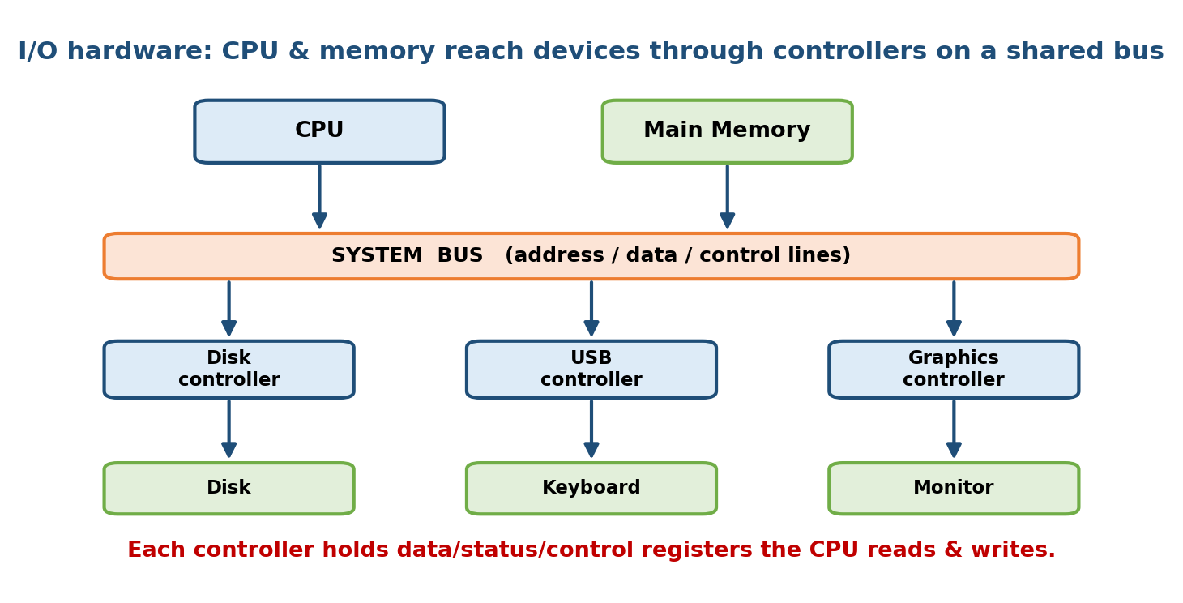
I/O hardware: the CPU and memory reach every device through its controller on a shared system bus; each controller exposes data, status, and control registers.
- Device — the physical thing (disk, keyboard, NIC).
- Device controller — the electronics that operate the device and talk to the bus (a disk controller, USB host controller, NIC). It contains a few registers and often a small local buffer.
- Port — a connection point / a controller register the CPU can read or write.
- Bus — shared wires connecting CPU, memory, and controllers. A daisy chain of buses is common: fast PCIe near the CPU, slower USB/SATA further out.
The four controller registers (learn these names):
Register | Direction | Purpose
Data-in | controller → CPU | byte(s) read from the device
Data-out | CPU → controller | byte(s) to send to the device
Status | controller → CPU | is it busy / ready / error / has data?
Control | CPU → controller | issue a command (read, write, seek)
Memory hook: the CPU never touches the device directly — it pokes the controller’s registers. “Set control = READ, then keep checking status until the data-in register is ready.” Everything in this module is a smarter way of doing that last “keep checking”.

MCQs
- The small processor that operates a device and talks to the bus? → device controller.
- The four controller registers? → data-in, data-out, status, control.
- A connection point / register the CPU addresses? → a port.

13.2 How the CPU Addresses Devices — Memory-Mapped vs Port-Mapped I/O
The CPU reads/writes controller registers using one of two addressing schemes.

Memory-mapped I/O
Device registers are given addresses in the ordinary memory address space. To talk to a device the CPU uses normal load/store instructions (MOV) — the same ones it uses for RAM. A range of physical addresses is simply routed to a device instead of to memory.
- Pro: no special instructions; any memory-manipulating code (and C pointers) can drive the device; large register spaces (framebuffers) are easy.
- Con: consumes part of the physical address space; caching must be disabled for those addresses (a stale cached status register would be a disaster).

Port-mapped (isolated) I/O
Devices live in a separate I/O address space, reached only by special instructions — on x86 the IN and OUT instructions with an 8/16-bit port number.
- Pro: keeps the memory address space fully for RAM; clearly separates I/O.
- Con: needs dedicated instructions and an extra control line; small address space.
 | Memory-mapped I/O | Port-mapped (isolated) I/O
Address space | shared with memory | separate I/O space
Instructions | ordinary MOV (load/store) | special IN / OUT
Caching | must be disabled for those addrs | N/A (separate space)
Typical use | ARM, RISC-V, modern PCIe, GPUs | legacy x86 peripherals
Memory hook: memory-mapped = the device pretends to be RAM (same addresses, same MOV). Port-mapped = the device lives on a different street with its own IN/OUT doors. Modern architectures lean almost entirely on memory-mapped I/O.

MCQs
- Scheme where device registers share the memory address space? → memory-mapped I/O.
- x86 instructions for port-mapped I/O? → IN / OUT.
- Why must memory-mapped device regions be uncached? → the CPU must see live status, not a stale cached copy.

13.3 Device Drivers — Block vs Character Devices

The role of a driver
A device driver is the piece of kernel code that knows the exact quirks of one controller and hides them behind a uniform interface the rest of the kernel calls. It is the single “translator” so the kernel can say read this block and not care whether the disk is SATA, NVMe, or a USB stick.
The kernel defines a small standard set of operations (in Unix: open, close, read, write, ioctl, …); each driver fills in those functions for its hardware. This is device independence in action (§13.10): the same read() call reaches the right driver through a function-pointer table.
Memory hook: the driver is a power adapter. Your laptop (kernel) has one plug shape; every country’s socket (device) is different; the adapter (driver) makes them fit. Swap the adapter, not the laptop.

Block vs character devices (a favourite MCQ)
Unix classifies devices into two families:
 | Block device | Character device
Unit of transfer | fixed-size blocks (e.g. 4 KB) | a stream of bytes
Access | random (any block by number) | usually sequential
Buffering/cache | goes through the buffer/page cache | often unbuffered / line-buffered
Examples | disk, SSD, USB drive | keyboard, mouse, serial port, terminal
ls -l tag | b | c
- A network card fits neither neatly and gets its own interface (the socket API), not a simple file-like read/write of blocks or bytes.
- A pseudo-device like /dev/null or /dev/random is a character device with no physical hardware behind it.

MCQs
- Kernel code that hides one controller’s quirks behind a uniform interface? → device driver.
- Disk vs keyboard device class? → block vs character.
- Which device type transfers a stream of bytes? → character.
- /dev/null is a ___ device → character.

13.4 The Three I/O Techniques — Programmed I/O vs Interrupt-Driven vs DMA
This is the centrepiece of the module. There are exactly three ways to move data between a device and memory, and they differ entirely in how much CPU they waste.
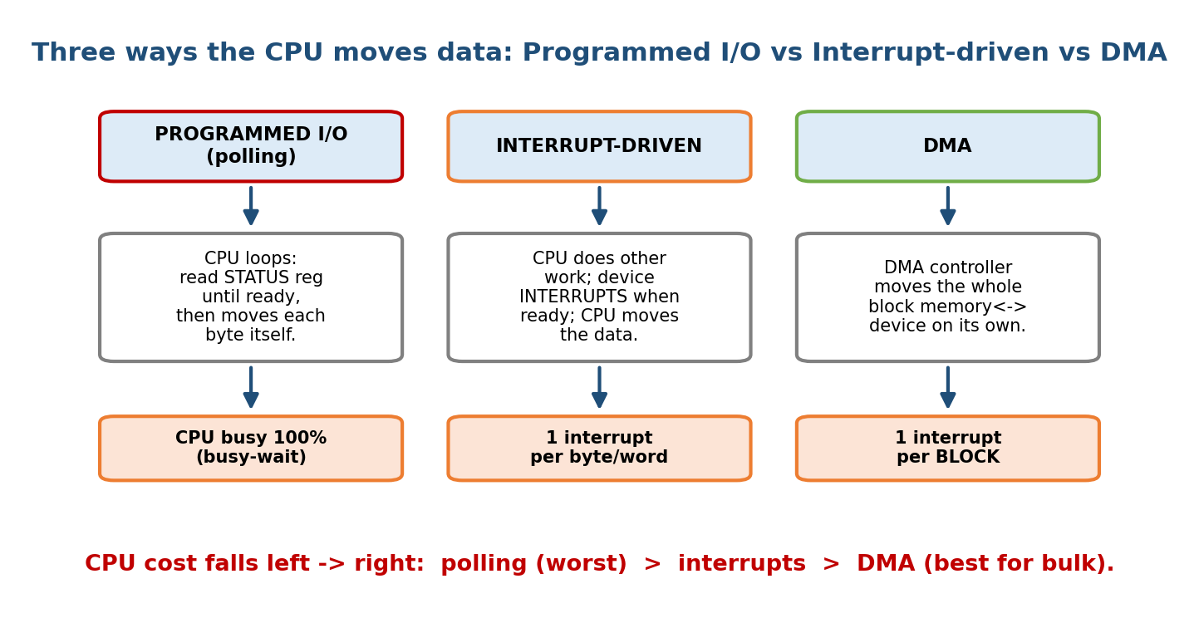
The three I/O techniques compared: programmed I/O busy-waits (CPU 100%), interrupt-driven I/O frees the CPU but interrupts once per byte/word, and DMA offloads the whole block with just one interrupt at the end.

1. Programmed I/O (polling / busy-waiting)
The CPU issues the command, then spins in a loop reading the status register until the device is ready, then moves each byte itself. The CPU is 100% busy doing nothing useful for the whole transfer.
loop: read STATUS register
if not READY: goto loop # busy-wait (polling)
read DATA-IN register -> memory
repeat for every byte
- When: tiny, fast, or embedded transfers where an interrupt would cost more than the wait; or very simple systems with no interrupt hardware.
- CPU cost: worst — the CPU wastes cycles polling.

2. Interrupt-driven I/O
The CPU issues the command and goes off to do other work. When the device becomes ready, the controller raises an interrupt; the CPU stops, runs an interrupt service routine (ISR) that moves the data, then resumes what it was doing.
- When: moderate-rate devices (keyboard, mouse, serial line) where the CPU has better things to do while waiting.
- CPU cost: far better than polling for waiting, but there is still one interrupt per byte/word, and each interrupt has real overhead (save state, run ISR, restore). For a fast disk moving millions of bytes, that overhead becomes huge — that is the problem DMA solves.

3. DMA (Direct Memory Access)
A dedicated DMA controller moves an entire block between the device and memory without the CPU touching each byte. The CPU just programs the DMA controller (source, destination, count) and is free until the whole block is done, when it gets one interrupt (detailed in §13.6).
- When: bulk transfers — disk, network, GPU, sound.
- CPU cost: best — one setup + one interrupt per block, regardless of block size.

The comparison table (memorise)
 | Programmed I/O (polling) | Interrupt-driven | DMA
Who moves each byte | CPU | CPU (in the ISR) | DMA controller
CPU while waiting | busy-wait (100%) | free to do other work | free to do other work
Interrupts | none | 1 per byte/word | 1 per block
Overhead per byte | polling cycles | interrupt handling | almost none
Best for | tiny/embedded transfers | moderate-rate devices | bulk transfers (disk/NIC)
CPU cost ranking | highest | medium | lowest
Memory hook: three ways to boil water. Polling = stare at the kettle the whole time. Interrupts = do chores, come when it whistles — but a kettle that whistles every drop is annoying. DMA = hire an assistant who fills the whole pot and taps you once when it’s done.

MCQs
- Which technique makes the CPU busy-wait? → programmed I/O (polling).
- Which has one interrupt per byte/word? → interrupt-driven I/O.
- Which moves a whole block with one interrupt? → DMA.
- Lowest CPU cost for bulk transfers? → DMA.

13.5 The Interrupt-Driven I/O Cycle
An interrupt is a hardware signal that makes the CPU pause its current program and jump to a handler. It is what turns “the CPU had to keep asking” into “the device tells the CPU when it’s ready.” (The mechanism was introduced in M2; here we apply it to I/O — see the interrupt-cycle diagram there.)
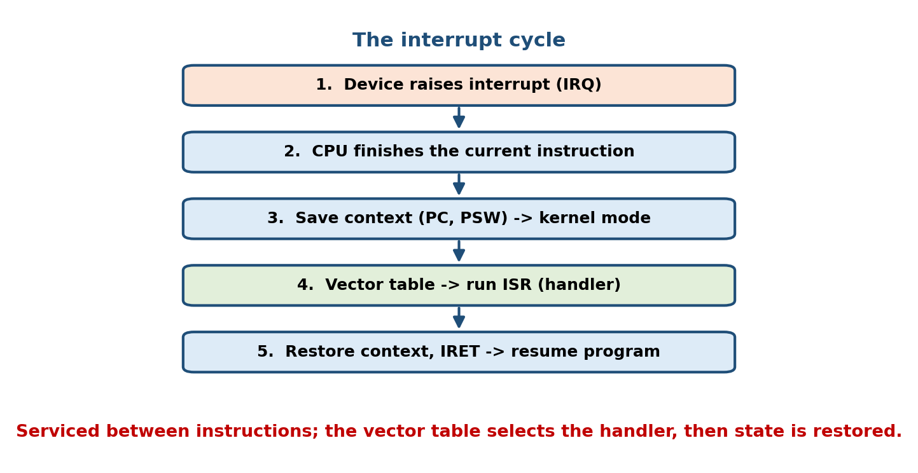
The interrupt-driven I/O cycle: the device controller raises an interrupt when ready; the CPU saves state, the ISR moves the data via the driver, then state is restored and the program resumes.
The cycle, step by step:
1. CPU issues an I/O command to the controller (via a driver), then continues
running OTHER work.
2. Device finishes / is ready -> controller asserts the INTERRUPT-REQUEST line.
3. CPU finishes the current instruction, then checks the interrupt line.
4. CPU SAVES its state (program counter, registers) and looks up the
INTERRUPT VECTOR to find the correct handler (ISR).
5. ISR (part of the device driver) runs: read/write the data register, clear
the interrupt, maybe wake the waiting process.
6. CPU RESTORES the saved state and RESUMES the interrupted program.
Key refinements: - Interrupt vector: a table mapping each interrupt number to its handler address, so dispatch is O(1) — the CPU doesn’t ask “who interrupted?”. - Maskable vs non-maskable: the CPU can temporarily mask (defer) ordinary interrupts during a critical section; a non-maskable interrupt (NMI) (e.g. power failure) cannot be ignored. - Priority levels: a higher-priority interrupt can pre-empt a lower one. - Top half / bottom half (Linux): the ISR does the bare minimum urgently (top half), and defers slower work to a softirq/tasklet/workqueue (bottom half) so interrupts stay disabled for as short a time as possible.
Memory hook: interrupt = a doorbell. You don’t stand at the door waiting (polling); you cook dinner and the bell (interrupt) makes you drop everything, answer (ISR), then go back to exactly where you were (restored state).

MCQs
- Table mapping interrupt number → handler address? → interrupt vector.
- Interrupt that cannot be masked (e.g. power fail)? → NMI.
- Linux name for the deferred, slower half of interrupt work? → bottom half (softirq/tasklet/workqueue).

13.6 DMA in Depth — Cycle Stealing and One Interrupt per Block
DMA (Direct Memory Access) exists to kill the “one interrupt per byte” tax of interrupt-driven I/O for bulk transfers. A separate DMA controller does the byte-by-byte moving; the CPU only sets it up and hears about it once at the end.
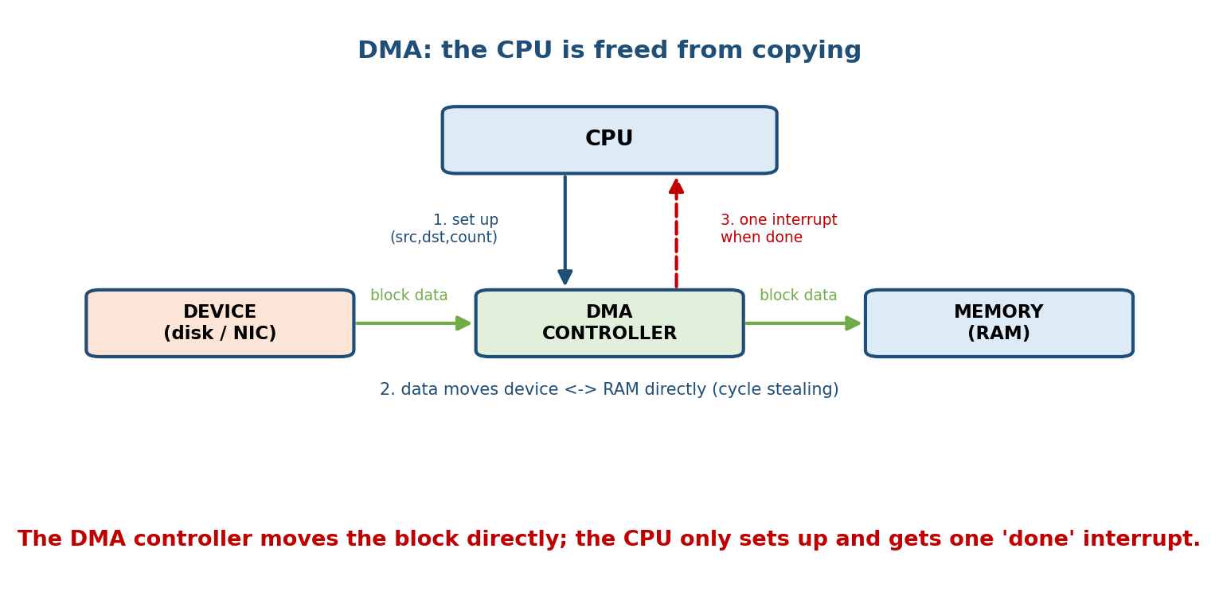
DMA: the CPU programs the DMA controller with source, destination, and count; the controller transfers the whole block directly to memory over the bus and raises a single interrupt when the block is complete.
The DMA transfer cycle:
1. CPU programs the DMA controller: source addr, destination addr, byte COUNT,
direction. Then the CPU goes back to other work.
2. DMA controller requests the BUS and moves data device <-> memory directly,
decrementing the count after each word. (CPU is NOT involved per word.)
3. When count = 0 (whole BLOCK done), the DMA controller raises ONE interrupt.
4. CPU's ISR handles completion (wake the waiting process). Done.

Cycle stealing vs burst mode
The DMA controller and the CPU share the same memory bus, so they must take turns:
- Cycle stealing: the DMA controller “steals” one bus cycle at a time between CPU accesses, transferring a word then releasing the bus. The CPU is only slightly slowed; this is the common mode.
- Burst mode: the DMA controller grabs the bus and transfers the whole block at once, blocking the CPU from memory during the burst — faster transfer, but the CPU stalls.
Cycle stealing, precisely: DMA and CPU contend for the memory bus. In cycle stealing the DMA takes the bus for one word, hands it back, and repeats — so the CPU loses only the occasional cycle rather than being frozen for the whole block.

The big win — tie back to M2
The decisive advantage is the interrupt count. To read a 4 KB block:
Interrupt-driven I/O : ~4096 interrupts (one per byte) -> huge ISR overhead
DMA : 1 interrupt (per BLOCK) -> CPU barely touched
That is why every disk, NIC, GPU, and sound card uses DMA. Cache coherence is the catch: because DMA writes to memory behind the CPU’s back, the OS/hardware must ensure caches don’t hold stale copies of the DMA’d region (snooping or explicit cache flush/invalidate).

MCQs
- DMA raises how many interrupts per block? → one.
- DMA mode that takes one bus cycle at a time? → cycle stealing.
- The main correctness worry when DMA writes memory directly? → cache coherence (stale cached copies).
- Why is DMA far cheaper than interrupt-driven I/O for a disk? → one interrupt per block instead of one per byte.

13.7 Buffering, Caching, and Spooling
These three services (introduced in M1) all sit between a fast producer and a slow consumer, but they solve different problems. Exams love to separate them.

Buffering — smooth out speed and size mismatches
A buffer is a memory area holding data in transit between device and application. It exists for three reasons: 1. Speed mismatch — device and CPU run at different rates (a fast disk feeding a slow modem, or vice-versa). 2. Transfer-size mismatch — reassemble small packets into a full block, or split a big write into device-sized chunks. 3. Copy semantics — copy the app’s data into a kernel buffer at write() time so later changes by the app don’t corrupt the in-flight write.
Single vs double buffering:
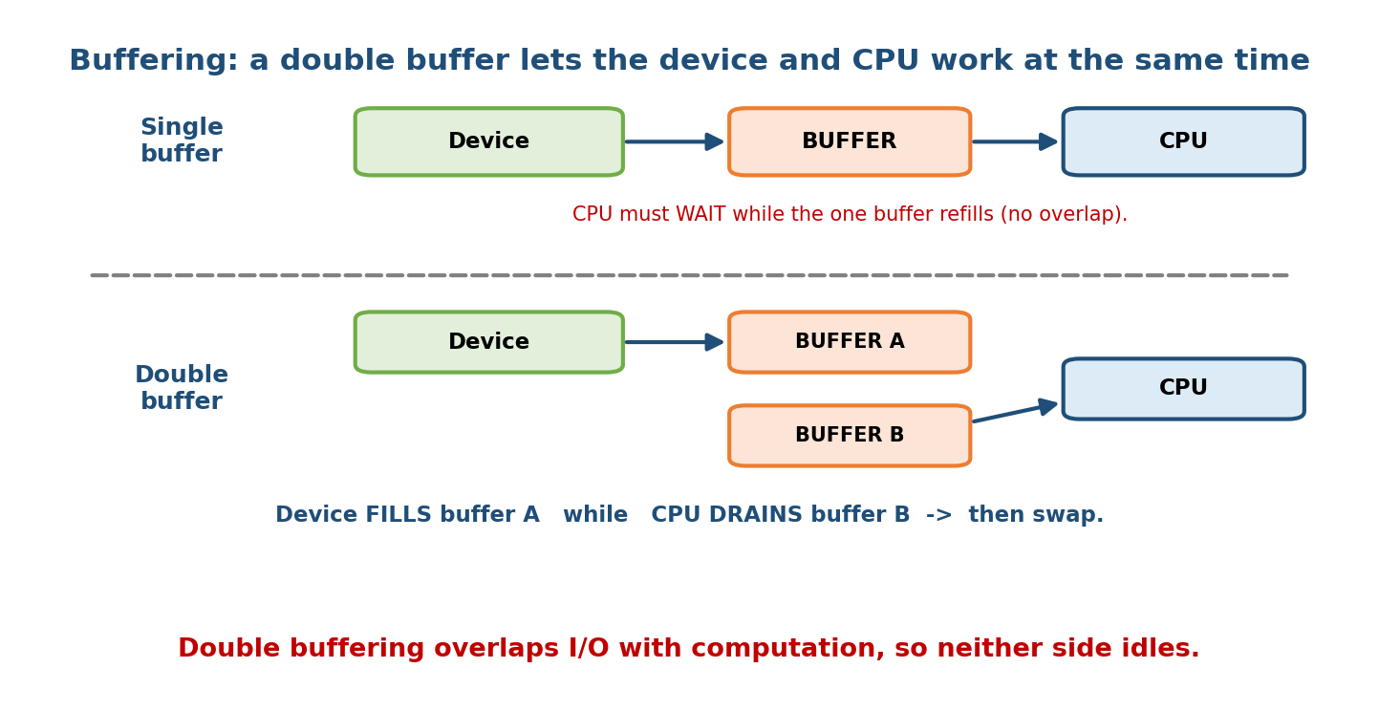
Buffering: with a single buffer the CPU must wait while the one buffer refills; with double buffering the device fills buffer A while the CPU drains buffer B, then they swap, so I/O overlaps computation.
- Single buffer: one region. While the CPU processes it, the device cannot fill it → the two cannot overlap; someone always waits.
- Double buffering: two buffers. The device fills A while the CPU drains B, then they swap. Now I/O and computation overlap — the classic way to keep both busy. (Generalises to circular buffering with N buffers for bursty streams.)

Caching — keep a copy of what’s likely reused
A cache holds a copy of frequently-used data in faster storage to avoid re-doing slow work (the disk page cache in RAM; the CPU cache over RAM).
Buffer vs cache — the exam distinction: a buffer holds the only copy of data in transit (it must be moved on). A cache holds a duplicate of data that also lives elsewhere, kept for reuse. Same RAM region can serve both roles, but the intent differs: move it once vs keep it for next time.

Spooling — a disk queue for a non-shareable device
Spooling (Simultaneous Peripheral Operation On-Line) uses the disk as a huge buffer for a device that can’t interleave requests — the textbook case is the printer. Jobs are written to a disk spool queue and printed one at a time, so many processes “print” instantly (to disk) and never wait for the physical printer.
Memory hook (from M1): buffer = small waiting room (RAM), in transit; cache = a saved copy kept for reuse; spool = a big waiting hall on disk for a device that serves one job at a time (printer).

MCQs
- Overlap I/O with computation using two regions? → double buffering.
- Holds the only copy, in transit? → buffer. Holds a reusable duplicate? → cache.
- Disk queue for a printer? → spooling.
- Single buffering’s flaw? → device and CPU can’t overlap (someone waits).

13.8 The Kernel I/O Subsystem and I/O Scheduling
Above the drivers, the kernel provides a device-independent I/O subsystem — a set of services every device gets “for free”:
- I/O scheduling — reorder the pending request queue for efficiency/fairness (the disk-scheduling algorithms of M12 live here; NVMe often uses none).
- Buffering, caching, spooling — as in §13.7.
- Naming & protection — map names like /dev/sda, C: to devices and enforce permissions.
- Error handling — retry transient failures; report permanent ones (EIO).
- I/O protection — I/O instructions are privileged; user programs must go through system calls, so no process can drive hardware directly (M2’s user/kernel mode).
- Data structures — the open-file table, per-device request queues, and a function-pointer table per driver.
The life of one read() (ties the whole module together):
read(fd, buf, n) --syscall trap--> kernel I/O subsystem
-> check cache: HIT? copy out, return. MISS? continue
-> pick device via open-file table -> enqueue request (I/O scheduling)
-> driver programs the controller / sets up DMA
-> process BLOCKS (goes to sleep), CPU runs someone else
-> device done -> INTERRUPT -> ISR -> DMA copied data to a kernel buffer
-> copy buffer -> user's buf, mark process READY
-> scheduler eventually resumes it; read() returns n

MCQs
- Where do the disk-scheduling algorithms live? → the kernel I/O subsystem (I/O scheduling).
- Why can’t a user program run IN/OUT directly? → I/O instructions are privileged (needs a system call).
- Kernel structure tracking each process’s open files? → the open-file table.

13.9 Blocking vs Non-Blocking vs Asynchronous I/O
From the application’s point of view, an I/O call behaves in one of three ways. This is the single most important section for backend interviews.

Blocking I/O (synchronous)
The calling thread sleeps until the I/O completes; then the call returns with the data. Simple to reason about, but one slow read stalls the whole thread.
n = read(fd, buf, 4096); // thread SLEEPS here until data arrives, then continues

Non-blocking I/O
The call returns immediately. If data isn’t ready it returns “would block” (EWOULDBLOCK/EAGAIN) instead of sleeping; the app must try again later (usually by polling many descriptors with select/poll/epoll). The data copy still happens synchronously once the call succeeds.
set O_NONBLOCK;
n = read(fd, buf, 4096); // returns NOW: either some bytes, or EAGAIN (try later)

Asynchronous I/O (async)
The call returns immediately and the transfer proceeds in the background; the app is notified on completion (via a callback, signal, or a completion queue). The app never waits and never re-polls for readiness — it is told when the whole operation is done.
aio_read(...); // returns NOW; kernel does the whole transfer
... do other work ...
// later: completion notification -> data is already in buf
The distinction that trips people up:
 | Returns immediately? | App waits for data? | Notified of what?
Blocking | no | yes (sleeps) | — (returns with data)
Non-blocking | yes | no (retries later) | readiness (“try now”)
Asynchronous | yes | no | completion (“it’s done”)
Memory hook: ordering a pizza. Blocking = stand at the counter until it’s baked. Non-blocking = keep walking back to ask “ready yet?” (readiness polling). Asynchronous = give your number and they call you when it’s done (completion).
The classic exam line: non-blocking tells you about readiness (“you can try now”); asynchronous tells you about completion (“it’s finished”). They are not the same thing.

MCQs
- Call that sleeps until data arrives? → blocking.
- Call that returns EAGAIN when not ready? → non-blocking.
- Non-blocking signals ___ ; async signals ___ → readiness ; completion.
- Which model does the OS complete the transfer in the background? → asynchronous.

13.10 Device Independence — the Layered I/O Stack
Everything above works because I/O is built in layers, each hiding the one below. This is why one read() works on a file, a pipe, a socket, and a USB stick.
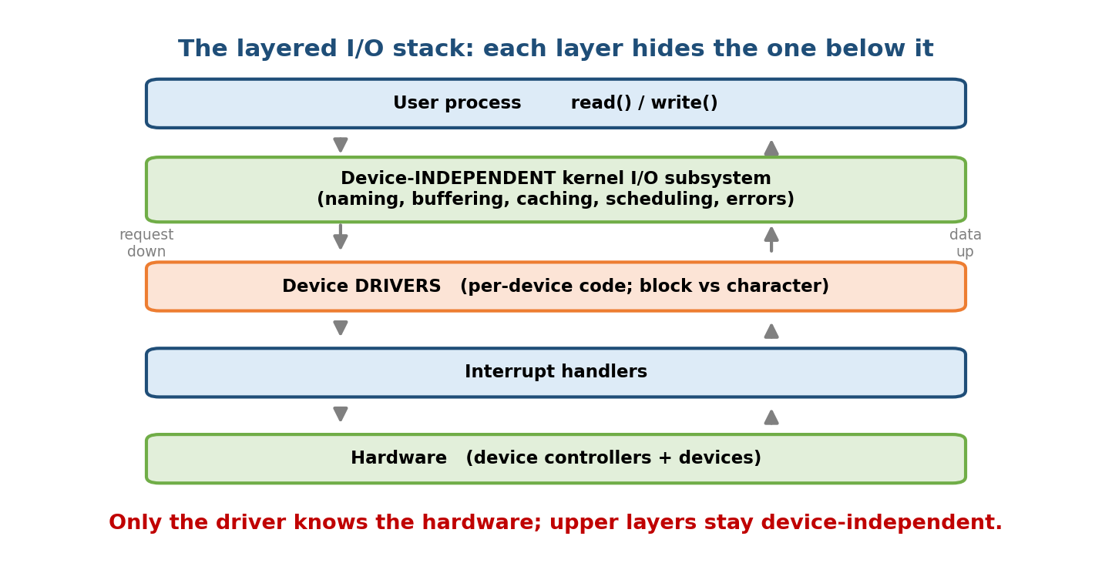
The layered I/O stack: a user process calls read()/write(); the device-independent kernel I/O subsystem handles naming, buffering, caching, scheduling, and errors; device drivers translate to hardware; interrupt handlers and the controllers sit at the bottom.
Layer | Responsibility | Device-specific?
User process | issues read()/write() | no
Device-independent kernel I/O | naming, buffering, caching, scheduling, errors, protection | no
Device drivers | translate uniform ops → this controller’s registers | yes
Interrupt handlers | catch completion, wake the driver | mostly
Hardware | controllers + devices | yes
The magic is the uniform driver interface (a table of open/read/write/ioctl function pointers): to add a new device you write one driver that fills that table — nothing above it changes. In Unix this is taken further with “everything is a file”: disks, terminals, and even the kernel’s own knobs appear as file paths (/dev/*, /proc/*, /sys/*) driven by the same read/write calls.

MCQs
- Which single layer is device-specific? → the device driver.
- What keeps upper layers unchanged when you add a device? → the uniform driver interface (function-pointer table).
- Unix philosophy that unifies devices and files? → “everything is a file”.

13.11 Real-World & Backend Perspectives — the Bridge to Async I/O (M20 teaser)
The blocking/non-blocking/async distinction of §13.9 is the story of scalable servers.
- The C10k problem: a server that uses one blocking thread per connection collapses at ~10,000 connections — too many threads, too much context-switching. The fix is event-driven I/O: one thread watches thousands of sockets and only acts on the ready ones.
- select/poll → epoll: select/poll re-scan all descriptors every call (O(n)); Linux epoll registers interest once and returns only the ready ones (O(ready)). This readiness model powers nginx, Node.js, Redis, Netty.
- io_uring (modern Linux): a true asynchronous, completion-based interface — the app posts requests to a submission queue (SQ) and reaps results from a completion queue (CQ) in shared memory, often with zero syscalls in the hot path. It generalises async to disk I/O too (which epoll never did well). Windows’ IOCP and BSD kqueue are the equivalents.
- DMA + zero-copy: sendfile()/splice() let the NIC DMA data straight from the page cache, skipping user-space copies — the §13.6 DMA idea taken to the network fast path.
The through-line: polling → interrupts → DMA (hardware level) is mirrored by blocking → readiness (epoll) → completion (io_uring) (software level). Same idea: stop the fast side from waiting on the slow side. This is developed fully in M20 (backend & systems programming).

MCQs
- Linux O(ready) readiness interface behind nginx/Node? → epoll.
- Linux completion-based async interface with SQ/CQ rings? → io_uring.
- Windows equivalent of epoll/io_uring? → IOCP.

13.12 Tradeoffs, Common Mistakes, Edge Cases
Common mistakes - Confusing non-blocking with asynchronous — readiness vs completion (§13.9). - Saying interrupt-driven I/O has no overhead — it still costs one interrupt per byte/word; that’s exactly why DMA exists. - Thinking DMA has no CPU cost at all — it costs a setup and one completion interrupt per block, plus bus contention (cycle stealing) and a cache coherence concern. - Mixing up buffer (only copy, in transit) and cache (reusable duplicate). - Forgetting memory-mapped device regions must be uncached. - Calling a printer queue “buffering” — it’s spooling (disk-backed, non-shareable device).
Edge cases - Very small/fast transfers: polling can beat interrupts (interrupt setup > the wait) — Linux NAPI even switches NICs from interrupts to polling under high load to avoid an interrupt storm (“livelock”). - Interrupt livelock: at extreme packet rates the CPU spends all its time in ISRs and makes no progress — mitigated by interrupt coalescing / NAPI polling. - Slow devices with DMA gain little (setup cost dominates); DMA shines for bulk.
Tradeoffs
Choice | Gains | Costs
Polling | no interrupt setup; simple | CPU busy-wait (wasted)
Interrupts | CPU free while waiting | overhead per byte/word
DMA | CPU free; 1 interrupt/block | setup + bus contention + coherence
Double buffering | overlaps I/O & compute | 2× buffer memory
Blocking I/O | simple code | one thread per slow op (C10k)
Async I/O (io_uring) | massive concurrency | complex, callback/queue code

13.13 Exam, Interview & Coding Perspectives
Exam (SEBI/RBI/GATE/C-DAC): the §13.4 comparison table (polling vs interrupt vs DMA — who moves data, interrupt count, CPU cost); memory-mapped vs port-mapped; DMA cycle stealing and one interrupt per block; block vs character devices; buffer vs cache vs spool; single vs double buffering; interrupt vector / NMI.
Interview: - “Blocking vs non-blocking vs async” — readiness vs completion; then “how does a server handle 10k connections?” → event loop + epoll (readiness), io_uring (completion). - “Why does DMA help?” → CPU offloaded, one interrupt per block not per byte. - “What’s a device driver / block vs character device?”
Coding/practical: - ls -l /dev → b (block) vs c (character) devices in the first column. - cat /proc/interrupts → per-device interrupt counts across CPUs. - strace -e trace=read,write,epoll_wait ./server → watch the real I/O syscalls. - lsblk, lspci, lsusb → the controller/bus topology of §13.1. - Set O_NONBLOCK with fcntl(); use epoll_create1/epoll_ctl/epoll_wait for the readiness loop.

13.14 Concept Checks & MCQs
- Small processor operating a device and talking to the bus? → device controller.
- Four controller registers? → data-in, data-out, status, control.
- Memory-mapped vs port-mapped I/O? → shared memory addresses + MOV vs separate I/O space + IN/OUT.
- Why must memory-mapped device regions be uncached? → CPU must see live status.
- Kernel code hiding one controller’s quirks? → device driver.
- Block vs character device examples? → disk/SSD vs keyboard/serial.
- Which I/O technique busy-waits? → programmed I/O (polling).
- Interrupts per byte in interrupt-driven I/O? → one per byte/word.
- Interrupts per block in DMA? → one.
- Lowest CPU cost for bulk transfers? → DMA.
- DMA mode taking one bus cycle at a time? → cycle stealing.
- Correctness worry when DMA writes memory directly? → cache coherence.
- Table mapping interrupt number → handler? → interrupt vector.
- Interrupt that can’t be masked? → NMI.
- Overlap I/O with compute using two regions? → double buffering.
- Buffer vs cache? → only copy, in transit vs reusable duplicate.
- Disk queue for a printer? → spooling.
- Non-blocking signals ___ ; async signals ___ → readiness ; completion.
- Call returning EAGAIN when not ready? → non-blocking read.
- Which single I/O layer is device-specific? → the device driver.
- Linux O(ready) readiness interface? → epoll. Completion-based ring interface? → io_uring.
- Unix philosophy unifying devices and files? → “everything is a file”.
True/False - Interrupt-driven I/O has no per-transfer overhead. → False (one interrupt per byte/word). - DMA needs the CPU to move each byte. → False (the DMA controller does). - Non-blocking I/O and asynchronous I/O are the same. → False (readiness vs completion). - A printer queue is an example of caching. → False (spooling). - Memory-mapped device registers can be safely cached. → False (must be uncached).
Scenario (answer it): > A NIC receives 1,000,000 small packets/sec. Under pure interrupt-driven I/O the CPU > hits interrupt livelock. Two fixes? → DMA (move packets to memory with far > fewer interrupts) + NAPI/interrupt coalescing (switch to polling under load > and batch completions). This is polling→interrupts→DMA and epoll→io_uring in one > real problem.

13.15 One-Page Revision Sheet
I/O HARDWARE: CPU/memory <--BUS--> DEVICE CONTROLLERS <--> devices.
Controller regs: DATA-IN, DATA-OUT, STATUS, CONTROL. PORT = a controller register.
ADDRESSING:
MEMORY-MAPPED device regs share MEMORY addresses; use MOV; must be UNCACHED (ARM/PCIe).
PORT-MAPPED separate I/O space; special IN/OUT instrs (legacy x86).
DRIVER = kernel code hiding one controller behind a uniform interface (fn-ptr table).
BLOCK device = fixed blocks, random, buffered (disk/SSD/USB) -> 'b'
CHAR device = byte stream, sequential (kbd/mouse/serial)-> 'c'
THREE I/O TECHNIQUES (CPU cost: POLLING > INTERRUPT > DMA):
PROGRAMMED I/O (poll) CPU busy-waits on STATUS, moves each byte -> CPU 100%
INTERRUPT-DRIVEN CPU works; device INTERRUPTS when ready -> 1 int / BYTE
DMA DMA controller moves whole block; CPU set-up -> 1 int / BLOCK
DMA: cycle stealing (1 bus cycle at a time) vs burst; watch CACHE COHERENCE.
INTERRUPT CYCLE: device raises IRQ -> CPU finishes instr -> SAVE state -> vector->ISR
-> ISR moves data/clears int -> RESTORE state -> resume. NMI = unmaskable.
Linux: TOP half (fast, in ISR) + BOTTOM half (softirq/tasklet/workqueue, deferred).
BUFFER = only copy, IN TRANSIT (speed/size mismatch, copy semantics).
single buffer = no overlap; DOUBLE buffer = device fills A while CPU drains B, swap.
CACHE = reusable DUPLICATE of data that lives elsewhere (page cache).
SPOOL = disk queue for a NON-shareable device (PRINTER).
KERNEL I/O SUBSYSTEM (device-independent): I/O scheduling(=disk sched M12), buffering,
caching, spooling, naming, protection(I/O instrs PRIVILEGED), error handling.
APP I/O MODELS:
BLOCKING sleeps until data (simple; 1 thread/conn -> C10k)
NON-BLOCKING returns now / EAGAIN; poll readiness (select/poll/EPOLL) -> READINESS
ASYNC returns now; kernel does it; notify on done (io_uring/IOCP)-> COMPLETION
LAYERS: user read()/write() -> device-INDEPENDENT kernel I/O -> DRIVERS(device-specific)
-> interrupt handlers -> hardware. "Everything is a file" (/dev,/proc,/sys).
BACKEND BRIDGE (M20): C10k -> epoll(readiness,O(ready)) -> io_uring(completion,SQ/CQ).
sendfile/splice = zero-copy via DMA. HW polling/interrupt/DMA == SW block/epoll/uring.

Flash cards
Front | Back
Four controller registers? | data-in, data-out, status, control
Memory-mapped vs port-mapped? | Shared mem addrs + MOV vs separate space + IN/OUT
Which technique busy-waits? | Programmed I/O (polling)
Interrupts per byte / per block? | Interrupt-driven (per byte) / DMA (per block)
DMA one-cycle-at-a-time mode? | Cycle stealing
DMA correctness worry? | Cache coherence
Block vs character device? | Disk (blocks, random) vs keyboard (byte stream)
Buffer vs cache? | Only copy, in transit vs reusable duplicate
Printer queue mechanism? | Spooling
Single vs double buffering? | No overlap vs fill A while drain B
Non-blocking signals…? async signals…? | Readiness vs completion
epoll vs io_uring? | Readiness (O(ready)) vs completion (SQ/CQ)
Which I/O layer is device-specific? | The device driver

Spaced repetition
- 24-hour: reproduce the polling/interrupt/DMA comparison table (who moves data, interrupt count, CPU cost) and the blocking/non-blocking/async table from memory.
- 7-day: explain DMA cycle stealing + “one interrupt per block”; buffer vs cache vs spool; memory-mapped vs port-mapped; block vs character devices.
- 30-day: given “a server must handle 100k connections,” walk from blocking → epoll (readiness) → io_uring (completion), and connect it to hardware polling/interrupts/DMA.

13.16 Summary
The I/O system is the OS’s answer to the nanosecond CPU vs millisecond device mismatch. The CPU never touches hardware directly: it drives controller registers (data-in/out, status, control) over a shared bus, addressed by memory-mapped (shared addresses, MOV, uncached) or port-mapped (IN/OUT) I/O, through a device driver that hides each controller behind a uniform interface (with block vs character device classes). The three ways to move data rank by CPU cost: programmed I/O (polling) busy-waits the CPU; interrupt-driven I/O frees the CPU but costs one interrupt per byte/word; and DMA offloads the whole block for one interrupt per block (via cycle stealing, with a cache-coherence catch). Around this, the kernel provides buffering (single vs double to overlap I/O and compute), caching (reusable copies), and spooling (disk queue for the printer), plus I/O scheduling, naming, protection, and error handling. From the app’s side, I/O is blocking, non-blocking (signals readiness), or asynchronous (signals completion) — the exact distinction that scales a backend from one thread per connection to epoll and io_uring.
Next, Module 14 — Linux Internals grounds all of this in one real kernel: how Linux actually implements processes, scheduling, memory, the VFS, and this very I/O stack (drivers, /dev, softirqs, epoll, io_uring) in production code.
You have mastered this module when you can: draw the CPU–controller–bus picture and name the four registers; contrast memory-mapped vs port-mapped I/O; reproduce the polling vs interrupt vs DMA table with CPU costs and interrupt counts; explain DMA cycle stealing and “one interrupt per block”; separate buffering, caching, and spooling (and single vs double buffering); and distinguish blocking, non-blocking (readiness), and asynchronous (completion) I/O — connecting them to epoll/io_uring — all without notes.

