Module 14 — Linux Internals
  - OS Mastery: SEBI IT / RBI / NABARD / GATE / C-DAC / Interview / Backend — In-Depth Notes (with visuals)
Prepared for nidhi.sharma@forensiccybertech.com
2026
Table of Contents

Module 14 — Linux Internals
Where this module sits. Modules 1–13 built the general theory of operating systems — processes (M4), threads (M5), scheduling (M6), synchronization (M7), memory & virtual memory (M9–M10), file systems (M11–M12), and I/O (M13). This module makes it concrete in the one kernel you will actually deploy on: Linux. Every backend server, every cloud VM, every Android phone, and every Docker container runs a Linux kernel. We open the hood and see how Linux implements those abstractions: task_struct and clone() for processes/threads, the Completely Fair Scheduler (CFS) for §M6 scheduling, the page cache / zones / OOM killer for §M9 memory, the VFS for §M11 files, and — most important for modern infra — cgroups + namespaces, the two kernel features that make containers (M17) possible. Learn this module and the rest of the course stops being abstract.
Importance ratings (out of 5):
Exam / Use | SEBI IT | RBI IT | GATE CS | Interview | Backend
This module | ★★★ | ★★★ | ★★ | ★★★★★ | ★★★★★
Most-asked PYQ / interview concepts: monolithic vs microkernel (Linux is a monolithic kernel with loadable modules); fork() vs clone() and how Linux represents a thread; CFS (vruntime, red-black tree, nice→weight); page cache and kswapd / OOM killer; the VFS four objects (superblock, inode, dentry, file); ext4 (extents, journaling); namespaces vs cgroups (isolation vs resource limits — the container foundation); systemd as PID 1; reading /proc/<pid> and /sys.

14.1 Linux Architecture — The Big Picture (first principles)
Linux is a monolithic kernel: the scheduler, memory manager, file systems, and device drivers all run together in one address space in kernel mode (fast direct calls, no message passing). But it is a modular monolith — drivers and file systems can be compiled as loadable kernel modules (LKMs) loaded at runtime (insmod / modprobe), giving it microkernel-like flexibility without the IPC cost.
Memory hook: Linux is a monolithic kernel with a plug-in socket. The engine block is one solid casting (monolithic = fast), but you can screw in extra parts while it runs (modules = flexible). This is the classic exam answer to “is Linux monolithic or microkernel?” → monolithic (modular).
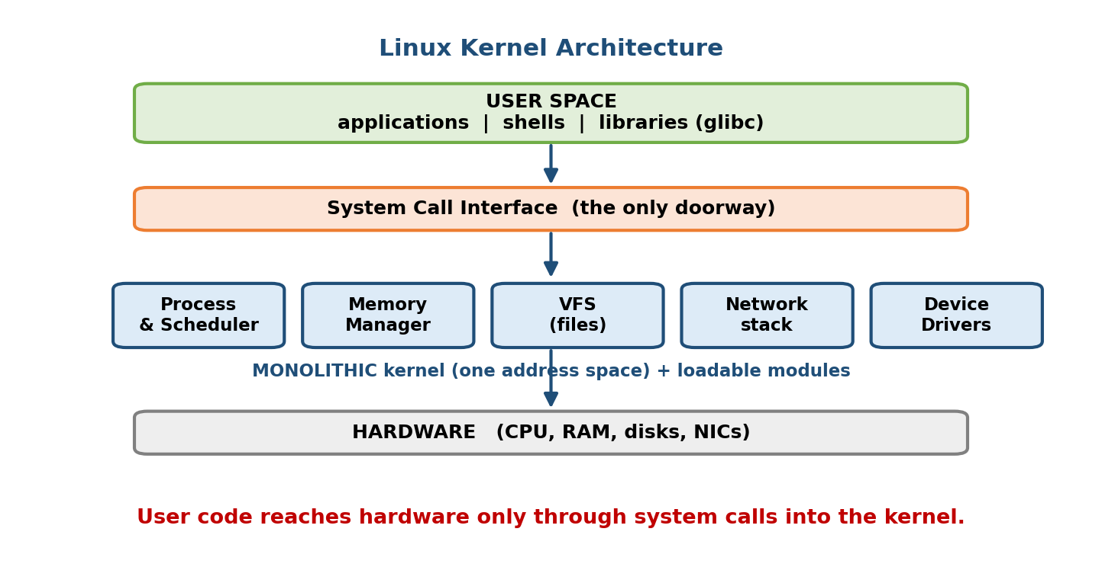
Linux kernel architecture: user space reaches the kernel only through the system-call interface; the monolithic kernel groups process management, memory management, VFS, networking, and device drivers, sitting on the hardware via arch-specific code.
The kernel is organised into a handful of subsystems, each mapping to an earlier module:
Subsystem | Job | Course link
Process management / scheduler | create, schedule, and kill tasks | M4, M5, M6
Memory management (MM) | virtual memory, paging, page cache | M9, M10
Virtual File System (VFS) | uniform interface over many filesystems | M11
Networking stack | sockets, TCP/IP, netfilter | M13 / networking
Device drivers | talk to hardware; char / block / net devices | M13
Arch layer | CPU-specific code (x86, ARM, RISC-V) | M2
User space vs kernel space. User programs never touch hardware directly. They call the C library (glibc), which issues a system call (syscall instruction on x86-64) to trap into kernel mode (§M3 dual-mode). Everything above the syscall line is user space; everything below runs with full privilege in kernel space.

MCQs
- Is Linux a microkernel or monolithic kernel? → monolithic, but modular (loadable kernel modules).
- How does user space enter the kernel? → via a system call (traps to kernel mode).
- Command to load a kernel module? → insmod / modprobe.

14.2 The Process/Thread Model — task_struct and clone()

One structure to rule them all: task_struct
Linux does not have separate “process” and “thread” objects. Every schedulable entity — whether you call it a process or a thread — is one task_struct (the kernel’s PCB, §M4). A task_struct holds the task’s PID, state, scheduling info, pointers to its memory (mm_struct), open files, signal handlers, and credentials.
Memory hook: to the Linux scheduler, there are no threads — only tasks. A “thread” is just a task that shares more with its siblings (same address space) than a “process” does. This one idea explains all of Linux’s process API.

fork(), clone(), and threads
- fork() creates a new process: a copy of the parent with its own address space (via copy-on-write, §M10 — pages are shared read-only until one side writes). Parent and child share nothing writable.
- clone() is the powerful primitive underneath. It creates a new task and lets you choose exactly what to share via flags:
clone() flag | Shares with parent
CLONE_VM | the address space (mm_struct) — this makes it a thread
CLONE_FILES | the open file descriptor table
CLONE_FS | filesystem info (cwd, root, umask)
CLONE_SIGHAND | signal handlers
CLONE_THREAD | same thread group (shared PID / getpid())
CLONE_NEWPID, CLONE_NEWNET, … | create new namespaces (§14.7)
The key insight: fork() and creating a thread are the same syscall with different flags. - fork() ≈ clone() with almost nothing shared (new address space). - **pthread_create()** ≈clone()withCLONE_VM | CLONE_FILES | CLONE_SIGHAND | CLONE_THREAD(share everything). Both end up as atask_struct` on the same run queue.
/* fork: child gets a private (copy-on-write) copy of memory */
pid_t pid = fork();
if (pid == 0) { /* child */ }
else if (pid > 0) { /* parent */ }
/* A thread = clone() sharing the address space (what pthread_create does under the hood) */
clone(fn, stack, CLONE_VM | CLONE_FILES | CLONE_SIGHAND | CLONE_THREAD, arg);
Thread group id (TGID). All threads of a process share a TGID (which is what getpid() returns); each thread also has its own kernel-level TID (what gettid() returns and what the scheduler uses). So user-space “PID” = kernel TGID.

MCQs
- What kernel structure represents both a process and a thread? → task_struct.
- Which clone() flag makes the child share the address space (i.e. a thread)? → CLONE_VM.
- fork() copies memory using what technique? → copy-on-write (COW).
- What does getpid() return for a multithreaded process? → the shared TGID.

14.3 The Completely Fair Scheduler (CFS)
CFS was Linux’s default scheduler from kernel 2.6.23 (2007) until 6.6 (2023), when it was replaced by EEVDF (see the note at the end). CFS remains the most important OS-scheduler to understand for interviews and exams because it perfected one elegant idea.

The idea: model an “ideal, perfectly-fair CPU”
On an ideal multitasking CPU with n runnable tasks, each would get exactly 1/n of the CPU at every instant. Real hardware runs one task at a time, so CFS tracks how far each task has fallen behind this ideal and always runs the one that is most behind. The bookkeeping variable for “how much CPU this task has received” is vruntime (virtual runtime).
Memory hook: CFS is a fairness debt collector. vruntime = “how much CPU you’ve already eaten.” CFS always serves the hungriest task — the one with the smallest vruntime.

vruntime, nice values, and weights
Every task accumulates vruntime as it runs. For a default-priority task (nice 0), vruntime advances at the same rate as real time. For other priorities, CFS scales the rate by the task’s weight:
vruntime += delta_exec * (NICE_0_LOAD / task_weight)
where delta_exec = real nanoseconds the task just ran
NICE_0_LOAD = 1024 (the weight of a nice-0 task)
- A high-priority task (negative nice → large weight) accumulates vruntime slowly, so it stays “hungry” and is picked more often → more CPU.
- A low-priority task (positive nice → small weight) accumulates vruntime fast, so it looks “full” quickly → less CPU.
Nice → weight mapping. Nice ranges from −20 (highest priority) to +19 (lowest). Weight ≈ 1024 / 1.25^nice, so each nice step changes CPU share by ~10%. Selected values from the kernel’s sched_prio_to_weight[] table:
nice | weight | relative CPU (2 tasks)
−20 | 88761 | vastly more
−5 | 3121 | more
0 | 1024 | baseline
+5 | 335 | less
+19 | 15 | almost none
Worked example (10% rule). Two CPU-bound tasks, nice 0 and nice 0 → each gets 50%. Now renice one to nice 1 (weight 820). Its share = 820 / (1024 + 820) ≈ 44%; the other gets 1024/1844 ≈ 56%. One nice level ≈ a ~10–12% swing — exactly the design goal.

The red-black tree — O(log n) “pick next”
CFS keeps all runnable tasks in a red-black tree keyed by vruntime (a balanced BST). The leftmost node is the task with the smallest vruntime — the one to run next — and CFS caches a pointer to it, so picking the next task is O(1); insertion/removal after a task runs is O(log n).
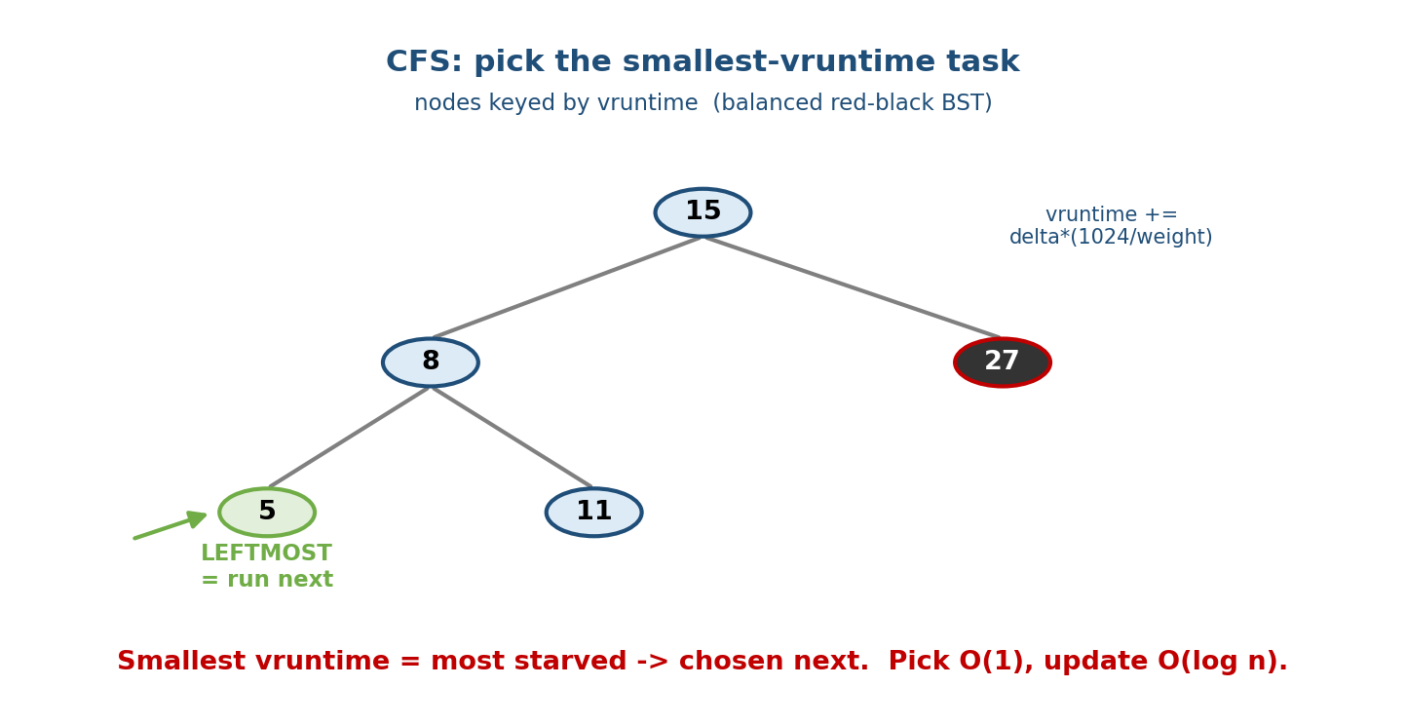
CFS keeps runnable tasks in a red-black tree ordered by vruntime; the leftmost node (smallest vruntime = most starved) is chosen to run next. A high-weight (low-nice) task accrues vruntime slowly and stays near the left, getting more CPU.
The scheduling loop:
1. pick the LEFTMOST task in the RB-tree (smallest vruntime = most behind).
2. run it for a slice (targeted so all tasks cycle within one "scheduling latency").
3. add the real time it ran to its vruntime (scaled by weight).
4. re-insert it into the tree at its new position; go to 1.
- No fixed time-quantum: CFS computes each task’s slice from a target scheduling latency (e.g. ~6 ms) divided among runnable tasks (with a minimum sched_min_granularity so slices don’t get absurdly tiny).
- New / woken tasks are given a vruntime close to the tree minimum (not 0) so a freshly-woken task doesn’t unfairly hog the CPU forever, yet still gets prompt service — great for interactive tasks that sleep a lot.
Why CFS feels responsive: a task that sleeps (waiting on I/O, like a text editor) doesn’t accrue vruntime while asleep, so on waking it has a small vruntime and jumps to the front — interactive apps get CPU quickly without any special “interactive priority” heuristic. Fairness is the responsiveness.
Note — CFS → EEVDF. Since kernel 6.6 (Nov 2023) the default is EEVDF (Earliest Eligible Virtual Deadline First), which adds an explicit latency knob and virtual deadlines on top of the same vruntime/weight machinery. Conceptually it is CFS + deadlines; the vruntime/nice/weight ideas above still apply. For exams, know CFS; for currency, know that EEVDF replaced it.

MCQs
- What variable does CFS use to track fairness? → vruntime (virtual runtime).
- Which task does CFS run next? → the one with the smallest vruntime (leftmost RB-tree node).
- Data structure holding runnable tasks in CFS? → a red-black tree (keyed by vruntime).
- Weight of a nice-0 task? → 1024 (NICE_0_LOAD); one nice step ≈ 10% CPU.
- What replaced CFS as the default scheduler in kernel 6.6? → EEVDF.

14.4 The Memory Manager — Zones, Page Cache, kswapd, OOM Killer
Linux implements the virtual-memory concepts of M9/M10. A few Linux-specific pieces are exam- and interview-favourites.

Zones — physical memory is not uniform
The kernel splits physical RAM into zones because some hardware can only use certain address ranges:
- ZONE_DMA / DMA32 — low addresses for old devices that can only DMA to the first 16 MB / 4 GB.
- ZONE_NORMAL — directly kernel-mapped RAM (the bulk on 64-bit systems).
- ZONE_HIGHMEM — memory not permanently kernel-mapped (a 32-bit relic; gone on 64-bit).
Free pages within a zone are handed out by the buddy allocator (splits/merges power-of-two page blocks to fight external fragmentation), and small kernel objects come from the slab/slub allocator on top of it.

The page cache — free RAM is wasted RAM
Linux uses all spare RAM as a disk cache: file data read from disk stays in the page cache so repeat reads are memory-speed (§M6-DBMS buffer-pool idea, but for the whole OS). Writes go to dirty pages flushed later by kernel threads (writeback). This is why free shows little “free” memory — it’s cache, and is instantly reclaimable.
Memory hook: on Linux, “free” RAM is failed caching. A healthy server has almost no truly-free RAM because the kernel filled it with page cache. That memory is available, not lost.

kswapd and reclaim
When free pages fall below a watermark, the kernel thread kswapd wakes and reclaims pages: it drops clean page-cache pages (free — just discard), writes back dirty pages, and swaps anonymous (heap/stack) pages out to the swap area. This keeps a pool of free pages ready. Under sudden pressure the allocating task may do direct reclaim itself (a stall).

The OOM killer
If reclaim can’t free enough and memory is truly exhausted, the kernel invokes the Out-Of-Memory (OOM) killer. It scores every process by an oom_score (based mostly on memory footprint, adjustable via oom_score_adj) and kills the highest-scoring process to save the system — famously “the OOM killer shot my database.” In containers, hitting a cgroup memory limit triggers OOM kill within that cgroup (§14.7).
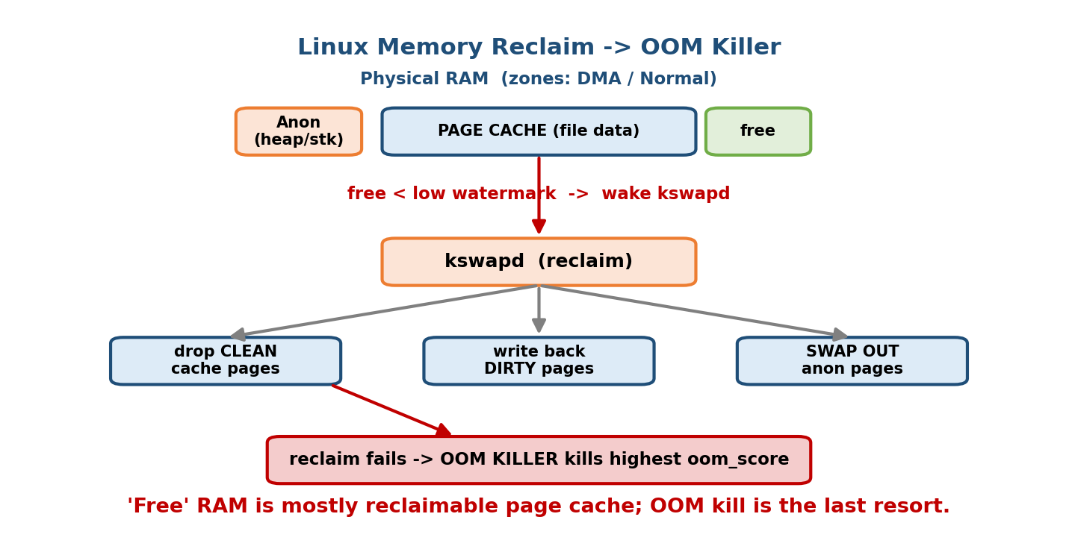
Linux memory reclaim path: physical RAM in zones (DMA/Normal), most of it used as page cache; when free pages cross the low watermark kswapd reclaims (drop clean pages, write back dirty, swap anonymous). If reclaim fails, the OOM killer picks the highest oom_score process and kills it.

MCQs
- Where does Linux cache file data read from disk? → the page cache.
- Kernel thread that reclaims memory when free pages get low? → kswapd.
- What happens when memory is truly exhausted? → the OOM killer kills the highest-oom_score process.
- Allocator that manages power-of-two free page blocks? → the buddy allocator.
- Does high “used”/low “free” memory on Linux indicate a problem? → No — it’s mostly reclaimable page cache.

14.5 The Virtual File System (VFS)
The VFS is the abstraction layer that lets one set of syscalls (open, read, write, close, stat) work over dozens of different filesystems (ext4, XFS, Btrfs, FAT, NFS, procfs…). Each filesystem implements a common set of operations; the VFS dispatches to them. This is textbook polymorphism in C (function-pointer “operations” tables) and is exactly the “extended machine” role of an OS (§M1).

The four core objects
VFS object | Represents | Lives | Analogy
superblock | a mounted filesystem as a whole | one per mount | the “volume header”
inode | a file’s metadata (size, perms, owner, block pointers) — no name | one per file | the file’s ID card
dentry | a directory entry: a name → inode link; builds the path tree | cached in RAM (dcache) | a name tag / index card
file | an open file by a process (holds the current offset, mode) | one per open() | a bookmark into the file
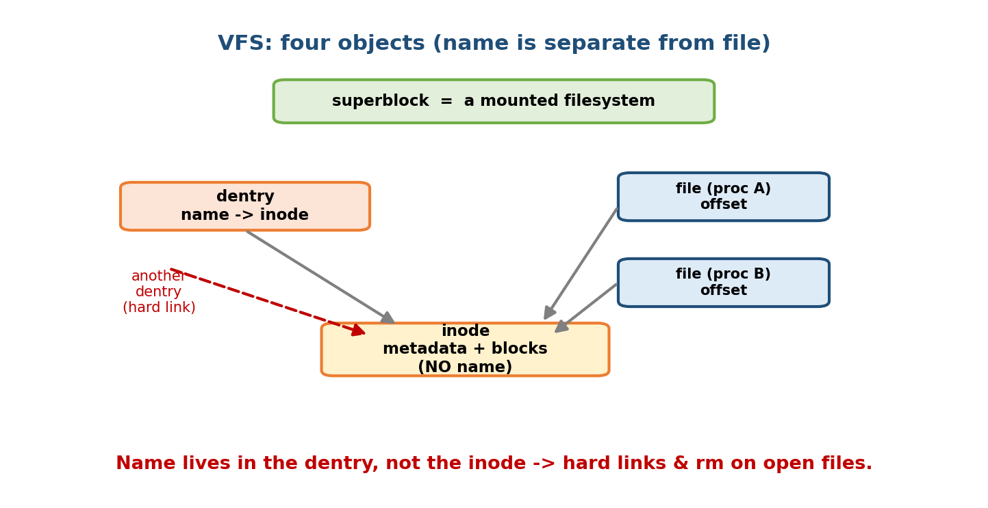
The four VFS objects: a superblock represents a mounted filesystem; a dentry maps a pathname component to an inode; an inode holds a file’s metadata and block pointers (but no name); a file object is a process’s open handle with its own read/write offset. Multiple file objects can point to the same inode.
The name-vs-file split (interview gold): an inode has no filename — the name lives in the dentry. That is why: - Hard links = two dentries pointing to the same inode (same file, two names; deleting one name just decrements the inode’s link count). - Deleting an open file works: unlink() removes the dentry, but the inode (and its data blocks) survive until the last file object closes — the classic “disk still full after rm; a process still holds it open.”
Memory hook: superblock = the filesystem; inode = the file; dentry = the name; file = your open handle (offset). Names and files are separate — that single fact explains hard links, rm on open files, and rename.

MCQs
- What lets read()/write() work identically on ext4, XFS, and NFS? → the VFS.
- Which VFS object stores a filename? → the dentry (NOT the inode).
- Two names for one file (same inode) is a ___ → hard link.
- Which object holds a process’s current read/write offset? → the file object.
- Why can you rm a file a process still has open? → the inode survives until the last file handle closes (dentry removed, link count → 0 later).

14.6 ext4 Basics
ext4 (2008) is the long-time default Linux filesystem — a practical example of the on-disk structures behind §14.5.
- Inodes + block groups. The disk is divided into block groups, each with its own inode table, block bitmap, and data blocks (locality → less seeking).
- Extents (the big ext3→ext4 change). Instead of listing every block individually (ext2/3’s indirect-block scheme), ext4 records extents — (start_block, length) runs of contiguous blocks. One extent can map thousands of blocks, so large files need far less metadata and are less fragmented.
- Journaling. ext4 keeps a journal (write-ahead log, §M11/M12): it records intended changes before applying them, so after a crash it replays/rolls back the journal to reach a consistent state without a full fsck. Modes: journal (data + metadata journaled, safest/slowest), ordered (metadata journaled, data written first — the default), writeback (metadata only, fastest/riskiest).
- Other niceties: delayed allocation, larger volumes/files, htree directory indexing for fast lookup in huge directories.
Memory hook: the two words for ext4 are extents (contiguous block runs → less metadata, less fragmentation) and journaling (crash consistency without a full disk scan). Successors XFS (great for huge/parallel I/O) and Btrfs/ZFS (copy-on-write, snapshots, checksums) push these ideas further.

MCQs
- What replaced indirect block pointers in ext4 for efficiency? → extents (start, length).
- What gives ext4 crash consistency without a full fsck? → the journal (write-ahead log).
- Default ext4 journaling mode? → ordered (metadata journaled, data first).

14.7 cgroups and Namespaces — The Foundation of Containers
This is the most important section for backend/DevOps interviews. Containers (Docker, Kubernetes pods — M17) are not a special kernel feature. They are just ordinary Linux processes wrapped in two independent kernel mechanisms:
- Namespaces = isolation (what a process can SEE).
- cgroups = resource control (how much a process can USE).
Memory hook: Namespaces give a process its own view; cgroups give it a budget. A container = a process with a private view (namespaces) and a spending limit (cgroups). Say this in any interview and you’ve nailed containers.

Namespaces — isolation
A namespace wraps a global system resource so that processes inside the namespace see their own isolated instance. Created with clone()/unshare() flags; visible under /proc/<pid>/ns/. The eight types (as of recent kernels):
Namespace | Isolates | So a container gets…
PID | process IDs | its own PID 1; can’t see host processes
Mount (mnt) | the mount table / filesystem view | its own root filesystem
Network (net) | interfaces, IPs, routes, ports | its own eth0, IP, firewall
UTS | hostname & domain name | its own hostname
IPC | System V IPC, POSIX msg queues | isolated shared memory
User | UID/GID mappings | root inside, unprivileged outside
Cgroup | the cgroup root view | its own cgroup hierarchy view
Time | boot & monotonic clocks | its own uptime (5.6+)
The user namespace is the security keystone: it maps UID 0 (root) inside the container to an unprivileged UID on the host. So even if an attacker becomes “root” in the container, they’re just a normal user to the host kernel — a big reason “rootless” containers are safer (tie-in to M16).

cgroups (control groups) — resource limits
cgroups organise processes into a hierarchy and limit / account / prioritise their resource use through controllers:
Controller | Limits
cpu | CPU shares / quota (e.g. “0.5 CPU”)
memory | RAM limit (exceed → cgroup OOM kill, §14.4)
io (blkio) | disk read/write bandwidth & IOPS
pids | max number of processes (fork-bomb protection)
cgroup v2 (the modern unified hierarchy) exposes this under /sys/fs/cgroup/... (a sysfs-style interface). When you run docker run --memory=512m --cpus=1.5, Docker is just writing those numbers into a cgroup.
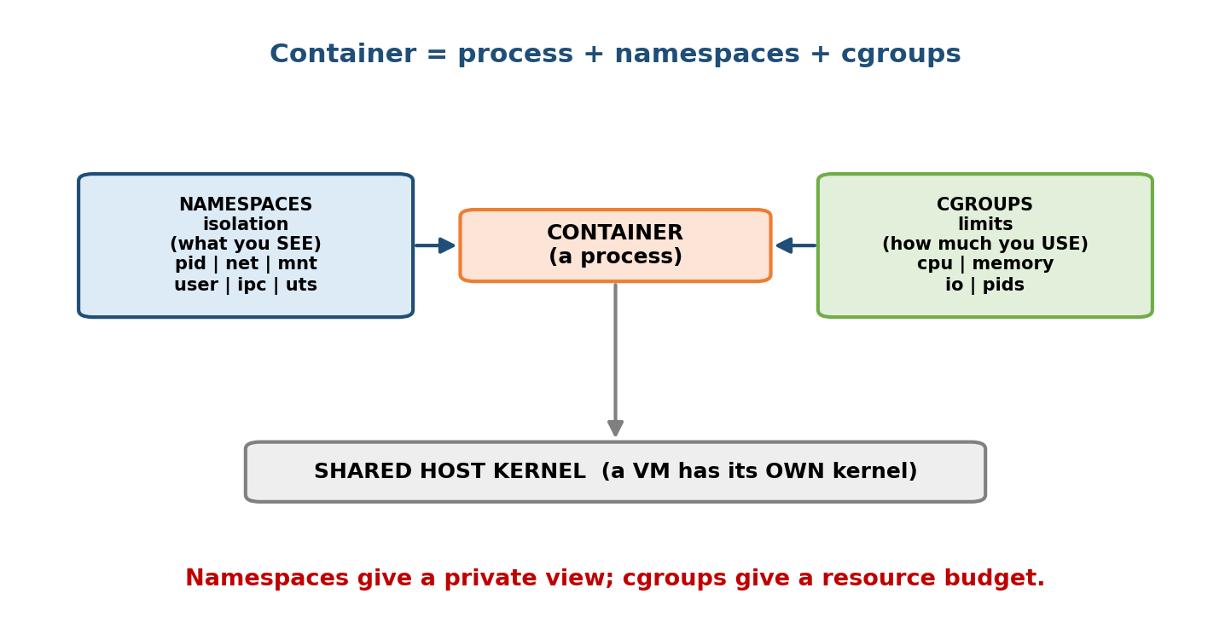
A container = a normal Linux process placed in new namespaces (isolation: its own PID/net/mnt/user view) and a cgroup (resource limits: cpu/memory/io/pids). Namespaces answer “what can I see?”; cgroups answer “how much can I use?”. Together they create a lightweight isolated environment sharing the host kernel.
Container vs VM (must-know, ties to M1 hypervisors and M16). A VM runs a full guest kernel on a hypervisor (strong isolation, heavy). A container shares the host kernel and is isolated only by namespaces + cgroups (lightweight, starts in ms, but a weaker security boundary — a kernel bug can escape it; §M16). This single distinction is asked constantly.

MCQs
- Which mechanism gives a container its isolated view (own PID 1, own network)? → namespaces.
- Which mechanism limits a container’s CPU/memory/IO? → cgroups.
- Which namespace makes a process root inside but unprivileged outside? → the user namespace.
- What happens when a cgroup exceeds its memory limit? → OOM kill within that cgroup.
- Do containers share the host kernel? → Yes (unlike VMs, which run their own kernel) — a weaker isolation boundary.

14.8 systemd and Init — Bringing Userspace to Life
After the kernel boots (bootloader → kernel → mounts root fs, §M2/M3), it starts the first user-space process, PID 1, the init system. PID 1 is special: it is the ancestor of every process and reaps orphaned zombies (§M4).
- Traditional SysV init ran numbered shell scripts sequentially (/etc/rc.d) — simple but slow (no parallelism) and no dependency tracking.
- systemd (today’s default on most distros) replaces it with units (.service, .socket, .mount, .timer, .target). It starts services in parallel, resolves dependencies, does socket activation (start a service on first connection), tracks each service’s processes in a cgroup (§14.7), restarts crashed services, and captures logs in the journal (journalctl).
Memory hook: PID 1 = init = the root of the process tree and the zombie reaper. Modern PID 1 = systemd: parallel, dependency-aware, cgroup-backed service manager. (In a container, PID 1 is usually your app — which is why you need proper signal handling / a tiny init like tini to reap zombies.)

MCQs
- What is PID 1 and what special duty does it have? → the init process; it reaps orphaned zombies and is the ancestor of all processes.
- Modern replacement for SysV init? → systemd (parallel, dependency-based).
- How does systemd track a service’s processes? → in a cgroup.

14.9 /proc and /sysfs — The Kernel as Files
Linux embodies the UNIX philosophy “everything is a file.” Two pseudo (virtual) filesystems — files backed by kernel data, not disk — let you read and tune the kernel with ordinary file tools (cat, echo).

/proc — processes and kernel state
/proc (procfs) exposes one directory per process (/proc/<pid>/) plus system-wide files:
Path | Shows
/proc/<pid>/status | state, memory, UID, threads of that process
/proc/<pid>/cmdline | the command line it was started with
/proc/<pid>/fd/ | symlinks to every open file descriptor
/proc/<pid>/maps | its virtual-memory map (which library/heap is where)
/proc/<pid>/ns/ | its namespaces (§14.7)
/proc/cpuinfo, /proc/meminfo | CPU and memory info
/proc/loadavg, /proc/mounts | load average, mounted filesystems
Tools like ps, top, and htop are just pretty printers for /proc.

/sys (sysfs) — devices and the driver model
/sys (sysfs) exposes the kernel device model: buses, devices, drivers, and their attributes as a clean tree — e.g. /sys/class/net/eth0/ (network device), /sys/block/sda/ (a disk), /sys/fs/cgroup/ (cgroups, §14.7). You often tune the kernel by writing here (e.g. echo 1 > /sys/.../parameter).
Rule of thumb: /proc ≈ processes + legacy kernel knobs; /sys ≈ devices + the modern driver/cgroup model. Both are virtual — the files have size 0 on disk; reading them runs kernel code.
# Real examples you can run today:
$ cat /proc/$$/status | head # info about your own shell ($$ = its PID)
$ ls /proc/1/ns # PID 1's namespaces
$ cat /proc/meminfo | grep Cached # size of the page cache (§14.4)
$ ls /sys/class/net # your network interfaces

MCQs
- What kind of filesystems are /proc and /sys? → pseudo/virtual filesystems (backed by kernel data, not disk).
- Where do you find a process’s open file descriptors? → /proc/<pid>/fd/.
- Where does a process’s virtual-memory map live? → /proc/<pid>/maps.
- Where does the modern cgroup interface live? → under /sys/fs/cgroup/.
- top/ps read their data from? → /proc.

14.10 Real-World & Backend Perspectives
- Every container you run (docker run, a Kubernetes pod) is §14.7 in action: namespaces for isolation, cgroups for --memory/--cpus limits, sharing the host kernel. Understanding this is the difference between “using Docker” and “debugging why the pod got OOM-killed.”
- “OOM-killed” incidents (§14.4): a container hits its cgroup memory limit and the kernel kills the process — you see exit code 137 (128 + SIGKILL 9). The fix is a memory limit or a leak fix, not “add RAM.”
- Load average & CFS: the numbers in top come from /proc/loadavg; how quickly your app gets CPU under contention is CFS (now EEVDF) fairness at work; nice/ renice and cgroup cpu.weight tune it.
- Page cache tuning: database and file servers live and die by the page cache; free -m “available” (not “free”) is the number that matters.
- Observability: strace shows the syscalls an app makes (the §14.1 syscall boundary); /proc/<pid>/maps and fd/ are your first stop when debugging leaks and “too many open files.”

14.11 Tradeoffs, Common Mistakes, Edge Cases
- Mistake: calling Linux a microkernel. It’s a monolithic (modular) kernel.
- Mistake: thinking threads and processes are different kernel objects in Linux. Both are task_structs; a thread just shares more (via clone() flags).
- Mistake: “my server has no free RAM!” — that’s the page cache; it’s reclaimable. Read available, not free.
- Mistake: confusing namespaces (isolation/visibility) with cgroups (resource limits). Different mechanisms; containers need both.
- Edge case: deleting a large open log file doesn’t free disk space until the writing process closes it — because the inode outlives the dentry (§14.5).
- Tradeoff (containers vs VMs): containers are lightweight but share the kernel → weaker isolation (M16). Multi-tenant untrusted workloads sometimes use VMs or micro-VMs (Firecracker/gVisor) for a stronger boundary.
- Edge case (CFS): a vruntime that’s grossly behind (e.g. a long-sleeping task) is clamped near the tree minimum on wake, so it can’t monopolise the CPU.

14.12 Exam, Interview & Coding Perspectives
- SEBI / RBI / NABARD / C-DAC: monolithic vs microkernel (Linux = monolithic); fork vs clone; what /proc is; init/systemd; ext4 journaling — mostly conceptual MCQs.
- GATE: lighter here, but fork() process-tree/printf counting questions and scheduling fairness recur; know CFS at a conceptual level.
- Interview (backend/infra — very high yield):
  - “How does Linux represent a thread vs a process?” → one task_struct; clone() flags decide sharing.
  - “Explain CFS.” → vruntime, run the smallest-vruntime task, RB-tree, nice→weight.
  - “What are namespaces vs cgroups?” → isolation (view) vs resource limits (budget); the container foundation.
  - “Why did my container get OOM-killed?” → cgroup memory limit → OOM killer.
  - “What’s the difference between a container and a VM?” → shared host kernel (namespaces+cgroups) vs full guest kernel on a hypervisor.
- Coding/practical: strace ./app (see syscalls), cat /proc/<pid>/maps, ls /proc/<pid>/fd, nsenter/unshare to play with namespaces, systemctl and journalctl for services.

14.13 Concept Checks & MCQs (test yourself)
- Linux kernel type? → monolithic, modular via loadable kernel modules.
- One structure for processes and threads? → task_struct.
- clone() flag that shares the address space (makes a thread)? → CLONE_VM.
- fork() shares memory via? → copy-on-write.
- CFS picks which task? → smallest vruntime (leftmost RB-tree node).
- Nice-0 weight and per-nice CPU change? → 1024, ~10% per level.
- Data structure in CFS? → red-black tree keyed by vruntime.
- What replaced CFS in kernel 6.6? → EEVDF.
- Kernel thread that reclaims memory? → kswapd.
- Reclaim fails, memory exhausted → ? → OOM killer (highest oom_score).
- Where is file data cached? → the page cache (reclaimable).
- VFS’s four objects? → superblock, inode, dentry, file.
- Which VFS object stores the name? → the dentry (not the inode).
- Two names → one inode is a ___ → hard link.
- ext4’s efficient block mapping? → extents; crash safety via journaling.
- Namespaces provide ; cgroups provide . → isolation (view) ; resource limits (budget).
- Namespace giving “root inside, unprivileged outside”? → user namespace.
- Container vs VM? → shares host kernel vs own guest kernel.
- PID 1’s special duty? → it’s init; reaps orphaned zombies.
- Modern init? → systemd (parallel, dependency-based, cgroup-backed).
- /proc and /sys are ___ filesystems → pseudo/virtual.
- Open FDs of a process live in? → /proc/<pid>/fd/.
True/False - Linux threads and processes are different kernel objects. → False (both task_struct). - A high vruntime means a task should run next. → False (smallest runs next). - On Linux, low “free” memory is a problem. → False (it’s page cache). - An inode stores the filename. → False (the dentry does). - Namespaces limit CPU/memory. → False (that’s cgroups). - A container runs its own kernel. → False (shares the host kernel).

14.14 One-Page Revision Sheet
LINUX = MONOLITHIC kernel + loadable MODULES. User space -> SYSCALL -> kernel.
Subsystems: process/sched | memory(MM) | VFS | net | drivers | arch.
PROCESS/THREAD:
task_struct = the PCB for BOTH processes and threads (no separate thread object).
fork() = clone() sharing ~nothing (own addr space, COPY-ON-WRITE).
thread = clone(CLONE_VM|CLONE_FILES|CLONE_SIGHAND|CLONE_THREAD) share everything.
getpid()=TGID (shared), gettid()=TID (per-thread, what scheduler uses).
CFS (default 2.6.23 -> 6.6; then EEVDF):
vruntime = "CPU already eaten". RUN THE SMALLEST vruntime (most starved).
vruntime += delta_exec * (1024 / weight). nice -20..+19, weight=1024/1.25^nice,
nice0 weight=1024, ~10% CPU per nice step.
Red-Black tree keyed by vruntime; leftmost = next (O(1) pick, O(log n) update).
Sleepers wake with small vruntime -> interactive & responsive. No fixed quantum.
MEMORY: zones(DMA/Normal/High) ; buddy allocator (power-of-2) ; slab (small objs).
PAGE CACHE = spare RAM caches disk (free RAM = wasted). "available" not "free".
kswapd reclaims at low watermark (drop clean / writeback dirty / SWAP anon).
OOM KILLER kills highest oom_score when reclaim fails (cgroup limit -> cgroup OOM).
VFS (one API over many FS): SUPERBLOCK=mounted FS | INODE=file metadata (NO name)
| DENTRY=name->inode | FILE=open handle (offset).
inode has NO name => hard link = 2 dentries -> 1 inode; rm on open file OK
(inode lives till last file closed).
EXT4 = EXTENTS (start,len runs) + JOURNALING (ordered=default). block groups.
CONTAINERS = process + NAMESPACES (isolation: what you SEE) + CGROUPS (limits: how
much you USE). Namespaces: pid/mnt/net/uts/ipc/USER(root in,unpriv out)/cgroup/time.
cgroup controllers: cpu/memory/io/pids. Container SHARES host kernel (VM = own kernel).
INIT: PID 1 = init = ancestor + reaps zombies. Modern = SYSTEMD (parallel, deps,
units, cgroup-tracked, journalctl).
/proc = per-process + kernel state (/proc/<pid>/{status,fd,maps,ns}); /sys = devices +
cgroups (/sys/fs/cgroup). Both PSEUDO/virtual (backed by kernel, not disk).

Flash cards
Front | Back
Linux kernel type? | Monolithic (modular / LKMs)
Process & thread structure? | one task_struct
fork vs thread creation? | same clone(), different share flags
CFS runs which task? | smallest vruntime
CFS data structure? | red-black tree (by vruntime)
Nice-0 weight / per-step CPU? | 1024 / ~10%
Replaced CFS in 6.6? | EEVDF
Memory reclaimer thread? | kswapd
Last-resort on OOM? | OOM killer (oom_score)
Free RAM used for? | page cache
VFS 4 objects? | superblock, inode, dentry, file
Which VFS object has the name? | dentry (not inode)
ext4 key features? | extents + journaling
Namespaces vs cgroups? | isolation (view) vs limits (budget)
“root inside, unpriv outside”? | user namespace
Container vs VM? | shared host kernel vs own kernel
PID 1 duties? | init + reap zombies
/proc & /sys are? | pseudo/virtual filesystems

Spaced repetition
- 24-hour: recite task_struct/clone, the CFS rule (run smallest vruntime), and namespaces-vs-cgroups.
- 7-day: explain the memory reclaim path (page cache → kswapd → swap → OOM), the four VFS objects, and container vs VM.
- 30-day: given “my container was OOM-killed” or “rm didn’t free space,” explain the exact kernel reason using cgroups/OOM and inode/dentry.

14.15 Summary
Linux is a monolithic, modular kernel reached only through system calls. It represents every process and thread as one task_struct, and builds threads and processes from the same clone() primitive by choosing what to share (CLONE_VM = a thread; fork() = a copy-on-write new address space). Its scheduler, CFS, keeps things fair by running the task with the smallest vruntime — stored in a red-black tree, weighted by nice values (~10% CPU per step) — and was replaced by the closely-related EEVDF in kernel 6.6. Its memory manager splits RAM into zones, uses spare RAM as page cache, reclaims via kswapd (and swap), and, as a last resort, invokes the OOM killer. The VFS abstracts many filesystems behind four objects — superblock, inode, dentry, file — where the crucial split of name (dentry) from file (inode) explains hard links and deleting open files; ext4 implements this with extents and journaling. Most important for modern infrastructure: namespaces (isolation — what a process can see) and cgroups (limits — how much it can use) together create containers, ordinary processes that share the host kernel. Userspace is launched by PID 1 (systemd), and the whole kernel is inspectable as files through /proc and /sys.
Next, Module 15 — Concurrency goes deeper into the hardest problem all of this rests on: making many tasks run correctly at once — atomics, memory ordering, and lock-free programming.
You have mastered this module when you can: say why Linux is monolithic-modular; explain task_struct/clone() and how a thread differs from fork(); describe CFS (vruntime, RB-tree, nice→weight) end to end; trace the memory-reclaim path to the OOM killer; name the four VFS objects and why name≠file; and crisply distinguish namespaces vs cgroups and container vs VM — all without notes.

