Module 15 — Concurrency
  - OS Mastery: SEBI IT / RBI / NABARD / GATE / C-DAC / Interview / Backend — In-Depth Notes (with visuals)
Prepared for nidhi.sharma@forensiccybertech.com
2026
Table of Contents

Module 15 — Concurrency
Where this module sits. Module 7 introduced synchronization — mutexes, semaphores, the critical-section problem — as the tools that keep concurrent code correct. This module goes one level deeper and lower, to the layer beneath the locks: what the hardware actually does when multiple cores touch the same memory. We separate concurrency from parallelism, expose why race conditions and memory visibility bugs happen even on “simple” code, and then meet the primitives locks are built from — atomic operations (CAS, fetch-and-add), memory ordering / barriers, and finally lock-free and wait-free programming (the Treiber stack, the ABA problem, false sharing). This is the hardest, highest-signal topic for senior backend / systems / AI-infra interviews, and the foundation for the concurrent data structures inside every database, kernel, and runtime.
Importance ratings (out of 5):
Exam / Use | SEBI IT | RBI IT | GATE CS | Interview | Backend
This module | ★★ | ★★ | ★★★ | ★★★★★ | ★★★★★
Most-asked PYQ / interview concepts: concurrency vs parallelism; what a race condition really is + memory visibility (why a flag loop hangs without volatile/atomics); atomic read-modify-write (CAS, fetch-and-add); the ABA problem; memory ordering (reordering, barriers/fences, acquire / release, sequential consistency); lock-free vs wait-free and when lock-free beats locks (and its dangers); false sharing.

15.1 Concurrency vs Parallelism (deeper than M5)
These two words are used interchangeably in casual speech and are wrong to conflate in an interview.
- Concurrency is a structuring property: a program is concurrent if it has multiple independent tasks in progress that may overlap in time. It is about dealing with many things at once — even on a single core (the OS time-slices them, §M6).
- Parallelism is an execution property: multiple tasks literally running at the same instant, which requires multiple cores/CPUs (§M1 multiprocessing). It is about doing many things at once.
Memory hook (Rob Pike’s line): “Concurrency is dealing with many things at once; parallelism is doing many things at once.” Concurrency is a way to structure a program; parallelism is a way to run it. You can have concurrency with zero parallelism (one core, many tasks), and you achieve parallelism by running concurrent tasks on many cores.
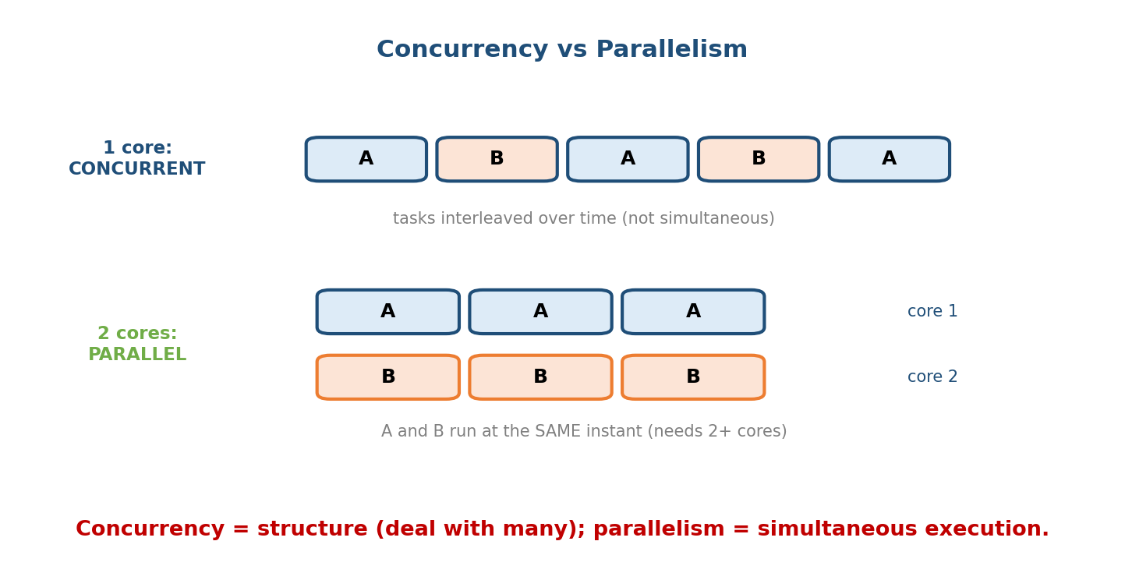
Concurrency vs parallelism: on one core, tasks A and B are interleaved over time (concurrent, not parallel); on two cores, A and B run simultaneously (parallel). Concurrency is a structure; parallelism is simultaneous execution needing multiple cores.
 | Concurrency | Parallelism
What | many tasks in progress | many tasks executing at once
Needs | 1+ core (interleaving is enough) | 2+ cores
Goal | responsiveness, structure | speedup / throughput
Example | a web server juggling 10k connections on 4 cores | multiply two matrices across 32 cores
The trap: adding cores gives parallelism, but only if your program is concurrent in a way that has independent work to run. And more concurrency on shared data means more synchronization — the subject of the rest of this module. (Amdahl’s law, §M6: the serial fraction caps the speedup no matter how many cores you add.)

MCQs
- One core, many interleaved tasks — concurrency, parallelism, or both? → concurrency only.
- What does parallelism require that concurrency doesn’t? → multiple cores/CPUs.
- “Dealing with many things at once” describes? → concurrency (doing = parallelism).

15.2 Race Conditions and Memory Visibility

A race condition, precisely
A race condition exists when the correctness of a program depends on the relative timing/interleaving of operations on shared mutable state. The classic example is a non-atomic increment:
Shared counter = 0. Two threads each do counter++ (which is really 3 steps):
Thread A Thread B
read counter (0)
read counter (0) <- both read 0
add 1 -> 1
add 1 -> 1
write counter (1)
write counter (1) <- one increment LOST
Result = 1, but two increments happened. Correct answer was 2. This is a DATA RACE.
counter++ is a read-modify-write (RMW): three machine steps (load, add, store). An interleaving between the load and the store loses updates. This is the same critical-section problem from §M7 — but here we care about the hardware-level reason it’s non-atomic.

Memory visibility — the subtler bug
Even without interleaving, a thread may never see another thread’s write, because of caches and compiler optimizations:
bool done = false; int data = 0;
Thread A (producer): Thread B (consumer):
data = 42; while (!done) { /* spin */ }
done = true; use(data); // may see data == 0 !
Two things can break this: 1. Compiler may hoist done out of the loop (it “proves” done never changes in B’s code) → B spins forever. 2. CPU/cache: A’s writes may sit in A’s store buffer / cache and reach B’s core out of order or late, so B sees done==true but data==0.
Memory hook: there are two concurrency demons, not one: (1) atomicity — updates stomping on each other (the counter); (2) visibility & ordering — one thread not seeing (or seeing reordered) another’s writes (the flag). Locks fix both; atomics + memory ordering fix them at a finer grain. volatile in C/C++ fixes neither for threading (it is not a concurrency tool — a very common myth).

MCQs
- Why is counter++ unsafe across threads? → it’s a read-modify-write (3 steps); interleaving loses updates (data race).
- Name the two distinct concurrency problems. → atomicity and visibility/ordering.
- Does C/C++ volatile make code thread-safe? → No (it’s for memory-mapped I/O, not thread synchronization).

15.3 Atomic Operations — CAS and Fetch-and-Add
An atomic operation completes indivisibly: no other thread can observe it half-done, and it can’t be interleaved. The hardware provides a few atomic read-modify-write (RMW) instructions that are the bedrock of all synchronization — locks, semaphores, and lock-free structures are built on them.

The workhorses
- Test-and-set / Exchange (XCHG) — atomically write a value and return the old one. Enough to build a spinlock.
- Fetch-and-add (XADD) — atomically old = *p; *p += n; return old. Perfect for counters, ticket locks, and sequence numbers — no lock needed:
// Thread-safe counter with NO lock — one atomic instruction:
new_value = fetch_and_add(&counter, 1); // atomic; no lost updates
- Compare-and-swap (CAS) — the universal primitive:
CAS(addr, expected, new): // all atomic, in hardware (x86: CMPXCHG)
if *addr == expected:
*addr = new
return true // success
else:
return false // someone else changed it; retry
Memory hook: CAS = “change it only if nobody touched it since I looked.” It’s the atomic version of “check the price tag, and buy only if it hasn’t changed.” Almost every lock-free algorithm is a CAS in a retry loop.
The CAS retry loop (how you do any atomic update, e.g. an atomic max):
do {
old = *addr; // read current value
new = f(old); // compute desired new value
} while (!CAS(addr, old, new)); // install it; retry if someone raced us
CAS is universal (Herlihy’s result): with CAS you can build a wait-free version of any concurrent object — test-and-set and fetch-and-add cannot. That’s why every language’s atomics (std::atomic, java.util.concurrent.atomic, Go’s sync/atomic) expose CAS.

MCQs
- Which atomic primitive is universal (can build anything)? → compare-and-swap (CAS).
- Best atomic for a shared counter with no lock? → fetch-and-add.
- What does CAS return/do on failure? → it doesn’t write; returns false → retry with the new current value.
- Locks and semaphores are ultimately built on? → atomic RMW instructions.

15.4 Memory Ordering and Memory Models
Even with atomics, there’s a deeper problem: the order you write instructions is NOT the order they execute or become visible. Compilers reorder for optimization; CPUs reorder for pipelining and use per-core store buffers and caches. A memory model is the contract stating which reorderings are allowed and how to stop them.

Reordering is real
On a weakly-ordered view, a core may make its stores visible to other cores out of program order. The classic Dekker/Store-Buffer litmus test:
Initially x = 0, y = 0.
Thread 1: x = 1; r1 = y;
Thread 2: y = 1; r2 = x;
Intuition says r1 and r2 can't BOTH be 0.
On real x86/ARM they CAN both be 0 — each store sits in a store buffer while the
load reads the other (still-zero) variable. This is store->load reordering.

Barriers / fences
A memory barrier (fence) is an instruction that forbids reordering across it and forces buffered writes to become visible. Types:
- Full barrier — no memory operation may move across it in either direction.
- Acquire barrier — later reads/writes can’t move before it (used after a lock acquire / load).
- Release barrier — earlier reads/writes can’t move after it (used before a lock release / store).

Acquire–release — the practical model
Most real code uses acquire/release semantics, which give exactly the guarantee you want cheaply:
- A release store publishes: everything the thread wrote before the release is visible to anyone who later does an acquire load of that same variable.
- An acquire load subscribes: after it sees the released value, it also sees all writes that happened before the release.
Fixes the §15.2 flag bug:
Thread A: data = 42;
store_release(&done, true); // publishes data too
Thread B: if (load_acquire(&done)) // subscribes
use(data); // now GUARANTEED to see 42
This is exactly what a mutex does: unlock is a release, lock is an acquire — which is why everything you did inside the critical section is visible to the next thread that takes the lock.
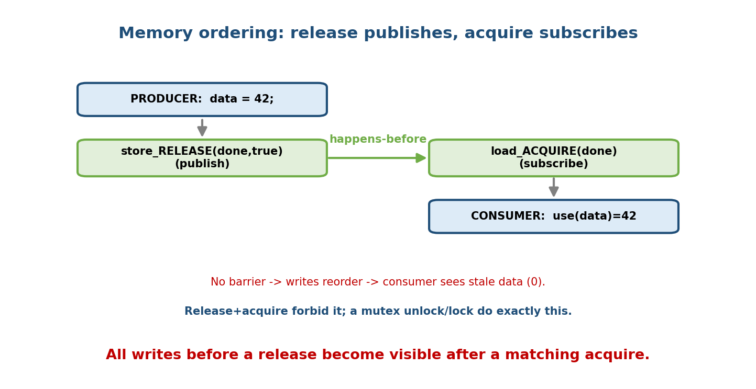
Memory ordering: without a barrier, a producer’s data write can be reordered after its flag write, so the consumer sees the flag set but stale data. A release store (producer) paired with an acquire load (consumer) forbids that reordering, so all writes before the release are visible after the acquire — this is the happens-before guarantee locks provide.

Sequential consistency (SC) — the strongest, simplest model
Sequential consistency (Lamport): the program behaves as if all operations from all threads ran in some single global interleaving that respects each thread’s program order. It’s the intuitive “no weird reordering” model — easiest to reason about but the most expensive (needs full barriers). std::atomic’s default (memory_order_seq_cst) and Java volatile give SC for the atomic variables. Ordering strength ladder (strong → weak):
Sequential Consistency (seq_cst) strongest, simplest to reason, slowest
Acquire / Release (acq/rel) publish/subscribe pairs, cheaper, common
Relaxed (relaxed) atomic value only, NO ordering (counters/stats)
Memory hook: release = publish, acquire = subscribe. A release store and a matching acquire load create a happens-before edge, so everything before the publish is seen after the subscribe. seq_cst = “one global order, no surprises” (safe default, slowest). relaxed = “atomic, but no ordering promises” (fine for a pure statistics counter, dangerous for flags).

MCQs
- Why can two threads’ stores appear out of order? → CPU store buffers / caches
  - compiler/CPU reordering.
- Instruction that forbids reordering & flushes writes? → a memory barrier (fence).
- Which pairing fixes the publish/see-stale-data bug? → release store + acquire load.
- Strongest, most intuitive (and slowest) model? → sequential consistency.
- A mutex unlock/lock act as which barriers? → release / acquire.

15.5 Lock-Free and Wait-Free Programming
Locks have real downsides: a thread holding a lock that gets preempted (§M6) blocks everyone waiting; locks risk deadlock, priority inversion, and convoying. Non-blocking algorithms avoid locks by using atomics (CAS) so that stopping one thread never blocks the whole system.

The hierarchy (progress guarantees)
Property | Guarantee | Meaning
Blocking (locks) | none | a stalled lock-holder can stall everyone
Lock-free | system-wide progress | some thread always makes progress (individuals may retry forever)
Wait-free | per-thread progress | every thread finishes in a bounded number of steps (no starvation)
Memory hook: lock-free = someone always makes progress; wait-free = everyone makes progress in bounded time. Wait-free is strictly stronger (and much harder/rarer). Lock-free is the common practical target.

The Treiber stack — the canonical lock-free structure
A lock-free stack (R. K. Treiber, 1986) is a singly-linked list where push/pop just CAS the head pointer in a retry loop:
push(v):
n = new Node(v)
do {
old = head // read current top
n.next = old
} while (!CAS(&head, old, n)) // install n as new head; retry on race
pop():
do {
old = head
if old == null: return EMPTY
next = old.next
} while (!CAS(&head, old, next)) // move head past old; retry on race
return old.value
No locks — concurrent pushers/poppers simply retry their CAS if another thread won the race. Some thread always succeeds → lock-free.
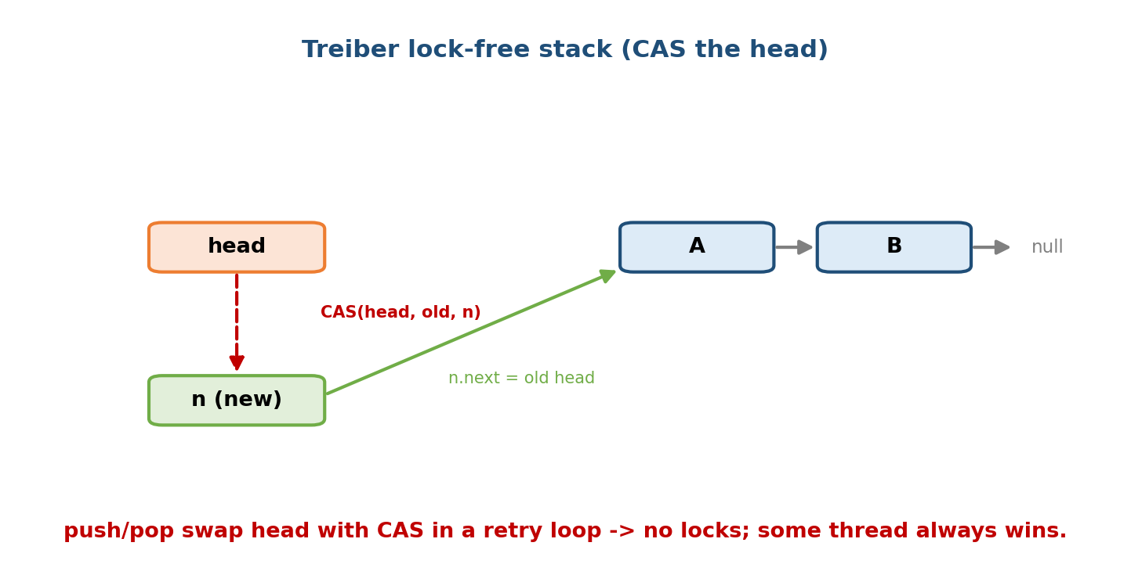
The Treiber lock-free stack: push allocates a node, points it at the current head, and CAS-swaps head to the new node; if another thread changed head first, the CAS fails and the operation retries. No locks — progress is guaranteed system-wide.

The ABA problem — the classic trap
CAS checks “is the value still what I read?” — but a value can change A → B → A between your read and your CAS. CAS sees “still A” and wrongly succeeds, even though the world changed underneath it:
1. Thread 1 reads head = A, plans CAS(&head, A, A.next).
2. Thread 1 is paused.
3. Thread 2 pops A, pops B, then pushes A back (reusing the freed node).
head is A again, but A.next now points somewhere STALE/freed.
4. Thread 1 resumes: CAS(&head, A, A.next) SUCCEEDS (head is "still" A!) —
and installs a dangling/old .next -> corruption.
Memory hook: ABA = “it looks unchanged, but it isn’t.” CAS compares values, not history. Fixes: - Tagged/versioned pointer — pack a counter with the pointer; every change bumps the counter, so A-with-tag-1 ≠ A-with-tag-3 (double-width CAS, CMPXCHG16B). Most common fix. - Hazard pointers or epoch-based reclamation / GC — don’t free/reuse a node while another thread might still reference it (this is why ABA is easy to hit in C/C++ manual memory and rarer under a garbage collector).

False sharing — a silent performance killer
Even independent atomic variables are slow if they share a cache line (~64 bytes). CPUs keep caches coherent per line, so when core 1 writes variable x and core 2 writes a different variable y on the same line, each write invalidates the other core’s copy — the line “ping-pongs” between cores. The program is logically correct but crawls.
struct Counters { long a; long b; }; // a and b on the SAME 64B cache line
Core1 keeps updating a; Core2 keeps updating b;
-> every write invalidates the other core's cached line -> massive slowdown.
Fix: PAD/ALIGN each hot variable to its own cache line (e.g. alignas(64)),
so a and b live on different lines and never invalidate each other.
Memory hook: false sharing = true contention on data you thought was separate. No logical sharing, but the cache line is shared. Fix by padding to 64 bytes / cache-line alignment. A classic “why did adding a second thread make it slower?” interview answer.

When lock-free beats locks — and its dangers
Use lock-free when: - The critical section is tiny (a pointer/counter swap) — CAS is cheaper than taking a lock. - You need progress under preemption/failure — a stalled thread mustn’t block others (real-time, kernel, high-contention counters, ring buffers). - Interrupt/signal-context code where blocking on a lock is forbidden.
Dangers (why not everything is lock-free): - Brutally hard to get right — ABA, memory reclamation, and subtle memory ordering bugs; needs expert review and tools. - Not automatically faster — under high contention the CAS retry storm can waste more CPU than a good lock; lock-free ≠ fast. - Livelock / starvation — threads can retry forever (lock-free guarantees system progress, not individual progress). - Memory management is the real monster in non-GC languages (when is it safe to free a node?).
Interview one-liner: “lock-free is about progress guarantees, not raw speed. Prefer a well-designed lock; reach for lock-free for tiny hot paths (counters, queues) or when a stalled thread must not block others — and budget for ABA and memory-ordering pain.”

MCQs
- Lock-free vs wait-free? → lock-free = some thread progresses; wait-free = every thread progresses in bounded steps.
- Canonical lock-free structure using CAS on the head? → the Treiber stack.
- What is the ABA problem? → a value goes A→B→A, so CAS wrongly succeeds (compares value, not history).
- Two common ABA fixes? → tagged/versioned pointers (double-width CAS) and hazard pointers / epoch reclamation / GC.
- Two threads updating different variables on the same 64B line → ? → false sharing (fix: pad/align to a cache line).
- Is lock-free always faster than locks? → No — CAS retry storms under high contention can be slower.

15.6 Real-World & Backend Perspectives
- Every high-performance system uses these primitives: java.util.concurrent (AtomicInteger, ConcurrentLinkedQueue — a lock-free Michael-Scott queue), Go’s sync/atomic and channels, C++ std::atomic, Rust’s Arc/Atomic* (whose type system forces correct sharing).
- Databases & kernels: lock-free/wait-free queues and RCU (read-copy-update) in the Linux kernel let readers run with zero locking; the page-cache and scheduler use atomics heavily (§M14).
- Metrics/counters: high-throughput request counters use fetch-and-add (or per-core sharded counters to dodge false sharing) instead of a mutex.
- Ring buffers: lock-free single-producer/single-consumer ring buffers (LMAX Disruptor) power low-latency trading and logging — and they pad head/tail indices to separate cache lines to avoid false sharing.
- AI infra (M19): GPU host-side pipelines, lock-free work queues, and atomic reference counts on tensors all rely on exactly these ideas; a subtle memory-ordering bug shows up as a “sometimes-wrong” result under load.

15.7 Tradeoffs, Common Mistakes, Edge Cases
- Mistake: using volatile for thread safety (C/C++). It gives neither atomicity nor ordering — use std::atomic / language atomics. (Java’s volatile does give visibility/ordering — don’t mix the two languages up.)
- Mistake: assuming “the code runs in the order I wrote it.” Compilers and CPUs reorder; only barriers/atomics constrain it.
- Mistake: “lock-free = fast.” It’s a progress property; under contention it can be slower than a good lock.
- Mistake: ignoring ABA in manual-memory lock-free code — leads to rare, brutal corruption.
- Edge case (false sharing): adding a thread makes the program slower because two hot variables share a cache line — pad to 64 bytes.
- Tradeoff: stronger memory order (seq_cst) = easier reasoning but slower; relaxed = fast but only safe for order-independent uses (pure counters).
- Edge case: a benign data race is still undefined behaviour in C/C++ — “it worked in testing” is not correctness.

15.8 Exam, Interview & Coding Perspectives
- GATE / C-DAC: the race-condition/lost-update reasoning, atomicity of read-modify-write, and concurrency-vs-parallelism definitions; ties back to §M7 (critical section, semaphores).
- SEBI / RBI / NABARD: mostly the concurrency-vs-parallelism distinction and race-condition concept as MCQs.
- Interview (senior backend/systems — extremely high yield):
  - “Concurrency vs parallelism?” → structure vs simultaneous execution.
  - “What’s a race condition / how do you fix it?” → shared mutable state + timing; lock or atomic.
  - “What is CAS? Write a CAS loop.” → the universal primitive + retry loop.
  - “Explain acquire/release / memory ordering.” → publish/subscribe happens-before.
  - “What’s the ABA problem?” → value A→B→A defeats CAS; fix with tags/hazard pointers.
  - “What is false sharing?” → different variables, same cache line, ping-pong.
  - “When would you go lock-free?” → tiny hot path / no-block-on-stall; mind the dangers.
- Coding/practical: implement a lock-free counter (fetch-and-add) and a Treiber stack (CAS loop); use ThreadSanitizer (-fsanitize=thread) to catch data races; perf c2c to detect false sharing.

15.9 Concept Checks & MCQs (test yourself)
- Concurrency vs parallelism? → dealing with many tasks (structure, 1+ core) vs doing many at once (execution, 2+ cores).
- Why is x++ racy across threads? → it’s a read-modify-write; interleaving loses updates.
- The two concurrency demons? → atomicity and visibility/ordering.
- Does C/C++ volatile synchronize threads? → No.
- The universal atomic primitive? → CAS.
- Best atomic for a lock-free counter? → fetch-and-add.
- What does a CAS loop do on failure? → retry with the fresh current value.
- What forbids memory reordering? → a memory barrier / fence.
- Release + acquire create a ___ edge → happens-before (publish/subscribe).
- Strongest memory model? → sequential consistency (slowest).
- Weakest useful order (atomic, no ordering)? → relaxed (counters/stats only).
- Lock-free vs wait-free? → some vs every thread makes bounded progress.
- Canonical lock-free stack? → Treiber stack (CAS on head).
- The ABA problem? → A→B→A fools CAS (value, not history).
- Two ABA fixes? → tagged pointers (DWCAS) / hazard pointers or GC.
- Two vars, same 64B line, two cores → ? → false sharing (pad to a cache line).
- Is lock-free always faster? → No (retry storms under contention).
- Mutex unlock/lock behave as which fences? → release / acquire.
True/False - Concurrency requires multiple cores. → False (parallelism does). - CAS can build any concurrent object. → True (universal). - Lock-free means no thread ever starves. → False (that’s wait-free). - volatile (C/C++) prevents data races. → False. - False sharing is a correctness bug. → False (a performance bug). - seq_cst is the fastest memory order. → False (it’s the slowest/strongest).

15.10 One-Page Revision Sheet
CONCURRENCY = dealing with many tasks (STRUCTURE; 1+ core, interleave).
PARALLELISM = doing many at once (EXECUTION; needs 2+ cores). Pike: deal vs do.
RACE CONDITION = correctness depends on timing of shared mutable state.
x++ = READ-MODIFY-WRITE (3 steps) -> interleave loses updates.
TWO demons: (1) ATOMICITY (2) VISIBILITY/ORDERING. Locks fix both.
C/C++ volatile fixes NEITHER (not a threading tool).
ATOMIC RMW (hardware; base of ALL sync):
test-and-set/XCHG -> spinlock ; FETCH-AND-ADD -> counters (no lock);
CAS(addr,expected,new) = write only if unchanged -> UNIVERSAL.
CAS loop: do{ old=*a; new=f(old);} while(!CAS(a,old,new));
MEMORY ORDERING (compiler+CPU REORDER; store buffers):
BARRIER/FENCE forbids reordering + flushes.
RELEASE store = PUBLISH ; ACQUIRE load = SUBSCRIBE -> happens-before.
(mutex unlock=release, lock=acquire => CS writes visible to next locker)
Ladder: seq_cst (strongest,intuitive,slow) > acquire/release > relaxed (no order).
NON-BLOCKING:
blocking(locks): stalled holder blocks all.
LOCK-FREE = SOME thread progresses (may retry forever).
WAIT-FREE = EVERY thread progresses in BOUNDED steps (stronger, rare).
TREIBER STACK = lock-free stack: CAS the head in a retry loop.
ABA problem: value A->B->A fools CAS (compares value, not history).
fix: TAGGED/versioned pointer (DWCAS) ; hazard pointers / epoch / GC.
FALSE SHARING: different vars on same 64B CACHE LINE -> ping-pong -> slow.
fix: pad/align to 64B. (perf bug, not correctness.)
LOCK-FREE when: tiny hot path, must not block on stall. Dangers: hard, ABA,
retry storms (NOT always faster), livelock/starvation.

Flash cards
Front | Back
Concurrency vs parallelism? | deal-with-many (structure) vs do-many-at-once (execution)
Why is x++ racy? | read-modify-write; interleave loses updates
Two concurrency demons? | atomicity + visibility/ordering
Does volatile (C/C++) synchronize? | No
Universal atomic primitive? | CAS
Lock-free counter primitive? | fetch-and-add
CAS on failure? | doesn’t write; retry
Publish/subscribe fences? | release / acquire (happens-before)
Strongest memory model? | sequential consistency (slowest)
Lock-free vs wait-free? | some vs every thread bounded progress
Canonical lock-free stack? | Treiber (CAS head)
ABA problem? | A→B→A fools CAS; tag/hazard-pointer fix
False sharing? | different vars, same 64B line → pad
Is lock-free always faster? | No (retry storms)

Spaced repetition
- 24-hour: recite concurrency-vs-parallelism, the lost-update trace, and the CAS loop.
- 7-day: explain acquire/release publish-subscribe, the Treiber stack, and the ABA problem with the A→B→A trace.
- 30-day: given “adding a thread made it slower” (false sharing) or “flag loop hangs / sees stale data” (ordering), diagnose and fix from first principles.

15.11 Summary
Concurrency (structure: many tasks in progress, even on one core) is not parallelism (execution: many tasks at once, needing many cores). Where they meet shared mutable state, two demons appear: atomicity (the lost-update race condition on a read-modify-write like x++) and visibility/ordering (caches, store buffers, and compilers making one thread’s writes late or reordered — and volatile fixes neither in C/C++). The hardware answer is atomic RMW instructions — fetch-and-add for counters and the universal CAS (“write only if unchanged”), used in a retry loop. Above that sits the memory model: barriers/fences stop reordering, release/acquire give a cheap publish/subscribe happens-before edge (exactly what a mutex’s unlock/lock do), and sequential consistency is the strongest, simplest, slowest guarantee. Built on CAS, lock-free (some thread always progresses) and wait-free (every thread progresses in bounded time) algorithms — the Treiber stack being the canonical example — avoid the perils of locks, but bring their own: the ABA problem (fixed with tagged pointers or hazard pointers), false sharing (fixed by padding to a 64-byte cache line), and the sober truth that lock-free is a progress guarantee, not a speed guarantee.
Next, Module 16 — Security builds on all of this: how the OS enforces privilege, isolation, and access control — the protections that keep concurrent, multi-tenant systems safe.
You have mastered this module when you can: cleanly separate concurrency from parallelism; explain a race condition and a memory-visibility bug and fix each; write a CAS loop and say why CAS is universal; explain acquire/release and sequential consistency; and describe the Treiber stack, the ABA problem, false sharing, and when (and when not) to go lock-free — all without notes.

