Module 16 — Security & Protection
  - OS Mastery: SEBI IT / RBI / NABARD / GATE / C-DAC / Interview / Backend — In-Depth Notes (with visuals)
Prepared for nidhi.sharma@forensiccybertech.com
2026
Table of Contents

Module 16 — Security & Protection
Where this module sits. Every earlier module quietly assumed one thing: that programs can’t trample each other or the kernel. Dual-mode operation (§M3), memory protection and paging (§M9–M10), file permissions (§M11), and the isolation of containers (§M14) are all security mechanisms. This module pulls them together into one coherent picture: how an OS protects itself and its users — the hardware privilege rings and dual-mode boundary; authentication vs authorization; the access-control models DAC / MAC / RBAC; Linux’s fine-grained capabilities; the MAC systems SELinux and AppArmor; secure boot; sandboxing with seccomp; why containers are a weaker security boundary than VMs; and the common OS attacks (privilege escalation, buffer overflow, TOCTOU) these defenses exist to stop. For a SEBI IT / cyber / backend role, this is the module that ties the whole course to the real world of breaches and defenses.
Importance ratings (out of 5):
Exam / Use | SEBI IT | RBI IT | GATE CS | Interview | Backend
This module | ★★★★★ | ★★★★ | ★★ | ★★★★ | ★★★★
Most-asked PYQ / interview concepts: protection rings & dual-mode (user/kernel); authentication vs authorization (the classic confusion); DAC vs MAC vs RBAC; principle of least privilege; Linux capabilities (vs all-or-nothing root); SELinux vs AppArmor (label vs path MAC); secure boot & chain of trust; seccomp sandboxing; container vs VM as a security boundary; buffer overflow (+ defenses: NX/DEP, ASLR, canaries), privilege escalation, TOCTOU race.

16.1 Privilege Rings and Dual-Mode Operation

The hardware foundation: rings
CPUs enforce protection with privilege rings — hardware modes with different powers. x86 defines four rings, 0–3:
Ring 0 = KERNEL (most privileged: all instructions, all memory, all I/O)
Ring 1 = (device drivers — rarely used)
Ring 2 = (rarely used)
Ring 3 = USER (least privileged: no direct hardware, restricted memory)
In practice mainstream OSes use only two: Ring 0 (kernel) and Ring 3 (user) — this is dual-mode operation (§M3). A mode bit in the CPU says which mode you’re in. Privileged instructions (halt, set the page table, do raw I/O, mask interrupts) are only legal in Ring 0; attempting them from Ring 3 traps to the kernel.
Memory hook: think of a castle with concentric walls. Ring 0 is the keep (the kernel — full power); Ring 3 is the outer courtyard (user programs). The only gate between them is the system call — a controlled, guarded doorway. Rings 1 and 2 are unused corridors most OSes skip. Virtualization added “Ring −1” (hypervisor mode, VMX root) below the guest kernel — the guest OS thinks it owns Ring 0, but the hypervisor sits beneath it (§M1, M17).
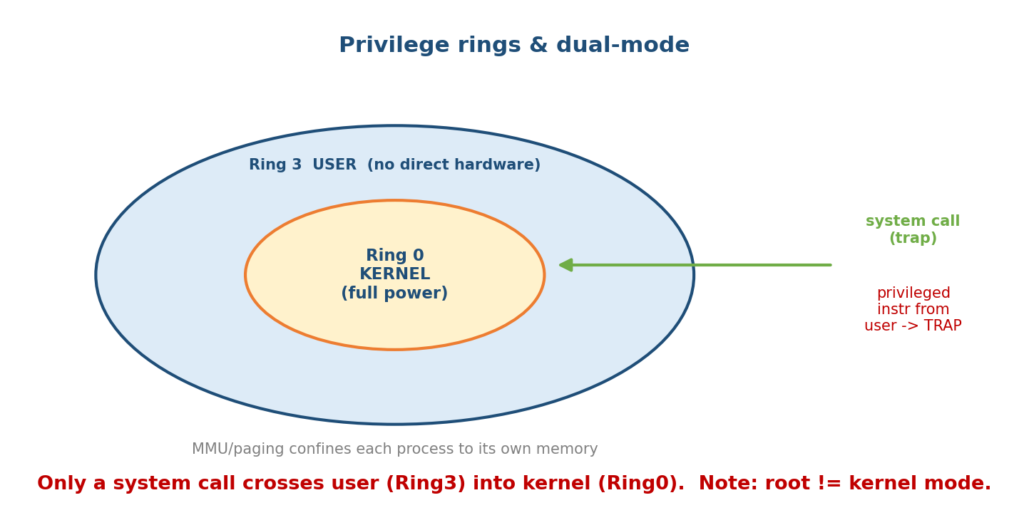
Protection rings and the dual-mode boundary: user programs run in Ring 3 with no direct hardware access; the kernel runs in Ring 0 with full privilege. The only controlled crossing is a system call (trap), which switches the mode bit to kernel mode. A privileged instruction attempted from user mode traps. Hypervisor mode (Ring -1) sits below the guest kernel.

Why dual-mode is the core protection
Without a hardware user/kernel split, any buggy or malicious program could: - run privileged instructions (halt the CPU, reprogram the MMU), - read/write any physical memory (steal another process’s data or the kernel’s), - talk to devices directly.
Dual-mode + the MMU/paging (§M9) confine each process to its own virtual address space and force every hardware request through the kernel via a system call, where it can be checked. This single mechanism is the root of all OS security.

MCQs
- How many privilege rings on x86, and which two are actually used? → four (0–3); OSes use Ring 0 (kernel) and Ring 3 (user).
- What is dual-mode operation? → CPU runs in user or kernel mode; privileged instructions only in kernel mode.
- The only controlled way from user to kernel mode? → a system call (trap).
- What confines a process to its own memory? → the MMU / paging (virtual address space).

16.2 Authentication vs Authorization
Two words constantly confused — keep them crisp.
- Authentication (AuthN) — “Who are you?” Proving identity. Factors: something you know (password, PIN), something you have (token, phone, smartcard), something you are (biometrics — fingerprint, face). MFA = combining two+ factors.
- Authorization (AuthZ) — “What are you allowed to do?” Deciding whether an already-authenticated identity may perform an action (read this file, call this API). This is what access control (§16.3) enforces.
Memory hook: AuthN = login (who you are); AuthZ = permissions (what you can do). You authenticate once (prove identity), then get authorized on every action. Order matters: authenticate first, authorize second — you can’t check permissions for an unknown identity.
- Accounting/Audit completes the trio (AAA): log who did what, when — the forensic trail after AuthN + AuthZ.

MCQs
- Authentication answers which question? → “Who are you?” (identity).
- Authorization answers which question? → “What may you do?” (permissions).
- The three authentication factors? → know / have / are (password / token / biometric).
- What is MFA? → using two or more different factors.

16.3 Access Control Models — DAC, MAC, RBAC
Access control is how the OS enforces authorization: given a subject (user / process) requesting an operation on an object (file, socket), decide allow/deny. Three models dominate.
Model | Who sets the policy? | Idea | Example
DAC (Discretionary) | the owner | owners grant/revoke access at their discretion | UNIX rwx file permissions, ACLs
MAC (Mandatory) | a central admin / system policy | system-wide labels; users cannot override | SELinux, AppArmor, military “Top Secret”
RBAC (Role-Based) | admin assigns roles | permissions attach to roles, users get roles | AWS IAM roles, DB GRANT role
- DAC is flexible and familiar (you chmod your own files) but weak: a tricked or compromised program runs with the user’s rights and can leak/spread (malware, trojans).
- MAC is strict: even root is bound by the system policy — a process labeled “web-server” can touch only what the policy permits, no matter who owns the file. Strong against compromise, harder to administer.
- RBAC scales administration: instead of granting each user directly, you define roles (e.g. “teller”, “auditor”) and assign users to roles — the model behind most enterprise and cloud IAM.
Memory hook: DAC = the owner decides (discretionary). MAC = the system decides, and nobody — not even root — can override (mandatory). RBAC = your job/role decides. DAC is a suggestion; MAC is the law; RBAC is your job title.
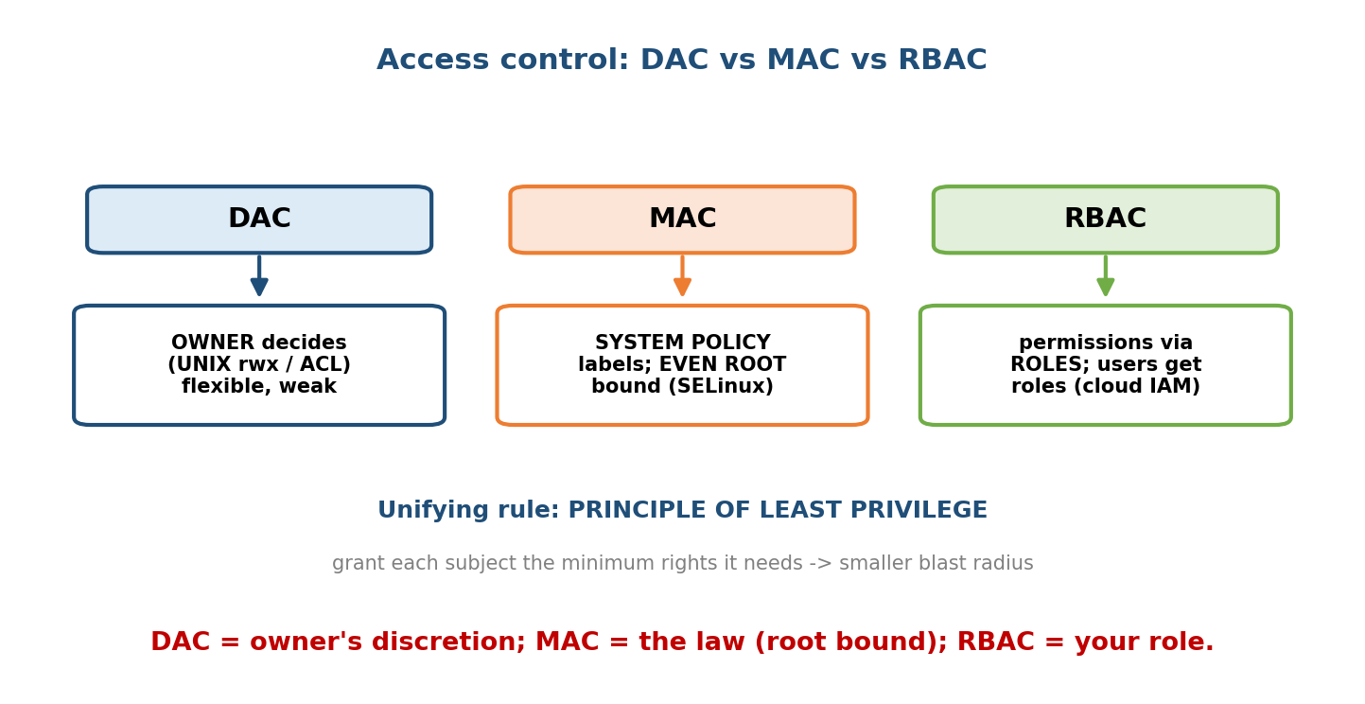
Access control models: DAC — the file owner grants rights (UNIX rwx), flexible but a compromised process inherits the user’s power. MAC — a central system policy labels subjects and objects; even root is confined. RBAC — permissions attach to roles, and users are assigned roles, scaling administration.
- Related term: ABAC (Attribute-Based) — decisions from attributes (department, time, device, location); the most flexible/expressive, common in modern cloud policy engines.

The principle of least privilege (PoLP)
The unifying rule behind all of this: every subject should have the minimum privileges needed to do its job — no more. A web server shouldn’t run as root; a backup job needs read, not write; a container should drop every capability it doesn’t use. PoLP shrinks the blast radius of any bug or breach.

MCQs
- UNIX rwx permissions are which model? → DAC (owner’s discretion).
- Model where even root can’t override policy? → MAC.
- Model where permissions attach to roles? → RBAC.
- State the principle of least privilege. → give each subject the minimum privileges it needs.

16.4 Linux Capabilities — Breaking Up Root
Traditional UNIX is all-or-nothing: you’re either root (UID 0, can do anything) or an ordinary user. That violates least privilege — a program that only needs to bind to port 80 (a privileged port) had to run as full root.
Linux capabilities split root’s power into ~40 independent units you can grant individually:
Capability | Grants just…
CAP_NET_BIND_SERVICE | bind to ports < 1024
CAP_NET_ADMIN | configure networking (interfaces, routing)
CAP_SYS_ADMIN | a huge grab-bag (mounts, etc.) — the “new root”, avoid it
CAP_CHOWN | change file ownership
CAP_KILL | send signals to any process
CAP_SYS_TIME | set the system clock
So a web server can get only CAP_NET_BIND_SERVICE and run as an unprivileged user — if it’s hacked, the attacker gets that one power, not all of root.
Memory hook: capabilities shatter the single “root key” into a keyring of small keys. Hand out only the keys a program needs (least privilege). Docker uses this: containers start with a reduced capability set and --cap-drop / --cap-add tune it. (Beware CAP_SYS_ADMIN — it’s so broad it’s effectively root.)

MCQs
- Problem with traditional root that capabilities fix? → root is all-or-nothing; capabilities give fine-grained privileges.
- Capability to bind to port 80 without full root? → CAP_NET_BIND_SERVICE.
- Which capability is so broad it’s “the new root”? → CAP_SYS_ADMIN.

16.5 SELinux vs AppArmor — Mandatory Access Control in Linux
Standard Linux permissions are DAC. SELinux and AppArmor add a MAC layer on top (via the Linux Security Modules / LSM hook framework): even if the DAC rwx bits would allow an action, the MAC policy can still deny it — confining each program to exactly what it should ever do.
 | SELinux | AppArmor
Policy is by | labels/contexts on every subject & object | file paths (profiles per program)
Origin/default | NSA; default on RHEL/Fedora/Android | Canonical; default on Ubuntu/SUSE
Granularity | very fine (types, roles, MLS) | coarser, per-program profiles
Learning curve | steep (labels everywhere) | gentler (readable path rules)
- SELinux labels everything (user:role:type:level) and allows an action only if a rule permits that subject type to act on that object type. Powerful and precise, but complex — hence the meme “just setenforce 0” (which you should not do).
- AppArmor confines a program by a profile listing the paths it may read/ write/execute — much easier to read and write, slightly less rigorous (path-based, so it can be fooled by hard links/renames in edge cases).
Memory hook: SELinux = label-based (“what type are you?”), AppArmor = path-based (“what files/paths may you touch?”). SELinux is stricter and harder; AppArmor is simpler and friendlier. Both are MAC via LSM and both confine a compromised service so a web-server exploit can’t read /etc/shadow.

MCQs
- Are default Linux permissions DAC or MAC? → DAC; SELinux/AppArmor add MAC.
- SELinux enforces via ; AppArmor via . → labels/contexts ; file paths (profiles).
- What framework do they hook into? → LSM (Linux Security Modules).
- Why MAC on top of DAC? → to confine a compromised process to only its intended actions (even root/allowing DAC bits can be overruled).

16.6 Secure Boot and the Chain of Trust
Security must start before the OS even loads — otherwise malware in the bootloader (a rootkit/bootkit) owns the machine beneath the OS’s defenses.
Secure Boot (a UEFI feature) enforces a chain of trust: each stage cryptographically verifies the signature of the next before running it.
UEFI firmware (trusted, keys in hardware)
-> verifies signature of BOOTLOADER (e.g. shim/GRUB)
-> verifies signature of KERNEL
-> kernel verifies signed MODULES/drivers
Any broken signature -> refuse to boot (or drop to recovery).
- Keys live in firmware (Platform Key, KEK, allowed/forbidden databases); only code signed by a trusted key runs.
- Measured boot / TPM: a TPM chip records a hash (“measurement”) of each stage into PCRs; remote attestation lets a server prove what it booted. This underpins disk encryption unlock and confidential computing.
Memory hook: secure boot = a relay race where each runner checks the next runner’s ID before handing off the baton. The root of trust is the firmware; if any stage’s signature fails, the chain breaks and boot stops — so a bootkit can’t insert itself below the OS.

MCQs
- What does Secure Boot verify at each stage? → the cryptographic signature of the next stage (chain of trust).
- Where is the root of trust? → the UEFI firmware (keys in hardware).
- Chip that measures/attests boot state? → the TPM (PCRs, remote attestation).

16.7 Sandboxing and seccomp
A sandbox confines a program to a restricted environment so that even if it’s compromised, it can’t reach the rest of the system. The tightest OS lever for this is limiting which system calls a process may make — because the syscall boundary (§16.1) is the only way a process asks the kernel to do anything.
seccomp (secure computing mode) does exactly that:
- seccomp strict mode: the process may call only read, write, _exit, and sigreturn — anything else → the kernel kills it.
- seccomp-BPF (the useful mode): attach a BPF filter that inspects each syscall (number + arguments) and returns allow / deny / kill / trap / errno. This lets you whitelist the ~40 syscalls a server actually needs and block the rest (e.g. block ptrace, mount, keyctl).
Memory hook: seccomp = a bouncer at the syscall door with a guest list. The program can only make the calls on the list; every other request gets it thrown out (killed). Fewer allowed syscalls = smaller kernel attack surface.
The modern sandbox stacks these layers (defense in depth): namespaces (isolate view) + cgroups (limit resources) + capabilities (drop root powers) + seccomp (whitelist syscalls) + MAC (SELinux/AppArmor confine). This is exactly how Docker/Kubernetes, Chrome’s renderer processes, and systemd service hardening sandbox untrusted code.
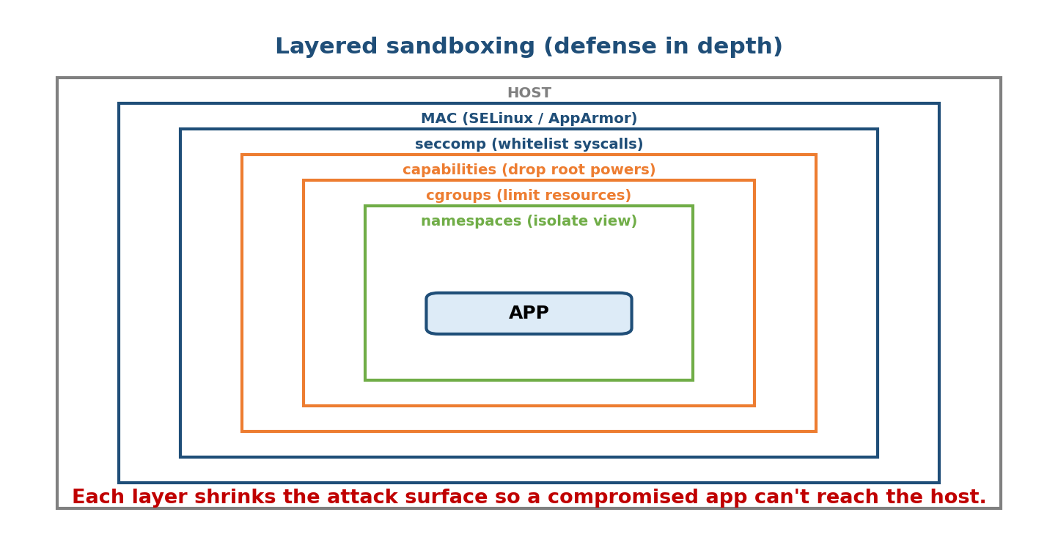
Layered sandboxing (defense in depth): a process is wrapped by namespaces (isolate what it sees), cgroups (limit resources), capabilities (drop unneeded root powers), seccomp (whitelist allowed syscalls), and MAC/SELinux (confine actions). Each layer shrinks the attack surface so a compromise of the app can’t reach the host.

MCQs
- What does seccomp restrict? → the system calls a process may make.
- seccomp strict mode allows only? → read, write, _exit, sigreturn.
- What makes seccomp-BPF flexible? → a BPF filter per-syscall (allow/deny/kill/ errno by number + args).
- Name the layers of a modern sandbox. → namespaces + cgroups + capabilities + seccomp + MAC.

16.8 Containers as a Security Boundary (weaker than a VM)
Because §M14’s namespaces + cgroups + capabilities + seccomp wrap a process tightly, containers feel isolated. But there is a fundamental limit:
Containers share the host kernel. A VM runs its own guest kernel on a hypervisor, so the isolation boundary is the small, hardware-enforced hypervisor (Ring −1). A container’s boundary is the entire Linux kernel’s syscall surface — millions of lines. A single kernel bug (a “container escape”) lets an attacker break out onto the host and every other container.
 | VM | Container
Isolated by | hypervisor (own guest kernel) | kernel namespaces/cgroups (shared kernel)
Attack surface | small hypervisor interface | huge (all kernel syscalls)
Isolation strength | strong | weaker
Weight / startup | heavy / seconds | light / milliseconds
Memory hook: a VM is a separate house; a container is a locked room in a shared house. Rooms are cheap and fast, but they share the same plumbing/wiring (the host kernel) — break the shared infrastructure and you’re into every room. For untrusted, multi-tenant workloads, use VMs / micro-VMs (Firecracker) / gVisor (a user-space kernel) for a stronger boundary; harden containers with seccomp + user namespaces + read-only rootfs + dropped capabilities + non-root.

MCQs
- Why is a container a weaker boundary than a VM? → it shares the host kernel; the attack surface is the whole kernel.
- Breaking out of a container onto the host is called? → a container escape.
- Stronger isolation for untrusted workloads? → VMs / micro-VMs (Firecracker) / gVisor.

16.9 Common OS Attacks (and the Defenses)
The protections above exist to stop specific attacks. Know these three cold.

16.9.1 Buffer overflow (memory-safety attack)
Writing past the end of a buffer overwrites adjacent memory. Classic stack smashing: overflow a local array to overwrite the return address, redirecting execution to attacker code (shellcode). This is the single most historically important OS attack and ties directly to memory protection (§M9/M10).
void f(char *input) {
char buf[64];
strcpy(buf, input); // NO bounds check!
} // if input > 64 bytes, it overwrites saved return
// address on the stack -> jump anywhere the attacker wants
Defenses (layered): - Stack canaries — a random guard value placed before the return address; corrupted canary at return → abort. - NX / DEP (No-eXecute / Data Execution Prevention) — mark the stack/heap non-executable (a paging permission bit, §M10) so injected data can’t run as code. - ASLR (Address Space Layout Randomization) — randomize stack/heap/library addresses each run, so the attacker can’t predict where to jump. - Memory-safe languages (Rust, Go, Java) — bounds-checked; eliminate the class.
Memory hook: the buffer-overflow arms race: canary (detect the smash) + NX/DEP (can’t run injected data) + ASLR (can’t find the target) — three independent layers, all leaning on hardware memory protection from §M9/M10.

16.9.2 Privilege escalation
Gaining more rights than you were granted — the goal of most attacks.
- Vertical: normal user → root/kernel (e.g. exploit a setuid binary, a kernel bug, or an over-broad capability). This is why least privilege, capabilities, seccomp, and MAC matter — they cap what a compromised process can become.
- Horizontal: access another user’s data at the same privilege level.
Common vectors: a setuid-root program with a bug (runs as root regardless of caller), a vulnerable kernel driver, or a mis-set capability. Defense = least privilege everywhere (drop privileges early, minimal setuid, capabilities not root, MAC confinement, patching).

16.9.3 TOCTOU (Time-Of-Check to Time-Of-Use)
A race condition (§M15) used as a security exploit: a program checks permission on a resource, then uses it — but the resource changes in the gap.
if (access("/tmp/file", W_OK) == 0) { // TIME-OF-CHECK: "may this user write it?"
// <-- attacker swaps /tmp/file for a symlink to /etc/passwd here
fd = open("/tmp/file", O_WRONLY); // TIME-OF-USE: now writes /etc/passwd!
}
The check and the use are not atomic; an attacker exploits the window (often by swapping a symlink). Defense: operate atomically — open() first then check the file descriptor (fstat on the fd, not the path), use O_NOFOLLOW, avoid check-then-act on filenames.
Memory hook: TOCTOU = “checked the ID at the door, but a different person walked in.” The fix is to check and act on the same handle atomically, not to re-look-up the name.

MCQs
- Overwriting a return address via a too-long input? → (stack) buffer overflow.
- Three buffer-overflow defenses? → canaries, NX/DEP, ASLR (+ memory-safe languages).
- Which paging bit powers NX/DEP? → the no-execute page permission (§M10).
- User → root is which escalation? → vertical privilege escalation.
- Check-then-use race on a file? → TOCTOU; fix by atomic fd-based operations.

16.10 Real-World & Backend Perspectives
- Every production hardening checklist is this module: run services non-root, drop capabilities, apply a seccomp profile, enable SELinux/AppArmor, use read-only root filesystems, and enforce least privilege IAM (RBAC/ABAC) in the cloud.
- Container security (very common interview ground): the layered sandbox (§16.7) plus the “container ≠ VM” boundary (§16.8) — real incidents (e.g. runc/Dirty COW-style bugs) are container escapes.
- Cloud IAM is RBAC/ABAC + least privilege at scale (AWS IAM roles/policies); most cloud breaches are over-broad permissions (a * policy) — an authorization failure, not a hacked password.
- Memory-safety is why the industry is moving security-critical code to Rust (browsers, kernels, Android) — it eliminates the buffer-overflow class from §16.9.1.
- Secure/measured boot + TPM underpin disk encryption, device attestation, and confidential computing (encrypted VMs) in modern data centres.
- Zero trust / defense in depth: never rely on one control; assume any single layer can fail (exactly why sandboxes stack §16.7’s layers).

16.11 Tradeoffs, Common Mistakes, Edge Cases
- Mistake: confusing authentication (who) with authorization (what) — the #1 exam and interview slip.
- Mistake: thinking root = kernel mode. Root is a user-space identity (still Ring 3); the kernel (Ring 0) is a separate boundary. A root process still makes syscalls.
- Mistake: treating a container like a VM for security — it’s a weaker boundary (shared kernel).
- Mistake: running everything as root “to avoid permission errors” — the opposite of least privilege; use capabilities.
- Mistake: using access() then open() (TOCTOU) — operate on the fd.
- Tradeoff: security vs usability/performance — MAC (SELinux) is strong but hard to administer; more sandbox layers add overhead; canaries/ASLR add tiny cost. Good security minimizes friction (least privilege by default).
- Edge case: DAC lets a tricked program leak data with the user’s rights — precisely why MAC exists to override it.
- Edge case: disabling SELinux (setenforce 0) “to make it work” removes your MAC layer — a common real-world security regression.

16.12 Exam, Interview & Coding Perspectives
- SEBI IT / cyber / RBI (very high yield): authentication vs authorization; DAC vs MAC vs RBAC; buffer overflow + defenses (ASLR/DEP/canary); privilege escalation; secure boot; least privilege; CIA triad (confidentiality/integrity/availability).
- GATE: lighter — mainly the protection/dual-mode and access-matrix (access control list vs capability list) concepts.
- Interview (backend/infra/security):
  - “AuthN vs AuthZ?” → who are you vs what can you do.
  - “DAC vs MAC vs RBAC?” → owner vs system-policy vs role.
  - “Why are containers less secure than VMs?” → shared host kernel, huge attack surface.
  - “How would you sandbox untrusted code?” → namespaces + cgroups + drop caps + seccomp + MAC (+ VM/gVisor if truly untrusted).
  - “Explain a buffer overflow and its defenses.” → overwrite return addr; canary / NX / ASLR.
  - “What is TOCTOU?” → check-then-use race; fix with atomic fd operations.
- Coding/practical: capsh --print, getcap/setcap, docker run --cap-drop=ALL --security-opt seccomp=profile.json, getenforce/aa-status, checksec (canary/NX/PIE/ASLR of a binary), mount /proc for /proc/<pid>/status seccomp state.

16.13 Concept Checks & MCQs (test yourself)
- x86 rings, and the two used? → 0–3; Ring 0 (kernel) + Ring 3 (user).
- Dual-mode: privileged instructions run only in? → kernel mode (Ring 0).
- AuthN vs AuthZ? → who you are vs what you may do.
- Three authentication factors? → know / have / are.
- DAC vs MAC vs RBAC? → owner decides / system policy (even root bound) / role-based.
- Principle of least privilege? → minimum privileges needed, no more.
- Fix for all-or-nothing root? → Linux capabilities.
- Capability to bind port 80? → CAP_NET_BIND_SERVICE.
- SELinux enforces via ; AppArmor via . → labels ; paths.
- Framework SELinux/AppArmor hook into? → LSM.
- What does Secure Boot verify? → each stage’s cryptographic signature (chain of trust); root = firmware.
- What does seccomp restrict? → the syscalls a process can make.
- Modern sandbox layers? → namespaces + cgroups + capabilities + seccomp + MAC.
- Container vs VM security? → container shares host kernel (weaker); VM has its own kernel (stronger).
- Breaking out of a container? → a container escape.
- Buffer overflow overwrites the ___? → return address (stack smashing).
- Three overflow defenses? → canary, NX/DEP, ASLR.
- Vertical vs horizontal escalation? → to higher privilege (root) vs another peer user.
- Check-then-use file race? → TOCTOU (fix: atomic fd ops).
- Is root the same as kernel mode? → No (root is a user identity, still Ring 3).
True/False - Authorization happens before authentication. → False (authenticate first). - Under MAC, root can override the policy. → False (that’s the point). - A container isolates as strongly as a VM. → False (shared kernel). - NX/DEP relies on a page permission bit. → True. - ASLR randomizes memory layout each run. → True. - Linux capabilities are all-or-nothing like root. → False (fine-grained). - TOCTOU is a type of race condition. → True.

16.14 One-Page Revision Sheet
RINGS: x86 has 0-3; OS uses Ring0=KERNEL + Ring3=USER = DUAL MODE.
privileged instrs only in Ring0; user->kernel ONLY via SYSCALL (trap).
MMU/paging confines each process to its own address space. (hypervisor = Ring -1)
NOTE: root != kernel mode. Root is a user identity, still Ring 3.
AUTHN vs AUTHZ: AuthN = WHO ARE YOU (identity; know/have/are; MFA=2+ factors).
AuthZ = WHAT MAY YOU DO (permissions). Authenticate FIRST, authorize each action.
AAA = + Accounting/audit.
ACCESS CONTROL:
DAC = owner decides (UNIX rwx/ACL) - flexible, weak (compromised proc = user rights)
MAC = system policy, EVEN ROOT BOUND (SELinux/AppArmor) - strong, complex
RBAC = permissions via ROLES (cloud IAM). ABAC = attribute-based.
PRINCIPLE OF LEAST PRIVILEGE = minimum rights needed -> smaller blast radius.
LINUX CAPABILITIES = split root into ~40 units (CAP_NET_BIND_SERVICE=port<1024,
CAP_NET_ADMIN, CAP_SYS_ADMIN='new root'/avoid). Docker --cap-drop/--cap-add.
SELINUX vs APPARMOR (both MAC via LSM, on top of DAC):
SELinux = LABEL/context based (strict, hard; RHEL/Android).
AppArmor = PATH/profile based (simpler; Ubuntu/SUSE).
SECURE BOOT (UEFI): CHAIN OF TRUST - each stage verifies next's SIGNATURE
firmware->bootloader->kernel->modules. root of trust=firmware. TPM=measure/attest.
SANDBOX = confine. SECCOMP = restrict SYSCALLS (strict: read/write/_exit/sigreturn;
seccomp-BPF: filter per syscall). LAYERS (defense in depth):
namespaces + cgroups + capabilities + seccomp + MAC.
CONTAINER vs VM (security): container SHARES host kernel -> huge attack surface,
WEAKER; VM = own guest kernel on hypervisor -> STRONGER. escape=container escape.
untrusted -> VM / micro-VM (Firecracker) / gVisor.
ATTACKS:
BUFFER OVERFLOW: overwrite return addr (stack smash). Defenses: CANARY + NX/DEP
(non-exec page bit) + ASLR (randomize) + memory-safe langs (Rust/Go).
PRIV ESCALATION: vertical(user->root, setuid/kernel bug) / horizontal(peer user).
TOCTOU: check-then-use RACE (access() then open()); fix = atomic fd ops (fstat fd).

Flash cards
Front | Back
Rings used by an OS? | 0 (kernel) + 3 (user) = dual mode
Root vs kernel mode? | root = user identity (Ring 3), not kernel mode
AuthN vs AuthZ? | who you are vs what you may do
DAC / MAC / RBAC? | owner / system policy (root bound) / role
Least privilege? | minimum rights needed
Fix for all-or-nothing root? | Linux capabilities
SELinux vs AppArmor? | labels vs file paths (both MAC/LSM)
Secure boot verifies? | each stage’s signature (chain of trust)
seccomp restricts? | which syscalls a process can make
Sandbox layers? | namespaces+cgroups+caps+seccomp+MAC
Container vs VM boundary? | shared kernel (weak) vs own kernel (strong)
Buffer overflow defenses? | canary, NX/DEP, ASLR
TOCTOU? | check-then-use race; fix with atomic fd ops

Spaced repetition
- 24-hour: recite AuthN-vs-AuthZ, DAC/MAC/RBAC, and the three buffer-overflow defenses.
- 7-day: explain capabilities, SELinux-vs-AppArmor, secure boot’s chain of trust, and why a container is weaker than a VM.
- 30-day: given “sandbox this untrusted binary” or “harden this service,” list the layered controls (least privilege, caps, seccomp, MAC, non-root) from memory.

16.15 Summary
OS security rests on one hardware idea: privilege rings / dual-mode, where user code (Ring 3) can reach the powerful kernel (Ring 0) only through a system call, and the MMU confines each process to its own memory. On top of that, we separate authentication (“who are you?”) from authorization (“what may you do?”), and enforce authorization with access-control models — DAC (owner decides, flexible but weak), MAC (system policy binds even root — SELinux by labels, AppArmor by paths), and RBAC (permissions via roles) — all governed by the principle of least privilege. Linux refines this with capabilities (root split into fine-grained powers), and hardens boot itself with Secure Boot’s chain of trust (each stage verifies the next’s signature, rooted in firmware/TPM). Modern sandboxing stacks layers — namespaces, cgroups, capabilities, seccomp (syscall whitelisting), and MAC — but a container remains a weaker boundary than a VM because it shares the host kernel. Finally, these defenses exist to stop real attacks: buffer overflows (beaten by canaries, NX/DEP, ASLR), privilege escalation (beaten by least privilege), and TOCTOU races (beaten by atomic fd operations).
This module closes the core-OS arc: from what an OS is (M1) to how it stays safe. Next, Module 17 — Virtualization & Containers builds directly on M14’s namespaces/ cgroups and this module’s isolation boundaries to explain the technology running the entire cloud.
You have mastered this module when you can: explain rings/dual-mode and why root ≠ kernel mode; distinguish authentication from authorization; compare DAC/MAC/RBAC and state least privilege; explain Linux capabilities, SELinux vs AppArmor, secure boot, and seccomp; argue why a container is a weaker boundary than a VM; and describe buffer overflow (with defenses), privilege escalation, and TOCTOU — all without notes.

