Module 17 — Virtualization & Containers
  - OS Mastery: SEBI IT / RBI / NABARD / GATE / C-DAC / Interview / Backend — In-Depth Notes (with visuals)
Prepared for nidhi.sharma@forensiccybertech.com
2026
Table of Contents

Module 17 — Virtualization & Containers
Where this module sits. Module 1 introduced the hypervisor in one line; Modules 4–5 taught processes and threads; Module 9–10 taught virtual memory; and Module 14 (Linux internals) taught namespaces and cgroups. This module ties them together into the two technologies that run the entire modern cloud: virtual machines (one physical box pretends to be many computers) and containers (one OS kernel pretends to be many isolated OSes). Virtualization is an operating-system idea taken one level up — instead of an OS sharing a CPU among processes, a hypervisor shares the hardware among whole guest OSes. Everything in Module 18 — Cloud Operating Systems is built on what you learn here.
Importance ratings (out of 5):
Exam / Use | SEBI IT | RBI IT | GATE CS | Interview | Backend
This module | ★★★★ | ★★★ | ★★ | ★★★★★ | ★★★★★
Most-asked PYQ concepts (SEBI / RBI / GATE / C-DAC): definition & benefits of virtualization; Type-1 vs Type-2 hypervisor (bare-metal vs hosted, with examples); full vs para-virtualization; hardware-assisted virtualization (Intel VT-x / AMD-V) and trap-and-emulate; VM vs container (the single most common modern MCQ — “which shares the host kernel?”); Docker image vs container, image layers / union file system, Dockerfile; cgroups vs namespaces (limits vs isolation); Kubernetes pod / node / control plane and why orchestration is needed.

17.1 What Is Virtualization — and Why? (first principles)

The problem
A physical server is bought for its peak load but sits idle most of the time — a classic data-centre server runs at 10–15% average CPU utilisation. Running one application per physical box therefore wastes ~85% of the hardware, plus its power, cooling, and rack space. We also want to run many different OSes (Windows, Linux, old and new) on one machine, keep them isolated so one crash or hack can’t touch the others, and move a whole running system from one box to another. A raw OS cannot do this — it assumes it owns the machine.

The idea
Virtualization is the creation of a software illusion of hardware (or of an OS) so that several isolated systems share one physical machine, each believing it has the machine to itself. The software that creates this illusion for whole operating systems is the hypervisor (also called a Virtual Machine Monitor, VMM).
Memory hook: an OS shares one CPU among many processes; a hypervisor shares one physical machine among many whole OSes. Same trick — time-share a resource and give each user the illusion of owning it — just one floor higher.

Why it matters (benefits)
- Consolidation / higher utilisation — pack many under-used servers onto one box (the original business case; drives cloud economics).
- Isolation — each VM is a sealed sandbox; a crash, virus, or reboot in one VM does not affect the others.
- Hardware independence & portability — a VM is just files; you can snapshot, clone, and live-migrate it to another physical host with no downtime.
- Flexibility — run any OS on any hardware; spin up/tear down machines in seconds (the foundation of “rent a server by the minute”).
- Efficiency & cost — fewer physical machines → less power, cooling, and space.

MCQs
- Software that lets one machine run many guest OSes? → hypervisor / VMM.
- One-line benefit that started it all? → server consolidation (higher utilisation).
- Moving a running VM to another host with no downtime is called? → live migration.

17.2 The Virtual Machine and the Hypervisor
A virtual machine (VM) is a software computer: it has a virtual CPU, virtual RAM, virtual disk, and virtual network card, all backed by slices of the real hardware. Inside it runs a complete, unmodified guest OS and its apps, which believe they are on a real machine.
The hypervisor is the thin layer that:
- partitions the real CPU, memory, and devices among the VMs,
- schedules virtual CPUs onto real CPUs (just as an OS schedules threads),
- isolates each VM, and
- traps any operation a guest tries that would affect real hardware and emulates it safely.
The three rules a VMM must satisfy (Popek & Goldberg, 1974 — a classic exam line): - Equivalence / fidelity — a program runs in the VM the same as on real hardware. - Resource control / safety — the VMM has complete control of the real resources; a guest can never bypass it. - Efficiency — most guest instructions run directly on the real CPU with no VMM intervention (otherwise it would be an emulator, not a virtualizer).
Emulation vs virtualization (don’t confuse them): an emulator (e.g. QEMU running ARM code on an x86 laptop) interprets/translates every instruction — slow but can fake different hardware. Virtualization runs the guest on the same CPU architecture, executing most instructions natively — fast.

MCQs
- The three Popek–Goldberg requirements? → equivalence, resource control, efficiency.
- VM vs emulator key difference? → a VM runs guest code natively on the same CPU; an emulator translates every instruction.

17.3 Type-1 vs Type-2 Hypervisors
Hypervisors come in two shapes depending on where they sit.
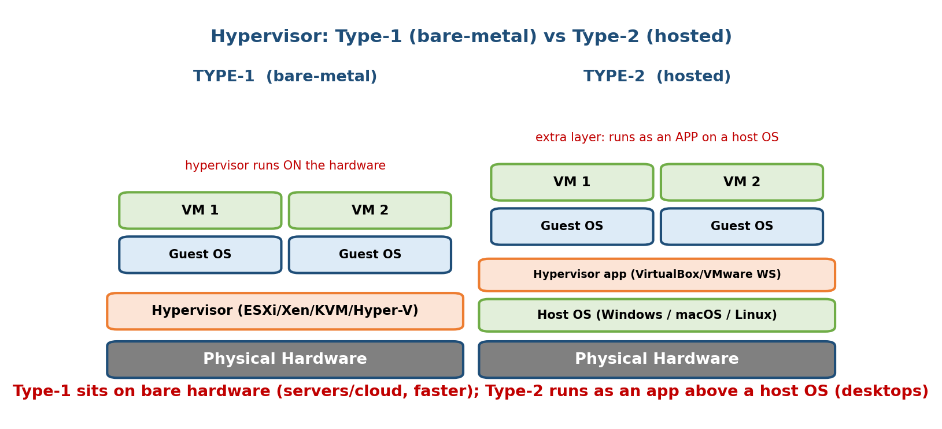
Type-1 runs directly on hardware (servers, cloud, faster); Type-2 runs as an app on top of a host OS (desktops, testing).
- Type-1 (bare-metal / native): the hypervisor runs directly on the hardware; guest OSes run on top of it. There is no host OS underneath. Fastest and most secure — the standard for servers and cloud data centres. Examples: VMware ESXi, Microsoft Hyper-V, Xen, KVM (KVM turns the Linux kernel itself into a Type-1 hypervisor).
- Type-2 (hosted): the hypervisor runs as an ordinary application inside a host OS (Windows/macOS/Linux). Easy to install on a laptop; slower because guest operations pass through the extra host-OS layer. Great for desktops, dev, and testing. Examples: Oracle VirtualBox, VMware Workstation/Player, QEMU (hosted mode), Parallels.
 | Type-1 (bare-metal) | Type-2 (hosted)
Runs on | hardware directly | inside a host OS (as an app)
Host OS below it | none | yes (Windows/macOS/Linux)
Speed | faster (one fewer layer) | slower (extra layer)
Isolation/security | stronger | weaker
Typical use | servers, cloud | laptops, testing
Examples | ESXi, Hyper-V, Xen, KVM | VirtualBox, VMware Workstation
Memory hook: Type-1 = “type won” = on the metal, wins on speed (cloud). Type-2 = “two layers” = hypervisor on top of a host OS (your laptop).
KVM edge case (interview favourite): KVM is a Linux kernel module. Because the hypervisor is the kernel running on bare metal, KVM is classed as Type-1, even though Linux can also run normal apps. This blurring is why the strict “1 vs 2” line is a bit academic — but exams still want bare-metal vs hosted.

MCQs
- Type-1 vs Type-2? → runs on hardware directly vs inside a host OS.
- Give three Type-1 examples. → ESXi, Hyper-V, Xen, KVM (any three).
- VirtualBox is Type-? → Type-2 (hosted).
- Which is faster and why? → Type-1 — no extra host-OS layer to cross.

17.4 How Virtualization Actually Works (the deep part)
To satisfy equivalence + control + efficiency, the VMM must let safe guest instructions run natively but intercept the dangerous ones (those that touch real hardware or change privilege). There are four techniques; exams love comparing them.

17.4.1 Trap-and-emulate (the classic mechanism)
The guest OS thinks it runs in kernel mode, but the VMM actually runs it in user mode (this is deprivileging). When the guest executes a privileged instruction (e.g. disable interrupts, load the page-table register), the CPU traps into the VMM, which emulates the instruction’s effect on the virtual hardware and returns. Ordinary (unprivileged) instructions run directly on the CPU at full speed.
guest user app ── runs natively ──────────────► real CPU
guest OS kernel ── privileged instruction ──► TRAP ──► VMM emulates ──► return
Popek–Goldberg theorem (why x86 was “not virtualizable”): trap-and-emulate works only if every sensitive instruction (one that touches real resources) is also a privileged instruction (one that traps in user mode). Old x86 had ~17 sensitive-but-not-privileged instructions (e.g. POPF) that silently failed instead of trapping — so pure trap-and-emulate was impossible. Two software fixes (17.4.2–17.4.3) and one hardware fix (17.4.4) were invented.

17.4.2 Full virtualization via binary translation (VMware’s original trick)
The guest OS runs completely unmodified. The VMM scans the guest kernel code just before it runs and rewrites the troublesome sensitive instructions on-the-fly into safe sequences that call the VMM (dynamic binary translation). User-mode code still runs natively. Pioneered by VMware in the late 1990s.
- Pro: any OS runs as-is (great compatibility). Con: translation overhead.

17.4.3 Para-virtualization (Xen’s trick)
The guest OS is modified: the sensitive instructions are replaced with explicit hypercalls (like a system call, but into the hypervisor). The guest knows it is virtualized and cooperates.
- Pro: low overhead (no trapping/translation guesswork). Con: you must change the guest OS — impossible for closed-source OSes without vendor help. Popularised by Xen.
One-line contrast: full virtualization = guest is fooled (unmodified); para-virtualization = guest cooperates (modified with hypercalls).

17.4.4 Hardware-assisted virtualization (Intel VT-x / AMD-V) — today’s default
Around 2005–2006, Intel (VT-x) and AMD (AMD-V) added CPU support that makes trap-and-emulate work without binary translation or guest modification. They add a new root mode (for the VMM) and non-root mode (for the guest), each with its own rings 0–3, plus a hardware VMCS (VM Control Structure) that defines exactly which guest events cause a VM exit into the VMM. Sensitive instructions now trap cleanly in hardware.
- Second-generation extended/nested page tables — EPT (Intel) / RVI/NPT (AMD) — let the CPU translate guest-virtual → guest-physical → host-physical addresses in hardware, removing the huge cost of the VMM maintaining “shadow page tables.” (This ties directly to M9/M10 paging — it is two levels of the same translation you already learned.)
- Result: modern hypervisors (KVM, ESXi, Hyper-V, Xen HVM) use hardware assistance; guests run unmodified and nearly at native speed.
Technique | Guest modified? | How sensitive instrs handled | Example
Trap-and-emulate | no | trap on privileged instr (needs “clean” ISA) | classic mainframes
Binary translation (full virt) | no | VMM rewrites guest kernel code | early VMware
Para-virtualization | yes | guest calls hypercalls | Xen (PV)
Hardware-assisted (VT-x/AMD-V) | no | CPU traps via root/non-root + VMCS | KVM, ESXi, Hyper-V

MCQs
- Trap-and-emulate: what runs the guest kernel in? → user mode (deprivileged); privileged instrs trap to the VMM.
- Why was classic x86 “not virtualizable”? → some sensitive instructions were not privileged (didn’t trap).
- Full vs para-virtualization? → guest unmodified vs modified (hypercalls).
- Intel’s and AMD’s hardware support are called? → VT-x and AMD-V.
- Hardware nested paging for VMs is called? → EPT (Intel) / NPT/RVI (AMD).

17.5 Containers vs Virtual Machines (the modern must-know)
A container takes virtualization one level higher. Instead of virtualizing the hardware and running a whole guest OS per instance, a container virtualizes the operating system: all containers share the single host kernel but each gets its own isolated view of processes, files, network, and users.
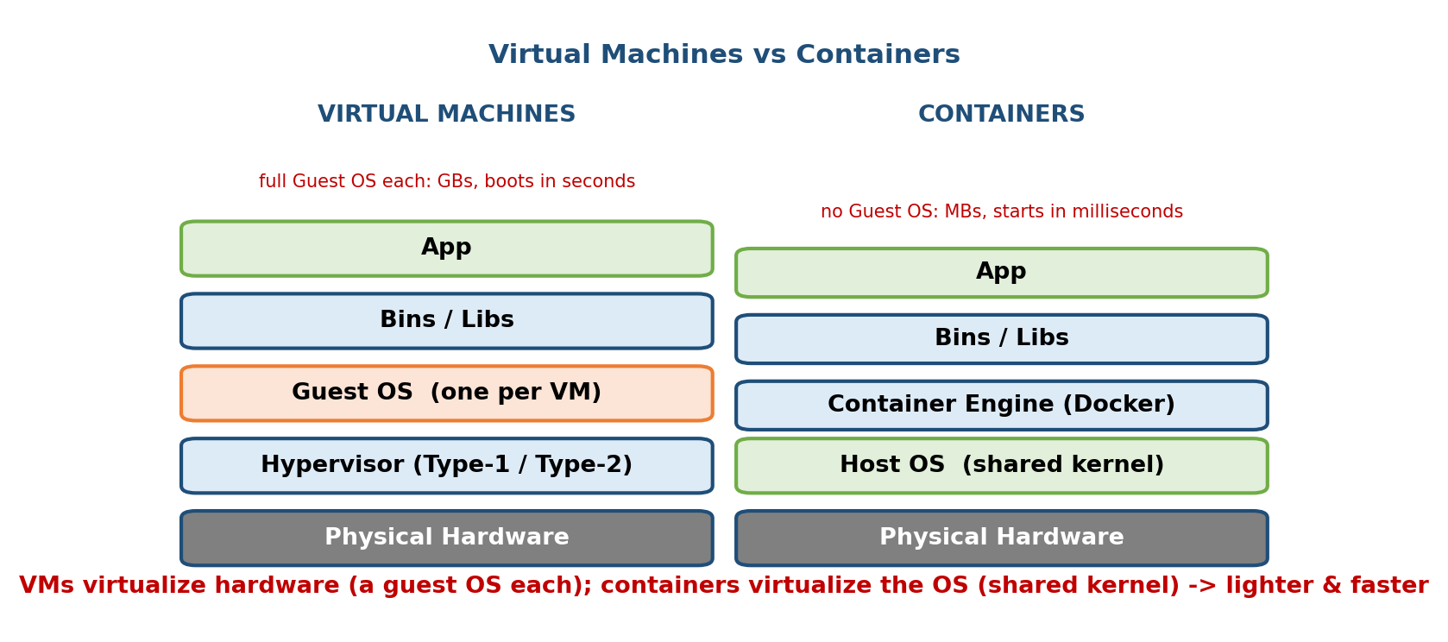
VMs give each instance a full guest OS on a hypervisor; containers share the host kernel through the container engine, so they are much lighter and start in milliseconds.
 | Virtual Machine | Container
Virtualizes | hardware | the OS (kernel)
Guest OS | one full OS per VM | none — shares the host kernel
Isolated by | hypervisor | namespaces + cgroups (kernel features)
Size | GBs | MBs
Start time | seconds (full boot) | milliseconds
Density (per host) | tens | hundreds–thousands
Isolation strength | strong (hardware boundary) | weaker (shared kernel)
Memory hook: A VM ships the whole house (its own OS); a container ships just the furniture (app + libs) and rents the shared foundation (the host kernel). That is why a container is MBs and boots in milliseconds, while a VM is GBs and boots in seconds.
The single most common modern MCQ: “Which one shares the host OS kernel?” → the container (a VM has its own kernel).

MCQs
- What does a container share that a VM does not? → the host OS kernel.
- Why do containers start faster than VMs? → no OS to boot (share the running kernel).
- Which gives stronger isolation? → the VM (hardware-level boundary).

17.6 How Containers Work — Namespaces + cgroups (tie to M14)
A container is not a special object in Linux — there is no “container” system call. A container is simply a normal process wrapped in two kernel features you met in Module 14, plus a layered filesystem (17.7):
- Namespaces → isolation (what a process can see). A namespace gives a process its own private view of one kind of global resource, so it cannot see or touch others’. Linux has these namespaces:
Namespace | Isolates
PID | process IDs — the container sees its app as PID 1, not the host’s PIDs
NET | network interfaces, IPs, ports, routing tables
MNT | mount points / the filesystem tree
UTS | hostname and domain name
IPC | System-V IPC, shared memory, message queues
USER | user & group IDs (map container root → unprivileged host user)
cgroup | the cgroup root a process sees
TIME | system clocks (boot/monotonic offsets)
- cgroups (control groups) → limits (how much a process can use). A cgroup meters and caps a group of processes’ resources: CPU shares/quota, memory limit, block-I/O bandwidth, PIDs count, and devices. Without cgroups, one container could starve the host (a “noisy neighbour”).
Memory hook — the two halves of a container: namespaces = walls (what you can SEE); cgroups = a budget (what you can USE). Isolation + limits = container. (Add the layered filesystem of 17.7 for the image.)
Why this matters (interview): because containers are just processes sharing the host kernel, they are lighter but less isolated than VMs. A kernel vulnerability exploited from inside a container can potentially escape to the host — a VM’s hardware boundary does not have this exposure. This one fact drives most container-security design (user namespaces, seccomp, gVisor, Kata/microVMs).

MCQs
- Namespaces provide ; cgroups provide . → isolation (visibility) ; resource limits.
- Which namespace makes the app appear as PID 1? → the PID namespace.
- Which kernel feature stops a “noisy-neighbour” container hogging CPU/RAM? → cgroups.
- Does a container have its own kernel? → no — it shares the host kernel.

17.7 Docker — Images, Layers, Containers, Dockerfile
Docker is the tool that made containers mainstream by giving them a simple package-build-run workflow. Learn its four core nouns.

The four core concepts
- Image — a read-only template: a snapshot of a filesystem (app + libraries
  - runtime) plus metadata (which command to run). Images are built once and shared via a registry (e.g. Docker Hub, ECR, GCR).
- Container — a running instance of an image: the image’s read-only layers plus one thin writable layer on top. You can run many containers from one image.
- Dockerfile — a text recipe of steps to build an image.
- Registry — the store you push/pull images from (Docker Hub is the public default).

Layers and the union filesystem
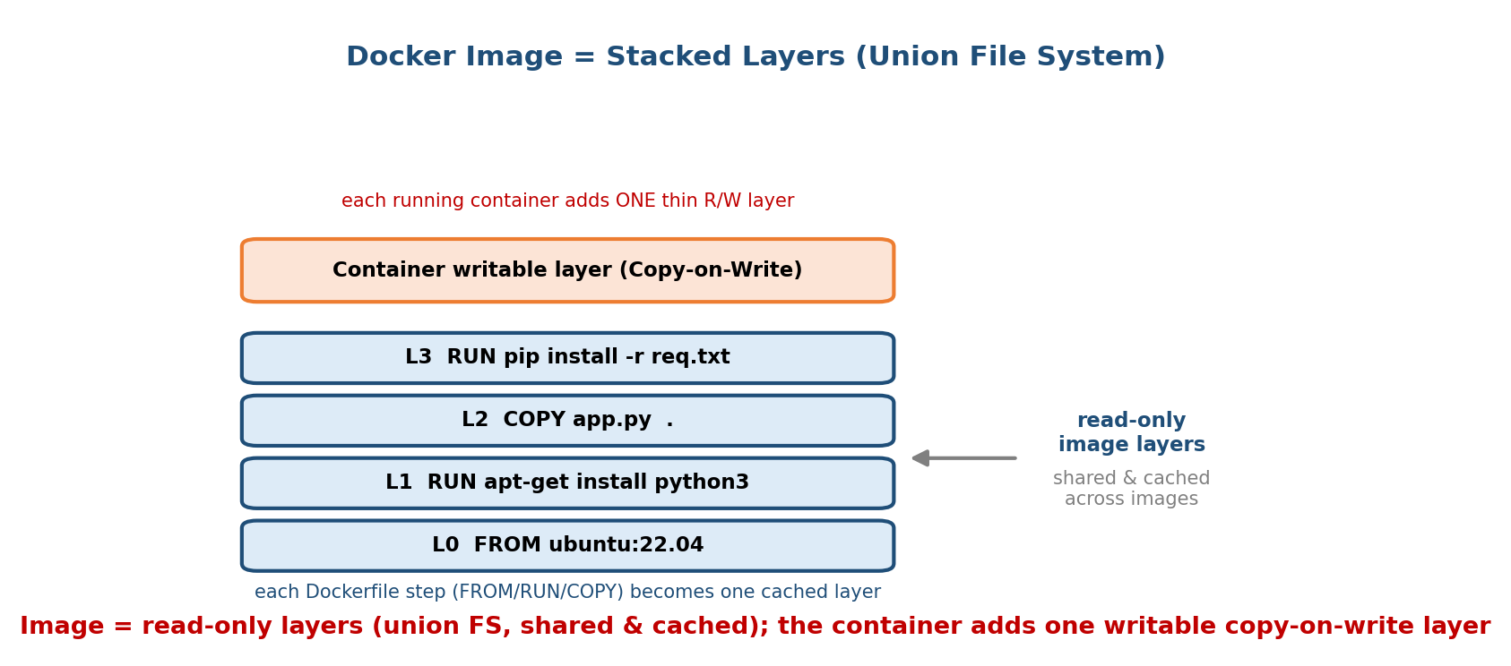
A Docker image is a stack of read-only layers (built from Dockerfile steps, shared and cached via a union filesystem); the running container adds one writable copy-on-write layer.
Each instruction in a Dockerfile that changes the filesystem creates one new read-only layer. A union (overlay) filesystem (Docker’s default driver is overlay2; older ones were AUFS, devicemapper) stacks these layers into a single view. Two big wins:
- Sharing & caching — layers are content-addressed and reused: if ten images all start FROM ubuntu:22.04, that base layer is stored and downloaded once. Rebuilds reuse cached layers for unchanged steps → fast builds.
- Copy-on-write (CoW) — the running container gets one thin writable layer. Reading a file comes from the shared read-only layers; writing first copies the file up into the writable layer. So starting a container copies almost nothing — hence millisecond startup and tiny per-container disk cost.
Memory hook: an image is like a stack of transparent sheets (layers); you see the combined picture. Running a container just lays one blank sheet on top to scribble on — the sheets below stay clean and shared.

A minimal Dockerfile (know these instructions)
FROM python:3.12-slim # base image (a layer) — start small
WORKDIR /app # set working directory inside the image
COPY requirements.txt . # copy build context → a layer
RUN pip install -r requirements.txt # run a command → a layer (deps cached)
COPY . . # copy the app source → a layer
EXPOSE 8000 # document the port the app listens on
CMD ["python", "app.py"] # default process to run when the container starts
Layer-order best practice (asked in interviews): put the rarely-changing steps (install dependencies) before the often-changing steps (copy source code). Since a changed layer invalidates every layer after it, copying requirements.txt and running pip install before COPY . . means editing your code doesn’t force a full dependency re-install — the cache is reused.
RUN vs CMD vs ENTRYPOINT: RUN executes at build time (creating a layer); CMD/ENTRYPOINT define what runs when the container starts.

MCQs
- Image vs container? → image is a read-only template; a container is a running instance (image + writable layer).
- What lets ten images share one Ubuntu base? → layers + union filesystem (content-addressed, cached).
- Docker’s default storage driver / union FS? → overlay2 (OverlayFS).
- Why does writing a file in a container not touch the image? → copy-on-write into the container’s writable layer.
- Where are images shared from? → a registry (e.g. Docker Hub).
- Which Dockerfile instruction sets the default process? → CMD (or ENTRYPOINT).

17.8 Kubernetes Basics — Orchestrating Containers at Scale
Docker runs containers on one machine. But production runs thousands of containers across many machines, and things constantly break: a container crashes, a node dies, traffic spikes. Doing this by hand is impossible. A container orchestrator automates it. Kubernetes (K8s) is the industry standard.

What orchestration gives you (why it exists)
- Scheduling / bin-packing — decide which node runs each container (§18.6).
- Self-healing — restart crashed containers; reschedule pods off a dead node.
- Scaling — add/remove replicas automatically as load changes (§18.7).
- Rolling updates & rollback — deploy a new version gradually, revert on failure.
- Service discovery & load balancing — give a stable name/IP to a set of replicas and spread traffic across them.

The architecture
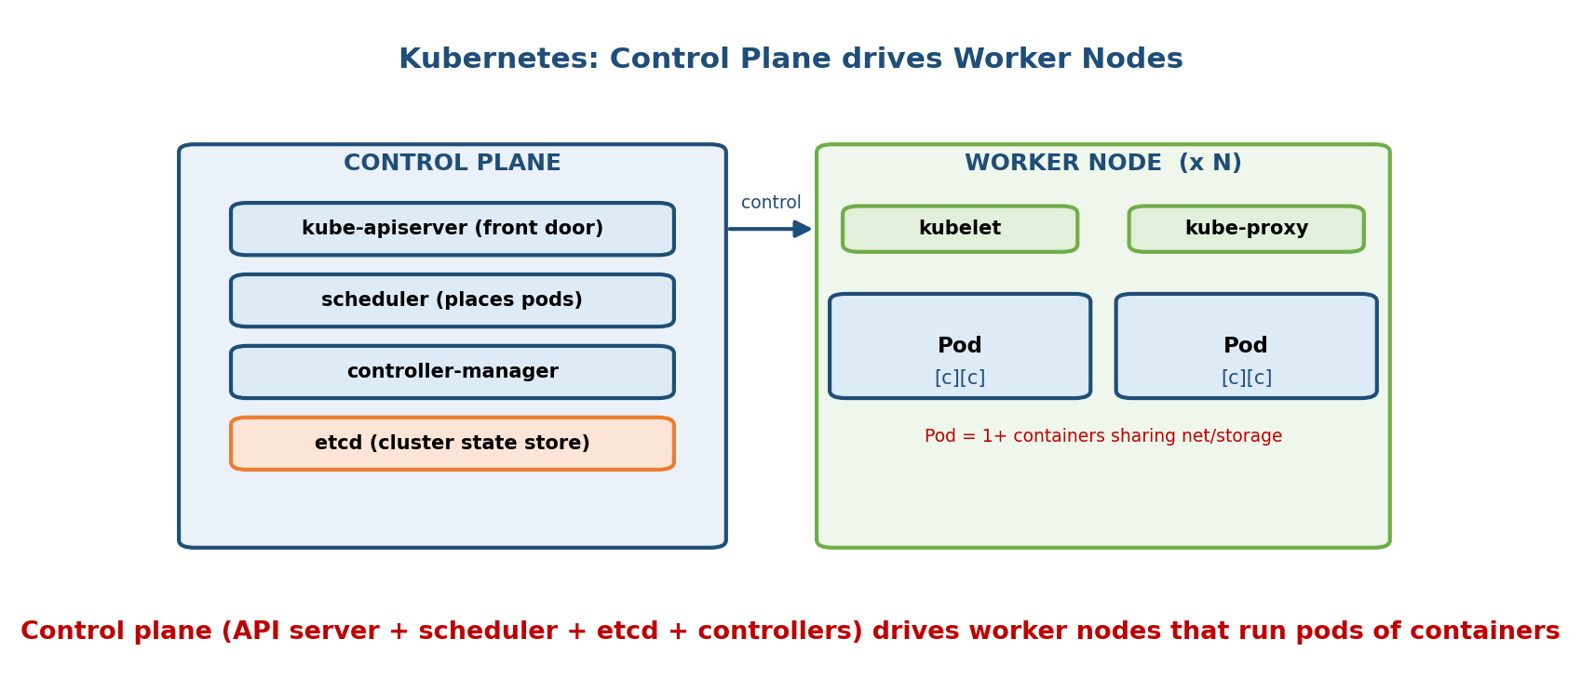
Kubernetes has a control plane (API server, scheduler, etcd, controllers) that manages worker nodes; each node runs pods, and a pod is one or more containers sharing network and storage.
Objects (smallest → largest):
- Container → Pod → Node → Cluster.
- Pod — the smallest deployable unit: one or more containers that share the same network (IP/port space) and storage volumes and are always scheduled together. (Usually one main container per pod.)
- Node — a worker machine (VM or physical) that runs pods.
- Cluster — the control plane plus all worker nodes.
Control plane (the “brain”):
Component | Job
kube-apiserver | the front door — all commands and state changes go through it
etcd | the cluster’s database — stores the entire desired + current state (key-value)
kube-scheduler | decides which node each new pod runs on (§18.6 bin-packing)
controller-manager | runs control loops that drive actual state → desired state (restart, replace)
Node components (the “hands”):
Component | Job
kubelet | agent on each node; starts/stops pods and reports health to the API server
kube-proxy | programs the node’s networking so pods/services are reachable
container runtime | actually runs the containers (containerd, CRI-O)
Memory hook — desired-state / control loop: you tell Kubernetes “I want 3 replicas” (the desired state). Controllers constantly compare desired vs actual and act to close the gap: if one pod dies, actual=2 < desired=3, so a new pod is created. You declare the what; Kubernetes figures out the how and keeps it true — this declarative, self-healing loop is the whole idea.
Deployment vs Pod (interview): you rarely create pods directly. A Deployment manages a ReplicaSet, which keeps N identical pods running and handles rolling updates. A Service gives that changing set of pods a stable virtual IP / DNS name so clients don’t chase individual pod IPs.

MCQs
- Smallest deployable unit in Kubernetes? → the Pod (1+ containers sharing net/storage).
- Where is the whole cluster state stored? → etcd.
- Which component chooses the node for a new pod? → the kube-scheduler.
- The per-node agent that runs pods? → kubelet.
- What keeps N replicas alive and self-heals? → a controller / ReplicaSet (declarative control loop).
- Why orchestrate at all? → scheduling, self-healing, scaling, rolling updates, service discovery across many nodes.

17.9 VM vs Container Trade-offs (decide with reasons)
Neither is “better” — they trade isolation for speed and density. Real systems often combine them (containers inside VMs in the cloud).
Dimension | Virtual Machine | Container | Winner
Isolation | hardware boundary via hypervisor | shared kernel (namespaces/cgroups) | VM
Security | strong (kernel escape ≠ host) | weaker (kernel exploit can escape) | VM
Start-up speed | seconds (boots an OS) | milliseconds (no boot) | Container
Size / image | GBs (full OS) | MBs (app + libs) | Container
Density per host | tens | hundreds–thousands | Container
Overhead | full guest OS per VM | ~none beyond the app | Container
OS flexibility | any guest OS (Windows on Linux host) | must match host kernel (Linux) | VM
Portability of a running instance | live-migrate whole VM | rebuild/restart from image | VM
How to choose: - Need to run a different OS, run untrusted/multi-tenant workloads, or want the strongest isolation → VM. - Need fast start, high density, easy CI/CD packaging, microservices → containers. - Want both (strong isolation and container speed) → microVMs (AWS Firecracker, Kata Containers, gVisor) — a tiny fast-booting VM per container. This is exactly what serverless platforms use (§18.5).

MCQs
- Container beats VM on? → speed, size, density, overhead.
- VM beats container on? → isolation, security, OS flexibility, live migration.
- Best of both worlds? → microVMs (Firecracker / Kata / gVisor).

17.10 Real-World & Backend Perspectives
- This is how every backend ships today. You build a Docker image in CI, push it to a registry, and Kubernetes (or ECS/Cloud Run) runs it as pods across a fleet — the direct application of §§17.7–17.8.
- “Works on my machine” solved. A container bundles the exact runtime, libraries, and OS files, so the code that passes tests locally is byte-for-byte what runs in production.
- Microservices = many small services, each a container, scaled independently — orchestration (K8s) is what makes that manageable.
- The cloud stacks both: your EC2 instance is a VM on a Type-1 hypervisor (§18.4), and inside it you run containers. Serverless (AWS Lambda, §18.5) runs your function in a Firecracker microVM — a container-speed VM.
- AI infra (M19): GPU training/inference jobs are shipped as containers with the CUDA runtime baked in, and scheduled onto GPU nodes by Kubernetes.

17.11 Tradeoffs, Common Mistakes, Edge Cases
- Mistake: “a container is a lightweight VM.” No — a container has no guest OS; it is a process sharing the host kernel. This is the #1 misconception.
- Mistake: swapping namespaces and cgroups. Namespaces = isolation (what you see); cgroups = limits (what you can use).
- Mistake: calling Docker Hub a “hypervisor.” Docker Hub is a registry (image store); Docker Engine runs containers; there is no hypervisor in plain containers.
- Edge case: you cannot run a Windows container on a Linux kernel (or vice versa) — containers must match the host kernel. Windows “Linux containers” run inside a hidden Linux VM.
- Edge case (security): because containers share the kernel, a kernel exploit can escape the container; VMs don’t share a kernel, so the blast radius is smaller. Hence microVMs (Firecracker/Kata) for untrusted multi-tenant code.
- Tradeoff: more isolation (VM) ⇒ more overhead & slower start; more density (container) ⇒ weaker isolation. Pick per workload.
- Mistake (Dockerfile): putting COPY . . before installing dependencies — it busts the layer cache on every code change (see §17.7).

17.12 Exam, Interview & Coding Perspectives
- SEBI / RBI / NABARD: expect 1–2 MCQs — hypervisor Type-1 vs Type-2 with examples; VM vs container (“which shares the kernel?”); Docker image vs container; benefits of virtualization.
- GATE: virtualization is light but the Popek–Goldberg idea, trap-and- emulate, and full vs para-virtualization can appear; the paging tie-in (nested/EPT) connects to M9/M10.
- Interview (very high yield for backend/AI-infra):
  - “Difference between a VM and a container?” → hardware vs OS virtualization; guest OS vs shared kernel; GB/seconds vs MB/milliseconds; strong vs lighter isolation.
  - “How does Docker make images small/fast?” → **layers + union FS + copy-on-write
    - caching.**
  - “What are cgroups and namespaces?” → limits and isolation.
  - “What does Kubernetes do that Docker doesn’t?” → orchestration across many nodes: scheduling, self-healing, scaling, rolling updates, service discovery.
- Coding/practical:
  - docker build -t app . → docker run -p 8000:8000 app → docker ps.
  - docker history <image> shows the layers; docker image ls shows sizes.
  - kubectl get pods/nodes, kubectl apply -f deploy.yaml, kubectl scale --replicas=5.
  - Inspect isolation: lsns lists namespaces; files under /sys/fs/cgroup/... show cgroup limits.

17.13 Concept Checks & MCQs (test yourself)
- Define virtualization in one line. → a software illusion of hardware/OS so many isolated systems share one physical machine.
- Hypervisor’s other name? → Virtual Machine Monitor (VMM).
- Type-1 vs Type-2? → bare-metal (on hardware) vs hosted (in a host OS).
- Give a Type-1 and a Type-2 example. → ESXi/KVM/Xen/Hyper-V ; VirtualBox.
- Popek–Goldberg’s three requirements? → equivalence, resource control, efficiency.
- Trap-and-emulate runs the guest kernel in which mode? → user mode (deprivileged).
- Full vs para-virtualization? → unmodified guest vs modified guest with hypercalls.
- Intel/AMD hardware virtualization? → VT-x / AMD-V (+ EPT/NPT nested paging).
- What does a container share with the host? → the kernel.
- Namespaces vs cgroups? → isolation (visibility) vs resource limits.
- Name three Linux namespaces. → PID, NET, MNT (also UTS/IPC/USER/cgroup/TIME).
- Docker image vs container? → read-only template vs running instance + writable layer.
- What is a Docker layer, and why cache it? → a filesystem diff per Dockerfile step; shared/cached to speed builds and downloads (union FS).
- Container writable layer uses which technique? → copy-on-write.
- Kubernetes smallest deployable unit? → Pod.
- Where is cluster state stored? → etcd. Which picks the node? → scheduler.
- Per-node agent? → kubelet.
- Why containers start in ms but VMs in seconds? → containers don’t boot an OS.
- Which has stronger isolation, VM or container, and why? → VM — a hardware boundary, not a shared kernel.
- Best-of-both technology for untrusted code? → microVMs (Firecracker / Kata).
True/False - A container has its own OS kernel. → False (shares the host kernel). - Type-2 hypervisors are faster than Type-1. → False. - cgroups isolate what a process can see. → False (that’s namespaces; cgroups limit usage). - A Docker image is read-only. → True. - You can run a Windows container directly on a Linux kernel. → False. - Changing an early Dockerfile layer invalidates the later layers’ cache. → True.

17.14 One-Page Revision Sheet
VIRTUALIZATION = software illusion of hardware/OS -> many isolated systems on 1 box.
Benefits: CONSOLIDATION(util up), ISOLATION, PORTABILITY(snapshot/clone/LIVE-MIGRATE), cost.
OS shares CPU among PROCESSES; HYPERVISOR shares HARDWARE among whole GUEST OSes.
VM = virtual CPU/RAM/disk/NIC + a full unmodified GUEST OS.
POPEK-GOLDBERG (VMM rules): EQUIVALENCE + RESOURCE CONTROL + EFFICIENCY (most instrs native).
Emulator = translate EVERY instr (slow, diff HW). Virtualizer = run natively (same HW).
HYPERVISOR:
TYPE-1 BARE-METAL on hardware, NO host OS, faster, cloud -> ESXi/Hyper-V/Xen/KVM
TYPE-2 HOSTED as an app in a host OS, slower, laptops -> VirtualBox/VMware WS
HOW IT WORKS:
TRAP-AND-EMULATE: guest kernel in USER mode; privileged instr TRAPS -> VMM emulates.
(needs sensitive ⊆ privileged; old x86 broke this -> ~17 bad instrs)
FULL VIRT (binary translation): guest UNMODIFIED, VMM rewrites bad instrs (early VMware)
PARA-VIRT: guest MODIFIED -> HYPERCALLS (Xen). low overhead, needs source.
HARDWARE-ASSISTED: Intel VT-x / AMD-V root/non-root + VMCS; EPT/NPT nested paging (today).
CONTAINER vs VM:
VM virtualizes HARDWARE (guest OS each, GBs, seconds, strong isolation).
CONTAINER virtualizes the OS -> SHARES HOST KERNEL (MBs, ms, high density, weaker isolation).
Container = NAMESPACES(isolation: what you SEE) + CGROUPS(limits: what you USE) + union FS.
namespaces: PID/NET/MNT/UTS/IPC/USER/cgroup/TIME.
DOCKER: IMAGE(read-only template, layered) -> CONTAINER(image + 1 writable CoW layer).
Each Dockerfile step = 1 LAYER; union FS (overlay2) -> layers SHARED + CACHED.
Registry = Docker Hub (push/pull). Order deps BEFORE code (cache!). CMD = default process.
KUBERNETES (orchestrate many nodes): Container < POD < NODE < CLUSTER.
Pod = 1+ containers sharing net/storage = smallest deployable unit.
CONTROL PLANE: apiserver(front door) | etcd(state) | scheduler(pick node) | controllers(loops).
NODE: kubelet(runs pods) | kube-proxy(net) | runtime(containerd).
Declarative desired-state + self-healing. Why: schedule/heal/scale/rolling-update/discover.
MICROVM (Firecracker/Kata/gVisor) = VM isolation at container speed (serverless).

Flash cards
Front | Back
Hypervisor other name? | Virtual Machine Monitor (VMM)
Type-1 vs Type-2? | Bare-metal (on hardware) vs hosted (in a host OS)
Type-1 examples? | ESXi, Hyper-V, Xen, KVM
Full vs para-virtualization? | Unmodified guest vs modified guest (hypercalls)
Intel/AMD HW virtualization? | VT-x / AMD-V (+ EPT/NPT)
Container shares what? | The host OS kernel
Namespaces vs cgroups? | Isolation (what you see) vs limits (what you use)
Image vs container? | Read-only template vs running instance (+writable layer)
Why images are small/fast? | Layers + union FS + copy-on-write + caching
Smallest K8s unit? | Pod (1+ containers)
Where is cluster state? | etcd
Picks a node for a pod? | kube-scheduler
VM vs container isolation? | VM stronger (hardware boundary)

Spaced repetition
- 24-hour: recite Type-1 vs Type-2 (+examples) and the VM-vs-container table (kernel, size, speed, isolation).
- 7-day: explain namespaces vs cgroups; Docker image/layer/container/CoW; the four virtualization techniques (trap-and-emulate, binary translation, para-virt, VT-x/AMD-V).
- 30-day: draw the Kubernetes control-plane/node diagram from memory and explain desired-state self-healing; choose VM vs container vs microVM for a given workload.

17.15 Summary
Virtualization creates a software illusion of hardware so one physical machine safely runs many isolated guest OSes, driven by a hypervisor (VMM). Hypervisors are Type-1 (bare-metal, on the hardware, fast, cloud: ESXi/Xen/KVM/ Hyper-V) or Type-2 (hosted, an app on a host OS: VirtualBox). Under the hood, a VMM obeys Popek–Goldberg (equivalence, control, efficiency) using trap-and-emulate, binary translation (full virtualization), para-virtualization (hypercalls), or today’s hardware-assisted VT-x/AMD-V with EPT/NPT nested paging. Containers push virtualization up a level: they share the host kernel, isolated by namespaces (what you see) and limited by cgroups (what you use), so they are MB-sized and start in milliseconds but give weaker isolation than a VM. Docker packages apps as layered, copy-on-write images shared via a registry, and Kubernetes orchestrates those containers across many nodes with a control plane (apiserver, etcd, scheduler, controllers) and declarative self-healing.
Next, Module 18 — Cloud Operating Systems scales all of this to the data centre: IaaS/PaaS/SaaS, EC2/Azure/GCP VMs, serverless/FaaS, and the schedulers and autoscalers that turn a fleet of machines into “an operating system for the whole data centre.”
You have mastered this module when you can: define virtualization and its benefits; separate Type-1 vs Type-2 with examples; explain trap-and-emulate and full/para/hardware-assisted virtualization; state precisely how a container differs from a VM (shared kernel = namespaces + cgroups); explain Docker images, layers, copy-on-write, and a Dockerfile; and sketch the Kubernetes architecture and why orchestration exists — all without notes.

