Module 18 — Cloud Operating Systems
  - OS Mastery: SEBI IT / RBI / NABARD / GATE / C-DAC / Interview / Backend — In-Depth Notes (with visuals)
Prepared for nidhi.sharma@forensiccybertech.com
2026
Table of Contents

Module 18 — Cloud Operating Systems
Where this module sits. Module 17 gave us the two building blocks — virtual machines and containers. This module scales them up to the data centre. The big idea: the same jobs a normal OS does for one computer — allocate CPU/RAM, schedule work, isolate users, meter usage — the cloud does for a fleet of thousands of computers. That is why we can call the cloud platform an “operating system for the data centre.” We cover the service models IaaS / PaaS / SaaS, cloud compute (EC2 / Azure VMs / GCP), serverless / FaaS, cloud scheduling (bin-packing), autoscaling, and multi-tenancy. This is the highest-yield module for backend and AI-infra interviews and appears in SEBI/RBI cloud MCQs.
Importance ratings (out of 5):
Exam / Use | SEBI IT | RBI IT | GATE CS | Interview | Backend
This module | ★★★★★ | ★★★★ | ★ | ★★★★★ | ★★★★★
Most-asked PYQ concepts (SEBI / RBI / NABARD): the NIST definition and its 5 essential characteristics; the three service models IaaS / PaaS / SaaS (with examples and who manages what); deployment models (public / private / hybrid / community); the shared-responsibility model; serverless / FaaS (pay-per-use, auto-scale, no server to manage); horizontal vs vertical scaling (elasticity); multi-tenancy; that a cloud VM = a guest OS on a Type-1 hypervisor.

18.1 The “Operating System for the Data Centre” (first principles)

The problem
A single OS turns one computer into a friendly, shared, isolated service for many processes. But a modern application runs on thousands of machines in a data centre. Who decides which machine runs your web server? Who restarts it when a machine dies? Who isolates your workload from another customer’s? Who meters and bills your usage? Managing this by hand is impossible.

The idea
Cloud computing delivers computing resources (compute, storage, networking) as an on-demand, pay-as-you-go service over the internet, backed by software that manages the whole fleet. That fleet-management software plays the role of an OS — one level up:
A normal OS (one machine) | The cloud (whole data centre)
schedules threads onto cores | schedules containers/VMs onto machines
allocates RAM/CPU to processes | allocates instances/quotas to tenants
isolates processes (user/kernel mode) | isolates tenants (VMs, namespaces)
meters CPU time | meters usage and bills it
provides abstraction (files, sockets) | provides abstraction (APIs: “give me a server”)
Memory hook: the cloud is an OS whose “processes” are whole virtual machines and containers, and whose “computer” is the entire data centre. Google’s own phrase is “The Datacenter as a Computer.”

NIST’s five essential characteristics (memorise for SEBI/RBI)
The US NIST definition is the exam-standard checklist for “is it really cloud?”:
- On-demand self-service — provision resources yourself, instantly, no human.
- Broad network access — reachable over the network from any device.
- Resource pooling — a shared pool serves many customers (multi-tenancy), assigned dynamically.
- Rapid elasticity — scale out/in quickly, seemingly unlimited.
- Measured service — usage is metered and you pay for what you use.
Memory hook (NIST 5): “On-demand, Broad access, Resource pooling, Elasticity, Measured” → “OB-REM.”

MCQs
- Who published the standard cloud definition + 5 characteristics? → NIST.
- “Pay only for what you use” is which characteristic? → measured service.
- Many customers sharing one pool of hardware is called? → resource pooling / multi-tenancy.

18.2 Cloud Service Models — IaaS / PaaS / SaaS
The three models differ by how much the provider manages vs how much you manage. As you go IaaS → PaaS → SaaS, the provider takes over more of the stack.
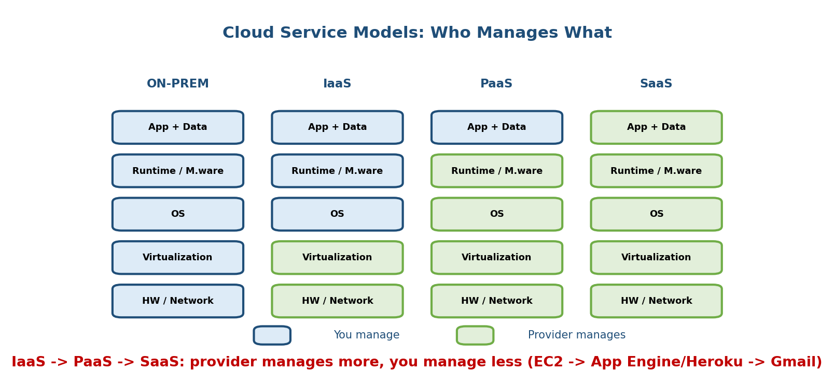
As you move IaaS to PaaS to SaaS, the provider manages more of the stack (hardware, virtualization, OS, runtime) and you manage less; on-prem you manage everything.
Model | You manage | Provider manages | Analogy | Examples
On-prem | everything | nothing | own the car | your own servers
IaaS (Infrastructure) | OS, runtime, app, data | HW, virtualization | rent the car | AWS EC2, Azure VMs, GCP Compute Engine
PaaS (Platform) | app + data only | HW…up to the runtime | taxi (you say where) | Google App Engine, Heroku, Azure App Service, Elastic Beanstalk
SaaS (Software) | just use it (settings/data) | the whole stack | bus (fixed route) | Gmail, Salesforce, Office 365, Dropbox
Memory hook — pizza-as-a-service: On-prem = cook at home (you buy everything). IaaS = take-and-bake (they give oven+ingredients, you cook). PaaS = pizza delivery (you just supply the table/drinks = your app+data). SaaS = eat at the restaurant (you just show up).
The exam trap — match example to model: EC2 = IaaS, App Engine/Heroku = PaaS, Gmail = SaaS. A very common MCQ gives you a product and asks the model.
Shared-responsibility model (RBI/SEBI + real life): security is split. The provider secures the cloud infrastructure (“security of the cloud”); the customer secures their data, access, and configuration (“security in the cloud”). The higher you go (IaaS→SaaS), the more the provider handles — but data governance is always yours (why RBI/SEBI insist on data localisation, auditability, and exit clauses).

MCQs
- EC2 is which model? → IaaS. App Engine? → PaaS. Gmail? → SaaS.
- In which model do you manage the OS? → IaaS (not PaaS/SaaS).
- Who secures customer data in the shared-responsibility model? → the customer (always).

18.3 Deployment Models (a quick MCQ section)
Cloud is also classified by who owns and can use the infrastructure:
- Public cloud — owned by a provider, shared by the general public over the internet (AWS, Azure, GCP). Cheapest, most elastic.
- Private cloud — dedicated to one organisation (on-prem or hosted). More control and compliance; costlier. (Banks/regulators often prefer this.)
- Hybrid cloud — combines public + private, with data/apps moving between them (e.g. sensitive data private, burst traffic to public).
- Community cloud — shared by several organisations with common concerns (e.g. a group of banks or government bodies).
Memory hook: public = shared apartment; private = own house; hybrid = house + rented storage unit; community = housing co-op.

MCQs
- Cloud dedicated to a single organisation? → private cloud.
- Mix of public and private? → hybrid cloud.

18.4 Cloud Compute — EC2 / Azure VMs / GCP (a VM on a hypervisor)
The core IaaS product is the cloud virtual machine — you rent a running guest OS by the second.
- AWS EC2 (“Elastic Compute Cloud”) — instances (t3, m6i, c7g…) sized by vCPU + RAM. Modern EC2 runs on the AWS Nitro hypervisor (a KVM-based Type-1 hypervisor with hardware offload; older EC2 used Xen).
- Azure Virtual Machines — VMs on Microsoft’s Hyper-V (Type-1) hypervisor.
- GCP Compute Engine — VMs on Google’s KVM-based (Type-1) hypervisor.
The one line that ties M17 to M18: a cloud VM is literally a guest OS running on a Type-1 (bare-metal) hypervisor in the provider’s data centre. When you “launch an EC2 instance,” the provider’s scheduler picks a physical host, the hypervisor carves out virtual CPU/RAM/disk/NIC, and your chosen OS image boots inside it. Everything from Module 17 §17.2–17.4 is happening under the hood.
What you get and manage on a cloud VM:
- You choose the OS image (AMI/VM image), install software, patch the OS, and scale the count — it’s IaaS (§18.2).
- The provider gives elasticity (start/stop in seconds), pay-per-second billing, snapshots, and live-migration behind the scenes.
Instance families = matching hardware to workload: general-purpose (balanced), compute-optimised (CPU-heavy), memory-optimised (in-memory DBs), and GPU/accelerated (ML training/inference — the entry point to M19 AI infra).

MCQs
- EC2 stands for? → Elastic Compute Cloud.
- A cloud VM runs on what? → a Type-1 (bare-metal) hypervisor.
- Azure VMs use which hypervisor? → Hyper-V. GCP? → KVM.
- Who patches the OS on an IaaS VM? → you (the customer).

18.5 Serverless / Functions-as-a-Service (FaaS)
Serverless flips the model: you upload just a function, and the platform runs it only when an event fires, auto-scales it, and bills per invocation (down to the millisecond). There are still servers — you just never see or manage them.
- Examples: AWS Lambda, Azure Functions, Google Cloud Functions / Cloud Run.
- Event-driven: a function runs in response to an HTTP request, a file upload, a queue message, a timer, etc.
- Scale to zero: if no events arrive, nothing runs and you pay nothing; a burst of events spins up many parallel instances automatically.
- Stateless & ephemeral: each invocation may run in a fresh sandbox; keep no local state (use a database/object store).

The OS view — sandboxes and cold starts
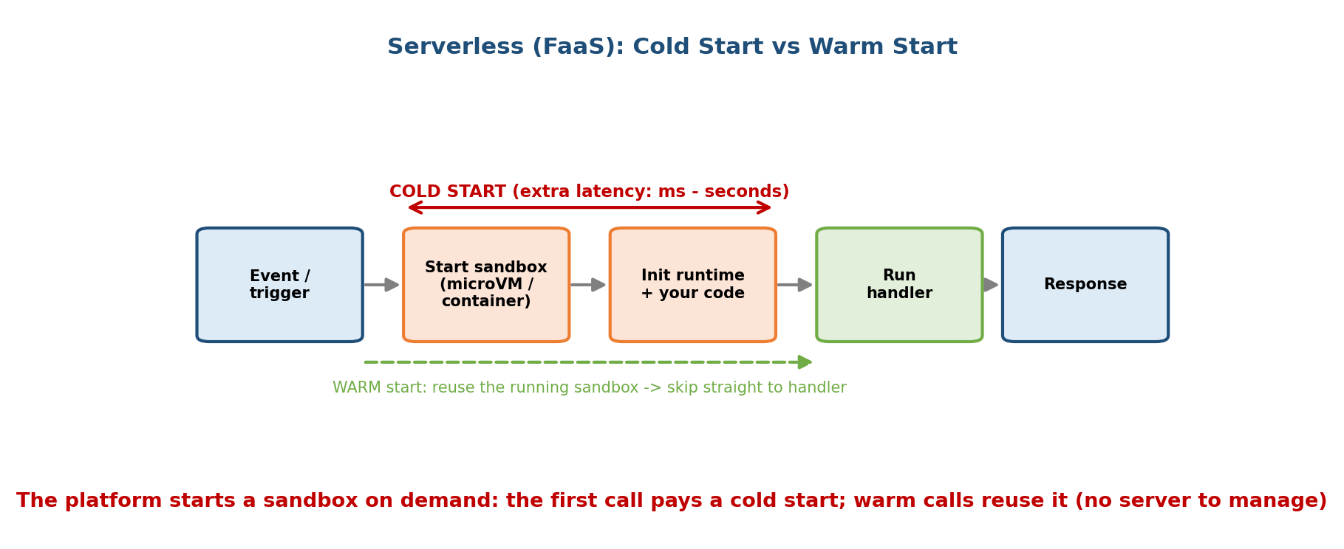
On the first invocation the platform must start a sandbox (a Firecracker microVM/container), load the runtime and your code, and initialise — this is the cold start; warm invocations reuse the running sandbox.
Under the hood the provider runs your function inside a tiny, fast-booting sandbox — AWS Lambda uses Firecracker microVMs (a §17.9 microVM: VM-grade isolation at container speed). The lifecycle:
- Cold start — the first call (or after idle/scale-out) must create the sandbox, load the language runtime, load your code, and run init. This adds latency (tens of ms to a few seconds).
- Warm start — the platform keeps the sandbox alive for a while, so the next call reuses it and skips straight to your handler → fast.
Memory hook: cold start = starting a cold car engine (choke, warm up); warm start = the engine’s already running, just drive. Reducing cold starts (smaller packages, provisioned concurrency, lightweight runtimes) is a core serverless-tuning skill.
From the OS perspective: serverless is the ultimate abstraction — the cloud hides the machine, the OS, and the process. You hand over a function; the platform handles placement, isolation, scaling, and metering — exactly the OS jobs of §18.1, now completely invisible.

MCQs
- What do you deploy in FaaS? → a function (no server to manage).
- Serverless billing model? → pay per invocation / execution time (scale to zero).
- What is a cold start? → latency to create + initialise the sandbox on the first/scaled-out call.
- What isolates an AWS Lambda invocation? → a Firecracker microVM (a microVM).

18.6 Resource Scheduling in the Cloud — Bin-Packing
With thousands of machines and millions of workloads, the platform must decide which workload runs on which machine. This is the cloud’s version of CPU scheduling (M6) — but the “jobs” are containers/VMs with CPU + memory requests and the “CPUs” are whole nodes.
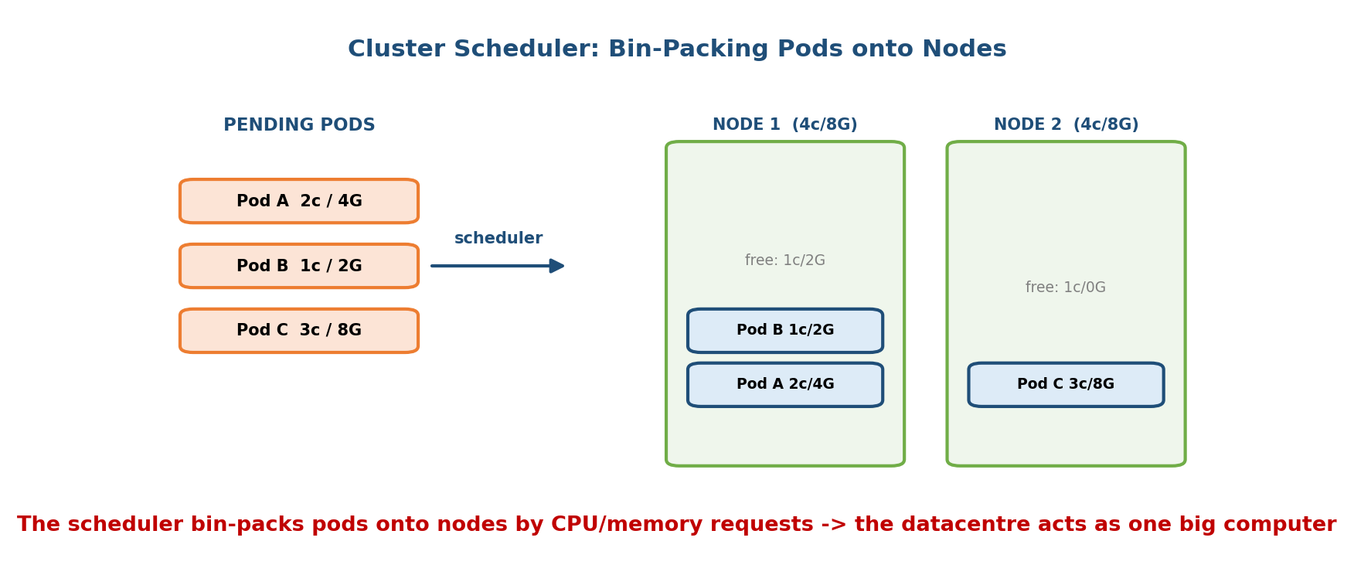
The cluster scheduler bin-packs pending pods onto nodes according to their CPU and memory requests, filling machines efficiently so the datacentre behaves like one big computer.
- Bin-packing: treat each node as a bin with a fixed CPU/RAM capacity, and each workload as an item of a given size. The scheduler packs items into as few bins as possible to maximise utilisation (fewer idle machines = lower cost). (Bin-packing is a classic NP-hard problem, so schedulers use fast heuristics like best-fit / most-requested.)
- Constraints beyond size: affinity/anti-affinity (“keep replicas on different nodes for fault tolerance”), taints/tolerations, GPU or zone requirements, headroom for spikes.
- Cluster-as-a-computer: systems like Google Borg, Kubernetes (§17.8), and Apache Mesos present the whole fleet as one giant computer — you submit work with a resource request and the scheduler finds a home for it.
Memory hook: the cloud scheduler is Tetris for servers — fit the workload blocks tightly so few machines sit half-empty. Pack too tightly, though, and a traffic spike has nowhere to go (leave headroom).
The scheduling tension (interview): utilisation vs reliability/latency. Packing tightly saves money but risks resource contention and no room for spikes; leaving slack wastes money but improves resilience. Real schedulers tune this balance with requests/limits and reserved headroom.

MCQs
- Placing workloads onto machines to maximise utilisation is called? → bin-packing.
- Google’s internal cluster manager (K8s’ ancestor)? → Borg.
- The trade-off in tight bin-packing? → utilisation vs contention/headroom.

18.7 Autoscaling — Elasticity in Practice
Elasticity (the NIST characteristic) is realised by autoscaling: adding or removing capacity automatically as load changes. There are two directions.
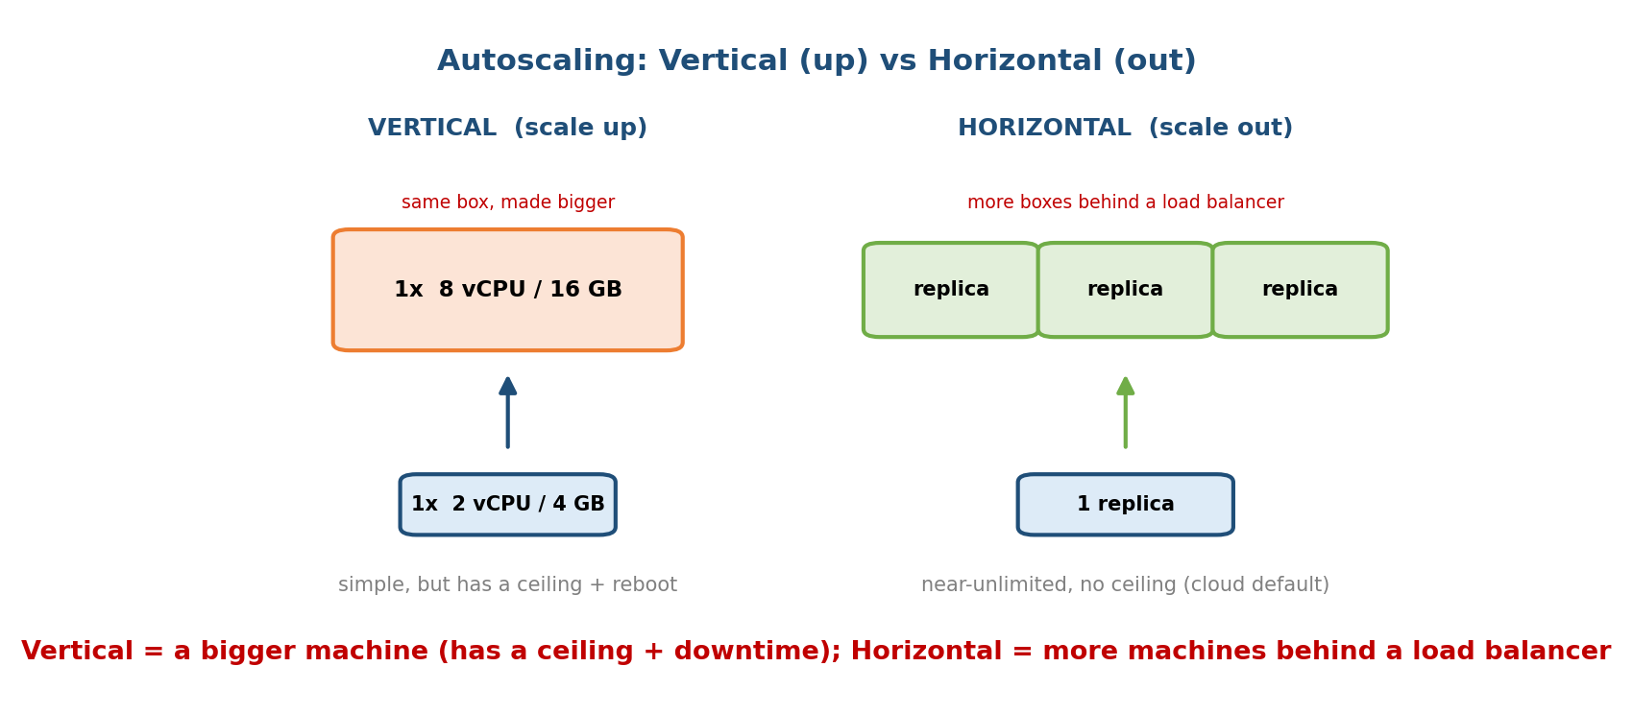
Vertical scaling makes one machine bigger (scale up, has a ceiling and needs a reboot); horizontal scaling adds more identical machines behind a load balancer (scale out, the cloud default).
- Vertical scaling (scale up/down) — give the same instance more resources (more vCPU/RAM). Simple, but has a hardware ceiling and usually needs a restart (downtime). Good for databases that are hard to distribute.
- Horizontal scaling (scale out/in) — add/remove more identical instances behind a load balancer. Near-unlimited, no downtime, resilient — the cloud default for stateless web/app tiers.
 | Vertical (scale up) | Horizontal (scale out)
Change | bigger machine | more machines
Limit | hardware ceiling | ~unlimited
Downtime | usually (reboot) | none
Resilience | single point of failure | high (many replicas)
Best for | stateful DBs | stateless services
Memory hook: vertical = a bigger truck; horizontal = more trucks. One truck can only get so big; you can always add more trucks.
What triggers scaling — the metrics:
- CPU utilisation (the classic: “scale out above 70% CPU”), memory, request rate / concurrency, queue length, response latency, or custom business metrics.
- Target tracking: keep a metric near a target (e.g. keep CPU ≈ 60%) — the autoscaler adds/removes instances to hold it.
The Kubernetes trio (interview): HPA (Horizontal Pod Autoscaler — more pods), VPA (Vertical Pod Autoscaler — bigger pods), and the Cluster Autoscaler (more nodes when pods can’t be placed). AWS’s equivalent is an Auto Scaling Group with a target-tracking policy.
Edge cases: scaling isn’t instant (new instances take time to boot/warm — the §18.5 cold-start problem again), and bad policies cause thrashing (flapping up and down). Cooldowns and predictive scaling smooth this.

MCQs
- Horizontal vs vertical scaling? → more machines vs a bigger machine.
- Cloud default for stateless web tiers? → horizontal (behind a load balancer).
- Common autoscaling metric? → CPU utilisation (also memory, request rate, queue length).
- Kubernetes component that adds nodes? → the Cluster Autoscaler (HPA adds pods).

18.8 Multi-Tenancy & Isolation
Multi-tenancy = many customers (tenants) share the same physical infrastructure — the engine of cloud economics (resource pooling). The hard part is keeping tenants isolated so they cannot see, affect, or attack each other.
Isolation layers (strongest → lightest):
Boundary | Isolation | Used for
Separate hardware | strongest | dedicated/regulated tenants
VM (hypervisor) | strong (hardware-enforced) | standard IaaS tenant separation
microVM (Firecracker) | strong + fast | serverless / function tenants
Container (namespaces + cgroups) | lighter (shared kernel) | tasks within one tenant
Process | weakest | same-app workers
- The “noisy neighbour” problem: one tenant’s heavy CPU/IO/network use degrades another’s performance. Solution: cgroups-style resource limits/quotas (M17 §17.6) and careful bin-packing (§18.6) with headroom.
- Security isolation: because containers share a kernel, untrusted multi-tenant workloads use VMs or microVMs for a hardware boundary (why Lambda uses Firecracker).
Memory hook: multi-tenancy = an apartment building. Everyone shares the foundation and plumbing (hardware), but strong walls (VMs/namespaces) stop neighbours seeing each other, and metered utilities (cgroups/quotas) stop one flat draining all the water.

MCQs
- Many customers sharing one infrastructure? → multi-tenancy.
- One tenant hogging shared resources? → the noisy-neighbour problem (fix with cgroups/quotas).
- Strongest common isolation for untrusted tenants? → VM / microVM (hardware boundary).

18.9 Real-World & Backend Perspectives
- The whole stack, top to bottom: your app runs in a container (M17), packed by a scheduler (§18.6) onto a VM (§18.4) that is a guest OS on a Type-1 hypervisor — and the platform autoscales (§18.7), meters, and isolates (§18.8) it. Every OS concept in this course reappears at data-centre scale.
- Backend deployment reality: most teams ship containers to Kubernetes (EKS/GKE/AKS) or a PaaS (Cloud Run, App Engine); latency-insensitive glue and event handlers go to serverless (Lambda).
- Cost engineering is scheduling: right-sizing instances, bin-packing density, autoscaling policies, and spot/preemptible instances directly shape the bill.
- AI infra (M19): training and inference run as GPU containers scheduled onto GPU instances; the same bin-packing/autoscaling ideas apply, plus GPU-aware scheduling and model-serving cold starts.
- Regulated finance (SEBI/RBI context): banks use private/hybrid clouds, demand data localisation, auditability, and exit/portability, and lean on the shared-responsibility model — the exam angle for these agencies.

18.10 Tradeoffs, Common Mistakes, Edge Cases
- Mistake: thinking “serverless = no servers.” There are servers — you just don’t manage them (the provider does).
- Mistake: mixing up service models. EC2 = IaaS, App Engine/Heroku = PaaS, Gmail = SaaS. Memorise one example each.
- Mistake: believing the provider secures your data. Shared responsibility — the provider secures the infra; you secure data, access, and config.
- Mistake: “vertical scaling is unlimited.” It hits a hardware ceiling and usually needs a reboot; horizontal is the near-unlimited path.
- Edge case: cold starts add latency to serverless (and to any freshly scaled-out instance) — mitigate with provisioned/pre-warmed capacity.
- Edge case: aggressive bin-packing raises utilisation but risks noisy neighbours and no headroom for spikes.
- Edge case: autoscaling thrashing (flapping) from twitchy metrics — use cooldowns/target-tracking.
- Tradeoff: control vs convenience — IaaS gives control (and toil); SaaS gives convenience (and lock-in). Public is cheap/elastic; private is controlled/compliant.

18.11 Exam, Interview & Coding Perspectives
- SEBI / RBI / NABARD (high yield): the NIST 5 characteristics; IaaS/PaaS/ SaaS with examples and who manages what; deployment models (public/private/ hybrid/community); shared-responsibility; elasticity/scaling; multi- tenancy; that a cloud VM is a guest OS on a Type-1 hypervisor.
- GATE: cloud is light in GATE, but virtualization, scheduling (bin- packing ≈ scheduling), and elasticity connect to core OS topics.
- Interview (backend/AI-infra — very high yield):
  - “IaaS vs PaaS vs SaaS?” → who manages the stack (+ EC2 / App Engine / Gmail).
  - “What is serverless / a cold start?” → deploy a function; latency to provision + init the sandbox on first/scaled-out call.
  - “Horizontal vs vertical scaling — which and why?” → horizontal for stateless services (no ceiling, no downtime, resilient).
  - “How does the cloud decide where to run my container?” → a scheduler bin-packs by CPU/RAM requests + constraints.
  - “How do you isolate tenants?” → VMs/microVMs (hardware) + namespaces/ cgroups (limits), guarding against noisy neighbours.
- Coding/practical:
  - aws ec2 run-instances …, an Auto Scaling Group with a target-tracking policy on CPU.
  - kubectl autoscale deployment web --min=2 --max=10 --cpu-percent=70 (HPA).
  - A Lambda function behind an API Gateway; observe the cold start on the first request.

18.12 Concept Checks & MCQs (test yourself)
- Who defines the standard “cloud” + 5 characteristics? → NIST.
- List the NIST 5. → on-demand self-service, broad network access, resource pooling, rapid elasticity, measured service.
- IaaS / PaaS / SaaS — one example each. → EC2 / App Engine (Heroku) / Gmail.
- In which model do you manage the OS? → IaaS.
- “Pay only for what you use” = which characteristic? → measured service.
- Private vs public vs hybrid cloud? → one org vs shared/public vs mix.
- A cloud VM runs on a ___ hypervisor. → Type-1 (bare-metal).
- EC2 / Azure / GCP hypervisors? → Nitro(KVM) / Hyper-V / KVM.
- What do you deploy in FaaS? → a function (serverless).
- What is a cold start? → latency to create + initialise the sandbox on first call.
- What isolates a Lambda invocation? → a Firecracker microVM.
- Horizontal vs vertical scaling? → more machines vs a bigger machine.
- Cloud default for stateless services? → horizontal (behind a load balancer).
- A common autoscaling metric? → CPU utilisation (also memory / request rate).
- Placing workloads on machines to maximise utilisation? → bin-packing.
- Google’s cluster manager (K8s ancestor)? → Borg.
- Many tenants sharing hardware? → multi-tenancy (resource pooling).
- One tenant hogging shared resources? → noisy neighbour (fix: cgroups/ quotas).
- Who secures customer data? → the customer (shared responsibility).
- Kubernetes autoscalers? → HPA (pods), VPA (pod size), Cluster Autoscaler (nodes).
True/False - Serverless means there are no servers. → False (you just don’t manage them). - EC2 is a PaaS. → False (it’s IaaS). - Vertical scaling is unlimited. → False (hardware ceiling + reboot). - A cloud VM is a guest OS on a Type-1 hypervisor. → True. - The provider secures your data in SaaS. → False (data is always the customer’s responsibility). - Horizontal scaling adds more instances behind a load balancer. → True.

18.13 One-Page Revision Sheet
CLOUD = on-demand, pay-as-you-go compute/storage/network over the internet.
"OS FOR THE DATA CENTRE": schedules VMs/containers onto machines, isolates tenants,
meters + bills usage, abstracts hardware behind APIs. ("Datacenter as a Computer")
NIST 5 (OB-REM): On-demand self-service | Broad network access | Resource pooling |
rapid Elasticity | Measured service.
SERVICE MODELS (provider manages MORE as you go down):
IaaS you manage OS+runtime+app; provider = HW+virt -> EC2, Azure VMs, GCP Compute
PaaS you manage app+data only -> App Engine, Heroku, Beanstalk
SaaS you just use it -> Gmail, Salesforce, Office365
(pizza-as-a-service). SHARED RESPONSIBILITY: provider = security OF cloud;
customer = security IN cloud (DATA always yours).
DEPLOYMENT: public(shared) | private(1 org) | hybrid(mix) | community(group).
COMPUTE: a cloud VM = a GUEST OS on a TYPE-1 (bare-metal) HYPERVISOR.
EC2->Nitro(KVM) / Azure->Hyper-V / GCP->KVM. Instance families = match HW to workload.
SERVERLESS / FaaS: deploy a FUNCTION; event-driven; auto-scale (to ZERO); pay per call.
Lambda / Azure Functions / Cloud Functions. Sandbox = Firecracker microVM.
COLD START = create+init sandbox+runtime+code on 1st/scaled call (latency).
WARM START = reuse the running sandbox (fast). Stateless + ephemeral.
SCHEDULING = BIN-PACKING: pack workloads (CPU/RAM requests) onto nodes (bins) to
maximise utilisation (NP-hard heuristics) + constraints (affinity/GPU/zone) + headroom.
Cluster-as-a-computer: Borg / Kubernetes / Mesos. Tension: utilisation vs contention.
AUTOSCALING (= elasticity):
VERTICAL scale up = bigger machine (ceiling + reboot; stateful DBs)
HORIZONTAL scale out = more machines behind LB (near-unlimited, no downtime; DEFAULT)
metrics: CPU util / memory / request rate / queue / latency (target tracking).
K8s: HPA(pods) VPA(pod size) Cluster Autoscaler(nodes); AWS Auto Scaling Group.
MULTI-TENANCY = many tenants share HW (resource pooling). Isolate strongest->lightest:
separate HW > VM > microVM > container(ns+cgroups) > process.
NOISY NEIGHBOUR: one tenant hogs resources -> fix with cgroups/quotas + headroom.

Flash cards
Front | Back
Standard cloud definition body? | NIST (5 characteristics)
NIST 5? | On-demand, broad access, pooling, elasticity, measured
IaaS / PaaS / SaaS example? | EC2 / App Engine / Gmail
Who manages the OS in IaaS? | You (the customer)
A cloud VM runs on? | A Type-1 (bare-metal) hypervisor
EC2 / Azure / GCP hypervisor? | Nitro(KVM) / Hyper-V / KVM
Serverless deploys what? | A function (FaaS)
Cold start? | Latency to create + init the sandbox
Lambda sandbox? | Firecracker microVM
Horizontal vs vertical? | More machines vs a bigger machine
Cloud scheduling problem? | Bin-packing (workloads → nodes)
Multi-tenancy risk? | Noisy neighbour (fix: cgroups/quotas)
Shared responsibility — your data? | Always the customer’s

Spaced repetition
- 24-hour: recite NIST-5 (OB-REM) and the IaaS/PaaS/SaaS examples + who-manages- what.
- 7-day: explain serverless + cold start; horizontal vs vertical scaling with reasons; bin-packing; multi-tenancy isolation layers.
- 30-day: given a workload (stateful DB, spiky web API, event handler, untrusted multi-tenant code), choose the service model + scaling strategy + isolation and justify it.

18.14 Summary
The cloud delivers compute on demand and, in doing so, acts as an operating system for the whole data centre — scheduling, isolating, metering, and abstracting a fleet of machines just as an OS does for one. The NIST definition (on-demand, broad access, resource pooling, elasticity, measured service) frames it, and the three service models — IaaS (rent the VM: EC2/Azure/GCP), PaaS (rent the platform: App Engine/Heroku), SaaS (rent the app: Gmail) — differ by who manages the stack, under a shared-responsibility split where your data is always yours. Cloud compute is a guest OS on a Type-1 hypervisor; serverless/FaaS hides even the OS and process, running your function in a Firecracker microVM with a cold-start cost. Behind the scenes a scheduler bin-packs workloads onto nodes, autoscaling adds capacity horizontally (more machines) or vertically (bigger machines) by metrics like CPU, and multi-tenancy shares hardware while VMs/microVMs + cgroups/namespaces keep tenants isolated and tame the noisy neighbour.
This closes the systems arc that began in Module 1: from one machine and one kernel, through processes, memory, and files, up to virtualization (M17) and now the cloud — the platform on which Module 19 — AI Infrastructure builds GPU scheduling and model serving.
You have mastered this module when you can: state the NIST-5 and classify a product as IaaS/PaaS/SaaS with the right example; explain the shared-responsibility model; describe a cloud VM as a guest OS on a Type-1 hypervisor; explain serverless and cold starts; contrast horizontal vs vertical autoscaling with reasons; explain bin-packing scheduling; and describe multi-tenancy isolation and the noisy-neighbour problem — all without notes.

