Module 19 — The AI-Engineering Perspective (GPUs, CUDA & LLM Serving as OS Problems)
  - OS Mastery: SEBI IT / RBI / NABARD / GATE / C-DAC / Interview / Backend — In-Depth Notes (with visuals)
Prepared for nidhi.sharma@forensiccybertech.com
2026
Table of Contents

Module 19 — The AI-Engineering Perspective (GPUs, CUDA & LLM Serving as OS Problems)
Where this module sits. Every idea in this course — scheduling (M6), memory management & paging (M9), virtual memory (M10), DMA & I/O (M2, M13), synchronization (M7), IPC (M4) — reappears, almost unchanged, when you build or run AI systems. A GPU is just another device the OS schedules; a CUDA kernel is a job dispatched to that device; CUDA streams are a pipeline that overlaps I/O with compute (double buffering); the GPU memory hierarchy is the same registers→cache→RAM story one level down; and modern LLM serving literally reinvents paging to manage attention memory (PagedAttention). This module is not a deep-learning tutorial — it is a map from AI infrastructure back to the OS concepts you already know, so an interviewer’s “how does an LLM server manage GPU memory?” becomes an OS question you can answer from first principles.
Importance ratings (out of 5):
Exam / Use | SEBI IT | RBI IT | GATE CS | Interview | Backend
This module | ★ | ★ | ★ | ★★★★ | ★★★★★
Most-asked interview/backend concepts: why GPUs (throughput vs latency cores); the CPU→GPU offload lifecycle; host vs device, kernel, grid / block / thread / warp (warp = 32 threads, SIMT); CUDA streams for overlapping copy and compute; the GPU memory hierarchy (registers → shared → L2 → global/HBM) and memory coalescing; pinned (page-locked) memory and why it enables DMA; multi-GPU NUMA / NVLink; LLM inference as a memory-management problem — KV-cache growth and PagedAttention = paging for attention; distributed training (data / tensor / pipeline parallelism, all-reduce) and why the bottleneck is usually memory and network, not FLOPs.

19.1 Why a GPU at all? The CPU→GPU Offload Model

Motivation (first principles)
A CPU core is a latency-optimised machine: a few very fast cores, deep pipelines, large caches, branch prediction — built to finish one thread of control as quickly as possible. A GPU is the opposite: a throughput-optimised machine with thousands of simple cores that run the same instruction on many data elements at once. Deep learning is mostly matrix multiplication — millions of identical multiply-adds with no branching — which is exactly the data-parallel work a GPU eats for breakfast.
The OS/hardware truth: the GPU is a peripheral device hanging off the PCIe bus (or NVLink), with its own memory (HBM). The CPU (the host) cannot run Python on the GPU; it must offload work to it, exactly the way it offloads a disk write — set up the data, kick off the device, and collect the result.
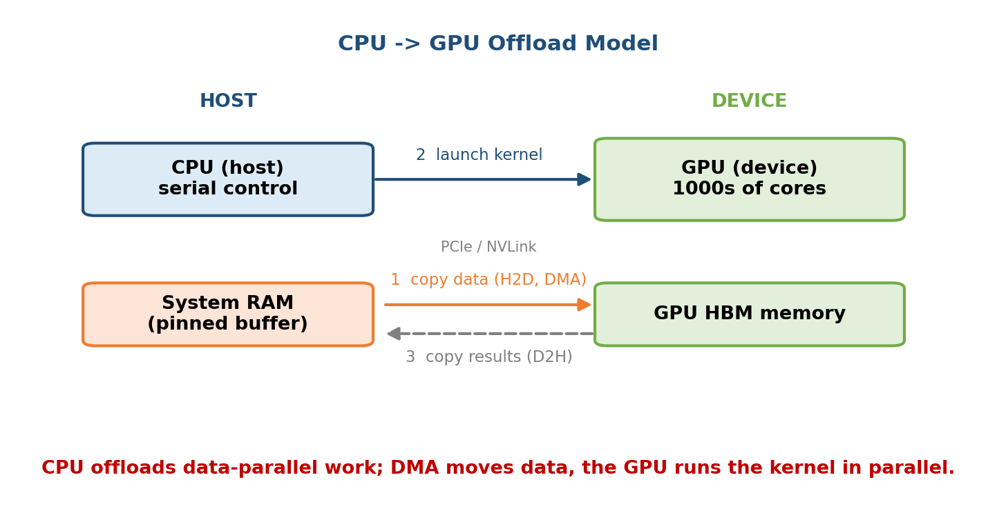
CPU offloads data-parallel work; DMA moves data over PCIe/NVLink, the GPU runs the kernel in parallel.
The offload lifecycle (memorise these four steps — they frame everything):
1. COPY data Host RAM -> GPU HBM (cudaMemcpy, done by DMA)
2. LAUNCH kernel<<<grid, block>>>() (host queues work on the device)
3. COMPUTE GPU runs 1000s of threads in parallel
4. COPY back GPU HBM -> Host RAM (cudaMemcpy, DMA again)
Memory hook: the GPU is the kitchen, the CPU is the head waiter. The waiter (CPU) never cooks; it carries orders and ingredients in (H2D copy), shouts the order (kernel launch), lets the many cooks work in parallel, and carries plates out (D2H copy). A restaurant is fast not because the waiter is fast, but because the kitchen parallelises.

The cost that dominates: data movement, not compute
Steps 1 and 4 are I/O over PCIe (~16–64 GB/s), while HBM inside the GPU runs at ~1–3 TB/s and compute is faster still. So the classic OS lesson returns: the slow link is the bottleneck. Good AI code, like good OS code, works hard to keep data on the fast side (in HBM) and overlap the slow copies with compute (§19.4). “Never let the fast unit sit idle waiting on I/O” — the same sentence that drove multiprogramming in M1 drives GPU programming.

MCQs
- CPU vs GPU core design goal? → latency (few fast cores) vs throughput (many simple cores).
- Where does GPU data physically live? → the GPU’s own HBM (device memory).
- The usual bottleneck in a GPU program? → data movement over PCIe (H2D/D2H), not the compute.

19.2 GPU Scheduling — the Same Ideas, One Level Down

The host-side queue and the device-side scheduler
When the host calls kernel<<<...>>>() it does not block; it enqueues the launch onto the GPU and returns (asynchronous). This is a producer–consumer queue (M7): the CPU produces work, the GPU consumes it. On the device, a hardware GigaThread / grid scheduler hands thread blocks to the Streaming Multiprocessors (SMs), and within each SM a warp scheduler picks which warp (group of 32 threads) issues next cycle.

Latency hiding = the GPU’s version of multiprogramming
A single SM keeps many warps resident at once. When one warp stalls on a slow global-memory read (hundreds of cycles), the warp scheduler instantly switches to another ready warp — with zero context-switch cost, because each warp’s registers are already allocated on-chip. This is literally multiprogramming from M1: “when one job blocks on I/O, run another.” The GPU just does it in hardware, per-cycle, to hide memory latency instead of disk latency.
OS concept (this course) | GPU equivalent
Process/job scheduled onto a CPU | thread block scheduled onto an SM
Ready queue, dispatcher | warp scheduler picks a ready warp each cycle
Multiprogramming (run another on I/O wait) | latency hiding (switch warps on a memory stall)
Context switch (save/restore registers) | free — warp registers stay resident on the SM
Time quantum / preemption | warps interleave per-instruction (fine-grained)
Oversubscription (more procs than CPUs) | launch far more threads than cores on purpose
Memory hook: an SM is a call-centre agent juggling many calls. The moment one caller says “hold on, let me find it” (memory stall), the agent takes the next call. Idle time disappears because there is always another ready warp. That is why you deliberately launch thousands of threads — to give the scheduler plenty to switch to.
Occupancy is the GPU word for “how many warps are resident vs the maximum.” High occupancy → more warps to hide latency behind → the SM rarely stalls. It is bounded by registers per thread and shared memory per block (a fixed budget per SM) — the same “resources are finite, allocation is a tradeoff” theme as OS memory management.

MCQs
- What hides memory latency on a GPU? → keeping many warps resident and switching to a ready warp on a stall (latency hiding = multiprogramming).
- Cost of a GPU “context switch” between warps? → effectively zero (registers stay on-chip).
- What is occupancy? → resident warps ÷ maximum warps per SM (limited by register/shared-memory budget).

19.3 The CUDA Runtime — Host vs Device, Kernels, and the Thread Hierarchy
CUDA is NVIDIA’s programming model for offloading to the GPU. Two facts organise everything:
- Host code runs on the CPU (ordinary C/C++/Python); device code (a kernel, marked __global__) runs on the GPU.
- A kernel is launched over a grid of thread blocks, and each block holds many threads; the same kernel body runs in every thread, distinguished only by its index. This is SIMT — Single Instruction, Multiple Threads.
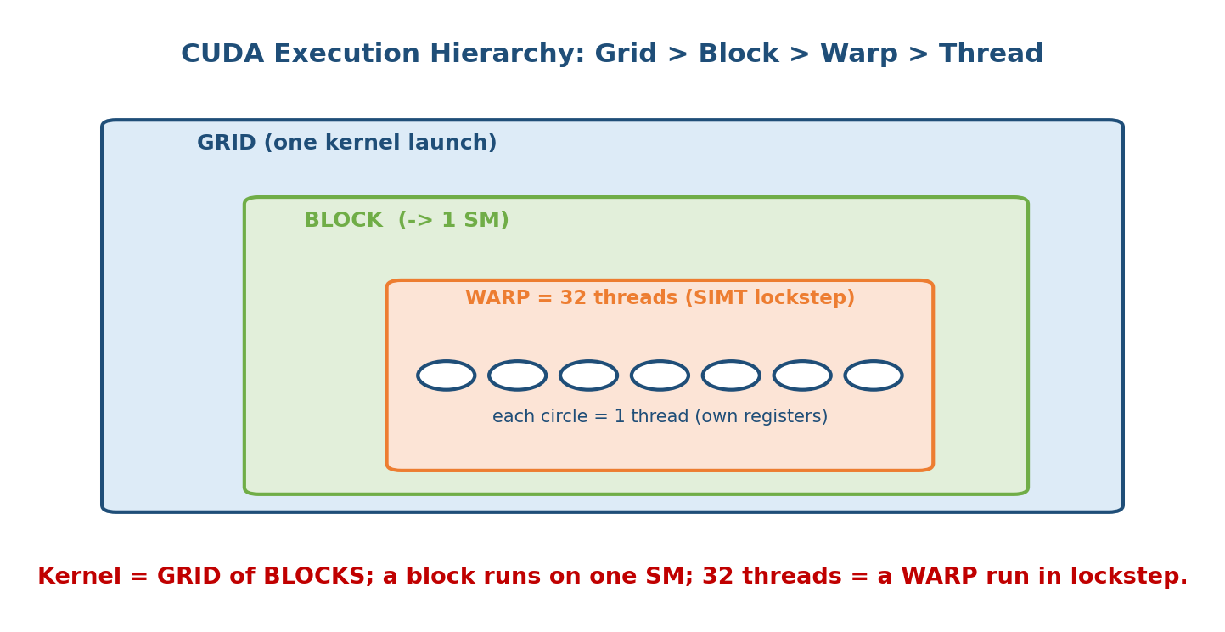
Kernel = a GRID of BLOCKS; each block runs on one SM; 32 threads form a WARP executed in lockstep.
Level | What it is | OS analogy
Grid | all threads of one kernel launch | a whole job
Block | group of threads that share shared memory + can __syncthreads() | a process with shared address space + a barrier
Warp | 32 threads that execute in lockstep (SIMT) | a gang scheduled together
Thread | one lane; has its own registers | a thread with private stack/registers
A minimal kernel (vector add) — note how each thread computes one element:
__global__ void vadd(const float *a, const float *b, float *c, int n) {
int i = blockIdx.x * blockDim.x + threadIdx.x; // this thread's global index
if (i < n) c[i] = a[i] + b[i]; // one element per thread
}
// host launches a grid of ceil(n/256) blocks x 256 threads:
vadd<<<(n + 255) / 256, 256>>>(dA, dB, dC, n);
The warp is the real scheduling unit (favourite trap). Threads are written individually, but the hardware issues instructions per warp of 32. Two consequences you must know: - Warp divergence: if threads in a warp take different branches of an if/else, the warp executes both paths serially with lanes masked off — halving throughput. Data-parallel code avoids per-thread branching. - Block size should be a multiple of 32, else the last warp runs with idle lanes (wasted like internal fragmentation in M9).
Memory hook: a warp is a rowing eight — all 32 oars must pull the same stroke at the same time. If half the crew rows a different stroke (divergent branch), the boat does both strokes one after the other and slows down.

MCQs
- __global__ marks code that runs on? → the device (GPU), launched from the host.
- How many threads in a warp? → 32 (executed in lockstep, SIMT).
- Why keep block size a multiple of 32? → so no warp runs with idle lanes.
- What is warp divergence? → threads in a warp taking different branches, forcing both paths to run serially.

19.4 CUDA Streams — Overlapping Copy and Compute (an OS-scheduling story)

The problem: the PCIe copy stalls the GPU
If you do the naive thing — copy all data H2D, then compute, then copy all results D2H — the GPU sits idle during both copies, and the copy engine sits idle during compute. It is the same waste as a CPU blocking on a full disk read before doing any work.

The fix: streams (independent queues that overlap)
A CUDA stream is an ordered queue of operations (copies + kernels) that run in order within the stream, but different streams can run concurrently. Modern GPUs have separate copy engines and compute engines, so a copy in stream B can run while a kernel computes in stream A. Split the work into chunks, put each chunk in its own stream, and the timeline turns from serial into a pipeline — this is double buffering / prefetching (the same trick as the DBMS buffer manager and OS read-ahead in M13).
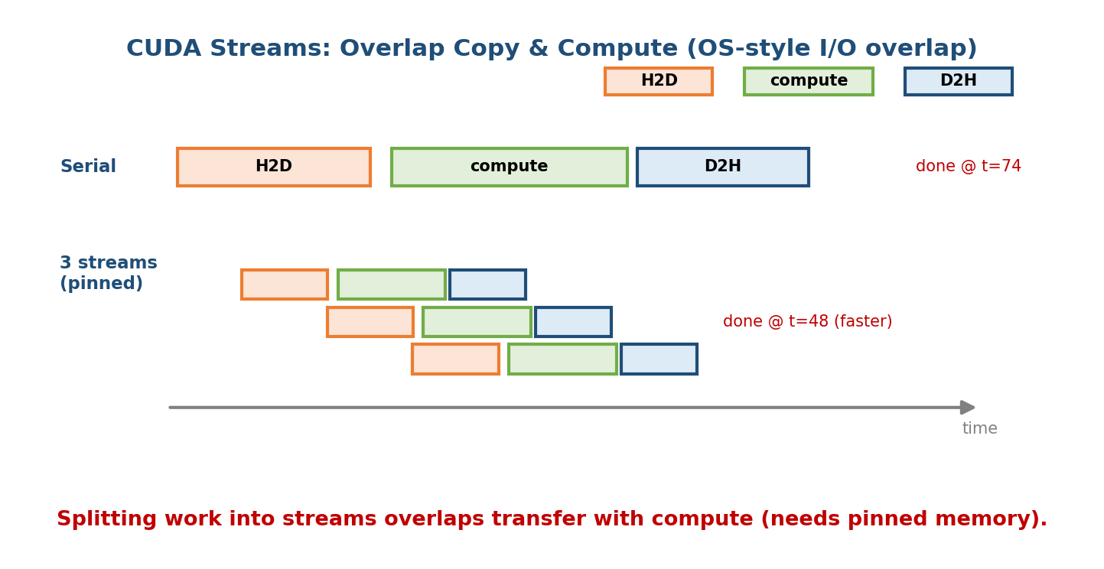
Splitting work into streams overlaps transfer with compute — the GPU analogue of OS double buffering/DMA overlap.
for (int c = 0; c < CHUNKS; ++c) {
cudaMemcpyAsync(dA+off, hA+off, sz, H2D, stream[c]); // copy chunk (engine 1)
process<<<g, b, 0, stream[c]>>>(dA+off, dC+off); // compute (engine 2)
cudaMemcpyAsync(hC+off, dC+off, sz, D2H, stream[c]); // copy back (engine 1)
} // while stream[0] computes, stream[1] is already copying in -> overlap
Two rules exams/interviews test: - The default stream (stream 0) is synchronising — it serialises with others. Real overlap needs explicit non-default streams. - cudaMemcpyAsync only truly overlaps when the host buffer is pinned (page-locked) memory (§19.6). With pageable memory the copy silently falls back to synchronous.
Memory hook: streams are an assembly line. Stage 1 (copy in), stage 2 (compute), stage 3 (copy out) each work on a different chunk at the same time, so no station is ever idle — exactly like overlapping I/O with CPU in a pipelined OS.

MCQs
- What lets a copy and a kernel run at the same time? → putting them in different (non-default) CUDA streams.
- The default stream (0) behaves how? → it synchronises with other streams.
- Prerequisite for true async cudaMemcpyAsync overlap? → pinned (page-locked) host memory.

19.5 The GPU Memory Hierarchy — the Same Pyramid, One Level Down
A GPU has its own memory hierarchy, and it maps cleanly onto the CPU one from M2/M9. Faster + smaller + closer at the top; slower + larger + shared at the bottom.
GPU memory | Scope | Speed | OS/CPU analogue
Registers | per thread | fastest (~1 cyc) | CPU registers
Shared memory / L1 | per block (on-chip) | very fast | a small scratchpad cache the programmer controls
L2 cache | whole GPU | fast | CPU L2/L3
Global memory (HBM) | whole GPU, off-chip | ~1–3 TB/s but ~hundreds of cycles latency | main RAM
Host RAM (over PCIe) | CPU side | slow link (~tens of GB/s) | a slow disk/network from the GPU’s view
Shared memory is the one to understand: it is a small, fast, on-chip scratchpad that all threads in a block can read/write — a software-managed cache. Tiling a matrix multiply through shared memory (load a tile once, reuse it 32 times) is the GPU version of “exploit locality; avoid the slow level,” identical in spirit to the DBMS buffer pool.

Memory coalescing — the GPU’s “sequential vs random I/O”
Global-memory accesses are served in transactions of a fixed width (e.g. 128 bytes). If the 32 threads of a warp read 32 consecutive 4-byte floats (4×32 = 128 B), the hardware coalesces them into one transaction. If they read scattered/strided addresses, it may take up to 32 transactions — 32× the memory traffic for the same data.
COALESCED (thread t reads a[t]): one 128-byte transaction -> full bandwidth
STRIDED (thread t reads a[t*17]): up to 32 transactions -> ~1/32 bandwidth
Memory hook: coalescing is sequential vs random disk I/O (M12/DBMS M6) all over again. One big contiguous read beats 32 scattered reads — on a disk and on HBM. Lay data out so neighbouring threads touch neighbouring addresses.

MCQs
- GPU shared memory is best described as? → a programmer-managed on-chip scratchpad/cache, shared per block.
- What is memory coalescing? → combining a warp’s consecutive accesses into one transaction (like sequential I/O).
- Slowest link from the GPU’s viewpoint? → host RAM over PCIe.

19.6 Pinned (Page-Locked) Memory & DMA — a Direct M9/M10 Payoff

First principles: why ordinary RAM cannot be DMA’d safely
Recall paging (M9/M10): your process sees virtual memory, and the OS may page out or relocate a physical frame at any time. But a DMA engine (M2) moves bytes using physical addresses with no knowledge of the page tables. If the OS moved a page mid-transfer, DMA would scribble on the wrong physical frame. So the GPU driver cannot DMA directly from ordinary pageable memory.

The fix: pin the pages
Pinned (page-locked) memory is host RAM the OS has locked in place — it cannot be paged out or moved (like mlock() in Linux). Now its physical address is stable, so the GPU’s DMA engine can stream from it directly.
PAGEABLE copy: Host pageable RAM --(CPU copies)--> hidden PINNED staging buffer
--(DMA)--> GPU HBM (two hops, slower, sync)
PINNED copy: Host PINNED RAM --(DMA)--------------> GPU HBM
(one hop, faster, can be truly async)
- With pageable memory the driver must first copy your data into a hidden pinned staging buffer, then DMA — an extra copy, and it forces the transfer to be synchronous.
- With pinned memory (cudaHostAlloc / cudaMallocHost) the DMA goes straight from your buffer → higher bandwidth and true async overlap (§19.4).
The tradeoff (edge case): pinned memory is scarce — it is unswappable physical RAM, so over-pinning starves the rest of the system and can hurt overall performance. Pin the hot transfer buffers (e.g. the data-loader’s output), not everything.
Memory hook: pinning is nailing a page to the floor so the DMA truck can load it without the OS shuffling it to another room mid-load. Great for the few boxes you ship constantly; terrible if you nail down the whole warehouse.
This is the clearest “AI infra is OS” moment: pinned memory only makes sense if you understand paging and DMA. It ties M2 (DMA), M9 (paging), and M10 (page replacement/locking) together.

MCQs
- Why can’t DMA use ordinary pageable memory directly? → the OS may page out/move the frame; DMA uses physical addresses.
- Two benefits of pinned memory? → faster (no staging copy) and enables true async transfers.
- Downside of too much pinned memory? → it is unswappable RAM; over-pinning starves the system.

19.7 Multi-GPU: NUMA, NVLink, and IPC for Data Loading

NUMA — the multi-GPU version of a topology you already know
In a multi-socket server, NUMA (Non-Uniform Memory Access) means a CPU core reaches its local memory bank faster than a remote one. Multi-GPU boxes have the same shape: each GPU sits under a particular PCIe root / CPU socket, so a GPU talks fastest to the CPU and NIC on its own socket. Pinning a data-loader process to the right NUMA node (near its GPU) can noticeably cut transfer latency — the same affinity/locality idea as CPU-cache and NUMA-aware scheduling.
Between GPUs, NVLink is a fast direct GPU-to-GPU interconnect (far faster than routing through PCIe and host RAM), and GPUDirect P2P / RDMA lets one GPU read another’s memory — or a NIC DMA straight into GPU memory — bypassing the CPU. This is DMA/zero-copy thinking applied across devices.

IPC and shared memory for the data pipeline
Training is often input-starved: the GPU finishes a batch before the CPU has decoded/augmented the next one. The fix is classic OS IPC (M4):
- Multiple worker processes decode data in parallel (e.g. PyTorch DataLoader(num_workers=k) forks worker processes).
- They hand batches to the trainer through shared memory (/dev/shm, POSIX shared memory) to avoid re-serialising large tensors over pipes — a zero-copy handoff using the shared-memory IPC model from M4.
- Watch out for fork + COW (M10): forked workers share pages copy-on-write, so touching large Python objects can silently blow up memory as pages get copied.
Memory hook: the data loader is a producer–consumer problem (M7) with a bounded buffer — CPU workers produce batches, the GPU consumes them, and shared memory is the buffer. If producers are too slow, the GPU (consumer) starves and utilisation drops.

MCQs
- Multi-GPU affinity to the nearest CPU/NIC is an instance of? → NUMA locality.
- What lets one GPU read another’s memory without the CPU? → NVLink / GPUDirect P2P (RDMA).
- PyTorch DataLoader workers hand tensors to the trainer via? → shared-memory IPC (avoids re-copy); beware fork COW.

19.8 LLM Inference as an OS Problem — KV-Cache & PagedAttention
This is the section interviewers love, because it is pure OS.

Why serving an LLM is a memory-management problem
A transformer generates text one token at a time. To avoid recomputing attention over the whole prompt each step, it caches the Keys and Values of every past token — the KV-cache. This cache grows with every generated token and is per-request. On a busy server with many concurrent conversations of unknown final length, the question “who gets which GPU memory, and how do we not waste it?” is exactly an OS memory-allocation problem.
Worked numerical — how big is a KV-cache?
KV bytes/token = 2 (K and V) x num_layers x hidden_size x bytes_per_element
Example (Llama-2-13B, fp16): 2 x 40 x 5120 x 2 bytes
= 819,200 bytes ~= 0.78 MiB per token
For a 2,048-token context: 2048 x 0.78 MiB ~= 1.6 GiB (ONE request!)
(With grouped-query attention (GQA) the KV heads are fewer, shrinking this — but the point stands: KV memory is huge and per-request.) Multiply by dozens of concurrent requests and GPU HBM fills instantly — memory, not compute, caps how many users you can serve.

The naive allocator wastes memory — just like early OS memory schemes
Early LLM servers reserved a single contiguous block per request, sized for the maximum possible length. This repeats the mistakes of contiguous memory allocation (M9):
- Internal fragmentation: a request that ends early leaves its big reserved block mostly empty.
- External fragmentation: freed blocks of different sizes leave holes too small to reuse.
- Over-reservation: you must reserve for the worst case, so you fit far fewer concurrent requests than the hardware could hold.

PagedAttention — literally paging, applied to attention
vLLM’s PagedAttention solves this with the exact idea from M9/M10 paging: stop demanding contiguous memory. Split the KV-cache into fixed-size blocks (e.g. 16 tokens each), store them anywhere in HBM, and keep a block table per request that maps logical KV blocks → physical GPU blocks — a page table for attention.
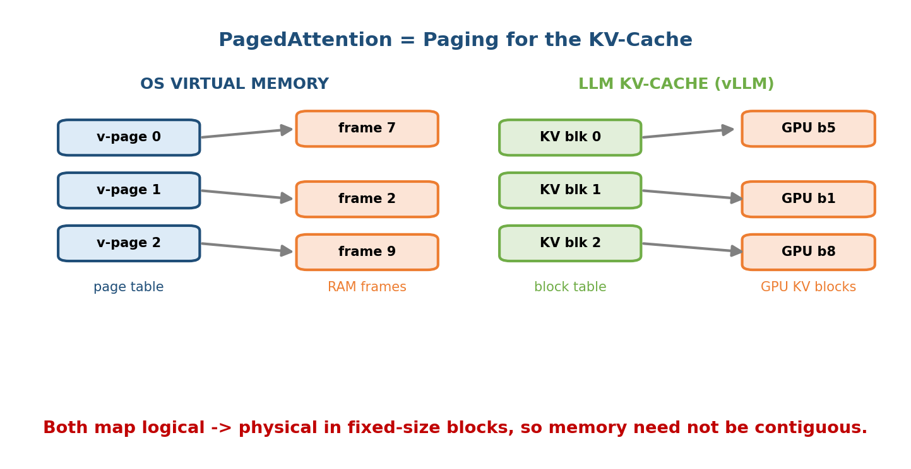
Both OS virtual memory and PagedAttention map logical -> physical in fixed-size blocks, so memory need not be contiguous.
OS paging (M9/M10) | PagedAttention (vLLM)
Fixed-size page/frame | fixed-size KV block (e.g. 16 tokens)
Page table: virtual page → physical frame | block table: logical KV block → physical GPU block
Frames allocated on demand (demand paging) | KV blocks allocated as tokens are generated
No external fragmentation (fixed frames) | no external fragmentation (fixed blocks)
Copy-on-write shared pages after fork | shared prefix blocks COW’d across requests
The payoffs are the same ones paging gave the OS: near-zero external fragmentation, so memory utilisation jumps and you fit many more concurrent requests; and sharing — two requests with the same system prompt can share those KV blocks copy-on-write (identical to fork COW in M10), until one diverges. vLLM reports this cuts KV waste from ~60–80% down to a few percent, raising throughput several-fold.
The one-line interview answer: “How does a modern LLM server manage GPU memory?” → “It pages the KV-cache. PagedAttention chops attention memory into fixed-size blocks with a per-request block table — OS virtual memory applied to attention — killing fragmentation and enabling COW prefix sharing.”
Memory hook: the KV-cache is a process’s growing heap, and PagedAttention is the MMU + page table that lets it grow into scattered frames instead of demanding one huge contiguous chunk.

MCQs
- What grows per token during LLM generation? → the KV-cache (cached keys & values).
- PagedAttention is analogous to which OS mechanism? → paging (virtual→physical via a block/page table).
- How do two requests with the same prompt save memory? → copy-on-write sharing of KV blocks (like fork COW).
- Which problem does contiguous KV allocation suffer? → internal & external fragmentation + over-reservation.

19.9 Distributed Training — When One GPU Isn’t Enough
Big models don’t fit (or train too slowly) on one GPU, so work is split across many. There are three axes of parallelism; know what each splits and its OS/network cost.
Parallelism | What is split | Communication | OS analogy
Data | the batch (each GPU has a full model copy, different data) | all-reduce gradients every step | replicas + a barrier/reduce sync (M7)
Tensor (model) | individual layers/matrices across GPUs | all-reduce within each layer (very chatty) | one job’s address space striped across nodes
Pipeline | groups of layers into stages on different GPUs | activations passed stage→stage | an assembly line; suffers startup “bubble”

All-reduce and why the network is the bottleneck
In data parallelism, after each step every GPU must average its gradients with all others — a collective all-reduce (NVIDIA’s NCCL uses a ring all-reduce). Each GPU ends up sending/receiving ~2×(N−1)/N × (model size) bytes every step. For a multi-billion-parameter model that is gigabytes of traffic per step, so the interconnect (NVLink within a node, InfiniBand/ RoCE across nodes) — not the math — usually caps scaling. This is the OS lesson yet again: past a point, communication/synchronisation overhead dominates (cf. Amdahl’s law and lock contention in M7).
- Pipeline bubble: while the pipeline fills and drains, some stages are idle — the same startup/pipeline-fill latency you see in any pipelined system. Splitting the batch into micro-batches shrinks the bubble.
- Stragglers & barriers: an all-reduce is a barrier — the slowest GPU sets the pace, exactly like the slowest thread at a barrier in M7.
Memory hook: distributed training is a synchronisation problem, not a math problem. FLOPs are cheap and parallel; the pain is all-reduce traffic and barriers, which are M7/networking, not linear algebra.

MCQs
- Data vs tensor vs pipeline parallelism split what? → the batch vs a single layer vs groups of layers (stages).
- What collective syncs gradients in data parallelism? → all-reduce (e.g. ring all-reduce via NCCL).
- The usual scaling bottleneck at large N? → the interconnect/network + barrier sync, not compute.
- What is the pipeline “bubble” and its fix? → idle stages during fill/drain; fixed by micro-batching.

19.10 Real-World & Backend Perspectives
- Serving stacks (vLLM, TensorRT-LLM, TGI) are, at heart, OS schedulers + memory managers for the GPU: they do continuous batching (add/remove requests from the running batch each step — like a ready queue), PagedAttention memory management, and preemption/swapping of KV blocks to host RAM when HBM is full (swapping, straight from M10).
- GPU utilisation is the KPI, and it is usually low because of the same OS villains: data-loading I/O starvation, PCIe transfer stalls, and synchronisation barriers. Fixing them is streams/pinning/overlap (§19.4–6).
- MPS / MIG (multi-tenancy): NVIDIA MIG partitions one physical GPU into isolated instances — virtualization/partitioning (M17) for GPUs; MPS lets multiple processes share a GPU context (time/space sharing).
- Cost: GPU HBM is the scarce, expensive resource; every trick in this module (paging the KV-cache, coalescing, overlap) is ultimately about serving more users per GPU-dollar — an ops/backend concern.

19.11 Tradeoffs, Common Mistakes, Edge Cases
- Mistake: thinking the GPU is “just faster.” It is throughput-oriented; latency-bound, branchy code runs worse on a GPU than a CPU.
- Mistake: measuring kernel time but ignoring H2D/D2H copies — the copies often dominate; always overlap them (streams + pinned).
- Mistake: using the default stream and expecting overlap (it serialises).
- Mistake: using cudaMemcpyAsync from pageable memory (silently synchronous — no overlap).
- Edge case: over-pinning host memory → unswappable RAM starves the OS.
- Edge case: warp divergence from data-dependent branches quietly halves throughput.
- Tradeoff: bigger blocks/more threads improve occupancy but each thread gets fewer registers — spilling to slow local memory. It’s the same finite-resource allocation tension as OS scheduling/memory.
- Edge case (LLM): small KV block size cuts fragmentation but adds block-table overhead — the classic page-size tradeoff from M9.

19.12 Exam, Interview & Coding Perspectives
- Interview (the money questions):
  - “Walk me through what happens when you call a CUDA kernel.” → offload lifecycle (§19.1) + async launch + warp scheduling (§19.2).
  - “How would you speed up a GPU pipeline that’s only 30% utilised?” → overlap copies with compute via streams + pinned memory; fix data-loader starvation; improve coalescing/occupancy.
  - “How does an LLM server manage GPU memory?” → PagedAttention = paging the KV-cache + COW prefix sharing + swapping to host (§19.8).
  - “Why doesn’t training scale linearly to 100 GPUs?” → all-reduce/network bottleneck + barrier/straggler overhead (§19.9).
- Backend/SRE: you’ll tune num_workers, pinned buffers, batch size, and --gpu-memory-utilization; every knob is an OS resource-allocation decision.
- GATE/SEBI/RBI: GPUs aren’t core syllabus, but the transferable concepts — DMA, paging, producer-consumer, barriers, NUMA — are, and this module is how they show up in practice.

19.13 Concept Checks & MCQs (test yourself)
- Two design philosophies: CPU vs GPU? → latency (few fast cores) vs throughput (many simple cores, SIMT).
- The four offload steps? → copy H2D → launch kernel → compute → copy D2H.
- Warp size? → 32 threads, executed in lockstep (SIMT).
- Grid ⊃ block ⊃ ? → warp (32) ⊃ thread.
- What hides GPU memory latency? → many resident warps; switch to a ready warp on stall (multiprogramming in hardware).
- Cost of switching warps? → ~zero (registers stay on-chip).
- Shared memory is? → a per-block, on-chip, programmer-managed scratchpad.
- Memory coalescing = ? → merging a warp’s consecutive accesses into one transaction (sequential vs random I/O).
- Why pinned memory for DMA? → pages can’t move/page-out; stable physical address; faster + async.
- Downside of over-pinning? → unswappable RAM starves the system.
- Real overlap of copy+compute needs? → non-default streams + pinned memory.
- Default stream (0) behaviour? → synchronising.
- Multi-GPU nearest-socket affinity is? → NUMA locality.
- GPU-to-GPU direct memory access? → NVLink / GPUDirect P2P (RDMA).
- DataLoader workers pass tensors via? → shared-memory IPC (beware fork COW).
- What grows per generated token? → the KV-cache.
- KV bytes/token formula? → 2 × layers × hidden × bytes.
- PagedAttention ≈ which OS mechanism? → paging (block table = page table).
- How do same-prompt requests save memory? → COW block sharing.
- Three parallelism axes? → data / tensor / pipeline.
- Gradient sync collective? → all-reduce (ring, NCCL).
- Large-scale training bottleneck? → interconnect + barriers, not FLOPs.
- Pipeline “bubble” fix? → micro-batching.
- Warp divergence effect? → both branches run serially (throughput halved).
- GPU partitioning for multi-tenancy? → MIG (virtualization, cf. M17).
True/False - A GPU speeds up any program. → False (only data-parallel, low-divergence work). - cudaMemcpyAsync from pageable memory overlaps compute. → False (silently sync). - A warp switch costs a full context save/restore. → False (registers stay resident). - PagedAttention needs contiguous KV memory. → False (that’s the whole point: non-contiguous blocks). - All-reduce acts like a barrier. → True (slowest GPU sets the pace).

19.14 One-Page Revision Sheet
WHY GPU: CPU=latency(few fast cores) ; GPU=throughput(1000s cores, SIMT).
OFFLOAD LIFECYCLE: (1)copy H2D (2)launch kernel<<<grid,block>>> (3)compute (4)copy D2H.
bottleneck = PCIe data movement (~tens GB/s) vs HBM ~TB/s -> OVERLAP copies w/ compute.
GPU SCHEDULING = MULTIPROGRAMMING in HW: many warps resident; on memory stall switch to a
READY warp (context switch ~FREE). occupancy = resident/max warps (limited by regs+shared mem).
block -> SM ; warp scheduler picks ready warp/cycle.
CUDA HIERARCHY: GRID > BLOCK (shares SHARED MEM, __syncthreads) > WARP (32, lockstep) > THREAD (regs).
WARP=32 (block size multiple of 32). WARP DIVERGENCE: if/else in a warp -> both paths serial.
STREAMS: ordered queue; different streams overlap (copy engine || compute engine) = double buffering.
default stream(0) SYNCHRONISES. async copy needs PINNED memory.
GPU MEM PYRAMID: registers(thread) > shared/L1(block, scratchpad) > L2 > GLOBAL/HBM > host RAM(PCIe).
COALESCING: warp reads 32 consecutive -> 1 transaction (like SEQUENTIAL I/O); strided -> up to 32x.
PINNED (page-locked) MEM: OS can't page-out/move it -> stable phys addr -> DMA direct (faster+async).
pageable => extra staging copy + sync. over-pinning = unswappable RAM starves system. (ties M2/M9/M10)
MULTI-GPU: NUMA affinity (GPU near its CPU/NIC); NVLink/GPUDirect P2P/RDMA = GPU<->GPU direct.
DataLoader = producer/consumer (M7); workers via SHARED MEMORY IPC (M4); beware fork COW (M10).
LLM INFERENCE = MEMORY MGMT: KV-CACHE grows/token, per-request.
KV bytes/token = 2 x layers x hidden x bytes (Llama13B fp16 ~0.78MiB/tok; 2048 tok ~1.6GiB).
naive contiguous alloc -> internal+external FRAGMENTATION (M9).
PAGEDATTENTION = PAGING: fixed KV blocks(~16 tok) + BLOCK TABLE (logical->physical). COW prefix share.
serving = continuous batching (ready queue) + swap KV to host when HBM full (SWAPPING, M10).
DISTRIBUTED TRAIN: DATA(split batch, all-reduce grads) / TENSOR(split a layer) / PIPELINE(stages, bubble).
all-reduce (ring/NCCL) ~2(N-1)/N x model bytes/step => NETWORK + BARRIER is the bottleneck, not FLOPs.

Flash cards
Front | Back
CPU vs GPU core goal? | Latency vs throughput (SIMT)
Offload 4 steps? | copy H2D → launch → compute → copy D2H
Warp size? | 32 threads, lockstep
Grid ⊃ ? ⊃ ? ⊃ ? | block ⊃ warp ⊃ thread
Hides GPU memory latency? | Switch to a ready warp (many resident)
Streams give you? | Overlap of copy & compute (needs pinned)
Coalescing? | Warp’s consecutive reads → 1 transaction
Why pinned memory? | Stable phys addr → DMA direct, async
PagedAttention ≈ ? | Paging the KV-cache (block table)
Prefix sharing uses? | Copy-on-write KV blocks
Gradient sync? | All-reduce (ring, NCCL)
Training bottleneck at scale? | Interconnect + barriers

Spaced repetition
- 24-hour: recite the offload lifecycle, the CUDA hierarchy (grid/block/warp/ thread, warp=32), and “PagedAttention = paging the KV-cache.”
- 7-day: explain warp-based latency hiding as multiprogramming; why pinned memory enables DMA (tie to M9/M10); coalescing as sequential I/O; the KV-cache numerical.
- 30-day: given a slow GPU pipeline or an LLM-serving memory problem, diagnose it using OS vocabulary (overlap, paging, NUMA, all-reduce/barrier) end-to-end.

19.15 Summary
AI infrastructure is operating-systems knowledge wearing new clothes. A GPU is a throughput device the host offloads to (copy in → launch → compute → copy out), and its hardware warp scheduler hides memory latency by switching to ready warps — multiprogramming (M1) in silicon. The CUDA model exposes a grid → block → warp(32) → thread hierarchy; streams overlap copy with compute (double buffering, M13); the memory pyramid (registers → shared → HBM) and coalescing replay the CPU cache and sequential-vs-random I/O lessons; and pinned memory only makes sense once you know paging + DMA (M2/M9/M10). Scaling out brings NUMA, NVLink/RDMA, and shared-memory IPC for the data pipeline. Most strikingly, LLM serving is a memory-management problem: the KV-cache grows per token, and PagedAttention manages it by paging — fixed blocks + a block table + copy-on-write sharing — the exact mechanism from M9/M10. And distributed training is a synchronisation problem: all-reduce traffic and barriers, not FLOPs, cap scaling.
There is no “next module” beyond the perspective set; if you continue, Module 20 — The Backend-Engineering Perspective shows the other place these OS primitives resurface: high-concurrency servers (event loops, epoll, io_uring, load balancing) built directly on scheduling (M6) and I/O (M13).
You have mastered this module when you can: narrate the CPU→GPU offload lifecycle; explain warp-based latency hiding as multiprogramming; draw the CUDA grid/block/warp/thread hierarchy and say why warp=32 matters; justify pinned memory from paging + DMA; compute a KV-cache size; and explain PagedAttention as paging (with COW prefix sharing) and distributed training’s all-reduce/ barrier bottleneck — all in OS terms, without notes.

