Module 20 — The Backend-Engineering Perspective (High-Concurrency Servers as OS Problems)
  - OS Mastery: SEBI IT / RBI / NABARD / GATE / C-DAC / Interview / Backend — In-Depth Notes (with visuals)
Prepared for nidhi.sharma@forensiccybertech.com
2026
Table of Contents

Module 20 — The Backend-Engineering Perspective (High-Concurrency Servers as OS Problems)
Where this module sits. A web server has one job: handle thousands of network connections at once, fast and without falling over. Every technique that makes that possible is a direct application of this course. A connection is a file descriptor (M11); serving it is I/O management (M13); choosing who runs next is CPU scheduling (M6); a worker is a process/thread (M4/M5); protecting shared state needs synchronization (M7). This module retraces the evolution of server architecture — process-per-connection → thread-per-connection → event loop — through the famous C10k problem, the I/O-multiplexing syscalls (select / poll / epoll / io_uring), the two canonical servers (Nginx vs Apache), and load balancing. The goal: when an interviewer asks “why is Nginx faster than Apache?” or “what is epoll?”, you answer with OS first principles, not buzzwords.
Importance ratings (out of 5):
Exam / Use | SEBI IT | RBI IT | GATE CS | Interview | Backend
This module | ★ | ★ | ★★ | ★★★★★ | ★★★★★
Most-asked interview/backend concepts: process vs thread vs event-loop server models and their memory/CPU cost; the C10k problem and why thread-per-connection doesn’t scale; blocking vs non-blocking I/O; I/O multiplexing — select / poll (O(n)) vs epoll (O(1)), edge- vs level-triggered; io_uring (shared submission/completion rings, fewer syscalls); Nginx (master + event-driven workers) vs Apache MPMs (prefork / worker / event); load balancing (L4 vs L7, round-robin / least- connections / IP-hash); worker/thread/connection pools; keep-alive and graceful restarts.

20.1 A Backend Server Is Just an OS Program

First principles: what “handling a request” really is
Strip away the framework and a TCP server is a short sequence of system calls (M2/M13) on file descriptors (M11) — a network socket is a file descriptor:
int s = socket(AF_INET, SOCK_STREAM, 0); // create a socket (an fd)
bind(s, ...); listen(s, backlog); // claim a port, set accept queue
for (;;) {
int c = accept(s, ...); // get next client connection (a new fd)
read(c, buf, n); // read the request (I/O -> may BLOCK)
/* ... produce response ... */
write(c, resp, m); // write the response (I/O -> may BLOCK)
close(c);
}
The entire art of a high-performance server is answering one question: while one connection is blocked on I/O (waiting for the client’s bytes to arrive over the slow network), what should the CPU do? That is the exact question M1 asked about the fast CPU and slow I/O, and every server model below is a different answer — just like every OS type was a different answer to “keep the CPU busy.”
Memory hook: a server is multiprogramming for network I/O. The network is the “slow disk”; connections are the “jobs”; the challenge is never letting the CPU idle while a socket waits. Servers differ only in how they overlap waiting connections.

MCQs
- A network connection is represented by? → a file descriptor (socket).
- The core problem a server solves? → what the CPU does while a connection is blocked on I/O (overlap many slow connections).
- Which syscall returns a new fd per client? → accept().

20.2 Three Concurrency Models — Process vs Thread vs Event Loop
There are three ways to serve many connections at once. Know what each spends (memory, context switches) and where each breaks.
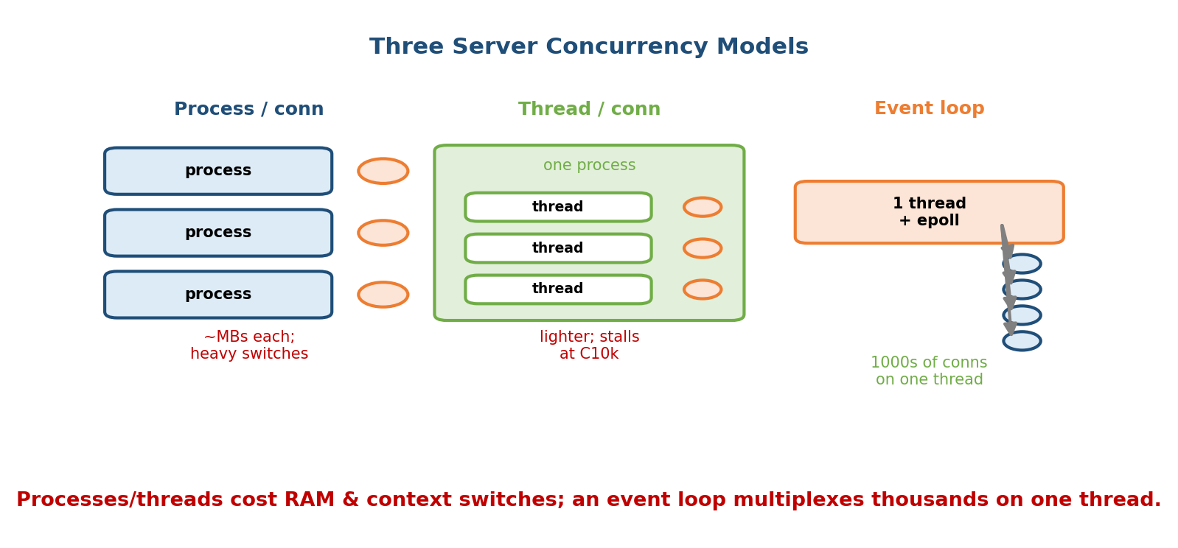
Processes/threads cost RAM and context switches; an event loop multiplexes thousands of connections on one thread.
Model | Unit per connection | Cost | Breaks when
Process-per-conn | a process (fork) | heaviest: MBs each, slow context switch, no shared memory | ~hundreds of conns
Thread-per-conn | a thread | lighter: shared address space, but ~1 MB stack each + context switches | ~10k conns (C10k)
Event loop | none — one thread multiplexes all via epoll | tiny per-conn state; but code must be non-blocking | CPU-bound work or a blocking call
- Process-per-connection (the oldest model, classic CGI / Apache prefork): simple and crash-isolated (one connection’s bug can’t corrupt another — the protection benefit of separate address spaces from M4), but a process costs megabytes and its context switch is expensive (flush TLB, swap address space — M9/M10). Doesn’t scale past a few hundred.
- Thread-per-connection: threads share one address space (M5), so they’re cheaper than processes, but each still needs a stack (~1 MB by default) and the scheduler must context-switch among thousands of them. This is what hits the C10k wall (§20.3). It also needs locks (M7) around shared state.
- Event loop (reactor): one thread (or one per core) uses I/O multiplexing (epoll) to watch all connections and only touches a connection when it’s actually ready. No per-connection thread, no giant stack, no thundering context switches — thousands of connections on a single thread. The catch: every operation must be non-blocking, or the one thread stalls and all connections freeze.
Memory hook (the trap): the event loop is a short-order cook working many orders alone — start the fries, flip a burger while they cook, plate a ready order — never standing and waiting on any one. The moment the cook blocks (waits for one pot to boil doing nothing else), every customer waits. That is why event-loop code must never make a blocking call.

MCQs
- Cheapest per-connection state? → the event loop (no thread/process per conn).
- Why does thread-per-connection cost so much at scale? → each thread’s stack (~1 MB) + context-switch overhead.
- The one rule of event-loop code? → never block the single thread.
- One advantage of process-per-connection? → crash isolation (separate address spaces).

20.3 The C10k Problem
C10k (Dan Kegel, ~1999) named the challenge of handling 10,000 concurrent connections on one server. The point isn’t the exact number — it’s that the thread/process-per-connection model has costs that grow linearly with connections, so it collapses well before the hardware’s limit.
Worked numerical — why thread-per-connection dies at 10k:
Memory: 10,000 connections x ~1 MB thread stack = ~10 GB just for stacks
Scheduler: the OS must time-slice 10,000 threads -> constant CONTEXT SWITCHES
each switch ~1-5 us of pure overhead (save/restore, cache/TLB churn, M6/M9)
Result: the CPU spends more time SWITCHING than WORKING (thrashing-like collapse)
Most of those 10,000 connections are idle at any instant (waiting on the network), yet each still costs a whole thread. The insight that broke C10k: decouple the number of connections from the number of threads. Watch all 10,000 fds with one call and only do work for the few that are ready — i.e. I/O multiplexing with epoll (§20.4), which is the foundation of the event-loop model.
Memory hook: C10k is the “one waiter per table” problem. Hiring 10,000 waiters (threads) for a 10,000-table restaurant is madness when most tables are just thinking. One sharp waiter who visits only tables with a raised hand (ready fds via epoll) serves them all. C10k → C10M is the same idea pushed further.

MCQs
- What does the C10k problem describe? → serving 10,000 concurrent connections on one machine.
- Why does thread-per-connection fail C10k? → memory (stacks) + context- switch overhead grow with connection count.
- The key idea that solved it? → decouple connections from threads via I/O multiplexing (epoll).

20.4 Blocking vs Non-Blocking I/O, and I/O Multiplexing (select / poll / epoll)

Blocking vs non-blocking
- Blocking I/O: read() on a socket with no data puts the thread to sleep until data arrives (the thread moves to the blocked/waiting state, M4). One thread can wait on one fd — hence one-thread-per-connection.
- Non-blocking I/O: with O_NONBLOCK, read() returns immediately — either data or the error EAGAIN/EWOULDBLOCK (“nothing right now”). Now a single thread can poll many fds — but naive polling busy-waits (burns CPU). The right tool is to ask the kernel to tell you which fds are ready: I/O multiplexing.

select / poll — O(n) per call
select() and poll() let one thread wait on many fds at once. But their cost grows with the number of fds watched:
- You pass the entire set of fds to the kernel on every call.
- The kernel scans all N fds to see which are ready.
- On return, you scan all N again to find the ready ones.
So each call is O(N) even if only one fd is ready. select() also caps out at FD_SETSIZE (typically 1024) fds. poll() removes the 1024 limit (uses an array instead of a bitmask) but is still O(N). At C10k, doing O(10,000) work per event, thousands of times a second, is the bottleneck.

epoll — O(1) ready notification (the Linux fix)
epoll (Linux) splits the work so the per-call cost depends on the number of ready fds, not the number watched:
epoll_create() -> make an epoll instance (a kernel object)
epoll_ctl(ADD) -> register an fd ONCE (kernel keeps it in an interest set, rbtree)
epoll_wait() -> returns ONLY the fds that are READY (kernel maintains a ready list)
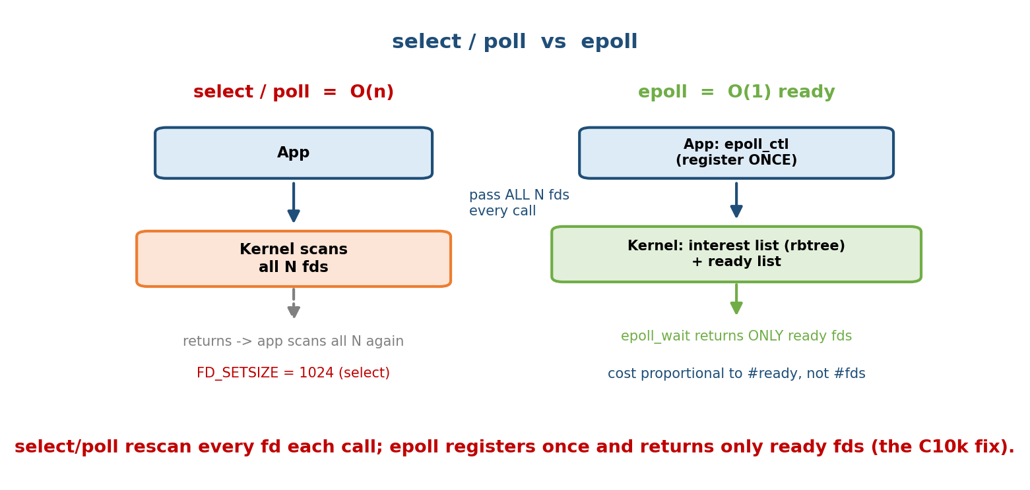
select/poll rescan every fd each call (O(n)); epoll registers once and returns only ready fds (O(1)) — the C10k fix.
Because you register fds once and the kernel pushes ready fds onto a ready list (via the same callback that wakes a blocked thread), epoll_wait returns in time proportional to the number of ready events, not the number of watched fds. Watching 10,000 mostly-idle connections costs almost nothing until they have work.
 | select | poll | epoll
fd limit | 1024 (FD_SETSIZE) | none | none
cost per call | O(N) | O(N) | O(ready) ≈ O(1)
fd set passed each call | yes (rebuilt) | yes | no (registered once)
portability | all POSIX | all POSIX | Linux only (BSD: kqueue)
Memory hook: select/poll = roll call every round (“Are you ready? You? You?” through all 10,000). epoll = a ticket system: register once, and the kernel only calls the numbers that are actually ready.

Level-triggered vs edge-triggered (the epoll trap)
epoll (and kqueue) support two notification modes — a favourite gotcha:
- Level-triggered (LT, default): epoll_wait keeps reporting an fd as long as it is ready (data remains in the buffer). Forgiving — you may read part of the data and get told again next time. Behaves like select/poll.
- Edge-triggered (ET): you’re notified only on the transition from not-ready → ready (the “edge”). You must drain the fd (read/write in a loop until EAGAIN), or you’ll miss data because you won’t be told again. Fewer wakeups (higher performance), but easy to get wrong.
The ET rule: with edge-triggered, always use non-blocking fds and loop until EAGAIN. Forgetting to drain is the classic “my server hangs under load” bug.

MCQs
- Non-blocking read() with no data returns? → EAGAIN/EWOULDBLOCK.
- Why is select O(N)? → it passes and scans all N fds every call; also capped at 1024.
- Why is epoll ≈ O(1)? → fds registered once; epoll_wait returns only ready fds from a kernel ready list.
- Edge-triggered requires you to? → drain the fd (loop until EAGAIN), using non-blocking fds.
- BSD/macOS equivalent of epoll? → kqueue.

20.5 io_uring — Asynchronous I/O Done Right
epoll has a residual cost: it tells you an fd is ready, but you still make a separate syscall (read/write) to do the actual I/O — and syscalls have overhead (mode switches, and post-Spectre mitigations made them pricier). It also never made disk I/O truly asynchronous.
io_uring (Jens Axboe, Linux 5.1, 2019) changes the contract from “tell me when I can do I/O” to “here is the I/O I want; wake me when it’s done.” It uses two shared ring buffers mapped between user space and the kernel:
Submission Queue (SQ): app WRITES I/O requests here (read/write/accept/...)
Completion Queue (CQ): kernel WRITES results here (app reads when ready)
Both rings are SHARED memory -> often NO syscall per operation (batch many, one io_uring_enter)
- Fewer syscalls: batch many operations and submit them with one call (or even zero, in polled mode) — versus epoll’s syscall-per-I/O.
- Truly async for everything: network and disk/file I/O, unlike epoll (which never handled regular-file reads asynchronously).
- Zero-copy friendly (registered buffers/fds).
This is the shared-memory IPC idea (M4) applied to the app↔kernel boundary, plus a producer–consumer ring (M7) — the app produces requests, the kernel produces completions.
Memory hook: epoll is a doorbell (“someone’s ready — go answer it yourself”); io_uring is a drop-box + out-tray: you leave your requests in the in-box and pick up finished results from the out-box, rarely bothering the kernel at all.

MCQs
- What does io_uring share between user and kernel? → two ring buffers (submission + completion queues) in shared memory.
- io_uring’s main win over epoll? → far fewer syscalls and true async for disk and network I/O.
- Which kernel introduced it? → Linux 5.1.

20.6 Nginx vs Apache — Two Architectures, One OS Lesson
The classic comparison makes all the above concrete.

Nginx — master + event-driven workers
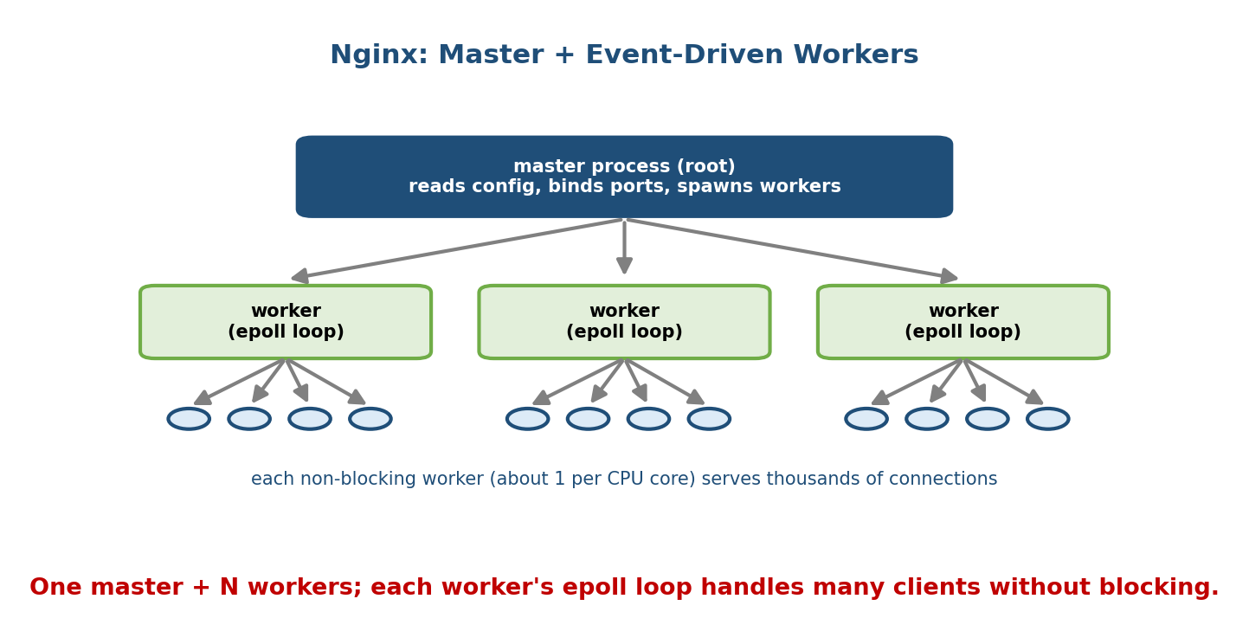
Nginx: one master + N non-blocking workers (about one per CPU core); each worker’s epoll loop serves thousands of connections.
- A master process (runs as root) reads config, binds the ports, and spawns/manages worker processes — but does not handle requests itself.
- Each worker runs a single-threaded, non-blocking event loop on epoll, and there is typically one worker per CPU core (so no oversubscription; the scheduler rarely context-switches them). Each worker juggles thousands of connections.
- Result: connection count is decoupled from thread count → low memory, few context switches, excellent at many idle/keep-alive connections and static content / reverse proxying. This is the event-loop model (§20.2) in production.

Apache — MPMs (Multi-Processing Modules)
Apache is configurable via MPMs that pick the concurrency model:
MPM | Model | Notes
prefork | process-per-connection (pool of pre-forked processes, no threads) | most compatible (safe for non-thread-safe modules like old mod_php); heaviest memory
worker | hybrid: several processes, each with many threads (thread-per-connection) | lighter than prefork; needs thread-safe modules
event | like worker but a dedicated thread manages keep-alive connections via a poll loop | frees worker threads from idle keep-alives — Apache’s answer to C10k
The interview answer — “Why is Nginx faster than Apache under high concurrency?” → Traditional Apache (prefork/worker) ties one process/thread per connection, so 10k mostly-idle keep-alive connections cost 10k threads’ worth of memory + context switches (C10k). Nginx uses a fixed, small pool of event-loop workers on epoll, so idle connections are nearly free. (Apache’s event MPM narrows the gap by handling keep-alives in a poll loop, but the fundamental model still differs.) It’s thread-per-connection vs event loop — the §20.2 tradeoff.

MCQs
- What does the Nginx master process do (and not do)? → binds ports & manages workers; does not serve requests.
- How many Nginx workers, typically? → about one per CPU core, each an epoll event loop.
- Apache prefork vs worker vs event MPM? → process-per-conn vs process+threads vs worker + dedicated keep-alive poll thread.
- Why can Apache prefork exhaust memory under load? → one process per connection (MBs each).

20.7 Load Balancing — Spreading Connections Across Servers
One server isn’t enough, so a load balancer (LB) fans connections across a pool of backends. LBs come in two layers (named after the OSI model) and use several algorithms.
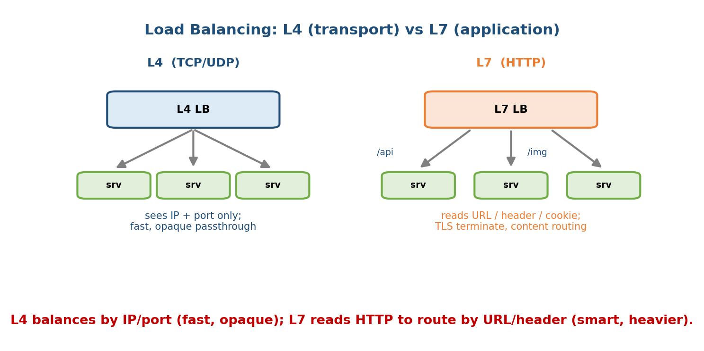
L4 balances by IP/port (fast, opaque); L7 reads HTTP to route by URL/header (smart, heavier).

L4 vs L7
 | L4 (transport) | L7 (application)
Operates on | TCP/UDP: IP + port | HTTP(S): URL, headers, cookies
Can it read the payload? | No (opaque passthrough) | Yes (parses HTTP)
Routing power | by connection (fast) | content-based (/api→A, /img→B), sticky sessions
Cost | lower latency, cheap | more CPU (parses/TLS-terminates), smarter
Examples | LVS/IPVS, AWS NLB | Nginx, HAProxy, AWS ALB
- L4 just forwards packets/connections by IP:port — fast and protocol- agnostic, but “dumb” (can’t route by URL).
- L7 understands HTTP, so it can do path/host-based routing, TLS termination, sticky sessions (route a user to the same backend via a cookie), and health-aware routing — at higher CPU cost.

Balancing algorithms (know these one-liners)
Algorithm | How it picks a backend | Good when
Round robin | next server in rotation | backends roughly equal
Weighted round robin | rotation biased by capacity | mixed-size servers
Least connections | server with fewest active conns | long-lived/uneven requests
IP hash | hash(client IP) → server | session stickiness without cookies
Least response time | fastest-responding server | latency-sensitive
Memory hook: these are the CPU-scheduling policies (M6) wearing a network hat. Round robin is literally RR; least connections is “shortest queue next” (like SJF’s spirit); IP hash is affinity/processor affinity. Load balancing = scheduling connections onto servers.

MCQs
- L4 vs L7 LB — what can each see? → IP+port only vs full HTTP (URL/ headers/cookies).
- Which algorithm gives session stickiness without cookies? → IP hash.
- Best algorithm for uneven, long-lived connections? → least connections.
- Where does TLS termination usually happen? → the L7 load balancer.

20.8 Pools, Keep-Alive, and Graceful Restarts
- Worker / thread / connection pools: creating a thread or a DB connection per request is expensive, so servers pre-create a fixed pool and reuse them. This is resource pooling — bounding concurrency to protect the machine (an admission-control/scheduling decision, M6). A too-small pool queues requests; a too-large one thrashes (context switches, M6/M9). The database connection pool is the most important one in practice (DB connections are heavy).
- HTTP keep-alive: reuse one TCP connection for many requests instead of paying the 3-way handshake (and TLS handshake) each time. Great for latency, but keep-alive connections sit idle holding a slot — which is exactly why the event-loop model (cheap idle connections) beats thread-per-connection for keep-alive-heavy traffic (§20.6).
- Graceful restart / zero-downtime deploy: to update config or binary without dropping connections, the server starts new workers, lets old workers finish their in-flight requests (“drain”), then exits them. Nginx does this by having the master fork new workers and signal old ones to stop accepting new connections while finishing current ones — an orderly process lifecycle (M4) operation. (Contrast a hard restart, which drops live connections.)
Memory hook: a pool is a fixed fleet of taxis — reused, not bought per-trip; keep-alive is keeping the meter running for a returning passenger; graceful restart is swapping drivers at a red light, not mid-highway.

MCQs
- Why use a thread/connection pool? → avoid per-request creation cost and bound concurrency.
- What does HTTP keep-alive save? → the repeated TCP (and TLS) handshake.
- Graceful restart avoids? → dropping in-flight connections (old workers drain first).

20.9 Real-World & Backend Perspectives
- Node.js / Redis / Nginx are all single-threaded event loops on epoll — which is why “don’t block the event loop” is the #1 Node rule (a CPU-heavy handler freezes all connections, §20.2).
- Go hides the model: goroutines look like thread-per-connection, but the Go runtime multiplexes millions of them onto a few OS threads using an internal epoll/netpoller — you write blocking-style code, the runtime does the event loop. Same for async/await runtimes (Rust tokio, Python asyncio).
- Thundering herd: if many workers accept() on the same socket, one event can wake them all to fight over one connection. Fixes: SO_REUSEPORT (each worker its own accept queue), or EPOLLEXCLUSIVE. This is a synchronization/wakeup problem (M7).
- Backpressure: when downstreams are slow, a good server limits accepts / queues rather than accepting infinitely and running out of memory — admission control, again scheduling (M6).
- Observability: ss/netstat (socket states), strace (the syscalls from §20.1), and load-testing tools (wrk, ab) reveal whether you’re bound by CPU, I/O, or context switches — the OS triad.

20.10 Tradeoffs, Common Mistakes, Edge Cases
- Mistake: blocking inside an event loop (a slow DB call, JSON.parse of a huge body, fs sync call) — all connections stall. Offload CPU work to a worker/thread pool.
- Mistake: using edge-triggered epoll without draining to EAGAIN on non-blocking fds → lost events, hung connections.
- Mistake: “more threads = faster.” Past ~cores, extra threads add context- switch overhead (M6) and lock contention (M7), reducing throughput.
- Mistake: unbounded connection/thread pools → memory exhaustion under a load spike (no backpressure).
- Edge case: keep-alive connections hold slots while idle — fine for event loops, deadly for thread-per-connection.
- Edge case: select’s 1024 fd cap silently breaks at scale — use epoll.
- Tradeoff: L7 LB (smart routing, TLS, content) vs L4 LB (lower latency, cheaper). Pick by whether you need to read the request.
- Tradeoff: event loop = max throughput but hard to program (callback/async); thread-per-connection = simple blocking code but limited scale. (Go/async runtimes try to give you both.)

20.11 Exam, Interview & Coding Perspectives
- Interview (very common):
  - “select vs poll vs epoll?” → O(N) + 1024 cap / O(N) no cap / O(ready), register once (§20.4). Mention edge vs level triggered.
  - “Why is Nginx faster than Apache?” → event loop vs thread-per-connection; idle keep-alives are cheap on Nginx (§20.6).
  - “What is the C10k problem?” → thread/process-per-conn costs scale with connections; solved by epoll + event loop (§20.3).
  - “L4 vs L7 load balancer?” → transport (IP:port) vs application (HTTP-aware) (§20.7).
  - “Why not block the event loop?” → one thread serves all; blocking freezes everyone (§20.2).
- Coding/practical: know the socket → bind → listen → accept → read/write → close skeleton (§20.1); set O_NONBLOCK; handle EAGAIN; size thread/DB pools to cores/DB limits; enable keep-alive and SO_REUSEPORT.
- GATE/SEBI/RBI: not core syllabus, but this module is where scheduling (M6), I/O (M13), processes/threads (M4/M5), and synchronization (M7) all cash out — great for cementing those concepts.

20.12 Concept Checks & MCQs (test yourself)
- A socket is a? → file descriptor.
- Server skeleton syscalls? → socket → bind → listen → accept → read/write → close.
- Three concurrency models? → process-per-conn / thread-per-conn / event loop.
- Cheapest per-connection cost? → event loop (no per-conn thread).
- C10k problem? → serving 10,000 concurrent connections; thread-per-conn scales poorly (memory + context switches).
- ~Memory for 10k threads’ stacks (1 MB each)? → ~10 GB.
- Blocking vs non-blocking read with no data? → sleeps vs returns EAGAIN.
- select fd limit? → 1024 (FD_SETSIZE).
- Why is select/poll O(N)? → pass & scan all N fds each call.
- Why is epoll ~O(1)? → register once, kernel returns only ready fds.
- Level- vs edge-triggered? → notified while ready vs only on the ready transition (ET must drain to EAGAIN).
- epoll’s BSD counterpart? → kqueue.
- io_uring’s two rings? → submission + completion queues (shared memory).
- io_uring vs epoll main win? → fewer syscalls + true async disk+net I/O.
- Nginx architecture? → master + event-loop workers (~1/core) on epoll.
- Apache prefork model? → process-per-connection.
- Apache event MPM adds? → a dedicated thread for keep-alive connections.
- L4 vs L7 LB? → IP:port (opaque) vs HTTP-aware (URL/header/cookie).
- Sticky sessions without cookies? → IP hash.
- Algorithm for uneven long connections? → least connections.
- What does keep-alive save? → repeated TCP/TLS handshake.
- Purpose of a thread/connection pool? → reuse + bound concurrency.
- Graceful restart does? → new workers start; old workers drain in-flight requests before exiting.
- Why “don’t block the event loop”? → one thread serves all conns; blocking freezes everyone.
- How does Go scale connections? → millions of goroutines multiplexed onto few OS threads via an internal netpoller (epoll).
True/False - poll removes select’s 1024 fd limit but is still O(N). → True. - epoll cost grows with the number of watched fds. → False (grows with ready fds). - Edge-triggered epoll works fine with blocking fds and a single read. → False (need non-blocking + drain to EAGAIN). - Nginx serves requests from its master process. → False (workers do). - An L4 load balancer can route by URL path. → False (that’s L7). - More threads always increase throughput. → False (context switches + lock contention).

20.13 One-Page Revision Sheet
SERVER = OS PROGRAM: socket->bind->listen->accept->read/write->close. socket = an fd.
Core question: what does CPU do while a conn is BLOCKED on network I/O? (multiprogramming, M1)
CONCURRENCY MODELS:
process-per-conn : MBs each, slow ctx switch, crash-isolated -> ~hundreds
thread-per-conn : ~1MB stack each + ctx switches + locks -> dies at C10k
EVENT LOOP : 1 thread + epoll, tiny per-conn state -> 1000s (must NOT block)
C10k: 10k conns; thread-per-conn = 10k x 1MB (~10GB) + constant ctx switches -> collapse.
FIX = decouple #conns from #threads = I/O MULTIPLEXING (epoll) + event loop.
BLOCKING vs NON-BLOCKING: blocking read sleeps ; non-blocking (O_NONBLOCK) returns EAGAIN.
I/O MULTIPLEXING:
select : O(N), pass+scan all N each call, FD_SETSIZE=1024 cap
poll : O(N), no 1024 cap (array)
EPOLL : register ONCE (epoll_ctl), epoll_wait returns ONLY READY fds -> ~O(ready)=O(1). Linux.
(BSD/mac = kqueue). LEVEL-triggered (default, notified while ready) vs
EDGE-triggered (only on transition -> MUST drain to EAGAIN, non-blocking fds).
io_uring (Linux 5.1): shared SUBMISSION+COMPLETION rings -> few/no syscalls, TRUE async disk+net.
NGINX: master(binds ports, mgr) + WORKERS(~1/core, single-thread epoll event loop). idle conns cheap.
APACHE MPMs: prefork(process/conn, heavy) | worker(procs x threads) | event(worker + keep-alive poll thread).
"Nginx > Apache under load" = event loop vs thread-per-conn (C10k).
LOAD BALANCING:
L4 = TCP/UDP IP:port, opaque, fast | L7 = HTTP-aware (URL/header/cookie), TLS-term, smart, costlier.
Algos: round-robin, weighted-RR, LEAST-CONNECTIONS, IP-HASH(stickiness), least-response-time.
(= CPU scheduling M6 for connections)
POOLS: pre-create+reuse threads/DB-conns, BOUND concurrency (too small=queue, too big=thrash).
KEEP-ALIVE: reuse 1 TCP conn (skip handshake) -> idle conns favor event loop.
GRACEFUL RESTART: start new workers, old workers DRAIN in-flight, then exit (zero downtime).

Flash cards
Front | Back
A socket is? | A file descriptor
Three server models? | Process- / thread-per-conn / event loop
C10k solved by? | epoll + event loop (decouple conns from threads)
select fd cap? | 1024 (FD_SETSIZE), O(N)
Why epoll ~O(1)? | Register once; returns only ready fds
ET epoll requires? | Non-blocking fds + drain to EAGAIN
io_uring rings? | Submission + completion (shared memory)
Nginx model? | Master + epoll event-loop workers (~1/core)
Apache prefork? | Process-per-connection
L4 vs L7? | IP:port (opaque) vs HTTP-aware
Sticky sessions w/o cookie? | IP hash
Don’t ___ the event loop | Block

Spaced repetition
- 24-hour: recite the three concurrency models + costs, and select/poll/epoll complexities (O(N)/O(N)/O(1), 1024 cap).
- 7-day: explain the C10k memory numerical; edge vs level triggered; why Nginx beats Apache under high concurrency; L4 vs L7.
- 30-day: given a server-scaling scenario, choose the model, multiplexing API, and LB (layer + algorithm) and justify each in OS terms (M4/M5/M6/M7/M13).

20.14 Summary
A backend server is an OS program whose whole job is deciding what the CPU does while connections block on network I/O — the multiprogramming question from M1, applied to sockets (file descriptors, M11). Serving one connection per process is crash-isolated but heavy; one per thread is lighter but hits the C10k wall (memory + context switches, M6/M9); the event loop decouples connections from threads by using I/O multiplexing. select/poll are O(N) (and select caps at 1024), while epoll registers fds once and returns only the ready ones (~O(1) — the C10k fix), with level- vs edge-triggered modes to master; io_uring goes further with shared submission/completion rings for near-syscall-free, truly async I/O. Nginx (master + epoll event-loop workers) beats classic Apache (prefork/worker thread-per-connection) under high, keep-alive-heavy concurrency — the same §20.2 tradeoff. Above the server, load balancers spread connections at L4 (IP:port) or L7 (HTTP-aware) using algorithms that are CPU scheduling (M6) for connections; and pools, keep-alive, and graceful restarts are resource management and process lifecycle (M4) in production. Every one of these is a concept from earlier modules, cashed out where performance is money.
This completes the perspective pair with Module 19 — the AI-Engineering Perspective: GPUs and LLM serving on one side, high-concurrency servers on the other, both showing that the operating system is the substrate of all modern systems engineering.
You have mastered this module when you can: write the socket→…→close skeleton and say where it blocks; contrast the three concurrency models with their costs; explain the C10k problem and its fix; compare select/poll/ epoll (complexity, fd cap, edge vs level) and place io_uring; explain why Nginx beats Apache under load; and choose an L4/L7 load balancer and algorithm — all grounded in scheduling (M6), I/O (M13), and processes/threads (M4/M5), without notes.

