Module 21 — Competitive Exams (OS for SEBI / RBI / NABARD / GATE / C-DAC)
  - OS Mastery: SEBI IT / RBI / NABARD / GATE / C-DAC / Interview / Backend — In-Depth Notes (with visuals)
Prepared for nidhi.sharma@forensiccybertech.com
2026
Table of Contents

Module 21 — Competitive Exams
Where this module sits. Modules 1–20 taught the subject. This capstone teaches how the subject is tested — and the same OS content is examined very differently across SEBI Grade A (IT) / RBI Grade B (IT) / NABARD / GATE CS / C-DAC (CCAT). GATE and C-DAC want you to compute (Gantt charts, page-fault counts, EAT, disk head movement, Banker’s algorithm); SEBI / RBI / NABARD want you to know (crisp conceptual MCQs, definitions, one-liners). This module maps every OS topic to every exam, gives per-exam strategy, the formulas to memorise cold, a memorise-cold concept list, and ~50 solved MCQs with worked answers grouped by topic. Treat it as the single sheet you revise the night before the paper.
Importance ratings (out of 5):
Exam / Use | SEBI IT | RBI IT | GATE CS | Interview | Backend
This module | ★★★★★ | ★★★★★ | ★★★★★ | ★★ | ★★
Most-asked PYQ concepts (SEBI / RBI / NABARD / GATE / C-DAC): CPU scheduling (Gantt + avg WT/TAT, SJF optimality, RR quantum); page replacement fault counts (FIFO/LRU/Optimal, Belady’s anomaly); EAT with TLB and demand-paging EAT; deadlock four conditions + Banker’s safe sequence; synchronization (semaphore wait/signal, critical-section requirements, classic problems); disk-scheduling head movement (FCFS/SSTF/SCAN/C-SCAN); inode max file size; paging vs segmentation; process states; thread models.

21.1 The Exam Landscape — “Compute It” vs “Know It”
Before choosing what to study, understand how each exam asks. Two families:
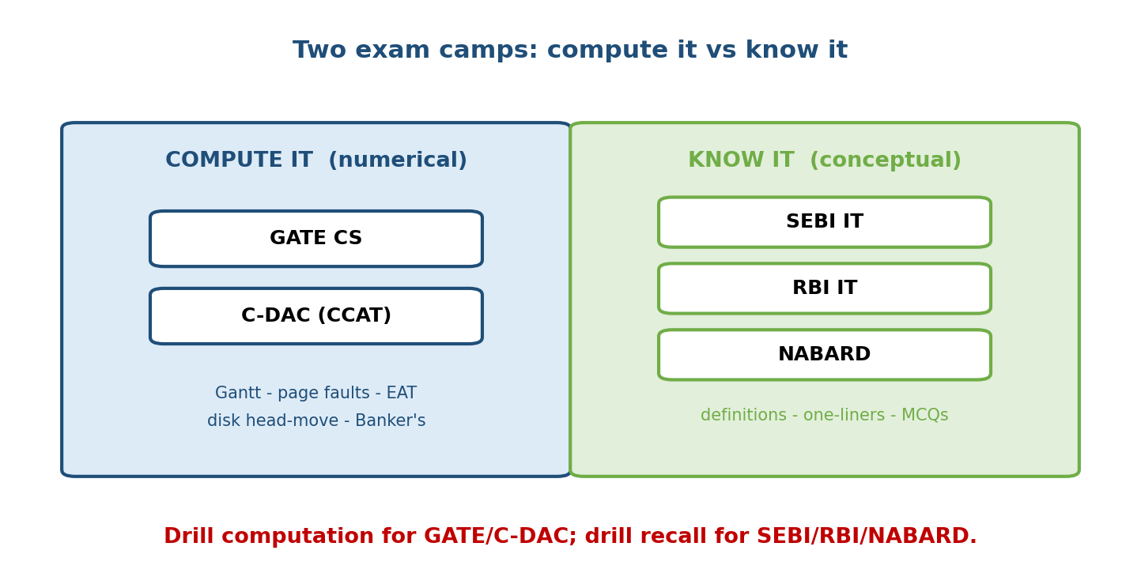
The five exams split into two camps: GATE and C-DAC test numerical computation (Gantt/paging/disk/Banker’s); SEBI, RBI and NABARD test conceptual recall (definitions, one-liners, MCQs).
- Compute-it exams (GATE, C-DAC/CCAT): give a concrete instance and ask you to trace or calculate a number — average waiting time, number of page faults, effective access time, total head movement, a safe sequence. Practice doing the arithmetic fast and correctly; reading is not enough.
- Know-it exams (SEBI IT, RBI IT, NABARD): objective MCQs across the whole IT syllabus (OS + DBMS + Networks + Cyber + emerging tech). OS questions are conceptual — definitions, “which is true”, one-line facts. Breadth + accuracy beat deep numerical drill here.
Memory hook: GATE/C-DAC = “compute it”; SEBI/RBI/NABARD = “know it”. Same syllabus, opposite question style — so split your prep accordingly.

Topic × Exam Relevance Matrix (all OS modules M1–M20)
Read down a column to plan a specific exam; read across a row to see where a topic pays off. (★ = light, ★★★★★ = heavily and repeatedly tested.)
# | Topic / Module | SEBI IT | RBI IT | NABARD | GATE CS | C-DAC
M1 | Introduction to OS (types, spooling, hypervisor) | ★★★ | ★★★ | ★★★ | ★★ | ★★★
M2 | Computer Hardware Foundations (interrupts, hierarchy) | ★★ | ★★ | ★★ | ★★ | ★★★
M3 | OS Architecture (kernel: monolithic/micro, dual mode) | ★★★ | ★★★ | ★★ | ★★★ | ★★★
M4 | Processes (PCB, states, context switch, IPC, fork) | ★★★ | ★★★ | ★★ | ★★★★★ | ★★★★
M5 | Threads (user/kernel, models, thread vs process) | ★★★ | ★★★ | ★★ | ★★★ | ★★★★
M6 | CPU Scheduling (FCFS/SJF/SRTF/RR/priority) | ★★★ | ★★★ | ★★ | ★★★★★ | ★★★★★
M7 | Process Synchronization (semaphores, CS, classics) | ★★★ | ★★★ | ★★ | ★★★★★ | ★★★★
M8 | Deadlocks (4 conditions, RAG, Banker’s) | ★★★ | ★★★ | ★★ | ★★★★★ | ★★★★
M9 | Memory Management (paging, segmentation, fragmentation) | ★★★ | ★★★ | ★★ | ★★★★★ | ★★★★★
M10 | Virtual Memory (demand paging, replacement, TLB, EAT) | ★★★ | ★★★ | ★★ | ★★★★★ | ★★★★★
M11 | File Systems (inode, allocation, directory, FAT) | ★★★ | ★★★ | ★★ | ★★★★ | ★★★★
M12 | Disk Management (disk scheduling, RAID) | ★★★ | ★★★ | ★★ | ★★★★★ | ★★★★
M13 | I/O Systems (polling, interrupt, DMA) | ★★ | ★★ | ★★ | ★★★ | ★★★
M14 | Linux Internals (commands, /proc, scheduler) | ★★★ | ★★★ | ★★ | ★★ | ★★★★
M15 | Concurrency (atomics, memory ordering, lock-free) | ★★ | ★★ | ★★ | ★★★ | ★★★★
M16 | Security (rings, DAC/MAC/RBAC, capabilities, sandboxing) | ★★★ | ★★★ | ★★ | ★★★ | ★★★
M17 | Virtualization (VMs, hypervisors, containers) | ★★★ | ★★★ | ★★ | ★★ | ★★★
M18 | Cloud OS (pooled resources, scheduling at scale) | ★★★ | ★★ | ★★ | ★ | ★★
M19 | AI Infrastructure (GPU scheduling, memory) | ★★ | ★★ | ★ | ★ | ★★
M20 | Backend Engineering (servers, epoll, load balancing) | ★★ | ★★ | ★ | ★★★ | ★★★★★
How to use it. For GATE/C-DAC, live in the ★★★★★ numerical rows — M6, M7, M8, M9, M10, M12 decide your marks. For SEBI/RBI/NABARD, sweep the ★★★ conceptual rows broadly (M1, M3, M4, M5, M11, M14, M15, M17) and understand the numerical topics well enough to answer a conceptual MCQ about them.

21.2 Per-Exam Strategy

GATE CS (numerical, trace-and-compute)
- Format: MCQ + MSQ + NAT (numerical answer type). OS is a standalone, reliably examined subject — historically ~5–8 marks every year, sometimes more.
- Highest-yield (do these until automatic):
  - CPU scheduling: draw the Gantt chart, then compute average waiting time / turnaround time; SJF/SRTF optimality; RR with a given quantum; priority + starvation.
  - Page replacement: count page faults for FIFO / LRU / Optimal on a given reference string; Belady’s anomaly (FIFO only).
  - Virtual memory: EAT with TLB, demand-paging EAT with a fault rate, multi-level page table address splitting.
  - Memory: paging address translation, internal vs external fragmentation, best/first/worst-fit placement.
  - Deadlock: the four conditions, Banker’s algorithm safe sequence, resource-allocation-graph cycle detection.
  - Synchronization: semaphore trace, counting-semaphore value, the critical-section requirements, classic-problem correctness.
  - Disk scheduling: total head movement for FCFS/SSTF/SCAN/C-SCAN/LOOK.
  - File systems: inode max file size from block/pointer sizes; number of disk accesses for indexed/linked allocation.
- Style: they give the numbers; you compute. Time yourself — a Gantt + averages should take < 3 minutes.

SEBI Grade A (IT) / RBI Grade B (IT) — your target
- Format: objective MCQs spread across the whole IT syllabus. OS is conceptual — you will see a handful of one-fact questions, not a full Banker’s table.
- Highest-yield: OS definitions & goals; process states and transitions; thread vs process; scheduling algorithm properties (which minimises WT, which starves, which is preemptive); deadlock four conditions; semaphore vs mutex; paging vs segmentation; internal vs external fragmentation; virtual memory / thrashing; RAID levels; inode / file allocation; basic Linux commands and the fork/exec idea.
- Strategy: breadth + speed + accuracy. Learn the one-liners and the traps (multiprogramming vs multitasking vs multiprocessing; internal vs external fragmentation; preemptive vs non-preemptive). Don’t over-invest in long numericals — but know enough of each to answer a conceptual variant.

NABARD (Development Assistant / Grade A IT)
- Format: general IT/CS awareness with some OS MCQs; lighter and more definitional than SEBI/RBI.
- Highest-yield: the same conceptual core as SEBI/RBI but shallower — definitions, types of OS, basic scheduling names, deadlock conditions, memory terms. Recall over calculation.

C-DAC (CCAT — for PG-DAC admission)
- Format: aptitude + CS fundamentals; the CS section is GATE-like but more direct. C programming, DSA, and OS fundamentals matter.
- Highest-yield: scheduling numericals, paging/page-fault counts, deadlock conditions + Banker’s, semaphores, disk scheduling, file allocation — plus quick, direct fact MCQs. Expect the compute style with a tighter time budget.
Memory hook (triage a question in 2 seconds): “Trace / compute a number” → GATE/C-DAC skill. “Which of the following is true about X” → SEBI/RBI/NABARD skill. Prepare both muscles; lead with the one your exam favours.

21.3 The Formulas to Memorise Cold
These generate the majority of numerical marks. Learn the formula and one worked number for each.
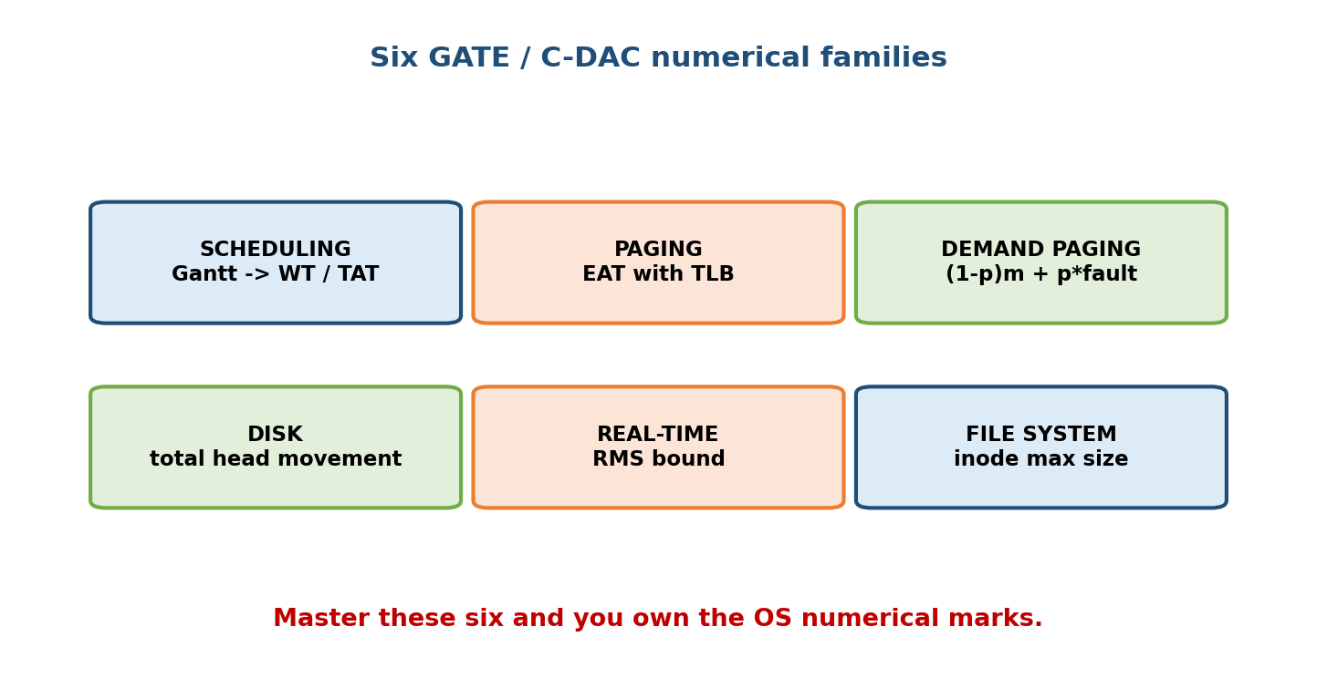
The six GATE/C-DAC numerical families: scheduling (Gantt→WT/TAT), paging (EAT with TLB), demand paging (fault-rate EAT), disk (head movement), real-time (RMS bound), file system (inode max size).

(1) Turnaround & Waiting time (scheduling)
Turnaround Time (TAT) = Completion Time − Arrival Time
Waiting Time (WT) = Turnaround Time − Burst (CPU) Time
Response Time = First-CPU Time − Arrival Time
Average = (sum over all processes) / (number of processes)
Worked (FCFS, all arrive at t=0, order P1,P2,P3, bursts 24,3,3): Gantt P1[0–24] P2[24–27] P3[27–30]. WT = 0, 24, 27 → avg WT = 51/3 = 17. TAT = 24, 27, 30 → avg TAT = 27. Reorder shortest-first (SJF: P2,P3,P1) and avg WT drops to 3 — SJF is provably optimal for average waiting time.

(2) Effective Access Time with a TLB (paging)
EAT = h × (TLB_time + mem_time) + (1 − h) × (TLB_time + 2 × mem_time)
h = TLB hit ratio ; mem_time = one memory access ; 2× because a miss needs
one access for the page table + one for the actual data.
(If TLB search time is ignored: EAT = h × mem + (1 − h) × 2·mem.)
Worked: h = 0.8, TLB = 20 ns, memory = 100 ns. EAT = 0.8×(20+100) + 0.2×(20+200) = 96 + 44 = 140 ns. (Ignoring TLB time: 0.8×100 + 0.2×200 = 120 ns.)

(3) Demand-paging EAT (with a page-fault rate)
EAT = (1 − p) × memory_access + p × page_fault_service_time
p = page-fault probability ; a fault costs a disk I/O (~ms), so it dominates.
Worked: memory = 200 ns, p = 0.001, fault service = 8 ms = 8,000,000 ns. EAT = 0.999×200 + 0.001×8,000,000 = 199.8 + 8000 = 8199.8 ns ≈ 8.2 µs — a single fault-in-a-thousand makes memory ~40× slower. Lesson: keep p tiny.

(4) Rate-Monotonic (RMS) schedulability bound (real-time)
A set of n periodic tasks is RMS-schedulable if Σ (Ci / Ti) ≤ n·(2^(1/n) − 1)
Ci = worst-case compute time, Ti = period. Bound → ln 2 ≈ 0.693 as n → ∞.
n=1 → 1.000 ; n=2 → 0.828 ; n=3 → 0.780 ; n=4 → 0.757.
Note: the bound is sufficient, not necessary — a task set above it may still be schedulable (test exactly). EDF (Earliest Deadline First) has a higher bound of 1.0 (100% utilisation).

(5) Disk head movement (disk scheduling)
Total head movement = Σ |current_position − next_position| over the service order.
FCFS : service in request order.
SSTF : always the nearest pending request (can starve far ones).
SCAN : go one direction to the disk END, reverse (elevator).
C-SCAN : go to the end, JUMP back to the start, continue one way (fairer waits).
LOOK / C-LOOK : like SCAN/C-SCAN but reverse at the LAST request, not the edge.
Worked (requests 82,170,43,140,24,16,190; head at 50; disk 0–199): FCFS = 32+88+127+97+116+8+174 = 642. SSTF = 208 (nearest-first: 50→43→24→16→82→140→170→190). SCAN toward 199 = (199−50)+(199−16) = 149+183 = 332. C-SCAN = (199−50)+(199−0)+(43−0) = 149+199+43 = 391 (counting the jump).

(6) Inode maximum file size (file systems)
pointers_per_block = block_size / pointer_size
max_file = ( #direct + PPB + PPB² + PPB³ ) × block_size
(12 direct + 1 single-indirect + 1 double + 1 triple, UNIX-style)
Worked: block = 1 KB, pointer = 4 B → PPB = 256. direct 12·1KB = 12 KB; single 256·1KB = 256 KB; double 256²·1KB = 64 MB; triple 256³·1KB = 16 GB. Total ≈ 16.06 GB (the triple-indirect dominates). (Block 4 KB, pointer 4 B → PPB = 1024 → max ≈ 4 TB.)

21.4 Frequently-Asked Concepts — Memorise Cold
These one-liners appear again and again across all five exams. Recite until reflex.
- Two roles of an OS: resource manager + extended (virtual) machine. Doorway = system call. Always-resident core = kernel.
- Trap trio: multiprogramming (many jobs in RAM, 1 CPU switches on I/O) vs multitasking (adds rapid time-slices) vs multiprocessing (many CPUs, true parallel).
- Process states: new → ready → running → waiting(blocked) → terminated. Only one process runs per CPU at a time. The PCB stores a process’s context.
- Context switch saves/restores the PCB — pure overhead, no useful work.
- Thread vs process: threads of one process share code/data/heap/files but have own stack + registers + PC. Threads are cheaper to create/switch.
- Scheduling one-liners: FCFS = non-preemptive, convoy effect; SJF = optimal avg WT (non-preemptive); SRTF = preemptive SJF; RR = preemptive, fair, quantum-driven; priority can starve (fix = aging).
- Deadlock 4 (Coffman) conditions (ALL must hold): mutual exclusion, hold-and-wait, no preemption, circular wait. Break any one → prevention.
- RAG: a cycle is necessary for deadlock; with single-instance resources a cycle is also sufficient. Banker’s = deadlock avoidance.
- Semaphore: wait/P/down decrements (may block); signal/V/up increments. Binary semaphore ≈ mutex; counting semaphore counts instances.
- Critical-section requirements: mutual exclusion, progress, bounded waiting. Peterson’s solution is software; TSL/test-and-set is hardware.
- Fragmentation: internal = wasted space inside a fixed block (paging); external = free space scattered in unusable gaps (segmentation/variable partitions), fixed by compaction.
- Paging vs segmentation: paging = fixed frames, no external frag, invisible to user; segmentation = variable logical units (code/stack/data), external frag, user-visible.
- Page fault = referenced page not in RAM → trap → load from disk. Thrashing = so many faults the CPU spends all its time paging (fix = working-set / reduce multiprogramming).
- TLB = cache of recent page-table entries; a hit avoids the extra page-table memory access.
- Belady’s anomaly: more frames → more faults; happens with FIFO only (LRU/Optimal are stack algorithms, immune).
- Disk scheduling: SSTF can starve; SCAN/C-SCAN = elevator; C-SCAN gives more uniform wait times.
- File allocation: contiguous (fast, external frag), linked (no random access), indexed/inode (random access via an index block).
- RAID: 0 = striping (no redundancy), 1 = mirroring (50%), 5 = distributed parity (min 3), 6 = double parity (min 4), 10 = mirror+stripe.
- Fork: fork() returns 0 to the child, child-PID to the parent, −1 on failure. A zombie = finished child not yet reaped (wait); an orphan = parent died first (re-parented to init/PID 1).

21.5 Solved MCQs by Topic (~50, with answers + one-line explanations)
Every numerical below is recomputed. Cover the answer, attempt, then check.

A. CPU Scheduling (M6)
- Non-preemptive scheduling that minimises average waiting time? → SJF (Shortest Job First) — provably optimal for average WT.
- FCFS, bursts 24, 3, 3 (order P1,P2,P3, all at t=0): average WT? → (0+24+27)/3 = 17. (Long job first = convoy effect.)
- Same three jobs under SJF (P2,P3,P1): average WT? → (0+3+6)/3 = 3.
- Round Robin, quantum 4, bursts P1=24,P2=3,P3=3 (arrive 0, queue P1,P2,P3): average WT? → 17/3 ≈ 5.67 (completions P2=7, P3=10, P1=30).
- SRTF, P1(0,8) P2(1,4) P3(2,9) P4(3,5): average waiting time? → 6.5 (completions P1=17, P2=5, P3=26, P4=10 → avg TAT = 13, avg WT = 6.5).
- Which algorithm suffers the convoy effect? → FCFS (a long job delays short ones behind it).
- Preemptive version of SJF is called? → SRTF (Shortest Remaining Time First).
- RR with a very large time quantum degenerates into? → FCFS. With a very small quantum? → high context-switch overhead.
- Priority scheduling’s classic problem and its fix? → starvation, fixed by aging (gradually raise a waiting job’s priority).
- Which scheduling metric does interactive/time-sharing care about most? → response time, not turnaround.

B. Memory Management & Paging (M9, M10)
- Wasted space inside an allocated fixed block is? → internal fragmentation (typical of paging).
- Free memory scattered in small unusable gaps is? → external fragmentation (fixed by compaction).
- Paging eliminates which fragmentation? → external (but introduces a little internal in the last page).
- Logical address 32-bit, page size 4 KB → bits for page offset? → log2(4096) = 12 bits (so 20 bits for the page number).
- EAT with TLB hit ratio 0.8, TLB 20 ns, memory 100 ns? → 0.8(120)+0.2(220) = 140 ns.
- Demand paging: memory 200 ns, fault rate 0.001, fault service 8 ms? → 0.999(200)+0.001(8,000,000) = 8199.8 ns ≈ 8.2 µs.
- Reference string 1,2,3,4,1,2,5,1,2,3,4,5 with 3 frames, FIFO → faults? → 9. With 4 frames, FIFO → 10 — this increase is Belady’s anomaly.
- Which replacement policies are immune to Belady’s anomaly? → LRU and Optimal (stack algorithms); FIFO is not.
- The optimal (theoretically best) replacement rule? → evict the page used farthest in the future (Bélády’s OPT — not implementable, used as a benchmark).
- Thrashing is? → excessive paging where the CPU does little useful work; fix with the working-set model / reduce degree of multiprogramming.
- A TLB is a cache of? → recent page-table entries (page → frame mappings).
- Multi-level page tables exist to? → avoid keeping one huge contiguous page table in memory (page the page table itself).
- Page size doubling tends to → less page-table overhead but more internal fragmentation.

C. Deadlocks (M8)
- The four (Coffman) conditions for deadlock? → mutual exclusion, hold-and-wait, no preemption, circular wait (all four together).
- Deadlock prevention works by? → ensuring at least one of the four conditions can never hold.
- Banker’s algorithm is a deadlock- ___ technique? → avoidance (grants a request only if the resulting state is safe).
- Banker’s: Available (3,3,2); Needs P0(7,4,3) P1(1,2,2) P2(6,0,0) P3(0,1,1) P4(4,3,1); Allocs P0(0,1,0) P1(2,0,0) P2(3,0,2) P3(2,1,1) P4(0,0,2). A safe sequence? → ⟨P1, P3, P4, P0, P2⟩ (P1 fits first, freeing resources for the rest).
- In a resource-allocation graph, a cycle means deadlock when? → resources are single-instance (then a cycle is necessary and sufficient).
- A “safe state” guarantees? → there exists an order in which all processes can finish; a safe state is never a deadlock.
- Recovery from deadlock by? → process termination or resource preemption (roll back a victim).

D. Process Synchronization (M7)
- Requirements a valid critical-section solution must meet? → mutual exclusion, progress, bounded waiting.
- wait() (a.k.a. P / down) on a semaphore does? → decrement; if the value goes negative the process blocks.
- A binary semaphore is essentially a? → mutex (lock) — values 0/1.
- A counting semaphore initialised to N controls? → up to N concurrent accesses to a resource pool.
- Peterson’s algorithm solves mutual exclusion for? → two processes, in software (needs flag[] + turn).
- Hardware primitive giving atomic read-modify-write? → test-and-set (TSL) / compare-and-swap.
- A race condition is? → outcome depends on the non-deterministic order of concurrent accesses to shared data.
- In producer–consumer, which semaphores are used? → a mutex + counting semaphores empty and full.
- Dining philosophers can deadlock because of? → circular wait on forks; fix with resource ordering / at-most-N-1 seated / an arbitrator.
- Difference between a semaphore and a mutex? → a mutex has ownership (only the locker unlocks); a semaphore is a signalling counter with no owner.

E. File Systems (M11)
- UNIX inode with 12 direct pointers, 1 KB blocks, 4 B pointers → max file size? → ≈ 16 GB (PPB = 256; triple-indirect 256³·1 KB dominates).
- Same but 4 KB blocks, 4 B pointers → max size ≈? → 4 TB (PPB = 1024).
- File allocation with no external fragmentation but no random access? → linked allocation.
- Allocation giving fast random access via an index block? → indexed (inode) allocation.
- Contiguous allocation’s drawbacks? → external fragmentation and hard file growth.
- FAT stands for and stores? → File Allocation Table — a table of block links (a linked list kept in one table for faster random access).
- What does an inode store? → file metadata (size, owner, permissions, timestamps, block pointers) — not the file name (that’s in the directory).

F. Disk Management (M12)
- Requests 82,170,43,140,24,16,190; head 50 — FCFS total head movement? → 642.
- Same set — SSTF total head movement? → 208 (nearest-first order 50→43→24→16→82→140→170→190).
- Same set — SCAN toward 199 total head movement? → 332 ((199−50)+(199−16)).
- Which algorithm can starve distant requests? → SSTF (always favours the nearest).
- Which gives the most uniform waiting time? → C-SCAN (services one direction then jumps back, treating the disk as circular).
- Average rotational latency = ? → ½ of one full rotation = ½ × 60/RPM.

21.6 Exam, Interview & Coding Perspectives
- GATE/C-DAC: the numerical families in §21.3 are the marks. Drill each until a Gantt+averages, a page-fault count, an EAT, or a head-movement total takes under three minutes with zero arithmetic slips.
- SEBI/RBI/NABARD: the §21.4 one-liners and the traps in §21.5’s conceptual MCQs are your bread and butter — accuracy and speed across breadth.
- Interview crossover: the reasons behind the formulas (why SJF is optimal, why FIFO thrashes, why SSTF starves) are exactly what interviewers probe — see Module 22.

21.7 One-Page Revision Sheet
TWO EXAM CAMPS: GATE/C-DAC = COMPUTE (Gantt, faults, EAT, head-move, Banker's)
SEBI/RBI/NABARD = KNOW (definitions, one-liners, "which is true")
SCHEDULING: TAT = Completion − Arrival ; WT = TAT − Burst ; Response = firstCPU − Arrival
SJF = optimal avg WT (non-preemptive) ; SRTF = preemptive SJF ; RR = fair, quantum
FCFS = convoy effect ; priority -> STARVATION (fix = AGING)
PAGING EAT (with TLB) = h(TLB+mem) + (1−h)(TLB+2·mem) [h=0.8,20,100 -> 140ns]
DEMAND PAGING EAT = (1−p)·mem + p·faultservice [200ns,p=.001,8ms -> ~8.2µs]
PAGE FAULTS: FIFO/LRU/OPTIMAL ; BELADY (more frames->more faults) = FIFO only
DEADLOCK 4 (all): mutual exclusion, hold&wait, no preemption, circular wait
Banker's = AVOIDANCE (grant only if resulting state SAFE). RAG cycle = deadlock if single-instance.
Safe seq example: ⟨P1,P3,P4,P0,P2⟩
SYNC: wait/P/down (dec, may block) ; signal/V/up (inc). binary sem ≈ mutex.
CS needs: MUTUAL EXCLUSION + PROGRESS + BOUNDED WAITING. Peterson(sw,2proc), TSL(hw).
FRAGMENTATION: internal(inside fixed block=paging) vs external(scattered gaps=segmentation, fix=compaction)
PAGING(fixed frames, no ext frag) vs SEGMENTATION(variable, user-visible, ext frag)
DISK head-move = Σ|cur−next|. FCFS / SSTF(starves) / SCAN,C-SCAN(elevator; C-SCAN uniform waits)
reqs 82,170,43,140,24,16,190 head50: FCFS=642, SSTF=208, SCAN(->199)=332
Avg rotational latency = 1/2 × 60/RPM.
INODE max = (12 + PPB + PPB² + PPB³) × block ; PPB = block/pointer
1KB block,4B ptr -> 16GB ; 4KB block,4B ptr -> 4TB.
RMS bound: Σ Ci/Ti ≤ n(2^(1/n)−1) -> ln2≈0.693 ; EDF bound = 1.0.

Flash cards
Front | Back
SJF is optimal for? | Average waiting time (non-preemptive)
Belady’s anomaly happens with? | FIFO only
EAT with TLB formula? | h(TLB+mem)+(1−h)(TLB+2·mem)
Deadlock four conditions? | Mutual excl., hold&wait, no preempt, circular wait
Banker’s algorithm is? | Deadlock avoidance (safe state)
CS requirements? | Mutual exclusion, progress, bounded waiting
Internal vs external frag? | Inside a fixed block vs scattered gaps
SSTF drawback? | Starvation of far requests
Inode max size? | (12+PPB+PPB²+PPB³)×block
Semaphore wait/signal? | Decrement (may block) / increment

Spaced repetition
- 24-hour: redo one Gantt (FCFS+SJF), one page-fault count (FIFO 3f vs 4f), one EAT, one disk head-movement — all from scratch.
- 7-day: recite the §21.4 concept list; state each scheduling algorithm’s one-line property and the four deadlock conditions.
- 30-day: given any numerical prompt, pick the right formula family from §21.3 and compute the answer without notes.

21.8 Summary
The five exams split cleanly into compute-it (GATE, C-DAC) and know-it (SEBI, RBI, NABARD). We built the topic × exam matrix across all twenty OS modules, gave per-exam strategy, and drilled the six formula families that generate the numerical marks — TAT/WT (with SJF optimal), EAT with TLB and demand-paging EAT, page-fault counts + Belady’s anomaly, Banker’s safe sequence, disk head movement, and inode max file size — every worked number recomputed. We compiled the memorise-cold concept list and ~50 solved MCQs grouped by scheduling, memory/paging, deadlock, synchronization, file systems, and disk. Practise the compute muscle for GATE/C-DAC and the recall muscle for SEBI/RBI/NABARD, and you can walk into any of these papers and pick up the OS marks fast.
Next, Module 22 — Interview Preparation turns the same material outward: how FAANG and backend/AI-infra interviews probe why these mechanisms work, plus scenario and production-debugging questions. After that, Module 23 ties the whole course together.
You have mastered this module when you can: state which of the five exams wants computation vs recall; reproduce all six formula families with one worked number each; compute a Gantt’s average WT, a FIFO/LRU fault count, an EAT, a Banker’s safe sequence, and a disk head-movement total from scratch; and rattle off the §21.4 concept one-liners without notes.

