Module 23 — Hands-On OS Projects (Build to Understand)
  - OS Mastery: SEBI IT / RBI / NABARD / GATE / C-DAC / Interview / Backend — In-Depth Notes (with visuals)
Prepared for nidhi.sharma@forensiccybertech.com
2026
Table of Contents

Module 23 — Hands-On OS Projects (Build to Understand)
Where this module sits. Modules 1–20 taught you the theory — processes, scheduling, memory, file systems, Linux internals. This is the capstone lab: you now build small versions of the OS yourself. Nothing cements “what is a context switch” like writing one with ucontext; nothing explains fragmentation like watching your own malloc leak it. Each project is a one-weekend build that turns a chapter of theory into ~200 lines of C you can put on GitHub and defend in an interview. This module is the bridge between knowing OS and being able to say you have written one. The revision kit that follows (M24) then compresses everything for the exam.
Importance ratings (out of 5):
Exam / Use | SEBI IT | RBI IT | GATE CS | Interview | Backend
This module | ★★ | ★★ | ★★ | ★★★★★ | ★★★★★
What this module gives you: these projects are low weight for written exams but the single highest-leverage thing for interviews and real backend/AI-infra work. A candidate who has built a shell, an allocator, and a thread library answers “how does fork work”, “explain a page fault”, and “what is a context switch” from muscle memory, not memorisation. Every project below explicitly links back to the module whose theory it makes real.

23.1 How to Use This Module (the build method)
Each project follows the same template so you can pick one up in a weekend:
- What you build — the one-line goal and scope.
- OS concepts it teaches — the exact modules (M1–M20) it makes concrete.
- Key data structures — the 2–3 structs at the heart of it.
- Step-by-step build plan — incremental stages, each runnable.
- Milestones — “you are done with stage N when …” checkpoints.
- What interviewers probe — the questions this project prepares you to nail.
The golden rule of these projects: always keep it running. Build the smallest thing that compiles and prints something, then add one feature at a time. A shell that only runs ls today beats a “complete” shell that never compiled.

Your environment (do this once)
You need Linux (real, a VM, or WSL2 on Windows) because these projects use POSIX system calls (fork, exec, mmap, /proc, ucontext, kernel modules) that do not exist on native Windows.
sudo apt update && sudo apt install build-essential gdb make # gcc, make, gdb
gcc --version # confirm toolchain
uname -r # your kernel version
- gcc -Wall -Wextra -g always — warnings on, debug symbols on.
- gdb and valgrind (sudo apt install valgrind) are your microscopes — valgrind catches the memory bugs the allocator project will teach you to make.
- strace ./yourprog shows every system call your program makes — the single best learning tool in this module. Run it on your shell to watch fork/execve.
Memory hook: theory tells you what the OS does; strace shows you it doing it. Keep a terminal open with strace while you build — it turns abstract syscalls into a live log.

23.2 Difficulty / Impact Table & Suggested Build Order
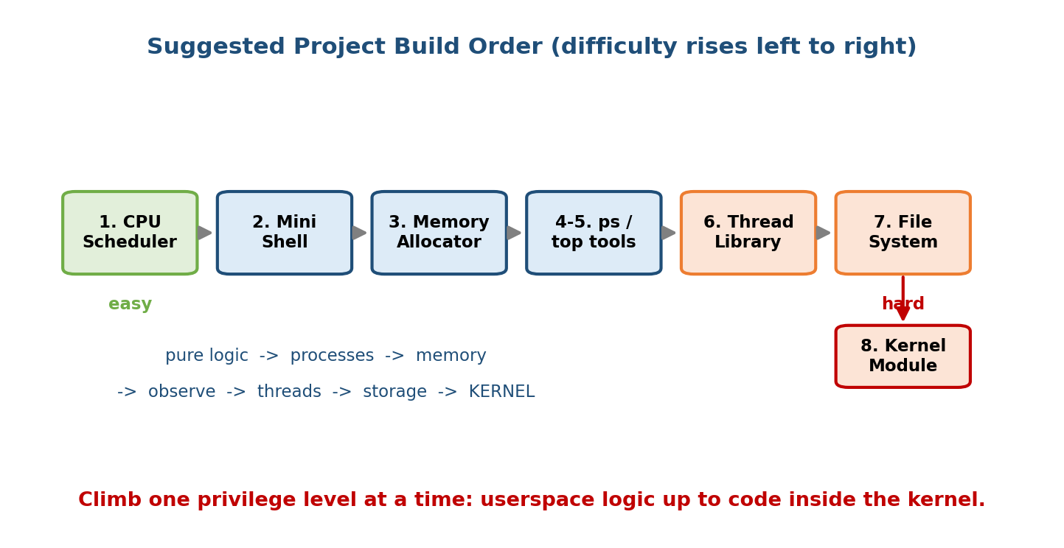
Suggested build order: start with the CPU scheduler (pure logic), climb through shell and allocator to the thread library and kernel module; difficulty and depth of OS insight rise together.
# | Project | Core module(s) | Difficulty | Interview impact | Weekend est.
1 | Mini CPU Scheduler (FCFS/SJF/RR) | M6 | ★☆☆☆☆ | ★★★☆☆ | 1
2 | Mini Shell (fork/exec/pipe/redir) | M4, M3 | ★★★☆☆ | ★★★★★ | 1–2
3 | Mini Memory Allocator (malloc/free) | M9 | ★★★☆☆ | ★★★★★ | 1–2
4 | Mini Process Manager (ps via /proc) | M4, M14 | ★★☆☆☆ | ★★★☆☆ | 1
5 | OS Monitoring Tool (top-like) | M4, M6, M9, M14 | ★★☆☆☆ | ★★★☆☆ | 1
6 | User-level Thread Library (ucontext) | M5, M6 | ★★★★☆ | ★★★★★ | 2
7 | Mini File System (inodes/blocks) | M11, M12 | ★★★★☆ | ★★★★☆ | 2–3
8 | Linux Kernel Module (hello + /proc) | M3, M14 | ★★★★★ | ★★★★☆ | 1–2
Suggested order (why this sequence):
- Scheduler first — pure algorithm, no tricky syscalls; it proves the M6 theory and gives an early win.
- Shell next — your first real dance with fork/exec/wait/pipe; the most discussed project in interviews.
- Allocator — now you understand memory from userspace; teaches sbrk/mmap and fragmentation.
- Process manager → monitoring tool — read the kernel’s own bookkeeping via /proc; light and rewarding after the allocator.
- Thread library — the hardest userspace project: you implement context switching yourself, which finally demystifies M5/M6.
- File system — a big data-structure project (inodes, bitmaps, blocks).
- Kernel module last — you now write code that runs in kernel mode; needs everything above to appreciate.
Memory hook: logic → processes → memory → observation → threads → storage → kernel. You climb from “pure C” to “code inside the kernel,” one privilege level at a time.

23.3 Project 1 — Mini CPU Scheduler (FCFS / SJF / Round Robin)

What you build
A command-line simulator: read a list of processes (arrival time, burst time), run a chosen algorithm, print the Gantt chart and the average waiting time (WT) and turnaround time (TAT). No real processes — pure simulation of M6.

OS concepts it teaches (→ M6)
- Scheduling algorithms: FCFS, SJF (non-preemptive), SRTF (preemptive SJF), Round Robin with a time quantum.
- The four metrics: turnaround, waiting, response time, throughput.
- Preemption vs non-preemption and the ready queue as a live data structure.
- Why RR trades average WT for responsiveness, and SJF is provably optimal for average WT.

Key data structures
typedef struct {
int pid, arrival, burst; /* input */
int remaining; /* for RR / SRTF */
int completion, tat, wt; /* computed output */
int started; /* first-run flag for response time */
} Proc;
Proc procs[MAX]; /* the process table */
int ready_q[MAX], head, tail; /* circular ready queue for RR */

Step-by-step build plan
- Parse input — read n and each (arrival, burst) into procs[].
- FCFS — sort by arrival; sweep a time cursor, set completion, derive tat = completion − arrival, wt = tat − burst.
- SJF (non-preemptive) — at each decision point pick the shortest-burst process among those that have arrived.
- Round Robin — maintain a circular queue; run each head for min(quantum, remaining); re-enqueue arrivals then the preempted job.
- Print a Gantt chart and averages; add a --algo flag to select.

Worked check (use this to validate your code — recompute by hand)
Input: P1(AT0,BT5) P2(AT1,BT3) P3(AT2,BT8) P4(AT3,BT6).
FCFS (run in arrival order):
| P1 | P2 | P3 | P4 |
0 5 8 16 22
CT : P1=5 P2=8 P3=16 P4=22
TAT: 5, 7, 14, 19 -> avg = 45/4 = 11.25
WT : 0, 4, 6, 13 -> avg = 23/4 = 5.75
SJF non-preemptive (at t=5 pick shortest arrived = P2; then P4 over P3):
| P1 | P2 | P4 | P3 |
0 5 8 14 22
CT : P1=5 P2=8 P4=14 P3=22
TAT: 5, 7, 20, 11 -> avg = 43/4 = 10.75
WT : 0, 4, 12, 5 -> avg = 21/4 = 5.25 (lowest avg WT — SJF is optimal)
Round Robin, quantum = 3 (add arrivals before the preempted job):
|P1|P2|P3|P4|P1|P3|P4|P3|
0 3 6 9 12 14 17 20 22
CT : P1=14 P2=6 P3=22 P4=20
TAT: 14, 5, 20, 17 -> avg = 56/4 = 14.0
WT : 9, 2, 12, 11 -> avg = 34/4 = 8.5 (worse avg, but everyone runs early)
The lesson your own numbers prove: SJF wins on average WT (5.25), FCFS is simple (5.75), RR is worst on average (8.5) yet best on responsiveness — exactly the M6 tradeoff, now demonstrated by code you wrote.

Milestones
- M1: FCFS prints a correct Gantt chart and averages matching the hand check.
- M2: SJF selects by shortest arrived burst; averages match.
- M3: RR with a --quantum flag; re-enqueue order correct.
- M4 (stretch): add SRTF and priority scheduling; plot avg WT vs quantum.

What interviewers probe
- “Which algorithm minimises average waiting time?” → SJF/SRTF (optimal).
- “What is the danger of SJF?” → starvation of long jobs; needs burst prediction.
- “How does the quantum affect RR?” → too large → FCFS; too small → overhead from constant context switches.
- “Difference between waiting and response time?” → WT = total time in ready queue; response = time to first run.

23.4 Project 2 — Mini Shell (fork / exec / wait, pipes, redirection)

What you build
A working Unix shell: a prompt loop that reads a command line, and runs external programs with argument passing, I/O redirection (>, <), pipes (ls | grep c | wc -l), background jobs (&), and a few built-ins (cd, exit). This is the classic OS project.

OS concepts it teaches (→ M4, M3)
- fork() — creating a child process (M4); the parent/child return-value trick.
- execvp() — replacing the process image with a new program.
- wait()/waitpid() — reaping children, reading exit status, avoiding zombies.
- pipe() + dup2() — inter-process communication and file-descriptor redirection (M4 IPC, M11 file descriptors).
- Process groups & signals — Ctrl-C handling (M4, M7 preview).
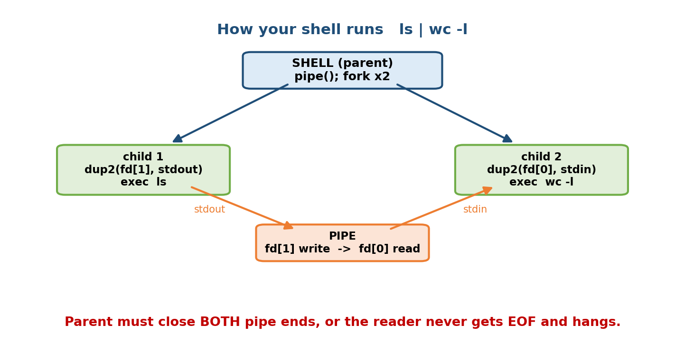
How ls | wc -l runs in your shell: the shell creates a pipe, forks two children, and each uses dup2() to wire its stdout/stdin to the pipe before exec.

The core pattern (the 12 lines every shell is built on)
pid_t pid = fork(); /* 1. duplicate the process */
if (pid == 0) { /* --- CHILD --- */
/* optional: redirect fds here with dup2() before exec */
execvp(argv[0], argv); /* 2. become the new program */
perror("execvp"); _exit(127); /* only runs if exec FAILED */
} else { /* --- PARENT (the shell) --- */
int status;
waitpid(pid, &status, 0); /* 3. wait for the child, reap zombie */
}
Memory hook: fork = clone, exec = become, wait = reap. The child is a copy that turns into the new program; the parent waits for it and collects its corpse (exit status) so it does not become a zombie.

Pipes and redirection (the dup2 insight)
A pipe is a pair of fds: fd[0] (read end), fd[1] (write end). To run A | B:
int fd[2]; pipe(fd);
if (fork()==0){ dup2(fd[1],STDOUT_FILENO); close(fd[0]);close(fd[1]); exec A; }
if (fork()==0){ dup2(fd[0],STDIN_FILENO ); close(fd[0]);close(fd[1]); exec B; }
close(fd[0]); close(fd[1]); /* PARENT must close BOTH ends */
dup2(oldfd, newfd) makes newfd refer to the same file as oldfd — so writing to stdout actually writes to the pipe. Redirection > file is the same trick with an open()ed file instead of a pipe end.
The #1 pipe bug (interviewers love this): if the parent (or a child) forgets to close unused pipe ends, the reader never sees EOF and hangs forever, because a pipe returns EOF only when all write ends are closed. Close every fd you do not need.

Key data structures
typedef struct { char *argv[MAXARGS]; char *infile, *outfile; int bg; } Cmd;
Cmd stages[MAXSTAGES]; /* one per pipeline segment */

Step-by-step build plan
- REPL — print a prompt, fgets a line, tokenise on spaces.
- Single command — fork + execvp + waitpid; run ls, pwd, echo.
- Built-ins — handle cd (must be built-in: it changes the shell’s cwd via chdir, so it cannot run in a child) and exit.
- Redirection — parse >/<, open() the file, dup2 onto std fds in child.
- Pipes — split on |, create pipes, wire stages with dup2, close all ends.
- Background & — do not waitpid; reap later with waitpid(-1, …, WNOHANG).
- Signals (stretch) — trap SIGINT so Ctrl-C kills the child, not the shell.

Milestones
- M1: runs external commands and built-in cd/exit.
- M2: > and < redirection work.
- M3: a two-stage pipe (ls | wc -l) works; then an N-stage pipeline.
- M4: background jobs with & and zombie reaping; Ctrl-C handled.

What interviewers probe
- “Why must cd be a built-in?” → it must change the shell’s own working directory; a child’s chdir dies with the child.
- “What is a zombie? An orphan?” → zombie = dead child not yet waited; orphan = child whose parent died (re-parented to init/PID 1).
- “Why close both pipe ends?” → otherwise the reader never gets EOF (deadlock).
- “What does exec do to the PID / open files?” → PID unchanged; open fds survive across exec unless marked close-on-exec.

23.5 Project 3 — Mini Memory Allocator (malloc / free, free-list, fragmentation)

What you build
Your own my_malloc() and my_free() — a heap allocator that requests memory from the OS (sbrk or mmap), carves it into blocks, tracks free blocks in a free list, and coalesces neighbours on free. You will see fragmentation.

OS concepts it teaches (→ M9)
- The heap and how userspace grows it (sbrk/brk, mmap).
- Dynamic allocation policies: first-fit, best-fit, worst-fit (M9).
- Internal vs external fragmentation — you will produce both.
- Coalescing and splitting blocks; block metadata (headers).
- Why real allocators use size classes / bins (glibc, jemalloc, tcmalloc).
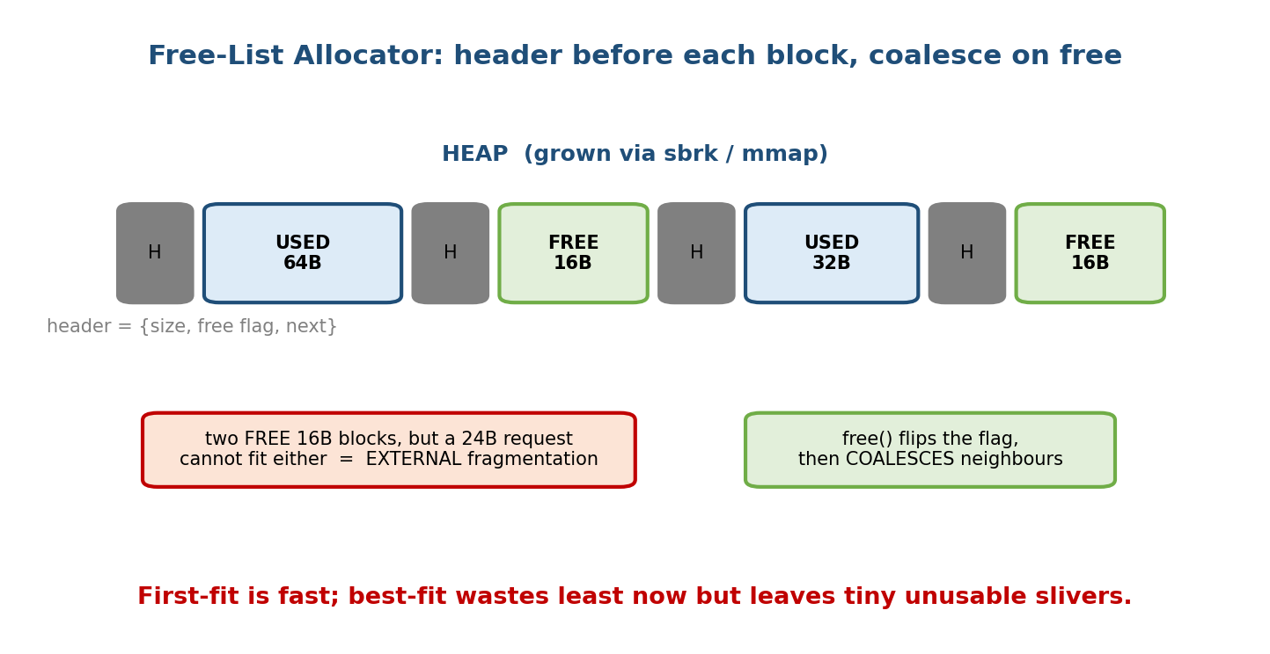
A free-list allocator: each block has a header (size, free flag); free() flips the flag and coalesces with free neighbours. Scattered small free blocks are external fragmentation.

Key data structures (the block header trick)
typedef struct block {
size_t size; /* payload size */
int free; /* 1 = free, 0 = in use */
struct block *next; /* next block in the list */
} Block; /* header sits JUST BEFORE the returned pointer */
#define HDR sizeof(Block)
Block *free_list = NULL; /* head of the free list */
The pointer you return to the user is (void*)(header + 1); on free(p) you recover the header with ((Block*)p) - 1. This “hidden header before the pointer” is exactly how real malloc finds a block’s size when you only hand it a raw pointer.

Step-by-step build plan
- Grow the heap — void *p = sbrk(size + HDR); (or mmap) to get raw bytes.
- First-fit malloc — walk free_list for a free block ≥ requested size; if none, grow the heap and append.
- Split — if the found block is much bigger, split it so the remainder stays free (reduces internal fragmentation).
- free() — flip free = 1; do not return to OS yet.
- Coalesce — on free, merge with the adjacent free block(s) to fight external fragmentation.
- Best-fit / worst-fit — add a policy flag and measure fragmentation for each.
Memory hook: internal fragmentation = wasted space inside a block you rounded up; external fragmentation = enough free memory total, but scattered in pieces too small for the request. Best-fit minimises leftover but creates lots of tiny slivers (bad external frag); first-fit is faster and often better in practice.

Milestones
- M1: my_malloc/my_free work for a few allocations; no crash.
- M2: blocks split and coalesce; a fragmentation counter drops after coalescing.
- M3: valgrind and a stress test (random malloc/free) run clean.
- M4 (stretch): add size-class bins and compare speed/fragmentation to glibc.

What interviewers probe
- “First-fit vs best-fit?” → best-fit least immediate waste but worst external fragmentation (tiny slivers); first-fit faster.
- “Internal vs external fragmentation?” → inside a block vs scattered between blocks; paging cures external, causes a little internal (last page).
- “How does free know the size?” → the header stored just before the pointer.
- “Why not return every freed block to the OS?” → sbrk/mmap syscalls are expensive; allocators cache freed memory for reuse.

23.6 Project 4 — Mini File System (inodes, blocks, directories)

What you build
A file system inside a single file (a “disk image”): you format a fixed-size file into a superblock, an inode table, a block bitmap, and data blocks, then implement create, write, read, ls, and delete on it. This makes M11/M12 completely concrete.

OS concepts it teaches (→ M11, M12)
- Inodes — metadata (size, permissions, block pointers) separate from the name.
- Direct + indirect block pointers and the max-file-size calculation (M11).
- Free-space management with a bitmap (M11).
- Directories as tables mapping name → inode number (M11).
- Blocks as the unit of allocation; internal fragmentation of the last block.

Key data structures
typedef struct { /* on-disk superblock */
int total_blocks, inode_count, block_size, data_start;
} Superblock;
typedef struct { /* one inode */
int used, size;
int direct[12]; /* direct block numbers */
int single_indirect; /* block full of block numbers */
} Inode;
typedef struct { char name[28]; int inode_no; } DirEntry; /* name -> inode */
unsigned char block_bitmap[NBLOCKS/8]; /* 1 bit per block */

Step-by-step build plan
- mkfs (format) — create the image file, write the superblock, zero the bitmap and inode table.
- Allocate blocks — scan the bitmap for a free bit, set it, return the block no.
- create(name) — grab a free inode, add a DirEntry to the root directory.
- write(name, data) — allocate data blocks, fill direct[], spill into single_indirect when you exceed 12 blocks.
- read / ls / delete — walk pointers to read; free bits + inode on delete.

Worked check — max file size (recompute by hand, then in code)
Block = 4 KB, pointer = 4 B → 1024 pointers per block; 12 direct + 1 single + 1 double + 1 triple indirect:
capacity (in blocks) = 12 + 1024 + 1024^2 + 1024^3
= 12 + 1024 + 1,048,576 + 1,073,741,824 = 1,074,791,436 blocks
max file size = 1,074,791,436 x 4096 B = 4,402,345,721,856 B ~= 4.00 TB
Your single_indirect-only version caps at (12 + 1024) x 4 KB = 4,144 KB ≈ 4.05 MB — a great milestone to verify before adding double/triple indirection.

Milestones
- M1: mkfs writes a valid superblock; you can re-open the image.
- M2: create + write + read a small file using only direct[].
- M3: files bigger than 12 blocks work via single_indirect.
- M4 (stretch): subdirectories, and a fsck that verifies the bitmap.

What interviewers probe
- “What is an inode; what does it not store?” → all metadata + block pointers, but not the file name (that lives in the directory).
- “How do hard links work?” → multiple directory entries → same inode (link count); file dies when count hits 0 (M11).
- “Compute the max file size” → the direct+indirect sum above — a GATE staple.
- “Why blocks, not bytes?” → amortise disk seeks; the cost is last-block internal fragmentation.

23.7 Project 5 — Mini Process Manager (a ps-like tool via /proc)

What you build
A program that lists running processes with PID, state, name, memory, and CPU — by reading the /proc filesystem, exactly as real ps/top do. No special syscalls; /proc is the kernel’s interface for this.

OS concepts it teaches (→ M4, M14)
- /proc as a virtual filesystem — the kernel exposes process state as files (M14).
- The PCB made visible — /proc/<pid>/stat and /status are the kernel’s process control block fields you learned in M4.
- Process states — you read R/S/D/Z/T (running, sleeping, uninterruptible, zombie, stopped) straight from the kernel (M4).
- The process tree — PPID links children to parents (M4).

Key data structures
typedef struct {
int pid, ppid;
char state; /* R,S,D,Z,T */
char comm[64]; /* command name */
long rss_pages; /* resident memory in pages */
unsigned long utime, stime; /* CPU jiffies in user/kernel mode */
} PInfo;

Step-by-step build plan
- Enumerate — opendir("/proc"); every entry whose name is all-digits is a PID.
- Parse /proc/<pid>/stat — one line of space-separated fields: pid, comm, state, ppid, …, utime, stime, …, rss.
- Human-readable — map state letters to words; convert RSS pages → MB (page size from sysconf(_SC_PAGESIZE)).
- Sort & print a table (by memory or CPU).
- Tree view (stretch) — build the PPID→children map and indent a tree.
Memory hook: everything is a file — even a running process. cat /proc/self/status shows this program’s own PCB. Your tool is just a formatter over files the kernel already writes.

Milestones
- M1: list every PID and its command name.
- M2: add state, PPID, and memory (RSS in MB).
- M3: sort by memory; add a --tree view.

What interviewers probe
- “What is /proc?” → a virtual (pseudo) filesystem — files backed by kernel data, not disk (M14).
- “Where does ps get its data?” → from /proc/<pid>/stat and /status.
- “What are the process states?” → R/S/D/Z/T (see M4); what’s a D (uninterruptible sleep) and why can’t you kill it easily.

23.8 Project 6 — OS Monitoring Tool (a top-like dashboard)

What you build
An interactive, refreshing terminal dashboard: overall CPU %, memory usage, load average, and the top-N processes — updating every second, like top. Builds directly on Project 5.

OS concepts it teaches (→ M4, M6, M9, M14)
- CPU utilisation computed as a delta of /proc/stat jiffies between samples (M6).
- Memory accounting — total/free/cached from /proc/meminfo (M9).
- Load average — the run-queue length over 1/5/15 min from /proc/loadavg (M6).
- Sampling — why you must diff two snapshots to get a rate (a real profiling idea).

The CPU-% insight (the one subtlety)
/proc/stat gives cumulative jiffies since boot. Instantaneous CPU% needs two reads:
CPU% = 100 * (1 - (idle2 - idle1) / (total2 - total1))
where total = user+nice+system+idle+iowait+irq+softirq
Memory hook: the kernel gives you a odometer (cumulative), not a speedometer (rate). To get speed, subtract two odometer readings over a known interval. That is the pattern behind every monitoring tool.

Key data structures
typedef struct { unsigned long user,nice,sys,idle,iowait,irq,softirq; } CpuTimes;
CpuTimes prev, cur; /* two samples, one second apart */

Step-by-step build plan
- CPU% — read /proc/stat, sleep 1s, read again, apply the delta formula.
- Memory bar — parse /proc/meminfo (MemTotal, MemAvailable).
- Process rows — reuse Project 5; compute per-process CPU% from utime/stime deltas.
- Refresh loop — clear screen (ANSI escape), redraw each second; add sort keys.

Milestones
- M1: live overall CPU% and memory bar refreshing each second.
- M2: top-N processes by CPU, updating.
- M3: keyboard sort toggles (CPU/mem) and a quit key.

What interviewers probe
- “Why does CPU% need two samples?” → /proc/stat is cumulative; you diff for a rate.
- “What is load average of 4 on a 4-core box?” → fully utilised, no queueing; >4 means processes are waiting (M6 run queue).
- “iowait vs idle?” → CPU idle because it is waiting on I/O vs simply idle.

23.9 Project 7 — User-Level Thread Library (context switch via ucontext)

What you build
A cooperative (green) threading library: thread_create, thread_yield, and a simple round-robin scheduler, all in userspace, by saving and restoring CPU context with ucontext. You implement a context switch by hand — the single best way to finally understand M5 and M6.

OS concepts it teaches (→ M5, M6)
- What a context switch actually is — save registers + stack pointer of one thread, restore another’s (M5, M6). You write it.
- Thread Control Block (TCB) — the userspace cousin of the PCB (M5).
- User-level vs kernel-level threads — you build N:1 (many user threads on one kernel thread) and feel its limitation (M5).
- Cooperative vs preemptive scheduling (M6); the run queue.

Key data structures
#include <ucontext.h>
typedef struct tcb {
ucontext_t ctx; /* saved registers + stack pointer */
char *stack; /* this thread's own stack */
int id, done;
struct tcb *next; /* ready-queue link */
} TCB;
TCB *current, *ready_head; /* the scheduler's state */

The heart of it (the two calls that are a context switch)
getcontext(&t->ctx); /* snapshot current context */
t->ctx.uc_stack.ss_sp = t->stack;
t->ctx.uc_stack.ss_size = STACKSZ;
t->ctx.uc_link = &main_ctx; /* where to go when done */
makecontext(&t->ctx, fn, 0); /* set entry function */
/* ... later, to switch from A to B: */
swapcontext(&A->ctx, &B->ctx); /* SAVE A, RESTORE B == a context switch */
Memory hook: swapcontext IS a context switch. It saves every register and the stack pointer of the running thread and loads another’s — precisely what the kernel does on a timer interrupt, except here you trigger it in thread_yield.

Step-by-step build plan
- One thread — makecontext a function, swapcontext into it, return.
- Two threads that yield — a ready queue; thread_yield = pick next + swapcontext.
- N threads, round-robin — schedule until all done; clean up stacks.
- Preemptive (stretch) — a SIGALRM timer that calls thread_yield — now you have built a preemptive scheduler and can explain the timer interrupt for real.

Milestones
- M1: control transfers into a created thread and back.
- M2: two threads alternate via cooperative yield.
- M3: N threads run to completion under a round-robin scheduler.
- M4: timer-based preemption works (the “aha” moment for M6).

What interviewers probe
- “What is saved during a context switch?” → registers, program counter, stack pointer (and, for processes, memory maps) — you literally saved them.
- “User-level vs kernel-level threads?” → your N:1 library: fast switches, but one blocking syscall blocks all threads, and no multicore parallelism (M5).
- “Cooperative vs preemptive?” → yield-based vs timer-interrupt based; you built both.
- “Why is a thread switch cheaper than a process switch?” → same address space, no TLB/page-table swap (M5, M10).

23.10 Project 8 — A Simple Linux Kernel Module (hello + a /proc entry)

What you build
A loadable kernel module (LKM): code that runs in kernel mode. Start with a “hello world” that logs on load/unload, then add a /proc/myinfo entry that returns text when read. You cross from userspace into the kernel — the ultimate OS project.

OS concepts it teaches (→ M3, M14)
- Kernel mode vs user mode — your code now runs with full privilege (M3).
- Monolithic kernel + loadable modules — how Linux extends itself at runtime (M3, M14).
- The /proc interface from the other side — you provide a /proc file (Project 5 read one; now you write one) (M14).
- No libc, no main — kernel code uses printk, module init/exit, and must never crash (a bug = kernel panic).

The skeleton
#include <linux/module.h>
#include <linux/init.h>
static int __init my_init(void){ printk(KERN_INFO "hello from kernel\n"); return 0; }
static void __exit my_exit(void){ printk(KERN_INFO "bye from kernel\n"); }
module_init(my_init);
module_exit(my_exit);
MODULE_LICENSE("GPL");
Build with a Makefile using the kernel build system (obj-m += mymod.o), make, then sudo insmod mymod.ko, dmesg | tail, sudo rmmod mymod.
Memory hook: a kernel module is surgery on a running OS. There is no safety net: a null-pointer deref in userspace is a segfault; in the kernel it can panic the machine. Test in a VM you do not mind rebooting.

Key APIs
printk(KERN_INFO ...) kernel's printf (writes to the ring buffer / dmesg)
module_init / module_exit register load/unload hooks
proc_create("myinfo",...) create a /proc entry backed by your read handler

Step-by-step build plan
- Toolchain — install linux-headers-$(uname -r); write the Makefile.
- Hello module — insmod, check dmesg, rmmod. Confirm both messages appear.
- /proc/myinfo — proc_create with a read handler that copies a string to userspace (copy_to_user / seq_file).
- Parameterise (stretch) — a module parameter (module_param) you set at load.

Milestones
- M1: module loads/unloads; messages in dmesg.
- M2: cat /proc/myinfo prints your text.
- M3: module accepts a load-time parameter and reports it.

What interviewers probe
- “User mode vs kernel mode?” → privilege level; syscalls are the gate between them (M3).
- “Why is Linux ‘monolithic with modules’?” → one big kernel address space, but drivers/features load at runtime as modules (M3, M14).
- “What happens if kernel code dereferences NULL?” → oops / panic — no process isolation to catch it.
- “Difference between printk and printf?” → printk runs in-kernel, has log levels, writes to the kernel ring buffer (dmesg), and cannot use libc.

23.11 Real-World & Backend Perspectives
- The shell project is the closest thing to how every process launcher works — container runtimes (Docker, runc), CI systems, and systemd all fork/exec/ wait and wire up fds exactly as you did.
- The allocator project is why senior backend engineers understand jemalloc/tcmalloc, memory fragmentation in long-running services, and why a Go/Java heap profile looks the way it does.
- The thread library is the mental model behind goroutines, async/await, and fibers — cooperative userspace scheduling over a few kernel threads (the M:N model). AI-infra (M19) serving stacks live and die by this.
- The monitoring tool is a baby top/htop/node_exporter; the /proc deltas you compute are exactly what Prometheus node exporters scrape in production.
- The kernel module is the entry point to device drivers and eBPF — the skills behind observability tools like bpftrace and high-performance networking.

23.12 Tradeoffs, Common Mistakes, Edge Cases
- Shell: forgetting to close pipe fds (hangs), running cd in a child (no effect), not reaping background children (zombie buildup).
- Allocator: returning a pointer without room for the header; forgetting to coalesce (external fragmentation explodes); alignment bugs (return 8/16-byte-aligned pointers).
- Thread library: too-small thread stacks (silent corruption); forgetting uc_link (falling off the end of a thread); assuming it gives multicore parallelism (it does not — it is N:1).
- File system: off-by-one in the bitmap; forgetting the last block is partially wasted (internal fragmentation); not persisting the superblock.
- Kernel module: testing on your main machine (test in a VM!); using libc or floating point in the kernel; memory leaks that persist until reboot.
- Monitoring: reporting cumulative jiffies as if instantaneous (must diff two samples).

23.13 Exam, Interview & Coding Perspectives
- Interviews (the big payoff): put 2–3 of these on your résumé with a one-line “what it taught me.” Expect deep-dives on fork/exec/wait, context switching, fragmentation, and /proc — all of which you can now answer from having built them.
- GATE/written: these projects reinforce the numericals (scheduling averages, max file size) you must compute in the exam; the code is a checker for your hand calculations.
- Coding rounds: the shell and allocator are common systems coding-round prompts (“implement a mini-shell / a memory pool”); you will have done it already.

23.14 Concept Checks & MCQs
- Which project best explains a context switch? → the thread library (swapcontext).
- Why must cd be a shell built-in? → it must change the shell’s own cwd.
- First-fit vs best-fit — which risks the most external fragmentation? → best-fit (tiny slivers).
- Where does a ps-tool get its data? → the /proc filesystem.
- To get instantaneous CPU% from /proc/stat you must? → diff two samples.
- What does dup2(fd, STDOUT_FILENO) achieve in a pipe? → redirects stdout to the pipe’s write end.
- A child that has exited but not been waited is a? → zombie.
- In an inode with 12 direct + single/double/triple indirect (4 KB block, 4 B pointer), max size ≈? → ~4 TB.
- swapcontext(&A,&B) does what? → saves A’s context, restores B’s (a context switch).
- Why can a kernel-module NULL deref be catastrophic? → it runs in kernel mode — no process isolation → panic.
- Which scheduling algorithm gives the lowest average WT? → SJF/SRTF.
- Why close both pipe ends in the parent? → so the reader receives EOF.

23.15 One-Page Revision Sheet
PROJECT -> WHAT IT TEACHES (module) -> KEY SYSCALLS/STRUCTS
1 CPU SCHEDULER (M6) FCFS/SJF/RR; TAT=CT-AT, WT=TAT-BT; SJF min avg WT; RR=quantum
2 SHELL (M4) fork=clone, exec=become, wait=reap; pipe()+dup2(); close all fds!
cd=builtin; zombie=unreaped; orphan->init(PID1)
3 ALLOCATOR (M9) sbrk/mmap; free-list; header BEFORE pointer; split+coalesce
first/best/worst fit; internal(inside) vs external(scattered) frag
4 PS TOOL (M4,M14) /proc/<pid>/stat & status = PCB made visible; states R/S/D/Z/T
5 TOP TOOL (M6,M9) /proc/stat cumulative -> DIFF two samples for CPU%; loadavg
6 THREAD LIB (M5,M6) ucontext: makecontext + swapcontext = CONTEXT SWITCH by hand
TCB; N:1 (one blocking call blocks all; no multicore)
7 FILE SYSTEM (M11) superblock+inode table+block bitmap+data; direct+indirect ptrs
maxsize=(12 + N + N^2 + N^3)*B ; name lives in DIRECTORY not inode
8 KERNEL MODULE (M3) insmod/rmmod; printk->dmesg; module_init/exit; proc_create; TEST IN VM
BUILD ORDER: scheduler -> shell -> allocator -> ps -> top -> threads -> filesystem -> kmod
GOLDEN RULE: always keep it compiling; add ONE feature at a time. strace to watch syscalls.

Flash cards
Front | Back
fork / exec / wait in one word each? | clone / become / reap
Pipe reader hangs — likely cause? | an unclosed write end (no EOF)
swapcontext(&A,&B) does? | saves A, restores B = a context switch
Best-fit’s downside? | worst external fragmentation (slivers)
Where malloc stores a block’s size? | header just before the pointer
Source of ps/top data? | /proc//stat & /proc/stat
Instantaneous CPU% needs? | diff of two /proc/stat samples
Max inode file size formula? | (direct + N + N² + N³) × block
Kernel module logging call? | printk (→ dmesg)
Why cd is built-in? | changes the shell’s own cwd

Spaced repetition
- 24-hour: re-derive the FCFS/SJF/RR averages by hand; recite fork/exec/wait.
- 7-day: explain a context switch using your swapcontext code; internal vs external fragmentation from your allocator.
- 30-day: whiteboard the ls | wc -l pipe wiring (pipe + fork×2 + dup2 + close); compute a max inode file size cold.

23.16 Summary
Theory becomes yours only when you build it. Eight weekend-sized projects turn Modules 1–20 into working C: a CPU scheduler proves the M6 averages; a shell makes fork/exec/wait, pipes, and redirection second nature; a memory allocator shows fragmentation and free-lists from M9; a ps/top pair reads the kernel’s own bookkeeping through /proc; a user-level thread library lets you write a context switch with ucontext (the deepest insight in the course); a mini file system realises inodes, bitmaps, and the max-file-size formula from M11; and a kernel module carries you across the line into kernel mode. Build in the order scheduler → shell → allocator → observers → threads → file system → kernel module, always keeping the code compiling and adding one feature at a time.
These are the projects that make an interviewer lean in — and the reason you will answer “how does the OS actually do it?” with “let me show you the one I wrote.”
Next, Module 24 — The Revision Kit compresses the entire course into formula sheets, cheat sheets, flash cards, and an exam-day strategy for your final sprint.
You have mastered this module when you can: pick the right project for a concept you want to prove; wire ls | wc -l with pipe/fork/dup2/close on a whiteboard; explain a context switch from your own swapcontext code; reason about first/best-fit fragmentation from your allocator; and describe how ps, top, and a kernel module talk to /proc — all from projects you have actually built.

