Module 24 — The Revision Kit (Your Final Sprint)
  - OS Mastery: SEBI IT / RBI / NABARD / GATE / C-DAC / Interview / Backend — In-Depth Notes (with visuals)
Prepared for nidhi.sharma@forensiccybertech.com
2026
Table of Contents

Module 24 — The Revision Kit (Your Final Sprint)
Where this module sits. This is the last module and it owns none of its own theory — it compresses the whole course. Modules 1–20 taught the concepts; M21–M23 gave you PYQs, practice, and projects. Now, in the final days before an exam or an interview, you need one place that holds every formula, every trap, every one-liner and a plan to review it. That is this module: a master formula sheet (all OS numericals recomputed and verified), cheat sheets per topic, a topic dependency graph, mind-maps, a consolidated flash-card deck, a spaced-repetition schedule, the common exam traps, a last-minute strategy, and the 50 one-liners that carry the most marks. Read nothing else the night before — read this.
Importance ratings (out of 5):
Exam / Use | SEBI IT | RBI IT | GATE CS | Interview | Backend
This module | ★★★★★ | ★★★★★ | ★★★★★ | ★★★★★ | ★★★★
Most-asked PYQ concepts (all modules, in one place): scheduling averages (TAT/WT); EAT with TLB and with page faults; page-fault counting (FIFO/LRU/Optimal + Belady’s anomaly); disk head movement (FCFS/SSTF/SCAN/ C-SCAN); Banker’s algorithm safe sequence; RMS utilisation bound n(2^(1/n)−1); inode max file size; effective access time with cache; address translation (page number/offset bits); semaphores & the classic synchronisation problems; deadlock’s four conditions.

24.1 How to Revise (the method that actually works)
- Recompute, don’t reread. OS marks come from numericals. Re-derive one Gantt chart, one EAT, one Banker’s sequence by hand every day — passive reading fails.
- Spaced repetition over cramming. Use the 24h / 7d / 30d schedule in §24.7. Ten minutes daily beats one panicked night.
- Traps first. Half of all lost marks are the traps in §24.8 (½-rotation, Belady, RAID-0 has no redundancy). Learn the traps and you claw back easy marks.
- Teach it. Explain “what is a page fault” or “why SJF is optimal” out loud. If you stumble, that is your next revision target.
- One page per topic. §24.5 condenses each module to a page — if you can reproduce that page from memory, you know the module.
Memory hook: R-C-T — Recompute a numerical, Cover the answer and recall the one-liner, Teach it to an empty chair. Do R-C-T for one topic a day.

24.2 Master Formula Sheet — EVERY OS Numerical (verified)
This is the centrepiece. Every formula below was re-derived and checked; the worked numbers are computed, not remembered.

A. CPU Scheduling (M6)
Turnaround Time (TAT) = Completion Time − Arrival Time
Waiting Time (WT) = TAT − Burst Time = (Completion − Arrival) − Burst
Response Time = First-CPU-start − Arrival Time
Average X = (Σ X) / n
Throughput = (jobs completed) / (total time)
CPU Utilisation = busy time / total time
Worked (one example that drives the whole topic): processes P1(AT0,BT5) P2(AT1,BT3) P3(AT2,BT8) P4(AT3,BT6).
Algo | Order (Gantt) | Avg TAT | Avg WT
FCFS | P1,P2,P3,P4 | 45/4 = 11.25 | 23/4 = 5.75
SJF (np) | P1,P2,P4,P3 | 43/4 = 10.75 | 21/4 = 5.25
RR (q=3) | P1,P2,P3,P4,P1,P3,P4,P3 | 56/4 = 14.0 | 34/4 = 8.5
SJF/SRTF gives the provably minimum average WT. RR’s average is worse but its response time is best. (Full traces are in M23 §23.3.)
- RR quantum rule: quantum too large → behaves like FCFS; too small → context-switch overhead dominates.
- Convoy effect: in FCFS a long job delays everyone behind it.

B. Real-Time Scheduling — Rate-Monotonic bound (M6)
A set of n periodic tasks is schedulable under RMS if:
U = Σ (Ci / Ti) ≤ n · (2^(1/n) − 1) (sufficient, not necessary)
as n → ∞ the bound → ln 2 ≈ 0.6931
EDF bound (optimal): U ≤ 1 (schedulable iff total utilisation ≤ 100%)
The bound values you should recognise (verified):
n | n(2^(1/n)−1)
1 | 1.000
2 | 0.828
3 | 0.780
4 | 0.757
5 | 0.743
∞ | 0.693 (ln 2)
Trap: the RMS bound is sufficient, not necessary — a set above the bound may still be schedulable (test it exactly). EDF is optimal: schedulable iff U ≤ 1.

C. Address Translation & Paging (M9, M10)
Logical address space = 2^m bytes ; Page size = 2^n bytes
→ offset bits = n ; page-number bits = m − n ; number of pages = 2^(m−n)
Physical address space = 2^p bytes → number of frames = 2^(p−n)
Page-table entries = number of pages = 2^(m−n)
Internal fragmentation ≈ half a page per process (average), on the last page

D. Effective Access Time — TLB / paging (M10)
No TLB (single-level page table): EAT = 2 × (memory access) [1 for table, 1 for data]
With TLB (hit ratio h, TLB time t, memory m):
EAT = h·(t + m) + (1 − h)·(t + 2m)
Multi-level (L levels) on a TLB miss:
EAT = h·(t + m) + (1 − h)·(t + (L + 1)·m)
Worked (verified): h = 80%, TLB t = 20 ns, memory m = 100 ns: EAT = 0.8·(20+100) + 0.2·(20+200) = 0.8·120 + 0.2·220 = 96 + 44 = 140 ns.

E. Effective Access Time — cache/memory two-level (M2)
EAT = H·Tc + (1 − H)·Tm (miss served straight from memory)
EAT = H·Tc + (1 − H)·(Tc + Tm) (miss also pays the cache probe first)
Worked (verified, simple form): H = 90%, Tc = 10 ns, Tm = 100 ns: EAT = 0.9·10 + 0.1·100 = 9 + 10 = 19 ns.

F. Demand Paging — EAT with page faults (M10)
EAT = (1 − p)·(memory access) + p·(page-fault service time)
p = page-fault rate ; a fault costs ~ms (disk) vs ~ns (memory)
Worked (verified): memory = 100 ns, page-fault service = 8 ms = 8,000,000 ns, p = 0.001: EAT = 0.999·100 + 0.001·8,000,000 = 99.9 + 8000 = 8099.9 ns ≈ 8.1 µs. One fault in a thousand makes memory ~80× slower — why we fear thrashing.

G. Page-Replacement — fault counting & Belady (M10)
Count faults for FIFO / LRU / Optimal on a reference string with F frames.
Optimal (OPT): evict the page used FARTHEST in the future (lower bound; unbeatable).
LRU: evict the least-recently USED (past). Stack algorithm → NO Belady anomaly.
FIFO: evict the oldest loaded. CAN suffer Belady's anomaly.
Worked (verified) — string 1 2 3 4 1 2 5 1 2 3 4 5:
Policy | Frames | Faults
FIFO | 3 | 9
FIFO | 4 | 10 ← more frames, MORE faults = Belady’s anomaly
LRU | 3 | 10
Optimal | 3 | 7 (the minimum)
OPT ≤ LRU always; Optimal is the theoretical floor. FIFO can get worse with more frames (this exact string proves it). LRU/OPT are stack algorithms — immune to Belady.

H. Disk Scheduling — head movement (M12)
Total head movement = Σ | next position − current position | (in cylinders)
FCFS : serve in arrival order.
SSTF : always the nearest request next (can starve far requests).
SCAN : sweep to one END, reverse, sweep back (elevator).
C-SCAN: sweep to the end, JUMP to the start, sweep the same direction (uniform wait).
LOOK / C-LOOK: like SCAN/C-SCAN but only go as far as the last request (no wasted end trip).
Worked (verified) — head = 53, requests 98,183,37,122,14,124,65,67, disk 0–199, moving toward larger first:
Algorithm | Total head movement
FCFS | 640
SSTF | 236
SCAN (to 199, then down) | 331
C-SCAN (to 199, wrap to 0, up) | 382
SSTF gives the least movement here but can starve; SCAN/C-SCAN are fairer. LOOK/C-LOOK would be lower (no trip to the physical end 199).

I. Deadlock — Banker’s Algorithm (M8)
Need = Max − Allocation
Work = Available ; Finish[i] = false for all i
Repeat: find an i with Finish[i]=false AND Need[i] ≤ Work
→ Work = Work + Allocation[i] ; Finish[i] = true
If all Finish[i]=true → SAFE (the order found is a safe sequence); else UNSAFE.
Worked (verified) — 5 processes, resources (A,B,C), Total = (10,5,7):
Alloc Max Need(=Max−Alloc)
P0 0 1 0 7 5 3 7 4 3
P1 2 0 0 3 2 2 1 2 2
P2 3 0 2 9 0 2 6 0 0
P3 2 1 1 2 2 2 0 1 1
P4 0 0 2 4 3 3 4 3 1
Available = Total − ΣAlloc = (10,5,7) − (7,2,5) = (3,3,2)
Safe sequence: P1 → P3 → P4 → P0 → P2 (each Need ≤ current Work; system is SAFE). Trap: safe ≠ no deadlock possible ever — it means a sequence exists that lets everyone finish from this state.

J. File System — inode max file size (M11)
Let block size = B, pointer size = P → pointers per block N = B / P
Direct blocks = d ; plus single, double, triple indirect:
Max file size = ( d + N + N² + N³ ) × B
Worked (verified): B = 4 KB, P = 4 B → N = 1024, d = 12: (12 + 1024 + 1,048,576 + 1,073,741,824) × 4096 = 4,402,345,721,856 B ≈ 4.00 TB.
Second variant (GATE-style): B = 1 KB, P = 4 B → N = 256, d = 10: (10 + 256 + 65,536 + 16,777,216) × 1024 = 17,247,250,432 B ≈ 16.06 GB.

K. Disk & Storage (from M12 / storage)
Average rotational latency = ½ × (60 / RPM) seconds (HALF a rotation)
Transfer time = data size / transfer rate
Disk access time = seek + rotational latency + transfer (+ controller)
Blocking factor bfr = floor(Block size / Record size)
Number of blocks = ceil(records / bfr)
Worked: disk at 6000 RPM → one rotation = 60/6000 = 10 ms; average rotational latency = 5 ms. With seek 4 ms and transfer 1 ms, total ≈ 10 ms.

L. Synchronisation quick-formulas (M7)
Counting semaphore: wait(S){ S--; if(S<0) block } ; signal(S){ S++; if(S≤0) wakeup }
|S| when negative = number of processes blocked on S.
Binary semaphore / mutex: value ∈ {0,1}.
Bounded buffer: semaphores empty=N, full=0, mutex=1.

24.3 Topic Dependency Graph (what to learn before what)
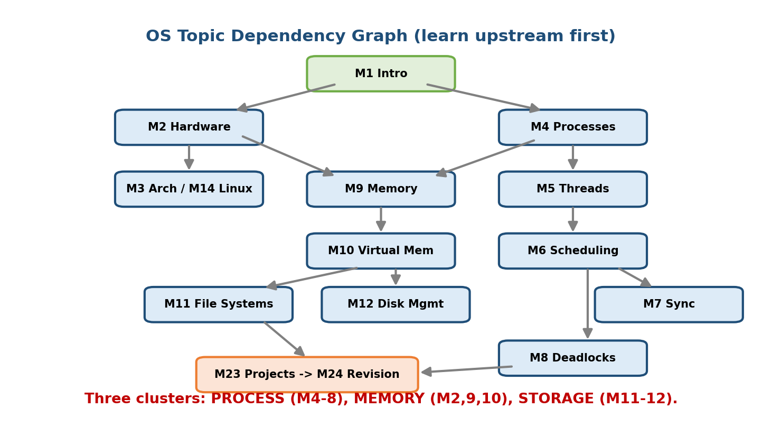
OS topic dependency graph: hardware and OS basics feed processes and threads, which feed scheduling, synchronization, and deadlocks; memory leads to virtual memory; storage leads to file systems and disk scheduling — all converging on Linux internals and systems projects.
Read this top to bottom: an arrow means “understand the source before the target.” If a later topic feels shaky, the fix is almost always an upstream node.
M1 Intro ─┬─> M2 Hardware ─┬─> M3 Architecture ──> M14 Linux internals
│ └─> M9 Memory ──> M10 Virtual memory ─┐
└─> M4 Processes ─┬─> M5 Threads ─┬─> M6 Scheduling │
│ └─> M7 Sync ─> M8 Deadlocks
└─> M11 File systems <── M12 Disk mgmt ┘
(everything feeds) ──────────────────────> M23 Projects ─> M24 Revision
The three natural clusters (revise as blocks): 1. Process world: M4 → M5 → M6 → M7 → M8 (processes, threads, scheduling, synchronisation, deadlocks). 2. Memory world: M2 → M9 → M10 (hierarchy, allocation, paging/virtual memory). 3. Storage world: M11 → M12 (file systems, inodes, disk scheduling).

24.4 Mind-Map Overviews (the whole course on one wall)
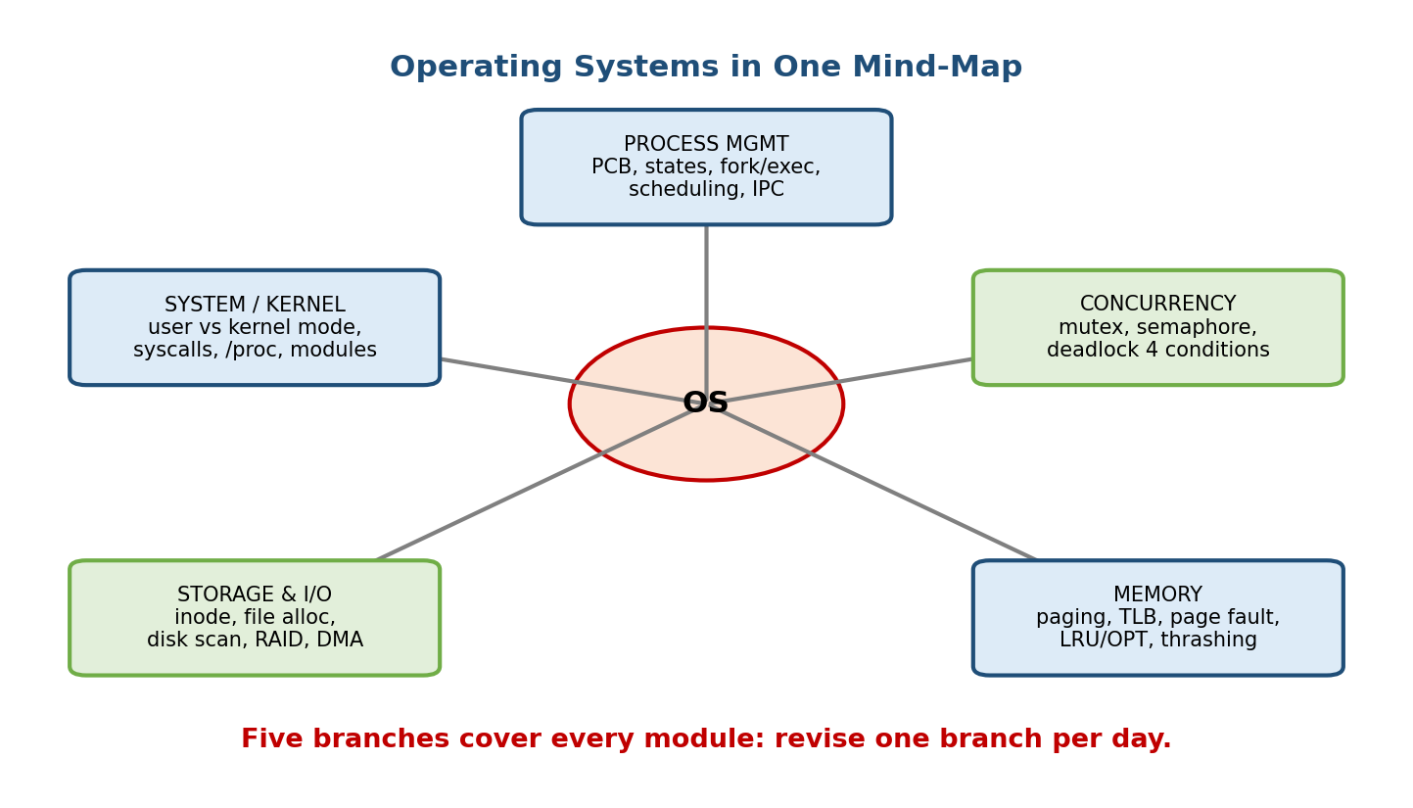
OS mind-map: five branches — Process Management, Memory Management, Storage & I/O, Concurrency, and System/Kernel — each with its key sub-topics radiating out.
Branch 1 — Process Management (M4–M6): PCB · states (new/ready/running/waiting/ terminated) · context switch · fork/exec/wait · scheduling (FCFS/SJF/SRTF/RR/ priority) · TAT/WT · IPC (pipes, shared memory, message passing).
Branch 2 — Concurrency (M7–M8): race condition · critical section · mutex · semaphore · monitor · producer–consumer · readers–writers · dining philosophers · deadlock’s 4 conditions (mutual exclusion, hold-and-wait, no preemption, circular wait) · Banker’s algorithm · RAG.
Branch 3 — Memory Management (M2, M9–M10): hierarchy · contiguous vs paging vs segmentation · MMU · logical vs physical address · TLB · page table (multi-level, inverted) · page faults · replacement (FIFO/LRU/OPT/CLOCK) · Belady · thrashing · working set · demand paging · copy-on-write.
Branch 4 — Storage & I/O (M11–M12): file · directory · inode · allocation (contiguous/linked/indexed) · free-space (bitmap/free-list) · disk geometry · disk scheduling (FCFS/SSTF/SCAN/C-SCAN/LOOK) · RAID · I/O methods (polling/interrupt/DMA).
Branch 5 — System / Kernel (M1–M3, M14): OS roles · types · user vs kernel mode · system calls · kernel architectures (monolithic/microkernel/hybrid) · boot process · /proc · loadable modules · virtualization/hypervisors.

24.5 One Page Per Topic (condensed cheat sheets)
Processes (M4). PCB holds PID, state, PC, registers, memory maps, open files. States: new→ready→running→(waiting)→ready→terminated. fork=clone (returns 0 to child, child-PID to parent), exec=replace image, wait=reap. Zombie = dead but un-waited; orphan → adopted by init (PID 1). IPC: shared memory (fast, needs sync), message passing (safe, slower), pipes, sockets.
Threads (M5). Share code/data/heap/files; own stack + registers + PC. User-level (fast, N:1, one blocking call blocks all), kernel-level (true parallelism, costlier). Models: many-to-one, one-to-one, many-to-many. Thread switch < process switch (same address space → no TLB flush).
CPU Scheduling (M6). Non-preemptive: FCFS, SJF. Preemptive: SRTF, RR, priority. SJF/SRTF = min average WT. RR fair/responsive, tune quantum. Priority → starvation → fix with aging. Metrics: TAT, WT, response, throughput. Convoy effect (FCFS).
Synchronisation (M7). Race condition needs a critical section with mutual exclusion + progress + bounded waiting. Tools: mutex, semaphore (wait/signal), monitor (language-level). Classics: producer–consumer (empty/full/mutex), readers–writers, dining philosophers (break circular wait). Peterson’s algorithm = software mutex for 2 processes. Priority inversion → priority inheritance.
Deadlocks (M8). Four necessary conditions together: mutual exclusion, hold-and-wait, no preemption, circular wait. Handle by prevent / avoid (Banker’s) / detect+recover / ignore (ostrich). RAG: a cycle ⇒ deadlock iff single instance per resource. Safe state ≠ deadlock; unsafe may deadlock.
Memory (M9). Contiguous (first/best/worst fit → external fragmentation) → paging (fixed frames, no external frag, small internal) and segmentation (logical, external frag). MMU maps logical→physical. Page table per process; TLB caches translations.
Virtual Memory (M10). Demand paging: load pages on fault. EAT dominated by fault cost. Replacement: FIFO (Belady), LRU, OPT (best), CLOCK/second-chance. Thrashing = more time paging than working → fix with working-set model / page-fault- frequency. Copy-on-write speeds fork.
File Systems (M11). File = named bytes + metadata (inode). Directory maps name→inode. Allocation: contiguous (fast, fragments), linked (no random access), indexed/inode (direct + single/double/triple indirect). Free space: bitmap or free-list. Hard link = another name → same inode; soft link = a path.
Disk Management (M12). Access = seek + ½-rotation + transfer. Scheduling: FCFS, SSTF (starves), SCAN/C-SCAN (elevator, fair), LOOK/C-LOOK (no end trip). SSD → no seek. RAID 0/1/5/6/10 (M12/storage).
Architecture (M3). User vs kernel mode; the boundary is the system call (trap → kernel). Monolithic (fast, Linux) vs microkernel (safe, message-passing) vs hybrid. Boot: firmware → bootloader → kernel → init/systemd.

24.6 Consolidated Flash Cards (meta-set across all modules)
Front | Back
Two roles of an OS? | Resource manager + extended (virtual) machine
App→OS doorway? | System call (trap into kernel mode)
PCB holds? | PID, state, PC, registers, memory maps, open files
fork returns? | 0 to child, child-PID to parent
Zombie vs orphan? | Dead-unreaped vs parent-died (→ init/PID 1)
Thread’s private parts? | Stack, registers, PC (shares code/data/heap)
Min average waiting time algo? | SJF / SRTF
RR quantum too small → ? | Context-switch overhead
4 deadlock conditions? | Mutual excl., hold-and-wait, no preempt, circular wait
Banker’s Need = ? | Max − Allocation
Safe state means? | A sequence exists letting all finish
Paging cures which fragmentation? | External (adds small internal)
TLB is? | Cache of page-table entries
EAT with faults dominated by? | Page-fault service time (disk, ~ms)
Belady’s anomaly in? | FIFO (LRU/OPT immune — stack algorithms)
Optimal replacement rule? | Evict page used farthest in future
Thrashing fix? | Working-set / page-fault-frequency
Inode does NOT store? | The file name (directory does)
Hard vs soft link? | Same inode vs a path string
Least disk movement (may starve)? | SSTF
Fair elevator disk scan? | SCAN / C-SCAN
Avg rotational latency? | ½ × (60/RPM)
User↔kernel switch trigger? | System call / interrupt / trap
Monolithic vs microkernel? | One kernel space vs minimal + message passing
RMS bound as n→∞? | ln 2 ≈ 0.693
Semaphore | S
Copy-on-write speeds? | fork (share pages until a write)
Convoy effect in? | FCFS (long job blocks the queue)

24.7 Spaced-Repetition Schedule
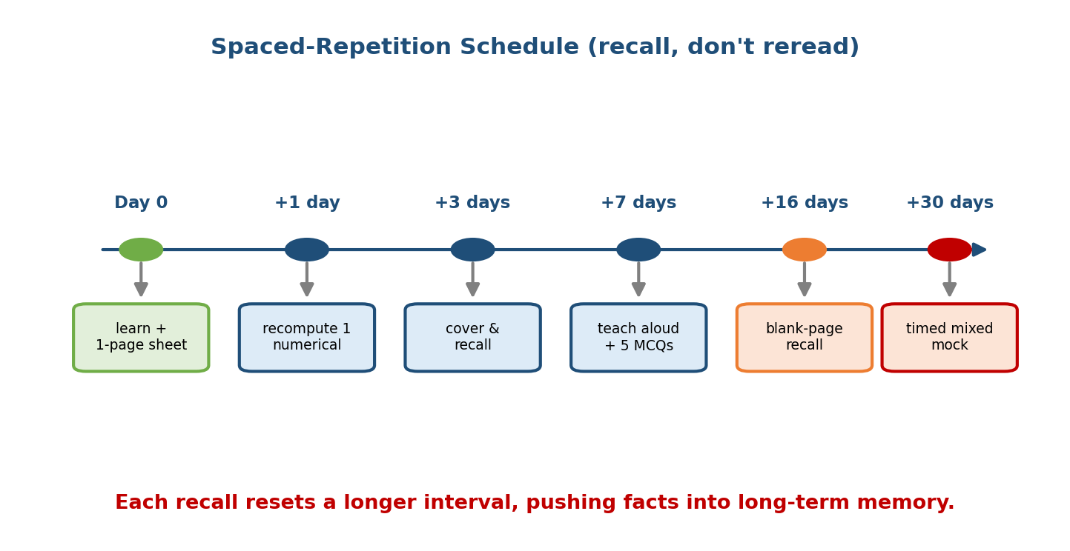
Spaced-repetition timeline: review at 1 day, 3 days, 7 days, 16 days, and 30 days — each review resets a longer interval, moving facts into long-term memory before exam day.
Map each module to a first-learn day, then review on the offsets below. Tick the box each time you recall from memory (not reread).
Interval | What you do | Time
Same day | Read the module + its one-page sheet (§24.5) | 30 min
+1 day | Recompute ONE numerical from the module; recite its flash cards | 10 min
+3 days | Cover-and-recall the cheat sheet; redo a harder numerical | 15 min
+7 days | Teach the topic aloud; do 5 mixed MCQs | 15 min
+16 days | Full-topic recall from a blank page | 20 min
+30 days | Timed mixed set (all modules) | 45 min
The 3-week countdown plan (before the exam): - Weeks −3 to −2: one cluster per day (process world → memory world → storage world), always with a hand-computed numerical. - Week −1: only §24.2 (formulas), §24.8 (traps), and §24.10 (one-liners); one full mixed mock daily. - Last 24 h: read §24.2, §24.8, §24.12 only. Sleep. Do not learn anything new.

24.8 Common Mistakes & Exam Traps (reclaim these marks)
- Rotational latency = ½ rotation, not a full one. (½ × 60/RPM.)
- RAID 0 has NO fault tolerance (despite the “0”); RAID 5 needs ≥3, RAID 6 ≥4.
- Belady’s anomaly is FIFO-only. LRU and Optimal are stack algorithms — immune.
- Optimal ≤ LRU always; Optimal is a theoretical lower bound (needs the future).
- SJF minimises average WT but can starve long jobs (needs burst prediction).
- RR: huge quantum → FCFS; tiny quantum → overhead. State the quantum you assume.
- Safe state ≠ deadlock-free forever — it means a finishing sequence exists now.
- A cycle in a RAG ⇒ deadlock only with single-instance resources; multi-instance needs the detection algorithm.
- Paging removes external fragmentation but adds internal (last page); pure segmentation is the opposite.
- EAT with page faults — convert units! ms vs ns differ by 10⁶; a tiny fault rate dominates the average.
- TLB EAT — on a miss you pay the page-table walk plus the data access (t + 2m for single-level).
- Inode max size — remember to add single + double + triple indirect, not just direct; and multiply by the block size at the end.
- Deadlock’s four conditions are necessary together — breaking any one prevents deadlock.
- Semaphore vs mutex: a mutex has an owner (only the locker unlocks); a semaphore is a counter anyone can signal.
- wait() reaps a child — forgetting it leaves zombies; the child’s parent must reap, or init adopts an orphan.
- Preemptive vs non-preemptive — SJF is non-preemptive, SRTF is its preemptive version; don’t mix the averages.
- Thrashing is a memory problem (too little RAM for the working set), not a CPU or disk-speed problem.

24.9 Last-Minute Exam Strategy
Before you start: - Skim the whole paper; mark the numericals — they are the highest, most certain marks. Do the ones you recognise (scheduling, EAT, disk, Banker’s) first. - Keep a formula strip in your head from §24.2: TAT/WT, EAT(TLB), EAT(fault), head-movement, Need=Max−Alloc, inode (d+N+N²+N³)·B, RMS n(2^(1/n)−1).
During numericals: - Draw the Gantt chart / page-frame table / RAG — never compute in your head. - Write units at every step (ns vs ms); convert once, up front. - For page-replacement, draw the frames as columns and mark hit/fault per column. - For Banker’s, write the Need matrix first, then sweep for a satisfiable process. - Recompute the average — a single arithmetic slip loses the whole sub-question.
For MCQs / one-liners: - Trust the traps list (§24.8): RAID-0, Belady=FIFO, ½ rotation, safe≠safe-forever. - Eliminate absolutes (“always/never”) unless you’re sure.
Time & nerves: - Budget ~1 min per mark; flag and move on if stuck — return later. - The night before: §24.2 + §24.8 + §24.10 only. Then sleep — recall beats cramming.

24.10 The 50 Most Important One-Liners
- OS = resource manager + extended (virtual) machine.
- App reaches the OS via a system call (trap to kernel mode).
- The always-resident core is the kernel.
- Multiprogramming = many jobs in RAM, 1 CPU switches on I/O wait.
- Multitasking = multiprogramming + rapid time slices (interactive).
- Multiprocessing = many CPUs, true parallelism.
- Hard RTOS: missed deadline = failure; soft: tolerable.
- Spooling = disk as buffer for a slow device (printer queue).
- Type-1 hypervisor = bare-metal; Type-2 = hosted.
- PCB stores PID, state, PC, registers, memory maps, open files.
- Process states: new → ready → running → waiting → terminated.
- fork returns 0 to child, child-PID to parent.
- exec replaces the image; wait reaps the child.
- Zombie = dead, un-waited; orphan → adopted by init (PID 1).
- Context switch saves/restores registers, PC, stack pointer.
- Threads share code/data/heap/files but own stack + registers + PC.
- Thread switch < process switch (same address space, no TLB flush).
- Thread models: many-to-one, one-to-one, many-to-many.
- SJF/SRTF = minimum average waiting time (optimal).
- RR quantum: too big → FCFS, too small → overhead.
- Priority scheduling → starvation → fixed by aging.
- Convoy effect = a long job stalls the FCFS queue.
- TAT = Completion − Arrival; WT = TAT − Burst.
- Critical section needs mutual exclusion + progress + bounded waiting.
- Semaphore = counter with wait/signal; mutex has an owner.
- Peterson’s algorithm = software mutex for two processes.
- Bounded buffer uses semaphores empty=N, full=0, mutex=1.
- Priority inversion fixed by priority inheritance.
- Deadlock needs 4 conditions together: mutual excl., hold-and-wait, no preempt, circular wait.
- Break any one condition → no deadlock.
- Banker’s: Need = Max − Allocation; find a safe sequence.
- Safe state ≠ deadlock-free forever; unsafe may deadlock.
- RAG cycle ⇒ deadlock iff single-instance resources.
- Paging removes external fragmentation, adds small internal.
- Segmentation is logical/variable-size → external fragmentation.
- MMU translates logical → physical addresses.
- TLB caches page-table entries; a hit avoids the walk.
- EAT(TLB, single-level) = h(t+m) + (1−h)(t+2m).
- Demand paging loads pages on fault; EAT dominated by fault cost (~ms).
- Belady’s anomaly = more frames, more faults — FIFO only.
- Optimal evicts the page used farthest in the future (lower bound).
- LRU/Optimal are stack algorithms — immune to Belady.
- Thrashing = excessive paging; fix with working-set / PFF.
- Copy-on-write makes fork cheap (share until a write).
- Inode holds metadata + block pointers but not the file name.
- Inode max size = (direct + N + N² + N³) × block, N = block/pointer.
- Hard link = same inode; soft link = a path string.
- Disk access = seek + ½-rotation + transfer.
- SSTF = least head movement but can starve; SCAN/C-SCAN = fair elevator.
- RAID 0 = no redundancy; RAID 5 ≥3 disks; RMS bound → ln 2 ≈ 0.693.

24.11 Concept Checks (mixed, all modules)
- Average WT for the §24.2 FCFS example? → 5.75.
- Which policy minimises average WT? → SJF/SRTF.
- EAT with h=80%, TLB=20 ns, mem=100 ns? → 140 ns.
- EAT with p=0.001, mem=100 ns, fault=8 ms? → ≈ 8100 ns.
- FIFO on 1 2 3 4 1 2 5 1 2 3 4 5: faults at 3 vs 4 frames? → 9 vs 10 (Belady).
- Least disk head movement here (§24.2 H)? → SSTF (236).
- Banker’s safe sequence for the §24.2 I example? → P1,P3,P4,P0,P2 (safe).
- RMS bound for n=3? → ≈ 0.780.
- Inode max size, B=4 KB, P=4 B, 12 direct? → ≈ 4 TB.
- EAT cache with H=90%, Tc=10, Tm=100? → 19 ns.
- Which fragmentation does paging cure? → external.
- Which replacement policies are immune to Belady? → LRU and Optimal.
- Number of pages if logical space 2^32, page 2^12? → 2^20 = 1,048,576.
- Deadlock’s four conditions? → mutual excl., hold-and-wait, no preempt, circular wait.
- Average rotational latency at 6000 RPM? → 5 ms.

24.12 One-Page Revision Sheet (the revision of the revision)
FORMULAS (verified):
TAT=CT-AT ; WT=TAT-BT ; avg=Σ/n ; SJF=min avg WT ; RR: big q->FCFS, small q->overhead
EAT(TLB,1lvl)= h(t+m)+(1-h)(t+2m) e.g. .8(120)+.2(220)=140ns
EAT(cache) = H*Tc+(1-H)*Tm e.g. .9*10+.1*100=19ns
EAT(faults) = (1-p)*ma + p*service e.g. .999*100+.001*8e6=8099.9ns
RMS bound = n(2^(1/n)-1) -> ln2=.693 ; EDF: U<=1
DISK access = seek + (1/2)(60/RPM) + transfer ; head move = Σ|Δ|
BANKER = Need=Max-Alloc ; safe if a seq lets all finish (P1,P3,P4,P0,P2)
INODE max = (d + N + N^2 + N^3)*B , N=B/P (4KB/4B,12 direct ~ 4TB)
PAGING = offset=n bits, pages=2^(m-n) ; paging kills EXTERNAL frag
TRAPS: rot latency=1/2 rotation | RAID0=no redundancy | Belady=FIFO only |
OPT<=LRU | safe!=deadlock-free forever | cycle=>deadlock iff single-instance |
SJF starves | thrashing=memory problem | convert ms<->ns (10^6)
DISK MOVEMENT (head53, 8 reqs): FCFS640 SSTF236 SCAN331 C-SCAN382 (SSTF least, may starve)
PAGE FAULTS (1,2,3,4,1,2,5,1,2,3,4,5): FIFO 3f=9 4f=10(Belady) | LRU=10 | OPT=7
CLUSTERS: [process: M4-M8] [memory: M2,M9,M10] [storage: M11,M12] [system: M1-M3,M14]
DEADLOCK 4: mutual-excl, hold-and-wait, no-preempt, circular-wait (break ANY one)

Flash cards (the final ten)
Front | Back
WT formula? | (Completion − Arrival) − Burst
Min avg WT algo? | SJF / SRTF
Belady’s anomaly? | FIFO only (more frames → more faults)
Optimal replacement? | Evict page used farthest in future
EAT(TLB) single-level? | h(t+m) + (1−h)(t+2m)
Banker’s Need? | Max − Allocation
Inode max size? | (d + N + N² + N³) × block
Least head movement? | SSTF (but starves)
RMS bound as n→∞? | ln 2 ≈ 0.693
4 deadlock conditions? | mutual-excl, hold-wait, no-preempt, circular-wait

Spaced repetition
- 24-hour: recompute one Gantt chart, one EAT, one page-fault count — from blank.
- 7-day: do the disk-movement four-way and a Banker’s safe sequence cold.
- 30-day: a full timed mixed mock across all modules; then reread §24.8 traps.

24.13 Summary — and the close of the whole course
This module is your compression of the entire OS course into a single sprint kit. The master formula sheet (§24.2) holds every numerical you can be asked — scheduling averages, EAT with TLB and with page faults, page-fault counting with Belady’s anomaly, disk head movement, the Banker’s safe sequence, the RMS bound n(2^(1/n)−1), and the inode max-file-size formula — each one recomputed and verified, not remembered. Around it sit the tools to retain it: a topic dependency graph and mind-maps to see the shape of the subject, one-page cheat sheets per module, a consolidated flash-card deck, a spaced-repetition schedule, the exam traps that quietly cost marks, a last-minute strategy, and the 50 one-liners that carry the most weight.
Step back and see what you have built across twenty-four modules. You started at “what is an OS?” and can now explain how a computer shares itself fairly, safely, and fast — how a process is born (fork/exec) and scheduled (FCFS→SJF→RR), how threads and semaphores tame concurrency without deadlock, how virtual memory gives every program its own vast address space over a tiny RAM, how file systems and disks turn spinning platters into named files, and how the kernel sits beneath it all. In M23 you even built small versions yourself. That is the whole arc of the subject — from the first system call to a shell you wrote.
Revise with recall, not rereading; lead with the numericals; respect the traps. Do that, and you walk into any SEBI / RBI / NABARD / GATE / C-DAC paper — or any systems interview — knowing not just the answers, but why they are the answers.
You have mastered this module — and the course — when you can: reproduce the master formula sheet from memory and compute every OS numerical cold; draw the topic dependency graph and place any concept on it; recite the 50 one-liners and the exam traps without hesitation; and explain, end to end, how an operating system shares a computer fairly, safely, and fast. That is OS mastery. Go earn the marks.

