Module 2 — The Physical Layer & Transmission Media
  - Computer Networks Mastery: SEBI IT / RBI / NABARD / GATE / C-DAC / Interview / Backend — In-Depth Notes (with visuals)
Prepared for nidhi.sharma@forensiccybertech.com
2026
Table of Contents

Module 2 — The Physical Layer & Transmission Media
Where this module sits. Module 1 gave us the layered map. Now we start at the very bottom — Layer 1, the Physical layer — whose only job is to move raw bits as signals across a medium. Everything above depends on this: if the physical link is slow or noisy, no clever protocol above can fix it. This module explains signals, the two famous limits (Nyquist & Shannon) that cap how fast any link can go, the media (copper, fibre, air), the performance metrics (bandwidth, latency, bandwidth-delay product) you’ll use for the rest of the course, and multiplexing. The Nyquist/Shannon numericals are a GATE/C-DAC staple.
Importance ratings (out of 5):
Exam / Use | SEBI IT | RBI IT | GATE CS | Interview | Backend
This module | ★★★ | ★★★ | ★★★★ | ★★ | ★★★
Most-asked PYQ concepts (SEBI / RBI / GATE / C-DAC): Nyquist (noiseless) and Shannon (noisy) channel-capacity numericals; bit rate vs baud rate; bandwidth; transmission impairments (attenuation, distortion, noise); guided vs unguided media (and “which is fastest / immune to EMI” → fibre); bandwidth-delay product; multiplexing (FDM/TDM/WDM); propagation vs transmission delay.

2.1 Data, Signals, Analog vs Digital
Data is information; a signal is the electrical/optical/radio representation that actually travels. Both data and signals can be analog (continuous) or digital (discrete levels).
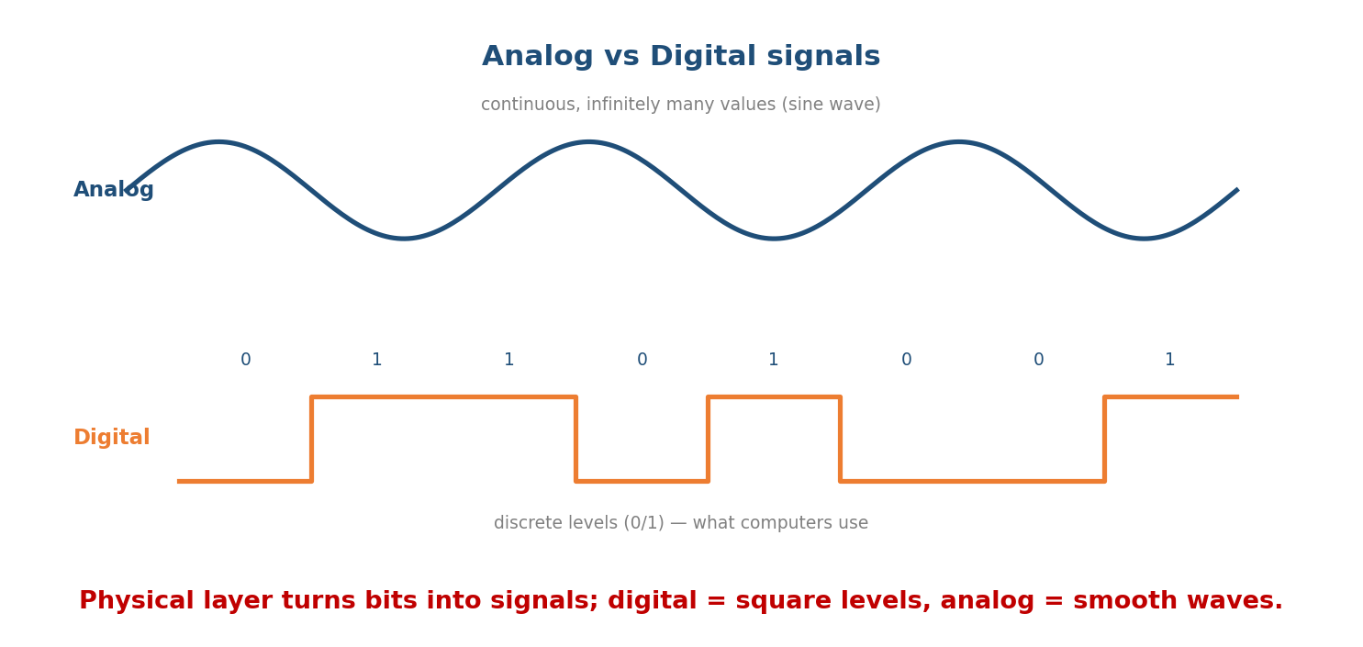
Analog signals are continuous waves; digital signals are discrete 0/1 levels — what computers send.
- Analog signal: a smooth wave with infinitely many values (e.g. a sine wave; voice on an old phone line).
- Digital signal: discrete levels — for binary, two levels for 0 and 1.
A periodic signal has three properties: amplitude (height/strength), frequency (cycles per second, Hz), and phase (shift). Frequency is the inverse of period: f = 1/T.
Memory hook: analog = a dimmer knob (any brightness); digital = a light switch (only on/off). Computers speak switches.

MCQs
- Frequency unit? → hertz (Hz) = cycles/second.
- f = ? in terms of period T? → 1/T.
- Which signal type do computers natively use? → digital.

2.2 Bandwidth, Bit Rate & Baud Rate (don’t mix these up)
- Bandwidth (analog sense): the range of frequencies a channel passes, measured in Hz (e.g. a channel from 1000–4000 Hz has bandwidth 3000 Hz).
- Bandwidth (digital/networking sense): loosely, the maximum bit rate a link can carry, in bits per second (bps).
- Bit rate: number of bits sent per second (bps).
- Baud rate (signal rate): number of signal units (symbols) sent per second.
The link between them: bit rate = baud rate × log₂(L), where L = number of signal levels (bits carried per symbol = log₂ L).
Memory hook: baud = symbols/sec, bit rate = bits/sec. If each symbol carries 2 bits (4 levels), the bit rate is twice the baud rate. Baud ≤ bit rate.
Worked example: a signal with baud = 1000 symbols/s using L = 8 levels → bit rate = 1000 × log₂8 = 1000 × 3 = 3000 bps.

MCQs
- Baud rate measures? → symbols (signal units) per second.
- bit rate = baud × ? → log₂(L) (L = levels).
- 2000 baud with 4 levels → bit rate? → 2000 × log₂4 = 2000 × 2 = 4000 bps.

2.3 Channel Capacity — Nyquist & Shannon (the GATE numericals)
Two formulas cap how fast a channel can go. Learn both and when to use which.

Nyquist — noiseless channel (theoretical max, you choose the levels)
C = 2 × B × log₂(L) bits/second
B = bandwidth (Hz), L = number of signal levels
Use Nyquist when the question is noiseless and gives you the number of levels.
Worked example: B = 3000 Hz, L = 2 (binary) → C = 2 × 3000 × log₂2 = 6000 × 1 = 6000 bps. With L = 4 → 2 × 3000 × 2 = 12000 bps.

Shannon — noisy channel (real-world max, set by noise)
C = B × log₂(1 + S/N) bits/second
S/N = signal-to-noise power ratio (a plain ratio, NOT decibels)
If S/N is given in decibels (dB), convert first: S/N = 10^(dB/10). A famous shortcut: log₂(1 + S/N) ≈ SNR_dB / 3 for large SNR.
Worked example: B = 3000 Hz, SNR = 30 dB → S/N = 10^(30/10) = 10³ = 1000 → C = 3000 × log₂(1001) ≈ 3000 × 9.97 ≈ 29,900 bps (≈ 30 kbps — the classic dial-up modem limit).

Which one? (the exam trick)
- Noiseless + levels given → Nyquist.
- Noisy + SNR given → Shannon.
- Both given → compute both and take the smaller (Shannon caps the true rate; Nyquist then tells you how many levels you may use).
Memory hook: Nyquist = “how many levels can I squeeze in?” (you control it). Shannon = “how much noise will let through?” (nature controls it). The real limit is the lower of the two.

MCQs
- Nyquist capacity formula? → C = 2B·log₂L.
- Shannon capacity formula? → C = B·log₂(1 + S/N).
- SNR = 30 dB as a ratio? → 1000 (10^(30/10)).
- If Nyquist gives 12 kbps and Shannon gives 8 kbps, the usable capacity is? → 8 kbps (the smaller).

2.4 Transmission Impairments (why signals degrade)
Signals weaken and distort as they travel. Three impairments:
Impairment | What happens | Fix
Attenuation | signal loses strength with distance | amplifiers (analog) / repeaters (digital)
Distortion | signal shape changes (components travel at different speeds) | equalisation
Noise | unwanted signals added (thermal, crosstalk, impulse) | shielding; higher SNR
Signal strength/loss is measured in decibels: dB = 10·log₁₀(P₂/P₁). A loss is negative dB; a gain is positive.
Memory hook: A-D-N: Attenuation (weaker), Distortion (mis-shapen), Noise (corrupted). Repeaters fight attenuation; SNR fights noise.

MCQs
- Loss of strength over distance? → attenuation.
- Digital device that regenerates a weakened signal? → repeater.
- Crosstalk is a form of? → noise.

2.5 Transmission Media — Guided vs Unguided
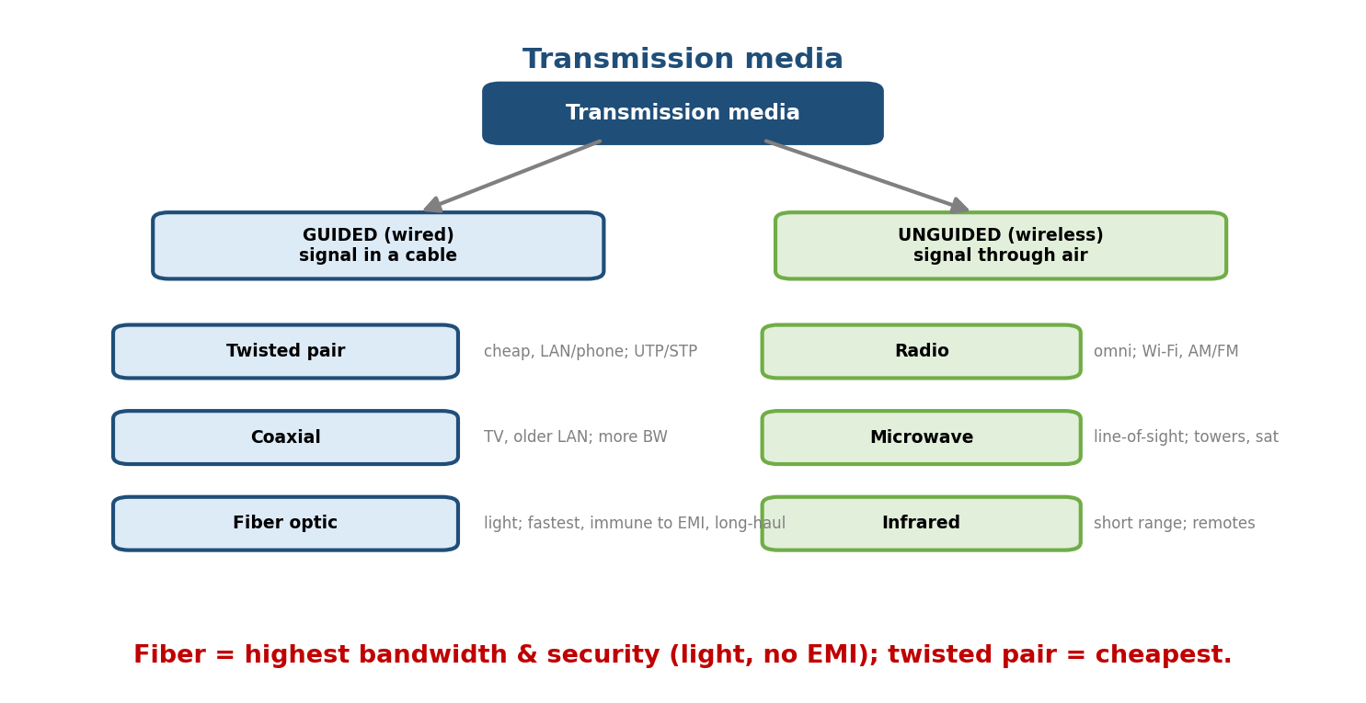
Guided media carry the signal inside a cable (twisted pair, coax, fibre); unguided media send it through air (radio, microwave, infrared).

Guided (wired)
Medium | Notes
Twisted pair (UTP/STP) | cheapest; phone & most LAN cabling (Cat5e/6); twisting reduces crosstalk; limited distance
Coaxial cable | more bandwidth & noise-immunity than twisted pair; cable TV, older LANs
Fibre optic | carries light; highest bandwidth, immune to EMI, very low attenuation, most secure; backbone & long-haul. Single-mode (long) vs multi-mode (short)

Unguided (wireless)
Medium | Notes
Radio waves | omnidirectional; Wi-Fi, AM/FM, cellular
Microwave | line-of-sight; towers & satellites; high bandwidth
Infrared | short-range, can’t pass walls; remotes, old IrDA
Memory hook: Fibre wins on speed, distance, and security (it’s light — no electromagnetic interference and hard to tap). Twisted pair wins on cost.

MCQs
- Fastest, EMI-immune guided medium? → fibre optic.
- Cheapest guided medium? → twisted pair.
- Which wireless medium needs line-of-sight? → microwave.
- Fibre carries data as? → light.

2.6 Network Performance — the Metrics You’ll Use All Course
- Bandwidth — max data rate of the link (bps).
- Throughput — actual measured rate (always ≤ bandwidth).
- Latency (delay) — total time for one bit/message to arrive, made of four parts:
Total delay = Transmission + Propagation + Queuing + Processing
Transmission delay = message size / bandwidth (time to PUSH bits onto link)
Propagation delay = distance / propagation speed (time for a bit to TRAVEL)
- Jitter — variation in delay (bad for voice/video).
- Bandwidth-Delay Product (BDP) = bandwidth × RTT = the number of bits “in flight” the link can hold — it sets how big TCP’s window must be (Module 8).
Worked example (transmission vs propagation): send a 1000-bit message over a 1 Mbps link that is 2000 km long (propagation speed 2×10⁸ m/s): - Transmission delay = 1000 / 10⁶ = 1 ms. - Propagation delay = 2×10⁶ m / 2×10⁸ = 10 ms. - Total ≈ 11 ms — here propagation dominates (long link, small message).
Memory hook: transmission delay = how long to load the truck; propagation delay = how long the truck drives to the destination.

MCQs
- Time to put all bits on the wire? → transmission delay = size/bandwidth.
- Time for a bit to travel the distance? → propagation delay = distance/speed.
- Bandwidth-delay product = ? → bandwidth × RTT (bits in flight).
- Variation in delay is called? → jitter.

2.7 Multiplexing — Sharing One Link
Multiplexing lets several signals share one physical link (a multiplexer combines them, a demultiplexer splits them at the far end).
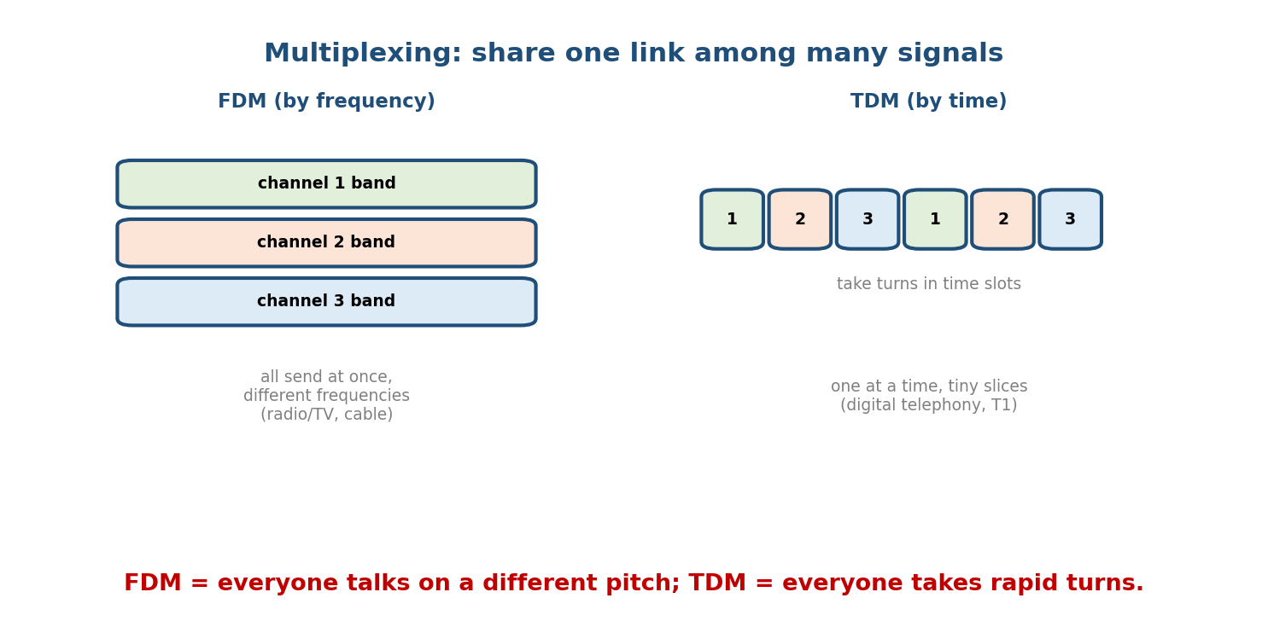
FDM gives each signal its own frequency band (all send at once); TDM gives each signal a time slot (they take turns).
Technique | Shares by | Example
FDM (Frequency-Division) | different frequency bands, all at once | radio/TV, cable
TDM (Time-Division) | different time slots, taking turns | digital telephony (T1/E1)
WDM (Wavelength-Division) | different light wavelengths (FDM for fibre) | fibre backbones
CDM/CDMA (Code-Division) | different codes, all at once | some cellular
TDM comes in two flavours: synchronous (fixed slots, even if a source is idle → wasted slots) and statistical (slots given on demand → efficient).
Memory hook: FDM = different radio stations (pitch); TDM = taking turns (time); WDM = different colours of light; CDMA = everyone talks at once in a different language (code).

MCQs
- FDM shares by? → frequency. TDM by? → time.
- WDM is basically FDM applied to? → fibre (light wavelengths).
- TDM type that wastes idle slots? → synchronous TDM.

2.8 Switching (how data crosses a network of links)
To connect many devices we don’t wire every pair; we route through switches.
- Circuit switching: reserve a dedicated path for the whole call (telephone network). Pros: guaranteed bandwidth. Cons: wastes capacity when idle; setup delay.
- Packet switching: data is split into packets, each routed independently; links are shared on demand (the Internet). Two sub-types:
  - Datagram (connectionless — IP): each packet routed independently, may arrive out of order.
  - Virtual circuit (connection-oriented — e.g. MPLS/ATM): a path is set up first, all packets follow it.
- Message switching: whole message stored-and-forwarded hop by hop (old telegraph; high delay).
Memory hook: circuit = a reserved private lane (phone); packet = everyone shares the road, cars routed independently (Internet).

MCQs
- The Internet uses which switching? → packet switching (datagram).
- Guaranteed dedicated bandwidth but wasteful when idle? → circuit switching.
- IP is datagram or virtual-circuit? → datagram (connectionless).

2.9 Real-World & Backend Perspectives
- BDP is why “fat long-distance links” need big TCP windows — a 1 Gbps link across the world (RTT 200 ms) holds 10⁹ × 0.2 = 200 Mbit ≈ 25 MB in flight; if TCP’s window is smaller, you can’t fill the pipe (Module 8; “long fat networks”).
- Latency ≠ bandwidth: a backend truth — adding bandwidth won’t fix a latency-bound app; propagation delay (speed of light) is a hard floor. This is why CDNs put content physically closer to users (Module 12).
- Fibre everywhere: data-center and backbone links are fibre for bandwidth and distance; “dark fibre” and WDM carry terabits per strand.

2.10 Tradeoffs, Common Mistakes, Edge Cases
- Mistake: treating bit rate and baud rate as equal — they’re equal only when each symbol carries 1 bit (2 levels).
- Mistake: plugging dB directly into Shannon — convert S/N = 10^(dB/10) first.
- Trap: forgetting the ×2 in Nyquist (C = 2B·log₂L, not B·log₂L).
- Edge case: more signal levels raise capacity (Nyquist) but are harder to tell apart under noise — Shannon is the real ceiling.

2.11 Exam, Interview & Coding Perspectives
- SEBI / RBI / NABARD: conceptual — media comparison (“which is fastest/immune to EMI”), analog vs digital, multiplexing types, switching types.
- GATE / C-DAC: the numericals — Nyquist, Shannon (with dB conversion), bit vs baud, transmission vs propagation delay, BDP. Practice until automatic.
- Interview: “difference between latency and bandwidth?” and “why does a CDN help?” — answer with propagation delay + BDP.

2.12 Concept Checks & MCQs (test yourself)
- Nyquist for B = 4 kHz, L = 4? → 2 × 4000 × 2 = 16,000 bps.
- Shannon for B = 1 kHz, S/N = 63? → 1000 × log₂64 = 6000 bps.
- Bit rate if baud = 4000, 16 levels? → 4000 × log₂16 = 16,000 bps.
- Which impairment do repeaters fight? → attenuation.
- Guided medium immune to EMI? → fibre optic.
- FDM vs TDM share by? → frequency vs time.
- Internet switching type? → packet (datagram).
- Transmission delay formula? → message size / bandwidth.
- BDP formula and meaning? → bandwidth × RTT = bits in flight.
- 40 dB SNR as a ratio? → 10,000 (10⁴).

2.13 One-Page Revision Sheet
PHYSICAL LAYER (L1): move raw BITS as signals. PDU = bits.
SIGNAL: analog(continuous wave) vs digital(discrete 0/1). f = 1/T (Hz). amp/freq/phase.
RATES: bandwidth(Hz analog | bps digital) ; bit rate(bits/s) ; baud(symbols/s).
bit rate = baud x log2(L). baud <= bit rate (equal only if L=2).
CAPACITY:
NYQUIST (noiseless): C = 2 * B * log2(L) <- you pick L
SHANNON (noisy): C = B * log2(1 + S/N) <- S/N is a RATIO
dB -> ratio: S/N = 10^(dB/10). approx log2(1+SNR) ~ dB/3.
BOTH given -> take the SMALLER. (Nyquist=levels, Shannon=noise ceiling.)
IMPAIRMENTS (A-D-N): Attenuation(weaker->repeater/amplifier) | Distortion(mis-shape) | Noise(SNR/shield).
dB = 10 log10(P2/P1).
MEDIA: GUIDED: twisted pair(cheap) < coax < FIBRE(fastest, EMI-immune, secure, light).
UNGUIDED: radio(omni,Wi-Fi) | microwave(line-of-sight, sat) | infrared(short,no walls).
PERFORMANCE: bandwidth>=throughput. Delay = Transmission(size/BW) + Propagation(dist/speed)
+ Queuing + Processing. Jitter = delay variation. BDP = BW x RTT = bits in flight.
Transmission = "load the truck"; Propagation = "truck drives there."
MULTIPLEXING: FDM(frequency) | TDM(time; sync wastes idle vs statistical) | WDM(light=FDM on fibre) | CDMA(codes).
SWITCHING: circuit(dedicated path, phone) | PACKET(shared; datagram=IP / virtual-circuit) | message(store-fwd).

Flash cards
Front | Back
Nyquist capacity | C = 2B·log₂L
Shannon capacity | C = B·log₂(1 + S/N)
dB → SNR ratio | 10^(dB/10)
bit rate vs baud | bit = baud × log₂L
Fastest / EMI-immune medium | fibre optic
Cheapest guided medium | twisted pair
Transmission delay | size / bandwidth
Propagation delay | distance / speed
Bandwidth-delay product | bandwidth × RTT
Internet switching | packet (datagram)

Spaced repetition
- 24-hour: redo one Nyquist and one Shannon numerical (with a dB→ratio step).
- 7-day: media comparison table; transmission vs propagation delay; multiplexing.
- 30-day: given B, L, and SNR, compute usable capacity and explain which limit binds.

2.14 Summary
The Physical layer turns bits into signals and pushes them across a medium. Signals are analog (continuous) or digital (discrete). We distinguish bandwidth, bit rate, and baud rate (bit rate = baud × log₂L), and cap throughput with two formulas: Nyquist (C = 2B·log₂L, noiseless) and Shannon (C = B·log₂(1+S/N), noisy) — with the real limit being the smaller. Signals suffer attenuation, distortion, and noise. Media split into guided (twisted pair → coax → fibre, the fastest and EMI-immune) and unguided (radio, microwave, infrared). We measure links by bandwidth, throughput, and delay (transmission + propagation + queuing + processing), and reason about pipes with the bandwidth-delay product. Finally, multiplexing (FDM/TDM/WDM/CDMA) shares a link, and switching (circuit vs packet) moves data across a network.
Next, Module 3 — The Data Link Layer climbs to Layer 2: how bits are grouped into frames, how errors are detected and corrected (parity, checksum, CRC, Hamming code), and how flow is controlled (stop-and-wait, sliding window) — with more high-value numericals.
You have mastered this module when you can: pick and apply Nyquist vs Shannon (converting dB), separate bit rate from baud, rank the media by speed/cost/EMI, split total delay into its four parts and compute transmission vs propagation delay, define the bandwidth-delay product, and contrast FDM/TDM and circuit/packet switching — all without notes.

