Module 3 — The Data Link Layer (Framing, Error & Flow Control)
  - Computer Networks Mastery: SEBI IT / RBI / NABARD / GATE / C-DAC / Interview / Backend — In-Depth Notes (with visuals)
Prepared for nidhi.sharma@forensiccybertech.com
2026
Table of Contents

Module 3 — The Data Link Layer (Framing, Error & Flow Control)
Where this module sits. The Physical layer (M2) moves raw bits but makes no promises — bits can flip, and a fast sender can drown a slow receiver. Layer 2, the Data Link layer (DLL), turns that unreliable bit-pipe into a reliable link between two directly-connected nodes. It groups bits into frames, detects and corrects errors, and controls the flow so nobody is overwhelmed. This is one of the most numerical-heavy modules in the syllabus — CRC, Hamming code, and sliding-window efficiency calculations appear in almost every GATE/C-DAC paper.
Importance ratings (out of 5):
Exam / Use | SEBI IT | RBI IT | GATE CS | Interview | Backend
This module | ★★★ | ★★★ | ★★★★★ | ★★ | ★★
Most-asked PYQ concepts (SEBI / RBI / GATE / C-DAC): CRC computation (polynomial division); Hamming code (number of parity bits, error position); framing (bit stuffing / byte stuffing); stop-and-wait vs sliding window efficiency (U = 1/(1+2a)); Go-Back-N vs Selective Repeat (window sizes 2^m−1 vs 2^(m−1)); piggybacking; parity vs checksum vs CRC (detection power).

3.1 What the Data Link Layer Does (first principles)
The DLL provides node-to-node delivery over one link. Its jobs:
- Framing — group bits into frames with clear start/end.
- Physical addressing — put source/destination MAC addresses on the frame (details in M4).
- Error control — detect (and sometimes correct) bit errors.
- Flow control — stop a fast sender from overwhelming a slow receiver.
- Access control — decide who may transmit when the medium is shared (M4).
The DLL has two sublayers: LLC (Logical Link Control — flow/error control) and MAC (Media Access Control — addressing + who-talks-when, covered in M4).
Memory hook: the DLL is a careful courier for one leg of the journey — it boxes the goods (framing), labels them (MAC), checks nothing broke (error control), and doesn’t hand over faster than the receiver can take (flow control).

MCQs
- The DLL delivers between? → two directly-connected nodes (node-to-node).
- Two DLL sublayers? → LLC and MAC.
- Which layer adds the MAC address? → Data Link (2).

3.2 Framing — Where Does a Frame Start and End?
The receiver sees a stream of bits; framing marks boundaries. Methods:
- Character/byte count: first field says how many bytes follow. Fragile — if the count is corrupted, all following frames desync.
- Byte (character) stuffing: mark frame with a FLAG byte; if the flag appears in data, insert an escape (ESC) byte before it (and escape the ESC too).
- Bit stuffing: frame delimited by the flag 01111110. In the data, after five consecutive 1s the sender inserts a 0; the receiver removes it. This guarantees the flag never appears inside data.
Bit-stuffing worked example: data 0111111 0111110 → after every five 1s insert a 0 → 011111**0**1 0111110 (sender stuffs a 0 after the first five 1s). The receiver strips the stuffed 0 to recover the original.
Memory hook: bit stuffing = “after five 1s, sneak in a 0” so the real flag 01111110 is never faked by the data.

MCQs
- Flag pattern in bit stuffing? → 01111110.
- Bit-stuffing rule? → after five consecutive 1s, insert a 0.
- Byte stuffing uses which special byte before a data-flag? → ESC.

3.3 Error Detection — Parity, Checksum, CRC
Noise flips bits. Detection adds redundant bits so the receiver can tell something changed (it can’t necessarily fix it).

Parity
- Simple (1-D) parity: add one bit so the total number of 1s is even (even parity). Detects any odd number of bit errors; misses even-numbered errors.
- 2-D parity: parity per row and per column — detects and can locate many errors.

Checksum
Sum the data words (with end-around carry), send the complement; receiver re-adds everything and expects all-1s. Used by IP/TCP/UDP headers. Weaker than CRC.

CRC (Cyclic Redundancy Check) — the workhorse
Treats the bit string as a polynomial and divides by a generator polynomial (using XOR / modulo-2 arithmetic). The remainder (CRC) is appended. The receiver divides the whole thing by the same generator — a non-zero remainder means error.
CRC worked example
Data : 1101011011 Generator G : 10011 (degree 4 -> append 4 zeros)
Dividend : 1101011011 0000 (data << 4)
Modulo-2 (XOR) long division by 10011:
1101011011 0000 ÷ 10011
... performing XOR division ...
Remainder (CRC) = 1110
Transmit : 1101011011 1110 (data + CRC)
Receiver : divides received frame by 10011 ->
remainder 0000 = OK ; non-zero = ERROR detected.
- A CRC with an r-bit remainder needs a generator of degree r (r+1 bits) and appends r zero bits to the data before dividing.
- CRC catches all single-bit errors, all odd errors (if G has a factor x+1), all burst errors shorter than r, and most longer ones — far stronger than checksum.
Memory hook: CRC = binary long division with XOR; remainder 0 at the receiver = clean. Degree of generator = number of CRC bits = zeros you append.

MCQs
- Simple parity misses which errors? → an even number of bit flips.
- CRC uses which arithmetic? → modulo-2 (XOR) polynomial division.
- Generator of degree r → how many CRC bits / appended zeros? → r.
- Receiver’s remainder is 0 → ? → no error detected.

3.4 Error Correction — Hamming Code
Detection just says “something broke.” Hamming code can correct a single-bit error by adding parity bits at power-of-two positions.
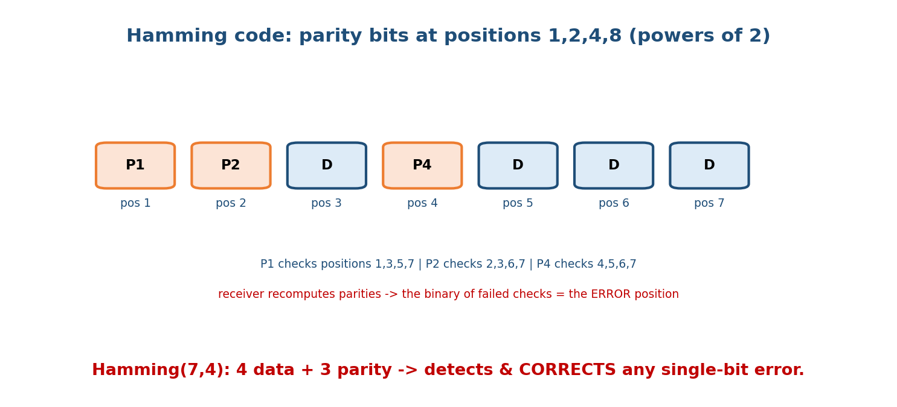
Hamming code places parity bits at positions 1,2,4,8…; each parity checks a fixed set of positions, so the failed checks spell out the error’s position in binary.
- Number of parity bits r for m data bits: choose the smallest r with 2^r ≥ m + r + 1.
- Placement: parity bits go at positions 1, 2, 4, 8, … (powers of 2); data fills the rest.
- Each parity covers positions whose binary index includes its bit: P1 checks 1,3,5,7…; P2 checks 2,3,6,7…; P4 checks 4,5,6,7,12….
- At the receiver: recompute each parity; the binary number formed by the failing checks is the position of the wrong bit — flip it to correct.
Worked example: for m = 4 data bits, 2^r ≥ 4 + r + 1 → r = 3 (since 2³ = 8 ≥ 8). So Hamming(7,4): 7 total bits, 4 data + 3 parity, corrects any single-bit error.
Memory hook: parity bits sit at powers of two; the syndrome (which checks fail, read as binary) points straight at the broken bit.

Detection vs correction (a classic distinction)
- To detect up to d errors, you need Hamming distance d + 1.
- To correct up to d errors, you need Hamming distance 2d + 1.

MCQs
- Parity bits for 4 data bits? → 3 (Hamming(7,4)).
- Parity-bit positions? → powers of 2 (1,2,4,8…).
- Hamming distance to correct d errors? → 2d + 1.
- The failing-checks binary number gives? → the error position.

3.5 Flow Control & ARQ — Stop-and-Wait
Flow control matches sender speed to receiver capacity. ARQ (Automatic Repeat reQuest) adds reliability: lost/corrupt frames are retransmitted using ACKs and timeouts.
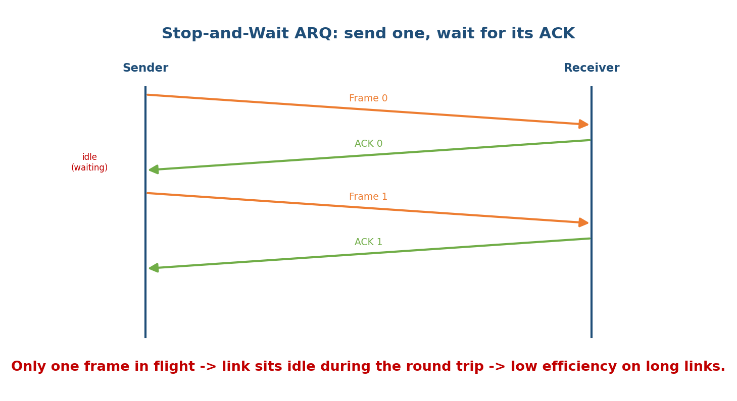
Stop-and-Wait: the sender transmits one frame and then waits for its ACK before sending the next, leaving the link idle for a full round trip.
Stop-and-Wait ARQ: send one frame, wait for its ACK, then send the next. Simple, but the link is idle during the round trip → poor efficiency on long/fast links.
Efficiency (the key formula). Let a = Tp / Tt where Tt = transmission time (frame/bandwidth) and Tp = propagation time:
Stop-and-Wait efficiency U = Tt / (Tt + 2·Tp) = 1 / (1 + 2a)
Throughput = U × Bandwidth
Worked example: bandwidth 1 Mbps, frame 1000 bits, Tp = 10 ms → Tt = 1000/10⁶ = 1 ms, a = 10/1 = 10 → U = 1/(1 + 20) = 1/21 ≈ 4.76%. The long link is almost idle — motivating sliding windows.

MCQs
- Stop-and-Wait efficiency? → 1/(1 + 2a), a = Tp/Tt.
- Why is Stop-and-Wait poor on long links? → link idle for the whole round trip.
- a is defined as? → Tp / Tt (propagation / transmission).

3.6 Sliding Window — Go-Back-N & Selective Repeat
To keep the pipe full, allow N unacknowledged frames in flight (a window).
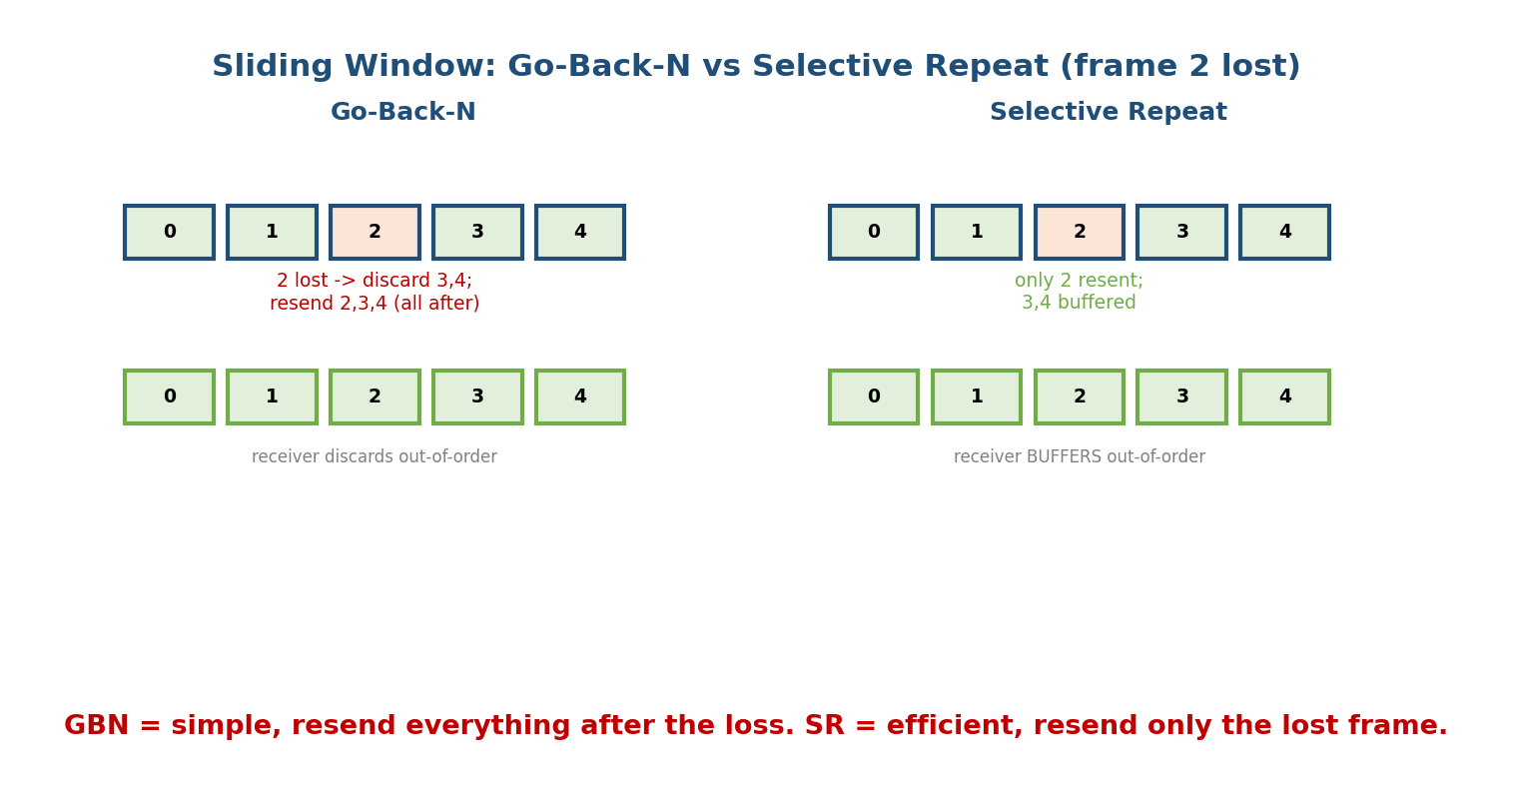
Go-Back-N discards out-of-order frames and resends everything from the lost frame; Selective Repeat buffers out-of-order frames and resends only the lost one.

Go-Back-N (GBN)
- Sender may send up to N frames without ACK; receiver accepts only in order and discards anything out of order.
- On a loss/timeout, the sender goes back and resends the lost frame and all after it. Simple receiver (no buffering), but wasteful on lossy links.
- Sender window ≤ 2^m − 1 (m = sequence-number bits). Receiver window = 1.

Selective Repeat (SR)
- Receiver buffers out-of-order frames and ACKs them individually; sender resends only the specific lost frame. Efficient but needs buffering + more bookkeeping.
- Sender & receiver window ≤ 2^(m−1) (must be ≤ half the sequence space to avoid ambiguity).

Efficiency (sliding window)
U = N / (1 + 2a) capped at 1 (when N ≥ 1 + 2a, the pipe is full, U = 100%)
N = window size, a = Tp/Tt
Optimal window to fill the pipe: N = 1 + 2a
Worked example: with a = 10 (from §3.5), Stop-and-Wait (N=1) gave 4.76%. To fill the pipe we need N = 1 + 2×10 = 21 frames in flight → U = 100%. This is why sliding windows exist.
Memory hook: GBN = “go back and redo from the mistake” (simple, wasteful). SR = “just redo the one that broke” (efficient, needs buffers). Window sizes: GBN 2^m−1, SR 2^(m−1).

MCQs
- GBN max sender window? → 2^m − 1. SR window? → 2^(m−1).
- Sliding-window efficiency? → N/(1 + 2a) (max 1).
- Which protocol buffers out-of-order frames? → Selective Repeat.
- Window size N to fully utilise the link? → N = 1 + 2a.

3.7 Piggybacking & Other Essentials
- Piggybacking: on a two-way link, attach the ACK for received data onto an outgoing data frame instead of sending a separate ACK — saves bandwidth (small delay while waiting for a data frame to ride on).
- NAK (negative ACK): explicitly requests a resend (used by Selective Repeat).
- Cumulative ACK: one ACK confirms all frames up to a number (GBN, TCP).

MCQs
- Combining an ACK with an outgoing data frame? → piggybacking.
- “ACK N” confirming everything up to N is a? → cumulative ACK.

3.8 Real-World & Backend Perspectives
- Ethernet frames (M4) are the DLL in practice: preamble, MAC addresses, type/length, payload, and a CRC-32 trailer (FCS) — exactly the framing + error detection here.
- The sliding window you learn here is the same idea TCP uses at Layer 4 (M8) — a window of unacknowledged data sized to the bandwidth-delay product (M2). DLL = one link; TCP = end-to-end, but the mechanism rhymes.
- Wi-Fi uses link-layer ARQ (retransmit lost frames) because radio is lossy — which is why Wi-Fi latency is jittery.

3.9 Tradeoffs, Common Mistakes, Edge Cases
- Mistake: confusing detection (parity/checksum/CRC — “something’s wrong”) with correction (Hamming — “fix it”). CRC does not correct.
- Mistake: SR window = 2^m − 1. It’s 2^(m−1) (half) — over-sizing causes sequence-number ambiguity.
- Trap: forgetting to append r zeros to the data before CRC division.
- Edge case: parity misses even-count errors; that’s why real links use CRC.

3.10 Exam, Interview & Coding Perspectives
- SEBI / RBI / NABARD: conceptual — framing methods, parity vs CRC vs Hamming, what piggybacking is, GBN vs SR difference.
- GATE / C-DAC: the numericals dominate — CRC remainder, Hamming parity-bit count & error position, stop-and-wait / sliding-window efficiency, window-size formulas. Drill these.
- Interview: “how does a sliding window improve throughput?” → the efficiency formula and bandwidth-delay-product intuition.

3.11 Concept Checks & MCQs (test yourself)
- Bit-stuffing rule and flag? → insert 0 after five 1s; flag 01111110.
- Generator degree 4 → CRC bits and appended zeros? → 4.
- Parity bits for 8 data bits? → smallest r with 2^r ≥ 8 + r + 1 → r = 4.
- Stop-and-Wait efficiency with a = 3? → 1/(1 + 6) = 1/7 ≈ 14.3%.
- GBN vs SR sender window (m bits)? → 2^m − 1 vs 2^(m−1).
- Sliding-window efficiency, N = 5, a = 2? → 5/(1 + 4) = 1 (100%).
- Which corrects a single-bit error? → Hamming code.
- Which is stronger detection: parity or CRC? → CRC.
- Combining ACK with a data frame? → piggybacking.
- Receiver discards out-of-order frames in? → Go-Back-N.

3.12 One-Page Revision Sheet
DLL (L2): node-to-node over ONE link. PDU=FRAME. Sublayers: LLC(flow/error)+MAC(address/access).
JOBS: framing, MAC addressing, error control, flow control, access control.
FRAMING: char-count(fragile) | byte stuffing(FLAG + ESC) | bit stuffing(after five 1s insert 0; flag 01111110).
ERROR DETECTION:
parity: even-parity; catches ODD errors, misses EVEN. 2-D locates errors.
checksum: sum + complement; used by IP/TCP/UDP; weak.
CRC: modulo-2 (XOR) poly division by generator G(degree r). append r zeros.
remainder=CRC; receiver remainder 0 => OK. catches bursts < r. STRONGEST.
ERROR CORRECTION (Hamming): parity at positions 1,2,4,8...(powers of 2).
parity bits r: smallest r with 2^r >= m+r+1. m=4 -> r=3 => Hamming(7,4).
syndrome (failed checks in binary) = ERROR POSITION -> flip it.
detect d errors: distance d+1 ; correct d: distance 2d+1.
FLOW/ARQ: a = Tp/Tt.
Stop-and-Wait U = 1/(1+2a).
Sliding window U = N/(1+2a) capped 1. Full pipe when N = 1+2a.
GBN: receiver in-order only, DISCARDS oob, resend-all-after-loss. Wsend <= 2^m - 1.
SR : receiver BUFFERS oob, resend-only-lost. Wsend=Wrecv <= 2^(m-1).
PIGGYBACKING = ACK rides on outgoing data. Cumulative ACK (GBN/TCP). NAK (SR).

Flash cards
Front | Back
Bit-stuffing rule | after five 1s, insert a 0 (flag 01111110)
CRC arithmetic | modulo-2 XOR polynomial division
CRC bits for gen degree r | r (append r zeros)
Hamming parity count | smallest r: 2^r ≥ m+r+1
Hamming parity positions | powers of 2 (1,2,4,8)
Correct d errors needs distance | 2d + 1
Stop-and-Wait efficiency | 1/(1+2a), a = Tp/Tt
Sliding-window efficiency | N/(1+2a), max 1
GBN vs SR window | 2^m−1 vs 2^(m−1)
Piggybacking | ACK carried on a data frame

Spaced repetition
- 24-hour: compute one CRC remainder and one Hamming parity-bit count from scratch.
- 7-day: stop-and-wait & sliding-window efficiency numericals; GBN vs SR windows.
- 30-day: given bandwidth/frame/Tp, find a, the efficiency, and the window size to reach 100% — without notes.

3.13 Summary
The Data Link layer turns the raw bit-pipe into a reliable link between two nodes. It performs framing (bit/byte stuffing), error detection (parity < checksum < CRC, the strongest, via modulo-2 division), and error correction (Hamming code, parity bits at powers of two, syndrome = error position). It controls flow and reliability with ARQ: Stop-and-Wait (efficiency 1/(1+2a), poor on long links) and sliding-window protocols — Go-Back-N (resend everything after a loss, window 2^m−1) and Selective Repeat (resend only the lost frame, window 2^(m−1)), with efficiency N/(1+2a). Extras like piggybacking and cumulative ACKs save bandwidth. These mechanisms reappear end-to-end in TCP (M8).
Next, Module 4 — The MAC Sublayer & LANs answers “who gets to talk on a shared medium?” — ALOHA, CSMA/CD (Ethernet), CSMA/CA (Wi-Fi), plus switching, ARP, and VLANs.
You have mastered this module when you can: stuff/unstuff bits, compute a CRC remainder and verify it, size and place Hamming parity bits and locate an error from the syndrome, derive stop-and-wait and sliding-window efficiency from a, and state the GBN vs SR window formulas and behaviours — all without notes.

