Module 9 — The Application Layer (DNS, HTTP, Email, DHCP)
  - Computer Networks Mastery: SEBI IT / RBI / NABARD / GATE / C-DAC / Interview / Backend — In-Depth Notes (with visuals)
Prepared for nidhi.sharma@forensiccybertech.com
2026
Table of Contents

Module 9 — The Application Layer (DNS, HTTP, Email, DHCP)
Where this module sits. We’ve climbed the whole stack — physical (M2), link (M3–M4), network (M5–M6), transport (M7–M8). Now we reach the top: Layer 7, the Application layer, where the protocols you actually use live — DNS (names → IPs), HTTP/HTTPS (the web), email (SMTP/IMAP/POP3), FTP, and DHCP (auto-configuration). These map directly to everyday tools and are heavily tested (which protocol, which port, which transport, request/response behaviour).
Importance ratings (out of 5):
Exam / Use | SEBI IT | RBI IT | GATE CS | Interview | Backend
This module | ★★★★ | ★★★★ | ★★★★ | ★★★★ | ★★★★★
Most-asked PYQ concepts (SEBI / RBI / GATE / C-DAC): DNS (hierarchy, recursive vs iterative, record types, port 53/UDP); HTTP methods & status codes, stateless + cookies, HTTP/1.1 vs 2 vs 3; HTTPS; email (SMTP send vs IMAP/POP3 retrieve); FTP (control/data, port 20/21); DHCP (DORA, ports 67/68); client-server vs P2P; protocol → port → transport mapping.

9.1 Application Architectures & the Layer’s Job
The Application layer provides network services directly to user programs (it does not include the apps themselves — the browser is the app; HTTP is the layer’s protocol). Two architectures:
- Client-server: clients request, a always-on server responds (web, email, DNS).
- Peer-to-peer (P2P): peers act as both client and server (BitTorrent, blockchain); scales with users, no central server.
Most protocols run over TCP (reliability) or UDP (speed) — knowing which is a classic exam point.

MCQs
- Is the web browser the “application layer”? → no — the protocol (HTTP) is; the browser is the app.
- BitTorrent uses which architecture? → P2P.
- Always-on host that answers requests? → server.

9.2 DNS — the Internet’s Phone Book
DNS (Domain Name System) translates human names (example.com) into IP addresses. It’s a distributed, hierarchical database, queried over UDP port 53 (TCP 53 for large responses / zone transfers).
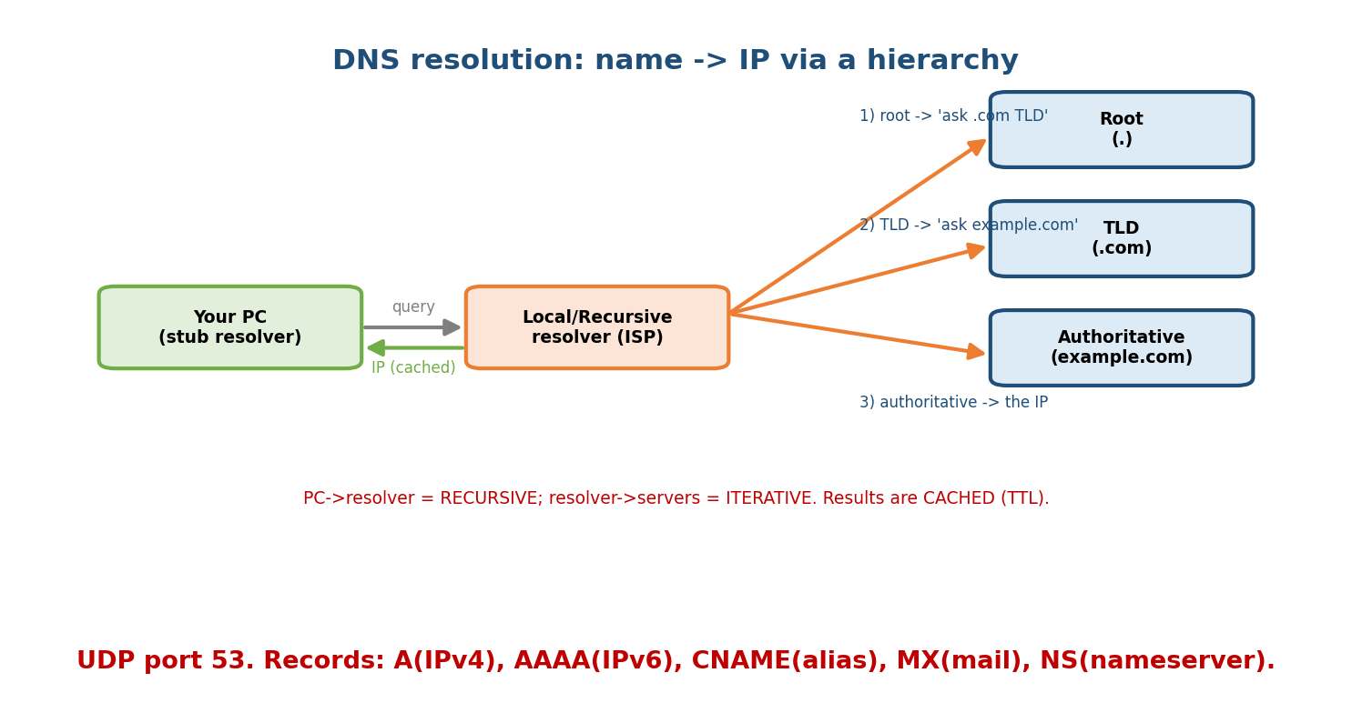
DNS resolves a name by walking the hierarchy: the recursive resolver queries root → TLD → authoritative servers, then caches the answer.
The hierarchy: root (.) → TLD (.com, .org, .in) → authoritative server for the domain. Resolution:
- Your PC (stub) asks its recursive resolver (ISP/8.8.8.8) — a recursive query.
- The resolver walks root → TLD → authoritative with iterative queries, then returns the IP and caches it (TTL-bounded).
Common record types: A (name→IPv4), AAAA (→IPv6), CNAME (alias), MX (mail server), NS (nameserver), PTR (reverse: IP→name), TXT (SPF/verify).
Memory hook: PC→resolver = recursive (“you do all the work”); resolver→servers = iterative (“go ask them”); everything is cached. DNS = phone book of the Internet.

MCQs
- DNS port & transport? → 53, mostly UDP.
- Recursive vs iterative? → PC→resolver = recursive; resolver→servers = iterative.
- Record for a mail server / IPv4 / alias? → MX / A / CNAME.
- What bounds how long a record is cached? → its TTL.

9.3 HTTP & HTTPS — the Web
HTTP (HyperText Transfer Protocol) is a stateless, text-based request/response protocol over TCP port 80 (HTTPS = HTTP over TLS, port 443).
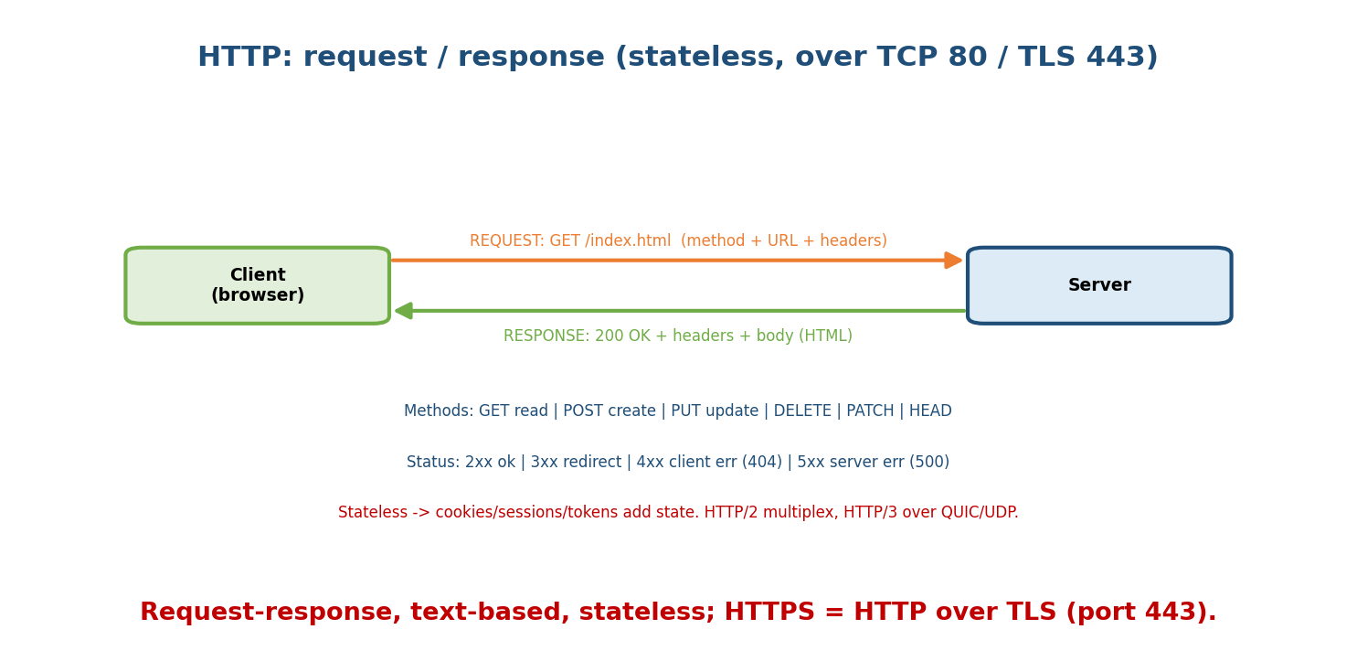
HTTP request/response: the client sends a method + URL + headers; the server returns a status code + headers + body. Stateless, so cookies/tokens add state.
- Methods: GET (read), POST (create/submit), PUT (replace), PATCH (partial update), DELETE, HEAD (headers only).
- Status codes: 1xx info, 2xx success (200 OK), 3xx redirect (301/302), 4xx client error (400 bad request, 401 unauthorized, 403 forbidden, 404 not found), 5xx server error (500, 502/503).
- Stateless → state added via cookies, sessions, or tokens (JWT).
- Versions: HTTP/1.1 (persistent connections, one request at a time per connection → head-of-line blocking); HTTP/2 (multiplexing many streams on one TCP connection, header compression); HTTP/3 (over QUIC/UDP, removes TCP head-of-line blocking).
Memory hook: request (method + URL + headers) → response (status + headers + body). 2xx good, 4xx your fault, 5xx server’s fault.

MCQs
- HTTP/HTTPS ports? → 80 / 443.
- 404 vs 500? → client error (not found) vs server error.
- What makes HTTP stateful? → cookies / sessions / tokens (HTTP itself is stateless).
- HTTP/2’s key improvement? → multiplexing (many streams per connection).

9.4 Email — SMTP, IMAP, POP3
Email uses different protocols to send vs retrieve:
Protocol | Job | Port
SMTP | send / relay mail (client→server, server→server) | 25 (587 submit)
POP3 | download mail to one device (then usually deletes from server) | 110
IMAP | sync mail across devices (stays on server, folders) | 143
Memory hook: SMTP pushes (sends); POP3/IMAP pull (retrieve). POP3 = download-and-go (one device); IMAP = stay-in-sync (many devices). MIME lets email carry attachments/non-text.

MCQs
- Protocol to send email? → SMTP (port 25).
- POP3 vs IMAP? → POP3 downloads (single device); IMAP syncs (multi-device).
- What lets email carry attachments? → MIME.

9.5 FTP & Other Protocols
- FTP (File Transfer Protocol): two connections — control (port 21) for commands and data (port 20) for the file. Not encrypted (use SFTP/FTPS). Active vs passive mode differ in who opens the data connection.
- Telnet (remote login, insecure) → replaced by SSH (port 22, encrypted).
- SNMP (network management), NTP (time sync), LDAP (directory).

MCQs
- FTP control vs data ports? → 21 (control) / 20 (data).
- Secure replacement for Telnet? → SSH (22).
- FTP uses how many connections? → two (control + data).

9.6 DHCP — Automatic IP Configuration
DHCP (Dynamic Host Configuration Protocol) auto-assigns a host its IP address, subnet mask, default gateway, and DNS servers — no manual setup. It uses the DORA exchange over UDP ports 67 (server) / 68 (client):
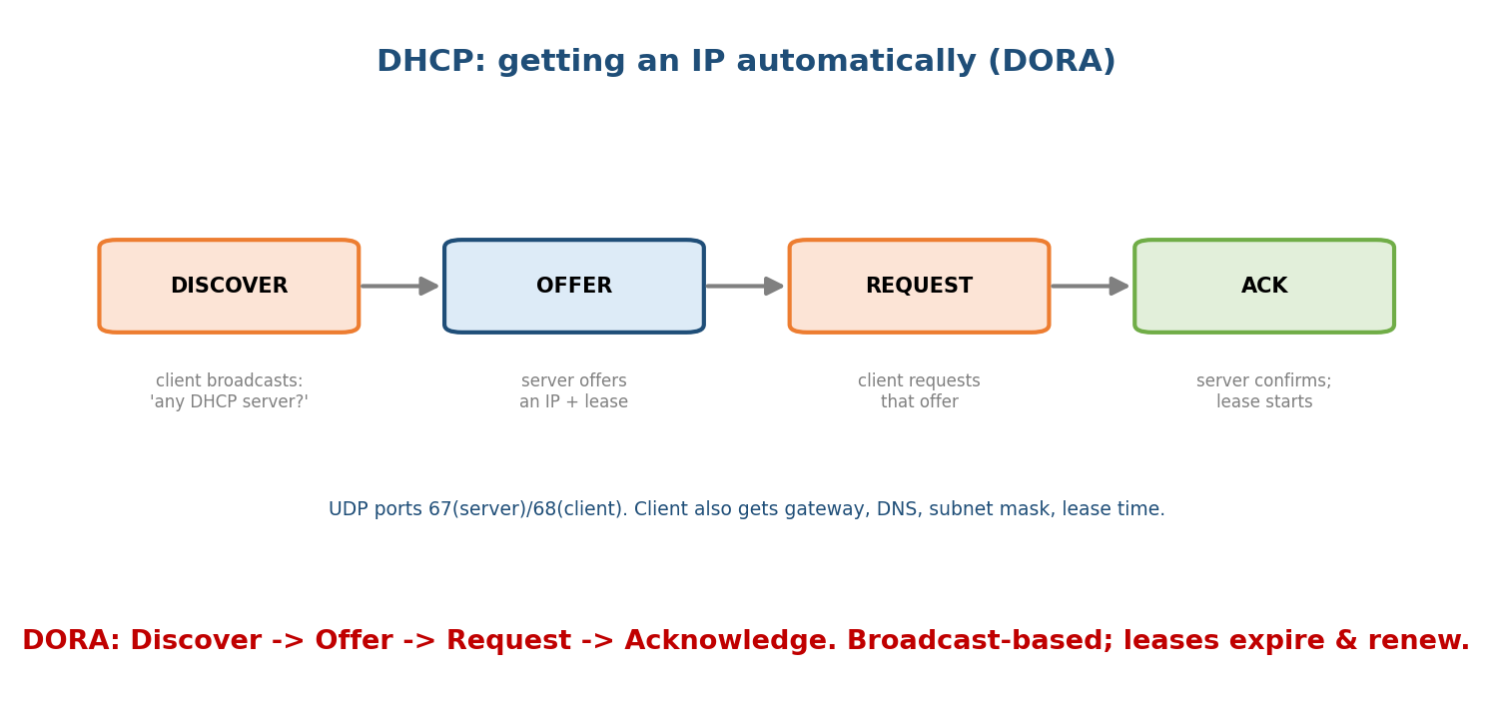
DHCP DORA: the client broadcasts DISCOVER, a server sends OFFER, the client sends REQUEST, and the server confirms with ACK — leasing an IP plus gateway/DNS/mask.
- Discover — client broadcasts “any DHCP server?”
- Offer — server offers an IP + lease.
- Request — client requests that offer (broadcast, so other servers withdraw).
- Acknowledge — server confirms; the lease begins (and is renewed later).
Memory hook: DORA — Discover, Offer, Request, Acknowledge. It’s broadcast-based (the client has no IP yet) and gives you everything to get online.

MCQs
- DHCP four steps? → DORA (Discover, Offer, Request, Acknowledge).
- DHCP ports? → 67 (server) / 68 (client), UDP.
- Besides an IP, DHCP provides? → subnet mask, gateway, DNS (and lease time).

9.7 Protocol → Port → Transport (memorise this table)
Protocol | Port | Transport | Purpose
HTTP / HTTPS | 80 / 443 | TCP | web
DNS | 53 | UDP (TCP for big) | name resolution
SMTP | 25 | TCP | send email
POP3 / IMAP | 110 / 143 | TCP | retrieve email
FTP | 20 / 21 | TCP | file transfer
SSH / Telnet | 22 / 23 | TCP | remote login
DHCP | 67 / 68 | UDP | auto IP config
SNMP | 161 | UDP | management

MCQs
- Which of these use UDP? → DNS, DHCP, SNMP (rest TCP).
- HTTPS vs SSH ports? → 443 / 22.

9.8 Real-World & Backend Perspectives
- DNS is the first step of almost every request — and a top outage cause (“it’s always DNS”). Backend adds CDNs, GeoDNS, and health-checked records.
- HTTP is the backend lingua franca — REST APIs, status codes, headers, caching, cookies/JWT for auth; HTTP/2 & HTTP/3 (QUIC) cut latency.
- DHCP + DNS + NAT (M5) are what silently get every device online.
- These app protocols ride the transport you learned in M7 — HTTP/SMTP/FTP on TCP; DNS/DHCP on UDP.

9.9 Tradeoffs, Common Mistakes, Edge Cases
- Mistake: thinking DNS is TCP — it’s UDP 53 normally (TCP only for large/zone transfers).
- Mistake: SMTP retrieves mail — no, SMTP sends; IMAP/POP3 retrieve.
- Trap: 4xx = client error, 5xx = server error (don’t swap).
- Edge case: HTTP is stateless by design; all “logged-in” state is bolted on via cookies/tokens — a frequent interview clarification.

9.10 Exam, Interview & Coding Perspectives
- SEBI / RBI / NABARD: protocol→port→transport table, DNS/DHCP basics, SMTP vs IMAP/POP3, HTTP status codes.
- GATE / C-DAC: DNS recursive/iterative + caching, HTTP persistent/non-persistent connection RTT counting, FTP two-connection model, DORA.
- Interview: “what happens when you type a URL?” (DNS → TCP → TLS → HTTP — ties the whole course), “GET vs POST”, “how does DNS work?”, “stateless HTTP + sessions”.

9.11 Concept Checks & MCQs (test yourself)
- DNS transport/port? → UDP 53.
- Recursive vs iterative query? → PC→resolver recursive; resolver→servers iterative.
- HTTP methods for read/create? → GET / POST.
- 401 vs 403 vs 404? → unauthorized / forbidden / not found.
- Send vs retrieve email protocols? → SMTP vs IMAP/POP3.
- FTP ports? → 21 control, 20 data.
- DHCP steps & ports? → DORA, 67/68 UDP.
- HTTP/3 runs over? → QUIC (UDP).
- Record types A/MX/CNAME? → IPv4 / mail / alias.
- Which use UDP: HTTP, DNS, SMTP, DHCP? → DNS, DHCP.

9.12 One-Page Revision Sheet
APPLICATION LAYER (L7): services to apps (protocol != the app). client-server vs P2P. PDU=data/message.
DNS (UDP 53): name->IP, distributed hierarchy root(.) -> TLD(.com) -> authoritative.
PC->resolver = RECURSIVE; resolver->servers = ITERATIVE. CACHED (TTL).
records: A(IPv4) AAAA(IPv6) CNAME(alias) MX(mail) NS(nameserver) PTR(reverse) TXT.
HTTP (TCP 80) / HTTPS (TLS 443): stateless request/response.
methods: GET POST PUT PATCH DELETE HEAD. status: 2xx ok/3xx redirect/4xx client(404)/5xx server(500).
state via cookies/sessions/JWT. HTTP1.1 persistent; HTTP2 multiplex; HTTP3 over QUIC/UDP.
EMAIL: SMTP(25) SEND/relay ; POP3(110) download-one-device ; IMAP(143) sync-multi-device. MIME=attachments.
FTP: control 21 + data 20 (two connections, unencrypted -> SFTP/FTPS). SSH(22) replaces Telnet(23).
DHCP (UDP 67/68): DORA = Discover(broadcast) -> Offer -> Request -> Acknowledge. gives IP+mask+gateway+DNS+lease.
PORT/TRANSPORT: HTTP80/HTTPS443/DNS53(UDP)/SMTP25/POP110/IMAP143/FTP20-21/SSH22/DHCP67-68(UDP)/SNMP161(UDP).
UDP ones: DNS, DHCP, SNMP. everything else TCP.

Flash cards
Front | Back
DNS port / transport | 53 / UDP
Recursive vs iterative | PC→resolver vs resolver→servers
MX / A / CNAME record | mail / IPv4 / alias
HTTP vs HTTPS port | 80 / 443
4xx vs 5xx | client error vs server error
Send vs retrieve email | SMTP vs IMAP/POP3
FTP ports | 21 control, 20 data
DHCP steps & ports | DORA; 67/68 UDP
HTTP/3 transport | QUIC (UDP)
App protocols on UDP | DNS, DHCP, SNMP

Spaced repetition
- 24-hour: recite the protocol→port→transport table + DORA + HTTP status classes.
- 7-day: DNS recursive/iterative + record types; SMTP vs IMAP/POP3; HTTP versions.
- 30-day: narrate “type a URL → page loads” touching DNS, TCP, TLS, HTTP — without notes.

9.13 Summary
The Application layer gives programs their network protocols. DNS (UDP 53) resolves names via a hierarchy (root → TLD → authoritative) using recursive (PC→resolver) and iterative (resolver→servers) queries with caching. HTTP (TCP 80) / HTTPS (TLS 443) is a stateless request/response protocol with methods (GET/POST/…), status codes (2xx/3xx/4xx/5xx), and cookies/tokens for state — evolving through HTTP/1.1 → 2 (multiplexing) → 3 (QUIC/UDP). Email splits into SMTP (send) and IMAP/POP3 (retrieve); FTP uses two connections (21/20); DHCP auto-configures hosts via DORA (UDP 67/68). The protocol → port → transport table ties it together — with DNS, DHCP, SNMP on UDP and the rest on TCP.
Next, Module 10 — Network Security & Cryptography covers how we protect all this: symmetric/asymmetric encryption, TLS/HTTPS, firewalls, VPNs, and common attacks.
You have mastered this module when you can: explain DNS resolution (recursive vs iterative + caching) and its records; list HTTP methods/status codes and the version differences; separate SMTP from IMAP/POP3; describe DORA; and fill the protocol → port → transport table — all without notes.

