Module 10 — Network Security & Cryptography
  - Computer Networks Mastery: SEBI IT / RBI / NABARD / GATE / C-DAC / Interview / Backend — In-Depth Notes (with visuals)
Prepared for nidhi.sharma@forensiccybertech.com
2026
Table of Contents

Module 10 — Network Security & Cryptography
Where this module sits. Modules 1–9 built a network that works. This one makes it safe. Packets cross untrusted links where anyone can read, alter, or forge them. Network security uses cryptography (encryption, hashing, signatures) plus firewalls, VPNs, and TLS to protect data. This is core for SEBI/RBI IT (and a bridge to the dedicated Cyber Security subject): symmetric vs asymmetric, hashing vs encryption, how HTTPS works, firewall types, and common attacks are all heavily tested.
Importance ratings (out of 5):
Exam / Use | SEBI IT | RBI IT | GATE CS | Interview | Backend
This module | ★★★★ | ★★★★★ | ★★★ | ★★★ | ★★★★
Most-asked PYQ concepts (SEBI / RBI / GATE / C-DAC): CIA triad; symmetric vs asymmetric encryption (AES/DES vs RSA/ECC); hashing (SHA/MD5) vs encryption; digital signatures & PKI/certificates/CA; TLS/SSL / HTTPS handshake; firewalls (packet-filter / stateful / proxy) & IDS/IPS; VPN / IPsec; common attacks (MITM, DoS/DDoS, spoofing, phishing, replay, SQL injection).

10.1 Security Goals — the CIA Triad (and friends)
- Confidentiality — only authorised parties can read the data (encryption).
- Integrity — data isn’t altered undetected (hashes, MACs).
- Availability — the service stays up (anti-DoS, redundancy).
- Plus Authentication (prove identity), Non-repudiation (can’t deny an action — digital signatures), and Authorization (what you’re allowed to do).
Memory hook: CIA — Confidentiality, Integrity, Availability. Encryption = confidentiality; hashing = integrity; signatures = authentication + non-repudiation.

MCQs
- Three CIA goals? → Confidentiality, Integrity, Availability.
- Which goal does encryption serve? → confidentiality.
- “Can’t deny you sent it” is? → non-repudiation.

10.2 Symmetric vs Asymmetric Encryption
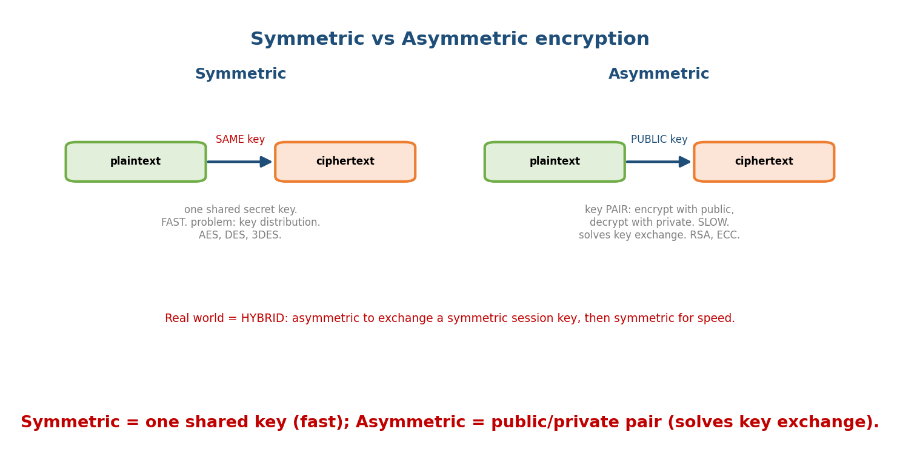
Symmetric encryption uses one shared key (fast, but key distribution is hard); asymmetric uses a public/private key pair (slower, but solves key exchange).
- Symmetric: one shared secret key encrypts and decrypts. Fast, good for bulk data. Problem: how to share the key securely. Algorithms: AES (modern standard), DES/3DES (old).
- Asymmetric (public-key): a key pair — encrypt with the public key, decrypt with the private key. Slow, but solves key distribution. Algorithms: RSA, ECC (Diffie-Hellman for key exchange).
- Hybrid (the real world): use asymmetric to exchange a symmetric session key, then symmetric for the actual data (this is exactly what TLS does).
Memory hook: symmetric = one shared key (fast); asymmetric = public/private pair (solves exchange, slow). Combine them = hybrid = TLS.

MCQs
- Symmetric vs asymmetric key(s)? → one shared vs public/private pair.
- Which is faster / used for bulk data? → symmetric (AES).
- Why use hybrid? → asymmetric to exchange the symmetric key, then symmetric for speed.

10.3 Hashing, MACs & Digital Signatures
- Hash function (SHA-256, MD5/SHA-1 broken): a one-way function mapping any input to a fixed-size digest. Properties: deterministic, one-way, collision- resistant, avalanche. Used for integrity (compare digests) — not encryption (you can’t reverse it).
- MAC / HMAC: a hash keyed with a secret → integrity + authentication (only someone with the key could have produced it).
- Digital signature: hash the message, then encrypt the hash with your private key. Anyone can verify with your public key → gives integrity, authentication, and non-repudiation.
Memory hook: encryption = confidentiality (reversible with a key); hashing = integrity (one-way). Signature = “hash then sign with private key.”

MCQs
- Is hashing reversible? → no (one-way).
- Encryption vs hashing purpose? → confidentiality vs integrity.
- A digital signature is made with the sender’s? → private key (verified with the public key).

10.4 PKI & Certificates
How do you trust that a public key really belongs to bank.com? PKI (Public Key Infrastructure): a trusted Certificate Authority (CA) issues a digital certificate binding a domain to its public key, signed by the CA. Your browser/OS ships with trusted root CAs, forming a chain of trust.
- A certificate contains: subject (domain), public key, issuer (CA), validity, and the CA’s signature.
- This is what stops a man-in-the-middle from faking a site’s key.

MCQs
- Who issues certificates? → a Certificate Authority (CA).
- A certificate binds a domain to its? → public key (signed by the CA).
- Trust flows along the? → chain of trust (to a root CA).

10.5 TLS / SSL & HTTPS
TLS (Transport Layer Security, successor to SSL) secures data in transit — it’s what puts the S in HTTPS (port 443). It combines everything above:
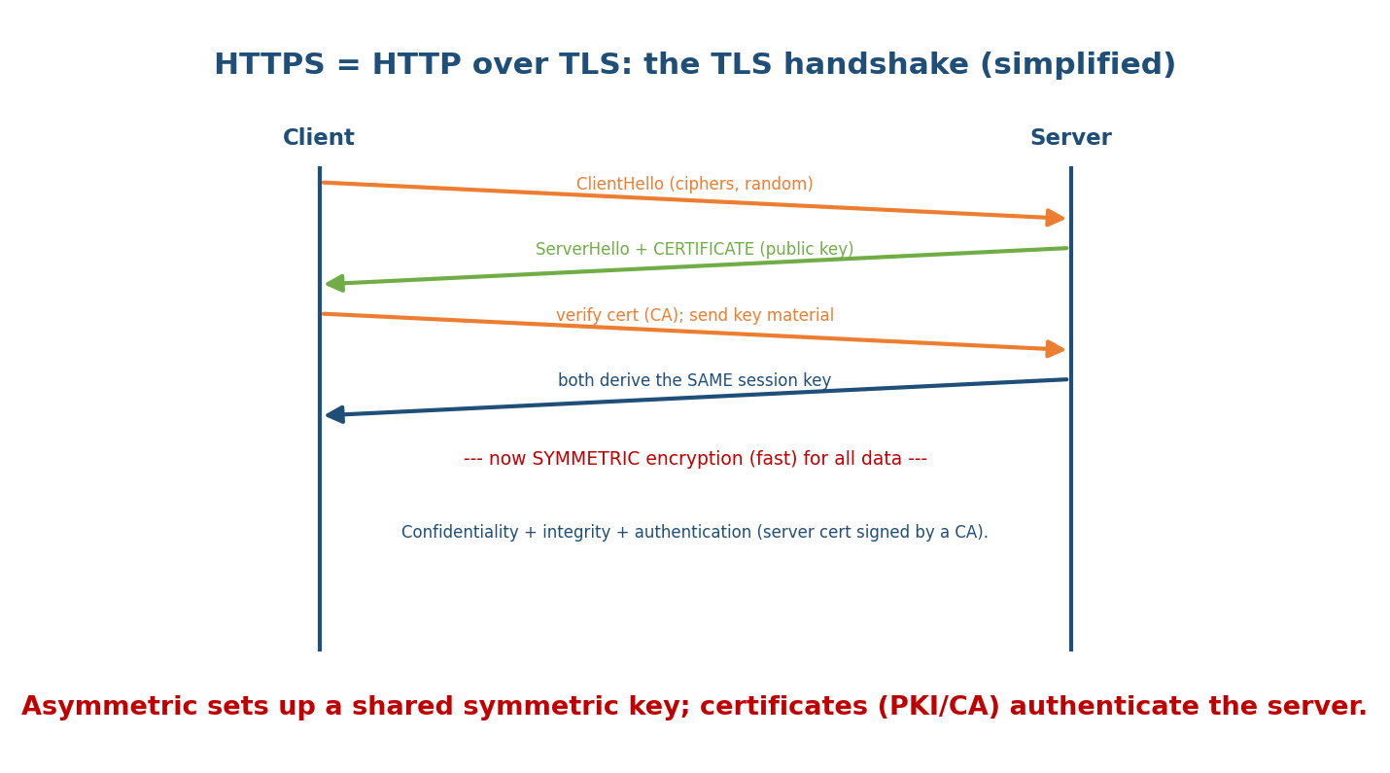
The TLS handshake: client and server negotiate, the server proves identity with a CA-signed certificate, they derive a shared symmetric key, then all data uses fast symmetric encryption.
- Handshake (asymmetric): negotiate ciphers; the server sends its certificate (public key, CA-signed); the client verifies it and they derive a shared symmetric session key.
- Data (symmetric): all traffic is then encrypted with the fast symmetric key, with a MAC for integrity.
Result: confidentiality + integrity + authentication — the padlock in your browser.
Memory hook: TLS = hybrid crypto in action — asymmetric + certificate to set up a symmetric key, then symmetric for speed.

MCQs
- HTTPS = HTTP over? → TLS (port 443).
- TLS uses which crypto where? → asymmetric (handshake) then symmetric (data).
- What authenticates the server in TLS? → its CA-signed certificate.

10.6 Firewalls, IDS/IPS & VPNs
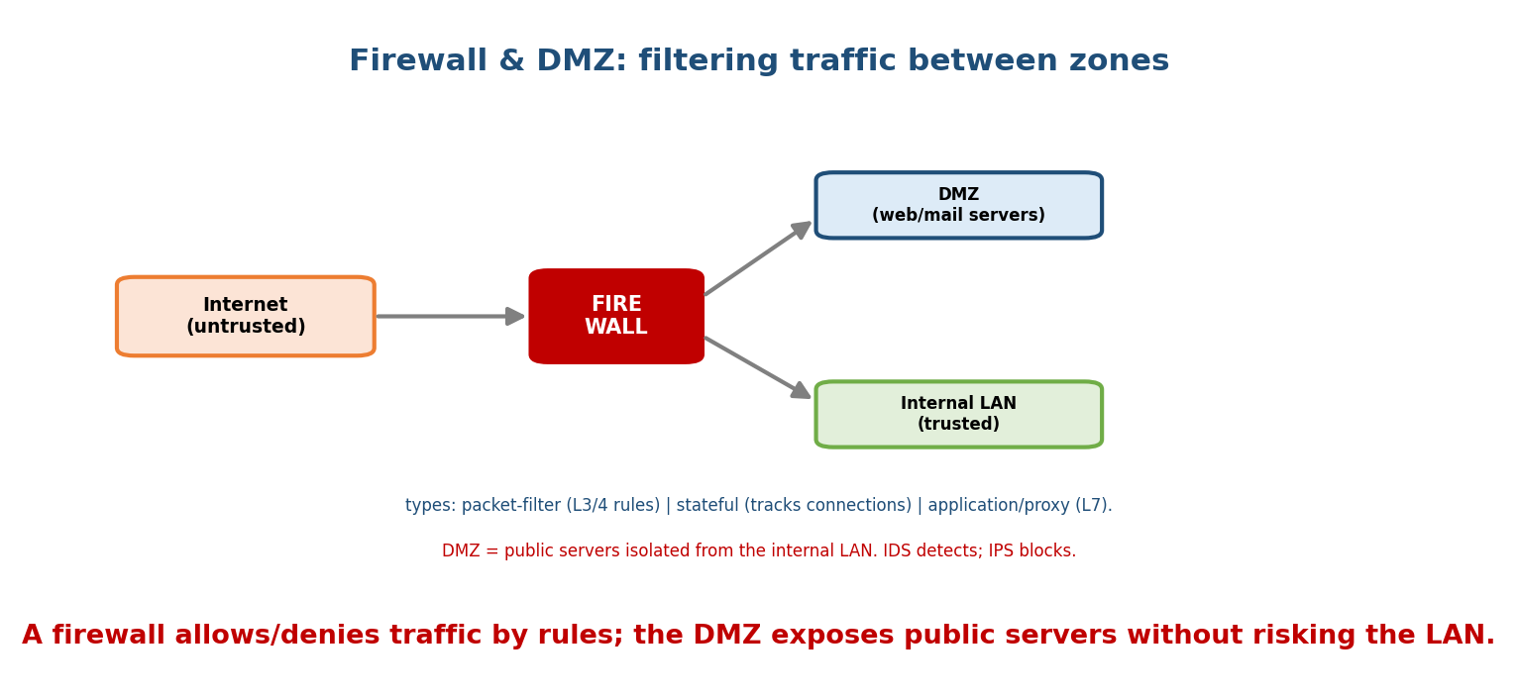
A firewall filters traffic between zones by rules; a DMZ isolates public servers from the trusted internal LAN.
- Firewall: allows/denies traffic by rules. Types: packet-filter (stateless, L3/4 rules on IP/port), stateful (tracks connection state), application/proxy (L7, inspects content). A DMZ isolates public servers from the internal LAN.
- IDS vs IPS: IDS detects and alerts on intrusions; IPS detects and blocks inline.
- VPN (Virtual Private Network): an encrypted tunnel over the public Internet, giving secure remote access / site-to-site links. IPsec (network-layer: AH for integrity, ESP for encryption; transport vs tunnel mode) and TLS/WireGuard VPNs.
Memory hook: firewall = gatekeeper by rules; IDS = alarm; IPS = alarm + lock; VPN = encrypted tunnel through the public Internet.

MCQs
- Firewall that tracks connection state? → stateful.
- IDS vs IPS? → detect/alert vs detect + block.
- VPN provides? → an encrypted tunnel (e.g. IPsec).
- What isolates public servers from the LAN? → a DMZ.

10.7 Common Network Attacks
Attack | What it does | Defence
MITM | intercept/alter traffic between two parties | TLS, cert pinning
DoS / DDoS | flood a service to exhaust it | rate limiting, scrubbing, CDNs
IP / ARP / DNS spoofing | forge addresses/records to redirect | authentication, DNSSEC, dynamic ARP inspection
Replay | resend captured valid messages | nonces, timestamps, sequence numbers
Phishing / social engineering | trick users into credentials | awareness, MFA
Packet sniffing | read traffic on a shared medium | encryption (TLS)
SYN flood | half-open TCP connections (a DoS) | SYN cookies (M7)
Memory hook: encryption defeats sniffing/MITM; nonces defeat replay; rate limiting defeats DoS; MFA + awareness defeat phishing.

MCQs
- Intercepting and altering traffic in transit? → MITM (defeated by TLS).
- Flooding to exhaust a service? → DoS/DDoS.
- Resending captured valid messages? → replay (defeated by nonces/timestamps).
- Forging “who has this IP” replies on a LAN? → ARP spoofing.

10.8 Real-World & Backend Perspectives
- TLS everywhere — every API/website should be HTTPS; backends manage certificates (Let’s Encrypt, rotation), TLS termination at load balancers, and mTLS between services.
- DDoS protection (Cloudflare/CDN scrubbing) and WAFs (application firewalls) are standard for public services.
- Zero-trust / VPN / mTLS secure internal traffic; secrets management (Vault) protects keys. This module is the bridge to the dedicated Cyber Security subject.

10.9 Tradeoffs, Common Mistakes, Edge Cases
- Mistake: “hashing encrypts data” — hashing is one-way (integrity), not encryption (confidentiality).
- Mistake: signing with the public key — you sign with your private key, verify with the public key.
- Trap: symmetric is faster but has the key-distribution problem; asymmetric solves distribution but is slow → hybrid.
- Edge case: encryption alone doesn’t give integrity/authentication — you also need a MAC/signature (TLS uses both).

10.10 Exam, Interview & Coding Perspectives
- SEBI / RBI / NABARD: CIA, symmetric vs asymmetric, hashing vs encryption, HTTPS/ TLS basics, firewall types, attack names — high frequency.
- GATE / C-DAC: RSA mechanics (public/private roles), Diffie-Hellman key exchange, digital-signature steps, IPsec AH vs ESP.
- Interview: “how does HTTPS work?” (hybrid + certs), “hashing vs encryption”, “symmetric vs asymmetric”, “how to stop MITM/replay”.

10.11 Concept Checks & MCQs (test yourself)
- CIA triad? → Confidentiality, Integrity, Availability.
- Symmetric vs asymmetric key(s)? → one shared vs public/private pair.
- Encryption vs hashing? → reversible confidentiality vs one-way integrity.
- Digital signature uses which key to sign? → the sender’s private key.
- HTTPS uses which two crypto types? → asymmetric (handshake) + symmetric (data).
- Who vouches for a public key? → a CA (certificate).
- IDS vs IPS? → detect vs detect + block.
- VPN provides? → encrypted tunnel (IPsec).
- Defence against MITM? → TLS (+ cert validation).
- Defence against replay? → nonces / timestamps / sequence numbers.

10.12 One-Page Revision Sheet
GOALS: CIA = Confidentiality(encryption) + Integrity(hash/MAC) + Availability(anti-DoS).
+ Authentication, Non-repudiation(signature), Authorization.
ENCRYPTION:
SYMMETRIC: 1 shared key; FAST; key-distribution problem. AES, DES/3DES.
ASYMMETRIC: public/private pair; encrypt w/ public, decrypt w/ private; SLOW; solves exchange. RSA, ECC, DH.
HYBRID (TLS): asymmetric to exchange a symmetric session key, then symmetric for data.
HASH (SHA-256): one-way, deterministic, collision-resistant, avalanche = INTEGRITY (not encryption). MD5/SHA1 broken.
MAC/HMAC = keyed hash (integrity+auth). SIGNATURE = hash then encrypt with PRIVATE key (integrity+auth+non-repudiation).
PKI: CA issues CERTIFICATE binding domain->public key (CA-signed). chain of trust to root CAs.
TLS/SSL (HTTPS 443): handshake(asymmetric + cert) -> shared symmetric key -> symmetric data + MAC.
DEFENCES: firewall (packet-filter L3/4 | stateful | proxy L7) + DMZ. IDS=detect, IPS=detect+block. VPN=encrypted tunnel (IPsec AH/ESP, tunnel/transport).
ATTACKS: MITM(->TLS) | DoS/DDoS(->rate limit/CDN) | IP/ARP/DNS spoof(->auth/DNSSEC) | replay(->nonce) | phishing(->MFA) | sniffing(->encrypt) | SYN flood(->SYN cookies).

Flash cards
Front | Back
CIA triad | Confidentiality, Integrity, Availability
Symmetric vs asymmetric | one shared key vs public/private pair
Faster / bulk crypto | symmetric (AES)
Hashing purpose | integrity (one-way)
Digital signature key | sign with private, verify with public
HTTPS crypto | asymmetric handshake + symmetric data
Certificate issuer | CA (chain of trust)
IDS vs IPS | detect vs detect+block
VPN | encrypted tunnel (IPsec)
Replay defence | nonce / timestamp / sequence number

Spaced repetition
- 24-hour: symmetric vs asymmetric vs hashing (purpose + example each); the CIA triad.
- 7-day: the TLS handshake as hybrid crypto; firewall types; attack → defence table.
- 30-day: explain end-to-end how HTTPS gives confidentiality + integrity + authentication — without notes.

10.13 Summary
Network security pursues the CIA triad (Confidentiality, Integrity, Availability) plus authentication and non-repudiation. Encryption gives confidentiality — symmetric (one shared key, fast: AES) vs asymmetric (public/private pair, solves key exchange: RSA/ECC) — combined as hybrid in practice. Hashing (SHA-256) is one-way and gives integrity; MACs add authentication; digital signatures (hash + private-key encryption) add non-repudiation. PKI/CAs issue certificates binding domains to public keys, which TLS uses to secure HTTPS (asymmetric handshake → symmetric data). Firewalls (packet-filter/stateful/proxy) + DMZ, IDS/IPS, and VPNs (IPsec) defend the network against attacks like MITM, DoS/DDoS, spoofing, replay, and sniffing.
Next, Module 11 — Wireless & Mobile Networks covers Wi-Fi (802.11, CSMA/CA), the hidden-terminal problem, Bluetooth, and cellular (2G→5G).
You have mastered this module when you can: state the CIA triad; contrast symmetric/asymmetric/hashing by purpose; explain digital signatures and PKI; walk the TLS handshake as hybrid crypto; classify firewalls and IDS vs IPS; and match common attacks to defences — all without notes.

