Module 11 — Wireless & Mobile Networks
  - Computer Networks Mastery: SEBI IT / RBI / NABARD / GATE / C-DAC / Interview / Backend — In-Depth Notes (with visuals)
Prepared for nidhi.sharma@forensiccybertech.com
2026
Table of Contents

Module 11 — Wireless & Mobile Networks
Where this module sits. Most of this course assumed wired links. But today the “last hop” is usually wireless — Wi-Fi and cellular. Wireless changes the rules: the medium is shared and unreliable, nodes move, and you can’t detect collisions the way wired Ethernet does. This module covers Wi-Fi (802.11, CSMA/CA), the hidden-terminal problem and RTS/CTS, Bluetooth, and cellular (2G→5G), plus wireless security (WPA2/WPA3).
Importance ratings (out of 5):
Exam / Use | SEBI IT | RBI IT | GATE CS | Interview | Backend
This module | ★★★ | ★★★ | ★★★ | ★★ | ★★
Most-asked PYQ concepts (SEBI / RBI / GATE / C-DAC): CSMA/CA vs CSMA/CD (why wireless can’t detect collisions); hidden & exposed terminal + RTS/CTS; Wi-Fi 802.11 standards & bands; Bluetooth (PAN, piconet); cellular generations (2G–5G) and cell/handoff concepts; WEP vs WPA2/WPA3; FDMA/TDMA/CDMA (from M2).

11.1 Why Wireless Is Different
- Shared, broadcast medium (air) — interference, fading, multipath.
- Can’t reliably detect collisions while transmitting (your own signal swamps the weak incoming one) → wired CSMA/CD won’t work; wireless uses CSMA/CA.
- Mobility — nodes move between access points/cells (handoff).
- Security — anyone in range can listen → encryption is mandatory (WPA2/WPA3).
- Higher error rates & variable bandwidth than wired.
Memory hook: wireless = “everyone shouting in a room you can’t fully hear.” You avoid collisions (CA) instead of detecting them (CD), and you must encrypt because everyone can eavesdrop.

MCQs
- Why can’t wireless use CSMA/CD? → it can’t detect collisions while sending.
- Wireless access method instead? → CSMA/CA (collision avoidance).
- Moving between APs/cells is called? → handoff/handover.

11.2 Wi-Fi (IEEE 802.11)
Architecture:
- Infrastructure mode: devices connect through an Access Point (AP) (the usual home/office Wi-Fi). A BSS = one AP + its clients; an ESS = multiple APs on one network.
- Ad-hoc mode: devices talk directly, peer-to-peer, no AP.
Access: CSMA/CA — sense idle, wait a random backoff, transmit, and expect an ACK (no ACK = assume collision/loss, retry). Optionally reserve the medium with RTS/CTS.
Standards (know the trend): 802.11 b/g (2.4 GHz) → n (2.4/5 GHz, MIMO) → ac (5 GHz, faster) → Wi-Fi 6/6E (ax) (efficient in dense areas) → Wi-Fi 7.
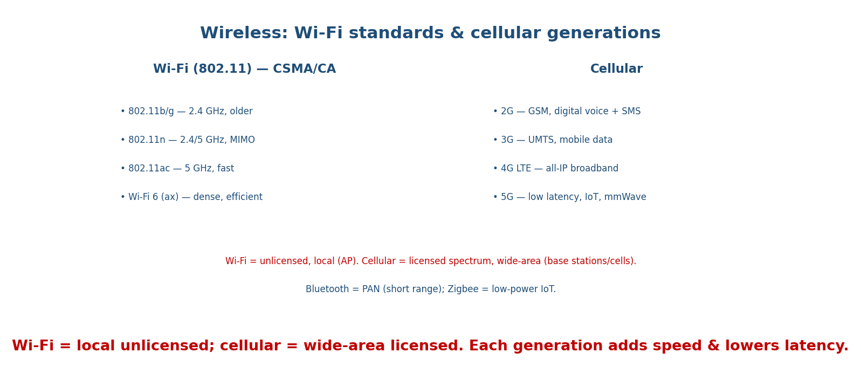
Wi-Fi standards and cellular generations: Wi-Fi is local & unlicensed (via an AP); cellular is wide-area & licensed, adding speed and lowering latency each generation.

MCQs
- Wi-Fi via an AP is which mode? → infrastructure.
- Wi-Fi access method? → CSMA/CA (with ACKs).
- Which 802.11 introduced MIMO? → 802.11n.

11.3 Hidden & Exposed Terminals; RTS/CTS
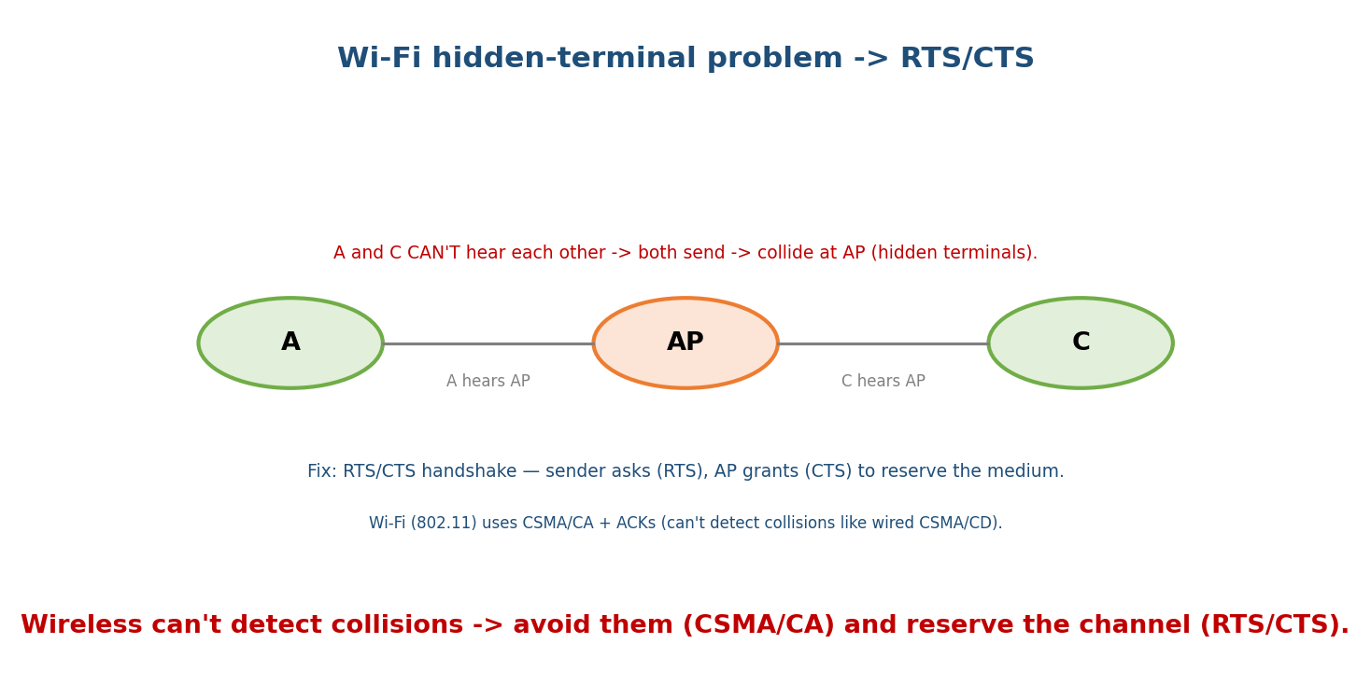
Two stations that can each reach the AP but not each other are hidden terminals: they transmit together and collide at the AP; RTS/CTS reserves the medium to prevent this.
- Hidden-terminal problem: A and C can both reach the AP but can’t hear each other, so they transmit at once and collide at the AP. Carrier sensing fails because they don’t sense each other.
- Exposed-terminal problem: a node needlessly defers because it hears another transmission that wouldn’t actually interfere with its intended receiver.
- RTS/CTS handshake: the sender sends a small RTS (Request To Send); the AP replies CTS (Clear To Send), which all nearby nodes hear and then stay quiet → reserves the medium and solves hidden terminals (at the cost of overhead).
Memory hook: hidden = can’t hear each other → collide at the AP; RTS/CTS = “ask permission out loud” so everyone in range backs off.

MCQs
- Hidden terminals collide where? → at the AP (they can’t hear each other).
- What solves the hidden-terminal problem? → RTS/CTS.
- Exposed terminal causes? → unnecessary deferral (lost throughput).

11.4 Bluetooth & Other Short-Range Wireless
- Bluetooth: a PAN technology (~10 m). Devices form a piconet (one master + up to 7 active slaves); uses frequency hopping in 2.4 GHz. BLE (Low Energy) for IoT/wearables.
- Zigbee: low-power, low-rate mesh for IoT/home automation.
- NFC: very short range (cm), contactless payments/tap.
- RFID: tags read by a reader (inventory, access cards).

MCQs
- Bluetooth network of 1 master + up to 7 slaves? → a piconet.
- Bluetooth range/class? → PAN (~10 m).
- Very-short-range tap-to-pay tech? → NFC.

11.5 Cellular Networks (2G → 5G)
The area is divided into cells, each served by a base station; frequencies are reused in non-adjacent cells. As you move, calls hand off between cells.
Gen | Key feature
1G | analog voice
2G | digital voice + SMS (GSM)
3G | mobile data (UMTS)
4G LTE | all-IP broadband, high speed
5G | very low latency, massive IoT, mmWave, high density
Multiple access across generations uses FDMA/TDMA/CDMA/OFDMA (from M2).
Memory hook: 2G digital voice, 3G data, 4G broadband/all-IP, 5G low-latency + IoT. Cellular = licensed, wide-area; Wi-Fi = unlicensed, local.

MCQs
- First digital cellular generation? → 2G.
- 4G’s architecture is? → all-IP (LTE).
- 5G’s headline benefit? → very low latency (+ IoT density).

11.6 Wireless Security
- WEP — original Wi-Fi security; broken (weak RC4/IV), do not use.
- WPA / WPA2 — WPA2 (AES-CCMP) is the long-time standard.
- WPA3 — current; stronger handshake (SAE), forward secrecy.
- Because the medium is open, encryption + strong auth are mandatory; also beware rogue APs / evil twins and deauth attacks.

MCQs
- Which Wi-Fi security is broken? → WEP.
- Modern Wi-Fi security standards? → WPA2 / WPA3.
- A fake AP impersonating a real one? → evil twin / rogue AP.

11.7 Real-World & Backend Perspectives
- Wi-Fi/cellular are the last hop for most users — app performance must tolerate jitter, loss, and handoffs (why TCP tuning, QUIC/HTTP-3, and retries matter).
- 5G + edge computing push compute closer to users for low latency (ties to CDNs, M12).
- IoT (BLE/Zigbee + cellular NB-IoT) is a huge growth area; constrained devices need lightweight protocols (CoAP/MQTT).

11.8 Tradeoffs, Common Mistakes, Edge Cases
- Mistake: saying Wi-Fi uses CSMA/CD — it uses CSMA/CA (can’t detect collisions).
- Mistake: confusing hidden (can’t hear each other → collide) vs exposed (hear each other → over-defer) terminals.
- Trap: WEP is insecure — the “secure” answers are WPA2/WPA3.
- Edge case: RTS/CTS helps hidden terminals but adds overhead — usually only used for larger frames.

11.9 Exam, Interview & Coding Perspectives
- SEBI / RBI / NABARD: CSMA/CA, Wi-Fi vs cellular, Bluetooth piconet, cellular generations, WEP/WPA.
- GATE / C-DAC: hidden/exposed terminal + RTS/CTS, 802.11 access details, FDMA/TDMA/ CDMA.
- Interview: “why does Wi-Fi use CA not CD?”, “what’s the hidden-terminal problem?”, “how does mobile handoff work?”.

11.10 Concept Checks & MCQs (test yourself)
- Wireless access method & why? → CSMA/CA (can’t detect collisions).
- Wi-Fi infrastructure vs ad-hoc? → via AP vs peer-to-peer.
- Hidden vs exposed terminal? → collide at AP vs over-defer.
- What solves hidden terminals? → RTS/CTS.
- Bluetooth 1-master/≤7-slave network? → piconet.
- 2G vs 4G? → digital voice+SMS vs all-IP broadband.
- Broken Wi-Fi security? → WEP.
- 802.11n added? → MIMO (2.4/5 GHz).
- 5G headline? → low latency + IoT density.
- Wi-Fi vs cellular spectrum? → unlicensed/local vs licensed/wide-area.

11.11 One-Page Revision Sheet
WIRELESS: shared broadcast air; can't detect collisions -> CSMA/CA (avoid) + ACKs, not CSMA/CD.
challenges: interference/fading, mobility(handoff), security(everyone hears), higher error.
WiFi 802.11: infrastructure(AP; BSS=1 AP, ESS=many) vs ad-hoc(peer).
access CSMA/CA + backoff + ACK. standards: b/g(2.4) -> n(MIMO,2.4/5) -> ac(5) -> WiFi6(ax) -> WiFi7.
HIDDEN terminal: A,C reach AP but not each other -> collide AT AP. fix = RTS/CTS (reserve medium).
EXPOSED terminal: over-defer unnecessarily.
SHORT-RANGE: Bluetooth=PAN ~10m, PICONET(1 master + <=7 slaves), freq hopping; BLE=IoT. Zigbee=low-power mesh. NFC=cm. RFID=tags.
CELLULAR: cells + base stations, frequency reuse, handoff.
1G analog | 2G digital voice+SMS(GSM) | 3G data(UMTS) | 4G all-IP broadband(LTE) | 5G low-latency+IoT+mmWave.
access: FDMA/TDMA/CDMA/OFDMA. Wi-Fi=unlicensed/local ; cellular=licensed/wide-area.
SECURITY: WEP=BROKEN. WPA2(AES) standard. WPA3(SAE, forward secrecy). beware rogue AP/evil twin, deauth.

Flash cards
Front | Back
Wireless access method | CSMA/CA (+ ACKs)
Why not CSMA/CD | can’t detect collisions while sending
Hidden terminal | can’t hear each other → collide at AP
Fix for hidden terminal | RTS/CTS
Bluetooth network | piconet (1 master + ≤7 slaves)
802.11n feature | MIMO
2G / 4G / 5G | digital voice / all-IP / low-latency+IoT
Broken Wi-Fi security | WEP
Modern Wi-Fi security | WPA2 / WPA3
Wi-Fi vs cellular | unlicensed local vs licensed wide-area

Spaced repetition
- 24-hour: CSMA/CA vs CSMA/CD; hidden vs exposed terminal + RTS/CTS.
- 7-day: 802.11 standards; cellular generations; WEP/WPA2/WPA3.
- 30-day: explain why wireless needs CA + ACKs and how RTS/CTS fixes hidden terminals — without notes.

11.12 Summary
Wireless networking works on a shared, unreliable, broadcast medium where nodes move and collisions can’t be detected — so Wi-Fi uses CSMA/CA (avoid, with ACKs and backoff) rather than CSMA/CD. 802.11 runs in infrastructure (via an AP) or ad-hoc mode, evolving b/g → n (MIMO) → ac → Wi-Fi 6/7. The hidden-terminal problem (nodes that can’t hear each other collide at the AP) is solved by RTS/CTS. Bluetooth forms piconets (PAN); cellular divides space into cells with handoff, advancing 2G (digital) → 3G (data) → 4G (all-IP) → 5G (low latency + IoT). Security moved from broken WEP to WPA2/WPA3.
Next, Module 12 — Modern & SDN / Cloud Networking covers software-defined networking, CDNs, load balancing, and QUIC/HTTP-3 — how today’s Internet actually scales.
You have mastered this module when you can: explain why wireless uses CSMA/CA not CSMA/CD; describe hidden vs exposed terminals and RTS/CTS; outline 802.11 modes & standards; define a piconet; sequence the cellular generations; and rank WEP/WPA2/WPA3 — all without notes.

