Module 7 — The Transport Layer (TCP & UDP)
  - Computer Networks Mastery: SEBI IT / RBI / NABARD / GATE / C-DAC / Interview / Backend — In-Depth Notes (with visuals)
Prepared for nidhi.sharma@forensiccybertech.com
2026
Table of Contents

Module 7 — The Transport Layer (TCP & UDP)
Where this module sits. The Network layer (M5–M6) delivers a packet host-to-host — but a host runs many programs at once. Layer 4, the Transport layer, delivers process-to-process using ports, and adds the reliability IP lacks. This is where TCP (reliable, ordered, connection-oriented) and UDP (fast, connectionless) live. The 3-way handshake, TCP vs UDP, ports/sockets, and sequence/ack numbers are among the most asked topics in the whole subject and in interviews.
Importance ratings (out of 5):
Exam / Use | SEBI IT | RBI IT | GATE CS | Interview | Backend
This module | ★★★★ | ★★★★ | ★★★★★ | ★★★★★ | ★★★★★
Most-asked PYQ concepts (SEBI / RBI / GATE / C-DAC): TCP vs UDP; the 3-way handshake (SYN/SYN-ACK/ACK) and 4-way teardown (FIN); ports & sockets (well-known ports); TCP header (seq/ack, flags, window); reliability (seq numbers, retransmission, RTO); flow control (receiver window); multiplexing/ demultiplexing; connection-oriented vs connectionless.

7.1 What the Transport Layer Does
- Process-to-process delivery via port numbers (the Network layer only reaches the host; ports reach the right program).
- Multiplexing / demultiplexing — combine data from many apps at the sender; deliver to the right app at the receiver, using (IP, port) = a socket.
- Reliability (TCP only): detect loss, retransmit, deliver in order, no duplicates.
- Flow control (TCP): don’t overrun the receiver.
- Congestion control (TCP): don’t overrun the network (Module 8).
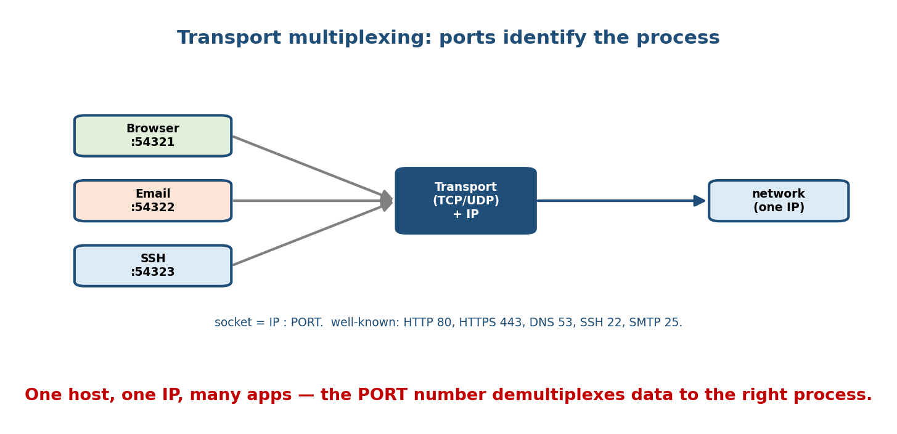
Many apps on one host share one IP; the port number demultiplexes each segment to the correct process (socket = IP : port).
Ports: 16-bit (0–65535). Well-known (0–1023): HTTP 80, HTTPS 443, DNS 53, SSH 22, SMTP 25, FTP 20/21, DHCP 67/68. Registered (1024–49151); dynamic/ephemeral (49152–65535, used by clients).
Memory hook: IP gets you to the building; the port is the apartment number. A socket = IP + port = one endpoint of a conversation.

MCQs
- Transport delivers to a? → process (via port), not just a host.
- A socket is? → (IP address, port number).
- Well-known port for HTTPS / DNS / SSH? → 443 / 53 / 22.
- Port number field size? → 16 bits (0–65535).

7.2 UDP — Fast & Connectionless
UDP (User Datagram Protocol) is a thin wrapper over IP: no connection, no reliability, no ordering, no congestion control — just ports + a checksum. Header is only 8 bytes (source port, dest port, length, checksum).
- Pros: low overhead, low latency, supports broadcast/multicast, no handshake/teardown.
- Cons: may lose/reorder/duplicate; the app must handle it if it cares.
- Used by: DNS, DHCP, VoIP/video, online games, streaming — where speed matters more than perfect delivery; and QUIC/HTTP-3 (reliability built on top of UDP in user space).
Memory hook: UDP = a postcard — cheap, fast, might get lost, no confirmation. Great when a late packet is worse than a lost one (live voice).

MCQs
- UDP header size? → 8 bytes.
- Does UDP guarantee delivery/order? → no.
- Two protocols that use UDP? → DNS, DHCP (also VoIP, QUIC).

7.3 TCP — Reliable & Connection-Oriented
TCP (Transmission Control Protocol) provides a reliable, ordered, byte-stream between two endpoints: connection setup/teardown, sequence/ack numbers, retransmission, flow control, and congestion control (M8).
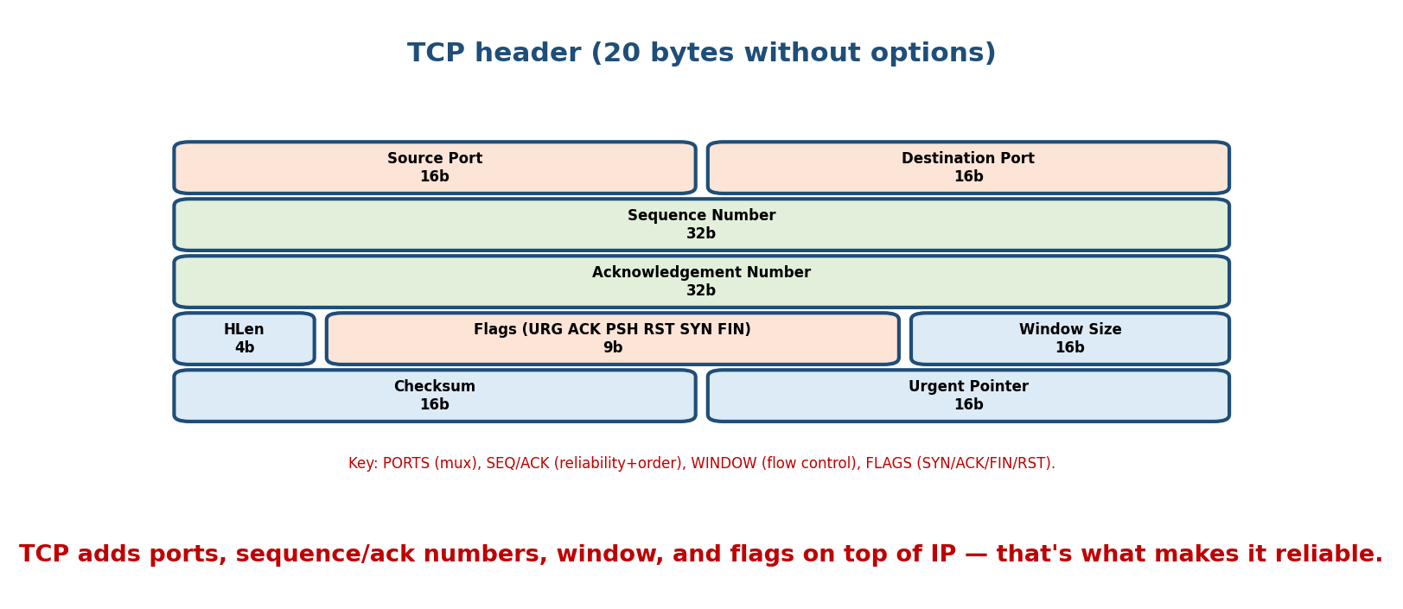
The 20-byte TCP header: ports, sequence and acknowledgement numbers, header length, flags, window size, checksum, and urgent pointer.
Key header fields:
- Source/Destination Port — the sockets.
- Sequence Number — byte offset of this segment’s first byte (enables ordering).
- Acknowledgement Number — next byte expected (cumulative ACK).
- Flags — SYN (open), ACK, FIN (close), RST (reset/abort), PSH, URG.
- Window Size — receiver’s free buffer (flow control).
- Checksum — error detection.
Memory hook: TCP = a phone call — dial (handshake), talk reliably in order, hang up (teardown). UDP = shouting a postcard into the void.

MCQs
- TCP delivers a? → reliable, ordered byte stream.
- Which field enables reordering? → sequence number.
- Flag to abruptly abort a connection? → RST.
- Which field carries flow-control info? → window size.

7.4 Connection Setup & Teardown (the handshake)
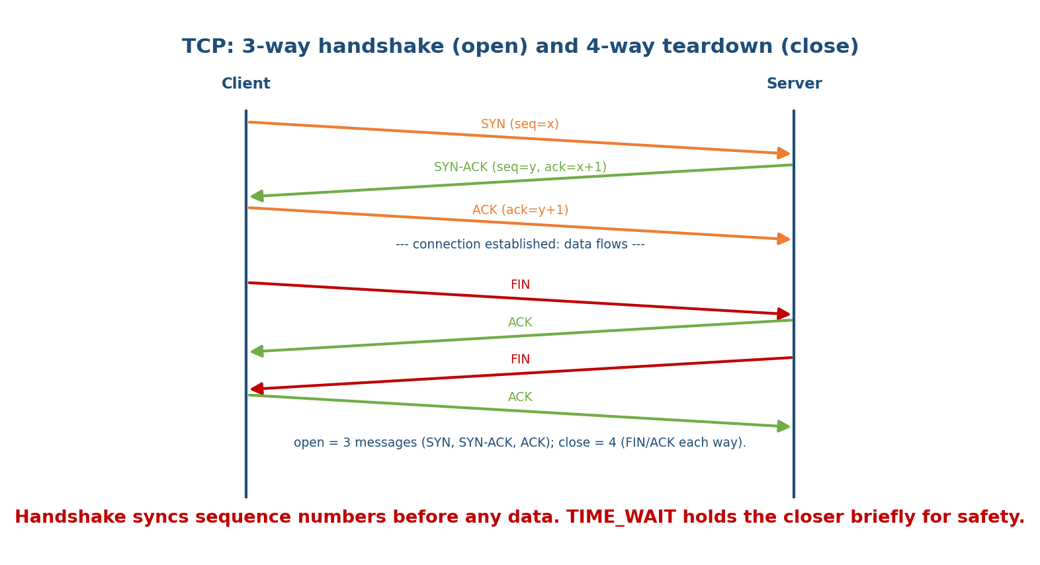
TCP opens with a 3-way handshake (SYN, SYN-ACK, ACK) that syncs sequence numbers, then closes with a 4-way exchange of FIN/ACK in each direction.
3-way handshake (open):
- Client → SYN (seq = x): “let’s talk; my start seq is x.”
- Server → SYN-ACK (seq = y, ack = x+1): “ok; my start seq is y, I got yours.”
- Client → ACK (ack = y+1): “got yours.” → connection established.
Why three? Both sides must agree on initial sequence numbers and confirm each other is reachable — two messages can’t confirm both directions.
4-way teardown (close): each side sends its own FIN and gets an ACK (the connection is full-duplex, so each direction closes independently). The active closer enters TIME_WAIT (~2×MSL) to absorb stray delayed segments before fully closing.
- SYN flood = a DoS attack: send many SYNs, never complete the handshake, exhausting the server’s half-open table (defended by SYN cookies).

MCQs
- The 3 handshake messages? → SYN, SYN-ACK, ACK.
- Why 3 (not 2)? → to sync sequence numbers and confirm both directions.
- Messages to close? → 4 (FIN + ACK each way).
- State the active closer waits in? → TIME_WAIT (~2·MSL).

7.5 Reliability & Flow Control
Reliability: every byte has a sequence number; the receiver sends cumulative ACKs (“next byte I expect”). Lost segments are retransmitted on timeout (RTO) or 3 duplicate ACKs (fast retransmit — M8). The RTO is set from a smoothed RTT estimate (RTT + variance, Jacobson’s algorithm).
Flow control (receiver-driven): the receiver advertises a window (rwnd) = free buffer space; the sender may have at most rwnd unacknowledged bytes in flight — a sliding window (the same idea as M3, now end-to-end). If the receiver’s window hits 0, the sender pauses and probes with window-update / zero-window probes.
Memory hook: flow control = the receiver saying “slow down, my inbox is filling” (rwnd). Congestion control (M8) = the network saying slow down.

MCQs
- TCP ACKs are? → cumulative (“next byte expected”).
- Two triggers for retransmission? → timeout (RTO) and 3 duplicate ACKs.
- Flow control uses which field? → receiver window (rwnd).
- RTO is derived from? → the estimated RTT (+ variance).

7.6 TCP vs UDP (the comparison you must know cold)
 | TCP | UDP
Connection | connection-oriented (handshake) | connectionless
Reliability | reliable (ACK + retransmit) | best-effort
Ordering | in-order (seq numbers) | no ordering
Flow / congestion control | yes | no
Header size | 20 bytes (min) | 8 bytes
Speed / overhead | slower, more overhead | fast, minimal
Broadcast/multicast | no | yes
Use cases | web, email, file transfer, SSH | DNS, DHCP, VoIP, video, games, QUIC
Memory hook: TCP = reliable phone call; UDP = fast postcard. Choose TCP when every byte must arrive correctly; UDP when speed beats perfection.

MCQs
- Header sizes TCP/UDP? → 20 / 8 bytes.
- Which supports multicast? → UDP.
- Video call — TCP or UDP? → UDP (late data is useless).
- File download — TCP or UDP? → TCP (must be exact).

7.7 Real-World & Backend Perspectives
- Sockets are the backend API: socket → bind → listen → accept (server) and connect (client) are exactly this layer (M20 in the OS notes). Ports are what your service “listens on.”
- TIME_WAIT piling up is a real ops issue on busy servers/load-balancers (tune reuse, keep-alive).
- QUIC / HTTP-3 move reliability + ordering into user space over UDP to cut handshake latency and avoid head-of-line blocking — a modern, heavily-tested trend.
- SYN floods and RST injection are classic network attacks tied to this layer (M10).

7.8 Tradeoffs, Common Mistakes, Edge Cases
- Mistake: “UDP has no header fields for reliability, so it’s useless” — it’s ideal when latency matters (voice) or the app adds its own reliability (QUIC).
- Mistake: thinking close is 3-way — open = 3, close = 4 (each direction FIN/ACK).
- Trap: flow control (rwnd, receiver) vs congestion control (cwnd, network) — two different windows; TCP sends min(rwnd, cwnd).
- Edge case: TIME_WAIT exists so a delayed duplicate from an old connection can’t be mistaken for the new one.

7.9 Exam, Interview & Coding Perspectives
- SEBI / RBI / NABARD: TCP vs UDP, handshake, ports, which protocol uses which transport (DNS=UDP, HTTP=TCP).
- GATE / C-DAC: handshake sequence-number arithmetic, header fields, flow-control window, connection states, efficiency (ties to M3 sliding window).
- Interview: “TCP vs UDP and when to use each?”, “explain the 3-way handshake”, “what is a socket?” — near-guaranteed questions.

7.10 Concept Checks & MCQs (test yourself)
- Socket = ? → (IP, port).
- 3-way handshake messages? → SYN, SYN-ACK, ACK.
- Why 3, not 2? → sync sequence numbers + confirm both directions.
- TCP vs UDP header size? → 20 / 8 bytes.
- Which is connectionless? → UDP.
- Two retransmission triggers? → RTO timeout, 3 dup ACKs.
- Flow-control window vs congestion window? → rwnd (receiver) vs cwnd (network); send min(rwnd,cwnd).
- Ports for HTTP/HTTPS/DNS/SSH? → 80/443/53/22.
- Teardown message count? → 4 (FIN/ACK each way).
- Protocol for VoIP? → UDP.

7.11 One-Page Revision Sheet
TRANSPORT (L4): PROCESS-to-process via PORTS. socket = (IP,port). mux/demux. PDU=SEGMENT.
PORTS: 16-bit. well-known 0-1023: HTTP80 HTTPS443 DNS53 SSH22 SMTP25 FTP20/21 DHCP67/68.
UDP (8B header): connectionless, unreliable, unordered, NO flow/congestion ctrl, supports multicast.
fast/low-overhead. used: DNS, DHCP, VoIP, video, games, QUIC. "postcard".
TCP (20B header): connection-oriented, RELIABLE, ordered byte-stream, flow+congestion control. "phone call".
header: srcPort|dstPort|SEQ|ACK|HLen|flags(SYN ACK FIN RST PSH URG)|WINDOW|checksum|urgptr.
SEQ=byte offset; ACK=next byte expected (CUMULATIVE).
HANDSHAKE (open, 3-way): SYN(x) -> SYN-ACK(y,ack x+1) -> ACK(ack y+1). syncs seq nums + both directions.
TEARDOWN (close, 4-way): FIN/ACK each direction. active closer -> TIME_WAIT (~2*MSL).
SYN flood = DoS (half-open); defend with SYN cookies.
RELIABILITY: seq + cumulative ACK; retransmit on RTO (from RTT estimate) or 3 DUP ACKs (fast retransmit).
FLOW CONTROL: receiver window rwnd (don't overrun RECEIVER). sender in-flight <= min(rwnd, cwnd).
(congestion control cwnd = don't overrun NETWORK -> Module 8.)
TCP vs UDP: reliable/ordered/heavy vs fast/unordered/light. TCP=web/email/file/SSH; UDP=DNS/VoIP/stream.

Flash cards
Front | Back
Socket | (IP, port)
3-way handshake | SYN, SYN-ACK, ACK
Why 3-way | sync seq numbers + both directions
Teardown messages | 4 (FIN/ACK each way)
TCP / UDP header size | 20 / 8 bytes
Cumulative ACK meaning | next byte expected
Retransmit triggers | RTO timeout; 3 dup ACKs
Flow vs congestion window | rwnd (receiver) vs cwnd (network)
Ports 80/443/53/22 | HTTP/HTTPS/DNS/SSH
Active closer state | TIME_WAIT (~2·MSL)

Spaced repetition
- 24-hour: draw the 3-way handshake with seq/ack numbers and the 4-way teardown.
- 7-day: TCP vs UDP table; ports; flow vs congestion window.
- 30-day: explain end-to-end how a browser opens a TCP connection and why UDP suits VoIP — without notes.

7.12 Summary
The Transport layer provides process-to-process delivery via ports (socket = IP + port) and multiplexing/demultiplexing. UDP is a thin, connectionless, unreliable wrapper (8-byte header) — fast and multicast-capable, ideal for DNS, DHCP, VoIP, and QUIC. TCP is connection-oriented and reliable (20-byte header): it opens with a 3-way handshake (SYN/SYN-ACK/ACK) that syncs sequence numbers, closes with a 4-way FIN exchange (with TIME_WAIT), and guarantees an ordered byte stream via sequence/cumulative-ACK numbers, retransmission (RTO or 3 dup ACKs), and flow control (receiver window rwnd). The sender is limited by min(rwnd, cwnd) — the second window, congestion, is next.
Next, Module 8 — Congestion Control & QoS covers cwnd: slow start, AIMD, fast retransmit/recovery (the TCP “sawtooth”), and traffic shaping (leaky/token bucket).
You have mastered this module when you can: define ports/sockets and list well-known ports; contrast TCP vs UDP and pick the right one; draw and explain the 3-way handshake (with seq numbers) and 4-way teardown; describe TCP reliability and flow control; and distinguish rwnd from cwnd — all without notes.

