Module 8 — Congestion Control & Quality of Service
  - Computer Networks Mastery: SEBI IT / RBI / NABARD / GATE / C-DAC / Interview / Backend — In-Depth Notes (with visuals)
Prepared for nidhi.sharma@forensiccybertech.com
2026
Table of Contents

Module 8 — Congestion Control & Quality of Service
Where this module sits. Module 7 showed flow control — not overwhelming the receiver (rwnd). But the network itself can be the bottleneck: too many senders → routers’ queues overflow → packets dropped → congestion collapse. Congestion control (the cwnd half of TCP) keeps the whole network stable, and QoS mechanisms give important traffic priority. The TCP congestion “sawtooth” (slow start + AIMD) and leaky/token bucket are classic, high-frequency exam topics.
Importance ratings (out of 5):
Exam / Use | SEBI IT | RBI IT | GATE CS | Interview | Backend
This module | ★★★ | ★★★ | ★★★★★ | ★★★★ | ★★★★
Most-asked PYQ concepts (SEBI / RBI / GATE / C-DAC): flow vs congestion control; slow start / congestion avoidance (AIMD); cwnd / ssthresh; fast retransmit & fast recovery (3 dup ACKs); timeout vs 3-dup-ACK reactions; TCP Tahoe vs Reno; leaky bucket vs token bucket; congestion collapse; AQM/RED, ECN.

8.1 Flow Control vs Congestion Control (don’t confuse them)
 | Flow control (M7) | Congestion control (this module)
Protects | the receiver | the network (routers/links)
Window | rwnd (advertised by receiver) | cwnd (computed by sender)
Signal | receiver’s buffer space | packet loss / delay
Sender limit | in-flight ≤ min(rwnd, cwnd) | (same)
Congestion happens when the offered load exceeds capacity: router queues fill, delay rises, and drops occur. Uncontrolled, this spirals into congestion collapse (everyone retransmits, making it worse).
Memory hook: flow control = “don’t flood the listener”; congestion control = “don’t flood the road.” TCP obeys the stricter of the two windows.

MCQs
- cwnd protects? → the network. rwnd protects? → the receiver.
- Sender’s in-flight limit? → min(rwnd, cwnd).
- Everyone retransmitting into an overloaded net = ? → congestion collapse.

8.2 TCP Congestion Control — Slow Start & AIMD (the sawtooth)
TCP has no direct view of the network, so it treats packet loss as a congestion signal and adjusts cwnd in phases:
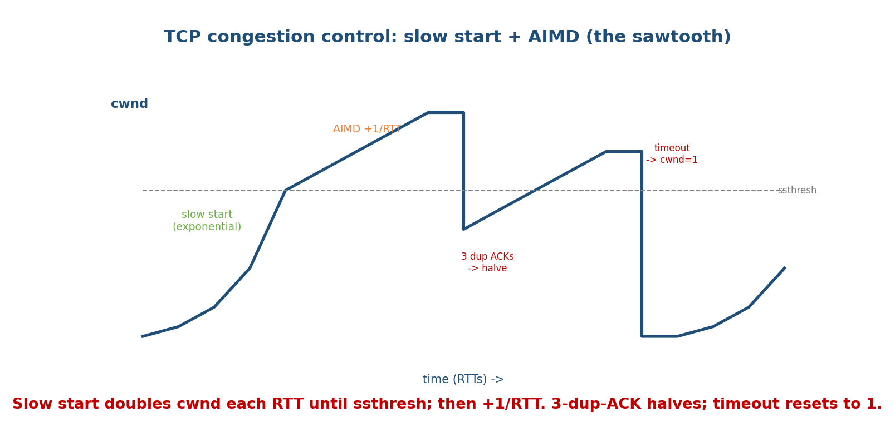
TCP congestion window: slow start grows exponentially to ssthresh, then AIMD grows linearly; a 3-dup-ACK loss halves cwnd (fast recovery) while a timeout resets it to 1.
- Slow start: begin cwnd = 1 MSS; double each RTT (exponential) until cwnd ≥ ssthresh (slow-start threshold).
- Congestion avoidance (AIMD): past ssthresh, grow linearly — +1 MSS per RTT (Additive Increase).
- On loss:
  - 3 duplicate ACKs (mild loss) → fast retransmit the missing segment, and halve cwnd (Multiplicative Decrease) → fast recovery (TCP Reno).
  - Timeout (severe loss) → set ssthresh = cwnd/2, cwnd = 1, restart slow start.
This AIMD (Additive Increase, Multiplicative Decrease) produces the characteristic sawtooth and is what makes TCP fair and stable across many flows.
Memory hook: “start slow (but double), then crawl up by 1; on trouble, cut in half; on disaster, start over.” Additive up, multiplicative down.

Tahoe vs Reno (a common exam distinction)
- TCP Tahoe: any loss (timeout or 3 dup ACKs) → cwnd = 1, slow start.
- TCP Reno: 3 dup ACKs → fast recovery (halve, don’t reset); only a timeout resets to 1. (Reno is the “sawtooth” above; most later variants build on it.)

MCQs
- Slow start growth pattern? → exponential (double per RTT).
- Congestion avoidance growth? → linear (+1 MSS/RTT) = AIMD.
- Reaction to 3 dup ACKs (Reno)? → fast retransmit + halve cwnd (fast recovery).
- Reaction to a timeout? → cwnd = 1, slow start (ssthresh = cwnd/2).
- Tahoe vs Reno on 3 dup ACKs? → Tahoe resets to 1; Reno halves (fast recovery).

8.3 Congestion Detection at Routers (AQM, ECN)
Routers can help before buffers overflow:
- Tail drop: the default — drop arriving packets once the queue is full (can cause synchronized global backoff).
- RED (Random Early Detection): an AQM (Active Queue Management) that drops/ marks packets randomly as the queue grows, signalling congestion early and avoiding synchronization.
- ECN (Explicit Congestion Notification): routers mark a bit instead of dropping; the receiver echoes it so the sender slows down without a loss — congestion signalling without dropping packets.

MCQs
- Dropping packets only when the queue is full is? → tail drop.
- AQM that drops early & randomly? → RED.
- Signalling congestion by marking (not dropping)? → ECN.

8.4 Quality of Service (QoS) & Traffic Shaping
QoS gives certain traffic (voice, video) better treatment (bandwidth, low delay/ jitter, low loss). Core tools:
Traffic shaping regulates the rate a source sends:
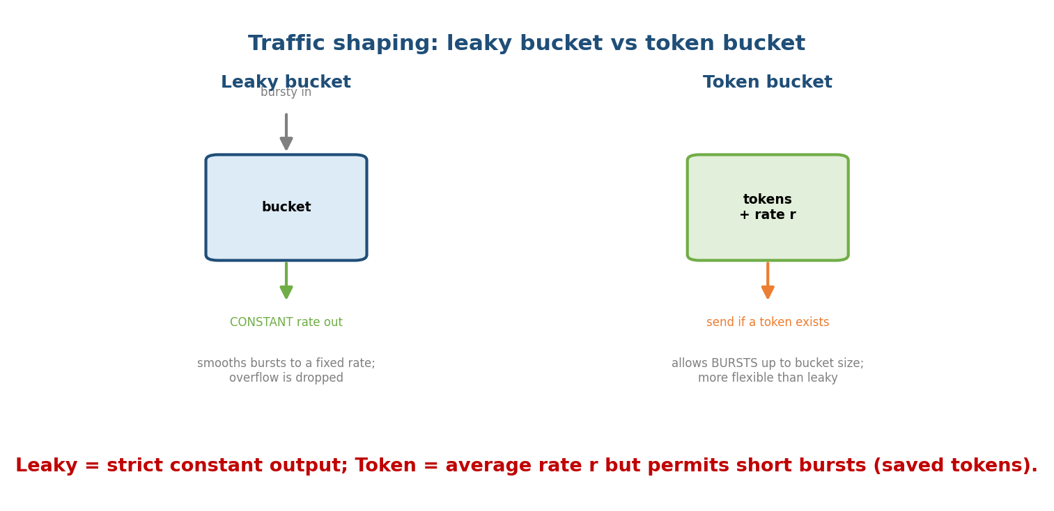
Leaky bucket emits at a constant rate and drops overflow; token bucket permits bursts up to the bucket size while enforcing an average rate.
- Leaky bucket: output is a constant rate regardless of bursty input; overflow is dropped. Smooths traffic but is inflexible (no bursts).
- Token bucket: tokens accumulate at rate r (up to bucket size b); a packet needs a token to be sent. Allows bursts (up to b) while limiting the average rate to r. More flexible than leaky bucket. Max burst ≈ b; long-term rate ≈ r.
Scheduling at routers: FIFO, priority queuing, Weighted Fair Queuing (WFQ) to divide bandwidth fairly among flows/classes.
QoS models: IntServ (per-flow reservations via RSVP — doesn’t scale) vs DiffServ (mark packets into classes via the DSCP field — scalable, widely used).
Memory hook: leaky bucket = strict metronome (constant out); token bucket = saved-up allowance (burst then refill).

MCQs
- Constant-output shaper? → leaky bucket.
- Shaper allowing bursts up to bucket size? → token bucket (avg rate r).
- Scalable QoS model marking classes? → DiffServ (DSCP).
- Fair per-flow scheduling? → WFQ.

8.5 Real-World & Backend Perspectives
- Modern TCP variants — CUBIC (Linux default, better for high-bandwidth links) and BBR (Google; models bandwidth + RTT instead of reacting to loss) — evolve the AIMD idea; interviews love “why BBR?”.
- Bufferbloat: oversized router buffers hide loss and inflate latency; AQM (CoDel/RED) and ECN fight it — a real backend/latency issue.
- QoS in practice: VoIP/video conferencing rely on DiffServ marking + WFQ; cloud load balancers and rate limiters use token buckets (the same algorithm as API rate limiting).

8.6 Tradeoffs, Common Mistakes, Edge Cases
- Mistake: confusing flow (rwnd, receiver) and congestion (cwnd, network) control — both cap the sender, but for different reasons.
- Mistake: thinking slow start is “slow” — it’s exponential (fast); it just starts small.
- Trap: timeout ⇒ cwnd = 1 (slow start); 3 dup ACKs ⇒ halve (fast recovery, Reno). Different severities, different reactions.
- Edge case: loss-based TCP misreads wireless loss (not congestion) as congestion, needlessly slowing down — a reason for BBR.

8.7 Exam, Interview & Coding Perspectives
- SEBI / RBI / NABARD: flow vs congestion control, slow start/AIMD idea, leaky vs token bucket, what QoS means.
- GATE / C-DAC: trace cwnd over RTTs (slow start → AIMD → loss), compute cwnd after events, Tahoe vs Reno, token-bucket burst/rate math.
- Interview: “how does TCP handle congestion?” → slow start + AIMD + fast recovery; “leaky vs token bucket?”; “why BBR/CUBIC?”.

8.8 Concept Checks & MCQs (test yourself)
- Flow vs congestion window? → rwnd (receiver) vs cwnd (network).
- Slow start vs congestion avoidance growth? → exponential vs linear (AIMD).
- cwnd after a timeout? → 1 MSS, slow start (ssthresh = cwnd/2).
- cwnd after 3 dup ACKs (Reno)? → halved (fast recovery).
- AIMD stands for? → Additive Increase, Multiplicative Decrease.
- Tahoe vs Reno? → Tahoe resets to 1 on any loss; Reno halves on 3-dup-ACK.
- Constant-rate shaper vs burst-allowing shaper? → leaky vs token bucket.
- Router marking instead of dropping? → ECN.
- Scalable QoS via packet classes? → DiffServ.
- Congestion collapse means? → throughput crashes as everyone retransmits.

8.9 One-Page Revision Sheet
FLOW CONTROL (M7) = don't overrun RECEIVER (rwnd). CONGESTION CONTROL = don't overrun NETWORK (cwnd).
sender in-flight <= min(rwnd, cwnd). congestion collapse = overload -> drops -> retransmit spiral.
TCP CONGESTION (cwnd), loss = congestion signal:
1) SLOW START: cwnd=1, DOUBLE per RTT (exponential) until cwnd >= ssthresh.
2) CONGESTION AVOIDANCE (AIMD): +1 MSS per RTT (linear).
3) LOSS:
- 3 DUP ACKs -> fast retransmit + cwnd/=2 -> FAST RECOVERY (Reno).
- TIMEOUT -> ssthresh=cwnd/2, cwnd=1, slow start.
AIMD (additive up, multiplicative down) -> sawtooth, fairness.
TAHOE: any loss -> cwnd=1. RENO: 3dupACK -> halve; timeout -> 1. (CUBIC/BBR = modern.)
ROUTER AQM: tail drop (queue full) | RED (drop early/random) | ECN (MARK not drop).
QoS: goals = bandwidth, low delay/jitter/loss.
SHAPING: leaky bucket(constant out, drop overflow) | token bucket(rate r, burst up to b).
SCHED: FIFO | priority | WFQ. MODELS: IntServ(RSVP per-flow, not scalable) | DiffServ(DSCP classes, scalable).

Flash cards
Front | Back
Flow vs congestion window | rwnd (receiver) vs cwnd (network)
Slow start growth | exponential (double/RTT)
Congestion avoidance | +1 MSS/RTT (AIMD)
After timeout | cwnd = 1, slow start
After 3 dup ACKs (Reno) | halve cwnd (fast recovery)
AIMD | Additive Increase, Multiplicative Decrease
Leaky vs token bucket | constant out vs burst up to b
ECN | mark (not drop) to signal congestion
RED | random early drop (AQM)
Scalable QoS model | DiffServ (DSCP)

Spaced repetition
- 24-hour: draw the cwnd sawtooth labelling slow start, AIMD, 3-dup-ACK halving, timeout reset.
- 7-day: flow vs congestion; Tahoe vs Reno; leaky vs token bucket.
- 30-day: trace cwnd across a sequence of RTTs and loss events; explain token-bucket burst vs average rate — without notes.

8.10 Summary
Congestion control protects the network (via cwnd), complementing flow control’s protection of the receiver (rwnd) — the sender obeys min(rwnd, cwnd). TCP treats loss as congestion and adjusts cwnd in phases: slow start (exponential to ssthresh), congestion avoidance (AIMD, +1/RTT), and on loss either fast recovery (halve, on 3 dup ACKs — Reno) or slow start (cwnd = 1, on timeout) — the sawtooth. Routers assist with AQM (RED) and ECN (mark, not drop). QoS prioritises important traffic via traffic shaping (leaky bucket = constant rate, token bucket = bursts up to b at average rate r), scheduling (WFQ), and models (DiffServ scales, IntServ doesn’t).
Next, Module 9 — The Application Layer reaches Layer 7: DNS, HTTP/HTTPS, email (SMTP/IMAP/POP3), FTP, and DHCP — the protocols you use every day.
You have mastered this module when you can: separate flow from congestion control; draw and narrate the cwnd sawtooth (slow start, AIMD, fast recovery, timeout); distinguish Tahoe vs Reno; contrast leaky vs token bucket; and explain RED/ECN and DiffServ — all without notes.

