Module 1 — Introduction to Networks & the Layered Models
  - Computer Networks Mastery: SEBI IT / RBI / NABARD / GATE / C-DAC / Interview / Backend — In-Depth Notes (with visuals)
Prepared for nidhi.sharma@forensiccybertech.com
2026
Table of Contents

Module 1 — Introduction to Networks & the Layered Models
Where this module sits. This is the map for the whole subject. Before we study cables (M2), Ethernet (M4), IP (M5), routing (M6), TCP (M7), or DNS/HTTP (M9), we need one mental framework that tells us where each of those topics lives and how they fit together. That framework is the layered model (OSI and TCP/IP). Almost every later module is really “a deep dive into one layer,” so getting this map right makes everything afterwards click — and layering itself is one of the most reliably asked exam topics.
Importance ratings (out of 5):
Exam / Use | SEBI IT | RBI IT | GATE CS | Interview | Backend
This module | ★★★★ | ★★★★ | ★★★★ | ★★★ | ★★★
Most-asked PYQ concepts (SEBI / RBI / GATE / C-DAC): the 7 OSI layers in order (and their one-line jobs); OSI vs TCP/IP differences; which layer does what (encryption? routing? MAC address? end-to-end delivery?); PDU names at each layer (segment/packet/frame/bits); encapsulation; which device works at which layer (hub/switch/router); protocol-to-layer matching (HTTP=App, IP=Network, Ethernet=Data Link).

1.1 What Is a Computer Network? (first principles)

Definition
A computer network is a set of autonomous computing devices connected by communication links so they can share data and resources. “Autonomous” matters: the machines are independent — none is the master of the others (that rules out, say, a CPU and its dumb terminal).
Why network at all? Four classic goals:
- Resource sharing — files, printers, compute, databases.
- Communication — email, chat, video calls.
- Reliability — replicate data so one failure isn’t fatal.
- Scalability / cost — many cheap machines beat one giant one.
Memory hook: a network is a postal system for data — it takes a message from a sender, moves it hop by hop, and delivers it to the right receiver, even across the whole planet.

Network types by scale (a favourite MCQ)
Type | Scope | Example
PAN | ~1 m (personal) | Bluetooth earbuds
LAN | a building/campus | office Ethernet/Wi-Fi
MAN | a city | cable-TV / metro network
WAN | country/global | the Internet

MCQs
- “Autonomous” in the network definition rules out? → a master–slave setup (e.g. CPU + dumb terminal).
- A city-wide network is a? → MAN.
- The Internet is a? → WAN (a network of networks).

1.2 Why Layering? (the single biggest idea in networking)
Networking is hugely complex: signals, addressing, routing, reliability, encryption, applications. Doing it all in one giant program would be unmaintainable. So we divide the work into layers, each with one job and a clean interface to the layer above and below.
Benefits of layering (exam-ready list):
- Modularity — change one layer (e.g. Wi-Fi → Ethernet) without touching others.
- Abstraction — an app says “send these bytes”; it needn’t know about cables.
- Interoperability — vendors that follow the same layer interface work together.
- Easier troubleshooting — isolate a fault to one layer.
Memory hook: layering is like sending a gift by courier — you wrap the gift (App), put it in a box (Transport), write the address (Network), the courier loads the truck (Data Link), and the road carries it (Physical). Each person only does their own step.

MCQs
- Main benefit of layering? → modularity (change one layer independently).
- Which principle lets an app ignore whether it’s on Wi-Fi or Ethernet? → abstraction.

1.3 The OSI Model — 7 Layers (know these cold)
The OSI (Open Systems Interconnection) model, from ISO, is the 7-layer reference model. It’s a teaching/standard model — real networks use TCP/IP — but exams love OSI because it separates every job cleanly.
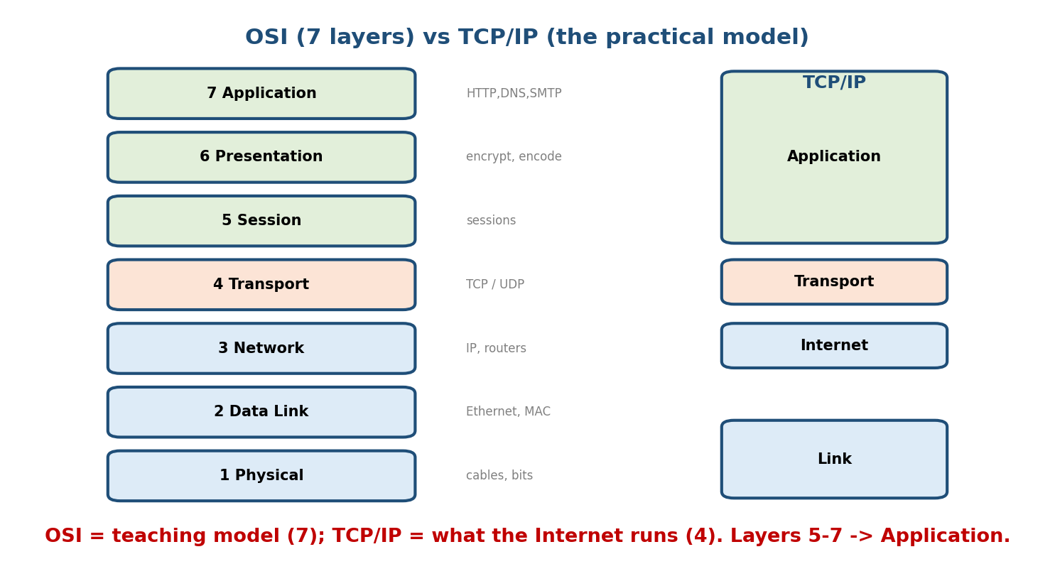
The OSI 7-layer reference model beside the practical 4-layer TCP/IP model; OSI’s top three layers all map to TCP/IP’s Application layer.
Top-to-bottom (Layer 7 → 1) with the one job of each:
# | Layer | One-line job | Example / protocol | PDU
7 | Application | interface to the user’s app | HTTP, DNS, SMTP, FTP | data
6 | Presentation | translation, encryption, compression | TLS/SSL, JPEG, ASCII | data
5 | Session | set up / manage / tear down sessions | NetBIOS, RPC | data
4 | Transport | end-to-end delivery, ports, reliability | TCP, UDP | segment
3 | Network | logical addressing + routing across networks | IP, routers | packet
2 | Data Link | node-to-node delivery on one link, MAC | Ethernet, switches | frame
1 | Physical | raw bits as signals on the medium | cables, hubs, NIC | bits
Mnemonic (top→bottom): “All People Seem To Need Data Processing” (Application, Presentation, Session, Transport, Network, Data Link, Physical). Bottom→top: “Please Do Not Throw Sausage Pizza Away.”

The exam traps — which layer does X?
- Encryption / compression → Presentation (6).
- Ports & end-to-end reliability (TCP) → Transport (4).
- Routing & IP addressing → Network (3).
- MAC address & error detection on a link → Data Link (2).
- Bits / voltage / connectors → Physical (1).

MCQs
- Encryption is handled by which OSI layer? → Presentation (Layer 6).
- Routing happens at which layer? → Network (Layer 3).
- The PDU at the Transport layer is a? → segment.
- MAC addresses live at which layer? → Data Link (Layer 2).

1.4 The TCP/IP Model — What the Internet Actually Uses
The TCP/IP model is the practical model the Internet runs on. It collapses OSI’s 7 into 4 (some books say 5, splitting Link into Data Link + Physical):
TCP/IP layer | = OSI layers | Key protocols
Application | 7 + 6 + 5 | HTTP, DNS, SMTP, FTP, TLS
Transport | 4 | TCP, UDP
Internet | 3 | IP, ICMP, routers
Link (Network Access) | 2 + 1 | Ethernet, Wi-Fi, ARP

OSI vs TCP/IP (a guaranteed exam comparison)
 | OSI | TCP/IP
Layers | 7 | 4 (or 5)
Role | reference/teaching model | practical, in-use model
Developed | ISO | DARPA / IETF
Layer coupling | strict, well-defined | protocols came first, model after
Transport delivery | both connection-oriented | TCP (CO) + UDP (CL)
Memory hook: OSI teaches, TCP/IP runs. OSI’s top three (Application, Presentation, Session) all fold into TCP/IP’s single Application layer.

MCQs
- TCP/IP has how many layers? → 4 (or 5 if Link is split).
- OSI’s Presentation + Session + Application map to which TCP/IP layer? → Application.
- Which model is “reference only”? → OSI.

1.5 Encapsulation — How Data Travels Down the Stack
When you send data, it moves down the sender’s stack; each layer wraps it with its own header (and Data Link adds a trailer too). At the receiver it moves up, each layer stripping its header (decapsulation).
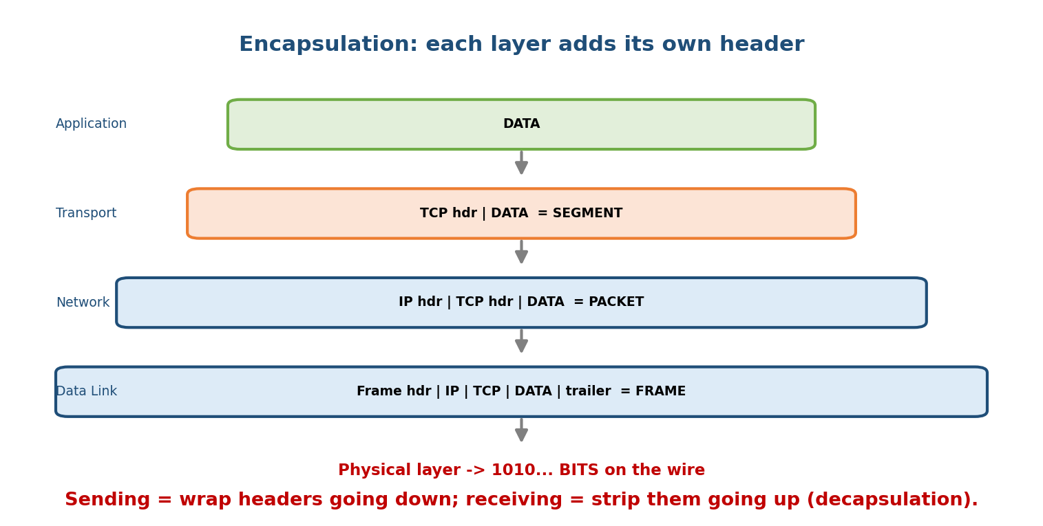
Going down the stack, each layer wraps the data in its own header; the names change: data → segment → packet → frame → bits.
The PDU (Protocol Data Unit) names are a classic one-mark question:
Application data
+ TCP/UDP header -> SEGMENT (Transport, L4)
+ IP header -> PACKET / datagram (Network, L3)
+ Frame header+trailer-> FRAME (Data Link, L2)
-> converted to -> BITS (Physical, L1)
Memory hook (PDU ladder): “Some People Fear Birthdays” — Segment, Packet, Frame, Bits (top of transport → wire).

MCQs
- Data + TCP header = ? → segment.
- Adding the IP header creates a? → packet (datagram).
- Decapsulation happens at the? → receiver (stripping headers going up).

1.6 Networking Devices by Layer (which box works where)
Device | Layer | What it does
Hub / repeater | 1 Physical | dumb signal copier; one collision domain (obsolete)
Switch / bridge | 2 Data Link | forwards frames by MAC address; separates collision domains
Router | 3 Network | forwards packets between networks by IP; separates broadcast domains
NIC | 1–2 | the network card; has the MAC address
Gateway / L7 proxy | up to 7 | translates between protocols / apps (e.g. API gateway)
Memory hook: Hub = broadcast to all; Switch = smart by MAC; Router = smart by IP (crosses networks). As you go up a layer, the device gets “smarter.”

MCQs
- A switch forwards using which address? → MAC (Layer 2).
- Which device connects two different networks? → router (Layer 3).
- A hub operates at which layer? → Physical (Layer 1).

1.7 A Day in the Life of a Web Request (tying it together)
You type https://example.com and press Enter. Watch the layers work:
1. Application : browser builds an HTTP GET request.
(DNS first resolves example.com -> an IP address — Module 9.)
2. Presentation: TLS encrypts the request (HTTPS).
3. Transport : TCP splits it into SEGMENTS, adds source/dest PORTS (443),
and sets up a connection (3-way handshake — Module 7).
4. Network : IP wraps each segment in a PACKET with source/dest IP;
routers forward it hop by hop (Module 6).
5. Data Link : each hop wraps the packet in a FRAME with MAC addresses;
ARP finds the next hop's MAC (Module 4).
6. Physical : bits go out as electrical/optical/radio signals.
At the server, the same stack runs in reverse (decapsulation) until the web server reads your HTTP GET. This one example previews the entire course.

1.8 Connection-Oriented vs Connectionless, and Service Models
- Connection-oriented (CO): set up a path/handshake first, then send (reliable, ordered) — like a phone call. Example: TCP.
- Connectionless (CL): just send each packet independently — like postcards. Example: UDP, and IP itself.
Two more terms exams mix up:
- Unicast (one→one), broadcast (one→all), multicast (one→group), anycast (one→nearest of a group).
- Simplex (one direction), half-duplex (both, one at a time — walkie-talkie), full-duplex (both at once — phone).

MCQs
- TCP is connection-oriented or connection-less? → oriented.
- Walkie-talkie communication is? → half-duplex.
- One-to-nearest-member delivery is? → anycast.

1.9 Real-World & Backend Perspectives
- Every API call you make is this stack in action: your HTTP request (L7) rides TCP (L4) over IP (L3) over Ethernet/Wi-Fi (L2). Debugging “why is my service slow/unreachable” is literally asking which layer failed.
- Tools by layer: ping/traceroute (L3), telnet/nc to a port (L4), curl (L7), ifconfig/ip (L2/3), Wireshark (see every layer’s header live).
- Cloud/backend: a load balancer is “L4 (TCP) vs L7 (HTTP)”; a CDN and API gateway live at L7; a VPC/router at L3. The OSI vocabulary is how infra is described.

1.10 Tradeoffs, Common Mistakes, Edge Cases
- Mistake: thinking TCP/IP has “no session/presentation layer functions.” It does — they’re just inside the Application layer (e.g. TLS does presentation’s encryption).
- Mistake: confusing Data Link (MAC, one link) with Network (IP, end-to-end). MAC = local hop; IP = the whole journey.
- Trap: a switch is L2, a router is L3 — mixing these is the #1 device error.
- Edge case: layering costs a little overhead (headers, copies), but the modularity is worth it — the Internet scaled precisely because of clean layers.

1.11 Exam, Interview & Coding Perspectives
- SEBI / RBI / NABARD: expect direct one-markers — layer order, which-layer-does-X, PDU names, OSI vs TCP/IP, device-to-layer. High-frequency, easy marks — memorise.
- GATE / C-DAC: same plus subtle traps (which layer adds which header; connection-oriented vs -less; the exact protocol→layer mapping).
- Interview: “What happens when you type a URL and press Enter?” — answer with the §1.7 layer walkthrough; it’s the most-asked networking interview question.

1.12 Concept Checks & MCQs (test yourself)
- List the 7 OSI layers top to bottom. → A, P, S, T, N, DL, Ph.
- Which two OSI layers does the TCP/IP Link layer cover? → Data Link + Physical.
- Encryption is at which layer? → Presentation (6).
- PDU at Network layer? → packet (datagram).
- Router vs switch — layers? → router = L3 (IP), switch = L2 (MAC).
- TCP vs UDP — connection type? → TCP oriented, UDP connectionless.
- Adding headers going down the stack is called? → encapsulation.
- The Internet is which network type by scale? → WAN.
- Which layer provides end-to-end delivery and ports? → Transport (4).
- Full-duplex example? → a phone call (both talk at once).

1.13 One-Page Revision Sheet
NETWORK = autonomous devices sharing data/resources. Goals: sharing, comms, reliability, scale.
SCALE: PAN(1m) < LAN(building) < MAN(city) < WAN(global=Internet).
WHY LAYERS: modularity, abstraction, interoperability, easy debugging.
OSI 7 (top->bottom) "All People Seem To Need Data Processing"
7 Application user apps HTTP,DNS,SMTP,FTP
6 Presentation ENCRYPT/compress/translate TLS,JPEG
5 Session sessions RPC,NetBIOS
4 Transport END-TO-END, PORTS, reliability TCP/UDP PDU=SEGMENT
3 Network ROUTING + IP addressing IP,router PDU=PACKET
2 Data Link node-to-node, MAC, error-detect Ethernet,switch PDU=FRAME
1 Physical raw BITS/signals cables,hub,NIC PDU=bits
TCP/IP 4: Application(=OSI 5-7) | Transport(4) | Internet(3) | Link(2+1).
OSI=teaching(7, ISO); TCP/IP=runs the Internet(4, DARPA/IETF).
PDU ladder (down): DATA -> SEGMENT(+TCP) -> PACKET(+IP) -> FRAME(+MAC hdr/trailer) -> BITS.
"Some People Fear Birthdays" = Segment, Packet, Frame, Bits.
Encapsulation=wrap headers down; decapsulation=strip headers up.
DEVICES: Hub=L1(broadcast) | Switch/Bridge=L2(MAC, collision domains) |
Router=L3(IP, broadcast domains) | NIC=L1-2(has MAC) | Gateway/proxy=up to L7.
CO vs CL: TCP=connection-oriented(phone); UDP/IP=connectionless(postcard).
CAST: unicast(1-1), broadcast(1-all), multicast(1-group), anycast(1-nearest).
DUPLEX: simplex | half(walkie-talkie) | full(phone).

Flash cards
Front | Back
OSI layer count / mnemonic | 7 — “All People Seem To Need Data Processing”
Encryption layer | Presentation (6)
Routing layer | Network (3)
MAC-address layer | Data Link (2)
Ports & end-to-end layer | Transport (4)
PDU: Transport / Network / Data Link | segment / packet / frame
Switch vs router layer | L2 (MAC) vs L3 (IP)
TCP/IP layer count | 4 (or 5)
OSI 5–7 map to TCP/IP | Application
Add headers going down = | encapsulation

Spaced repetition
- 24-hour: recite the 7 OSI layers + one job each + PDU names, from memory.
- 7-day: OSI vs TCP/IP table; which-layer-does-X traps; device-to-layer.
- 30-day: narrate “URL to page load” through all layers without notes.

1.14 Summary
A computer network connects autonomous devices to share data and resources, ranging in scale from PAN → LAN → MAN → WAN (the Internet). Because networking is so complex, we split it into layers, each with one job — giving modularity, abstraction, and interoperability. The OSI model defines 7 layers (Application, Presentation, Session, Transport, Network, Data Link, Physical), while the TCP/IP model collapses these into the 4 layers the Internet actually runs. Data moves down the sender’s stack via encapsulation — becoming a segment → packet → frame → bits — and up the receiver’s stack via decapsulation. Different devices operate at different layers (hub = L1, switch = L2, router = L3), and services are connection-oriented (TCP) or connectionless (UDP).
Next, Module 2 — The Physical Layer & Transmission Media goes to Layer 1: how bits actually become signals on copper, fibre, and radio, and the limits (bandwidth, Nyquist, Shannon) that cap how fast we can send.
You have mastered this module when you can: recite the 7 OSI layers top-to- bottom with each layer’s job and PDU; map OSI to TCP/IP; explain encapsulation and name the PDU at each layer; say which device works at which layer; and walk a web request through all seven layers — all without notes.

