Module 5 — The Network Layer & IP Addressing
  - Computer Networks Mastery: SEBI IT / RBI / NABARD / GATE / C-DAC / Interview / Backend — In-Depth Notes (with visuals)
Prepared for nidhi.sharma@forensiccybertech.com
2026
Table of Contents

Module 5 — The Network Layer & IP Addressing
Where this module sits. The Data Link layer (M3–M4) moves a frame across one link. But the Internet is millions of links. Layer 3, the Network layer, provides end-to-end delivery across many networks using logical (IP) addresses and routing. This module is about the addressing half: IPv4, classes, subnetting, CIDR, special addresses, NAT, the IP header (and fragmentation), ICMP, and IPv6. Routing algorithms come next (M6). Subnetting is the single most exam-tested CN skill — we drill it with worked numericals.
Importance ratings (out of 5):
Exam / Use | SEBI IT | RBI IT | GATE CS | Interview | Backend
This module | ★★★★ | ★★★★ | ★★★★★ | ★★★ | ★★★★
Most-asked PYQ concepts (SEBI / RBI / GATE / C-DAC): subnetting (network/ broadcast/first/last host, #subnets, #hosts = 2^h − 2); subnet mask ↔ prefix (CIDR); classes A/B/C and default masks; CIDR aggregation/supernetting; private addresses & NAT; IPv4 header fields (TTL, protocol, fragmentation offset); fragmentation numericals (MTU, offset in units of 8); ICMP (ping/traceroute); IPv6 (128-bit, notation, why).

5.1 What the Network Layer Does
- Logical addressing — every host gets an IP address (works across links, unlike the local-only MAC).
- Routing — choose a path across networks (M6); forwarding — move a packet to the next hop using the routing table.
- Fragmentation & reassembly — split a packet if it exceeds a link’s MTU.
- Best-effort, connectionless — IP does not guarantee delivery, order, or no-duplication (that’s TCP’s job, M7). IP just tries its best.
Memory hook: IP is the postal address of the Internet — it gets a packet from any host to any host, hop by hop, but makes no delivery promises (that’s the courier’s “we’ll try”). MAC = which house on this street; IP = which house on Earth.

MCQs
- IP delivery guarantee? → best-effort (no guarantee; connectionless).
- MAC vs IP scope? → MAC = local link, IP = end-to-end.
- Splitting a big packet for a small-MTU link is? → fragmentation.

5.2 IPv4 Addresses & Classes
An IPv4 address is 32 bits, written as four octets in dotted decimal (192.168.1.10), each 0–255. An address has a network part and a host part.
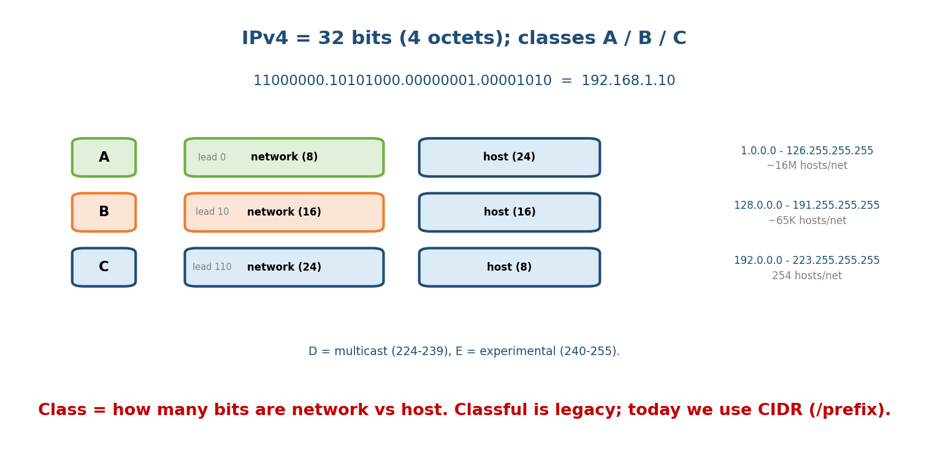
IPv4 is 32 bits in four octets; classes A/B/C set how many leading bits are network vs host, with characteristic first-octet ranges.
Class | Leading bits | 1st octet range | Default mask | Hosts/network
A | 0 | 1–126 | /8 (255.0.0.0) | ~16 million
B | 10 | 128–191 | /16 (255.255.0.0) | ~65,000
C | 110 | 192–223 | /24 (255.255.255.0) | 254
D | 1110 | 224–239 | — | multicast
E | 1111 | 240–255 | — | experimental
(127.x.x.x is reserved for loopback — 127.0.0.1 = localhost.)
Memory hook: first octet tells the class — A ≤ 126, B ≤ 191, C ≤ 223, D ≤ 239, E ≤ 255. Classful wastes addresses, so the real world uses CIDR (§5.4).

MCQs
- IPv4 address length? → 32 bits.
- First octet 150 → which class? → B (128–191).
- 224–239 is reserved for? → multicast (Class D).
- Loopback address? → 127.0.0.1.

5.3 Subnetting — the Core Exam Skill
Subnetting borrows bits from the host part to create smaller subnets. The subnet mask (or /prefix) marks how many bits are network+subnet (1s) vs host (0s).
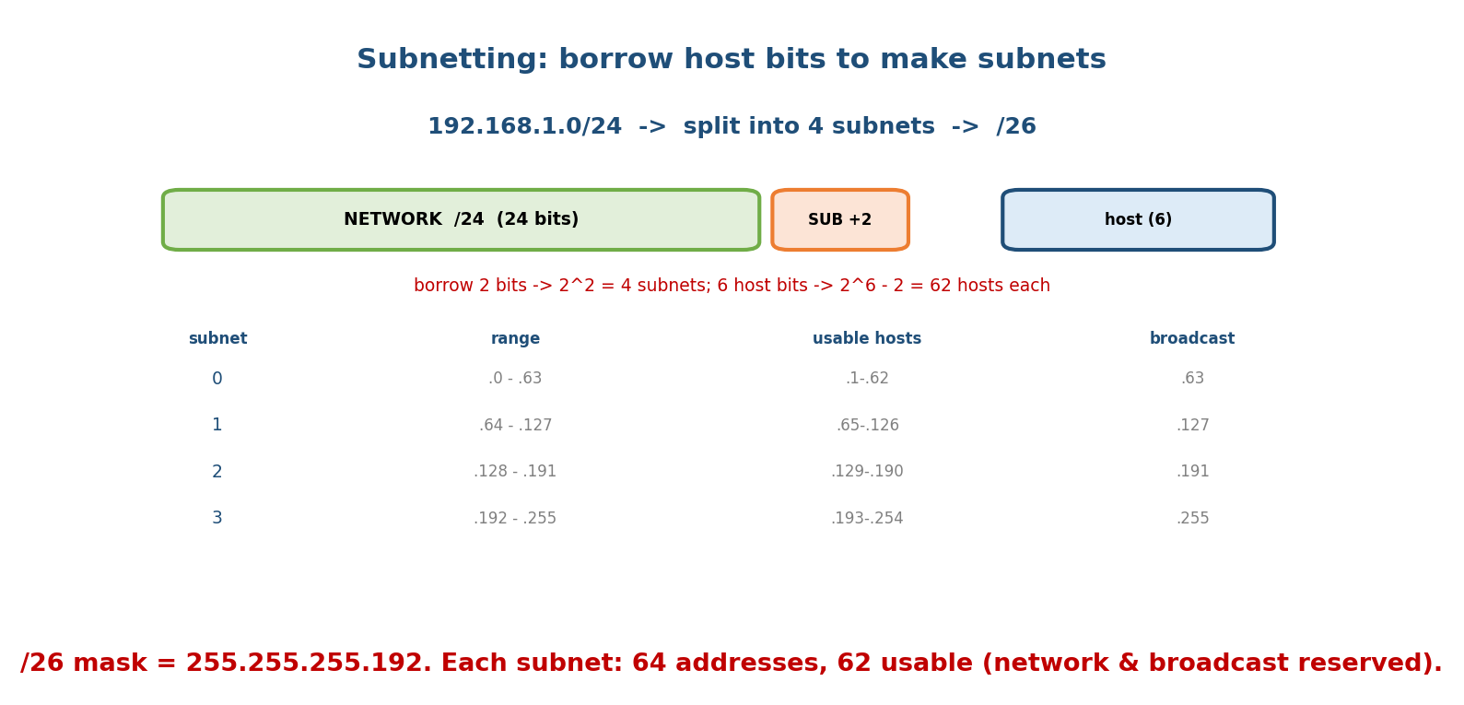
Splitting 192.168.1.0/24 into four /26 subnets: borrow 2 host bits (2² = 4 subnets), leaving 6 host bits (2⁶−2 = 62 hosts each).
The formulas (memorise):
prefix /p -> host bits h = 32 - p
number of subnets = 2^(bits borrowed)
addresses per subnet = 2^h
usable hosts per subnet = 2^h - 2 (minus network & broadcast addresses)
block size (per octet) = 256 - (mask octet value)
Worked example 1 — analyse an address. Given 192.168.1.100/26: - Mask /26 = 255.255.255.192; host bits h = 32 − 26 = 6; block size 256 − 192 = 64. - Subnets step by 64: .0, .64, .128, .192. .100 falls in the .64 block. - Network = 192.168.1.64, Broadcast = 192.168.1.127, first host .65, last host .126, usable = 2⁶ − 2 = 62.
Worked example 2 — split a network. “Divide 192.168.1.0/24 into 4 subnets”: - Need 4 = 2² subnets → borrow 2 bits → new prefix /26. - Subnets: .0/26, .64/26, .128/26, .192/26; each has 62 usable hosts.
Worked example 3 — size for hosts. “A subnet must fit 500 hosts”: - Need 2^h − 2 ≥ 500 → h = 9 (2⁹−2 = 510). Prefix = 32 − 9 = /23.
Memory hook: hosts halve, subnets double each time you borrow a bit. Always subtract 2 for host count (network + broadcast are not assignable).

VLSM (Variable-Length Subnet Masking)
Real networks use different-size subnets from one block (a /30 for a 2-host link, a /25 for a big LAN). Assign largest subnets first. This avoids the waste of fixed subnetting.

MCQs
- Usable hosts in a /26? → 62 (2⁶−2).
- To make 8 subnets, borrow how many bits? → 3 (2³).
- /29 gives how many usable hosts? → 2³ − 2 = 6 (great for point-to-point +).
- Network address of 10.1.1.200/26? → 10.1.1.192.

5.4 CIDR & Supernetting (classless addressing)
CIDR (Classless Inter-Domain Routing) drops fixed classes and uses an explicit /prefix of any length (e.g. 10.0.0.0/12). Benefits:
- Flexible allocation — give an org exactly what it needs, not a whole class.
- Route aggregation (supernetting) — combine many small routes into one, shrinking routing tables.
Aggregation worked example: 200.1.0.0/24, 200.1.1.0/24, 200.1.2.0/24, 200.1.3.0/24 share the first 22 bits → aggregate to 200.1.0.0/22 (one route instead of four).
Memory hook: subnetting splits (more, smaller); supernetting merges (fewer, bigger). CIDR = “prefix length is whatever you say,” not tied to A/B/C.

MCQs
- CIDR notation for a 255.255.255.0 mask? → /24.
- Four consecutive /24s aggregate to? → a /22.
- CIDR’s routing-table benefit? → aggregation (fewer routes).

5.5 Special & Private Addresses; NAT
- Private ranges (RFC 1918) — not routable on the Internet: 10.0.0.0/8, 172.16.0.0/12, 192.168.0.0/16.
- Loopback 127.0.0.0/8 (localhost). APIPA 169.254.0.0/16 (self-assigned when DHCP fails). Network address (all host bits 0) and broadcast (all host bits 1) are reserved.
NAT (Network Address Translation) lets many private hosts share one public IP, tracked by port (PAT). It conserves scarce IPv4 addresses and hides the internal network.
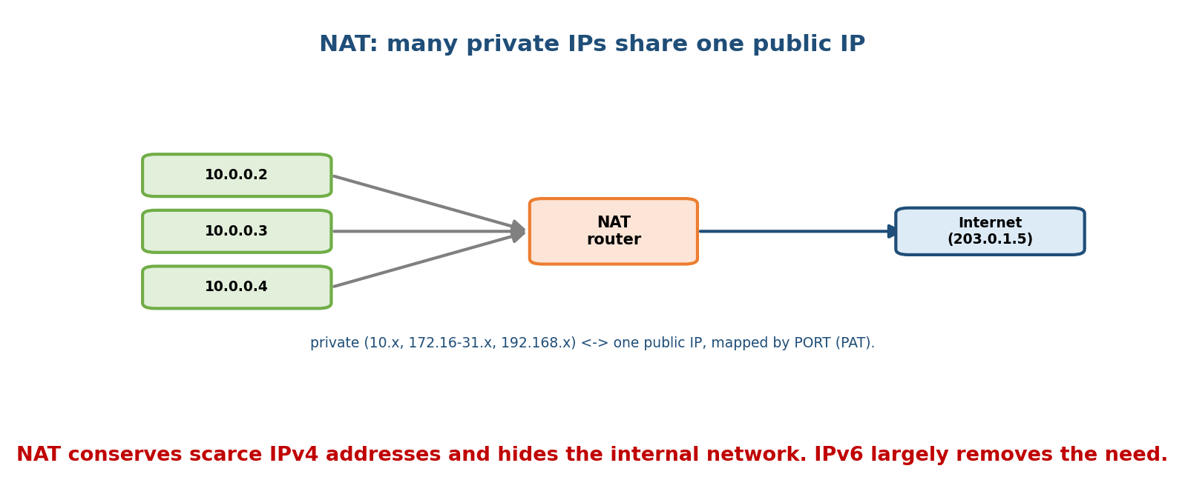
NAT maps many private IPs to one public IP using port numbers, conserving IPv4 addresses and masking the internal network.
Memory hook: private IPs are “internal extensions”; NAT is the receptionist that maps them to one public number using port “extension” numbers.

MCQs
- Three private ranges? → 10/8, 172.16/12, 192.168/16.
- APIPA range (DHCP failed)? → 169.254.0.0/16.
- NAT tracks internal hosts by? → port number (PAT).

5.6 The IPv4 Header & Fragmentation
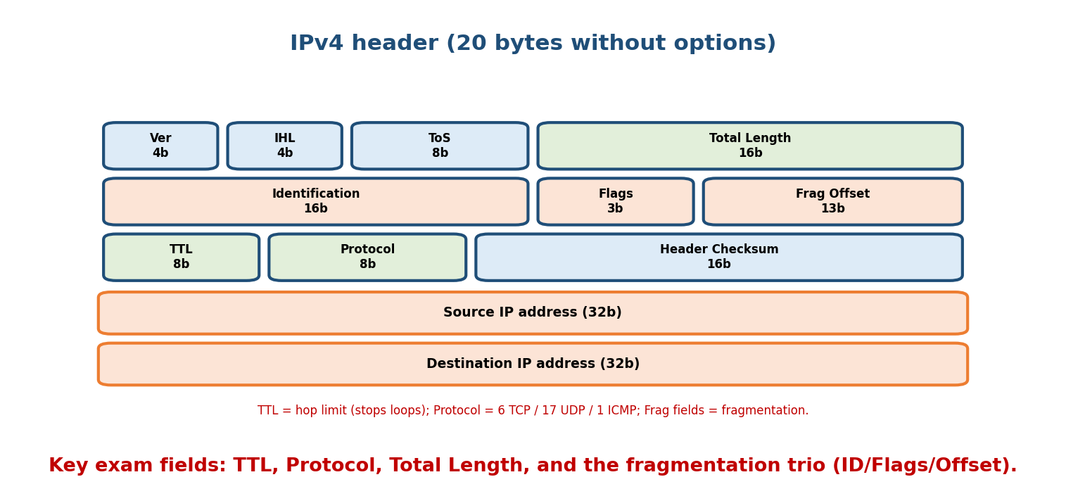
The 20-byte IPv4 header: version/IHL/ToS, total length, the fragmentation trio (identification/flags/offset), TTL, protocol, checksum, and source/destination IPs.
Key fields:
- Version (4), IHL (header length), Total Length (header+data, max 65,535).
- TTL (Time To Live): decremented each hop; at 0 the packet is dropped (stops loops). traceroute exploits this.
- Protocol: what’s inside — 6 = TCP, 17 = UDP, 1 = ICMP.
- Fragmentation trio: Identification (same for all fragments of a packet), Flags (DF = don’t fragment, MF = more fragments), Fragment Offset (position of this fragment, in units of 8 bytes).
Fragmentation worked example: a 4000-byte packet (20-byte header → 3980 data) must cross a link with MTU = 1500. Each fragment’s data must be a multiple of 8: max data per fragment = 1480 (1500 − 20; 1480 is divisible by 8). - Frag 1: data 0–1479, offset = 0, MF = 1. - Frag 2: data 1480–2959, offset = 1480/8 = 185, MF = 1. - Frag 3: data 2960–3979 (1020 bytes), offset = 2960/8 = 370, MF = 0 (last).
Memory hook: offset is counted in 8-byte units (so non-last fragments carry a multiple of 8 bytes). TTL = “hops left”; DF = “don’t fragment me.”

MCQs
- Field that prevents infinite loops? → TTL.
- Protocol number for TCP / UDP / ICMP? → 6 / 17 / 1.
- Fragment offset is measured in units of? → 8 bytes.
- Flag meaning “more fragments follow”? → MF = 1.

5.7 ICMP — the Network Layer’s Messenger
ICMP (Internet Control Message Protocol) carries error/diagnostic messages for IP (it rides inside IP packets, protocol 1). Examples: destination unreachable, time exceeded (TTL=0), echo request/reply.
- ping = ICMP echo request/reply → is the host reachable + round-trip time.
- traceroute/tracert = send packets with increasing TTL (1, 2, 3…); each router that drops one at TTL=0 replies “time exceeded,” revealing the path hop by hop.

MCQs
- ping uses? → ICMP echo request/reply.
- traceroute works by manipulating? → the TTL field.
- ICMP sits at which layer? → Network (3) (rides in IP).

5.8 IPv6 — Why & What
IPv4’s ~4.3 billion addresses ran out. IPv6 uses 128-bit addresses (~3.4×10³⁸ — effectively unlimited), written as 8 groups of 4 hex digits (2001:0db8:0000:0000:0000:ff00:0042:8329), shortened with :: (one run of zeros) and dropped leading zeros → 2001:db8::ff00:42:8329.
Improvements over IPv4:
- Vast address space → no NAT needed; end-to-end addressing restored.
- Simpler, fixed 40-byte header (extension headers for options); no header checksum; no router fragmentation (only the source fragments).
- Built-in IPsec, better multicast, SLAAC (stateless auto-config).
- Transition: dual-stack (run both), tunnelling (6in4), translation (NAT64).
Memory hook: IPv4 = 32 bits (dotted decimal, ran out); IPv6 = 128 bits (hex, :: shorthand, no NAT, no router fragmentation).

MCQs
- IPv6 address length? → 128 bits.
- What does :: mean in IPv6? → one run of all-zero groups (used once).
- IPv6 removed which IPv4 header features? → checksum and router fragmentation.

5.9 Real-World & Backend Perspectives
- Subnetting is daily backend/cloud work: an AWS VPC is a CIDR block (e.g. 10.0.0.0/16) you carve into subnets (public/private) per AZ — exactly §5.3.
- NAT & private IPs are why your laptop’s 192.168.x.x reaches the Internet; NAT traversal (STUN/TURN) is a real problem for peer-to-peer/WebRTC.
- TTL shows up as the “hop limit” in traceroute, and as a cause of “why can’t I reach X” (routing loops drop packets at TTL 0).
- IPv6 is now majority traffic for big providers (Google reports ~40%+); backend services must be dual-stack.

5.10 Tradeoffs, Common Mistakes, Edge Cases
- Mistake: forgetting −2 for usable hosts (network + broadcast are reserved). (Exception: modern /31 point-to-point links use both addresses — RFC 3021.)
- Mistake: fragment offset in bytes — it’s in 8-byte units.
- Trap: class D/E aren’t for hosts (multicast/experimental).
- Edge case: NAT breaks true end-to-end addressing (a reason IPv6 exists), and complicates protocols that embed IPs (FTP, SIP).

5.11 Exam, Interview & Coding Perspectives
- SEBI / RBI / NABARD: classes & ranges, private addresses, IPv4 vs IPv6, what NAT/ ICMP do, subnet-mask ↔ prefix.
- GATE / C-DAC: subnetting (network/broadcast/host counts, VLSM), CIDR aggregation, fragmentation (offsets), header fields — pure numericals; be fast.
- Interview: “how does subnetting work / what’s a /24?”; “what is NAT and why?”; “IPv4 vs IPv6?” — all core.

5.12 Concept Checks & MCQs (test yourself)
- Usable hosts in /28? → 2⁴ − 2 = 14.
- Network of 172.16.20.10/20? → 172.16.16.0 (block size 16 in 3rd octet).
- Aggregate 172.16.0.0/24 … 172.16.7.0/24 → ? → 172.16.0.0/21 (8 = 2³).
- Protocol numbers TCP/UDP/ICMP? → 6/17/1.
- A 5000-byte packet, MTU 1500 → data per fragment (mult. of 8)? → 1480.
- Fragment offset for the 2nd fragment above? → 185 (1480/8).
- Private class-C range? → 192.168.0.0/16.
- IPv6 length & IPv4 length? → 128 vs 32 bits.
- traceroute manipulates? → TTL.
- Prefix to fit 1000 hosts? → /22 (2¹⁰−2 = 1022).

5.13 One-Page Revision Sheet
NETWORK LAYER (L3): logical addressing + routing/forwarding + fragmentation. IP = best-effort, connectionless. PDU=PACKET.
IPv4 = 32 bits, 4 octets. CLASS by 1st octet: A 1-126(/8) | B 128-191(/16) | C 192-223(/24)
| D 224-239 multicast | E 240-255. 127=loopback.
SUBNETTING: h = 32 - prefix. subnets = 2^borrowed. addrs/subnet = 2^h. USABLE = 2^h - 2.
block size = 256 - mask_octet. /26=255.255.255.192 (64 block, 62 hosts).
network=host bits all 0; broadcast=all 1; first=net+1; last=bcast-1.
size for N hosts: smallest h with 2^h - 2 >= N. VLSM: assign biggest subnets first.
CIDR: any prefix length. SUPERNET/aggregate: 4 x /24 (same top 22 bits) -> /22.
PRIVATE (RFC1918): 10/8, 172.16/12, 192.168/16. APIPA 169.254/16. NAT: many private<->1 public via PORT (PAT).
IPv4 HEADER (20B): Ver|IHL|ToS|TotalLen | ID|Flags(DF,MF)|FragOffset | TTL|Protocol|Checksum | SrcIP|DstIP.
TTL=hops left(0=drop). Protocol 6=TCP 17=UDP 1=ICMP. OFFSET in 8-byte units. non-last frag data = multiple of 8.
ICMP (proto 1): errors/diagnostics. ping=echo req/reply. traceroute=increasing TTL.
IPv6 = 128 bits, 8 hex groups, :: = one zero-run. no NAT, fixed 40B header, NO checksum, NO router-fragmentation,
IPsec, SLAAC. transition: dual-stack / tunnel / NAT64.

Flash cards
Front | Back
Usable hosts formula | 2^h − 2 (h = 32 − prefix)
/26 mask & hosts | 255.255.255.192; 62
Class ranges A/B/C | 1–126 / 128–191 / 192–223
Private ranges | 10/8, 172.16/12, 192.168/16
Supernet 4×/24 | one /22
Protocol nums TCP/UDP/ICMP | 6 / 17 / 1
Fragment offset unit | 8 bytes
TTL purpose | hop limit; stops loops
IPv6 length | 128 bits
:: in IPv6 | one run of zero groups

Spaced repetition
- 24-hour: given an IP/prefix, find network, broadcast, host range, and usable count (three examples).
- 7-day: split a block into N subnets (VLSM); aggregate routes; fragmentation offsets.
- 30-day: design a VPC-style addressing plan (public/private subnets) from one CIDR block — without notes.

5.14 Summary
The Network layer provides best-effort, end-to-end delivery across many networks using 32-bit IPv4 addresses (classes A/B/C, plus D multicast / E experimental). Subnetting borrows host bits to make subnets — with the core formulas host bits = 32 − prefix, subnets = 2^borrowed, and usable hosts = 2^h − 2 — and VLSM lets subnets vary in size. CIDR replaces classes with arbitrary prefixes and enables route aggregation (supernetting). Private addresses + NAT conserve scarce IPv4. The IPv4 header carries TTL, Protocol, and the fragmentation trio (offset in 8-byte units), while ICMP powers ping/traceroute. Finally, IPv6 (128-bit, hex with ::) fixes address exhaustion, drops NAT and router fragmentation, and simplifies the header.
Next, Module 6 — Routing Algorithms & Protocols answers how routers choose paths: distance-vector vs link-state, Dijkstra & Bellman-Ford, and the real protocols (RIP, OSPF, BGP).
You have mastered this module when you can: classify an address and find its network/broadcast/host range/usable count from any prefix; split a block into subnets (fixed and VLSM) and aggregate routes; explain private addressing and NAT; read the IPv4 header and compute fragment offsets; and contrast IPv4 with IPv6 — all without notes.

