Module 1 — Introduction to DBMS & Database Architecture
  - DBMS Mastery: SEBI IT / RBI / GATE / Interview — In-Depth Notes (with visuals)
Prepared for nidhi.sharma@forensiccybertech.com
2026
Table of Contents

Module 1 — Introduction to DBMS & Database Architecture
Why this module comes first. Before you can normalize a table, tune an index, or reason about a transaction, you must understand what a database actually is, why humanity invented it, and how it is structured inside. Almost every other DBMS topic is an answer to a problem first raised in this module. Students who skip the foundations later confuse “schema” with “instance”, “logical” with “physical”, and fail easy 1-mark exam questions. We will not let that happen. We start from the world before databases and build the whole architecture brick by brick.
Importance ratings (out of 5):
Exam / Use | SEBI IT | RBI IT | GATE CS | Interview | Backend
This module | ★★★★★ | ★★★★ | ★★★ | ★★★ | ★★★
Most-asked PYQ concepts from this module (SEBI/RBI/GATE): data independence (logical vs physical), the three-schema (ANSI-SPARC) architecture, levels of data abstraction, schema vs instance, DDL/DML/DCL/TCL classification, DBMS vs file system advantages, data models (hierarchical/ network/relational), DBMS vs RDBMS + Codd’s 12 rules, 2-tier vs 3-tier architecture, and roles of the DBA.

1.1 The World Before Databases — Why DBMS Was Invented

Motivation (the problem that existed)
Imagine a bank in 1965. It has three departments — Savings, Loans, and Accounts. Each department wrote its own programs (in COBOL) and each kept its own files on tape or disk. The savings program had a file with customer name, address, and balance. The loans program also stored the customer’s name and address (because it needed them too). So did accounts.
This “every-application-owns-its-files” style is called the file-processing system. It worked — until it didn’t. Here is what went wrong, and each pain point below is literally the reason a DBMS feature exists:
Problem in file systems | What actually happened | DBMS feature that fixes it
Data redundancy | Customer address stored in 3 files = 3× storage | Single shared database
Data inconsistency | Customer moves; address updated in 1 file, not the others | Centralized control + constraints
Difficulty accessing data | New report (“customers in PIN 110001 with balance > 1L”) needs a new program each time | Query language (SQL)
Data isolation | Data scattered in many files/formats; hard to combine | One integrated model
Integrity problems | “balance ≥ 0” rule buried inside program code, easy to violate | Integrity constraints
Atomicity problems | Transfer ₹500: debit succeeds, then crash before credit → money vanishes | Transactions (atomicity)
Concurrent-access anomalies | Two clerks update the same balance at once → one update lost | Concurrency control
Security problems | Hard to give a teller access to balances but not to loan data | Authorization / views
First-principles takeaway: A DBMS is not magic. It is the accumulated set of solutions to these eight concrete failures of file processing. Memorize this table — SEBI/RBI love “Which of the following is NOT an advantage of DBMS?”
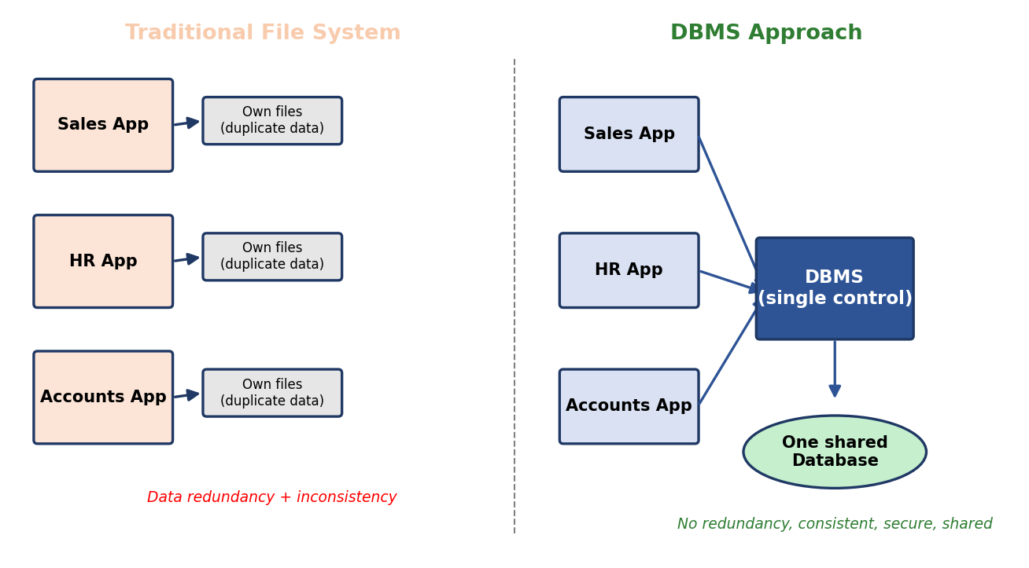
Left: each application owns duplicate files (redundant, inconsistent). Right: all applications share one DBMS-controlled database.

Definition
A Database is an organized, related collection of data representing some aspect of the real world (called the mini-world or Universe of Discourse).
A Database Management System (DBMS) is the software that lets you define, construct, manipulate, and share a database while enforcing integrity, security, concurrency, and recovery.
Database + DBMS software + applications + users = a Database System.

Intuition
Think of a DBMS as a librarian for data:
- You don’t walk into the stacks and grab books yourself (you don’t read raw disk blocks). You ask the librarian (you write SQL).
- The librarian knows where every book is (indexes), keeps the catalog consistent (constraints), won’t let two people check out the last copy (concurrency control), and can rebuild the catalog after a fire (recovery).

Historical background (so the names make sense)
1963 Charles Bachman — IDS (at GE), the first DBMS; forerunner of the
network/CODASYL model (CODASYL formalized it ~1969-71)
1968 IMS (IBM) — hierarchical model (tree-structured), used for Apollo program
1970 E. F. Codd (IBM) publishes "A Relational Model of Data for Large Shared
Data Banks" — the relational model. (Turing Award, 1981.)
1974 System R (IBM) and Ingres (Berkeley) — first relational prototypes;
System R gives birth to SEQUEL, later renamed SQL.
1979 Oracle ships the first commercial relational DBMS.
1986 SQL becomes an ANSI standard.
2000s NoSQL rises for web-scale (Google Bigtable, Amazon Dynamo, MongoDB).
2010s+ NewSQL & distributed SQL (Google Spanner, CockroachDB).
Exam nugget: Codd = relational model. Bachman = network model (and an early Turing Award). These two names appear in PSU IT papers.

1.1A Data Models — The Evolution (Hierarchical → Network → Relational → …)

Motivation
A data model is a set of concepts for describing data, relationships, and constraints — i.e. the “shape” in which we organize data. Over 60 years the dominant shape changed as engineers hit walls. Knowing this evolution answers a recurring SEBI/RBI question (“Which model uses a tree structure?”) and gives you the intuition for why the relational model won.
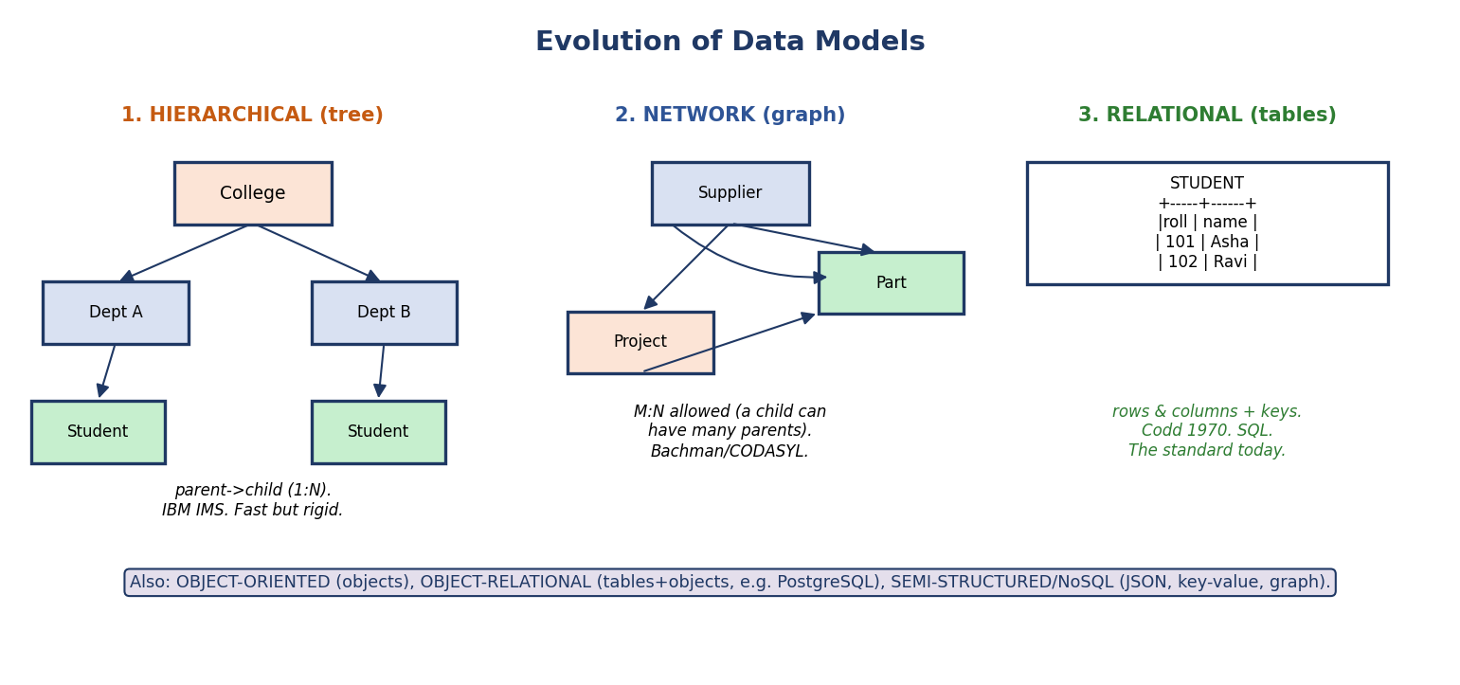
Three classic data models: hierarchical (tree, parent→child 1:N), network (graph, M:N allowed), relational (tables with keys).
Model | Shape | Idea | Pain that killed it / Note
Hierarchical | Tree | Each child has exactly one parent (1:N only). IBM IMS (1968), used in Apollo. | Cannot model M:N naturally; rigid; navigation by pointers.
Network | Graph | A child can have many parents (M:N). Bachman/CODASYL. | Very complex pointer “navigation”; hard to change.
Relational | Tables (relations) | Data as rows & columns, linked by keys, queried declaratively. Codd, 1970. | The winner — simple, math-backed, SQL. (Modules 3–5.)
Object-Oriented | Objects | Stores objects directly (with methods). | Good for complex types; niche.
Object-Relational | Tables + object types | Relational core + user-defined types (e.g. PostgreSQL). | Mainstream extension of relational.
Semi-structured / NoSQL | JSON, key-value, column, graph | Flexible/schema-light, web-scale. | Module 11 (MongoDB, Cassandra, Neo4j).
First-principles “why relational won”: the older models forced the programmer to navigate pointers (procedural — “how to get there”). Codd’s insight was to make queries declarative (“what I want”), letting the system figure out the path. That separation is the same idea as data independence — hide the “how”, expose the “what”.
Exam nuggets: Hierarchical = tree (one parent). Network = graph (many parents, Bachman/CODASYL). Relational = tables (Codd). These three are the most-tested.

1.2 Data Abstraction — Hiding Complexity in Three Layers

Motivation
A modern database may store billions of rows in compressed B+-tree files across many disks. If an application programmer had to know all of that just to read a customer’s name, nobody would ever finish writing software. The DBMS therefore hides the messy details behind layers — exactly like how you drive a car without understanding combustion. This hiding is called data abstraction.

The three levels
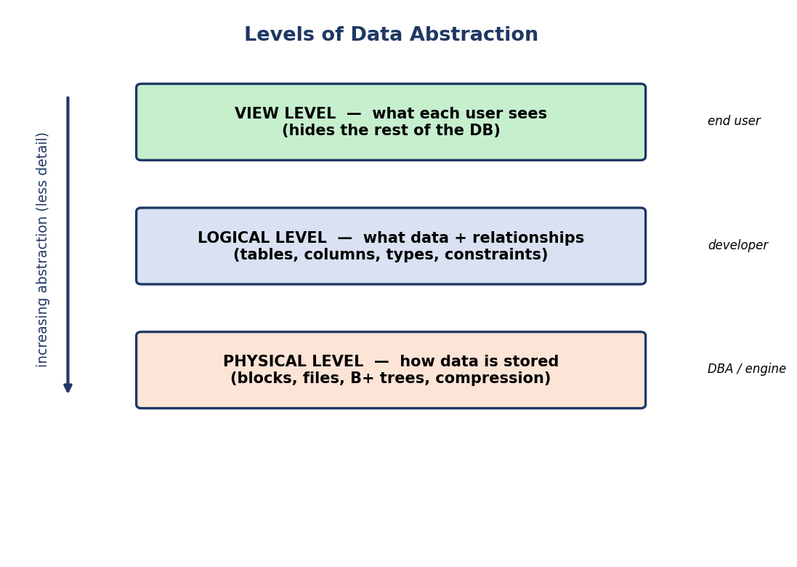
Three levels of abstraction: physical (how stored) → logical (what data) → view (what a user sees).
- Physical level (lowest / internal): How data is actually stored — files, pages/blocks, B+-tree indexes, compression, record layout. Concerns the DBA and the storage engine. Example: “Customer rows are stored in a heap file, with a B+-tree index on customer_id, blocks of 8 KB.”
- Logical level (middle / conceptual): What data is stored and what relationships exist — tables, columns, datatypes, keys, constraints. This is the developer’s world. Example: Customer(id INT, name VARCHAR(50), city VARCHAR(30)).
- View level (highest / external): What a particular user sees — a tailored slice that hides the rest for simplicity and security. Example: a teller’s view exposes name, balance but hides loan_history.
Analogy (locks it in): Physical = the engine and gearbox. Logical = the dashboard (speed, fuel — meaningful quantities). View = a chauffeur who only tells the passenger “we’ll arrive in 10 minutes.”

Concept check (think before reading on)
Q: When you write SELECT name FROM Customer;, which level of abstraction are you operating at? A: The logical level. You name a table and a column; you neither create a personal view nor touch storage details.

1.3 Schema vs Instance — The Single Most Confused Pair

Definition
- Schema: the overall design / structure of the database — the table definitions, columns, types, and constraints. Set up once, changes rarely.
- Instance (a.k.a. state / snapshot): the actual data stored at a particular moment. Changes constantly (every INSERT/UPDATE/DELETE).
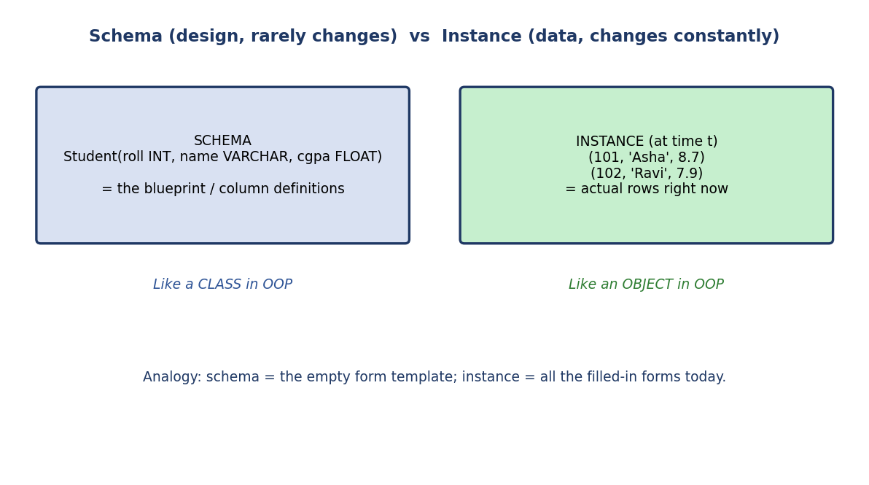
Schema is the blueprint (like a class); an instance is the data right now (like an object).

Intuition
The cleanest analogy in all of DBMS:
Schema ≈ a CLASS in OOP (the template / type)
Instance ≈ an OBJECT in OOP (a concrete value at runtime)
Schema ≈ an empty exam answer sheet (the printed form)
Instance ≈ all the answer sheets filled in by students today

Three kinds of schema (maps onto the three levels)
- Physical schema — design at the physical level.
- Logical schema — design at the logical level (the one we usually mean).
- View schema (subschema) — design at the view level.
Why SEBI/GATE test this: a typical 1-marker is “Which changes more frequently — schema or instance?” → instance. Or *“The logical schema is also called ___“* → conceptual schema.

1.4 The Three-Schema (ANSI-SPARC) Architecture

Motivation & problem statement
We now formalize the three levels into the famous ANSI/SPARC three-schema architecture (1975). Its single purpose: separate the user’s view of data from how it is physically stored, so that changes at one layer don’t break the layers above. That separation is called data independence (next section), and it is the crown jewel of database design.

The architecture
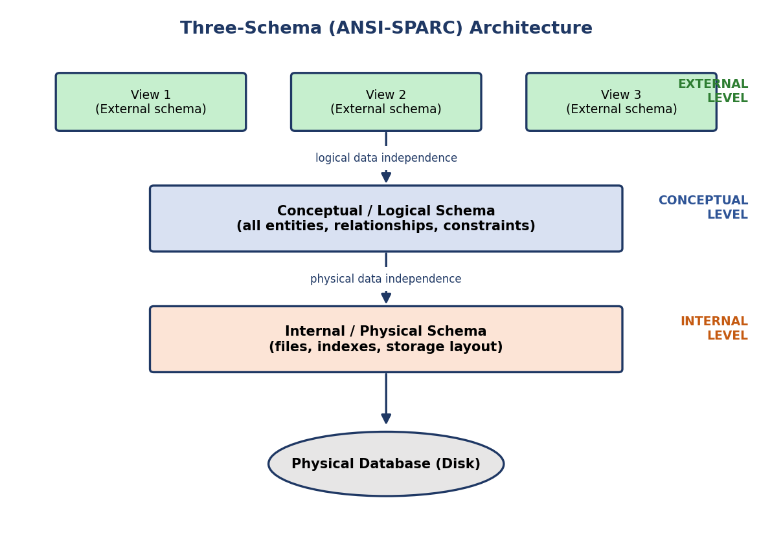
ANSI-SPARC three-schema architecture: external views map to one conceptual schema, which maps to one internal schema, which maps to disk.
- External level (views): many external schemas, one per user group. Each view shows only the relevant part of the database.
- Conceptual level: exactly one conceptual schema describing the whole database for the community of users — entities, relationships, constraints, without storage details.
- Internal level: exactly one internal schema — physical storage structures, file organizations, indexes.
The DBMS maintains mappings between the levels:
- External/Conceptual mapping — connects each view to the conceptual schema.
- Conceptual/Internal mapping — connects the conceptual schema to storage.
Memory trick: “E-C-I” from top to bottom = External, Conceptual, Internal. “Many views, one logical truth, one physical reality.”

Internal working (how a read travels the layers)
User asks (external view)
│ external/conceptual mapping
▼
Conceptual schema decides which tables/relationships
│ conceptual/internal mapping
▼
Internal schema locates files/blocks/indexes on disk
▼
Bytes come back up, reshaped into the user's view

1.4A Two-Tier vs Three-Tier Architecture (Client–Server)

⚠️ First, kill the #1 confusion
Students mix up two different “architectures”:
- The three-schema (ANSI-SPARC) architecture (§1.4) is about levels of abstraction inside the DBMS (external / conceptual / internal). It answers “how is the data described?”
- The tier architecture (this section) is about physical deployment — how many machines/layers sit between the user and the database. It answers “who talks to whom over the network?”
Memory hook: Schemas = how data is described. Tiers = where software is deployed. Different questions, often asked back-to-back to trick you.

Motivation & the tiers
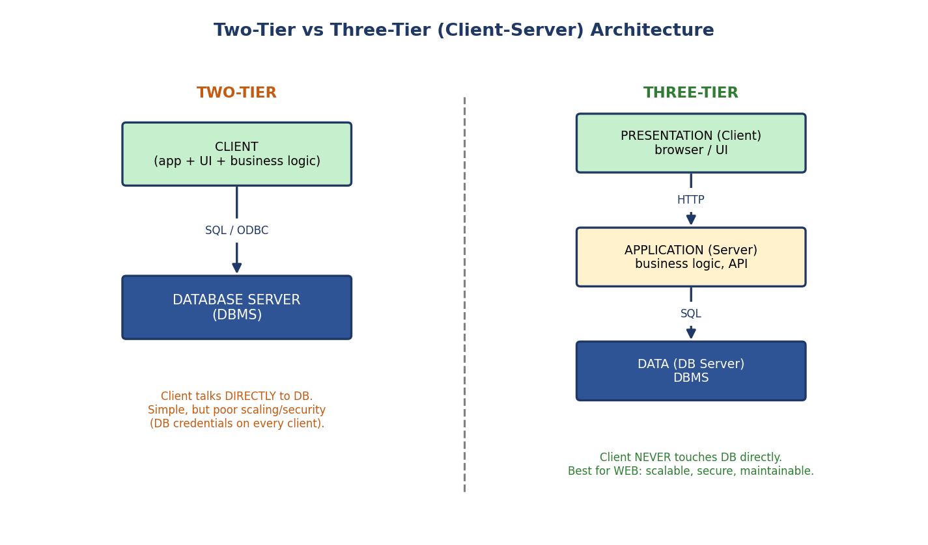
Two-tier: client (UI + logic) talks directly to the DB server via SQL/ODBC. Three-tier: presentation (browser) → application server (logic) → database server; client never touches the DB.
One-tier: everything (UI, logic, DB) on a single machine — e.g. a local SQLite app. Simplest, single user.
Two-tier (Client–Server): the client holds the UI and business logic and talks directly to the database server using SQL (often over ODBC/JDBC).
- 👍 Simple, fast for small LANs.
- 👎 Poor scaling (each client opens a DB connection), and security risk — DB credentials and logic live on every client.
Three-tier: insert a middle application/logic tier between client and DB:
- Presentation tier — the client (browser/mobile UI). Knows nothing about the DB.
- Application (logic) tier — the server with business rules, an API; the only layer that talks to the DB.
- Data tier — the DBMS.
- 👍 Scalable (add app servers behind a load balancer), secure (clients never see the DB), maintainable (change logic without touching clients).
- 👎 More moving parts.
- This is the standard architecture of essentially every web application.
 | Two-Tier | Three-Tier
Layers | Client ↔ DB | Client ↔ App server ↔ DB
Business logic | on the client | on the app server
Scalability | limited | high
Security | weak (DB exposed) | strong (DB hidden)
Typical use | small LAN tools | web/enterprise apps
Interview soundbite: “We use three-tier so the browser never holds DB credentials and we can scale the stateless app tier horizontally.” This single line shows you understand why the middle tier exists.

Concept check
Q: A bank’s internet-banking site has a browser, a set of API servers, and an Oracle database. Which tier model, and which tier enforces “withdraw ≤ balance”? A: Three-tier; the rule lives in the application (logic) tier.

1.5 Data Independence — The Crown Jewel

Definition
Data independence is the capacity to change the schema at one level without having to change the schema at the next higher level. There are two kinds:
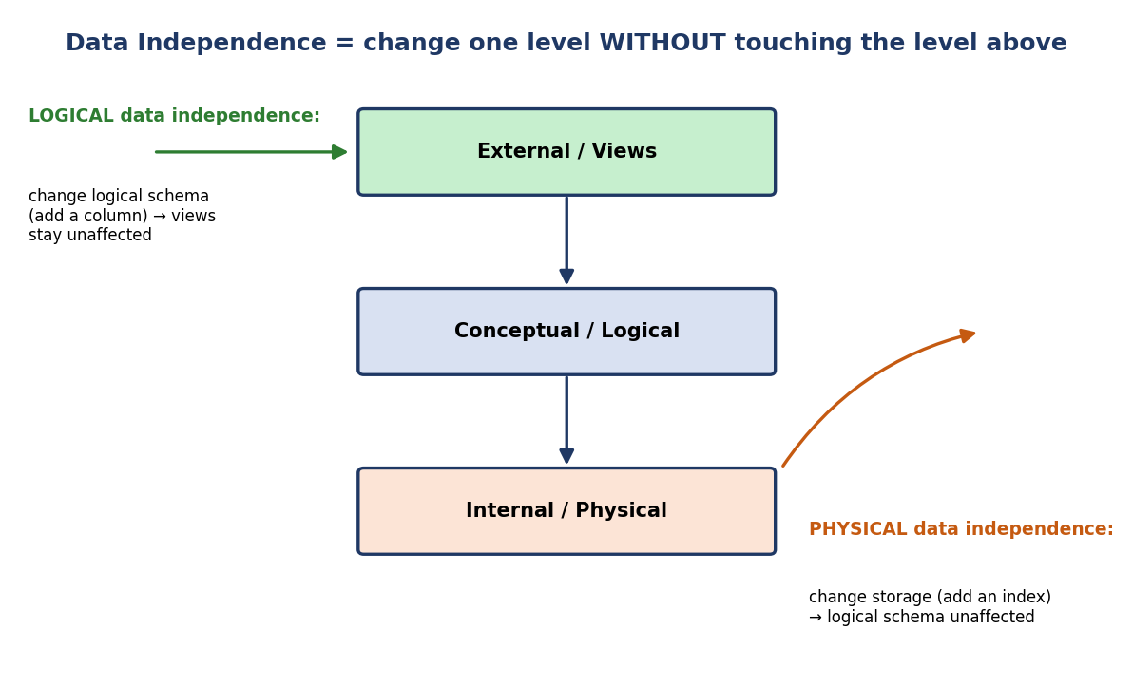
Logical data independence shields views from logical changes; physical data independence shields the logical schema from storage changes.
- Physical Data Independence (PDI): change the internal/physical schema (add an index, switch from a heap to a hashed file, move to a new disk) without changing the conceptual/logical schema.
  - Easier to achieve — and almost every DBMS provides it well.
  - Example: you create an index on Customer(city) to speed up queries. No table definition changes; no application changes.
- Logical Data Independence (LDI): change the conceptual/logical schema (add a new column, add a new table, split a table) without changing the external/view schemas (and thus without changing existing applications).
  - Harder to achieve — because applications depend closely on the logical structure.
  - Example: you add a loyalty_points column to Customer. The teller’s old view (name, balance) still works untouched.
The exam mnemonic that never fails: “Logical is harder, Physical is easier.” And remember the direction: each kind protects the level above it from a change below it.

First-principles: why do we even want this?
Software outlives hardware. A logical schema designed in 2010 may run on disks, SSDs, and cloud storage across its life. If every storage upgrade forced a rewrite of all applications, software maintenance would be impossible. Data independence is what lets the storage team and the application team evolve separately. It is the database world’s version of “program to an interface, not an implementation.”

Common mistake (very frequently tested)
✗ “Adding an index requires changing the logical schema.” Wrong. Adding an index is a physical change; thanks to physical data independence, the logical schema is untouched.

Concept check
Q: You migrate the database to faster NVMe disks and re-block the files. Which data independence makes this painless for application programmers? A: Physical data independence (storage changed; logical schema unchanged).

1.6 Database Languages (DDL / DML / DCL / TCL)

Motivation
A DBMS needs commands to (a) define structure, (b) change data, (c) control access, and (d) bound transactions. SQL bundles all four families into one language, but exams test you on the classification.
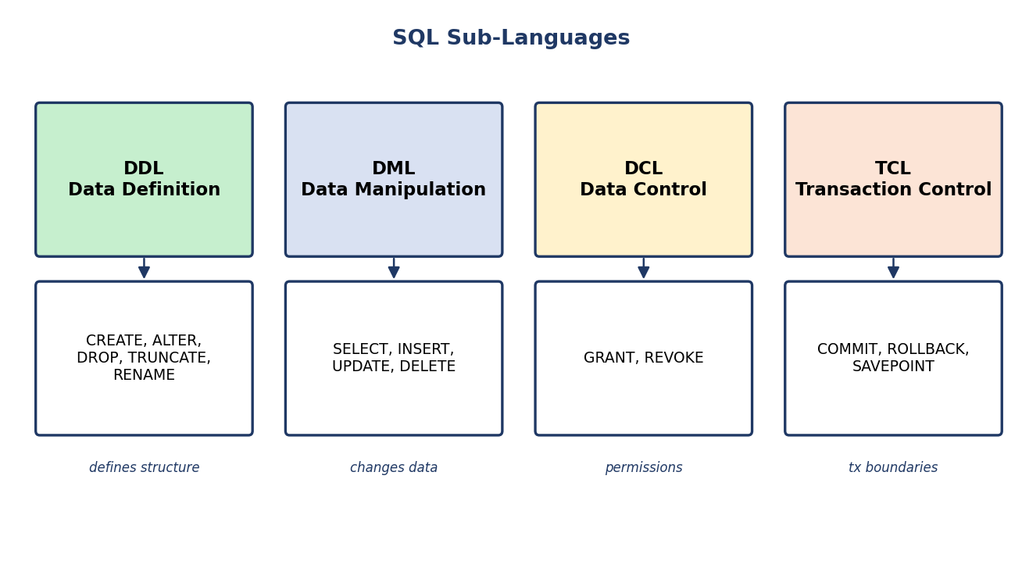
SQL sub-languages: DDL defines structure, DML changes data, DCL controls permissions, TCL bounds transactions.
Family | Full form | Commands | Purpose | Auto-commit?
DDL | Data Definition Language | CREATE, ALTER, DROP, TRUNCATE, RENAME | define/modify structure | Usually yes*
DML | Data Manipulation Lang. | SELECT, INSERT, UPDATE, DELETE | query/change data | No
DCL | Data Control Language | GRANT, REVOKE | permissions / security | Usually yes*
TCL | Transaction Control Lang | COMMIT, ROLLBACK, SAVEPOINT | transaction boundaries | —
Some books call the query part (SELECT) DQL (Data Query Language). If you see DQL in an option, it means “SELECT”.
*Accuracy note (vendor-dependent — interview gotcha): DDL/DCL auto-commit is not universal. In Oracle & MySQL, DDL like CREATE/DROP issues an implicit commit (you can’t roll it back). In PostgreSQL & SQL Server, DDL and GRANT/REVOKE are transactional — you can wrap them in a transaction and ROLLBACK. For a written exam, “DDL auto-commits” is the expected answer; in an interview, mention the PostgreSQL exception — it signals depth. Also, RENAME is vendor-specific (standard SQL uses ALTER TABLE … RENAME).

Internal working — DDL builds the data dictionary
When you run a DDL statement like CREATE TABLE, the DBMS doesn’t just allocate storage — it records the new structure in the data dictionary (a.k.a. system catalog): a special set of tables describing all tables, columns, types, constraints, indexes, and users. This “data about data” is metadata. Every query consults the dictionary first (“does this table exist? is this user allowed?”).
Active vs passive data dictionary (a classic PSU/GATE MCQ): an active data dictionary is managed automatically by the DBMS and stays in sync with the schema (any DDL change updates it instantly) — this is what modern RDBMSs have. A passive data dictionary is maintained separately/manually (e.g. as documentation) and can fall out of sync. Active = self-updating by the DBMS; passive = manual, may be stale.

Classic traps (memorize)
- DELETE vs TRUNCATE vs DROP:
  - DELETE FROM T; → DML, removes rows (can have WHERE), logged, can be rolled back, keeps the table structure.
  - TRUNCATE TABLE T; → DDL, removes all rows fast (no WHERE), minimally logged, usually cannot be rolled back, keeps the structure.
  - DROP TABLE T; → DDL, removes the structure + data entirely.
- TRUNCATE resets identity counters; DELETE does not.

MCQs
- GRANT SELECT ON Account TO teller; belongs to which family? → DCL.
- Which is a DDL command: UPDATE, COMMIT, ALTER, GRANT? → ALTER.
- Which can be rolled back: TRUNCATE or DELETE? → DELETE (generally).

1.6A DBMS vs RDBMS, and Codd’s 12 Rules

DBMS vs RDBMS (a guaranteed exam comparison)
A DBMS stores data and lets you manage it. An RDBMS (Relational DBMS) is a DBMS that follows Codd’s relational model — data in tables with relationships enforced by keys, queried with SQL.
Feature | DBMS | RDBMS
Data storage | files / hierarchical / network | tables (relations)
Relationships | via navigation/pointers | via foreign keys
Keys & constraints | weak / manual | enforced (PK/FK/UNIQUE/CHECK)
Normalization | not really supported | supported
Multi-user / ACID | limited | full support
Data volume | small | large
Examples | file systems, XML stores, older IMS | MySQL, PostgreSQL, Oracle, SQL Server
One-liner to remember: Every RDBMS is a DBMS, but not every DBMS is an RDBMS. RDBMS = DBMS + tables + keys + SQL + ACID.

Codd’s 12 Rules (actually 13: Rule 0 to Rule 12)
E. F. Codd published 12 rules (numbered 0–12, so 13 total) that a system must satisfy to be called truly relational. You don’t need to memorize all 13 verbatim, but SEBI/PSU papers ask “Codd gave how many rules?” (12, with a Rule 0) and occasionally name one. The most important to recognize:
- Rule 0 — Foundation: must manage the DB entirely through its relational capabilities.
- Rule 1 — Information: all data represented as values in tables.
- Rule 2 — Guaranteed access: every value reachable by table + primary key + column (no pointers).
- Rule 3 — Systematic NULL treatment: NULLs handled uniformly (unknown / not applicable), independent of datatype.
- Rule 4 — Active online catalog: the data dictionary itself is relational and queryable with the same language.
- Rule 5 — Comprehensive sub-language: one language (SQL) for definition, manipulation, control, transactions.
- Rule 6 — View updating; Rule 7 — High-level insert/update/delete (set at a time, not row-by-row).
- Rules 8 & 9 — Physical & Logical data independence (the §1.5 ideas — note Codd named them explicitly!).
- Rule 10 — Integrity independence; Rule 11 — Distribution independence; Rule 12 — Non-subversion (no low-level bypass of the rules).
Fun fact for interviews: no commercial RDBMS fully satisfies all 12 rules. They’re an ideal benchmark, not a checklist any product fully passes.
Exam nuggets: Codd = 12 rules (0–12). Rules 8 & 9 are exactly physical & logical data independence. Rule 4 = the relational catalog.

1.6B Quick Previews & Classifications (ACID, Keys, DBMS Types, OLTP vs OLAP)
This module name-drops a few terms that deserve a one-line anchor now (full depth comes in later modules). These are high-frequency 1-mark exam questions.

ACID — the four transaction guarantees (full detail: Module 9)
When a DBMS runs a transaction (a logical unit of work, e.g. a money transfer), it guarantees ACID:
Letter | Property | Plain meaning | Bank-transfer example
A | Atomicity | all-or-nothing | debit + credit both happen, or neither
C | Consistency | DB moves from one valid state to another | total money unchanged; constraints hold
I | Isolation | concurrent txns don’t corrupt each other | two transfers at once ≠ wrong balance
D | Durability | once committed, survives crashes | after “success”, power loss can’t undo it
Memory hook: All-or-nothing, Correct state, Isolated from others, Durable forever. Guaranteed by the transaction manager + recovery (Modules 9–10).

Keys — the one-line preview (full detail: Module 3)
- Super key: any set of attributes that uniquely identifies a row.
- Candidate key: a minimal super key (no extra attributes).
- Primary key: the one candidate key you choose (unique + not NULL).
- Foreign key: an attribute referencing another table’s primary key (the glue between tables).

Types of DBMS (by location & users — common SEBI/RBI MCQ)
Type | Meaning
Centralized | data + DBMS on a single site/machine
Distributed | data spread across multiple sites, appears as one DB (Module 11)
Parallel | multiple CPUs/disks work on one query for speed
Cloud / Hosted | DBMS as a managed service (e.g. Amazon RDS, Aurora)
Single-user vs Multi-user | one user at a time vs many concurrent users

OLTP vs OLAP (very frequently asked; full detail: Module 11)
 | OLTP (Online Transaction Processing) | OLAP (Online Analytical Processing)
Purpose | day-to-day transactions | analysis / reporting / BI
Operations | many short INSERT/UPDATE/DELETE | few, complex, read-heavy queries
Data | current, detailed | historical, aggregated
Example | ATM withdrawal, order placement | “total sales by region last 5 years”
Schema | highly normalized | star/snowflake (denormalized)
Memory hook: OLTP = writes/operations (running the business). OLAP = reads/analysis (understanding the business).

1.7 DBMS Architecture — How the Engine Is Built Inside

The overall structure
A DBMS is internally organized into two big subsystems sitting above the disk: the Query Processor (turns your SQL into actions) and the Storage Manager (moves data between disk and memory safely).
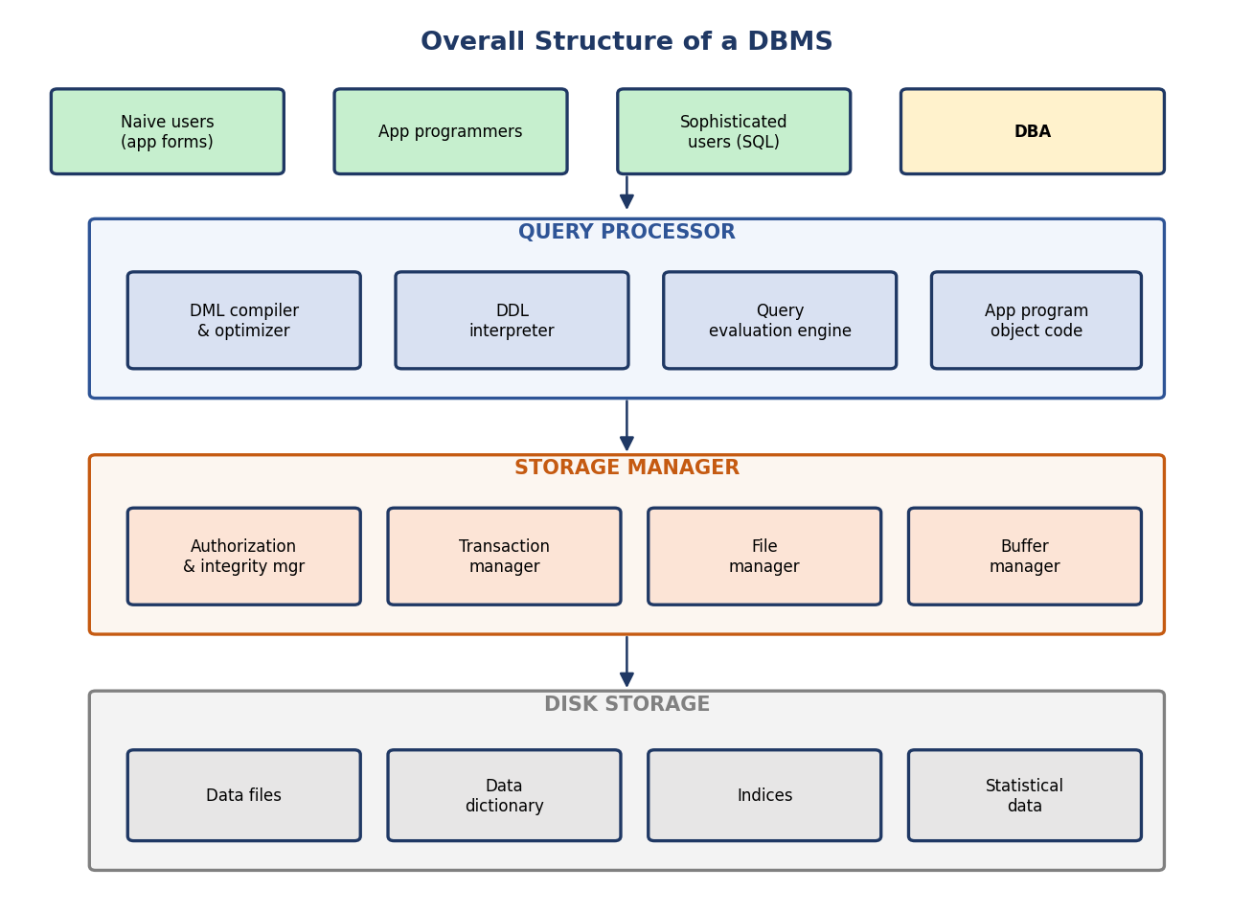
Overall DBMS structure: users on top, Query Processor, Storage Manager, then disk storage with data files, dictionary, and indices.
Query Processor components
- DDL interpreter — processes DDL, updates the data dictionary.
- DML compiler / optimizer — translates DML into a low-level evaluation plan, and optimizes it (picks the cheapest plan using indexes & statistics).
- Query evaluation engine — executes the chosen plan.
Storage Manager components
- Authorization & integrity manager — checks the user’s rights and that integrity constraints hold.
- Transaction manager — guarantees ACID: keeps the DB consistent despite crashes, and isolates concurrent transactions.
- File manager — manages disk space allocation and on-disk data structures.
- Buffer manager — fetches blocks from disk into RAM and decides what to keep cached (this is the performance-critical component).
On disk
- Data files (the actual rows), data dictionary (metadata), indices (for fast lookup), and statistics (used by the optimizer).

Dry run — the life of one query
Let’s trace SELECT name FROM Customer WHERE city = 'Mumbai'; end to end:
1. Parser checks syntax → builds a parse tree.
2. Semantic check + authorization: does Customer exist? is 'city' a column?
is this user allowed to SELECT? (consults data dictionary)
3. Optimizer: is there an index on city? If yes, plan = "index scan";
else plan = "full table scan". Picks the cheaper plan using statistics.
4. Evaluation engine runs the plan.
5. Buffer manager: needed block already in RAM? -> use it (fast, ~100 ns).
Else read it from disk (slow, ~10 ms) into the buffer pool.
6. Transaction manager ensures this read sees a consistent snapshot.
7. Rows with city='Mumbai' are projected to just 'name' and returned.
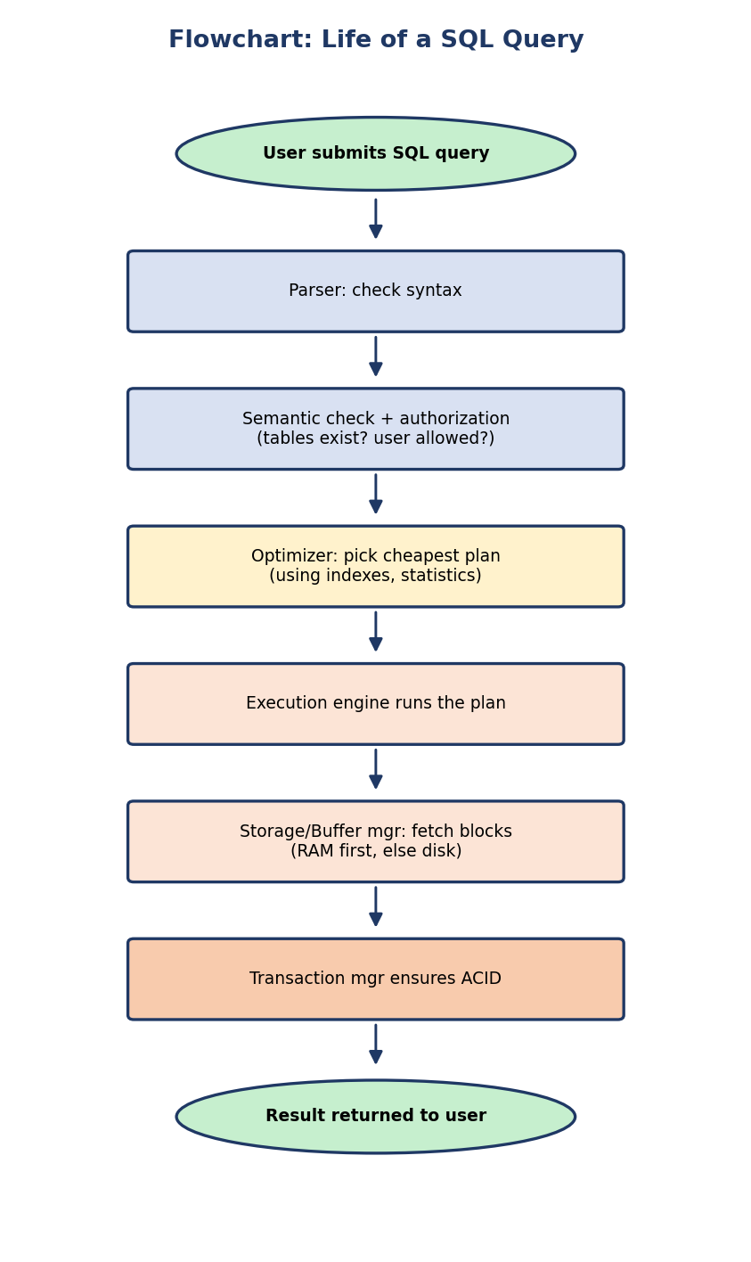
Flowchart — life of a SQL query: parse → authorize → optimize → execute → fetch blocks → ACID → result.
Why the buffer manager matters most: a RAM hit is ~100,000× faster than a disk read. Almost all of database performance engineering is “keep the right blocks in RAM.” We will return to this in the Storage and Indexing modules.

1.8 Database Users and the DBA
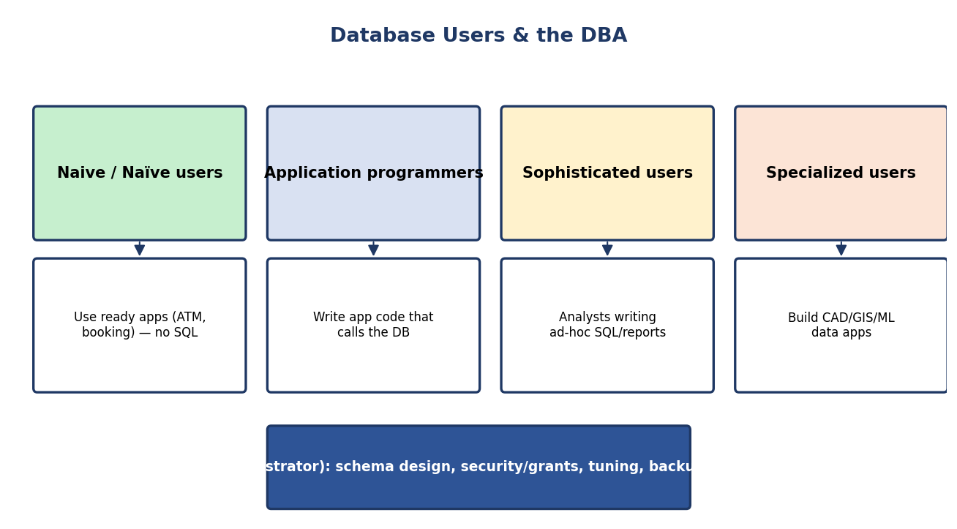
Database users (naive, application programmers, sophisticated, specialized) and the DBA who administers everything.
- Naive / naïve users: interact through ready-made apps (ATM screen, railway booking). They never see SQL.
- Application programmers: write the programs those users click through (embedding SQL in Java/Python, etc.).
- Sophisticated users: analysts/data scientists who write ad-hoc SQL and build reports directly.
- Specialized users: build complex domain apps (CAD, GIS, ML pipelines).
The Database Administrator (DBA) is the central authority who:
- defines the schema and storage structure,
- grants/revokes authorization (security),
- monitors and tunes performance (indexes, query plans),
- handles backup and recovery,
- plans capacity and upgrades.
Interview line: “The DBA owns the non-functional guarantees — security, availability, performance, recoverability — so application teams can focus on business logic.”

1.9 Should You Even Use a DBMS? (Decision Flowchart)
A DBMS is powerful but not free — it adds cost, complexity, and overhead. Use this decision flow:
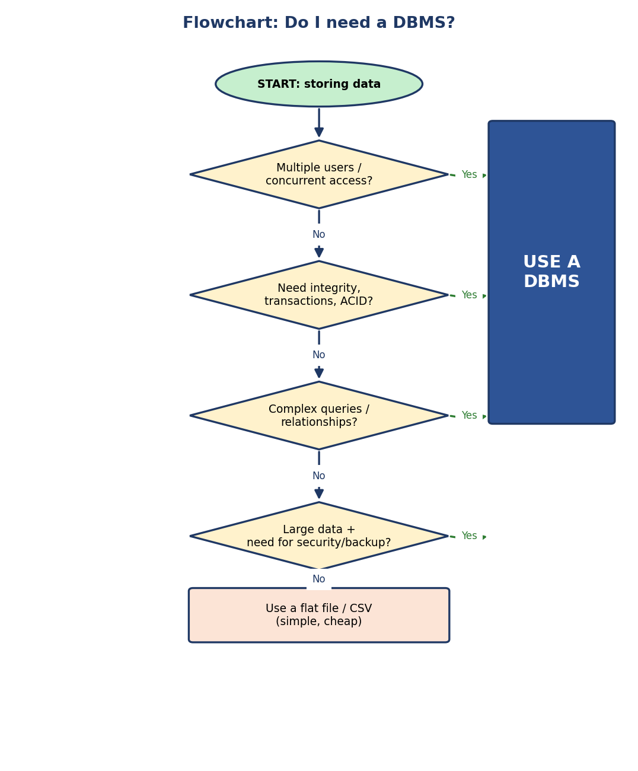
Flowchart — Do I need a DBMS? Multiple users, ACID, complex queries, or large secured data → yes; otherwise a flat file may do.
When a DBMS is overkill: tiny config files, single-user throwaway scripts, write-once log files. Here a flat file or SQLite-style embedded store is enough.
When a DBMS is essential: concurrent users, money/medical/legal data needing integrity & audit, complex relationships and queries, security and backup requirements — i.e. virtually every serious backend system.

1.10 DBMS Across the Industry (Real-World Lenses)
- Real-world example (banking): the eight file-system problems in §1.1 are exactly why core banking runs on RDBMS — atomic transfers, audit, concurrency for millions of users.
- Backend example: a typical web app uses PostgreSQL/MySQL. The three-schema idea shows up directly: ORM models = logical schema; database views = external schema; storage engine + indexes = internal schema.
- System-design perspective: “single source of truth”, read replicas (external-level scaling), and schema migrations (logical data independence in action) are all this module’s ideas at scale.

1.11 Tradeoffs, Performance, Security, Edge Cases
Tradeoffs of using a DBMS
Gain | Cost
Integrity, concurrency, recovery, security | Software + license + hardware cost
Single source of truth, less redundancy | Added complexity, need for a DBA
Powerful declarative queries (SQL) | Overhead vs a raw file for trivial workloads
Performance: dominated by disk vs RAM access (buffer manager) and by good indexing/optimization (Modules 6–8). Declarative SQL lets the optimizer choose fast plans you didn’t hand-code.
Security: authorization (DCL GRANT/REVOKE), views to expose only permitted columns, and the integrity manager enforcing constraints. The DBA is accountable for all of this.
Common mistakes (exam + real life) - Confusing schema (rarely changes) with instance (constantly changes). - Swapping the two data independences — logical is harder; physical is easier. - Calling TRUNCATE a DML command (it’s DDL). - Thinking the logical schema knows about indexes (it doesn’t — that’s physical).
Edge cases - A database can have many external schemas but only one conceptual and one internal schema. - Some lightweight stores (SQLite) blur the layers, but the conceptual model still applies.

1.12 Exam, Interview & Coding Perspectives
Competitive-exam (SEBI / RBI / GATE) perspective — what gets asked - Definitions: DBMS advantages over file systems (the 8-row table). - Three-schema architecture & the two mappings. - Data independence (logical vs physical) — which is harder, which protects what. - Schema vs instance; conceptual = logical synonym. - Classify a command into DDL/DML/DCL/TCL. - DELETE vs TRUNCATE vs DROP. - Codd → relational model; Bachman → network model.
Interview perspective - “Why not just use files?” → recite the 8 problems. - “What is data independence and why do you care?” → maintainability/evolution. - “Walk me through what happens when I run a SELECT.” → §1.7 dry run.
Coding/practical perspective - Install PostgreSQL; run CREATE TABLE, then inspect the catalog: SELECT * FROM information_schema.tables; — you are literally reading the data dictionary. - Create a VIEW and notice you’ve built an external schema.

1.13 Concept Checks & MCQs (test yourself)
- T/F: A database can have multiple conceptual schemas. → False (one conceptual, many external).
- Adding an index on a column relies on which independence? → Physical.
- The “data about data” stored by the DBMS is called ___. → metadata / data dictionary / system catalog.
- Which changes more often, schema or instance? → Instance.
- COMMIT belongs to which language family? → TCL.
- Which level does an end user of an ATM operate at? → View (external).
- Logical data independence is (easier / harder) than physical. → Harder.
- Who published the relational model? → E. F. Codd (1970).
- Which component decides which disk blocks stay in RAM? → Buffer manager.
- TRUNCATE is a ___ command. → DDL.
- Which data model uses a tree structure (one parent per child)? → Hierarchical.
- In three-tier architecture, where does business logic live? → Application (middle) tier.
- “Every RDBMS is a DBMS but not vice-versa” — what does RDBMS add? → tables + keys + SQL + ACID (relational model).
- Codd gave how many rules? → 12 (numbered 0–12); rules 8 & 9 are physical & logical data independence.
- Network model (many parents per child) is associated with ___ → Bachman / CODASYL.
- ACID stands for ___ → Atomicity, Consistency, Isolation, Durability.
- “Once committed, survives a crash” is which ACID property? → Durability.
- OLTP is for ___ and OLAP is for ___ → transactions (writes) / analysis (reads).
- A minimal super key is called a ___ → candidate key.
- Data spread across many sites but appearing as one DB = ___ DBMS → distributed.
Fill in the blanks - The architecture with external/conceptual/internal levels is the ___ → ANSI-SPARC three-schema. - The mapping between views and the logical schema is the ___ mapping → external/conceptual.
Scenario question > A new compliance rule requires storing each customer’s PAN. You add a pan > column to Customer. Existing teller applications, which use a view of > (name, balance), keep running with no change. Which property made this > possible? → Logical data independence.

1.14 One-Page Revision Sheet
DBMS = software to define/construct/manipulate/share a database with
integrity, security, concurrency, recovery.
8 FILE-SYSTEM PROBLEMS DBMS SOLVES:
redundancy, inconsistency, hard access, isolation, integrity,
atomicity, concurrency anomalies, security.
DATA MODELS: Hierarchical(tree,1 parent,IMS) | Network(graph,M:N,Bachman/CODASYL)
| Relational(tables,keys,Codd 1970) | Object | Object-Relational | NoSQL
DBMS vs RDBMS: RDBMS = DBMS + tables + keys + SQL + ACID. Codd's 12 rules(0-12);
rules 8&9 = physical & logical data independence; rule 4 = relational catalog.
ABSTRACTION (top→bottom): VIEW → LOGICAL → PHYSICAL
3-SCHEMA (ANSI-SPARC): EXTERNAL(many) → CONCEPTUAL(one) → INTERNAL(one)
mappings: external/conceptual, conceptual/internal
TIERS (deployment, NOT schemas!): 1-tier(all one box) | 2-tier(client<->DB) |
3-tier(client<->APP server<->DB; web standard; logic in middle tier)
ACID (txn guarantees): Atomicity(all-or-nothing) Consistency(valid state)
Isolation(concurrent safe) Durability(survives crash). [Modules 9-10]
KEYS: super >= candidate(minimal) >= primary(chosen, not null); foreign(ref PK).
DBMS TYPES: centralized | distributed | parallel | cloud | single/multi-user.
OLTP(writes, day-to-day, normalized) vs OLAP(reads, analysis, star schema).
SCHEMA = design (rarely changes) ≈ class
INSTANCE = data now (changes a lot) ≈ object
conceptual schema = logical schema (synonyms)
DATA INDEPENDENCE:
Physical DI = change storage, logical unaffected (EASIER)
Logical DI = change logical, views/apps unaffected (HARDER)
LANGUAGES:
DDL: CREATE ALTER DROP TRUNCATE RENAME (structure; auto-commit)
DML: SELECT INSERT UPDATE DELETE (data)
DCL: GRANT REVOKE (permissions)
TCL: COMMIT ROLLBACK SAVEPOINT (transactions)
DELETE(DML, rollback-able) | TRUNCATE(DDL, fast, no WHERE) | DROP(DDL, kills table)
ENGINE: Query Processor (DDL interp, DML optimizer, eval engine)
Storage Manager (authz/integrity, transaction, file, BUFFER mgr)
Disk: data files, data dictionary(metadata), indices, statistics
HISTORY: Bachman→network; Codd(1970)→relational; SQL from System R/SEQUEL.
DBA: schema, security, tuning, backup/recovery, capacity.

Flash cards (cover the right side)
Front | Back
Logical vs physical DI — which is harder? | Logical (apps depend on logical structure)
Conceptual schema synonym? | Logical schema
Many or one conceptual schema? | One (many external, one conceptual, one internal)
TRUNCATE is which family? | DDL
Who invented the relational model? | E. F. Codd (1970)
Fastest-impact perf component? | Buffer manager (RAM vs disk)
Metadata lives in? | Data dictionary / system catalog

Spaced-repetition schedule
- 24-hour revision: redo all 20 MCQs + the one-page sheet from memory.
- 7-day revision: re-explain the three-schema architecture and both data independences aloud, as if teaching a junior.
- 30-day revision: classify 15 mixed SQL commands into DDL/DML/DCL/TCL and re-derive the 8 file-system problems unaided.

1.15 Summary
We started in the pre-database world and watched eight concrete failures of file processing force the invention of the DBMS. We then climbed the three levels of abstraction (view → logical → physical), formalized them as the ANSI-SPARC three-schema architecture, and saw why the separation between them — data independence — is the most valuable property in database design (logical harder, physical easier). We distinguished schema (design) from instance (data), classified the DDL/DML/DCL/TCL languages, opened up the DBMS engine (query processor + storage manager, with the buffer manager as the performance heart), and traced one query through it. Finally we met the users and the DBA, and learned when a DBMS is and isn’t worth it.
Everything that follows — the ER model, the relational model, SQL, normalization, indexing, transactions, recovery — is a deep dive into one of the boxes you just saw in the engine diagram. You now have the map. Next module: the ER model, where we learn to design the conceptual schema before a single table exists.
You have mastered this module when you can, from a blank page: draw the three-schema architecture, explain both data independences with an example each, list the eight file-system problems, classify any SQL command, and trace a query through the engine — all without notes.

