Module 2 — Entity-Relationship (ER) & Enhanced ER (EER) Model
  - DBMS Mastery: SEBI IT / RBI / GATE / Interview — In-Depth Notes (with visuals)
Prepared for nidhi.sharma@forensiccybertech.com
2026
Table of Contents

Module 2 — Entity-Relationship (ER) & Enhanced ER (EER) Model
Where this module sits. In Module 1 we said the conceptual schema is the single, storage-free description of what data the whole organization holds. But how do you create that schema in the first place — before a single CREATE TABLE exists? You draw a picture. The ER model is that picture: a high-level, visual way to design a database that both a non-technical manager and a programmer can read. This module teaches you to design a database the way professionals actually do — diagram first, tables later.
Importance ratings (out of 5):
Exam / Use | SEBI IT | RBI IT | GATE CS | Interview | Backend
This module | ★★★★★ | ★★★★ | ★★★★ | ★★★ | ★★★
Most-asked PYQ concepts (SEBI / RBI / GATE): cardinality ratios (1:1, 1:N, M:N), weak entities & identifying relationships, total vs partial participation, which symbol means what (oval/diamond/rectangle/underline), how many tables an ER diagram maps to (especially “M:N needs a separate table”), and specialization/generalization (ISA) in EER, recursive (unary) relationships, and the Chen vs Crow’s-foot notations.

2.1 Motivation — Why a Picture Before Tables?

The problem
Suppose a college director tells you: “Students enroll in courses and get grades; instructors teach courses and belong to departments.” If you jump straight to SQL, three different developers will produce three different table designs, and you’ll discover mistakes (missing relationships, wrong keys) only after data is loaded — when fixing them is expensive.
We need a design language that is:
- Visual — a manager can verify it without knowing SQL.
- DBMS-independent — not tied to Oracle/MySQL/Postgres.
- Precise enough to be mechanically converted into tables later.

The solution — the ER model
Peter Chen introduced the Entity-Relationship model in 1976. Its genius: the real world is made of things (entities) and connections between things (relationships). Draw those, annotate them, and you have a blueprint that maps to tables by fixed rules.
First-principles view: an ER diagram is just a typed graph. Nodes = entities, edges = relationships, labels = attributes and constraints. Everything else is notation on top of that graph.
Real-world sentence: "A STUDENT enrolls in a COURSE and receives a GRADE."
│ │ │
entity relationship attribute (of the relationship)
Exam nugget: Peter Chen, 1976 → ER model. (Pairs with Codd 1970 → relational model, from Module 1.)

2.2 The Three Building Blocks + Notation
Everything in an ER diagram is built from three shapes. Memorize this legend — SEBI/RBI ask “which symbol represents X” directly.
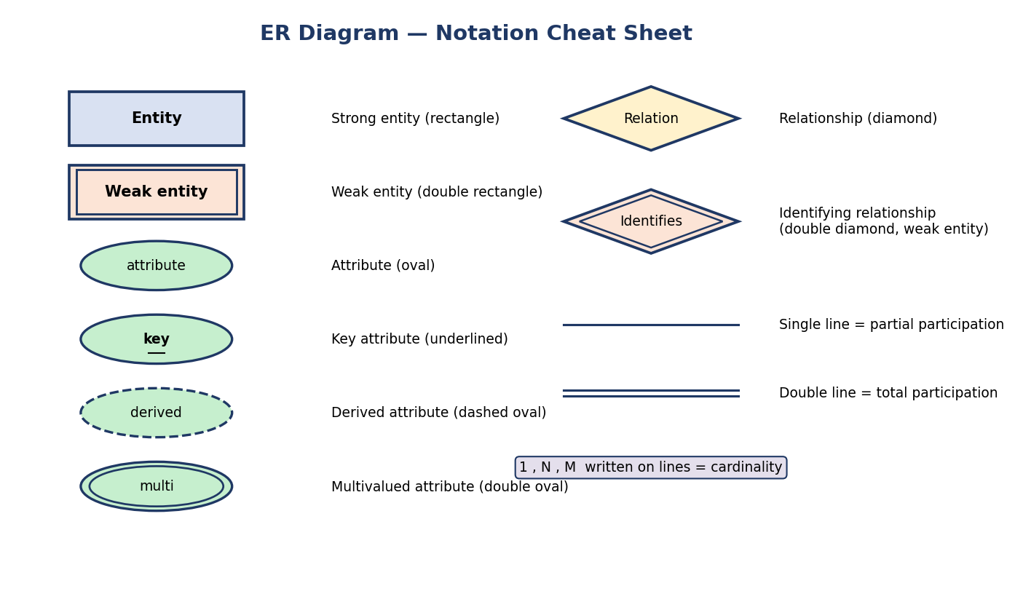
ER notation cheat sheet: rectangle=entity, double rectangle=weak entity, oval=attribute, underlined=key, dashed oval=derived, double oval=multivalued, diamond=relationship, double diamond=identifying, single/double line=partial/total participation.
Shape | Means
Rectangle | Entity (strong)
Double rectangle | Weak entity
Oval/Ellipse | Attribute
Underlined oval | Key attribute
Dashed oval | Derived attribute
Double oval | Multivalued attribute
Diamond | Relationship
Double diamond | Identifying relationship (for weak entity)
Single line | Partial participation
Double line | Total participation
1, N, M on a line | Cardinality ratio

Two notations: Chen (exam) vs Crow’s Foot (industry)
The shapes above are Chen notation (1976) — what GATE/SEBI exams use. But real tools (ERwin, Lucidchart, dbdiagram.io, MySQL Workbench) and most interviews use Crow’s Foot notation, where cardinality is drawn as symbols on the line ends instead of diamonds and 1/N/M labels. You must recognize both.
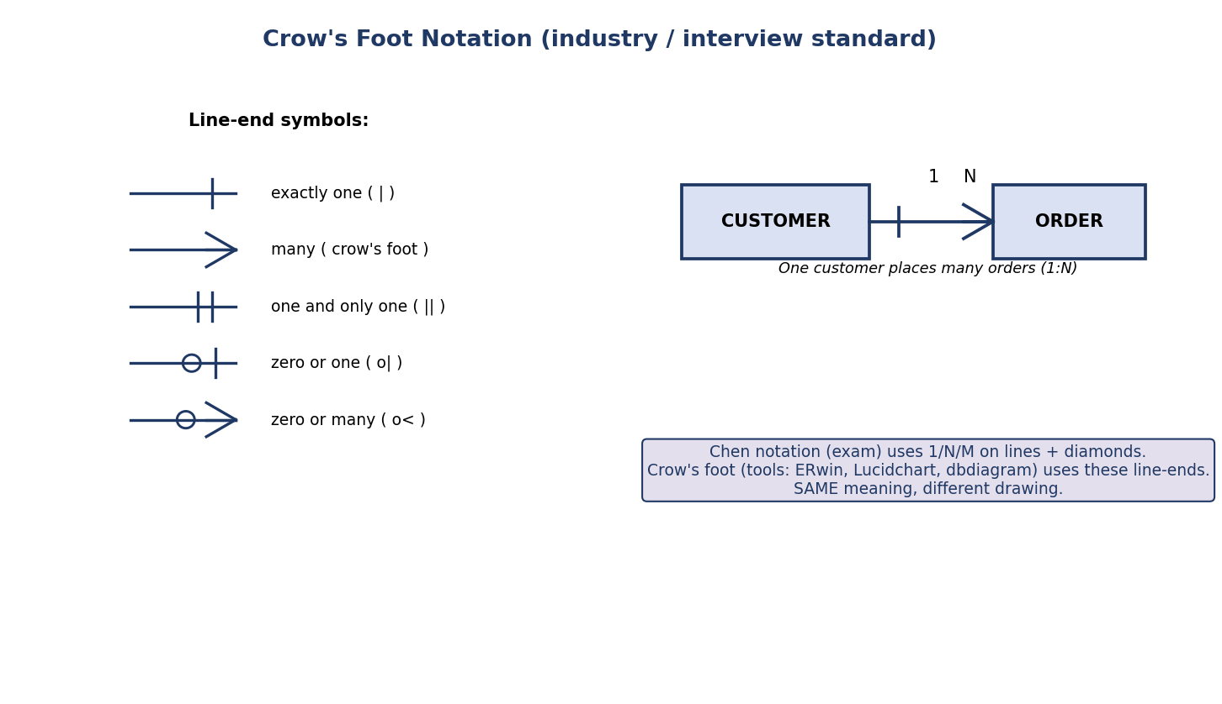
Crow’s foot notation: line-end symbols — bar = one, crow’s foot = many, double bar = exactly one, circle+bar = zero or one, circle+crow’s foot = zero or many; example CUSTOMER 1:N ORDER.
Meaning | Crow’s foot symbol | Chen equivalent
exactly one | ──┤ (bar) | 1
many | ──< (crow’s foot) | N / M
one and only one | ──╫ (double bar) | 1, total
zero or one | ──o┤ (circle + bar) | 1, partial
zero or many | ──o< (circle + crow’s foot) | N, partial
The circle (o) = optional/zero = partial participation. A bar/crow’s-foot without a circle = mandatory = total participation. So crow’s foot encodes cardinality AND participation together on each end — very compact.
How to read a crow’s-foot end precisely (min, max): each end carries two markers. The inner marker (closer to the entity box: a single bar | or the crow’s foot <) gives the maximum (one vs many). The outer marker (a circle o or a bar |) gives the minimum (0 = optional, 1 = mandatory). So o< = “(0, many)” and ╫/|| = “(1, 1) exactly one”. This matches the (min,max) notation in §2.5.
Interview tip: if asked to “draw the schema”, crow’s foot looks more professional; if it’s a written exam, stick to Chen (diamonds + 1/N/M).

2.3 Entities and Entity Sets

Definition
- An entity is a real-world object that is distinguishable from others — a specific student “Asha”, a specific course “DBMS-101”.
- An entity set (entity type) is a collection of entities of the same kind — the set of all STUDENTs. In an ER diagram, the rectangle labelled STUDENT represents the entity set, not one student.
Subtle but tested: the rectangle is the entity type/set; the rows of data later are the entity instances. (Recall Module 1’s schema vs instance — same idea.)

Strong vs Weak entities
- A strong entity has a key attribute of its own that uniquely identifies each instance (e.g. STUDENT.roll_no).
- A weak entity has no key of its own. It can only be identified in combination with a related owner (identifying) entity, using a partial key (a.k.a. discriminator). It is drawn as a double rectangle and connects to its owner through a double diamond (identifying relationship), always with total participation.
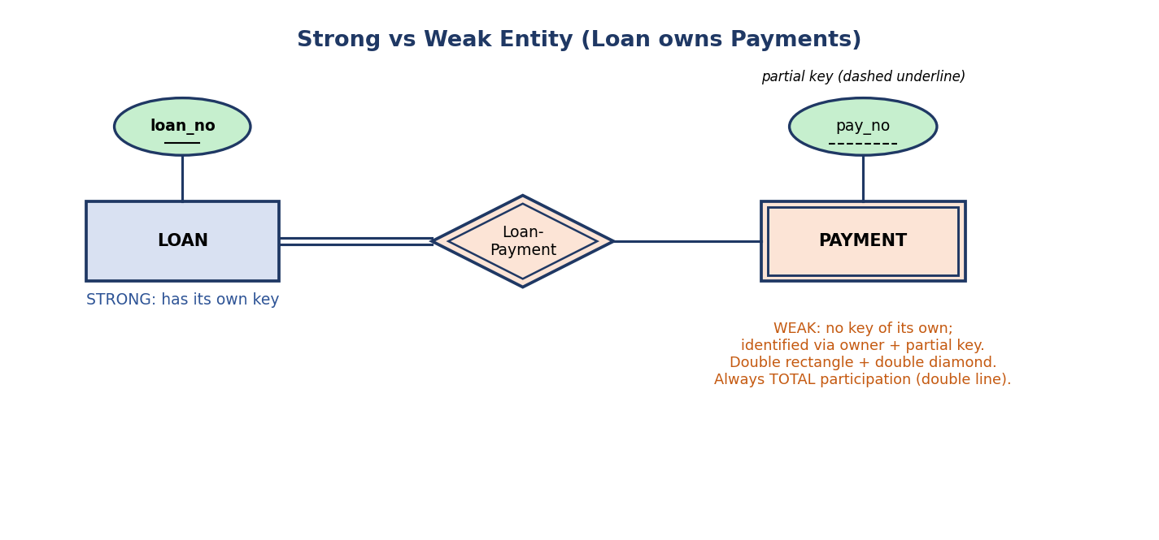
Strong entity LOAN (key loan_no) owns weak entity PAYMENT (partial key pay_no, dashed underline) through identifying relationship Loan-Payment (double diamond, double line for total participation).
Classic example. A PAYMENT for a loan: payment #1, #2, #3 … restart for each loan, so pay_no alone is not unique across all loans. A payment is identified only as (loan_no, pay_no). Hence PAYMENT is weak, owned by LOAN.
Why it matters (first principles): a weak entity models a “part” whose identity depends on a “whole”. If the owner row is deleted, the weak rows make no sense — this is why weak entities map to tables with the owner’s key as part of their primary key and a foreign key (you’ll see this in §2.9).

Concept check
Q: A ROOM is numbered 101, 102 … but every building restarts at 101. Is ROOM weak or strong? A: Weak — identified only as (building_id, room_no); owner = BUILDING.

2.4 Attributes — Every Flavour
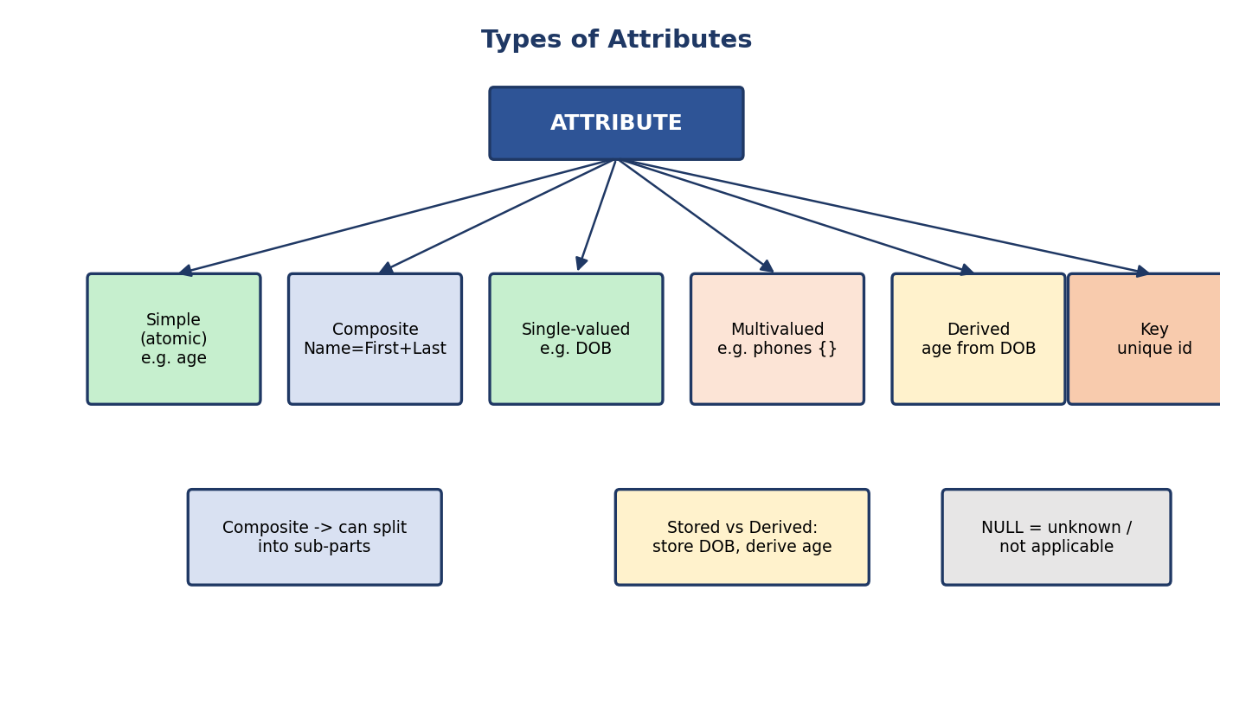
Types of attributes: simple, composite, single-valued, multivalued, derived, key; plus stored-vs-derived and NULL meaning.
Type | Meaning | Symbol | Example
Simple/atomic | Cannot be divided | oval | age, gender
Composite | Splits into sub-parts | oval with sub-ovals | name → {first, last}
Single-valued | One value per entity | oval | date_of_birth
Multivalued | Many values per entity | double oval | phone_numbers {…}
Derived | Computed from other data, not stored | dashed oval | age (from dob + today)
Stored | Actually stored (the opposite of derived) | oval | dob
Key | Uniquely identifies the entity | underlined oval | roll_no
NULL | Value unknown / not applicable / missing | — | middle_name = NULL
Composite vs multivalued — the classic confusion: composite = one value made of parts (one full name). Multivalued = several independent values (three phone numbers). Composite splits down; multivalued repeats across.
Why derived attributes exist: storing age would go stale every birthday. Store the stable fact (dob) and derive the volatile one (age). This is a first-principles design rule: store the source of truth, compute the rest.

MCQs
- phone_numbers for a person is best modelled as ___ → multivalued (double oval).
- age computed from dob is a ___ attribute → derived (dashed oval).
- A key attribute is shown by ___ → underlining it.

2.5 Relationships, Degree, Cardinality, Participation

Relationship and relationship set
A relationship is an association among entities (“Asha enrolls in DBMS-101”). A relationship set is the collection of such associations of the same type, drawn as a diamond (ENROLLS). Relationships can themselves have attributes — e.g. the grade belongs to the enrollment, not to the student or the course alone.

Degree of a relationship (how many entity types participate)
Unary (degree 1): EMPLOYEE --supervises--> EMPLOYEE (recursive / self relationship)
Binary (degree 2): STUDENT --enrolls--> COURSE (the most common)
Ternary (degree 3): DOCTOR -- prescribes --> PATIENT, and the DRUG too
Exam line: most relationships are binary. A relationship connecting an entity to itself is recursive (unary) and needs role names (e.g. “supervisor”/“subordinate”).

Cardinality ratio — the most-tested ER concept
Cardinality answers: how many entities of one set can relate to how many of the other?
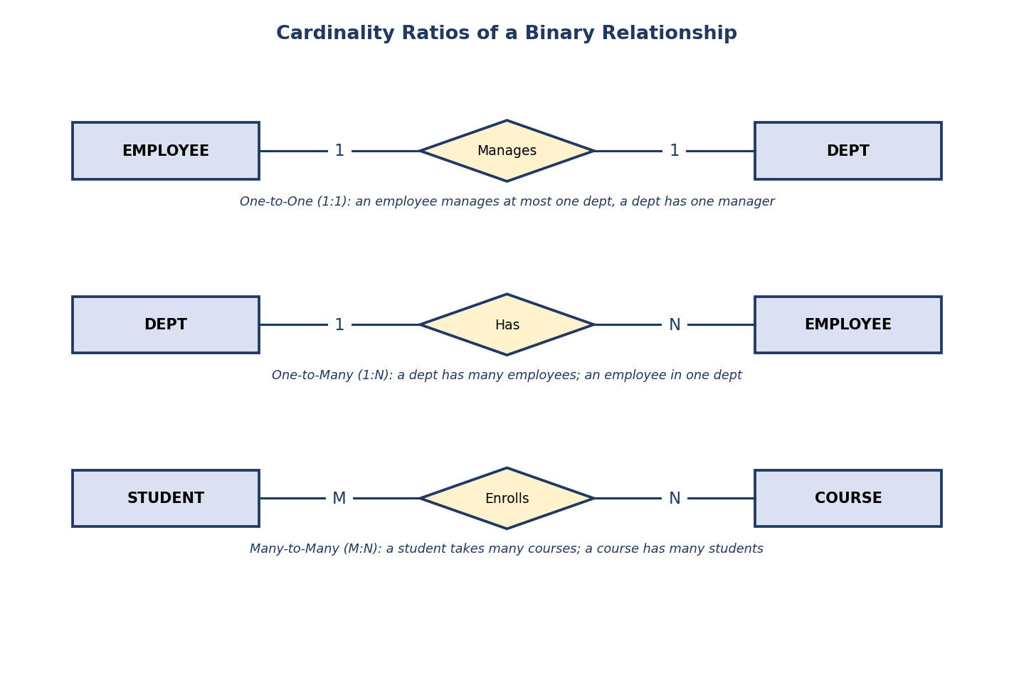
Three cardinality ratios: 1:1 (Employee–Manages–Dept), 1:N (Dept–Has–Employee), M:N (Student–Enrolls–Course).
Ratio | Reads as | Example
1:1 | one ↔ one | an employee manages one dept; a dept has one manager
1:N | one → many | a dept has many employees; an employee is in one dept
M:N | many ↔ many | a student takes many courses; a course has many students
The single most important mapping fact (memorize): a M:N relationship always becomes its own separate table; a 1:N does not (you just add a foreign key on the “many” side). This is asked in nearly every PSU/GATE paper.

Participation constraint — total vs partial
Participation asks: must every entity take part in the relationship, or only some?
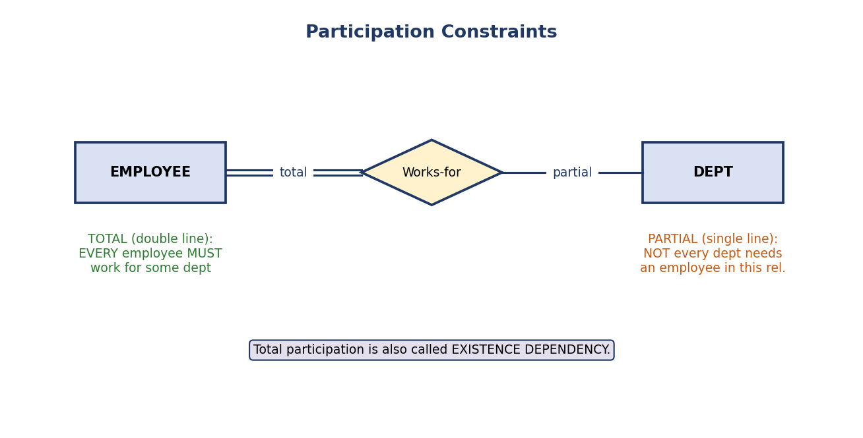
Participation: double line (total) = every employee must work for a dept; single line (partial) = not every dept needs an employee here.
- Total participation (double line): every entity instance must participate. Example: every EMPLOYEE must Works-for some DEPT. Also called existence dependency.
- Partial participation (single line): participation is optional. Example: not every EMPLOYEE Manages a dept (only managers do).
Weak entities always have total participation in their identifying relationship (they cannot exist without the owner).

Min-max (look-here) notation — alternative you may see
Some books write (min, max) on each edge, e.g. (1,1), (0,N). Here min=1 means total participation, min=0 means partial. max=N means many. It encodes cardinality and participation together.
⚠️ Trap: in (min,max) notation the numbers attach to the near entity and read “looking from that entity”; in the simple 1/N/M notation the label is placed on the line. Read the question’s convention carefully.
Concrete contrast (the classic GATE side-flip trap). Take “every DEPT has many EMPLOYEEs; every EMPLOYEE belongs to exactly one DEPT” (a 1:N):
Chen: DEPT ──1──< Works >──N── EMPLOYEE (label on the line)
(min,max): DEPT (1,N) ── Works ── (1,1) EMPLOYEE (label on the near entity)
Notice the numbers appear on opposite sides in the two notations! In Chen the “N” sits near the relationship on the EMPLOYEE side (many employees per dept); in (min,max) the EMPLOYEE end reads (1,1) (each employee → exactly one dept). Same reality, mirrored placement — this is precisely what trips students up in exams.

Recursive (unary) relationships — in depth
A recursive relationship connects an entity set to itself. The same entity plays two different roles, so we must label the roles to read it.
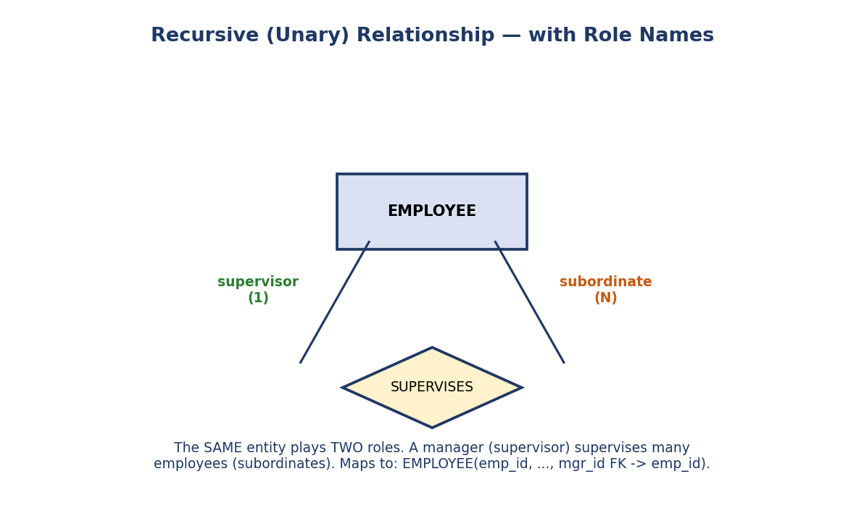
Recursive relationship: EMPLOYEE SUPERVISES EMPLOYEE; one end is the role “supervisor” (1), the other “subordinate” (N). Maps to a self-referencing foreign key mgr_id.
Classic example — employee hierarchy. An EMPLOYEE supervises other EMPLOYEEs. One employee is the supervisor (the “1” side), many are subordinates (the “N” side). Without role names the diagram is ambiguous.
How it maps to a table (very common interview question): a recursive 1:N becomes a self-referencing foreign key — the table points back to its own primary key:
EMPLOYEE(emp_id PK, name, dept_id, mgr_id FK -> EMPLOYEE.emp_id)
└── mgr_id of an employee = emp_id of their boss
Why this matters in practice: org charts, threaded comments (a comment replies to a comment), category trees (a category has a parent category), and “friends/follows” graphs are all recursive relationships. The self-FK pattern is something backend engineers write constantly.
Exam trap: the degree of a recursive relationship is 1 (unary) — it involves one entity set, even though two “lines” are drawn to it.

Concept check
Q: “Every account must belong to a branch, but a branch may have zero accounts.” Translate to constraints. A: ACCOUNT side = total (double line); BRANCH side = partial; cardinality BRANCH:ACCOUNT = 1:N.

2.6 Worked Example — A Full University ER Diagram
Let’s apply everything to one realistic schema and read it aloud.
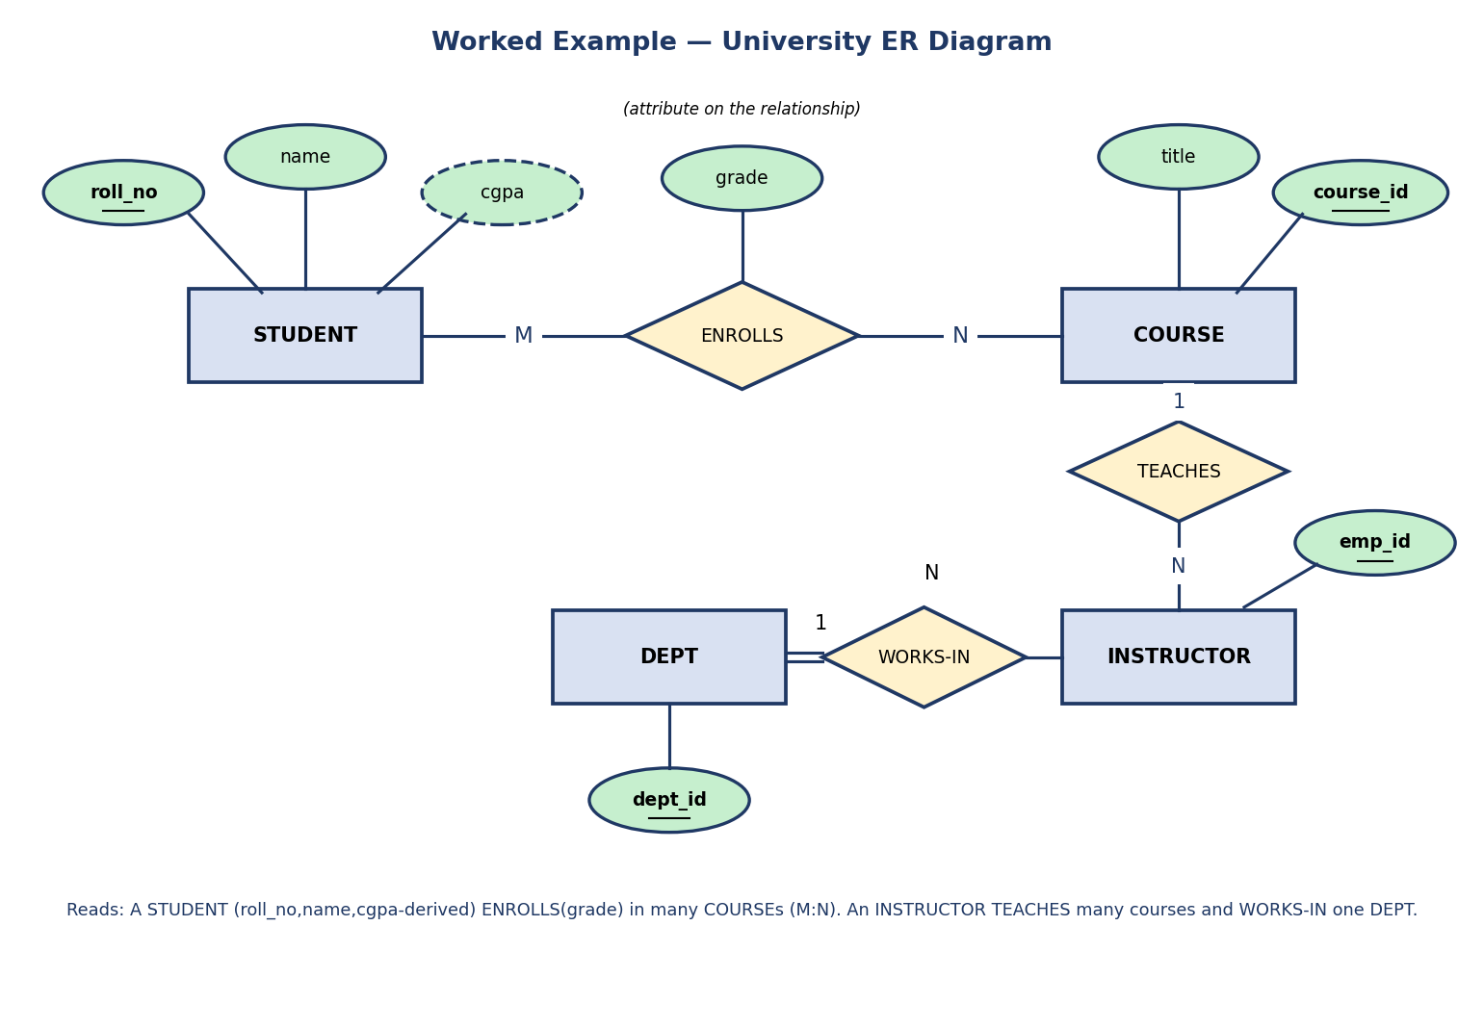
University ER diagram: STUDENT (roll_no key, name, cgpa derived) ENROLLS (grade) in COURSE (course_id key, title) as M:N; INSTRUCTOR (emp_id) TEACHES courses (1:N) and WORKS-IN DEPT (dept_id) as N:1.
How to read it:
- STUDENT has key roll_no, attribute name, and a derived cgpa (dashed).
- STUDENT ENROLLS in COURSE; the ratio is M:N, and grade is an attribute on the relationship (it depends on the pair student+course).
- INSTRUCTOR TEACHES COURSE with ratio 1:N (one instructor, many courses).
- INSTRUCTOR WORKS-IN exactly one DEPT (N:1, with total participation on the instructor side — every instructor must be in a department).
Active recall: before reading the next section, predict how many tables this diagram produces. (Answer in §2.9.)

2.7 EER — Enhanced ER: Specialization, Generalization, Aggregation
Basic ER struggles with “is-a” hierarchies and with relationships that involve other relationships. EER adds three features.

Specialization / Generalization (the ISA hierarchy)
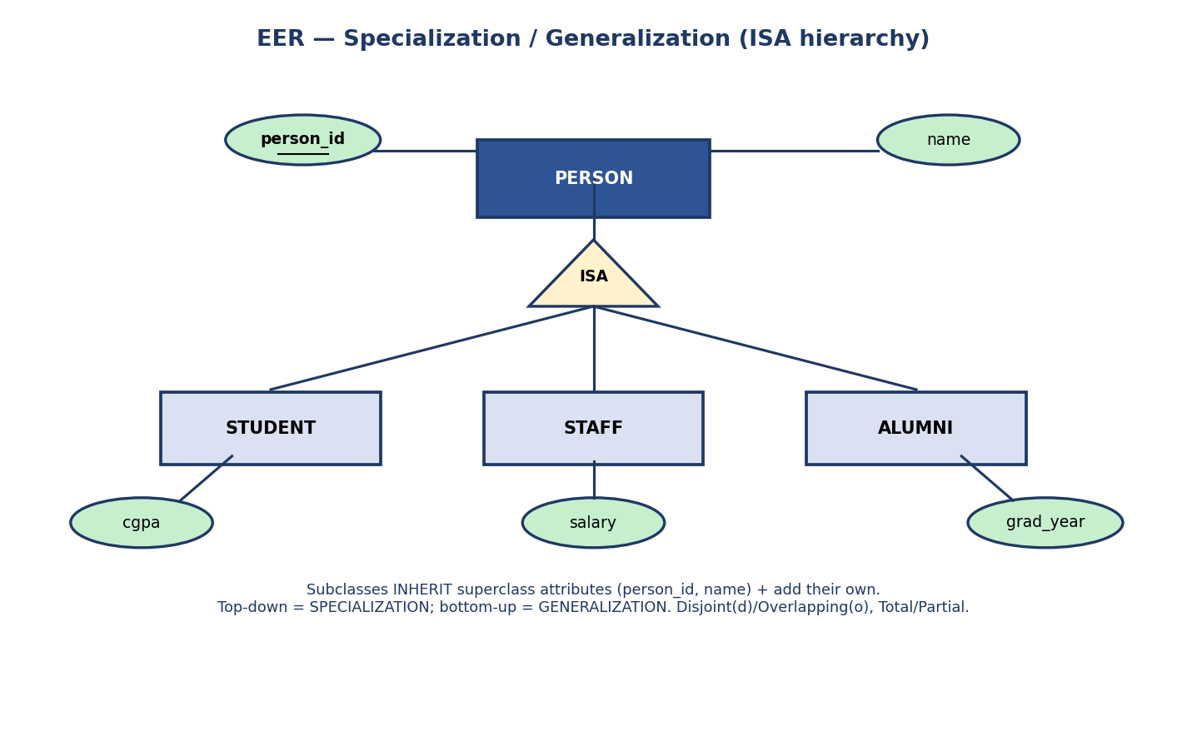
EER ISA hierarchy: PERSON superclass (person_id, name) specializes into STUDENT (cgpa), STAFF (salary), ALUMNI (grad_year) via an ISA triangle; subclasses inherit superclass attributes.
- Specialization (top-down): start with a general entity PERSON and split it into sub-types STUDENT, STAFF, ALUMNI that each add their own attributes.
- Generalization (bottom-up): notice that CAR and TRUCK share attributes, and combine them into a general VEHICLE. Same picture, opposite thinking direction.
- Inheritance: subclasses inherit all superclass attributes and relationships (STUDENT automatically has person_id, name), then add their own (cgpa).
- The relationship is drawn with an ISA triangle.
Two constraint dimensions (frequently tested):
Dimension | Options | Meaning
Disjointness | Disjoint (d) / Overlapping (o) | can an entity be in more than one subclass? d = no, o = yes
Completeness | Total / Partial | must every superclass entity be in some subclass?
Example: a PERSON could be both STUDENT and STAFF → overlapping. A SHAPE is exactly one of CIRCLE/SQUARE/TRIANGLE → disjoint, total.
How membership is decided (GATE EER point):
- Attribute-defined (predicate-defined) specialization: a value of a defining attribute of the superclass decides the subclass — e.g. EMPLOYEE.job_type = 'engineer' puts the row in the ENGINEER subclass. The discriminator attribute is shown on the ISA line.
- User-defined specialization: there is no defining attribute; the database user explicitly assigns each entity to a subclass.
Shared subclass / specialization lattice (multiple inheritance): a subclass can inherit from more than one superclass (e.g. TEACHING_ASSISTANT is both a STUDENT and an EMPLOYEE). This turns the hierarchy (tree) into a lattice, and the shared subclass inherits attributes from all its parents.

Aggregation
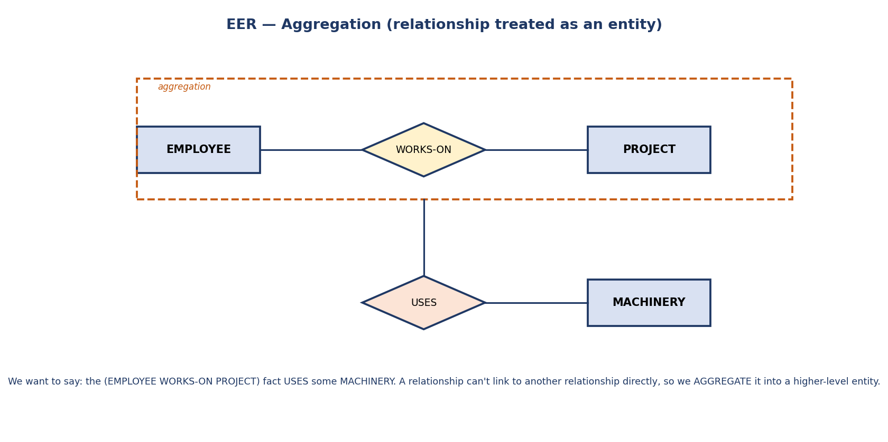
EER aggregation: the relationship (EMPLOYEE WORKS-ON PROJECT), enclosed in a dashed box, is treated as a higher-level entity that participates in the USES relationship with MACHINERY.
Problem aggregation solves: ER does not allow a relationship to connect to another relationship. But sometimes a fact about a relationship needs its own relationship. Example: the fact “(EMPLOYEE WORKS-ON PROJECT)” itself USES some MACHINERY. We aggregate the WORKS-ON relationship into a single higher-level entity (the dashed box), which can then participate in USES.
Interview soundbite: “Aggregation = treating a relationship as if it were an entity, so it can take part in further relationships.”

Category / Union type (the fourth EER feature)
A category (or union type) is a subclass whose members come from the union of several different superclasses. Contrast with normal specialization, where one superclass splits into subclasses.
- Specialization: PERSON → {STUDENT, STAFF} — subclasses share one superclass.
- Category: OWNER is a subclass of the union of PERSON, BANK, and COMPANY (a vehicle’s owner could be a person or a bank or a company). Drawn with a ∪ (union) circle, sometimes labelled U.
PERSON ┐
BANK ├──∪──► OWNER (an OWNER is a member of ONE of these superclasses)
COMPANY┘
Specialization vs Category (don’t confuse): in specialization an instance inherits from one superclass and the subclass adds attributes. In a category, an instance belongs to exactly one of several different superclasses (selective inheritance). Category is rarely asked but appears in GATE EER theory.

2.8 First-Principles: How the DBMS Uses the ER Design
The ER diagram is a conceptual artifact — it never runs. But it directly becomes the logical schema (Module 1’s middle layer) through a mechanical translation, and from there the storage engine builds the physical layer.
ER diagram (conceptual) --8 rules--> Relational tables (logical) --engine--> files/indexes (physical)
This is why getting the ER model right matters so much: errors here propagate all the way down. A missing relationship means a missing foreign key means an application that can’t answer a question it should.

2.9 ER → Relational Mapping (the 8 Rules)
This is the bridge from “picture” to “tables”. Learn these eight rules; SEBI/GATE test them as “how many tables / which foreign key goes where”.
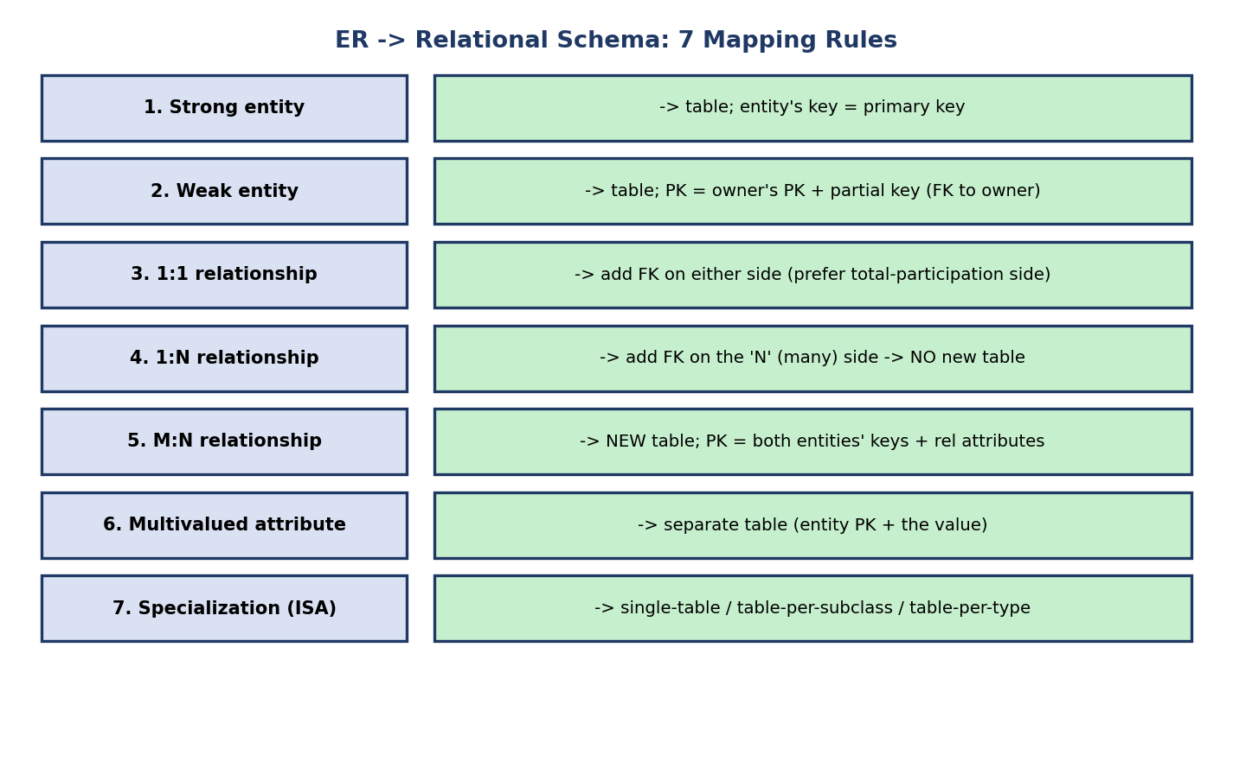
ER-to-relational mapping: 8 rules covering strong entity, weak entity, 1:1, 1:N, M:N, multivalued attribute, specialization, and ternary relationship.
- Strong entity → its own table. The entity’s key attribute becomes the primary key. (STUDENT(roll_no, name).)
- Weak entity → its own table, whose primary key = owner’s PK + the partial key, with the owner’s PK also a foreign key. (PAYMENT(loan_no, pay_no, amount), PK = (loan_no, pay_no).)
- 1:1 relationship → no new table; put a foreign key on either side (prefer the side with total participation, to avoid NULLs). Special case: if both sides have total participation, you can merge both entities into a single table with no loss.
- 1:N relationship → no new table; put the foreign key on the “N” (many) side. (EMPLOYEE(emp_id, …, dept_id FK).) Any attributes of a 1:N relationship also migrate to the “N”-side table (they’re determined by the N side).
- M:N relationship → a NEW table whose primary key is the combination of both entities’ keys, plus any relationship attributes. (ENROLLS(roll_no, course_id, grade), PK = (roll_no, course_id).)
- Multivalued attribute → a separate table (entity’s PK + the value). One row per value. (PHONE(emp_id, phone_no).)
- Specialization (ISA) → one of three strategies: (a) one table for the whole hierarchy with a type discriminator; (b) one table per subclass (each includes inherited attributes); (c) one table for superclass + one per subclass (joined by the shared key).
- Ternary (degree-3) relationship → a NEW table whose primary key is the combination of all THREE participating entities’ keys (plus any relationship attributes). E.g. SUPPLIES(supplier_id, part_id, project_id, qty), PK = (supplier_id, part_id, project_id). (This is a classic GATE/SEBI trap — a ternary always becomes its own table; you cannot fold it into a single FK.)
Answer to §2.6’s active-recall question — the university diagram maps to:
STUDENT(roll_no, name) -- rule 1
COURSE(course_id, title, emp_id FK) -- rule 1 + rule 4: TEACHES is 1:N,
-- so instructor emp_id is a FK here
INSTRUCTOR(emp_id, name, dept_id FK) -- rule 1 + rule 4: WORKS-IN is N:1
DEPT(dept_id, dname) -- rule 1
ENROLLS(roll_no, course_id, grade) -- rule 5: M:N -> new table
So: 5 tables (STUDENT, COURSE, INSTRUCTOR, DEPT, ENROLLS). The 1:N relationships (TEACHES, WORKS-IN) became foreign keys, not tables; only the M:N (ENROLLS) became a table. This is the exact reasoning a numerical question expects.

Dry run — count the tables (exam-style)
Given: entities A, B, C. Relationships: A–B is 1:N, B–C is M:N, A has a multivalued attribute. Tables? A, B, C (3) + the M:N B–C (1) + the multivalued attribute (1) = 5 tables. A–B 1:N adds only a foreign key in B. ✔
Variant: entities A, B, C with one ternary relationship among all three. Tables? A, B, C (3) + the ternary (1) = 4 tables; the ternary table’s PK = (key_A, key_B, key_C). ✔ (Don’t fold a ternary into a foreign key — common mistake.)
Interview follow-up (M:N → two 1:N): you can always replace an M:N relationship by introducing an associative (junction) entity in the middle, turning it into two 1:N relationships. STUDENT —1:N→ ENROLLMENT ←N:1— COURSE. This is exactly what the M:N join table is, viewed as an entity. Useful when the relationship itself gains its own attributes/keys (e.g. an enrollment gets an enrollment_id, timestamp, status).

2.10 Flowchart — How to Design an ER Diagram from Requirements
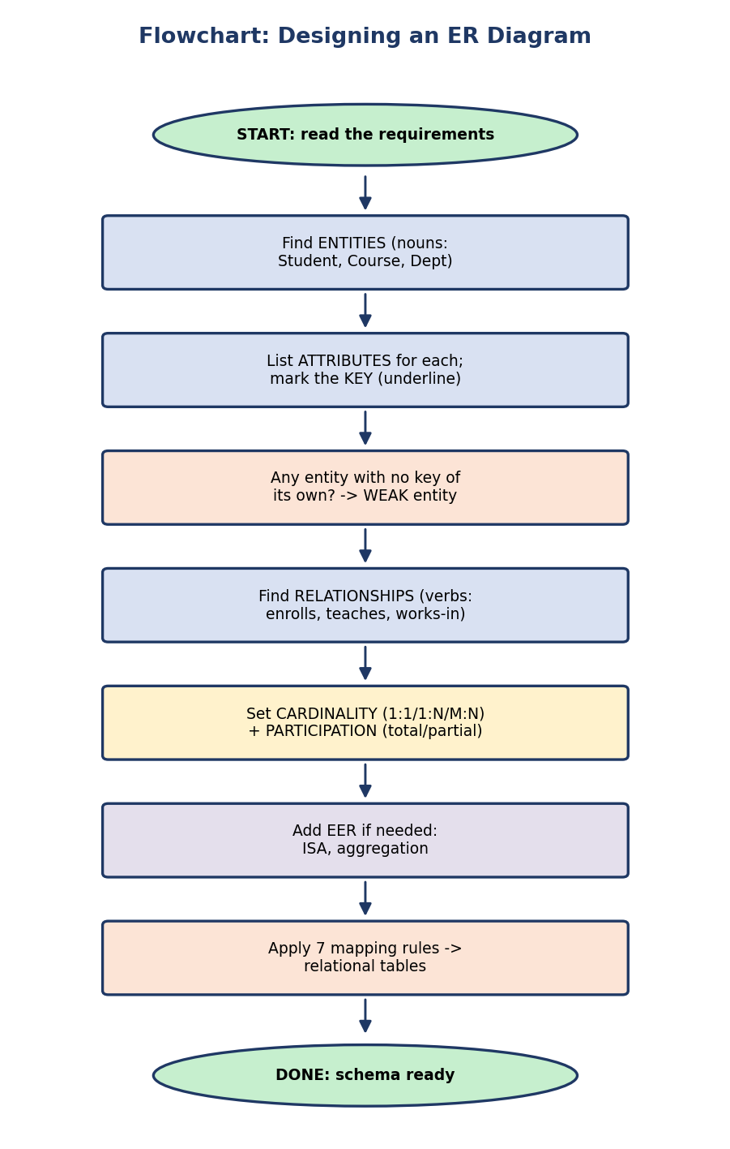
Flowchart for ER design: read requirements → find entities (nouns) → list attributes + mark keys → spot weak entities → find relationships (verbs) → set cardinality + participation → add EER (ISA/aggregation) → apply 8 mapping rules → schema ready.
The practical heuristic (works in interviews and exams):
- Nouns in the requirement → candidate entities / attributes.
- Verbs → candidate relationships.
- Ask of each entity: does it have its own key? If no → weak.
- Ask of each relationship: how many ↔ how many? (cardinality) and must all participate? (participation).

2.11 Real-World & Backend Perspectives
- Real-world / backend: ER diagrams are the standard first step in any product database design. Tools (dbdiagram.io, MySQL Workbench, draw.io) let teams agree on the model before coding. The “M:N needs a join table” rule is something backend engineers apply weekly (e.g. users ↔ roles → user_roles).
- System design: the ER model is how you communicate a data model in a design interview — draw entities and relationships before discussing sharding or caching.

2.12 Tradeoffs, Common Mistakes, Edge Cases
Tradeoffs
Strength of ER model | Limitation
Visual, intuitive, DBMS-independent | No standard for operations/behavior (it’s structural only)
Maps mechanically to tables | Many notations exist (Chen vs Crow’s-foot vs UML) → confusion
Great for communication with non-engineers | Hard to show complex constraints precisely
Common mistakes (exam + real life) - Treating an M:N relationship as if it needs no table — it always needs one. - Putting a 1:N foreign key on the wrong (one) side — it goes on the many side. - Drawing a relationship’s attribute (like grade) on an entity instead of on the diamond. - Forgetting that a weak entity has total participation and a partial key (dashed underline), not a full key. - Confusing composite (one value, many parts) with multivalued (many values).
Edge cases - Ternary relationships generally cannot be replaced by three binary ones without losing meaning (a frequent GATE trap). When mapped, a ternary becomes its own table with all three keys as the composite PK (mapping rule 8). - A recursive relationship needs role labels to be readable. - A 1:1 relationship with total participation on both sides can be merged into a single table.

2.13 Concept Checks & MCQs
- A diamond in an ER diagram represents ___ → a relationship.
- A double oval represents a ___ attribute → multivalued.
- Which relationship type always needs a separate relation when mapped? → M:N.
- A weak entity’s key in the table is ___ → owner’s PK + partial key.
- “Every loan must have a customer” is which constraint? → total participation (of LOAN).
- ER model was proposed by ___ in ___ → Peter Chen, 1976.
- The ISA triangle in EER represents ___ → specialization/generalization (inheritance).
- Aggregation is used when ___ → a relationship must participate in another relationship.
- A relationship of degree 3 is called ___ → ternary. (When mapped → one table with all THREE keys as the composite primary key.)
- name = {first, last} is a ___ attribute → composite.
True/False - A 1:N relationship is mapped to its own table. → False (FK on the N side). - A derived attribute is physically stored. → False. - Overlapping specialization allows an entity in two subclasses. → True.
Scenario (interview) > “Model a hospital where a PATIENT can have many APPOINTMENTs, each with one > DOCTOR, and we record the appointment’s date and diagnosis.” Identify entities, > relationships, cardinalities. > Sketch: PATIENT (1) — has — (N) APPOINTMENT (N) — with — (1) DOCTOR; > date, diagnosis are attributes of APPOINTMENT. Two 1:N relationships → > APPOINTMENT carries patient_id and doctor_id as foreign keys.

2.14 One-Page Revision Sheet
ER MODEL (Peter Chen, 1976) = visual conceptual design.
SHAPES:
rectangle = entity double rectangle = weak entity
oval = attribute underlined = key dashed = derived
double oval = multivalued diamond = relationship
double diamond = identifying (weak) triangle = ISA (EER)
single line = partial double line = total participation
ENTITY: strong (own key) | weak (no key -> owner PK + PARTIAL key, dashed underline,
identifying double-diamond, ALWAYS total participation)
ATTRIBUTES: simple | composite(one value,parts) | single | multivalued(many values)
| derived(not stored, dashed) | stored | key(underlined) | NULL
RELATIONSHIP:
degree: unary(recursive, SAME entity, 2 roles, self-FK mgr_id)/binary/ternary
cardinality: 1:1 | 1:N | M:N
participation: total(double line)/partial(single line)
NOTATIONS: Chen(exam: diamonds + 1/N/M) vs Crow's foot(industry: line-end symbols;
bar=one, crow=many, circle=optional/partial)
EER: specialization(top-down)/generalization(bottom-up); inheritance;
disjoint(d)/overlapping(o); total/partial; aggregation(relationship as entity);
category/union(subclass of UNION of many superclasses)
MAPPING TO TABLES (8 rules):
strong->table(PK=key) weak->table(PK=owner PK+partial key, FK)
1:1->FK either side 1:N->FK on MANY side (NO new table)
M:N->NEW table(PK=both keys+attrs) multivalued->separate table
specialization->single/per-subclass/superclass+subclass tables
ternary->NEW table, PK = all THREE entity keys
EER specialization membership: attribute-defined (discriminator attr) vs user-defined;
shared subclass = multiple inheritance (lattice).
TERNARY (degree 3) -> its own table, PK = all THREE entity keys (don't fold!).
1:N relationship attributes -> migrate to the N-side table.
M:N <-> two 1:N via an associative/junction entity (same thing as the join table).
GOLDEN RULE: only M:N (and multivalued, and weak, and ternary) create EXTRA tables;
1:1 and 1:N become foreign keys.

Flash cards
Front | Back
Which ratio needs a separate table? | M:N
1:N foreign key goes on which side? | The “many” (N) side
Weak entity participation? | Always total
Symbol for derived attribute? | Dashed oval
ISA triangle means? | Specialization/generalization (inheritance)
Aggregation solves? | Relationship participating in a relationship
Recursive relationship degree? | Unary (1) — same entity, 2 roles, self-FK
Crow’s foot: circle (o) means? | Optional / zero / partial participation
Category (union type) is? | Subclass of the union of many superclasses
ER model author & year? | Peter Chen, 1976

Spaced repetition
- 24-hour: redraw the university ER diagram from memory; map it to 5 tables.
- 7-day: explain weak entity, total participation, and M:N mapping aloud.
- 30-day: given a 4-line requirement, produce a full ER diagram + table count.

2.15 Summary
The ER model lets us design a database as a picture before writing any SQL. We learned its three building blocks — entities (strong/weak), attributes (simple, composite, multivalued, derived, key), and relationships (with degree, cardinality 1:1/1:N/M:N, and participation total/partial) — and the exact notation for each. We extended to EER with specialization/generalization (the ISA hierarchy, with disjoint/overlapping and total/partial constraints) and aggregation. Finally, we crossed the bridge from picture to logical schema with the 8 mapping rules, and saw the golden exam fact: only M:N relationships (plus weak entities and multivalued attributes) create extra tables; 1:1 and 1:N become foreign keys.
In Module 1 we learned the layers of a database; here we learned to design the conceptual layer. Next, in Module 3 — the Relational Model & Algebra, we make those tables mathematically precise (keys, integrity constraints) and learn the relational algebra that every SQL query is secretly compiled into.
You have mastered this module when you can, from a one-paragraph requirement, draw a correct ER diagram (right shapes, cardinalities, participation), extend it with ISA/aggregation where needed, and convert it to the exact set of tables — stating why each table exists — without notes.

