Module 3 — Relational Model, Keys, Integrity & Relational Algebra
  - DBMS Mastery: SEBI IT / RBI / GATE / Interview — In-Depth Notes (with visuals)
Prepared for nidhi.sharma@forensiccybertech.com
2026
Table of Contents

Module 3 — Relational Model, Keys, Integrity & Relational Algebra
Where this module sits. In Module 2 we designed a database as a picture (ER) and mapped it to tables. Now we make those tables mathematically precise. The relational model is the theory underneath every SQL database on earth. Relational algebra is the secret language your queries are compiled into — when you understand it, SQL stops being magic and query optimization (Module 8) becomes obvious. This module is the theoretical heart of the whole subject and one of the highest-scoring areas in SEBI/GATE.
Importance ratings (out of 5):
Exam / Use | SEBI IT | RBI IT | GATE CS | Interview | Backend
This module | ★★★★★ | ★★★★ | ★★★★★ | ★★★ | ★★★
Most-asked PYQ concepts (SEBI / RBI / GATE): definitions of degree & cardinality; super / candidate / primary / foreign key differences; prime vs non-prime attribute; entity & referential integrity; the relational algebra operators and what each outputs; which operators are fundamental vs derived; natural join result and tuple counts; division (“for all” queries); TRC vs DRC; and the fact that algebra and calculus have equal expressive power.

3.1 The Relational Model — Basics

Motivation & first principles
Codd’s 1970 idea was radical in its simplicity: store all data as mathematical relations (tables), and query them with operations from set theory and logic. No pointers, no navigation — just tables and operators that take tables in and give tables out. That “tables in → table out” property is called closure, and it is why you can nest queries.

Definitions (learn this vocabulary cold — it is tested directly)
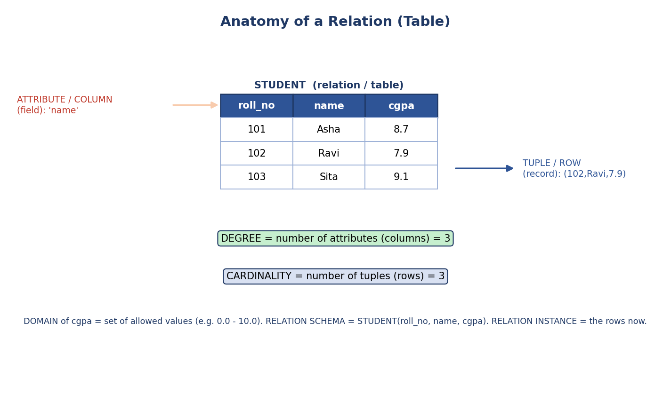
Anatomy of a relation: columns are attributes, rows are tuples, degree = number of columns, cardinality = number of rows, each column draws from a domain.
- Relation: a table. Formally, a subset of the Cartesian product of domains.
- Tuple: a row (a single record).
- Attribute: a column (a named field).
- Domain: the set of allowed atomic values for an attribute (e.g. cgpa ∈ [0.0, 10.0]). Domains must be atomic (indivisible) — this is the 1NF requirement (Module 5).
- Degree (arity): the number of attributes (columns).
- Cardinality: the number of tuples (rows).
- Relation schema: the design — STUDENT(roll_no, name, cgpa).
- Relation instance / state: the actual set of tuples at a moment.
- Relational database schema: the set of all relation schemas together.
Exam trap (memorize): Degree = columns, Cardinality = rows. Students swap these constantly. Degree sounds like “degree of complexity = how many attributes”; cardinality is “how many things (rows)”.

Properties of relations (each one is a possible MCQ)
- No duplicate tuples — a relation is a set, so every row is unique.
- Tuples are unordered — there is no “first” row.
- Attributes are unordered — columns are referenced by name, not position.
- All values are atomic — no lists/sets inside a cell (1NF).
- Each attribute has a distinct name within a relation.
Why “no duplicates & unordered” matters: it is exactly why SELECT can return rows in any order unless you say ORDER BY, and why π (projection) automatically removes duplicates. SQL relaxes the “set” rule to a multiset (bag) — it can keep duplicates unless you write DISTINCT. (A classic algebra-vs-SQL difference.)

Concept check
Q: A relation has 6 columns and 100 rows. Its degree and cardinality? A: Degree = 6, cardinality = 100.

3.2 Keys — The Complete Picture
Keys are how we uniquely identify rows and link tables. This is one of the most frequently tested topics in the entire syllabus.
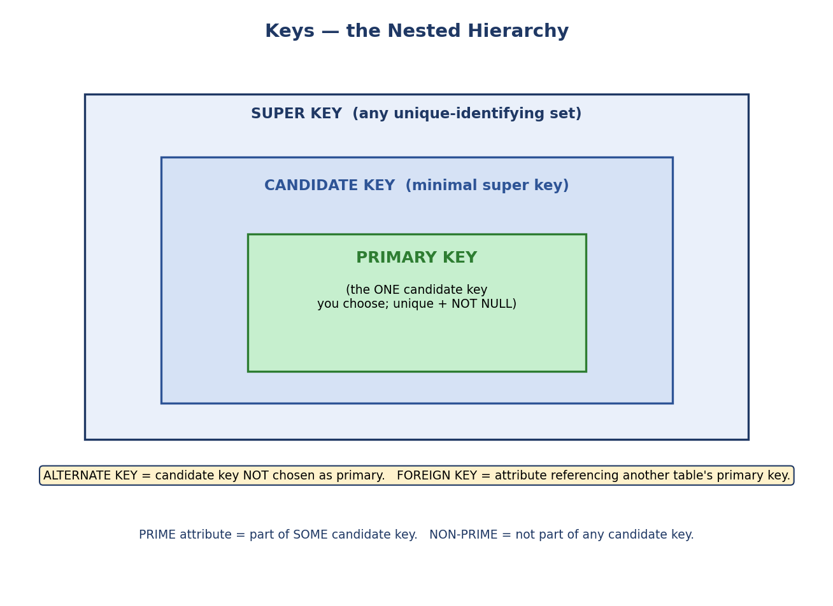
Keys hierarchy: super key ⊇ candidate key (minimal) ⊇ primary key (the chosen one). Alternate keys are unchosen candidates; foreign keys reference another table’s PK.

The hierarchy (think nested boxes)
Key | Definition | Example on STUDENT(roll_no, email, name, dob)
Super key | Any set of attributes that uniquely identifies a tuple | {roll_no}, {roll_no, name}, {email, dob} …
Candidate key | A minimal super key (remove any attribute and it stops being unique) | {roll_no}, {email}
Primary key | The one candidate key chosen as the main identifier; unique + NOT NULL | {roll_no}
Alternate key | A candidate key not chosen as primary | {email}
Foreign key | An attribute that references another relation’s primary key | dept_id in EMPLOYEE → DEPT.dept_id
Composite key | A key made of two or more attributes | {roll_no, course_id} in ENROLLS
Surrogate key | An artificial, system-generated id (e.g. auto-increment) | id SERIAL
Super key vs candidate key (the #1 confusion): every candidate key is a super key, but a super key is a candidate key only if it is minimal. {roll_no, name} is a super key but not a candidate key (because roll_no alone already works — name is redundant).

PRIMARY KEY vs UNIQUE constraint (frequent SEBI/interview question)
Both enforce uniqueness, but they are not the same:
 | PRIMARY KEY | UNIQUE
Uniqueness | yes | yes
NULLs allowed? | No (entity integrity) | Yes (usually one NULL, or several depending on DBMS)
How many per table? | exactly one | many
Role | the row’s main identity | an alternate-key enforcement
So a primary key = UNIQUE + NOT NULL + only one per table. The other candidate keys are typically declared with a UNIQUE constraint (they are the alternate keys).

Prime vs Non-prime attributes (heavily tested in normalization)
- Prime attribute: an attribute that is part of some candidate key.
- Non-prime attribute: an attribute that is part of no candidate key.
Example: if candidate keys are {roll_no} and {email}, then roll_no and email are prime; name and dob are non-prime. You will need this exact definition for 2NF/3NF in Module 5.

How many super keys? (a favourite GATE numerical)
A super key is any attribute set that contains a candidate key. So count the subsets that include at least one full candidate key.
Case 1 — exactly ONE candidate key of 1 attribute, n attributes total: number of super keys = 2^(n−1) (the key attribute must be present; each of the other n−1 attributes is independently in or out).
Worked example: R(A, B, C, D) with the single candidate key {A}. Super keys = all subsets that contain A = 2^(4−1) = 8.
Case 2 — TWO disjoint candidate keys, each 1 attribute (e.g. {A} and {B}): count subsets containing A OR B, by inclusion–exclusion: 2^(n−1) + 2^(n−1) − 2^(n−2) = 3 · 2^(n−2).
Worked example: R(A, B, C, D) with candidate keys {A} and {B}. Super keys = 3 · 2^(4−2) = 3 · 4 = 12.
Case 3 — a COMPOSITE candidate key (e.g. the only candidate key is {A,B} in R(A,B,C,D)): a super key is any subset that contains {A,B}. Both A and B must be present; the remaining n − 2 attributes are each optional → super keys = 2^(n−2) = 2^2 = 4 (namely AB, ABC, ABD, ABCD).
General principle (use this, not a memorized formula): the number of super keys = the number of attribute subsets that contain at least one candidate key. For one key it’s a clean power of two; for multiple/overlapping keys, use inclusion–exclusion over “contains key₁ OR key₂ OR …”.
⚠️ Trap (the reason this is tested): the simple 2^(n−1) formula is valid only when there is exactly one single-attribute candidate key. The moment a relation has a second candidate key (like our STUDENT with both {roll_no} and {email}), you must use inclusion–exclusion. Always count “subsets containing some candidate key”, never blindly apply 2^(n−1).

Finding candidate keys (the algorithm you’ll reuse in Module 5)
When a relation comes with functional dependencies (FDs — Module 5), you find candidate keys systematically using attribute closure. The flow below is the exact procedure; we go deep on closure in Module 5, but the shape of the algorithm is worth seeing now.
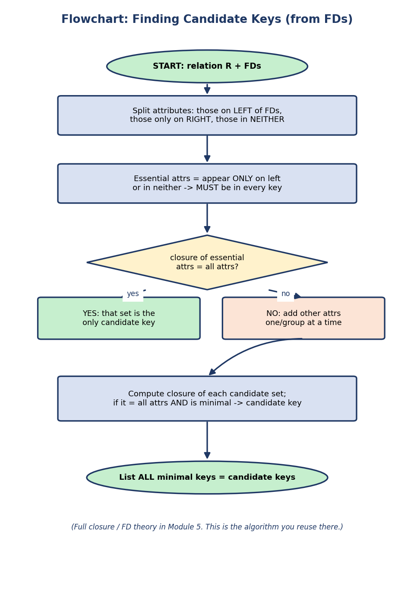
Flowchart for finding candidate keys: split attributes by where they appear in FDs, find essential attributes that must be in every key, take their closure, then extend minimally until the closure covers all attributes.
The intuition: attributes that appear only on the left of FDs (or in no FD at all) must be in every candidate key — nothing can determine them, so they can’t be derived. Start there, take the closure, and add the fewest extra attributes needed to reach all attributes.

MCQs
- A minimal super key is a ___ → candidate key.
- A primary key cannot be ___ → NULL (entity integrity).
- {roll_no, name} where roll_no alone is unique — is it a candidate key? → No (not minimal; it’s a super key only).
- An attribute in some candidate key is called ___ → prime.

3.3 Integrity Constraints — Rules That Keep Data Valid
Constraints are conditions the DBMS enforces automatically so the database can never reach an invalid state. This is one of the core advantages of a DBMS over files (Module 1).
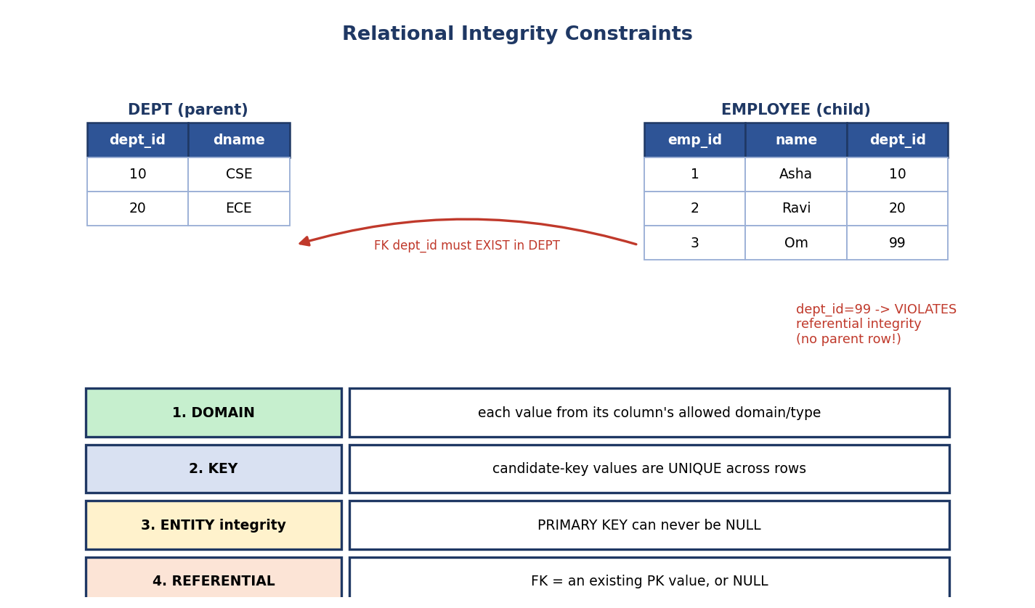
Integrity constraints: domain (valid values), key (uniqueness), entity integrity (PK not NULL), referential integrity (FK must match an existing PK).
Constraint | Rule | Violation example
Domain | each value comes from the attribute’s domain/type | putting 'abc' in an INT age column
Key | candidate-key values are unique across all tuples | two students with the same roll_no
Entity integrity | the primary key is never NULL (and unique) | a row with roll_no = NULL
Referential integrity | a foreign key value must match an existing primary-key value in the referenced table, or be NULL | EMPLOYEE.dept_id = 99 when no DEPT 99 exists

Referential integrity in depth (the one with the arrow)
A foreign key creates a parent → child link (e.g. DEPT is parent, EMPLOYEE is child). The DBMS protects this link on three operations:
- Insert/Update a child with a dept_id that has no parent → rejected.
- Delete/Update a parent that still has children → controlled by a referential action:
  - RESTRICT / NO ACTION — block it.
  - CASCADE — delete/update the children too.
  - SET NULL — set the children’s FK to NULL.
  - SET DEFAULT — set the children’s FK to a default value.
Interview soundbite: “A foreign key with ON DELETE CASCADE means deleting a parent automatically cleans up its children — convenient, but dangerous if you didn’t expect a chain delete.” This shows practical awareness backends care about.
Exam nuggets: Entity integrity = PK not NULL. Referential integrity = FK references an existing PK (or is NULL). These two phrasings appear verbatim in SEBI/RBI papers.

Concept check
Q: Why can a foreign key be NULL but a primary key cannot? A: A NULL FK simply means “this row isn’t linked to a parent yet” (optional relationship). A NULL PK would mean the row has no identity — forbidden by entity integrity.

NULL and three-valued logic (a guaranteed gotcha)
NULL means “unknown / not applicable / missing” — it is not zero and not an empty string. Because a value may be unknown, SQL logic has three truth values: TRUE, FALSE, UNKNOWN.
- Any comparison with NULL yields UNKNOWN: NULL = NULL → UNKNOWN (not TRUE!), NULL > 5 → UNKNOWN.
- A WHERE clause keeps a row only when the predicate is TRUE — so rows where the condition is UNKNOWN are dropped.
- To test for NULL you must use IS NULL / IS NOT NULL, never = NULL.
- Aggregates ignore NULLs: COUNT(col) skips NULLs (but COUNT(*) counts all rows); AVG/SUM ignore NULLs too.
A | B | A AND B | A OR B
TRUE | UNKNOWN | UNKNOWN | TRUE
FALSE | UNKNOWN | FALSE | UNKNOWN
UNKNOWN | UNKNOWN | UNKNOWN | UNKNOWN
Exam/interview nugget: SELECT * FROM T WHERE age = NULL; returns zero rows (the predicate is UNKNOWN for every row). The correct query is WHERE age IS NULL. This trips up nearly everyone once.

3.4 Relational Algebra — The Operators
Relational algebra is a procedural query language: you describe a sequence of operations. Each operator takes one or two relations and returns a relation (closure), so operations chain into expressions.

The 6 FUNDAMENTAL operators (everything else is built from these)
Op | Name | Picks / does | SQL analogue
σ (sigma) | Selection | filters rows by a predicate | WHERE
π (pi) | Projection | keeps chosen columns (and de-dups) | SELECT cols
ρ (rho) | Rename | renames a relation/attributes | AS
∪ | Union | rows in A or B | UNION
− | Set difference | rows in A but not B | EXCEPT
× | Cartesian product | every row of A paired with every row of B | CROSS JOIN
Exam favourite: “Which of these is NOT a fundamental/primitive operator?” The fundamentals are σ, π, ρ, ∪, −, ×. Intersection (∩), join (⋈), and division (÷) are DERIVED (can be expressed using the six above).

Selection (σ) and Projection (π)
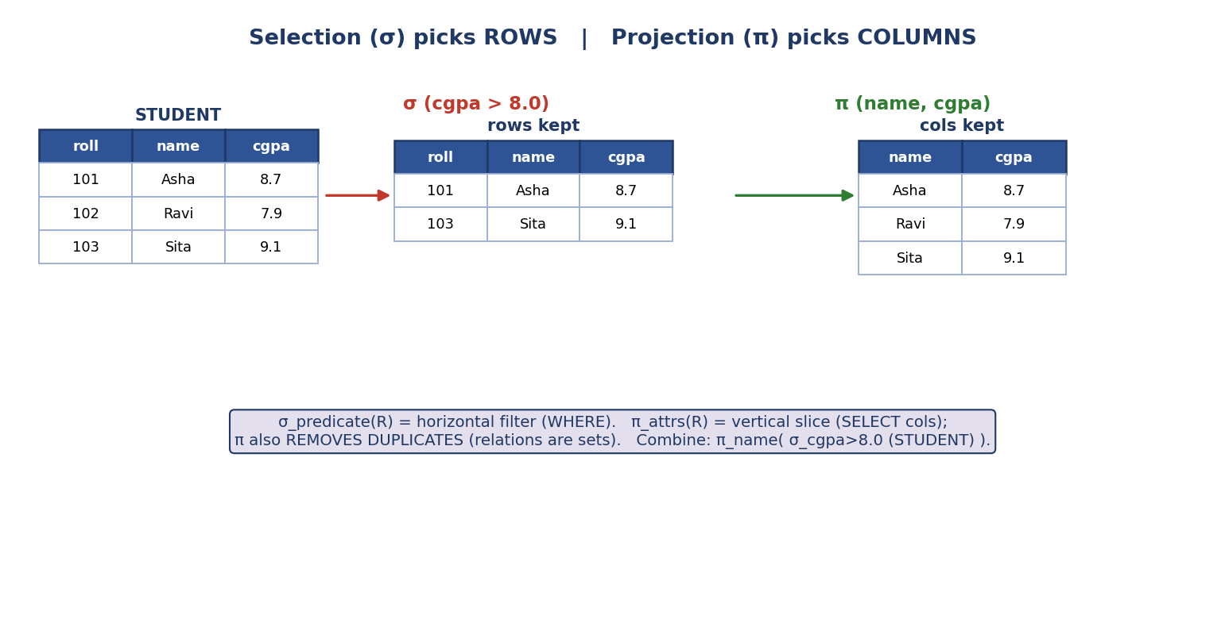
Selection σ keeps rows matching a predicate (horizontal filter); projection π keeps chosen columns and removes duplicates (vertical slice).
- σ_predicate(R): keeps the rows where the predicate is true. σ_cgpa > 8.0 (STUDENT).
- π_attrlist(R): keeps only those columns, removing duplicate rows. π_name, cgpa (STUDENT).
- Combine them: π_name ( σ_cgpa > 8.0 (STUDENT) ) = “names of students with cgpa above 8”.
The classic π trap: projection removes duplicates (because a relation is a set). So π_dept(EMPLOYEE) returns each department once, even if 100 employees share it. In SQL you’d need SELECT DISTINCT dept.

Set operations (∪, ∩, −) and union compatibility
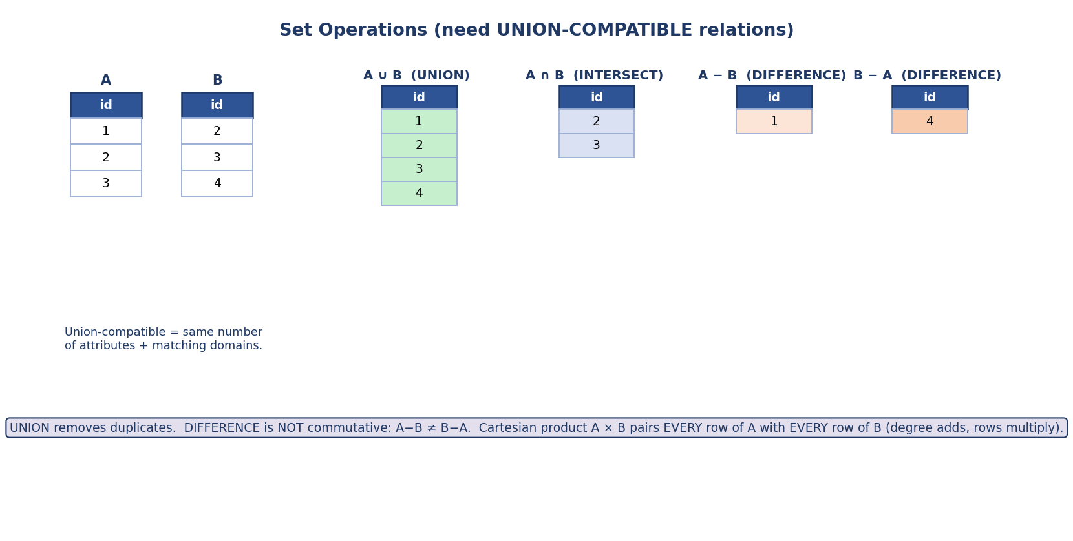
Set operations on union-compatible relations: union (all, de-duplicated), intersection (common), difference A−B and B−A (not commutative).
To apply ∪, ∩, or −, the two relations must be union-compatible:
- same number of attributes (same degree), and
- corresponding attributes have the same (compatible) domains.
- A ∪ B — tuples in A or B (duplicates removed).
- A ∩ B — tuples in both. (Derived: A ∩ B = A − (A − B).)
- A − B — tuples in A not in B. Not commutative: A − B ≠ B − A.

Cartesian product (×) and Joins
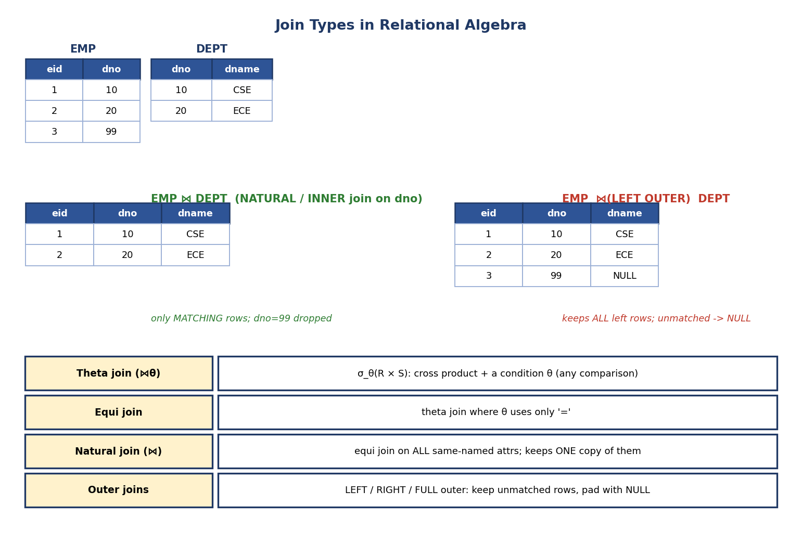
Join types: natural/inner join keeps only matching rows; theta join adds any condition; equi join uses ‘=’; outer joins keep unmatched rows padded with NULL.
- Cartesian product A × B: pairs every row of A with every row of B. Degree = degree(A)+degree(B); rows = |A|×|B|. Rarely useful alone (it’s huge and meaningless), but it’s the basis of all joins.
- Theta join R ⋈θ S = σθ(R × S): cross product, then keep rows satisfying condition θ (any comparison: <, >, =, ≠).
- Equi join: a theta join whose θ uses only equality (=).
- Natural join R ⋈ S: an equi join on all attributes with the same name, automatically, keeping only one copy of each shared attribute. The most-used join.
- Outer joins keep unmatched rows, padding the missing side with NULL. They are derived operators (a natural/theta join unioned with the unmatched rows padded by NULLs):
  - Left outer — all rows of the left relation.
  - Right outer — all rows of the right relation.
  - Full outer — all rows of both.
Natural join tuple-count trap (GATE): the result size depends purely on how many rows match on the join attribute(s). It can be 0 (no matches), up to |R|×|S| (if every row shares the same join value). Never assume natural join keeps |R| rows — if a join value repeats on both sides, rows multiply. And if R and S share no common attribute names, natural join degenerates into a Cartesian product (every pair, since the “match on shared attributes” condition is vacuously true).
Outer-join NULL rule (which side gets NULLs): the kept side’s unmatched rows are padded with NULL in the other side’s columns. Left outer keeps all left rows (right columns become NULL when unmatched); right keeps all right rows; full keeps both. In the image above, EMP row dno=99 is kept by the left outer join with dname = NULL.

Division (÷) — “for ALL” queries
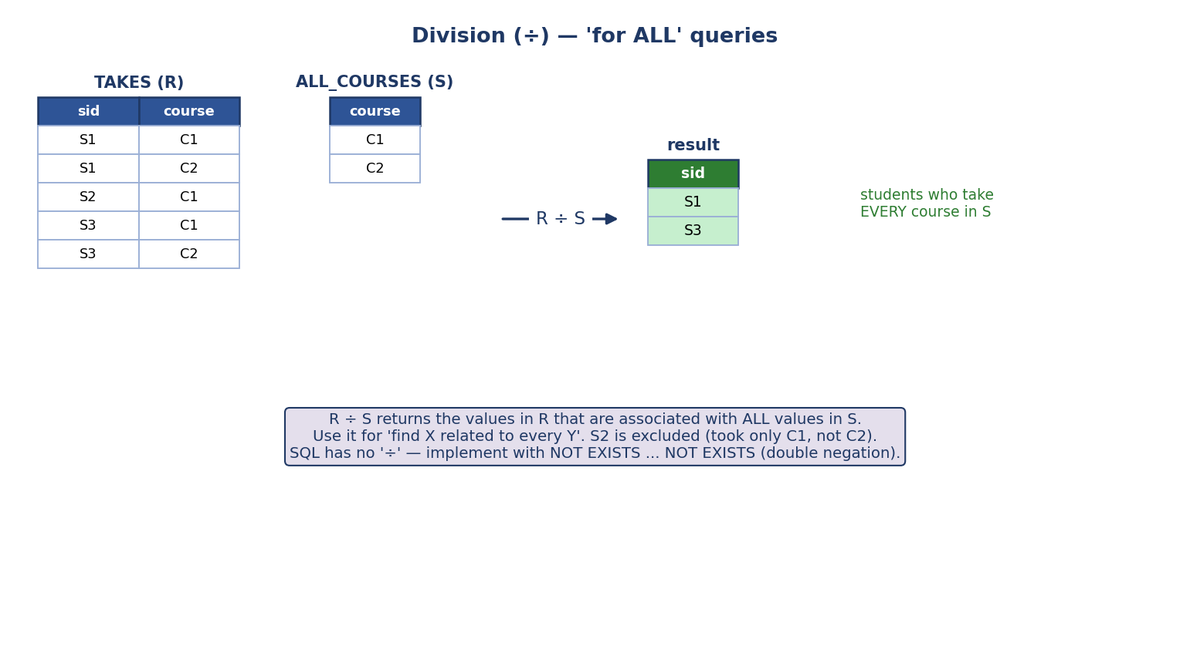
Division R ÷ S returns values in R associated with every value in S — e.g. students who take all required courses.
R ÷ S answers “find the X that are related to every Y in S.”
Example: TAKES(sid, course) ÷ ALL_COURSES(course) = students who have taken every course in ALL_COURSES. A student who took only some is excluded.
Why it matters: “for all” is the one thing SQL has no direct keyword for — you implement division with double NOT EXISTS (there is no Y in S such that the pair (X,Y) is not in R). This exact pattern is a common interview question.
Dry run with actual rows (work it, then check):
TAKES (R) ALL_COURSES (S)
sid | course course
S1 | C1 C1
S1 | C2 C2
S2 | C1
S3 | C1
S3 | C2
R ÷ S → { S1, S3 }
Why: S1 took {C1, C2} ⊇ {C1, C2} ✔; S3 took {C1, C2} ✔; S2 took only {C1}, so it is excluded (it did not take every course in S). The result schema is schema(R) − schema(S) = {sid}. (Requirement: schema(S) ⊆ schema(R).)

Extended relational algebra (aggregation, grouping, assignment)
Pure algebra has no “average” or “group by” — but real queries need them, so the algebra is extended with a few more operators (these appear in GATE and map directly to SQL):
- Generalized projection — projection that allows computed expressions, e.g. π_(name, salary*12) (EMP) (yearly salary). Maps to SELECT salary*12.
- Aggregation / grouping ᵍℱ (often written γ or ℱ): dept ℱ COUNT(eid), AVG(salary) (EMP) = “group by dept, then count employees and average salary per group”. This is exactly SQL’s GROUP BY + aggregate functions (COUNT, SUM, AVG, MIN, MAX).
- Assignment ← — name an intermediate result to build a query in steps: Temp ← σ_cgpa>8 (STUDENT), then π_name (Temp). Purely for readability.
Mapping to SQL: σ → WHERE, generalized π → SELECT expr, ℱ → GROUP BY + aggregates, aggregate-with-condition → HAVING. You’ll use all of these constantly in Module 4 (SQL).

Building an expression and reading it as a tree
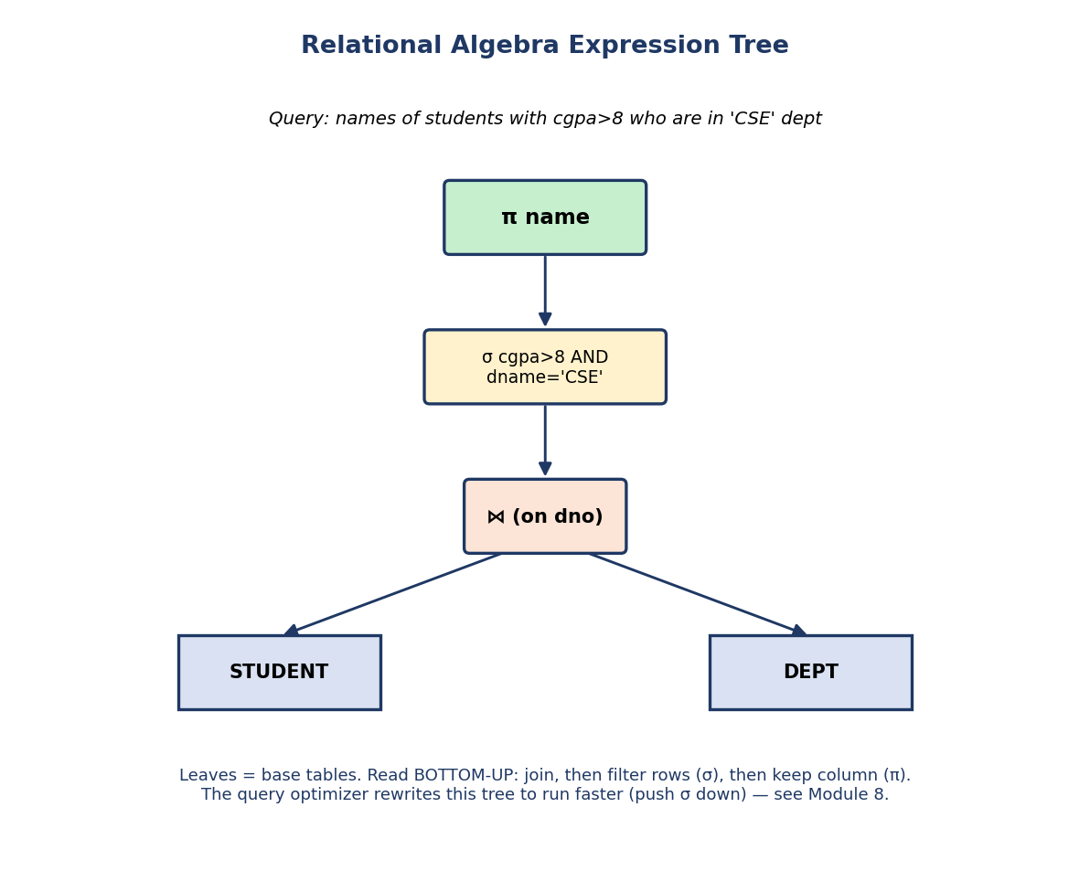
Relational algebra expression tree: leaves are base tables, then join, then selection, then projection at the root; read bottom-up.
Any algebra query can be drawn as a tree: base tables are leaves; operators are internal nodes; you evaluate bottom-up. The optimizer later rearranges this tree (e.g. pushing σ down so filtering happens before the expensive join) — that’s the bridge to Module 8.
Core equivalence (transformation) rules — these are why two queries can give the same answer (GATE/SEBI test these):
- σ cascade: σ_a(σ_b(R)) = σ_b(σ_a(R)) = σ_{a AND b}(R) (selections commute and combine).
- σ push-down through join: σ_θ(R ⋈ S) = (σ_θ(R)) ⋈ S when θ uses only R’s attributes — filter early, join late (the #1 optimization).
- π cascade: π_a(π_b(R)) = π_a(R) when a ⊆ b.
- Join commutativity & associativity: R ⋈ S = S ⋈ R; (R ⋈ S) ⋈ T = R ⋈ (S ⋈ T) — lets the optimizer pick the cheapest join order.
These rewrites preserve the result (the relations are equal) but change the cost. Module 8 uses them for cost-based optimization.

Dry run (do it yourself, then check)
Query: “Names of employees in the ‘CSE’ department.” Tables: EMPLOYEE(eid, name, dno), DEPT(dno, dname). Algebra: π_name ( σ_dname='CSE' ( EMPLOYEE ⋈ DEPT ) ). Steps: (1) natural join on dno → combined rows; (2) σ keeps CSE rows; (3) π keeps the name column. ✔

3.5 Relational Calculus — Saying What, Not How
Relational calculus is a declarative (non-procedural) language: you describe the properties of the result with logic, not the steps to compute it.
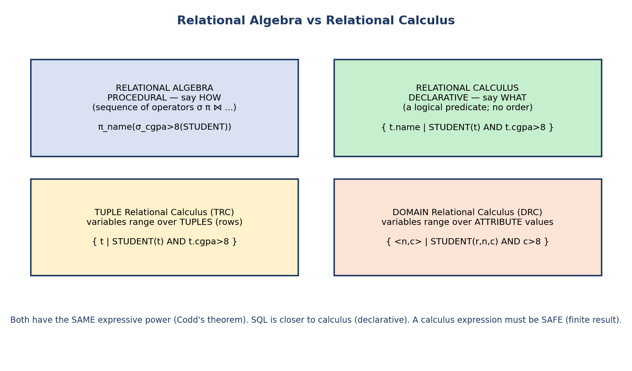
Relational algebra (procedural, operators) vs calculus (declarative, predicate); tuple calculus ranges over rows, domain calculus over attribute values; equal expressive power.

Tuple Relational Calculus (TRC)
Variables range over tuples (rows). Form: { t | P(t) } — “the set of tuples t such that predicate P(t) is true.”
{ t.name | STUDENT(t) AND t.cgpa > 8 }
→ names of students with cgpa above 8
Uses quantifiers ∃ (there exists) and ∀ (for all).

Domain Relational Calculus (DRC)
Variables range over individual attribute values (domains). Form: { <x1, x2, …> | P(x1, x2, …) }.
{ <n, c> | ∃ r ( STUDENT(r, n, c) AND c > 8 ) }
→ (name, cgpa) pairs for cgpa above 8
A “for all” (∀) example (the division query, in calculus):
{ <s> | ∃ ... ( TAKES(s, _) ) AND
∀ c ( ALL_COURSES(c) → TAKES(s, c) ) }
→ students s who have taken EVERY course c in ALL_COURSES
Read it as: “for every course c, if it’s in ALL_COURSES, then s took it.” The ∀ … → pattern is exactly how calculus expresses what algebra does with ÷ and SQL does with double NOT EXISTS.

Two key theorems (exam gold)
- Equivalence: relational algebra, TRC, and (safe) DRC all have the same expressive power (Codd’s theorem). Anything one can express, the others can. This common power defines what “relationally complete” means.
- Safety: a calculus expression must be safe — it must produce a finite result that depends only on values actually in the database (e.g. { t | NOT STUDENT(t) } is unsafe — infinitely many tuples aren’t students).
SQL’s lineage: SQL is closer to calculus (you declare what you want), but it is implemented by translating to algebra (the how) for execution. So you write calculus-style, the engine runs algebra. Best of both worlds.
Exam nuggets: Algebra = procedural. Calculus = declarative. TRC ranges over tuples; DRC over domain values. All three are equally powerful. SQL ≈ calculus in style, algebra in execution.

3.6 Real-World & Backend Perspectives
- Backend: every WHERE is a σ, every SELECT col is a π, every JOIN ... ON is a theta/equi join, UNION/EXCEPT are the set ops. When you read an EXPLAIN plan, you are literally reading an algebra expression tree the optimizer chose.
- Performance intuition: “filter early, join late” — pushing σ below ⋈ is the single most important hand-optimization, and it comes straight from algebra equivalence rules.
- Constraints in production: foreign keys with the right ON DELETE action prevent orphaned rows; choosing a surrogate key vs a natural key is a real design debate (surrogates are stable; natural keys carry meaning).

3.7 Tradeoffs, Common Mistakes, Edge Cases
Common mistakes (exam + real life) - Swapping degree (columns) and cardinality (rows). - Calling a non-minimal super key a “candidate key”. - Forgetting that projection removes duplicates (algebra is set-based). - Thinking natural join always keeps |R| rows (it depends on matches; can multiply, or become a Cartesian product if no shared attribute). - Listing ∩, ⋈, ÷ as fundamental operators — they are derived. - Believing SQL = relational algebra exactly — SQL is a multiset (bag), allows duplicates, and has NULL 3-valued logic.
Edge cases - A − B is not the same as B − A (difference isn’t commutative); union and intersection are commutative. - Natural join with no common attributes = Cartesian product. - A foreign key may reference its own table (recursive, e.g. mgr_id). - NULL complicates everything: NULL = NULL is unknown, not true.
Tradeoffs
Relational model strength | Limitation
Simple, math-backed, closure enables nesting | Flat tables don’t fit hierarchical/graph data as naturally (Module 11 NoSQL)
Declarative SQL → optimizer picks fast plans | Abstraction can hide expensive operations (accidental Cartesian products)
Strong integrity guarantees | Constraints add write-time overhead

3.8 Exam, Interview & Coding Perspectives
Competitive-exam (SEBI/RBI/GATE): degree/cardinality; key definitions & counting super keys (2^(n−1)); prime/non-prime; entity vs referential integrity; fundamental vs derived operators; output of σ/π/⋈/÷; natural-join tuple counts; algebra vs calculus & their equivalence; TRC vs DRC.
Interview: “Explain the difference between WHERE and a JOIN condition” (σ vs join); “How would you express find customers who bought every product?” (division → double NOT EXISTS); “What’s the difference between a candidate key and a primary key?”; “What does ON DELETE CASCADE do?”.
Coding/practical (PostgreSQL): - Write π_name(σ_cgpa>8(STUDENT)) as SELECT DISTINCT name FROM student WHERE cgpa > 8; and observe DISTINCT mimicking projection’s de-dup. - Implement division with double NOT EXISTS and test it. - Add a foreign key with ON DELETE CASCADE, delete a parent, watch children go.

3.9 Concept Checks & MCQs
- Degree of R(A,B,C,D,E) → 5.
- Number of super keys of R(A,B,C) with candidate key {A} → 2^2 = 4.
- Which is NOT fundamental: σ, π, ⋈, − → ⋈ (join is derived).
- Entity integrity says ___ → primary key is not NULL.
- Referential integrity says ___ → FK matches an existing PK, or is NULL.
- π in relational algebra automatically ___ → removes duplicates.
- Natural join with no common attribute name becomes ___ → Cartesian product.
- “Find students who took ALL courses” uses which operator → division (÷).
- TRC variables range over ; DRC over → tuples / domain values.
- Algebra is ___ and calculus is ___ → procedural / declarative.
- SELECT * FROM T WHERE age = NULL; returns ___ rows → zero (use IS NULL).
- NULL = NULL evaluates to ___ → UNKNOWN (not TRUE).
- PRIMARY KEY = UNIQUE + ___ + only one per table → NOT NULL.
- Super keys of R(A,B,C,D) with candidate keys {A} and {B} → 3·2² = 12.
- SQL GROUP BY + COUNT corresponds to which extended-RA operator → aggregation (ℱ/γ).
True/False - A − B = B − A. → False. - Every super key is a candidate key. → False (only minimal ones). - Algebra and calculus have equal expressive power. → True. - Projection keeps duplicate rows. → False (it removes them).
Scenario > “List the distinct cities of customers who have NOT placed any order.” > Algebra sketch: π_city(CUSTOMER) − π_city(CUSTOMER ⋈ ORDER) > (all customer cities, minus cities of customers who ordered). Uses difference > and a join.

3.10 One-Page Revision Sheet
RELATION basics: relation=table, tuple=row, attribute=column, domain=allowed values
DEGREE = # columns CARDINALITY = # rows (don't swap!)
schema = design; instance = current rows
Properties: no dup tuples, unordered rows, unordered cols, atomic values (1NF)
(SQL relaxes to MULTISET/bag — allows dups unless DISTINCT)
KEYS (nested): SUPER >= CANDIDATE(minimal) ; PRIMARY = chosen candidate (unique+NOT NULL)
ALTERNATE = unchosen candidate ; FOREIGN = ref another PK ; COMPOSITE = multi-attr
PRIME attr = in SOME candidate key ; NON-PRIME = in NONE
PK vs UNIQUE: PK = UNIQUE + NOT NULL + one per table; UNIQUE allows NULL & many
# super keys: ONE 1-attr cand key -> 2^(n-1) ; TWO disjoint 1-attr keys -> 3·2^(n-2)
(general: count subsets containing SOME candidate key, inclusion-exclusion)
NULL = unknown -> 3-valued logic (TRUE/FALSE/UNKNOWN). NULL=NULL is UNKNOWN.
use IS NULL (never = NULL). Aggregates ignore NULL; COUNT(*) counts all rows.
INTEGRITY: domain | key(unique) | ENTITY(PK not null) | REFERENTIAL(FK=existing PK or NULL)
FK actions on delete/update: RESTRICT | CASCADE | SET NULL | SET DEFAULT
RELATIONAL ALGEBRA (procedural):
FUNDAMENTAL (6): sigma σ(rows) | pi π(cols,dedup) | rho ρ(rename) | ∪ | − | ×
DERIVED: ∩ , ⋈ (theta/equi/NATURAL), ÷ , outer joins
EXTENDED: generalized π (computed cols) | aggregation ℱ/γ (GROUP BY+COUNT/SUM/AVG)
| assignment ← (name intermediate results)
σ=WHERE, π=SELECT cols, ℱ=GROUP BY, ×=CROSS JOIN
union-compatible (for ∪ ∩ −): same degree + compatible domains
A−B ≠ B−A ; natural join w/ no common attr = ×
DIVISION ÷ = "for ALL" = double NOT EXISTS in SQL
RELATIONAL CALCULUS (declarative):
TRC { t | P(t) } over tuples ; DRC { <x,..> | P } over domain values
must be SAFE (finite). Algebra = TRC = DRC in power (relationally complete).
SQL: calculus in style, algebra in execution.

Flash cards
Front | Back
Degree vs cardinality? | Degree = columns, cardinality = rows
Minimal super key? | Candidate key
Fundamental RA operators? | σ π ρ ∪ − × (join/∩/÷ are derived)
Entity integrity? | Primary key not NULL
Referential integrity? | FK = existing PK value, or NULL
π side effect? | Removes duplicate rows
“For all” operator? | Division ÷ (SQL: double NOT EXISTS)
Algebra vs calculus? | Procedural vs declarative (equal power)
Natural join, no common attr? | Becomes Cartesian product
Prime attribute? | Part of some candidate key

Spaced repetition
- 24-hour: redo all 15 MCQs + write σ/π/⋈/÷ examples from memory.
- 7-day: translate 5 English queries into relational algebra and into SQL.
- 30-day: derive ∩ and ⋈ from the 6 fundamentals; explain division + its SQL.

3.11 Summary
The relational model represents all data as relations (tables) of tuples over attributes drawn from domains, with degree = columns and cardinality = rows. We learned the full key hierarchy (super ⊇ candidate ⊇ primary, plus alternate/foreign/composite/surrogate) and the prime/non-prime distinction you’ll reuse in normalization. We saw the four integrity constraints — domain, key, entity (PK not NULL), and referential (FK matches an existing PK) — and how foreign keys are protected with CASCADE / SET NULL actions. Then we built up relational algebra: the six fundamental operators (σ, π, ρ, ∪, −, ×) and the derived ones (∩, the joins, and division for “for all” queries), reading queries as expression trees. Finally, relational calculus (TRC over tuples, DRC over domains) gave us the declarative side, with the key theorem that algebra and calculus are equally powerful — and the insight that SQL is calculus in style, algebra in execution.
Next, Module 4 — SQL turns all of this into the language you’ll actually type; then Module 5 — Normalization uses keys, FDs, and prime attributes to design tables with no redundancy.
You have mastered this module when you can: define degree/cardinality and every key type with an example; state entity vs referential integrity exactly; list which RA operators are fundamental vs derived; write σ/π/⋈/÷ for an English query; and explain why algebra and calculus have equal power — all without notes.

