Module 4 — SQL (Structured Query Language)
  - DBMS Mastery: SEBI IT / RBI / GATE / Interview — In-Depth Notes (with visuals)
Prepared for nidhi.sharma@forensiccybertech.com
2026
Table of Contents

Module 4 — SQL (Structured Query Language)
Where this module sits. Module 3 gave us the theory (relational algebra). SQL is the language you actually type — the declarative front-end that the database translates into algebra and runs. SQL is the single most practical topic in this entire course: it is asked in almost every IT exam, every backend interview, and used every day on the job. We’ll connect every SQL feature back to the algebra you already learned, so nothing feels arbitrary.
Importance ratings (out of 5):
Exam / Use | SEBI IT | RBI IT | GATE CS | Interview | Backend
This module | ★★★★★ | ★★★★★ | ★★★★ | ★★★★★ | ★★★★★
Most-asked PYQ concepts (SEBI / RBI / GATE): output prediction of a given query; WHERE vs HAVING; GROUP BY rules; join types & their results (inner/outer/self); correlated vs non-correlated subqueries; aggregate functions + NULL behaviour; UNION vs UNION ALL; DDL vs DML vs DCL vs TCL classification; constraints; the logical execution order of clauses; and DELETE vs TRUNCATE vs DROP.

4.1 What SQL Is, and Its Sub-Languages
SQL (originally SEQUEL, from IBM’s System R) is a declarative language: you say what you want, not how to get it. The optimizer picks the how.
SQL groups into four sub-languages (you met these in Module 1 — here we use them):
Family | Commands | Purpose
DDL (Definition) | CREATE, ALTER, DROP, TRUNCATE, RENAME | define/modify structure
DML (Manipulation) | SELECT, INSERT, UPDATE, DELETE | query/change data
DCL (Control) | GRANT, REVOKE | permissions
TCL (Transaction) | COMMIT, ROLLBACK, SAVEPOINT | transaction boundaries
Set-based, not row-based. Unlike algebra (pure sets), SQL works on multisets (bags) — it can return duplicate rows unless you use DISTINCT. Remember this; it explains many “why did I get extra rows?” bugs.
DELETE vs TRUNCATE vs DROP (guaranteed exam question): DELETE (DML) removes chosen rows, can have WHERE, is logged, rollback-able; TRUNCATE (DDL) removes all rows fast, no WHERE, resets identity; DROP (DDL) removes the table itself (structure + data).
⚠️ TRUNCATE rollback is vendor-dependent: in Oracle/MySQL it auto-commits (cannot be rolled back). In PostgreSQL & SQL Server it is transactional — you can roll it back inside a transaction. For a written exam the expected answer is usually “TRUNCATE can’t be rolled back” (Oracle view); in an interview, state the vendor difference.

4.2 DDL — Defining Structure
CREATE TABLE student (
roll INT PRIMARY KEY,
name VARCHAR(50) NOT NULL,
email VARCHAR(80) UNIQUE,
cgpa DECIMAL(3,1) CHECK (cgpa >= 0 AND cgpa <= 10),
dept_id INT REFERENCES dept(id),
active BOOLEAN DEFAULT TRUE
);
ALTER TABLE student ADD COLUMN phone VARCHAR(15); -- add a column
ALTER TABLE student DROP COLUMN phone; -- remove a column
DROP TABLE student; -- remove table entirely
Common data types: INT/BIGINT, DECIMAL(p,s)/NUMERIC, FLOAT, CHAR(n) (fixed) vs VARCHAR(n) (variable), DATE/TIME/TIMESTAMP, BOOLEAN, TEXT.
CHAR(n) vs VARCHAR(n): CHAR is padded to a fixed length (good when values are all the same size, e.g. country codes); VARCHAR stores only what you put in (good for variable text). A frequent 1-marker.

4.3 DML — Inserting, Updating, Deleting
INSERT INTO student (roll, name, cgpa) VALUES (101, 'Asha', 8.7);
INSERT INTO toppers (roll, name) -- INSERT ... SELECT: bulk-copy
SELECT roll, name FROM student WHERE cgpa >= 9; -- rows from a query
UPDATE student SET cgpa = 9.0 WHERE roll = 101;
DELETE FROM student WHERE cgpa < 5.0;
The most dangerous SQL mistake: UPDATE/DELETE without a WHERE changes every row. DELETE FROM student; empties the whole table. Always write the WHERE first.

DCL — controlling access (GRANT / REVOKE)
GRANT SELECT, INSERT ON student TO analyst; -- give privileges
GRANT ALL PRIVILEGES ON student TO admin_user;
REVOKE INSERT ON student FROM analyst; -- take them back
Principle of least privilege: give each user/role only the rights it needs (e.g. a reporting account gets SELECT only). A frequent SEBI-IT security point.

TCL — transaction boundaries (COMMIT / ROLLBACK / SAVEPOINT)
BEGIN; -- start a transaction
UPDATE account SET bal = bal - 500 WHERE id = 1;
UPDATE account SET bal = bal + 500 WHERE id = 2;
SAVEPOINT after_debit; -- optional checkpoint
-- ROLLBACK TO after_debit; -- undo to the savepoint
COMMIT; -- make all changes permanent
-- ROLLBACK; -- or undo the WHOLE transaction
COMMIT makes changes permanent (durable); ROLLBACK undoes the transaction; SAVEPOINT marks a point you can partially roll back to. (Full transaction theory — ACID, isolation, concurrency — is Module 9.)

4.4 The SELECT Statement — Structure & Execution Order
This is the heart of SQL. The clauses are written in one order but executed in another — understanding this removes 90% of beginner confusion.
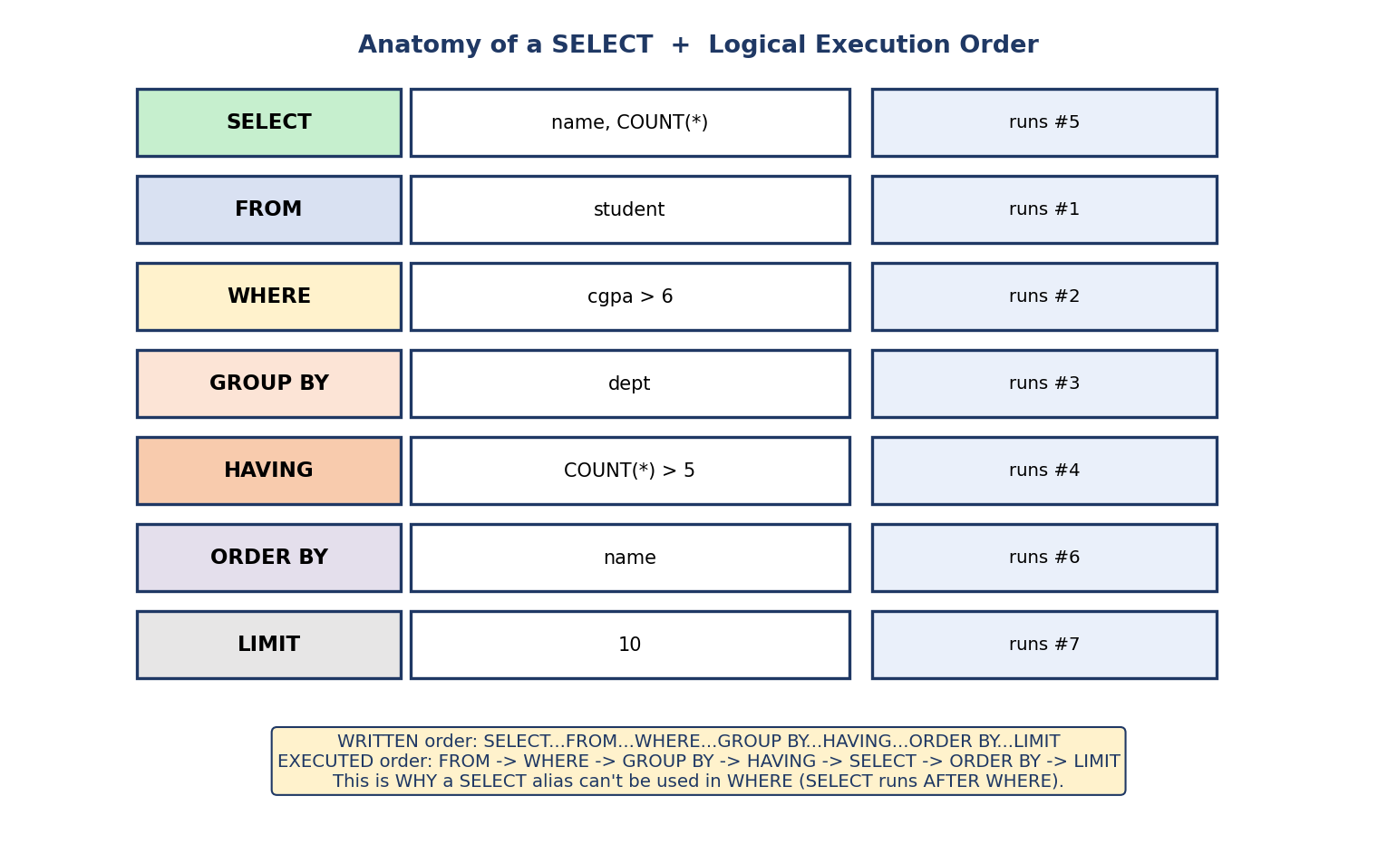
SELECT anatomy: the clauses SELECT/FROM/WHERE/GROUP BY/HAVING/ORDER BY/LIMIT, with their logical execution order numbered FROM→WHERE→GROUP BY→HAVING→SELECT→ORDER BY→LIMIT.
SELECT dept, COUNT(*) -- 5. choose/compute columns
FROM student -- 1. row source
WHERE cgpa > 6 -- 2. filter rows
GROUP BY dept -- 3. form groups
HAVING COUNT(*) > 5 -- 4. filter groups
ORDER BY dept -- 6. sort
LIMIT 10; -- 7. cut
Logical execution order: FROM → WHERE → GROUP BY → HAVING → SELECT → ORDER BY → LIMIT.
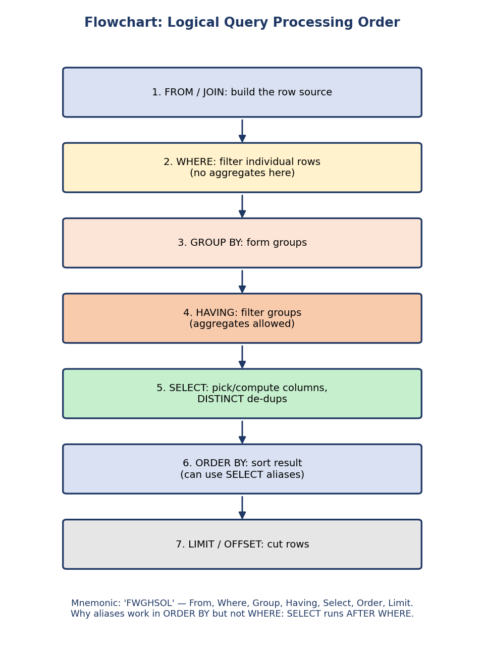
Flowchart of logical query processing: FROM/JOIN, then WHERE, GROUP BY, HAVING, SELECT, ORDER BY, LIMIT — in that execution order.
Why this matters (classic interview question): “Can I use a column alias defined in SELECT inside the WHERE clause?” No — WHERE runs before SELECT, so the alias doesn’t exist yet. But you can use it in ORDER BY (which runs after SELECT). Mnemonic: F-W-G-H-S-O-L.
Basic building blocks:
SELECT DISTINCT city FROM student; -- DISTINCT removes duplicate rows (like π)
SELECT * FROM student WHERE cgpa BETWEEN 6 AND 8;
SELECT * FROM student WHERE name LIKE 'A%'; -- pattern: % = any chars, _ = one char
SELECT * FROM student WHERE dept_id IN (1, 2, 3);
SELECT * FROM student WHERE email IS NULL; -- never = NULL
SELECT name, cgpa*10 AS percentage FROM student ORDER BY cgpa DESC;
Operators worth memorizing: BETWEEN a AND b (inclusive), IN (list), LIKE (% = any string, _ = single char), IS NULL/IS NOT NULL, AND/OR/NOT. ORDER BY col DESC for descending.

4.5 Joins — Combining Tables
Joins are SQL’s version of the algebra joins from Module 3. This is one of the most heavily tested and most practically used topics.
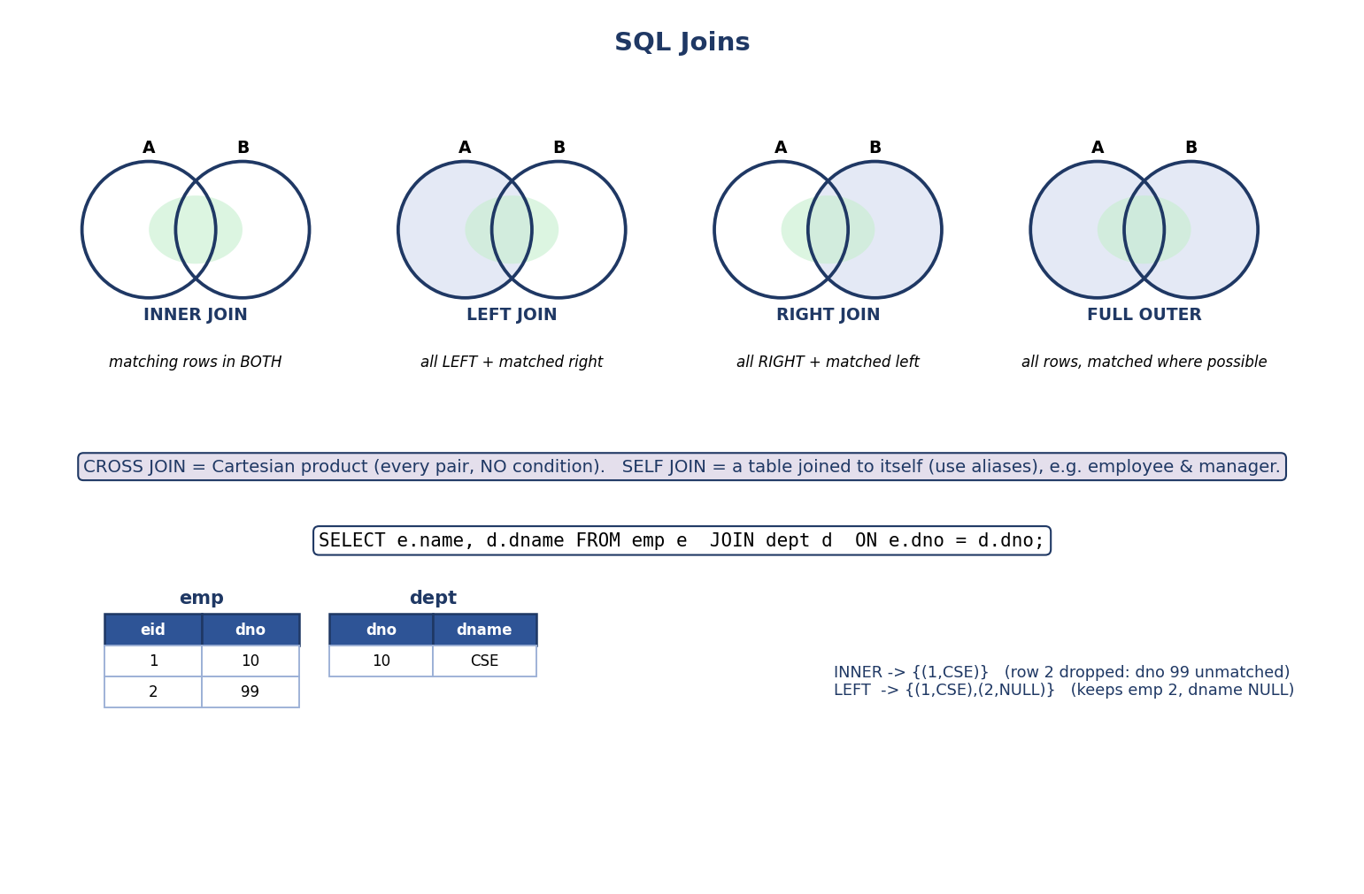
SQL joins: INNER (matching rows only), LEFT (all left + matched right), RIGHT (all right + matched left), FULL OUTER (all rows); plus CROSS and SELF joins, with a worked emp/dept example.
Join | Keeps | Algebra equivalent
INNER JOIN | only rows that match in both | theta/equi/natural join
LEFT (OUTER) JOIN | all left rows + matched right (NULLs if none) | left outer
RIGHT (OUTER) JOIN | all right rows + matched left | right outer
FULL OUTER JOIN | all rows from both, matched where possible | full outer
CROSS JOIN | every pair (no condition) | Cartesian product ×
SELF JOIN | a table joined to itself (use aliases) | join on same table
-- INNER: employees with their department name (unmatched dropped)
SELECT e.name, d.dname
FROM emp e JOIN dept d ON e.dno = d.dno;
-- LEFT: ALL employees, even those with no department (dname = NULL)
SELECT e.name, d.dname
FROM emp e LEFT JOIN dept d ON e.dno = d.dno;
-- SELF: each employee with their manager's name
SELECT e.name AS employee, m.name AS manager
FROM emp e JOIN emp m ON e.mgr_id = m.eid;
Interview gold — find rows with NO match: a LEFT JOIN + WHERE right.key IS NULL returns left rows that have no matching right row (“employees with no department”, “customers with no orders”). This “anti-join” pattern comes up constantly.
NATURAL JOIN and USING (GATE/SEBI favourite — and a real gotcha):
SELECT * FROM emp NATURAL JOIN dept; -- auto-joins on ALL same-named columns
SELECT * FROM emp JOIN dept USING (dno); -- join on the named common column(s)
- NATURAL JOIN automatically equi-joins on every column with the same name in both tables, and keeps one copy of each. It’s the algebra natural join.
- ⚠️ The gotcha: if the tables happen to share an unintended same-named column (e.g. both have created_at), NATURAL JOIN silently joins on it too, giving wrong results. Prefer explicit JOIN ... ON or USING(col) in production. This is a classic PYQ “predict the output” trap.
Exam trap: an INNER JOIN can return more rows than either table if the join column has duplicates (rows multiply), or fewer if many rows don’t match. Never assume the count.

4.6 Aggregates, GROUP BY and HAVING
Aggregate functions collapse many rows into one value: COUNT, SUM, AVG, MIN, MAX.
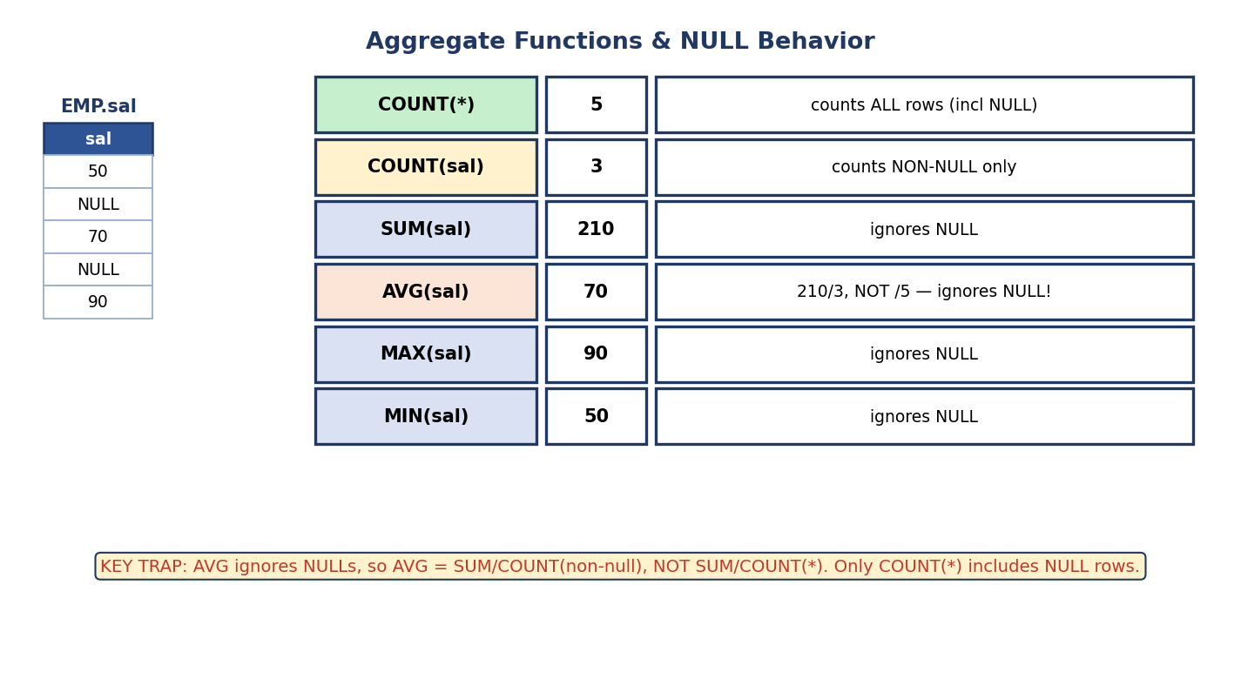
Aggregate functions and NULL: COUNT(*) counts all rows including NULL; COUNT(col), SUM, AVG, MIN, MAX all ignore NULLs — so AVG = SUM/COUNT(non-null).
The NULL trap (asked everywhere): all aggregates except COUNT(*) ignore NULLs. So AVG(sal) = SUM(sal) / COUNT(sal) (non-null count), not divided by the total number of rows. COUNT(*) counts every row; COUNT(col) counts only non-NULL values.
COUNT(DISTINCT col) counts the number of distinct non-NULL values — e.g. COUNT(DISTINCT dept) = how many different departments. SUM(DISTINCT …) and AVG(DISTINCT …) exist too. A common PYQ and reporting pattern.
GROUP BY partitions rows into groups; the aggregate is computed per group. HAVING then filters those groups.
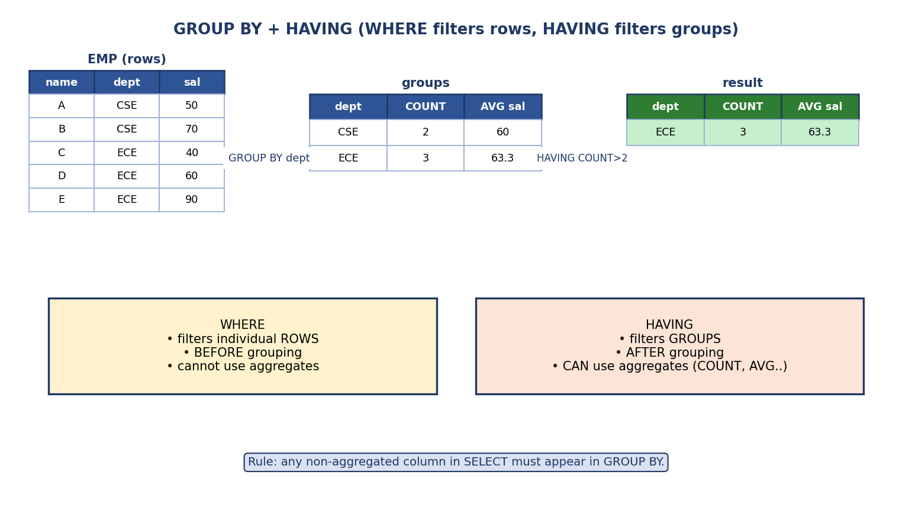
GROUP BY + HAVING: rows are grouped by a column, aggregates computed per group, then HAVING filters groups (whereas WHERE filtered individual rows before grouping).
SELECT dept, COUNT(*) AS n, AVG(sal) AS avg_sal
FROM emp
WHERE sal > 0 -- filter ROWS first
GROUP BY dept -- then group
HAVING COUNT(*) > 2 -- then filter GROUPS
ORDER BY avg_sal DESC;
 | WHERE | HAVING
Filters | individual rows | groups
Runs | before GROUP BY | after GROUP BY
Aggregates allowed? | No | Yes
The golden GROUP BY rule: every column in SELECT that is not inside an aggregate must appear in GROUP BY. Otherwise it’s ambiguous (which row’s value would it show?). This is a guaranteed exam/interview point.
Why a SELECT alias usually can’t be used in HAVING: HAVING (step 4) runs before SELECT (step 5) in the execution order, so the alias doesn’t exist yet — repeat the aggregate expression (HAVING COUNT(*) > 2) instead of its alias. (Same reason aliases fail in WHERE; they do work in ORDER BY.)

4.7 Subqueries (Nested Queries)
A subquery is a query inside another. Closure (Module 3) is what makes this possible — a query returns a relation, which another query can use.
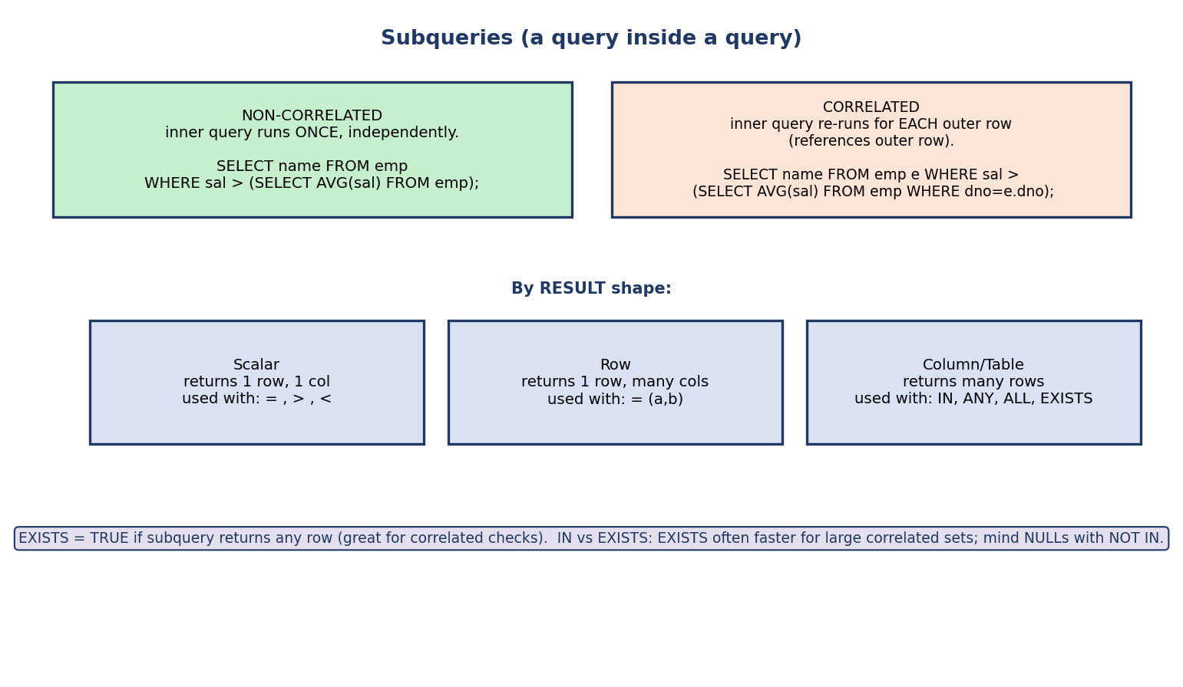
Subqueries: non-correlated (inner runs once, independent) vs correlated (inner re-runs per outer row, references it); by result shape — scalar, row, table — used with =, IN, ANY, ALL, EXISTS.
Non-correlated — inner query runs once, independently:
SELECT name FROM emp
WHERE sal > (SELECT AVG(sal) FROM emp); -- "above average"
Correlated — inner query references the outer row, so it re-runs for each outer row:
SELECT name FROM emp e
WHERE sal > (SELECT AVG(sal) FROM emp WHERE dno = e.dno); -- above own-dept average
By result shape & operators:
- Scalar (1 row, 1 col) → use with =, >, <.
- Column/Table (many rows) → use with IN, ANY/SOME, ALL, EXISTS.
-- IN: employees in departments located in 'Mumbai'
SELECT name FROM emp WHERE dno IN (SELECT dno FROM dept WHERE city='Mumbai');
-- EXISTS: departments that HAVE at least one employee (correlated)
SELECT dname FROM dept d WHERE EXISTS (SELECT 1 FROM emp e WHERE e.dno = d.dno);
IN vs EXISTS vs NOT IN: EXISTS stops at the first match (often faster for correlated checks). NOT IN is dangerous with NULLs — if the subquery returns any NULL, NOT IN yields no rows (because x <> NULL is UNKNOWN). Prefer NOT EXISTS for “anti” queries. (Recall NULL 3-valued logic from Module 3.)
Division in SQL (“students who took every course”) = double NOT EXISTS — there is no required course that the student has not taken. This is the SQL realization of algebra’s ÷.

4.8 Set Operations
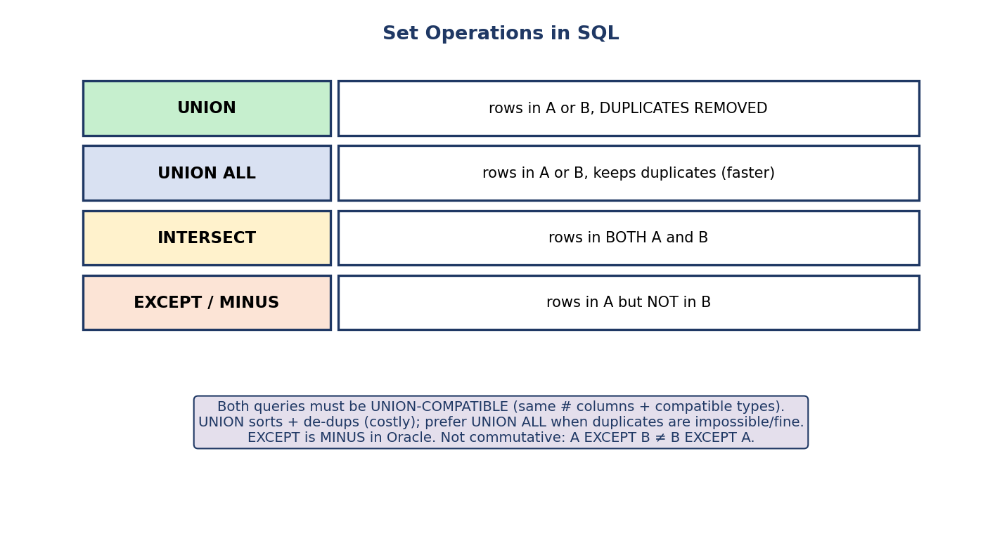
Set operations in SQL: UNION (combine, remove duplicates), UNION ALL (keep duplicates, faster), INTERSECT (common rows), EXCEPT/MINUS (in A not B).
SELECT city FROM customer
UNION -- removes duplicates (sorts → costly)
SELECT city FROM supplier;
SELECT city FROM customer
UNION ALL -- keeps duplicates (faster, no sort)
SELECT city FROM supplier;
- UNION — combine, remove duplicates. UNION ALL — combine, keep duplicates (faster; use when duplicates are impossible or acceptable).
- INTERSECT — rows in both. EXCEPT (Oracle: MINUS) — rows in the first but not the second.
- All require the two queries to be union-compatible (same number of columns, compatible types).
Exam nugget: UNION does extra work (sort + de-dup); UNION ALL is cheaper. If you know there are no duplicates, always prefer UNION ALL.

4.8A More Query Tools (ANY/ALL, CASE, LIMIT/OFFSET, Window Functions)

ANY / ALL (with subqueries)
- > ALL (subquery) → greater than every value = greater than the max.
- > ANY (subquery) (a.k.a. SOME) → greater than at least one = greater than the min.
SELECT name FROM emp WHERE sal > ALL (SELECT sal FROM emp WHERE dno = 20);
-- earns more than EVERY employee in dept 20 (i.e. > max of dept 20)
GATE trap: = ANY is equivalent to IN; <> ALL is equivalent to NOT IN.

CASE (conditional expression)
SELECT name,
CASE WHEN cgpa >= 9 THEN 'A'
WHEN cgpa >= 7 THEN 'B'
ELSE 'C' END AS grade
FROM student;
CASE adds if-then-else logic inside SELECT (and even inside aggregates for “conditional counting”: SUM(CASE WHEN ... THEN 1 ELSE 0 END)).

LIMIT / OFFSET (pagination) and multi-key ORDER BY
SELECT * FROM student ORDER BY cgpa DESC, name ASC -- tie-break by name
LIMIT 10 OFFSET 20; -- rows 21–30 (page 3 of size 10)
ORDER BY a, b sorts by a, breaking ties with b. LIMIT n OFFSET m is the standard pagination pattern. (Use NULLS FIRST/LAST to control where NULLs sort.)

Window functions (interview-tier — beyond core GATE, but FAANG-frequent)
A window function computes a value across a set of rows related to the current row, without collapsing them into one row (unlike GROUP BY).
SELECT name, dept, sal,
RANK() OVER (PARTITION BY dept ORDER BY sal DESC) AS rnk,
ROW_NUMBER() OVER (PARTITION BY dept ORDER BY sal DESC) AS rn
FROM emp;
- PARTITION BY = the groups; ORDER BY = ordering within each group.
- ROW_NUMBER() → 1,2,3… (unique). RANK() → ties share a rank, then skips (1,1,3). DENSE_RANK() → ties share, no skip (1,1,2).
The famous “Nth highest salary” interview question: wrap the window query and filter WHERE rnk = 2 (use DENSE_RANK if ties should count as one salary). This is the modern, clean answer; the older way is a nested subquery (§4.15).

4.9 Constraints
Constraints enforce data integrity at the schema level (the SQL realization of Module 3’s integrity rules).
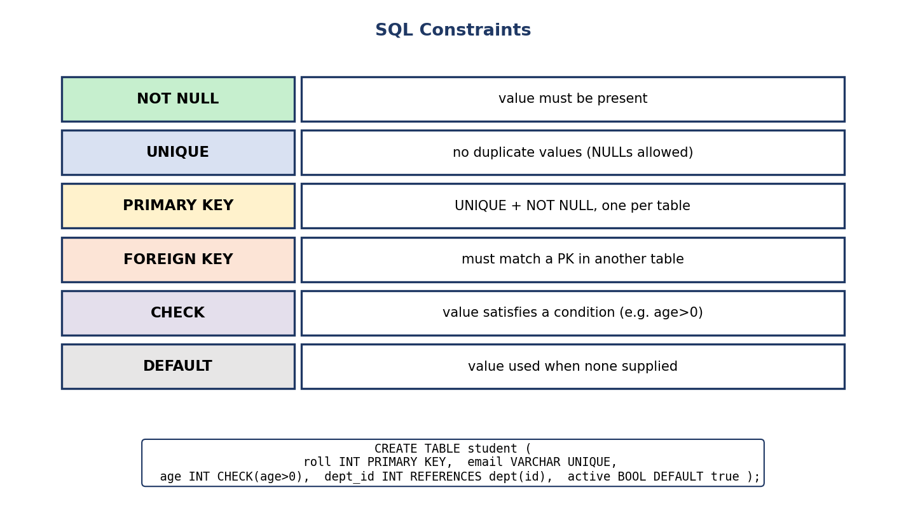
SQL constraints: NOT NULL, UNIQUE, PRIMARY KEY (= UNIQUE + NOT NULL, one per table), FOREIGN KEY (references a PK), CHECK (condition), DEFAULT (fallback value).
Constraint | Enforces
NOT NULL | value must be present
UNIQUE | no duplicates (NULLs allowed)
PRIMARY KEY | UNIQUE + NOT NULL, one per table
FOREIGN KEY ... REFERENCES | must match a PK in another table (referential integrity)
CHECK (condition) | value must satisfy a condition
DEFAULT value | value used when none is supplied
FOREIGN KEY (dept_id) REFERENCES dept(id) ON DELETE CASCADE;
Recall from Module 3: ON DELETE CASCADE / SET NULL / RESTRICT control what happens to child rows when a parent is deleted.

4.10 Views
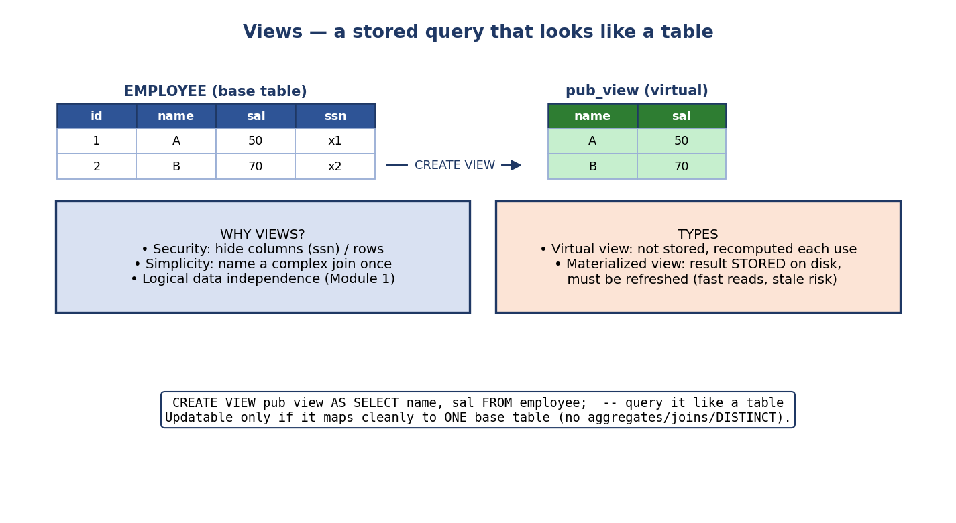
Views: a CREATE VIEW makes a virtual table from a query (e.g. hiding the ssn column); virtual views recompute each use, materialized views store the result on disk.
A view is a stored query that you can use like a table.
CREATE VIEW pub_emp AS
SELECT name, dept FROM employee; -- hides salary, ssn
SELECT * FROM pub_emp WHERE dept = 'CSE'; -- query it like a table
Why views matter: - Security — expose only certain columns/rows (hide salary, ssn). - Simplicity — name a complex join once, reuse it. - Logical data independence (Module 1) — the base tables can change while the view’s interface stays stable.
Virtual vs Materialized: - Virtual view (default) — not stored; recomputed every time it’s queried (always fresh). - Materialized view — the result is stored on disk (fast reads), but must be refreshed and can be stale.
Updatable views: you can INSERT/UPDATE through a view only if it maps cleanly to one base table — no aggregates, GROUP BY, DISTINCT, or joins. A common exam/interview question.

4.11 Indexes, Triggers, Procedures (overview)
Index — a structure that speeds up lookups (CREATE INDEX idx ON emp(dno);). It makes reads faster but writes slightly slower and uses extra space. (Full internals — B+ trees, hashing — are Module 7.)
Trigger — code that runs automatically on an INSERT/UPDATE/DELETE event.
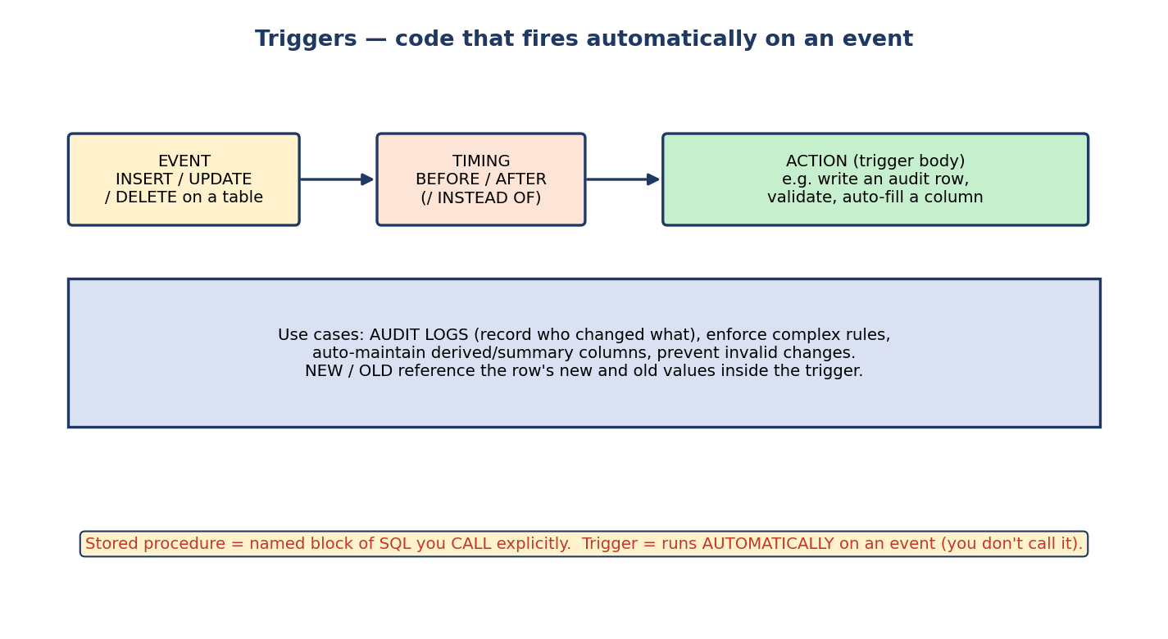
Triggers: an event (INSERT/UPDATE/DELETE) at a timing (BEFORE/AFTER/INSTEAD OF) fires the trigger body — e.g. write an audit row; NEW/OLD hold the new and old row values.
CREATE TRIGGER audit_sal AFTER UPDATE ON emp
FOR EACH ROW
INSERT INTO audit(eid, old_sal, new_sal) VALUES (OLD.eid, OLD.sal, NEW.sal);
- Event: INSERT / UPDATE / DELETE. Timing: BEFORE / AFTER / INSTEAD OF.
- NEW/OLD refer to the new and old row values.
- Uses: audit logs, complex validation, auto-maintaining derived columns.
Stored procedure — a named block of SQL you call explicitly (CALL my_proc(...)).
Trigger vs Stored Procedure (interview): a trigger fires automatically on an event; a stored procedure runs only when you call it.
Cursor — a mechanism to process a query result row by row (procedural). Avoid when a set-based query works — cursors are slow.

4.12 Real-World & Backend Perspectives
- EXPLAIN/EXPLAIN ANALYZE shows the query plan (the algebra tree + chosen joins/indexes). Reading it is the core skill of SQL performance tuning.
- The N+1 query problem: running one query per row in a loop instead of a single join — a top backend performance bug. Fix with a JOIN or IN.
- Indexes make WHERE/JOIN/ORDER BY fast; the optimizer uses them automatically. Over-indexing slows writes.
- Parameterized queries (not string concatenation) prevent SQL injection — a critical security practice (see §4.14).

4.13 Tradeoffs, Common Mistakes, Edge Cases
Common mistakes - UPDATE/DELETE without WHERE (changes all rows). - Using = NULL instead of IS NULL. - Putting an aggregate in WHERE (must be HAVING). - Forgetting non-aggregated SELECT columns must be in GROUP BY. - Assuming UNION keeps duplicates (it doesn’t — UNION ALL does). - NOT IN with a subquery that can return NULL (returns nothing) — use NOT EXISTS. - Expecting a column alias to work in WHERE (it runs before SELECT).
Edge cases - COUNT(*) vs COUNT(col) differ when NULLs exist. - An INNER JOIN on a duplicated key multiplies rows. - CROSS JOIN / a join with a missing ON becomes a Cartesian product (row explosion). - NULL in GROUP BY forms its own group.
Tradeoffs
Strength | Cost
Declarative — optimizer finds fast plans | accidental Cartesian products / N+1 are easy to write
Powerful joins/aggregation/subqueries | complex queries get hard to read
Constraints enforce integrity | add write-time overhead

4.14 Security — SQL Injection (must-know)
SQL injection happens when user input is concatenated directly into a query:
-- VULNERABLE: if user types ' OR '1'='1
"SELECT * FROM users WHERE name = '" + input + "'"
→ SELECT * FROM users WHERE name = '' OR '1'='1' -- returns everyone!
Fix: use parameterized queries / prepared statements (the driver sends data separately from code), grant least-privilege DB accounts, and validate input. This is the #1 web vulnerability historically and a frequent SEBI-IT / interview topic.

4.15 Exam, Interview & Coding Perspectives
Exam (SEBI/RBI/GATE): predict the output of a query; WHERE vs HAVING; GROUP BY rules; join results & counts; correlated vs non-correlated subqueries; aggregate + NULL behaviour; UNION vs UNION ALL; DDL/DML/DCL/TCL; DELETE vs TRUNCATE vs DROP; constraint identification.
Interview: “Find the 2nd highest salary” (subquery / LIMIT OFFSET / window function); “customers with no orders” (LEFT JOIN … IS NULL / NOT EXISTS); “WHERE vs HAVING”; “what is a correlated subquery”; “how do you prevent SQL injection”; “INNER vs LEFT JOIN”.
Coding (try in PostgreSQL): - 2nd highest salary: SELECT MAX(sal) FROM emp WHERE sal < (SELECT MAX(sal) FROM emp); - Department-wise average, only depts with >2 employees: a GROUP BY ... HAVING. - Anti-join: customers with no orders via LEFT JOIN ... WHERE o.id IS NULL.

4.16 Concept Checks & MCQs
- Which runs first: WHERE or SELECT? → WHERE.
- Aggregate in a row filter → must use ___ not WHERE → HAVING.
- COUNT(*) vs COUNT(col) differ when ___ → NULLs exist (col has NULLs).
- UNION vs UNION ALL: which removes duplicates? → UNION.
- DELETE vs TRUNCATE: which can be rolled back? → DELETE always; TRUNCATE is vendor-dependent (rolls back in PostgreSQL/SQL Server, not in Oracle/MySQL).
- A LEFT JOIN + WHERE right.key IS NULL finds ___ → left rows with no match.
- Subquery that re-runs per outer row is ___ → correlated.
- To prevent SQL injection use ___ → parameterized / prepared statements.
- Can a SELECT alias be used in WHERE? → No (in ORDER BY → yes).
- Updatable view requires ___ → maps to one base table (no agg/join/distinct).
- > ALL (subquery) means greater than the ___ → maximum. > ANY → minimum.
- = ANY is equivalent to ___ ; <> ALL to ___ → IN ; NOT IN.
- Which gives 1,1,3 for ties: RANK or DENSE_RANK? → RANK (DENSE_RANK gives 1,1,2).
- GRANT/REVOKE belong to which family? → DCL. COMMIT/ROLLBACK? → TCL.
- Page 3 of size 10 → LIMIT 10 OFFSET ___ → 20.
- NATURAL JOIN joins on ___ → all columns with the same name (keeps one copy).
- COUNT(DISTINCT dept) returns ___ → number of distinct non-NULL departments.
- Can a SELECT alias be used in HAVING? → No (HAVING runs before SELECT).
True/False - AVG(col) divides by the number of rows including NULLs. → False (ignores NULLs). - TRUNCATE is DML. → False (DDL). - HAVING can use aggregate functions. → True. - A column alias defined in SELECT can be used in HAVING (most DBs). → Often False; use the aggregate expression.
Scenario / output prediction > emp(name, dno) has rows (A,10)(B,10)(C,20)(D,NULL). > SELECT dno, COUNT(*) FROM emp GROUP BY dno; → > (10,2) (20,1) (NULL,1). NULL forms its own group; COUNT(*) counts the row.

4.17 One-Page Revision Sheet
SQL = declarative; works on MULTISETS (dups allowed unless DISTINCT).
SUBLANGUAGES: DDL(create/alter/drop/truncate) DML(select/insert/update/delete)
DCL(grant/revoke) TCL(commit/rollback/savepoint)
DELETE(DML,WHERE,rollback) | TRUNCATE(DDL,all,fast,no rollback) | DROP(DDL,kills table)
EXECUTION ORDER (F-W-G-H-S-O-L):
FROM -> WHERE -> GROUP BY -> HAVING -> SELECT -> ORDER BY -> LIMIT
(alias works in ORDER BY, NOT in WHERE — SELECT runs after WHERE)
WHERE filters ROWS (before group, no aggregates) | HAVING filters GROUPS (after, aggregates ok)
GROUP BY rule: every non-aggregated SELECT col must be in GROUP BY
JOINS: INNER(matches) LEFT(all left+NULL) RIGHT(all right) FULL(all)
CROSS(cartesian) SELF(alias). NATURAL(auto on same-named cols, keep 1 copy; gotcha!)
USING(col). Anti-join: LEFT JOIN ... WHERE r.key IS NULL.
AGGREGATES: COUNT(*) counts ALL rows; COUNT(col)/SUM/AVG/MIN/MAX ignore NULL.
AVG = SUM/COUNT(non-null).
SUBQUERY: non-correlated(once) vs correlated(per outer row).
scalar(=,>) | many-row(IN/ANY/ALL/EXISTS). NOT IN + NULL = empty -> use NOT EXISTS.
division ("for all") = double NOT EXISTS.
SET OPS: UNION(dedup) UNION ALL(keep dups,faster) INTERSECT EXCEPT/MINUS. union-compatible.
ANY/ALL: >ALL = > max ; >ANY = > min ; =ANY = IN ; <>ALL = NOT IN.
CASE = if-then-else in SELECT. LIMIT n OFFSET m = pagination. ORDER BY a,b = tie-break.
WINDOW FN (interview): RANK/ROW_NUMBER/DENSE_RANK OVER(PARTITION BY.. ORDER BY..);
ROW_NUMBER=unique; RANK=ties skip(1,1,3); DENSE_RANK=ties no skip(1,1,2). "Nth highest".
DCL: GRANT/REVOKE (least privilege). TCL: BEGIN/COMMIT/ROLLBACK/SAVEPOINT (ACID->M9).
CONSTRAINTS: NOT NULL | UNIQUE(nulls ok) | PRIMARY KEY(unique+not null,1/table)
| FOREIGN KEY(refs PK, ON DELETE CASCADE/SET NULL) | CHECK | DEFAULT
VIEW = stored query (security/simplicity/independence). virtual(recompute) vs
materialized(stored, refresh). updatable only if maps to ONE table.
TRIGGER = auto on event(INSERT/UPDATE/DELETE), timing BEFORE/AFTER, NEW/OLD.
vs PROCEDURE = called explicitly. CURSOR = row-by-row (slow).
SECURITY: SQL injection -> use PARAMETERIZED / PREPARED statements.

Flash cards
Front | Back
WHERE vs HAVING? | WHERE = rows (pre-group); HAVING = groups (post-group, aggregates)
Execution order? | FROM-WHERE-GROUP-HAVING-SELECT-ORDER-LIMIT
COUNT(*) vs COUNT(col)? | * counts all rows; col ignores NULLs
UNION vs UNION ALL? | UNION de-dups; UNION ALL keeps dups (faster)
Find “no match” rows? | LEFT JOIN + WHERE right IS NULL (or NOT EXISTS)
Correlated subquery? | Inner re-runs per outer row, references it
Prevent SQL injection? | Parameterized / prepared statements
TRUNCATE vs DELETE? | DELETE=DML,WHERE,rollback; TRUNCATE=DDL,all,fast (rollback vendor-dependent)
Updatable view needs? | Maps to one table, no agg/join/distinct
Trigger vs procedure? | Trigger auto on event; procedure called explicitly

Spaced repetition
- 24-hour: write 10 queries (join, group+having, correlated subquery, anti-join).
- 7-day: predict output of 10 tricky queries (NULLs, UNION, GROUP BY).
- 30-day: solve “2nd highest salary”, “dept-wise top earner”, “customers with no orders”, “students who took every course” from scratch.

4.18 Summary
SQL is the declarative language that turns relational algebra into something you type. We covered the four sub-languages (DDL/DML/DCL/TCL), the all-important SELECT with its logical execution order (FROM→WHERE→GROUP BY→HAVING→ SELECT→ORDER BY→LIMIT), every join (inner/left/right/full/cross/self and the anti-join pattern), aggregates + GROUP BY/HAVING with the NULL rules, subqueries (correlated vs non-correlated, and division via double NOT EXISTS), set operations (UNION vs UNION ALL), constraints, views (virtual vs materialized), and triggers/procedures/cursors. Finally we covered the production essentials — EXPLAIN, the N+1 problem, and SQL injection defense.
Every feature ties back to Module 3’s algebra: WHERE = σ, SELECT cols = π, JOIN = ⋈, UNION/EXCEPT = set ops, GROUP BY = aggregation. Next, Module 5 — Normalization uses functional dependencies and keys to design schemas these queries run against without redundancy.
You have mastered this module when you can: write a multi-table query with GROUP BY/HAVING and a correlated subquery; explain the execution order and why aliases fail in WHERE; produce the “no-match” and “every-Y” patterns; predict a query’s output with NULLs and GROUP BY; and explain SQL injection defense — all without notes.

