Module 6 — Storage & File Organization
  - DBMS Mastery: SEBI IT / RBI / GATE / Interview — In-Depth Notes (with visuals)
Prepared for nidhi.sharma@forensiccybertech.com
2026
Table of Contents

Module 6 — Storage & File Organization
Where this module sits. Modules 2–5 were the design half (ER → relational → SQL → normalization). Now we go under the floor: where do tables physically live, and why is disk the villain of database performance? Everything about indexing (Module 7), query processing (Module 8), and recovery (Module 10) is shaped by one brutal fact — disk is ~100,000× slower than RAM. This module explains the hardware, how records are packed into blocks, the file-organization choices, RAID, and the buffer manager that hides disk latency. GATE loves the disk-access-time and RAID numericals.
Importance ratings (out of 5):
Exam / Use | SEBI IT | RBI IT | GATE CS | Interview | Backend
This module | ★★★ | ★★★ | ★★★★ | ★★ | ★★★
Most-asked PYQ concepts (SEBI / RBI / GATE): disk access time (seek + rotational latency + transfer) numericals; RAID levels (min disks, usable space, fault tolerance, RAID 0/1/5/6/10); blocking factor & number-of-blocks calculations; spanned vs unspanned; file organization (heap vs sequential vs hashed vs clustered); buffer replacement (LRU); primary vs secondary storage (volatile vs non-volatile).

6.1 The Memory Hierarchy — Why Disk Is the Enemy

Motivation (first principles)
A CPU can execute a billion instructions per second, but if it must wait ~10 ms for a disk read, it wastes ~10 million instruction-cycles per read (10⁹ /s × 0.01 s = 10⁷). The entire field of database storage exists to avoid touching the disk — and when we must, to touch it as few times and as sequentially as possible.
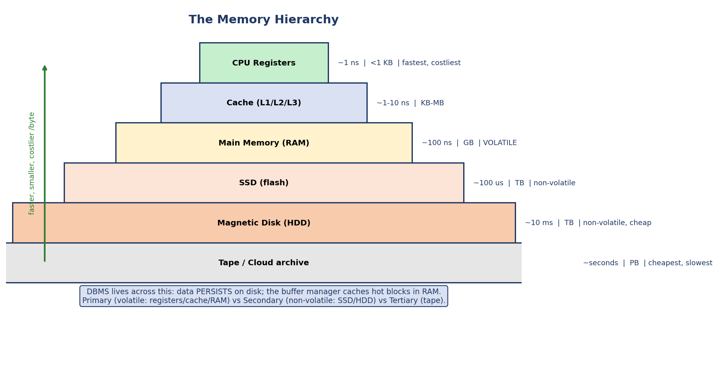
The memory hierarchy pyramid: registers, cache, RAM (volatile) → SSD, disk, tape (non-volatile); faster/smaller/costlier at the top.
Level | Speed | Size | Volatile?
Registers | ~1 ns | <1 KB | yes
Cache (L1/L2/L3) | ~1–10 ns | KB–MB | yes
Main memory (RAM) | ~100 ns | GB | yes (volatile)
SSD (flash) | ~100 µs | TB | no
Magnetic disk (HDD) | ~10 ms | TB | no
Tape / archive | seconds | PB | no
The two great divides: - Volatile vs non-volatile: RAM and above lose data on power loss; SSD/HDD persist. This is why a database must write to disk to be durable (the D in ACID) and why recovery (Module 10) exists. - Primary (directly CPU-addressable: registers/cache/RAM) vs secondary (disk/SSD) vs tertiary (tape) storage.
The cost ratio that drives everything: a RAM access (~100 ns) vs a disk access (~10 ms) is a ~100,000× difference. Database performance ≈ “how often did we avoid the disk.”

6.2 Magnetic Disk Geometry
Even in the SSD era, exams (and the cost model of query optimization) are taught on magnetic disks because their access cost is easy to reason about.
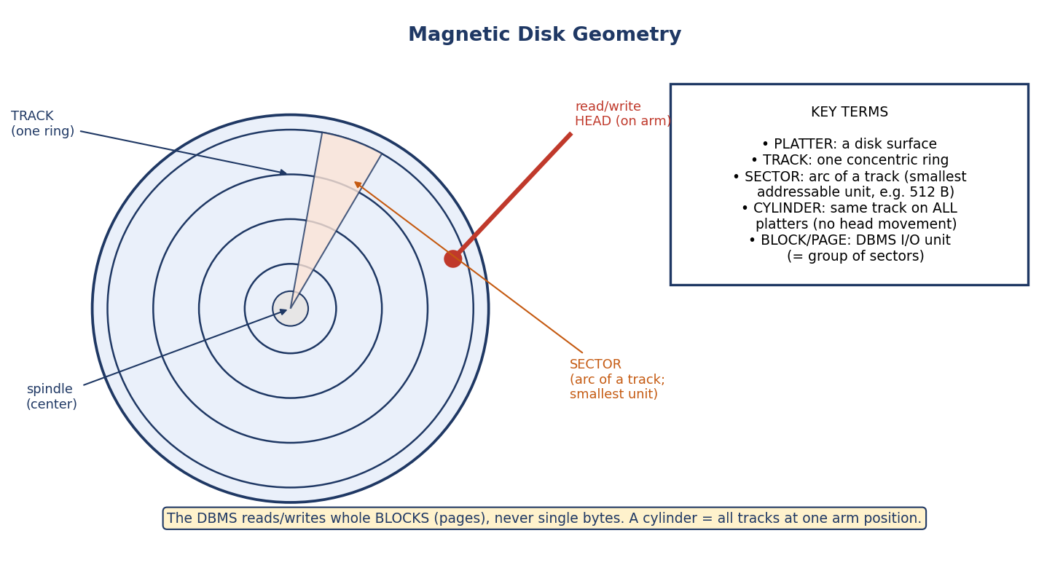
Disk geometry: platters, concentric tracks, sectors (arcs), a cylinder (same track across platters), spindle, and the read/write head on a moving arm.
Term | Meaning
Platter | a circular disk surface (data on both sides)
Track | one concentric ring on a platter
Sector | an arc of a track — the smallest addressable unit (e.g. 512 B / 4 KB)
Cylinder | the same track on all platters (readable with no arm movement)
Read/write head | floats just above the surface, on a moving arm
Block / Page | the DBMS’s I/O unit — a group of contiguous sectors
Key insight: the DBMS never reads a single byte or row from disk — it reads a whole block (page), typically 4–16 KB. A block is an integer multiple of the sector size (e.g. 8 × 512 B sectors = a 4 KB block; the OS/DBMS chooses how many sectors form a block). So “how many block accesses?” is the cost metric, not “how many bytes”. Storing related data in the same block / same cylinder minimizes expensive arm movement.

6.3 Disk Access Time (the GATE numerical)
The time to read a block has three parts. Memorize the breakdown — it is asked almost every year.
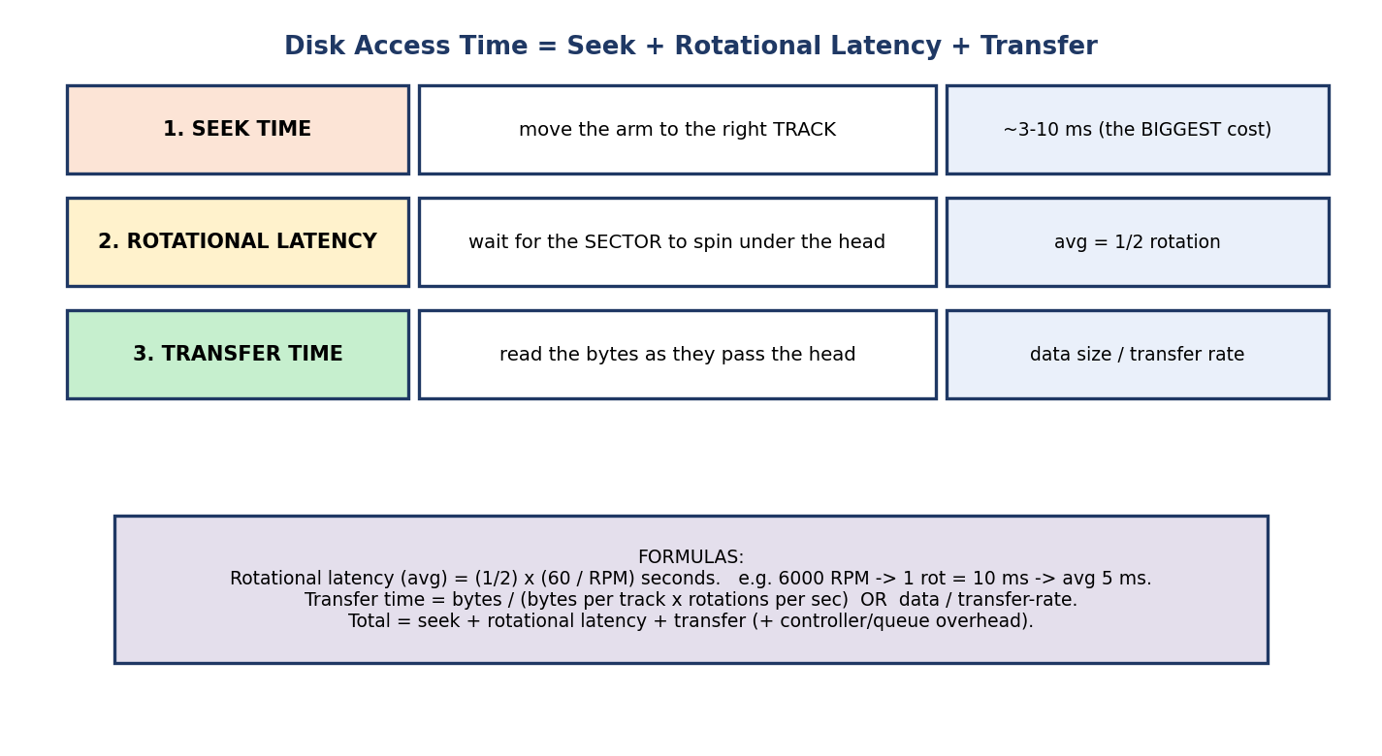
Disk access time = seek time (move arm to track) + rotational latency (wait for sector) + transfer time (read bytes).
- Seek time — move the arm to the correct track. Mechanical, the largest component (~3–10 ms).
- Rotational latency — wait for the desired sector to rotate under the head. Average = ½ of one full rotation.
- Transfer time — time to actually read the bytes as they pass the head.
Average rotational latency = (1/2) × (60 / RPM) seconds
Transfer time = data size / transfer rate
Total access time = seek + rotational latency + transfer (+ controller overhead)
Worked example: disk at 6000 RPM. One rotation = 60/6000 = 0.01 s = 10 ms. Average rotational latency = 10/2 = 5 ms. If seek = 4 ms and transfer = 1 ms, total ≈ 4 + 5 + 1 = 10 ms for that block.
Why sequential beats random: reading 100 blocks scattered across the disk pays 100 seeks; reading 100 contiguous blocks pays ~one seek. This is why databases prize sequential I/O and why a full scan can beat random index lookups when many rows match.

6.4 RAID — Redundant Array of Independent Disks
RAID combines multiple physical disks into one logical unit for speed (parallelism), reliability (redundancy), or both. RAID is for availability, NOT a backup — it won’t save you from an accidental DELETE or corruption.

RAID 0 (striping) and RAID 1 (mirroring)
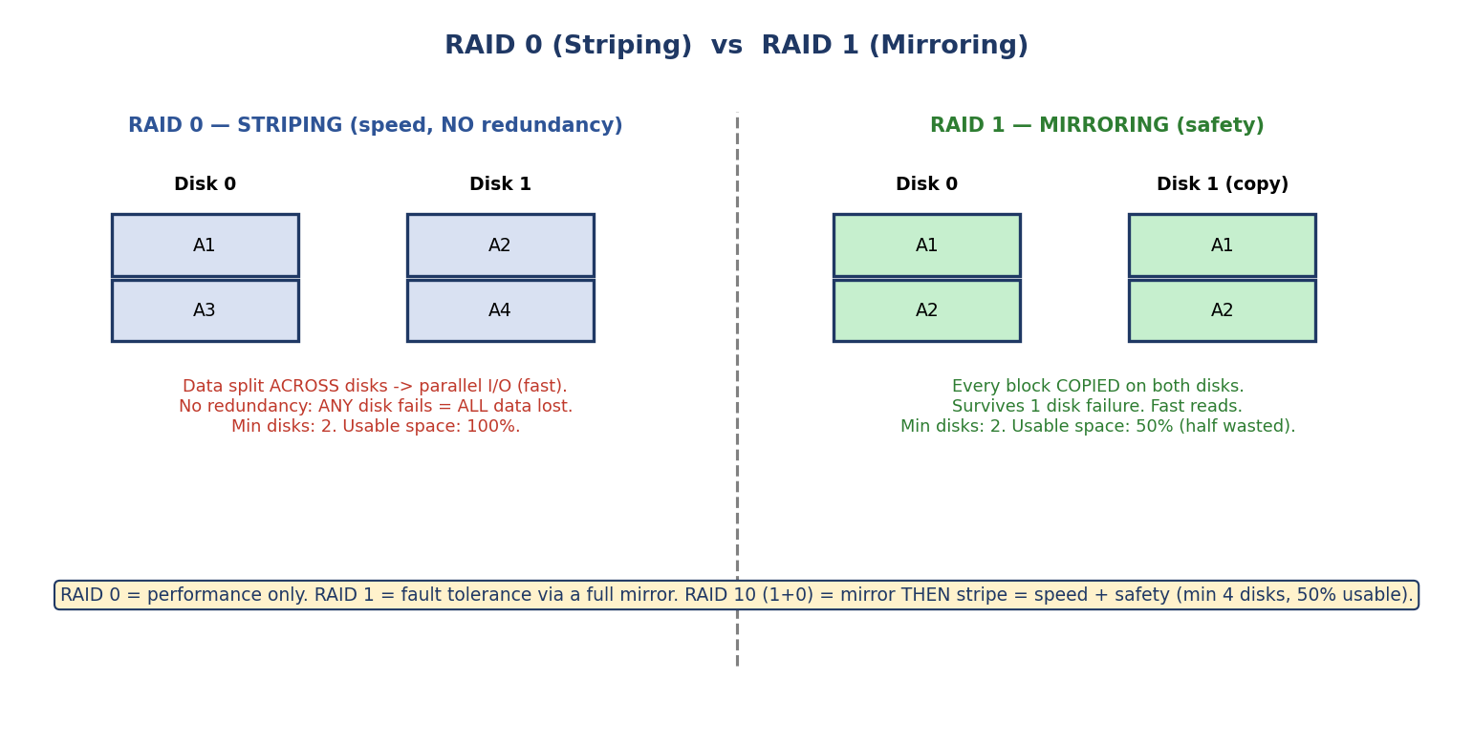
RAID 0 stripes data across disks for speed with no redundancy; RAID 1 mirrors every block on a second disk for fault tolerance.
- RAID 0 — Striping: data split across disks → parallel I/O (fastest), but no redundancy — any disk failure loses all data. Min 2 disks, 100% usable.
- RAID 1 — Mirroring: every block copied on a second disk → survives 1 failure, fast reads. Min 2 disks, 50% usable.

RAID 5 and 6 (parity) — and how parity works
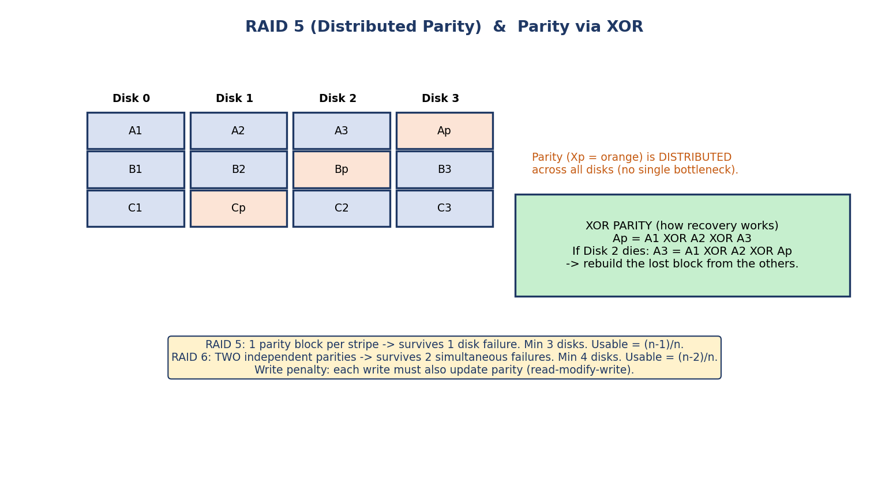
RAID 5 distributes parity blocks across all disks; parity is computed with XOR, so a lost block is rebuilt from the surviving blocks plus parity.
- RAID 5 — Striping + distributed parity: one parity block per stripe, rotated across disks (no single parity bottleneck). Survives 1 disk failure. Min 3 disks, usable = (n−1)/n.
- RAID 6 — Two parities: survives 2 simultaneous failures. Min 4 disks, usable = (n−2)/n.
How XOR parity recovers data (a favourite exam point): P = A1 ⊕ A2 ⊕ A3. If the disk holding A3 dies, rebuild it: A3 = A1 ⊕ A2 ⊕ P. XOR is its own inverse, so any one missing block is recoverable from the rest. Write penalty: every write must also update parity (read-modify-write), so RAID 5/6 writes are slower than reads.
Why RAID 5 rotates parity — the RAID 4 baseline (GATE point): RAID 4 is block-level striping with one dedicated parity disk. Because every write must update that single parity disk, it becomes a write bottleneck. RAID 5 fixes this by distributing (rotating) the parity across all disks — no single disk is the parity hotspot. (RAID 2 = bit-level/Hamming and RAID 3 = byte-level with dedicated parity are obsolete — know that they exist, but 0/1/5/6/10 are what’s used and tested.)

Comparison & RAID 10
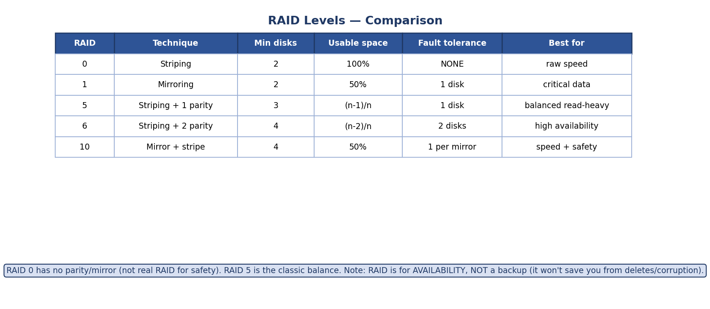
RAID comparison table: levels 0/1/5/6/10 with technique, minimum disks, usable space, fault tolerance, and best-use.
RAID | Technique | Min disks | Usable | Survives | Best for
0 | striping | 2 | 100% | nothing | raw speed
1 | mirroring | 2 | 50% | 1 disk | critical data
5 | stripe + 1 parity | 3 | (n−1)/n | 1 disk | read-heavy, balanced
6 | stripe + 2 parity | 4 | (n−2)/n | 2 disks | high availability
10 (1+0) | mirror then stripe | 4 | 50% | 1 per mirror | speed and safety
Exam nuggets: RAID 0 = no fault tolerance (despite the “0”). RAID 1 = 50% overhead. RAID 5 needs ≥3 disks; RAID 6 needs ≥4. RAID 10 (a.k.a. 1+0) is the go-to for databases needing both performance and redundancy.

6.5 Records & Blocking

Record types
- Fixed-length records: every record the same size → record i lives at offset i × size (easy, fast). Wastes space when fields vary.
- Variable-length records: fields vary (VARCHAR, optional/repeating fields) → need length prefixes, delimiters, or an offset table. Compact but harder to navigate.

Blocking factor (the calculation)
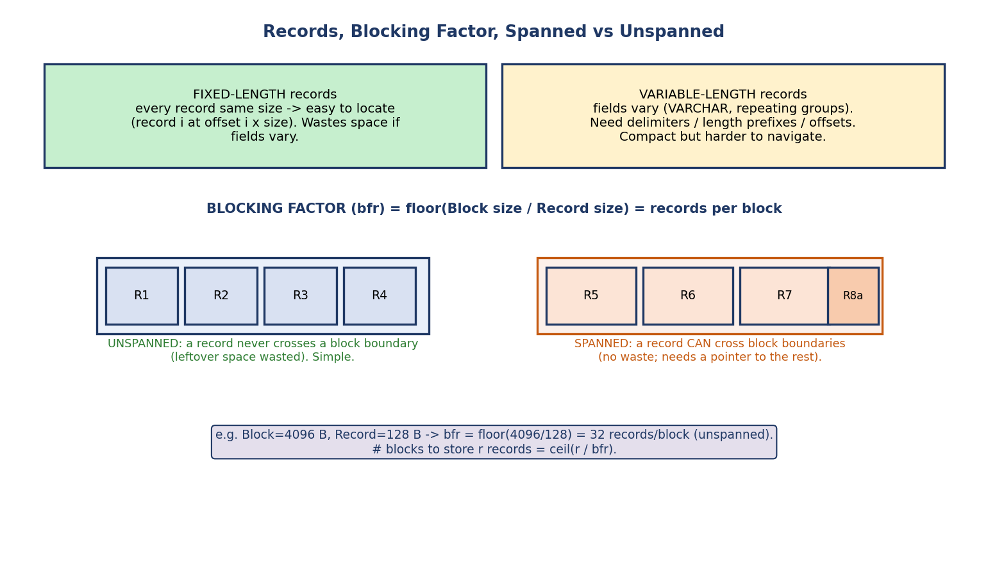
Records and blocking: fixed vs variable length, blocking factor = block size / record size, and spanned vs unspanned records.
The blocking factor (bfr) = how many records fit in one block:
bfr = floor( Block size / Record size ) (unspanned)
Number of blocks to store r records = ceil( r / bfr )
Worked example: Block = 4096 B, Record = 128 B → bfr = floor(4096/128) = 32 records/block. To store 1,000 records: ceil(1000/32) = 32 blocks.

Spanned vs unspanned
- Unspanned: a record never crosses a block boundary. Leftover space at the block’s end is wasted, but access is simple. (Used when records < block.)
- Spanned: a record may cross block boundaries (with a pointer to the continuation). No wasted space, and required when a record is larger than a block.
Exam trap: with unspanned blocking, bfr = floor(B/R) and the leftover B − (bfr × R) bytes per block are wasted. With spanned, there’s essentially no waste but you pay pointer-chasing overhead.

6.6 File Organization
A file organization is how a table’s records are arranged in its data file. Each choice optimizes a different access pattern.
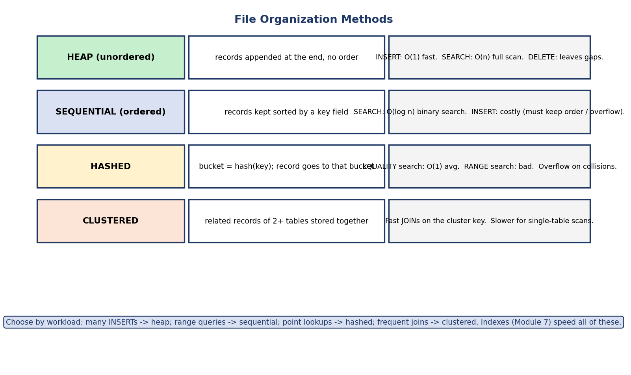
File organization methods: heap (unordered, fast insert), sequential (ordered, binary search), hashed (O(1) point lookup), clustered (related tables stored together for joins).
Organization | How | Search | Insert | Best for
Heap (unordered) | append at end, no order | O(n) full scan | O(1) fast | bulk loads, small tables
Sequential (ordered) | sorted by a key | O(log n) binary search | costly (keep order / overflow) | range queries, sorted scans
Hashed | bucket = hash(key) | O(1) avg (equality) | O(1) avg | point lookups by key
Clustered | related rows of 2+ tables stored together | fast on cluster key | complex | frequent joins
How to choose (decision): - Many inserts / no search pattern → heap. - Range queries (BETWEEN, ORDER BY) → sequential. - Exact-match lookups by key → hashed (but bad for ranges — hashing scatters neighbouring keys). - Frequent joins of related tables → clustered.
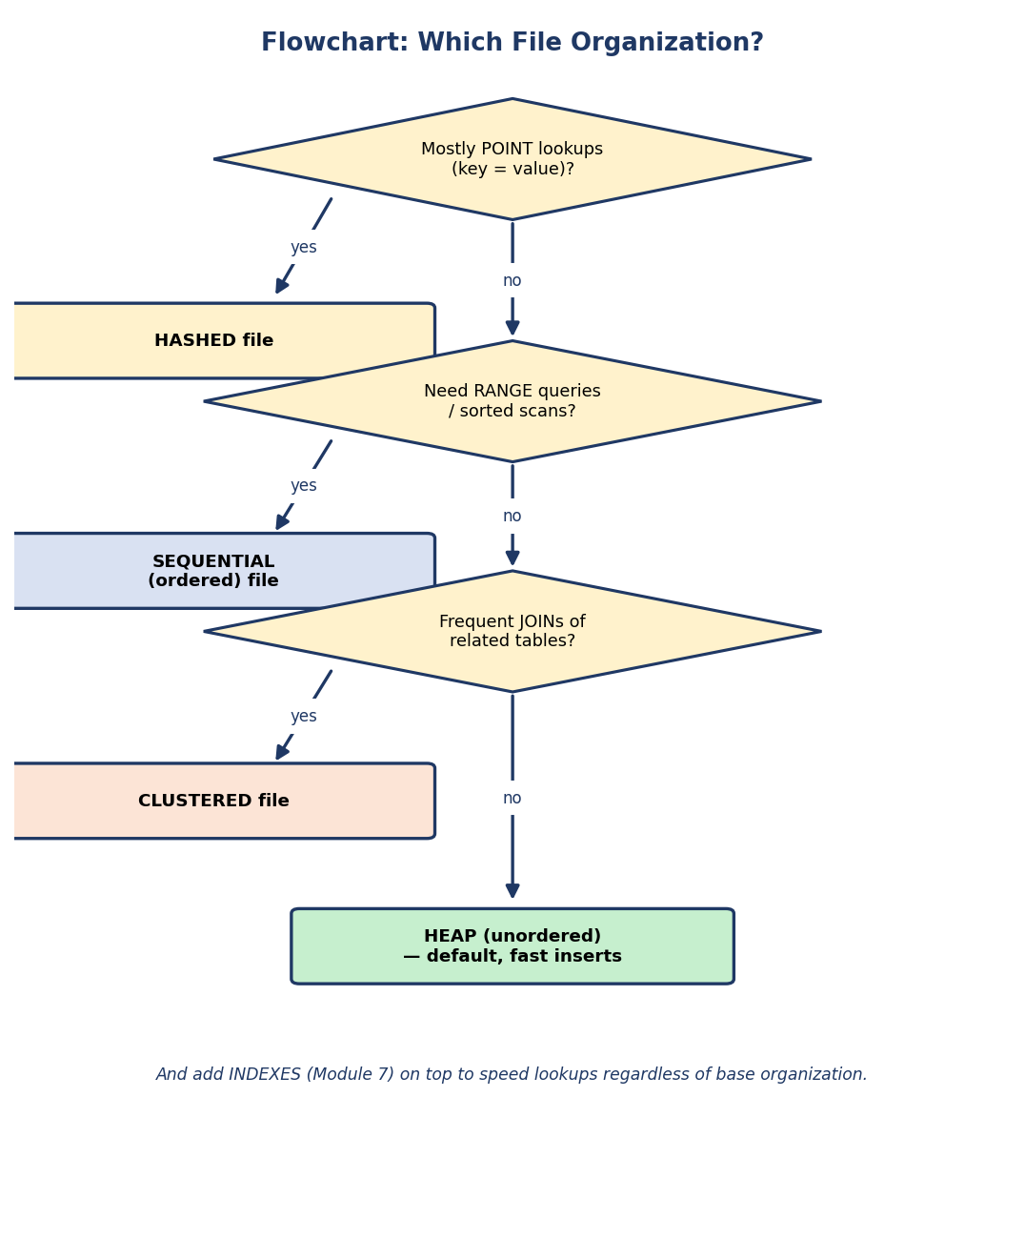
Flowchart for choosing a file organization: point lookups → hashed; range queries → sequential; frequent joins → clustered; otherwise heap.
Reality check: in practice you use a heap + indexes (Module 7). Indexes give you fast lookups without committing the base file to one access pattern.

6.7 The Buffer Manager — Hiding Disk Latency
The buffer manager is the performance heart of a DBMS (we met it in Module 1). It keeps a pool of disk blocks (pages) cached in RAM so repeated accesses don’t hit the disk.
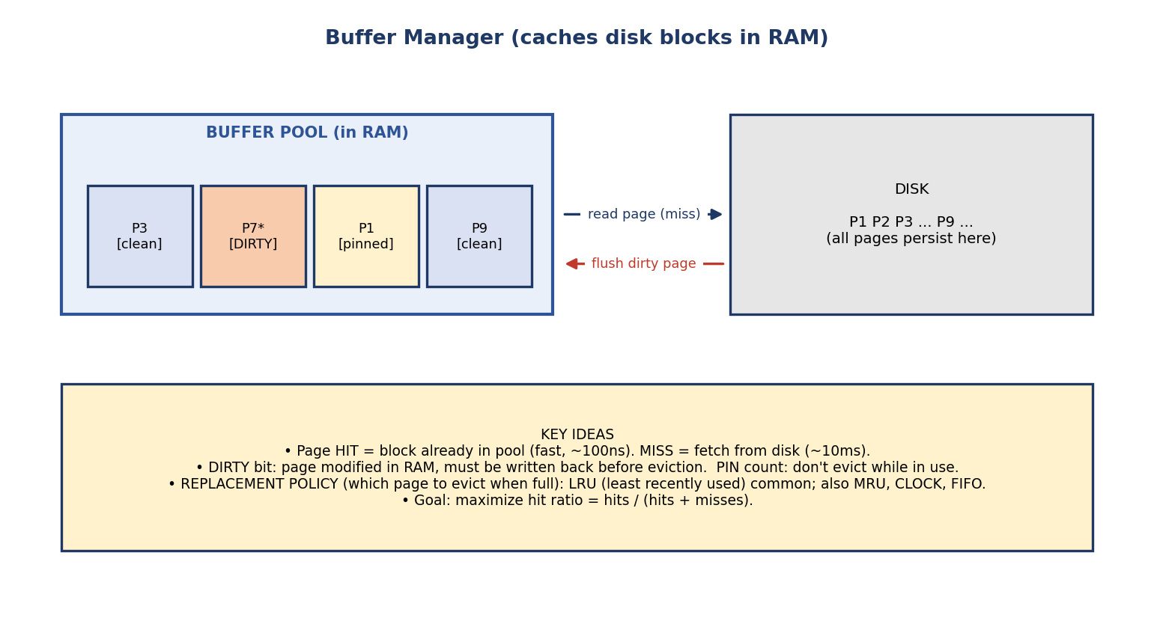
Buffer manager: a buffer pool of page frames in RAM (some clean, some dirty, some pinned); a miss reads a page from disk, dirty pages are flushed back before eviction.
Core concepts:
- Page hit = the block is already in the pool (~100 ns). Page miss = fetch from disk (~10 ms). Hit ratio = hits / (hits + misses) — maximize it.
- Dirty bit: a page modified in RAM is dirty and must be written back to disk before its frame is reused.
- Pin count: a page in active use is pinned so it can’t be evicted.
- Replacement policy (which page to evict when the pool is full):
  - LRU (Least Recently Used) — evict the page unused for longest (most common).
  - MRU (Most Recently Used) — better for some scan patterns.
  - CLOCK (second-chance) — an efficient LRU approximation.
  - FIFO — simplest; can suffer Belady’s anomaly.
Why LRU usually wins: databases have temporal locality — a page used recently is likely used again soon (e.g. an index root). LRU keeps hot pages and evicts cold ones.
Double buffering / prefetching (read-ahead): during a sequential scan the DBMS reads the next block while the CPU is still processing the current one, overlapping I/O with computation so the CPU rarely stalls on the disk. This is why a large sequential scan can sustain near-disk-bandwidth throughput.
Force vs no-force / steal vs no-steal (preview of Module 10 recovery): these policies decide when dirty pages reach disk relative to COMMIT. They directly shape what the recovery manager must undo/redo. We cover them in Module 10.

6.8 Real-World & Backend Perspectives
- SSD vs HDD: SSDs have no seek/rotational latency (no moving parts), so the “random vs sequential” gap shrinks — but sequential is still faster, and SSDs add concerns like write amplification and wear. The DBMS cost model is changing, but block-based I/O and the buffer pool remain.
- Page size tuning: PostgreSQL uses 8 KB pages; bigger pages help sequential scans, smaller pages reduce wasted I/O for random access.
- shared_buffers / buffer pool size is one of the first things a DBA tunes — it’s literally the §6.7 buffer pool. Too small → thrashing (constant misses).
- RAID in production: databases commonly run on RAID 10 (speed + redundancy) or RAID 6 (capacity + double-failure protection), with separate disks for data vs the write-ahead log.

6.9 Tradeoffs, Common Mistakes, Edge Cases
Common mistakes (exam + real life) - Forgetting rotational latency is the average = ½ rotation, not a full one. - Thinking RAID 0 gives fault tolerance (it gives none). - Mixing up RAID min-disk counts (5 → ≥3, 6 → ≥4, 10 → ≥4). - Treating RAID as a backup (it isn’t — it protects against disk failure, not human error/corruption). - Using hashed organization and expecting fast range queries (it’s terrible at ranges). - Forgetting unspanned blocking wastes the leftover bytes per block.
Edge cases - A record larger than a block forces spanned organization. - On SSD, “seek time” ≈ 0, so the classic disk cost model overestimates random-read cost. - LRU can still thrash if the working set exceeds the pool (sequential flooding) — hence MRU/scan-resistant policies.
Tradeoffs
Choice | Gains | Costs
Larger block/page | better sequential throughput | more wasted space on random access
More mirroring (RAID 1/10) | safety + read speed | 50% capacity overhead
Parity (RAID 5/6) | space-efficient redundancy | write penalty (parity update)
Bigger buffer pool | higher hit ratio | less RAM for everything else

6.10 Exam, Interview & Coding Perspectives
Exam (SEBI/RBI/GATE): disk-access-time numericals; rotational latency = ½ rotation; RAID level properties (min disks, usable %, fault tolerance); XOR parity recovery; blocking factor & block-count calculations; spanned vs unspanned; file organization trade-offs; LRU.
Interview: “Why is sequential I/O faster than random?” (one seek vs many); “What does the buffer pool do?”; “RAID 5 vs RAID 10?”; “Is RAID a backup?” (no).
Coding/practical: - In PostgreSQL, inspect SHOW shared_buffers; and SHOW block_size; — that’s the §6.7 pool and the §6.2 page. - Use EXPLAIN (ANALYZE, BUFFERS) to see buffer hits vs reads for a query.

6.11 Concept Checks & MCQs
- Smallest addressable unit on a disk? → sector.
- Largest component of disk access time? → seek time.
- Average rotational latency at 6000 RPM? → 5 ms (½ × 10 ms).
- RAID level with striping and NO redundancy? → RAID 0.
- Minimum disks for RAID 5? → 3. For RAID 6? → 4.
- Usable capacity of RAID 1? → 50%. RAID 5 with n disks? → (n−1)/n.
- bfr for Block=2048, Record=256 (unspanned)? → floor(2048/256) = 8.
- A record bigger than a block requires ___ organization → spanned.
- Best file organization for equality lookups by key? → hashed.
- Most common buffer replacement policy? → LRU.
- Is RAID a backup? → No (availability, not backup).
- Same track across all platters is a ___ → cylinder.
- RAID level with a dedicated parity disk (write bottleneck)? → RAID 4 (RAID 5 fixes it by rotating parity).
- A block is an integer multiple of the ___ size → sector.
- Reading the next block while processing the current one is called ___ → double buffering / prefetching (read-ahead).
True/False - RAID 0 can survive one disk failure. → False. - Rotational latency averages a full rotation. → False (½ rotation). - Hashed files are great for range queries. → False. - Heap files have O(1) insert. → True.
Numerical (do it): > Disk: 10,000 RPM, avg seek 4 ms, transfer rate 100 MB/s, block = 4 KB. > Avg rotational latency = ½ × (60/10000) s = ½ × 6 ms = 3 ms. > Transfer = 4 KB / 100 MB/s ≈ 0.04 ms. > Total ≈ 4 + 3 + 0.04 ≈ 7.04 ms per random block.

6.12 One-Page Revision Sheet
MEMORY HIERARCHY (fast→slow): registers > cache > RAM (VOLATILE) | SSD > HDD > tape (non-volatile)
RAM ~100ns vs disk ~10ms = ~100,000x. DBMS goal = avoid disk; read whole BLOCKS.
primary(CPU-addressable) vs secondary(disk) vs tertiary(tape).
DISK GEOMETRY: platter, TRACK(ring), SECTOR(arc=smallest unit), CYLINDER(same track all platters),
head on arm, BLOCK/PAGE = DBMS I/O unit.
DISK ACCESS TIME = SEEK(move arm, biggest) + ROTATIONAL LATENCY(avg = 1/2 rotation = 1/2 * 60/RPM)
+ TRANSFER(data/rate). Sequential >> random (1 seek vs many).
RAID (availability, NOT backup):
0 stripe min2 100% survives 0 (speed only)
1 mirror min2 50% survives 1
4 stripe + DEDICATED parity disk -> that disk = write bottleneck (RAID 5 fixes it)
5 stripe+1parity min3 (n-1)/n survives1 parity ROTATED (no bottleneck); write penalty
6 stripe+2parity min4 (n-2)/n survives2
10 mirror+stripe min4 50% survives 1/mirror (speed+safety)
XOR parity: P=A1^A2^A3 ; lost A3 = A1^A2^P. (RAID 2/3 obsolete)
DOUBLE BUFFERING / prefetch: read next block while CPU processes current (sequential scans).
RECORDS: fixed(offset = i*size) vs variable(length prefix/delimiter).
bfr = floor(Block/Record); #blocks = ceil(r/bfr).
UNSPANNED(no cross block, wastes leftover) vs SPANNED(crosses, no waste, needs pointer;
required if record > block).
FILE ORG: HEAP(unordered, O(1) insert, O(n) search) | SEQUENTIAL(ordered, O(log n), range-good)
| HASHED(O(1) equality, range-BAD) | CLUSTERED(related tables together, join-good).
BUFFER MANAGER: pool of pages in RAM. hit(~100ns)/miss(~10ms). DIRTY bit(flush before evict),
PIN(don't evict in use). Replacement: LRU(common), MRU, CLOCK, FIFO(Belady). maximize hit ratio.

Flash cards
Front | Back
Biggest disk-access component? | Seek time
Avg rotational latency? | ½ × (60/RPM)
RAID 0 fault tolerance? | None
RAID 5 / 6 min disks? | 3 / 4
RAID 5 usable space? | (n−1)/n
XOR parity recovery? | lost = XOR of the survivors + parity
Blocking factor? | floor(Block size / Record size)
Record > block needs? | Spanned organization
Hashed file weakness? | Range queries
Common eviction policy? | LRU
Is RAID a backup? | No (availability only)

Spaced repetition
- 24-hour: redo the disk-access and bfr numericals; recite RAID min-disks/usable.
- 7-day: explain seek vs rotational vs transfer; XOR parity recovery; LRU.
- 30-day: given a workload, pick the file organization + RAID level with reasons.

6.13 Summary
Storage starts from one hard fact: the memory hierarchy makes disk ~100,000× slower than RAM, so a DBMS reads whole blocks (pages) and works hard to avoid the disk. We learned disk geometry (platter/track/sector/cylinder) and the disk-access-time formula (seek + rotational latency [½ rotation] + transfer), then RAID (0 striping, 1 mirroring, 5/6 parity with XOR recovery, 10 for speed+safety — and that RAID is not a backup). We packed records into blocks via the blocking factor (floor(B/R)) and distinguished spanned vs unspanned. We compared file organizations (heap, sequential, hashed, clustered) by access pattern, and saw the buffer manager cache pages in RAM with a dirty bit, pinning, and an LRU replacement policy to maximize the hit ratio.
This sets up Module 7 — Indexing & Hashing, where we build the data structures (B/B+ trees, hash indexes) that make the disk-bound lookups of Module 4’s queries fast — and Module 8 — Query Processing, whose cost model is literally counting the block accesses we just learned about.
You have mastered this module when you can: compute disk access time and blocking factor from given numbers; state every RAID level’s min disks / usable space / fault tolerance and explain XOR parity recovery; choose a file organization for a workload; and explain what the buffer manager, dirty bit, and LRU do — all without notes.

