Module 7 — Indexing & Hashing
  - DBMS Mastery: SEBI IT / RBI / GATE / Interview — In-Depth Notes (with visuals)
Prepared for nidhi.sharma@forensiccybertech.com
2026
Table of Contents

Module 7 — Indexing & Hashing
Where this module sits. Module 6 told us the painful truth: disk is ~100,000× slower than RAM, and the cost of a query is “how many blocks did we read?” An index is the data structure that turns an O(n) full scan into an O(log n) — or O(1) — lookup. This is the single most important performance topic in databases, and one of the highest-scoring areas in GATE (B+ tree order/height numericals appear almost every year). Get B+ trees right and you understand how every real database makes queries fast.
Importance ratings (out of 5):
Exam / Use | SEBI IT | RBI IT | GATE CS | Interview | Backend
This module | ★★★★ | ★★★★ | ★★★★★ | ★★★ | ★★★★
Most-asked PYQ concepts (SEBI / RBI / GATE): B+ tree order / fan-out / height numericals; B-tree vs B+ tree differences; dense vs sparse; primary vs clustering vs secondary index; B+ tree insertion (leaf split, copy-up); extendible hashing (global/local depth, directory doubling); static hashing & overflow; bitmap index; number of block accesses for a search.

7.1 What Is an Index? (first principles)

Motivation
To find “the customer with id 5000” in a 10-million-row table with no index, the DBMS must scan every block — potentially hundreds of thousands of disk reads. An index is a small, sorted auxiliary structure of (search-key, pointer) entries that lets us locate the record with a handful of reads — exactly like the index at the back of a book.
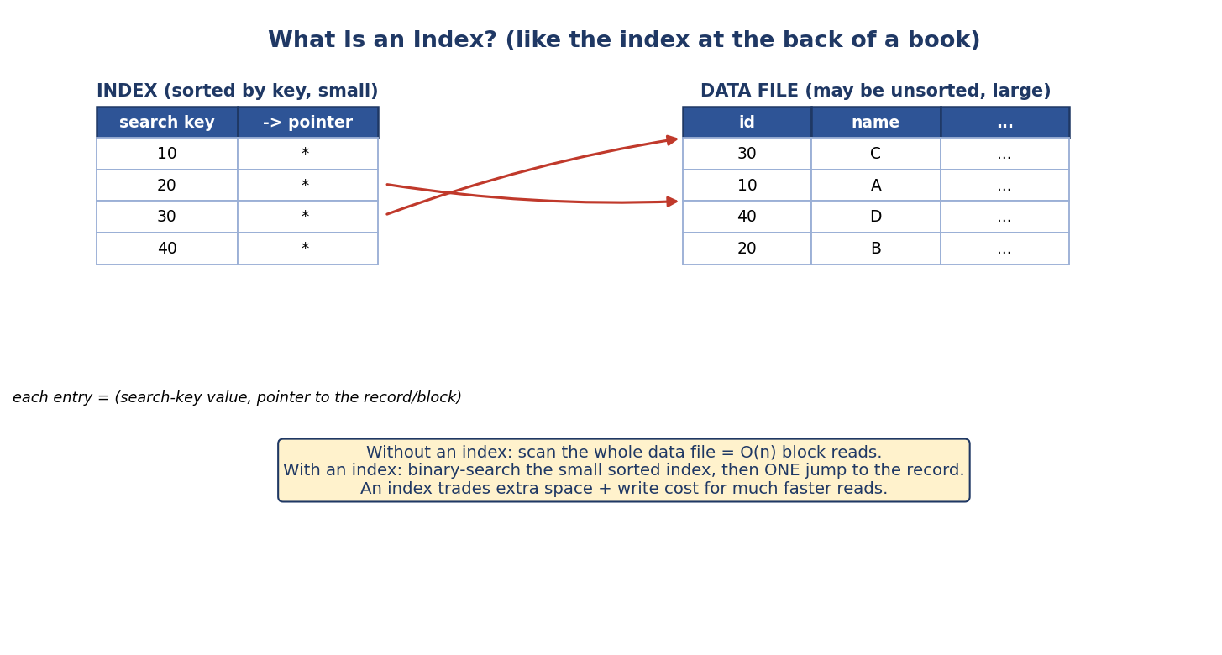
An index: a small sorted file of (search-key, pointer-to-record) entries pointing into a large, possibly unsorted data file.
- Search key: the attribute(s) the index is built on.
- Index entry: (search-key value, pointer) — the pointer locates the record or its block.
- The index is small and sorted, so we binary-search it, then make one jump to the data.
The fundamental trade-off: an index speeds up reads but costs extra space and slows down writes (every INSERT/UPDATE/DELETE must also update the index). So you index the columns you search/join/sort on, not every column.

7.2 Ordered Indexes — Primary, Clustering, Secondary; Dense vs Sparse
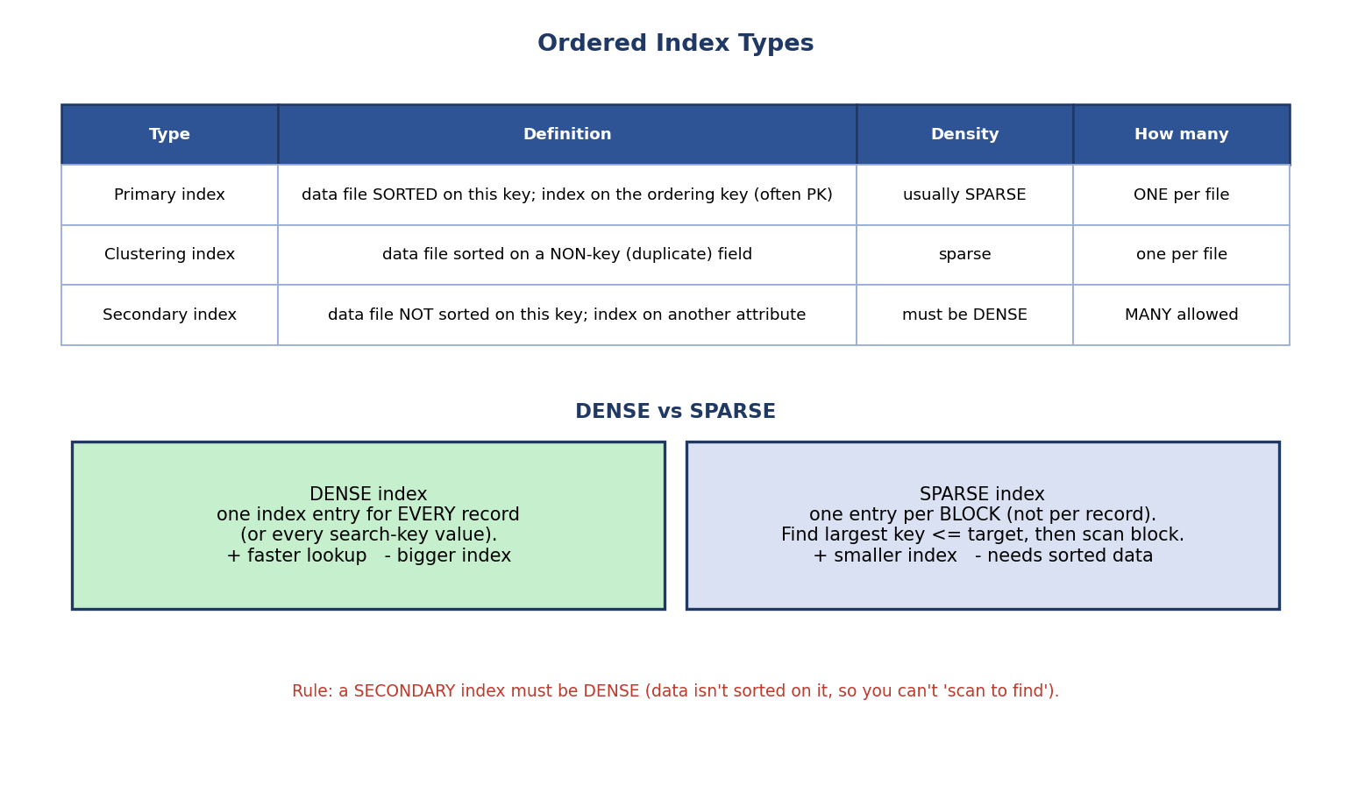
Index types: primary (data sorted on key, sparse), clustering (sorted on non-key), secondary (data not sorted on this key, must be dense); plus dense vs sparse.
Type | Data file is… | Density | How many per table
Primary index | sorted on this (usually key) field | usually sparse | one
Clustering index | sorted on a non-key (duplicate) field | sparse | one
Secondary index | not sorted on this field | must be dense | many
Primary vs clustering: both require the data file to be physically sorted on the indexed field. Primary is on a key (unique ordering field); clustering is on a non-key (records with the same value cluster together). A file can have only one physical sort order → only one primary/clustering index.

Dense vs Sparse
- Dense index: an entry for every record (or every distinct search-key value). Faster lookups, bigger index.
- Sparse index: an entry for every block (one per block). Find the largest key ≤ target, then scan within that block. Smaller index, but requires the data file to be sorted.
Key rule (exam): a secondary index must be dense — because the data file isn’t sorted on that field, you can’t “scan forward to find” a missing key, so every value needs its own entry. A primary index can be sparse (data is sorted, so one entry per block suffices).
Industry terminology — clustered vs non-clustered (SEBI/RBI MCQ): - Clustered index = the table is physically stored in the index’s order (the data is the index leaf). This is the primary/clustering index — one per table (a file has only one physical order). (In MySQL InnoDB the primary key is the clustered index.) - Non-clustered index = a separate structure holding (key → row pointer), leaving the table in its own order. This is a secondary index — many per table. So: clustered ≈ primary/clustering (one); non-clustered ≈ secondary (many).

7.3 Multilevel Indexes → the idea behind trees
A single-level index can itself become too large to search quickly. Solution: build an index on the index, repeating until the top level fits in one block.
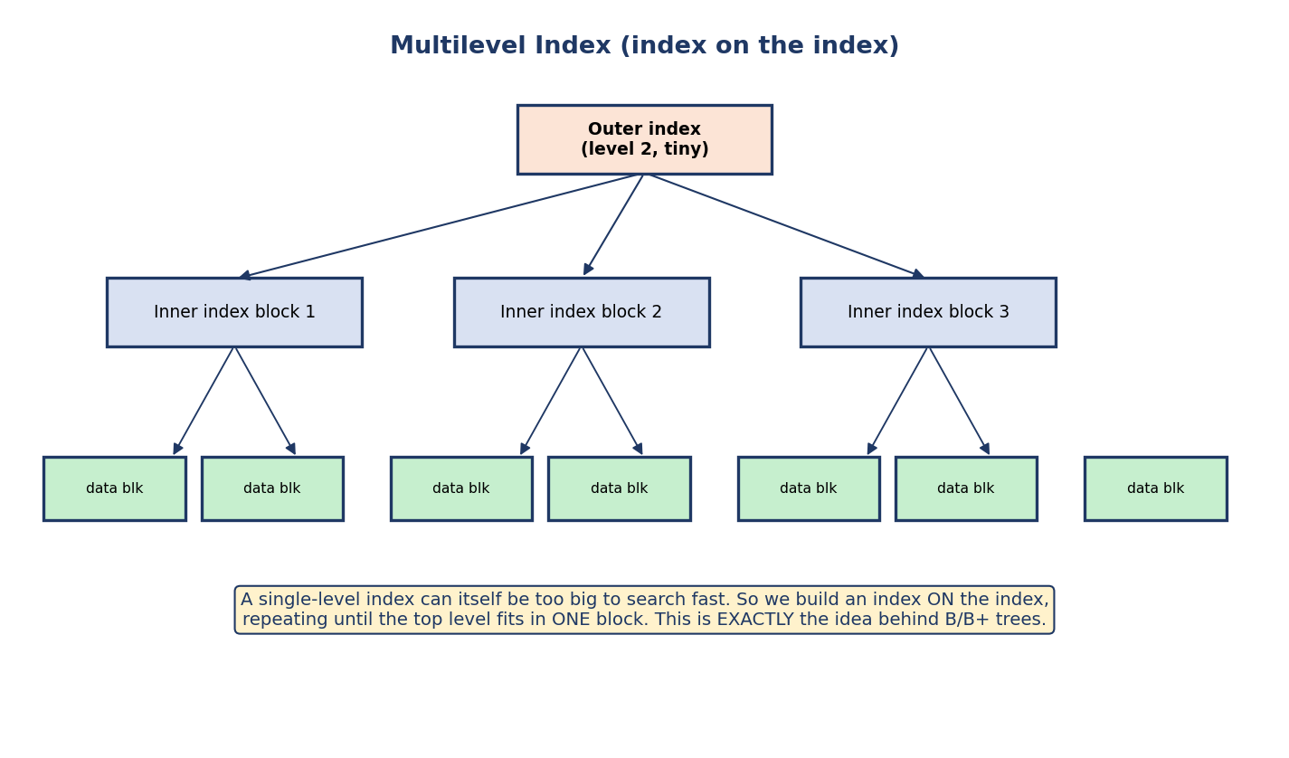
Multilevel index: an outer index points to inner index blocks, which point to data blocks — repeated until the top fits in one block.
ISAM (Indexed Sequential Access Method) is the classic static multilevel ordered index — the historical predecessor to B+ trees. It’s built once over a sorted file; the index levels are fixed. Its weakness: inserts go to overflow chains (the static index can’t grow/rebalance), so after many inserts the overflow chains get long and performance degrades — exactly the problem dynamic trees solve.
This is precisely the idea behind B-trees and B+ trees — a multilevel, self-balancing index that automatically keeps itself shallow as data grows and shrinks (unlike static ISAM). Next we build them.

7.4 B-Trees
A B-tree of order p is a balanced multilevel index where:
- each node holds up to p − 1 keys and p child-pointers,
- every node (except the root) is at least half full (≥ ⌈p/2⌉ children),
- keys appear at every level, and each key carries a pointer to its data record.
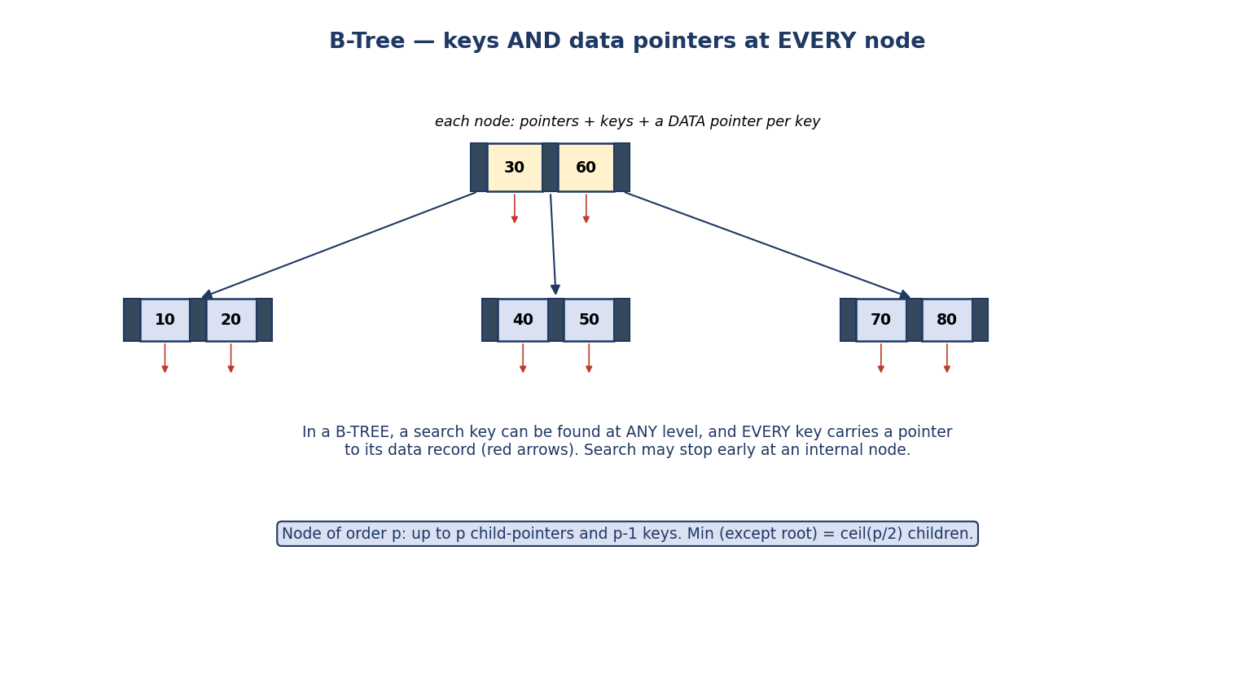
B-tree node: pointers and keys, with a data pointer attached to every key at every level; a search can stop early at an internal node.
The B-tree property: because keys (with their data pointers) live at all levels, a search can stop early if it finds the key in an internal node. But this also means internal nodes carry data pointers, which lowers the fan-out (fewer keys per node), making the tree taller — the downside B+ trees fix.

7.5 B+ Trees — the index every database actually uses
A B+ tree modifies the B-tree with one decisive change: data pointers live ONLY in the leaves, and all leaves are linked in a sorted list.
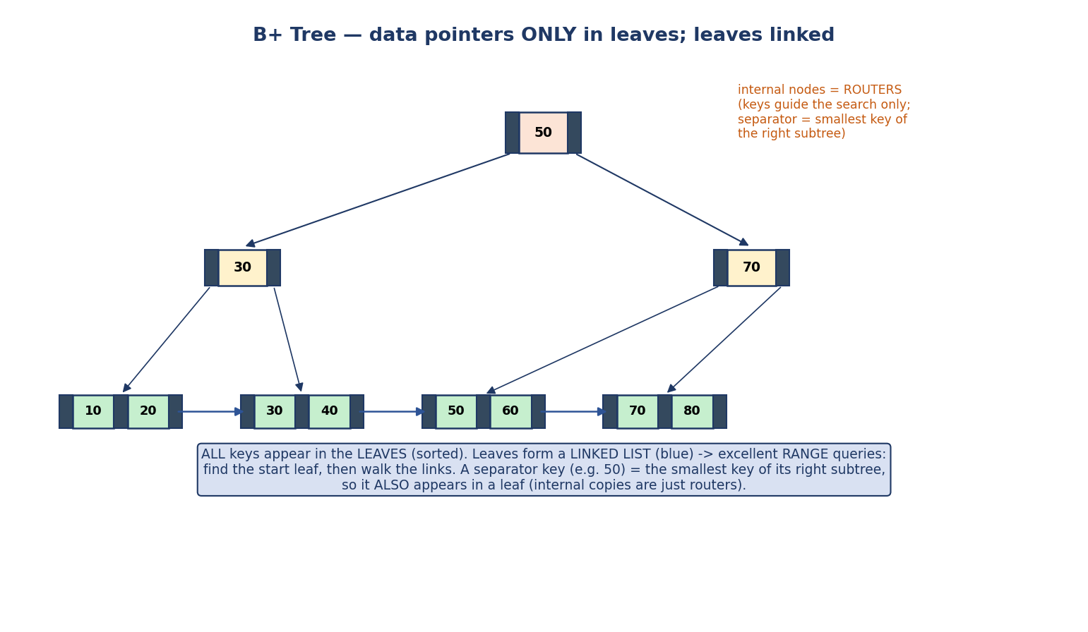
B+ tree: internal nodes are routers (keys only), all keys appear in the sorted leaves which hold the data pointers and are connected as a linked list; separator = smallest key of the right subtree.
- Internal nodes are pure routers — their keys only guide the search; they hold no data pointers.
- All keys appear in the leaves (sorted). A separator key in an internal node equals the smallest key of its right subtree, so it also appears in a leaf (the internal copy is just a router).
- Leaves are a linked list → range queries are trivial: find the start leaf, then walk the links.
Why B+ trees win (and why “database index” ≈ B+ tree): because internal nodes carry no data pointers, they pack more keys per node → higher fan-out → a shorter tree → fewer disk reads. Plus, linked leaves make range scans cheap. Almost every RDBMS index (MySQL, PostgreSQL, Oracle) is a B+ tree.

B-tree vs B+ tree (a guaranteed comparison)
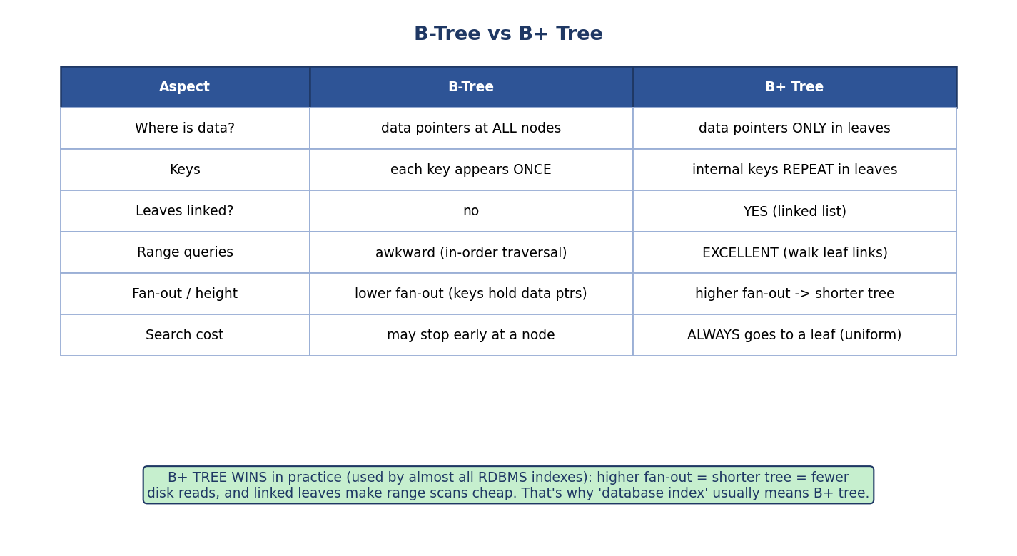
B-tree vs B+ tree comparison: data location, key repetition, linked leaves, range queries, fan-out/height, search cost.
Aspect | B-Tree | B+ Tree
Data pointers | at all nodes | only in leaves
Keys | each key appears once | internal keys repeat in leaves
Leaves linked? | no | yes (linked list)
Range queries | awkward (traversal) | excellent (walk leaf links)
Fan-out / height | lower fan-out, taller | higher fan-out, shorter
Search cost | may stop early | always reaches a leaf (uniform)

7.6 B+ Tree: Order, Fan-out & Height (the GATE numerical)
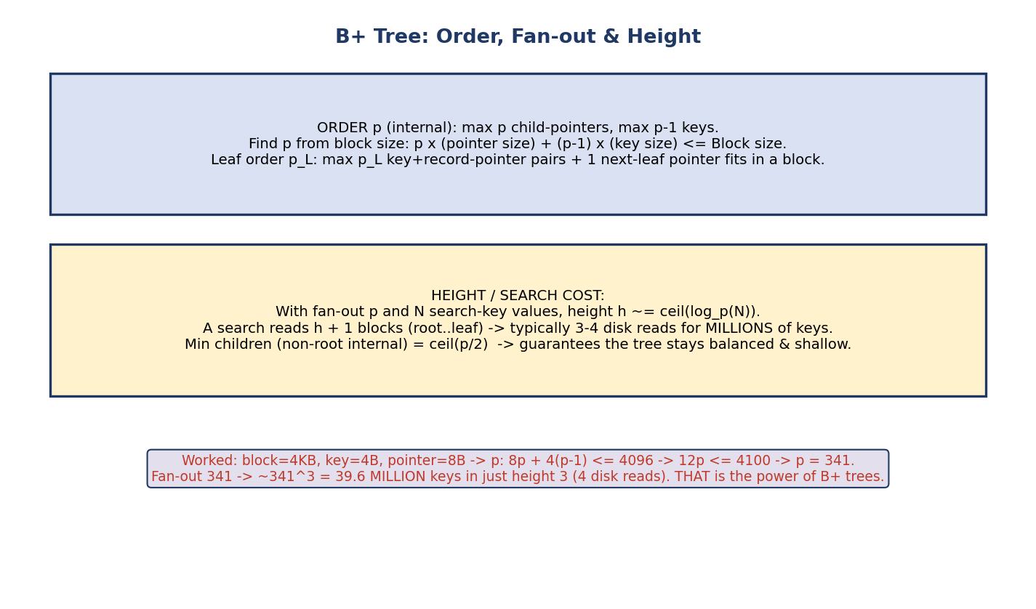
B+ tree order, fan-out and height: deriving order p from block size, and how high fan-out gives tiny height for millions of keys.
Finding the order p (internal node) from the block size:
p × (block-pointer size) + (p − 1) × (key size) ≤ Block size
Worked example: Block = 4096 B, key = 4 B, block-pointer = 8 B. 8p + 4(p − 1) ≤ 4096 → 12p − 4 ≤ 4096 → 12p ≤ 4100 → p ≤ 341.67 → p = 341 (take the floor).
Height & search cost: with fan-out p and N search-key values, height ≈ ⌈log_p(N)⌉, and a search reads (height + 1) blocks (root → leaf).
The “wow” fact: fan-out 341 → 341³ ≈ 39.6 million keys in a tree of height 3 → a key among ~40 million is found in just ~4 disk reads. That is why B+ trees dominate. (Internal nodes are usually cached in RAM, so real lookups are even faster.)
Leaf node order p_leaf: a leaf holds (search-key, record-pointer) pairs plus one next-leaf pointer: p_leaf × (key + record-pointer) + (block-pointer) ≤ Block size.
Balance guarantee: every internal node (except root) has ≥ ⌈p/2⌉ children, so the tree can never become a skewed chain — height stays O(log N).

7.7 B+ Tree Insertion (leaf split & copy-up)
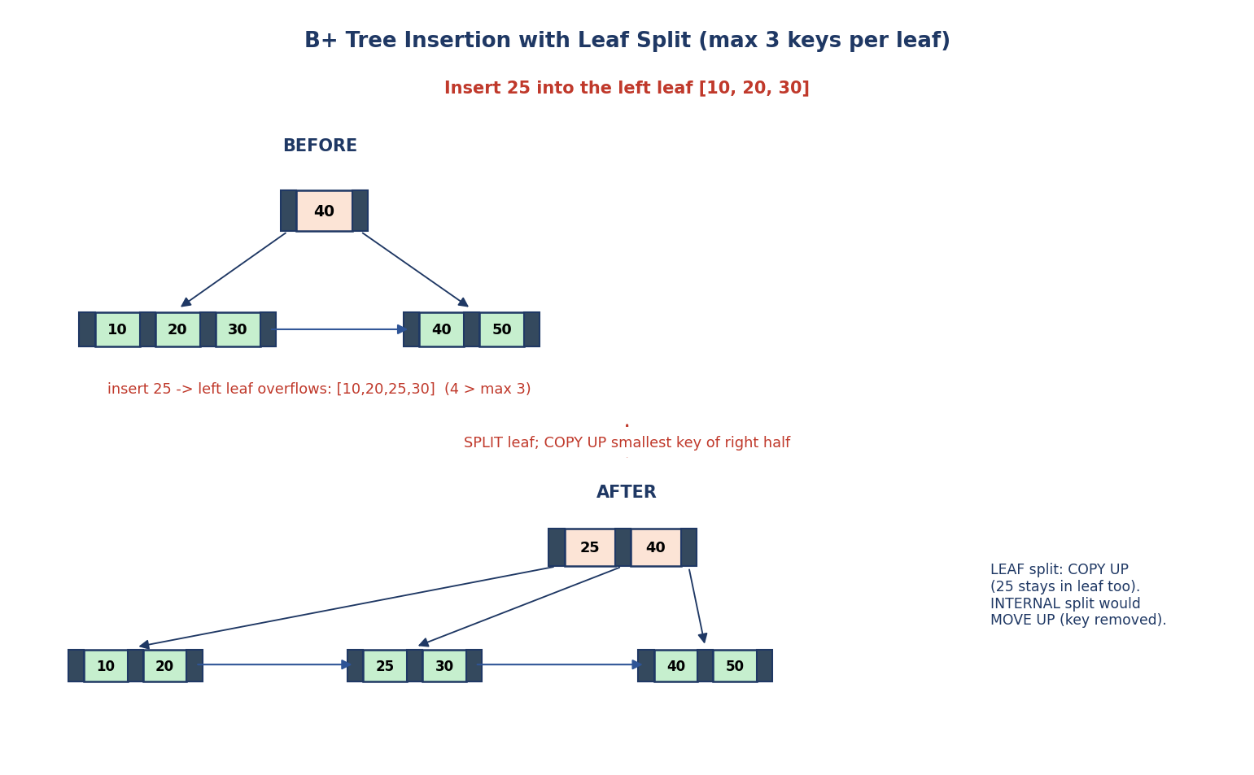
B+ tree insertion: inserting 25 into a full leaf [10,20,30] overflows; the leaf splits into [10,20] and [25,30], and 25 (smallest of the right half) is copied up to the parent.
Algorithm: find the correct leaf; insert in sorted order. If the leaf overflows (more than the max keys), split it into two and copy up the smallest key of the right half to the parent. If the parent overflows too, split it (internal split moves up the middle key) — recursively up to the root.
The crucial leaf-vs-internal distinction (exam favourite): - Leaf split → COPY UP: the separator key is copied to the parent and also stays in the leaf (all keys must remain in the leaves). - Internal split → MOVE UP (push up): the middle key moves to the parent and is removed from the node (internal keys are only routers).
Worked (from the diagram): insert 25 into a B+ tree leaf [10,20,30] (max 3 keys). It overflows to [10,20,25,30] → split into [10,20] and [25,30], copy up 25. The root [40] becomes [25,40], now with three leaves [10,20] [25,30] [40,50] — and you can verify the routing: <25 → [10,20], 25≤k<40 → [25,30], ≥40 → [40,50]. ✔
Deletion (brief): remove the key from its leaf; if the node underflows (drops below its minimum occupancy — roughly half full, the exact threshold depends on the textbook’s leaf-capacity convention), borrow a key from a sibling, or merge with a sibling and adjust the parent (which may cascade up). Symmetric to insertion. (For numericals, always use the minimum-fill convention your exam/textbook states.)

7.8 Hashing — O(1) Lookups by Key
Indexes give O(log n); hashing aims for O(1) average lookups for equality searches. A hash function maps a key to a bucket (a block).

Static hashing
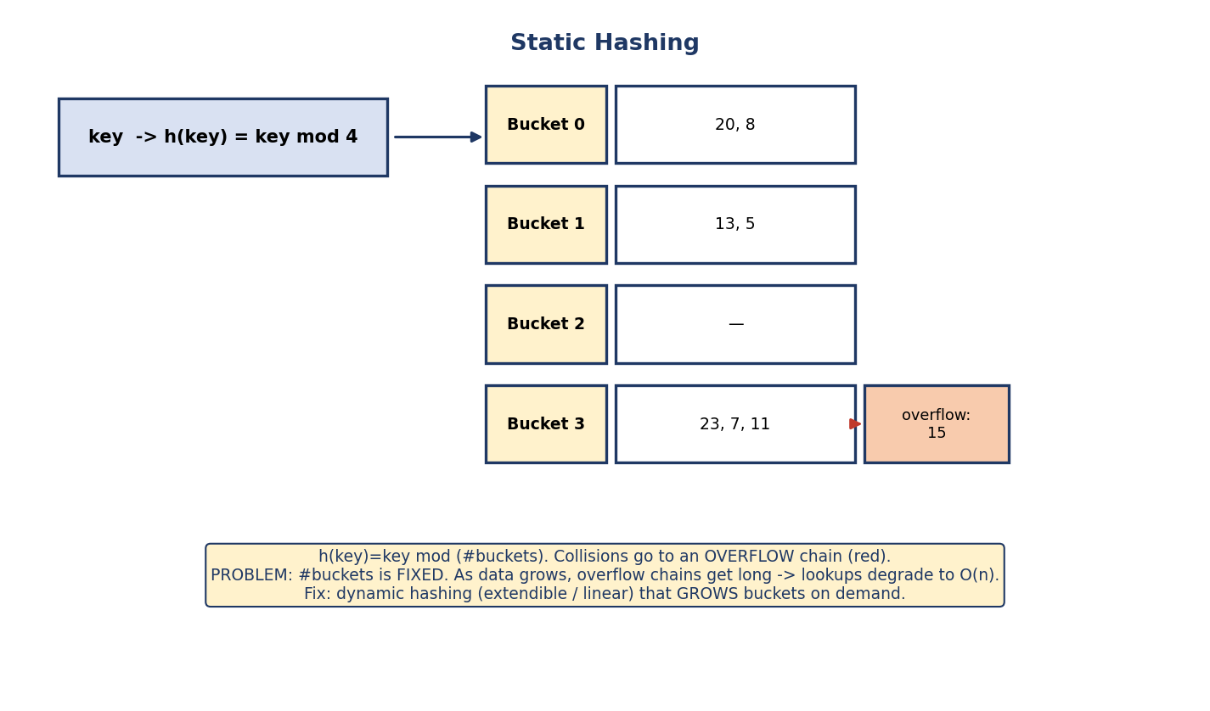
Static hashing: h(key)=key mod 4 maps each key to one of 4 fixed buckets; collisions go to an overflow chain.
bucket = h(key), e.g. h(key) = key mod (#buckets). Multiple keys hashing to the same bucket are stored together; when a bucket fills, extras go to an overflow chain.
Collision-resolution methods (exam contrast): - Chaining (closed addressing): overflowing records go to linked overflow buckets — the bucket “chains” extra blocks. (This is what DB static hashing typically uses.) - Open addressing: on collision, probe for another free slot — linear probing (next slot), quadratic probing, or double hashing. No overflow chain, but clustering can hurt.
The fatal flaw of static hashing: the number of buckets is fixed. As data grows, overflow chains get long and lookups degrade toward O(n). As data shrinks, buckets sit empty. Fixing this requires dynamic hashing.

Extendible hashing (dynamic)
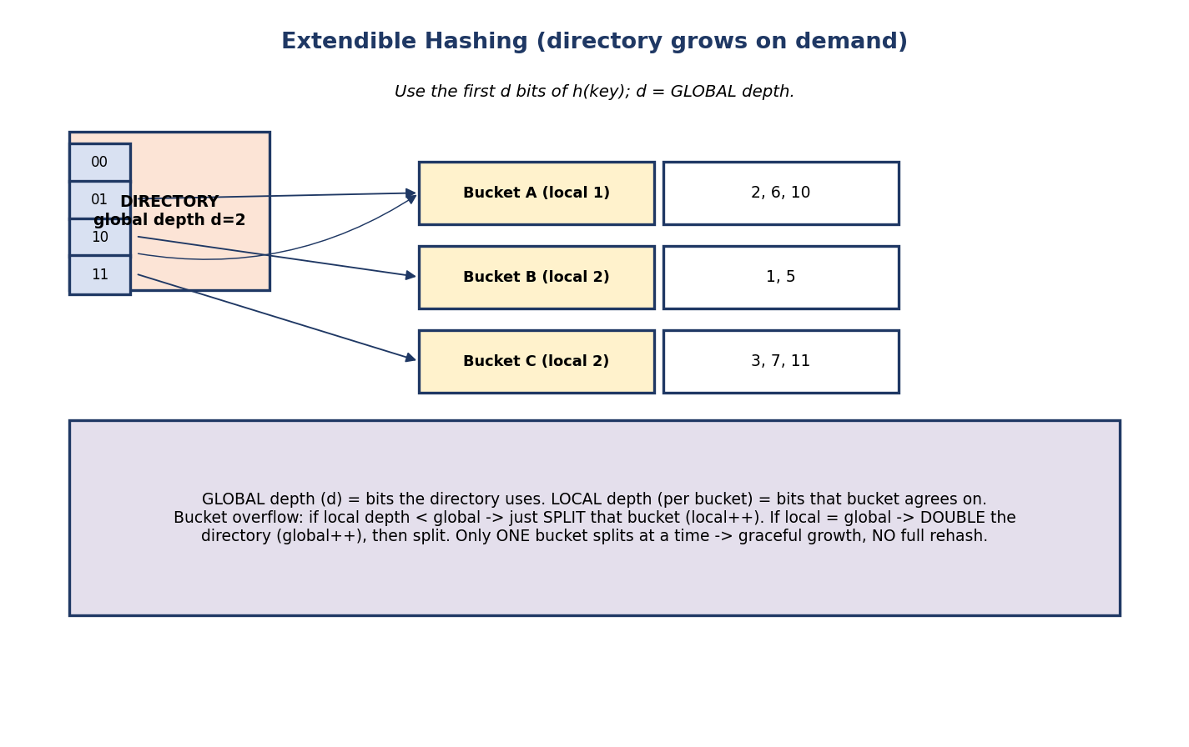
Extendible hashing: a directory addressed by the first d bits (global depth) of the hash points to buckets with their own local depth; overflow either splits a bucket or doubles the directory.
Extendible hashing grows gracefully using a directory:
- Global depth (d): how many leading bits of h(key) the directory uses (directory size = 2^d).
- Local depth: how many bits a particular bucket agrees on.
- On overflow:
  - if local depth < global depth → just split that bucket (local depth++),
  - if local depth == global depth → double the directory (global depth++), then split.
The big win: only one bucket splits at a time — no full rehash of all data (unlike rebuilding a static hash table). The directory doubles occasionally, but buckets are shared.
Linear hashing is another dynamic scheme that grows buckets one at a time in a fixed order without a directory (using a split pointer). Know it exists; extendible hashing is the one GATE tests in detail.

Hashing vs B+ tree
Decision: hash = O(1) for exact-match (WHERE id = 5) but useless for ranges (it scatters neighbouring keys). B+ tree = O(log n) but handles both equality and ranges/sorting. That’s why B+ tree is the default index.

7.9 Bitmap Index
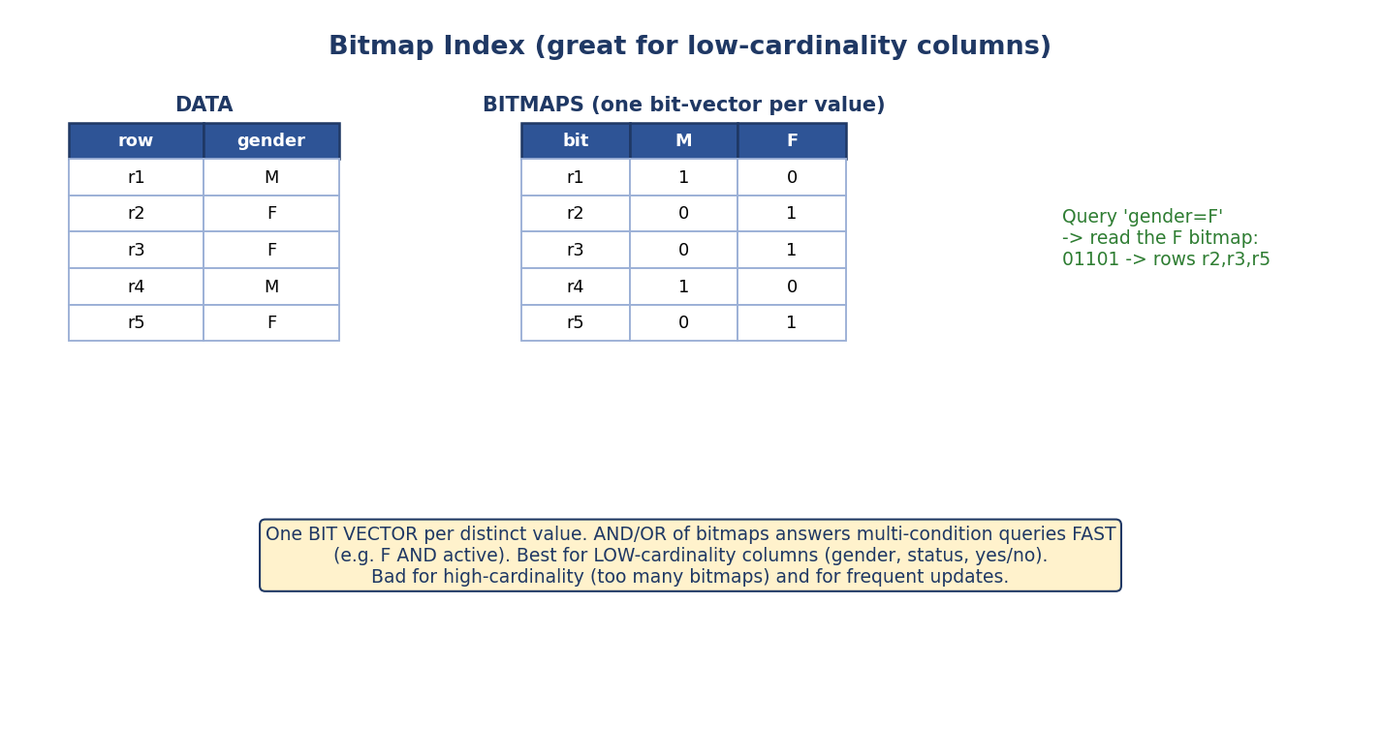
Bitmap index: one bit-vector per distinct column value; a query reads the matching bitmap (and ANDs/ORs bitmaps for multi-condition queries).
A bitmap index stores, per distinct value, a bit-vector with one bit per row (1 = this row has that value). Query gender = 'F' just reads the F bitmap; multi-condition queries (F AND active) are fast bitwise AND/OR.
- Best for low-cardinality columns (gender, status, yes/no) used in analytics.
- Bad for high-cardinality (too many bitmaps) and frequent updates (bit maintenance is costly).

7.10 Choosing an Index
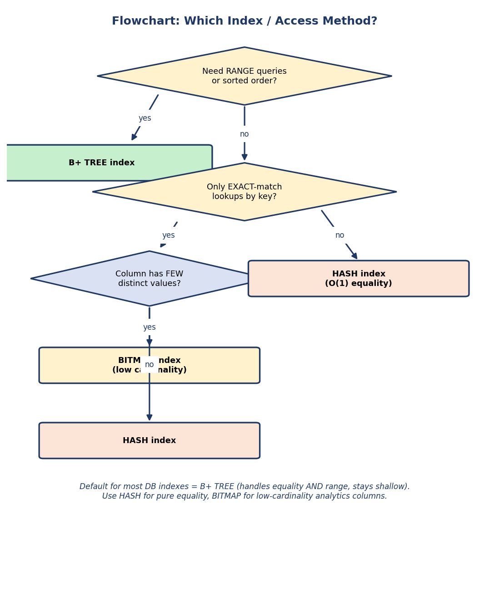
Flowchart: range queries → B+ tree; exact-match only → hash (or bitmap if low cardinality); default → B+ tree.
- Range queries / sorting / general purpose → B+ tree (the default).
- Pure equality lookups → hash index (O(1)).
- Low-cardinality analytics columns → bitmap.
- Don’t over-index: each index speeds reads but slows every write and uses space.

7.11 Real-World & Backend Perspectives
- CREATE INDEX idx ON emp(dno); builds a B+ tree by default in PostgreSQL/ MySQL. EXPLAIN shows whether the optimizer chose an index scan vs a seq scan.
- Composite / covering indexes: INDEX(a, b) helps WHERE a=? AND b=? and WHERE a=?, but not WHERE b=? (leftmost-prefix rule). A covering index includes all columns a query needs, so the table isn’t touched at all.
- Clustered index in practice: in MySQL InnoDB the primary key IS the clustered index — the table is physically stored as that B+ tree.
- Write amplification: every index multiplies write cost; high-write tables keep indexes lean.

7.12 Tradeoffs, Common Mistakes, Edge Cases
Common mistakes (exam + real life) - Saying a secondary index can be sparse (it must be dense). - Confusing leaf split (copy-up) with internal split (move-up). - Using hashing and expecting fast range queries (it can’t). - Forgetting B-tree stores data pointers at all levels (lower fan-out), B+ tree only in leaves. - In the order formula, forgetting it’s p pointers but p−1 keys. - Thinking more indexes are always better (they slow writes).
Edge cases - A table can have only one primary/clustering index (one physical sort order) but many secondary indexes. - B+ tree with all internal nodes cached → a lookup is effectively one disk read (the leaf). - Extendible hashing directory can double even when only one bucket was full.
Tradeoffs
Index choice | Gain | Cost
B+ tree | range + equality, shallow | update cost, space
Hash | O(1) equality | no ranges, resize pain (static)
Bitmap | fast multi-condition on low-cardinality | bad for high-cardinality / updates
More indexes | faster reads | slower writes, more space

7.13 Exam, Interview & Coding Perspectives
Exam (SEBI/RBI/GATE): compute B+ tree order from block size; height / block accesses; dense vs sparse; primary vs clustering vs secondary; B-tree vs B+ tree; leaf split copy-up; extendible hashing global/local depth & directory doubling; static hashing overflow; bitmap use-case.
Interview: “Why are database indexes B+ trees, not hash tables or binary search trees?” (disk-friendly high fan-out + ranges); “What’s a covering index?”; “When does an index hurt?” (write-heavy tables); “leftmost-prefix rule”.
Coding/practical: - CREATE INDEX then EXPLAIN ANALYZE a query to see index scan vs seq scan. - Build a composite index and test which WHERE clauses use it (leftmost prefix).

7.14 Concept Checks & MCQs
- An index trades ___ for faster reads → space + write cost.
- A secondary index must be ___ → dense.
- Which can be sparse: primary or secondary? → primary.
- In a B-tree, data pointers are at ___ → every node. In a B+ tree? → only leaves.
- Which has higher fan-out (shorter tree)? → B+ tree.
- B+ tree order: 8p + 4(p−1) ≤ 4096 → p = ? → 341.
- Leaf split in a B+ tree does ___ up; internal split does ___ up → copy / move.
- Hashing is bad for which query type? → range queries.
- In extendible hashing, the directory doubles when ___ → a bucket’s local depth equals the global depth and it overflows.
- Bitmap index is best for ___ columns → low-cardinality.
- Max keys in a B-tree/B+ tree node of order p? → p − 1.
- Leaves of a B+ tree are connected as a ___ → linked list (for ranges).
- Clustered index ≈ ___ (one per table); non-clustered ≈ ___ (many) → primary/ clustering / secondary.
- Static multilevel index whose inserts degrade via overflow chains? → ISAM.
- Two collision-resolution families? → chaining (closed addressing) and open addressing (probing).
True/False - A B+ tree stores data pointers in internal nodes. → False. - A table can have many clustering indexes. → False (one sort order). - Static hashing handles growth gracefully. → False (fixed buckets). - B+ tree internal keys also appear in leaves. → True.
Numerical (do it): > Block = 1024 B, key = 6 B, pointer = 10 B. Find the B+ tree order p (internal). > 10p + 6(p−1) ≤ 1024 → 16p − 6 ≤ 1024 → 16p ≤ 1030 → p ≤ 64.4 → p = > 64. With fan-out 64, height 3 holds 64³ ≈ 262,000 keys.

7.15 One-Page Revision Sheet
INDEX = (search-key, pointer) sorted aux structure. Trades SPACE + WRITE cost for fast reads.
ORDERED INDEXES:
PRIMARY : data sorted on key field; can be SPARSE; ONE per table.
CLUSTERING: data sorted on NON-key; sparse; one per table.
SECONDARY: data NOT sorted on field; MUST be DENSE; MANY per table.
DENSE = entry per record. SPARSE = entry per block (data must be sorted).
CLUSTERED index = table physically in index order (primary/clustering, ONE).
NON-CLUSTERED = separate structure -> row pointers (secondary, MANY).
MULTILEVEL INDEX = index on index -> idea behind B/B+ trees.
ISAM = static multilevel ordered index; inserts -> overflow chains -> degrades (B+ tree fixes).
B-TREE: order p -> p pointers, p-1 keys; data ptrs at ALL nodes; keys appear ONCE; search may stop early.
B+ TREE: data ptrs ONLY in leaves; ALL keys in leaves (sorted); leaves LINKED LIST (range-good);
internal = routers (separator = smallest key of right subtree). HIGHER fan-out -> shorter tree.
-> the default RDBMS index.
ORDER from block: p*ptr + (p-1)*key <= Block. e.g. 8p+4(p-1)<=4096 -> p=341.
HEIGHT ~ ceil(log_p N); search reads height+1 blocks. fan-out 341, h=3 -> ~40M keys in 4 reads.
MIN children (non-root) = ceil(p/2) -> balanced.
B+ INSERT: leaf overflow -> SPLIT + COPY UP smallest key of right half. internal overflow -> MOVE UP middle.
B+ DELETE: underflow (< ceil(p/2)-1) -> borrow from sibling or MERGE.
HASHING (equality O(1), NO ranges):
STATIC: bucket=h(key)=key mod B; fixed buckets -> overflow chains as data grows (degrades).
COLLISIONS: chaining (closed addressing, overflow buckets) vs open addressing (linear/quadratic probe).
EXTENDIBLE: directory by first d bits (global depth); bucket local depth.
overflow: local<global -> split bucket; local=global -> DOUBLE directory then split. No full rehash.
LINEAR: grows one bucket at a time via split pointer, no directory.
BITMAP: one bit-vector per distinct value; AND/OR for multi-condition. LOW-cardinality only.
CHOOSE: ranges/sort/general -> B+ tree; pure equality -> hash; low-cardinality analytics -> bitmap.

Flash cards
Front | Back
Secondary index density? | Must be dense
Primary index can be? | Sparse
Data pointers in B+ tree? | Only in leaves
Higher fan-out: B-tree or B+? | B+ tree
B+ order formula? | p·ptr + (p−1)·key ≤ block
Leaf split vs internal split? | Copy-up vs move-up
Hashing weakness? | Range queries
Extendible: directory doubles when? | local depth = global depth & overflow
Bitmap best for? | Low-cardinality columns
Leaves linked → good for? | Range queries
Max keys per order-p node? | p − 1

Spaced repetition
- 24-hour: compute B+ tree order & height for 2 block-size problems; redo MCQs.
- 7-day: draw a B+ tree insertion with a leaf split (copy-up); explain B-tree vs B+.
- 30-day: trace an extendible-hashing insert sequence that doubles the directory; pick the right index for 5 workloads.

7.16 Summary
Indexing is how databases beat the disk. An index is a small sorted (search-key, pointer) structure that trades space + write cost for fast reads. We classified ordered indexes — primary (sorted key, can be sparse), clustering (sorted non-key), and secondary (unsorted field, must be dense) — and the dense vs sparse distinction. Multilevel indexing led to B-trees (data pointers at all levels) and the dominant B+ tree (data only in linked leaves, internal nodes as routers, high fan-out → shallow tree → few disk reads, great for ranges). We did the order/height numericals (p·ptr + (p−1)·key ≤ block; fan-out 341 → ~40M keys in height 3) and insertion (leaf split copy-up vs internal split move-up). Then hashing for O(1) equality — static (fixed buckets, overflow) and the dynamic extendible hashing (global/local depth, directory doubling, no full rehash) — and bitmap indexes for low-cardinality analytics.
Next, Module 8 — Query Processing & Optimization uses these access methods and the Module 6 cost model to decide how to actually run a query (which index, which join algorithm), turning the relational algebra of Module 3 into an efficient execution plan.
You have mastered this module when you can: compute a B+ tree’s order and height from block/key/pointer sizes; explain dense vs sparse and primary vs secondary; contrast B-tree and B+ tree and say why B+ wins; perform a B+ tree insertion with a leaf split (copy-up); and trace extendible hashing through a directory doubling — all without notes.

